* Simulation waveform



* 加法

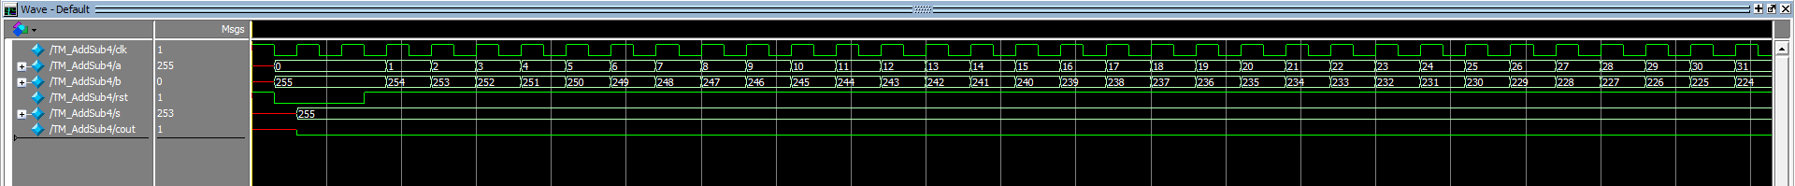

* 減法

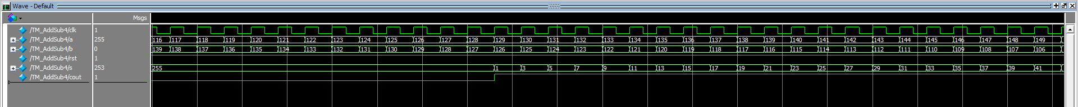

* RTL schematic

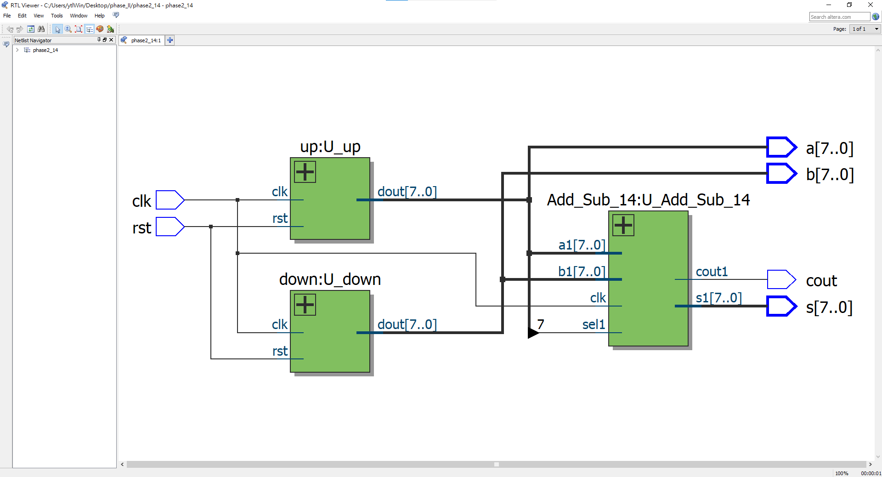

* Technology schematic

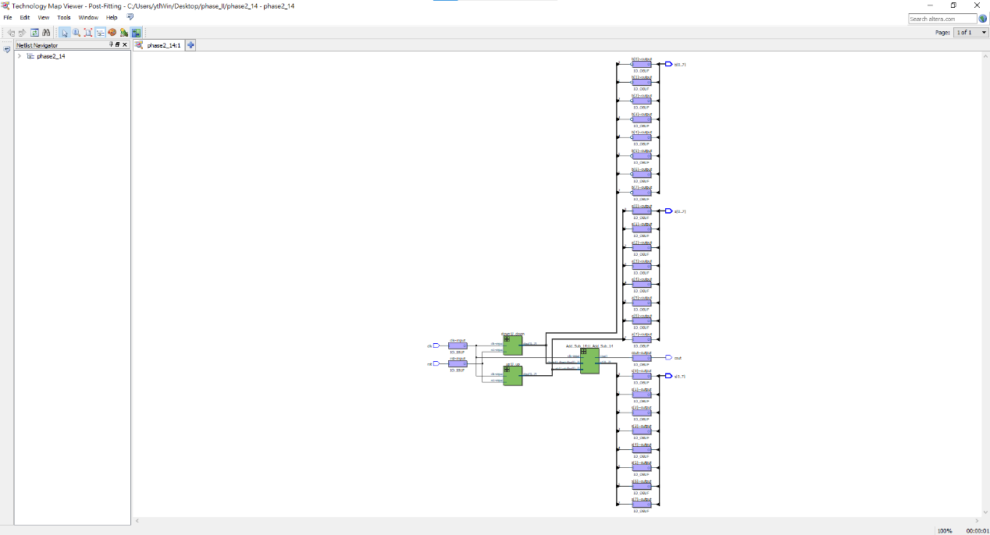

* Pin assignment

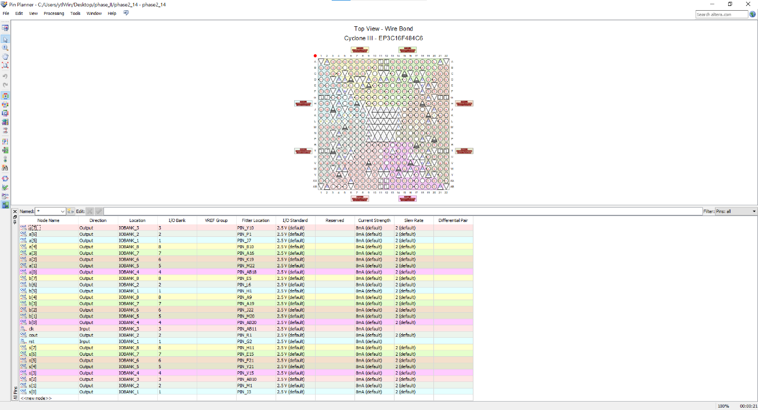

* Post-Simulation waveform

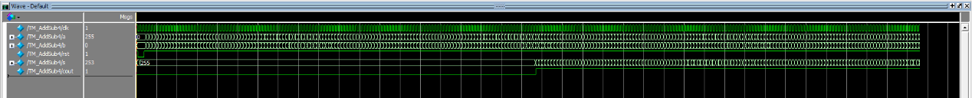

* 加法(timing delay)

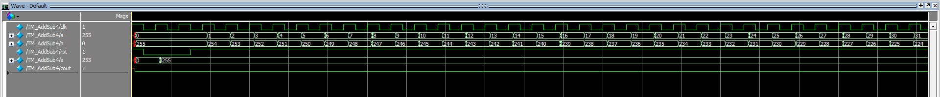

* 減法(timing delay)

