CST8227 Interfacing Midterm Practice Test

1. Answer the following questions pertaining to pulse width modulation:
   * 1. Calculate the duty cycle of the waveform
     2. Write one line of code that would send this waveform to a Teensyduino pin

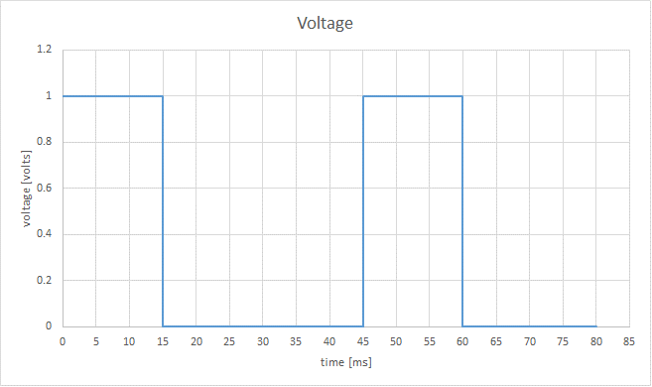

$$Formula:$$

$\% Duty Cycle=\frac{ton}{ton+toff}*100\%$, t = time [s]

**Ton = 15 ms**

**Toff = (45 – 15) ms = 30 ms**

**% duty cycle = 15 / 15 + 30 = 15 / 45 = 1/3 = 33.3%**

**33.3% of 255 (max RGB) = ~84**

**analogWrite( pin, 84 );**

1. Calculate the total resistance for the following circuit:

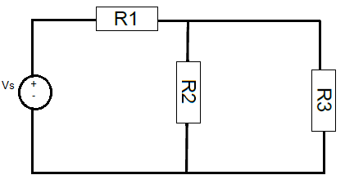Vs = 10 volts

R1 = 1 KΩ

R2 = 5 KΩ

R3 = 10 KΩ

RT = R1 + (R2 || R3)

= 1 KOhm + (5 x 10 / 5 + 10) KOhm

= 1 + (50/15)

= 1 + 3.333

= 4.3 KOhm

1. Calculate the size of a resistor such that the target current is obtained? Assume that Vcc = 5.0 volts. The target current that the circuit should allow is 5 mA, and the voltage drop across the LED = 1.9 Volts.

R = V / I

= (5.0 – 1.9) Volts / 0.005 Amps

= 3.1 V / 0.005 A

= 620 Ohms

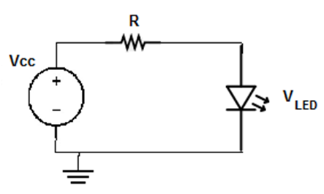

1. **Part B: Multiple Choice [7 marks – 1 mark each]**
   * + 1. Three types of microprocessor memory pools are Flash, RAM, and EEPROM. Which of these memory pools on Teensyduino 3.2, contains the sketch that is uploaded by the user?
          1. **Flash** b. RAM c. EEPROM d. Both a and b e. none of these
       2. What functions must be defined in every Arduino (and Teensy) program?
          1. void setup() and void run()
          2. void init() and void loop()
          3. void setup() and void while()
          4. void init() and void run()
          5. **void setup() and void loop()**
       3. How many shift registers (the ones used in the course) would need to be connected together, so that the output of the entire shift register circuit has the same size bus as the ARM Cortex chip that is on board the Teensyduino 3.2?
          1. 2 b. 4 c. 6 d. 8 e. none of these
       4. Assume that **value** = 24 and **i** = 3. What is the output of printf("%d\n", ((value >> i) & 0x02) ); (11000 >> 3) & 00000010
          1. 0 b. 1 c**. 2** d. 5 e. none of these
       5. A common anode 7-segment display is a device that
          1. Has all anodes connected to ground (0 volts)
          2. Has all of the anodes connected together
          3. Has all of the cathodes connected to Vcc (the power supply)
          4. Has all of the cathodes connected together
          5. None of these