Algonquin College Logo



# MODEL TASK[1] FOR ASSIGNMENT 2 - SCANNER

# RE – TD – TT for Platypus 2.0 – 5 marks in A2

Team: [Matthew Leblanc] - ID: [040961708]

/ [Yuliia Topalova]- ID: [040981104]

* ***Note:*** *This task is part of the Assignment 2 from Compilers Course. Any problem contact your lab professor.*

### PART 1: RE – Regular Expression (1 mark)

**Activity:** Considering the following syntax:

* **L** = [*A-Za-z*] (Letters)
* **D** = [*0-9*] (Digits)
* **P** = . (Point – for float numbers)
* **S** = *$* (SVID terminator)
* **Q** = ‘ (String delimitator: single quotes)
* **E** = *EOFS* (End of file symbol)
* **O** = [^**LDPSQE**] (Other chars)

Describe in Platypus 3.0:

* **AVID** (arithmetic variable identifier)
* **SVID** (string variable identifier)
* **IL** (integer literal)
* **FPL** (floating point literal)
* **SL** (string literal)

**Answer:**

**AVID = L ( L | D )*  
SVID = S ( L | D )* S**

**IL = D^+  
FLP = ( IL ) P ( D )*  
SL = (^ Q E*)**

### PART 2: TD – Transition Diagram (2 marks)

**Activity:** Starting from the following diagram, create the complete TD for Platypus 3.0:

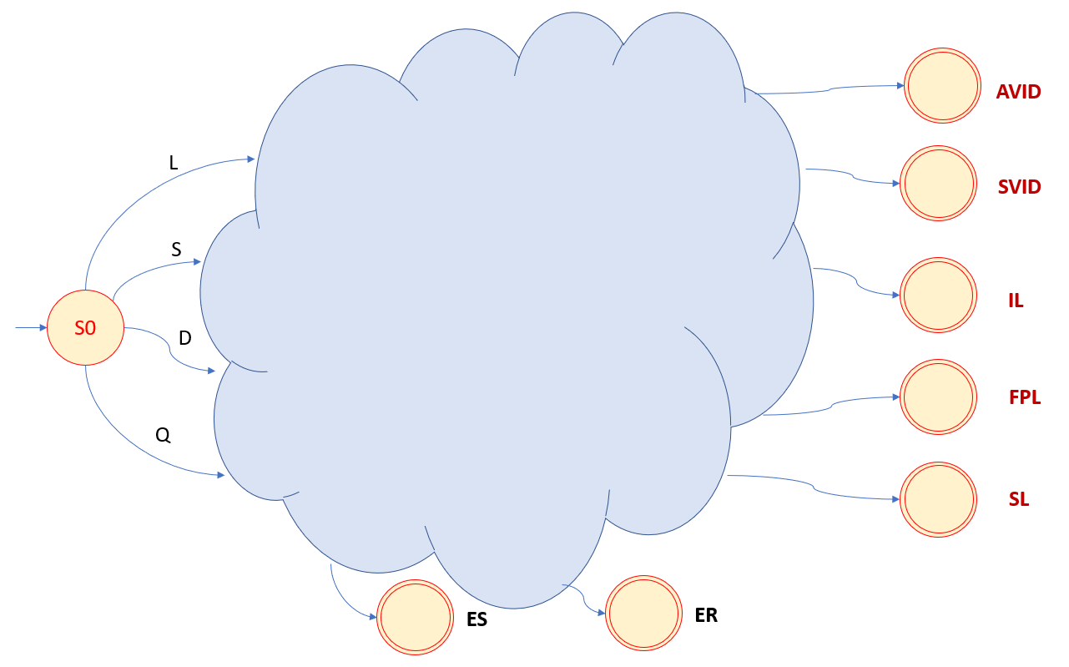

Where:

* **AVID**: Final state that recognizes arithmetic variable identifier.
* **SVID**: Final state that recognizes string variable identifier.
* **IL**: Final state that recognizes integer literals.
* **FPL**: Final state that recognizes float point literals.
* **SL**: Final state that recognizes string literals
* **ES**: Error state that does not retract.
* **ER**: Error state that **retracts**.

**Suggestion:** Use MS Video or PowerPoint to create the diagram (you can create an additional space to include the image / picture here).

**Answer:**

### PART 3: TT – Transition Table (2 marks)

**Activity:** Complete the following table that defines the DFA for Platypus 2,0:

|  |  |  |  |  |  |  |  |  |
| --- | --- | --- | --- | --- | --- | --- | --- | --- |
| **State** | **L** | **D** | **P** | **S** | **Q** | **E** | **O** | **Type** |
| **0** | 1 | 5 | ES | 3 | 9 | ER | ES | **NOAS** |
| **1** | 1 | 1 | 2 | 2 | 2 | 2 | 2 | **NOAS** |
| **2** | IS | IS | IS | IS | IS | IS | IS | **ASWR** |
| **3** | 3 | 3 | ES | 4 | ES | ER | ES | **NOAS** |
| **4** | IS | IS | IS | IS | IS | IS | IS | **ANSR** |
| **5** | 6 | 5 | 7 | 6 | 6 | 6 | 6 | **NOAS** |
| **6** | IS | IS | IS | IS | IS | IS | IS | **ASWR** |
| **7** | 8 | 7 | 8 | 8 | 8 | 8 | 8 | **NOAS** |
| **8** | IS | IS | IS | IS | IS | IS | IS | **ASWR** |
| **9** | 9 | 9 | 9 | 9 | 10 | ER | 9 | **NOAS** |
| **10** | IS | IS | IS | IS | IS | IS | IS | **ASNR** |
| **11** | IS | IS | IS | IS | IS | IS | IS | **ASNR** |
| **12** | IS | IS | IS | IS | IS | IS | IS | **ASWR** |

Use the following representation to this table:

* **For input symbols (quotations) – columns L, D, P, S, Q, E, O:**
  + **Numbers** = For indicate states (from 0 to 12)
  + **ES** = Error state (no retract)
  + **ER** = Error state with retract
* **For input symbols (double quotes) – column Type:**
  + **Accepting state type** = ASWR (with retract) or ASNR (no retract)
* **For state type:**
  + **AVID** (arithmetic variable identifier)
  + **SVID** (string variable identifier)
  + **IL** (integer literal)
  + **FPL** (floating point literal)
  + **SL** (string literal)

*Update: 1st Jan 2021.*

1. Adapted from resources developed by Prof. Svillen Ranev (Algonquin College, 2019)