340. Longest Substring with At Most K Distinct Characters
Hard
Given a string, find the length of the longest substring T that contains at most k distinct characters.
Example 1:
Input: s = "eceba", k = 2
Output: 3
Explanation: T is "ece" which its length is 3.
Example 2:
Input: s = "aa", k = 1
Output: 2
Explanation: T is "aa" which its length is 2.
Approach 1 (using sliding window + dictionary): with time complexity O(nk)
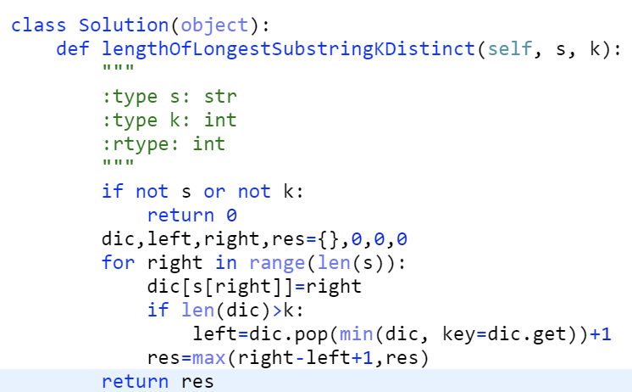
Approach 2 (using sliding window + ordered dictionary): with time complexity O(n)
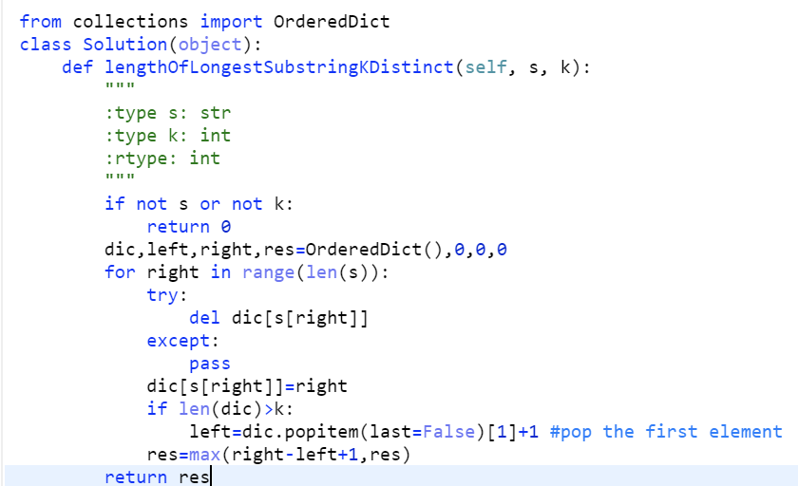
Analyzation: https://leetcode.com/articles/longest-substring-with-at-most-k-distinct-characte/

159. Longest Substring with At Most Two Distinct Characters
Medium
72114Add to ListShare
Given a string s , find the length of the longest substring t that contains at most 2 distinct characters.
Example 1:
Input: "eceba"
Output: 3
Explanation: t is "ece" which its length is 3.
Example 2:
Input: "ccaabbb"
Output: 5
Explanation: t is "aabbb" which its length is 5.
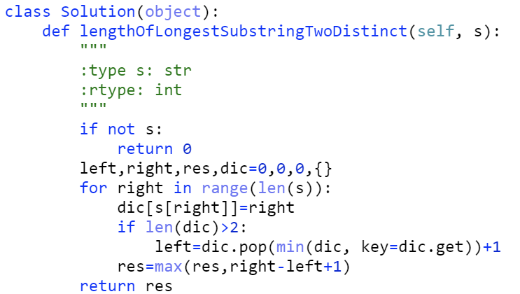
Analyzation: https://leetcode.com/articles/longest-substring-with-at-most-two-distinct-charac/

681. Next Closest Time
Medium
Given a time represented in the format "HH:MM", form the next closest time by reusing the current digits. There is no limit on how many times a digit can be reused.
You may assume the given input string is always valid. For example, "01:34", "12:09" are all valid. "1:34", "12:9" are all invalid.
Example 1:
Input: "19:34"
Output: "19:39"
Explanation: The next closest time choosing from digits 1, 9, 3, 4, is 19:39, which occurs 5 minutes later. It is not 19:33, because this occurs 23 hours and 59 minutes later.
Example 2:
Input: "23:59"
Output: "22:22"
Explanation: The next closest time choosing from digits 2, 3, 5, 9, is 22:22. It may be assumed that the returned time is next day's time since it is smaller than the input time numerically.
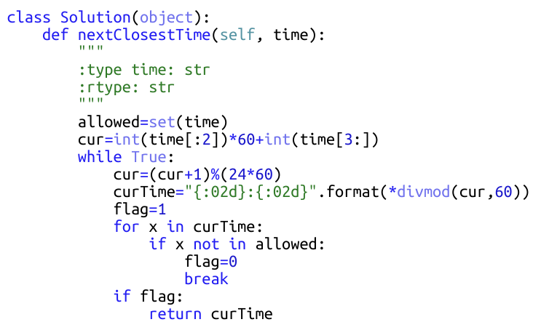

Format in python: https://www.geeksforgeeks.org/python-format-function/

348. Design Tic-Tac-Toe
Medium
Design a Tic-tac-toe game that is played between two players on a n x n grid.
You may assume the following rules:
- A move is guaranteed to be valid and is placed on an empty block.
- Once a winning condition is reached, no more moves is allowed.
- A player who succeeds in placing n of their marks in a horizontal, vertical, or diagonal row wins the game.
Example:
Given n = 3, assume that player 1 is "X" and player 2 is "O" in the board.
TicTacToe toe = new TicTacToe(3);
toe.move(0, 0, 1); -> Returns 0 (no one wins)
|X| | |
| | | | // Player 1 makes a move at (0, 0).
| | | |
toe.move(0, 2, 2); -> Returns 0 (no one wins)
|X| |O|
| | | | // Player 2 makes a move at (0, 2).
| | | |
toe.move(2, 2, 1); -> Returns 0 (no one wins)
... (skip two step)
|X| |O|
| |O| | // Player 1 makes a move at (2, 0).
|X| |X|
toe.move(1, 0, 2); -> Returns 0 (no one wins)
|X| |O|
|O|O| | // Player 2 makes a move at (1, 0).
|X| |X|
toe.move(2, 1, 1); -> Returns 1 (player 1 wins)
|X| |O|
|O|O| | // Player 1 makes a move at (2, 1).
|X|X|X|
Follow up:
Could you do better than O(n^2) per move() operation?
