mTUNE mp3 sdk - Integration Guide – With Startapp AD Network (www.mp3sdk.com)

IF YOU ARE USING startapp AS THE AD NETWORK THEN DO NOT USE THIS sdk jar. PLEASE USE mobilecore sdk JAR.

mTune mp3sdk is an Free SDK for Android Applications to download mp3 file on the device. You may develop your own android mp3 downloader applications and upload on google play, opera, amazon or other android app stores.

Add this mandatory activity in the application manifest file

<!-- YouTube Downloader requires this Activity. Dont Delete it -->
<activity android:name="com.startapp.android.publish.list3d.List3DActivity"
android:theme="@android:style/Theme" />

<activity android:name="com.startapp.android.publish.AppWallActivity"
android:configChanges="orientation|keyboardHidden|screenSize"
android:theme="@android:style/Theme.Translucent" />

There are only two calls to make to mtune mp3sdk for downloading a mp3

- MP3SDK engine = MP3SDK.getInstance(Activity activity, int MP3engineID);
Where MP3engineID is :

MP3SDK.MP3_ENGINE_GO_EAR
Or
MP3SDK. MP3_ENGINE_MP3_SKULL
Or
MP3SDK. MP3_ENGINE_SOUND_BOWL

Get the search String or the song string and call

- List <tracks> allTracks = engine.searchMP3Tracks(Activity activity , String [] Params );

Pass your search string to the parameters.

In order to download the song mp3
- engine.previewOrDownloadMP3(Activity activity ,int trackID);
trackID == Track.getID();

code snippet :

public void onItemClick(AdapterView<?> parent, View view, int position, long id) {

Tracks entry = (Tracks) parent.getAdapter().getItem(position);
try {
engine.previewOrDownloadMP3(MainActivity.this,
entry.getId());
} catch (Exception e) {
e.printStackTrace();
}
}

Downloaded zip file. It will have documentation file, latest Jar, Test Application and String Library. Import “mtune SDK Test App” and “mp3 SDK String Library” into eclipse. Set “mp3 SDK String Library” as reference library to Test App.

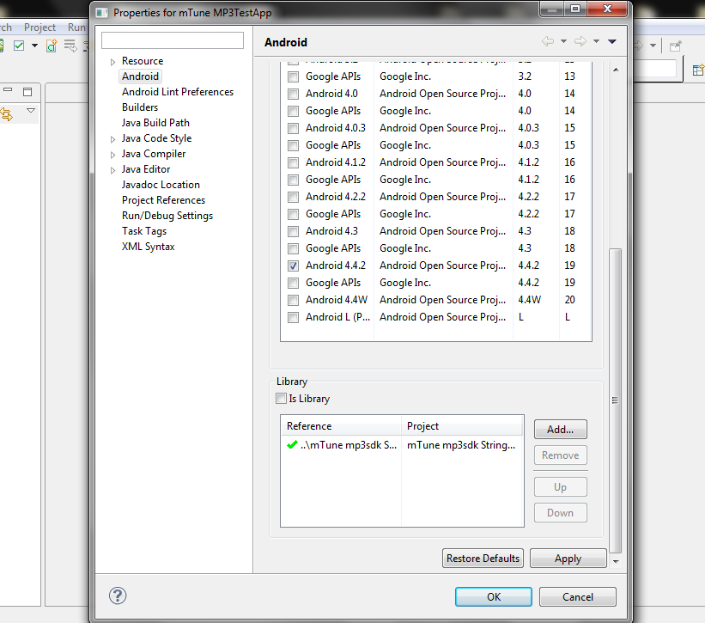

NOTES:
- We have included a test application you may also integrate your ads and upload the app directly by changing the package name to the android app stores
- We have included one of our ad in the sdk. You will not be able to remove the same.
- The jars present in the test app libs folder, please include those jars in your project also.

SUPPORT 24*7 :
Please visit www.mp3sdk.com

Email: mtune.mp3sdk@gmail.com

