DELIVERABLE 6
User Journey Diagrams
Liberation Ecosystem Website Strategy and Information Architecture Sprint

Project Owner and Executor | John Mark
Product and Operations Manager | Destine
Vision and Final Direction | Skyler
Project Stage | Research, structure, and low-fidelity planning
Review Gate | Journey validation before later wireframes and implementation planning
Status | Working recommendation; routes align with Deliverables 4 and 5
Date | 3 August 2026
Source basis: the five required journeys in the project brief and the canonical routes, trust requirements, and page relationships defined in Deliverables 2, 4, and 5.
Purpose, Method, and Journey Legend
This deliverable visualizes the five required user journeys from first contact to the smallest appropriate next action. Each journey shows the public pages or interactions involved, the trust evidence needed at decision points, and the boundary that prevents the pathway from becoming a guarantee.

Journey design principles
- Route by immediate need or role before explaining the full ecosystem.
- Use the least demanding next action that can responsibly advance trust.
- Place privacy, compensation, conduct, consent, and no-guarantee information beside the action they govern.
- Use human review where a submission may lead to work, partnership, network participation, or sensitive relationship decisions.
- Treat the journeys as possible paths, not automatic funnels or promises.
- Keep international outreach and complex member infrastructure outside the current journeys.

Visual legend
Element | Meaning | Design implication
Numbered card | A page, content step, or human interaction | Must have a clear purpose and one next action.
Route label | Canonical page or section from Deliverable 4 | Does not create an additional unapproved page.
Arrow | Expected direction of travel | A user may pause, leave, or return.
Trust checkpoint | Evidence, safeguard, or expectation near the step | Visible before submission, scheduling, work, or public listing.
Success condition | Smallest appropriate outcome | Deeper access is not the only valid result.
Five-Journey Overview
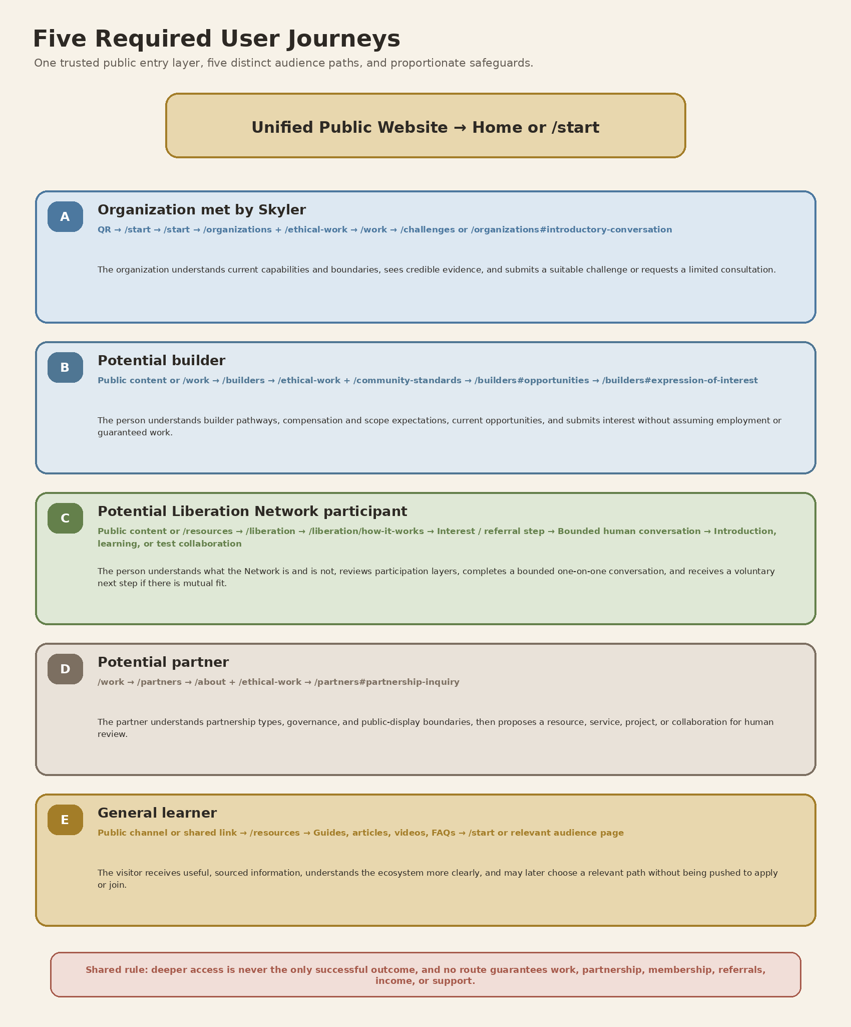
Figure 1. Shared public entry layer and five distinct audience journeys.
Journey A — Organization met by Skyler
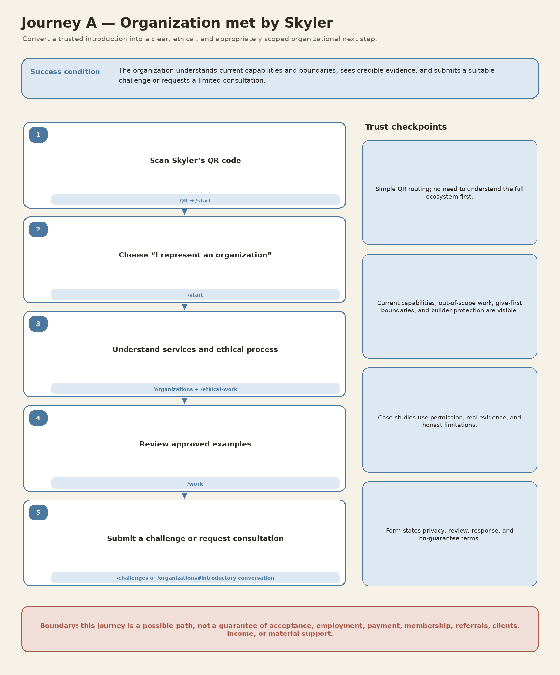
Figure 2. Journey A path and trust checkpoints.
Entry condition | Human review / decision | Successful endpoint | Primary failure risks
Trusted introduction or QR scan | Challenge or consultation review | Suitable submission or bounded conversation request | Overpromising, sensitive data, unlimited free-work expectations, weak proof
Journey B — Potential builder
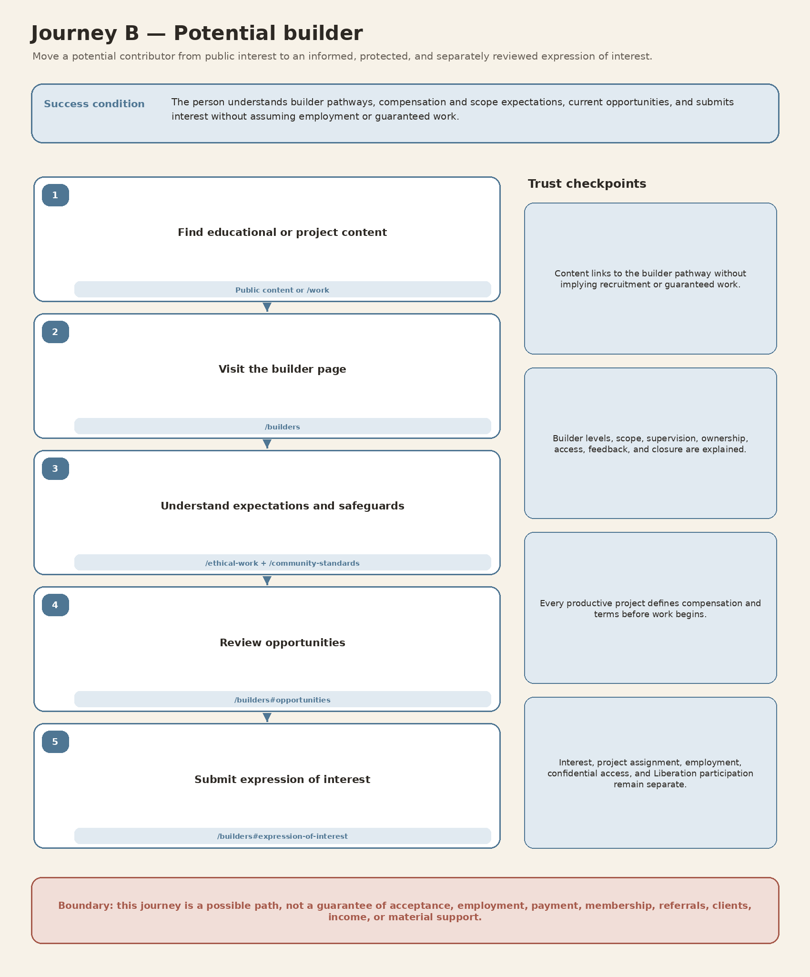
Figure 3. Journey B path and trust checkpoints.
Entry condition | Human review / decision | Successful endpoint | Primary failure risks
Educational or project content creates interest | Opportunity and fit review | Informed expression of interest | Unpaid speculative work, employment implication, scope or ownership ambiguity
Journey C — Potential Liberation Network participant
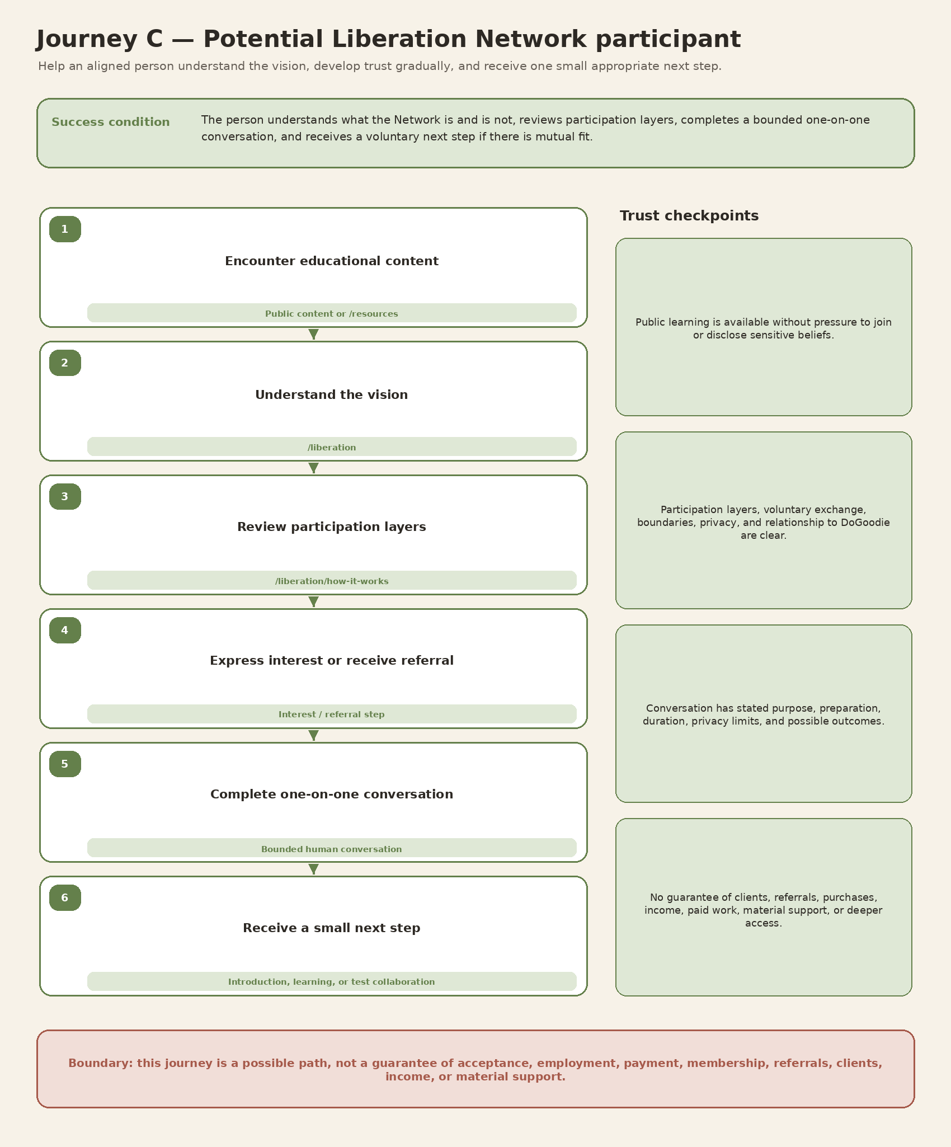
Figure 4. Journey C path and trust checkpoints.
Entry condition | Human review / decision | Successful endpoint | Primary failure risks
Educational content, referral, or values-aligned interest | Mutual-fit and one-on-one review | Small voluntary next step | Unbounded support, privacy loss, ideological pressure, guaranteed-benefit assumptions
Journey D — Potential partner
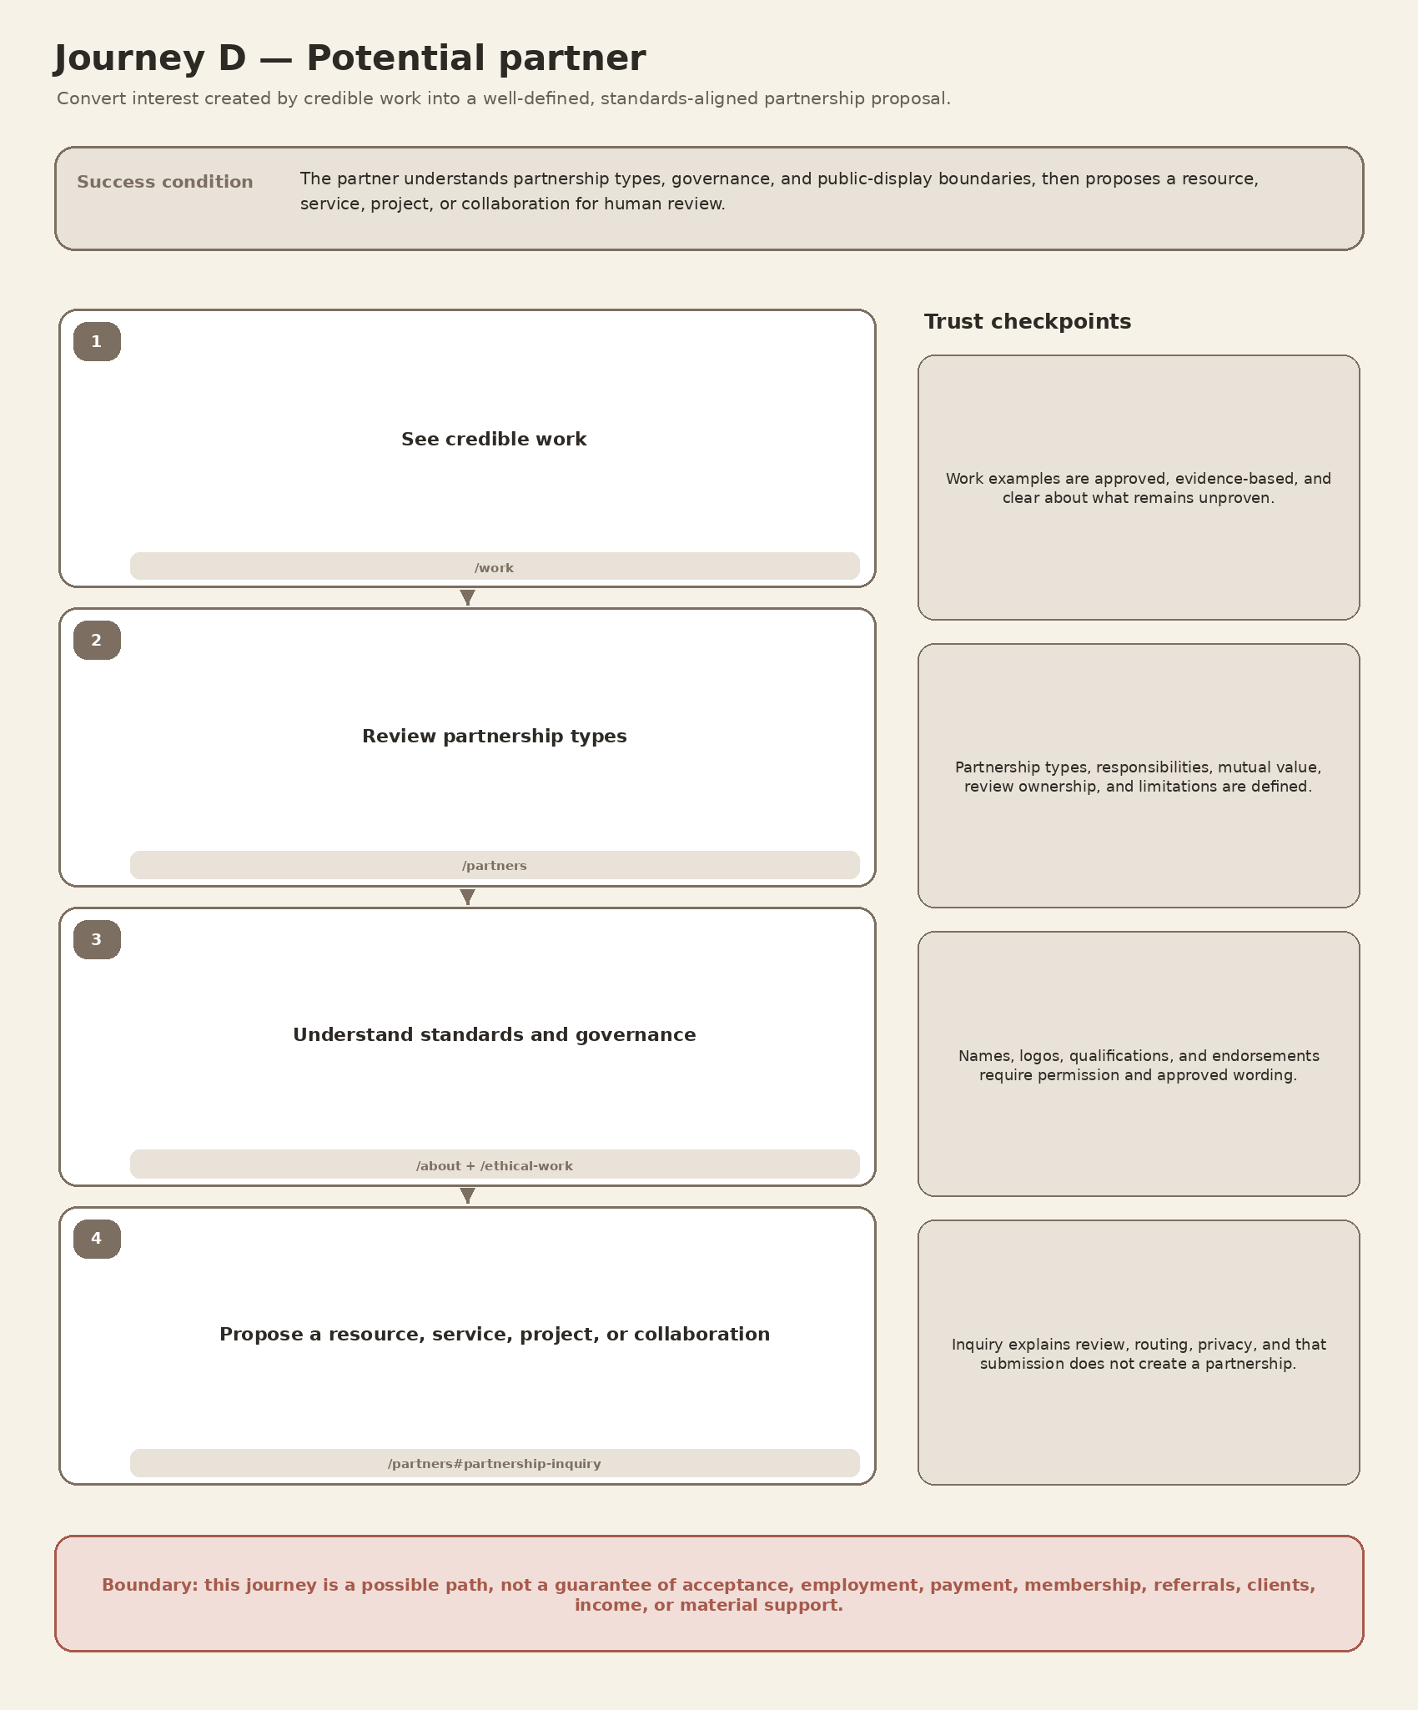
Figure 5. Journey D path and trust checkpoints.
Entry condition | Human review / decision | Successful endpoint | Primary failure risks
Credible work or trusted introduction | Strategic partnership review | Well-scoped partnership proposal | Logo misuse, vague commitments, unreviewed provider endorsement
Journey E — General learner
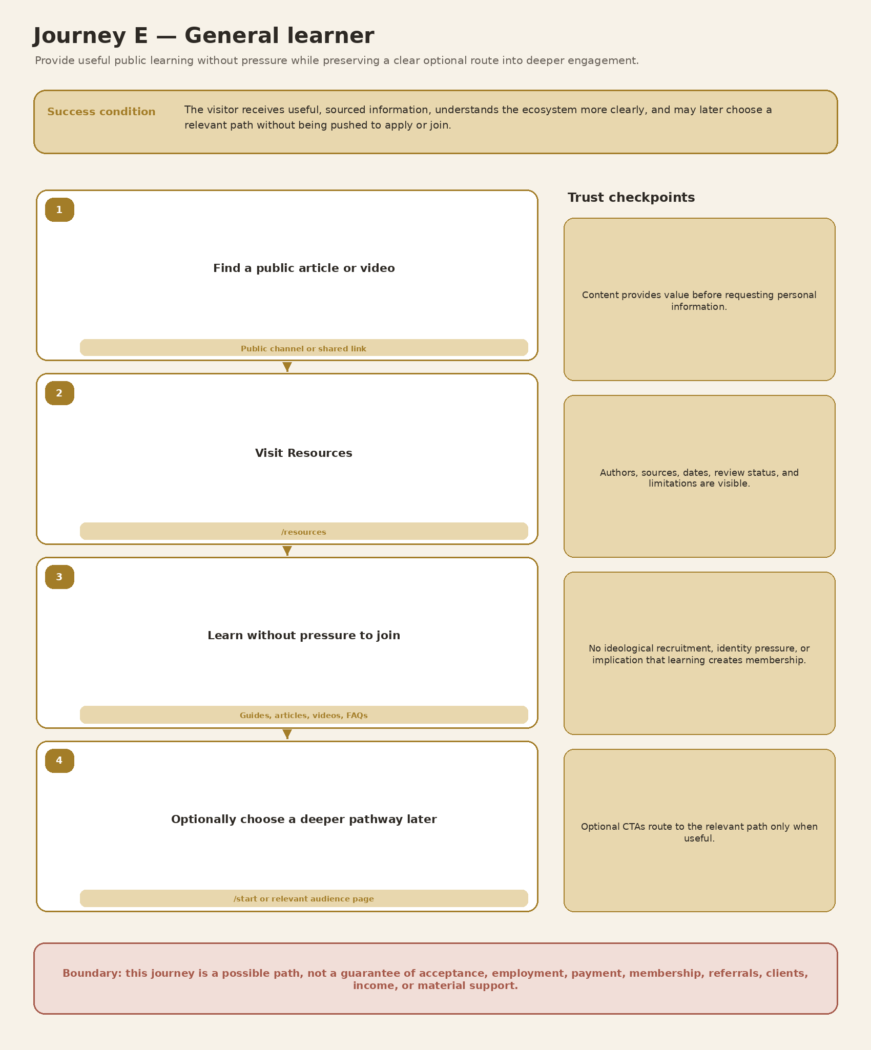
Figure 6. Journey E path and trust checkpoints.
Entry condition | Human review / decision | Successful endpoint | Primary failure risks
Public article, video, guide, or shared link | No review required for public learning | Useful learning and optional deeper route | Pressure to join, weak sourcing, unnecessary data collection
Cross-Journey Requirements and Handoffs
The journeys share infrastructure but should not collapse into one universal intake or community funnel.
Shared node or handoff | Journeys | Required content or process | Boundary
/start audience router | A–E | Short choices, previews, no sensitive fields, route testing | Choosing a path is not approval or application.
/ethical-work | A, B, D | Scope, compensation, ownership, supervision, feedback, closure | Does not promise available paid work or legal representation.
/work evidence | A, B, D | Approved examples, artifacts, permission, limitations | Cannot imply endorsement or proven scale beyond facts.
/community-standards | B, C | Consent, privacy, boundaries, solicitation, concern reporting | Protect safety without ideological purity testing.
Human review | A, B, C, D | Named owner, fit criteria, response expectations, possible outcomes | Submission creates no work, membership, partnership, or service obligation.
/privacy notices | A, B, C, D | Data minimization, sensitive-data warning, retention and sharing | Do not collect unnecessary sensitive information.
/resources | B, C, E | Authors, sources, dates, review status, limitations | Learning remains available without joining.

Measurement recommendations
- Measure route selection and completion separately; deeper participation is not the only success.
- Track page-level drop-off to find unclear wording, excessive friction, or missing trust evidence.
- Publish response times only after the team can consistently meet them.
- Record hold, referral, or decline reasons without exposing sensitive personal judgments.
- Do not publish conversion or impact metrics until the data is reliable, consented, and interpretable.

Definition of Done — Deliverable 6
- ☐ All five required journeys are represented visually.
- ☐ Each journey uses canonical pages and relationships from Deliverable 4.
- ☐ Each journey identifies entry, decisions, primary action, and successful endpoint.
- ☐ Each journey includes trust and safeguard checkpoints.
- ☐ The five audience journeys remain distinct.
- ☐ One-on-one trust development is visible without promising membership or benefits.
- ☐ Give-first and supervised collaboration are visible without promising unlimited free work.
- ☐ Public learning remains useful without pressure to join.
- ☐ Future directories, matching, payments, marketplaces, accounts, and international outreach are not current steps.
- ☐ The diagrams are clear enough to support stakeholder review and later wireframes.

Review Questions for Destine and Skyler
- Are the success conditions appropriately modest and realistic?
- Which conditional actions can the team actually operate at launch?
- Who owns each human review, and what response expectation can be published?
- Does the Liberation journey balance invitation, mutual fit, privacy, and gradual trust?
- Are the organization and builder journeys sufficiently protective against unpaid work and overpromising?
- Is /start simple enough to serve as Skyler’s primary QR destination?
END OF DELIVERABLE 6

