Game Information Document

Game Title: Minecraft | Genre (assigned by Microsoft): First Person Adventure
Xbox 360 titleID: 584111F7
Developer: Mojang/4J Sudios | Est Release Date: 04/18/12

Game Synopsis:

Please use this section to give a brief overview of what the game is about.
Minecraft is distinctive looking sandbox construction game created by Markus 'Notch' Persson. The game involves players creating and destroying various types of blocks in a three dimensional environment. The player plays ‘Steve’, a friendly looking avatar and he can destroy or create blocks, forming fantastic structures, creations and even works of art. It is also a game of survival because at night, monsters come out, and you must build a house, and craft tools to survive the night.

Levels/Stages:
Total number of levels/stages: no limit | Number of levels/stages in Trial: 20mins play time.

Achievements:
Achievement name: | Steps necessary to reach Achievement: | Gamer Points awarded
Taking Inventory | Open your inventory. | 10
Getting Wood | Punch a tree until a block of wood pops out. | 10
Benchmarking | Craft a workbench with four blocks of wooden planks. | 10
Time to Farm! | Make a Hoe | 10
Bake Bread | Turn wheat into bread. | 20
The Lie | Bake a cake using: wheat, sugar, milk and eggs. | 40
Time to Strike! | Use planks and sticks to make a sword. | 10
Monster Hunter | Attack and destroy a monster. | 20
Cow Tipper | Harvest some leather. | 15
When Pigs Fly | Use a saddle to ride a pig, and then have the pig get hurt from fall damage while riding it. | 40
Time to Mine! | Use planks and sticks to make a pickaxe. | 10
Getting an Upgrade | Construct a better pickaxe. | 15
Hot Topic | Construct a furnace out of eight cobblestone blocks. | 15
Delicious Fish | Catch and cook fish! | 15
Acquire Hardware | Smelt an iron ingot. | 15
On A Rail | Travel by minecart to a point at least 1 km in a single direction from where you started. | 40
Leader of the Pack | Befriend five wolves | 30
MOAR Tools | Construct one type of each tool(pickaxe,spade,hoe & axe) | 15
Dispense With This | Construct a Dispenser | 20
In to the Nether | Construct a Nether Portal | 40

Please consider this feedback when designing your achievements
https://arcadedeveloperforum.team.partners.extranet.microsoft.com/Lists/Developer%20Support/DispForm.aspx?ID=296&Source=https%3A%2F%2Farcadedeveloperforum%2Eteam%2Epartners%2Eextranet%2Emicrosoft%2Ecom%2FLists%2FDeveloper%2520Support%2FAllItems%2Easpx

https://arcadedeveloperforum.team.partners.extranet.microsoft.com/Lists/Developer%20Support/DispForm.aspx?ID=283&Source=https%3A%2F%2Farcadedeveloperforum%2Eteam%2Epartners%2Eextranet%2Emicrosoft%2Ecom%2FLists%2FDeveloper%2520Support%2FAllItems%2Easpx

Showcase features:
Please use this area to list out or describe the things that make this game special. If this game is already released in other mediums, what makes this version different/better than the original? What graphical enhancements are being made?
It’s Minecraft but on your Xbox. Solid frame rate at 1080p. Faithfully based on v.1.6.6 but planning to update regularly like the PC version. Xbox version supports 4 player splitscreen exclusively.

Trial Version Info:

Please fill in the below based on which type of Trial experience is implemented.

What type of trial experience will you be using in your title?
Limited functionality Timed demo

Limited Functionality (please fill out this section if you have implemented a limited functionality based demo):

What is available during demo mode?

What is not available during demo mode?
What is the users experience when they access the unlocked features?
What is the users experience when they access locked features?

What functionality have you implemented to encourage the user to purchase the full version of the game?

Timed Demo (please fill out this section if you have implemented a time based demo):

Amount of time?
40 minutes, though Sentient dynamic configuration is implemented to allow that time to change.

What functionality is available?
Players play in the tutorial/trial map only. Night and Day cycle will happen once the player completes the tutorial section. Split screen local multiplayer is available – other players press start on a controller to join.

What is the users experience when they access locked features?
When the user tries to Save from the Pause menu, they will receive an upsell to tell them they need the full game to be able to save.

What functionality have you implemented to encourage the user to purchase the full version of the game?
Achievements and Avatar Awards will upsell the full game.

What is the user experience when time expires?
Upsell screenshot slideshow and messaging.

Note: You should not save any user information and should not upload any scores while in Demo mode. All Demos must be Live Aware and users should be able to view leader boards.

Controller Layout:

This image can be used to diagram what controls your game is going to use and what they do:
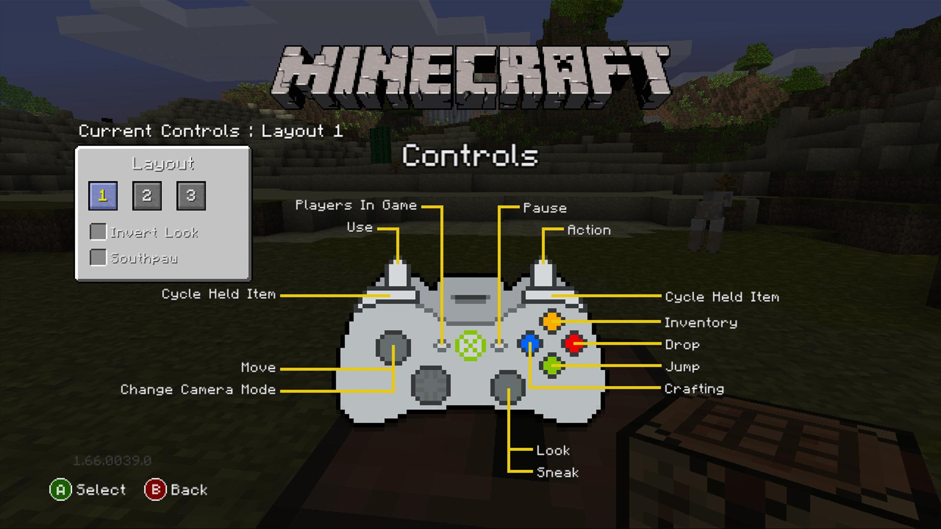

Leader Board usage description:

Leaderboard name: | What data is stored/displayed: | Arbitrated | How are players ranked/rated: | When is data posted:
Travelling | This Leaderboard will display the distances travelled by walking, falling, in a minecart, and in a boat | Y N | players are ranked by the combined values of all the distances, with the highest combined total being ranked at 1. | a first post, then 5 minute timers, then on an exit
Mining Blocks | This leaderboard will display the number of blocks of each type below that the player has mined. | Y N | Players will be ranked by the total number of items mined, with the highest value ranked as number 1. | a first post, then 5 minute timers, then on an exit
Farming | This leaderboard will display the number of items of each type below that the player has mined, collected, or milked. | Y N | Players will be ranked by the total number of items, with the highest value ranked as number 1 | a first post, then 5 minute timers, then on an exit
Kills | This leaderboard will display the number of kills of each type of enemy | Y N | Players will be ranked by the total number of kills, with the highest value ranked as number 1. This leaderboard will not be present for the Peaceful difficulty. | a first post, then 5 minute timers, then on an exit

Singleplayer:
Number of players:
Indicate the number of players the submission supports on one Xbox 360:
1 1-2 1-3 1-4 Other:
Explain the different singleplayer gameplay modes:

Multiplayer:
Xbox Live: multiplayer support the game is always in multiplayer mode, although can be set to offline game.
Does the submission support multiplayer sessions on Xbox Live? Y N
Indicate the maximum number players per session on Xbox Live: 8
Indicate the maximum number of players per console when playing on Xbox Live: 4
Up to four players in split-screen on a single console (HD only), and up to eight players in a Live online game. All LIVE games are Friends only.
If there are different numbers for different session types, please describe:
Does the submission support cooperative gameplay? Y N
Does the submission support tournament gameplay? Y N
Explain the different multiplayer gameplay modes:
Does the submission support Host migration? Y N
Does the submission support join in progress? Y N Friends only
What type of network implementation will you be using in your title?
Microsoft provided Self-built Other: QNet

Save System:
Will your title have saves? Y N
Manual Autosave Both
Save location:
Profile Save file
What information is being saved: Map status, player inventory and stats for player 1 all players that join that map upto 64 players total.

Settings:
Profile (preferred) Save file
What settings are being saved: (Controls selection, Invert Look, Southpaw, Music and Sound Effects volumes, Gamma setting, View bobbing, 2 player split-screen setting, and game difficulty mode).

Additional Downloadable Content:
Please explain plan and details of what additional downloadable content will be made available for your title:

Downloadable content for the game is planned, but is not yet designed. At this stage will at least be Skins packs. Major DLC will not happen until after the game reaches ‘final release’ parity with the PC game (approx. 8months after release).

This game has been approved for major updates to occur via TU; 1.6.6 (present) to 1.7.3 to 1.8.1 etc.

Cheats/Easter Eggs:
Please use this section to list out any cheat codes and/or easter eggs you plan to release in the game. Cert requires all Easter Eggs to be disclosed.

The splash text that appears on the Main Menu will change from the random selection to some specific selections depending on the date.

9th November – “Happy birthday, ez!”

1st June – “Happy birthday, Notch!”

24th December – “Merry X-Mas!” (intentionally Christmas Eve)

1st January – “Happy new year!”

Facebook App Link

The game has Facebook sharing built in to allow users to capture screenshots and post them to Facebook.
To test this functionality on Partnernet, link your Partnernet account the 4J Minecraft facebook developer account –

username:minecraft.facebook@4jstudios.com
pword: S1lverytay

If you don’t already have a link set up, then selecting Share from the Pause menu should allow you to set this up in game.

You can access this account on the web at https://developers.facebook.com/apps

Title Managed Storage

We’ll be storing some game graphics used for certain gamertag xuids on TMS.
There will be a file on TMS which has a list of offline XUIDs and any of a name, cape graphic or a skin graphic linked to the XUID. The corresponding graphics will also be on TMS.

These will be up on Title Managed Storage today. There is an xml file linking gamertag XUIDS to skins and/or cloaks.
The capes are:-

Mojang_Cape.png
DB_Cape.png
4J_Cape.png
1M_Cape,png

There’s only one skin at the moment –

Deadmau5_skin.png

This can be expanded in the future by updating the xuids.xml file, and adding new pngs.

The game also checks TMS for a “Default_Cape.png”, and gives everyone playing this cape if it is present. This allows the ‘special days’ feature like the Java game has had.

We will have some debug functionality available in a Release/Debug build only (not Content Package build). No Cheats or easter eggs will exist in the final release.

Please provide other documentation:
Technical Development Description
Game Design Document
Test tools and debug hooks

