CytoVisProjectTutorial

This tutorial is prepared to introduce “CytoVisProject” app. CytoVisProject is created for visualizing and helping to analyze of PROV-O formatted .xml files. CytoVisProject can visualize PROV-O formatted .xml files with using a XSLT Engine named Saxon. Requirements for transforming it is Saxon and a VisMap file. You can download Saxon from the below link.

<http://saxon.sourceforge.net/>

Tutorial is divided into 3 part:

* Creating a Jar File
* Installing Jar File To The Cytoscape
* Usage of CytoVisProject

To start using of this app you need to create a jar file from the files of CytoVisProject with using a Java IDE an installing it to the Cytoscape.

Creating A Jar File

To create a jar file follow the below steps.

1. Open the CytoVisProject folder with a Java IDE.
2. Add Maven dependencies to the Project which is given in the dependencies file of the CytoVisProject.

* If you do not have Maven you can download and install by following the instructions here: <https://maven.apache.org/install.html>
* For adding a dependency to Maven run this command at console sceen with filling the inside of quotation marks.

mvn install:install-file -Dfile=”Jar File’s Path” -DgroupId=”groupId” -DartifactId=”artifactId” -Dversion=”version” -Dpackaging=jar

* After installing .jar files which is in dependencies files, add below code to pom.xml file.

<dependency>

<groupId> groupId e</groupId>

<artifactId> artifactId </artifactId>

<version> version </version>

</dependency>

1. After adding Maven dependencies, now you can create a jar file. For doing this in IntelliJ idea in the top menü follow “File – Project Structure” path.
2. Choose the Artifacts under the Project Settings and click "+" plus icon.
3. Under the Add tab follow the "JAR - From modules with dependencies" path.
4. Click Ok and after choosing Output Directory (where JAR file will be create) click Ok buton again.

After following the steps above Jar file will be created in the directory that you choosed.

Installing Jar File To The Cytoscape

Now you will learn how to install the jar file that you create with the applying above instructions to the Cytoscape.

1. In the Cytoscape interface click the “Apps” part which is located in top menu and then choose “Apps Manager” tab.
2. Under the “Install Apps” tab click “Install From File” button and choose the jar file that you created.
3. After the installation you should see "Installed" status under the “Currently Installed” tab.

If you see any other thing than the "Installed" message, open the JAR file (you can open with a program like Winrar) and change the MANIFEST.MF files under the META-INF folder with the MANIFEST.MF file that is in the APP folder which is again in the META-INF folder of the CytoVisProject’s documents.

Usage of CytoVisProject

The article here is about how to use CytoVisProject’s tools which is also located in the Help part of CytoVisProject app.

PROV-O Import:

In the PROV-O import section you can transfrom a PROV-O formatted .xml file to .csv files which is an excel table an also can visualize in Cytoscape. You need to have a XSLT Engine named Saxon which you can download from below link:

<http://saxon.sourceforge.net/>

For this transform process you need to complete 3 steps below.

* 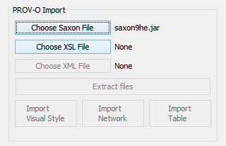Choose Saxon File
* Choose XSL File (which can tell to transformer how to extract edge and node files.)

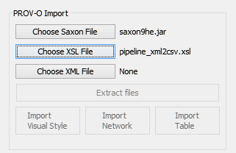

* Choose XML File (PROV-O File)

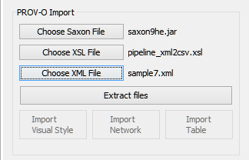

After these steps click the “Extract Files” button and then the edges and nodes files will be extracted in “C:/provoTransformerPlugin” path.

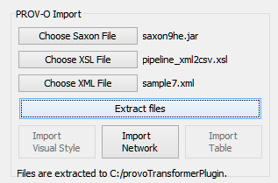

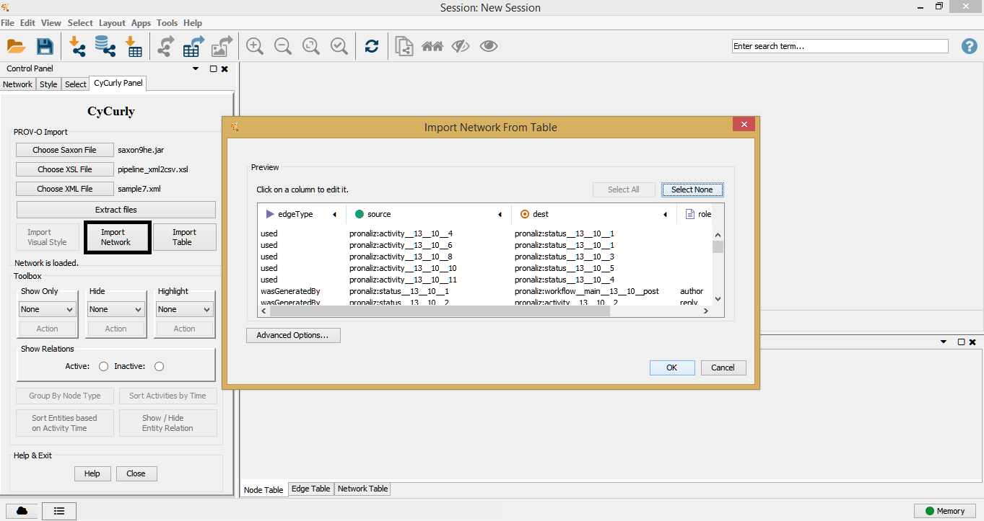Now you can import your network (edges) and your table (nodes) from the “Import Network” and “Import Table” buttons with left click.

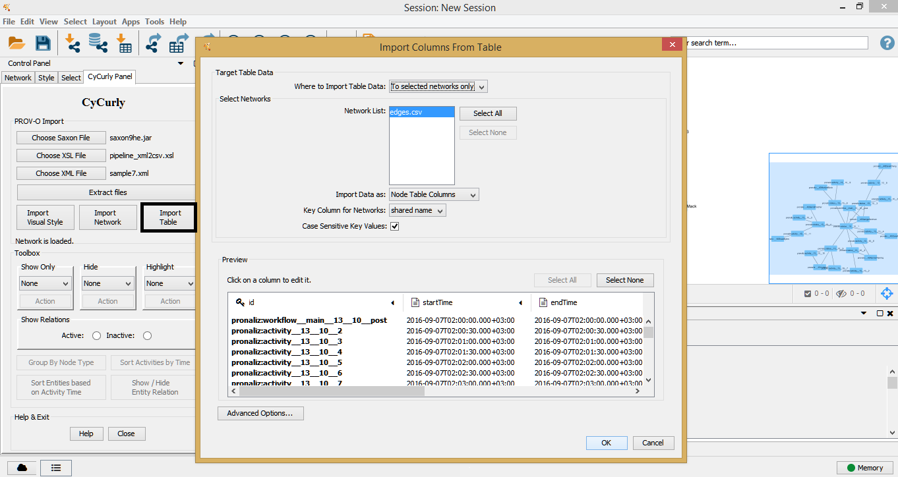

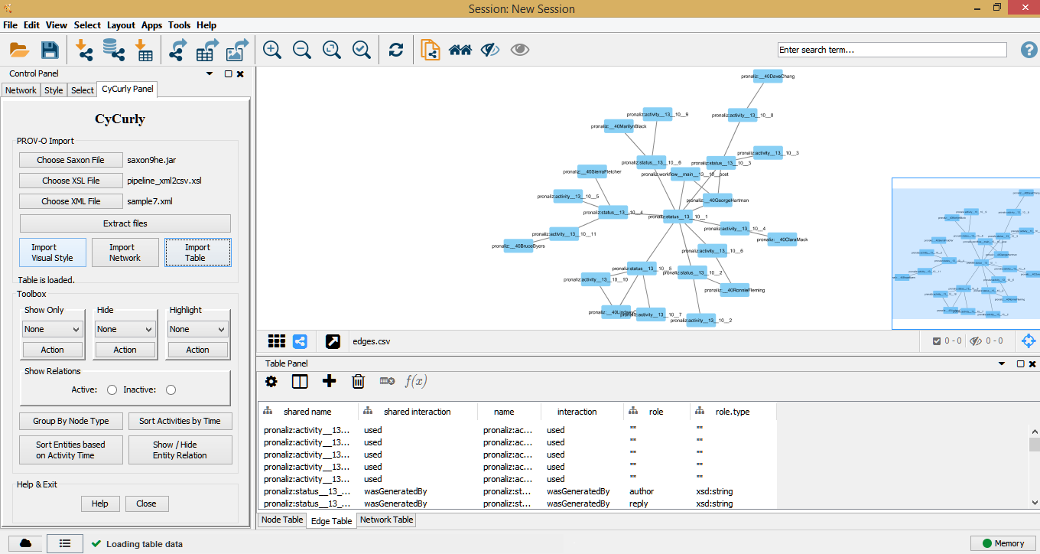

If you do not want import files that you just extracted, then right click to “Import Network” and “Import Table” buttons to choose another file.

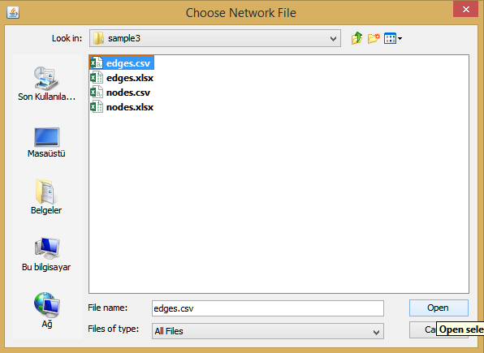

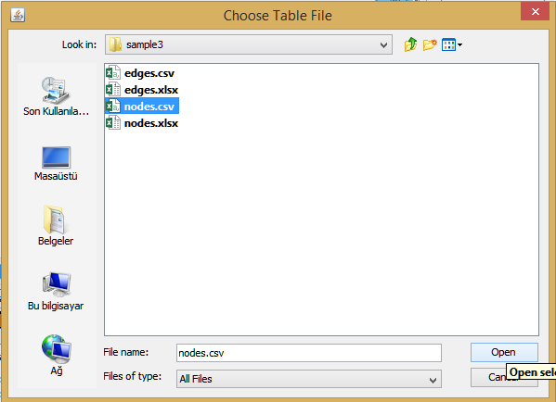

And you can also import your visual style file from “Import Visual Style” part.

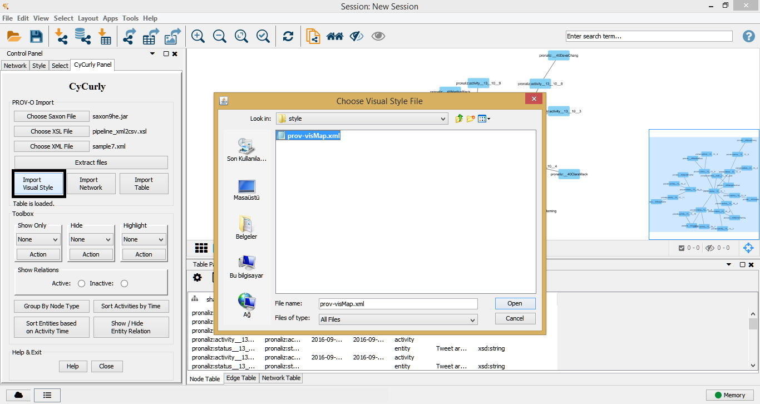

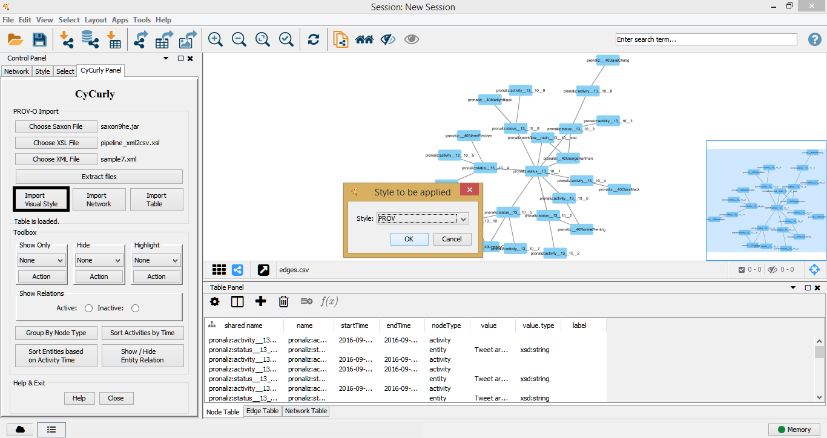

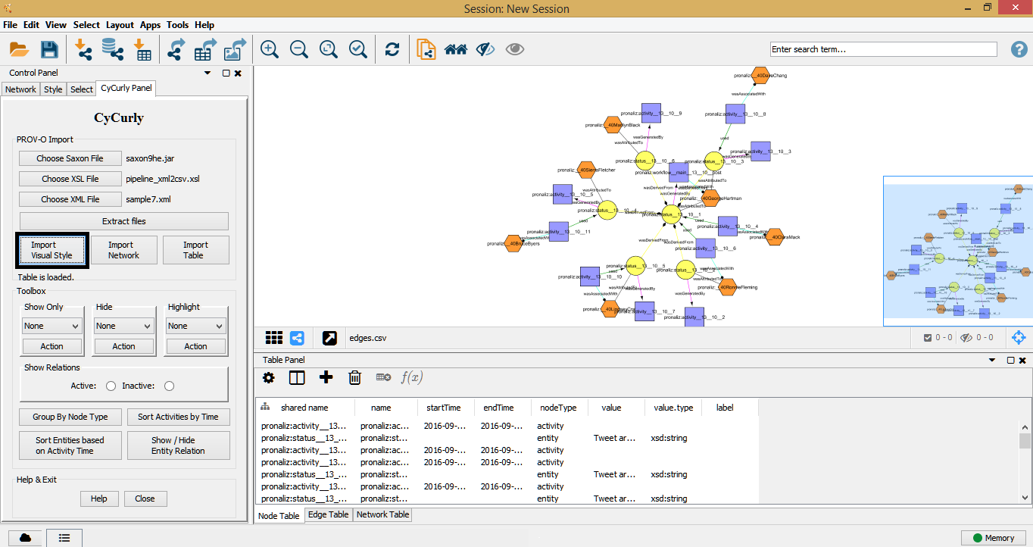

Toolbox:

Second part of CyCurly app is for help to analyze these networks. Toolbox section has 8 features. All of these features will be active after a network and a table is imported.

**Show Only:** You can show only agent / activity / entity / all nodes in the network. But there is an error occure while trying to show all nodes which is mentioned at the bottom of this document. To show all nodes and edges click to Select menu on top and then click “Show all nodes and edges” tab.

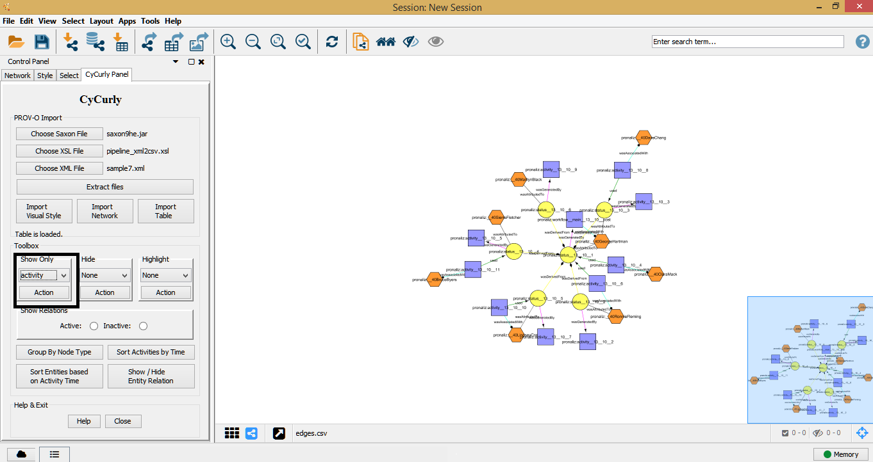

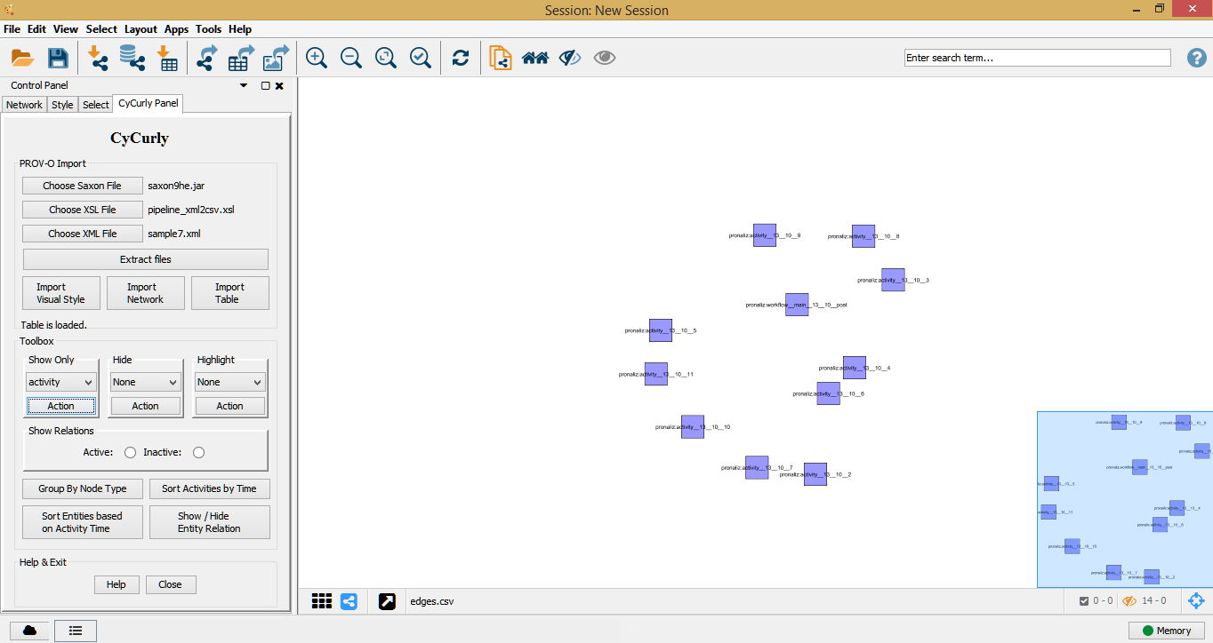

**Hide:** You can hide agent / activity / entity nodes in the network.

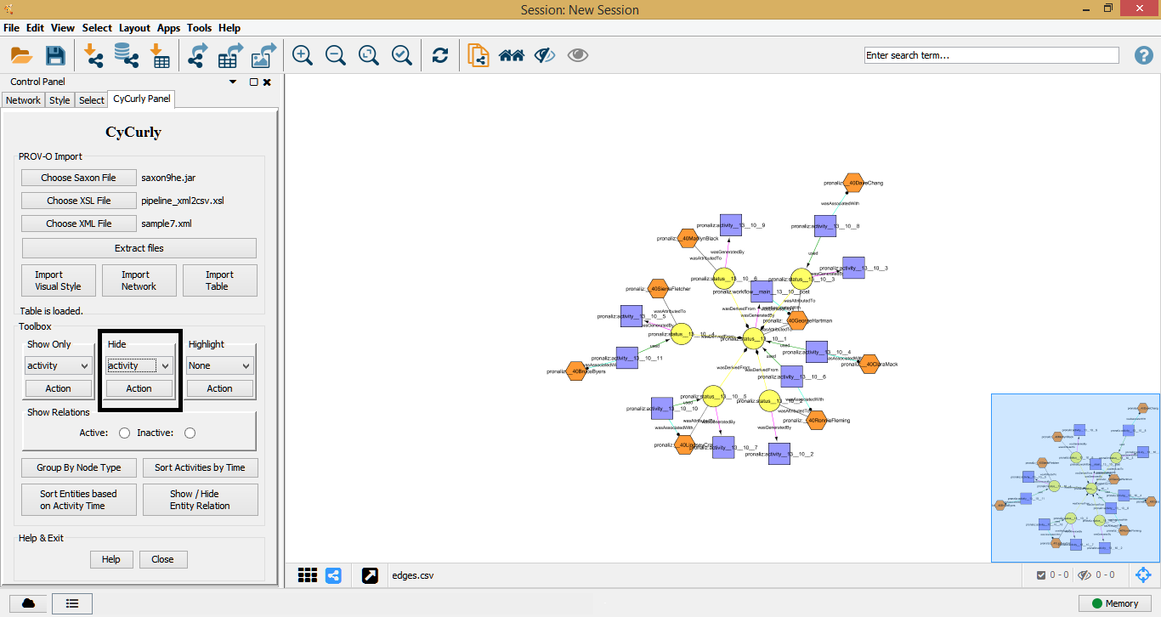

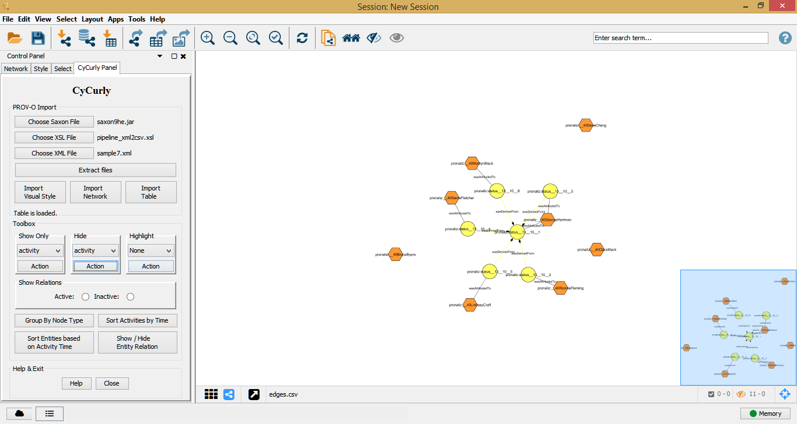

**Highlight:** You can highlight agent / activity / entity nodes in the network.

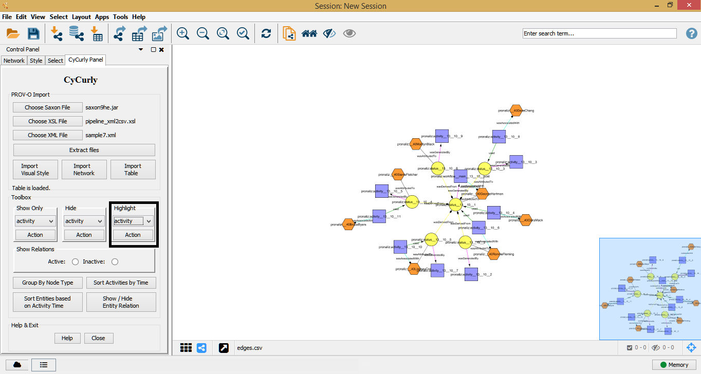

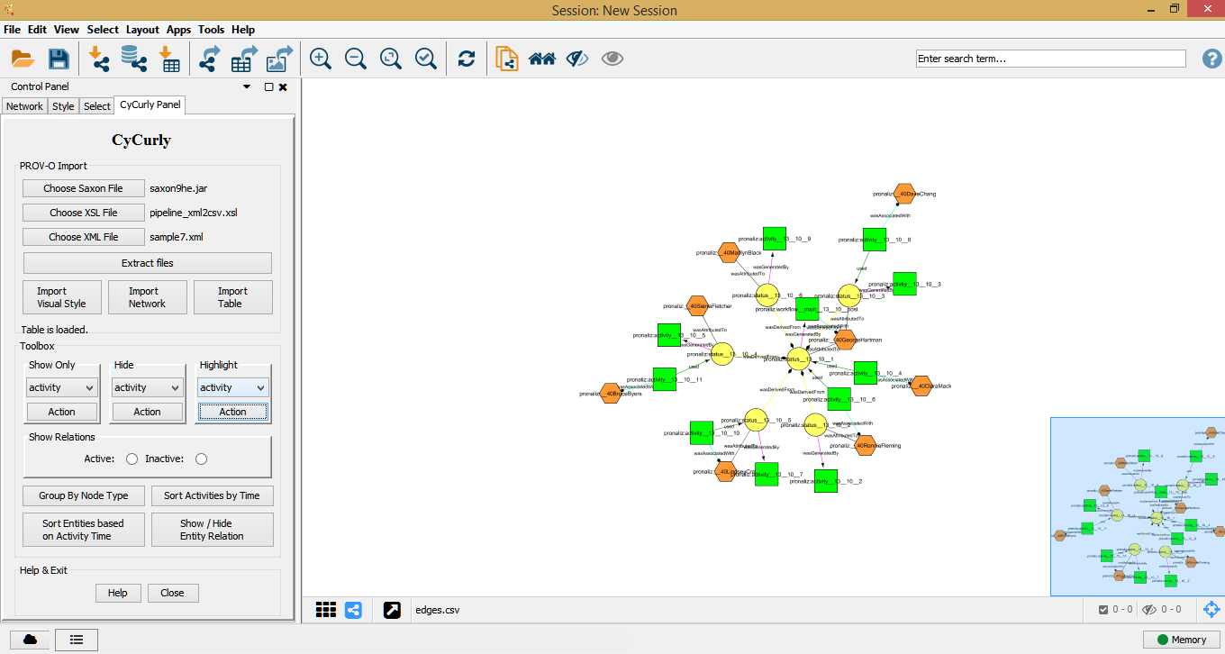

**Show Relations:** When you make active this part you can see the hiden relations of a node when you select it.

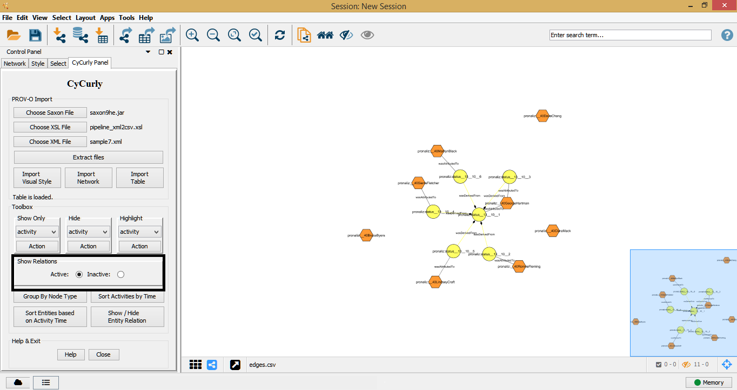

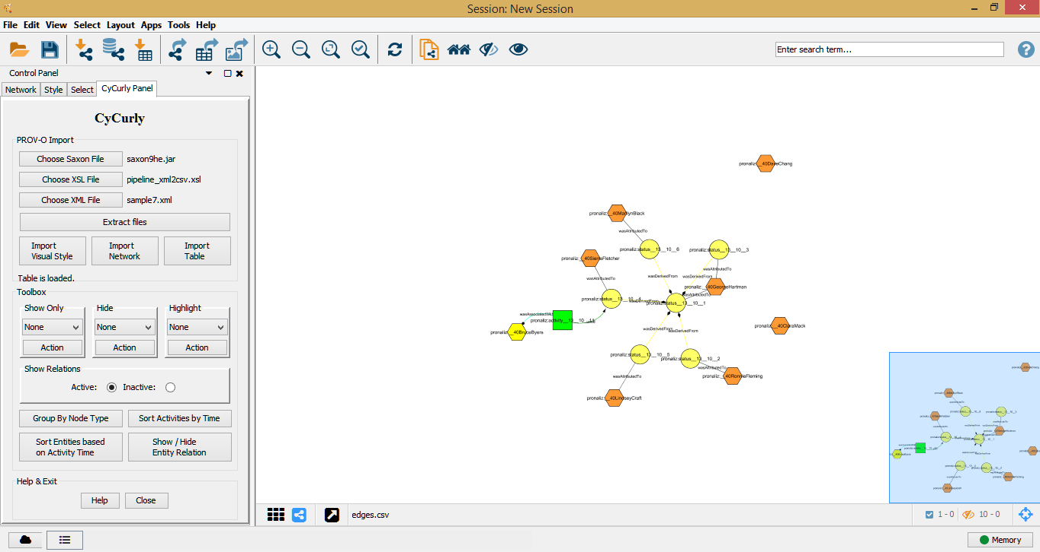

**Group by Node Type:** This feature allows you to highlight all the node which has same node type with the selected node.

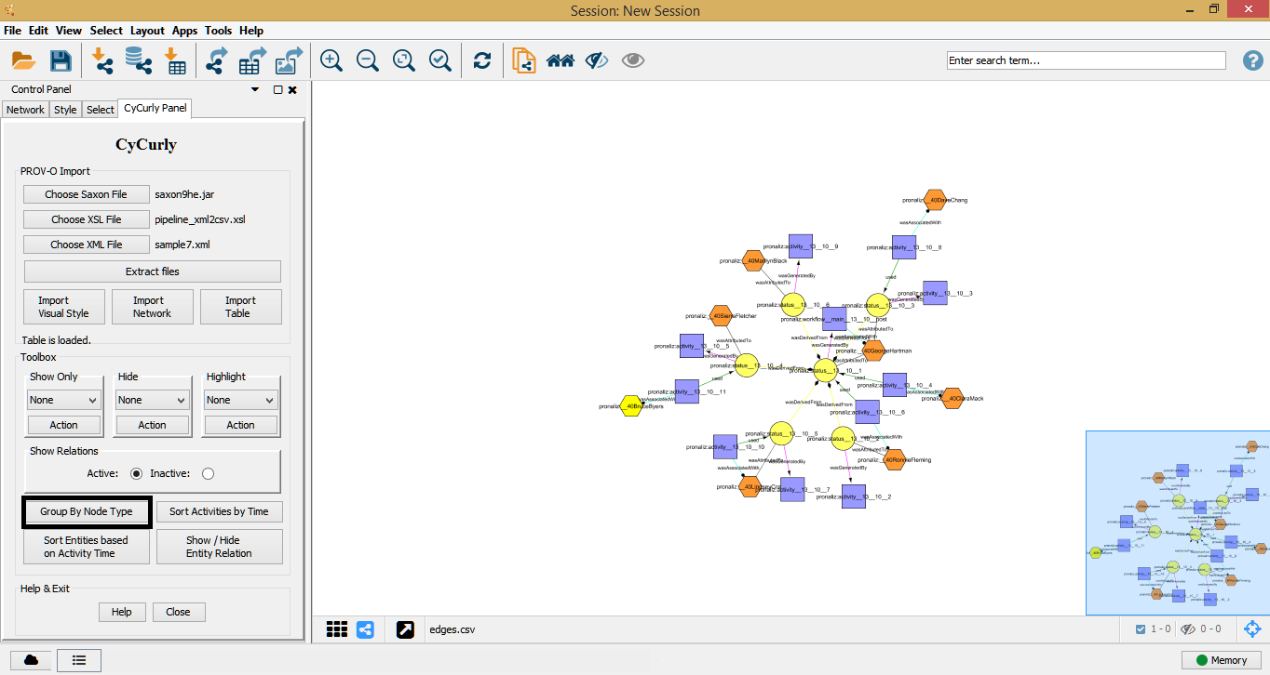

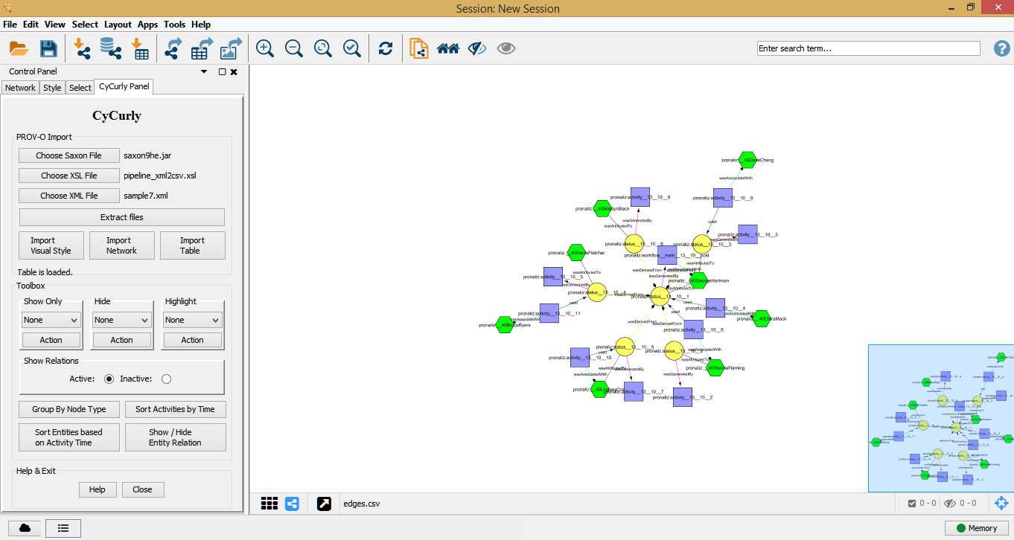

**Sort Activities by Time:** It sorts all activities by time(from left to right). And the relations(agents and entities) of all activities will be close to it. The nodes which is not connected with any activities will be located at the bottom side of network.

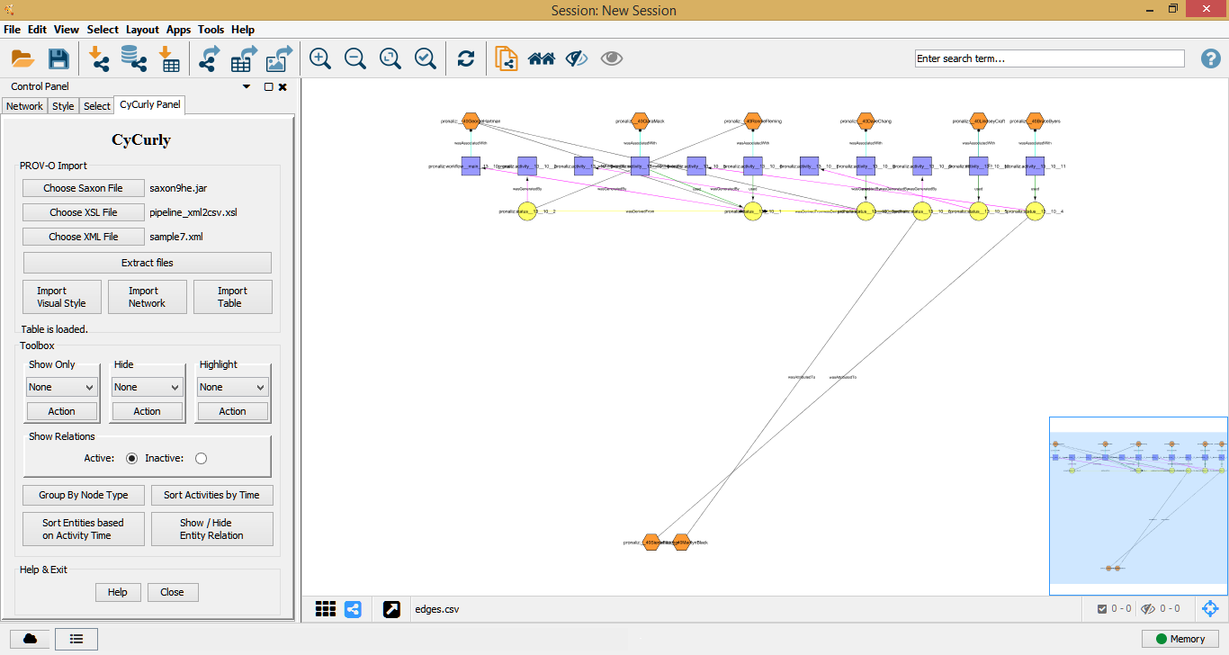

**Sort Entities Based on Activity Time:** This sorts all activities of an entity based on their start time and the agents which is related to this entity will be close to the entity. The nodes which is not connected with any entity will be located at the bottom side of network.

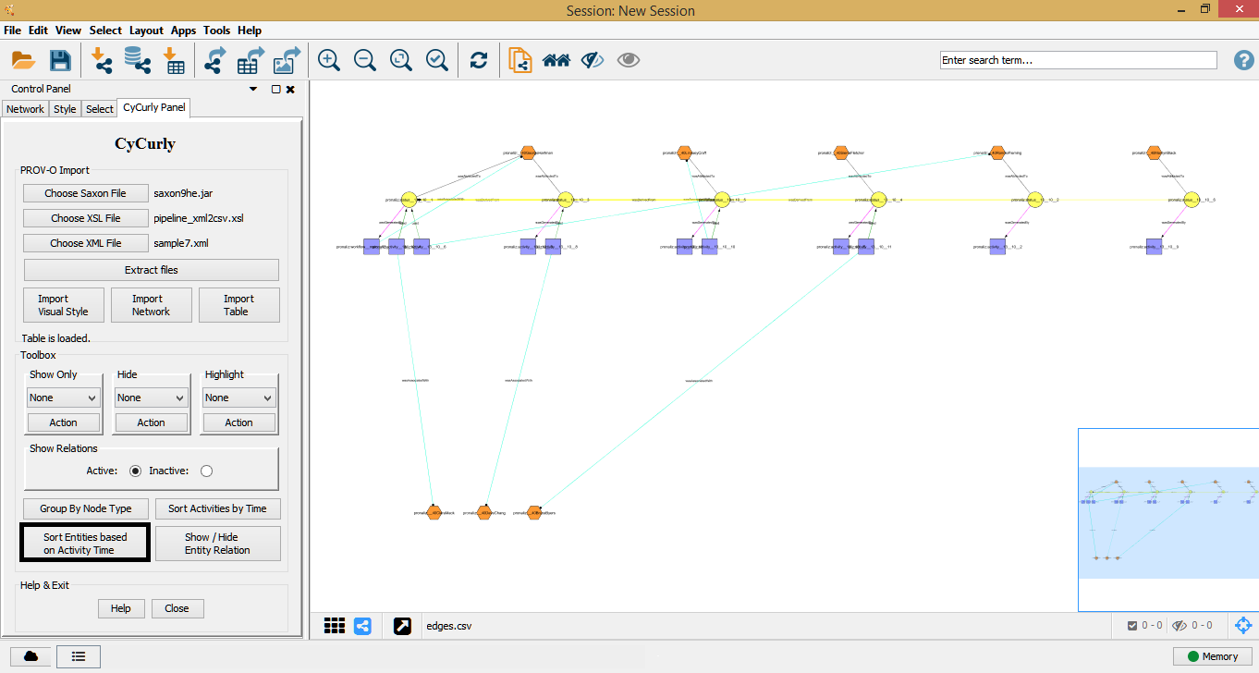

**Show / Hide Entity Relation:** This will show / hide all the nodes of selected entities.

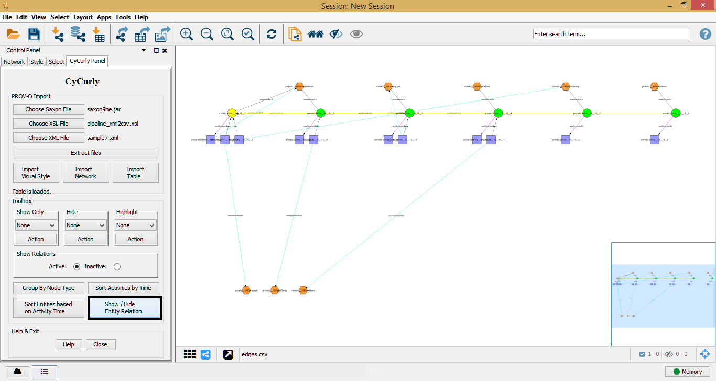

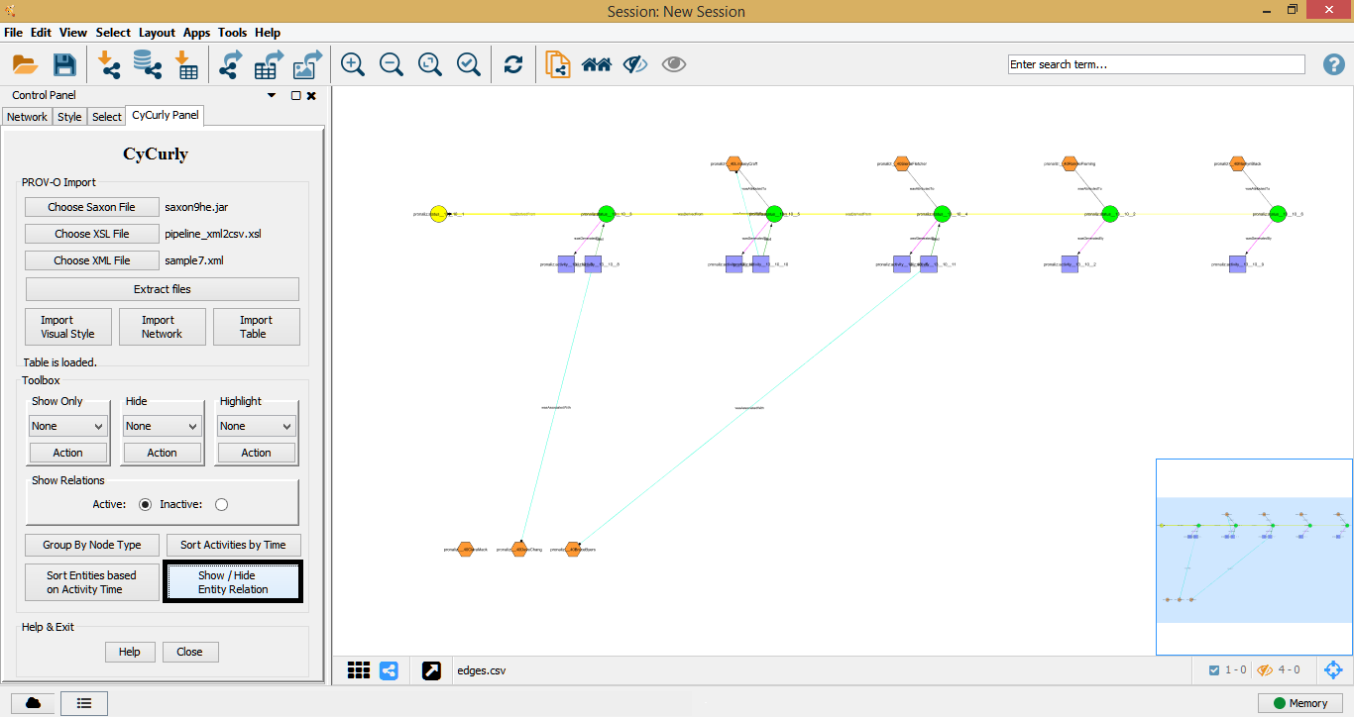

Known Errors

* At show only section of toolbox panel, we can not show all nodes because of unknown reasons for now.