**The Price is Right: Financial Data Analysis**

**BONUS MATERIALS**

1. **Bonus Material: Balance Sheet**
   1. Most people aren’t going to create a BS in Tableau, but as this document shows, it can “almost” be done if you have good structured finance data. Depending on your data, you probably won’t be able to complete the Equity Section of the balance sheet because of retained earnings, net income and cumulative translation adjustments. These values aren’t often stored in transactions.  
      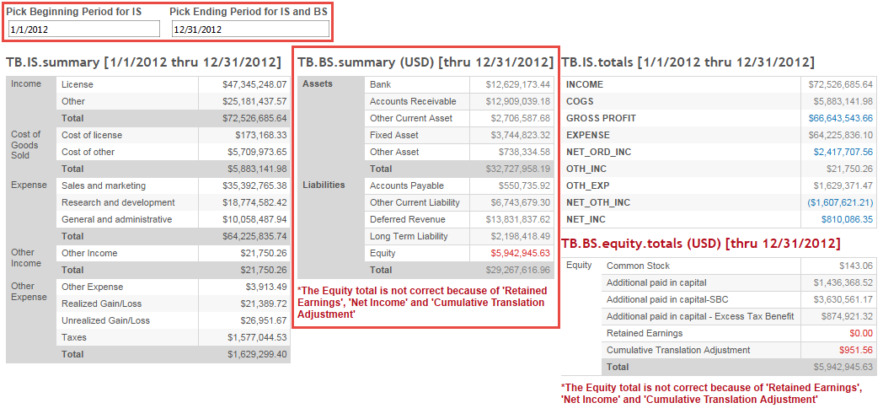
   2. How to build the BS Data Source. Note: The parameter used to pick the ending period is necessary so that the transaction amounts can be re-evaluated based on the latest period’s consolidated exchange rates. If all of your data is in a single currency, you won’t have to adjust the transactions for the currencies rates of each subsidiary.   
      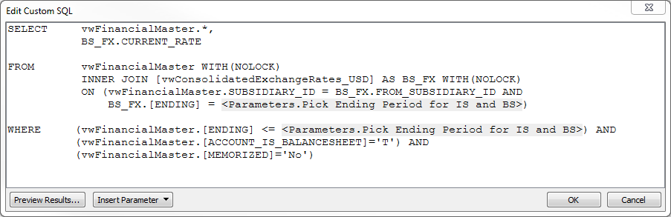
   3. How to build the BS sheet.  
      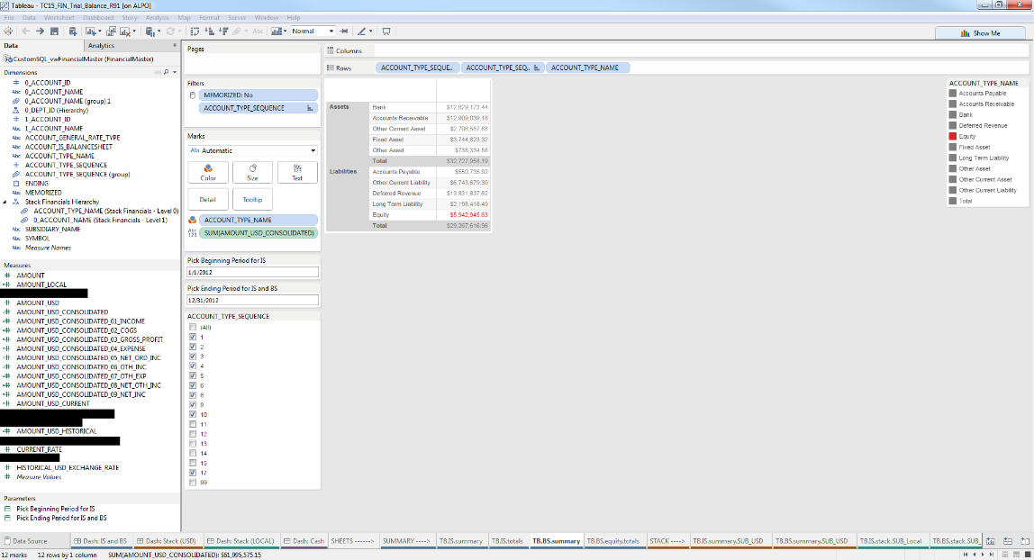
   4. How the BS totals work.

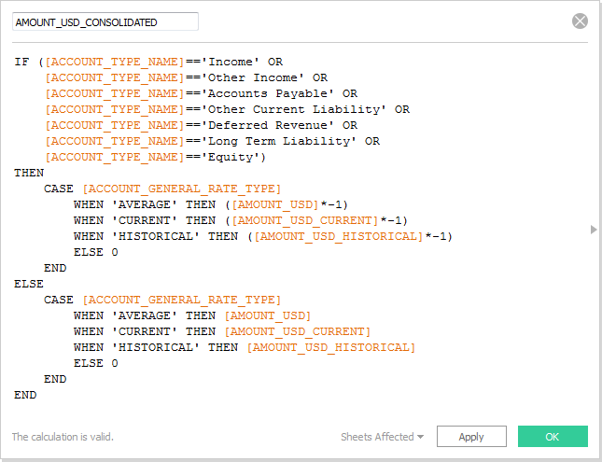

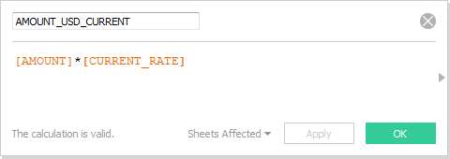 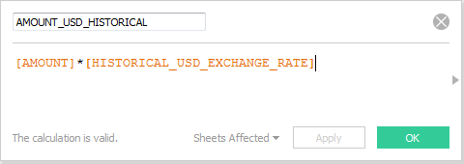

1. **Bonus Material: Dash of Dashboards**
   1. Now that you have all of these awesome dashboards for your executives, how can you help them find them?
   2. You can create special projects on tableau server, you could imbed the dashboard from tableau server into a company portal, you can send them emails
   3. or…you can create a Table of Contents, but I like to call it ‘Dashboards of Dashboards‘.
   4. Dashboard before selection  
      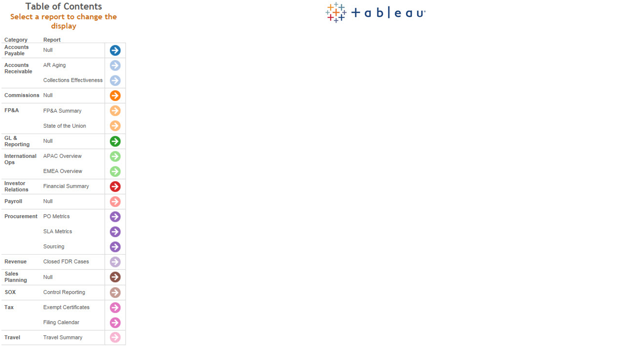
   5. Dashboard after selection  
      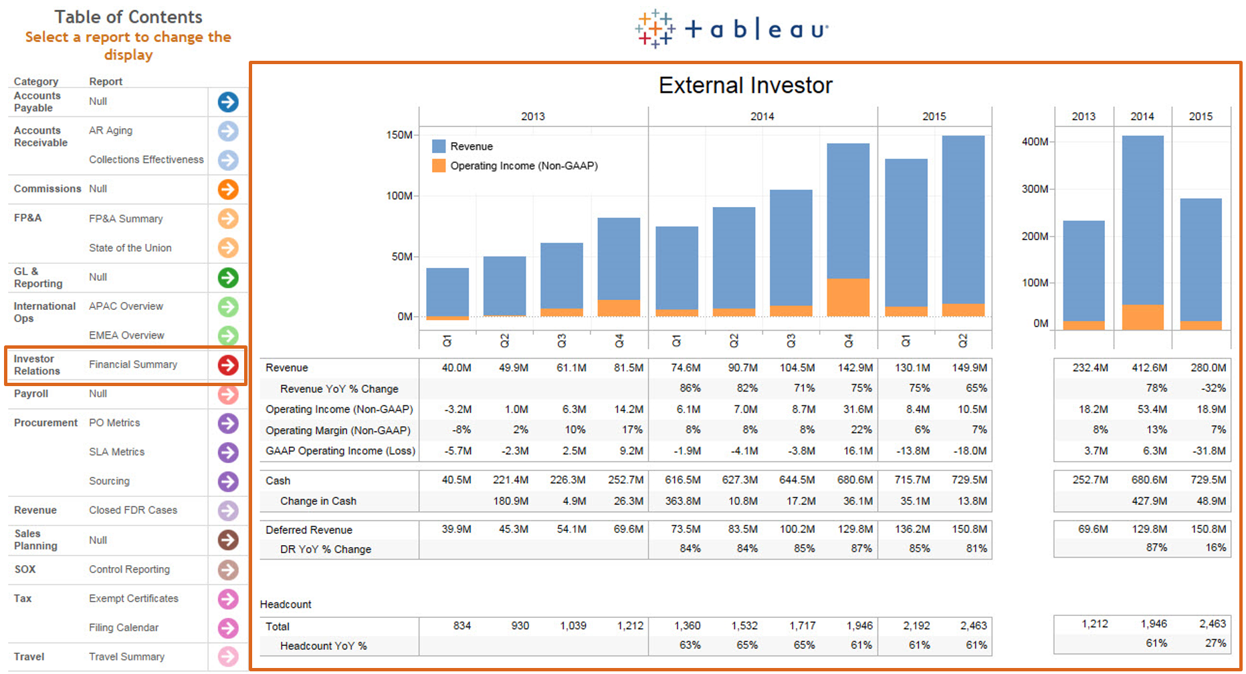
   6. How did we do it?  
      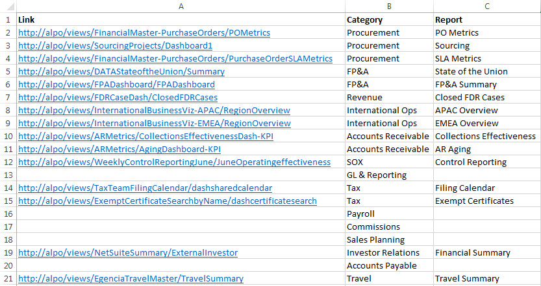  
        
      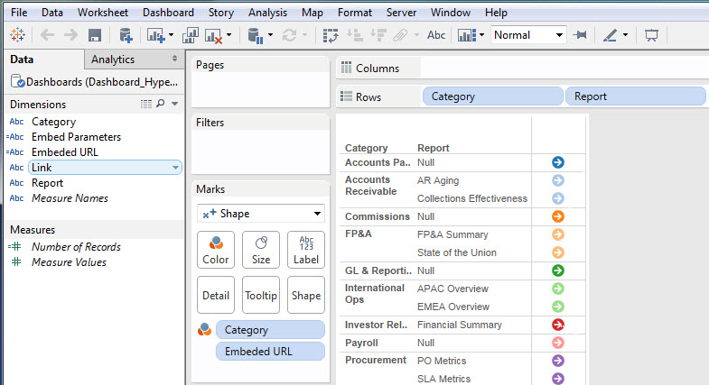  
        
      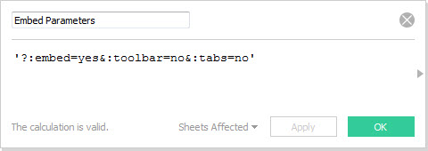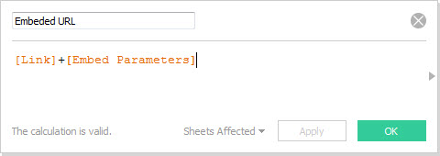

**APPENDIX**

**Account Hierarchy (Levels 0 thru 4)**

QRY_LEVEL_account_0

SELECT tbl_NetSuite_Accounts.EXTRACT_DATE, tbl_NetSuite_Accounts.TYPE_NAME, 0 AS 0_ACCOUNT_LEVEL, 0 AS 0_ACCOUNT_PARENT_ID, tbl_NetSuite_Accounts.ACCOUNT_ID AS 0_ACCOUNT_ID, tbl_NetSuite_Accounts.NAME AS 0_ACCOUNT_NAME, 0 AS 1_ACCOUNT_LEVEL, 0 AS 1_ACCOUNT_PARENT_ID, tbl_NetSuite_Accounts.ACCOUNT_ID AS 1_ACCOUNT_ID, tbl_NetSuite_Accounts.Name AS 1_ACCOUNT_NAME, 0 AS 2_ACCOUNT_LEVEL, 0 AS 2_ACCOUNT_PARENT_ID, tbl_NetSuite_Accounts.ACCOUNT_ID AS 2_ACCOUNT_ID, tbl_NetSuite_Accounts.Name AS 2_ACCOUNT_NAME, 0 AS 3_ACCOUNT_LEVEL, 0 AS 3_ACCOUNT_PARENT_ID, tbl_NetSuite_Accounts.ACCOUNT_ID AS 3_ACCOUNT_ID, tbl_NetSuite_Accounts.Name AS 3_ACCOUNT_NAME, 0 AS 4_ACCOUNT_LEVEL, 0 AS 4_ACCOUNT_PARENT_ID, tbl_NetSuite_Accounts.ACCOUNT_ID AS 4_ACCOUNT_ID, tbl_NetSuite_Accounts.Name AS 4_ACCOUNT_NAME

**FROM tbl_NetSuite_Accounts**

**WHERE (((tbl_NetSuite_Accounts.PARENT_ID) Is Null));**

QRY_LEVEL_account_1

SELECT tbl_NetSuite_Accounts.EXTRACT_DATE, tbl_NetSuite_Accounts.TYPE_NAME, qry_level_account_0.[0_ACCOUNT_LEVEL], qry_level_account_0.[0_ACCOUNT_PARENT_ID], qry_level_account_0.[0_ACCOUNT_ID], qry_level_account_0.[0_ACCOUNT_NAME], 1 AS 1_ACCOUNT_LEVEL, tbl_NetSuite_Accounts.PARENT_ID AS 1_ACCOUNT_PARENT_ID, tbl_NetSuite_Accounts.ACCOUNT_ID AS 1_ACCOUNT_ID, tbl_NetSuite_Accounts.NAME AS 1_ACCOUNT_NAME, 1 AS 2_ACCOUNT_LEVEL, tbl_NetSuite_Accounts.PARENT_ID AS 2_ACCOUNT_PARENT_ID, tbl_NetSuite_Accounts.ACCOUNT_ID AS 2_ACCOUNT_ID, tbl_NetSuite_Accounts.name AS 2_ACCOUNT_NAME, 1 AS 3_ACCOUNT_LEVEL, tbl_NetSuite_Accounts.PARENT_ID AS 3_ACCOUNT_PARENT_ID, tbl_NetSuite_Accounts.ACCOUNT_ID AS 3_ACCOUNT_ID, tbl_NetSuite_Accounts.name AS 3_ACCOUNT_NAME, 1 AS 4_ACCOUNT_LEVEL, tbl_NetSuite_Accounts.PARENT_ID AS 4_ACCOUNT_PARENT_ID, tbl_NetSuite_Accounts.ACCOUNT_ID AS 4_ACCOUNT_ID, tbl_NetSuite_Accounts.Name AS 4_ACCOUNT_NAME

**FROM tbl_NetSuite_Accounts INNER JOIN qry_level_account_0 ON tbl_NetSuite_Accounts.PARENT_ID = qry_level_account_0.[0_ACCOUNT_ID];**

QRY_LEVEL_account_2

SELECT tbl_NetSuite_Accounts.EXTRACT_DATE, tbl_NetSuite_Accounts.TYPE_NAME, qry_level_account_1.[0_ACCOUNT_LEVEL], qry_level_account_1.[0_ACCOUNT_PARENT_ID], qry_level_account_1.[0_ACCOUNT_ID], qry_level_account_1.[0_ACCOUNT_NAME], qry_level_account_1.[1_ACCOUNT_LEVEL], qry_level_account_1.[1_ACCOUNT_PARENT_ID], qry_level_account_1.[1_ACCOUNT_ID], qry_level_account_1.[1_ACCOUNT_NAME], 2 AS 2_ACCOUNT_LEVEL, tbl_NetSuite_Accounts.PARENT_ID AS 2_ACCOUNT_PARENT_ID, tbl_NetSuite_Accounts.ACCOUNT_ID AS 2_ACCOUNT_ID, tbl_NetSuite_Accounts.NAME AS 2_ACCOUNT_NAME, 2 AS 3_ACCOUNT_LEVEL, tbl_NetSuite_Accounts.PARENT_ID AS 3_ACCOUNT_PARENT_ID, tbl_NetSuite_Accounts.ACCOUNT_ID AS 3_ACCOUNT_ID, tbl_NetSuite_Accounts.name AS 3_ACCOUNT_NAME, 2 AS 4_ACCOUNT_LEVEL, tbl_NetSuite_Accounts.PARENT_ID AS 4_ACCOUNT_PARENT_ID, tbl_NetSuite_Accounts.ACCOUNT_ID AS 4_ACCOUNT_ID, tbl_NetSuite_Accounts.name AS 4_ACCOUNT_NAME

**FROM tbl_NetSuite_Accounts INNER JOIN qry_level_account_1 ON tbl_NetSuite_Accounts.PARENT_ID = qry_level_account_1.[1_ACCOUNT_ID];**

QRY_LEVEL_account_3

SELECT tbl_NetSuite_Accounts.EXTRACT_DATE, tbl_NetSuite_Accounts.TYPE_NAME, qry_level_account_2.[0_ACCOUNT_LEVEL], qry_level_account_2.[0_ACCOUNT_PARENT_ID], qry_level_account_2.[0_ACCOUNT_ID], qry_level_account_2.[0_ACCOUNT_NAME], qry_level_account_2.[1_ACCOUNT_LEVEL], qry_level_account_2.[1_ACCOUNT_PARENT_ID], qry_level_account_2.[1_ACCOUNT_ID], qry_level_account_2.[1_ACCOUNT_NAME], qry_level_account_2.[2_ACCOUNT_LEVEL], qry_level_account_2.[2_ACCOUNT_PARENT_ID], qry_level_account_2.[2_ACCOUNT_ID], qry_level_account_2.[2_ACCOUNT_NAME], 3 AS 3_ACCOUNT_LEVEL, tbl_NetSuite_Accounts.PARENT_ID AS 3_ACCOUNT_PARENT_ID, tbl_NetSuite_Accounts.ACCOUNT_ID AS 3_ACCOUNT_ID, tbl_NetSuite_Accounts.NAME AS 3_ACCOUNT_NAME, 3 AS 4_ACCOUNT_LEVEL, tbl_NetSuite_Accounts.PARENT_ID AS 4_ACCOUNT_PARENT_ID, tbl_NetSuite_Accounts.ACCOUNT_ID AS 4_ACCOUNT_ID, tbl_NetSuite_Accounts.Name AS 4_ACCOUNT_NAME

**FROM tbl_NetSuite_Accounts INNER JOIN qry_level_account_2 ON tbl_NetSuite_Accounts.PARENT_ID = qry_level_account_2.[2_ACCOUNT_ID];**

QRY_LEVEL_account_4

SELECT tbl_NetSuite_Accounts.EXTRACT_DATE, tbl_NetSuite_Accounts.TYPE_NAME, qry_level_account_3.[0_ACCOUNT_LEVEL], qry_level_account_3.[0_ACCOUNT_PARENT_ID], qry_level_account_3.[0_ACCOUNT_ID], qry_level_account_3.[0_ACCOUNT_NAME], qry_level_account_3.[1_ACCOUNT_LEVEL], qry_level_account_3.[1_ACCOUNT_PARENT_ID], qry_level_account_3.[1_ACCOUNT_ID], qry_level_account_3.[1_ACCOUNT_NAME], qry_level_account_3.[2_ACCOUNT_LEVEL], qry_level_account_3.[2_ACCOUNT_PARENT_ID], qry_level_account_3.[2_ACCOUNT_ID], qry_level_account_3.[2_ACCOUNT_NAME], qry_level_account_3.[3_ACCOUNT_LEVEL], qry_level_account_3.[3_ACCOUNT_PARENT_ID], qry_level_account_3.[3_ACCOUNT_ID], qry_level_account_3.[3_ACCOUNT_NAME], 4 AS 4_ACCOUNT_LEVEL, tbl_NetSuite_Accounts.PARENT_ID AS 4_ACCOUNT_PARENT_ID, tbl_NetSuite_Accounts.ACCOUNT_ID AS 4_ACCOUNT_ID, tbl_NetSuite_Accounts.NAME AS 4_ACCOUNT_NAME

**FROM tbl_NetSuite_Accounts INNER JOIN qry_level_account_3 ON tbl_NetSuite_Accounts.PARENT_ID = qry_level_account_3.[3_ACCOUNT_ID];**

qry_UNION_account_hierarchy

SELECT * FROM QRY_LEVEL_account_4

UNION ALL SELECT * FROM QRY_LEVEL_account_3

UNION ALL SELECT * FROM QRY_LEVEL_account_2

UNION ALL SELECT * FROM QRY_LEVEL_account_1

UNION ALL SELECT * FROM QRY_LEVEL_account_0;

**Department Hierarchy (Levels 0 thru 4)**

QRY_LEVEL_dept_0

SELECT tbl_NetSuite_Departments.DEPT_EXTRACT_DATE, 0 AS 0_DEPT_LEVEL, 0 AS 0_DEPT_PARENT_ID, tbl_NetSuite_Departments.DEPARTMENT_ID AS 0_DEPT_ID, tbl_NetSuite_Departments.NAME AS 0_DEPT_NAME, IIf(IsNull([DEPT NAME]),[NAME],[DEPT NAME]) AS **[0_DEPT_FULL_NAME]**, 0 AS 1_DEPT_LEVEL, 0 AS 1_DEPT_PARENT_ID, tbl_NetSuite_Departments.DEPARTMENT_ID AS 1_DEPT_ID, tbl_NetSuite_Departments.Name AS 1_DEPT_NAME, **[0_DEPT_FULL_NAME]** AS **[1_DEPT_FULL_NAME]**, 0 AS 2_DEPT_LEVEL, 0 AS 2_DEPT_PARENT_ID, tbl_NetSuite_Departments.DEPARTMENT_ID AS 2_DEPT_ID, tbl_NetSuite_Departments.Name AS 2_DEPT_NAME, **[1_DEPT_FULL_NAME]** AS **[2_DEPT_FULL_NAME]**, 0 AS 3_DEPT_LEVEL, 0 AS 3_DEPT_PARENT_ID, tbl_NetSuite_Departments.DEPARTMENT_ID AS 3_DEPT_ID, tbl_NetSuite_Departments.Name AS 3_DEPT_NAME, **[2_DEPT_FULL_NAME]** AS **[3_DEPT_FULL_NAME]**, 0 AS 4_DEPT_LEVEL, 0 AS 4_DEPT_PARENT_ID, tbl_NetSuite_Departments.DEPARTMENT_ID AS 4_DEPT_ID, tbl_NetSuite_Departments.Name AS 4_DEPT_NAME, **[3_DEPT_FULL_NAME]** AS 4_DEPT_FULL_NAME

**FROM tbl_NetSuite_Departments**

**WHERE (((tbl_NetSuite_Departments.PARENT_ID) Is Null));**

QRY_LEVEL_dept_1

SELECT tbl_NetSuite_Departments.DEPT_EXTRACT_DATE, qry_level_dept_0.[0_DEPT_LEVEL], qry_level_dept_0.[0_DEPT_PARENT_ID], qry_level_dept_0.[0_DEPT_ID], qry_level_dept_0.[0_DEPT_NAME], qry_level_dept_0.[0_DEPT_FULL_NAME], 1 AS 1_DEPT_LEVEL, tbl_NetSuite_Departments.PARENT_ID AS 1_DEPT_PARENT_ID, tbl_NetSuite_Departments.DEPARTMENT_ID AS 1_DEPT_ID, tbl_NetSuite_Departments.Name AS 1_DEPT_NAME, IIf(IsNull([DEPT NAME]),[NAME],[DEPT NAME]) AS **[1_DEPT_FULL_NAME]**, 1 AS 2_DEPT_LEVEL, tbl_NetSuite_Departments.PARENT_ID AS 2_DEPT_PARENT_ID, tbl_NetSuite_Departments.DEPARTMENT_ID AS 2_DEPT_ID, tbl_NetSuite_Departments.Name AS 2_DEPT_NAME, **[1_DEPT_FULL_NAME]** AS **[2_DEPT_FULL_NAME]**, 1 AS 3_DEPT_LEVEL, tbl_NetSuite_Departments.PARENT_ID AS 3_DEPT_PARENT_ID, tbl_NetSuite_Departments.DEPARTMENT_ID AS 3_DEPT_ID, tbl_NetSuite_Departments.Name AS 3_DEPT_NAME, **[2_DEPT_FULL_NAME]** AS **[3_DEPT_FULL_NAME]**, 1 AS 4_DEPT_LEVEL, tbl_NetSuite_Departments.PARENT_ID AS 4_DEPT_PARENT_ID, tbl_NetSuite_Departments.DEPARTMENT_ID AS 4_DEPT_ID, tbl_NetSuite_Departments.Name AS 4_DEPT_NAME, **[3_DEPT_FULL_NAME]** AS 4_DEPT_FULL_NAME

**FROM tbl_NetSuite_Departments INNER JOIN qry_level_dept_0 ON tbl_NetSuite_Departments.PARENT_ID = qry_level_dept_0.[0_DEPT_ID];**

QRY_LEVEL_dept_2

SELECT tbl_NetSuite_Departments.DEPT_EXTRACT_DATE, qry_level_dept_1.[0_DEPT_LEVEL], qry_level_dept_1.[0_DEPT_PARENT_ID], qry_level_dept_1.[0_DEPT_ID], qry_level_dept_1.[0_DEPT_NAME], qry_level_dept_1.[0_DEPT_FULL_NAME], qry_level_dept_1.[1_DEPT_LEVEL], qry_level_dept_1.[1_DEPT_PARENT_ID], qry_level_dept_1.[1_DEPT_ID], qry_level_dept_1.[1_DEPT_NAME], qry_level_dept_1.[1_DEPT_FULL_NAME], 2 AS 2_DEPT_LEVEL, tbl_NetSuite_Departments.PARENT_ID AS 2_DEPT_PARENT_ID, tbl_NetSuite_Departments.DEPARTMENT_ID AS 2_DEPT_ID, tbl_NetSuite_Departments.Name AS 2_DEPT_NAME, IIf(IsNull([DEPT NAME]),[NAME],[DEPT NAME]) AS **[2_DEPT_FULL_NAME]**, 2 AS 3_DEPT_LEVEL, tbl_NetSuite_Departments.PARENT_ID AS 3_DEPT_PARENT_ID, tbl_NetSuite_Departments.DEPARTMENT_ID AS 3_DEPT_ID, tbl_NetSuite_Departments.Name AS 3_DEPT_NAME, **[2_DEPT_FULL_NAME]** AS **[3_DEPT_FULL_NAME]**, 2 AS 4_DEPT_LEVEL, tbl_NetSuite_Departments.PARENT_ID AS 4_DEPT_PARENT_ID, tbl_NetSuite_Departments.DEPARTMENT_ID AS 4_DEPT_ID, tbl_NetSuite_Departments.Name AS 4_DEPT_NAME, **[3_DEPT_FULL_NAME]** AS 4_DEPT_FULL_NAME

**FROM tbl_NetSuite_Departments INNER JOIN qry_level_dept_1 ON tbl_NetSuite_Departments.PARENT_ID = qry_level_dept_1.[1_DEPT_ID];**

QRY_LEVEL_dept_3

SELECT tbl_NetSuite_Departments.DEPT_EXTRACT_DATE, qry_level_dept_2.[0_DEPT_LEVEL], qry_level_dept_2.[0_DEPT_PARENT_ID], qry_level_dept_2.[0_DEPT_ID], qry_level_dept_2.[0_DEPT_NAME], qry_level_dept_2.[0_DEPT_FULL_NAME], qry_level_dept_2.[1_DEPT_LEVEL], qry_level_dept_2.[1_DEPT_PARENT_ID], qry_level_dept_2.[1_DEPT_ID], qry_level_dept_2.[1_DEPT_NAME], qry_level_dept_2.[1_DEPT_FULL_NAME], qry_level_dept_2.[2_DEPT_LEVEL], qry_level_dept_2.[2_DEPT_PARENT_ID], qry_level_dept_2.[2_DEPT_ID], qry_level_dept_2.[2_DEPT_NAME], qry_level_dept_2.[2_DEPT_FULL_NAME], 3 AS 3_DEPT_LEVEL, tbl_NetSuite_Departments.PARENT_ID AS 3_DEPT_PARENT_ID, tbl_NetSuite_Departments.DEPARTMENT_ID AS 3_DEPT_ID, tbl_NetSuite_Departments.Name AS 3_DEPT_NAME, IIf(IsNull([DEPT NAME]),[NAME],[DEPT NAME]) AS **[3_DEPT_FULL_NAME]**, 3 AS 4_DEPT_LEVEL, tbl_NetSuite_Departments.PARENT_ID AS 4_DEPT_PARENT_ID, tbl_NetSuite_Departments.DEPARTMENT_ID AS 4_DEPT_ID, tbl_NetSuite_Departments.Name AS 4_DEPT_NAME, **[3_DEPT_FULL_NAME]** AS 4_DEPT_FULL_NAME

**FROM tbl_NetSuite_Departments INNER JOIN qry_level_dept_2 ON tbl_NetSuite_Departments.PARENT_ID = qry_level_dept_2.[2_DEPT_ID];**

QRY_LEVEL_dept_4

SELECT tbl_NetSuite_Departments.DEPT_EXTRACT_DATE, qry_level_dept_3.[0_DEPT_LEVEL], qry_level_dept_3.[0_DEPT_PARENT_ID], qry_level_dept_3.[0_DEPT_ID], qry_level_dept_3.[0_DEPT_NAME], qry_level_dept_3.[0_DEPT_FULL_NAME], qry_level_dept_3.[1_DEPT_LEVEL], qry_level_dept_3.[1_DEPT_PARENT_ID], qry_level_dept_3.[1_DEPT_ID], qry_level_dept_3.[1_DEPT_NAME], qry_level_dept_3.[1_DEPT_FULL_NAME], qry_level_dept_3.[2_DEPT_LEVEL], qry_level_dept_3.[2_DEPT_PARENT_ID], qry_level_dept_3.[2_DEPT_ID], qry_level_dept_3.[2_DEPT_NAME], qry_level_dept_3.[2_DEPT_FULL_NAME], qry_level_dept_3.[3_DEPT_LEVEL], qry_level_dept_3.[3_DEPT_PARENT_ID], qry_level_dept_3.[3_DEPT_ID], qry_level_dept_3.[3_DEPT_NAME], qry_level_dept_3.[3_DEPT_FULL_NAME], 4 AS 4_DEPT_LEVEL, tbl_NetSuite_Departments.PARENT_ID AS 4_DEPT_PARENT_ID, tbl_NetSuite_Departments.DEPARTMENT_ID AS 4_DEPT_ID, tbl_NetSuite_Departments.Name AS 4_DEPT_NAME, IIf(IsNull([DEPT NAME]),[NAME],[DEPT NAME]) AS 4_DEPT_FULL_NAME

**FROM tbl_NetSuite_Departments INNER JOIN qry_level_dept_3 ON tbl_NetSuite_Departments.PARENT_ID = qry_level_dept_3.[3_DEPT_ID];**

qry_UNION_dept_hierarchy

SELECT * FROM QRY_LEVEL_dept_4

UNION ALL SELECT * FROM QRY_LEVEL_dept_3

UNION ALL SELECT * FROM QRY_LEVEL_dept_2

UNION ALL SELECT * FROM QRY_LEVEL_dept_1

UNION ALL SELECT * FROM QRY_LEVEL_dept_0;

**Actual + Forecast + Budget Exports**

1. Aggregate the Actuals

SELECT

ap.ENDING,

tl.DEPARTMENT_ID,

tl.ACCOUNT_ID,

SUM(CAST((ISNULL(tl.[AMOUNT],0) * ISNULL(csr.[AVERAGE_RATE],0)) AS money)) AS ACTUAL_AMOUNT_USD

FROM dbo.TRANSACTIONS AS t WITH (NOLOCK)

INNER JOIN dbo.TRANSACTION_LINES AS tl WITH (NOLOCK)

ON t.TRANSACTION_ID = tl.TRANSACTION_ID

INNER JOIN dbo.ACCOUNTING_PERIODS AS ap WITH (NOLOCK)

ON t.ACCOUNTING_PERIOD_ID = ap.ACCOUNTING_PERIOD_ID

INNER JOIN dbo.SUBSIDIARIES AS s_fr WITH (NOLOCK)

ON tl.SUBSIDIARY_ID = s_fr.SUBSIDIARY_ID

INNER JOIN dbo.CONSOLIDATED_EXCHANGE_RATES AS csr WITH (NOLOCK)

ON s_fr.SUBSIDIARY_ID = csr.FROM_SUBSIDIARY_ID

AND ap.ACCOUNTING_PERIOD_ID = csr.ACCOUNTING_PERIOD_ID

WHERE ap.ENDING IS NOT NULL -- exclude SOs AND POs (and other non-posting transactions)

AND t.MEMORIZED != 'Yes' -- exclude 'memorized' transactions

AND csr.TO_SUBSIDIARY_ID = 1 -- only include subsidiary exchange rates to USD

GROUP BY

ap.ENDING,

tl.DEPARTMENT_ID,

tl.ACCOUNT_ID ;

1. Aggregate the Budgets

SELECT fft.[SCENARIO] ,

fft.[VERSION] ,

fft.[ENDING] ,

fft.[DEPARTMENT_ID] ,

fft.[ACCOUNT_ID] ,

CAST (0 AS money) AS [ACTUAL_AMOUNT_USD] ,

SUM(fft.[AMOUNT_USD]) AS [BUDGET_AMOUNT_USD] ,

CAST (0 AS money) AS [FORECAST_AMOUNT_USD]

FROM dbo.FINANCE_Forecast_Transactions AS fft WITH (NOLOCK)

WHERE SCENARIO = 'Budget'

GROUP BY fft.[SCENARIO] ,

fft.[VERSION] ,

fft.[ENDING] ,

fft.[DEPARTMENT_ID] ,

fft.[ACCOUNT_ID] ;

1. Aggregate the Forecasts

SELECT fft.[SCENARIO] ,

fft.[VERSION] ,

fft.[ENDING] ,

fft.[DEPARTMENT_ID] ,

fft.[ACCOUNT_ID] ,

CAST (0 AS money) AS [ACTUAL_AMOUNT_USD] ,

CAST (0 AS money) AS [BUDGET_AMOUNT_USD] ,

SUM(fft.[AMOUNT_USD]) AS [FORECAST_AMOUNT_USD]

FROM dbo.FINANCE_Forecast_Transactions AS fft WITH (NOLOCK)

WHERE SCENARIO = 'Forecast'

GROUP BY fft.[SCENARIO] ,

fft.[VERSION] ,

fft.[ENDING] ,

fft.[DEPARTMENT_ID] ,

fft.[ACCOUNT_ID] ;

1. Union all three parts together

SELECT

'Actual' AS SCENARIO ,

'Final' AS [VERSION] ,

sa.ENDING ,

sa.DEPARTMENT_ID ,

sa.ACCOUNT_ID ,

sa.ACTUAL_AMOUNT_USD ,

0 AS BUDGET_AMOUNT_USD ,

0 AS FORECAST_AMOUNT_USD

FROM dbo.vwSummaryActual AS sa WITH (NOLOCK)

UNION ALL

SELECT

sf.SCENARIO ,

sf.[VERSION] ,

sf.ENDING ,

sf.DEPARTMENT_ID ,

sf.ACCOUNT_ID ,

sf.ACTUAL_AMOUNT_USD ,

sf.BUDGET_AMOUNT_USD ,

sf.FORECAST_AMOUNT_USD

FROM dbo.vwSummaryForecast AS sf WITH (NOLOCK)

UNION ALL

SELECT

sb.SCENARIO ,

sb.[VERSION] ,

sb.ENDING ,

sb.DEPARTMENT_ID ,

sb.ACCOUNT_ID ,

sb.ACTUAL_AMOUNT_USD ,

sb.BUDGET_AMOUNT_USD ,

sb.FORECAST_AMOUNT_USD

FROM dbo.vwSummaryBudget AS sb WITH (NOLOCK)

1. Bring in our account and department hierarchies

SELECT

su.SCENARIO ,

su.[VERSION] ,

su.ENDING ,

su.DEPARTMENT_ID ,

su.ACCOUNT_ID ,

su.ACTUAL_AMOUNT_USD ,

su.BUDGET_AMOUNT_USD ,

su.FORECAST_AMOUNT_USD ,

dh.[0_DEPT_ID] ,

dh.[0_DEPT_NAME] ,

dh.[0_DEPT_FULL_NAME] ,

dh.[1_DEPT_ID] ,

dh.[1_DEPT_NAME] ,

dh.[1_DEPT_FULL_NAME] ,

dh.[2_DEPT_ID] ,

dh.[2_DEPT_NAME] ,

dh.[2_DEPT_FULL_NAME] ,

dh.[3_DEPT_ID] ,

dh.[3_DEPT_NAME] ,

dh.[3_DEPT_FULL_NAME] ,

dh.[4_DEPT_ID] ,

dh.[4_DEPT_NAME] ,

dh.[4_DEPT_FULL_NAME] ,

a.[0_ACCOUNT_ID] ,

a.[0_ACCOUNT_NAME] ,

a.[1_ACCOUNT_ID] ,

a.[1_ACCOUNT_NAME] ,

a.[2_ACCOUNT_ID] ,

a.[2_ACCOUNT_NAME] ,

a.[3_ACCOUNT_ID] ,

a.[3_ACCOUNT_NAME] ,

a.[4_ACCOUNT_ID] ,

a.[4_ACCOUNT_NAME] ,

a.ACCOUNTNUMBER ,

a.ACCOUNTNUMBER_1 ,

a.ACCOUNTNUMBER_2 ,

a.ACCOUNTNUMBER_3 ,

a.ACCOUNTNUMBER_4 ,

a.ACCOUNTNUMBER_5 ,

a.ACCOUNTNUMBER_3_NAME ,

a.ACCOUNT_TYPE_NAME ,

a.ACCOUNT_IS_ALLOCATED_OVERHEAD ,

a.ACCOUNT_SPECIAL_CATEGORY

FROM dbo.vwSummaryUnion AS su WITH (NOLOCK)

INNER JOIN dbo.vwDepartmentHierachy AS dh WITH (NOLOCK)

ON su.DEPARTMENT_ID = dh.DEPARTMENT_ID

INNER JOIN dbo.vwAccountHierachy AS a WITH (NOLOCK)

ON su.ACCOUNT_ID = a.ACCOUNT_ID

WHERE a.ACCOUNT_IS_BALANCESHEET = 'F' ;

**THE END**