YILDIZ TECHNICAL UNIVERSITY
COMPUTER ENGINEERING DEPARTMENT
MULTIMEDIA COURSE
Homework-3: Color Image Histogram and Image Retrieval
Due 10 of May 2016

In this homework, you will obtain the histograms of colored images in two different color spaces, RGB and HSV.

1. RGB color model
The RGB color model is composed of the primary colors Red, Green, and Blue. This system defines the color model that is used in most color CRT monitors and color raster graphics. They are considered the "additive primaries" since the colors are added together to produce the desired color. The RGB model uses the Cartesian coordinate system as shown in Figure 1. (a). Notice the diagonal from (0,0,0) black to (1,1,1) white which represents the grey-scale. Figure 1. (b) is a view of the RGB color model looking down from "White" to origin.
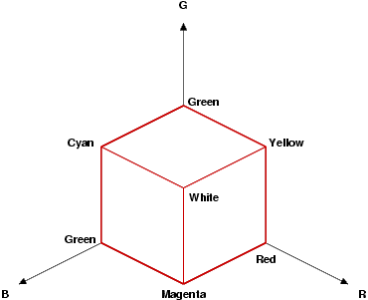
Figure 1. (a) RGB coordinates system

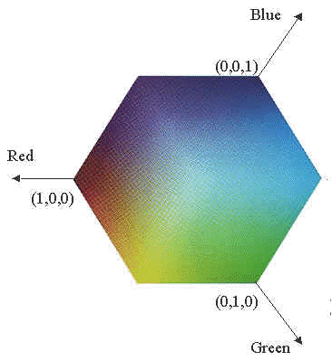
Figure1. (b) RGB color model
2. HSV Color Model
The HSV stands for the Hue, Saturation, and Value based on the artists (Tint, Shade, and Tone). The coordinate system is a hexacone in Figure 2. (a). And Figure 2.(b) a view of the HSV color model. The Value represents intensity of a color, which is decoupled from the color information in the represented image. The hue and saturation components are intimately related to the way human eye perceives color resulting in image processing algorithms with physiological basis.
As hue varies from 0 to 1.0, the corresponding colors vary from red, through yellow, green, cyan, blue, and magenta, back to red, so that there are actually red values both at 0 and 1.0. As saturation varies from 0 to 1.0, the corresponding colors (hues) vary from unsaturated (shades of gray) to fully saturated (no white component). As value, or brightness, varies from 0 to 1.0, the corresponding colors become increasingly brighter.
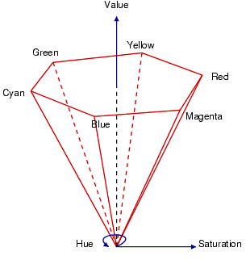
Figure 2. (a) HSV coordinates system
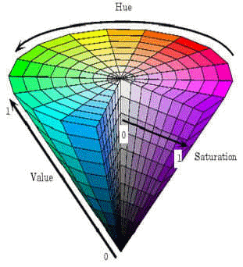
Figure 2. (b) HSV color model
3. Color conversion
In order to use a good color space for a specific application, color conversion is needed between color spaces. The good color space for image retrieval system should preserve the perceived color differences. In other words, the numerical Euclidean difference should approximate the human perceived difference.
3.1 RGB to HSV conversion
In Figure 3., the obtainable HSV colors lie within a triangle whose vertices are defined by the three primary colors in RGB space:
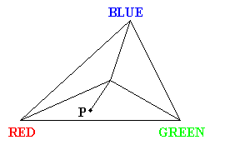.
Figure 3. Obtainable HSV color from RGB color space
The hue of the point P is the measured angle between the line connecting P to the triangle center and line connecting RED point to the triangle center. The saturation of the point P is the distance between P and triangle center. The value (intensity) of the point P is represented as height on a line perpendicular to the triangle and passing through its center. The grayscale points are situated
onto the same line. And the conversion formula is as follows :
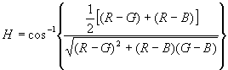,
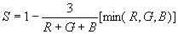,
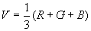
4.Color Histogram:
The color histogram for an image is constructed by counting the number of pixels of each color.

4.1 Color histogram definition
An image histogram refers to the probability mass function of the image intensities. This is extended for color images to capture the joint probabilities of the intensities of the three color channels. More formally, the color histogram is defined by,
where A , B and C represent the three color channels (R,G,B or H,S,V) and N is the number of pixels in the image. Computationally, the color histogram is formed by discretizing the colors within an image and counting the number of pixels of each color.
When a perceptually uniform color space is chosen uniform quantization may be appropriate. If a non-uniform color space is chosen, then non-uniform quantization may be needed.

The color histogram can be thought of as a set of vectors. For gray-scale images these are two dimensional vectors. One dimension gives the value of the gray-level and the other the count of pixels at the gray-level. For color images the color histograms are composed of 4-D vectors. This makes color histograms very difficult to visualize.

4.2 Histogram euclidean distance
Let h and g represent two color histograms. The euclidean distance between the color histograms h and g can be computed as:
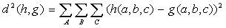
In this distance formula, there is only comparison between the identical bins in the respective histograms. Two different bins may represent perceptually similar colors but are not compared cross-wise. All bins contribute equally to the distance.

5- Your Study at Homework:

5.1 Download an image database:
You will download the image data (1000 test image) from a web site ( http://wang.ist.psu.edu/docs/related/ )The original 1000 images has 10 categories (Africans & villages, Beach, Buildings, Buses, Dinosaurs, Elephants, Flowers, Horses, Mountains & glaciers, Food).

However, in order to reduce the computation time of the whole process, only the first 10 out of 100 images from each category will used to obtain the histograms. You should give the new names to these 100 images, have numbers as their names from 0 to 99 with JPEG-compressed for convenience and for saving storage. The images are true color .jpg images and you can read them with imread function in MATLAB. (The new file names can also arranged in MATLAB with string processes functions. )

5.2 Quantization
RGB Space:
In order to reduce computation time, a 256x256x256 = 16777216 color image (8 bits in each color channel R,G,B) is quantized into a 8 x 8 x 8 = 512 color image in RGB color space. Otherwise, it will take really long time to compute and compare 16777216 bins of a histogram with others. This is a trade-off between performance and time. Since R,G and B have same distance in its color space, they are quantized into same levels.

HSV space:
A RGB color space image should first be transformed to a HSV color space image. In HSV color space, quantization of hue requires the most attention. The hue circle consists of the primaries red, green and blue separated by 120 degrees. A circular quantization at 20 degree steps sufficiently separates the hues such that the three primaries and yellow, magenta and cyan are represented each with three sub-divisions. Saturation and value are each quantized to three levels yielding greater perceptual tolerance along these dimensions. Thus, H is quantized to 18 levels and S & V is quantized to 3 levels. The quantized HSV space has 18x3x3 = 162 histogram bins.

5.3 Computation and comparison of histogram for image retrieval
Computation of histogram is simple. All you will do is just to count number of pixels that correspond to a specific color in quantized color space whether it is the RGB color space or the HSV space. In order to compare histograms of two images, you first need to generate specific codes for all histogram bins. In this experiment, (r : 0~7, g: 0~7, b: 0~7 ) codes were generated for 512 RGB histogram bins and (h: 0~17, s: 0~2, v: 0~2) codes were generated for 162 HSV histogram bins.
Then, you will select one of the image from database as a test image and then compute “histogram euclidean distances” for all remaining images in database. Since the number of bins of quantized HSV color space to be compared is less than a third, it was expected that the comparison in HSV color space would be done faster than in RGB color space.

