The input is a stereo pair of images I_{l}(left) and I_{r} (right).
Let p_{l} and p_{r} be pixels in the left and right image, 2W+1 the width (in pixel) of the correlation window, R(p_{l}) the search region in the right image associated with p_{l}, and ψ(u,v) a function of two pixel values, u, v.
For each pixel p_{l} = [i, j]^{T} of the left image:

1. for each displacement d = [d₁,d₂]^{T} ∈ R(p_{l}) compute
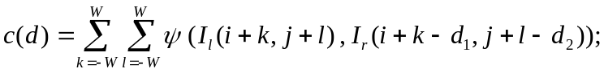

2. the disparity of p_{l} is the vector 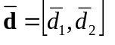that maximizes c(d) over R(p_{l}):
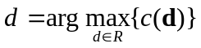

The output is an array of disparities (the disparity map), one per each pixel of I_{l}.

Two widely adopted choices for the function ψ(u,v) are

ψ(u,v)=u.v

which yields the cross-correlation between the window in the left image and the search region in the right image, and

ψ(u,v)=-(u-v)²
which perform the so called SSD (sum of squered distance) or block matching.

