1. **Installation**

The major tasks involved in Installation are:

* Install Visual Studio Code (recommendation)
* Install MongoDB
* Install NodeJS

1. **Database setup**

In MongoDB Compass,

1. Create new database named web_ISD, and create 3 new collection named as 3 files in folders db
2. Import 3 files below which are in db folder to the web_ISD database

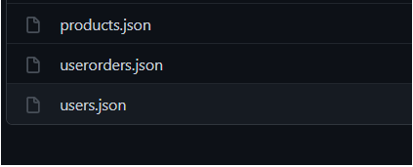

1. **Run Server**

To run your web server, in command:

* Type “npm install” to install modules:
* Type “npm start” to run web server:

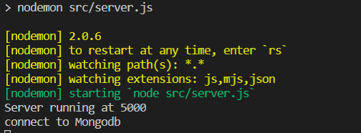

* Visit http://localhost:5000 and you will see Kimi Cosmetic Website.

1. **Admin account**

Email: admin@test.com

Password: 123456

You can access to website to be administrator to gain access to privilleges as following: editing, adding, removing and updating products in the database