1. Hãy trình bày một cơ chế giải quyết đa try cập (multiple access) trong một giao thức mạng không dây mà bàn biết) VD 802.11, 802.15,4,... Hãy nêu một ứng dụng thwucj tế mà công ngehj mạng này được áp dụng, vẽ sơ đồ triển khai ứng dụng..
   1. **Introduce**

ZigBee is a high-level communication protocol developed based on the IEEE 802.15.4 wireless communication standard, using radio signals for personal area networks (PAN). ZigBee is suitable for applications that do not require too high data transfer rates but require a great degree of security and long up time

* 1. **Wireless communication standard IEEE 802.15.4**

IEEE (Institute of Electrical and Electronics Engineers) is a non-profit organization that aims to research and develop technologies related to electrical and electronic equipment. The 802 group specializes in networking technologies, and the 802.15 division is dedicated to wireless networking standards. IEEE 802.15.4 specifies radio communications within a range of 10 meters to 100 meters and operates in three main frequency bands: * Range 868 - 868.8 MHz (Europe): only one signal channel, in this range the baud rate is 20kb / s. * Range 902 - 928 MHz (USA, Canada, Australia): there are 10 signal channels from 1 to 10 with baud rate usually 40kb / s.v * Range 2.4 - 2.4835 GHz (most other countries in the world): 16 signal channels from 11 to 26 with speed transmission 250 kb / s.

* 1. **The structure of the ZigBee protocol**

Similar to other communication protocols, ZigBee also has a multi-layered stack architecture, in which the physical layer and the Medium Access Control (MAC) layer are defined like the IEEE 802.15.4 standard. Then the ZigBee Alliance defined four more main components: the network layer, the application layer, the ZigBee device objects (ZDO) and user objects (which allows customization for each application). In particular, the addition of ZDOs is the most significant improvement, because these are the objects that perform many tasks such as defining the roles of devices, organizations and requiring access to the network, security. for the device ...

* 1. **The component of Zigbee**

A ZigBee network consists of 3 types of devices:

* ZC (Zigbee Coordinator): This is an original device capable of deciding the network structure, defining the addressing method and keeping the address table. Each network has only one Coordinator and it is also a unique component can communicate with other networks.

ZR (Zigbee Router): has the functions of intermediate routing to transmit data, detect and map surrounding nodes, monitor, control, collect data like normal node. Routers are usually in active mode to communicate with other parts of the network.

* ZED (Zigbee End Device): these nodes only communicate with Coordinator or Router near it, they are considered as the end point of the network and only operate / read information from physical components. ZED has a simple construction and is usually in sleep mode to save energy. They are only "awakened" when they need to receive or send a certain message. These devices are generally divided into two categories: FFD (Full Function Device) and RFD (Reduced Function Device). In which FFD can act as a Coordinator, Router or End Device, while RFD can only act as the End Device in a ZigBee network.

* 1. **ZigBee network architecture**

The ZigBee standard has 3 basic network configurations, depending on the specific application, people set up the network according to different configurations:

* Star Network

Network only Coordinator (ZC) and End Devices (ZED). When the ZC is activated for the first time it becomes the PAN network coordinator. Each star network has its own PAN ID to operate independently. The network has only one ZC connected to other FFDs and RFDes. ZED does not transmit data directly to each other.

* Mesh Network

The mesh network has the advantage of allowing continuous communication and has the ability to self-reconfigure around a shielded path by jumping from node to node until a connection is established. Each node in the grid has the ability to connect and route traffic with neighboring nodes.

Characteristics: similar to star network, but in this mess network there is the appearance of ZR. ZR plays the role of data routing, expanding the network and it is also capable of controlling and collecting data.

* Cluster Tree Topology

This structure is a special form of a mesh topology, in which most devices are FFD and a RFD, connect to the network as a discrete node at the end of the tree branch. Any FFD can act as a coordinator, providing sync signals for other devices and coordinators. Therefore, this type of network structure has high coverage and scalability. In this type of network configuration, although there can be more than one coordinator, there is only one PAN coordinator.

* 1. ZigBee and other communication protocols

The table compares ZigBee to popular wireless communication protocols such as Wifi, Bluetooth and GSM / GPRS / CDMA.

Application

The object that this technology aims at is control network for smart home (SmartHome), medical care (Health Care), intelligent energy management (Smart Energy), ... Especially, in the model Smart home, Zigbee is an indispensable technology, helping to meet all the needs of users to perform the process of controlling indoor devices. Application of Zigbee in smart home model It can be seen that the application of Zigbee in the smart home model is very large. Zigbee can be divided into several categories such as: Heavyweight Zigbee, Remote Zigbee, Healthcare Zigbee, ... Zigbee remote control technology In Smarthome, Zigbee provides a global standard to an Smart home can control or control lighting equipment, energy management, security, safety of the house, as well as connect to other ZigBee networks. In the world there are many companies that manufacture specialized products for this standard. In addition, Zigbee offers a global, easy-to-use standard for luminaire products. It allows the user to have wireless control or control over all types of lights such as LEDs, bulbs, or switches in your home. In particular, the energy management system will make your home more environmentally friendly. Zigbee technology does not affect the environment and society much, it makes your life simpler and easier.

1. : So soánh ưu nhược điểm Proactive và Reactive

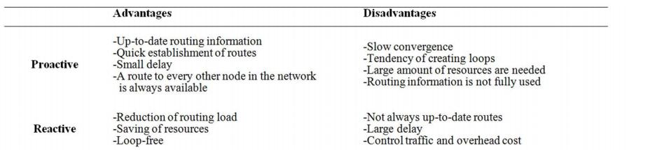

**Communication technology: Since sensors in a nuclear reactor have a semi-short transmission channel (1 m), Zigbee is a possible short range communication technology in this case.**

**Zigbee uses standard 802.15.4 radio waves with the highest transmission rate of 250kbps, supporting low power devices.**

**In order to communicate sensors using zigbee technology, these sensors must communicate with each other according to adhoc network model and need a Gateway to connect the internal zigbee ad network with other transmission communication technologies ( network IP, 3G, 4G, LTE, Wifi, ...)**

**Data transmission protocol: to monitor data from the sensors in a nuclear reactor, you need a multiplication protocol that allows many-one-many and MQTT to be a suitable choice. Broker MQTT is placed on the cloud, all variables in the adhoc network in the factory publish real time data to the broker. From the data gathered on Broker, it is easy for us to monitor and analyze the data collected by the sensors.**

**Besides, we can use CoAP to display the devices in the factory from the outside internet. To control devices just request to the URI of that device.**

**All of the above technologies are for IoT networks with the goal of targeting networks and devices with limited resources.**

**6LowPAN**

**System stack overview.**

6LowPan is responsible for transmitting larger IP (IPv6) packets into smaller frames (IEEE 802.15.4) capable of transmitting over the network.

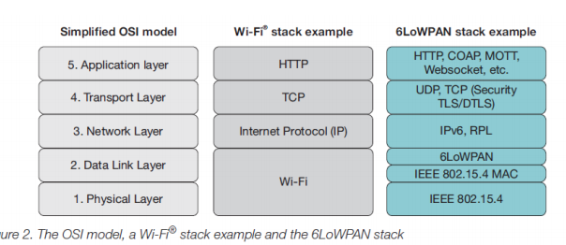

6LowPan uses an adaptation layer between the data link and the network layer to transmit information through the IEEE 802.15.4 standard.

**In the Physical layer**, data is converted into signals that are transmitted through the air. 6LowPan uses IEEE 802.15.4 standard connection.

**Data Link layer**, this layer provides direct connection between two hosts directly together. The Mac address is used to connect between two hosts. As mentioned above, in 6LowPan there is a compatibility layer that allows the transmission of IPv6 messages using IEEE 802.15.4 standard frames.

**The network layer** uses the IP address to route data.

**The Transport layer** is used to exchange data between sessions on different hosts. This allows for data transfer across many different applications. In embedded devices, due to limited memory and power, TCP cannot be used. Instead, UDP protocol is used.

**In the application layer,** TCP cannot be used in the 6LowPan network due to power and memory constraints. Therefore, people seek to replace HTTP with other protocols such as COAP (protocol for sending messages over UDP similar to HTTP, RFC 7252).

**Internet Protocol version 6(IPv6) over IEEE 802.15.4**

**However, the transmission of IPv6 packets using IEEE 802.15.4 frames does face some difficulties. Here are the difficulties:**

**1) IPv6 raises the MTU from 576 bytes to 1280 bytes. Meanwhile, the throughput of IEEE 802.15.4 is only 250 kpbs and the frame length is only 128 bytes.**

**2) IEEE 802.15.4 uses 2 address types: short address and EUI-64 extension address to optimize header and memory.**

**3) 6LowPan network has very limited power and memory (16 Kb Ram and 128 Kb Rom).**

**c. Auto configuration and neighbor discovery.**

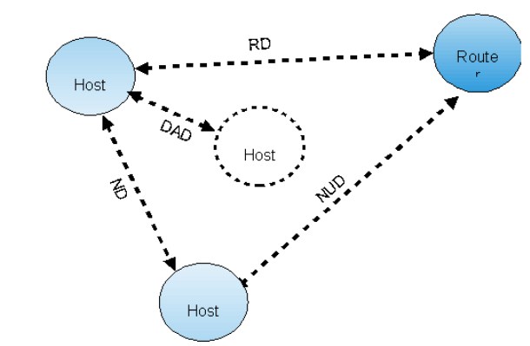

Auto configuration and neighbor discovery is a self-created protocol

Output the IP address for the device (other than the DHCP of IPv4).

The host communicates with neighbors through the NDP (neighbor discovery protocol) protocol.

All routers on the network send RD packets to handle the IPv6 prefix. If a host wants to join the 6LowPan network it has to generate a unicast address (FE80: IID), then use the ND packet sent to neighbors to see if there is a duplicate address, the process is called. is DAD (Detection Address Duplicate).

If not, receive any NA packet reporting the same address

then that address is a unique address. Host sends RD packet to get correct prefix of that network.

**Note**

**Benefits of 6LoWPAN technology:**

* Low power RF + IPv6 = Wireless embedded Internet technology
* 6LoWPAN makes this possible
* The benefits of 6LoWPAN include:
  + Dependable, open standards, long service life
  + ▪ Easy to learn-curve
  + ▪ Transparent Internet integration
  + ▪ Network maintenance capabilities
  + ▪ Global scalability
  + ▪ Allows a standard API socket
  + ▪ Minimal usage of code and memory
  + ▪ Integrated Direct Internet Terminal: Multiple topology options

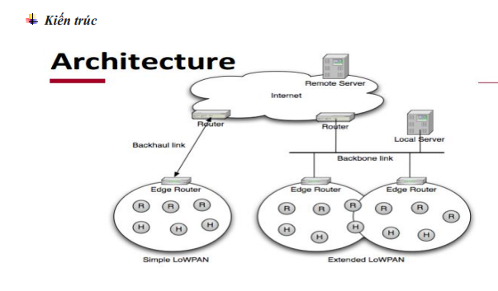

- LoW PASs are primitive networks

- LoWPAN is simple

* Simple edge router

-Extended LoWPAN

* Extensive LoWPAN Multiple Edge routers with common backbone links

- Ad-hoc LoWPAN

* There are no routes outside of LoWPAN

-Internet integration issues

* Maximum transmission unit
* ▪ Application protocol
* ▪ IPv4 connectivity
* ▪ Firewall and NAT
* ▪ Protection

**Adaptive features( Tính năng thích ứng)**

- Efficient header compression

* ▪ Base header and IPv6 extension, UDP header

-Fragmentation

* ▪ 1280 byte MTU IPv6 frame -> 127 bytes 802.15.4

**Additional features( Tính năng bổ sung)**

* Support for example 64-bit and 16-bit 802.15.4 addresses
* Useful for low power link layers such as IEEE 802.15.4, narrow band ISM
* and power line communication
* Automatically configures the network using neighbor detection
* Supports Unicast, multicast and broadcast
  + Multicast is compressed and mapped to broadcast
* Supports IP routing (eg IETF RPL)
* Support using link grid (example 802.15.5)

**Internet protocol v6**

- IPv6 (RFC 2460) = Next Generation Internet Protocol

▪ Complete the redesign of the IP address

Hierarchical 128-bit address with detachable storage identifier

Non-state automatic configuration

▪ Simple addressing and routing management

Most data traffic is still not IPv6 but ...

▪ Most computer operating systems already have IPv6

▪ Governments are beginning to require IPv6

▪ Most routers already have IPv6 support

▪ So the IPv6 transition is coming

• Annual IPv6 growth rate of 1400% (2009)

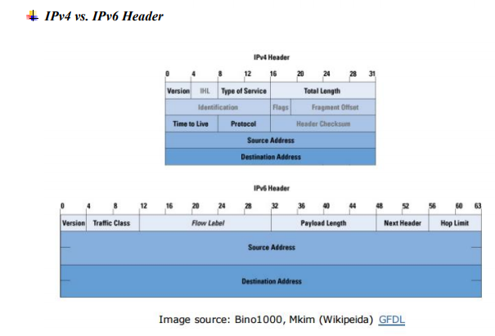

**6LoWPAN format**

6LoWPAN is an adaptive header format

Allows the use of IPv6 over low-energy wireless links

Compress the IPv6 header

UDP header compression

- Format was originally defined in RFC4944

- Updated by draft-ietf-6lowpan-hc (Ongoing)

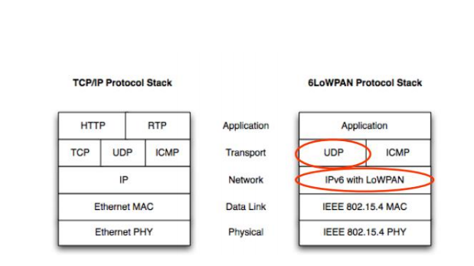

**Compressing the 6LowPAN Header at a glance:D**

Compression state

- Independent compression of the flow

- Simple trick on the IPv6 / UDP header

- Common value for header field => compact form

Version is always 6

Traffic Class and Traffic Label are 0

• The payload length always comes from the L2 header

Source and Destination

• The address can be deleted (link-local) and / or compressed

Depends on the "context" of the transmission

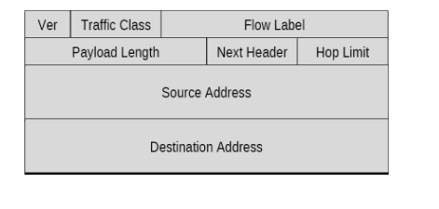

**IPv6 address**

- 128-bit IPv6 Address = 64-bit Prefix + 64-bit Interface ID (IID)

- The 64-bit prefix is hierarchical

• Identify the network you are using and where it is located globally

- 64-bit IID defines the network interface

Must be unique to that network

Usually statelessly formed from the MAC address of the interface

▪ Called stateless address autoconfiguration (RFC2462)

There are different types of IPv6 addresses

• Loopback (0 :: 1) and Unspecified (0 :: 0)

Unicast with a global scope (eg 2001: :) or link locally (FE80: :)

• Multicast address (starting with FF: :)

• Anycast address (unicast special-purpose address)

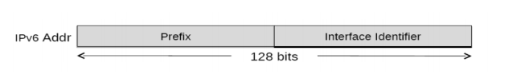

**IPv6 addresses are compressed in 6LoWPAN**

- Prefix

• Addresses in the 6LoWPAN range usually contain a common prefix

Buttons typically communicate with one or more central devices

• Set the state (context) for such prefixes - only the maintenance state

Supports up to 16 6LoWPAN IPv6 compression contexts

- Interface ID

Usually derived from addr L2 during autoconfiguration

Elide when the Interface Identifier can be derived from the L2 header

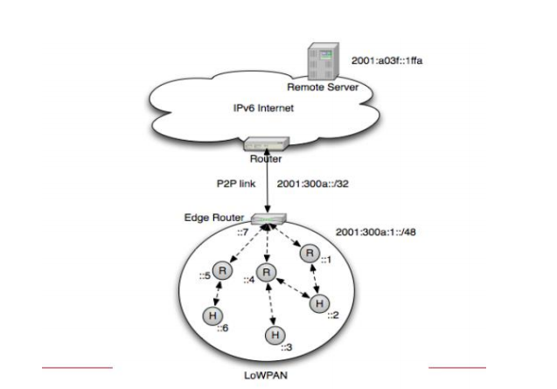

The Header Compression header - TF (Lớp lưu lượng và Nhãn lưu lượng) • 0: Carried Inline (ECN+DSCP+Flow), 1: ECN+Flow, 2: ECN+DSCP, 3: Tất cả bằng 0 - NH (nén header tiếp theo) • 0: Carry Inline, 1: header tiếp theo được nén - HLIM (Hop Limit = Inline, 1, 64, 255) • 0: Carried Inline, 1: 1, 2: 64, 3: 255 - CID (Context Identifier Extension) • 0: No 1-byte CID identifier, 1: 1-byte identifier follows - SAC/DAC (Source/Destination Address Compression) • 0: Stateless, 1: Context-based - SAM/DAM (Source/Destination Address Mode) • 0: 16 bytes inline, 1: 8 bytes inline, 2: 2 bytes inline, 3: elided - M (Multicast Destination) • 0: Destination is not multicast, 1: Destination is multicast

**Setting up and running 6LoWPAN**

Automated configuration is very important in embedded networks

For a 6LoWPAN network to start working:

* Connection layer link between nodes (operator)
* Network layer address configuration, discovery of neighbors, registrations
* (bootstrapping)
* Routing algorithm sets paths (initialize route)
* Continuous protection

**IPv6 Neighbor Discovery**

- IPv6 is the format - ND is the brains

• "One Step Routing Protocol" is defined in RFC4861

- Define interfaces between neighbors

- Find neighbor

Neighbor Solicitation / Neighbor Acknowledgment

- Find routing

Router Solicitation / Router Advertisement

- Address resolution using NS / NA

-Detect duplicate addresses using NS / NA

-Neighbor Unreachability Detection using NS / NA

- DHCPv6 can be used in conjunction with ND

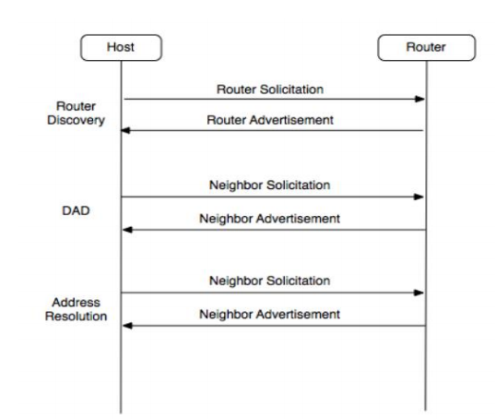

- The ND standard for IPv6 is not compliant with 6LoWPAN:

* + Assumes a unique link to the IPv6 subnet prefix
* Assume that nodes are always on
* Uses multiple multicast traffic (broadcast / flood in 6LoWPAN)
* Does not support efficient multitasking via example: 802.15.4

- 6LoWPAN Neighbor Discovery provides:

* An appropriate link and subnet model for the public wireless network
* low productivity
* Minimized node-initiated control traffic
* Registration button (NR) and confirmation button (NC)
  + Duplicate address detection (DAD) and recovery
* Support for Edge Router infrastructure expansion

- ND for 6LoWPAN has been identified in draft-ietf-6lowpan-nd (in progress

onion)

**Types of routing protocols**

- Algorithm classes:

* Distance-vector: Link associated with the cost, used to find the route
* shortest way. Each router along the path stores the next local hop information
* next to its routing table.

-Link-state: Each node receives complete information about the network, typically flooding.

Each node computes a computed shortest line for each destination.

-Types of signals

* Actively: Route information is obtained before it is considered needed
* set.
* Reactive: Route information is dynamically detected when needed.

-Route metrics is an important metric

**6LoWPAN Routing**

* Here we consider IP routing (at layer 3)
* Routing within a LoWPAN
  + Single-interface routing
  + Flat address space (exact-match)
  + Stub network (no transit routing)

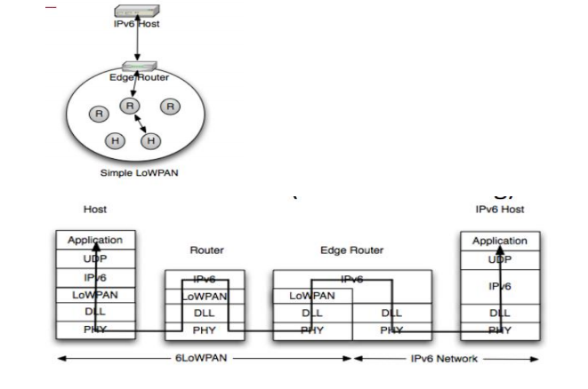

**7****. Zigbee vs WiFi**

|  |  |  |
| --- | --- | --- |
|  | Zigbee | WIFI |
| 1. IEEE Standard | IEEE 802.15.4 | IEEE 802.11.x (x là a,b,g,.v..v) |
| 2. Operating Frequency | works at 900-928 MHz and 2.4GHz.  In Europe, Zigbee operates at 868MHz | work at 2.4GHz, 5GHz (recently developed wifi that allows operating at 60GHz) |
| Channel Bandwidth | 1MHz | 0.3, 0.6 or 2MHz |
| Network Range | - WPAN (Wireless Personal Area Networks).  10-30m in common applications; There are a number of applications that can reach 100m. | WAP and WALAN, average range 30-100m. |
| Data transfer speed | Maximum = 250kps; quite low compared to the lowest speed of wifi. | Faster than Zigbee in terms of data transfer.  - The speed of wifi according to each standard:  802.11b: maximum = 11mbps.  802.11a & 802.11c: maximum = 54mbps |
| Bit Time (thời gian truyền 1 bit/ 1 data rate of transfer cho trước) | 4micro seconds | 0.00185 micro seconds |
| . Power Consumption | Designed "assemble and forget" -> less energy consumption.  Zigbee consumes about of the energy of wifi | Not really good at consuming less energy, so  Works for more than 10hrs require backup batteries. |
| . Network Elements | 3 loại: Zigbee coordinator, Zigbee end router, Zigbee end device. | -Point-to-point network.  -- Wifi router is used when needing to connect multiple devices,  or need to connect to the internet |
| Network Size (in one network) | Over 65,000 nodes | 32 |
| . Network Security | - Advanced Encryption Security (AES) methods for encryption. - CCB-CCM methods for network security | WEP, WPA and WPA2 protocols for network encryption and security, respectively. |
| Applications | Often used as exchange data, Zigbee is popular in wireless connection between wireless sensors, eg automatic indoor systems or industrial coordination systems. | Wi-Fi is often a good choice for internet connection. Used to  Perform data exchange between computer and modem, streaming music / videos. |

**8. Zigbee vs 6LowPan**

|  |  |
| --- | --- |
| Zigbee | 6loWPAN |
| Zigbee devices cannot communicate directly with other devices on the internet | 6loWPAN devices can communicate directly to the internet |
| The Zigbee network is managed by an coordinator that implements the app-layer protocol and sends data back to the server | Servers can collect data directly from the devices without waiting for the coordinators to process the request |
| If the coordinators fail, the zigbee network will no longer be able to connect to the internet | No coordinators are needed to connect to the internet |
| Slow data transmission | Fast data transfer |
| The network layer uses 64-bit IEEE 802.15.4 addresses | IPv6 nodes are assigned IP addresses of 128 bits |

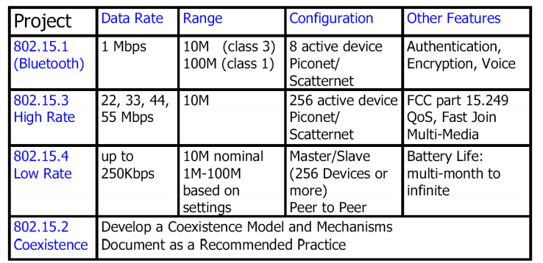

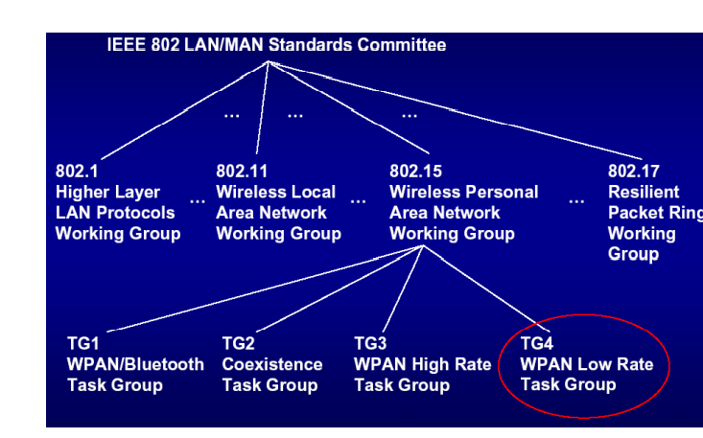

**IoT Project**

* **Project name: Smart watering**
* **Overview:**

**Smart watering** building a large scale and general architecture, which can apply for whole agriculture. By using lora wan technology to connect IoT device in long distance, this topology can be deployed in thousands of hectares of farm or forest.

* **Main function**:
  + predict the time of water run out and predicting future temperature and humidity conditions.
  + Automatic watering: when the temperature is too high or the humidity is too low, the tree will be watered.
  + Monitor the water level in the tank.
  + Monitor the values of the sensor.
  + Schedule: set the time for the automatic irrigation system.
  + Remote control system via web.
  + Trigger: change parameters on operating conditions of the pump (temMax, moiMin).
* Technology
  + Connection: Lora, Wifi
  + Web server: C# and ASP.NET Core framework
  + AI server: python
  + Database: MSSqlserver
* Architecture

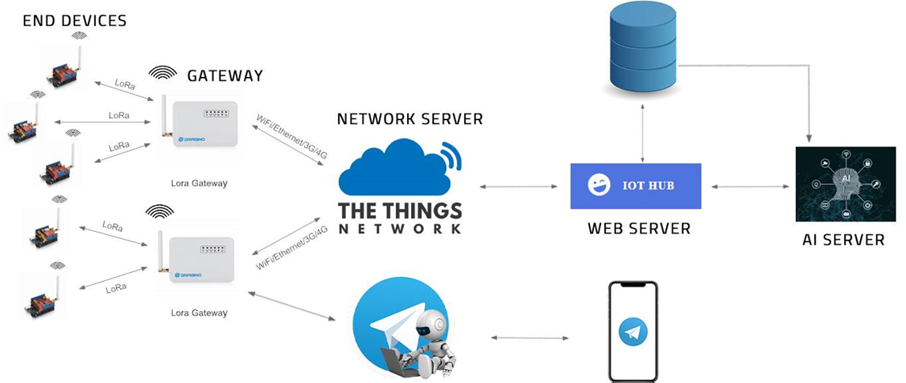

* Context:

On a field, it is divided into multiple zones and each zone will have one piece of equipment (Esp32 Lora, pump, sensor ..). These modules (ESP32 Lora) will send data back to the Lora gateway. At this point, the Lora gateway will forward data to the Network server ( TheThingNetWork )(https://www.thethingsnetwork.org). Then The network server will parse and create HTTP requests to continue forward this packet to the back-end server (ASP.NET). It will retrieve the data and process it.

Besides, there will be an additional Python server that will pull data from the database and run AI algorithms: Based on the collected temperature and humidity information, this server will run a deep learning algorithm to predict the future temperature and humidity values.

And an interesting feature is warning characteristics. If these systems have an important notification. And it must send and not for admin immediately. So, it can not send via Lora, because Lora has latency. The solution we propose is to write an AI bot in telegram. Thank for, when having a warning, Automatically, the admin will receive a message in the Telegram app