


Hadoop开发技术实战
实训报告
项目名称： 三国演义人物数据分析
班级名称： 数据科学与大数据技术1班
小组编号： 1
组长： 杨天佑

目录
1. 项目概述 2
1.1. 项目简介 2
1.2. 项目分工 2
2. 项目实现过程 2
2.1. 数据采集 2
2.2. 数据预处理 4
2.3. 数据分析 11
2.4. 数据可视化 17
3. 特色与创新 39
4. 评分表 40

项目概述

项目简介
详见readme文档

项目实现过程

数据采集
import csv
import re
import requests
from bs4 import BeautifulSoup

header = {
'User-Agent': 'Mozilla/5.0 (Windows NT 10.0; Win64; x64) AppleWebKit/537.36 (KHTML, like Gecko) Chrome/91.0.4472.124 Safari/537.36',
'Accept': 'text/html,application/xhtml+xml,application/xml;q=0.9,image/webp,*/*;q=0.8',
'Accept-Language':'zh-CN,zh;q=0.8,zh-TW;q=0.7,zh-HK;q=0.5,en-US;q=0.3,en;q=0.2',
'Accept-Encoding': 'gzip, deflate',
'Connection': 'keep-alive',
}

i = 1
while True:
url = 'https://www.shicimingju.com/book/sanguoyanyi/'+str(i)+'.html'
response = requests.get(url, headers=header)
response.encoding = 'UTF-8'
print(i,response)
i += 1
if str(response) != '<Response [200]>':
print(i)
break
else:
html_content = response.text
soup = BeautifulSoup(html_content, features='lxml')
print(soup.h1.text)
with open("三国演义全文/"+soup.h1.text+".txt",'w',encoding="UTF-8") as f:
f.write(soup.h1.text+"\n")
for p in soup.find_all('p') :
if not p.find('a') and not "com" in p.text:
print(p.text.strip())
f.write(" "+p.text.strip()+"\n")
f.close()

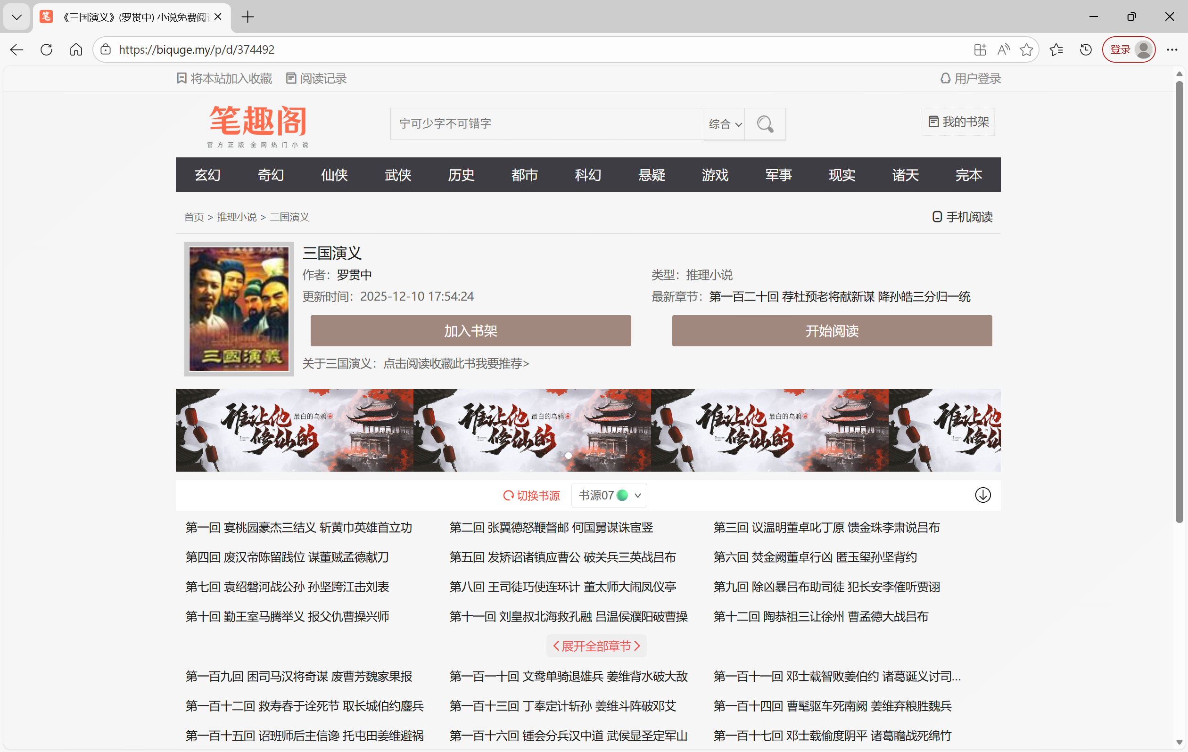
图2.1.1 网页原页面
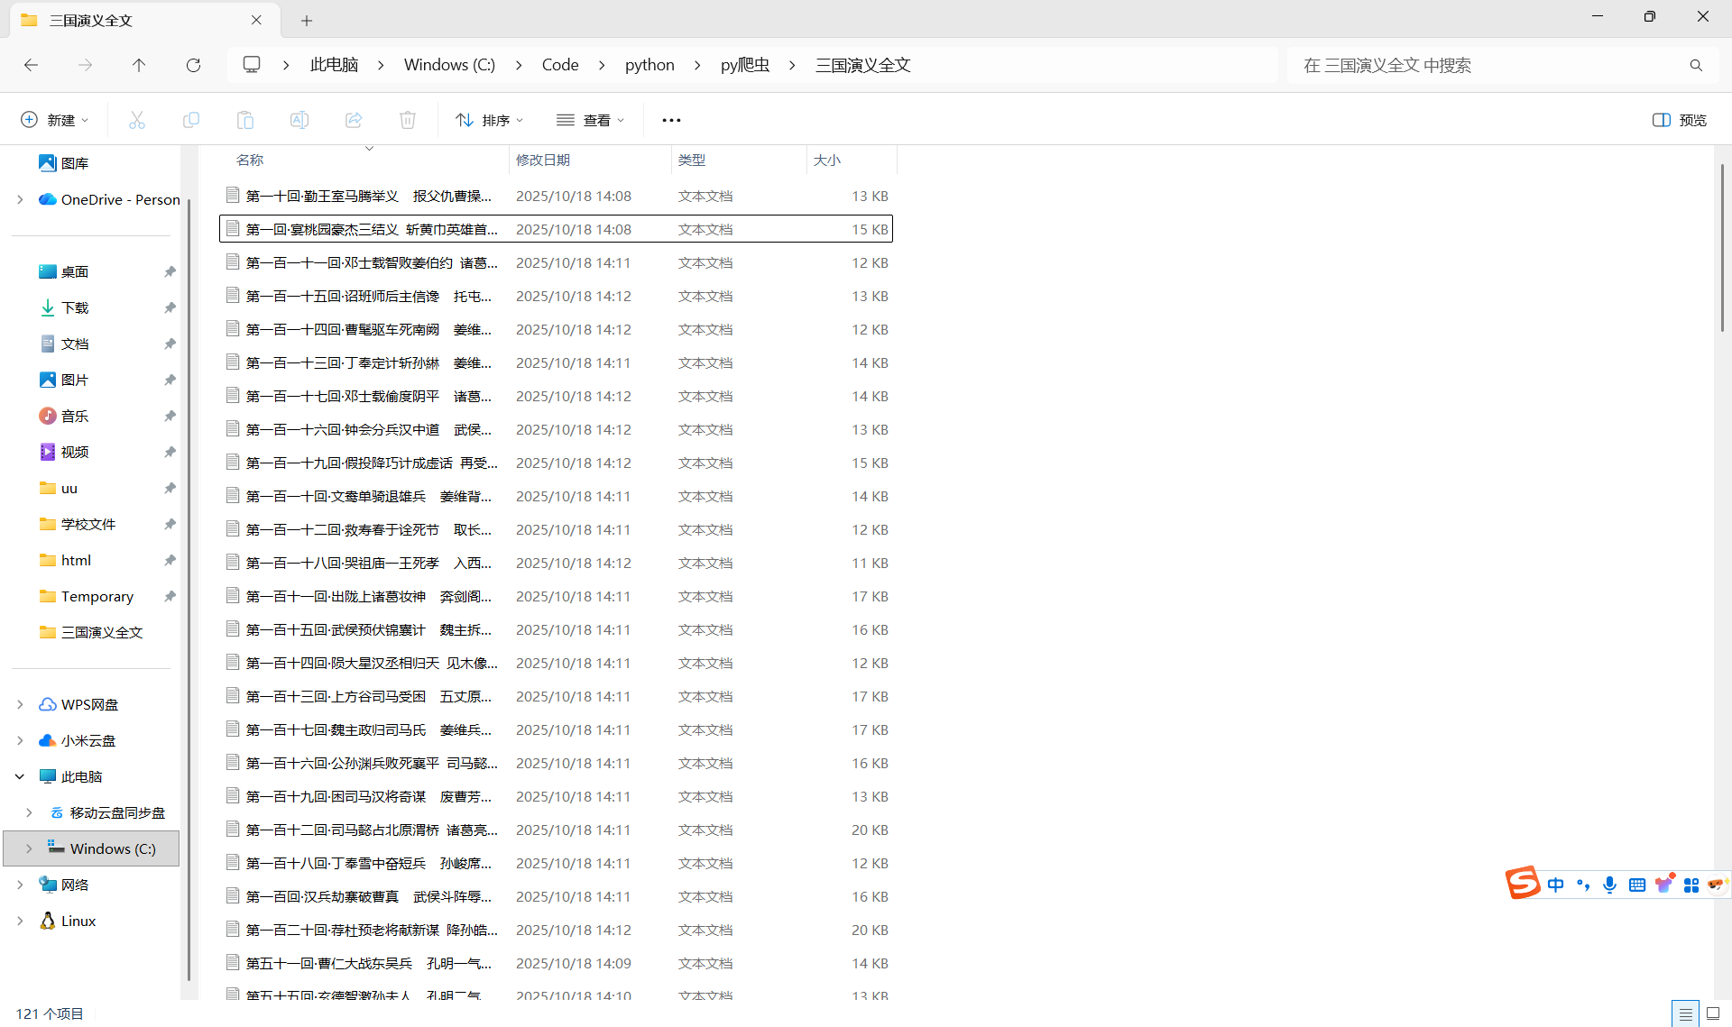
图2.1.2 爬取结果

数据预处理
Python部分；
import os
import cn2an
import re

filePath = "C:\Code\python\py爬虫\三国演义全文"

#清洗章回数为阿拉伯数字
def chapter():
pattern = r'(?<=\第).+?(?=\回)'
# 遍历文件夹
for dirpath, dirnames, filenames in os.walk(filePath):
for filename in filenames:
print(filename)
num = re.findall(pattern,filename)
if len(num)!=0:
num_changed = cn2an.cn2an(num[0])
print(num_changed)
name_origin = filename.split('·')
name_changed = str(num_changed)+'.'+str(name_origin[1])
print(name_changed)
os.rename(filename,name_changed)

#按段落划分
def paragraph():
path = 'C:\Code\python\py爬虫\三国演义全文'
for dirpath, dirnames, names in os.walk(path):
i=0
for name in names:
i+=1
with open(path+f'\\{name}', 'r', encoding='utf-8') as file:
text = file.read()

paragraphs = re.split(r'\n', text.strip())
print(repr(text[:1000])) # 打印文本的前1000个字符，使用repr显示特殊字符
# 输出结果
for idx, paragraph in enumerate(paragraphs, start=1):
print(f"段落 {idx}:\n{paragraph}\n")
with open(f"C:\Code\python\py爬虫\分段\\{i}.{idx}.txt",'w',encoding='utf-8') as f:
f.write(paragraph)

paragraph()

MapReduce部分：
提取人物出现的对应段落
package cn.itcast.hadoop.sg.ChapterPerson;
import com.hankcs.hanlp.HanLP;
import com.hankcs.hanlp.seg.common.Term;
import org.apache.hadoop.io.LongWritable;
import org.apache.hadoop.io.Text;
import org.apache.hadoop.mapreduce.Mapper;
import org.apache.hadoop.mapreduce.lib.input.FileSplit;
import java.io.IOException;

public class ChapterPersonMapper extends Mapper<LongWritable, Text, Text, Text> {
private String chap;
private final Text outKey = new Text();
private final Text outVal = new Text();
@Override
protected void setup(Context context) throws IOException {
String fileName = ((FileSplit) context.getInputSplit()).getPath().getName();
int dot = fileName.lastIndexOf('.');
chap = dot > 0 ? fileName.substring(0, dot) : fileName;
}
@Override
protected void map(LongWritable key, Text value, Context context)
throws IOException, InterruptedException {
String line = value.toString().trim();
if (line.isEmpty()) return;
for (Term t : HanLP.segment(line)) {
if (!t.nature.startsWith("nr")) continue;
// ===== 只改这里 =====
String std = PersonDict.normalize(t.word); // ① 别名→标准
if (PersonWhitelist.contains(std)) { // ② 白名单过滤
outKey.set(std);
outVal.set(chap);
context.write(outKey, outVal);
}
}
}
}

读取对应配置文件

package cn.itcast.hadoop.sg.ChapterPerson;

import java.io.*;
import java.nio.charset.StandardCharsets;
import java.util.Collections;
import java.util.HashMap;
import java.util.Map;
import java.util.Properties;

public final class PersonDict {

private static final Map<String, String> ALIAS = new HashMap<>();

static {
// 利用类加载器从 classpath 根目录读取
try (InputStream is = PersonDict.class.getClassLoader()
.getResourceAsStream("person-alias.properties");
BufferedReader reader = new BufferedReader(
new InputStreamReader(is, StandardCharsets.UTF_8))) {
Properties props = new Properties();
props.load(reader);
props.forEach((k, v) -> ALIAS.put(k.toString().trim(), v.toString().trim()));
} catch (IOException e) {
throw new RuntimeException("加载 person-alias.properties 失败", e);
}
}

/** 外部唯一入口：任意人名 → 标准化人名 */
public static String normalize(String name) {
if (name == null) return null;
return ALIAS.getOrDefault(name, name);
}

/** 只读视图，供调试或外部只读遍历 */
public static Map<String, String> unmodifiableView() {
return Collections.unmodifiableMap(ALIAS);
}

private PersonDict() {}
}

读取对应配置文件

package cn.itcast.hadoop.sg.ChapterPerson;

import java.io.*;
import java.nio.charset.StandardCharsets;
import java.util.Collections;
import java.util.HashSet;
import java.util.Set;

public final class PersonWhitelist {

private static final Set<String> NAMES = new HashSet<>();

static {
try (BufferedReader br = new BufferedReader(new InputStreamReader(
PersonWhitelist.class.getClassLoader()
.getResourceAsStream("person-whitelist.properties"),
StandardCharsets.UTF_8))) {
String line;
while ((line = br.readLine()) != null) {
line = line.trim();
if (line.isEmpty() || line.startsWith("#")) continue;
NAMES.add(line);
}
} catch (IOException e) {
throw new RuntimeException("加载白名单失败", e);
}
}

/** 快速判断是否为合法人物 */
public static boolean contains(String name) {
return name != null && NAMES.contains(name);
}

/** 只读视图，调试用 */
public static Set<String> unmodifiableView() {
return Collections.unmodifiableSet(NAMES);
}

private PersonWhitelist() {}
}

配置文件

# ===== 蜀汉 =====
玄德=刘备
云长=关羽
关公=关羽
翼德=张飞
孔明=诸葛亮
卧龙=诸葛亮
子龙=赵云
# ===== 曹魏 =====
孟德=曹操
阿瞒=曹操
丞相=曹操
仲达=司马懿
公明=徐晃
文远=张辽
儁乂=张郃
妙才=夏侯渊
元让=夏侯惇
# ===== 孙吴 =====
伯符=孙策
仲谋=孙权
公瑾=周瑜
# ===== 东汉 / 群雄 =====
本初=袁绍
公路=袁术
奉先=吕布
温侯=吕布
汉室=汉献帝
天子=汉献帝
献帝=汉献帝
董贼=董卓
仲颖=董卓

配置文件：人物对应各个势力

# ===== 蜀汉 =====
刘备
关羽
张飞
诸葛亮
赵云

# ===== 曹魏 =====
曹操
司马懿
徐晃
张辽
张郃
夏侯渊
夏侯惇

# ===== 孙吴 =====
孙策
孙权
周瑜

# ===== 东汉 / 群雄 =====
袁绍
袁术
吕布
汉献帝
董卓

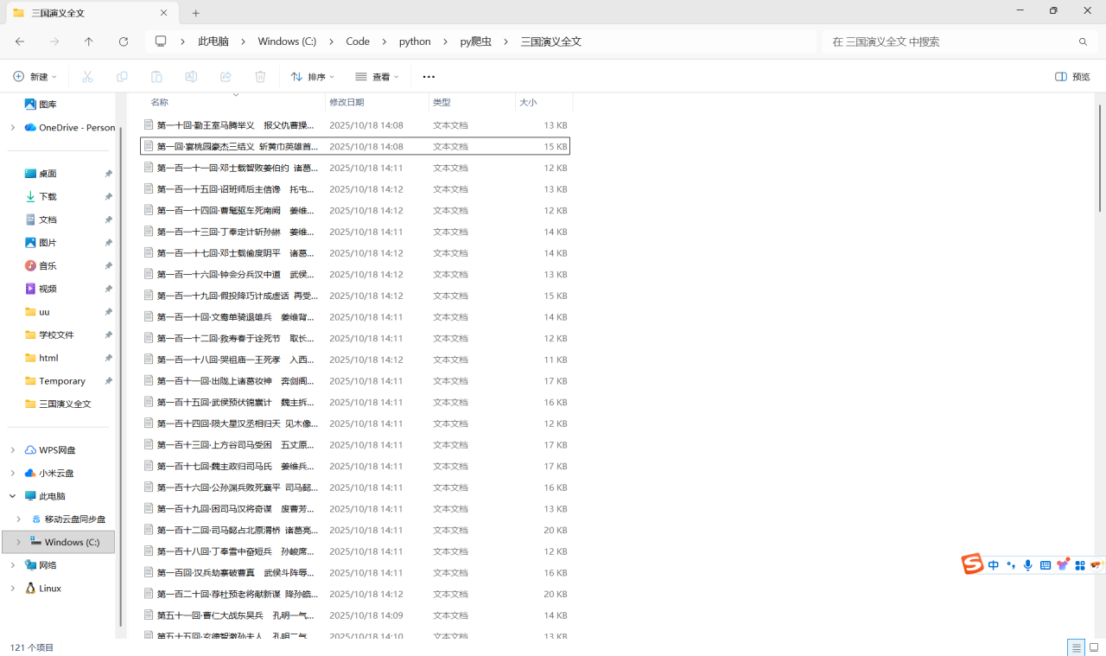
图2.2.1 未清洗的数据
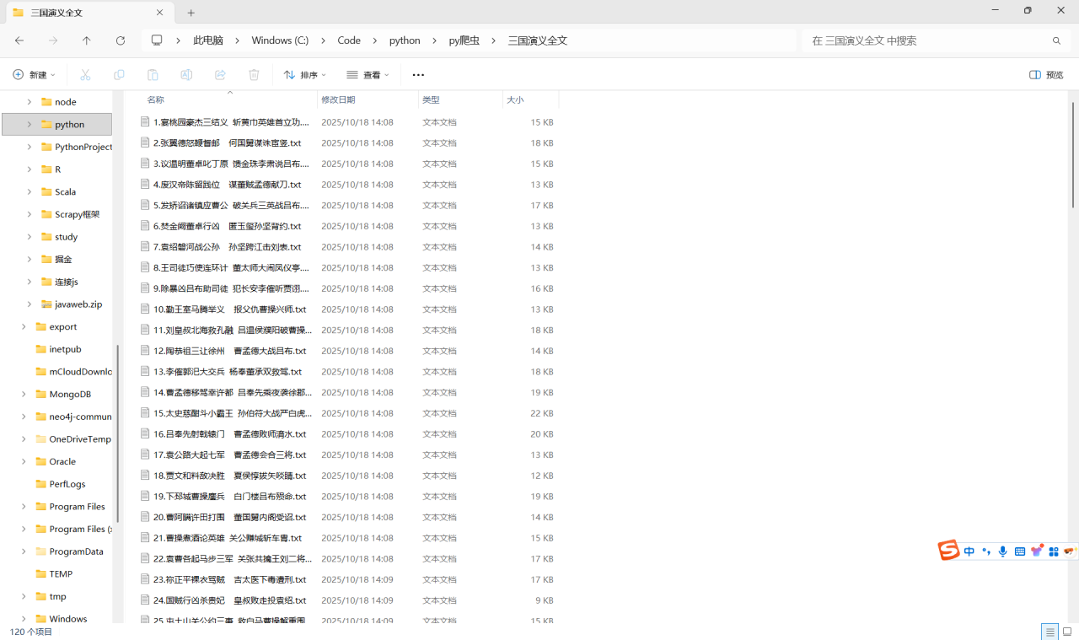
图2.2.2 第一次清洗(修改章回数为数字)
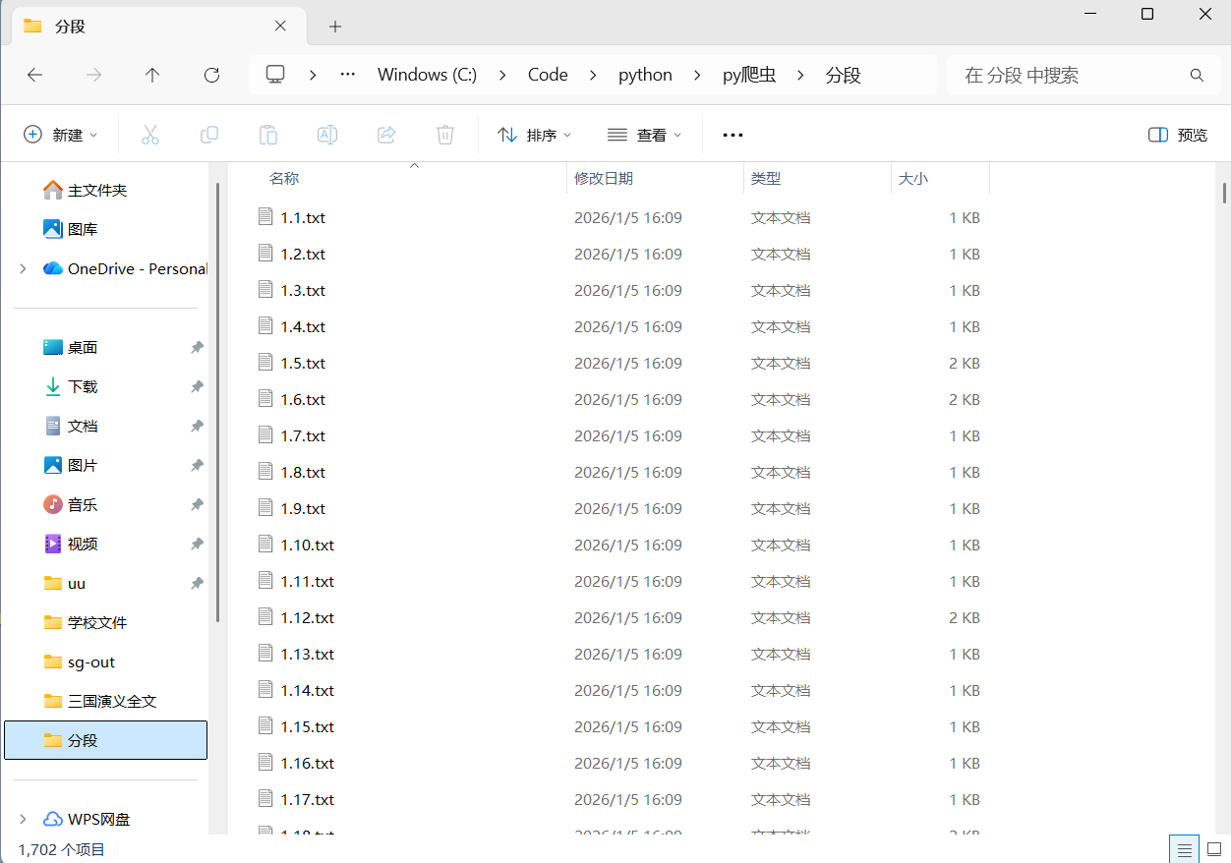
图2.2.3 第二次清洗(把每个章节按段落拆分)

数据分析
-- 图2.3.1 建库、建表
CREATE DATABASE IF NOT EXISTS sg_analysis;
USE sg_analysis;
CREATE EXTERNAL TABLE person_chap (
name STRING,
chap_list STRING
)
ROW FORMAT DELIMITED
FIELDS TERMINATED BY '\t'
LOCATION '/user/me/hive/person_chap';
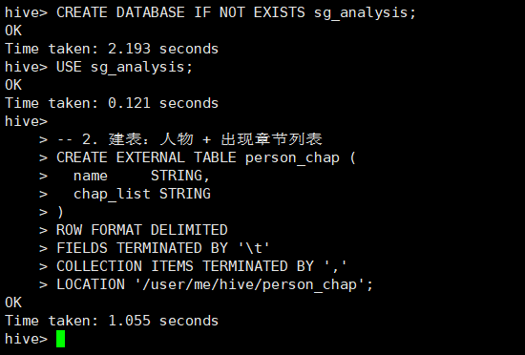

-- 图2.3.2 抽样
SELECT * FROM person_chap LIMIT 10;
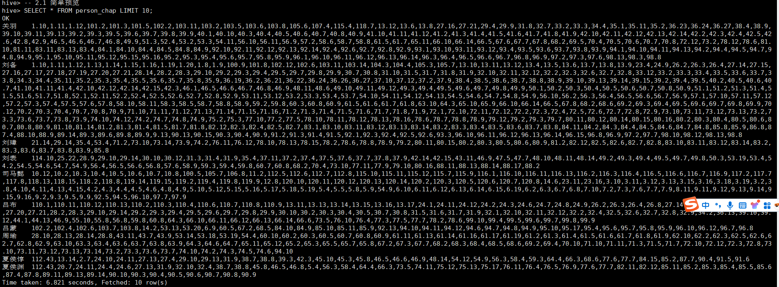

-- 图2.3.3 统计人物出现章节数 TOP10
SELECT name,
size(split(chap_list, ',')) AS chap_cnt
FROM person_chap
ORDER BY chap_cnt DESC
LIMIT 10;
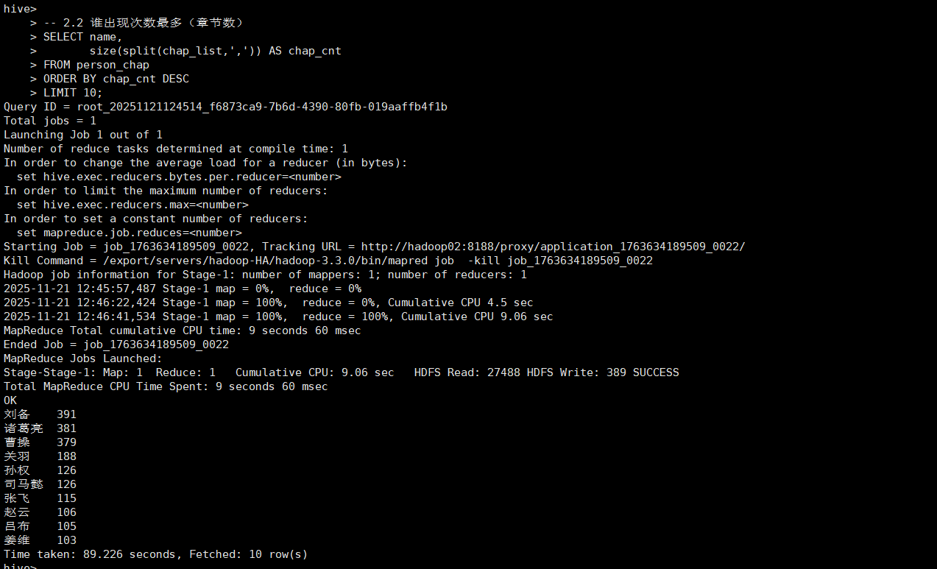

-- 图2.3.4 把“章节列表”炸成行，建视图
CREATE VIEW person_chap_explode AS
SELECT name, chap
FROM person_chap
LATERAL VIEW explode(split(chap_list, ',')) t AS chap;
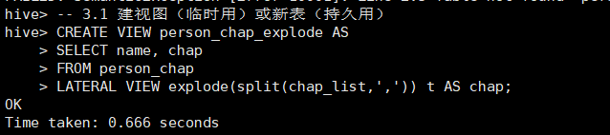

-- 图2.3.5 查询第1章出现过的人物
SELECT DISTINCT name
FROM person_chap_explode
WHERE chap LIKE '1.%';
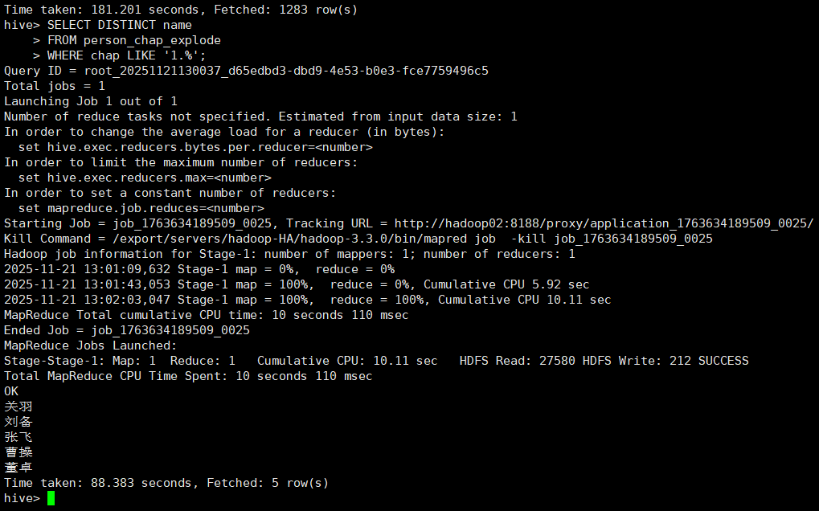
-- 图2.3.6 按章节聚合人物，生成 para_persons 表
CREATE TABLE para_persons AS
SELECT chap,
collect_set(name) AS persons
FROM person_chap_explode
GROUP BY chap;
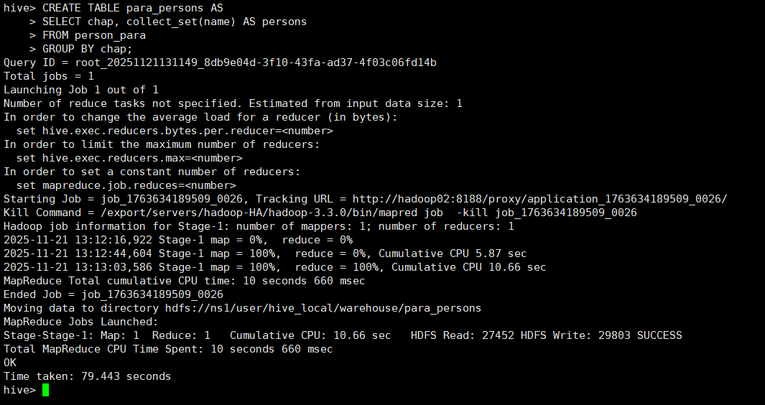
-- 图2.3.7 共现网络：生成无序人物对
-- 7.1 先炸集合
CREATE VIEW para_edges_raw AS
SELECT chap,
person1,
person2
FROM para_persons
LATERAL VIEW explode(persons) t1 AS person1
LATERAL VIEW explode(persons) t2 AS person2
WHERE person1 <= person2; -- 保证无序对，去自环
-- 7.2 汇总成共现表
CREATE TABLE cooccurrence_network AS
SELECT person1,
person2,
count(*) AS weight,
concat_ws(',', collect_set(chap)) AS paragraphs
FROM para_edges_raw
GROUP BY person1, person2;
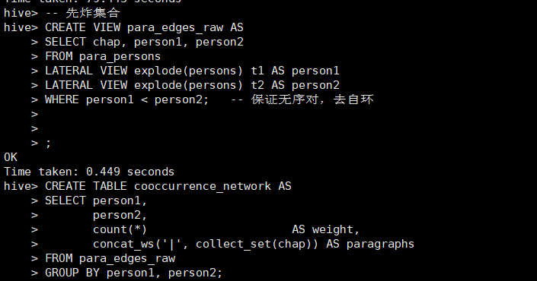
-- 图2.3.8 把人物出现章节数持久化到 CharacterChapterCount
CREATE TABLE IF NOT EXISTS CharacterChapterCount (
name STRING,
chapter_count INT
)
ROW FORMAT DELIMITED
FIELDS TERMINATED BY '\t'
STORED AS TEXTFILE;
INSERT INTO TABLE CharacterChapterCount
SELECT name,
size(split(chap_list, ',')) AS chapter_count
FROM person_chap;
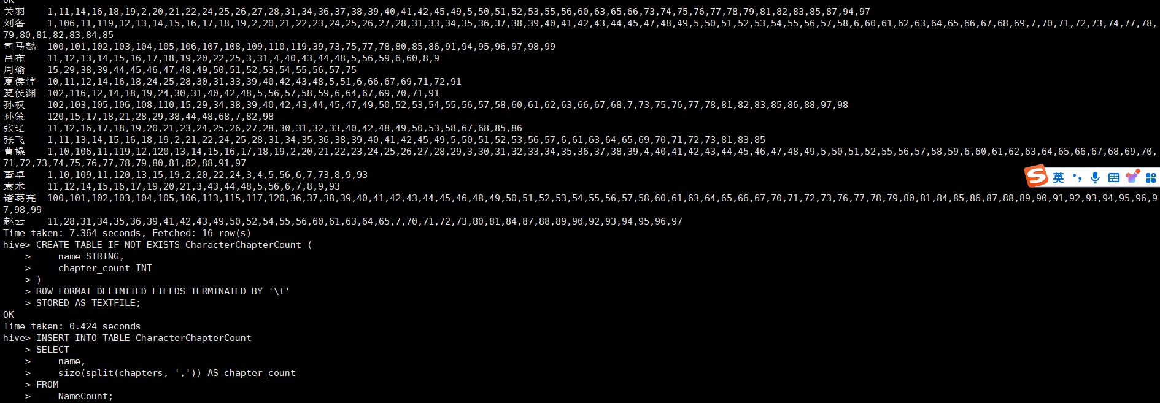
-- 图2.3.9 章节跨度统计：计算每个人物首次/末次出现章节及跨度
CREATE TABLE IF NOT EXISTS chapter_stat(
name STRING, -- 人物
min_ch INT, -- 首次出现章节
max_ch INT, -- 末次出现章节
diff INT -- 跨度（末次-首次）
);
INSERT INTO chapter_stat
SELECT name,
CAST(MIN(ch) AS INT) AS min_ch,
CAST(MAX(ch) AS INT) AS max_ch,
CAST(MAX(ch) - MIN(ch) AS INT) AS diff
FROM (
SELECT name,
CAST(split(chapter_list,',')[i] AS INT) AS ch
FROM CharacterChapterCount
LATERAL VIEW posexplode(split(chapter_list,',')) t AS i, ch
) tmp
GROUP BY name;
SELECT * FROM chapter_stat LIMIT 100;
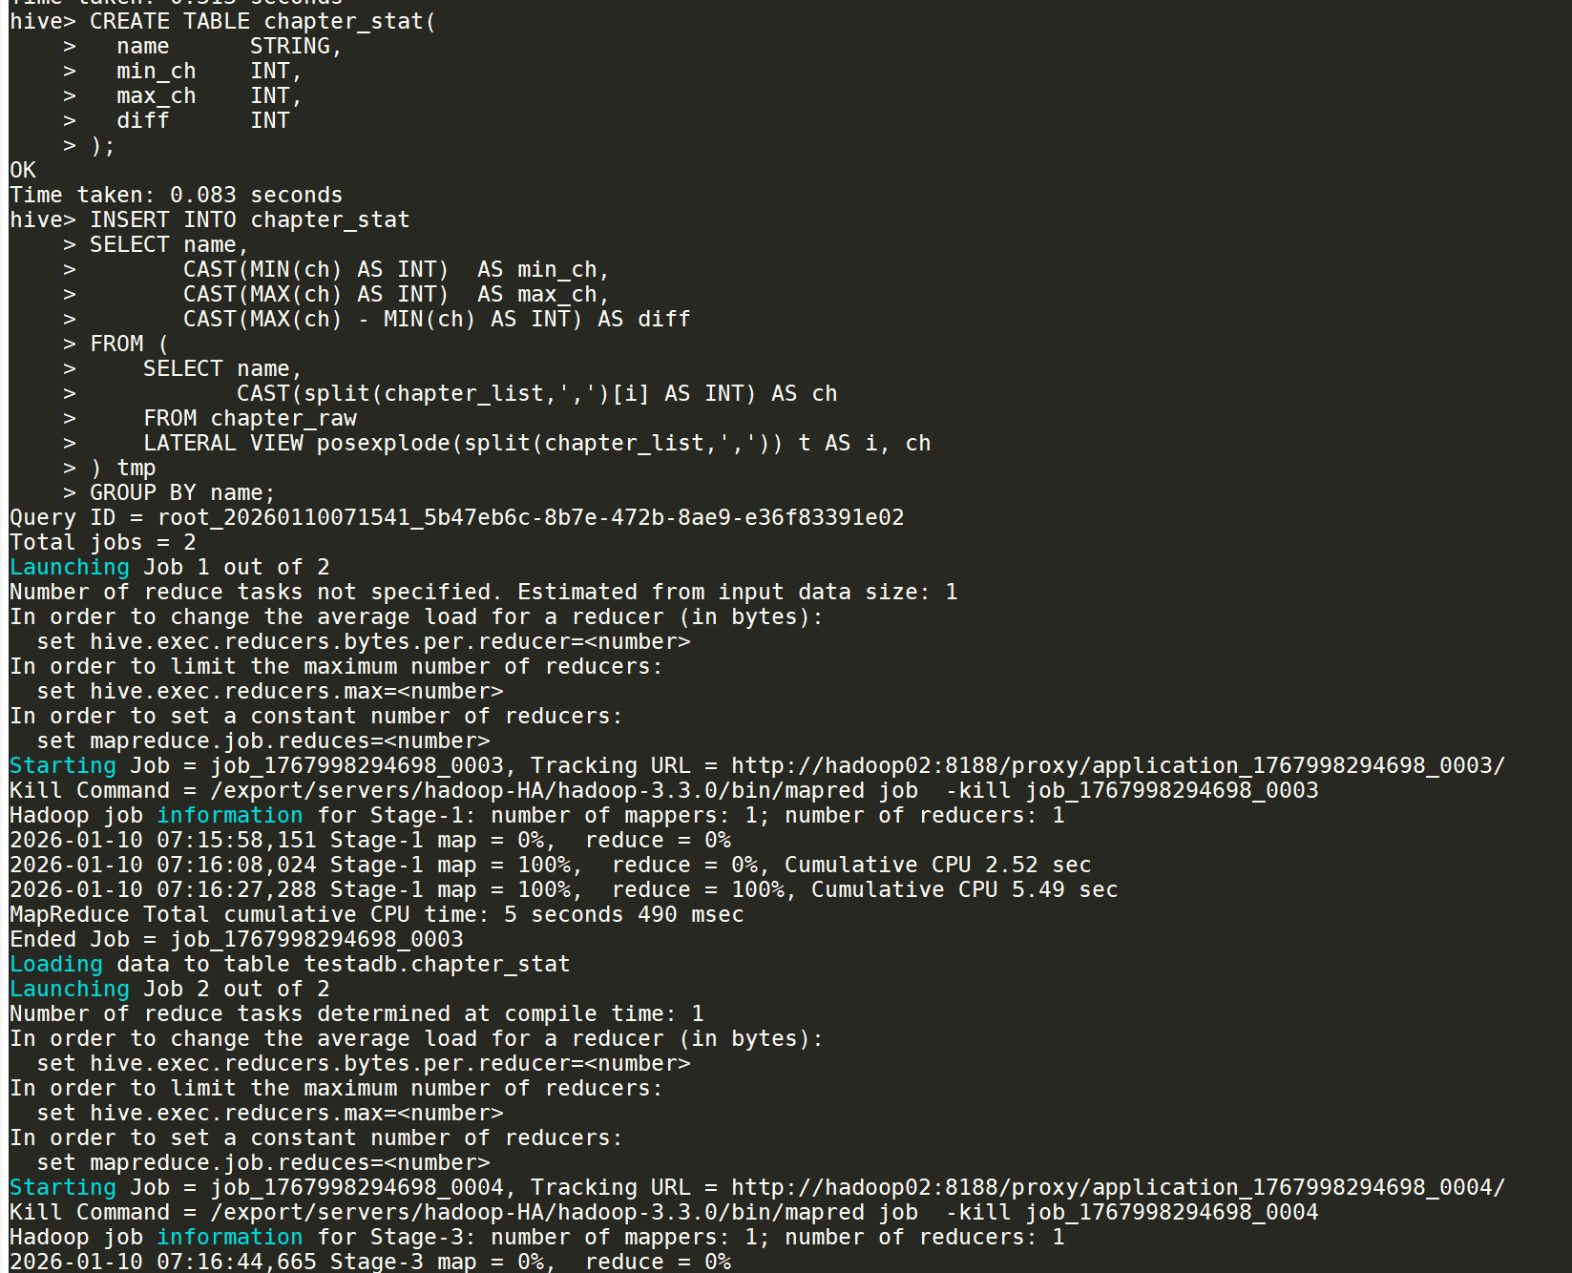
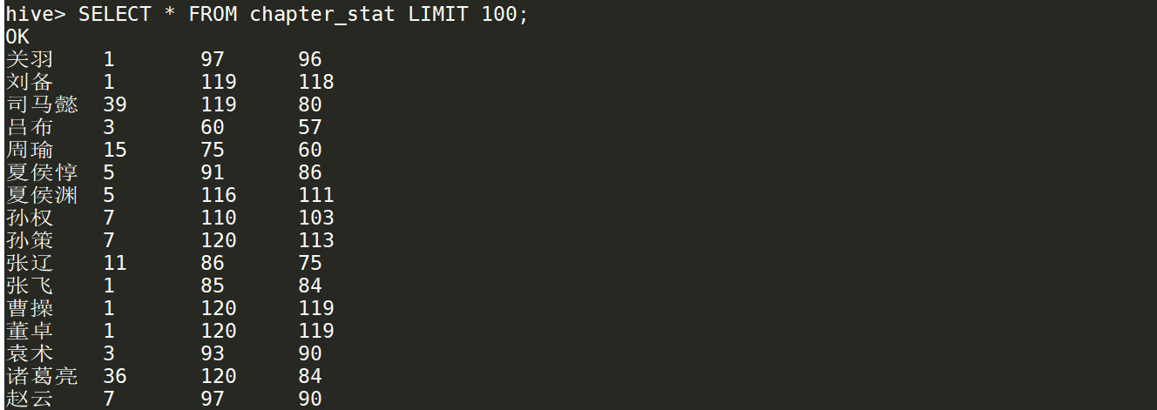

数据可视化
2.4.1 Java数据可视化：
代码：
controller部分，处理3个图表请求

// 获取人物出场数据 - 根据选择的人物
@GetMapping("/character/data")
@ResponseBody
public List<CharacterChapterCount> getCharacterData(@RequestParam(required = false) List<String> names) {
if (names == null || names.isEmpty()) {
// 如果没有指定人物，则返回所有数据
return characterChapterCountService.getAllCharacterChapterCounts();
} else {
// 根据指定人物查询数据
return characterChapterCountService.getAllCharacterChapterCounts()
.stream()
.filter(item -> names.contains(item.getCharacterName()))
.collect(Collectors.toList());
}
}

// 获取人物生命线数据 - 根据选择的人物
@GetMapping("/lifeline/data")
@ResponseBody
public List<CharacterLifeLine> getCharacterLifeLineData(@RequestParam(required = false) List<String> names) {
if (names == null || names.isEmpty()) {
// 如果没有指定人物，则返回所有数据
return characterLifeLineService.getAllCharacterLifeLines();
} else {
// 根据指定人物查询数据
return characterLifeLineService.getCharacterLifeLinesByNames(names);
}
}

// 获取势力出场数据
@GetMapping("/force/data")
@ResponseBody
public List<ForceAppearance> getForceData() {
return forceAppearanceService.getAllForceAppearance();
}

// 处理人物关系图生成请求
@PostMapping("/submit")
@ResponseBody
public Map<String, Object> submit(@RequestParam("selectedButtons") String selectedButtons) {
Map<String, Object> response = new HashMap<>();

try {
// 解析选择的人物
String[] peopleArray = selectedButtons.split(",");
List<String> selectedPeople = Arrays.asList(peopleArray);

// 使用数据库生成关系图
String outputPath = "三國共現網絡.html";
relationGraphService.generateRelationGraph(selectedPeople, outputPath);

response.put("success", true);
response.put("message", "网络图生成成功！");
} catch (Exception e) {
response.put("success", false);
response.put("error", "生成失败: " + e.getMessage());
e.printStackTrace(); // 打印堆栈跟踪以进行调试
}

return response;
}

人物生命线数据访问接口

package com.example.javaweb.mapper;

import com.example.javaweb.entity.CharacterLifeLine;
import org.apache.ibatis.annotations.Mapper;
import org.apache.ibatis.annotations.Param;
import java.util.List;

@Mapper
public interface CharacterLifeLineMapper {
//获取所有人物生命线数据
List<CharacterLifeLine> getAllCharacterLifeLines();

//根据人物名称获取生命线数据
CharacterLifeLine getCharacterLifeLineByName(@Param("name") String name);

//根据多个姓名获取生命线数据
List<CharacterLifeLine> getCharacterLifeLinesByNames(@Param("names") List<String> names);
}
人物出场数据访问接口

package com.example.javaweb.mapper;

import com.example.javaweb.entity.CharacterChapterCount;
import org.apache.ibatis.annotations.Mapper;

import java.util.List;

@Mapper
public interface CharacterChapterCountMapper {
//查询所有人物出场章数数据
List<CharacterChapterCount> findAll();

//查询出场章数最多的前N个人物
List<CharacterChapterCount> findTopN(int n);
}

人物关系数据访问接口
package com.example.javaweb.mapper;

import com.example.javaweb.entity.Edge;
import org.apache.ibatis.annotations.Mapper;
import org.apache.ibatis.annotations.Param;

import java.util.List;

@Mapper
public interface EdgeMapper {
//查询所有边数据
List<Edge> findAll();

//根据源节点和目标节点查询边
List<Edge> findBySrcAndDst(@Param("src") String src, @Param("dst") String dst);

//查询指定人物之间的边
List<Edge> findByNodesIn(@Param("nodes") List<String> nodes);
}

人物生命线服务实现

package com.example.javaweb.Service.impl;

import com.example.javaweb.Service.CharacterLifeLineService;
import com.example.javaweb.entity.CharacterLifeLine;
import com.example.javaweb.mapper.CharacterLifeLineMapper;
import org.springframework.beans.factory.annotation.Autowired;
import org.springframework.stereotype.Service;

import java.util.List;

@Service
public class CharacterLifeLineServiceImpl implements CharacterLifeLineService {

@Autowired
private CharacterLifeLineMapper characterLifeLineMapper;

@Override
public List<CharacterLifeLine> getAllCharacterLifeLines() {
return characterLifeLineMapper.getAllCharacterLifeLines();
}

@Override
public CharacterLifeLine getCharacterLifeLineByName(String name) {
return characterLifeLineMapper.getCharacterLifeLineByName(name);
}

@Override
public List<CharacterLifeLine> getCharacterLifeLinesByNames(List<String> names) {
return characterLifeLineMapper.getCharacterLifeLinesByNames(names);
}
}

截图：
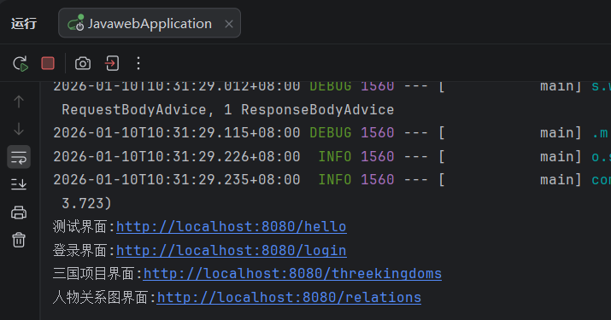
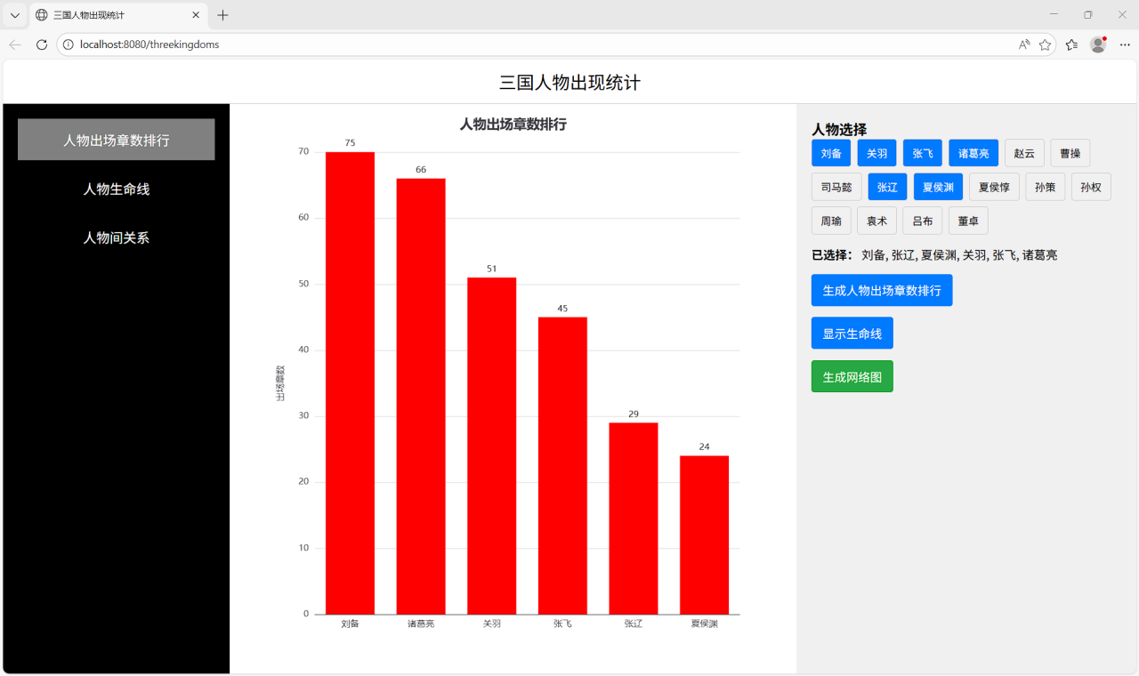
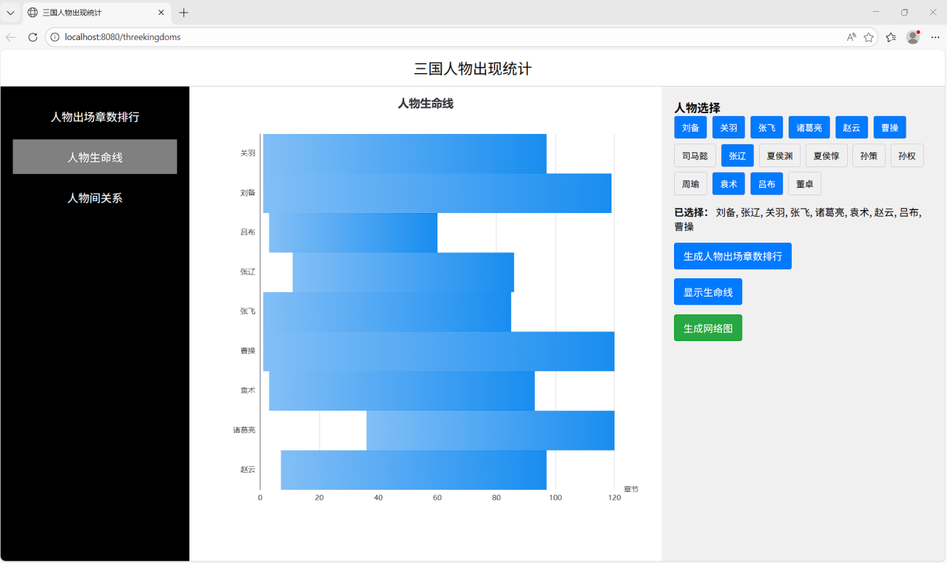
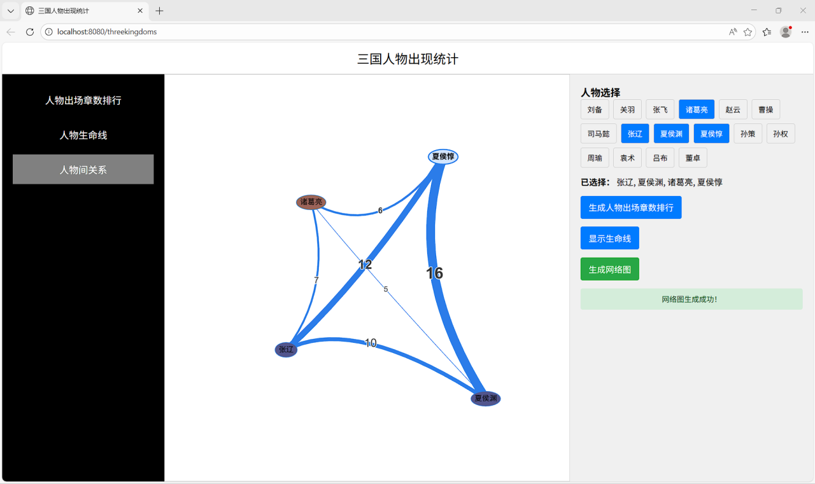
2.4.2 Python数据可视化：
核心代码：

数据连接类：
class Database:
@staticmethod
def get_connection():
try:
conn = pymysql.connect(
host=app.config['MYSQL_HOST'],
port=app.config['MYSQL_PORT'],
user=app.config['MYSQL_USER'],
password=app.config['MYSQL_PASSWORD'],
database=app.config['MYSQL_DATABASE'],
charset='utf8mb4',
cursorclass=pymysql.cursors.DictCursor
)
return conn
except Exception as e:
print(f"数据库连接失败: {e}")
return None

@staticmethod
def execute_query(query, params=None, fetch_one=False):
conn = Database.get_connection()
if not conn:
return None
try:
with conn.cursor() as cursor:
cursor.execute(query, params or ())
if fetch_one:
result = cursor.fetchone()
else:
result = cursor.fetchall()
conn.commit()
return result
except Exception as e:
print(f"查询执行失败: {e}")
return None
finally:
conn.close()

各势力戏份占比API：
@app.route('/api/faction_timeline')
def get_faction_timeline():
try:
faction_map = {
'魏': ['曹操', '司马懿', '夏侯惇', '夏侯渊', '张辽'],
'蜀': ['刘备', '关羽', '张飞', '诸葛亮', '赵云'],
'吴': ['孙权', '周瑜', '孙策'],
'群': ['吕布', '董卓', '袁术']
}
sql = "SELECT name, chapter_count FROM character_chapter_count"
result = Database.execute_query(sql)
if not result:
return jsonify({'error': '没有找到数据'}), 404
faction_totals = {'魏': 0, '蜀': 0, '吴': 0, '群': 0}
for item in result:
name = item['name']
count = item['chapter_count']
faction_found = False
for faction, characters in faction_map.items():
if name in characters:
faction_totals[faction] += count
faction_found = True
break
if not faction_found:
faction_totals['群'] += count
total_chapters = sum(faction_totals.values())
pie_data = []
colors = {'魏': '#1e3a8a', '蜀': '#7c2d12', '吴': '#166534', '群': '#9ca3af'}
for faction, total in faction_totals.items():
if total > 0:
percentage = round((total / total_chapters) * 100, 1)
pie_data.append({
'name': faction,
'value': total,
'percentage': percentage,
'itemStyle': {'color': colors.get(faction, '#9ca3af')}
})
pie_data.sort(key=lambda x: x['value'], reverse=True)
return jsonify({
'success': True,
'data': {'pie_data': pie_data, 'total_chapters': total_chapters}
})
except Exception as e:
print(f"获取势力数据失败: {e}")
return jsonify({'success': False, 'error': str(e)}), 500

人物出场章数排行API：
@app.route('/api/character_ranking', methods=['POST'])
def get_selected_character_ranking():
try:
data = request.get_json()
selected_characters = data.get('characters', [])
if not selected_characters:
sql = "SELECT name, chapter_count FROM character_chapter_count ORDER BY chapter_count DESC LIMIT 5"
result = Database.execute_query(sql)
else:
placeholders = ','.join(['%s'] * len(selected_characters))
sql = f"SELECT name, chapter_count FROM character_chapter_count WHERE name IN ({placeholders}) ORDER BY chapter_count DESC LIMIT 5"
result = Database.execute_query(sql, selected_characters)
if not result:
return jsonify({'error': '没有找到数据'}), 404
names = [item['name'] for item in result]
counts = [item['chapter_count'] for item in result]
return jsonify({
'success': True,
'data': {'names': names, 'counts': counts}
})
except Exception as e:
return jsonify({'success': False, 'error': str(e)}), 500
人物关系数据API：
@app.route('/api/character_relations', methods=['POST'])
def get_character_relations():
try:
data = request.get_json()
selected_characters = data.get('characters', [])
if len(selected_characters) < 2:
return jsonify({'success': False, 'error': '至少选择两个人物'}), 400
placeholders = ','.join(['%s'] * len(selected_characters))
sql = f"SELECT source, target, weight FROM edges WHERE source IN ({placeholders}) AND target IN ({placeholders}) AND source != target ORDER BY weight DESC"
params = selected_characters * 2
result = Database.execute_query(sql, params)
if not result:
return jsonify({'error': '没有找到关系数据'}), 404
nodes = []
links = []
for char in selected_characters:
sql_count = "SELECT chapter_count FROM character_chapter_count WHERE name = %s"
count_result = Database.execute_query(sql_count, (char,), fetch_one=True)
chapter_count = count_result['chapter_count'] if count_result else 10
nodes.append({
'name': char,
'value': chapter_count,
'symbolSize': min(50, 10 + chapter_count / 2)
})
for item in result:
links.append({
'source': item['source'],
'target': item['target'],
'value': item['weight']
})
return jsonify({
'success': True,
'data': {'nodes': nodes, 'links': links}
})
except Exception as e:
return jsonify({'success': False, 'error': str(e)}), 500
加载并渲染饼状图（各势力戏份占比）：
function loadFactionTimeline() {
fetch('/api/faction_timeline')
.then(response => response.json())
.then(data => {
if (data.success) {
renderPieChart(data.data);
} else {
alert('加载数据失败: ' + (data.error || '未知错误'));
}
})
.catch(error => {
console.error('Error:', error);
alert('网络请求失败');
});
}

function renderPieChart(chartData) {
const chartDom = document.getElementById('main-chart');
if (echartsInstance) {
echartsInstance.dispose();
}
echartsInstance = echarts.init(chartDom);
const pieData = chartData.pie_data;
const totalChapters = chartData.total_chapters;
const option = {
title: {
text: '各势力戏份占比饼状图',
left: 'center',
textStyle: {
fontSize: 20,
fontWeight: 'bold',
color: '#2c3e50'
}
},
tooltip: {
trigger: 'item',
formatter: function(params) {
return `<div style="font-weight:bold;margin-bottom:5px;">${params.name}</div>
<div>出场章数: ${params.data.value}章</div>
<div>占比: ${params.data.percentage}%</div>`;
},
backgroundColor: 'rgba(255, 255, 255, 0.95)',
borderColor: '#ddd',
borderWidth: 1,
textStyle: {
color: '#333'
}
},
legend: {
orient: 'vertical',
left: '5%',
top: 'middle',
textStyle: {
fontSize: 14
},
formatter: function(name) {
const data = pieData.find(item => item.name === name);
return data ? `${name}: ${data.value}章 (${data.percentage}%)` : name;
},
selectedMode: false
},
series: [
{
name: '势力戏份占比',
type: 'pie',
radius: ['40%', '70%'],
center: ['55%', '50%'],
data: pieData,
selectedMode: false,
hoverAnimation: true,
emphasis: {
scale: true,
scaleSize: 10,
itemStyle: {
shadowBlur: 10,
shadowOffsetX: 0,
shadowColor: 'rgba(0, 0, 0, 0.5)'
},
label: {
show: true,
fontSize: 16,
fontWeight: 'bold'
}
},
label: {
show: true,
formatter: '{b}: {d}%',
fontSize: 14
},
labelLine: {
show: true,
length: 20,
length2: 30,
smooth: true
},
itemStyle: {
borderRadius: 8,
borderColor: '#fff',
borderWidth: 2
},
silent: false,
states: {
hover: {
scale: true,
scaleSize: 10
},
emphasis: {
scale: true,
scaleSize: 10
}
}
}
],
legendSelect: false,
event: {
legendSelectChanged: null
}
};
echartsInstance.setOption(option);
echartsInstance.on('legendselectchanged', function(params) {
return false;
});
echartsInstance.setOption({
legend: {
selectedMode: false
}
});
window.addEventListener('resize', function() {
echartsInstance.resize();
});
}
加载并渲染柱状图（人物出场章数排行）：
function loadCharacterRanking(characters = []) {
fetch('/api/character_ranking', {
method: 'POST',
headers: {
'Content-Type': 'application/json',
},
body: JSON.stringify({ characters: characters })
})
.then(response => response.json())
.then(data => {
if (data.success) {
renderBarChart(data.data);
} else {
alert('加载数据失败: ' + (data.error || '未知错误'));
}
})
.catch(error => {
console.error('Error:', error);
alert('网络请求失败');
});
}

function renderBarChart(chartData) {
const chartDom = document.getElementById('main-chart');
if (echartsInstance) {
echartsInstance.dispose();
}
echartsInstance = echarts.init(chartDom);
const option = {
title: {
text: '人物出场章数排行（前5名）',
left: 'center',
textStyle: {
fontSize: 20,
fontWeight: 'bold',
color: '#2c3e50'
}
},
tooltip: {
trigger: 'axis',
axisPointer: {
type: 'shadow'
},
formatter: '{b}: {c} 章'
},
grid: {
left: '10%',
right: '10%',
bottom: '10%',
top: '15%',
containLabel: true
},
xAxis: {
type: 'category',
data: chartData.names,
axisLabel: {
fontSize: 14,
rotate: 0
}
},
yAxis: {
type: 'value',
name: '出场章数',
nameLocation: 'end',
nameTextStyle: {
fontSize: 14,
padding: [0, 0, 0, 5]
},
min: 0,
axisLabel: {
fontSize: 14
}
},
series: [
{
name: '出场章数',
type: 'bar',
data: chartData.counts,
barWidth: '60%',
itemStyle: {
color: function(params) {
return getFactionColor(chartData.names[params.dataIndex]);
}
},
label: {
show: true,
position: 'top',
formatter: '{c}章',
fontSize: 14,
fontWeight: 'bold'
}
}
]
};
echartsInstance.setOption(option);
window.addEventListener('resize', function() {
echartsInstance.resize();
});
}
加载并渲染关系图（人物关系网络）：
function loadCharacterRelations(characters) {
fetch('/api/character_relations', {
method: 'POST',
headers: {
'Content-Type': 'application/json',
},
body: JSON.stringify({ characters: characters })
})
.then(response => response.json())
.then(data => {
if (data.success) {
renderRelationChart(data.data);
} else {
alert('加载关系数据失败: ' + (data.error || '未知错误'));
}
})
.catch(error => {
console.error('Error:', error);
alert('网络请求失败');
});
}

function renderRelationChart(chartData) {
const chartDom = document.getElementById('main-chart');
if (echartsInstance) {
echartsInstance.dispose();
}
echartsInstance = echarts.init(chartDom);
const chartContainer = chartDom.parentElement;
const chartWidth = chartContainer.clientWidth;
const chartHeight = chartContainer.clientHeight;
const boundary = {
minX: -chartWidth / 2 + 50,
maxX: chartWidth / 2 - 50,
minY: -chartHeight / 2 + 50,
maxY: chartHeight / 2 - 50
};
const nodeValues = chartData.nodes.map(node => node.value || 10);
const maxNodeValue = Math.max(...nodeValues);
const minNodeValue = Math.min(...nodeValues);
const nodeValueRange = maxNodeValue - minNodeValue || 1;
const linkValues = chartData.links.map(link => link.value || 1);
const maxLinkValue = 85;
const minLinkValue = Math.min(...linkValues);
const linkValueRange = maxLinkValue - minLinkValue || 1;
const nodes = chartData.nodes.map((node, index) => {
const angle = (index / chartData.nodes.length) * 2 * Math.PI;
const radius = Math.min(chartWidth, chartHeight) / 4;
let x = Math.cos(angle) * radius;
let y = Math.sin(angle) * radius;
x = Math.max(boundary.minX, Math.min(boundary.maxX, x));
y = Math.max(boundary.minY, Math.min(boundary.maxY, y));
const chapterCount = node.value || 10;
const logValue = Math.log10(chapterCount + 1);
const maxLogValue = Math.log10(maxNodeValue + 1);
const normalizedValue = logValue / maxLogValue;
const symbolSize = 20 + normalizedValue * 20;
return {
name: node.name,
value: chapterCount,
symbolSize: symbolSize,
x: x,
y: y,
draggable: true,
itemStyle: {
color: getFactionColor(node.name),
borderColor: '#fff',
borderWidth: 2,
shadowBlur: 10,
shadowColor: 'rgba(0, 0, 0, 0.3)'
},
label: {
show: true,
position: 'right',
fontSize: 14,
fontWeight: 'bold',
color: '#333'
},
category: 0
};
});
const links = chartData.links.map(link => {
const weight = link.value || 1;
const normalizedWeight = (weight - minLinkValue) / linkValueRange;
const thicknessFactor = Math.pow(normalizedWeight, 0.5);
const lineWidth = 3 + thicknessFactor * 17;
return {
source: link.source,
target: link.target,
value: weight,
lineStyle: {
width: lineWidth,
color: '#444',
opacity: 0.7,
curveness: 0.1
}
};
});
const option = {
title: {
text: '人物关系网络图',
left: 'center',
textStyle: {
fontSize: 20,
fontWeight: 'bold',
color: '#2c3e50'
},
},
tooltip: {
trigger: 'item',
formatter: function(params) {
if (params.dataType === 'node') {
return `<div style="font-weight:bold;margin-bottom:5px;">${params.data.name}</div>
<div>出场章数: ${params.data.value}章</div>`;
} else if (params.dataType === 'edge') {
return `<div style="font-weight:bold;margin-bottom:5px;">${params.data.source} ↔ ${params.data.target}</div>
<div>共现次数: ${params.data.value}次</div>`;
}
},
backgroundColor: 'rgba(255, 255, 255, 0.9)',
borderColor: '#ddd',
borderWidth: 1,
textStyle: {
color: '#333'
}
},
legend: {
show: false
},
series: [
{
type: 'graph',
layout: 'none',
data: nodes,
links: links,
roam: 'scale',
focusNodeAdjacency: false,
label: {
show: true,
position: 'right',
formatter: '{b}',
fontSize: 14,
fontWeight: 'bold'
},
edgeSymbol: ['none', 'none'],
edgeSymbolSize: 0,
edgeLabel: {
show: false,
},
lineStyle: {
color: function(edge) {
return edge.data.lineStyle.color;
},
width: function(edge) {
return edge.data.lineStyle.width;
},
opacity: function(edge) {
return edge.data.lineStyle.opacity;
},
curveness: function(edge) {
return edge.data.lineStyle.curveness || 0;
}
},
emphasis: {
scale: false,
focus: 'none',
label: {
show: true,
fontSize: 16,
fontWeight: 'bold'
},
lineStyle: {
width: function(edge) {
return edge.data.lineStyle.width + 2;
},
opacity: 1
}
},
draggable: true,
categories: [{
name: '三国人物',
itemStyle: {
color: '#3498db'
}
}],
force: {
initLayout: 'none',
repulsion: 0,
gravity: 0,
edgeLength: 0
},
itemStyle: {
borderColor: '#fff',
borderWidth: 2
}
}
],
animation: true,
animationDuration: 2000,
animationEasing: 'quinticInOut'
};
echartsInstance.setOption(option);
let isDragging = false;
let draggedNodeIndex = -1;
echartsInstance.getZr().on('mousedown', function(event) {
if (event.event.button !== 0) return;
const pointInPixel = [event.offsetX, event.offsetY];
const pointInGrid = echartsInstance.convertFromPixel({ seriesIndex: 0 }, pointInPixel);
if (!pointInGrid) return;
for (let i = 0; i < nodes.length; i++) {
const node = nodes[i];
const distance = Math.sqrt(
Math.pow(pointInGrid[0] - node.x, 2) +
Math.pow(pointInGrid[1] - node.y, 2)
);
if (distance < node.symbolSize / 2) {
isDragging = true;
draggedNodeIndex = i;
event.stop();
event.cancelBubble = true;
break;
}
}
});
echartsInstance.getZr().on('mousemove', function(event) {
if (!isDragging || draggedNodeIndex === -1) return;
const pointInPixel = [event.offsetX, event.offsetY];
const pointInGrid = echartsInstance.convertFromPixel({ seriesIndex: 0 }, pointInPixel);
if (!pointInGrid) return;
let newX = pointInGrid[0];
let newY = pointInGrid[1];
newX = Math.max(boundary.minX, Math.min(boundary.maxX, newX));
newY = Math.max(boundary.minY, Math.min(boundary.maxY, newY));
nodes[draggedNodeIndex].x = newX;
nodes[draggedNodeIndex].y = newY;
echartsInstance.setOption({
series: [{
data: nodes
}]
});
event.stop();
event.cancelBubble = true;
});
echartsInstance.getZr().on('mouseup', function(event) {
if (isDragging && draggedNodeIndex !== -1) {
console.log('结束拖动节点:', nodes[draggedNodeIndex].name);
}
isDragging = false;
draggedNodeIndex = -1;
});
chartDom.addEventListener('wheel', function(event) {
if (isDragging) {
event.preventDefault();
event.stopPropagation();
}
}, { passive: false });
window.addEventListener('resize', function() {
echartsInstance.resize();
});
}
势力颜色辅助函数：
function getFactionColor(name) {
const wei = ['曹操', '司马懿', '夏侯惇', '夏侯渊', '张辽'];
const shu = ['刘备', '关羽', '张飞', '诸葛亮', '赵云'];
const wu = ['孙权', '周瑜', '孙策'];
const qun = ['吕布', '董卓', '袁术'];
if (wei.includes(name)) return '#1e3a8a';
if (shu.includes(name)) return '#7c2d12';
if (wu.includes(name)) return '#166534';
return '#9ca3af';
}
截图：
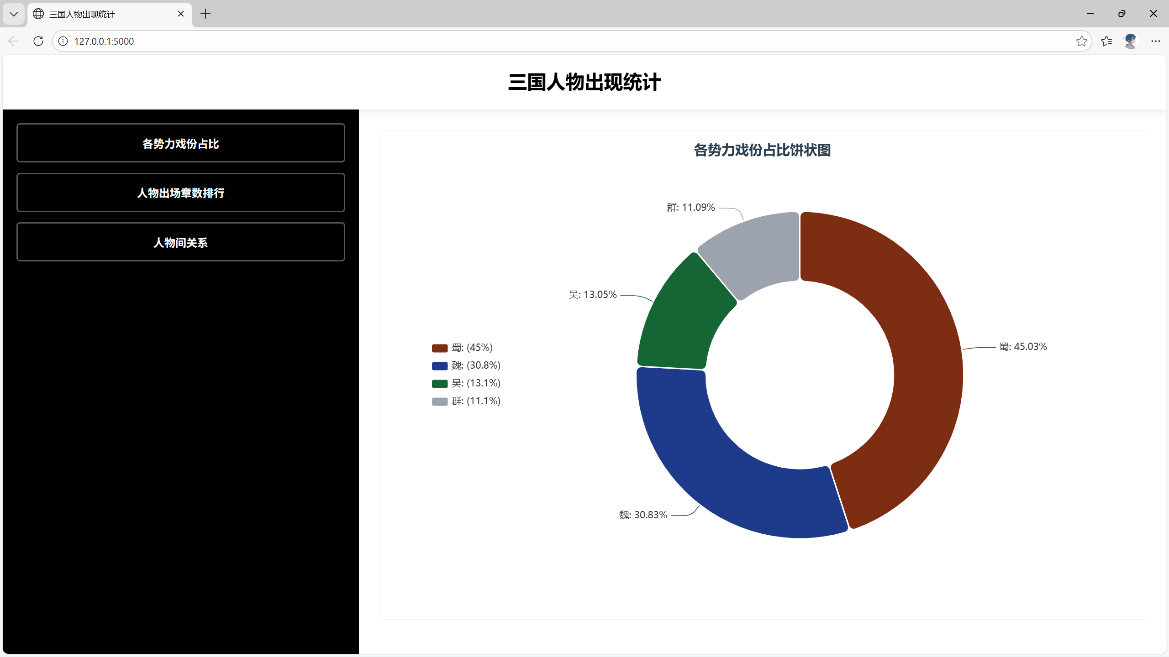
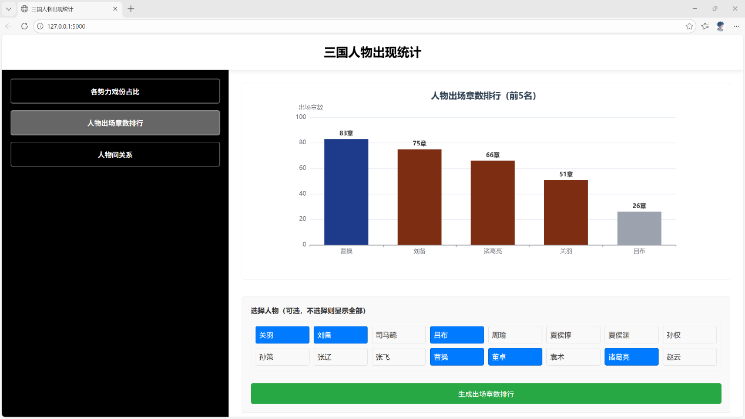
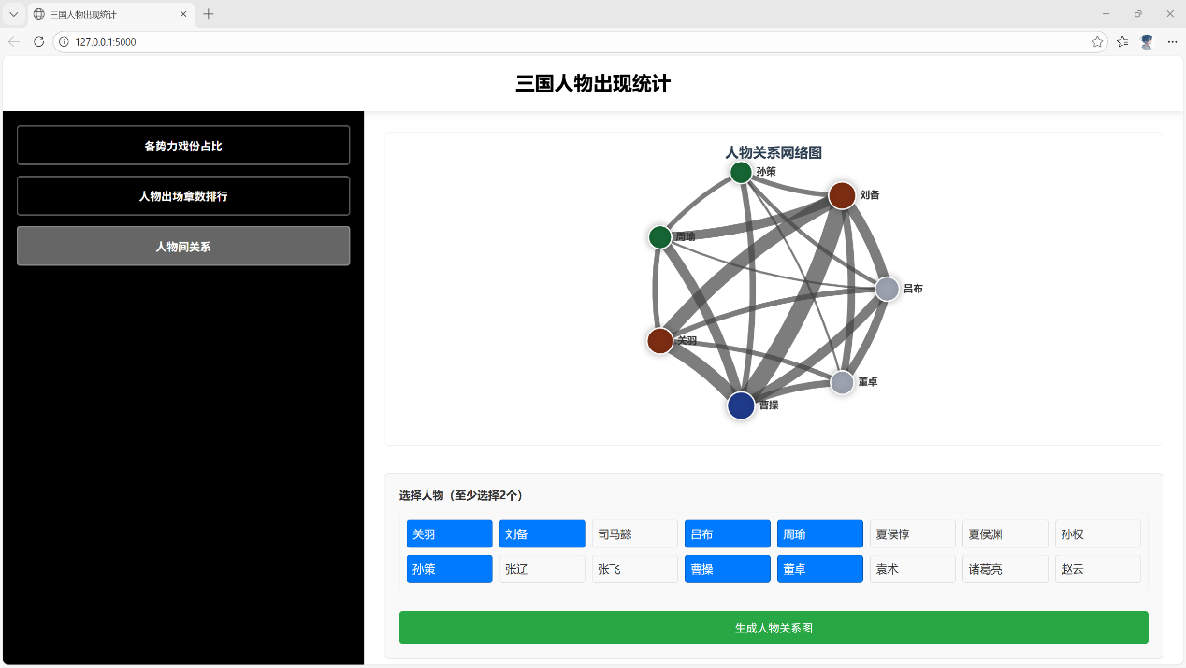

特色与创新
本项目通过 Python 爬虫技术全自动获取《三国演义》全文并按章节拆分，再利用 Hive 数据仓库进行人物出场统计、共现关系分析等复杂计算，最终用 Java 和 Python 双语言实现可视化展示，整个过程覆盖了大数据处理的全链路技术。
我们做了针对数据处理的创新设计。考虑到《三国演义》中人物称谓繁多的特点，比如刘备又称 “玄德”、关羽又称 “云长”，专门构建了人物别名映射库和白名单过滤机制，通过配置文件统一规范人名表述，有效避免了因称谓不统一导致的分析误差。同时，可以通过修改配置文件实现对任意中文文本进行人物数据统计，可以作为通用工具使用。
交互体验的优化是本项目的另一大亮点。我们充分考虑了用户的实际使用需求，在前端设计了直观的按钮选择功能，用户只需勾选感兴趣的人物或势力，系统就能自动向后端传输请求，快速返回对应的数据并生成可视化图表。所有图表都能根据用户选择实时更新，且支持节点拖拽、图表缩放等交互操作。这种设计让分析结果更加直观易懂，实现了技术实用性与用户体验的双重提升。

评分表
学号 | 姓名 | 团队分数 |  |  | 个人分数 | 总分
 |  | 总体设计(30分) | 实训报告(20分) | 特色与创新(10分) | 工作量  (40分)
1632308301011 | 杨天佑
1632308301281 | 杨荣源
1632308301211 | 赵刚
1632308301121 | 吴益晨
评分标准：
（1）总体设计：系统架构合理（5分），技术应用全面（10分），代码编写规范（5分），界面设计美观（10分）。
（2）实训报告：文字表述详细准确（10分），图表制作精良（5分），排版整齐规范（5分）。
（3）特色与创新：扩展部分无雷同现象（5分），有创新性（5分）。
（4）工作量：个人分工（20分），完成度（20分）。

