客户端接口

api基础地址：<http://139.198.11.78:8080/mylawyer>

调试期间， 客户端userId 传 2 ，律师端 lawyerId传 3

每个业务地址：api基础地址+业务地址，例如：首页api地址：

http://139.198.11.78:8080/mylawyer/pub/c/homePage

所有的返回均带有错误代码对象——err。code为0表示正常。如：

|  |
| --- |
| {  "err":{  "code":0,  "msg":"正常",  "eventId":"xxxx-xxxx-xxxx"  },  .....  } |

## 1.1首页

1、地址：/pub/c/homePage

2、请求方式：post

3、请求参数：无

4、返回

|  |  |  |  |
| --- | --- | --- | --- |
|  | **必选** | **类型** | **说明** |
| err | true | Object | 0为成功 其他为失败 |
| adList | true | Ad[] | 顶部法律援助信息 |

Ad返回

|  |  |  |  |  |
| --- | --- | --- | --- | --- |
| **返回值字段** | **必选** | **类型** | **说明** | |
| adId |  | long | 广告id | |
| picURL | true | String | 首页上显示的图片URL |
| innerPicUrl | true | String | 点击后内容的图片的URL |
| content | true | String | 点击后页面内文字 |

例：

|  |
| --- |
| {  "code": 0,  "msg": "正常",  "data": {  "adList": [  {  "adId": 1,  "picURL": "http://127.0.0.1:8080/mylawyer/pic/7",  "innerPicUrl": "http://127.0.0.1:8080/mylawyer/pic/7",  "content": "猎鹰私人律师平台秉持“个人平等享受司法保护”的原则，免费为部分经济困难、急需法律帮助的刑事犯罪嫌疑人、刑事被告人、刑事被害人提供法律援助。\n如有迫切需要法律援助的当事人，可将您的相关情况介绍和材料及您的联系方式，发到平台的免费法律援助专门联系邮箱：falvyuanzhu@mylawyerchina.com。私人律师平台将对相关情况予以评估，如决定免费提供法律援助，将按照您留下的联系方式和您联系。",  "type": 0  },  {  "adId": 31,  "picURL": "http://127.0.0.1:8080/mylawyer/pic/1534",  "innerPicUrl": "http://127.0.0.1:8080/mylawyer/pic/1534",  "content": "专家预约通道：在猎鹰私人律师平台，除专业律师外，还有刑事、民事各领域的法律专家团队，如王牧教授、赵秉志教授、陈兴良教授、阮齐林教授、张凌教授、张明楷教授，提供专家级别的法律服务；如您需要法律专家提供深度专业法律服务，可将您的相关情况介绍、材料、联系方式及需要专家提供法律服务的意向发送到预约邮箱：xiangshushan110@163.com ；也可通过电话010-53651311直接进行预约。",  "type": 0  }  ]  }  } |

## 1.2免费咨询提交

1、地址：/c/freeask

2、请求方式：post, 注意，图片随文字一同上传，需要使用Multipart Body请求

3、请求参数：

|  |  |  |  |
| --- | --- | --- | --- |
| **字段** | **必选** | **类型** | **说明** |
| userId | true | long | 客户ID |
| ~~city~~ | ~~false~~ | ~~String~~ | ~~城市~~ |
| ~~district~~ | ~~false~~ | ~~String~~ | ~~当前经纬度所在区~~ |
| ~~longitude~~ | ~~false~~ | ~~double~~ | ~~经度~~ |
| ~~latitude~~ | ~~false~~ | ~~double~~ | ~~纬度~~ |
| content | true | String | 问题内容 |
| category | false | long | 问题类别 |
| type | True | String | 送1，标识为免费咨询 |
| pic1 | false | Data | 图片1 |
| pic2 | false | Data | 图片2 |
| pic3 | false | Data | 图片3 |

4.返回

|  |  |  |  |
| --- | --- | --- | --- |
|  | **必选** | **类型** | **说明** |
| err | true | Object | 0为成功 其他为失败 |
| ~~freeaskId~~ | ~~true~~ | ~~long~~ | ~~提交成功后，所提问题的Id,前端需要用此Id作为会话详情页请求参数，获知所提问问题是否被抢答。~~ |
| chatId | true | long | 提交成功后，所提问题的Id,前端需要用此Id作为会话详情页请求参数，获知所提问问题是否被抢答。 |

例如：

{

"code": 0,

"msg": "正常",

"data": {

"freeaskId": 1462,

"chatId": 350

}

}

## 1.3打赏咨询提交

1、地址：/c/ makeMoneyAskOrderAndGetPayInfo

2、请求方式：post, 注意，图片随文字一同上传，需要使用Multipart Body请求

3、请求参数：

|  |  |  |  |
| --- | --- | --- | --- |
| **字段** | **必选** | **类型** | **说明** |
| userId | true | long | 客户ID |
| ~~city~~ | ~~false~~ | ~~String~~ | ~~城市~~ |
| ~~district~~ | ~~false~~ | ~~String~~ | ~~当前经纬度所在区~~ |
| ~~longitude~~ | ~~false~~ | ~~double~~ | ~~经度~~ |
| ~~latitude~~ | ~~false~~ | ~~double~~ | ~~纬度~~ |
| content | true | String | 问题内容 |
| category | false | long | 问题类别 |
| money | true | long | 打赏金额 |
| payType | true | int | 支付方式，字典：   |  |  | | --- | --- | | 1 | 支付宝支付 | | 2 | 微信支付 | | 3 | 余额支付 | |
| type | True | String | 送2，标识为打赏咨询 |
| pic1 | false | Data | 图片1 |
| pic2 | false | Data | 图片2 |
| pic3 | false | Data | 图片3 |

4.返回

|  |  |  |  |
| --- | --- | --- | --- |
|  | **必选** | **类型** | **说明** |
| err | true | Object | 0为成功 其他为失败 |
| wx | false | WXPay | 微信支付所需要的信息，选择支付宝支付时，返回null |
| ~~zfb~~ | ~~false~~ | ~~ZFBPay~~ | ~~支付宝支付做需要的信息，选择微信支付时，返回null~~ |
| zfbNew | false | zfbNew | 支付宝支付做需要的信息，选择微信支付时，返回null |
| orderId | true | long | 订单ID，打赏提问，返回支付信息，如果客户端支付成功，用此Id作为请求聊天详情的标识。 |
| ~~freeaskId~~ | ~~true~~ | ~~long~~ | ~~问题Id,备用，（弃用）~~ |

**WXPay**返回

|  |  |  |  |
| --- | --- | --- | --- |
| **返回值字段** | **必选** | **类型** | **说明** |
| appid | true | String | 调用接口提交的公众账号ID |
| partnerId | true | String | 调用接口提交的商户号 |
| prepayId | true | String | 预支付交易会话标识 |
| package | true | String | 返回Sign=WXPay |
| nonceStr | true | String | 随机字符串 |
| timeStamp | true | String | 时间戳 |
| sign | true | String | 签名 |

**zfbNew返回**

|  |  |  |  |
| --- | --- | --- | --- |
| **返回值字段** | **必选** | **类型** | **说明** |
| orderPayInfoString | true | String | 支付宝客户端直接使用该支付字符串 |

例：

|  |
| --- |
| {  "code": 0,  "msg": "正常",  "data": {  "zfbNew": {  "orderPayInfoString": "alipay_sdk=alipay-sdk-java-dynamicVersionNo&app_id=2016080200149429%3B&biz_content=%7B%22body%22%3A%22%E6%89%93%E8%B5%8F%E5%92%A8%E8%AF%A2%22%2C%22out_trade_no%22%3A%2220170801154253817%22%2C%22product_code%22%3A%22QUICK_MSECURITY_PAY%22%2C%22subject%22%3A%22%E6%89%93%E8%B5%8F%E5%92%A8%E8%AF%A2%22%2C%22timeout_express%22%3A%2230m%22%2C%22total_amount%22%3A%224%22%7D&charset=UTF-8&format=json&method=alipay.trade.app.pay&notify_url=http%3A%2F%2F127.0.0.1%3A8080%2Fmylawyer%2Fpub%2FZfbNotify%3B&sign=aJWCcQTLT1PV5yhmQLT57e37yyAUbG%2F9%2F4XwLpzcPEECIjLnN9g2Y1kN1JkN%2BPCqpNAbMKOl8UTmWuylm7iN8SzC6znF8ZtbQ%2FF8%2FIcVXPDDJl9lg%2F9HH9Lgo7v4BhyN3EpvDrg9S1lrHbpo4Bg8iAtSpAzHtJU6qLTmsPDFuVt4ABiZR77JpI58%2BLz3wu2ptMvn9Nx5wm%2FQEkcDKyzq6eEV8x8EE3%2F2nxuG%2FkKQ8GaeJ5wcqzx2O13E0nFs56LuOeWO%2FByIQrFC3ltWKveyICRVbob46Od%2F9jxfTa8AOjhN%2Fqzn3lb4emIXCemrCJtST2kEfVETZt8m94KRvCu1GQ%3D%3D&sign_type=RSA2&timestamp=2017-08-01+15%3A43%3A15&version=1.0"  },  "freeaskId": 1463,  "orderId": 688  }  } |

## 1.4 快速咨询类别

1、地址：/c/freeAskCategory

2、请求方式：post

3、请求参数：无

4、返回

|  |  |  |  |
| --- | --- | --- | --- |
|  | **必选** | **类型** | **说明** |
| err | true | Object | 0为成功 其他为失败 |
| allSpecial | true | Special[] | 快速咨询问题类别 |

Special返回

|  |  |  |  |  |
| --- | --- | --- | --- | --- |
| **返回值字段** | **必选** | **类型** | **说明** | |
| id |  | long | 类别id | |
| name | true | String | 类别名称 |

## 1.5免费咨询价格和用户当前积分

1、地址：/c/my/pointsInfo

2、请求方式：post

3、请求参数：

|  |  |  |  |
| --- | --- | --- | --- |
| **字段** | **必选** | **类型** | **说明** |
| userId | true | long | 客户ID |

4、返回：

|  |  |  |  |
| --- | --- | --- | --- |
|  | **必选** | **类型** | **说明** |
| err | true | Object | 0为成功 其他为失败 |
| askPrice | true | long | 单次积分咨询价格（即积分数） |
| userId | true | long | 用户id |
| points | true | long | 当前用户积分 |

## 1.6图片服务

客户端不直接使用

1.地址：/pic/{picId}

2.请求方式：get/post

3:请求参数：

|  |  |  |  |
| --- | --- | --- | --- |
| **参数** | **必选** | **类型** | **说明** |
| userId | true | long | 登陆人id |
| picId | true | int | 图片id，可以是头像id，也可以是聊天中的图片id |

4.返回

图片文件

## 1.7获取单个会话列表

1.地址：/c/conversation/getList

2.请求方式：get/post

3:请求参数：

|  |  |  |  |
| --- | --- | --- | --- |
| **字段** | **必选** | **类型** | **说明** |
| userId | true | long | 客户ID |
| **chatId** | **true** | **long** | **对话ID，**  **免费咨询提交成功后获取聊天详情；**  **或者通过服务列表页获取聊天详情；** |
| **orderId** | **true** | **long** | **咨询通过购买并支付的方式时，客户端支付成功的话，通过此Id获取聊天详情。** |
| **~~freeaskId~~** | **~~false~~** | **~~long~~** | **~~提问成功后返回的问题Id，没有传0（弃用）~~** |
| conversationId | false | long | ID 从那条开始获取数据 |
| [direction](C:/Users/%E6%82%A6%E6%9D%A8/AppData/Local/youdao/Dict/Application/6.3.67.5025/resultui/frame/javascript:void(0);) | true | int | 数据方向 0向上 1向下 |
| size | true | int | 条数 |

1. 返回

|  |  |  |  |
| --- | --- | --- | --- |
|  | **必选** | **类型** | **说明** |
| err | true | Object | 0为成功 其他为不成功**~~，~~**  **~~特殊说明下：-130错误码，代表没有找到会话信息。客户端从提问进入的详情页获得此代码后需要特殊处理。~~** |
| conversationList |  | Conversation[] | 对话列表 |
| chatId | true | int | 聊天Id |
| **userServiceId** | **true** | **int** | **用户服务标识（评价，送心意传递此参数）** |
| **status** | **true** | **string** | **“0”未接单，“1”进行中，“2”：已完成** |
| evaStatus | true | bool | true已评价，false,未评价 |
| hasMore | true | Boolean | 是否还有更多 |
| **fromType** | **true** | **int** | 订单类型 **~~1图文咨询 2免费提问，3，打赏咨询~~**  **1、私人律师 2 图文咨询 3 电话咨询**  **7、免费咨询、9 打赏咨询** |
| ~~order~~ | ~~false~~ | ~~Order~~ | ~~订单信息~~~~（弃用）~~ |
| ~~freeask~~ | ~~false~~ | ~~Freeask~~ | ~~免费提问（弃用）~~ |

conversation返回

|  |  |  |  |
| --- | --- | --- | --- |
| **返回值字段** | **必选** | **类型** | **说明** |
| conversationId | true | long | 对话Id |
| from | true | int | 发起对话方0用户 1律师 |
| userId | false | long | 用户Id |
| lawyerId | false | long | 律师id |
| name |  | String | 姓名 | |
| headURL |  | String | 头像图片URL |
| content | true | String | 内容，如果是图片 返回图片URL |
| isPicture | true | Boolean | 是否为图片 |
| time | true | String | 对话时间 |

**~~Freeask返回~~**

|  |  |  |  |
| --- | --- | --- | --- |
| **~~返回值字段~~** | **~~必选~~** | **~~类型~~** | **~~说明~~** |
| **~~freeaskId~~** | **~~true~~** | **~~long~~** | **~~免费提问Id~~** |
| **~~content~~** | **~~true~~** | **~~String~~** | **~~免费提问内容~~** |
| **~~status~~** | **~~true~~** | **~~int~~** | **~~状态~~**   |  |  | | --- | --- | | **~~1~~** | **~~进行中~~** | | **~~2~~** | **~~已结束~~** | |

**~~Order返回~~**

|  |  |  |  |
| --- | --- | --- | --- |
| **~~返回值字段~~** | **~~必选~~** | **~~类型~~** | **~~说明~~** |
| **~~orderId~~** | **~~true~~** | **~~long~~** | **~~订单ID~~** |
| **~~status~~** | **~~true~~** | **~~int~~** | **~~订单状态~~**   |  |  | | --- | --- | | **~~1~~** | **~~进行中~~** | | **~~2~~** | **~~已结束~~** | | **~~3~~** | **~~已评论~~** | |

例：

|  |
| --- |
| {  “err”: {  “code”: 0,  “msg”: “正常”,  “eventid”: “xxxx-xxxx-xxxx”  },  “conversationList”: [  {  “conversationId”: 1,  “from”: 0,  “userId”: 1111,  “lawyerId”: 1,  “name”: “张三”,  “headURL”: “http://xxxxxxxxxx/mylawyer-demo/c/pic/301”,  “content”: “您好，有问题想要咨询您”,  “isPicture”: 0,  “time”: “2015-06-29 17:21:11”  },  {  “conversationId”: 1,  “from”: 1,  “userId”: 1111,  “lawyerId”: 1,  “name”: “李四”,  “headURL”: “http://xxxxxxxxxx/mylawyer-demo/c/pic/301”,  “content”: “好的，请说”,  “isPicture”: 0,  “time”: “2015-06-29 17:22:11”  }  ],  “hasMore”: true,  “fromType”: 1~~,~~  ~~“order”: {~~  ~~“orderId”: 1,~~  ~~“status”: 1~~  ~~},~~  ~~“freeask”: {~~  ~~“freeaskId”: 0,~~  ~~“content”: “”,~~  ~~“status”: 0~~  ~~}~~  } |

## 1.8获取免费提问详情

1.地址：/c/freeaskDetail

2.请求方式：get

3:请求参数：

|  |  |  |  |
| --- | --- | --- | --- |
| **字段** | **必选** | **类型** | **说明** |
| freeaskId | true | long | 免费提问Id |
| userId | true | long | 用户ID |

4.返回

|  |  |  |  |
| --- | --- | --- | --- |
|  | **必选** | **类型** | **说明** |
| err | true | Object | 0为成功 其他为不成功 |
| freeask | false | Freeask | 免费提问 |

freeask返回

|  |  |  |  |
| --- | --- | --- | --- |
| **返回值字段** | **必选** | **类型** | **说明** |
| freeaskId | true | long | 问题ID |
| content | true | String | 问题内容 |
| picList | true | array | ［pic1,pic2,pic3］图片URL |
| createTime | true | string | 创建时间 |
| status | true | int | 免费提问状态   |  |  | | --- | --- | | 1 | 未接单 | | 2 | 进行中 | | 3 | 已结束 | |
| name |  | String | 姓名 |
| userId | true | long | 用户id |
| headURL |  | String | 头像图片URL |
| category | true | int | 问题类别 |
| categoryName | true | String | 类别名称 |
| type | true | String | “1”免费咨询，“2”打赏咨询 |
| money | false | Double | type为2打赏咨询时对应的打赏金额 |

例：

|  |
| --- |
| {  "err": {  "code": 0,  "msg": "正常",  "eventid": "xxxx-xxxx-xxxx"  },  "freeask": {  "freeaskId": 1,  "userId": 1,  "content": "我有个问题想问问",  "picList": [  "http://xxxx/freeask/1",  "http://xxxx/freeask/2"  ],  "createTime": "2015-07-02",  "status": 1  }  } |

## 1.9评价律师服务

1.地址：/c/comment

2.请求方式：get/post

3:请求参数：

|  |  |  |  |
| --- | --- | --- | --- |
| **字段** | **必选** | **类型** | **说明** |
| userId | true | long | 客户ID |
| lawyerId | true | long | 律师ID |
| **userServiceId** | **true** | **long** | **评价的服务Id；orderId ,freeaskId弃用** |
| **~~orderId~~** | **~~true~~** | **~~long~~** | **~~订单ID~~** |
| **~~freeaskId~~** | **~~true~~** | **~~long~~** | **~~免费提问ID~~** |
| Score | true | int | 整体评价，很满意 5，满意 3 ，不满意 1 |
| commonTag | false | string | 常用标签，123,343,213,12 |
| customTag | false | string | 标签1, 标签2,( 每个标签长度做20个字以内限制。) |
| comment | false | string | 文字评价 |

1. 返回

|  |  |  |  |
| --- | --- | --- | --- |
|  | **必选** | **类型** | **说明** |
| err | true | Object | 0为成功 其他为失败 |

例：

|  |
| --- |
| {  “err”: {  “code”: 0,  “msg”: “正常”,  “eventid”: “xxxx-xxxx-xxxx”  }  } |

## 1.10常用评价标签列表

1.地址：/c/commonTagList

2.请求方式：get/post

3:请求参数：无

1. 返回

|  |  |  |  |
| --- | --- | --- | --- |
|  | **必选** | **类型** | **说明** |
| err | true | Object | 0为成功 其他为失败 |
| tagList | true | Tag[] | 常用标签列表 |

Tag返回:

|  |  |  |  |
| --- | --- | --- | --- |
| **返回值字段** | **必选** | **类型** | **说明** |
| id | true | long | 问题ID |
| tag | true | String | 标签内容 |

例：

|  |
| --- |
| {  "err": {  "code": 0,  "msg": "正常",  "eventId": ""  },  "tagList": [  {  "id": 1,  "tag": "态度非常好"  },  {  "id": 2,  "tag": "回复很及时"  },  {  "id": 3,  "tag": "回答很专业"  },  {  "id": 4,  "tag": "棒极了"  },  {  "id": 5,  "tag": "意见有帮助"  },  {  "id": 6,  "tag": "非常敬业"  },  {  "id": 7,  "tag": "666"  }  ]  } |

## 1.11送心意

1、地址：/c/ giveMoneyOrderAndGetPayInfo

2、请求方式：post, 注意

3、请求参数：

|  |  |  |  |
| --- | --- | --- | --- |
| **字段** | **必选** | **类型** | **说明** |
| userId | true | long | 客户ID |
| lawyerId | true | long | 律师Id |
| money | true | long | 送心意金额 |
| payType | true | int | 支付方式，字典：   |  |  | | --- | --- | | 1 | 支付宝支付 | | 2 | 微信支付 | | 3 | 余额支付 | |
| type | True | String | 1:普通心意（律师主页赠送）， 2，订单心意 |
| **~~orderId~~** | **~~false~~** | **~~long~~** | **~~如果此次赠送跟某订单有关，即通过咨询上下文赠送，则送相关订单Id~~** |
| **~~freeaskId~~** | **~~false~~** | **~~long~~** | **~~如果此次赠送跟某快速咨询有关，即通过快速咨询上下文赠送，则送相关咨询Id~~** |
| **userServiceId** | **false** | **long** | **如果从服务详情页送的心意，则传userServiceId,** |
| summary | true | String | 送心意的话 |

4.返回

|  |  |  |  |
| --- | --- | --- | --- |
|  | **必选** | **类型** | **说明** |
| err | true | Object | 0为成功 其他为失败 |
| wx | false | WXPay | 微信支付所需要的信息，选择支付宝支付时，返回null |
| zfbNew | false | zfbNew | 支付宝支付做需要的信息，选择微信支付时，返回null |
| orderId | true | long | 送心意订单ID，备用 |

**WXPay**返回

|  |  |  |  |
| --- | --- | --- | --- |
| **返回值字段** | **必选** | **类型** | **说明** |
| appid | true | String | 调用接口提交的公众账号ID |
| partnerId | true | String | 调用接口提交的商户号 |
| prepayId | true | String | 预支付交易会话标识 |
| package | true | String | 返回Sign=WXPay |
| nonceStr | true | String | 随机字符串 |
| timeStamp | true | String | 时间戳 |
| sign | true | String | 签名 |

**zfbNew返回**

|  |  |  |  |
| --- | --- | --- | --- |
| **返回值字段** | **必选** | **类型** | **说明** |
| orderPayInfoString | true | String | 支付宝客户端直接使用该支付字符串 |

例：

|  |
| --- |
| {  “err”: {  “code”: 0,  “msg”: “正常”,  “eventid”: “xxxx-xxxx-xxxx”  },  “wx”: {  “appid”: “xx”,  “partnerId”: “xx”,  “prepayId”: “xx”,  “package”: “xx”,  “nonceStr”: “xx”,  “ricelist”: “xx”,  “sign”: “xx”  },  "zfbNew": {  "orderPayInfoString": "alipay_sdk=alipay-sdk-java-dynamicVersionNo&app_id=2016080200149429%3B&biz_content=%7B%22body%22%3A%22%E6%89%93%E8%B5%8F%E5%92%A8%E8%AF%A2%22%2C%22out_trade_no%22%3A%2220170413094557710%22%2C%22product_code%22%3A%22QUICK_MSECURITY_PAY%22%2C%22subject%22%3A%22%E6%89%93%E8%B5%8F%E5%92%A8%E8%AF%A2%22%2C%22timeout_express%22%3A%2230m%22%2C%22total_amount%22%3A%224%22%7D&charset=UTF-8&format=json&method=alipay.trade.app.pay&notify_url=http%3A%2F%2F139.198.11.78%3A8080%2Fmylawyer%2Fpub%2FZfbNotify%3B&sign=nYN3y2tMB4ZL8jsg35xzK%2FGTaK7WeAngh02PFno4ZX3eFhs8n9Ym6d1RQFnPxscYr3RH%2FNY%2BcltZd%2F0FksHvBVW7tSgkO5l35IvJUMOMYRbVJ8LchNW53C3Rqd5R50muOA3A%2BQIx4peko2gdS4gBBz%2B6KJV07czqoQH557fqlpXGJOmScJCm2WEwtHnIkrVdap8%2BeY1OJuu5gHo1B%2BAVtPMSuSDYLgPCu88a7F0%2BOgAO%2B%2B3Jx9vW0iuogrcim70vKiltdrxUKwIsY2Ej3il%2BJBzZgQCenXRlSstHLS50yU0ReEs%2F%2Bg9Thqtiw%2FHweaYnSys%2Bc66VXG0MSBj8iJx8eg%3D%3D&sign_type=RSA2&timestamp=2017-04-13+09%3A45%3A58&version=1.0"  },  “orderId”:123  } |

## 1.12是否已收藏（关注）律师

1.地址：/c/isFavorite

2.请求方式：get/post

3:请求参数：

|  |  |  |  |
| --- | --- | --- | --- |
| **字段** | **必选** | **类型** | **说明** |
| userId | true | long | 客户ID |
| lawyerId | true | long | 律师ID |

4.返回

|  |  |  |  |
| --- | --- | --- | --- |
|  | **必选** | **类型** | **说明** |
| err | true | Object | 0为成功 其他为失败 |
| favorite | true | Boolean | Boolean |

例：

|  |
| --- |
| {  "err": {  "code": 0,  "msg": "正常",  "eventid": "xxxx-xxxx-xxxx"  },  " favorite ": false  } |

## 1.13收藏（关注）律师

1.地址：/c/favoriteLawyer

2.请求方式：get/post

3:请求参数：

|  |  |  |  |
| --- | --- | --- | --- |
| **字段** | **必选** | **类型** | **说明** |
| userId | true | long | 客户ID |
| lawyerId | true | long | 律师ID |
| favorite | true | Boolean | 是否收藏,true/false |

4.返回

|  |  |  |  |
| --- | --- | --- | --- |
|  | **必选** | **类型** | **说明** |
| err | true | Object | 0为成功 其他为失败 |
| favorite | true | Boolean | Boolean |

例：

|  |
| --- |
| {  "err": {  "code": 0,  "msg": "正常",  "eventid": "xxxx-xxxx-xxxx"  },  " favorite ": false  } |

## 1.14 服务列表

**~~1.地址：/c/conversation/chatList~~**

2.请求地址：/c/conversation/userServiceList

2.请求方式：get/post

3:请求参数：

|  |  |  |  |
| --- | --- | --- | --- |
| **字段** | **必选** | **类型** | **说明** |
| userId | true | long | 客户ID |
| page | true | int | 页数 |
| size | true | int | 行数 |
| **type** | **false** | **int** | **对话类型 ~~0-全部 1-图文订单 2-免费提问 3,打赏咨询~~**  **0-全部**  **1-快速咨询(包括免费和打赏)**  **2-图文咨询**  **3电话咨询，**  **4私人律师** |
| status | false | string | 默认“0”:全部，“1”：进行中，”2”：已完成 |

1. 返回

|  |  |  |  |
| --- | --- | --- | --- |
|  | **必选** | **类型** | **说明** |
| err | true | Object | 0为成功 其他为不成功 |
| **~~chatList~~** |  | **~~Chat[]~~** | **~~对话列表~~** |
| **serviceList** |  | **Service[]** | **服务列表** |
| hasMore | true | Boolean | 是否还有下一页 |

Service返回

|  |  |  |  |
| --- | --- | --- | --- |
| **返回值字段** | **必选** | **类型** | **说明** |
| **serviceId** | **true** | **long** | **服务唯一标识Id,** |
| **type** | **true** | **int** | **对话类型~~1-图文订单 2-免费提问 3 打赏咨询~~**  **1快速咨询 2 图文咨询 3电话咨询**  **4 私人律师** |
| **targetId** | **true** | **long** | **对话ID，或者是电话咨询Id** |
| **lawyer** | **true** | **Lawyer** | **律师信息** |
| **user** | **true** | **User** | **用户信息** |
| **status** | **true** | **String** | **服务的具体状态，**  **当前服务：咨询的状态**  **已完成服务：对应的评价内容** |
| **serviceContent** | **false** | **String** | **服务内容** |
| **lastServiceTime** | **false** | **String** | **最后服务的时间** |
| **serviceAmount** | **true** | **double** | **服务价格。** |

lawyer返回

|  |  |  |  |
| --- | --- | --- | --- |
| **返回值字段** | **必选** | **类型** | **说明** |
| name |  | String | 姓名 |
| lawyerId | true | long | 律师id |
| headURL |  | String | 头像图片URL |

**user**返回

|  |  |  |  |
| --- | --- | --- | --- |
| **返回值字段** | **必选** | **类型** | **说明** |
| name |  | String | 姓名 |
| userId | true | long | 用户id |
| headURL |  | String | 头像图片URL |

例：暂无

## 1.15 发送对话

1.地址：/c/conversation/send

2.请求方式：get/post

3:请求参数：

|  |  |  |  |
| --- | --- | --- | --- |
| **字段** | **必选** | **类型** | **说明** |
| userId | true | long | 客户ID |
| chatId | true | long | 对话ID |
| content | false | String | 内容 |
| picture | false | data | 图片 |

1. 返回

|  |  |  |  |
| --- | --- | --- | --- |
|  | **必选** | **类型** | **说明** |
| err | true | Object | 0为成功 其他为不成功  -131，对话已结束 |
| conversation | true | Conversation | 这行对话的信息 |

Conversation返回

|  |  |  |  |  |  |
| --- | --- | --- | --- | --- | --- |
| **返回值字段** | **必选** | **类型** | **说明** | | |
| conversationId |  | long | 对话内容ID | | |
| from | true | int | 发起对话方0用户 1律师 |
| userId | false | long | 用户Id |
| lawyerId | false | long | 律师id |
| name | true | String | 姓名 | |
| headURL | false | String | 头像图片URL |
| content | true | String | 内容，如果是图片 返回图片URL |
| isPicture | true | Boolean | 是否为图片 |
| time | true | String | 对话时间 |

例：

|  |
| --- |
| {  “code”: 0,  “msg”: “正常”,  “eventid”: “xxxx-xxxx-xxxx”,  “data”: {  “conversation”: {  “conversationId”: 1,  “from”: 0,  “userId”: 1111,  “name”: “张三”,  “headURL”: “http://www.microdreams.net:88/mylawyer/c/pic/100”,  “contentcontent”: “您好，有问题想要咨询您”,  “isPicture”: false,  “time”: “2015-06-29 17:21:11”  }  },  } |

## 1.16 用户余额

1.地址：/c/my/balanceInfo

2.请求方式：get/post

3:请求参数：

|  |  |  |  |
| --- | --- | --- | --- |
| **字段** | **必选** | **类型** | **说明** |
| userId | true | long | 客户ID |

1. 返回

|  |  |  |  |
| --- | --- | --- | --- |
|  | **必选** | **类型** | **说明** |
| err | true | Object | 0为成功 其他为失败 |
| balance | true | double | 当前余额 |
| **~~priceList~~** |  | **~~Price[]~~** | **~~价格列表~~** |

Price返回

|  |  |  |  |
| --- | --- | --- | --- |
| **~~返回值字段~~** | **~~必选~~** | **~~类型~~** | **~~说明~~** |
| **~~priceId~~** |  | **~~long~~** | **~~价格的id~~** |
| **~~cycle~~** |  | **~~String~~** | **~~周期单位~~** |
| **~~price~~** |  | **~~double~~** | **~~价格~~** |
| **~~isOpen~~** |  | **~~Boolean~~** | **~~是否开通~~** |

例：

|  |
| --- |
| {  “code”: 0,  “msg”: “正常”,  “eventid”: “xxxx-xxxx-xxxx” ,  “data”: {  “balance”: 500,  “pricelist”: [  {  “priceId”: 1,  “isOpen”: true,  “cycle”: “”,  “price”: 100  },  {  “priceId”: 1,  “isOpen”: true,  “cycle”: “”,  “price”: 1000  },  {  “priceId”: 1,  “isOpen”: true,  “cycle”: “”,  “price”: 10000  }  ] }  } |

## 1.17 律师基本信息

1.地址：/c/lawyerbasic

2.请求方式：get/post

3:请求参数：

|  |  |  |  |
| --- | --- | --- | --- |
| **字段** | **必选** | **类型** | **说明** |
| lawyerId | true | long | 律师ID |

4.返回

|  |  |  |  |
| --- | --- | --- | --- |
|  | **必选** | **类型** | **说明** |
| err | true | Object | 0为成功 其他为失败 |
| lawyer | true | Lawyer | 律师 |
| special | true | string[] | 擅长分类 |

## 1.18 律师详情页

1.地址：/c/lawyer

2:请求参数：

|  |  |  |  |
| --- | --- | --- | --- |
| **字段** | **必选** | **类型** | **说明** |
| lawyerId | true | long | 律师ID |
| userId | true | long | 用户Id |

3返回：

|  |  |  |  |
| --- | --- | --- | --- |
|  | **必选** | **类型** | **说明** |
| err | true | Object | 0为成功 其他为失败 |
| lawyer | true | Lawyer | 律师 |
| customerReply | true | Comment[] | 用户默认全部评论 |

Lawyer:

|  |  |  |  |
| --- | --- | --- | --- |
|  | **必选** | **类型** | **说明** |
| name | true | String | 律师名称 |
| lawyerId | true | int | 律师Id |
| headURL | true | String | 律师头像 |
| lawyerOfficeName | true | String | 律所名称 |
| tags | true | String[] | 评价标签 |
| special | true | String[] | 擅长领域 |
| serviceScore | true | double | 服务好评率 |
| serviceCount | true | int | 服务人次 |
| notes | true | string | 律师简介 |
| favorite | true | boolen | 当前用户是否收藏该律师 |
| favoriteNum | true | int | 律师被收藏数 |
| city | true | string | 城市 |
| district | true | string | 所在地区 |
| serviceList | true | Service[] | 三项服务开通状态，和价格列表。具体看示例  "serviceName": "图文咨询",  "serviceType": 2,  "isOn": false,  "notes": "以图文方式按次解答客户的法律咨询问题。",  "imgURL": "http://127.0.0.1:8080/mylawyer/pic/2",  "inService": true, |
| scoreCounts | true | ScroeCount[] | 各评价得分，数量，具体看示例  score: 得分值，查看不同得分评价时作为参数传递。  scoreShowName:展示名称  scount:得分数量 |
| giveMoneyCount | true | int | 送心意数 |

Comment:

|  |  |  |  |
| --- | --- | --- | --- |
|  | **必选** | **类型** | **说明** |
| commentId | true | int | 评论id |
| phoneNo | true | String | 用户号码 |
| content | true | string | 评论抬头 |
| notes | true | string | 评论内容 |
| serviceScore | true | int | 评分 |
| headURL | true | string | 用户头像 |
| commentDate | true | date | 评论时间 |

例如：

{

"code": 0,

"msg": "正常",

"data": {

"lawyer": {

"name": "律师之家",

"lawyerId": 3,

"headURL": "http://127.0.0.1:8080/mylawyer/pic/1539",

"lawyerOfficeName": "不知道",

"tags": [

"回复很及时",

"非常敬业",

"回答很专业",

"态度非常好",

"666"

],

"special": [

"合同纠纷",

"房产纠纷",

"婚姻继承",

"债权债务",

"侵权纠纷"

],

"serviceScore": 63.7,

"serviceCount": 203,

"favorite": true,

"favoriteNum": 1,

"notes": "我该说点啥好",

"sex": 1,

"district": "北京市市辖区",

"city": "北京市",

"serviceList": [

{

"serviceName": "私人律师",

"serviceType": 1,

"isOn": true,

"notes": "服务周期内，专业律师为客户提供个人法律顾问服务，解决法律需求。",

"imgURL": "http://127.0.0.1:8080/mylawyer/pic/1",

"inService": true,

"priceList": [

{

"priceId": 1,

"isOpen": true,

"cycle": "周",

"price": 500

},

{

"priceId": 2,

"isOpen": false,

"cycle": "月",

"price": 0

},

{

"priceId": 3,

"isOpen": false,

"cycle": "年",

"price": 0

}

]

},

{

"serviceName": "图文咨询",

"serviceType": 2,

"isOn": false,

"notes": "以图文方式按次解答客户的法律咨询问题。",

"imgURL": "http://127.0.0.1:8080/mylawyer/pic/2",

"inService": true,

"priceList": [

{

"priceId": 4,

"isOpen": true,

"cycle": "次",

"price": 0

}

]

},

{

"serviceName": "电话咨询",

"serviceType": 3,

"isOn": true,

"notes": "以电话方式按次解答客户的法律咨询问题。",

"imgURL": "http://127.0.0.1:8080/mylawyer/pic/3",

"inService": true,

"priceList": [

{

"priceId": 5,

"isOpen": true,

"cycle": "分钟",

"price": 5

}

]

}

],

"scoreCounts": [

{

"score": 0,

"scoreShowName": "全部",

"scount": 243

},

{

"score": 5,

"scoreShowName": "很满意",

"scount": 207

},

{

"score": 3,

"scoreShowName": "满意",

"scount": 31

},

{

"score": 1,

"scoreShowName": "不满意",

"scount": 5

}

],

"giveMoneyCount": 5

},

"customerReply": [

{

"commentId": 310,

"phoneNo": "1521086***6",

"content": "新的测试",

"notes": "[]",

"serviceScore": 3,

"headURL": "http://127.0.0.1:8080/mylawyer/pic/1540",

"commentDate": "2017-08-01 16:12:49"

},

{

"commentId": 309,

"phoneNo": "1521086***6",

"content": "我们等你的的111",

"notes": "[]",

"serviceScore": 3,

"headURL": "http://127.0.0.1:8080/mylawyer/pic/1540",

"commentDate": "2017-08-01 13:31:44"

}

]

}

}

## 1.19 获取律师的被评价列表

1.地址：/c/getCommentList

2.请求参数：

|  |  |  |  |
| --- | --- | --- | --- |
| **字段** | **必选** | **类型** | **说明** |
| score | false | int | 满意度评分，  0 全部  5 很满意  3 满意  1 不满意 |
| lawyerId | true | int | 律师Id |
| page | true | int | 页码 |
| size | true | int | 每页返回数量 |

3.返回：

|  |  |  |  |
| --- | --- | --- | --- |
|  | **必选** | **类型** | **说明** |
| err | true | Object | 0为成功 其他为失败 |
| hasMore | true | boolen | 是否有更多 |
| customerReply | true | Comment[] | 用户默认全部评论 |

Comment：

|  |  |  |  |
| --- | --- | --- | --- |
|  | **必选** | **类型** | **说明** |
| commentId | true | int | 评论id |
| phoneNo | true | String | 用户号码 |
| content | true | string | 评论抬头 |
| notes | true | string | 评论内容 |
| serviceScore | true | int | 评分 |
| headURL | true | string | 用户头像 |
| commentDate | true | date | 评论时间 |

4.示例：

## 1.20 获取律师的送心意列表

1.地址：/c/getGiveMoneyList

2.请求参数：

|  |  |  |  |
| --- | --- | --- | --- |
| **字段** | **必选** | **类型** | **说明** |
| type | false | int | 满意度评分，  0 全部，默认值  1 普通心意，通过律师详情页赠送；  2 服务心意，通过服务详情页赠送； |
| lawyerId | true | int | 律师Id |
| page | true | int | 页码 |
| size | true | int | 每页返回数量 |

3.返回：

|  |  |  |  |
| --- | --- | --- | --- |
|  | **必选** | **类型** | **说明** |
| err | true | Object | 0为成功 其他为失败 |
| hasMore | true | boolen | 是否有更多 |
| Givemoney | true | Givemoney [] | 用户默认全部心意列表 |

Givemoney：

|  |  |  |  |
| --- | --- | --- | --- |
|  | **必选** | **类型** | **说明** |
| userId | true | int | 用户Id |
| phoneNo | true | String | 用户号码 |
| type | true | int | 1 普通心意，通过律师详情页赠送；  2 服务心意，通过服务详情页赠送； |
| money | true | double | 赠送金额 |
| summary | true | string | 评论内容 |
| giveTime | true | date | 赠送时间 |

4.示例：

## 1.21私人律师服务购买页

1.地址：/c/personalLawyerServiceInfo

2.请求参数：

|  |  |  |  |
| --- | --- | --- | --- |
| **字段** | **必选** | **类型** | **说明** |
| lawyerId | true | int | 律师Id |
| userId | true | int | 用户Id |

3.返回：

|  |  |  |  |
| --- | --- | --- | --- |
|  | **必选** | **类型** | **说明** |
| lawyer | true | Lawyer | 律师基本信息 |
| service | true | Service | 服务基本信息 |

Lawyer:

|  |  |  |  |
| --- | --- | --- | --- |
|  | **必选** | **类型** | **说明** |
| name | true | String | 律师名称 |
| lawyerId | true | String | 律师Id |
| headURL | true | String | 头像路径 |
| special | true | String[] | 擅长领域 |

Service:

|  |  |  |  |
| --- | --- | --- | --- |
|  | **必选** | **类型** | **说明** |
| serviceType | true | int | 服务类型 |
| serviceName | true | String | 服务名称 |
| serviceNo | true | int | 售出数量 |
| pricelist | true | Price | 价格列表  priceId :价格Id,用于购买服务时作为参数传递。  isOpen：价格是否开通，开通的才可购买。  cycle:周期。  price:价格。 |

4 示例：

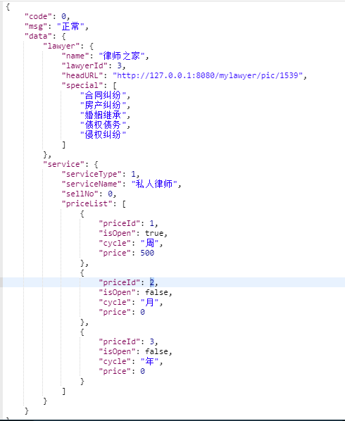

## 1.22图文咨询购买页

1.地址：/c/textChatServiceInfo

2.请求参数：

|  |  |  |  |
| --- | --- | --- | --- |
| **字段** | **必选** | **类型** | **说明** |
| lawyerId | true | int | 律师Id |
| userId | true | int | 用户Id |

3.返回：

|  |  |  |  |
| --- | --- | --- | --- |
|  | **必选** | **类型** | **说明** |
| isOn | true | boolen | 是否开通 |
| serviceName | true | String | 服务名称 |
| serviceType | true | int | 服务类型id |
| serviceNo | true | int | 售出数量 |
| pricelist | true | Price | 价格列表  priceId :价格Id,用于购买服务时作为参数传递。  isOpen：价格是否开通，开通的priceId才可作为参数传递。  cycle:周期。  price:价格。 |
| content | true | string | 图文咨询的描述 |

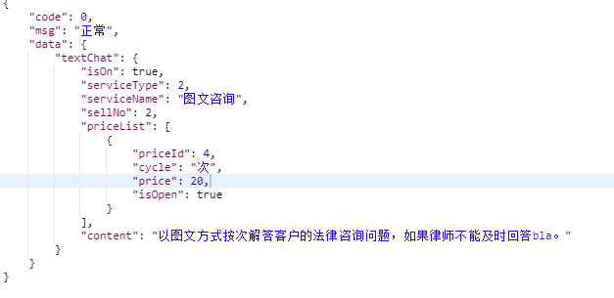

## 1.23订单支付

1.地址：/c/makeOrderAndGetPayInfo

2.请求参数：

|  |  |  |  |
| --- | --- | --- | --- |
| **字段** | **必选** | **类型** | **说明** |
| lawyerId | true | int | 律师Id |
| userId | true | int | 用户Id |
| priceId | true | int | 价格Id，此值从服务购买接口里返回的priceList中获取。 |
| number | true | int | 购买数量 |
| payType | true | int | 支付方式：1 –支付宝 2-微信 3-余额 |

3.返回：

|  |  |  |  |
| --- | --- | --- | --- |
|  | **必选** | **类型** | **说明** |
| err | true | Object | 0为成功 其他为失败，  -20 ：在服务期内 |
| wx | false | WXPay | 微信支付所需要的信息，选择支付宝支付时，返回null |
| zfbNew | false | zfbNew | 支付宝支付做需要的信息，选择微信支付时，返回null |
| orderId | true | long | 订单ID，返回支付信息，如果客户端支付成功，用此Id作为请求聊天详情的标识orderId的值传递。 |

**WXPay**返回

|  |  |  |  |
| --- | --- | --- | --- |
| **返回值字段** | **必选** | **类型** | **说明** |
| appid | true | String | 调用接口提交的公众账号ID |
| partnerId | true | String | 调用接口提交的商户号 |
| prepayId | true | String | 预支付交易会话标识 |
| package | true | String | 返回Sign=WXPay |
| nonceStr | true | String | 随机字符串 |
| timeStamp | true | String | 时间戳 |
| sign | true | String | 签名 |

**zfbNew返回**

|  |  |  |  |
| --- | --- | --- | --- |
| **返回值字段** | **必选** | **类型** | **说明** |
| orderPayInfoString | true | String | 支付宝客户端直接使用该支付字符串 |

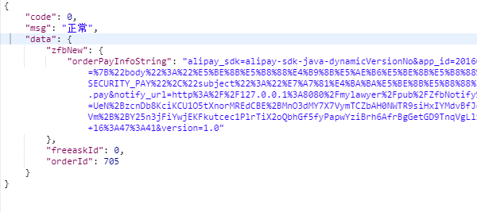

## 1.24 我的律师

1.地址：/c/myLawyerList

2.请求参数

|  |  |  |  |
| --- | --- | --- | --- |
| **字段** | **必选** | **类型** | **说明** |
| userId | true | int | 用户Id |
| page | true | int | 页码 |
| size | true | int | 每页返回数量 |

3.返回

|  |  |  |  |
| --- | --- | --- | --- |
|  | **必选** | **类型** | **说明** |
| hasMore | true | boolen | 是否有更多 |
| lawyerList | true | Lawyer[] | 关注或购买的律师列表 |

Lawyer:

|  |  |  |  |
| --- | --- | --- | --- |
|  | **必选** | **类型** | **说明** |
| lawyerId |  |  |  |
| name | true | string | 律师名称 |
| headURL | true | string | 头像 |
| special | true | string[] | 擅长领域 |
| lawyerOfficeName | true | string | 律师名称 |
| serviceCount | true | int | 服务总次数 |
| serviceScore | true | double | 好评率 |
| serviced | true | boolen | 是否未我服务过，【购买过】。为false即是收藏的。 |

4.示例

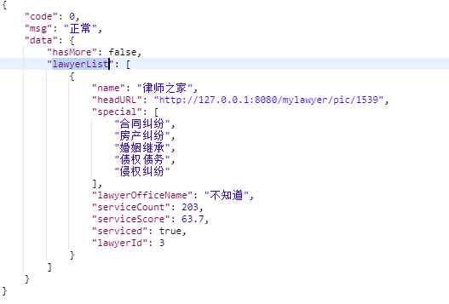

## 1.25 发现列表

1.地址 ：/c/discovery

2.请求参数

|  |  |  |  |
| --- | --- | --- | --- |
| **字段** | **必选** | **类型** | **说明** |
| userId | true | int | 用户Id |
| page | true | int | 页码 |
| size | true | int | 每页返回数量 |
| category | false | int | 问题分类，全部为0或不传 |
| keywords | false | string | 搜索关键字 |

3.返回

|  |  |  |  |
| --- | --- | --- | --- |
|  | **必选** | **类型** | **说明** |
| hasMore | true | boolen | 是否有更多 |
| userDiscoveries | true | UserDiscovery[] | 发现列表 |

UserDiscovery：

|  |  |  |  |
| --- | --- | --- | --- |
|  | **必选** | **类型** | **说明** |
| chatId | true | int | 聊天id |
| userServiceId | true | int | 服务id |
| category | true | int | 分类 |
| categoryName | true | string | 分类名称 |
| content | true | string | 提问内容 |
| lawyerName | true | string | 律师名称 |
| headURL | true | string | 律师头像 |
| supportCount | true | int | 问题点赞数 |
| officeName | true | string | 律师名称 |
| createDate | true | date | 提问时间 |

4.示例

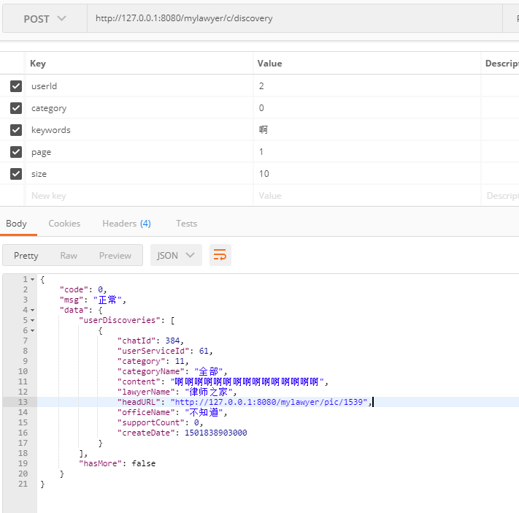

## 1.26 发现内容详情

此页面：用到的接口有：1.17、1.27、1.28

1、地址：/c/ conversation/getDiscoveryDetail

2、请求参数

|  |  |  |  |
| --- | --- | --- | --- |
| **字段** | **必选** | **类型** | **说明** |
| userId | true | int | 用户Id |
| chatId | true | int | 聊天id |
| ~~direction~~ | ~~false~~ | ~~int~~ | ~~数据方向 0向上 1向下~~ |
| size | true | int | 每页返回数量 |
| page | true | int | 页码 |
| ~~conversationId~~ | ~~false~~ | ~~int~~ | ~~起始的对话id~~ |

3、返回

|  |  |  |  |
| --- | --- | --- | --- |
|  | **必选** | **类型** | **说明** |
| chatId | true | int | 聊天id |
| userServiceId | true | int | 服务id |
| lawyerId | true | int | 律师id |
| hasMore | true | boolen | 列表是否有更多内容 |
| conversationList | true | conversation[] | 对话内容列表 |

conversation:

|  |  |  |  |
| --- | --- | --- | --- |
| **返回值字段** | **必选** | **类型** | **说明** |
| conversationId | true | long | 对话Id |
| from | true | int | 发起对话方0用户 1律师 |
| userId | false | long | 用户Id |
| lawyerId | false | long | 律师id |
| name |  | String | 姓名 | |
| headURL |  | String | 头像图片URL |
| content | true | String | 内容，如果是图片 返回图片URL |
| isPicture | true | Boolean | 是否为图片 |
| time | true | String | 对话时间 |

示例：

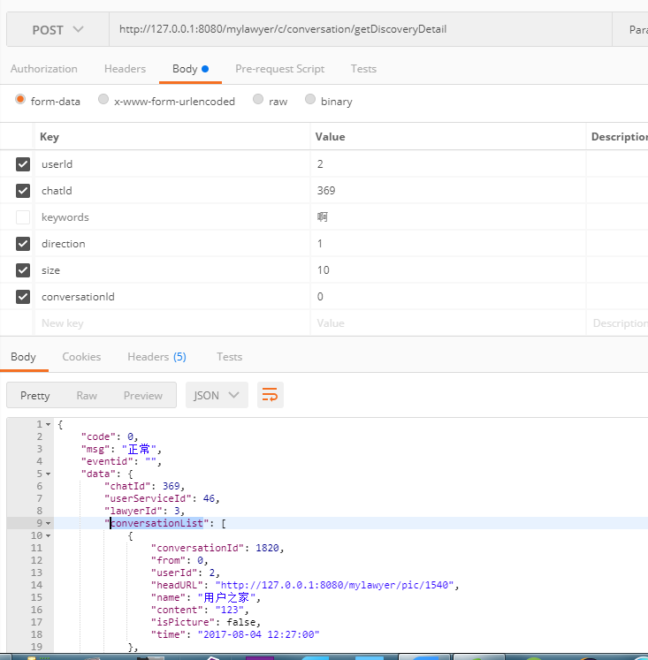

## 1.27 是否点赞某发现

1.地址：/c/isSupportUserService

2.请求参数：

|  |  |  |  |
| --- | --- | --- | --- |
| **字段** | **必选** | **类型** | **说明** |
| userId | true | int | 用户Id |
| userServiceId | true | int | 某发现服务Id |

3、返回

|  |  |  |  |
| --- | --- | --- | --- |
|  | **必选** | **类型** | **说明** |
| supported | true | boolen | 是否点赞，true:已点赞，false,未点赞 |

## 1.28 用户点赞/取消点赞某发现

1、地址：c/supportUserService

2、请求参数：

|  |  |  |  |
| --- | --- | --- | --- |
| **字段** | **必选** | **类型** | **说明** |
| userId | true | int | 用户Id |
| userServiceId | true | int | 某发现服务Id |
| up | true | boolen | true,点赞，false取消点赞 |

3、返回：

|  |  |  |  |
| --- | --- | --- | --- |
|  | **必选** | **类型** | **说明** |
| supported | true | boolen | true:已点赞，false,未点赞 |

## 1.29 找律师查询接口

1.地址：/c/ lawyerList

2.请求参数：

|  |  |  |  |
| --- | --- | --- | --- |
| **字段** | **必选** | **类型** | **说明** |
| userId | true | int | 用户Id |
| city | false | String | 城市 |
| district | false | String | 地区 |
| **office** | **false** | **Integer** | **律所代码，暂时保留，先不启用。**  **首页通过点击推荐律所时传递律所名称到searchKey参数** |
| special | false | Integer | 律师专长代码，此参数值可从找律师首页点击擅长领域图标获得，也可在搜索页通过专长筛选项获得。 |
| serviceType | false | String | 服务类型：可多选，多值用半角逗号隔开  1：私人律师 2：图文咨询3：电话咨询 |
| yearfrom | false | Integer | 执业年限开始，如果此参数数有值，yearto 也应有值，yearto 如果不填，默认给100。 |
| yearto | false | Integer | 执业年限结束，如果此参数数有值，yearfrom也应有值。 |
| pricefrom | false | Integer | 价格区间开始，如果此参数数有值，priceto也应有值。 |
| priceto | false | Integer | 价格区间结束，如果此参数数有值，pricefrom也应有值。如果不填，默认给100000 |
| searchKey | false | String | 搜索关键字，搜索目标为：律师名称，律所名称，擅长领域。 |
| size | true | Integer | 每页返回数量 |
| page | true | Integer | 页码，从1开始。 |
| sort | false | Integer | 排序：1、综合 2、评价等级由 3、咨询人次  4、执业年限，5 价格由低到高，6，价格由高低 |

3：返回

|  |  |  |  |
| --- | --- | --- | --- |
|  | **必选** | **类型** | **说明** |
| hasMore | true | boolen | 律师列表是否有更多 |
| lawyerList | true | Lawye[] | 律师列表 |

Lawyer:

|  |  |  |  |
| --- | --- | --- | --- |
| **返回值字段** | **必选** | **类型** | **说明** |
| lawyerId | true | int | 律师id |
| name | true | string | 律师名称 |
| headURL | true | String | 头像 |
| special | true | string[] | 律师专长 |
| tags | true | String[] | 评价标签 | |
| lawyerOfficeName | true | String | 律师名称 |
| serviceYears | true | int | 执业年限 |
| serviceCount | true | int | 服务人次 |
| serviceScore | true | double | 服务评分 |
| textPrice | true | double | 图文咨询价格，和电话咨询价格相比较，取小值作为展示价格。 |
| telPrice | true | double | 电话咨询价格 |
| favoriteNum | true | int | 被收藏数，备用。 |
| serviced | true | boolen | 是否为我服务过。 |

示例：

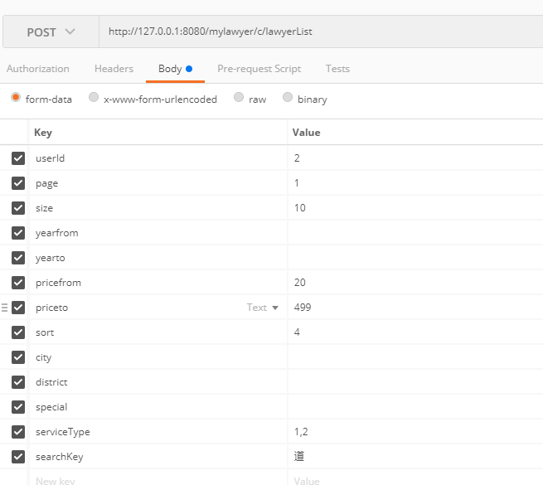

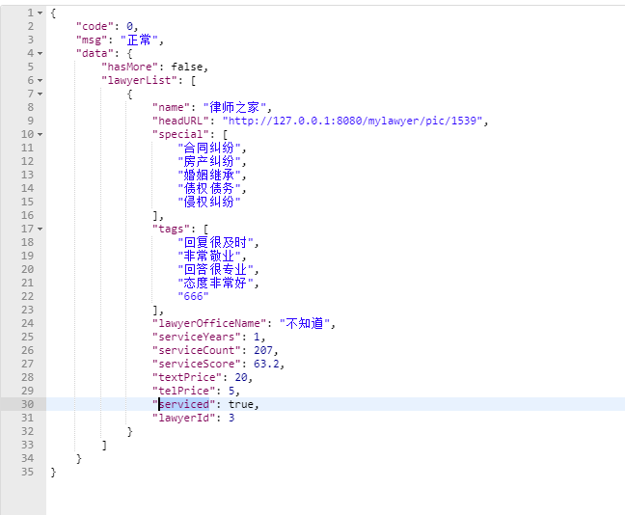

## 1.30 我的积分明细

1、地址：/c/my/ pointsHistory

2、请求参数：

|  |  |  |  |
| --- | --- | --- | --- |
| **字段** | **必选** | **类型** | **说明** |
| userId | true | int | 用户Id |
| page | true | int | 页码 |
| size | true | int | 每页返回数量 |

3、返回：

|  |  |  |  |
| --- | --- | --- | --- |
|  | **必选** | **类型** | **说明** |
| hasMore | true | boolen | 是否有更多明细 |
| pointsHistories | true | history[] | 明细列表  History:  "userId": 用户Id  "tranType":  1-新用户注册，加  2-付费咨询，加  3-评价服务，加  4-送心意， 加  5-分享，加  7-免费问，减  "number": 变动数量  "summary": 变动摘要,  "tranTime": 变动时间 |

4、示例：

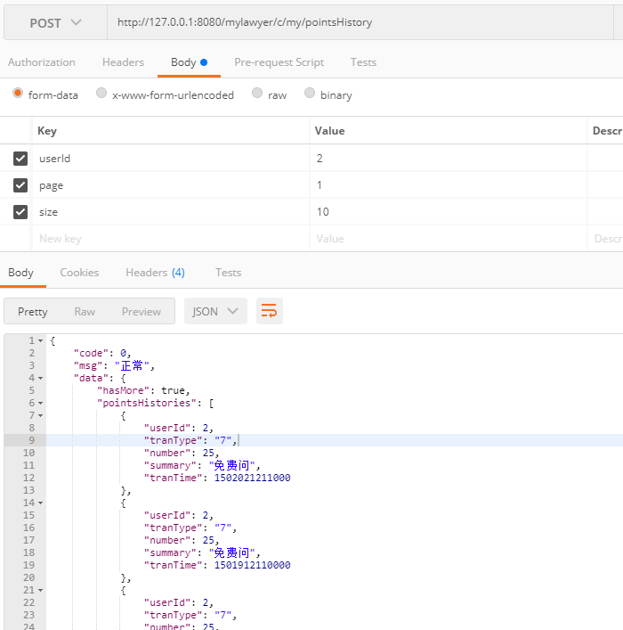

## 1.31 我的钱包账目明细

1、地址：/c/my/ balanceHistory

2、请求参数：

|  |  |  |  |
| --- | --- | --- | --- |
| **字段** | **必选** | **类型** | **说明** |
| userId | true | int | 用户Id |
| page | true | int | 页码 |
| size | true | int | 每页返回数量 |

3、返回：

|  |  |  |  |
| --- | --- | --- | --- |
|  | **必选** | **类型** | **说明** |
| hasMore | true | boolen | 是否有更多明细 |
| balanceHistories | true | history[] | 明细列表  History:  "userId": 用户Id  "tranType":  1 ,充值；  2，购买服务 ；  3，提现 ;  4: 收取服务费  5 ：送心意 ;  6 ： 收心意;  7：退款；  "amount": 变动金额  "summary": 变动摘要,  "tranTime": 变动时间，  “withDrawInfoId": 当type是 提现的时候，此字段值为提现id，点击 可 到 提现进度页面。 |

## 1.32 添加银行卡

1、地址：/c/wallet/bankCardAdd

2、请求参数：

|  |  |  |  |
| --- | --- | --- | --- |
| **字段** | **必选** | **类型** | **说明** |
| userId | true | int | 用户Id |
| cardno | true | string | 银行卡卡号 |
| cardholder | true | string | 持卡人姓名 |
| bankname | true | string | 银行名称 |
| province | true | string | 银行省份 |
| cardtype | true | string | 银行卡种类：储蓄卡，信用卡 |

返回：

|  |  |  |  |
| --- | --- | --- | --- |
|  | **必选** | **类型** | **说明** |
| out | true | out | "code": 0, 添加成功，否则失败  {  "code": 0,  "msg": "正常"  } |

## 1.33 管理银行卡

1、地址：/c/wallet/bankCardList

2、请求参数：

|  |  |  |  |
| --- | --- | --- | --- |
| **字段** | **必选** | **类型** | **说明** |
| userId | true | int | 用户Id |

返回：

|  |  |  |  |
| --- | --- | --- | --- |
|  | **必选** | **类型** | **说明** |
| out | true | out | "code": 0, 添加成功，否则失败  {  "code": 0,  "msg": "正常"  } |
| CardList | true | Card[] | 银行卡列表：  {  "id": 1,  "userId": 2,  "cardno": "***1094",  "cardholder": "张三",  "bankname": "建设银行",  "province": "山东省",  "cardtype": "信用卡"  } |

## 1.34 银行卡删除

1、地址：/c/wallet/delbankCard

2、请求参数：

|  |  |  |  |
| --- | --- | --- | --- |
| **字段** | **必选** | **类型** | **说明** |
| userId | true | int | 用户Id |
| cardId | true | int | 银行卡Id，从银行卡列表选择 |

返回：

## 1.35 提现

1、地址：/c/wallet/applyTX

2、请求参数：

|  |  |  |  |
| --- | --- | --- | --- |
| **字段** | **必选** | **类型** | **说明** |
| userId | true | int | 用户Id |
| cardId | true | int | 银行卡Id，从银行卡列表选择 |
| money | true | double | 提取金额 |

3、返回：

|  |  |  |  |
| --- | --- | --- | --- |
|  | **必选** | **类型** | **说明** |
| out | true | out | "code": 0, 添加成功，否则失败  {  "code": 0,  "msg": "正常"  } |
| progressInfo | true | progressInfo | "id": 提现id  **"lawyerId": 用户Id，**  **"userId": 用户Id，这两个值是一样的。**  "cardNum": "***1094",  "bankName": "建设银行",  "applyName": "张三",  "money": 50, 提现金额  "status": 1, 1- 已申请，处理中； 2：提现成功  "createTime": 创建时间, |

## 1.36 提现验证码