DC Electronic Load

Daniel Yong

Hussain Alhijab

Joseph Fuchs

Yu Heng Lai

**Functional System Requirements**

REVISION – Draft

01 March 2021

Functional System Requirements

for

DC Electronic Load

Prepared by: Group 28

Group 28 03/012021

Author Date

Approved by:

Joey Fuchs 03/01/2021

Project Leader Date

_____________________________

Professor Nowka Date

_____________________________

Onder Dincel Date

**Change Record**

|  |  |  |  |  |
| --- | --- | --- | --- | --- |
| **Rev.** | **Date** | **Originator** | **Approvals** | **Description** |
| **1** | March 1, 2021 | Daniel Yong  Hussain Alhijab  Joseph Fuchs  Yu Heng Lai |  | Draft Release |
| **2** | April 28, 2021 | Daniel Yong  Hussain Alhijab  Joseph Fuchs  Yu Heng Lai |  | Draft Revision |

**Table of Contents**

**Table of Contents III**

**List of Tables IV**

**No table of figures entries found. IV**

**List of Figures V**

**1.** **Introduction** 6

1.1. Purpose and Scope 6

1.2. Responsibility and Change Authority 6

**2.** **Applicable and Reference Documents** 7

2.1. Applicable Documents 7

2.2. Reference Documents 7

2.3. Order of Precedence 7

**3.** **Requirements 4**

3.1. System Definition 8/9

3.2. Characteristics 9

3.2.1. Functional / Performance Requirements 9

3.2.2. Physical Characteristics 9

3.2.3. Electrical Characteristics 10

3.2.4. Environmental Requirements 10

**4.** **Support Requirements 11**

**Appendix A Acronyms and Abbreviations 1****2**

**List of Tables**

**No table of figures entries found**

**List of Figures**

**Figure 1. Project Conceptual Image 1**

**Figure 2. Block Diagram of System 4**

# 

# 

# Introduction

## Purpose and Scope

The DC Electronic Load project aims to test products and devices for better production and ensure that the products are free of power issues. The project will provide the users to test their products with constant current independent of voltage, constant voltage independent of current, and constant power. The project is directed to users who want to test small products that do not require much power because one of the limitations of this project is that it can only provide 25W as a maximum power. On the other hand, the accuracy of the DC load we are working on is relatively high. Another advantage is that the project does not cost as much as a regular DC Electronic Loads that can be found in the market. A picture of how the project will look like after completion can be seen below.

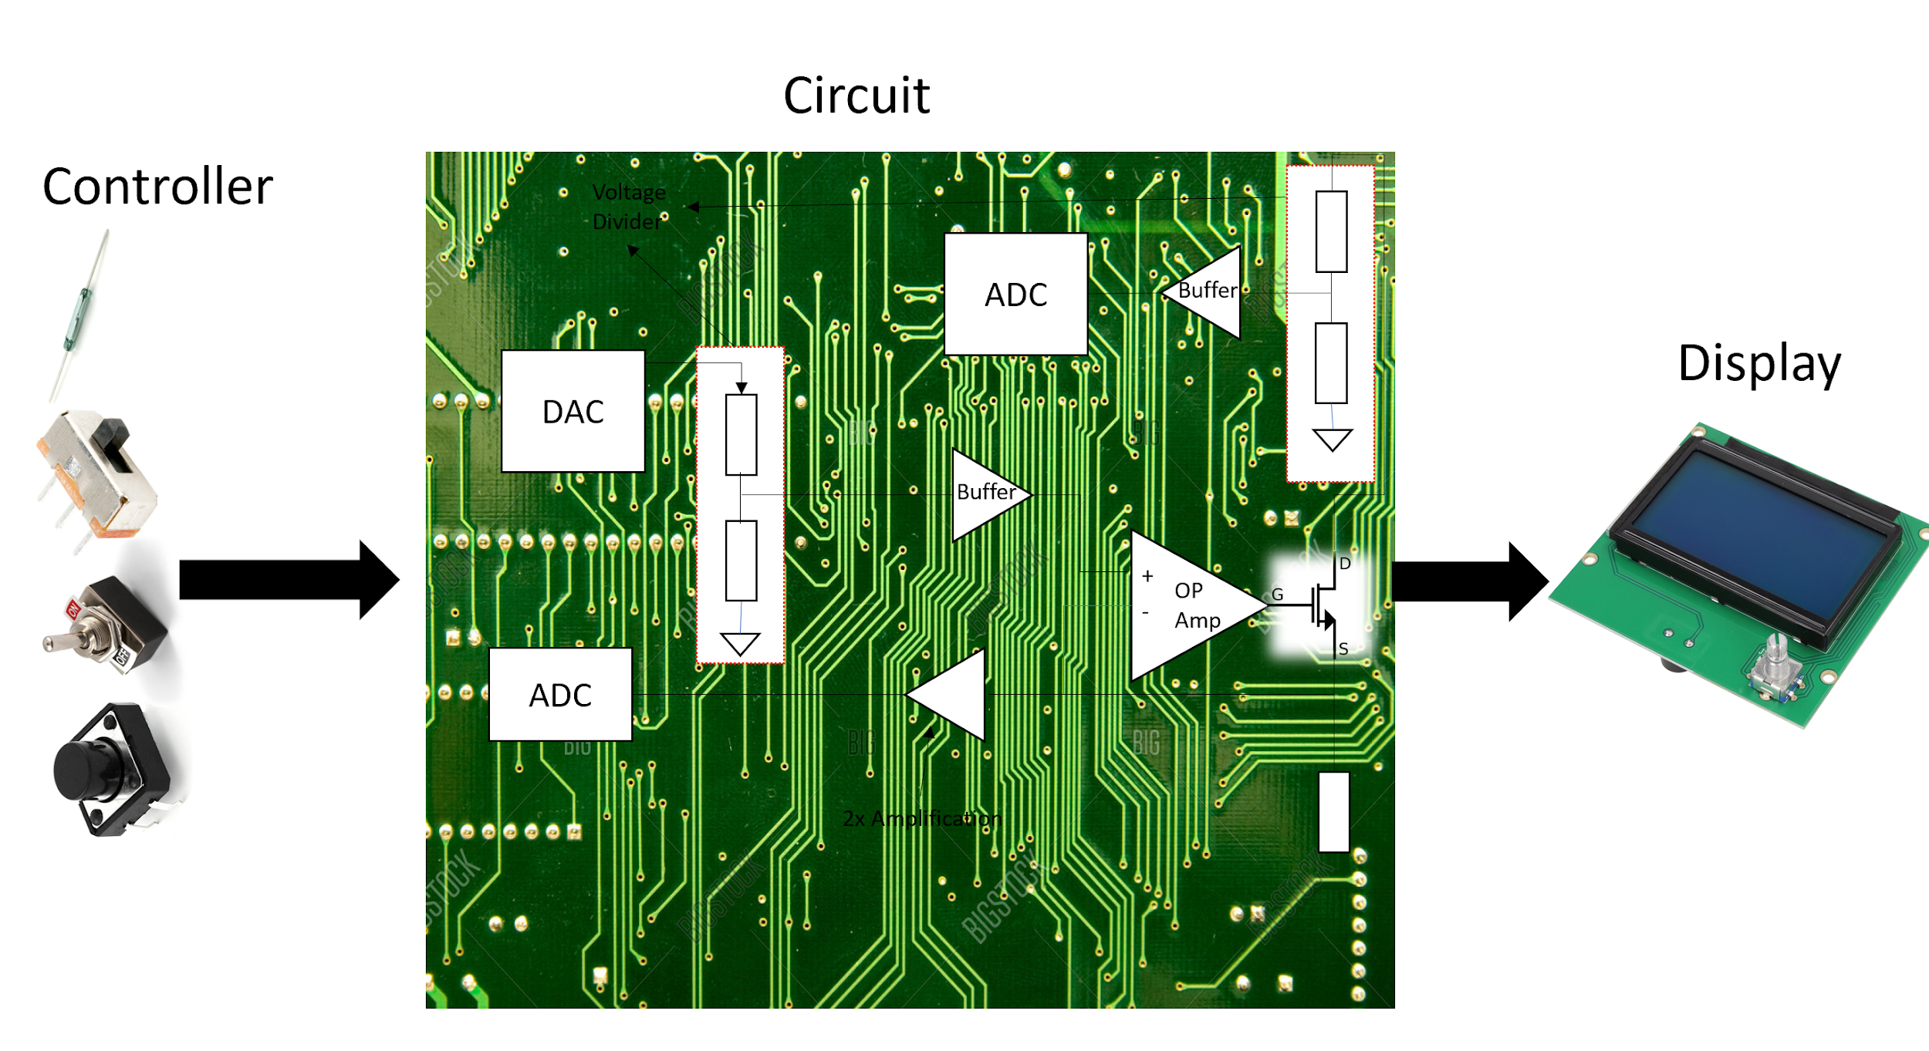

**Figure 1. Project Conceptual Image**

## Responsibility and Change Authority

The team leader, Joey Fuchs, is charged with ensuring that the project is going as planned in terms of design and specification. Any changes that need to be made have to be approved by the team leader and the sponsor of this project, Doctor Nowka.

# Applicable and Reference Documents

## Applicable Documents

|  |  |  |
| --- | --- | --- |
| **Document Number** | **Revision/Release Date** | **Document Title** |
| DOD-HDBK-791 | 3/17/1998 | Maintainability Design Techniques Metric |
| MIL-HDBK-217 | Revision F – 2/28/1995 | Reliability Prediction of Electronic Equipment |
| MIL-HDBK-263 | Revision B – 7/31/1994 | Electrostatic Discharge Control Handbook for Protection of Electrical and Electronic Parts, Assemblies and Equipment |
| MIL-HDBK-338 | Revision B – 10/1/1998 | Electronic Reliability Design |
| MIL-HDBK-2084 | 7/31/1995 | General Requirements for Maintainability of Avionic & Electronic Systems & Equipment |
| MIL-HDBK-5400 | 11/30/1995 | Electronic Equipment, Airborne General Guidelines |
| IPC A-610E | Revision E – 4/1/2010 | Acceptability of Electronic Assemblies |
| MIL-DTL-38999 | Revision L – 5/10/2012 | General Specification for Connectors, Electrical, Circular, Miniature, High Density, Quick Disconnect (Bayonet, Threaded, and Breech Coupling), Environment Resistant, Removable Crimp and Hermetic Solder Contacts |
| MIL-STD-461 | Revision E – 8/20/1999 | Requirements for the Control of Electromagnetic Interface Characteristics of Subsystems and Equipment |

## Reference Documents

The following documents are reference documents utilized in the development of this specification. These documents do not form a part of this specification and are not controlled by their reference herein.

|  |  |  |
| --- | --- | --- |
| **Document Number** | **Revision/Release Date** | **Document Title** |
| AD8630 | N/A | Zero-Drift Single-Supply Rail-to-Rail Input/Output Operational Amplifier |
| MCP4725 | N/A | 12-Bit Digital-to-Analog Converter |
| MCP3426 | N/A | 16-Bit Multi-Channel ΔΣ Analog-to-Digital Converter |
| P30N06LE | N/A | N-Channel 60 V (D-S) MOSFET |
| LM7805 | N/A | 3-Terminal 1A Positive Voltage Reg |
| TCH35 TO220 | N/A | 35 Watt TO220 Package Thick Film Power |

# Requirements

## System Definition

A 25W max Electronic DC Load. This DC load has settings for constant voltage and current or a power input limit. The constant current mode will allow for a range of input voltage while maintaining a constant current to be drawn from the source being tested. The Constant power setting will allow for testing a constant voltage supply and reading the current drawn. These settings will be controlled in two ways. The first being dials that are directly on the device and the second through an android app. The maximum power this DC load is designed to draw from the input supply is 25W.

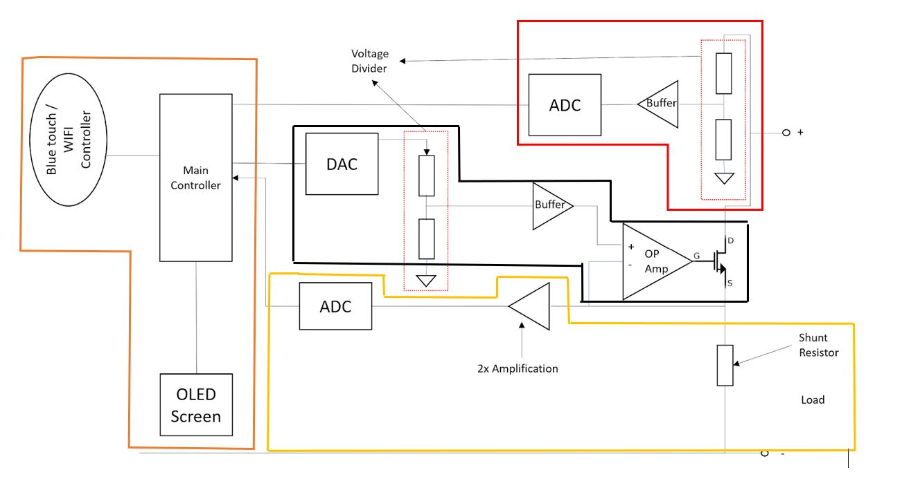

**Figure 2. Block Diagram of System**

**Orange:** At the far left of this block diagram in the orange block is the wireless receiver that will receive data from the smart device using the application designed for this DC load, the OLED screen displaying the readings and settings, and the microcontroller controlling the overall system.

**Black:** In the middle of the diagram in the black box is what controls the amount of current flowing through the MOSFET transistor. The DAC (Digital to Analog Converter) converts a digital signal representing a calculated voltage and converts it into an analog voltage. Next to the DAC is a voltage divider that will send a proportional voltage from the DAC to a buffer to the right of it to provide the required current for the Operational amplifier to the right of the buffer. The operational amplifier will send an amplified voltage to the MOSFET to control the current flowing through it.

**Yellow:** At the bottom in the yellow box is the feedback signal that will read the current flowing through the circuit. The node at the shunt resistor will show a voltage proportional to the current which will then get amplified to an op-amp as shown to the left of the shunt resistor. The amplified voltage will then be converted to a digital signal through the ADC (Analog to Digital Converter) and will then be read by the microcontroller.

**Red:** At the top in the red box is the feedback signal that will read the voltage provided by the source. The voltage divider to the right will proportionally step down the source voltage below 5V and send it to a buffer to the left of it. The reason the voltage needs to be below 5V is because the maximum voltage the buffer can output is 5V. The voltage will then be converted to a digital signal through the ADC (Analog to Digital Converter) and will then be read by the microcontroller.

## Characteristics

### Functional / Performance Requirements

#### Operational Temperatures

Operating temperature for the Microcontroller is between -40C and 85C. Since these are the minimum and maximum temperatures, it is suggested for users to stay in operating temperatures ranging between 10C to 70C.

### Physical Characteristics

#### Mass

Our device does not have a specified weight constraint. However, as a device that performs various measurements, we want it to be easily transportable. With that in mind, a weight of 1- 3 pounds.

#### Mounting

Since our device will be portable in order to serve as a testing device, there will be no specific mounting mechanism or location. The controller, circuit, and display will be mounted on a PCB.

### Electrical Characteristics

#### Inputs

1. The source to be tested. It consists of a positive and a negative input.
2. The power to supply the overall system. 12V at a minimum of 1A.
3. Dials and switches to control the settings of the system.
4. A wireless receiver containing data from an application designed for this system.

##### Input Voltage Level

1. The maximum power input will be 25W. The maximum voltage will be 25V at a max 1A. The minimum voltage input will be 7V at a max 1A

##### External Commands

1. The Electronic DC Load System shall document all external commands in the appropriate ICD.

#### Outputs

1. The output of this system will be on an LED screen displaying the results.
2. Results will be constant voltage and/or constant current.

### Environmental Requirements

1. This device will work best in temperatures close to 25 C. Before using the device the user should make sure that they are in a dry environment. Humid environments or spilled liquids on the device may result in a short circuit possibly resulting in damaging the device or harm to the user.

#### Thermal

When testing loads that reach the maximum operating power, the temperature of the internal components will get very hot. These components will constantly be cooled through passive cooling with a heat sink and will be actively cooled with the use of a fan.

*Rationale: As more current flows through the MOSFET and shunt resistor the become less efficient and will expel waste energy in the form of heat.*

# 

# Support Requirements

1. This system includes but does not require an application to control the settings of the device.
2. The system will include everything except for the source to be tested. It will include a power supply for the device.

# Appendix A: Acronyms and Abbreviations

Hz Hertz

ICD Interface Control Document

kHz Kilohertz (1,000 Hz)

LCD Liquid Crystal Display

LED Light-emitting Diode

mA Milliamp

MHz Megahertz (1,000,000 Hz)

W Watt

PCB Printed Circuit Board

RMS Root Mean Square

TBD To Be Determined

TTL Transistor-Transistor Logic

N/A Not Applicable