DC Electronic Load

Daniel Yong

Hussain Alhijab

Joseph Fuchs

Yu Heng Lai

**Interface Control Document**

REVISION – Draft

01 March 2021

Interface Control Document

for

DC Electronic Load

Prepared by:

Group 28 03/01/2021

Author Date

Approved by:

Joey Fuchs 03/01/2021

Project Leader Date

_____________________________

Professor Nowka Date

_____________________________

Onder Dincel Date

**Change Record**

|  |  |  |  |  |
| --- | --- | --- | --- | --- |
| **Rev.** | **Date** | **Originator** | **Approvals** | **Description** |
| **1** | March 1,  2021 | [Joey Fuchs  Hussain Alhijab  Yu-Heng Lai  Daniel Yong ] |  | Draft Release |
| **2** | April 28, 2021 | [Joey Fuchs  Hussain Alhijab  Yu-Heng Lai  Daniel Yong ] |  | Draft Revision |

**Table of Contents**

**Overview** **6**

References 7

Definitions 7

**Physical Interface** **8**

Weight 8

Dimensions 8

Dimension of subsystem name 8

Mounting Locations 8

**Thermal Interface** **9**

**Electrical Interface** **10**

Primary Input Power 10

Polarity Reversal 10

Signal Interfaces 10

Video Interfaces 10

User Control Interface 10

**Communications / Device Interface Protocols** **11**

Wireless Communications 11

Host Device 11

**List of Tables**

**Controller Subsystem Dimensions 8**

**List of Figures**

**Figure 1: Preliminary E-Load General Diagram 6**

# Overview

The focus of this interface control document (ICD) is about the essential parts of the project, DC Electronic Load, and the working details, and the concept of operation for each subsystem for the entire project. This document aims to describe how each subsystem works and how they correlate and interface in order to achieve the goal of creating this project and get it to work as described in the concept of operation document and fulfill the requirements mentioned in the FSR and the ConOps documents. Additionally, the ICD will provide details about the structure of the project and detailed description of each subsystem. A diagram for describing the overall project is provided and can be seen in the following figure.

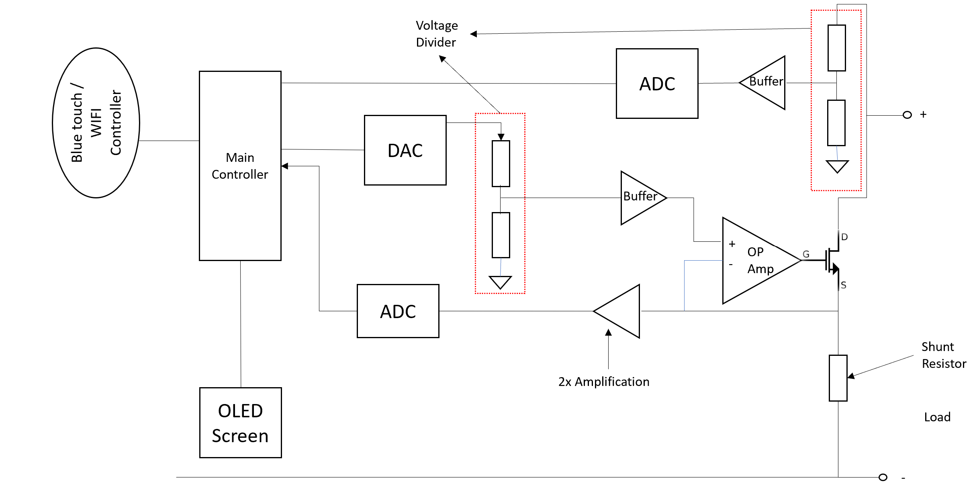

**Figure 1: Preliminary E-Load General Diagram**

References and Definitions

Provide any references (i.e., standards documents) and definitions. Examples are shown below.

## References

**MIL-STD-810F**

**Environmental Engineering Considerations and Laboratories Tests**

1 Jan 2000

Change Notice 2

30 Aug 2002

**American National Standard for VME64 (ANSI/VITA 1-1994 (R2002))**

4 Apr 1995

**American National Standard for VME64 Extensions (ANSI/VITA 1.1-1997)**

7 Oct 1998

## Definitions

CCA Circuit Card Assembly

mA Milliamp

mW Milliwatt

MHz Megahertz (1,000,000 Hz)

TBD To Be Determined

TTL Transistor-Transistor Logic

VME VERSA-Module Europe

# Physical Interface

## Weight

* + 1. Our device does not have a specified weight constraint. However, as a device that performs various measurements, we want it to be easily transportable. With that in mind, a weight of 1-3 pounds.

## Dimensions

* + 1. Similar to Section 2.1.1, we have no specified constraint on the dimensions of our device. It should be small enough and light enough to be easily transported, so our ideal dimensions will be less than or equal to 1 ft x 1ft x 1ft. The following dimensions are in inches.

### Dimension of Controller

|  |  |  |
| --- | --- | --- |
| **Component** | **Length** | **Width** |
| Arduino Nano | 1.7 | 0.73 |

* + 1. Dimension of Circuit

9CM*15CM

* + 1. Dimension of Display

TBD

## Mounting Locations

2.3.1. Since our device will be portable in order to serve as a testing device, there will be no specific mounting mechanism or location. The controller, circuit, and display will be mounted on a PCB.

# Thermal Interface

Provide detail on any thermal interfaces that your project may have. Do you need cooling and air circulation? Do you need heatsinks? If you use a heatsink, does it need a cold wall?

* + 1. When testing loads that reach the maximum operating power, the temperature of the internal components will get very hot. Cooling and air circulation will be necessary to make sure our internal components will continue to operate through extended use of our device. Our components will be constantly cooled through passive cooling with a heat sink and will be actively cooled with the use of a fan. These methods are enough for thermal regulation of our device; use of water cooling or a cold plate will be unnecessary given the minimum and maximum current values that will be used.

# Electrical Interface

## Primary Input Power

* + 1. Our inputs will be the source that is being tested, and the power supply. The test source will consist of a positive and negative input, and our power supply will be 12V at a minimum of 1A.

## Polarity Reversal

* + 1. Input does NOT support reversed polarity. This may result in damage to the device. Circuit protection is providence within the device but is not intended for normal operations

## Signal Interfaces

* + 1. Wireless Communication between the microcontroller and the application will utilize a bluetooth module.

## Video Interfaces

* + 1. All values and measurements will be displayed on an LED screen. The user will also be able view measurements through a mobile application.

## User Control Interface

* + 1. Our device has dials and switches to control the settings of the system. Likewise, our device can also be controlled through a mobile application and results can be displayed on both devices.

# Communications / Device Interface Protocols

## Wireless Communications

For wireless communications, two Arduinos will be used to communicate wirelessly. The first arduino will send commands to the second Arduino which, naturally, will receive the commands from the first Arduino and execute them. The module that will be used in this project is NRF24L01Transceiver. This chip uses 2.4 GHz band and it should be able to operate with baud rates from 250 kbps up to 2 Mbps.

## Host Device

The system can use another way of controlling when wireless communication is not available. The system can be controlled by using a keypad that has buttons. The keypad will be simple as this project aims to design a simple DC electronic load in a short time. the keypad will send signals to the microcontroller to make desirable changes to the settings which can be seen on an LCD screen.