Movie Overview
Arrival is a science fiction movie that focuses on language, communication, and understanding. The movie begins when twelve alien spacecraft suddenly appear in different locations around the world. The United States military brings in Louise Banks, a linguistics professor, to help communicate with the aliens, known as Heptapods. Louise works with physicist Ian Donnelly and a military team to understand why the aliens came to Earth and what they want from humans.
One of the main challenges in the movie is that humans and the Heptapods do not share the same language or way of communicating. Louise cannot simply translate their language because there is no dictionary or previous information about it. She has to start from the beginning by establishing basic words and meanings. As she learns more about the Heptapods' written language, she discovers that they communicate using complex circular symbols called logograms. The communication problems shown in Arrival connect closely to Natural Language Processing (NLP), where computers are trained to process, interpret, and understand human language. The movie demonstrates how context, ambiguity, grammar, and differences in language can make communication difficult.
NLP Challenges
One major NLP challenge shown in Arrival is ambiguity. A word or symbol can have different meanings depending on how it is used. This becomes an important problem when humans interpret one of the Heptapods' messages as "use weapon." Some countries see the word "weapon" as a threat and believe the aliens may be dangerous. However, Louise explains that they may not fully understand what the Heptapods mean by the word. It could have another meaning, such as a tool or something being offered to humanity. This is similar to ambiguity in NLP because a computer cannot always determine the correct meaning of a word without understanding its context.
Another challenge is understanding context and meaning. Learning individual words does not automatically mean that someone understands an entire message. Natural language processing involves more than recognizing individual words. NLP systems also use syntactic and semantic analysis to understand the relationships and meanings of words within context (Stryker and Holdsworth). This problem can be seen in Arrival when Louise has to determine the meaning of the Heptapods' symbols based on how they are used instead of simply translating each symbol individually. Louise has to understand how the Heptapods organize their language and how different symbols work together. This is similar to NLP systems because they need to examine relationships between words instead of processing every word separately. For example, the word "bank" can describe a financial institution or the side of a river. The words around it help an NLP system determine which meaning is being used.
The movie also demonstrates the challenge of communicating between languages that have completely different structures. Human written languages generally follow certain patterns and directions, while the Heptapods communicate through complex circular logograms. Louise has to identify patterns in these symbols before she can understand complete messages. This can be compared to machine translation, where an NLP system must recognize differences in grammar, sentence structure, and meaning between languages. Translating the words directly may not communicate the original meaning correctly.
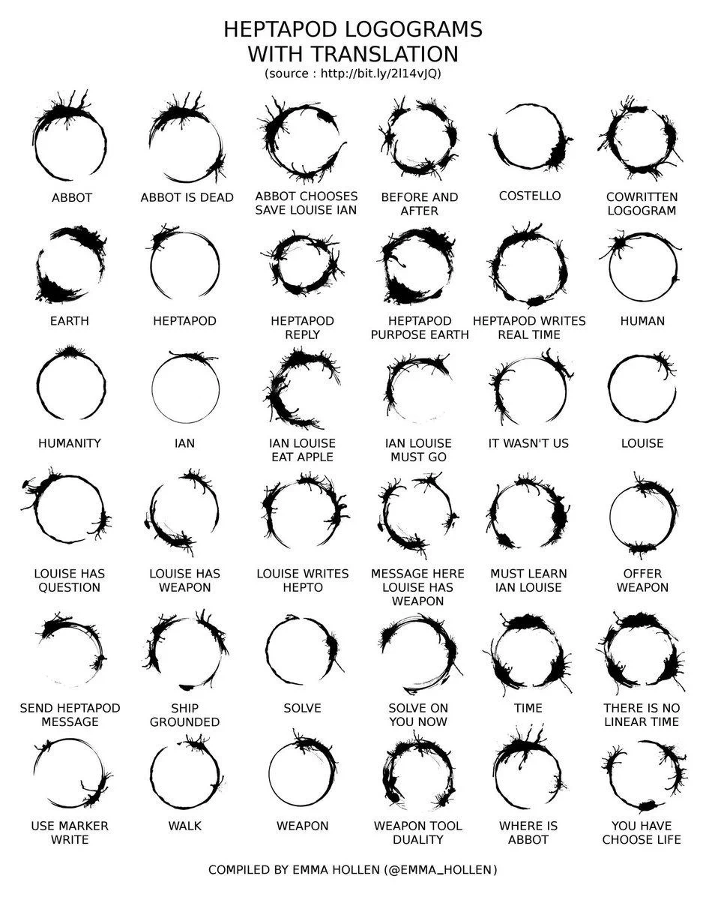
Communication Methods and NLP Approaches
Louise uses a step-by-step approach to communicate with the Heptapods. Instead of immediately asking complicated questions about why they came to Earth, she begins with basic concepts. She introduces herself and uses written words along with actions to establish connections between words and their meanings. As communication continues, Louise and her team collect more examples of the Heptapods' logograms and compare them to identify patterns. This allows them to gradually build a better understanding of the alien language.
Louise's method can be connected to rule-based NLP. Rule-based NLP uses predefined language rules to process text. In the movie, Louise tries to identify rules and patterns in the Heptapods' language, such as how symbols are structured and how different parts of a logogram contribute to its meaning. Once patterns are discovered, they can be used to help interpret new messages.
Her approach can also be connected to statistical NLP. Statistical NLP uses large amounts of language data to identify patterns and estimate the meaning of new information. Louise and her team collect many samples of the Heptapods' writing and compare them with previous interactions. The more examples they collect, the more information they have to determine what unfamiliar symbols may mean.
Modern deep learning NLP could also be useful in a situation similar to the one shown in Arrival. A machine-learning system could analyze a large collection of alien symbols and search for complicated patterns that humans might not immediately notice. Technologies such as pattern recognition, machine translation, semantic analysis, and language models could assist linguists with analyzing the data. However, the movie also demonstrates that technology alone may not be enough. Louise repeatedly uses human judgment, context, and interaction with the Heptapods to verify whether an interpretation makes sense. This shows the importance of combining NLP technology with human understanding when dealing with an unfamiliar and complex language.

Work Cited
Stryker C, Holdsworth J. What is NLP (natural language processing)? IBM. August 11, 2024. Accessed September 24, 2026. https://www.ibm.com/think/topics/natural-language-processing

