**Android - Assignment 1**

**AndrewID: yuzheng**

**1. Contrast an Android Project created with and without an Activity.**

Answer:

**With Activity**

Usually, android project would have at least one activity. Activity is a key component of an Android application, which can provide method to interact with user, such as print some information to user, wait user input something or take photo and so on. Activity just like a space or window, it would support user interfaces so that user can control the application base on it. Sometime, an application would have more than one activity, one of them is the main activity and it would appear immediately after user launch the application. Once we enter a new activity, the previous activity would stop and would be put into stack, so that if you put the “back” button, the stack would pop it and resume it.

In order to control activity transition, we can override the callback function so that we can make the application do appropriate work when its activity state change. There are various callback function, the fundamental method for lifecycle such as onCreate(), onStart(), onResume(), onPause(), onStop(), onDestory() and onRestart().

**Without Activity**

Also, sometimes we would want to create an application such as a server, which would support a client application. This kind of application does not need to interact with user, which means they do not need to have any activity. We would called them **Android project without Activity.** Such as A Service, it is an application component that can perform long-running operations in the background and does not provide a user interface. Another application component can start a service and it will continue to run in the background even if the user switches to another application.

The Android project without activity would not live on the lifecycle of callback function since it does not need to interact with user. So, for this project, we would use Context.startService() function to start this application and use Context.stopService() function to stop it. We have to notice that once we use the Context.stopService() function, no matter how many Context.startService() you called before, all service would be stop immediately.

Compare with Android project with Activity, Android project without Activity would have less key function, it would only have onCreate(), onStart() and onDestory(). Plus, Android project with Activity would have many activities, but only have one activity is active, others is stop and would be put into stack. The Android project without Activity have one instance, and can be start many time, but once they call the Context.stopService() function, they all would be stop.

**2. After watching video (Pranav Mistry @ MIT Labs - http://www.youtube.com/watch?v=YrtANPtnhyg) what assumptions can you make about current mobile computing replacing desktop computing. Comment on current implementation(s) and what are your assumption about how mobile computing will continue to evolve. Use the following references: 1. Android 5.0 features; 2. Google Glass; 3. iPhone 5; 4. iPad 3; 5. Gaming Consoles; 6. TV and Autoapps.**

Answer:

The video is good. From this video, we can know that the mobile computing will replace desktop in more and more scenario. Also, we can find that the size of mobile devices would be smaller and smaller and the power consumption would be decreased in future. And mobile computing ability will become more and more mature. Why we think the mobile computing will replace desktop computing? First, the mobility is the key of reason. Since we have enjoy the convenience which from smart phone, we would know the tend will continue. For example, just like if we want to share something such as photo or file, originally, we have to find a computer to do it. But now, we can do it wherever you in, just using our mobile phone. Second, we can find mobile device’s computing ability is increasing. From the Video, we can find that mobile device can do almost everything computer can do. But the mobile device will be more convenient than PC.

According to the question, we can make some comments about the current implement.

**Android 5.0 features**

**Android 5.0 is called Lollipop.** Lollipop have many new feature such as new notification, device sharing and so on. We can pick up some of them and show how the new Android version can support. **OK Google** is a new way that user can use voice to control your mobile phone. OK Google can easy access to information and performing tasks. Even if your screen is off, you can say “OK Google” on device with digital signal processing support such as Nexu6. Also, you can talk to Google on the go to get quick answers, and send a text, get directions and more. It is a brilliant way to interact with device, so that user can free their hand, and interact with device easier. **Device Sharing,** Lollipop just provides more flexible sharing with family and friend.

**Google Glass**

I think in the next few years, Google Glass would become more and more popular and would be the majority mobile device people use in future. By using Google Glass, we can have better experience with like video game, movie and presentation and so on. We would have different way to control the mobile device such as use our eye.

**iPhone 5 and iPad 3**

Compare with the first generation of iPhone and iPad. We can find that they become lighter and lighter, and the size of screen is various now. I think this tend would continue in the future. Also, the intelligent will be smarter than now, for example, the recognition ability of Siri would more accurate. The way to unlock our device will become more convenient.

**Gaming Consoles**

The most important even for gaming consoles, I think is Oculus and Hololens. They all represent VR technical advance. It make game become cooler than before. When you play game, you will feel you just inside the real game world, that will be great experience for every one, whatever you like game or not before.

**TV and Autoapps**

How can we put new technique and former product together? I think the TV and auto apps are good answer for this. By applying new technique, we can make our TV become more useful than before. Now, we can watch our favorite show any time, and do other thing through TV. Use the big screen of TV, we can have great experience when we watching movie or playing game.

**How mobile computing will continue to evolve.**

In my opinion, in future, mobile computing will become more and more popular and it would influent every part of life. Also, I think the way, which device interact with user, would be various, maybe would appear some new way to interact with user, such as what Google Glass and HoloLens did, provide a whole new way to interact with user.

**3. Describe the execution lifecycle for an Android App when running on a physical Android Device.**

Answer:

The Android application lifecycle diagram would be displayed below:

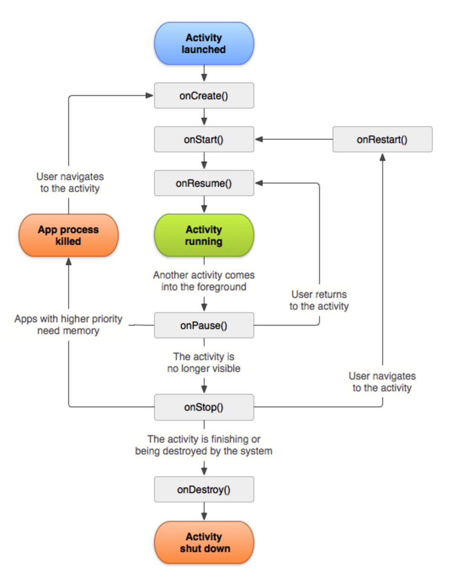

In order to figure out the execution lifecycle for an Android Application, we can first review the state of Activity in Android.

1. Active and Running state. This state would happen when an activity is in the front and focus in it. It is visible and active to user;
2. Pause state. This state, the activity would be visible for user, but it would not be active and not focus in;
3. Stop state. When this state happens, which means the activity would not be visible for user anymore;
4. Destroyed/Dead state. The Activity would be dead or destroyed when it no longer exists in the memory.

Since we have review the state of activity, we can start to explain the lifecycle of Android application.

First, we launch an activity in an android application, it would calls the onCreate() method. It would create the graph user interface and initialize the data element. This method is provided with a Bundle object as parameter to restore the UI state. Then, it would calls onStart() method, it would set the application to be visible to user, but the activity is not active now. Once it calls the onResume() method, the activity would become visible and active for user, the user can interact with the application now. Also, the activity would be the top of the activity stack. Now, the state of Activity is running/active state and waiting for input from user.

When user want to resume another activity on top of stack, or the user want to navigate to other parts of system, the onPause() method would be called. If the activity would be killed by the system, the onPause() must be called former. Since it is possible that the activity would be killed by the system at pause state, so we have to save the user interface configuration and critical data at this method.

On a real physical device, there are some user’s action would effect the activity of application. For example, in general, once user presses the Home button, the activity would enter paused state. Also, if another activity or notification could not completely obscures the visibility of underlying activity, the device would enter sleep.

For the Pause state, there are two possible actions would be executed: 1. The user maybe would resume the activity or transfer to the paused activity, the activity would be running or active again after we call onResume() method; 2. The system maybe would kill the activity if the memory is not enough. So, if we would to reload the activity, the system would call onCreate() and restoring the previous configuration from bundle object.

Once the activity under stopped state, there is 3 possible actions would be happened: 1. System would kill it to free resources. If we would to restart it, it would call onCrate() to reload it; 2. It would be called onRestart(), onStart() amd onResume() method to help user back to the activity again; 3. onDestory() method would be called. Once the activity is finished, the system would called the onDestory() method.