**Assignment2 Result show**

**Andrew ID: yuzheng**

In order save TA’S time, I show the application page flow below:

1. Enter the Main page, you can click the **“ADD MORTGAGE”** Button enter the add mortgage page.

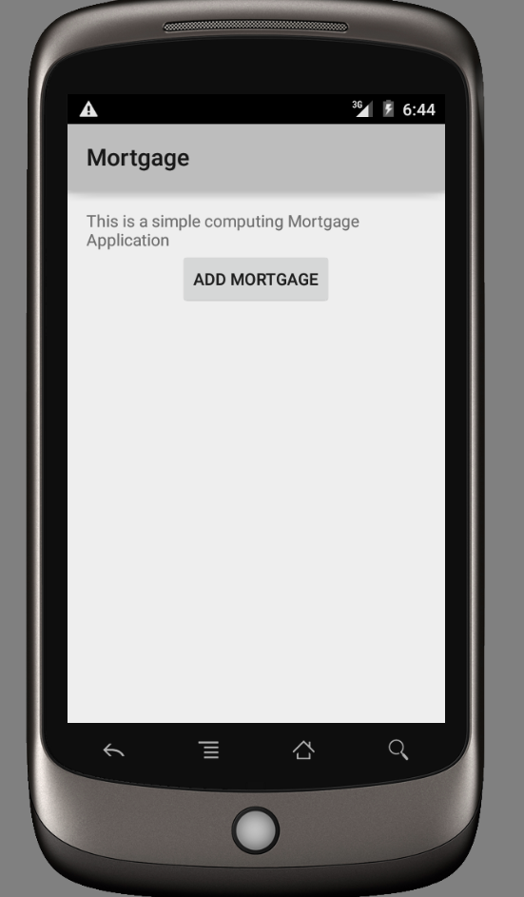

1. After we enter the Add Mortgage Page, the application will wait for user add the data.

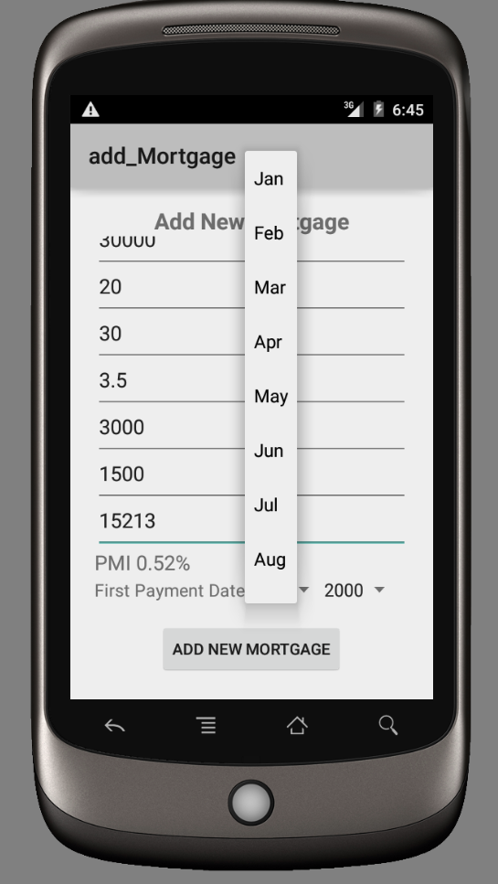

1. If user input the **error** data, the application would mention that and user have to input the legal data.

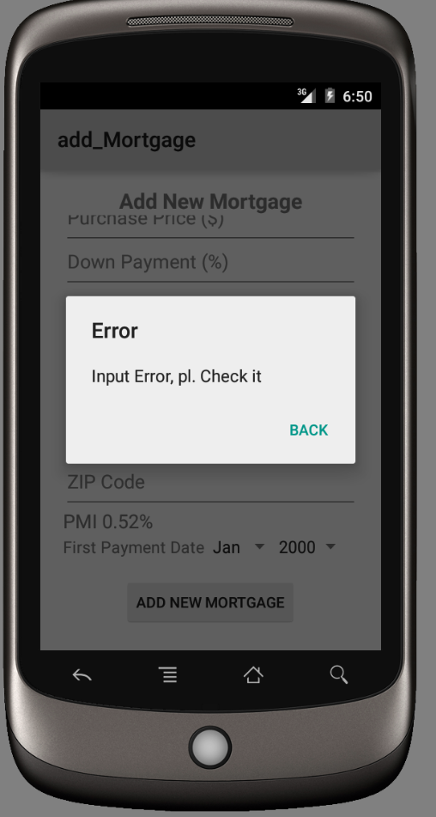

1. After user input the data, application would enter the View Result Page, and it would show the computing result for user.

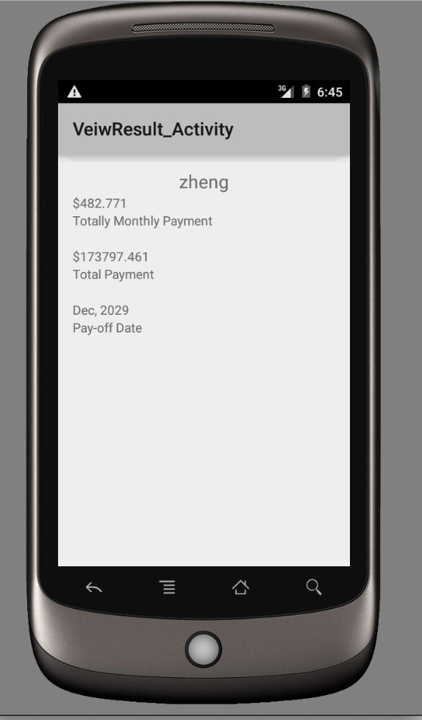

1. Meanwhile, the result would store local database, SQLite. We can review that the data has successfully store in database. We can check it on the log. Below is the result.

