**Documentation for Project1 unit3: Car Configuration**

**Here are additional files we add base on the unit2:**

MultiEditOption.java: This is interface, which is use to do the multithread operation, and it would be implemented by ProxyAutomobile.java.

EditOptions.java: This class is used to deal with synchronize issue. I only provide two multithreading function since this time my goal is just learn how to do the multithreading.

This is the new class diagram for this unit:

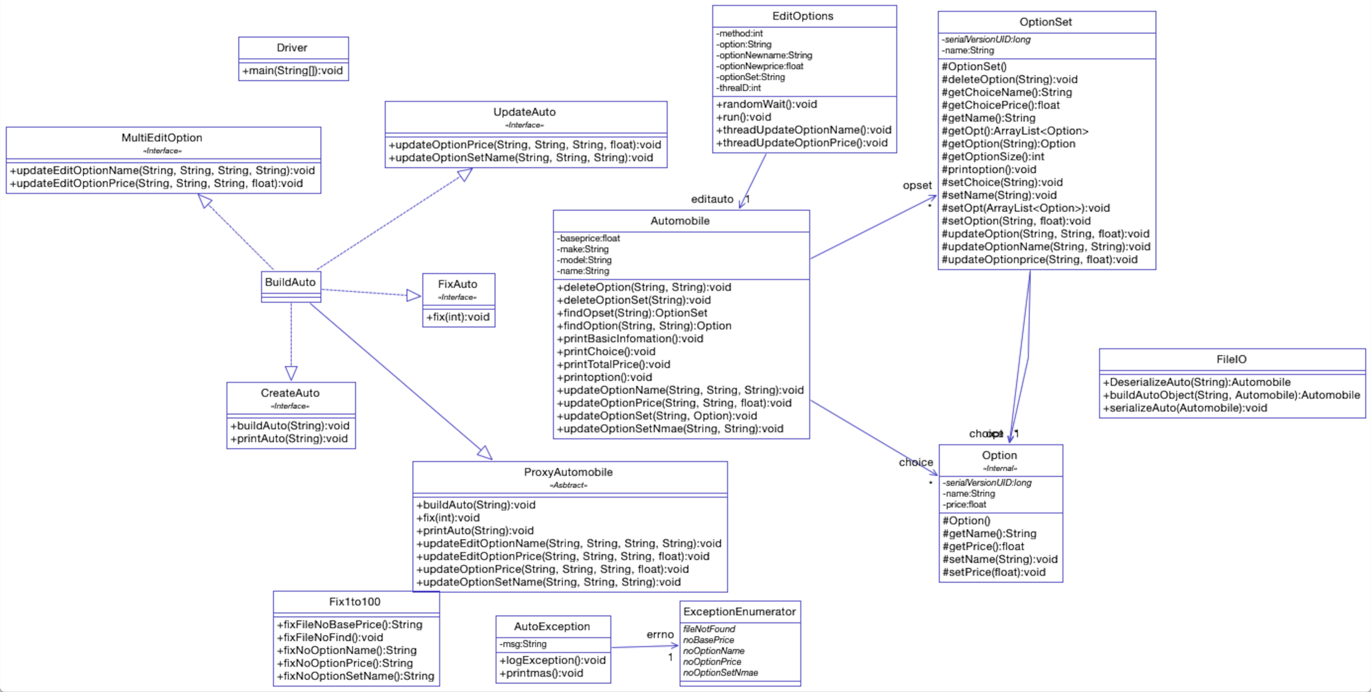

**Test:**

In this time, we would set a test to demonstrate the Object Locking usage.

In order to demonstrate the Object locking usage, I modified the updateOptionPrice function. Originally, each time we invoke the function, the option price would be change into a new price what we set. Now, we change the function, make it become that each time we invoke it, the option price would be add into a new price which we set, which means the newprice = oldprice + newprice. So, the below is our test, for test one, we invoke the function for 3 times, each time we add 1000 into the price. We would expect that the final option price is 3000. Here are test results.

**Test case 1:** We remove the synchronized from the class, obverse the result and find if causes data corruption. And we would found that the result is not meet for our expectation.

The test result detail just in the file: **test_output_1.txt**

**Test case 2:** We use synchronized in class, obverse the result and find if causes data corruption. And we can found that it would not cause data corruption.

The test result detail just in the file: **test_output_2.txt**