**Documentation for Project1 unit3: Car Configuration**

Here is the class diagram of server and client:

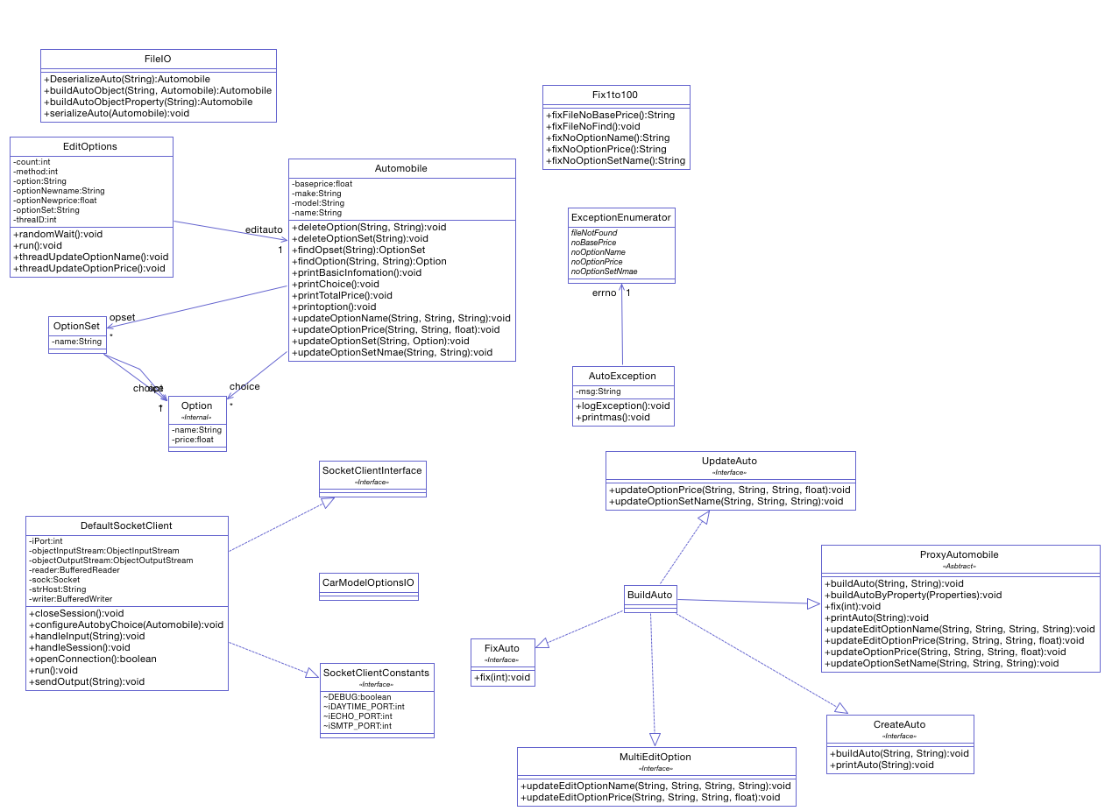

**Client**

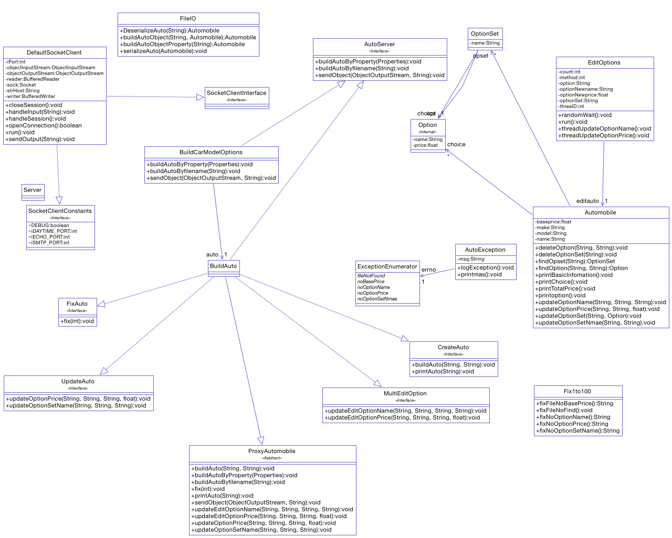

Server

**Here are additional files we add base on the unit3:**

**Step 1:**

In this step, we add a function called buildAutoObjectProperty(Properties p) and buildAutoObjectProperty(String fileName), it can read data from property type of file to build a AutoMobile instance.

**Step 2:**

In this step, we create a package called server. And the server contain below file:

AutoServer.java: It’s an interface, would be implemented by BuildAuto and AutoServer.

BuildCarModelOptions.java: providing some basic functions such as buildAutoByProperty(), which is building a Automobile instance by using a properties file.

DefaultSocketServer.java: implement all action in the server.

Server.java: It’s a main function that running the server and closing it.

**Step 3:**

In this step, we create a package called client. And the client contain below file:

CarModelOptionsIO.java: It a main function that set up a new client, and waiting to handle all data from user and server.

DefaultSocketClient.java: Contain all useful function provide to CarModelOptionsIO class, such as read data from a properties file, sent it to server; got the car model from server, and verifying the model is create successfully.

In this step, we use three files to test the function, there are Focus.Properties, Toyota.Properties and GTR.txt file, and the detail of test result we have shown at the **test_output1.txt** file. Here is image we cut for the test result.

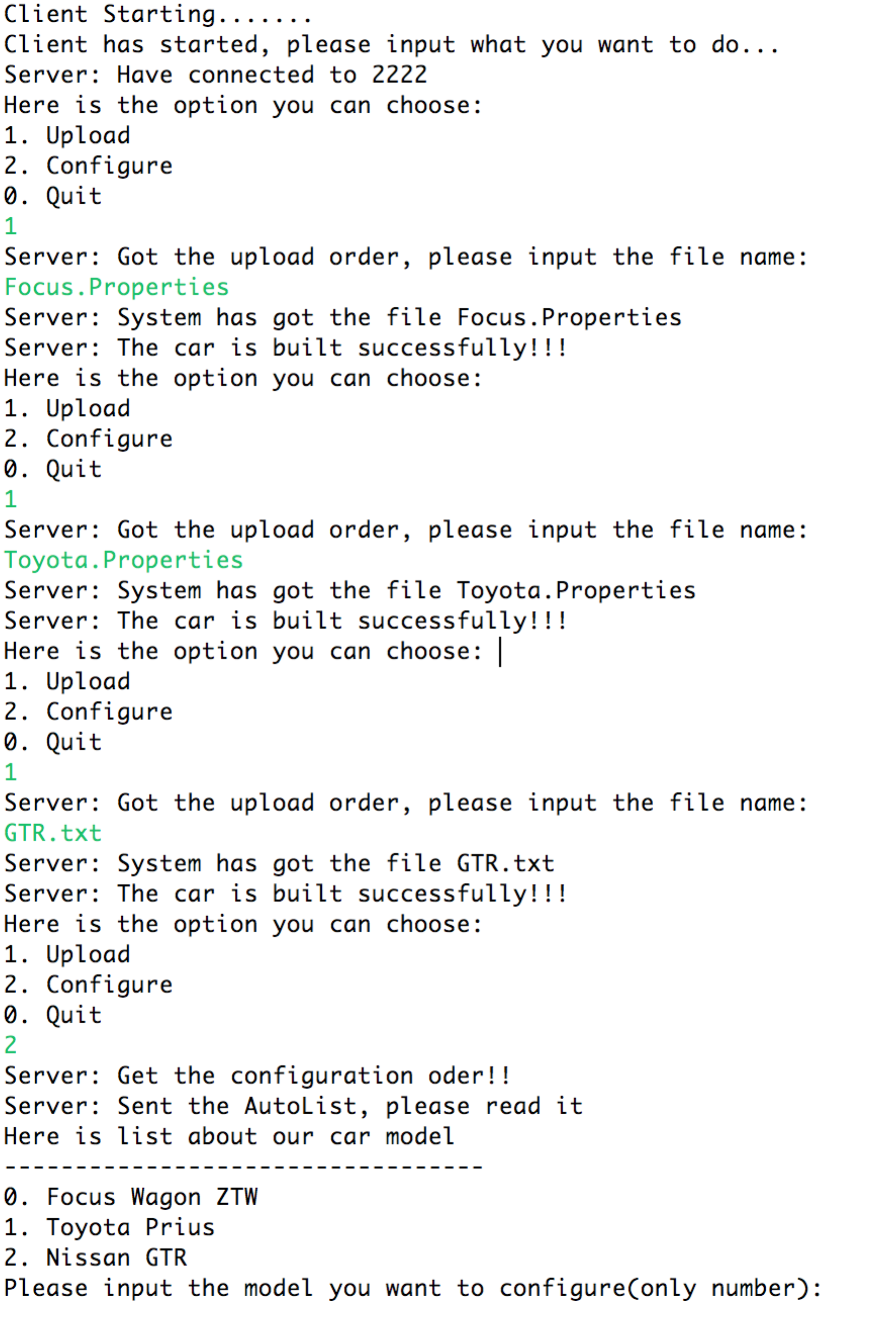

**Step 4:**

In this step, in order to enhance the function in client and server, we add some function for dealing with when user want to configure a car when they receipt a car model.

1. Add a function called getModelList, it would send a model list for user, that user can choose the option according to the car model information.
2. Add a function called sendObject, and would send a car model user chose. User would deal with the car model in client and configure a car they liked.

We also test these functions, the detail of test result we have shown in **test_output2.txt** file.

Here is the snap image we cut for the test result.

