**Documentation for Project1 unit4:** Building Client-Server model

**Andrew ID: yuzheng**

Here is the class diagram of project1 unit5 servelet.:

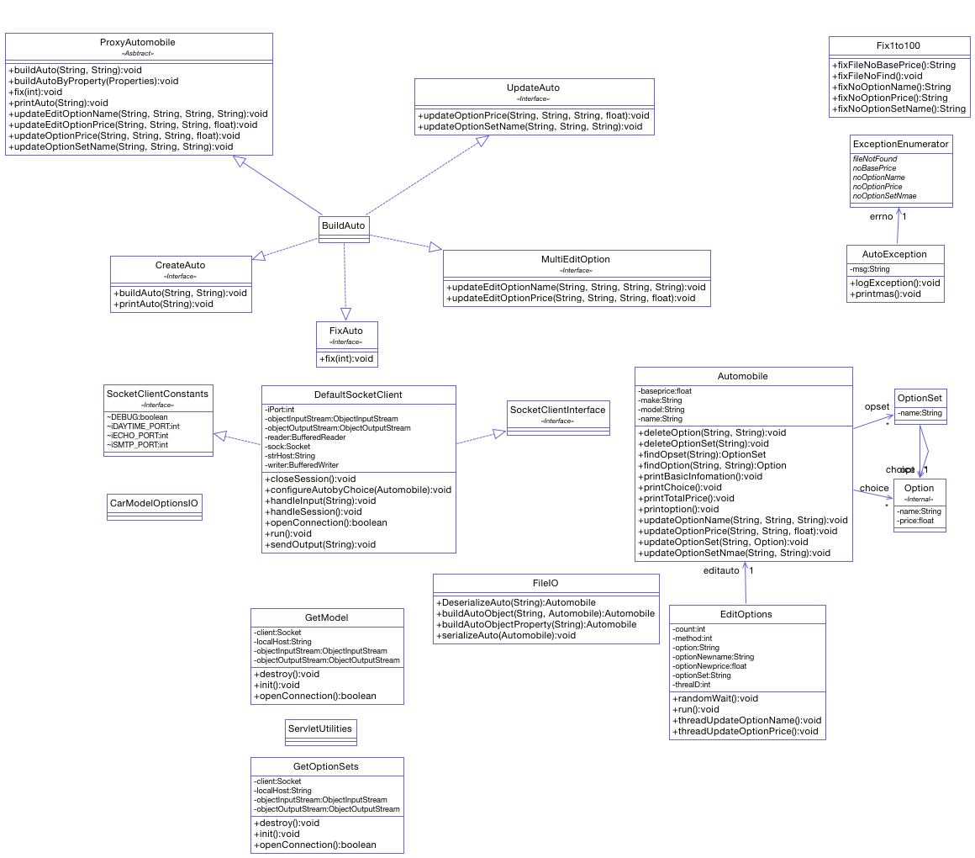

**Project Description:**

In this time, we build a web dynamic project by using Eclipse. For this project, we also extend the code from Project1 unit4. But we also add some code to this project for meeting our requirement from handout.

Here are the main files we focus on this time.

1. GetModel.java is the first servlet， which interacts with the Client (created in Unit 4), to get the list of available models.
2. GetOptionSets.java is the second servlet, which can interact with the Client (created in Unit 4), to get the data for the list of available OptionSets.
3. GetResult.jsp is the jsp file, which shows the OptionSets and prints the selected choices with total vehicle cost.

**Showing Result**

The below is the result from our project, you can review it and save your time to restart the project.

1. Run the Server.

Go to the unit5Server, server package, run the Server.java as java application.

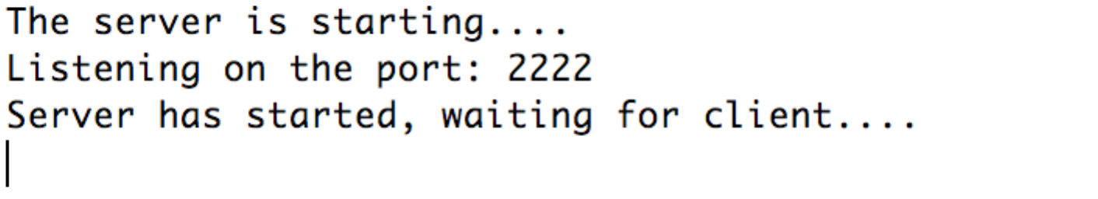

1. Run the terminal client.

Go to the project1unit5_servlet, client package, run the CarModelOptionsIO.java as application.

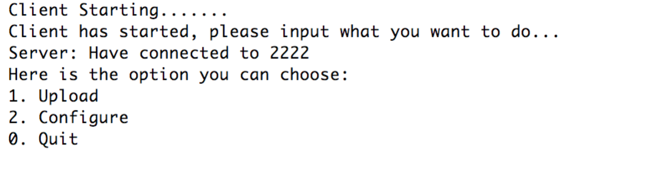

1. Upload car model to server. At least upload one car. When you upload the car, please input the correct file name.

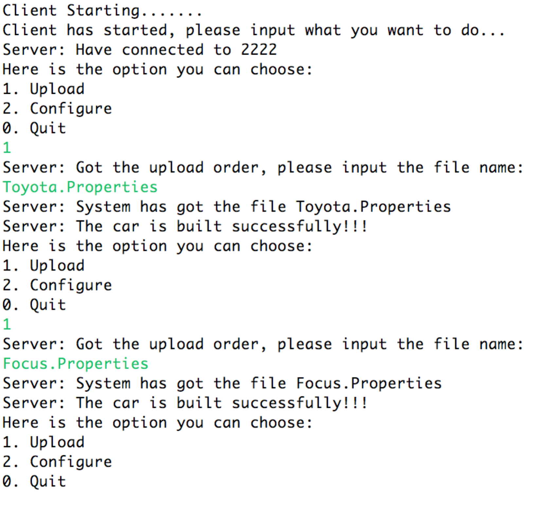

1. Run the project1unit5servlet project on your Tomcat, and then, access to the address: localhost:8080/project1unit5_servlet. Click the “Enter System”

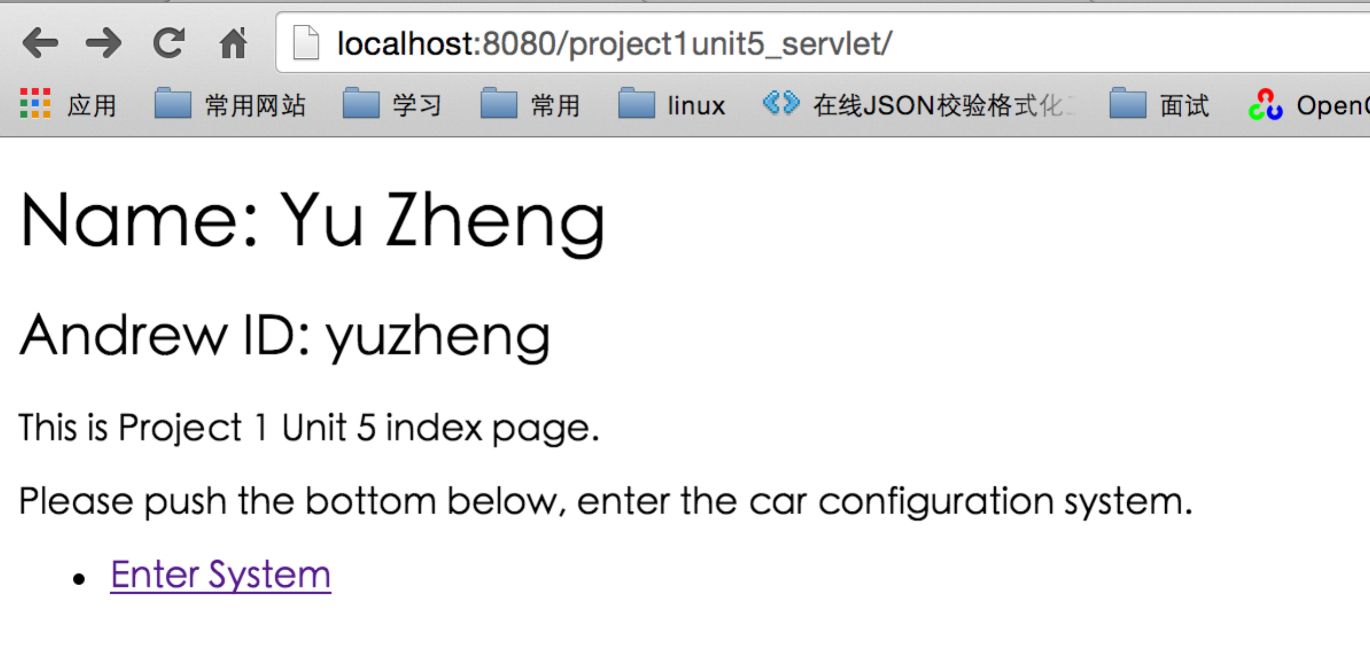

1. You can see the list of model in the web page, choose one of then, and then click the “submit” button.

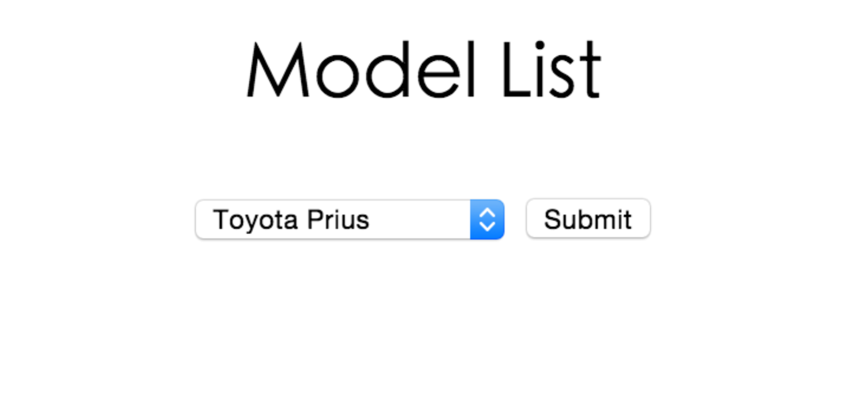

1. Now, you can start to configure your car. When you select all option, click the “Done” button.

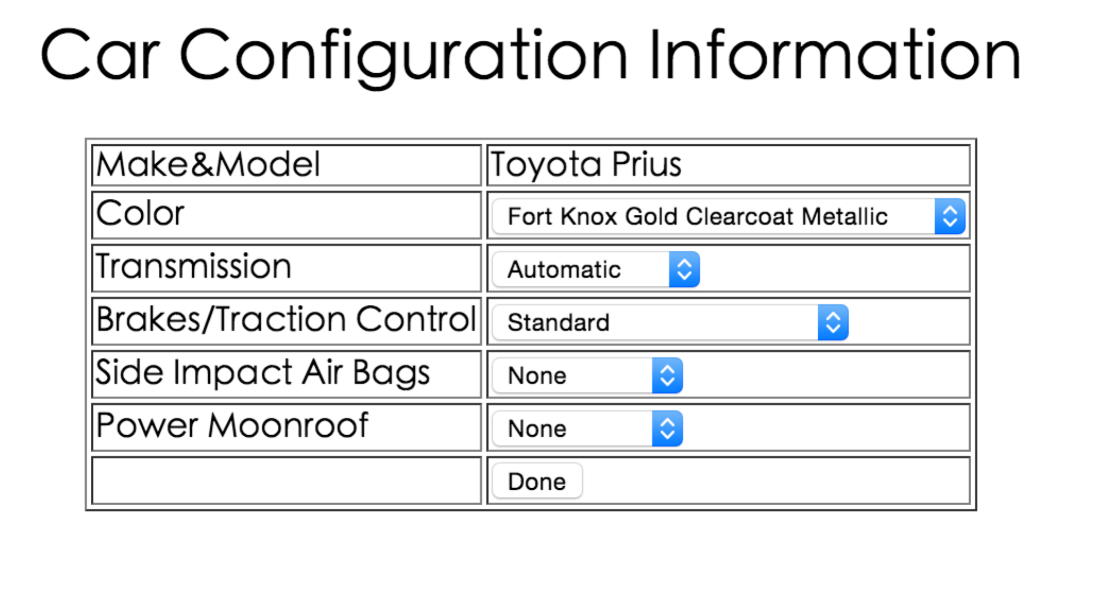

1. You will see the result from the GetResult.jsp web page.

