1. Minimize the DFA given by the following transition table and draw transition diagram for the minimized DFA:

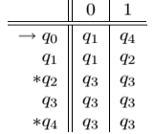

Solution:

* + - * 1. Divide the set of states into two sets, one set containing all non-final states and the other containing all the final states. This partition is called P**o**.
        2. Initialize k = 1.
        3. Find Pk by partitioning the different sets of Pk-1. In each set of Pk-1, we will take all possible pair of states. If two states of a set are distinguishable, we will split the sets into different sets in Pk. Two states q1 and q2 are distinguishable in partition Pk for any input symbol ‘a’, if δ (q1, a) and δ (q2, a) are in different sets in partition Pk-1.
        4. Repeat Step 3 until no change in partition occurs(Stop when Pk = Pk-1)
        5. All states of one set are merged into one. No. of states in minimized DFA will be equal to no. of sets in Pk.

Po = {qo, q1, q3} {q2, q4}

P1 = {qo, q1} {q3} {q2, q4}

P2 = {qo, q1} {q3} {q2, q4}

P3 = {qo,q1} {q3} {q2, q4}

Since P2 = P3, we stop now.

So we have 3 states in minimized DFA: {qo, q1} is starting state, {q2, q4} is final state.

Let us replace them: A = {qo, q1}, B = {q2, q4}, C = {q3}.

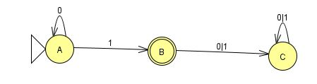

Fig 1. Transition diagram of minimized DFA.

6)Consider the following NFA with -transitions:

|  |
| --- |
|  |
|  | C:\Users\cv\AppData\Local\Temp\ksohtml17344\wps2.png |

* 1. Convert it into NFA without -transitions. Show all the steps
  2. Design the minimized DFA of the NFA without -transitions you constructed in (a) and show the resulting diagram

**Solution:**

1. To convert the given -NFA to NFA:

Step 1: Find Closure of all statesStep 2: Extended Transition Function for all states: δ'(q0,a)=CL( δ(CL(q0),a))Step 3: Set of all final states F’ consists of all states whose E-Closure contains a final state in F.

**Step 1: Find Closure of all states:**

CL(qo) = {qo, q1, q2} CL(q1) = {q1, q2}

CL(q2) = {q2}, CL(q3) = {q3, q2}

CL(q4) = {q4}, CL(q5) = {q5}

**Step 2. δ' transition for all states is obtained by:**

δ'(q0,a)=CL( δ(CL(q0),a))

The δ' transition on q0 is obtained as:

δ'(q0,a) = CL( δ(CL(q0),a)) = CL(δ(qo,q1,q2),a) = CL(δ(q0, a) U δ(q1, a) U δ(q2, a))

= CL(Ф U q3 U q4) = {q2, q3, q4}

δ'(q0,b) = CL( δ(CL(q0),b)) = CL(δ(qo,q1,q2),b) = CL(δ(q0, b) U δ(q1, b) U δ(q2, b))

= CL(q3 UФUФ) = CL(q3) = {q3, q2}

The δ' transition on q1 is obtained as:

δ'(q1,a) = CL( δ(CL(q1),a)) = CL(δ(q1,q2), a) = CL(δ(q1, a) U δ(q2, a)) = CL(q3 U q4) = {q3, q2, q4}

δ'(q1,b) = CL( δ(CL(q1),b)) = CL(δ(q1,q2), b) = CL(δ(q1, b) U δ(q2, b)) = CL(ФUФ) = Ф

The δ' transition on q2 is obtained as:

δ'(q2,a) = CL( δ(CL(q2),a)) = CL(δ(q2),a) = CL(q4) = {q4}

δ'(q2,b) = CL( δ(CL(q2),b)) = CL( δ(q2),a)) = CL(q5)={q5}

The δ' transition on q3 is obtained as:

δ'(q3,a) = CL( δ(CL(q3),a)) = CL(δ(q3,q2),a) = CL(δ(q3, a) U δ(q2, a)) = CL(ФUq4) = CL(q4) = {q4}

δ'(q3,b) = CL( δ(CL(q3),b)) = CL(δ(q3,q2),b) = CL(δ(q3, b) U δ(q2, b)) = CL(q5UФ) = CL(q5) = {q5}

The δ' transition on q4 is obtained as:

δ'(q4,a) = CL( δ(CL(q4),a)) = CL(δ(q4,a)) = CL(q5) = {q5}

δ'(q4,b) = CL( δ(CL(q4),b)) = CL(δ(q4,b)) = CL(q3) = {q3, q2}

The δ' transition on q5 is obtained as:

δ'(q5,a) = CL( δ(CL(q5),a)) = CL(δ(q5,a)) = CL(Ф) = Ф

δ'(q5,b) = CL( δ(CL(q5),b)) = CL(δ(q5,b)) = CL(Ф) = Ф

Now we will summarize all the computed δ' transitions:

δ'(q0,a) = {q2, q3, q4} δ'(q0,b) = {q3, q2}

δ'(q1,a) = {q3, q2, q4} δ'(q1,b) = Ф

δ'(q2,a) = {q4} δ'(q2,b) = {q5}

δ'(q3,a) = {q4} δ'(q3,b) = {q5}

δ'(q4,a) = {q5} δ'(q4,b) = {q3, q2}

δ'(q5,a) = Ф δ'(q5,b) = Ф

State q5 become the final state as ε-closure q5 contain the final state q5.

|  |  |  |
| --- | --- | --- |
| States | a | B |
| → qo | {q2, q3, q4} | {q3, q2} |
| q1 | {q3, q2, q4} | Ф |
| q2 | {q4} | {q5} |
| q3 | {q4} | {q5} |
| q4 | {q5} | {q3, q2} |
| *q5 | Ф | Ф |

The transition diagram of NFA is:

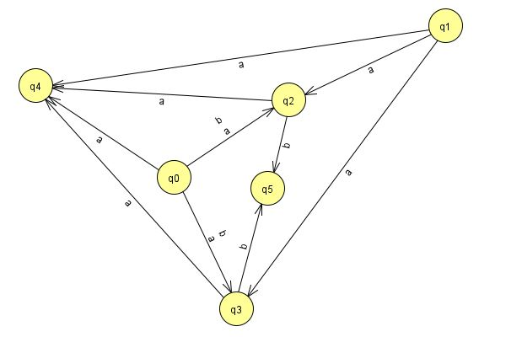

1. Design the minimized DFA of the NFA without -transitions you constructed in (a) and show the resulting diagram

Step 1. We use the table for NFA we constructed:

|  |  |  |
| --- | --- | --- |
| States | a | B |
| → qo | {q2, q3, q4} | {q3, q2} |
| q1 | {q3, q2, q4} | Ф |
| q2 | {q4} | {q5} |
| q3 | {q4} | {q5} |
| q4 | {q5} | {q3, q2} |
| *q5 | Ф | Ф |

First we have to convert it into DFA. To convert it to DFA, we use the transition table of NFA we constructed.

So, let us draw the transition table for corresponding DFA of above NFA.

In DFA we cannot go to more than one state by accepting a particular input from a given state. If a state moves to multiple states on accepting a particular input, we will combine those states as a single state .

Below is the transition diagram of corresponding DFA for the given NFA:

|  |  |  |
| --- | --- | --- |
| States | a | B |
| → qo | {q2, q3, q4} | {q3, q2} |
| {q2, q3, q4} | {q4, q5} | {q2, q3, q5} |
| {q3, q2} | {q4} | {q5} |
| *{q4, q5} | {q5} | {q3, q2} |
| *{q2, q3, q5} | {q4} | {q5} |
| {q4} | {q5} | {q3, q2} |
| *{q5} | {q6} | {q6} |
| {q6} | {q6} | {q6} |

We have 8 states in DFA formed. We can replace these states as below:

A = q0, B = {q2, q3, q4}, C = {q3, q2}, D = {q4, q5}, E = {q2, q3, q5}, F = {q4}, G = {q5}, H = {q6}

D, E, and G are final states.

The transition diagram for minimized DFA is:

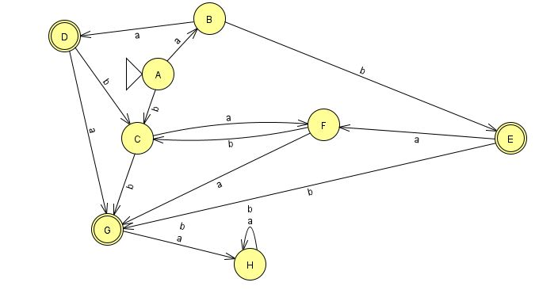

Transition table for minimized DFA:

|  |  |  |
| --- | --- | --- |
| States | A | b |
| →A | B | C |
| B | D | E |
| C | F | G |
| *D | G | C |
| *E | F | G |
| F | G | C |
| *G | H | H |
| H | H | H |

Now let us design minimized DFA:

* + - * 1. Po = {A, B, C, F, H} {D, E, G}
        2. P1 = {A,H} {B} {C} {F} {D} {E} {G}
        3. P2 = {A} {H} {B} {C} {F} {D} {E} {G}
        4. P3 = {A} {H} {B} {C} {F} {D} {E} {G}

Since P2 = P3, we stop. We see that DFA is already minimized.