Lab 2 Report

Name 陳宇宏
Student ID 110598067
Date 2022/04/17

- Test Plan
  - Test requirements
The Lab 2 requires to (1) select 15 methods from 6 classes of the SUT (GeoProject), (2) design Unit test cases by using input space partitioning (ISP) technique for the selected methods, (3) develop test scripts to implement the test cases, (4) execute the test scripts on the selected methods, (5) report the test results, and (6) specify your experiences of designing test cases systematically using the ISP technique.
In particular, based on the statement coverage criterion, the test requirements for Lab 2 are to design test cases with ISP for each selected method so that “each statement of the method will be covered by at least one test case and the minimum statement coverage is 70% (greater than Lab 1)”.

  - Test Strategy
To satisfy the test requirements listed in Section 1, a proposed strategy is to
- select those 10 methods that were chosen in Lab1 and 5 new methods that are NOT selected previously. If possible, some of the methods do NOT have primitive types of input or output parameters (if possible).
- set the objective of the minimum statement coverage to be greater than that of Lab 1 and adjust the test objective based on the time available (if necessary).
- design the test cases for those selected methods by using the input space partitioning (ISP) technique.

  - Test activities
To implement the proposed strategy, the following activities are planned to perform.

No. | Activity Name | Plan hours | Schedule Date
1 | Study GeoProject | 1 | 4/16
2 | Learn ISP and JUnit | 1 | 4/16
3 | Design test cases for the selected methods | 2 | 4/16
4 | Implement test cases | 6 | 4/17
5 | Perform tests | 0.2 | 4/17
…
n | Complete Lab2 report | 1 | 4/17

  - Design Approach
The ISP technique will be used to design the test cases. Specifically, the possible partitions and boundary values of input parameters shall be identified first using the Mine Map and domain knowledge (if applicable). The possible valid combinations of the partitions (i.e., all combination coverage) as well as the boundary values shall be computed for the input parameters of each selected method. Each of the partition combination can be a possible test case. Add more test cases by considering the possible values and boundary of the outputs for the methods or by using test experiences.

  - Success criteria
All test cases designed for the selected methods must pass (or 90% of all test cases must pass) and the statement coverage should have achieved at least 70%.

- Test Design
都寫在excel檔案裡
The Excel file of test cases…

- Test Implementation
The design of test cases specified in Section 2 was implemented using JUnit 4. The test scripts of 3 selected test cases are given below. The rest of the test script implementations can be found in the link (or JUnit files).

No. | Test method | Source code
1 | +encodeHash(double,double):String | 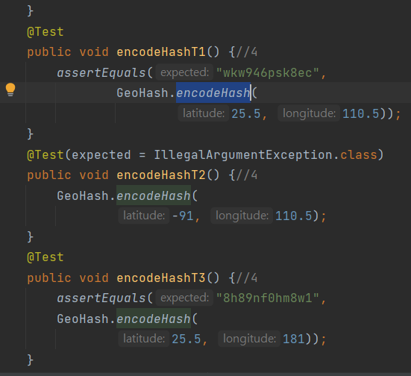
2 | + encodeHash(LatLong):String | 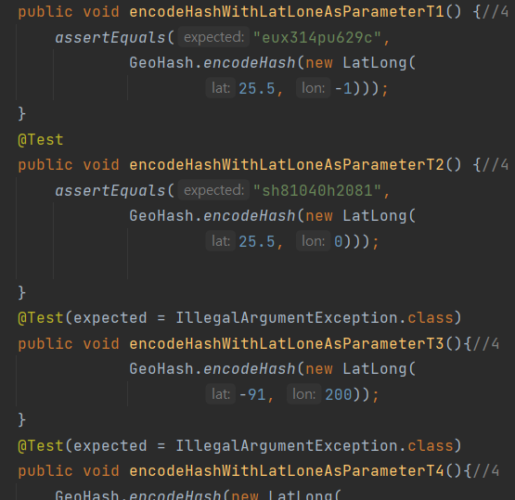
3 | +hashContains(String, double, double):boolean | 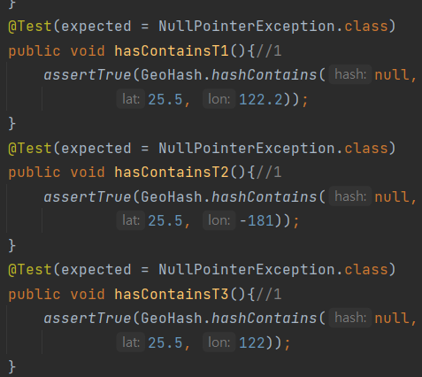

- Test Results
  - JUnit test result snapshot

  - Code coverage snapshot
- Coverage of each selected method

- Total coverage
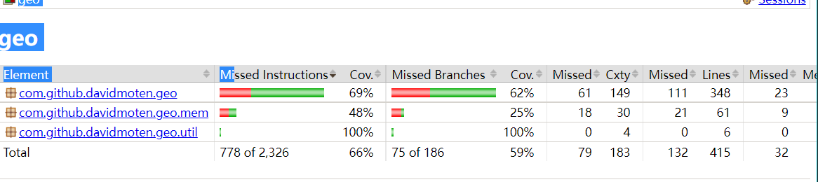

  - CI result snapshot (3 iterations for CI)

- CI#1
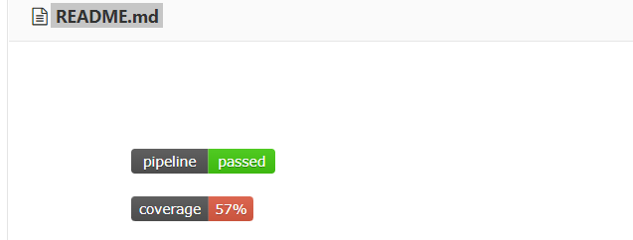

- CI#2
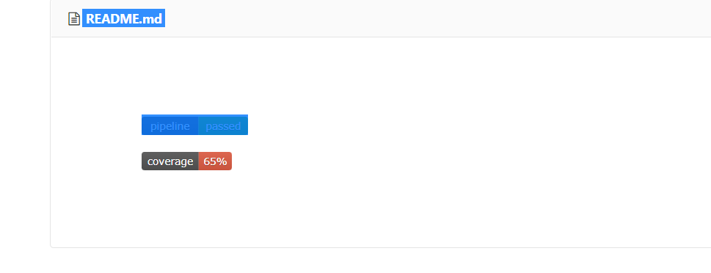
- CI#3
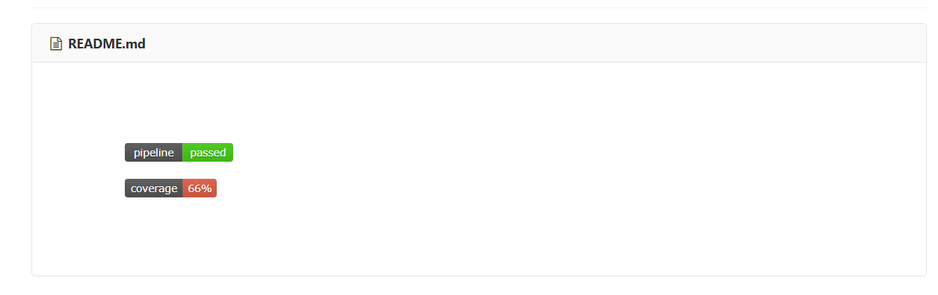
- CI Pipeline
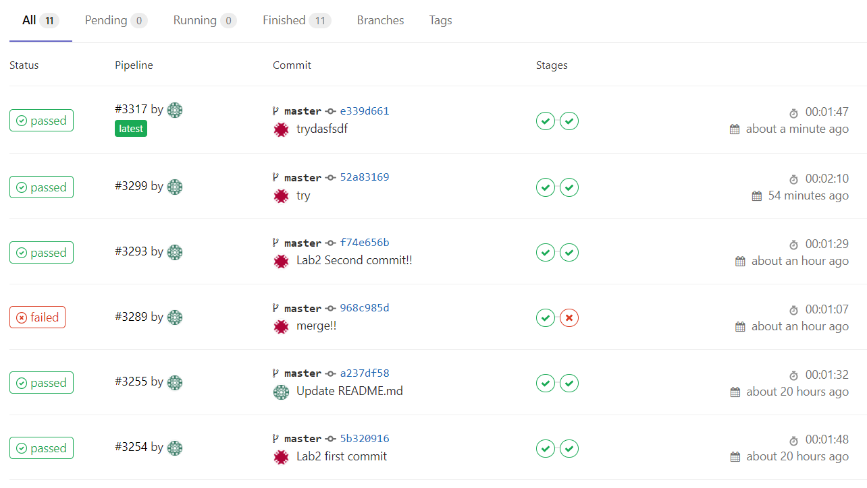

- Summary
In Lab 2, 15 test cases have been designed and implemented using JUnit and the ISP technique. The test is conducted in 3 CI and the execution results of the 15 test methods are all passed. The total statement coverage of the test is 70%. Thus, the test requirements described in Section 1 are satisfied. Some lessons learned in this Lab are …

