**Machine Learning in Finance Lab – Week 05**

**Liao, Yu-Ching**

**Part 1. EDA:**

* **Scatter Plot Metrics:**

* **Shape of Data:**

The number of Columns is 31 .

The number of Rows is 8071 .

* **Nature (truncated):**

* **Summary of Statistics:**

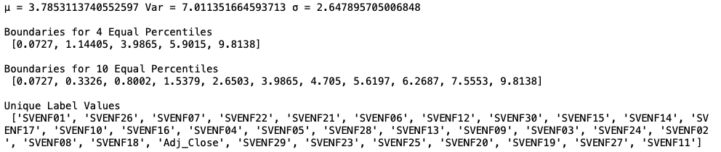

* **QQ Plot:**

* **Summary of data:**

* **Plot out data:**

* **Cross Plotting Pairs:**

* **Correlations (truncated):**

* **Correlations Visualization:**

**Part 2. PCA:**

**Part 3. Linear Regression VS SVM:**

* **Linear Regression with all features:**

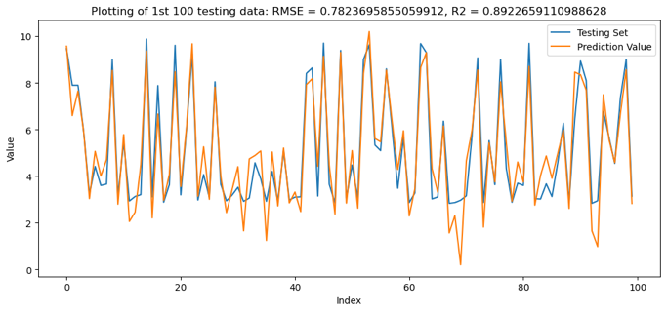

* **Linear Regression with PCA:**

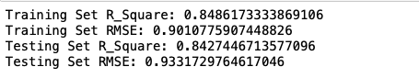

* **SVM** **with all features:**

* **SVM with PCA:**

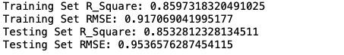

**Part 4. Conclusion:**

From the R_square and RMSE, we can notice that, with PCA, the performance of the model **will not necessary be better**. In this case, I think it is because, reducing the features from 30 to 3, we may have as well reduced the pivotal signal of data.

And to compare Linear Regression and SVM, we can notice that **none of them is significantly better**. However, there is **large gap in their learning times (as shown below)**.

As a result, I would still use linear regression if there are no necessity to use SVM, and I would test several different number of components so that we can still retain pivotal signal in our model.

|  |  |  |  |  |
| --- | --- | --- | --- | --- |
|  | Linear Reg. (all) | Linear Reg. (PCA) | SVM (all) | SVM (PCA) |
| R_Square (Train) | 0.89 | 0.84 | 0.88 | 0.85 |
| R_Square (Test) | 0.89 | 0.84 | 0.89 | 0.85 |
| RMSE (Train) | 0.77 | 0.90 | 0.81 | 0.91 |
| RMSE (Test) | 0.78 | 0.92 | 0.82 | 0.95 |
| Times | 323ms | 282ms | 12.9s | 10.9s |

**Part 5. Appendix:**

Github:<https://github.com/yu7yu7/IE517_Machine-Learning-in-Finance-Lab/blob/main/IE517_SP23_HW5/ML_Week05_HW.ipynb>

**Part 6. Sign:**

My name is Yu-Ching Liao.

My NetID is ycliao3.

I hereby certify that I have read the University policy on Academic Integrity and that I am not in violation.