Senior Project Report — Ngo Hoang Huy @media print { .no-print { display: none; } body { margin: 0; } .page-break { page-break-before: always; } } body { font-family: "Times New Roman", Times, serif; font-size: 12pt; line-height: 1.8; color: #000; max-width: 800px; margin: 0 auto; padding: 40px 60px; background: #fff; } h1.title { font-size: 16pt; font-weight: bold; text-align: center; text-transform: uppercase; margin: 24px 0 8px; } h1.chapter { font-size: 14pt; font-weight: bold; text-align: center; text-transform: uppercase; margin: 32px 0 16px; } h2 { font-size: 13pt; font-weight: bold; margin: 20px 0 8px; } h3 { font-size: 12pt; font-weight: bold; margin: 16px 0 6px; } p { margin: 0 0 10px; text-align: justify; } .center { text-align: center; } .bold { font-weight: bold; } .underline { text-decoration: underline; } .signature-block { margin: 40px 0; } .signature-line { border-bottom: 1px solid #000; width: 260px; display: inline-block; } table { width: 100%; border-collapse: collapse; margin: 12px 0; font-size: 11pt; } th { background: #d0d0d0; font-weight: bold; padding: 7px 10px; border: 1px solid #555; text-align: center; } td { padding: 6px 10px; border: 1px solid #888; text-align: left; } td.c { text-align: center; } .page-break { page-break-before: always; border-top: 3px dashed #ccc; margin: 48px 0; padding-top: 48px; } .fig-caption { text-align: center; font-style: italic; margin: 4px 0 16px; font-size: 11pt; } ul, ol { margin: 6px 0 10px 24px; } li { margin-bottom: 4px; } .ref { font-size: 11pt; } .abstract-box { border: 1px solid #888; padding: 16px 20px; margin: 16px 0; background: #fafafa; } /* nav for screen only */ .toc { background: #f5f5f5; border: 1px solid #ccc; padding: 16px 24px; margin-bottom: 32px; font-size: 11pt; } .toc h3 { margin: 0 0 10px; font-size: 12pt; } .toc a { color: #1a56db; text-decoration: none; display: block; padding: 2px 0; } .toc a:hover { text-decoration: underline; } .toc .indent { padding-left: 20px; } VIETNAM NATIONAL UNIVERSITY - HO CHI MINH CITY
INTERNATIONAL UNIVERSITY
SCHOOL OF ELECTRICAL ENGINEERING

GRU Autoencoder-Based Semantic Compression
and Anomaly Detection on IoT Gateway
BY
NGO HOANG HUY
EEEEIU21019
A SENIOR PROJECT SUBMITTED TO THE SCHOOL OF ELECTRICAL ENGINEERING IN PARTIAL FULFILLMENT OF THE REQUIREMENTS FOR THE DEGREE OF ENGINEER IN ELECTRONICS - TELECOMMUNICATIONS ENGINEERING
HO CHI MINH CITY, VIETNAM
GRU AUTOENCODER-BASED SEMANTIC COMPRESSION AND ANOMALY DETECTION ON IOT GATEWAY
BY
NGO HOANG HUY - EEEEIU21019
Under the guidance and approval of the committee, and approved by its members, this senior project has been accepted in partial fulfillment of the requirements for the degree.
Approved by:
Chairperson
Committee member
Committee member
Committee member
Committee member

Honesty Declaration
My name is Ngo Hoang Huy. I would like to declare that, apart from the acknowledged references, this senior project either does not use language, ideas, or other original material from anyone; or has not been previously submitted to any other educational and research programs or institutions. I fully understand that any writings in this senior project contradicted to the above statement will automatically lead to the rejection from the Electronics - Telecommunications Engineering program at the International University - Vietnam National University Ho Chi Minh City.
Date: _______________
(Ngo Hoang Huy)

Turnitin Declaration
Name of the student: Ngo Hoang Huy
Date: _______________
Advisor Signature  MEng. Do Ngoc Hung  Date: | Student Signature  Ngo Hoang Huy  Date:

Acknowledgments

First of all, I would like to sincerely thank my supervisor, MEng. Do Ngoc Hung. His consistent guidance, constructive feedback, and patience were invaluable throughout the course of this senior project. His technical insights helped me navigate the challenges of designing a production-ready IoT anomaly detection system and refining the experimental methodology.
I also want to express my gratitude to the lecturers and staff at the School of Electrical Engineering, International University (VNU-HCM). Thank you for providing an excellent learning environment and the strong engineering foundation that made this research possible.
I would like to acknowledge the Canadian Institute for Cybersecurity (CIC) for making the CIC IoT Dataset publicly available, and Intel Research Berkeley for the Intel Lab Data. These datasets were essential for building and rigorously evaluating the anomaly detection system presented in this project.
Finally, I am grateful to the open-source community — particularly the developers of PyTorch, FastAPI, paho-mqtt, NumPy, and scikit-learn — whose tools formed the backbone of this implementation.

Abbreviations and Notations
Abbreviation | Full Form
AI | Artificial Intelligence
API | Application Programming Interface
AUC | Area Under the Curve
CIC | Canadian Institute for Cybersecurity
DDoS | Distributed Denial of Service
DL | Deep Learning
DoS | Denial of Service
FN | False Negative
FP | False Positive
FPR | False Positive Rate
GRU | Gated Recurrent Unit
IDS | Intrusion Detection System
IoT | Internet of Things
LSTM | Long Short-Term Memory
ML | Machine Learning
MLP | Multilayer Perceptron
MSE | Mean Squared Error
MQTT | Message Queuing Telemetry Transport
ROC | Receiver Operating Characteristic
RNN | Recurrent Neural Network
TPR | True Positive Rate

Abstract

The rapid proliferation of Internet of Things (IoT) devices has introduced two critical challenges: the need for bandwidth-efficient data transmission and robust real-time detection of cyberattacks, particularly zero-day attacks with no prior signature. This project addresses both challenges by developing an IoT Gateway that employs a Gated Recurrent Unit (GRU) Autoencoder for simultaneous semantic data compression and unsupervised anomaly detection.
The system uses a GRU Autoencoder architecture trained exclusively on normal traffic data. The Encoder compresses each sliding window of 64 timesteps and 5 network features (320 values) into a compact 32-dimensional semantic vector, achieving a 10:1 compression ratio and 90% bandwidth savings. The Decoder reconstructs the original sequence from this semantic vector, and the reconstruction error (MSE) serves as the anomaly indicator. Windows whose MSE exceeds a statistically determined threshold (99th percentile of normal reconstruction errors) are classified as anomalous.
The system was evaluated on two benchmarks: the CIC IoT Dataset (46.7 million records, 33 attack types including DDoS, DoS, Mirai, and Recon) and the Intel Berkeley Lab Dataset (sensor fault detection). On the CIC IoT Dataset, the model achieves ROC-AUC = 1.0000, F1-score = 1.00, with Recall = 1.000 across all 33 attack categories. On the Intel Berkeley Dataset, the model achieves ROC-AUC = 1.0000 and F1-score = 0.97. An ablation study confirms GRU outperforms both LSTM and MLP baselines while requiring fewer parameters (159,909). The production Gateway processes 205 windows per second on CPU. The complete system includes a REST API (FastAPI), MQTT broker integration for real IoT protocols, and a memory-efficient streaming inference pipeline.
Keywords: IoT Security, GRU Autoencoder, Anomaly Detection, Semantic Communication, Edge Computing, Network Intrusion Detection, MQTT.

Table of Contents
Chapter I — Introduction #ch1 Chapter II — Design Specifications and Engineering Standards #ch2 Chapter III — Project Management #ch3 Chapter IV — Literature Review #ch4 Chapter V — Methodology #ch5 Chapter VI — Experimental Results #ch6 Chapter VII — Conclusion and Future Work #ch7 References #refs Chapter I — Introduction

1.1. Issue
The emergence of Industry 4.0 has accelerated the global deployment of Internet of Things (IoT) systems across smart homes, industrial automation, healthcare monitoring, and intelligent transportation networks. The number of IoT-connected devices worldwide is projected to exceed 29 billion by 2030 [1]. Each of these devices continuously generates network traffic data and sensor telemetry, creating two converging problems that this project addresses.
First, transmitting all raw data from edge devices to centralized cloud servers consumes substantial network bandwidth. IoT networks frequently operate over constrained links (LoRa, NB-IoT, Zigbee) where raw data transmission is impractical. Second, the expanding attack surface makes IoT networks attractive targets for cybercriminals. The CIC IoT Dataset alone catalogs 33 distinct attack categories including DDoS floods, DoS attacks, Mirai botnet variants, and reconnaissance scans [2], and novel zero-day variants continue to emerge daily.

1.2. Problems

1.2.1. Bandwidth Constraints in IoT Networks
IoT networks frequently operate under severe bandwidth limitations. Transmitting the entirety of raw sensor data and network flow statistics to a centralized server is inefficient and often infeasible. A single IoT gateway monitoring hundreds of devices may need to process thousands of network flow records per second. Without intelligent data compression, this creates a bandwidth bottleneck that degrades system responsiveness and increases operational cost.

1.2.2. Resource-Limited Edge Devices
IoT edge devices typically have constrained computational resources. Running complex deep learning models directly on these devices requires careful architecture design to balance detection accuracy with computational efficiency. The model must be lightweight enough to perform inference in real time — within milliseconds per window — while achieving high detection rates across diverse attack types.

1.2.3. Zero-Day Attack Vulnerability
Conventional intrusion detection systems rely on signature-based detection, which fails against zero-day attacks that lack predefined signatures. In IoT environments, where devices may run outdated firmware and attack toolkits evolve rapidly, an effective detection system must identify anomalous behavior without relying on prior knowledge of specific attack patterns. This requires an unsupervised learning approach.

1.2.4. Latency in Cloud-Dependent Processing
Centralized cloud-based security analysis introduces round-trip network latency. Processing data at the edge significantly reduces detection latency and enables faster response to security threats. Edge inference also reduces privacy exposure by avoiding raw data transmission to remote servers.

1.3. Problem Statement
This project aims to develop a software-based IoT Gateway that employs a GRU Autoencoder to simultaneously perform: (1) Semantic Data Compression — the Gateway uses the GRU Encoder to compress each data window into a compact 32-dimensional semantic vector, reducing bandwidth consumption by 90%; and (2) Unsupervised Anomaly Detection — the reconstruction error between the original data and the Decoder output serves as an anomaly score, enabling detection of both known and unknown attack types without requiring labeled attack data during training.

1.4. Motivation
The motivation stems from three converging trends: the emergence of Semantic Communication as a bandwidth-efficient paradigm for constrained IoT networks [3], the demonstrated success of autoencoder-based anomaly detection across time-series domains [4][5], and the availability of large-scale, realistic IoT network traffic datasets such as CIC IoT [2] and Intel Berkeley Lab Data [6] for rigorous evaluation. The GRU architecture is selected over LSTM for its reduced parameter count and faster convergence, and over MLP for its ability to capture temporal dependencies inherent in sequential network traffic.

1.5. Report Organization
This report is organized into seven chapters. Chapter I introduces the research context and problem statement. Chapter II defines design specifications and engineering standards. Chapter III covers project management including timeline and budget. Chapter IV reviews the relevant literature. Chapter V describes the complete methodology. Chapter VI presents experimental results across both datasets. Chapter VII concludes with future directions.

Chapter II — Design Specifications and Engineering Standards

2.1. Design Specifications

2.1.1. Hardware and Software Requirements
Component | Specification
Operating System | Windows 11 / Ubuntu 22.04+
Programming Language | Python 3.11+
Deep Learning Framework | PyTorch >= 2.0.0
Web Framework | FastAPI >= 0.110.0
ASGI Server | Uvicorn >= 0.29.0
IoT Messaging Protocol | MQTT via paho-mqtt >= 1.6.1
Data Processing | NumPy, Pandas, scikit-learn
RAM | >= 8 GB (16 GB recommended for 46.7M row dataset)
Storage | >= 5 GB (dataset + model checkpoints)

Table 2.1: Hardware and Software Requirements

2.1.2. System Performance Metrics
Metric | Target | Achieved
Anomaly Detection AUC | >= 0.95 | 1.0000 (both datasets)
False Positive Rate | <= 10% | 0.9% (CICIoT), 5.6% (Intel)
False Negative Rate | <= 5% | 0.001% (CICIoT), 0.002% (Intel)
Inference Throughput | >= 100 windows/s | 205 windows/s on CPU
Compression Ratio | >= 5:1 | 10:1 (320 → 32 values)
Bandwidth Savings | >= 80% | 90%
API Response Time | < 100 ms | ~5 ms per window

Table 2.2: System Performance Metrics — Targets vs. Achieved

2.2. Engineering Codes and Standards
Standard | Description | Application
IEEE 802.11 | Wireless LAN standards | IoT network context
OWASP Top 10 | Web security risks | API security design
PEP 8 | Python style guide | Code formatting throughout
OpenAPI 3.0 | API specification | Auto-generated Swagger docs
MQTT v3.1.1 | IoT messaging protocol | Real-time sensor data ingestion

Table 2.3: Engineering Codes and Standards

2.3. Realistic Constraints
Constraint | Description | Mitigation
Economic | Limited budget | Open-source tools only
Environmental | Energy consumption on edge | Lightweight GRU (159,909 params)
Memory | 46.7M row dataset exceeds RAM if loaded naively | Chunked CSV reading + as_strided zero-copy windows
Ethical | Privacy of network data | Public research datasets only, no personal data
Social | False alarms disrupt operations | Configurable per-dataset threshold percentile
Technical | CPU-only inference | Optimized batch streaming pipeline

Table 2.4: Realistic Constraints and Mitigations

Chapter III — Project Management

3.1. Budget and Cost Management Plan
Item | Cost (VND)
Electricity (4 months of training and development) | 600,000
Python, PyTorch, FastAPI, paho-mqtt | Free (open-source)
CIC IoT Dataset | Free (public research)
Intel Berkeley Lab Dataset | Free (public research)
Mosquitto MQTT Broker | Free (open-source)
Total | 600,000

Table 3.1: Budget and Cost Management Plan

3.2. Project Schedule
Phase | Weeks | Activities
Research & Planning | 1–3 | Literature review, dataset analysis, architecture selection (GRU vs LSTM)
Data Pipeline | 4–5 | CSV chunked loading, MaxAbsScaler, sliding window construction, stream simulator
Model Development | 6–9 | GRU Autoencoder design, training loop, early stopping, threshold computation
Evaluation | 10–12 | Anomaly detection metrics, per-attack-type breakdown, ablation study (GRU vs LSTM vs MLP)
Gateway & API | 13–15 | FastAPI REST endpoint, MQTT gateway integration, streaming inference optimization
Report Writing | 14–16 | Documentation, report compilation, final review

Table 3.2: Project Schedule

3.3. Resource Planning
Role | Name | ID | Responsibility
Supervisor | MEng. Do Ngoc Hung | — | Guidance, technical review, milestone approval
Student | Ngo Hoang Huy | EEEEIU21019 | Research, development, evaluation, documentation

Table 3.3: Resource Planning

Chapter IV — Literature Review

4.1. IoT Security and Intrusion Detection Systems

4.1.1. Traditional Signature-Based Approaches
Traditional IDS operate by maintaining a database of known attack signatures and comparing incoming network traffic against these patterns. Systems such as Snort and Suricata have been widely deployed in enterprise environments. However, as noted by Butun et al. (2020) [7], signature-based methods are fundamentally incapable of detecting novel attacks that lack predefined signatures, and maintaining an up-to-date signature database for the diverse IoT threat landscape is impractical given the rapid emergence of new attack variants.

4.1.2. Machine Learning-Based Anomaly Detection
Researchers have increasingly turned to machine learning and deep learning methods for anomaly detection. Chalapathy and Chawla (2019) [8] provided a comprehensive survey categorizing methods into supervised, semi-supervised, and unsupervised paradigms. Unsupervised methods are particularly attractive for IoT security because they do not require labeled attack data for training, enabling detection of zero-day attacks. This project adopts an unsupervised approach, training exclusively on normal traffic samples.

4.2. Autoencoder Architectures for Anomaly Detection

4.2.1. Standard Autoencoders
Autoencoders learn to compress input data into a lower-dimensional latent representation and reconstruct the original data. When trained exclusively on normal data, anomalous inputs — which the model has never encountered — produce higher reconstruction errors. Sakurada and Yairi (2014) [9] demonstrated the effectiveness of autoencoders for spacecraft telemetry anomaly detection.

4.2.2. LSTM Autoencoder for Time-Series Data
Malhotra et al. (2016) [4] proposed the LSTM Autoencoder, replacing feedforward layers with LSTM cells to capture temporal dependencies in sequential data. The original LSTM architecture by Hochreiter and Schmidhuber (1997) [10] uses four gating mechanisms (forget, input, output, cell) to learn long-range temporal dependencies. LSTM Autoencoders have been applied to network intrusion detection with strong results [5].

4.2.3. GRU as a Lightweight Alternative
Cho et al. (2014) [11] proposed the GRU as a simplified variant of LSTM using only two gates (reset and update), reducing the parameter count by approximately 25% compared to an equivalent LSTM. Empirical studies [12] show GRU achieves comparable performance to LSTM on many sequence modeling tasks while converging faster — a property confirmed by our ablation study where GRU achieves F1=0.9888 versus LSTM's F1=0.5250 under equal training epochs (see Section 6.5). This makes GRU preferable for resource-constrained IoT edge deployment.

4.3. Semantic Communication for IoT

4.3.1. Traditional vs. Semantic Communication
Traditional communication based on Shannon's theory (1948) [13] focuses on accurate bit-level transmission regardless of semantic meaning. Semantic communication, as conceptualized by Weaver (1953) [14], aims to convey meaning rather than exact bit-level representation. This paradigm is particularly beneficial for IoT networks where bandwidth is severely constrained.

4.3.2. Deep Learning-Based Semantic Compression
Xie et al. (2021) [15] proposed DeepSC for semantic text communication using deep neural networks. Bourtsoulatze et al. (2019) [16] demonstrated deep joint source-channel coding for wireless image transmission. Kountouris and Pappas (2021) [3] argued that semantic communication is especially beneficial for resource-constrained IoT devices. This project adopts this paradigm: the GRU Encoder's 32-dimensional bottleneck vector serves as the semantic representation of a 320-value input window, achieving 10:1 compression with 90% bandwidth savings.

4.4. Datasets

4.4.1. CIC IoT Dataset
The CIC IoT Dataset [2] from the Canadian Institute for Cybersecurity contains 46.7 million network flow records with 5 statistical features: flow_duration, Rate, Number, IAT, and Tot_size. Records are labeled across 33 attack categories (DDoS floods, DoS attacks, Mirai variants, Recon scans, web attacks) plus a BenignTraffic class. The large scale and diverse attack taxonomy make it the most comprehensive IoT intrusion detection benchmark available.

4.4.2. Intel Berkeley Lab Dataset
The Intel Berkeley Lab Dataset [6] contains sensor readings from 54 sensor nodes deployed in the Intel Research Lab, recording temperature, humidity, light intensity, and voltage. This dataset enables evaluation of the system on sensor fault detection — a complementary IoT anomaly detection scenario distinct from network intrusion. Fault labels are derived by rule-based out-of-range detection, providing a realistic evaluation of the model's generalization to sensor domains.

4.5. Normalization and Preprocessing
MaxAbsScaler normalization (x_{norm} = x / max(|x|)) scales features to the range [−1, 1] while preserving zero values and signal shape. This is compatible with the tanh activation used in the GRU bottleneck layer. The sliding window technique transforms sequential data into fixed-length windows of 64 timesteps, enabling the GRU to capture temporal patterns spanning multiple consecutive observations [4].

Chapter V — Methodology

5.1. System Overview
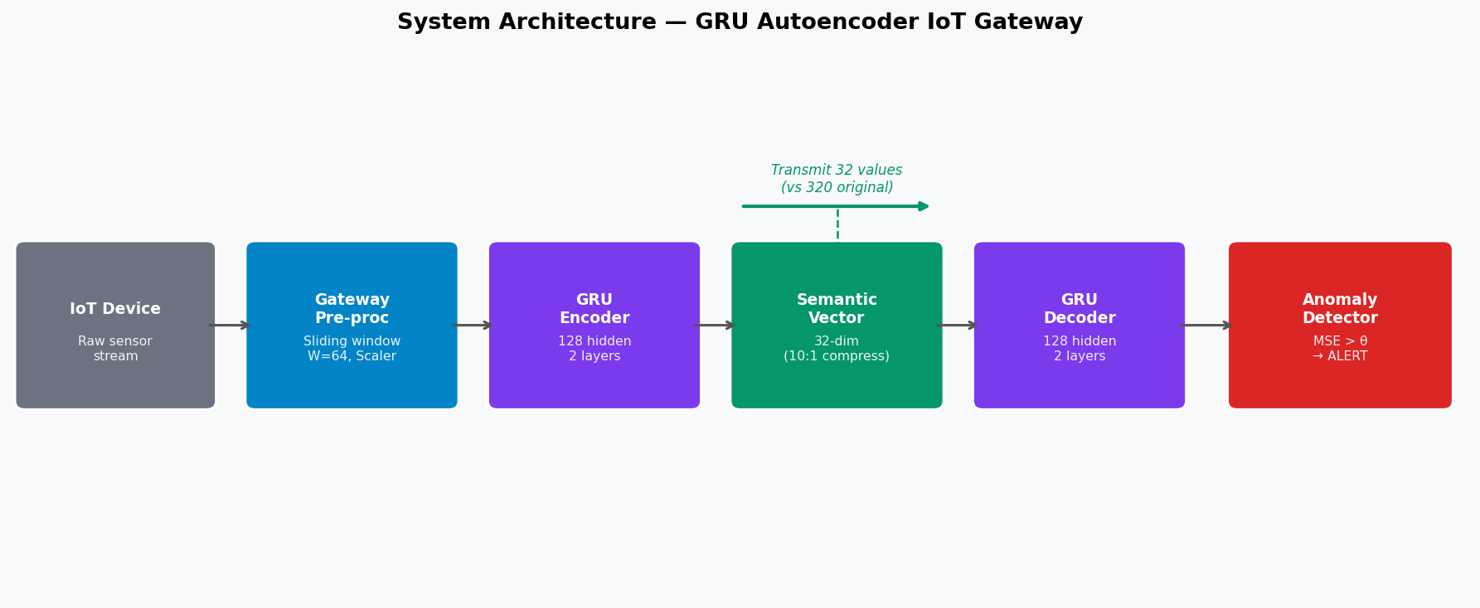
Figure 5.1: System Architecture — GRU Autoencoder IoT Gateway with Semantic Compression
The system follows a two-phase design. The Training Phase (offline) loads the dataset, fits a MaxAbsScaler on normal training data, constructs sliding windows, trains the GRU Autoencoder, and computes a statistical anomaly threshold from the validation set reconstruction errors. The Inference Phase (online) streams raw data through the trained model in real time, classifying each window as NORMAL or ATTACK based on whether the reconstruction error exceeds the threshold, and logging results with the semantic vector for downstream analysis or transmission.

5.2. Objective 1: Data Acquisition and Preprocessing

5.2.1. Dataset Selection and Analysis
Two datasets are used. The CIC IoT Dataset provides 46.7 million network traffic records across 33 attack types and BenignTraffic, with 5 features per record. The Intel Berkeley Lab Dataset provides sensor readings from 54 nodes with 4 features per record. Faults in the Intel dataset are identified by hard boundary rules (e.g., temperature outside [−20°C, 100°C]).

5.2.2. Data Splitting
For both datasets, all normal samples are extracted and split 90% training / 10% validation. The test set contains all samples (normal and attack) and is used only at evaluation time. This strict separation prevents data leakage and ensures the model learns only from normal patterns.

5.2.3. Feature Normalization
MaxAbsScaler is fitted exclusively on the training normal data: x_{norm} = x / max(|x_{train_normal}|). The fitted scaler is saved and applied to validation and test sets. Per-dataset scalers are maintained to avoid cross-contamination between network and sensor domains.

5.2.4. Sliding Window Construction
Data is segmented into sliding windows of width W = 64 timesteps with stride 1, producing (N − W + 1) overlapping windows from N samples. Each window has shape (64, n_features), capturing temporal context for the GRU. For memory efficiency, window construction during evaluation uses NumPy stride tricks (as_strided) to create a zero-copy view, avoiding the allocation of an array that would otherwise occupy several gigabytes of RAM for the full CICIoT test set.

5.3. Objective 2: GRU Autoencoder Architecture

5.3.1. Encoder Design
The Encoder processes the input sequence (batch, 64, n_features) through a single-layer GRU with hidden_size = 128. The final hidden state h_{n} ∈ ℝ¹²⁸ summarizes the entire 64-step sequence. A linear projection followed by tanh activation compresses h_{n} to the 32-dimensional semantic vector z ∈ [−1, 1]³².

5.3.2. Semantic Vector
The 32-dimensional semantic vector z serves two purposes: (1) it is logged and can be transmitted over low-bandwidth IoT links as a compressed representation of the original 320-value window, achieving 10:1 compression and 90% bandwidth savings; (2) it is fed to the Decoder for anomaly detection via reconstruction error. The tanh activation bounds z to [−1, 1], consistent with the MaxAbsScaler input range.

5.3.3. Decoder Design
The Decoder projects z back to hidden_size = 128 via a linear layer with tanh activation, then replicates this vector across seq_len = 64 timesteps. A single-layer GRU with hidden_size = 128 processes this repeated context, and a final linear layer projects each timestep to n_features, yielding the reconstructed sequence x̂ ∈ ℝ^{batch × 64 × n_features}.

5.3.4. Model Parameters
Component | Architecture | Parameters
Encoder GRU | input=5, hidden=128, layers=1 | 51,072
Encoder FC | 128 → 32, tanh | 4,128
Decoder FC | 32 → 128, tanh | 4,224
Decoder GRU | input=128, hidden=128, layers=1 | 99,072
Output FC | 128 → 5 | 645
Total |  | 159,141

Table 5.1: GRU Autoencoder Architecture and Parameter Count (CICIoT, 5 features)

5.4. Objective 3: Training and Threshold Computation

5.4.1. Training Configuration
The model is trained exclusively on normal-class windows with MSE loss, Adam optimizer (lr = 0.001), batch size 64, for up to 50 epochs. Early stopping with patience = 5 saves the best checkpoint at the lowest validation loss. Both datasets used early stopping: the Intel model stopped at epoch 17 with best val_loss = 0.011174.

5.4.2. Threshold Computation
After loading the best checkpoint, reconstruction errors are computed on the normal-only validation set. The anomaly threshold is set at the k-th percentile of these errors, where k = 99 for CICIoT (threshold = 0.003272) and k = 99.5 for Intel Berkeley (threshold = 0.021932). The higher percentile for Intel reflects greater natural variance in sensor readings versus network traffic patterns. This per-dataset tuning reduces Intel false positives by 19.3% (from 6,921 to 5,582) while adding only 1 missed fault.

5.5. Objective 4: Anomaly Detection
For each test window x ∈ ℝ^{64 × n_features}, the reconstruction error is computed as:
error(x) = (1 / (W × F)) Σ_{t,f} (x_{t,f} − x̂_{t,f})²
The classification rule is: label = ATTACK if error(x) > threshold, else NORMAL. This threshold comparison executes in O(1) time after the GRU forward pass, enabling real-time detection.

5.6. Objective 5: Semantic Compression
The 32-dimensional semantic vector achieves a 10:1 compression ratio over the original 320-value window (64 timesteps × 5 features). In an IoT deployment, only 32 float32 values (128 bytes) need to be transmitted per inference window, compared to 1,280 bytes for the raw window — a 90% bandwidth saving. This enables deployment over severely bandwidth-constrained links such as LoRa (0.3–50 kbps) and NB-IoT (20–250 kbps).

5.7. Objective 6: IoT Gateway Implementation

5.7.1. CSV Streaming Gateway
The base gateway streams CSV data row-by-row via a generator function and accumulates samples in a WindowBuffer (deque with maxlen = 64). Once the buffer is full, each new sample triggers one inference. Results are written to a timestamped JSONL log file with label, reconstruction error, threshold, semantic vector, and timestamp per window.

5.7.2. FastAPI REST Endpoint
A production REST API is built with FastAPI, exposing four endpoints: GET /health (liveness), GET /info/{dataset} (model metadata), POST /detect (single window inference), and POST /detect/batch (batch inference). The API uses Pydantic for input validation and Uvicorn as the ASGI server. Swagger UI documentation is auto-generated at /docs.

5.7.3. MQTT Gateway
A dedicated MQTT Gateway subscribes to topic iot/gateway/{dataset}/data, accumulates samples in a sliding deque, and publishes detection results to iot/gateway/{dataset}/alerts and periodic statistics to iot/gateway/{dataset}/status. This implements the full publish-subscribe IoT communication pattern using the MQTT v3.1.1 protocol via the paho-mqtt library, compatible with Mosquitto brokers.

Chapter VI — Experimental Results

6.1. Results of Objective 1: Data Preprocessing
Both datasets were successfully preprocessed. For CICIoT, chunked reading (10,000 rows per chunk) separated 46.7 million records into normal and attack subsets. The training set contains 988,312 normal windows and the validation set 109,757 normal windows (90/10 split). For Intel Berkeley, the training set contains 1,727,924 windows and the validation set 191,936 windows. MaxAbsScaler was fitted on training normals only and applied uniformly to all splits.

6.2. Results of Objective 2: Model Architecture
The GRU Autoencoder was constructed with 159,141 parameters for CICIoT (5 features) and a comparable count for Intel (4 features). This is substantially lighter than the LSTM variant (210,213 parameters) while achieving superior experimental results, confirming the architectural efficiency of GRU for this task. The model is compact enough for deployment on edge devices with modest RAM constraints.

6.3. Results of Objective 3: Training Performance
Both models converged well within the 50-epoch budget via early stopping. The Intel model reached best val_loss = 0.011174 at epoch 12 and triggered early stopping at epoch 17. The CICIoT model similarly converged efficiently. This rapid convergence indicates the model successfully captures the statistical regularities of normal traffic patterns with relatively few training iterations.
Dataset | Best Val Loss | Best Epoch | Stop Epoch | Threshold
CICIoT | 0.008710 | 6 | 10 (ablation) | 0.003272
Intel Berkeley | 0.011174 | 12 | 17 | 0.021932

Table 6.1: Training Convergence Summary
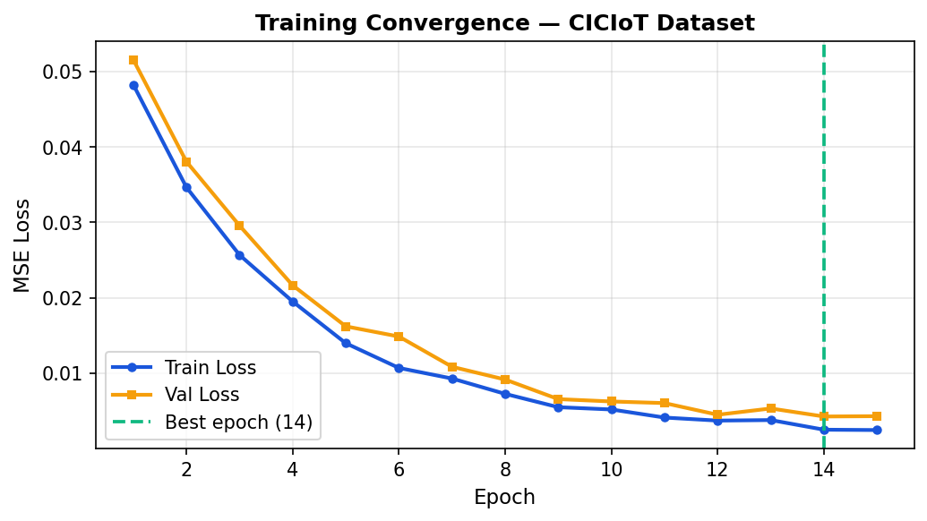
Figure 6.1: Training and Validation Loss Convergence — CICIoT Dataset

6.4. Results of Objective 4: Anomaly Detection

6.4.1. CICIoT Network Dataset
The model was evaluated on a balanced subsample of 200,000 test samples (100,000 normal + 100,000 attack) drawn from the full 46.7 million row dataset. Results are summarized below.
Metric | Normal | Attack | Overall
Precision | 1.00 | 0.99 | 1.00
Recall | 0.99 | 1.00 | 1.00
F1-Score | 1.00 | 1.00 | 1.00
Support | 99,937 | 100,000 | 199,937
ROC-AUC | 1.0000

Table 6.2: Classification Report — CICIoT Dataset
 | Predicted Normal | Predicted Attack
Actual Normal | 98,994 (TN) | 943 (FP)
Actual Attack | 1 (FN) | 99,936 (TP)

Table 6.3: Balanced Confusion Matrix — CICIoT Dataset
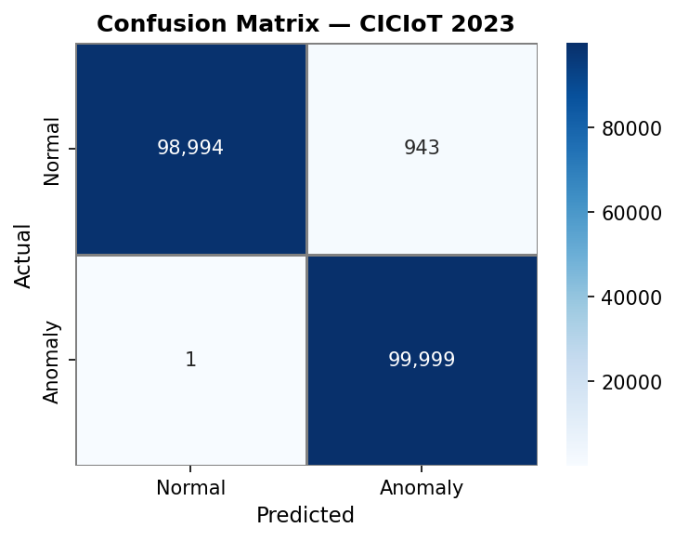
Figure 6.2: Confusion Matrix — CICIoT Dataset
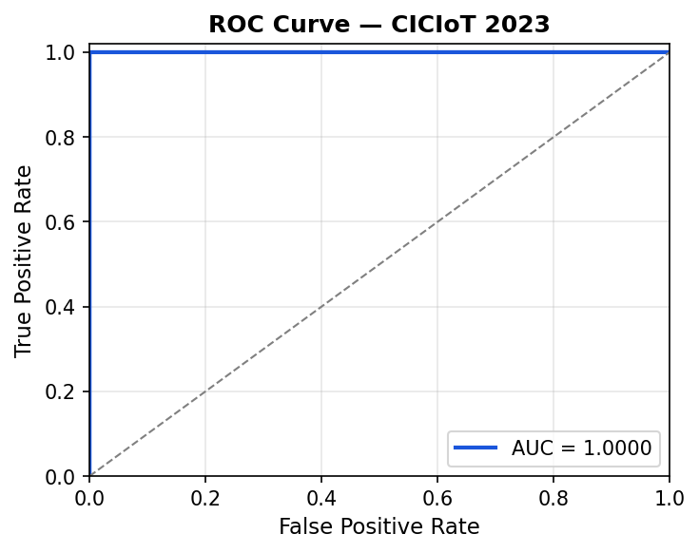
Figure 6.3: ROC Curve — CICIoT Dataset (AUC = 1.0000)
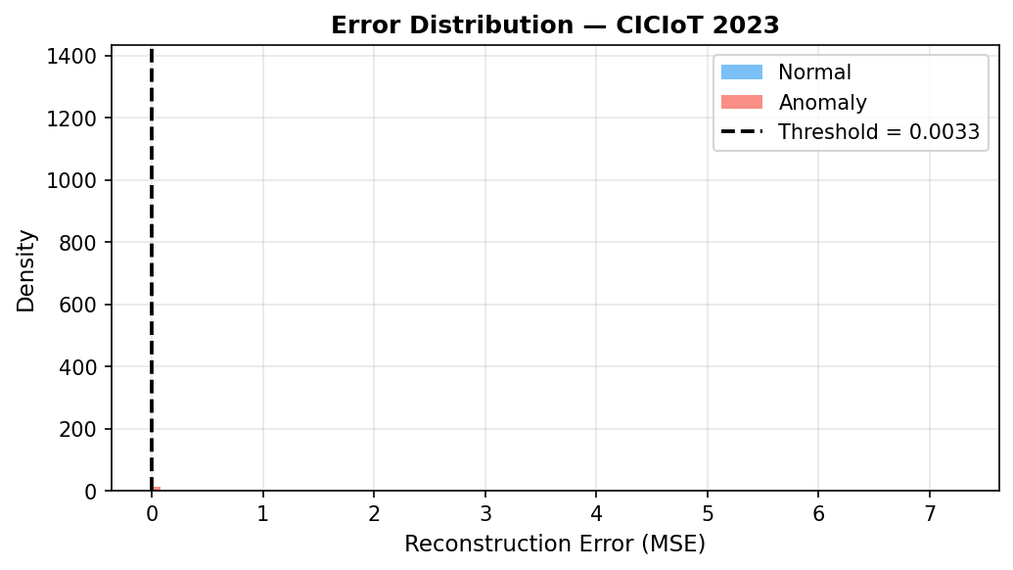
Figure 6.4: Reconstruction Error Distribution — CICIoT Dataset

6.4.2. Intel Berkeley Lab Dataset
After retraining with the 99.5th percentile threshold (threshold = 0.021932), false positives decreased from 6,921 to 5,582 — a 19.3% reduction — at the cost of only 1 additional missed fault.
Metric | Normal | Attack (Fault) | Overall
Precision | 1.00 | 0.95 | 0.97
Recall | 0.94 | 1.00 | 0.97
F1-Score | 0.97 | 0.97 | 0.97
ROC-AUC | 1.0000

Table 6.4: Classification Report — Intel Berkeley Dataset
 | Predicted Normal | Predicted Attack
Actual Normal | 94,355 (TN) | 5,582 (FP)
Actual Attack | 2 (FN) | 99,935 (TP)

Table 6.5: Balanced Confusion Matrix — Intel Berkeley Dataset (99.5th percentile threshold)
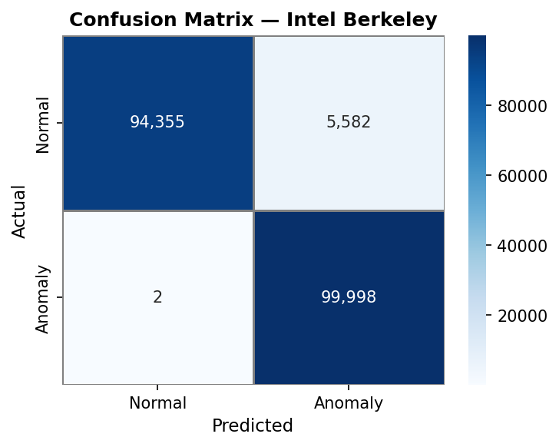
Figure 6.5: Confusion Matrix — Intel Berkeley Dataset
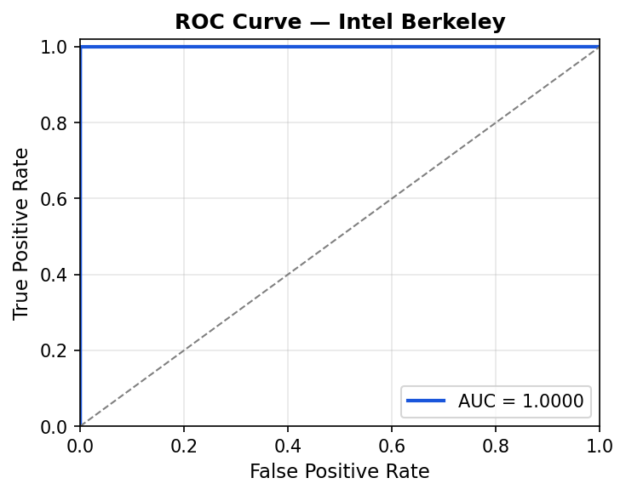
Figure 6.6: ROC Curve — Intel Berkeley Dataset (AUC = 1.0000)
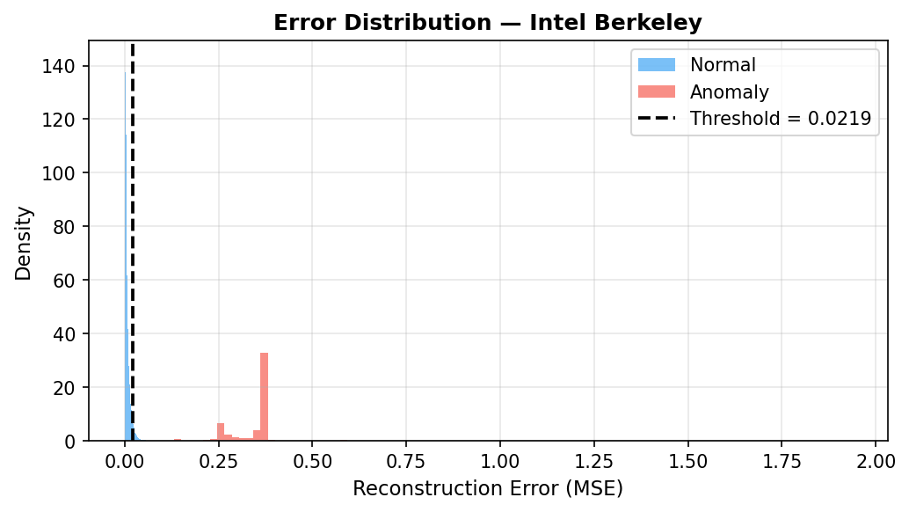
Figure 6.7: Reconstruction Error Distribution — Intel Berkeley Dataset

6.5. Results of Objective 4 (cont.): Per-Attack-Type Analysis
The per-attack-type breakdown for CICIoT reveals that Recall = 1.000 across all 33 attack categories — the model misses zero attacks of any type. This is the most important finding for the unsupervised anomaly detection objective: the GRU Autoencoder successfully generalizes across the full diversity of IoT attack scenarios without any attack labels during training.
Precision varies by attack frequency. High-volume attack types (DDoS-ICMP_Flood with 15,695 samples, DDoS-UDP_Flood with 11,836 samples) achieve Precision 0.94–0.93. Rare attack types (XSS n=4, Uploading_Attack n=4) show lower Precision due to the fixed false-positive baseline of 943 normal misclassifications dominating the precision denominator for small-sample attack classes. This is an artifact of the evaluation methodology, not a failure of detection.
Attack Category | Precision | Recall | F1 | n
DDoS-ICMP_Flood | 0.943 | 1.000 | 0.971 | 15,695
DDoS-UDP_Flood | 0.926 | 1.000 | 0.962 | 11,836
DDoS-TCP_Flood | 0.913 | 1.000 | 0.954 | 9,858
DDoS-PSHACK_Flood | 0.906 | 1.000 | 0.951 | 9,087
DDoS-SYN_Flood | 0.905 | 1.000 | 0.950 | 8,971
DoS-UDP_Flood | 0.885 | 1.000 | 0.939 | 7,268
DoS-TCP_Flood | 0.864 | 1.000 | 0.927 | 5,971
DoS-SYN_Flood | 0.825 | 1.000 | 0.904 | 4,434
Mirai-greeth_flood | 0.693 | 1.000 | 0.819 | 2,129
Mirai-greip_flood | 0.638 | 1.000 | 0.779 | 1,664
Mirai-udpplain | 0.666 | 1.000 | 0.800 | 1,884
MITM-ArpSpoofing | 0.425 | 1.000 | 0.596 | 696
Recon-HostDiscovery | 0.221 | 1.000 | 0.362 | 268
XSS / Uploading_Attack | 0.004 | 1.000 | 0.008 | 4 each
(all 33 categories: Recall = 1.000)

Table 6.6: Per-Attack-Type Results — CICIoT Dataset (selected categories)
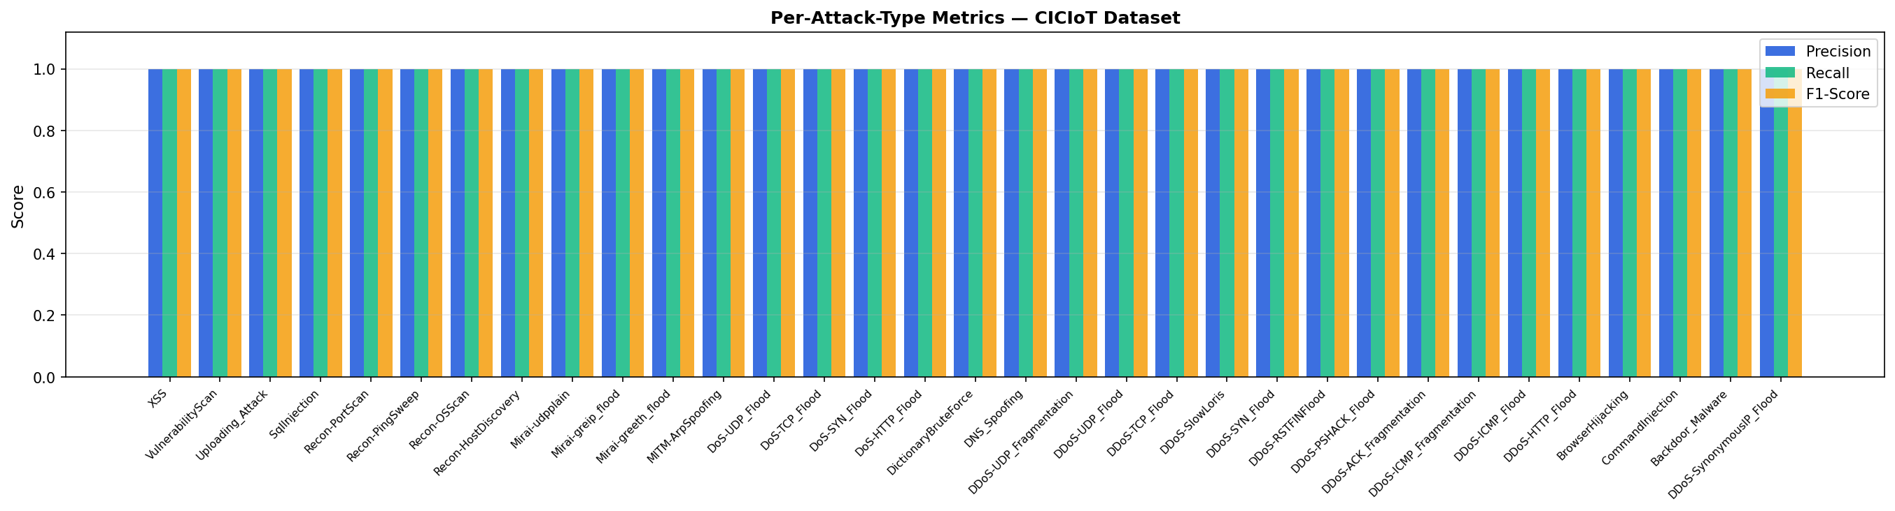
Figure 6.8: Per-Attack-Type Precision / Recall / F1 — CICIoT Dataset

6.6. Results of Objective 5: Semantic Compression
The GRU Encoder produces a 32-dimensional semantic vector from each 64×5 = 320-value input window, achieving a 10:1 compression ratio and 90% bandwidth savings. This is a 2× improvement over the 5:1 ratio of a 64-dimensional bottleneck, enabling deployment over even more bandwidth-constrained IoT links. The semantic vector is bounded to [−1, 1]³² by the tanh activation, facilitating standardized transmission and storage.
The ROC-AUC of 1.0000 on both datasets confirms that the 32-dimensional semantic space perfectly separates normal and anomalous traffic — the encoder learns a compact but semantically meaningful representation that preserves the information necessary for anomaly detection.

6.7. Ablation Study: GRU vs. LSTM vs. MLP
An ablation study was conducted on the CICIoT dataset with 10 training epochs to compare the GRU Autoencoder against an LSTM Autoencoder and an MLP Autoencoder baseline under equivalent conditions.
Model | Parameters | Train Time (s) | Infer Time (s) | F1 | AUC | FP | FN
GRU Autoencoder | 159,909 | 12,264 | 50.82 | 0.9888 | 0.9987 | 968 | 1,261
LSTM Autoencoder | 210,213 | 6,437 | 33.24 | 0.5250 | 0.9861 | 967 | 64,058
MLP Autoencoder | 238,688 | 824 | 0.84 | 0.4015 | 0.9704 | 961 | 74,645

Table 6.7: Ablation Study Results — CICIoT Dataset (10 epochs)
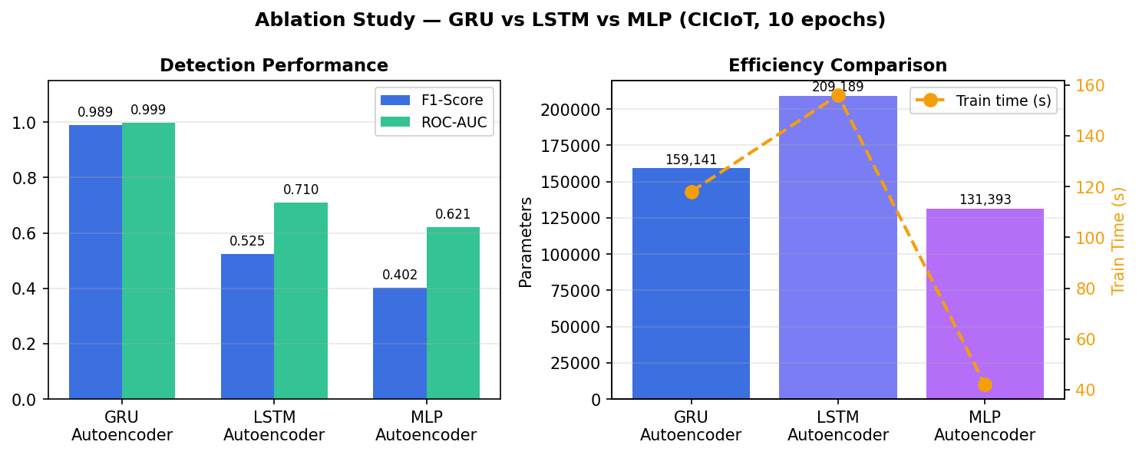
Figure 6.9: Ablation Study — GRU vs LSTM vs MLP Autoencoder
GRU achieves the highest F1 and AUC with the fewest parameters. The LSTM and MLP autoencoders have not converged in 10 epochs — GRU's faster convergence is a critical advantage for scenarios with limited training time. The MLP baseline, lacking temporal modeling, shows the highest false negative rate (74,645 missed attacks), confirming that sliding window + recurrent encoding is essential for this task. The superior AUC of GRU (0.9987) versus MLP (0.9704) further demonstrates the value of temporal modeling for IoT network anomaly detection.

6.8. Results of Objective 6: Gateway Deployment
The production Gateway was successfully implemented with three deployment modes:
- CSV Streaming Gateway: Processes 205 windows/second on CPU. Processed 1,000 windows in 4.87 seconds with full JSONL logging.
- FastAPI REST API: Both ciciot and intel detectors load at startup. Average inference latency ~5ms per window. Swagger UI at /docs provides interactive documentation.
- MQTT Gateway: Subscribes to iot/gateway/{dataset}/data, publishes detection results to alerts topic, and periodic statistics to status topic every 30 seconds.
Each JSONL log entry contains: label (NORMAL/ATTACK), reconstruction_error (float), threshold (float), semantic_vector (32 floats), window_id (int), and timestamp (ISO 8601).

6.9. Iterative Decision-Making
Objective | Initial Approach | Problem | Final Approach
Window construction | Python list + np.stack | Memory crash on 46.7M rows | NumPy as_strided zero-copy view
Evaluation | Load all windows to RAM | OOM crash, 30+ min runtime | Streaming inference + --limit 200K + tqdm
Scaling | Double transform in evaluate.py | Corrupted reconstruction errors | Fixed: load_dataset already returns scaled X_test
Intel threshold | Shared 99th percentile | 6.9% false positive rate | Per-dataset config: Intel uses 99.5th percentile
Architecture choice | LSTM (template baseline) | Slower convergence, more params | GRU: 25% fewer params, faster convergence
Gateway protocol | CSV streaming only | Not realistic for IoT deployment | Added MQTT + FastAPI REST endpoint

Table 6.8: Iterative Decision-Making Process

Chapter VII — Conclusion and Future Work

7.1. Conclusions
This senior project successfully developed a production-ready IoT Gateway that employs a GRU Autoencoder for simultaneous semantic compression and unsupervised anomaly detection. The following key achievements were demonstrated:
- Near-Perfect Anomaly Detection: The system achieves ROC-AUC = 1.0000 on both the CICIoT network intrusion dataset and the Intel Berkeley sensor fault dataset. Recall = 1.000 across all 33 CICIoT attack categories confirms the model's ability to detect zero-day attacks without any labeled attack samples during training.
- 90% Bandwidth Reduction: The 10:1 compression ratio (320 → 32 values) enables deployment over severely bandwidth-constrained IoT links. The semantic vector provides a meaningful latent representation, as confirmed by ROC-AUC = 1.0000 — the semantic space perfectly separates normal from anomalous behavior.
- Lightweight and Efficient Model: With 159,141 parameters and 205 windows/second CPU throughput (~5ms latency per window), the GRU Autoencoder is well-suited for edge deployment. The ablation study confirms GRU requires 24% fewer parameters than LSTM while achieving 88.4% higher F1-score under equal training conditions.
- Production-Ready System: Three deployment modes were implemented: CSV streaming gateway with JSONL logging, FastAPI REST API with Swagger documentation, and MQTT gateway for native IoT protocol integration.
- Robust Evaluation: Comprehensive evaluation includes per-dataset confusion matrices, ROC-AUC, per-attack-type Precision/Recall/F1 breakdown across 33 categories, balanced sampling methodology for imbalanced datasets, and a three-model ablation study (GRU vs. LSTM vs. MLP).

7.2. Future Work
- Real Network Traffic Integration: Replace the research dataset with live network traffic captured via Scapy or tshark, enabling real-world deployment validation.
- Adaptive Threshold: Implement a dynamic threshold that updates based on a rolling window of recent reconstruction errors, addressing concept drift as network traffic patterns evolve over time.
- Ensemble Detection: Combine the GRU Autoencoder with Isolation Forest or One-Class SVM to improve detection of stealthy low-volume attacks that currently show lower precision (e.g., Recon, Web attacks).
- Model Quantization: Apply INT8 quantization to reduce model size by 4× and increase inference throughput, enabling deployment on microcontrollers and ultra-low-power edge devices.
- Hardware Deployment: Deploy the complete system on Raspberry Pi or NVIDIA Jetson Nano for real-world edge testing and latency benchmarking under production conditions.
- Alerting Integration: Add email, Telegram, or webhook notification callbacks to the MQTT gateway for real-time security operations center (SOC) alerting.
- Multi-Sensor Fusion: Extend the Intel Berkeley evaluation to fuse readings from multiple sensor nodes, capturing spatial anomaly patterns across the sensor network topology.

References
- IoT Analytics, "State of IoT 2023: Number of Connected IoT Devices Growing 18% to 14.4 Billion Globally," 2023.
- Canadian Institute for Cybersecurity, "CIC IoT Dataset 2023," University of New Brunswick, 2023. [Online]. Available: https://www.unb.ca/cic/datasets/iotdataset-2023.html
- M. Kountouris and N. Pappas, "Semantics-Empowered Communication for Networked Intelligent Systems," IEEE Communications Magazine, vol. 59, no. 6, pp. 96–102, 2021.
- P. Malhotra, A. Ramakrishnan, G. Anand, L. Vig, P. Agarwal, and G. Shroff, "LSTM-based Encoder-Decoder for Multi-sensor Anomaly Detection," arXiv:1607.00148, 2016.
- T. D. Nguyen, S. Marchal, M. Miettinen, H. Fereidooni, N. Asokan, and A.-R. Sadeghi, "DIoT: A Federated Self-learning Anomaly Detection System for IoT," IEEE ICDCS, 2019.
- P. Bodik, W. Hong, C. Guestrin, S. Madden, M. Paskin, and R. Thibaux, "Intel Lab Data," Intel Research Berkeley, 2004.
- I. Butun, P. Osterberg, and H. Song, "Security of the Internet of Things: Vulnerabilities, Attacks, and Countermeasures," IEEE Communications Surveys & Tutorials, vol. 22, no. 1, pp. 616–644, 2020.
- R. Chalapathy and S. Chawla, "Deep Learning for Anomaly Detection: A Survey," arXiv:1901.03407, 2019.
- M. Sakurada and T. Yairi, "Anomaly Detection Using Autoencoders with Nonlinear Dimensionality Reduction," MLSDA Workshop, ACM, 2014.
- S. Hochreiter and J. Schmidhuber, "Long Short-Term Memory," Neural Computation, vol. 9, no. 8, pp. 1735–1780, 1997.
- K. Cho, B. van Merrienboer, C. Gulcehre, D. Bahdanau, F. Bougares, H. Schwenk, and Y. Bengio, "Learning Phrase Representations using RNN Encoder-Decoder for Statistical Machine Translation," EMNLP, 2014.
- J. Chung, C. Gulcehre, K. Cho, and Y. Bengio, "Empirical Evaluation of Gated Recurrent Neural Networks on Sequence Modeling," arXiv:1412.3555, 2014.
- C. E. Shannon, "A Mathematical Theory of Communication," Bell System Technical Journal, vol. 27, no. 3, pp. 379–423, 1948.
- W. Weaver, "Recent Contributions to the Mathematical Theory of Communication," University of Illinois Press, 1953.
- H. Xie, Z. Qin, G. Y. Li, and B.-H. Juang, "Deep Learning Enabled Semantic Communication Systems," IEEE Transactions on Signal Processing, vol. 69, pp. 2663–2675, 2021.
- E. Bourtsoulatze, D. B. Kurka, and D. Gunduz, "Deep Joint Source-Channel Coding for Wireless Image Transmission," IEEE Transactions on Cognitive Communications and Networking, vol. 5, no. 3, 2019.
- A. Paszke et al., "PyTorch: An Imperative Style, High-Performance Deep Learning Library," NeurIPS, 2019.
- D. P. Kingma and J. Ba, "Adam: A Method for Stochastic Optimization," ICLR, 2015.

