CliPP2 simulation study
  - Biological assumptions, staged comparisons, and validation protocol
Version 1.1 | November 6, 2026 | Aligned with workflow Protocol 2.1

1. Study purpose and revision decisions
This study evaluates two questions: whether the Stage 2 minimum-reference multiplicity cap improves reconstruction without excluding true mutation states, and whether subsequent full-support reassessment improves decisions given the reference that the earlier stages actually produced. Protocol 2.1 restores the original integer support in Stage 3. It does not refit the reference, recover missing candidates, or reassess mutations outside the selected target population [W1, Sections 8–14].
The primary mechanistic endpoint is true-multiplicity exclusion by the Stage 2 cap. The principal practical endpoints are correct resolution, wrong accepted assignments, false clonal merges, CCF error, and unresolved fraction. Stage 3 support retention is an exact implementation invariant under correct original CN and model-compatible truth; it is not evidence of correct assignment.
Generate physical chromosome-copy histories, SNV acquisition, regional clone mixtures, and read counts before applying the workflow. Derive integer multiplicities from those histories. Do not generate them by imposing the cap inequality that the study is intended to test. Preserve the project's integer-multiplicity assumption throughout the principal biological study.
The study has three levels: deterministic mechanism tests; fixed-reference experiments isolating read uncertainty and candidate availability; and complete estimated workflows. A cap can fail biologically even when the single-state observation model is exactly correct. Controlled source snapshots establish mechanisms; their frequency must be estimated separately with the actual fitter.

1.1 Changes required by Protocol 2.1
Protocol element | Revised simulation requirement
Stage 1 | Original integer support 1 through original major CN; free-centroid fitting.
Stage 2 | Keep the minimum of every qualified original-reference call as an upper cap; use original support when no call qualifies.
Stage 3 | One assignment pass, using original full support for every target and every candidate.
Unmerged Stage 2 members | Unchanged non-target population F and reference provenance; their multiplicity records do not determine support.
Former Stage 3 restrictions | Retire donor qualification, donor maxima/floors, no-donor fallback, cap–floor coupling, paired support-policy assignment, and support-stability labels.
Main comparison design | Five outputs A, B, C, B3, and C3; at most three fits and two assignment passes per dataset.
Main Stage 3 evaluation | Change from combined baseline, support/source-call containment, reference limitations, calibration, and reach of reassessment.

Retain free-centroid Stage 1/2 fits, membership-only clonal merging, the fixed all-one Stage 3 clonal candidate, native unmerged Stage 2 centroids, equal final-cluster priors, and multiplicity marginalization. Preserve original CN, counts, purity, masks, source estimates, and labels. This revision follows the supplied Protocol 2.1; earlier implementation documents require a compatibility audit and do not establish that the new workflow is already implemented [W1,W2].

1.2 Relationship to the earlier simulation benchmark
The legacy CliPPSim4k design varied purity, CNA rate, depth, and cluster number, with independently generated mutation-level CN, minimum CCF separation 0.2, and 50 replicates for each of 81 combinations [L1]. Retain it as a separate reproducibility benchmark when its generator and truth are available. The new core shares event histories among mutations in a segment, includes close and exactly aliased CCF explanations, and attributes errors to specific workflow stages. Equal weights across constructed families describe this design, not the prevalence of evolutionary histories in patients.

2. Biological assumptions and their testable implications
Mutation multiplicity depends on timing relative to copy gain and on which physical chromosome copy carries the mutation. Duplication can copy an existing mutation, whereas a later mutation or one on the other homolog need not be duplicated. Genuine clonal mutations in one segment can therefore have different integer multiplicities [1]. The examples below are constructed consequences of those mechanisms, not estimates of their population frequencies.
Assumption or choice | Required contrast or audit
One integer allele-specific CN state per region–segment | Validate a common state across cancer genotypes present in that region. Explicit mixed-state inputs are scope-rejection fixtures.
One integer multiplicity among carrier cells | Validate constant carrier-copy count and 1 ≤ true multiplicity ≤ original major CN for positive-carrier pairs.
A sampled all-region clonal reference is available and recognized | Adequate trunk evidence, absent assayed trunk mutations, near-clonal decoys, contamination, and unsampled lineages.
The smallest qualified reference call is a valid cap | Favorable histories versus higher-multiplicity clonal or subclonal remainder mutations.
Native call qualification protects the cap | Correct calls, finite-read errors, wrong native CCFs, and shared CN/purity errors.
Full Stage 3 support retains eligible truth | Exact containment under correct CN; distinguish inherited CN-support errors from implementation failures.
The frozen reference contains useful alternatives | Missing, duplicated, distorted, and unresolved candidates; K = 1; errors outside the target set.
Equal cluster and uniform regional multiplicity priors yield useful probabilities | A model-matched control versus selected, imbalanced, event-generated targets.
Additional regions improve discrimination | Distinct versus redundant clone mixtures, missing distinguishing regions, and fixed total depth.

2.1 The remaining ordering hypothesis concerns Stage 2
Let Rrs be the qualified calls from the preserved Stage 1 reference G0 in region r and segment s. With a nonempty qualified set and correct contributor multiplicities, the truth-derived cap is:
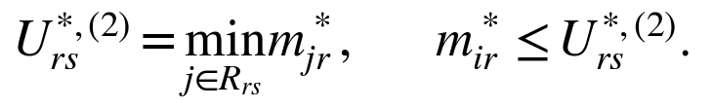
The inequality must hold for every original-eligible Stage 2 remainder pair with positive true carrier prevalence and a defined integer multiplicity. Such pairs include both biologically clonal and subclonal mutations. At true CCF zero, support still follows the numerical contract, but no biological multiplicity accuracy or truth-exclusion outcome is scored. The remainder can contain true clonal mutations that Stage 1 split from, missed, or allocated outside G0. Clonality and common segment membership alone do not establish this ordering.
The estimated cap replaces contributor truth with accepted native Stage 1 calls. If the qualified set is empty, the cap is original major CN. Qualification uses the native Stage 1 CCF, not the imposed all-one assignment center. Stage 1 support must equal original full support, so native-support and original-support qualification are one calculation with an explicit equivalence audit [W1, Section 6.2].

2.2 Stage 3 replaces the ordering hypothesis with containment
For a model-compatible positive-carrier pair with correct supplied CN:
It follows directly that the true integer is retained in Stage 3. Every genuine valid native source call is also retained because accepted Stage 2 support is a subset of original support. These guarantees apply to all candidates, including those whose native centroids were learned under a cap.
Containment does not guarantee that the true CCF candidate remains available, that a native capped centroid is accurate, that the mutation belongs to the reassessment population, or that the data distinguish multiplicity from CCF. Nonzero Stage 3 exclusion in the correctly specified core is an implementation or data-integrity failure. If supplied major CN is too small, exclusion is inherited from the input support and is reported separately.

3. Derive the simulation and inference models

3.1 Generate clones, copies, and current carrier populations
Let v index extant malignant genotypes and fvr their regional cancer-cell fractions. Fractions are nonnegative and sum to one in each region. An ancestral genotype may persist alongside descendants. Store each segment copy's parental homolog, copy ID, parent-copy ID, and mutation set. An SNV is placed on an existing copy; gain duplicates that copy and its mutations; deletion removes it; WGD duplicates all copies. Copy-neutral LOH records loss and replacement by retained-homolog copies. Descendants inherit their parent's physical-copy state.
Keep parental homolog identity separate from final major/minor labels. Generate CN at segment level. When breakpoints differ, track common atomic intervals and derive the original regional segment map. Let Viv be mutant-copy count for mutation i in genotype v, and Cvs total CN for genotype v in segment s. Then:
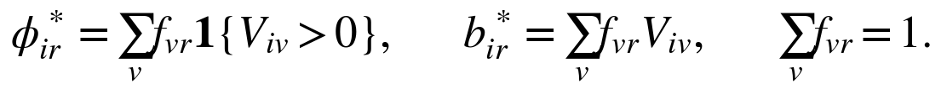
The first quantity is current carrier-cell prevalence; the second is mean mutant-copy burden per cancer cell. Record acquisition branch, current carriers, sampled CCF vector, and ubiquity in any unsampled lineages separately. Mutation loss can separate acquisition history from current carrier prevalence [4]. The fitting target is the observable CCF partition; different branches with the same sampled CCF vector need not be distinguishable. A group that is clonal in one region can remain subclonal across the full sampled vector [2].

3.2 Derive the read probability from copy contributions
Normal cells contribute no mutant copies in this somatic-SNV model. With purity rho and normal CN CN, total-copy contribution is the weighted normal plus malignant contribution. Consequently:
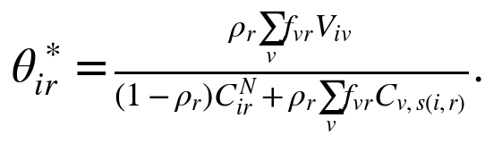
This general expression validates the simulator; it does not introduce mixed-state inference. In the principal study, every cancer genotype present in a region shares the reported allele-specific state (A,B), and every carrier of a mutation in that region has the same positive integer multiplicity m*. Exclude recurrent acquisition or copy histories violating the declared 1-through-major-CN support. The malignant total-copy sum is then A+B and the mutant-copy sum is m*phi*, giving exactly:
Validate this reduction for every core pair before generating reads. For absent mutations, CCF is zero and no biological multiplicity accuracy is scored. Generate depth N and ALT count Y conditional on depth:
Distinguish observed zero ALT at positive depth, zero depth, missing measurement, and explicit exclusion. For the primary acquisition grid, use Poisson depth with each specified regional mean; additional coverage-dispersion models belong to a labeled sensitivity panel.

3.3 Derive the one-pass Stage 3 assignment likelihood
At fixed reference candidate k and multiplicity m, predicted read probability is a m phi-ref. Uniform prior mass 1/A on each integer gives the regional emission:
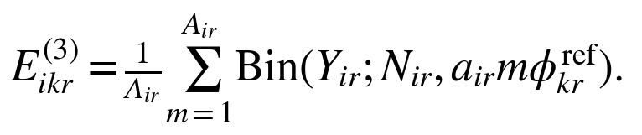
Independent regional multiplicity priors make the multi-region marginal likelihood a product of these sums; no Cartesian enumeration is required. Let b be the endpoint-safe binomial log mass and Oi the informative observed regions. Then:
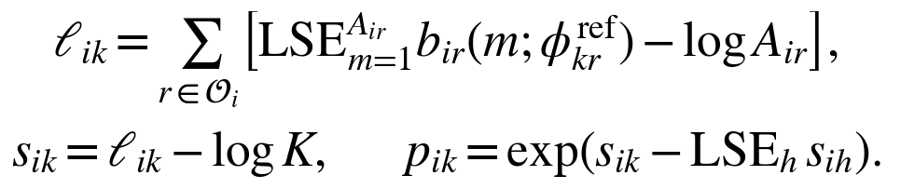
The candidate prior is 1/K, independent of source-group size, fitted mixture weight, or number of merged groups. Original CN always determines D. No empirical multiplicity frequency or native conditional posterior replaces the uniform prior. Minus log A and minus log K cancel in within-target relative probabilities but remain in absolute likelihoods and scores. A normalized posterior alone cannot detect their omission [W1, Sections 11–12].
Validated CN, CCF in [0,1], and m ≤ A keep read probabilities in [0,1]. Preserve exact endpoints: positive ALT at probability zero and positive REF at probability one have zero likelihood. A target without informative observations receives missing probabilities, not the formal empty-product prior. All-impossible candidates give an incompatible result, not a uniform vector. NaNs and invalid inputs are integrity failures.

3.4 Separate conditional multiplicity from read fit
At the displayed best candidate k*, conditioning the same joint model on that candidate cancels the uniform multiplicity weight. The regional distribution is:
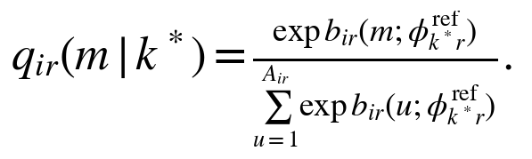
This quantifies multiplicity uncertainty at a particular center; it is not a joint guarantee about that center and the true multiplicity. Native source calls remain separate. For read-fit screening, compare the best permitted component with the saturated binomial fit at observed ALT fraction Y/N:
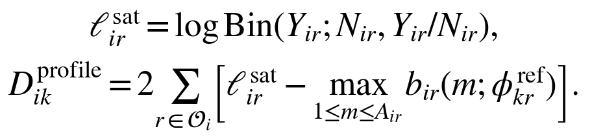
The maximization serves only this discrepancy. Membership uses the marginalized likelihood from Section 3.3. The target mean discrepancy divides by the number of informative regions; missing and excluded regions enter neither term nor denominator. A marginal discrepancy defined using ell instead of the component maximum includes the mixture normalization and is a different statistic.

3.5 Derive what support restoration can and cannot improve
At the same fixed center, let SU sum binomial masses over 1 through Stage 2 cap U, and Sadded sum those over U+1 through A. If SU is positive:
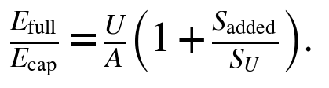
Restoration adds explanations but changes their normalized prior weights. Marginal likelihood and assignment confidence need not increase. At the same fixed center, the conditional MAP stays unchanged or switches to an added integer above U; it cannot move to a smaller integer under the smallest-maximizer tie rule. If the best candidate changes, no such ordering of the reported conditional MAP is guaranteed. The maximum component likelihood cannot decrease at a fixed center, so its profiled residual cannot worsen. These fixed-center diagnostics do not create a second production assignment policy.
For an integer retained from the capped support, the conditional probability has the exact relationship below. It cannot increase at the same center merely because support is enlarged:
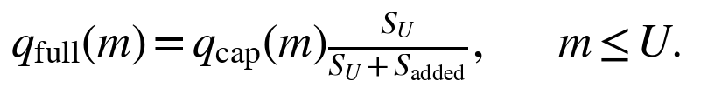

4. Deterministic biological and numerical mechanism cases

4.1 A cap from a correct reference call excludes a true clonal remainder
Place trunk mutation E on homolog H1 and trunk mutation R on H2; duplicate H1 on the trunk. Final CN is (2,1), and both mutations are clonal, with multiplicities 2 and 1 respectively. In a declared controlled Stage 1 split, G0 contains R while E enters the Stage 2 remainder. A correct R call sets cap 1 and excludes E's true multiplicity.
At sufficient depth, E's expected VAF cannot be matched by m = 1 and CCF ≤ 1. A discrepancy screen may prevent its clonal merge. If its group remains unmerged, E belongs to F and Stage 3 never reassesses it. If E enters a merged target group, Stage 3 restores m = 2, but assignment still depends on the frozen reference. Measure both branches. A perfect CCF partition would initially put E and R together; this controlled split tests the recovery problem, not an oracle's expected partition.

4.2 Cap-induced false clonality can survive restoration
Place trunk mutation R on H2, split into two equally abundant lineages, and place mutation D on H1 in one lineage before independently duplicating H1 in both. Both lineages end at CN (2,1), satisfying the single-state model. R is clonal with multiplicity 1; D has multiplicity 2 and CCF 1/2. Thus:
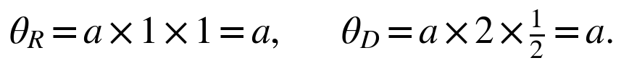
A cap of 1 derived from a correct reference call gives D the exact alternative explanation m = 1, CCF = 1. If D merges and no subclonal reference survives, Stage 3 cannot invent the missing CCF = 1/2 candidate. With K = 1, a compatible clonal candidate has relative probability one even though D is biologically subclonal. If the subclonal candidate remains, full support retains both latent explanations without guaranteeing resolution.
Repeat with regional lineage fractions (0.35, 0.50, 0.65, 0.80), retaining final CN (2,1). This breaks the exact clonal-versus-half-prevalent alias. For a matched missingness control, use fractions (0.50, 0.50, 0.50, 0.65), so only the final region distinguishes the explanations. Mask that observation to restore exact equality across informative regions. Separate exact aliasing, weak information, and identifiable configurations.

4.3 Low-multiplicity clonal targets remain supported but can be ambiguous
Add trunk mutation E on H1 before the parallel gains. The three classes are E: m = 2, CCF = 1; R: m = 1, CCF = 1; and D: m = 2, CCF = 1/2. In a controlled complete frozen reference with clonal and half-prevalent candidates, R's true clonal explanation and the alternative subclonal explanation both predict a. Stage 3 must include multiplicity 1 regardless of qualification outcomes or multiplicities recorded for F.
At high depth, one exactly matching component per candidate with the same support weight makes their evidence approach equality in this construction. At finite depth, other mixture components can favor a candidate; equality of one component pair does not require equal marginal posteriors. Do not require the ordinary fitter to distinguish count-identical classes in order to pass this controlled-reference fixture.

4.4 Restore original support after capped fitting
Use original A = 4, B = 0, purity 1, ALT 2, REF 1, and fixed CCF 1. Binomial masses for multiplicities 1, 2, 3, and 4 are 0.140625, 0.375, 0.421875, and 0. Under Stage 2 cap U = 2, the emission is 0.2578125. Under full Stage 3 support, it is 0.234375 and the conditional MAP becomes 3 with probability 0.45.
Verify restoration for newly merged Stage 2 targets and every candidate label, including native capped reference centers. A fresh Stage 3 support view must use original major CN, never a cached cap. This case tests support, denominator preservation, normalization, and MAP changes; it is not a biological accuracy claim.

4.5 Separate unused-record invariance from reference sensitivity
Freeze target data, original CN, masks, candidate labels/centroids, priors, and thresholds. Change, permute, or remove unused multiplicity records belonging to F. All Stage 3 supports, scores, probabilities, and decisions must remain identical. Separately perturb or replace a reference centroid to measure genuine reference sensitivity. Refitting after changing F is not an invariance test because the learned reference may legitimately change.

4.6 Include valid non-applicable and incomplete-reference cases
Include no eligible clonal reference, valid empty Stage 2 remainder, nonempty Stage 2 with an unsupported region, empty target requests, no qualified Stage 2 contributors, K = 1, duplicate candidate vectors, and a globally subclonal group with regional CCFs (1, 0.65, 0.25). Include unresolved unmerged groups as candidates with their flags. A failed fit does not establish subclonality, and posterior one does not establish adequate fit.

5. Scenario families and retained integer scope
Use twelve families, varying independent event histories and regional mixtures within each. Controlled source snapshots and estimated end-to-end runs are distinct result strata.
ID | Family | Main question
S01 | Diploid, single-copy null | Are full-support calculations and expected unchanged behavior correct?
S02 | Shared trunk gains followed by single-copy subclonal SNVs | When does a biologically valid Stage 2 cap help?
S03 | Mixed clonal timing/homolog classes in the remainder | Does the cap exclude high-multiplicity clonal mutations, and can reassessment reach them?
S04 | Parallel gains with equal final CN | Can a cap from correct reference calls create false clonality and remove a necessary alternative?
S05 | Mixed clonal multiplicities and newly merged targets | Does Stage 3 restore all original integers while exposing remaining ambiguity?
S06 | WGD timing and shared evolutionary history | How do integer multiplicities and cross-region dependence affect fitting and calibration?
S07 | Globally subclonal, locally clonal groups | Are full CCF vectors used and valid local CCF-one observations preserved?
S08 | Near-clonal selection, contaminated G0, and false merges | How do tolerance and reference selection propagate into the all-one candidate?
S09 | Sparse/dense contributors and minimum-call errors | How does one low call or low-multiplicity class change the Stage 2 cap?
S10 | Missingness, zero ALT, exclusions, and absent reference evidence | Are fallback, skip, no-information, and incompatible branches distinguished?
S11 | Missing, duplicated, or distorted reference candidates | Which errors persist because the reference is incomplete or a mutation lies in F?
S12 | Exact and approximate multiplicity–CCF aliases | When do full support, more regions, and greater depth still fail to identify truth?

S06 includes shared-trunk WGD and parallel lineage WGD after selected lineage-specific mutations, constrained to common final CN and constant integer carrier multiplicity in each region. Histories are validated before counts; multiplicities are never repaired afterward to make a cap valid. Shared events can correlate regional multiplicities even though the inference prior factorizes across regions.
Classify cap validity pair by pair and segment by segment. Do not discard a model-compatible history because it violates the cap inequality. Record histories outside the single-state/integer-support scope separately; do not mix them into the main accuracy denominator.

5.1 Technical sensitivities with integer biological truth
Use selected base histories for purity error, wrong integer CN, segment-map errors, overdispersion, mapping bias, and discovery-related masks. Proposed settings are design choices, not prevalence estimates: purity offsets ±0.05 and ±0.10 with valid resampling; one-copy major/minor errors in 5% and 15% of segments; and boundary/mapping perturbations in 5% and 15% of intervals. Validate supplied CN and genuine mapping status. Keep generated reads unchanged when perturbing inference inputs.
For overdispersion, use beta-binomial intraclass correlations 0.01 and 0.05, with binomial sampling as the zero control. For interior true probability theta, set kappa = 1/eta − 1, draw p from Beta(theta kappa, (1 − theta) kappa), then draw ALT counts at p. Handle exact endpoints separately. For allele bias, multiply true ALT odds by 0.8 or 1.25. Begin with single perturbations and add a small prespecified combined panel.
Fractional effective multiplicity and hidden mixed-state cancer CN are not alternative models in this revised principal study. Explicit unsupported-input examples can test scope rejection. Any future biological misspecification study relaxing these assumptions requires a separately identified extension and separate conclusions.

6. Comparisons that identify each stage's contribution

6.1 Five outputs from three fits
Fit Stage 1 once and freeze its selected G0. Fit exactly the same remainder outside G0 using original support and using the qualified-reference cap. Each resulting frozen reference receives one full-support Stage 3 pass.
Output | Execution | Required evaluation view
A | Native Stage 1 with original support | Native membership, centers, multiplicities, and selected G0.
B | Stage 2 with original support on the fixed remainder | Native remainder fit and screened combined membership/reference.
C | Stage 2 with the reference cap on the same remainder | Native remainder fit and screened combined membership/reference.
B3 | Full-support Stage 3 using B's frozen reference | New target assignments and unchanged B non-target memberships.
C3 | Full-support Stage 3 using C's frozen reference | Production Protocol 2.1 outcome.

B and C share G0, original counts, CN, purity, masks, region axes, fitting settings, and paired algorithm seeds. Preserve both their native and combined pre-assignment views; these require extra reporting, not extra fitting. B versus A on the common remainder before merging measures removal/refitting effects. Comparing native and combined views within B or C reveals the membership-merge effect. C versus B on native remainder outputs measures the cap's fitting effect; its combined-view contrast also includes changed merge decisions.
B3 versus B and C3 versus C measure reassessment from each workflow's own combined baseline. This includes the fixed all-one assignment center, equal candidate priors, and decision rules; it is not solely a support-restoration effect. C3 versus B3 measures downstream cap consequences, including altered centroids, candidate count, merges, and targets. Both Stage 3 arms use full support. The uncapped comparator is a simulation qualification arm, not an extra production requirement.

6.2 Freeze targets, unchanged members, and references separately
For each Stage 2 arm h, targets are G0 plus members of its merged Stage 2 groups; Fh contains accepted members of its unmerged groups. Require:
Here Ch is the accepted combined population, Q2 the number of accepted Stage 2 groups, and M the number merged. The reference has one all-one clonal candidate and every unmerged native Stage 2 vector. Merged groups are not duplicate candidates. Keep all candidates and equal priors even when a candidate attracts no accepted targets. Preserve native source estimates instead of averaging or overwriting them.
The three group classifications are clonal-merge eligible, nonclonal, and unresolved. Nonclonal requires adequate coverage/native diagnostics and failure of the strict L2 criterion; inadequate evidence or failed screening remains unresolved. Unresolved unmerged candidates retain their flags. F memberships remain unchanged; Stage 3 supplies them no new probabilities or conditional multiplicities [W1, Sections 9–10].
Compare practical outcomes on the common original mutation universe, retaining filtered, unresolved, and unavailable results. Report G0, newly merged targets, FB/FC, target intersection, and each arm's exclusive targets. A supplementary comparison on TB intersect TC holds target identity fixed but does not hold centers, candidate composition, or K fixed. A prespecified external target panel scored against both learned references and a complete true reference isolates reference differences without each workflow's target-selection difference.

6.3 Truth-based interventions and read reuse
First calculate caps from true multiplicities in declared source sets before generating reads. This establishes structural validity without an optimizer. Next estimate contributor calls at true fixed CCFs to isolate read uncertainty and qualification. After ordinary fitting, replace calls for the exact same selected contributor IDs with truth while keeping the IDs fixed. A cap still excluding truth after that substitution implicates biological ordering or source selection, rather than call error alone.
If a selected contributor has zero true carrier prevalence or lacks a defined scalar integer truth, mark call-only substitution as not evaluable for that region–segment and attribute this limitation to source/reference selection. Do not substitute zero, invent a positive truth, or remove that contributor while claiming to hold contributor IDs fixed.
Such substituted calls are diagnostic counterfactuals, not newly accepted native fits. Changing cap metadata alone cannot change Stage 3 at fixed targets and centers. An intervention intended to repair cap-induced reference error must rerun Stage 2, merging, and Stage 3, with its additional fits budgeted separately. Requalifying at true centers or replacing G0 with all true clonal mutations is another intervention that changes selection. Keep the actual selected-set experiment so residual clonal mutations remain testable.
Score a common target panel at complete true centers and learned B/C references to separate likelihood ambiguity from reference error. The principal workflow reuses reads for fitting, selection, merging, and reassignment. An auxiliary independent-count audit freezes the reference and targets using the first count sample, then scores a second sample from the same latent tumor. Also use a fixed-total-depth split experiment when assessing reuse without extra sequencing. Whole-procedure uncertainty requires repeating the relevant upstream stages, not only resampling assignments at a favorable fixed reference.

7. Acquisition grid, sample sizes, and computation budget

7.1 Proposed primary and development designs
Use four regions, approximately 1,500 mutations, and 50 segments as the default scale. The standard tree has four observable CCF groups: trunk, an ancestral subclone, its descendant, and a sibling. Generate nonnegative extant proportions, then derive CCFs by summing carriers, preserving tree constraints. Family-specific mechanisms may require other group counts. Allocate mutation counts separately from cancer-cell fractions.
Generate 50 independent histories per family. Render each at the four acquisition settings below, with paired seeds across methods. These are repeated observations of a history, not four independent biological replicates. Purity, coverage, and CN are relevant to subclonal detectability [3]; the particular grid values below are proposed study settings.
Setting | Purity in each region | Mean depth per region
A1 | 0.30 | 100
A2 | 0.30 | 500
A3 | 0.80 | 100
A4 | 0.80 | 500

Panel | Histories | Datasets | Maximum fits | Maximum Stage 3 passes
Main: 12 × 50 histories, four acquisitions | 600 | 2,400 | 7,200 | 4,800
Development: 12 × 10 histories, two corners | 120 | 240 | 720 | 480
Combined core | 720 | 2,640 | 7,920 | 5,280

The development histories are disjoint from the main cohort. Use low-information and high-information corners and a representative timing subset. Freeze templates, primary cells, seeds, thresholds, evaluation rules, and source/build identities before generating or inspecting final-cohort outcomes. Valid skip branches reduce the listed maxima. These are job counts, not runtime predictions. Removing a duplicate assignment halves main scoring-pass count from 9,600 to 4,800, but does not imply a measured twofold runtime improvement.
If the timing pilot makes the budget impractical, reduce a balanced design before opening final outcomes. Preserve every mechanism family and paired arm. Do not stop or expand a cell based on whether it favors the workflow.

7.2 Targeted panels and explicit optional costs
Avoid a full Cartesian product. Use matched sensitivities for region count 1, 2, 4, 8; depth 30, 100, 300, 1,000; purity 0.2, 0.5, 0.9; and heterogeneous regional acquisition. Compare fixed depth per region with fixed total depth. Derive additional regional mixtures from the same latent tree.
Vary available Stage 2 reference-contributor counts per segment across 0, 1, 5, 20, and 100 in controlled panels with target population fixed. Report actual qualified counts. Use CCF contrasts near 0.02, 0.05, 0.10, and 0.20 where tree constraints permit; mutation-group fractions 1%, 5%, 20%; and K = 2, 4, 8 in selected cases. Include K = 1 as a separate branch fixture.
A proposed optional reference panel uses S03, S04, S05, S11, and S12, with 20 prespecified main histories per family and two acquisition corners: 200 datasets. Scoring one external panel against B, C, and complete true references adds 600 assignment passes and no native fits. Independent second-count scoring at B/C adds 400 passes. A two-fold fixed-total-depth experiment that refits three fits and evaluates two references per training half adds 1,200 fits and 800 passes. These additions are optional, outside the core budget, and must be selected before results are inspected. Corrected-cap refits and other sensitivities require their own enumerated ledger.
For scaling, use 1,000, 5,000, and 20,000 mutations with 2, 4, and 8 regions and moderate/high major CN. Measure elapsed time and peak memory. Stage 3 work scales with K times the sum of original major CN over informative target pairs; complete-mutation batching controls memory. Candidate count alone is not a runtime predictor.

7.3 Precision and independent units
For a paired tumor-history difference delta, use independent histories as the sampling units:
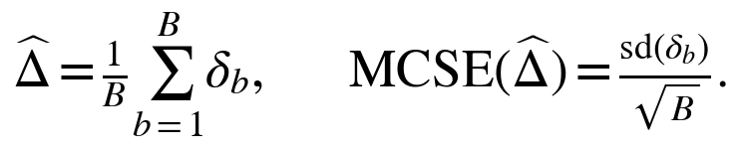
Use a paired bootstrap over histories, carrying all methods and acquisition renderings together. Shared segments, purity, fitted centers, and contributors prevent mutation-level independence. Report each family and an explicitly equal-weighted macro-average. With 50 independent histories, a binary tumor-level outcome has worst-case MCSE about 0.071. The main panel estimates substantial effects, not negligible rare-error risk.
For a claim about a tumor-level harmful-event rate below 1%, predeclare at least 300 independent histories in that critical cell. Zero events then gives an approximate one-sided 95% upper bound of 3/300; nonzero events require an appropriate interval. A precision-driven extension must be specified before inspecting whether the effect favors the method.

8. Evaluation endpoints, denominators, and reassessment reach

8.1 Stage 2 truth exclusion and Stage 3 containment
Define V2 as original-CN-eligible, positive-carrier mutation–region pairs with validated integer truth in the actual Stage 2 remainder. Evaluate all such pairs, then the informative observed subset, to distinguish structural exclusion from its immediate read-level impact. For the capped arm C:
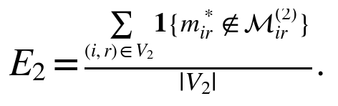
Report pair-, mutation-, segment-, and tumor-level exclusion, including the fraction of tumors with any affected pair. A zero denominator is not applicable. In supplied-CN-error panels, separate truth already outside supplied original support from additional exclusion by the cap. Count additional exclusions over both all V2 pairs and the subset whose truth remains inside supplied original support. Keep originally excluded observations in population/status accounting.
For every eligible Stage 3 target–region pair and every candidate, require exact equality with original support. For genuine valid observed native source calls, require containment:
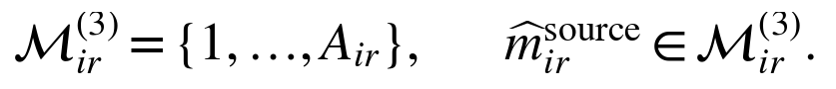
Both violation counts must be zero in qualified runs. True-integer exclusion must also be zero under correct supplied CN and the principal biological model. Record inherited CN-support defects separately. Missing source calls remain missing; containment does not prove call accuracy or compatibility with the imposed all-one center [W1, Sections 11, 15–17]. Stratify targets into qualified G0 contributors, other G0 members, and newly merged Stage 2 members. Do not score biological multiplicity where true CCF is zero.

8.2 Reference construction, clustering, CCF, and multiplicity
Measure true-clonal availability, selected-G0 purity, true clonal mutations left outside G0, and segment/multiplicity-class coverage. Distinguish appropriate no-reference outcomes from failure to recognize an available reference. Biological clonal truth requires CCF one in every requested region; tolerance-based eligibility is a separate decision.
Report newly merged nonclonal mutations over all newly merged mutations and over all true nonclonal Stage 2 members. Report unmerged true clonal mutations over all true clonal Stage 2 members. Include group-level counts and unresolved classifications with explicit denominators.
For A, B, and C, report ARI, pairwise co-clustering precision/recall, and observable-CCF-group count error on the common accepted population. Keep native and combined-membership views separate. For CCF error, distinguish three estimates: preserved native source centers; constructed reference centers, including all-one coordinates; and centers of newly accepted assignments. Compute mutation–region RMSE over known truth with available estimates and report coverage. Reference-center imposition and reassignment can make different contributions to that error.
For informative positive-carrier pairs, report multiplicity exact-call accuracy, absolute error, qualified-call coverage, and qualified-call correctness. Separate conditioning on true centers from conditioning on learned or wrongly selected centers. After Stage 3, use accepted-only partition metrics with coverage; unresolved targets must not become one artificial cluster. Preserve reference K separately from occupied accepted labels.

8.3 Assignment denominators and before/after transitions
For each of B3 and C3, define evaluable targets before thresholding: targets with biological truth and at least one informative observation. Filtered/no-information targets are reported separately. Incompatible, tied, low-confidence, and unresolved-fit targets remain in the evaluable denominator. Numerical failures are unavailable analyses, not scientific abstentions; report their rates over all planned cells.
Let Neval count evaluable targets, Nacc accepted targets, Nc correctly accepted targets, and Nw wrongly accepted targets:
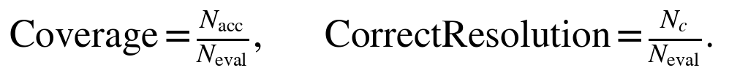
Selective error is undefined at zero acceptance. Against exact biological clonal truth, score whether an accepted label is the designated clonal candidate; retain every unmerged candidate's nonclonal or unresolved quality flag. This measures correct membership in the designated clonal group, without declaring every unmerged group biologically subclonal. Use this endpoint and CCF error as primary outcomes. Multiclass correctness is primary with true references and secondary with learned references under Section 8.6.
Compare each target with its combined pre-assignment clonal membership. Calculate transitions separately for the primary clonal decision and secondary multiclass endpoint:
Baseline decision | New accepted outcome | Interpretation
Correct | Correct | Correct decision retained.
Wrong | Correct | Error corrected.
Wrong | Wrong | Accepted error persists.
Correct | Wrong | Error introduced.
Correct | Unresolved | Correct resolution lost.
Wrong | Unresolved | Baseline error withheld without correct resolution.

Report each cell over Neval. Recovery additionally uses baseline-wrong targets as its denominator; introduced-error rate additionally uses baseline-correct targets. Reassignment to an unmerged group alone does not establish correct recovery. Retain precise assignment statuses and source-stage strata.

8.4 How much earlier error can reassessment reach?
For each arm, reconcile reassessed targets T and unchanged accepted non-targets F. Memberships in F must be identical before and after Stage 3; these mutations receive no new assignment posterior. Compare C3 with B3 on the original mutation universe, then on their common targets and the controlled common panel. Report target-set differences because selection is part of the cap's downstream effect.
For a prespecified correctness endpoint, restrict to mutations with accepted combined membership and evaluable biological truth in both successful B/C results. Define the cap-associated error set H as mutations correct under B and wrong under C. This is a paired operational contrast. Split H into targeted and unchanged members:
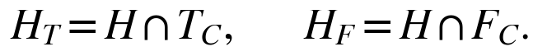
Report recovered targets, persistently wrong accepted targets, unresolved targets, and unchanged non-target errors over all H, with conditional target recovery over HT. Membership recovery obeys the procedural ceiling:
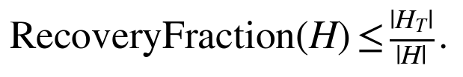
Zero-sized sets give NA. Report available paired-cell counts and all-planned-cell failures separately. Full-support restoration can correct a target decision while leaving other cap-associated errors untouched; it cannot supply an omitted reference candidate [W1, Sections 14, 17].

8.5 Cap activity and contributor quality
Report the fraction of eligible remainder pairs with cap below original major CN, support-width distributions, contributor counts, and original-support fallback rates by reason. Measure accepted-contributor accuracy, qualification sensitivity, and harmful-minimum frequency. Missing diagnostic functionality is an integrity failure, not fallback. Density experiments vary qualified Stage 1 contributors only; Stage 3 has no contributor aggregation. Use all qualified calls.
For intuition, if each of n qualified calls independently has probability e of falling below a specified target's required multiplicity, subtracting the probability that all avoid the event gives:
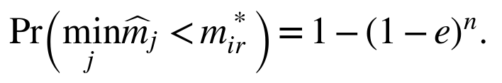
Shared CCF, purity, and CN can correlate errors; e also depends on biological multiplicity classes and qualification. Estimate actual behavior empirically rather than treating contributors as independent replicates.

8.6 Probability calibration and candidate correspondence
Equal candidate priors do not match automatically the class frequencies of targets selected for apparent clonality. Assess reliability, Brier score, log loss, and confidence-stratified error on all finite probability outputs, including unaccepted targets. Report probability availability over Neval. Analyze natural selected targets, the common external panel, and true-reference controls separately; stratify K = 1, source stage, CN, depth, and cap severity.
The designated all-one candidate supplies the primary operational clonal probability. For secondary multiclass scores, map it only to exact sampled-region clonal truth. Map each unmerged candidate to its most frequent observable truth class among frozen source members, requiring at least 80% purity. Resolve exact count ties by lowest canonical truth-class ID. Freeze this evaluation convention before final generation; target reassignment outcomes cannot determine the map.
Sum probabilities when several candidates map to one truth class. Keep unmapped mass as a separate category without renormalization. Give an accepted unmapped assignment no correct-resolution credit and report mapping failures with secondary best/worst-case accuracy bounds. Include an absent true class with probability zero; report infinite log loss before any labeled display truncation. Report false acceptance of targets whose true class is absent. Distinguish mapped biological-clonal mass from probability on the designated candidate when they differ.
Candidate splitting, merging, or omission changes prior mass assigned to biological alternatives because each final candidate receives 1/K. Uniform regional multiplicity priors also need not reproduce event-history frequencies. A calculation control draws memberships uniformly, draws regional multiplicities independently and uniformly over original support, and generates binomial counts at true fixed references. Its calibration checks the matched model; calibration on selected biological targets remains empirical [W1, Sections 11–13, 17].

9. Identifiability, region count, and threshold development

9.1 Define observational aliases before comparing methods
With identical CN and purity, admissible latent configurations produce identical regional read distributions when their multiplicity–CCF products agree:
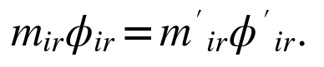
Require agreement in every informative region for an exact joint alias. Greater depth cannot distinguish identical distributions. Additional regions help only when their observed prevalence patterns break the equality; missing a distinguishing region can restore ambiguity.
Define primary information strata using true CN/purity, original biological support, and the complete truth reference. Let a* be the coefficient computed from true inputs. For each competing truth candidate h, calculate the minimum component-level expected log-likelihood separation:
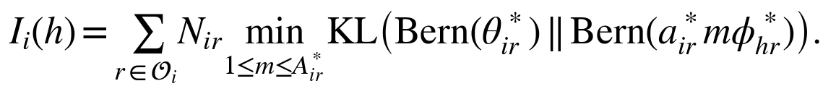
Exclude the target's own observable truth class when finding the minimum competing value. If no competing truth class exists, report this diagnostic as not applicable. Zero identifies an exact component explanation. Marginal probabilities can still differ because other component contributions and prior weights differ; this diagnostic is not the inference score. Verify constructed aliases by read-probability agreement within 1e-12. Prespecify weak information as a positive minimum no greater than 2 natural-log units. Larger values do not guarantee correct mixture fitting.
Report learned-reference and capped-support diagnostics separately. Removing an alternative through an assumed cap must not relabel an intrinsically aliased case as identifiable. A held-out read check measures prediction but cannot resolve exact latent aliases.

9.2 Retain the strict unnormalized L2 rule
For every coordinate equal to one minus delta:
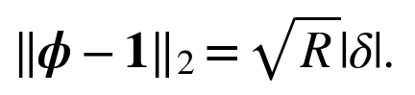
At fixed tolerance, adding regions changes eligibility even before read noise. Delta 0.04 gives distance 0.08 for four regions and approximately 0.113 for eight. Preserve strict inequality and report regional deviations alongside the norm. Compare informative new mixtures with redundant regions, and fixed per-region depth with fixed total depth. Do not silently replace the rule with RMS distance [W1, Section 6.3].

9.3 Develop C3 thresholds without final-cohort leakage
Use disjoint development histories. Proposed grids are clonal tolerance 0.05/0.10/0.15, contributor concentration 0.90/0.95/0.99, and assignment probability 0.80/0.90/0.95/0.99. Predeclare separate pair, group-mean, group-outlier, target-mean, and target-outlier screen settings. Stage 1 native/full-support qualification shares one audited calculation. Numerical tie tolerances come from qualification, not accuracy optimization.
Define the development population using prespecified biological family/event-history criteria and the true-reference, original-support information stratum before evaluating configurations. Keep those cases fixed, including cases in which estimated reference selection or cap derivation produces a violation. Actual run-specific cap validity is descriptive and never removes a configuration's harmful cases from its objective.
Choose the primary C3 setting to maximize correct end-to-end clonal-group decisions per fixed original evaluable mutation, subject to empirical selective error at most 5% among new accepted target decisions. The tuning numerator combines unchanged F outcomes and accepted target outcomes; report their contributions separately. Unresolved or unavailable outcomes receive no correct-decision credit. This fixed-universe objective differs from target-conditional correct resolution in Section 8.3 and avoids rewarding a setting merely for selecting easier targets. Reject settings with zero target acceptance. Freeze aggregation across families/acquisitions, weighting each family equally. Resolve ties by lower target wrong acceptance, higher assignment threshold, higher contributor threshold, smaller clonal tolerance, then fixed configuration ID. If no setting qualifies, revise development before freezing the final study. This proposed objective is not a guaranteed error bound.
Apply the selected settings unchanged to B3 and the paired upstream comparisons. State that tuning targets C3; B3 is not separately optimized. Freeze thresholds, inequalities, seeds, source identities, and endpoints before final generation. Keep adverse and aliased families in final reporting. Publish the prespecified sensitivity curves without choosing replacements from final results.
Descriptive residual screens are not calibrated tests; retain fit_status = not_tested unless a declared test runs. Independent-read and fixed-total-depth split audits assess reuse of evidence. Uncertainty claims for the full procedure must repeat reference selection, cap derivation, fitting, merging, and assignment. Resampling only the last stage answers a fixed-reference question [W1, Sections 14, 17].

10. Implementation and execution sequence

10.1 Freeze the implementation and study contract
Audit the chosen source revision before relying on an assignment interface. Verify native evaluation paths, bindings, cache identities, and the requested CPU or CUDA route. Interface names remain proposals until implemented and qualified. Freeze study_plan.json with scenarios, integer truth rules, seeds, source/build/input hashes, region identities, thresholds, resource limits, output schemas, and acceptance criteria [W1, Sections 4 and 16].
Keep biological inputs separate from multiplicity support. Stage 2 supplies its cap as explicit multiplicity_max; every stage has lower endpoint 1. Propagate the cap through initialization, component grids, pilot evaluation, scalar/group refitting, joint scoring, conditional calls, output verification, and execution caches. Preserve original CN denominators and exclusions. Include effective support and protocol semantics in fingerprints; reject incompatible libraries. A new arbitrary-lower-bound feature is unnecessary for this revision.
Qualify Stage 1 reference calls at accepted native CCFs. Require genuine eligible mapping, observed positive depth, valid native CCF greater than zero, a native integer within its accepted support, a unique preferred native call under the tie policy, conditional probability at least the concentration threshold, and a passing native residual screen. Because native Stage 1 support is original full support, one calculation supplies native/full-support qualification after equivalence is checked. Preserve every qualified contributor in the minimum. Retain capped Stage 2 group residuals at native and all-one centers, together with original-support diagnostics at those same coordinates. Missing diagnostic functionality is an implementation failure, not an empty contributor pool.

10.2 Establish mechanisms before estimating performance
Validate physical-copy histories and integer carrier multiplicity, then run deterministic examples and fixed-reference experiments before complete workflows. Keep simulator/evaluator truth inaccessible to the inference runner. After numerical qualification, use the development pilot to estimate time and memory and freeze the final design before generating the final cohort.
Execute A, B, C, B3, and C3 where applicable: one Stage 1 fit, two planned Stage 2 support conditions on the same frozen remainder, and one full-support reassessment for each combined reference. This is at most three fits and two assignment passes. Save each combined baseline before reassessment. Pair data, fitting configuration, and planned seeds across B and C; do not pretend their resulting targets or references are identical. Compare each reassessment with its own combined baseline and use the declared common-population analysis for cross-arm effects.
Construct Stage 3 support afresh from original major CN. Freeze targets, all final candidates, full-precision regional centers, and equal priors. Use one all-one candidate and every unmerged native Stage 2 vector, including unresolved groups. Never inherit the capped prepared dataset, update memberships sequentially, or refit centers during assignment. Batch complete mutations and measure runtime; wider support can increase individual-pass cost.

10.3 Preserve applicability and provenance
Distinguish no eligible clonal reference, validly empty Stage 2, unsupported fitting regions, failed fitting, empty prediction requests, and informative K = 1 assignment. A fitting population cannot silently lose an unsupported requested region; prediction may retain a region without target observations. Preserve failed-attempt evidence and every original mutation's status.
Use fresh outputs and staged publication with identity, schema, hash, and population checks. Report all planned-cell failure and applicability rates alongside comparisons among successful arms. Historical full-support assignment results are reusable only after matching targets, biological inputs/masks, reference labels/centers, priors, support, numerical semantics, diagnostics, and thresholds. Historical analyses keep their protocol identity. Document revision alone does not run analyses or replace accepted results [W1, Sections 11.3 and 18].
An optional independent simulator or read-level/BAM validation panel follows establishment of the count-level mechanisms. Published reconstruction benchmarks distinguish ideal truth inputs from variant-calling and CN errors [5,6]. Such external validation complements the event-generated study; a full BAM simulation is unnecessary to demonstrate an algebraic cap violation.

11. Numerical fixtures and protocol invariants

11.1 Exact emission fixtures
Use fixed tolerances and check absolute emissions/log scores, not only normalized posteriors. A cluster-independent normalization error can disappear from posterior comparisons [W1, Section 16.3].
Fixture | Required result
Full support: purity 1, original major CN 4, minor CN 0, ALT 2, REF 1, CCF 1; integers 1 through 4 | Component masses 0.140625, 0.375, 0.421875, 0. Emission 0.234375 = 15/64. Conditional MAP 3 with probability 0.45.
Stage 2 cap: same biological inputs, cap 2; integers 1 and 2 | Emission (0.140625 + 0.375)/2 = 0.2578125 = 33/128. Original total CN stays 4 in read probabilities; only mixture width becomes 2. Dividing the component sum by 4 incorrectly gives 0.12890625.
Marginalization versus profiling: purity 1, major CN 2, minor CN 0, ALT 1, REF 1; support 1 through 2 | CCF 1 gives masses (0.5, 0); CCF 0.6 gives (0.42, 0.48). Marginal emissions 0.25 and 0.45 give equal-prior posteriors 5/14 and 9/14. Profiling reverses the ranking because 0.5 exceeds 0.48; assignment must use the marginal result.

Full-support emissions must reproduce the qualified native single-state emission at identical inputs and CCF. This does not require reproducing an entire Stage 1 fit. Test restoration from caps 1, 2, and 3 when original major CN is 4, including newly merged targets and every reference candidate. Test both endpoints and the major-CN-1 singleton.

11.2 Observation, containment, and execution invariants
Observed zero ALT at positive depth is informative. Missing, zero-depth, and excluded observations contribute no read evidence or new multiplicity call. Positive ALT at probability zero and positive REF at probability one have zero likelihood. Distinguish no-information targets from informative targets with all candidates impossible; do not publish a formal empty-product prior or replace impossible scores with a uniform posterior. Invalid CN, ambiguous mapping, NaNs, and inconsistent native support are integrity failures.
Every eligible target–region pair uses integers 1 through original major CN for every candidate. Genuine valid observed native source calls and conditional calls must be contained. Absence of a genuine observed native call receives missing containment-audit status. Containment does not require the native call to remain the conditional MAP at a different center. Changing unused F multiplicity records or their order at fixed inputs/reference must not change scores or support; F memberships remain unchanged.
Validate complete regional identities and admissibility before batching. Row order, batch size, worker scheduling, and label renaming preserve aligned probabilities within qualified tolerance; tie representatives follow the renamed public-label order. Independently qualify CPU and CUDA when requested. Narrow support cannot rescue an original-CN exclusion. Test zero, one, and multiple merges, Stage 2 contributor rejection/fallback, and empty prediction outputs [W1, Section 16.2].

11.3 Decisions, ties, and fit gates
Apply integrity checks before scientific statuses. Use the following precedence [W1, Sections 13–14].
Status | Condition
filtered | Every region excluded by original eligibility.
no_information | No informative read observations; probabilities and labels missing.
incompatible | Informative observations but every candidate impossible; probabilities and labels missing.
ambiguous_tie | Exact or numerical maximum-score tie.
low_confidence | Unique best candidate below the posterior threshold.
unresolved_fit | Unique best meets the threshold but fails a required screen or requested calibrated test.
assigned_relative | Unique best meets the threshold and passes required gates.

Keep best_cluster_label separate from assigned_cluster_label; unresolved rows have no accepted label. Preserve secondary flags despite precedence. Posterior threshold equality passes. A numerical tie occurs when the best-minus-second log-score gap is at most the frozen tolerance in absolute log-odds units; never scale tolerance by absolute likelihood magnitude. Ties take precedence. Exact score ties display the lowest public label among maxima. Conditional multiplicity ties display the smallest maximizing integer: a tie between 2 and 3 displays 2.
For one finite candidate with K greater than 1, the second log score is negative infinity and the gap is positive infinity. For informative compatible K = 1, posterior is 1 and entropy 0; second-candidate and margin fields are missing. Report conditional calls at the displayed best candidate even when membership remains unresolved; high concentration does not resolve membership ambiguity. At CCF zero with compatible zero ALT, conditional multiplicity equals its prior and is uninformative. Singleton probability 1 reflects structural CN information.
Clonal eligibility uses strict unnormalized L2 distance below its tolerance. Contributor concentration uses an inclusive threshold. Target fit screening requires finite profiled discrepancy, mean no greater than its cutoff, and a fraction of informative regions exceeding the pair threshold no greater than its outlier cutoff. Do not inherit group coverage/count minima. Report fit_screen_status separately from fit_status; without a requested calibrated test, fit_status is not_tested even for accepted rows. Requested tests must complete before acceptance and do not modify membership probabilities.

12. Outputs and scientific interpretation criteria

12.1 Study and workflow records
Retain study_plan.json, truth_clones.tsv, truth_events.tsv, truth_pairs.tsv, and input_catalog.tsv with copy ancestry, integer truth, all mutation–region keys, read acquisition, and perturbation provenance. Keep controlled source_snapshots/ separate from native arm_outputs/. Restrict bound_audit.tsv to Stage 2 cap contributors, qualification, native/true calls, fallback, and exclusions. Publish tumor_metrics.tsv and comparison_report with history-level uncertainty, applicability/failures, and source identities.
Preserve native Stage 1/2 outputs and the exact Stage 2 records stage2_segment_multiplicity_bounds.tsv and stage2_reference_call_qualification.tsv. Publish versioned Stage 3 records [W1, Section 15].
Output | Required contents
<tumor_id>_mutation_assignments.tsv | One row per target: source stage/group, combined baseline, one ordered K-probability vector, best/accepted labels, best/second probabilities, gap, entropy, ties, fit/assignment statuses, and reassessment outcome.
<tumor_id>_assignment_multiplicity.tsv | Exactly NT × R unique keys: original CN/counts/masks, observation status, eligible support endpoints 1 and original major CN, conditioning label/CCF, MAP/probability/tie/information, native call, and source-call containment.
<tumor_id>_assignment_summary.json | Protocol/schema/input/reference/settings/build/device identity; support_policy=original_full_1_to_major_cn; multiplicity_prior=uniform_within_region; cluster_prior=equal_per_final_cluster; status/outcome counts, source strata, and produced-table hashes.

Also retain assignment_reference_centers.tsv, assignment_reference_provenance.tsv, and stage3_vs_two_stage.tsv covering every original mutation. Keep the ordered label namespace explicit. A summary hash, if used, is stored separately rather than self-referentially.

12.2 Reconcile baseline outcomes and populations
Relationship to the combined baseline | Reassessment outcome
Target accepted into the merged clonal candidate | retained_clonal
Target accepted into an unmerged candidate | reassigned_to_unmerged_reference
Target without accepted assignment | unresolved_target, with precise assignment status
Accepted combined member outside T | unchanged_non_target
Original mutation outside accepted combined membership | not_in_accepted_combined_population, with original workflow status

Verify Ncombined = N0 + N2 and K = 1 + Q2 − M; unique source-to-final mappings; disjoint T and F covering accepted combined membership; target statuses summing to NT; and exactly NT × R regional keys. Preserve original biological inputs, native source estimates, all candidate centers, and equal priors. Keep empty-occupancy candidates. Distinguish reference K, occupied accepted labels, F, and unresolved targets. Separate original-reference targets from newly merged Stage 2 targets. Stage 3 receives no new optimized joint-fit score or native membership certificate.

12.3 Scientific decision criteria
A valid integer-history counterexample can reject universal Stage 2 cap validity, but does not estimate patient-population frequency. Claim cap benefit in a named regime only when the cap is active, paired endpoints improve, truth exclusion is reported, and practical errors satisfy prespecified margins. Assess reassessment benefit against its own combined baseline, with acceptance coverage, correct resolution, and wrong accepted assignments on declared comparable denominators.
Proposed noninferiority margins for the identifiable, ordering-valid primary stratum remain 1 percentage point for wrong accepted targets per evaluable target, 1 percentage point for mutation-weighted false clonal merges, and 0.5 percentage points for additional Stage 2 true-multiplicity exclusion. The merge/exclusion margins compare C with B; the assignment margin applies to declared practical decision comparisons. Freeze or revise these research tolerances in study_plan.json. Structural positive controls require zero exclusion. Core Stage 3 truth containment and valid native-source-call containment require exactly zero violations; no practical margin relaxes these invariants. Report inherited supplied-CN errors separately. Imprecise margin estimates are inconclusive, and adversarial families remain reported.
The main report should contain six scientific figure groups: physical-copy counterexamples; Stage 2 cap-exclusion/activity heatmaps; paired fitting/merging/reassessment effects; error–coverage curves and baseline transitions; probability reliability with reference-completeness strata; and sensitivity to CN, depth, regions, contributor density, and input errors. Show individual history points and paired changes where feasible, with history-level intervals.
Attribution must distinguish call error, source selection, cap-induced reference distortion, missing candidates, and exact aliases. Full support preserves possible integers while Stage 2 centers remain cap-dependent; it cannot repair unchanged F or distinguish identical read distributions. Repeat all upstream stages for end-to-end uncertainty. Numerical agreement and confident conditional probabilities alone establish neither biological correctness nor a global clustering optimum [W1, Section 17]. The intended conclusion specifies where the Stage 2 cap helps or harms and how much full-support reassessment corrects, preserves, or leaves unresolved given its frozen reference and selected targets.

References and source protocol
[1] Gerstung M, et al. The evolutionary history of 2,658 cancers. Nature. 2020;578:122–128. https://doi.org/10.1038/s41586-019-1907-7
[2] Frankell AM, et al. The evolution of lung cancer and impact of subclonal selection in TRACERx. Nature. 2023;616:525–533. https://doi.org/10.1038/s41586-023-05783-5
[3] Dentro SC, et al. Characterizing genetic intra-tumor heterogeneity across 2,658 human cancer genomes. Cell. 2021;184:2239–2254.e39. https://doi.org/10.1016/j.cell.2021.03.009
[4] Satas G, et al. SCARLET: Single-cell tumor phylogeny inference with copy-number constrained mutation losses. Cell Systems. 2020;10:323–332.e8. https://doi.org/10.1016/j.cels.2020.04.001
[5] Salcedo A, et al. A community effort to create standards for evaluating tumor subclonal reconstruction. Nature Biotechnology. 2020;38:97–107. https://doi.org/10.1038/s41587-019-0364-z
[6] Salcedo A, et al. Crowd-sourced benchmarking of single-sample tumor subclonal reconstruction. Nature Biotechnology. 2025;43:581–592; published online June 11, 2024. https://doi.org/10.1038/s41587-024-02250-y
[W1] CliPP2 three-stage workflow. Protocol 2.1, complete revised specification. Latest supplied attachment; governs this simulation-plan revision. https://chatgpt.com/library?file_id=libfile_fb93efd6dcd08191866d45f20d2e3ee1&account_id=personal
[W2] CliPP2 implementation plan. Earlier project specification based on source ecd6ac3510183e182db16768687e3343cfe4acb2. Retained as implementation provenance; compatibility with Protocol 2.1 must be checked before execution. https://chatgpt.com/library?file_id=libfile_843cd8c2d27881919f4578154a4f00d1&account_id=personal
[L1] CliPP supplementary information, Section 1.2, CliPPSim4k. Project source document for the historical benchmark. https://chatgpt.com/library?file_id=libfile_3b385bb48fa88191bc6676ec386ddb59&account_id=personal

