

本科生毕业论文（设计）
外文翻译及原稿

译文1题目： | Detangler: Visual Analytics for Multiplex Networks
原稿1出处： | Eurographics Conference on Visualization （EuroVis） 2015

学 院： 计算机科学与技术学院
专 业： 数字媒体技术
班 级：2022计算机科学与技术学院(实验班)
学 号： 202203151108
学生姓名： 黄佳煜
指导老师： 汤颖
提交日期： 2026.3.20

Detangler：多层网络的可视分析
作者：B. 勒努斯特 ¹²、G. 梅朗松 ²、T. 芒茨纳 ³
1 日本东京国立情报学研究所 & 法国国家科学研究中心日法联合信息学实验室 UMI 3527
2 法国波尔多大学 & 法国国家科学研究中心波尔多计算机科学研究所 UMR 5800 & 法国国家信息与自动化研究所波尔多西南分部，波尔多
3 加拿大不列颠哥伦比亚大学，温哥华
摘要 多层网络包含不同类型的连接边，能够表达多种相互重叠的关系类型。网络分析的一项核心任务是评估并理解群体内聚性，即基于网络的底层结构，解释为何不同元素会归为同一群体。本文提出可视分析系统 Detangler，通过双联动视图为多层网络的群体内聚性分析提供支持。该视图采用了由原始多层网络衍生而来的新型数据抽象结构 —— 基底网络与催化网络。本文贡献了两种创新技术，助力用户分析多层网络的复杂结构，同时避免直接可视化网络带来的严重视觉混乱问题。协调布局视觉编码技术为基底视图与催化视图提供了空间稳定性；轴心刷选交互技术基于底层多层网络的计算结果，实现视图间的联动高亮，支持用户在催化网络与基底网络的子集间灵活切换分析。本文结合应用场景展示了该系统在标注新闻文档分析领域的应用成果，并给出初步的专家反馈；同时以美国独立运动早期的社会网络群体内聚性分析为第二个应用场景，验证系统有效性。
关键词：多层网络；可视分析；群体内聚性；数据抽象；联动视图；协调布局；轴心刷选

1 引言
在网络数据的探索性可视分析中，检测结构模式的高层任务通常涉及理解群体构成这一底层抽象任务。理解并解释同一群体内元素的聚合原因可拆解为多个相关问题：是什么让一个群体成为整体？这些实体为何相互关联？不同群体间存在哪些差异？所有群体的同质性是否一致？
本研究的研究动机源于与法国国家视听研究院（INA）档案管理员的合作，该机构负责对法国过去数十年播出的所有新闻素材进行存档与转售。档案管理员需根据电视记者、平面媒体记者、纪录片导演和当代脱口秀创作者等各类用户的需求对文档进行分组，分组依据涵盖人物、地点、主题等多种维度。他们需要验证所构建的文档组是否与用户需求高度匹配，因此亟需对群体结构进行细致分析。
例如，在报纸文章、电视新闻片段等新闻文档集合中，若两篇文档内容相似，可推断二者间存在关联。文档分组的方式多种多样，可依据涉及的同一人物、描述的同一地点或围绕的同一主题进行划分，每种分组方式都会产生一组不同的连接关系。为精准捕捉文档间的完整关系结构，网络需采用多层结构，将由某一类相似性度量产生的连接边分配至独立层，与其他相似性度量对应的连接边相区分。这种包含不同类型连接边的网络被称为多层网络^{[DDSRC*13]}。
多层网络的群体内聚性分析工作具有较大难度，原因在于其需同时表达多种相互重叠的关系类型。该问题非常适合通过交互式可视分析解决 —— 结合用户发起的交互式探索与先进的计算支持，即可视分析方法。多层网络的数据抽象与群体内聚性分析的任务抽象相结合的研究思路，已在生物信息学、数字人文等多个领域得到应用。本文展示了两个应用场景：一是启发本研究的、与档案管理员合作的标注新闻文档分析，二是基于美国独立运动早期数据的社会网络分析。
本文的研究贡献主要体现在四个方面：第一，设计并实现了 Detangler 系统，为多层网络的交互式可视分析提供支持；第二，提出了由原始多层网络衍生的两种新型网络数据抽象结构 —— 基底网络包含作为探索核心的实体，催化网络捕捉这些实体间的关联关系（在上述新闻文档示例中，基底为文档，文档通过催化主题建立连接）；第三，提出协调布局这一视觉编码技术，为基底网络与催化网络视图提供空间稳定性；第四，设计了一种交互技术，支持用户通过对一个视图中的选中对象进行轴心分析，在基底视图与催化视图间灵活切换，同时基于底层多层网络的计算结果实现另一视图的联动高亮。

2 多层网络
为阐释多层网络的核心思想，图1（a）展示了一个由论文、作者和描述论文主题的关键词构成的书目数据集实例。对该网络进行建模的简单方式是采用传统的单层基底网络，所有连接边为同一类型，例如图1（b）中的合著网络，节点为作者，连接边为论文，即合作发表论文的作者间存在连接。
对该数据集进行更完整建模的方式是采用多层网络（连接边可包含不同类型），这类网络也被称为异质网络^{[ABHR*13]}、多层网络^{[HD11]}或多模态网络^{[GKL*13]}。在上述书目示例中，连接边簇对应特定合著者之间的共同关键词，如图1（c）所示。对这类网络进行视觉编码的直接方式是通过颜色区分不同类型的连接边，形成叠加的视觉层，但该方法在可扩展性方面存在至少两大挑战：受限于非连续小区域颜色的辨识度^{[Mun14][Section 10.3.1]}，连接边类型的数量上限约为 10 种；节点和连接边的数量上限虽无明确界定，但即使仅有数十个元素，视觉混乱问题也会凸显，该表示方法无法扩展至数百个元素的规模。
在本文提出的新型数据抽象结构中，视觉编码与交互通过由多层网络衍生的两个网络实现，如图1（d）所示。基底网络的构建规则为：基底为原始多层网络中的节点；若多层网络中一对基底节点间存在至少一条带类型的连接边，则二者在基底网络中通过一条连接边相连。图1（d）中的简单示例为全连接基底网络，但实际应用中基底网络可呈现任意结构。催化网络的构建规则为：催化剂由多层网络中的连接边类型生成，并作为催化网络中的节点；若催化剂所编码的连接边类型在多层网络中至少共现一次，则对应的催化剂间存在连接，即当多层网络中两个基底通过类型 a 和类型 b 的两条连接边相连时，催化剂 a 与催化剂b 间存在连接边，图1（e）阐释了该构建过程。催化剂可被理解为基底间建立连接的关联动因。
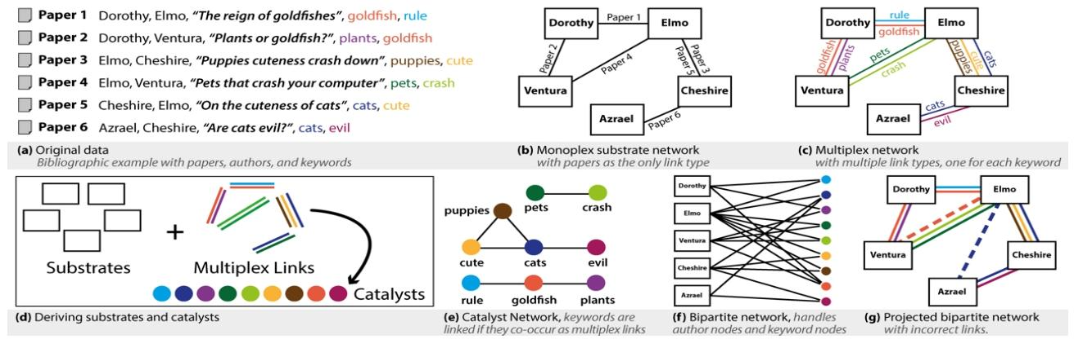
图 1:数据抽象示意图（a）原始数据（b）单层基底网络（c）多层网络（d）基底与催化网络（e）催化网络（f）二部网络（g）投影二部网络（含错误连接）
催化网络中的单个节点对应原始多层网络中同一类型的所有连接边 —— 这些连接边在直接可视化中会形成复杂的视觉层。本文提出的抽象方法与散点图矩阵探索^{[WAG05]}中的诊断抽象方法理念相似，元散点图中的每个节点代表原始数据集中的整个散点图；同时也与PivotGraph 表示方法^{[Wat06]}的理念相通，催化图是对复杂结构的视觉紧凑式整合。通过精心设计的交互技术，这种双网络抽象结构的全部优势得以发挥，用户可通过在不同感兴趣子集间的灵活切换，快速深入分析网络结构，具体内容见第 4 节。
该数据抽象结构将前文提出的关于群体归属的一般性问题，转化为针对这两个新型网络的具体问题：基底间如何交互？催化剂间的交互程度如何？催化网络的结构特征是什么？两个网络如何相互融合？

2.1 与其他抽象方法的对比
本文提出的抽象结构将基底节点与催化节点相区分。二部网络抽象是对包含两种类型节点的网络进行建模的经典方法，一个显而易见的问题是：二部网络表示是否足以完成群体内聚性分析任务？答案是否定的，因为将多层网络简单投影为二部网络会丢失关键信息。图 1（f）中的二部网络阐释了这一问题：该网络包含作者和关键词两种节点类型，同类型节点间无法建立直接连接；通过从二部网络投影构建新的基底 - 基底多层网络，无法恢复原始多层网络。投影过程会引入额外的边，因为与同一催化剂相连的基底会形成两两连接，如图1（g）所示。由该二部网络重构的多层网络包含错误连接：埃尔莫与阿兹瑞尔并未合作发表论文，二者仅各自发表过与 “猫” 相关的论文。只有当基底与催化剂间的关联关系完全对称时（例如连接边对应节点间的相似性），两种表示方法才等价，而包括上述书目示例在内的许多实际应用场景中，连接边均具有非对称性。
本文提出的抽象方法也比将多层网络简单投影为加权单层网络的方法更具优势。尽管加权单层网络的可视化难度更低，但同样会丢失大量关键信息。图2 展示了两个不同的多层网络实例，其投影后的基底网络完全相同，但催化网络的拓扑结构却截然不同（环形与星形）。

2.2 缠结度量
本文基于勒努斯特等人^{[RMV14]}提出的三种缠结度量方法展开研究。其中一种度量方法针对单个催化剂：催化剂缠结指数表示每个催化剂与其他催化剂的融合程度，例如图 2 展示了环形拓扑的两两重叠与星形拓扑的一对多重叠之间的差异。另外两种度量方法适用于任意规模的子图（直至整个网络）：子图缠结强度表示某一群体中所有催化剂的整体融合程度，粗略而言，当基底因同一动因（即同一类型的催化剂）建立连接时，群体内聚性比基底通过不同类型催化剂连接时更强；群体内聚性分析还需考虑催化剂在群体内的调用是否均衡，子图缠结同质性表示整个群体中所有催化剂融合的均衡程度。本文将这三种度量方法应用于视觉编码与交互设计，具体内容见第 4 节和第 5 节。
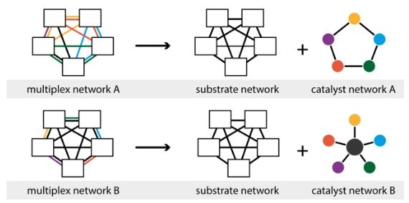
图 2: 加权投影同样会丢失信息；这两个多层网络的投影基底网络完全相同，但催化网络拓扑结构差异显著

3 相关工作
现有多层网络可视化研究中，部分工作采用基于分层和分区的直接视觉编码方法，可扩展性较差。例如，施勒尔等人^{[STF*13]}提出通过颜色编码区分多层网络的连接边类型，这会导致第2节中提及的问题 —— 未过滤视图存在严重的视觉混乱，而过滤视图仅能展示少量可用信息；德多梅尼科等人[DDPA14]提出将网络划分为多个层，并在倾斜的 3D 平面上展示，这带来了将 3D 空间用于网络等抽象数据可视化的经典问题^{[Mun14][Section6.3]}。这些方法均未为群体内聚性分析任务提供交互支持。
部分现有系统聚焦于多层网络间的对比分析，尽管设计了精细的视觉编码方式，但仍未支持群体内聚性分析。阿尔珀等人^{[ABHR*13]}提出将加权投影同时以节点 - 连接边视图和邻接矩阵视图进行视觉编码，用于脑连接分析，其研究重点是对比多个群体以分析差异，而本文聚焦于分析单个群体以探究其聚合动因；哈斯科埃等人^{[HD11]}强调叠加层与并列层的结合，但研究重点同样是群体间对比而非内聚性分析。
里什等人提出了多种用于密集连接图^{[RDLC12]}（包括含多种连接边类型的网络）交互的可扩展技术；克伦和尤素菲^{[KJ13]}提出在节点的径向布局周围设置多条超边。本文的方法则从数据抽象层面解决问题——通过引入催化网络，将原始多层网络中一整个包含多条连接边的视觉层用单个节点表示，而非在原始网络上直接应用交互技术。
已有多位学者提出了基于不同表示形式间轴心切换的交互技术，与本文提出的灵活切换交互技术理念相似。 NetLens ^{[KPLB07]}和 GraphTrail ^{[DHRL*12]}均依赖于基于轴心的交互，但未提供节点 - 连接边视图，因此无法支持群体内聚性分析等需要拓扑结构理解的任务；PivotPath ^{[DRRD12]}虽提供了节点-连接边视图，但存在第 2.1 节中提及的二部网络相关问题；RelE 系统^{[SFMB12]}支持不同节点-连接边视图间的轴心切换，但该系统高度聚焦于覆盖网络流量优化这一特定任务，无法支持群体内聚性分析。
与群体内聚性分析任务最相关的前期研究是加尼等人^{[GKL*13]}的设计研究，该论文最后将群体内聚性分析列为一个具有研究价值的开放问题。其研究聚焦于社会网络分析中的多层网络，但更强调多节点类型问题而非多连接边类型问题；将多层网络表示为k部网络，会导致第 2 节中描述的信息丢失问题，此外，由于节点-连接边视图仅局限于局部邻域，该方法无法支持全局拓扑结构理解。
该多实体分析研究还与其他相关研究成果相关，如 Jigsaw^{[GLK*13]}、Orion ^{[HP14]}和 Ploceus^{[LNS14]}，这些研究聚焦于将表格数据转换为网络数据，为多层网络分析提供了具体的应用场景。尽管Jigsaw支持一定的轴心交互，但这些研究均未涉及细粒度的拓扑结构分析。

4 交互设计
Detangler 可视分析系统的设计涵盖交互技术与视觉编码技术两方面，本节介绍交互设计，视觉编码技术将在第 5 节阐述。
Detangler系统设计的交互技术，通过支持用户对选定项目子集进行深入分析、在基底网络与催化网络间进行轴心切换，实现对多层网络中群体内聚性的分析支持。我们将在两个视图间反复进行轴心切换的交互过程称为灵活切换交互。

4.1 从基底到催化剂的轴心切换
要在基底网络与催化网络间映射项目子集并反映底层多层网络的真实结构，需要精细的交互与算法设计。该问题的复杂性源于两个网络间的关联既非传递性也非对称性：催化剂与多层网络的边相关联，具体而言，一个催化剂对应多层网络中某一特定类型的边及其连接的节点。
图3 展示了从基底到催化剂的轴心切换流程实例：用户通过选中基底网络中的一个子集发起轴心切换；系统随后找到由这些节点在底层多层网络中诱导的子图，即找出多层网络中直接连接任意一对选中节点的所有边；基于该多层子图计算新的缠结度量，包括子图的缠结同质性和缠结强度两个群体度量；在计算过程中，可同步提取对应于该多层子图的催化子图，无需额外的计算开销；此外，系统还会基于该多层子图，计算网络中每个催化剂的个体缠结指数，并利用新计算的值更新催化视图中所有节点的大小。当未选中任何子图时，节点大小展示的是基于整个多层网络计算的缠结指数值。
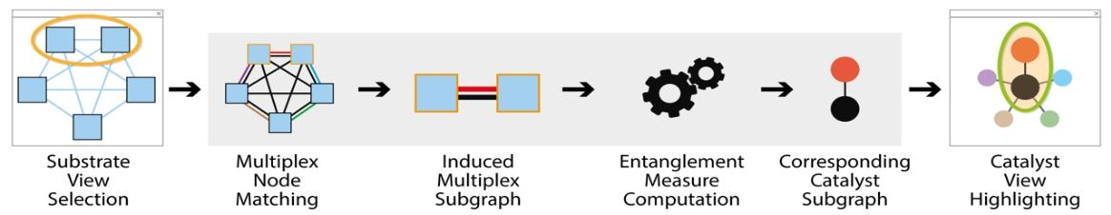
图 3: 从基底到催化剂的轴心切换。用户在基底视图中选择节点。Detangler 系统提取对应的多层网络节点，并生成由这些节点在多层网络中连接边构成的诱导子图。系统计算该子图的缠结同质性与缠结强度两类群体缠结度量，同时同步提取催化网络中对应的子图。此外，系统还将基于该子图，为每个催化节点计算新的个体缠结指数。

4.2 从催化剂到基底的轴心切换
可定义从催化剂到基底的类似轴心切换操作，但由于数据抽象结构的非对称性，该操作与从基底到催化剂的切换并非完全相同：催化网络中的单个节点对应多层网络中的多条边。系统并非通过诱导子图，而是通过将边集限制为与选中催化剂对应的类型，并将节点集限制为这些边所连接的节点，来选择多层子图。Detangler支持与（AND）和或（OR）两种选择模式，如图 4 所示，后续的计算过程（包括缠结度量计算）与从基底到催化剂的切换相似。
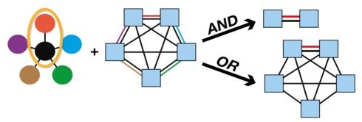
图 4: 从催化剂到基底的两种轴心切换模式。限制性更强的 “与（AND）” 操作符仅输出通过所有指定催化剂连接的基底节点；扩展性更强的 “或（OR）” 模式则输出通过任意一条催化连接边连接的基底节点

4.3 循环轴心切换：灵活切换
先从基底到催化剂进行轴心切换，再从催化剂到基底进行轴心切换，这一过程构成灵活切换交互，如图 5 所示。在灵活切换中，与选中基底群体对应的催化剂被作为催化网络中的新选中对象，随后系统得到在多层网络中通过这些催化剂连接的新基底集合。我们将该循环称为 “灵活切换”，以强调连续轴心切换交互的非对称性：灵活切换结束时选中的基底集合与初始集合并不相同。例如，当我们从一组作者轴心切换至其合著论文中的关键词集后，可能会进一步提出问题：还有哪些作者发表过与这些关键词相关的论文？
使用与操作符的灵活切换往往会快速收敛至空集，即经过少量几次轴心切换后便无基底被选中；而使用或操作符的灵活切换在几次切换后，会收敛至所有可能的基底集合。
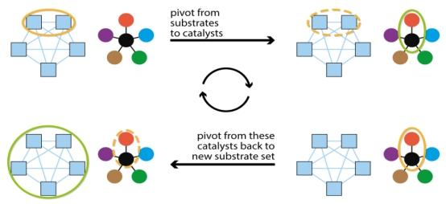
图 5: 通过连续轴心切换实现基底与催化网络间的灵活切换

5 视觉编码
Detangler 系统的界面如图 6 所示，包含两个并排的主视图，采用协同的节点 - 连接边布局：左侧为基底网络视图，右侧为催化网络视图；最左侧为两个辅助视图：底部是交互菜单，顶部是当前选中对象的缠结度量详情视图。
本文选择节点 - 连接边布局的依据源于戈尼姆等人^{[GFC04]}提出的两个准则：从任务角度，将拓扑结构分析任务视为群体内聚性分析核心任务的基础；从数据角度，这两个衍生网络的边密度远低于底层的多层网络，视觉复杂度处于可管理范围。节点位置由本文提出的协调布局技术确定，详细内容见 5.3 节。为突出两个视图的差异，基底节点采用方形编码，催化节点采用圆形编码；催化节点的大小编码其相对于当前选中集合的缠结指数。

5.1 套索
两个衍生网络视图通过联动高亮实现协同，视图间的轴心对应关系按第4 节所述方法计算。选中操作采用麦格芬和尤西卡^{[MJ09]}提出的套索技术，支持对不规则形状或矩形区域进行灵活选择。套索绘制完成后可作为刷选工具拖动，当套索捕捉到新节点时，该节点会被标红高亮为选中节点，系统实时触发新的缠结分析；另一视图中的对应节点会以红色轮廓高亮，连接边以红色高亮。所有催化节点会立即根据新计算的缠结指数调整大小。为突出高亮对象，其他对象的透明度会调至 50%。套索选择可在任一视图中进行，在下文的论述中，将绘制套索进行选择的视图称为源视图，另一视图称为目标视图。
两个全局缠结度量（缠结强度与缠结同质性）通过颜色直接视觉编码于套索上，其值被归一化至 0-1 的同一值域。图 6（b）展示了本文设计的分段连续颜色渐变方案：主连续区域结合三种色调，亮度呈单调递减趋势；值域底部的低值以高亮度黄色表示，在白色背景下形成细微的亮度变化，辨识度较低；值域中部为中等亮度的绿色；值域顶部为低亮度的深蓝色。颜色尺度在底部以白色分段，在顶部通过色调和亮度的离散变化切换为亮紫色，与值域顶部附近的深蓝色相比，以更醒目的方式突出最大值。
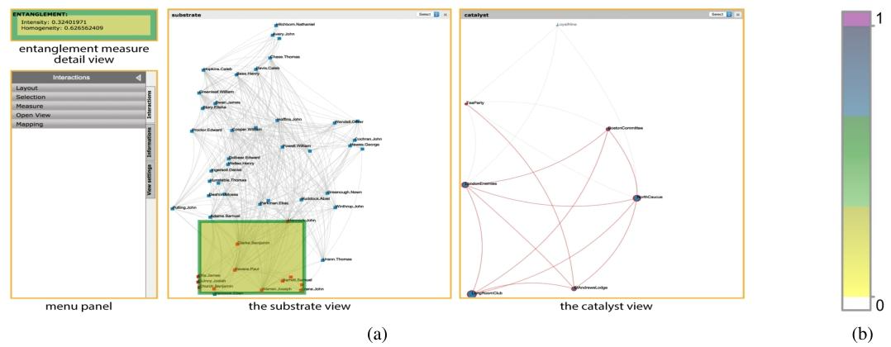
图6: Detangler 系统界面（a）四个视图以橙色标注并附标签说明。当前源视图为左侧的基底视图，其中矩形套索显示用户选中区域；目标视图为右侧的催化视图，展示对应的高亮内容。左侧设有两个辅助视图：缠结度量详情视图与菜单面板。（b）分段连续颜色渐变方案。底部段为白色；主连续段包含三种色调，亮度呈单调递减趋势；顶部段为亮紫色，通过色与亮度的离散变化实现最大对比度。
缠结同质性值映射至套索的粗轮廓，缠结强度值由套索的内部填充颜色表示。左上方的缠结视图以数值形式展示这些度量值，并在其自身的轮廓和内部以相同颜色编码，实现套索与该辅助视图间的视觉关联。图 6 展示的是矩形套索，图 7、9 和 10 展示的是不规则形状套索。左下角的控制面板包含多个选项卡和按钮，支持用户将催化剂对应操作符在与和或模式间切换。

5.2 灵活切换交互
双击套索选中的对象即可执行灵活切换操作，此时目标节点变为源节点，视觉编码也会相应调整。该操作序列包含四种状态，需通过视觉编码进行清晰区分：源视图中未被选中对象的正常状态为蓝色节点和浅灰色连接边；源视图中的选中节点为红色；目标视图中的高亮状态为节点红色轮廓、连接边红色；目标视图中的暗化状态为将其他对象的透明度调至50%。图 7 以灵活切换序列实例展示了这些编码方式。
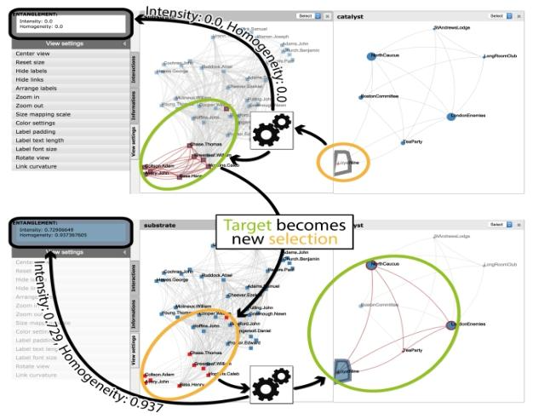
图7: 灵活切换序列图（展示轴心切换步骤间的视觉编码变化）。图中采用 Detangler 系统截图呈现，而非图 5 中的示意图。

5.3 协调布局
本文提出协调布局技术，通过提供空间稳定性降低用户操作多个视图的认知负荷，助力用户轻松匹配两个视图中的对应对象。由于两个视图包含不同的实体，设计支持该对应关系的布局需要明确的算法支持，图 8 阐释了该算法的核心流程，具体步骤如下：
1. 仅为催化网络生成布局，随后移除催化节点间的连接边，如图 8（a）所示；
2. 将催化剂分为低缠结度和高缠结度两类：设计初衷是让基底靠近低缠结度催化剂（这类催化剂仅与少量特定基底相关联）；相反，由于高缠结度催化剂与大量基底相连，仅用于解决歧义问题，而非作为主要的 “引力中心”，以避免形成杂乱的连接结构；
3. 在布局中添加基底节点，通过临时连接边将基底锚定至其所有相连的低缠结度催化剂；若基底无相连的低缠结度催化剂，则将其锚定至所有相连的高缠结度催化剂，如图 8（b）所示；
4. 固定催化节点的位置，运行布局算法仅移动锚定的基底节点，如图 8（c）所示（本文在步骤 1 和步骤 4 中均采用标准的力导向算法，也可选用其他布局算法）；
5. 在独立的基底视图和催化视图中，采用经协调的节点位置，基底节点与其重要的催化剂间保持空间稳定性，如图 9 所示。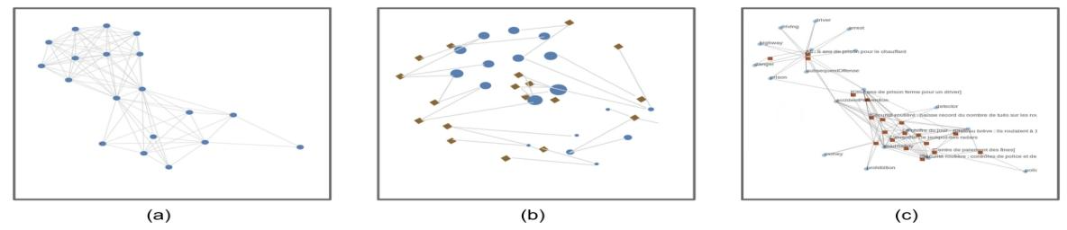
图 8: 协调布局示意图。（a）生成催化网络布局（b）移除连接边，基于缠结度将基底分配至对应催化剂（c）分离催化剂与基底前，固定催化节点位置并生成基底布局

6 系统实现
Detangler 系统已开源在http://detangler. labri.fr:31497，其实现基于两个可视化框架：采用 Tulip ^{[AAB*47]}完成网络与布局计算，结合 D3^{[BOH11]}和 jquery-ui 作为前端实现视觉对象的渲染；两个服务器间的协同基于客户端 - 服务器架构实现。
Detangler 系统充分利用了 Tulip 的全套图操作功能，包括为布局和颜色编码使用不同的度量指标、执行诱导子图查找等图论分组操作；同时也得益于 D3 的所有交互功能和即时部署能力。
该系统可对包含数十至数百个催化剂、数百个基底的多层网络实现交互式帧率。当前的可扩展性瓶颈在于 SVG 渲染和与服务器的通信，通过采用 WebGL 的不同渲染架构（如 Tulip 自身的渲染架构），可轻松实现算法层面的进一步扩展。Detangler 系统的研究重点是双视图抽象带来的感知可扩展性—— 单个视觉对象即可捕捉到在以往研究中需要一整个视觉层的多个对象才能表达的信息。

7 应用结果
本文展示了 Detangler 系统在群体内聚性分析中的两个应用场景：一是启发本研究的法国国家视听研究院（INA）标注新闻文档分析，二是社会网络分析实例；同时展示了在系统迭代优化过程中，中期专家反馈环节的结果（补充视频和材料详细展示了交互式分析过程）。

7.1 应用场景 1：道路安全
第一个应用场景是基于 INA 标注新闻文档构建的小型网络，该网络源于 “道路安全” 相关的查询。在该多层网络中，基底为文档，催化剂为以关键词形式存在的文档标注。该网络包含 19 份文档和 19 个关键词，通过 334 条多层边连接，在 Detangler 系统中表示为 19 个基底节点、105 条基底边，以及 19 个催化节点、85 条催化边，如图9 所示。
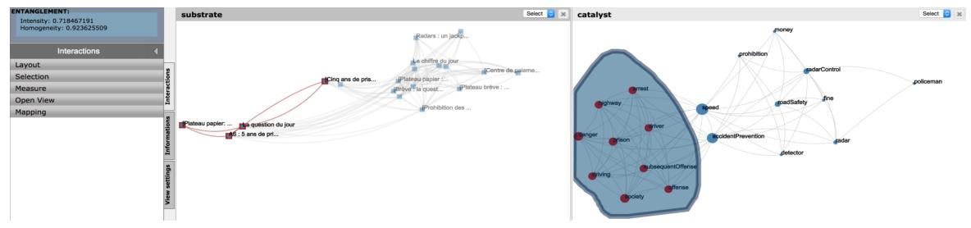
图 9: 涉及速度与道路安全的 INA 文档数据集。右侧催化视图显示两个主题聚类，通过 “事故预防” 与 “速度” 两个桥节点相连。用户已对左侧聚类进行套索选择并设为源节点；套索蓝色内部表明该群体具有高缠结值，即内聚性较强。左侧基底视图中，四个文档被高亮标记为目标节点。协调布局技术为这两个视图提供了空间稳定性。
该场景验证了协调布局与轴心切换的结合如何解答以下问题：该群体是否具有同质性？若群体内部存在子群体，其子群体的内聚性如何？
在用户未选中任何对象时，缠结详情视图显示全局缠结同质性为 0.52、缠结强度为 0.33，清晰表明该群体的内聚性整体较弱。催化网络的拓扑结构显示存在两个聚类，由 “速度” 和 “事故预防” 两个桥节点分隔；左侧聚类包含 9 个催化关键词（包括 “监狱”）。对该聚类进行套索选择后，基底视图中高亮显示 4 份文档，套索的蓝色内部反映出缠结同质性 0.93、缠结强度 0.72 的高缠结值，表明对应的文档形成了内聚性更强的子群体。对这些文档的内容分析显示，其均报道了同一则新闻：一名不良司机因多次超速违章被判处监禁。

7.2 应用场景 2：保罗・里维尔
第二个应用场景是 18 世纪美国独立运动的社会网络^{[Fis94]}。在该多层网络中，基底为人物，催化剂为各类社团。图10 展示了该网络的结构：917 条多层边连接 49 个人物（对应 417 条基底边）和 7 个社团（对应 16 条催化边）。参考希利从保皇党情报分析师角度的分析^{[Hea13]}，我们将这些社团称为 “恐怖组织团伙”。
该场景验证了灵活切换交互在发现具有特定行为的人物和社团中的应用价值。保罗・里维尔是美国中小学生熟知的历史人物，但这些社团大多并不为人所知。本文利用 Detangler 系统分析以下问题：多层网络结构是否能体现保罗・里维尔的重要性？是否能反映这些社团间的相互影响？
在图10（a）中，用户对保罗・里维尔进行了套索选择，可观察到其与 5 个社团存在关联。以保罗・里维尔为起点，通过这些社团向基底网络进行一次或操作符的灵活切换，结果显示其可连接至网络中的所有其他人物 —— 正如他在著名的深夜骑行中所做的那样，所有人物节点均以红色轮廓高亮。图10（b）则展示了使用与操作符进行灵活切换的结果：仅有保罗・里维尔仍被选中，表明无人能完成这次深夜骑行。多层网络结构确实揭示了里维尔声名远扬的底层原因。
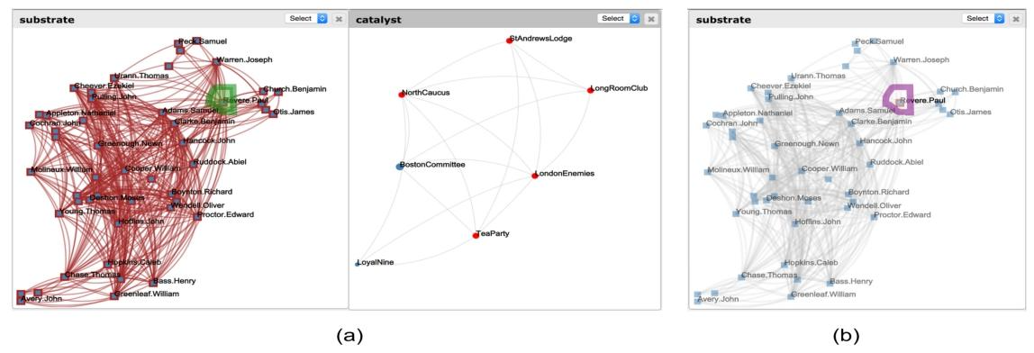
图10: 美国独立运动数据集。右侧催化视图展示恐怖组织团伙，左侧基底视图展示保罗・里维尔等相关人员。（a）对保罗・里维尔进行套索选择后，使用 “与（AND）” 操作符进行灵活切换，结果显示他可连接至网络中的所有其他相关人员 —— 正如他在著名的深夜骑行中所完成的壮举。（b）相比之下，使用 “或（OR）” 操作符进行灵活切换的结果表明，他是唯一与所有人都存在关联的人，因此也是唯一能够完成那次骑行任务的人。

7.3 专家反馈
本文基于 Detangler 系统的早期原型，与专家用户开展了初步实验，重点收集形成性评价的定性反馈，而非总结性评价的定量数据；未对分析时间和错误率进行定量测量，通过受控实验验证 Detangler 系统的效用将作为未来的研究工作。
研究团队收集了四位法国国家视听研究院（INA）档案管理员的反馈，为每位参与者安排了独立的 3 小时实验环节，要求其分析 12 个不同的 INA 文档组数据集。每个数据集包含 20-80 个基底文档，由 20-150 个催化关键词标注。参与者使用三种不同的界面完成分析任务：Detangler 系统、包含标题和关键词的 Microsoft Excel 电子表格、由 Tulip 实现的、以边表示关键词的文档单层网络视图。所有参与者均有丰富的电子表格使用经验，研究团队为其提供了 20 分钟的两个网络基界面培训。参与者需完成四项核心任务：查找特定的文档子群体、发现异常文档、判断文档组的内聚性、阐释文档组的主题脉络。因此，该实验在任务和界面方面采用被试内设计，数据集的展示顺序在参与者间进行了平衡处理。
实验结束后，参与者基于 5 点李克特量表，从五个维度对每个界面进行评分：易用性（系统操作方式的清晰程度）、简洁性（界面是否避免呈现导致认知过载的无关信息）、可读性（参与者能否清晰识别重要信息）、交互性（交互是否流畅，能否让参与者保持沉浸式分析状态）、理解性（界面是否有助于参与者理解群体构成）；同时要求参与者以任意百分比表示使用每种工具进行分析的信心程度。实验最后通过半结构化访谈，收集参与者的开放式定性意见。
图11 展示了实验结果（由 Bertifier^{[PDF14]} 工具可视化）：用户 U1 无任何可视化使用经验，对可视化技术持怀疑态度，是唯一一位对电子表格分析更有信心的参与者；用户 U2 和 U3 有一定的网络和树状图可视化使用经验，用户 U4 在以往的项目中积累了丰富的网络可视化使用经验，这三位参与者使用 Detangler 系统进行分析的信心程度均高于其他界面。
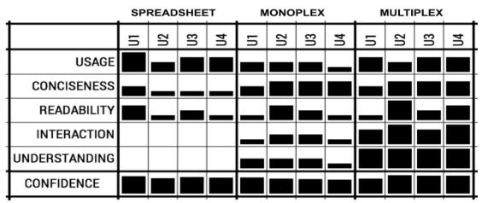
图 11: 主观评分与整体置信度
易用性评分结果初步证实，使用 Detangler 系统进行多层网络分析具有可行性；交互性和理解性的评分模式呈现一致特征：电子表格评分较低，单层网络评分中等，多层网络（Detangler）评分较高。此外，理解性评分对 Detangler 系统的偏向性尤为明显，这是因为该系统是专为群体内聚性分析目标设计的。
访谈过程中，所有参与者均对 Detangler 系统的以下特性给予正面评价：并排的网络视图设计、灵活切换交互的易用性、催化视图的信息丰富性、缠结度量与自身群体内聚性心智模型的匹配度。用户 U2 和 U4 认可协调布局的可读性，用户 U4 指出 Detangler 系统在开放式的 “主题脉络阐释” 任务中具有显著的实用价值。以下为参与者的反馈摘录（英文翻译）：
U1：我对图可视化技术了解甚少，但尽管该系统看似复杂，其学习过程却非常直观。
U2：我喜欢将文档与术语相关联的设计…… 催化视图很好地概括了文档中的核心内容。
U3：它就像词云，但比词云更好，因为它能体现术语间的层级关系。
U4：催化视图能轻松分离出与文档组相关的不同概念。
参与者提出的关于系统局限性的负面反馈，已在后续的迭代优化中得到解决，包括优化标签管理（所有参与者均提出该问题）、设计更流畅的灵活切换触发方式（用户 U3 提出）。部分功能需求暂未实现，包括展示更多的描述性统计数据（用户 U1、U2、U3 提出）、优化工作流整合并增加导出和历史记录支持（用户 U4 提出）。

8 结论与未来工作
本文提出了用于群体内聚性分析的可视分析系统 Detangler：提出的新型数据抽象结构通过基底网络和催化网络这两个衍生数据，实现了可扩展的多层网络分析，两个网络通过底层多层网络的缠结计算建立关联；将传统上需要以复杂结构形成完整视觉层的同一类型连接边，整合为衍生催化网络中的单个节点。本文提出的协调布局技术为基底网络和催化网络视图提供了空间稳定性，灵活切换交互技术通过在两个视图的选中子集间进行非对称轴心切换，实现了视图间的联动。
一个具有研究价值的开放问题是：如何将本文的方法从单多层网络分析扩展至多多层网络分析 —— 即基底集合唯一，而催化剂包含多个类别，该需求由一位专家反馈参与者提出。另一开放问题是动态多层网络的管理，需要设计特定的交互技术，支持与时间相关信息的探索分析。

参考文献
[AAB∗14] AUBER D., ARCHAMBAULT D., BOURQUI R., DE LEST M., DUBOIS J., PINAUD B., LAMBERT A., MARY P., MATHIAUT M., MELANÇON G.: Tulip III. In Encyclopedia of Social Network Analysis and Mining, Alhajj R., Rokne J., (Eds.). Springer, 2014, pp. 2216–2240. 7
[ABHR∗13] ALPER B., BACH B., HENRY RICHE N., ISEN BERG T., FEKETE J.-D.: Weighted graph comparison tech niques for brain connectivity analysis. In Proceedings of the SIGCHI Conference on Human Factors in Computing Systems (CHI) (2013), ACM, pp. 483–492. 2, 3
[BOH11] BOSTOCK M., OGIEVETSKY V., HEER J.: D3: Data driven documents. IEEE Transactions on Visualization and Com puter Graphics 17, 12 (2011), 2301–2309. 7
[DDPA14] DE DOMENICO M., PORTER M. A., ARENAS A.: Multilayer analysis and visualization of networks. arXiv preprint arXiv:1405.0843 (2014). 3
[DDSRC∗13] DE DOMENICO M., SOLÈ-RIBALTA A., COZZO E., KIVELÄ M., MORENO Y., PORTER M. A., GÒMEZ S., ARENAS A.: Mathematical formulation of multi-layer networks. arXiv preprint arXiv:1307.4977 physics.soc-ph (2013). 1
[DHRL∗12] DUNNE C., HENRY RICHE N., LEE B., METOYER R., ROBERTSON G.: GraphTrail: Analyzing large multivariate, heterogeneous networks while supporting exploration history. In Proceedings of the SIGCHI Conference on Human Factors in Computing Systems (CHI) (2012), ACM, pp. 1663–1672. 4
[DRRD12] DORK M., RICHE N. H., RAMOS G., DUMAIS S.: PivotPaths: Strolling through faceted information spaces. IEEE Transactions on Visualization and Computer Graphics 18, 12 (2012), 2709–2718. 4
[Fis94] FISCHER D. H.: Paul Revere’s ride. Oxford University Press, 1994. 8
[GFC04] GHONIEM M., FEKETE J.-D., CASTAGLIOLA P.: A comparison of the readability of graphs using node-link and matrix-based representations. In Proceedings of the IEEE Sym posium on Information Visualization (InfoVis) (2004), IEEE, pp. 17–24. 5
[GKL∗13] GHANI S., KWON B. C., LEE S., YI J. S., ELMQVIST N.: Visual analytics for multimodal social network analysis: A design study with social scientists. IEEE Transac tions on Visualization and Computer Graphics 19, 12 (2013), 2032–2041. 2, 4
[GLK∗13] GORG C., LIU Z., KIHM J., CHOO J., PARK H., STASKO J.: Combining computational analyses and interactive visualization for document exploration and sensemaking in jig saw. IEEE Transactions on Visualization and Computer Graph ics 19, 10 (2013), 1646–1663. 4
[HD11] HASCOËT M., DRAGICEVIC P.: Visual comparison of document collections using multi-layered graphs. Tech. rep., LIRMM-00601851, 2011. 2, 3
[Hea13] HEALY K.: Using metadata to find Paul Revere.
http://kieranhealy.org/blog/archives/2013/06/09/using-metadata-to-find-paul-revere/, 2013. 8
[HP14] HEER J., PERER A.: Orion: A system for modeling, transformation and visualization of multidimensional heteroge neous networks. Information Visualization 13, 2 (2014), 111 133. 4
[KJ13] KERREN A., JUSUFI I.: A novel radial visualization ap proach for undirected hypergraphs. In Proceedings of the Eu rographics Conference on Visualisation (EuroVis)(2013). Short paper (2013). 4
[KPLB07] KANG H., PLAISANT C., LEE B., BEDERSON B. B.: NetLens: iterative exploration of content-actor network data. In formation Visualization 6, 1 (2007), 18–31. 4
[LNS14] LIU Z., NAVATHE S. B., STASKO J. T.: Ploceus: Mod eling, visualizing, and analyzing tabular data as networks. Infor mation Visualization 13, 1 (2014), 59–89. 4
[MJ09] MCGUFFIN M. J., JURISICA I.: Interaction techniques for selecting and manipulating subgraphs in network visualiza tions. IEEE Transactions on Visualization and Computer Graph ics 15, 6 (2009), 937–944. 5
[Mun14] MUNZNER T.: Visualization Analysis and Design. A K Peters Visualization Series, CRC Press, 2014. 2, 3
[PDF14] PERIN C., DRAGICEVIC P., FEKETE J.: Revisiting Bertin matrices: New interactions for crafting tabular visualiza tions. IEEE Transactions on Visualization and Computer Graph ics 20, 12 (2014), 2082–2091. 9
[RDLC12] RICHE N. H., DWYER T., LEE B., CARPENDALE S.: Exploring the design space of interactive link curvature in network diagrams. In Proceedings of the International Working Conference on Advanced Visual Interfaces (AVI) (2012), ACM, pp. 506–513. 3
[RMV14] RENOUST B., MELANÇON G., VIAUD M.-L.: Entan glement in multiplex networks: understanding group cohesion in homophily networks. Social Network Analysis- Community De tection and Evolution XVIII, 274 (2014). 3
[SFMB12] SEDLMAIR M., FRANK A., MUNZNER T., BUTZ A.: RelEx: Visualization for actively changing overlay network spec ifications. IEEE Transactions on Visualization and Computer Graphics 18, 12 (2012), 2729–2738. 4
[STF∗13] SCHREURS B., TEPLOVS C., FERGUSON R., DE LAAT M., BUCKINGHAM SHUM S.: Visualizing social learning ties by type and topic: rationale and concept demon strator. In Proceedings of the Third International Conference on Learning Analytics and Knowledge (2013), ACM, pp. 33–37. 3
[WAG05] WILKINSON L., ANAND A., GROSSMAN R.: Graph theoretic scagnostics. In Proceedings of the IEEE Symposium on Information
Visualization (InfoVis) (2005), IEEE Computer Society, pp. 157–164. 2
[Wat06] WATTENBERG M.: Visual exploration of multivariate graphs. In Proceedings of the SIGCHI Conference on Human Factors in Computing Systems (CHI) (2006), ACM, pp. 811–819. 2

Detangler: Visual Analytics for Multiplex Networks
Authors: B. Renoust¹², G. Melançon², T. Munzner³
¹National Institute of Informatics & JFLI CNRS UMI 3527, Tokyo, Japan
²University of Bordeaux & LaBRI CNRS UMR 5800 & INRIA Bordeaux Sud Ouest, Bordeaux, France
³University of British Columbia, Vancouver, Canada
Source: Eurographics Conference on Visualization (EuroVis) 2025, Volume 34 (2015), Number 3
Guest Editors: H. Carr, K.-L. Ma, G. Santucci
Abstract: A multiplex network has links of different types, allowing it to express many overlapping types of relationships. A core task in network analysis is to evaluate and understand group cohesion; that is, to explain why groups of elements belong together based on the underlying structure of the network. We present Detangler, a system that supports visual analysis of group cohesion in multiplex networks through dual linked views. These views feature new data abstractions derived from the original multiplex network: the substrate network and the catalyst network. We contribute two novel techniques that allow the user to analyze the complex structure of the multiplex network without the extreme visual clutter that would result from simply showing it directly. The harmonized layout visual encoding technique provides spatial stability between the substrate and catalyst views. The pivot brushing interaction technique supports linked highlighting between the views based on computations in the underlying multiplex network to leapfrog between subsets of catalysts and substrates. We present results from the motivating application domain of annotated news documents with a usage scenario and preliminary expert feedback. A second usage scenario presents group cohesion analysis of the social network of the early American independence movement.
Key Words: Categories and Subject Descriptors (according to ACM CCS): Visualization [Human-centred computing]: Visualization Techniques-Graph drawings

1. Introduction
In the exploratory visual analysis of network data, the high-level task of detecting structural patterns often involves the lower-level abstract task of understanding groups. Understanding and explaining the reasons that elements of the same group belong together can be framed as many related questions: What makes a group a whole? Why are these entities tied together? How do different groups compare to each other? Are all groups equally homogeneous?
Our motivation to address this problem came from working with archivists at INA, the French national institute responsible for archiving and reselling all news material broadcast within France over the past several decades. They must create groups of documents in response to requests from a diverse set of potential users including television and print journalists, documentary filmmakers, and contemporary talk show creators. These groups are based on many possible criteria, including people, places, and topics. The archivists need to validate that the proposed groups are a good match with these requests, and thus are interested in examining the group structure in detail.
For example, in a collection of news documents such as newspaper articles and TV news excerpts, links between documents can be inferred if they share similar content. There are several different ways to group documents together: according to whether they concern the same people, or describe the same places, or are about the same topics. Each of these ways of grouping them yields a different set of link relationships. To precisely capture the full structure of the relationships between documents, the network should have multiple layers, where the links induced by sharing one kind of similarity are assigned to a different layer than those for a different similarity measure. This kind of network, where there are links of different types, is called a multiplex network ^{[DDSRC∗13]}.
The task of analyzing group cohesion is difficult with multiplex networks because they express many overlapping types of relationships simultaneously. This problem is well suited for interactive visual analysis through a combination of interactive exploration initiated by the user and sophisticated computational support; in short, visual analytics. The combination of the data abstraction of multiplex networks and the task abstraction of group cohesion analysis arises in many domain contexts from bioinformatics to digital humanities. In this paper we present two usage scenarios: an annotated news document example from the archivists who originally piqued our interest in this problem, and a social network analysis example using data from the early American independence movement.
The first contribution of this paper is the design and implementation of Detangler, a system to support the interactive visual analysis of multiplex networks. A second contribution is the new data abstraction of two networks derived from the original multiplex network: the substrate network contains the entities that are the focus of exploration, and the catalyst network captures the connections between these entities. In the motivating example above, the substrates are documents, and they are linked through catalyst topics. The third contribution is a visual encoding technique that supports spatial stability between the views of the substrate and catalyst networks through harmonized layout. The fourth contribution is an interaction technique that allows users to leapfrog between the substrate and catalyst views by pivoting across a selection in one view to see linked highlighting in the other based on computations carried out in the underlying multiplex network.

2. Multiplex Networks
To illustrate the ideas behind multiplex networks, Figure 1(a) has the concrete example of a bibliographic dataset composed of papers, authors, and keywords that describe paper topics. A simple way to model this network would be the traditional monoplex substrate network where all links are of a single type, such as the co-authorship network shown in Figure 1(b) where nodes are authors and links are papers; thus, people who have published a paper together are connected.
The more complete way to model this dataset is as a multiplex network, where links can have different types. Alternate names for this kind of network include heterogeneous ^{[ABHR∗13]}, multilayer ^{[HD11],} and multimodal ^{[GKL∗13]}. In our bibliographic example, families of links correspond to keywords in common between specific coauthors, as shown in Figure 1(c). A straightforward way to visually encode these networks is to visually distinguish the different link types with colors, resulting in superimposed visual layers. This approach has at least two challenges in terms of scalability. The upper limit on the number of link types is around ten because of the well-known limits on the distinguishability of small regions of non-contiguous colors ^{[Mun14][Section 10.3.1]}. The upper limit for the number of nodes and links is not as crisply defined, but visual clutter can be problematic even with dozens of items; the representation does not scale to hundreds of items.
In the new data abstraction that we propose, the visual encoding and interaction takes place via two networks derived from this multiplex network, as shown in Figure 1(d). The substrate network is constructed as follows. The substrates are the nodes in the original multiplex network. A pair of substrate nodes may be connected by multiple links in the multiplex network. It is connected with a single link in the substrate network if the two nodes are connected with at least one typed link in the multiplex network. The simple example in Figure 1(d) has a fully connected substrate network, but in general any structure is possible. The catalyst network is constructed as follows. Catalysts are created from link types in the multiplex network and are considered as nodes in the catalyst network. Catalysts are linked when the type they encode co-occur at least once in the multiplex network. That is, there is a link between catalyst a and b whenever two substrates are linked through two links of type a and b in the multiplex network. Figure 1(e) illustrates this construction. Catalysts can be understood as the reasons why substrates are linked to one another.

Figure 1: Data abstractions. (a) Original data. (b) Monoplex substrate network. (c) Multiplex network. (d) Substrates and catalysts. (e) Catalyst network. (f) Bipartite network. (g) Projected bipartite network contains incorrect links.
A single node in this catalyst network corresponds to all links of the same type in the original multiplex network, which would be a visually complex layer in the obvious representation. Our proposed abstraction thus has a similar spirit to the scagnostics abstraction for exploring scatterplot matrices ^{[WAG05]}, where each node in the metascatterplot represents an entire scatterplot in the original dataset. It also shares the spirit of the PivotGraph representation ^{[Wat06]}, where the catalyst graph acts as a visually compact roll-up of a complex structure. The full power of this dual-network abstraction is unleashed with carefully designed interaction techniques so that the user can quickly drill down by leapfrogging between different subsets of interest, as described in Section 4.
This data abstraction allows the general questions about group membership that we identified above to be expressed as more specific questions about these two new networks: How do the substrates interact? How much do the catalysts interact? What is the shape of the catalyst network? How do these two networks fit together?

2.1. Comparison to Other Abstractions
Our abstraction distinguishes substrate nodes from catalyst nodes. The abstraction of a bipartite network is a well-known way to model networks with two types of nodes, and an obvious question is whether a bipartite representation would suffice for the group cohesion analysis task. It would not suffice because simply projecting a multiplex network down into a bipartite network loses crucial information. The bipartite network shown in Figure 1(f) illustrates the problem. In the bipartite network, the two node types are authors and keywords and there cannot be direct links between nodes of the same type. Building a new substrate-to-substrate multiplex network by projecting from the bipartite network does not recover the original multiplex network. Additional edges are introduced by the projection since substrates connected with a given catalyst become pairwise connected, as shown in Figure 1(g). The multiplex network that is reconstructed from this bipartite network contains incorrect links: Elmo and Azrael have not co-authored a paper, even though they each have written papers on the topic of cats. These two representations are only equivalent in the case where the association between substrates and catalysts is fully symmetric, for example if the links correspond to similarity between nodes. Many interesting use cases have asymmetric links, including this bibliographic example.
Our abstraction also is more powerful than simply projecting the multiplex network into a weighted monoplex network. While these networks are much easier to visualize, they also lose a great deal of crucial information. Figure 2 shows an example of two different multiplex networks that project to identical substrate networks but have completely different catalyst network topologies: ring vs. star.

2.2. Entanglement Measures
We build on the previous work of three entanglement measures proposed by Renoust et al. ^{[RMV14]}. One of these operates on individual catalysts: the entanglement index for each catalyst indicates how well each catalyst mixes with others. The entanglement index for each catalyst indicates the extent to which each catalyst mixes with others. For example, Figure 2 shows the difference between the two-by-two overlaps of the circular topology and the one-to-many overlaps of the star topology. The other two operate on an entire subgraph of any size, up to the entire network. The entanglement intensity of an entire subgraph indicates how much all of the catalysts in that group mix together. Roughly speaking, group cohesion is more intense when substrates are all connected for the same reasons – that is, via catalysts of the same type – than if they are connected through catalysts of different types. The analysis of cohesion should also consider whether catalysts are invoked equally within a group. The entanglement homogeneity of an entire subgraph indicates how balanced the mix of all catalysts together is across the whole group. We use these three measures for both visual encoding and interaction, as discussed in Sections 4 and 5.

Figure 2: Weighted projections also lose information; these two multiplex networks have identical projected substrate networks but very different catalyst network topologies.

3. Related Work
Some previous work on multiplex network visualization uses straightforward visual encoding approaches based on layering and partitioning that do not scale. For example, Schreurs et al. ^{[STF∗13]} propose distinguishing between multiplex link types with color coding, leading to the problems discussed in Section 2; the unfiltered view suffers from extreme visual clutter and the filtered view shows only a tiny fraction of the available information. De Domenico et al. ^{[DDPA14]} propose partitioning the network into multiple layers on tilted 3D planes, leading to the well-known problems associated with the use of 3D space for abstract data such as networks ^{[Mun14][Section 6.3]}. These approaches do not provide interaction support for the group cohesion analysis task.
Some previous systems focus on the task of comparison between multiplex networks; while they feature carefully designed visual encodings, they still do not support group cohesion analysis. Alper et al. ^{[ABHR∗13]} propose the use of weighted projections visually encoded as both node-link views and adjacency matrix views for analyzing brain connectivity. They focus on comparing multiple groups to understand how they differ, whereas we focus on looking at one group to understand what makes it cohesive. Hascoet et al. ^{[HD11]} emphasize the combination of superimposed and side-by-side layers, but again with a focus on comparison between groups rather than cohesion.
Riche et al. propose several scalable techniques for interacting with densely connected graphs ^{[RDLC12]}, including networks with multiple link types. Kerren and Jusufi in ^{[KJ13]} lays out multiple hyperlinks around a radial layout of nodes. Our approach handles the problem at the data abstraction level by introducing the catalyst networks, where a single node corresponds to an entire visual layer with many links in the full multiplex network, rather than at the level of interaction techniques applied to that original network.
Several authors have proposed interaction techniques that rely on pivoting between different representations, as does our leapfrog interaction technique. While both NetLens ^{[KPLB07]} and GraphTrail ^{[DHRL∗12]} rely on pivot-based interaction, they do not provide node-link views and thus do not support tasks that require topological understanding, such as the graph cohesion analysis task. PivotPaths ^{[DRRD12]} does provide node-link views but succumbs to the problems of the bipartite networks discussed in Section 2.1. The RelEx system ^{[SFMB12]} does support pivoting between different node-link views, but it is highly focused on a specific task of overlay network traffic optimization, and does not support the graph cohesion analysis task.
The previous work that comes closest to addressing the group cohesion analysis task is a design study from Ghani et al. ^{[GKL∗13]}: this task is alluded to as an interesting open problem at the end of the paper. They focus on analyzing multiplex networks that arise in social network analysis, but emphasizing the problem of multiple node types more than of multiple link types. The multiplex network is represented a k-partite network, leading to the information loss problems that we characterize in Section 2; moreover, global topological understanding is not supported because node-link views are limited to local neighborhoods.
This multiple entities analysis also connects to other interesting works such Jigsaw ^{[GLK∗13]}, Orion ^{[HP14]}, and Ploceus ^{[LNS14]}, which focus on the transformation of data from tables to networks, thus leading to tangible cases in which we would like to analyse a multiplex network. Although Jigsaw allows some pivot interaction, fine-grained topological analysis is not addressed by these works.

4. Interaction
The design of the Detangler visual analytics system encompasses both interaction and visual encoding techniques. We present the interaction design in this section, and then cover visual encoding in Section 5.
Detangler features interaction techniques designed to support cohesion analysis for the groups that occur within the underlying multiplex network by supporting drill-down for interactively chosen subsets of items by pivoting between the substrate and catalyst networks. We call the result of pivoting back and forth between these views a leapfrog interaction.

4.1. Pivoting From Substrates
Mapping subsets of items between the substrate and catalyst networks in a way that reflects the true structure of the underlying multiplex network requires careful interaction and algorithm design. The complexity of the problem is due to the fact that the association between these networks is neither transitive nor symmetric. Catalysts are associated with multiplex network edges. Specifically, a catalyst corresponds to the combination of multiplex edges of a particular type and the nodes that they connect in the multiplex network.
Figure 3 shows an example of the pivot pipeline mapping from substrates to catalysts. The user initiates the pivot by selecting a subset of the substrate nodes. The system then finds the subgraph of the underlying multiplex network induced by those nodes; that is, finding all multiplex edges that directly connect any pair of these nodes in the multiplex network. New entanglement measures are computed based on that multiplex subgraph. The group entanglement measures of homogeneity and intensity are computed for that subgraph. Conveniently, the catalyst subgraph that corresponds to that multiplex subgraph is also extracted as a side effect of that computation without any further computational overhead. Moreover, the individual measure of the entanglement index for every single catalyst in the network is computed with respect to that multiplex subgraph, and those new values are used to update all of the node sizes in the catalyst view. When no subgraph is selected, the node sizes show entanglement index values computed with respect to the entire multiplex network.

Figure 3: Pivoting from substrates to catalysts. The user selects nodes in the substrate view. Detangler retrieves the corresponding multiplex nodes and creates the induced subgraph of edges that connect them in the multiplex network. It computes the two group entanglement measures of homogeneity and intensity for this subgraph, and along the way finds the corresponding subgraph in the catalyst network. It also computes new individual entanglement index measures for each catalyst node with respect to this subgraph.

4.2. Pivoting From Catalysts
An analogous operation of pivoting from catalysts to substrates can be defined, but it is not identical because of the asymmetry in the data abstractions. A single catalyst node corresponds to multiple edges within the multiplex network. Instead of an induced subgraph, we select the multiplex subgraph by limiting the set of edges of type corresponding to the selected catalysts, and restrict the set of nodes to those that they connect. Detangler supports two different selection modes, AND and OR, as shown in Figure 4. The rest of the computation is similar, including the entanglement computation.

Figure 4: The two modes of pivoting from catalysts. The more restrictive AND operator yields only the substrate nodes connected through all of the designed catalysts; the more expansive OR mode yields the substrates nodes connected through any of the catalyst links.

4.3. Looped pivot: leapfrogging
The combination of pivoting from substrates to catalysts and then pivoting from catalysts to substrates results in a leapfrog interaction, as shown in Figure 5. In a leapfrog, the catalysts corresponding to the group of selected substrates is used as the new selection in the catalyst network. We then obtain a new set of substrates that are connected within the multiplex network by those catalysts. We call this loop a leapfrog to emphasize the asymmetric nature of back to back pivot interaction: the set of substrates selected at the end of the leapfrog is not the same as the initial set. For example, when we pivot from a group of authors to the set of keywords in their co-authored papers, we may then want to ask the follow-up question Who else is publishing papers with these same keywords?

Figure 5: Leapfrogging between substrates and catalysts through back-to-back pivots.
Leapfrogging using the AND operator tends to quickly converge to the empty set where no substrates are selected after a small number of pivots, whereas leapfrogging with the OR operator converges to the whole set of all possible substrates after a few pivots.

5. Visual Encoding
The Detangler interface is shown in Figure 6. It features two main side-by-side views with coordinated node-link layouts: the substrate network on the left and the catalyst network on the right. Two supporting views are on the far left: an interaction menu on the bottom and a detail view for the entanglement measures for the current selection on the top.

Our choice of node-link layouts was guided by the two criteria from Ghoniem et al. ^{[GFC04]}. From a task point of view, we identify topological structure analysis tasks as a building block of our motivating group cohesion analysis task. From a data point of view, both of these derived networks are considerably more sparse in terms of edge density than the underlying multiplex network, so the visual complexity is manageable. The node positions are determined by our new harmonized layout technique, as discussed in detail in Section 5.3. To emphasize the difference between the views, substrate nodes are encoded as squares and catalyst nodes as circles. Catalyst node size encodes its entanglement index with respect to the current selection set.

5.1. Lasso
The two derived network views are coordinated with linked highlighting, where the pivot correspondence between views is computed as described in Section 4. The selection itself is handled using the lasso technique proposed by McGuffin and Jurisica ^{[MJ09]} that supports fluid selection of either irregularly shaped or rectangular areas. Once drawn, the lasso can be dragged as a brush. Whenever the lasso captures a new node, it is highlighted as a selected node with red fill, and a new entanglement analysis is triggered on the fly. Corresponding nodes in the other view are highlighted with red outlines for the nodes and red coloring for the links. All catalyst nodes are immediately resized according to the newly computed entanglement indices. To emphasize the highlighted items, the other items are dimmed to a transparency level of 50%. Lasso selection can occur in either view. In the discussion below, we will refer to the view used to select, in which we draw the lasso, as the source view; the other view is called the target view.
The two global entanglement measures, namely intensity and homogeneity, are directly visually encoded onto the lasso using color. These values are normalized to the same domain, ranging from 0 to 1. Figure 6b shows our sequential-segmented color ramp. The main sequence region combines three hues in order of monotonically decreasing luminance. At the bottom of the range, low values are shown with low salience as high-luminance yellow, for a subtle luminance change against the white background. The middle of the range is a mid-luminance green hue, and the top of the sequence is a low-luminance dark blue. The scale is segmented at the bottom to white and at the top with a discrete change of both hue and luminance to bright purple, emphasizing maximum values in a salient way compared to the dark blue values near the top of the range.

Figure 6: The Detangler interface. (a) The four views are annotated in orange and labelled. The current source is the substrate view on the left with a rectangular lasso showing the user’s selection, and the target is the catalyst view on the right showing corresponding highlighting. The two secondary views are on the left: the entanglement measure detail view and the menu panel. (b) Sequential-segmented color ramp. The bottom segment is white; the main sequence has three hues with monotonically decreasing luminance; the top segment is bright purple, with discrete change of hue and luminance for maximal contrast.
The entanglement homogeneity value is mapped to the thick perimeter of the lasso, and the entanglement intensity value is shown by the lasso’s interior fill color. The entanglement view in the upper left displays these values numerically, and also encodes them as colors in its own perimeter and interior to provide a visual association between the lasso and this secondary view. Figure 6 shows a rectangular lasso, while Figures 7, 9, and 10 show irregularly shaped lassos. The lower left control panel has tabs with additional buttons that allow users to switch the catalyst correspondence operator between AND and OR modes.

Figure 7: Leapfrog sequence showing visual encoding changes between pivot steps, with Detangler screenshots rather than the schematic diagram in Figure 5.

5.2. Leapfrog interaction
Leapfrogging is performed by double-clicking on a lasso selection, turning the target nodes into the source nodes and changing the visual encoding changes accordingly. This sequence of operations requires four states that must be distinguishably visually encoded. The normal state for items that are not selected in the source view is blue nodes and light grey links. Selected nodes in the source view are red. In the target view, the highlighted state is that nodes are outlined in red and links are red, and the dimmed state reduces the other items in that view with 50% transparency. Figure 7 shows these encodings in a leapfrog sequence example.

5.3. Harmonized layout
We introduce a harmonized layout technique designed to limit the cognitive load of manipulating multiple views by providing spatial stability so that users can easily match up corresponding items between the two views. Since the two views contain different entities, designing a layout to support this correspondence requires explicit algorithmic support. Figure 8 illustrates the algorithm. The high-level sequence of operations is:
- Create a layout for only the catalyst network, and then remove the links between the catalyst nodes, as in Figure 8(a).
- Divide the catalysts into two classes: low entanglement and high entanglement. The intent is that substrates should be kept close to low-entanglement catalysts that refer to a limited number of specific substrates. In contrast, because they are linked to many substrates, high-entanglement catalysts are only used to resolve ambiguities rather than as primary magnets to avoid hairballs.
- Add substrate nodes in the layout. Anchor substrates with temporary links to all low-entanglement catalysts that they are connected to. If there are no low-entanglement catalysts to which they can be attached, connect them to all their high-entanglement catalysts, as in Figure 8(b).
- Pin the catalyst nodes and run a layout algorithm that only moves the anchored substrates, as in Figure 8(c). Our implementation uses a standard force directed algorithm in both Steps 1 and 4, but other layouts are also possible.
- Use the harmonized node positions in the layouts in the separate substrate and catalyst views. The substrate nodes share spatial stability with their significant catalysts, as shown in Figure 9.

Figure 8: Harmonized layout illustration. (a) Lay out the catalyst network. (b) Remove edges. Assign substrates to catalysts based on their entanglement. (c) Lay out the substrates without moving the catalysts, prior to separating catalysts and substrates.

6. Implementation
Detangler, publicly available at http://detangler.labri.fr:31497, is implemented on top of two visualization frameworks. We use Tulip ^{[AAB∗14]} for network and layout computations, and D3 ^{[BOH11]} in conjunction with jquery-ui as a front end for rendering the visual objects. The coordination between the two servers is built on top of a server-client architecture.
Detangler benefits from the full suite of Tulip’s graph manipulation capabilities, including the ability to use different metrics for layout and coloring, and to carry out graph-theoretic grouping operations such as finding induced subgraphs. It also benefits from all of the interaction and immediate deployment capabilities of D3.
Detangler provides interactive frame rates for multiplex networks containing dozen or hundreds of catalysts and hundreds of substrates. The current scalability bottlenecks are SVG rendering and communication with the server. Achieving further algorithmic scalability would be straightforward by using a different rendering architecture that uses WebGL, such as Tulip itself. The focus with Detangler is the perceptual scalability provided by the dual-view abstraction, where a single visual object captures information that would require an entire visual layer of many objects in previous work.

7. Results
We present two different usage scenarios for group cohesion analysis with Detangler: our motivating application of annotated news documents from the INA, and an example from social network analysis. (The supplemental video and materials walk through an interactive session in more detail.) We also present results from an expert feedback session midway through our iterative refinement process.

7.1. Usage Scenario: Road Safety
Our first usage scenario is a small network of annotated INA documents that resulted from the query road safety. In this multiplex network, the substrates are documents, and the catalysts are annotations on these documents in the form of keywords. The set of 19 documents and 19 keywords are connected through 334 multiplex links, now represented by 19 substrate nodes and 105 substrate links with 19 catalyst nodes and 85 catalyst links, as shown in Figure 9.

Figure 9: INA dataset of documents concerning speed and road safety. The right catalyst view shows two clusters of topics connected by the bridge nodes accident prevention and speed. The user has lassoed the cluster on the left as source nodes; the blue interior color shows high entanglement values, indicating that the group is cohesive. The left substrate view shows four documents highlighted as target nodes. The harmonized layout provides spatial stability between these two views.
This scenario demonstrates how the combination of harmonized layout and pivoting can answer the questions: Is this group homogeneous? If there are subgroups within it, how cohesive are they?
Before the user selects any items, the entanglement detail view displays global entanglement measures of 0.52 for homogeneity and 0.33 for intensity, clearly indicating that the group is not very cohesive at all. The topology of the catalyst network shows two clusters separated by two bridge nodes: the catalysts speed and accidentPrevention. The cluster on the left consists of 9 catalyst keywords, including prison. Lassoing this group reaches 4 documents in the substrate view, and the blue lasso interior reflects the high entanglement values of 0.93/0.72 showing that the corresponding documents form a more cohesive subgroup. Reading these documents showed that they report on a specific news story about a bad driver condemned to prison due to subsequent offenses of exceeding the speed limit.

7.2. Usage Scenario: Paul Revere
The second usage scenario presents the 18th century social network of the American independence movement ^{[Fis94]}. In this multiplex network, the substrates are people, and the catalysts are societies. Figure 10 shows the 917 multiplex links connecting 49 people (with 417 substrate links) and 7 societies (with 16 catalyst links). Following Healy’s analysis from a royalist intelligence analyst point of view [Hea13], we refer to these as terrorist cells.

Figure 10: American independence movement dataset. The right catalyst view shows terrorist cells, and the left substrate view shows terrorists such as Paul Revere. (a) Lassoing Paul Revere and then leapfrogging with the AND operators shows that he can reach every other terrorist in the network, as he did in his famous ride. (b) In contrast, leapfrogging with the OR operator shows that he is the only person with connections to all others, and is thus the only person who could have done that ride.
This scenario demonstrates the use of leapfrogging to find people and societies that present specific behaviors. We note that Paul Revere is famous to most American schoolchildren, but many of these societies are not. We use Detangler to analyze the questions Does the multiplex network structure reveal Paul Revere’s importance? Does it reveal influences between these societies?
In Figure 10(a) the user has lassoed Paul Revere. We can observe that he is connected to five societies. A single leapfrog from him through these societies back to the substrate network using the OR operator illustrates that he can reach every other person in the network – as he did in his famous night-long ride – because they are all highlighted with red outlines. Figure 10(b) instead shows the result of leapfrogging with AND operator: he is the only person still selected, showing that nobody else could have done this long night ride. The multiplex network structure does indeed reveal the basis for Revere’s enduring fame.

7.3. Expert feedback session
We ran a preliminary experiment with expert users on an early prototype of Detangler, with a focus on qualitative impressions for formative rather than summative evaluation. We did not conduct quantitative measurements of time and error; a controlled experiment to validate Detangler’s utility remains as future work.
We gathered feedback from four experts, archivists from INA, with a separate 3-hour session for each participant. We asked each participant to analyze 12 different INA document group datasets. Each dataset was composed of between 20 and 80 substrate documents, annotated by between 20 and 150 catalyst keywords. The participants used three different interfaces: Detangler, a Microsoft Excel spreadsheet with title and keywords, and a monoplex network view of documents with edges representing keywords implemented in Tulip. All participants had extensive prior experience with spreadsheet usage and were given a 20-minute training session on the two network-based interfaces. Participants were asked to carry out 4 main tasks: find specific subgroups of documents, find outlier documents, indicate how cohesive the group of documents is, and tell the story of the document group. The experiment was thus within-subjects for tasks and interfaces, with dataset ordering counterbalanced between participants.
At the end of the session, participants rated each interface on Likert scales from 1 to 5 with respect to five criteria: usage, namely clarity of how to use the system; conciseness, namely whether the interface avoids presenting unnecessary information that leads to cognitive overload; readability, namely whether the participant could clearly see the important information; interaction, namely whether the interaction was sufficiently fluid to keep participants in a state of flow; and understanding, namely whether the interface allowed a good understanding of the group’s composition. They were also asked to indicate how confident they felt in conducting an analysis with each tool, as an arbitrary percentage. We finished with semi-structured interviews with open-ended qualitative questions.
Figure 11 shows the results, portrayed by Bertifier ^{[PDF14]}. U1 had no previous experience with visualization and was rather skeptical about it, and was the only participant who felt more confident with spreadsheets over all. Both U2 and U3 had some previous experience with network and tree visualizations, and U4 had extensive previous experience with using network visualization from a previous project; these three had more confidence analyzing with Detangler than with the other interfaces.

Figure 11: Subjective ratings and overall confidence.
The Usage results provide some preliminary confirmation that multiplex network analysis with Detangler was useable. The pattern for Interaction and Understanding was low ratings for spreadsheets, medium for monoplex networks, and high for multiplex networks. Also, understanding is particularly biased in favor of Detangler, which was designed specifically for the objective of group cohesion analysis.
All participants gave positive feedback during the interviews on the utility of side by side network views, the ease of use of the leapfrog interaction, the informativeness of the catalyst view, and the match of the entanglement measures to their mental models of group cohesion. U2 and U4 noted the readability of the harmonized layout, and U4 noted that analysis with Detangler was notably useful for the open-ended storytelling task. Quotes include (English translations):
- U1: I did not know much about graph visualization, but even if the system is complex, I like that it is intuitive to learn.
- U2: I like that we can associate the documents from the terms.[...] The catalyst view sums up well what happens in the documents.
- U3: It is like a word-cloud but better because it gives a sense of a hierarchy between terms.
- U4: The catalyst view makes it easy to isolate the different concepts concerning the group of documents.
Some negative feedback about limitations was subsequently addressed in our iterative refinement process, including better label management (all) and a more fluid way to trigger leapfrogging (U3). Some feature requests were not addressed, including displaying more descriptive statistics (U1, U2, U3) and better workflow integration with export and history support (U4).

8. Conclusion and Future Work
We have presented Detangler, a visual analytics system for group cohesion analysis. Our novel data abstraction supports scalable analysis with the derived data of substrate and catalyst networks; they are linked together through entanglement computations on the underlying multiplex network. All links of the same type, which are traditionally represented as a full visual layer with complex structure, are rolled up into a single node in the derived catalyst network. Our harmonized layout technique provides spatial stability between the substrate and catalyst networks, and our leapfrog interaction technique connects them through asymmetric pivoting between selected subsets in each.
An interesting open question is how to extend our approach from the analysis of single-multiplex to multiple-multiplex networks, where there is still a single set of substrates but multiple categories of catalysts, as requested by one of the expert feedback session participants. Another open problem is the management of dynamic multiplex networks, with specific interaction designed to support the exploration of time-related information.

References
[AAB∗14] AUBER D., ARCHAMBAULT D., BOURQUI R., DE LEST M., DUBOIS J., PINAUD B., LAMBERT A., MARY P., MATHIAUT M., MELANÇON G.: Tulip III. In Encyclopedia of Social Network Analysis and Mining, Alhajj R., Rokne J., (Eds.). Springer, 2014, pp. 2216–2240. 7
[ABHR∗13] ALPER B., BACH B., HENRY RICHE N., ISEN BERG T., FEKETE J.-D.: Weighted graph comparison tech niques for brain connectivity analysis. In Proceedings of the SIGCHI Conference on Human Factors in Computing Systems (CHI) (2013), ACM, pp. 483–492. 2, 3
[BOH11] BOSTOCK M., OGIEVETSKY V., HEER J.: D3: Data driven documents. IEEE Transactions on Visualization and Com puter Graphics 17, 12 (2011), 2301–2309. 7
[DDPA14] DE DOMENICO M., PORTER M. A., ARENAS A.: Multilayer analysis and visualization of networks. arXiv preprint arXiv:1405.0843 (2014). 3
[DDSRC∗13] DE DOMENICO M., SOLÈ-RIBALTA A., COZZO E., KIVELÄ M., MORENO Y., PORTER M. A., GÒMEZ S., ARENAS A.: Mathematical formulation of multi-layer networks. arXiv preprint arXiv:1307.4977 physics.soc-ph (2013). 1
[DHRL∗12] DUNNE C., HENRY RICHE N., LEE B., METOYER R., ROBERTSON G.: GraphTrail: Analyzing large multivariate, heterogeneous networks while supporting exploration history. In Proceedings of the SIGCHI Conference on Human Factors in Computing Systems (CHI) (2012), ACM, pp. 1663–1672. 4
[DRRD12] DORK M., RICHE N. H., RAMOS G., DUMAIS S.: PivotPaths: Strolling through faceted information spaces. IEEE Transactions on Visualization and Computer Graphics 18, 12 (2012), 2709–2718. 4
[Fis94] FISCHER D. H.: Paul Revere’s ride. Oxford University Press, 1994. 8
[GFC04] GHONIEM M., FEKETE J.-D., CASTAGLIOLA P.: A comparison of the readability of graphs using node-link and matrix-based representations. In Proceedings of the IEEE Sym posium on Information Visualization (InfoVis) (2004), IEEE, pp. 17–24. 5
[GKL∗13] GHANI S., KWON B. C., LEE S., YI J. S., ELMQVIST N.: Visual analytics for multimodal social network analysis: A design study with social scientists. IEEE Transac tions on Visualization and Computer Graphics 19, 12 (2013), 2032–2041. 2, 4
[GLK∗13] GORG C., LIU Z., KIHM J., CHOO J., PARK H., STASKO J.: Combining computational analyses and interactive visualization for document exploration and sensemaking in jig saw. IEEE Transactions on Visualization and Computer Graph ics 19, 10 (2013), 1646–1663. 4
[HD11] HASCOËT M., DRAGICEVIC P.: Visual comparison of document collections using multi-layered graphs. Tech. rep., LIRMM-00601851, 2011. 2, 3
[Hea13] HEALY K.: Using metadata to find Paul Revere.
http://kieranhealy.org/blog/archives/2013/06/09/using-metadata-to-find-paul-revere/, 2013. 8
[HP14] HEER J., PERER A.: Orion: A system for modeling, transformation and visualization of multidimensional heteroge neous networks. Information Visualization 13, 2 (2014), 111 133. 4
[KJ13] KERREN A., JUSUFI I.: A novel radial visualization ap proach for undirected hypergraphs. In Proceedings of the Eu rographics Conference on Visualisation (EuroVis)(2013). Short paper (2013). 4
[KPLB07] KANG H., PLAISANT C., LEE B., BEDERSON B. B.: NetLens: iterative exploration of content-actor network data. In formation Visualization 6, 1 (2007), 18–31. 4
[LNS14] LIU Z., NAVATHE S. B., STASKO J. T.: Ploceus: Mod eling, visualizing, and analyzing tabular data as networks. Infor mation Visualization 13, 1 (2014), 59–89. 4
[MJ09] MCGUFFIN M. J., JURISICA I.: Interaction techniques for selecting and manipulating subgraphs in network visualiza tions. IEEE Transactions on Visualization and Computer Graph ics 15, 6 (2009), 937–944. 5
[Mun14] MUNZNER T.: Visualization Analysis and Design. A K Peters Visualization Series, CRC Press, 2014. 2, 3
[PDF14] PERIN C., DRAGICEVIC P., FEKETE J.: Revisiting Bertin matrices: New interactions for crafting tabular visualiza tions. IEEE Transactions on Visualization and Computer Graph ics 20, 12 (2014), 2082–2091. 9
[RDLC12] RICHE N. H., DWYER T., LEE B., CARPENDALE S.: Exploring the design space of interactive link curvature in network diagrams. In Proceedings of the International Working Conference on Advanced Visual Interfaces (AVI) (2012), ACM, pp. 506–513. 3
[RMV14] RENOUST B., MELANÇON G., VIAUD M.-L.: Entan glement in multiplex networks: understanding group cohesion in homophily networks. Social Network Analysis- Community De tection and Evolution XVIII, 274 (2014). 3
[SFMB12] SEDLMAIR M., FRANK A., MUNZNER T., BUTZ A.: RelEx: Visualization for actively changing overlay network spec ifications. IEEE Transactions on Visualization and Computer Graphics 18, 12 (2012), 2729–2738. 4
[STF∗13] SCHREURS B., TEPLOVS C., FERGUSON R., DE LAAT M., BUCKINGHAM SHUM S.: Visualizing social learning ties by type and topic: rationale and concept demon strator. In Proceedings of the Third International Conference on Learning Analytics and Knowledge (2013), ACM, pp. 33–37. 3
[WAG05] WILKINSON L., ANAND A., GROSSMAN R.: Graph theoretic scagnostics. In Proceedings of the IEEE Symposium on Information
Visualization (InfoVis) (2005), IEEE Computer Society, pp. 157–164. 2
[Wat06] WATTENBERG M.: Visual exploration of multivariate graphs. In Proceedings of the SIGCHI Conference on Human Factors in Computing Systems (CHI) (2006), ACM, pp. 811–819. 2

