2209466 英中对照版
2022 MCM Problem A · Optimal Power Distribution of a Cyclist
读法：黑字为原文，蓝字为译文，一句一段、上下对应；蓝字里的小字括号是该术语第一次出现时的英文原词。
术语表（按首次出现排序，18 条）
# | 英文 | 中文 | 说明：为什么容易译错
1 | Fatigue Physiological Model | 疲劳生理模型 | 本文两大主模型之一，描述平均输出功率与持续输出时间的关系
2 | power curve | 功率曲线 | 原文另有 power profile / power-time curve / power output curve 三种写法，均指同一物
3 | aerobic respiration | 有氧呼吸
4 | anaerobic respiration | 无氧呼吸
5 | Aerobic and Anaerobic Energy Fatigue Model | 有氧与无氧能量疲劳模型 | 由上面两个子模型合并而成
6 | ordinary least squares | 普通最小二乘法（OLS） | 用数据拟合模型参数的估计方法
7 | Single Objective Programming | 单目标规划 | 目标函数只有完赛时间一个
8 | decision variable | 决策变量 | 本文指骑行者在赛道各位置施加的功率
9 | constraints | 约束条件 | 骑手状态与赛道条件
10 | dynamic programming | 动态规划 | 求解功率分配最优策略的算法
11 | sensitivity analysis | 灵敏度分析 | 改变输入看结果变化幅度
12 | wind resistance | 风阻
13 | rolling resistance | 滚动阻力
14 | FTP | 功能性阈值功率（Functional Threshold Power） | 有氧供能的上限功率
15 | time trial | 个人计时赛 | 车手单独出发、按时间排名
16 | draft strategy | 跟骑策略 | 跟在队友身后减少风阻
17 | camber | 路拱（赛道横坡） | 赛道左右倾斜的角度
18 | insensitive | 不敏感的 | 结果对该因素变化不敏感＝该因素影响小

Optimal Power Distribution of a Cyclist
自行车骑手的功率最优分配
Bicycle road races have always been popular and competitive. For the cyclists, it is of vital importance to distribute the power properly on the course. In order to help riders distribute their limited energy reasonably, we established a model to simulate the rider's power output to find the optimal distribution of their power.
自行车公路赛一直广受欢迎、竞争激烈。对车手而言，在赛道上合理分配功率至关重要。为帮助车手合理分配有限的体力，我们建立了一个模拟车手功率输出的模型，以求出其功率的最优分配方案。
Firstly, we established a Fatigue Physiological Model to characterize riders' power curve, which describes a rider's average power output as a function of sustained output time. From the perspective of aerobic respiration and anaerobic respiration, we fully consider the limitation of energy and the process of energy recovery, and establish Aerobic and Anaerobic Energy Fatigue Model. We fit the model to the obtained data using the ordinary least squares to verify the validity of the model, considering different types and genders of the riders. The power curves of different riders are provided, and the relationship between their features and model parameters was also explored. The specific results are shown in Figure 6 and its analysis.
首先，我们建立了疲劳生理模型（Fatigue Physiological Model）来刻画车手的功率曲线（power curve），该曲线把车手的平均输出功率描述为持续输出时间的函数。我们从有氧呼吸（aerobic respiration）与无氧呼吸（anaerobic respiration）的角度，充分考虑能量受限与能量恢复过程，建立了有氧与无氧能量疲劳模型（Aerobic and Anaerobic Energy Fatigue Model）。我们用普通最小二乘法（ordinary least squares）把模型拟合到所获得的数据上，以检验模型的有效性，并考虑了不同类型、不同性别的车手。文中给出了不同车手的功率曲线，并探讨了他们的特征与模型参数之间的关系。具体结果见图 6 及其分析。
Secondly, we establish an Optimal Individual Power Distribution Model to provide an optimal power allocation strategy, which describes the relationship between the power applied by the rider and the position on the track. A Single Objective Programming model is established, using the race time as the optimization objective, the rider state and track conditions as constraints, and the power applied by the rider as the decision variable. A resistance model is built to describe resistance and a track undulation and turn model are used to describe the track conditions. Based on above model and rider's power curve, we use dynamic programming to obtain the optimal power distribution strategy and corresponding shortest time. The effect of track conditions and rider status on rider power distribution was also investigated. Distribution diagrams of power output and discussions will be shown in Section 5.4.
其次，我们建立了最优个人功率分配模型，以给出最优的功率分配策略，该模型描述了车手施加的功率与赛道上位置之间的关系。我们建立了单目标规划（Single Objective Programming）模型：以比赛时间为优化目标，以车手状态与赛道条件为约束条件（constraints），以车手施加的功率为决策变量（decision variable）。我们建立了阻力模型来描述阻力，并用赛道起伏模型与弯道模型来描述赛道条件。基于上述模型与车手的功率曲线，我们用动态规划（dynamic programming）求得最优功率分配策略及相应的最短时间。我们还考察了赛道条件与车手状态对功率分配的影响。功率输出分布图与相关讨论见第 5.4 节。
Thirdly, we performed a sensitivity analysis for weather conditions, including wind direction and wind speed. The previous resistance model was improved to wind resistance model. In 24 environments with eight directions of wind and three levels of wind speed, the shortest game time was calculated, as shown in Figure 13. Completion time has changed greatly, reaching a maximum of 16%, so the results are considered sensitive to weather conditions.
第三，我们针对天气条件（包括风向与风速）做了灵敏度分析（sensitivity analysis）。此前的阻力模型被改进为风阻（wind resistance）模型。我们在 8 个风向、3 个风速等级共 24 种环境下计算了最短比赛时间，结果见图 13。完赛时间变化很大，最大达到 16%，因此我们认为结果对天气条件是敏感的。
Fourthly, we performed a sensitivity analysis of rider deviations from the power distribution strategy. We use MATLAB to randomly make change on optimal power distribution strategy, using the mean absolute value of the deviation between the rider's actual power output and the optimal power at each position as a measure of the degree of deviation. The relationship between completion time and degree of deviation is shown in Table 4. Completion time did not increase by 10% until the average deviation change reached 5%. Therefore, we believe that the model results are insensitive to rider deviation from target power. For a near-optimal time, the time reference ranges for each position of the track are shown in Table 5.
第四，我们针对车手对功率分配策略的偏离做了灵敏度分析。我们用 MATLAB 对最优功率分配策略施加随机扰动，并以车手在各位置的实际输出功率与最优功率之差的平均绝对值作为偏离程度的度量。完赛时间与偏离程度之间的关系见表 4。直到平均偏差变化达到 5%，完赛时间才增加 10%。因此我们认为，模型结果对车手偏离目标功率并不敏感（insensitive）。对于接近最优的用时，赛道上各位置的时间参考区间见表 5。
Finally, we consider the features of team time trial and generalize the individual game model to the Team Strategy Decision Model. We consider the effect of blocking wind among team members, modify the wind resistance model, and propose the draft strategy and drop strategy. In addition, we also provide a guidance for individual time trial.
最后，我们考虑团队计时赛的特点，把个人赛模型推广为团队策略决策模型。我们考虑了队员之间的挡风效应，改进了风阻模型，并提出跟骑（draft strategy）策略与掉队策略。此外，我们还给出了个人计时赛（time trial）的参赛指导。
Keywords: Individual Time Trial, Power Curve, Optimal Power Distribution, Dynamic Programming
关键词：个人计时赛、功率曲线、最优功率分配、动态规划
1 Introduction
1 引言
1.1 Problem Background
1.1 问题背景
There are many types of road cycling competitions, in which the individual time trial requires the cyclist to ride a certain distance alone, with the completion time as the result, and the one with the shortest time wins.
公路自行车赛有很多类型，其中个人计时赛要求车手单独骑行一段距离，以完成时间计成绩，用时最短者获胜。
The curvilinear relationship between power output and its duration can serve as an essential feature of high-intensity exercise, a concept known as a power curve. Essentially, this concept describes the tolerable duration of high-intensity exercise. It represents the maximum power an athlete can deliver over a certain period of time and has enormous potential applications in optimizing athletic training programs and performance and improving the quality of life of individuals with chronic diseases [1].
输出功率与持续时间之间的曲线关系，可以作为高强度运动的一个本质特征，这一概念被称为功率曲线。从根本上说，这一概念描述的是高强度运动可承受的持续时间。它表示运动员在某一时间段内能输出的最大功率，在优化运动训练方案与运动表现、改善慢性病患者生活质量等方面有巨大的应用潜力 [1]。
Different types of riders have different shapes of power curves. In a given time-trial run, they need to manage their power distribution so that to finish the race in the least amount of time. Figure 1 shows a cyclist in competition.
不同类型的车手，功率曲线形状不同。在一次给定的计时赛中，他们需要管理好自己的功率分配，以便用最少的时间完成比赛。图 1 展示了一位正在比赛的车手。
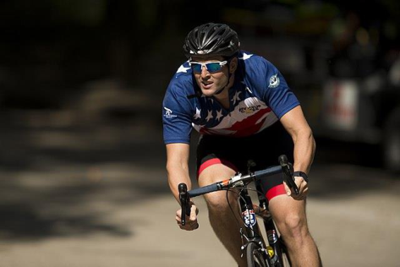
Figure 1: A cyclist in competition [2]
图 1：比赛中的车手 [2]
1.2 Restatement of the Problem
1.2 问题的重述
Considering the background information and restricted conditions identified in the problem statement, we need to develop a model to determine the optimal power distribution of one rider for one course and solve the following problems:
结合题目给出的背景信息与限制条件，我们需要建立一个模型，确定一名车手在一条赛道上的最优功率分配，并解决以下问题：
• Problem 1: Give the definition of power profiles for both types of riders, taking into account riders of different genders. One of the riders is a time trial specialist; the other is required to be of another type.
• 问题 1：给出两类车手的功率曲线定义，并考虑不同性别的车手。其中一名车手是计时赛专家，另一名要求为其他类型。
• Problem 2: Apply the above model to three specific time trial courses.
• 问题 2：将上述模型应用于三条具体的计时赛赛道。
• Problem 3: Analyze the influence of weather conditions on model results and sensitivity of the model to this influence.
• 问题 3：分析天气条件对模型结果的影响，以及模型对这一影响的灵敏度。
• Problem 4: Analyze the sensitivity of the model to deviation from the result power distribution.
• 问题 4：分析模型对偏离所得功率分配结果的灵敏度。
• Problem 5: Discuss how to develop the model to provide the best power usage scenario for a six-person team competing in a team time trial.
• 问题 5：讨论如何将模型推广，为参加团队计时赛的六人车队给出最佳的功率使用方案。
1.3 Literature Review
1.3 文献综述
The problem that this paper aims at is the power distribution of cyclist during cycling, which has been discussed in previous studies. Andrew M. Jones et al. introduced the power curve into intermittent high-intensity exercise, and used the existing two-parameter model (hyperbolic relationship between power and duration) to make better predictions for athlete fatigue monitoring [3]. Morton extended the two-parameter model to a three-parameter model, and established a new power curve model [4]. Dr. Andrew Coggan et al. used a three-parameter model to analyze the advantages and disadvantages of different types of riders through statistical data, and obtained the corresponding power curve [5].
本文所针对的问题是车手骑行过程中的功率分配，已有研究对此做过讨论。Andrew M. Jones 等人把功率曲线引入间歇性高强度运动，并用现有的两参数模型（功率与持续时间之间的双曲关系）为运动员疲劳监测做出了更好的预测 [3]。Morton 把两参数模型扩展为三参数模型，建立了新的功率曲线模型 [4]。Andrew Coggan 博士等人用三参数模型，通过统计数据分析了不同类型车手的优缺点，得到了相应的功率曲线 [5]。
There is also a lot of research on how to properly distribute power for the rider to win. The critical power model of Monod and Scherrer is a widely recognized model for optimizing pace strategy and analyzing the endurance capacity of cyclists. It consists of two parts: infinite aerobic and limited anaerobic [6]. A more complex model is the three-component Morton-Margaria model, or the 3-Tank model [7], which is another feasible bioenergy model that provides a direction for research on power distribution in bicycle racing.
关于如何合理分配功率以帮助车手取胜，也有大量研究。Monod 与 Scherrer 的临界功率模型，是被广泛认可的用于优化配速策略、分析车手耐力的模型。它由两部分组成：无限的有氧供能与有限的无氧供能 [6]。更复杂的模型是三分量的 Morton–Margaria 模型，或称三槽模型 [7]，它是另一种可行的生物能量模型，为自行车比赛中的功率分配研究提供了方向。
1.4 Our Work
1.4 我们的工作
We need a model that works for any type of rider to characterize the relationship between the rider's position on the track and the force applied. Our work mainly includes the following parts:
我们需要一个适用于任何类型车手的模型，用来刻画车手在赛道上的位置与所受作用力之间的关系。我们的工作主要包括以下几部分：
Firstly, we refer to previous literature and propose our Cyclist’s Physiological Model of Fatigue based on the three-Tank model, including aerobic energy fatigue model and anaerobic energy fatigue model. We used this model to explain the rider's power curve. After that, we performed least squares fitting on the curves of different riders, and used the obtained parameters to distinguish riders into different categories.
首先，我们参考已有文献，在三槽模型的基础上提出车手疲劳生理模型，其中包括有氧能量疲劳模型与无氧能量疲劳模型。我们用该模型解释了车手的功率曲线。随后，我们对不同车手的曲线做了最小二乘拟合，并用得到的参数把车手划分为不同类别。
Next, we established a resistance model dominated by aerodynamic resistance and rolling friction resistance, and revised the resistance model when considering the influence of weather conditions. In addition, we abstract the track as a function of ground undulation as a function of race schedule and curves as a function of race schedule. This is our Optimal Individual Power Distribution model. After that, we used the specific track data and the proposed fatigue physiological model to solve it by dynamic programming, and obtained the best power-race curve and the best finish time of the player on the track.
接着，我们建立了以空气阻力与滚动摩擦（rolling resistance）阻力为主的阻力模型，并在考虑天气条件影响时对该阻力模型做了修正。此外，我们把赛道抽象为随赛程变化的地面起伏函数与随赛程变化的弯道函数。这就是我们的最优个人功率分配模型。随后，我们用具体的赛道数据与所提出的疲劳生理模型，通过动态规划求解，得到了最佳功率—赛程曲线以及车手在该赛道上的最佳完赛时间。
Then, we separately conduct sensitivity analysis to wind speed and direction and power deviation, and analyze the strengths and weaknesses of the model.
然后，我们分别对风速风向与功率偏差做了灵敏度分析，并分析了模型的优缺点。
Finally, we generalized the model to team time trials. To account for the resistance reduction effect between teams, we reworked the resistance model for individuals in team matches. After that, we considered the possible strategies in the team game—Draft and Drop, and took the positions of these strategies as new decision variables, and theoretically the optimal solution in the team game can be obtained.
最后，我们把模型推广到团队计时赛。为考虑队伍之间的减阻效应，我们针对团队比赛中的个人重新改写了阻力模型。随后，我们考虑了团队比赛中可能的策略——跟骑与掉队，把这些策略中的位置作为新的决策变量，理论上可以求得团队比赛中的最优解。
For better understanding of the overall model, a flowchart is provided to describe our process.
为便于理解整体模型，我们给出了一张流程图来描述建模过程。
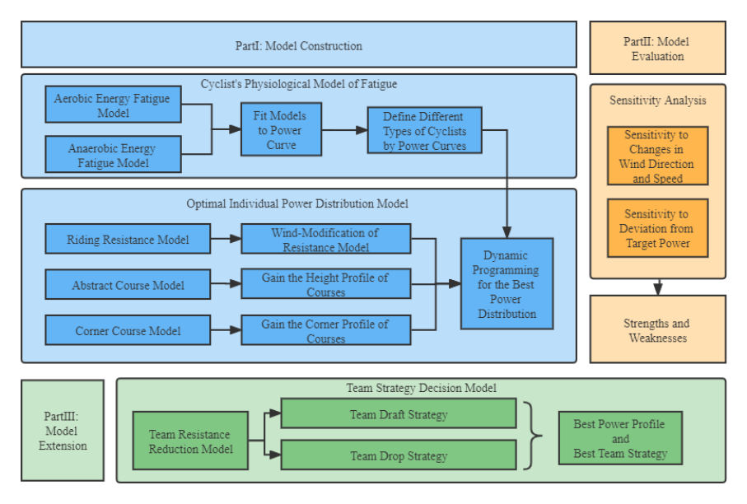
Figure 2：Overview of our work
图 2：本文工作总览
图中文字对照（英文 → 中文）
Part I: Model Construction | 第一部分：模型构建 | Cyclist's Physiological Model of Fatigue | 车手疲劳生理模型
Aerobic Energy Fatigue Model | 有氧能量疲劳模型 | Anaerobic Energy Fatigue Model | 无氧能量疲劳模型
Fit Models to Power Curve | 用功率曲线拟合模型 | Define Different Types of Cyclists by Power Curves | 按功率曲线划分车手类型
Optimal Individual Power Distribution Model | 最优个人功率分配模型 | Riding Resistance Model | 骑行阻力模型
Wind-Modification of Resistance Model | 阻力模型的风阻修正 | Abstract Course Model | 赛道抽象模型
Gain the Height Profile of Courses | 得到赛道高度剖面 | Corner Course Model | 弯道模型
Gain the Corner Profile of Courses | 得到赛道弯道剖面 | Dynamic Programming for the Best Power Distribution | 用动态规划求最优功率分配
Part II: Model Evaluation | 第二部分：模型评价 | Sensitivity Analysis | 灵敏度分析
Sensitivity to Changes in Wind Direction and Speed | 对风向与风速变化的灵敏度 | Sensitivity to Deviation from Target Power | 对偏离目标功率的灵敏度
Strengths and Weaknesses | 优缺点 | Part III: Model Extension | 第三部分：模型推广
Team Strategy Decision Model | 团队策略决策模型 | Team Resistance Reduction Model | 团队减阻模型
Team Draft Strategy | 团队跟骑策略 | Team Drop Strategy | 团队掉队策略
Best Power Profile and Best Team Strategy | 最优功率曲线与最优团队策略
2 Assumptions and Justifications
2 假设与理由
Considering that practical problems always contain many complex factors, first of all, we need to make reasonable assumptions to simplify the model, and each hypothesis is closely followed by its corresponding explanation:
考虑到实际问题总包含许多复杂因素，首先我们需要作出合理假设以简化模型，而每个假设后面都紧跟对应的说明：
• Assumption 1: Cyclists will never be influenced by others during the race. According to the cycling individual time trial rules of UCI, the riders start alone at certain intervals. So, the rider will not be influenced by others during the race.
• 假设 1：比赛中车手不会受到他人的影响。按照 UCI 的自行车个人计时赛规则，车手按一定间隔单独出发。因此，车手在比赛中不会受到他人影响。
• Assumption 2: Energy of cyclists is limited during the race. On the one hand, this comes from the limitation of the topic, and on the other hand, cyclists usually do not supplement energy in actual races.
• 假设 2：比赛中车手的能量是有限的。一方面这来自题目的限定，另一方面车手在实际比赛中通常不会补充能量。
• Assumption 3: The only sources of resistance are the viscous resistance of the air and the rolling friction of the ground. Because these two resistances account for the largest part [8], while the small resistance from the transmission efficiency of the bicycle chain can be ignored.
• 假设 3：阻力只来自空气的黏性阻力与地面的滚动摩擦。因为这两项阻力占比最大 [8]，而来自自行车链条传动效率的微小阻力可以忽略。
• Assumption 4: Cyclists move in one dimension along the track, regardless of track width. This is a reasonable simplification of the model. Analysis of lateral motion introduces unnecessary complexity.
• 假设 4：车手沿赛道做一维运动，不考虑赛道宽度。这是对模型的合理简化。分析横向运动会带来不必要的复杂性。
• Assumption 5: The influence of weather on the players only exists in the wind direction and speed, and does not consider the influence of rainfall or snowfall. This is a reasonable simplification of the model, as actual races are generally not played in harsher weather conditions.
• 假设 5：天气对选手的影响只存在于风向与风速，不考虑降雨或降雪的影响。这是对模型的合理简化，因为实际比赛一般不会在更恶劣的天气条件下进行。
3 Definitions and Notations
3 定义与符号
3.1 Definitions
3.1 定义
Power-to-weight ratio: The ratio of the rider's output power to his own body weight. The higher the value, the stronger the climbing ability.
功重比：车手输出功率与其自身体重之比。数值越高，爬坡能力越强。
Functional Threshold Power: The maximum average power a rider can achieve during an hour of full and steady riding. It is an important indicator of a rider's aerobic capacity. Also known as lactate threshold, it is usually determined by testing.
功能性阈值功率（FTP）：车手在一小时全力且稳定骑行中能达到的最大平均功率。它是衡量车手有氧能力的重要指标。又称乳酸阈值，通常通过测试确定。
Critical Power: The maximum average power a rider can get during a given period of time while riding with full force and stability.
临界功率：车手在给定时间段内全力且稳定骑行所能达到的最大平均功率。
Sharp turn: The turning angle is greater than or equal to 90 degrees within 50 meters.
急弯：50 米内转角大于等于 90 度。
3.2 Notations
3.2 符号说明
The key mathematical notations used in this paper are listed in Table 1.
本文使用的关键数学符号列于表 1。
（样例到此为止：涵盖原 PDF 第 1 页与第 3–6 页，止于表 1 之前。全文 25 页可按同一格式续做。）

