2203120 英中对照版
2022 MCM Problem C · Trading Strategy Model Based on Dynamic Programming
读法：黑字为原文，蓝字为译文，一段英文一段中文，上下对应；蓝字里的小字括号是该术语第一次出现时的英文原词。
术语表（按首次出现排序，18 条）
# | 英文 | 中文 | 说明：为什么容易译错
1 | Trading Strategy | 交易策略 | 本文主题：按价格决定每日买卖
2 | Dynamic Programming | 动态规划 | 本文核心方法
3 | ARIMA | ARIMA 模型 | 自回归积分滑动平均
4 | Commission | 手续费 | 每次交易按比例抽取
5 | Portfolio | 投资组合 | 现金+黄金+比特币
6 | Return | 收益率 | 期末净值与初始之比
7 | Risk | 风险 | 用价格变化方差度量
8 | Constraint | 约束条件 | 资金与持仓限制
9 | Objective Function | 目标函数 | 最大化最终收益
10 | Sensitivity Analysis | 灵敏度分析 | 扰动参数看结果变化
11 | Transaction | 交易 | 买或卖一次
12 | Threshold | 阈值 | 触发交易的临界值
13 | Volatility | 波动率 | 价格波动的剧烈程度
14 | Robustness | 稳健性 | 参数变动下结论是否稳定
15 | Prediction | 预测 | 用历史价格推未来
16 | Backtesting | 回测 | 用历史数据检验策略
17 | Trader Type | 交易者类型 | 普通型/激进型等
18 | Asset | 资产 | 可交易的标的物

Trading Strategy Model Based on Dynamic
基于动态规划的
Programming
交易策略模型
Summary
摘要
It is of great signiﬁcance for traders to buy and sell volatile assets reasonably in market transactions. Traders choose diﬀerent trading strategies and get diﬀerent beneﬁts. This paper studies the best trading strategies for diﬀerent traders based on the daily prices of gold and bitcoin in the past.
在市场交易中合理地买卖波动性资产对交易者而言具有重要意义。交易者选择不同的交易策略，从而获得不同的收益。本文基于过去黄金和比特币的日价格，研究针对不同交易者的最优交易策略。
For problem 1, the original data is preprocessed ﬁrstly, including ﬁlling the missing value by the daily price of gold in the past, and standardize all the original data. Following the processed data, the ARIMA model is used to establish the price prediction model. Correlation coeﬃceents between the prediction results and the price of gold and bitcoin are 0.8592 and 0.9304 respectively. The eﬀectiveness of our model is denoted. Thirdly, a dynamic programming model with largest total assets and risk as the regular termis is established, with the constraints hit rate and transaction volume limit.
针对问题 1，首先对原始数据进行预处理，包括用过去的黄金日价格填补缺失值，并对所有原始数据进行标准化。在预处理后的数据基础上，采用 ARIMA（ARIMA 模型） 模型建立价格预测模型。预测结果与黄金、比特币价格之间的相关系数分别为 0.8592 和 0.9304。由此表明了模型的有效性。第三，建立了以总资产最大化和风险为正则项的动态规划模型，其约束条件为成交率和交易量限制。
Lastly, the optimal daily trading strategy is solved with dynamic programming method. Final proﬁt is $ 132089.1078 on September 10, 2021.
最后，采用动态规划方法求解出每日最优交易策略。2021 年 9 月 10 日的最终收益为 $ 132089.1078。
For problem 2, we prove our strategy is the best judged from the generalization ability, robustness and beneﬁt of the model.
针对问题 2，我们从模型的泛化能力、稳健性和收益性出发，证明我们的策略是最优的。
By adjusting the variable parameters in the model, the strategies suitable for three traders are formed, which are insurance type, common type and radical type. The solution method of problem 1 is used to obtain the changes of each asset and the total earnings of the three trading strategies. Furthermore, the variable parameters in the model are disturbed, and the total assets change within a certain range, indicating that the model has strong anti-interference ability. Finally, the assets obtained by the three types of trading strategies are $14312.6827, $50040.5474 and $132089.1078 respectively. It can be seen that our model yield can resist inﬂation greatly.
通过调整模型中的可变参数，形成了适用于三类交易者的策略，即保险型、普通型和激进型。采用问题 1 的求解方法，得到三种交易策略下各资产的变化及总收益。此外，对模型中的可变参数进行扰动，总资产在一定范围内变化，表明模型具有较强的抗干扰能力。最终，三类交易策略所获得的资产分别为 $14312.6827、$50040.5474 和 $132089.1078。可以看出，我们的模型收益能够很好地抵御通货膨胀。
For problem 3, ﬁrstly, the sensitivity is deﬁned as the change rate of transaction frequency. By changing the transaction cost of gold and bitcoin, it is calculated that the sensitivity of gold transaction cost is 0.0422 and that of bitcoin transaction cost is 0.0658.
针对问题 3，首先将灵敏度定义为交易频率的变化率。通过改变黄金和比特币的交易成本，计算出黄金交易成本的灵敏度为 0.0422，比特币交易成本的灵敏度为 0.0658。
It can be seen from the comparison that the transaction strategy is more sensitive to the transaction cost of bitcoin. Secondly, the impact of transaction cost on transaction frequency, asset return and asset risk are analyzed. We ﬁnd that when the transaction cost increases, the transaction frequency, asset return and asset risk are decreases correspondingly.
通过比较可以看出，交易策略对比特币的交易成本更为敏感。其次，分析了交易成本对交易频率、资产收益率和资产风险的影响。我们发现，当交易成本增加时，交易频率、资产收益率和资产风险相应地降低。
For problem 4, we summarize the models and strategies established in the ﬁrst three questions, and introduce to traders in the form of memorandum how to simply use the trading strategy to trade and the beneﬁts brought by diﬀerent trading strategies.
针对问题 4，我们总结了前三个问题所建立的模型和策略，并以备忘录的形式向交易者介绍如何简单地使用交易策略进行交易，以及不同交易策略所带来的收益。
Keywords: quantitative investment; ARIMA model; dynamic programming
关键词：量化投资；ARIMA 模型；动态规划
— 原文第 3 页 —
1 Introduction
1 引言
1.1 Problem Background
1.1 问题背景
Market traders buy and sell volatile assets frequently, with a goal to maximize their total return. There is usually a commission for each purchase and sale. Two such assets are gold and bitcoin.The price changes of bitcoin and gold from September 11, 2016 to September 10, 2021 are shown in Figure 1. The source of gold daily prices is London Bullion Market Association and the source of bitcoin daily prices is NASDAQ.
市场交易者频繁买卖波动性资产，目标是使其总收益最大化。每次买入和卖出通常都需要支付手续费。黄金和比特币就是两种这样的资产。2016 年 9 月 11 日至 2021 年 9 月 10 日期间比特币和黄金的价格变化如图 1 所示。黄金日价格的来源为伦敦金银市场协会，比特币日价格的来源为纳斯达克。
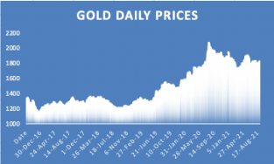
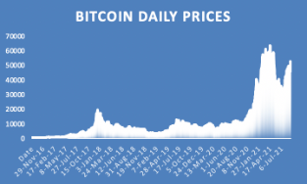
(a) Gold daily prices, U.S. dollars per troy ounce
(a) 黄金日价格，单位：美元/金衡盎司
(b) Bitcoin daily prices, U.S. dollars per bitcoin
(b) 比特币日价格，单位：美元/比特币
Figure 1: The prices of two assets
图 1：两种资产的价格
1.2 Restatement of the Problem
1.2 问题重述
In this problem, we are asked by a trader to develop a model that uses only the past stream of daily prices to date to determine each day if the trader should buy, hold, or sell their assets in their portfolio. We will start with $1000 on September 11, 2016 and use the ﬁve-year trading period, from September 11, 2016 to September 10, 2021. On each trading day, the trader will have a portfolio consisting of cash, gold, and bitcoin [C, G, B] in U.S. dollars, troy ounces, and bitcoins, respectively.We should only use these data to solve the following problems:
在本问题中，一位交易者要求我们建立一个模型，该模型仅使用截至当日的过去日价格数据，来确定交易者每天是否应买入、持有或卖出其投资组合中的资产。我们将从 2016 年 9 月 11 日的 1000 美元开始，并使用为期五年的交易期，即 2016 年 9 月 11 日至 2021 年 9 月 10 日。在每个交易日，交易者将拥有一个由现金、黄金和比特币组成的投资组合 [C, G, B]，分别以美元、金衡盎司和比特币为单位。我们仅应使用这些数据来求解以下问题：
• Develop a model that gives the best daily trading strategy based only on price data up to that day. Use the model and strategy to predict the value of the initial $1000 investment on September 10, 2021.
• 建立一个仅基于截至当日的价格数据给出最优每日交易策略的模型。使用该模型和策略预测 2021 年 9 月 10 日初始 1000 美元投资的价值。
• Present evidence that the model provides the best strategy.
• 给出该模型提供了最优策略的证据。
• Determine how sensitive the strategy is to transaction costs and how transaction costs aﬀect the strategy and results.
• 确定该策略对交易成本的敏感程度，以及交易成本如何影响策略和结果。
• Communicate the strategy, model, and results to the trader in a memorandum of at most two pages.
• 以不超过两页的备忘录向交易者传达该策略、模型和结果。
1.3 Problem Analysis
1.3 问题分析
For problem 1, The premise of formulating the strategy is to accurately predict the price trend of gold and bitcoin in the future. Therefore, it is necessary to establish a price prediction model to lay the foundation for formulating the strategy. Common time series prediction models include LSTM,
针对问题 1，制定策略的前提是准确预测未来黄金和比特币的价格走势。因此，有必要建立价格预测模型，为制定策略奠定基础。常用的时间序列预测模型包括 LSTM、
— 原文第 4 页 —
BP neural network, RNN, encoder-decoder model, etc. In view of the simplicity and eﬃciency of ARIMA model, which only needs endogenous variables rather than other exogenous variables, we choose to use ARIMA model.
BP 神经网络、RNN、编码器-解码器模型等。鉴于 ARIMA 模型仅需要内生变量而无需其他外生变量，具有简单高效的特点，我们选择使用 ARIMA 模型。
Next, establish a trading strategy model according to the established indicators, give the trading strategy and calculate the ﬁnal income. Intuitively, the price ﬂuctuation of bitcoin is much greater than that of gold, so we guess the risk is greater than that of gold. Therefore, the risk of investment can be described by the variance of price change. This is essentially a dynamic programming problem. We can quantify the return and risk, take the maximum beneﬁt as the objective function, ﬁnd the constraints and establish the model.
接下来，依据已建立的指标构建交易策略模型，给出交易策略并计算最终收益。直观上，比特币的价格波动远大于黄金，因此我们推测其风险也大于黄金。因此，投资风险可以用价格变动的方差来刻画。这本质上是一个动态规划问题。我们可以对收益率与风险进行量化，以收益最大化为目标函数，确定约束条件并建立模型。
With regard to problem 2, The optimization of the model can be proved from three aspects: generalization ability, robustness and proﬁt. The generalization ability of the model is reﬂected in that changing the parameters in the model can make the model formulate diﬀerent kinds of strategies. Therefore, we divide the strategies into insurance type, common type and radical type. The robustness of the model means that small changes in parameters will not aﬀect the overall strategy, and the anti-interference of the model is strong. It also shows that compared with other investments, our strategy has a better rate of return.
对于问题 2，可以从泛化能力、稳健性和盈利性三个方面证明模型的优化效果。模型的泛化能力体现在：改变模型中的参数可以使模型制定出不同类型的策略。因此，我们将策略划分为保险型、普通型和激进型。模型的稳健性是指参数的微小变化不会影响整体策略，模型抗干扰能力较强。这也表明，与其他投资方式相比，我们的策略具有更高的收益率。
As for problem 3, It is known that the transaction cost is the Commission. Intuitively, the increase of commission should appropriately reduce the transactions. The decrease of commission can increase the number of transactions. The ultimate goal is to maximize the income. Based on the transaction strategy model established by the ﬁrst question, by changing the cost α in the model and observing the corresponding changes of transaction frequency, asset return and asset risk, we can get the sensitivity of three types of strategies to transaction cost.
对于问题 3，已知交易成本即手续费。直观上，手续费的提高应适当减少交易次数。手续费的降低则可以增加交易次数。最终目标是使收益最大化。基于第一问所建立的交易策略模型，通过改变模型中的成本 α 并观察交易频率、资产收益率与资产风险的相应变化，可以得到三类策略对交易成本的灵敏度。
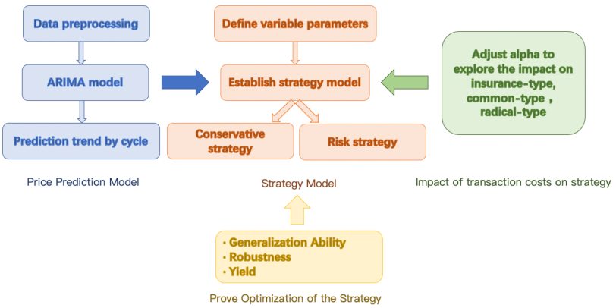
Figure 2: Overall structure
图 2：总体结构
图中文字对照（英文 → 中文）
Data preprocessing | 数据预处理 | ARIMA model | ARIMA 模型
Prediction trend by cycle | 按周期预测走势 | Price Prediction Model | 价格预测模型
Define variable parameters | 设定可变参数 | Establish strategy model | 建立策略模型
Conservative strategy | 保守策略 | Risk strategy | 风险策略
Strategy Model | 策略模型 | Adjust alpha to explore the impact on insurance-type, common-type, radical-type | 调整 α 以考察对保守型/普通型/激进型交易者的影响
Impact of transaction costs on strategy | 交易成本对策略的影响 | Generalization Ability | 泛化能力
Robustness | 稳健性 | Yield | 收益
Prove Optimization of the Strategy | 证明策略的优化
— 原文第 5 页 —
2 General Assumptions and Notations
2 总体假设与符号说明
2.1 Assumptions
2.1 假设
To simplify our problems, we make the following basic assumptions, each of which is adequately justiﬁed.
为简化问题，我们作出如下基本假设，每条假设均有充分依据。
• All data are authentic.
• 所有数据均真实可靠。
• The investor is physically and mentally healthy and has no burden such as huge loans.
• 投资者身心健康，且不承担巨额贷款等负担。
• Without considering inﬂation and other economic changes in recent years, only tabular data are used.
• 不考虑近年来的通货膨胀及其他经济变化，仅使用表格数据。
• All transactions are conducted in US dollars. The commission is deducted from the amount paid instead of being given separately.
• 所有交易均以美元进行。手续费从支付金额中扣除，而非另行支付。
• Since it is only US $1000, the minimum transaction unit of US dollar and bitcoin under normal circumstances is not considered for the universality of the model.
• 由于资金仅为 1000 美元，出于模型的普适性，不考虑正常情况下美元与比特币的最小交易单位。
2.2 Notations
2.2 符号说明
In this work, we use the nomenclature in Table 1 in the model construction. Other nonefrequent-used symbols will be introduced once they are used.
本文在模型构建中使用表 1 中的符号。其他不常用符号将在使用时予以说明。
Table 1: Notations
表 1：符号说明
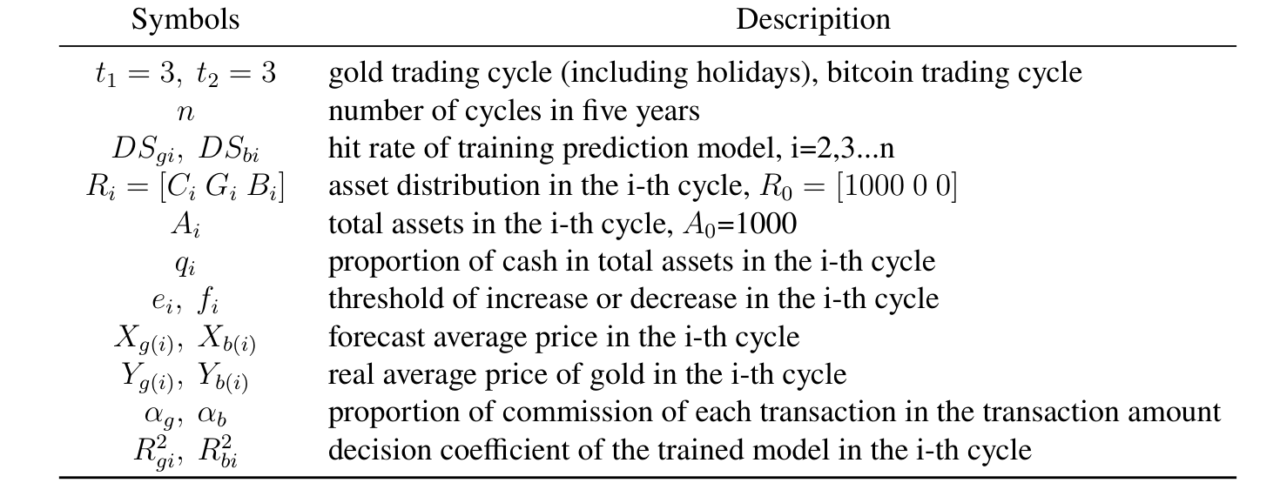
（上表为原文表 1 原样：符号列在原 PDF 中是矢量图形，文字层里只剩说明与单位。中文对照依次为：P_o 有氧呼吸能量输出功率；v_o(P_o) 有氧能量池消耗率；P_N 无氧呼吸能量输出功率；v_N(P_N) 无氧能量池消耗率；W_N 无氧能量储备；t 持续时间；v_R(P_o) 无氧能量池恢复率；P(t) 车手总输出功率；R_T 总阻力；v_f 车手相对空气的速度；C_R 滚动摩擦系数；F 车手提供的功率；x 车手在赛道上的位置；φ(x) 赛道坡度角；f(x) 海拔；g(x) 弯道；δ(x) 行进方向与风向的夹角；v_w 风速；h(x) 跟骑的最优决策函数。）
3 Problem 1: Prediction and Strategy in the Investment
3 问题 1：投资中的预测与策略
In this section, based on the existing data, we use ARIMA model to predict the price trend of gold and bitcoin in the future, so as to establish a model and give the best daily trading strategy. Dynamic programming is used to estimate the value of the initial $1000 investment by September 10, 2021.
本节基于已有数据，运用 ARIMA 模型预测黄金与比特币的未来价格走势，从而建立模型并给出最优的每日交易策略。采用动态规划估算初始 1000 美元投资到 2021 年 9 月 10 日的价值。
— 原文第 6 页 —
3.1 Data Preprocessing
3.1 数据预处理
Before data analysis, the availability of data must be guaranteed.
在数据分析之前，必须保证数据的可用性。
• Missing value processing. Unlike bitcoin, which is traded daily, gold is traded only on trading days, so the data is not continuous. For the convenience of subsequent modeling, the missing value is ﬁlled with the mean value before and after the day.
• 缺失值处理。与每日均进行交易的比特币不同，黄金仅在交易日交易，因此数据并不连续。为便于后续建模，缺失值以该日前后两日的均值填补。
• Data standardization. In regression prediction, standardization gives eigenvalues equal weight. Since we predict by period, we process the data by period. Calculate the mean(¯x) and standard deviation(SD) of data(x), then the processed data x′ = ^{(x−¯x)}
• 数据标准化。在回归预测中，标准化使各特征值具有相同的权重。由于我们按周期预测，因此按周期对数据进行处理。计算数据(x)的均值(¯x)与标准差(SD)，则处理后的数据 x^{′} = ^{(}^{x}^{−}^{¯}^{x}^{)}
SD .
3.2 Model Establishment of Problem 1
3.2 问题 1 的模型建立
3.2.1
Price Prediction Model
价格预测模型
Improving forecasting especially time series forecasting accuracy is an important yet often diﬃcult task facing decision makers in many areas. Autoregressive integrated moving average (ARIMA) models are one of the most popular linear models in time series forecasting, which have been widely applied in order to construct more accurate hybrid models during the past decade [2].
提高预测精度，尤其是时间序列预测精度，是许多领域决策者面临的一项重要而又往往困难的任务。自回归积分滑动平均（ARIMA）模型是时间序列预测中最常用的线性模型之一，近十年来已被广泛应用于构建更精确的混合模型 [2]。
ARIMA model combines three basic methods:
ARIMA 模型结合了三种基本方法：
• Autoregressive(AR). Describe the relationship between the current value and the historical value, and use the historical time data of the variable to predict itself. The order of AR model is recorded as p value.The formula is as follows:
• 自回归（AR）。描述当前值与历史值之间的关系，并利用变量的历史时间数据对自身进行预测。AR 模型的阶数记为 p 值。公式如下：
where, and α is the coeﬃcient, ϵ_{t} stands for error.
其中，α 为系数，ϵ_{t} 表示误差。
• Integrated(I). When the time series becomes stationary, the diﬀerence needs to be made, and the order of the diﬀerence is recorded as d value. Generally, ﬁrst order is enough.
• 差分(I)。当时间序列变得平稳时，需要进行差分，差分的阶数记为 d 值。通常一阶差分即已足够。
The model is called ARIMA (p, d, q), as shown in the ﬁgure3, where p is the autoregressive term, q is the moving average term, and D is the number of diﬀerences. We will follow the steps listed below to build and solve our model.
该模型称为 ARIMA (p, d, q)，如图 3 所示，其中 p 为自回归项，q 为移动平均项，D 为差分次数。我们将按照下列步骤建立并求解模型。
— 原文第 7 页 —
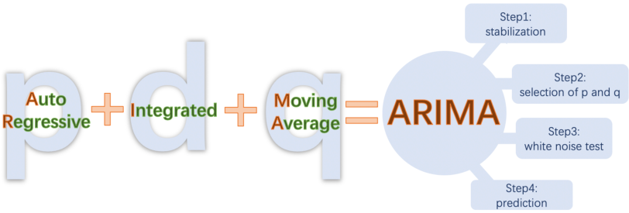
Figure 3: Structure of ARIMA model
图 3：ARIMA 模型的结构
step1 Stabilization
步骤 1 平稳化
To use ARIMA model, the time series must be stationary. We use the Augmented Dickeyfuller unit root test to test the stationarity. If the P value obtained from ADF test is less than 0.05, it is a stable time series. If it is unstable, we convert the non-stationary process into a stationary process by diﬀerence method. It can be seen from the table 2 that the time series becomes stable after the ﬁrst-order diﬀerence.
使用 ARIMA 模型时，时间序列必须是平稳的。我们采用增广 Dickey-Fuller 单位根检验来检验平稳性。若 ADF 检验得到的 P 值小于 0.05，则为平稳时间序列。若其非平稳，我们通过差分方法将非平稳过程转化为平稳过程。由表 2 可见，时间序列经一阶差分后变得平稳。
Table 2: P value of gold and bitcoin time series before and after diﬀerence
表 2：黄金与比特币时间序列差分前后的 P 值
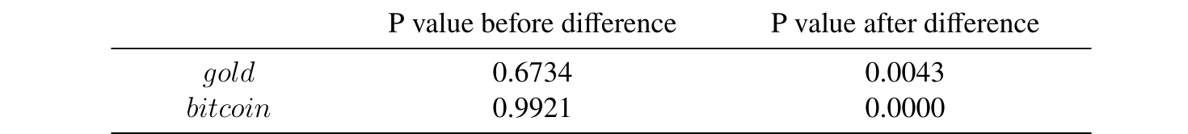
step2 Selection of p and q
步骤 2 p 与 q 的选择
Use autocorrelation function(ACF) and partial autocorrelation function(PACF) to determine the values of p and q. the conﬁrmation method is shown in the table 3.
利用自相关函数(ACF)与偏自相关函数(PACF)确定 p 与 q 的取值，判定方法如表 3 所示。
Table 3: Conﬁrmation method of p value and q value
表 3：p 值与 q 值的判定方法
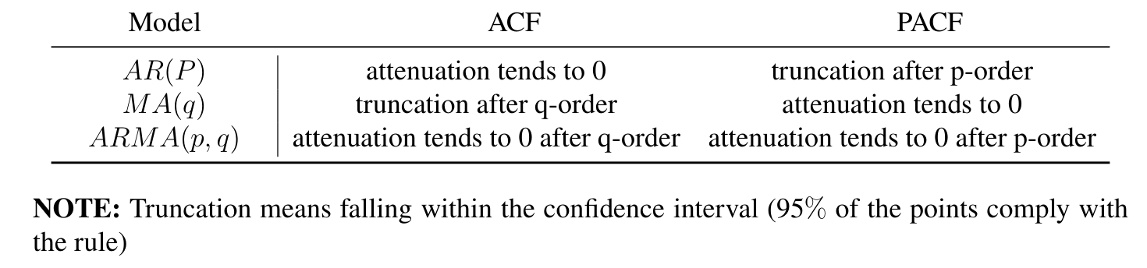
Figure 4 (a) shows the truncation of gold data using level 2 ACF and level 1 PACF, and Figure 4 (b) shows the truncation of bitcoin data using level 2 ACF and level 2 PACF.
图 4(a) 给出黄金数据在 2 阶 ACF 与 1 阶 PACF 下的截尾情况，图 4(b) 给出比特币数据在 2 阶 ACF 与 2 阶 PACF 下的截尾情况。由此，我们可以分别确定 p 值与 q 值。
— 原文第 8 页 —
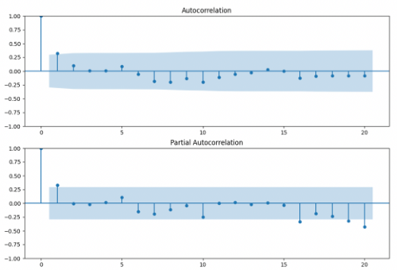
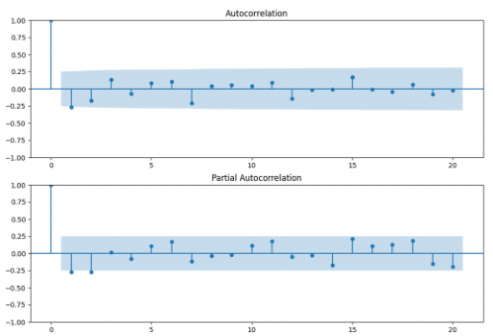
(a) ACF chart and PACF chart of gold
(a) 黄金的 ACF 图与 PACF 图
(b) ACF chart and PACF chart of bitcoin
(b) 比特币的 ACF 图与 PACF 图
Figure 4: ACF chart and PACF chart
图 4：ACF 图与 PACF 图
step3 White noise test
步骤 3 白噪声检验
If the white noise is obtained, it means that the useful information in the time series has been extracted, and the rest are all random disturbances, which cannot be predicted and used.[9] If the residual sequence passes the white noise test, the modeling can be terminated, because there is no information to continue to extract.
若得到白噪声，则说明时间序列中的有用信息已被提取，其余均为无法预测和利用的随机扰动。[9] 若残差序列通过白噪声检验，则建模即可终止，因为没有信息可以继续提取。
The ARIMA model of gold is ARIMA(2,1,1) and bitcoin is ARIMA(2,1,2). The p value of the white noise test output of this model is very close to 0, indicating that it follows the normal distribution with the mean value of 0, that is, it is a white noise.
黄金的 ARIMA 模型为 ARIMA(2,1,1)，比特币的为 ARIMA(2,1,2)。该模型输出的白噪声检验的 p 值非常接近于 0，表明其服从均值为 0 的正态分布，即为白噪声。
step4 Prediction
步骤 4 预测
In order to predict the future market timely and accurately, we use the data of 30 consecutive days as the training set and the data of the next 3 days as the test set. The moving step of the training set is 3. The prediction results of one cycle are shown in the ﬁgure 5. The correlation coeﬃcient R² of gold is 0.8592 and that of bitcoin is 0.9304. The prediction results of the model are relatively successful and can be used.
为及时、准确地预测未来市场，我们以连续 30 天的数据作为训练集，以随后 3 天的数据作为测试集。训练集的滑动步长为 3。一个周期的预测结果如图 5 所示。黄金的相关系数 R^{2} 为 0.8592，比特币的为 0.9304。该模型的预测结果较为成功，可以使用。
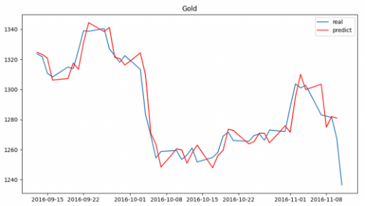
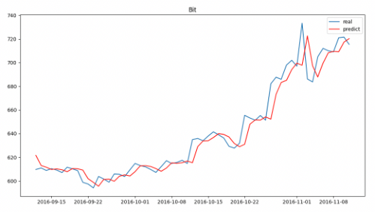
(a) Forecast chart of gold in one cycle
(a) 一个周期内黄金的预测图
(b) Forecast chart of bitcoin in one cycle
(b) 一个周期内比特币的预测图
Figure 5: Forecast charts in one cycle
图 5：一个周期内的预测图
— 原文第 9 页 —
3.2.2
Trading Strategy Model
交易策略模型
The best daily trading strategy is given only according to the price data. We need to judge the forecast data and give the strategy according to the forecast. Therefore, we deﬁne variable parameters as shown in the table 4 to quantify the strategy.
最佳日交易策略仅依据价格数据给出。我们需要对预测数据作出判断，并依据预测给出策略。因此，我们定义如表 4 所示的变量参数，以量化策略。
Table 4: Variable parameters
表 4：变量参数
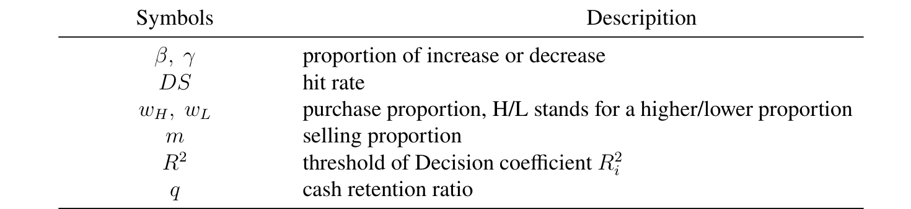
Decision coeﬃcient(R²): it is used to evaluate the volatility predicted by the model. The closer the index value is to 1, the higher the ﬁtting performance of the model.
决策系数(R^{2})：用于评价模型所预测的波动率。该指标值越接近 1，模型的拟合效果越好。
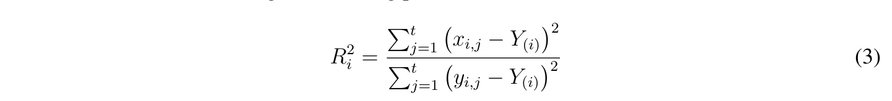
where x_{i,j} represents the predicted value of day j in cycle i and y_{i,j} represents the actual value of day j in cycle iand Y_{(i)} represents the mean of the true value in cycle i.
其中 x_{i,j} 表示第 i 个周期第 j 天的预测值，y_{i,j} 表示第 i 个周期第 j 天的实际值，Y_{(}_{i}_{)} 表示第 i 个周期真实值的均值。
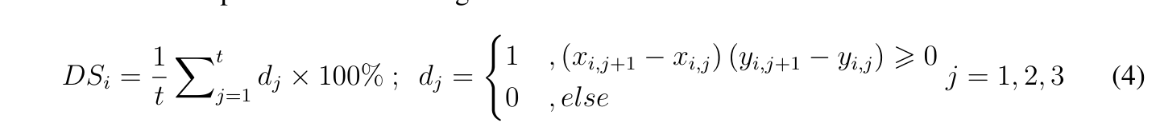
where d_{i} represents the predicted rise and fall in cycle i. If the rise and fall of the real value is the same as that of the predicted value, it is 1, on the contrary, it is 0.
其中 d_{i} 表示第 i 个周期内的预测涨跌。若真实值的涨跌与预测值的涨跌相同，则取 1，反之取 0。
In addition, we make the following assumptions:
此外，我们作出如下假设：
• The period from September 11, 2016 to November 11, 2016 is the zero cycle, and no transaction is conducted as the experience accumulation period. Since November 12, 2016 is the ﬁrst cycle, the number of cycles is n = 588.
• 2016 年 9 月 11 日至 2016 年 11 月 11 日为零周期，作为经验积累期不进行交易。由于 2016 年 11 月 12 日为第一个周期，故周期数 n = 588。
• If the transaction starts from the second cycle, the asset situation in the ﬁrst week is the same as that in the zero cycle.
• 若从第二个周期开始交易，则第一周的资产状况与零周期相同。
• Since gold is not traded during holidays, when the predicted value of gold price in a certain period is empty, it means that gold is not traded in that period.
• 由于黄金在节假日不交易，当某一时期黄金价格的预测值为空时，即表示该时期黄金不交易。
— 原文第 10 页 —
• The Commission is deducted from the amount paid instead of being given separately.
• 手续费从支付金额中扣除，而不是单独支付。
We use i to record the cycle, in which cycle 0 is the experience accumulation period, which only predicts and does not trade. 3 days is a cycle. We use j to record the day. The total number of cycles is 588. Pay attention to the diﬀerence between trading days of gold and bitcoin.
我们用 i 记录周期，其中第 0 个周期为经验积累期，该周期只进行预测而不进行交易。3 天为一个周期。我们用 j 记录天数。周期总数为 588。需要注意黄金与比特币交易日的差异。
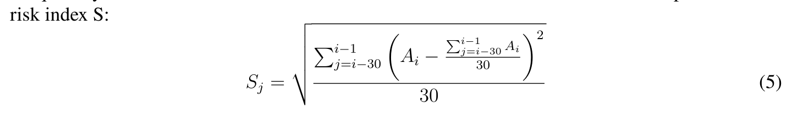
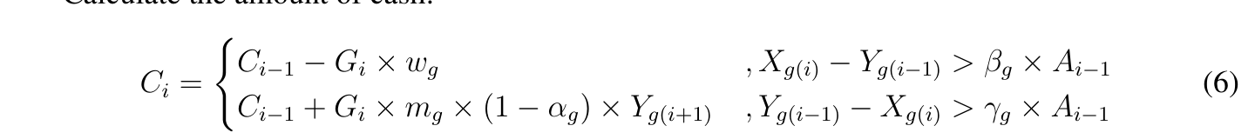
(
C_{i−1} −B_{i} × w_{b}, X_{b(i)} −Y_{b(i−1)} > β_{b} × A_{i−1}
C_{i} =
C_{i−1} + B_{i} × m_{b} × (1 −α_{b}) × Y_{b(i+1)}, Y_{b(i−1)} −X_{b(i−1)} > γ_{b} × A_{i−1}
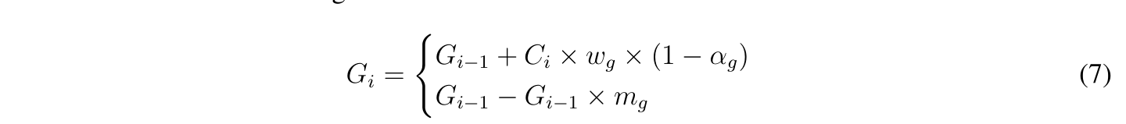
(
G_{i−1} + B_{i} × w_{b} × (1 −α_{b})
B_{i} =
G_{i−1} −G_{i−1} × m_{b}
Then the total asset formula is:
则总资产公式为：
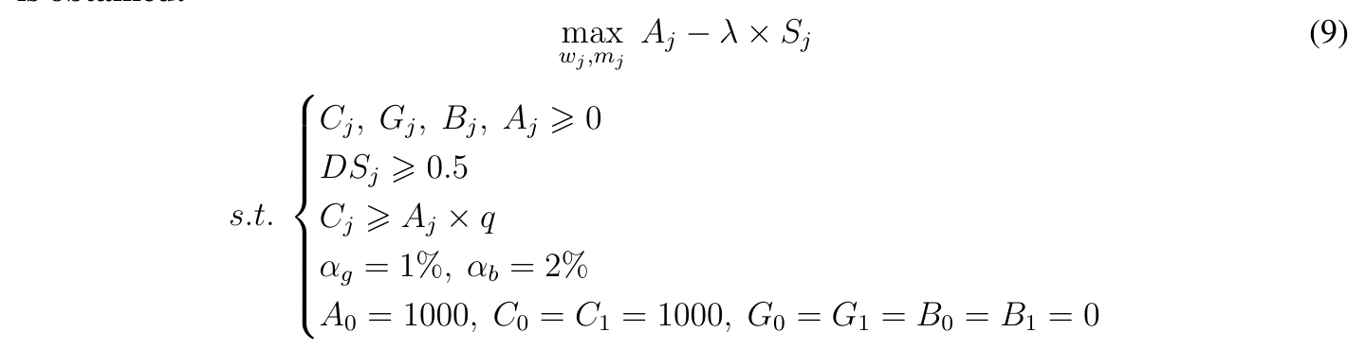
— 原文第 11 页 —
where, W_{j} represents the roportion of gold and bitcoin bought on day j, m_{j} represents the roportion of gold and bitcoin sought on day j, A_{j} represents the total assets on day j, λ represents the coeﬃcient of regular term, which is used to control risk and return, S_{j} represents the current day risk. The ﬁrst constraint indicates that all assets are positive, the second constraint indicates that the accuracy of the model is greater than 0.5, the third constraint indicates that the remaining capital of the transaction is greater than q times of the total assets, and α indicates the transaction cost, A₀, C₀, G₀, B₀ represents the total assets, cash, gold and bitcoin before the ﬁrst day of trading, C₁, G₁, B₁ represents the amount of cash, gold and bitcoin before trading on day 2.
其中，W_{j} 表示第 j 天买入黄金与比特币的比例，m_{j} 表示第 j 天卖出黄金与比特币的比例，A_{j} 表示第 j 天的总资产，λ 表示正则项系数，用于控制风险与收益，S_{j} 表示当日风险。第一个约束条件表示所有资产均为正，第二个约束条件表示模型的准确率大于 0.5，第三个约束条件表示交易剩余的现金大于总资产的 q 倍，α 表示交易成本，A_{0}、C_{0}、G_{0}、B_{0} 表示交易第一日之前的总资产、现金、黄金与比特币，C_{1}、G_{1}、B_{1} 表示第二日交易之前的现金、黄金与比特币数量。
3.3 Model Solving: Finding Strategies
3.3 模型求解：寻找策略
After the trading strategy model is established, we need to solve the model. The speciﬁc steps are as follows:
交易策略模型建立之后，我们需要对模型进行求解。具体步骤如下：
step1 Datainitialization. Set i = 1, knowα_{g} = 1%, set parameterβ_{g}, γ_{g}, ds, R², w_{Hg}, w_{Lg}, m_{g}, q, initial asset distributionR₁ = R₀ = [1000 0 0], total assets r₁ = r₀ = 1000.
step1 数据初始化。令 i = 1，已知 α_{g} = 1%，设定参数 β_{g}、γ_{g}、ds、R^{2}、w_{Hg}、w_{Lg}、m_{g}、q，初始资产分布 R_{1} = R_{0} = [1000 0 0]，总资产 r_{1} = r_{0} = 1000。
step2 Calculate hit rate (DS). The prediction model hit rate(Formula 4) can evaluate the accuracy of the trained model in predicting the rise and fall. When the accuracy is high enough, you can continue to follow the next steps.
step2 计算命中率(DS)。预测模型的命中率(式4)可以评估训练好的模型在预测涨跌方面的准确性。当准确率足够高时，可以继续执行后续步骤。
step3 Determine whether to trade. Firstly, due to the cost in the transaction, in order to avoid excessive cost caused by frequent transaction, the transaction is carried out only when the increase and decrease reach a certain threshold. Secondly, in order to avoid too little cash left in the transaction, the transaction can be carried out only when the cash meets the reserved amount. The speciﬁc process is shown in the ﬁgure 6.
step3 判断是否进行交易。首先，由于交易存在成本，为避免频繁交易造成过高的成本，只有当涨跌幅达到一定阈值时才进行交易。其次，为避免交易中留存现金过少，只有当现金满足预留金额时才能进行交易。具体过程如图 6 所示。
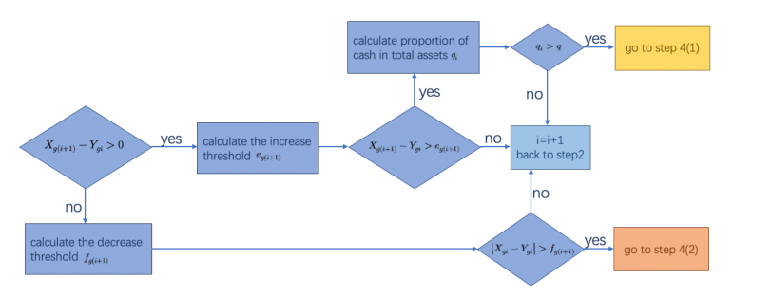
Figure 6: The process of determining whether to trade
图 6：判定是否交易的过程
图中文字对照（英文 → 中文）
X_g(i+1) − Y_gi > 0 | 当日价格高于昨日 | calculate the increase threshold e_g(i+1) | 计算上调阈值 e
calculate the decrease threshold f_g(i+1) | 计算下调阈值 f | calculate proportion of cash in total assets q_i | 计算现金占总资产的比例 q
q_i > q | 现金比例超过阈值 q | go to step 4(1) | 转到第 4(1) 步
go to step 4(2) | 转到第 4(2) 步 | i=i+1 back to step2 | 令 i=i+1，返回第 2 步
|X_gi − Y_gi| > f_g(i+1) | 价差绝对值超过下调阈值
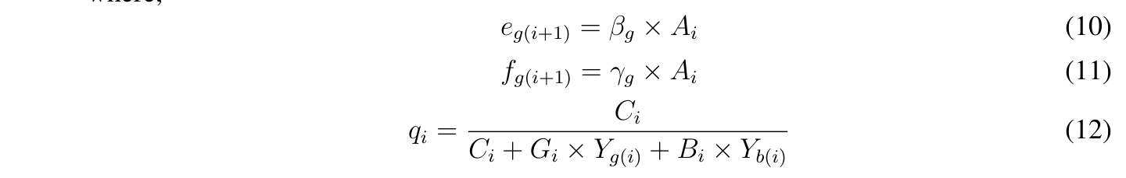
— 原文第 12 页 —
step4 Determine the number of transactions. Prediction model discrimination coeﬃcient R² gi can evaluate the volatility predicted by the trained model. The smaller the variable, the more stable the model is, and the proportion of buying gold during trading can be increased. The speciﬁc process is shown in the ﬁgure 7.
步骤 4 确定交易次数。预测模型的判别系数 R^{2} gi 可以评价训练所得模型预测的波动率。该变量越小，模型越稳定，交易中买入黄金的比例可以提高。具体过程如图 7 所示。
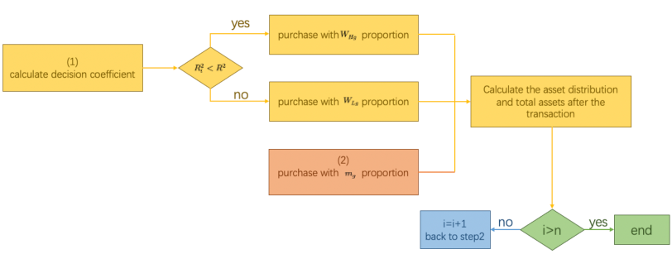
Figure 7: The process of determining the number of transactions
图 7：确定交易次数的过程
Where, the formula for total assets is
其中，总资产的计算公式为
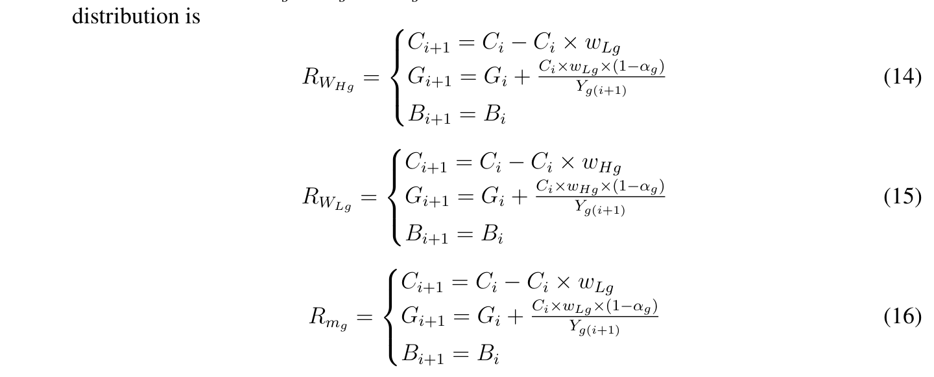
In the formula, Y_{g(i+1)} represents the real average price of gold on (i+1) day.
式中，Y_{g}_{(}_{i}_{+1)} 表示第 (i+1) 天黄金的实际平均价格。
3.4 Results and Model Evaluation
3.4 结果与模型评价
3.4.1
Model Results
模型结果
Using Python Programming and our model, set variable parameters: β_{b} = 0, β_{g} = 0.5, γ_{b} = 0.3, γ_{g} = 0.3, w_{Hg} = 0.8, w_{Hb} = 0.4, q = 0.01, the initial investment value of $1000 will be $132089.11 by September 10, 2021. The number of transactions is 9, and the ﬁnal asset distribution
利用 Python 编程和我们的模型，设定可变参数：β_{b} = 0, β_{g} = 0.5, γ_{b} = 0.3, γ_{g} = 0.3, w_{Hg} = 0.8, w_{Hb} = 0.4, q = 0.01，初始投资额 $1000 到 2021 年 9 月 10 日将达到 $132089.11。交易次数为 9，最终资产分配为
— 原文第 13 页 —
[C,G,B]=[22.31, 0.16, 2.84]. The changes of assets during the ﬁve-year period are shown in the ﬁgure below.
[C,G,B]=[22.31, 0.16, 2.84]。五年期间资产的变化如下图所示。
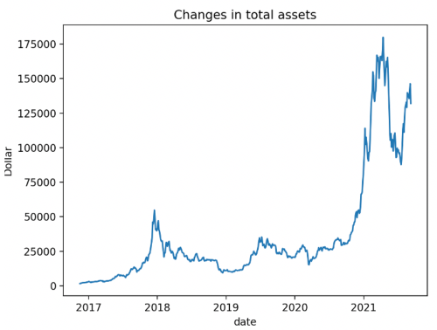
Figure 8: The changes of total assets during the ﬁve-year period
图 8：五年期间总资产的变化
3.4.2
Model Evaluation
模型评价
This result is obtained using two models. Firstly, ARIMA model is used for prediction, and we get good results: The correlation coeﬃcient R² of gold is 0.8592 and that of bitcoin is 0.9304. They are close to 1, indicating that the predicted value is highly correlated with the real value.
该结果是使用两个模型得到的。首先，使用 ARIMA 模型进行预测，我们得到了良好的结果：黄金的相关系数 R^{2} 为 0.8592，比特币的为 0.9304。二者接近 1，表明预测值与真实值高度相关。
Through the trading strategy model, we get speciﬁc beneﬁts. The strategy model has high availability:
通过交易策略模型，我们得到了具体的收益。该策略模型具有较高的可用性：
• The model is only based on the price changes of gold and bitcoin in recent ﬁve years, so the model has low requirements for data.
• 该模型仅基于近五年黄金和比特币的价格变化，因此模型对数据的要求较低。
• Our model puts forward variable parameters such as β, γ, w_{H}, w_{L}, m, q to form a parameter list. By changing the parameters in the list, we can achieve diﬀerent income results. In the future, we can form an investment prediction software according to the model. We only need to understand the meaning of relevant parameters to realize asset management. Therefore, our model is relatively simple and easy to understand.
• 我们的模型提出了 β、γ、w_{H}、w_{L}、m、q 等可变参数，构成参数列表。通过改变列表中的参数，我们可以获得不同的收益结果。未来，我们可以依据该模型形成一款投资预测软件。我们只需了解相关参数的含义即可实现资产管理。因此，我们的模型相对简单且易于理解。
• The parameters in the model have a large variable range and are more ﬂexible.
• 模型中的参数可变范围较大，更为灵活。
These ensures the reliability of the results.
这些保证了结果的可靠性。
4 Problem 2: Prove Optimization of the Strategy
4 问题 2：证明策略的优化
Our model proposes multiple variable parameters, which can achieve diﬀerent beneﬁts by changing parameters, so the model has good generalization ability. At the same time, the small change of parameters will not aﬀect the overall strategy, and the model is robust.
我们的模型提出了多个可变参数，通过改变参数可以实现不同的收益，因此该模型具有良好的泛化能力。同时，参数的微小变化不会影响整体策略，模型具有稳健性。
Compared with other investments, our strategy has a better rate of return. The following will explain the
与其他投资相比，我们的策略具有更高的收益率。下面将说明
— 原文第 14 页 —
generalization ability, robustness and proﬁt margin of the model to prove the optimization of the strategy.
模型的泛化能力、稳健性和利润空间，以证明策略的优化性。
4.1 Generalization Ability of the Model
4.1 模型的泛化能力
Successful investment comes from two factors: one is traders’ correct understanding of the market, and the other is trading rationality. According to the reference materials[7], we divide traders into the following three types:
成功的投资源于两个因素：一是交易者对市场的正确认识，二是交易的理性。根据参考文献[7]，我们将交易者分为以下三种类型：
• Insurance-type. The purpose of such traders’ investment behavior is mainly to obtain longterm capital income, that is, they hope to obtain investment income regularly, and also hope to obtain diﬀerential proﬁts through the change of capital price in a longer term. At the same time, before investing, traders should generally master suﬃcient information and make a rational analysis of the expected proﬁts and risks of the target assets.
• 保险型。此类交易者投资行为的目的主要是获取长期资本收益，即他们希望定期获得投资收益，也希望在较长时期内通过资本价格的变化获取差价收益。同时，交易者在投资之前通常应掌握充分的信息，并对目标资产的预期收益与风险作出理性分析。
• Common-type. The purpose of such traders is mainly to obtain large proﬁts in a short period of time and are willing to bear some risks. Its way mainly depends on the short-term price ﬂuctuation diﬀerence to obtain proﬁts. They take technical analysis as the main means and make speculative decisions based on historical price ﬂuctuation experience. Generally speaking, the probability of success of Common-type investors is not low, but the probability of failure is also high. Its behavior has strong subjective initiative, and the probability of success depends on its accuracy in predicting market ﬂuctuations.
• 普通型。此类交易者的目的主要是在短期内获取较大利润，并愿意承担一定风险。其方式主要依靠短期价格波动的差价获取利润。他们以技术分析为主要手段，依据历史价格波动经验作出投机决策。一般来说，普通型投资者的成功概率并不低，但失败的概率也较高。其行为具有很强的主观能动性，成功的概率取决于其对市场波动预测的准确性。
• Radical-type. The characteristics of radical traders’ behavior are based on luck and opportunity, trading in the market with luck and hoping to make huge proﬁts in the short term. Generally speaking, the risk is very high. Unless they need money urgently, have the psychology of gamblers or have the ability to take risks, most people will not use this investment method.
• 激进型。激进型交易者行为的特点是以运气和机会为基础，凭运气在市场中进行交易，期望在短期内获取巨额利润。一般而言，其风险很高。除非急需用钱、具有赌徒心理或具备承担风险的能力，大多数人不会采用这种投资方式。
In the model, for three types of traders, the corresponding parameters are adjusted as shown in the table 5:
在模型中，针对三类交易者，相应参数按表 5 所示进行调整：
Table 5: Adjustment of variable parametersvariable parameters
表 5：可变参数的调整
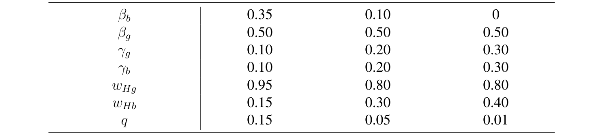
Solve the model according to diﬀerent parameters adjustments and get the changes of various
根据不同的参数调整求解模型，得到各类
— 原文第 15 页 —
types of traders’ assets. The ﬁgure 9 shows the changes of various assets of insurance-type traders in ﬁve years. See the Appendix A for the ﬁgures of the other two types.
类型交易者资产的变化。图 9 展示了保险型交易者在五年内各项资产的变化。另外两种类型的图形见附录 A。
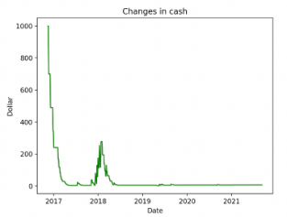
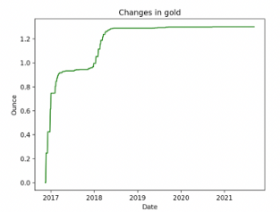
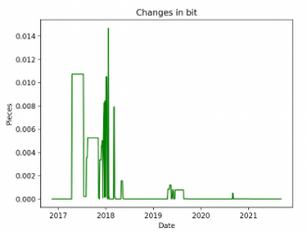
(a) Changes of cash
(a) 现金的变化
(b) Changes of gold
(b) 黄金的变化
(c) Changes of bitcoin
(c) 比特币的变化
Figure 9: Changes of various assets of insurance-type traders
图 9：保险型交易者各项资产的变化
The changes of total assets of three types of traders are shown in the ﬁgure 10:
三类交易者总资产的变化如图 10 所示：
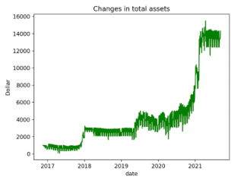
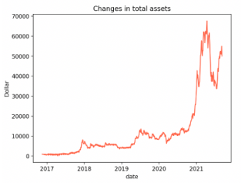
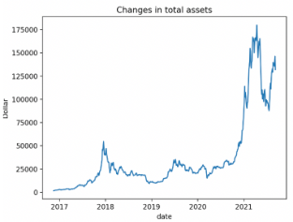
(a) Insurance-type
(a) 保险型
(b) Common-type
(b) 普通型
(c) Radical-type
(c) 激进型
Figure 10: Changes in total assets of three types of traderss
图 10：三类交易者总资产的变化
Table 6: Results of three types of strategies
表 6：三类策略的结果
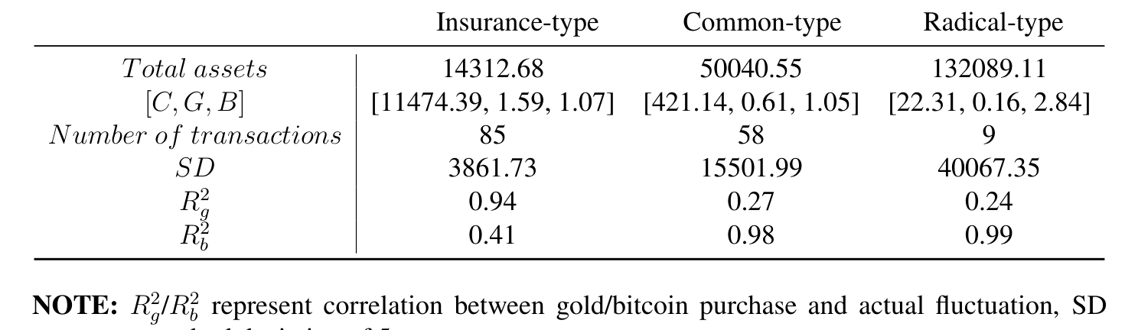
_{g}/R²b represent correlation between gold/bitcoin purchase and actual ﬂuctuation, SD represent standard deviation of 5-year assets.
_{g}/R^{2}b 表示黄金/比特币买入与实际波动的相关性，SD 表示 5 年资产的标准差。
Reading the data in the table 8, although radical investors have more returns, the value of SD is very large, that is, assets change greatly, so they have to bear corresponding risks. It can be
阅读表 8 中的数据，尽管激进型投资者的收益更多，但 SD 值很大，即资产变化很大，因此他们不得不承担相应的风险。可以
— 原文第 16 页 —
seen from the number of transactions that any disturbance in the market may disturb insurance investors. From R², we can ﬁnd that the more traders tend to venture capital, the more they will buy bitcoin; Gold symbolizes stable and conservative investment. Thus, our model gives a variety of practical and feasible strategies.
从交易次数看出，市场的任何扰动都可能干扰保险型投资者。从 R^{2} 可以发现，交易者越倾向于风险投资，就越会购买比特币；黄金则象征稳定而保守的投资。因此，我们的模型给出了多种切实可行的策略。
4.2 Robustness of the Model
4.2 模型的稳健性
In practical problems, the perturbation of system characteristics or parameters is often inevitable. The good robustness of the model means that the model has strong anti-interference ability, which means that the system has the ability to maintain a certain performance under the disturbance of uncertainty. As shown in the ﬁgure 11, ﬁgure 12, ﬁgure 13, they show the changes of total assets when disturbing the W_{H}, W_{L} and M parameters of gold and bitcoin respectively.
在实际问题中，系统特性或参数的扰动往往不可避免。模型的良好稳健性意味着模型具有很强的抗干扰能力，即系统具有在不确定性扰动下保持一定性能的能力。如图 11、图 12、图 13 所示，它们分别展示了扰动黄金和比特币的 W_{H}、W_{L} 与 M 参数时总资产的变化。
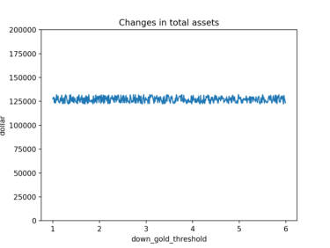
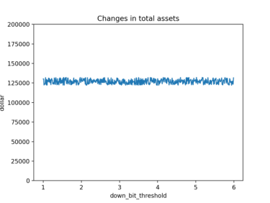
(a) gold
(a) 黄金
(b) bitcoin
(b) 比特币
Figure 11: The impact of w_{L} on total assets
图 11：w_{L} 对总资产的影响
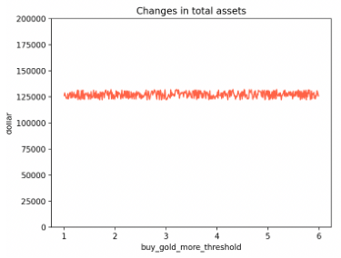
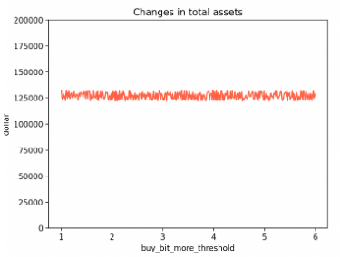
(a) gold
(a) 黄金
(b) bitcoin
(b) 比特币
Figure 12: The impact of w_{H} on total assets
图 12：w_{H} 对总资产的影响
— 原文第 17 页 —
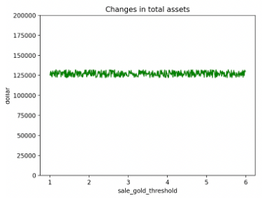
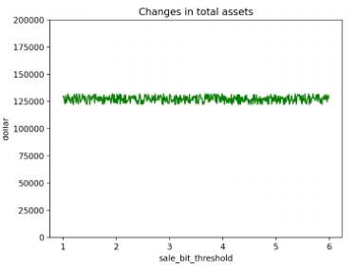
(a) gold
(a) 黄金
(b) bitcoin
(b) 比特币
Figure 13: The impact of m on total assets
图 13：m 对总资产的影响
As can be seen from the ﬁgure above, if these variables are disturbed, the ﬁnal income of the model is stable within a certain range. In fact, if the other parameters β, γ, q are disturbed, the ﬁnal return and investment risk of the model are stable within a certain range. The model has good robustness, so it is proved that the strategy we give is the best.
从上面的图可以看出，若对这些变量施加扰动，模型的最终收益在一定范围内保持稳定。事实上，若对其他参数 β、γ、q 施加扰动，模型的最终收益率与投资风险也在一定范围内保持稳定。该模型具有良好的稳健性，从而证明我们给出的策略是最优的。
4.3 Yield of the Strategy
4.3 策略的收益率
In the real economic market, because the issue of paper money sometimes exceeds the actual amount needed in circulation, there is often inﬂationso we need to manage money.Under diﬀerent levels of inﬂation, the portfolio is diverse.In reality, money, stocks and bonds are generally used as investment representatives.The portfolio in this question only includes gold ,bitcoin and cash.
在现实经济市场中，由于纸币的发行有时超过流通所需的实际数量，因而经常出现通货膨胀，所以我们需要理财。在不同程度的通货膨胀下，投资组合是多样的。在现实中，通常以货币、股票和债券作为投资的代表。本题中的投资组合只包括黄金、比特币和现金。
Set the bank deposit interest rate as r, inﬂation rate as I,deposit amount as a, Then the actual value of the deposit after ﬁve years is
Where A represents the actual value of the money after ﬁve years of deposit in the bank.
其中 A 表示资金在银行存放五年后的实际价值。
It can be seen from the data, from 2016 to 2021,the inﬂation rate was 7%, the bank deposit interest rate was 0.5%, so the actual value of $1000 after ﬁve years is $139.2436.In contrast, with our portfolio, our total assets are $14312.6827, $50040.5474 and $132089.1078 respectively when we choose insurance, common and radical investments. The results obtained by our model are several times higher than the more conservative ﬁnancial behavior, so our model has higher income and can resist inﬂation.
从数据可以看出，2016 年至 2021 年通货膨胀率为 7%，银行存款利率为 0.5%，因此 1000 美元在五年后的实际价值为 139.2436 美元。相比之下，采用我们的投资组合，当选择保险型、普通型和激进型投资时，我们的总资产分别为 14312.6827 美元、50040.5474 美元和 132089.1078 美元。我们的模型所得到的结果比更为保守的理财方式高出数倍，因此我们的模型具有更高的收益，并能够抵御通货膨胀。
5 Problem 3: Sensitivity of Strategy to Transaction Cost
5 问题 3：策略对交易成本的灵敏度
Based on the transaction strategy model established by the ﬁrst question, we can get the sensitivity of the strategy to the transaction cost by changing the cost α in the model and observing the corresponding changes of transaction frequency, asset return and asset risk.
基于第一问所建立的交易策略模型，通过改变模型中的成本 α，并观察交易频率、资产收益率和资产风险的相应变化，我们可以得到策略对交易成本的灵敏度。
— 原文第 18 页 —
5.1 Sensitivity Diﬁnition
5.1 灵敏度的定义
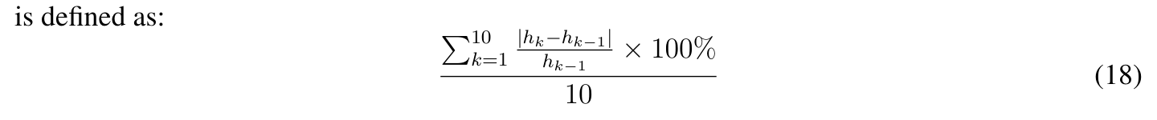
This indicator reﬂects the change rate of transaction frequency.
该指标反映了交易频率的变化率。
5.2 Impact of Transaction Costs on Strategy
5.2 交易成本对策略的影响
In question 2, we divide the strategy model into insurance type, common type and radical type. When exploring the impact of cost on strategy, we should also consider these three aspects. Let’s take the common type as an example to explore the impact of various changes of α on the strategy. We mainly explore through transaction frequency, asset return and asset risk, in which asset risk is characterized by the variance of return. Speciﬁcally, it is investigated through the changes of the following four costs.
在问题 2 中，我们将策略模型划分为保险型、普通型和激进型。在探讨成本对策略的影响时，我们也应从这三个方面加以考虑。下面以普通型为例，探讨 α 的各种变化对策略的影响。我们主要通过交易频率、资产收益率和资产风险进行探讨，其中资产风险以收益率的方差来刻画。具体地，通过以下四种成本的变化加以考察。
a. α_{g} fell 0.1% each time and α_{b} remained unchanged.
a. α_{g} 每次下降 0.1%，α_{b} 保持不变。
b. α_{g} remained unchanged and α_{b} fell 0.2% each time.
b. α_{g} 保持不变，α_{b} 每次下降 0.2%。
c. α_{g} rise 1% each time and α_{b} remained unchanged.
c. α_{g} 每次上升 1%，α_{b} 保持不变。
d. α_{g} remained unchanged and α_{b} rise 2% each time.
d. α_{g} 保持不变，α_{b} 每次上升 2%。
Figure 14 shows the change of strategy in case a.
图 14 展示了情形 a 中策略的变化。从图中可以看出，黄金成本的微小变化不会对交易者的决策产生影响。
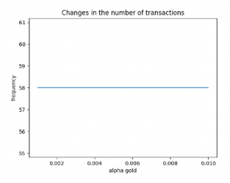
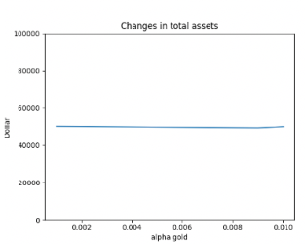
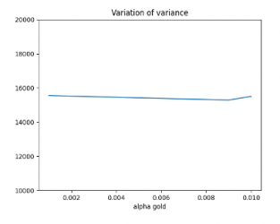
(a) Changes of transaction frequency
(a) 交易频率的变化
(b) Changes of return
(b) 收益率的变化
(c) Changes of risk
(c) 风险的变化
Figure 14: Change of strategy in case a
图 14：情形 a 中策略的变化
The result of case c is shown in the ﬁgure 15. In this case, we increase the transaction cost of gold by 0.1% each time. After reading the picture, it is found that:
情形 c 的结果如图 15 所示。在该情形下，我们将黄金的交易成本每次提高 0.1%。观察图形后可发现：
1. If the cost increases to a certain extent, it will reduce the number of transactions and the total income.
1. 当成本上升到一定程度时，会减少交易次数和总收益。
— 原文第 19 页 —
2. The cost increases, the transactions become less, and the possible risks are reduced.
2. 成本上升，交易减少，可能的风险也随之降低。
3. The changes of the three indicators are synchronous and consistent.
3. 三个指标的变化是同步且一致的。
It can be seen that in the face of the continuous rise in the cost of gold, our model has not ignored, keenly felt this signal, and the change direction is in line with the reality. The strategy is relatively sensitive to transaction costs.
可以看出，面对黄金成本的持续上升，我们的模型并未忽视，而是敏锐地感受到了这一信号，且变化方向与实际相符。该策略对交易成本较为敏感。
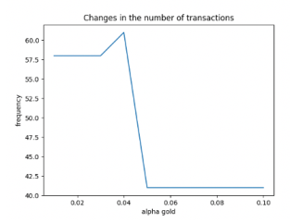
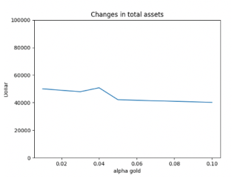
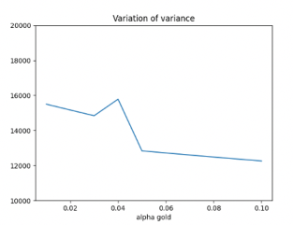
(a) Changes of transaction frequency
(a) 交易频率的变化
(b) Changes of return
(b) 收益率的变化
(c) Changes of risk
(c) 风险的变化
Figure 15: Change of strategy in case c
图 15：情形 c 中策略的变化
Table 7 lists the sensitivity of the strategies of the three transaction types to the cost of gold and bitcoin respectively.
表 7 分别列出了三种交易类型的策略对黄金成本和比特币成本的灵敏度。
Table 7: The sensitivity of three types of strategies to two costs
表 7：三类策略对两种成本的灵敏度
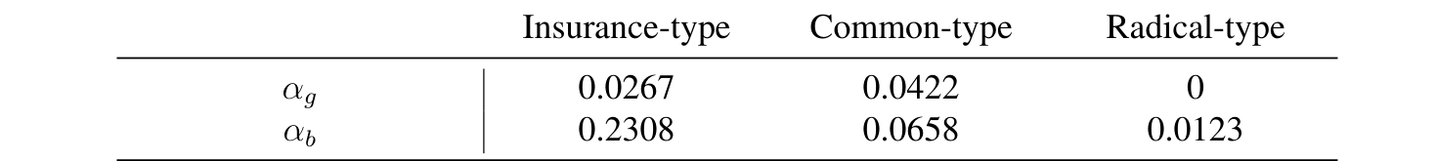
Through the data in the table, we can ﬁnd that:
通过表中的数据，我们可以发现：
• The sensitivity of trading strategy to the cost of bitcoin is higher than that to the cost of gold.
• 交易策略对比特币成本的灵敏度高于对黄金成本的灵敏度。
• The insurance-type strategy is more sensitive to the cost of bitcoin, and the common-type strategy is more sensitive to the cost of gold.
• 保险型策略对比特币成本更为敏感，普通型策略对黄金成本更为敏感。
• The sensitivity of radical-tupe strategy to cost is generally low.
• 激进型策略对成本的灵敏度总体较低。
6 Conclusion
6 结论
6.1 Strengths
6.1 优点
• Our model puts forward variable parameters to form a parameter list. By changing the parameters in the list, we can achieve diﬀerent income results. In the future, we can form
• 我们的模型提出了可变参数，从而构成一个参数列表。通过改变列表中的参数，我们可以获得不同的收益结果。未来，我们可以据此形成
— 原文第 20 页 —
an investment prediction software according to the model. We only need to understand the meaning of relevant parameters to realize asset management. Therefore, our model is relatively simple and easy to understand.
一款基于该模型的投资预测软件。我们只需理解相关参数的含义，即可实现资产管理。因此，我们的模型相对简单，易于理解。
• The parameters in the model have a large variable range and are more ﬂexible.
• 模型中的参数可变范围较大，更为灵活。
• The model is only based on the price changes of gold and bitcoin in recent ﬁve years, so the model has low requirements for data.
• 该模型仅基于近五年黄金和比特币的价格变化，因此对数据的要求较低。
6.2 Possible Improvements
6.2 可能的改进
• In the process of solving the model, the mixed purchase strategy of gold and bitcoin is not well considered, which needs to be improved.
• 在模型求解过程中，对黄金与比特币的混合购买策略考虑不足，有待改进。
• Due to the lack of ﬁnancial knowledge, the establishment of the model is not necessarily perfect.
• 由于缺乏金融知识，模型的建立未必完善。
7 Memorandum
7 备忘录
Memorandum
备忘录
To: traders
致：交易者
From: Team #2203120
来自：2203120 队
Subject: Investment model, Trading Strategy and Results of Bitcoin and Gold
主题：比特币与黄金的投资模型、交易策略及结果
Date: February 22, 2022
日期：2022 年 2 月 22 日
With the development of economy and the popularization of ﬁnancial management concept, more and more people have joined the ranks of investment. In addition to the traditional treasury bonds, funds, stocks, gold and so on, virtual currency has increasingly appeared in people’s vision, setting oﬀa "currency speculation fever". Investment involves both returns and risks. In order to explore the best trading strategy, our team has established a trading strategy model based on the price trend of gold and bitcoin in the past ﬁve years to help you better invest.
随着经济的发展和理财观念的普及，越来越多的人加入了投资的行列。除传统的国债、基金、股票、黄金等之外，虚拟货币日益出现在人们的视野中，掀起了一股“炒币热”。投资既涉及收益，也涉及风险。为探寻最优的交易策略，我们团队基于近五年黄金和比特币的价格走势建立了交易策略模型，以帮助您更好地进行投资。
STRATEGY
策略
The strategy we designed mainly focuses on three questions: when to trade, what kind of assets to trade and how much to trade.
我们设计的策略主要关注三个问题：何时交易、交易何种资产以及交易多少。
— 原文第 21 页 —
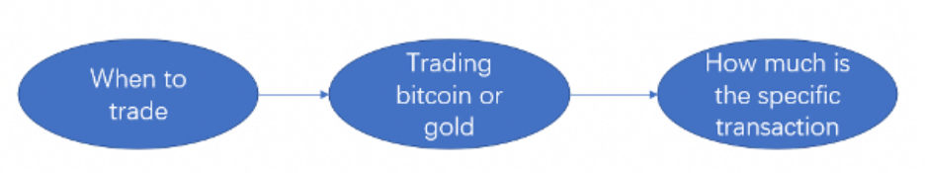
Figure 16: Structure of transaction strategy model
图 16：交易策略模型的结构
图中文字对照（英文 → 中文）
When to trade | 何时交易 | Trading bitcoin or gold | 交易比特币还是黄金
How much is the specific transaction | 具体交易多少
When to trade. We measured the hit rate of the current model, the rise and fall of gold
何时交易。我们衡量了当前模型的命中率、黄金
• and bitcoin, and the proportion of cash after trading. Only when the three indicators meet the trading conditions at the same time can the transaction be carried out, and it is decided whether to buy or sell. On the contrary, if the trading conditions are not met, wait until the next cycle for judgment
• 与比特币的涨跌情况，以及交易后现金所占的比例。只有当三个指标同时满足交易条件时，才可以进行交易，并决定是买入还是卖出。相反，若不满足交易条件，则等待下一个周期再作判断。
• Deal what. By setting the threshold of increase and decrease, compare the rise and fall range of gold and bitcoin, measure the risk and return of trading bitcoin and gold, and decide to trade gold or bitcoin.
• 交易什么。通过设置涨跌幅阈值，比较黄金与比特币的涨跌幅度，衡量交易比特币与黄金的风险和收益率，决定交易黄金还是比特币。
• How much is the deal. If we decide to buy, we will use the decision coeﬃcient of the current model to decide how much to buy. When the judgment coeﬃcient is small, it means that the model we currently use is relatively stable and the risk is small. Therefore, when purchasing, we can appropriately increase the purchase proportion, on the contrary, reduce the purchase proportion; If we decide to sell, we will sell according to the preset proportion.
• 交易多少。若决定买入，我们将利用当前模型的决策系数来决定买入多少。当判断系数较小时，说明我们当前使用的模型相对稳定，风险较小。因此，买入时可适当提高买入比例，反之则降低买入比例；若决定卖出，则按照预先设定的比例卖出。
For the above strategies, by changing the variable parameters in the strategy, three strategies can be formed: insurance type, common type and radical type, which are suitable for diﬀerent traders and have good generalization ability. Secondly, when the variable parameters in the strategy are disturbed, the results show that the total assets change within a certain range, indicating that the anti-interference ability of the model is strong. Finally, by comparing the beneﬁts of $1000 deposited in the bank for ﬁve years and the ﬁve-year trading of this strategy, it can be seen that our strategy can resist inﬂation to a certain extent.
对于上述策略，通过改变策略中的可变参数，可以形成保险型、普通型和激进型三种策略，适用于不同的交易者，并具有良好的泛化能力。其次，当策略中的可变参数受到扰动时，结果表明总资产在一定范围内变化，说明模型的抗干扰能力较强。最后，通过比较将 $1000 存入银行五年与本策略五年交易的收益，可以看出我们的策略能够在一定程度上抵御通货膨胀。
MODEL
模型
The strategy is based on the prediction of the future. In view of the simplicity and eﬃciency of ARIMA model, which only needs endogenous variables rather than other exogenous variables, we choose ARIMA model as the price prediction model. In order to predict the future market timely and accurately, we use the data of 30 consecutive days as the training set and the data of the next 3 days as the test set. The correlation coeﬃcient R² between gold’s prediction result and the real value is 0.8591, and bitcoin’s R² is 0.9304, which are close to 1, indicating that the correlation between the predicted value and the real value is strong and the prediction accuracy is high. Such prediction lays a solid foundation for follow-up work.
该策略建立在对未来的预测之上。鉴于 ARIMA 模型简单高效，只需内生变量而无需其他外生变量，我们选择 ARIMA 模型作为价格预测模型。为了及时、准确地预测未来市场，我们使用连续 30 天的数据作为训练集，将后 3 天的数据作为测试集。黄金的预测结果与真实值之间的相关系数 R^{2} 为 0.8591，比特币的 R^{2} 为 0.9304，均接近 1，说明预测值与真实值之间的相关性较强，预测精度较高。这样的预测为后续工作奠定了坚实的基础。
— 原文第 22 页 —
The determination of trading strategy is essentially a dynamic programming problem. We need to maximize the return while taking into account the risk. Therefore, establish the objective function:
交易策略的确定本质上是一个动态规划问题。我们需要在考虑风险的同时最大化收益率。因此，建立目标函数：
^{w}j^{,m}j A^{j} −λ × S^{j}max
where, W_{j} represents the roportion of gold and bitcoin bought on day j, m_{j} represents the roportion of gold and bitcoin sought on day j, A_{j} represents the total assets on day j, λ represents the coeﬃcient of regular term, which is used to control risk and return, S_{i} represents the current day risk.
其中，W_{j} 表示第 j 天买入黄金与比特币的比例，m_{j} 表示第 j 天卖出黄金与比特币的比例，A_{j} 表示第 j 天的总资产，λ 表示正则项系数，用于控制风险与收益率，S_{i} 表示当日的风险。
By changing the coeﬃcient of the regular term λ, the risk can be adjusted and divided into three investment strategies: steady investment, common investment and radical investment.
通过改变正则项系数 λ，可以调节风险，并划分为稳健型投资、普通型投资和激进型投资三种投资策略。
RESULTS
结果
Through the training of parameters, we have obtained models for three diﬀerent populations. The best returns and some transaction information of the three models are shown in the table below:
通过对参数的训练，我们得到了针对三类不同人群的模型。三种模型的最佳收益率及部分交易信息如下表所示：
Table 8: Results of three types of strategies
表 8：三类策略的结果
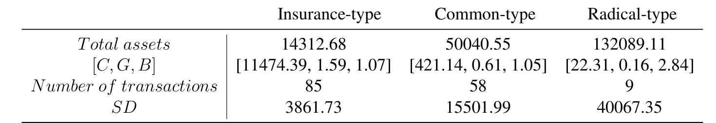
Through the analysis of the results, we can see that:
通过对结果的分析，我们可以看到：
• The amount of investment is mainly bitcoin.
• 投资金额主要集中于比特币。
• Insurance investment tends to trade many times and is vulnerable to market inﬂuence. Aggressive investments make fewer transactions.
• 保险型投资倾向于多次交易，易受市场影响。激进型投资的交易次数较少。
— 原文第 24 页 —
Appendices
附录
Appendix A
附录 A
Changes of Various Types of Traders’ Assetes
各类交易者资产的变化
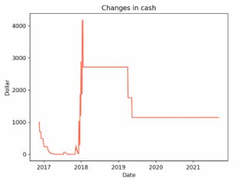
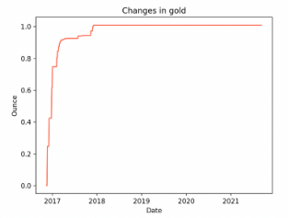
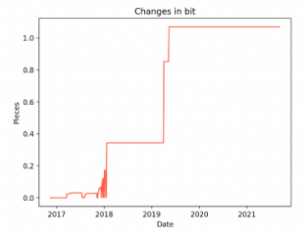
(a) Changes of cash
(a) 现金的变化
(b) Changes of gold
(b) 黄金的变化
(c) Changes of bitcoin
(c) 比特币的变化
Figure 17: Changes of various assets of common-type traders
图 17：普通型交易者各类资产的变化
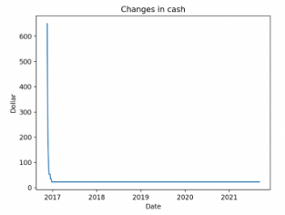
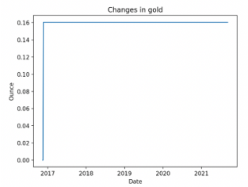
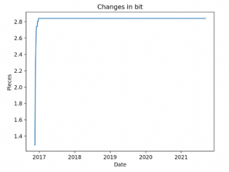
(a) Changes of cash
(a) 现金的变化
(b) Changes of gold
(b) 黄金的变化
(c) Changes of bitcoin
(c) 比特币的变化
Figure 18: Changes of various assets of radical-type traders
图 18：激进型交易者各类资产的变化
— 原文第 23 页 —
References
[1] Conlon. T and McGee. R. Safe haven or risky hazard? Bitcoin during the Covid-19 bear market. FINANCE RESEARCH LETTERS, 35, 2020.
[2] Khashei. M and Bĳari. M. A novel hybridization of artiﬁcial neural networks and ARIMA models for time series forecasting. APPLIED SOFT COMPUTING, 11(2):2664-2675, 2011.
[3] Aasim, Singh. SN and Mohapatra. A. Repeated wavelet transform based ARIMA model for very short-term wind speed forecasting. RENEWABLE ENERGY, 136:758-768, 2019.
[4] Valipour. M, Banihabib. ME and Behbahani. SMR. Comparison of the ARMA, ARIMA, and the autoregressive artiﬁcial neural network models in forecasting the monthly inﬂow of Dez dam reservoir. JOURNAL OF HYDROLOGY, 476:433-441, 2013.
[5] Mahjoub. C, Bellanger. JJ, Kachouri. A and Jeannes. RL. On the performance of temporal Granger causality measurements on time series: a comparative study. SIGNAL IMAGE AND VIDEO PROCESSING, 14(5):955-963, 2020.
[6] Chen. JS, Hou. JL, Wu. SM and Chang-Chien. YW. Constructing investment strategy portfolios by combination genetic algorithms. EXPERT SYSTEMS WITH APPLICATIONS, 36(2):3824-3828, 2009.
[7] Wang. S, Wang. XG, Meng. FL, Yang. RJ, Zhao. YJ. Investor behaviour monitoring based on deep learning. BEHAVIOUR & INFORMATION TECHNOLOGY, 40 (9):XLII-LIII, 2021.
[8] Michael. SC. Can information technology enable proﬁtable diversiﬁcation?
An empirical examination. JOURNAL OF ENGINEERING AND TECHNOLOGY MANAGEMENT, 24(3):167-185, 2007.
[9] Mitic. P. Is a Reputation Time Series White Noise? INTELLIGENT DATA ENGINEERING AND AUTOMATED LEARNING - IDEAL 2017, 10585:543-550, 2017.
[10] Daigle. CL and Ridge. EE, Investing in stockpeople is an investment in animal welfare and agricultural sustainability. ANIMAL FRONTIERS, 8(3):53-59, 2018.
[11] Mariana. CD, Ekaputra. IA and Husodo. ZA. Are Bitcoin and Ethereum safe-havens for stocks during the COVID-19 pandemic? FINANCE RESEARCH LETTERS, 38, 2021.
[12] Conlon. T, Corbet. S and Mcgee. RJ. Are cryptocurrencies a safe haven for equity markets? An international perspective from the COVID-19 pandemic. RESEARCH IN INTERNATIONAL BUSINESS AND FINANCE, 54, 2020.
（全文完。公式与表格在原 PDF 中是矢量图形，未纳入本对照版；可按文中「原文第 N 页」标记翻到 2203120.pdf 对照查看。）

