2215444 英中对照版
2022 ICM Problem D · How Can We Realize the Full Potential of Our Data?
读法：黑字为原文，蓝字为译文，一段英文一段中文，上下对应；蓝字里的小字括号是该术语第一次出现时的英文原词。
术语表（按首次出现排序，20 条）
# | 英文 | 中文 | 说明：为什么容易译错
1 | Data Analysis (D&A) System | 数据分析（D&A）系统 | 论文主题：企业用来管理、分析数据的整套体系
2 | Maturity | 成熟度 | 系统在人员、技术、流程三方面达到的水平
3 | Data Analysis System Maturity Model (DAMM) | 数据分析系统成熟度模型 | 本文自建的核心评价模型
4 | Capability Maturity Model (CMM) | 能力成熟度模型 | DAMM 的原型，1986 年卡内基梅隆大学提出
5 | Grounded Theory | 扎根理论 | 从原始材料自下而上归纳出指标的方法
6 | Indicator | 指标 | 评价体系里的每一个打分项
7 | Analytic Hierarchy Process (AHP) | 层次分析法 | 主观赋权：靠两两比较定权重
8 | Entropy Weight Method (EWM) | 熵权法 | 客观赋权：靠数据离散程度定权重
9 | Combination Weight | 组合权重 | 把主观权重与客观权重按系数合成
10 | Membership Function | 隶属函数 | 把分数映射成等级的函数
11 | Maturity Level | 成熟度等级 | M1–M5 共五档
12 | Linear Programming | 线性规划 | 任务 2 在预算约束下求最优改进量
13 | System Dynamics | 系统动力学 | 用反馈回路仿真系统随时间的演化
14 | MAPE | 平均绝对百分比误差 | 衡量仿真值与实测值偏差的百分比指标
15 | Apriori | Apriori 算法 | 挖掘指标与等级之间关联规则的算法
16 | Support | 支持度 | 关联规则在全部样本中出现的比例
17 | Confidence | 置信度 | 前件成立时后件也成立的比例
18 | Association Rule | 关联规则 | “若 A 则 B”形式的挖掘结果
19 | Sensitivity Analysis | 灵敏度分析 | 改动参数看结论是否依然成立
20 | Seaport | 海港 | ICM 是一家跨洲货运海港公司

How Can We Realize the Full Potential of Our Data?
如何充分实现数据的潜力？
Summary
摘要
With the development of technology and the explosive growth of data, data is becoming an important strategic asset in today's society, and it is more and more important to establish a suitable system to manage and analyze the data. In this paper, we build a model to analyze the factors affecting the maturity of data analysis systems, revealing how to make better use of data, and formulate plans to maximize the potential of data assets.
随着技术的发展与数据的爆炸式增长，数据正成为当今社会重要的战略资产，建立合适的系统来管理与分析数据也愈发重要。本文建立模型分析影响数据分析系统成熟度（Maturity）的因素，揭示如何更好地利用数据，并制定使数据资产潜力最大化的方案。
In Task1: First, based on the grounded theory, we comprehensively consider the ICM company requirements as well as the factors of the maturity model literature given in the title, screening out the indicators that affect data analysis to establish a data analysis system capability maturity evaluation model (DAMM). Then we use the Analytic Hierarchy Process combined with the Entropy Weight Method (AHP-EWM) to perform a combined weighting analysis on the weight values of the relevant indicators. Finally, we introduce the concept of membership function, dividing the system maturity into five levels, and calculating the system maturity index score of 0.8173 points (the highest score is 1), which is in the relatively mature fourth level ( the highest is the fifth level).
在任务 1 中：首先，基于扎根理论（Grounded Theory），我们综合考虑 ICM 公司的需求以及题目给出的成熟度模型文献中的因素，筛选出影响数据分析的指标（Indicator），建立数据分析系统能力成熟度评价模型（DAMM）。随后，我们采用层次分析法（Analytic Hierarchy Process）结合熵权法（Entropy Weight Method）（AHP-EWM），对相关指标的权重值进行组合权重（Combination Weight）分析。最后，我们引入隶属函数（Membership Function）的概念，将系统成熟度划分为五个等级，并计算出系统成熟度指数得分为 0.8173 分（最高分为 1），处于相对成熟的第四级（最高为第五级）。
In Task2: First, we use a linear programming model to quantitatively analyze, and in the case of limited optimization costs, we transform the problem into maximizing the system maturity index. Then, we use system dynamics to simulate and obtain the index values corresponding to different maturity levels for qualitative analysis, verifying the validity of the model by comparing the difference between the simulation results and the evaluation model of task 1. Finally, we combine the two methods, and based on the differences between the fourth and fifth levels of maturity, we give suggestions that ICM companies need to invest in teamwork and technical management. In Task3: In order to formulate an agreement to measure the effectiveness of the system, we divide different index levels from the perspectives of people, technology and process, using the Apriori to analyze the rule association between the three groups of indicators, combined with system dynamics simulation in the way of simulation, we give the relevant agreement of the ICM data analysis system in the connection mechanism between people, technology, process and the three together.
在任务 2 中：首先，我们采用线性规划（Linear Programming）模型进行定量分析，在优化成本有限的情形下，将问题转化为系统成熟度指数的最大化。随后，我们采用系统动力学（System Dynamics）进行仿真，得到不同成熟度等级（Maturity Level）对应的指标值以进行定性分析，并通过比较仿真结果与任务 1 评价模型之间的差异来验证模型的有效性。最后，我们结合两种方法，基于第四级与第五级成熟度之间的差异，给出 ICM 公司需在团队协作与技术管理方面进行投入的建议。在任务 3 中：为制定衡量系统有效性的协议，我们从人员、技术与流程的视角划分不同的指标层级，运用 Apriori 算法（Apriori）分析三组指标之间的规则关联，并结合系统动力学（System Dynamics）的仿真方式，给出 ICM 数据分析系统在人员、技术、流程之间以及三者共同作用下的关联机制的相关协议。
In Task4: First, we evaluate the model based on the differences in data analysis systems of seaport companies with different scales, and conduct multiple sets of simulations based on the model proposed in task 2 simulation. Then, we compare the errors between the simulated maturity index and the results obtained by the DAMM model, which are all smaller than 5%, showing the good applicability of the model to seaport companies of different sizes. Finally, combined with the International Standard Plan of "Quality Management System Requirements" (ISO9001), we analyze the reasons for the universality of DAMM, and give three benefits for customers to adopt DAMM for ICM.
在任务 4 中：首先，我们基于不同规模海港（Seaport）公司数据分析系统的差异对模型进行评价，并依据任务 2 所提模型进行多组仿真。随后，我们比较仿真得到的成熟度指数与 DAMM 模型所得结果之间的误差，二者均小于 5%，表明模型对不同规模的海港公司具有良好的适用性。最后，结合《质量管理体系要求》国际标准（ISO9001），我们分析 DAMM 具有普适性的原因，并给出客户采用 DAMM 为 ICM 带来的三项收益。
Keywords: data analysis; maturity evaluation model; AHP-EWM; system dynamics; Apriori
关键词：数据分析；成熟度评价模型；AHP-EWM；系统动力学；Apriori
— 原文第 3 页 —
1 Introduction
1 引言
1.1 Problem Background
1.1 问题背景
With the completion of the information revolution in the 1950s, the main body representing advanced productivity has been banned by informatization. Nowadays, data and information have become strategic materials for enterprises and companies to compete. Only by properly managing and making full use of information can cold data be transformed into visible wealth. Therefore, mature data analysis capabilities have become the top priority to enhance the competitive advantage of enterprises. The complete cognition of the data analysis system can undoubtedly clarify the direction of enterprise optimization and development. As a consequence, a reasonable assessment of its own data analysis capabilities has become the key for enterprises to improve themselves and enhance user loyalty.
随着 20 世纪 50 年代信息革命的完成，代表先进生产力的主体已被信息化所淘汰。如今，数据与信息已成为企业竞争的战略物资。只有妥善管理与充分利用信息，冰冷的数据才能转化为可见的财富。因此，成熟的数据分析能力已成为提升企业竞争优势的重中之重。对数据分析系统的完整认知无疑能够明晰企业优化与发展的方向。因此，对自身数据分析能力进行合理评估，已成为企业自我提升并增强用户忠诚度的关键。
1.2 Restatement of the Problem
1.2 问题重述
Considering the background information and restricted conditions identified in the problem statement, we need to solve the following problems:
考虑问题陈述中给出的背景信息与限制条件，我们需要解决以下问题：
• Provide indicators to measure the maturity of Intercontinental Cargo (ICM) D&A systems (including talent, technology and process).
• 提供衡量洲际货运（ICM）D&A 系统成熟度（包括人才、技术与流程）的指标。
• Establish a model for Intercontinental Cargo Company (ICM) to evaluate the maturity of its own D&A system, and provide the modification method that ICM needs to make to the system to fully realize the potential of data.
• 建立洲际货运公司（ICM）评价其自身 D&A 系统成熟度的模型，并给出 ICM 为充分实现数据潜力所需对系统进行的改进方式。
• Give the protocol that ICM needs to make to measure the effectiveness of the D&A system.
• 给出 ICM 为衡量 D&A 系统有效性所需的协议。
• Apply the model to ports of other sizes and different industries, analyze the adaptability of the model, point out the superiority of the model indicators, and analyze the possible benefits to ICM companies if ICM customers use the evaluation model.
• 将该模型应用于其他规模和不同行业的海港，分析模型的适应性，指出模型指标的优越性，并分析若 ICM 客户使用该评价模型，ICM 公司可能获得的收益。
• Write a letter to ICM Collaborative users describing our approach and increasing confidence in ICM Collaborative D&A systems.
• 致信 ICM Collaborative 用户，说明我们的方法，并增强其对 ICM Collaborative D&A 系统的信心。
1.3 Literature Review
1.3 文献综述
In 1979, Nolan proposed the growth stage model to study the development of enterprise information data system, and it became the prototype of the maturity model. In 1986, Carnegie Mellon University in the United States developed the Capability Maturity Model (CMM) [1] based on the Nolan model. Its main contents are divided into the qualitative analysis of capability maturity and the evaluation index system of capability maturity model. After the capability maturity model is established, many scholars begin to improve the maturity model and apply it in different fields according to the characteristics of different fields. For example, human resources maturity model, customer information quality management maturity model, enterprise information maturity model.
1979 年，Nolan 提出成长阶段模型以研究企业信息数据系统的发展，该模型成为成熟度模型的原型。1986 年，美国卡内基梅隆大学在 Nolan 模型的基础上提出了能力成熟度模型（Capability Maturity Model）（CMM）[1]。其主要内容包括能力成熟度的定性分析与能力成熟度模型的评价指标体系。能力成熟度模型建立之后，许多学者开始结合不同领域的特点对成熟度模型加以改进，并将其应用于不同领域。例如人力资源成熟度模型、客户信息质量管理成熟度模型、企业信息成熟度模型。
In the research of various scholars, Pekka Berg [2] constructed the R&D quality maturity model, by constructing the dimensions of the quality maturity model, the maturity level and
在众多学者的研究中，Pekka Berg [2] 构建了研发质量成熟度模型，通过构建质量成熟度模型的维度、成熟度等级与
— 原文第 4 页 —
the characteristics of each maturity, and establishing a detailed evaluation method to study the R&D quality of enterprises. process, and test the effect of this model in R&D quality improvement through case analysis. Kirazli and Moetz[3] introduced the factors of risk management into the maturity model, formulated a four-level model of enterprises' digital process, and paid attention to the potential risks brought by the implementation of digital technology by enterprises, but the impact of digital technology on enterprises The advantages are lacking in elaboration. Dr. J.Kent Crawford [4] proposed the PMS project management maturity. The model establishes a clear project management system and determines the maturity level of project management. By analyzing the status quo of project management, and then on the basis of the model evaluation results, put forward the corresponding improvement measures.
各成熟度的特征，并建立详细的评价方法，以研究企业的研发质量过程，并通过案例分析检验该模型在研发质量提升中的效果。Kirazli 和 Moetz[3] 将风险管理因素引入成熟度模型，制定了企业数字化过程的四级模型，并关注企业实施数字技术所带来的潜在风险，但对数字技术给企业带来的优势缺乏阐述。J.Kent Crawford 博士 [4] 提出了 PMS 项目管理成熟度。该模型建立了清晰的项目管理体系，并确定项目管理的成熟度等级。通过分析项目管理现状，进而依据模型评价结果提出相应的改进措施。
Through the analysis and summary of many literatures, it can be seen that many scholars pay extensive attention to the digital management of enterprises, and have done a lot of research on it. In terms of enterprise digitalization, scholars believe that many enterprises are limited by their own resources and capabilities, and need to rely on third-party digital platforms to achieve digital management. Generally speaking, there is still a lack of research on digital maturity models.
通过对大量文献的分析与总结可以看出，众多学者对企业数字化管理给予了广泛关注，并开展了大量研究。在企业数字化方面，学者们认为许多企业受自身资源与能力的限制，需要依托第三方数字平台来实现数字化管理。总体而言，关于数字化成熟度模型的研究仍相对缺乏。
1.4 Our Work
1.4 我们的工作
Our work in this problem is mainly shown in the figure 1:
我们在此问题中的工作主要如图 1 所示：
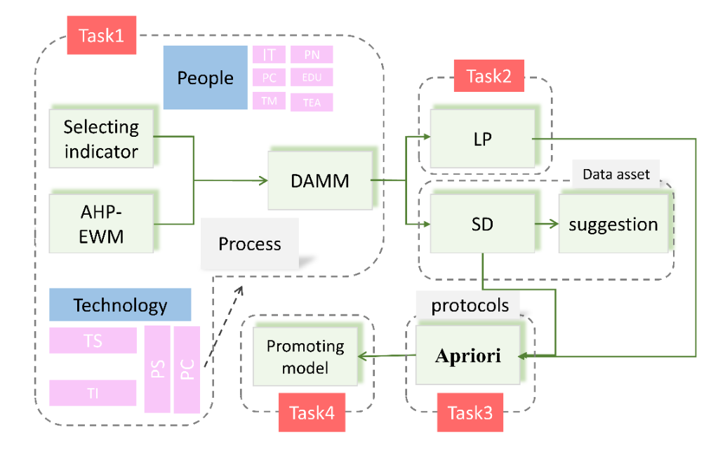
Figure 1 Our Work
图 1：我们的工作
图中文字对照（英文 → 中文）
Task1 | 任务 1 | Task2 | 任务 2
Task3 | 任务 3 | Task4 | 任务 4
People | 人员 | Technology | 技术
Process | 流程 | Selecting indicator | 选取指标
AHP-EWM | AHP-EWM 组合赋权 | DAMM | DAMM 模型
LP | 线性规划 | SD | 系统动力学
suggestion | 改进建议 | Data asset | 数据资产
Apriori | Apriori 算法 | protocols | 协议
Promoting model | 模型推广 | IT / PN / PC / EDU / TM / TEA | IT 能力／人数／人员成本／学历／团队合作／人才管理
TS / TI / PS / PC | 技术稳定性／技术创新／处理速度／流程覆盖
2 Assumptions and Justifications
2 假设与论证
We made the following assumptions to help us build the model. These constructions are
我们作出以下假设以帮助建立模型。这些构建是
— 原文第 5 页 —
the background and basis for our subsequent analysis.
我们后续分析的背景与依据。
• Assumption 1：It is assumed that ICM's data analysis system is comprehensive in terms of people, technology, and processes.
• 假设 1：假定 ICM 的数据分析系统在人员、技术和流程方面是全面的。
Justification: Although the general description given in the title is not necessarily all the indicators concerned by ICM's data analysis system, in order to make the indicator analysis clear and controllable, we assume that other indicators that affect data analysis found later are not considered by the system and belong to the part of maturity that needs to be improved.
论证：尽管题目给出的一般性描述未必涵盖 ICM 数据分析系统所关注的全部指标，但为使指标分析清晰可控，我们假定系统未考虑后续发现的其他影响数据分析的指标，且这些指标属于有待提升的成熟度部分。
• Assumption 2：It is assumed that the literature we have checked is relatively comprehensive and scientific.
• 假设 2：假定我们查阅的文献较为全面且具有科学性。
Justification: In order to make the DAMM model scientific and reasonable, it is assumed that the literature we have checked is comprehensive and scientific, which means that our analysis is consistent with objective cognition and facts.
论证：为使 DAMM 模型科学合理，假定我们查阅的文献全面且具有科学性，这意味着我们的分析与客观认知和事实相一致。
• Assumption 3：It is assumed that ICM clients are limited to collective companies, ignoring a small number of self-employed individuals.
• 假设 3：假定 ICM 客户仅限于集体企业，忽略少数个体经营者。
Justification: In real work, intercontinental freight companies may also trade with a small number of self-employed individuals, but the vast majority of customers are of little value and significance because of individual people, technology and processes. • Assumption 4：Assume that the estimated costs that ICM can use to improve the data analysis system are known.
论证：在实际工作中，洲际货运公司也可能与少数个体经营者进行交易，但由于个体在人员、技术和流程方面的价值与意义很小，绝大多数客户并不属于此类。• 假设 4：假定 ICM 可用于改进数据分析系统的预估成本是已知的。
Justification: This is done to analyze how to use the data assets to their fullest potential.
论证：此举旨在分析如何最充分地利用数据资产。
3 Notations
3 符号说明
The key mathematical notations used in this paper are listed in Table 1.
本文使用的主要数学符号列于表 1。
Table 1: Notations used in this paper
表 1：本文使用的符号
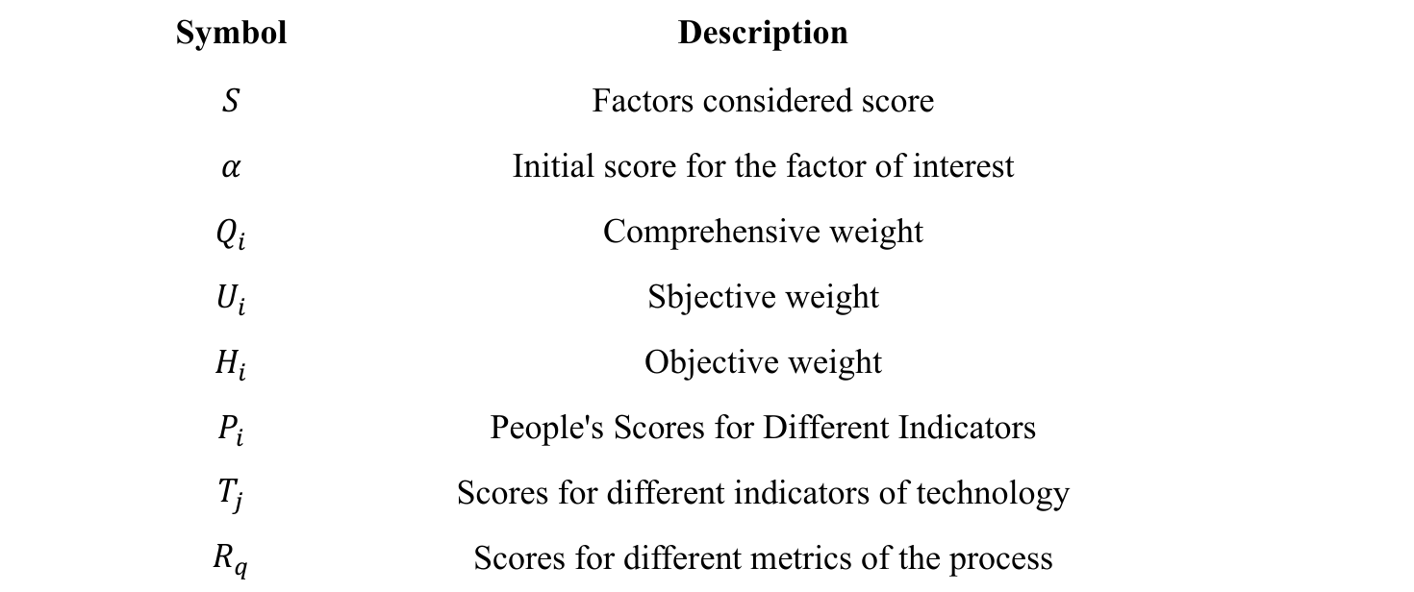
（上表为原文表 1 原样贴图。符号含义依次为：S 考虑因素得分；α 关注因素的初始分；Q_i 综合权重；U_i 主观权重（原文误写为 Sbjective）；H_i 客观权重；P_i 人员类各指标的得分；T_j 技术类各指标的得分；R_q 流程类各指标的得分。）
— 原文第 6 页 —
4 TASK 1: DAMM Based on AHP-EWM
4 任务 1：基于 AHP-EWM 的 DAMM
4.1 Indicator selection
4.1 指标选取
There are many factors that describe the maturity of an enterprise data analysis system, but the systematic index system is definitely not the bigger the better. Based on the analysis method of grounded theory, we can summarize the experience from the original data, and then rise to the system level to help us better build an evaluation system. Therefore, we are in the numerous literature on maturity models (some maturity models are shown in the table 2 below) Extract available indicators, and follow the principles of generalization, completeness and little overlap, and select more representative indicators as the main dimension of enterprise data analysis system maturity measurement。
描述企业数据分析系统成熟度的因素众多，但系统的指标体系绝非越多越好。基于扎根理论的分析方法，我们可以从原始数据中总结经验，进而上升至系统层面，以帮助我们更好地构建评价体系。因此，我们在众多关于成熟度模型的文献（部分成熟度模型见下表 2）中提取可用指标，并遵循概括性、完整性与低重叠的原则，选取较具代表性的指标作为企业数据分析系统成熟度测度的主要维度。
Table 2 Partial maturity model
表 2：部分成熟度模型
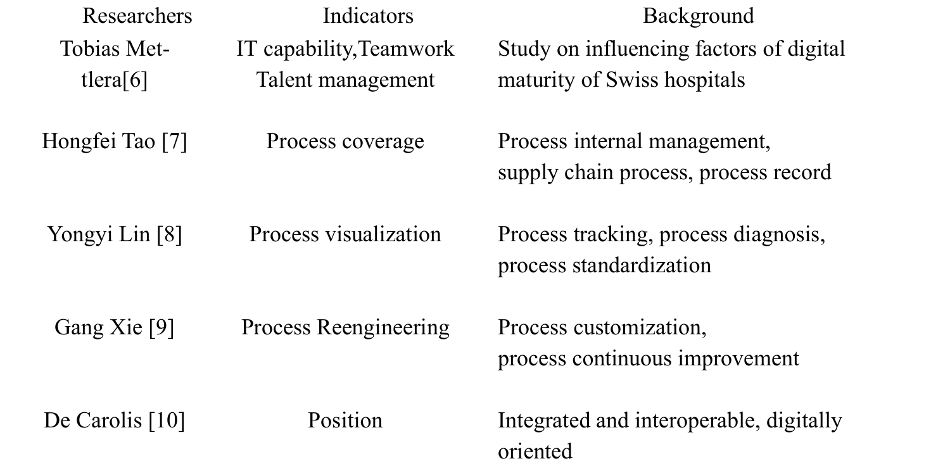
According to the above literature, We develop the data analysis system maturity model (DAMM) based on CMM, which comprehensively reflects the maturity level of the enterprise D&A system and provides strategic guidance for enterprise system diagnosis, transformation and upgrading.
根据上述文献，我们基于 CMM 构建了数据分析系统成熟度模型（Data Analysis System Maturity Model）（DAMM），该模型全面反映企业 D&A 系统的成熟度等级，并为企业系统诊断、改造与升级提供策略指导。
By constructing the Data Analysis System Maturity Model (DAMM), we analyze the key performance impacted by the maturity of the enterprise data analysis system from the perspectives of people, technology and process, and evaluate the system network from three perspectives formed from the grounded theory. The relationship diagram is as shown in figure 2：
通过构建数据分析系统成熟度模型（DAMM），我们从人员、技术与过程三个视角分析受企业数据分析系统成熟度影响的关键绩效，并基于扎根理论形成的三个视角对系统网络进行评价。关系图如图 2 所示：
— 原文第 7 页 —
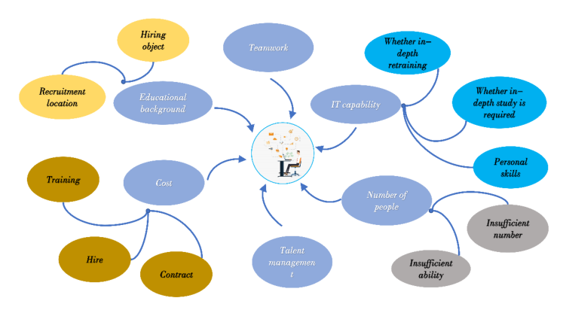
Figure 2 People-Related Metrics
图 2：人员相关指标
图中文字对照（英文 → 中文）
Hiring object | 招聘对象 | Recruitment location | 招聘地点
Educational background | 学历背景 | Training | 培训
Cost | 成本 | Hire | 招聘
Contract | 合同 | Teamwork | 团队合作
Talent management | 人才管理 | IT capability | IT 能力
Number of people | 人数 | Insufficient number | 人数不足
Insufficient ability | 能力不足 | Personal skills | 个人技能
Whether in-depth study is required | 是否需要深入学习 | Whether in-depth retraining | 是否需要深度再培训
Analyzing the figure 2, the data analysis system maturity evaluation model we constructed comprehensively answered the confusion of ICM company recruitment managers about people factors. For example, from the perspective of the company's use of people, we consider the people expenditure cost index, which better summarizes ICM's problems in training talents, hiring or contracting; By using educational qualification evaluation indicators, the model can better solve the problem of recruiting talent location, hiring goals, and so on. In addition, based on the grounded theory, in the empirical summary of the references, our model also gives two important indicators of teamwork and talent management that a more complete maturity model should focus on in terms of people.
分析图 2 可知，我们构建的数据分析系统成熟度评价模型全面回答了 ICM 公司招聘管理人员在人员因素方面的困惑。例如，从企业用人视角出发，我们考虑人员支出成本指标，该指标更好地概括了 ICM 在人才培养、招聘或外包方面的问题；通过采用学历评价指标，该模型能更好地解决人才招聘地点、招聘目标等问题。此外，基于扎根理论，在对参考文献的经验总结中，我们的模型还给出了团队协作与人才管理两项重要指标，说明更完整的成熟度模型在人员方面应予以关注。
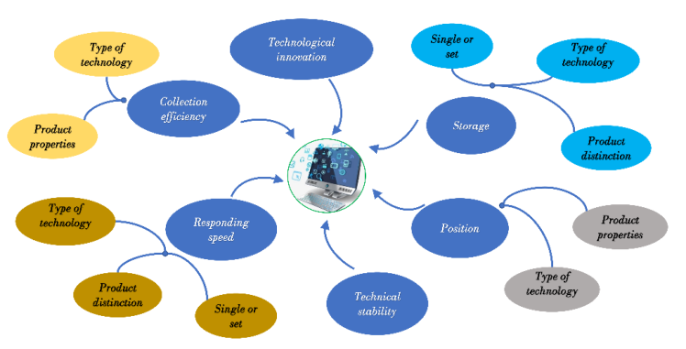
Figure 3 Technology-Related Metrics
图 3：技术相关指标
图中文字对照（英文 → 中文）
Collection efficiency | 采集效率 | Technological innovation | 技术创新
Responding speed | 响应速度 | Technical stability | 技术稳定性
Storage | 存储能力 | Position | 定位能力
Type of technology | 技术类型 | Product properties | 产品特性
Product distinction | 产品区分度 | Single or set | 单件或成套
From the figure 3, we can know that DAMM has also completed the evaluation of technology-related key performance at the technical level, and is similar to the analysis at employee level, adding two important indicators such as technological innovation and technological stability, the specific analysis process will not be repeated here.
由图 3 可知，DAMM 亦完成了技术层面技术相关关键绩效的评价，且与员工层面的分析类似，补充了技术创新与技术稳定性等两项重要指标，具体分析过程在此不再赘述。
— 原文第 8 页 —
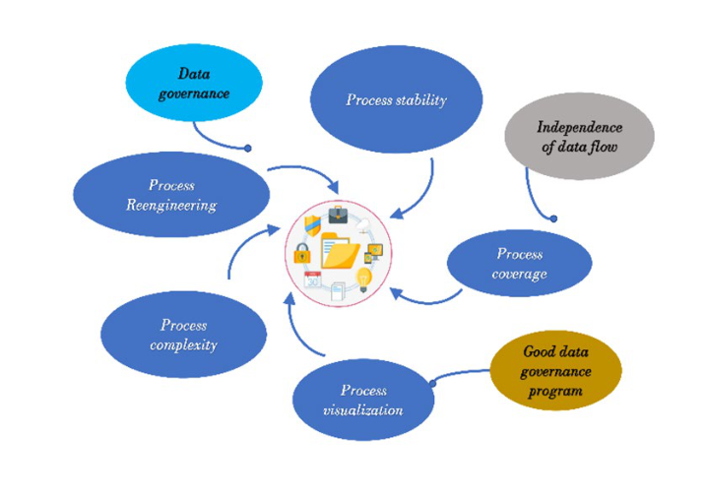
Figure 4 Process-Related Metrics
图 4：过程相关指标
图中文字对照（英文 → 中文）
Process coverage | 流程覆盖 | Process visualization | 流程可视化
Process Reengineering | 流程再造 | Process complexity | 流程复杂度
Process stability | 流程稳定性 | Data governance | 数据治理
Independence of data flow | 数据流独立性 | Good data governance program | 良好的数据治理方案
Comprehensive analysis of figures 2 to 4 shows that the evaluation system (DAMM) we constructed has well answered ICM's questions about the relationship between people, technology and process. In addition, based on many literatures on enterprise maturity models, we have added relatively complete measures in all three aspects. Therefore, a more comprehensive and scientific data analysis system maturity evaluation model (DAMM) is constructed.
综合分析图 2 至图 4 可知，我们构建的评价体系（DAMM）很好地回答了 ICM 关于人员、技术与过程之间关系的问题。此外，基于众多关于企业成熟度模型的文献，我们在上述三个方面均补充了较为完整的测度。因此，构建了更为全面、科学的数据分析系统成熟度评价模型（DAMM）。
Specifically for ICM, we constructed a hierarchy of ICM's current data analysis maturity evaluation indicators based on ICM's description and analysis of people and technical processes, as shown in the figure 5 below.
具体针对 ICM，我们依据 ICM 对人员与技术过程的描述与分析，构建了 ICM 当前数据分析成熟度评价指标的层级结构，如下图 5 所示。
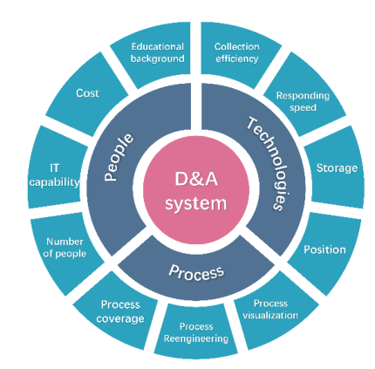
Figure 5 Maturity evaluation index system
图 5：成熟度评价指标体系
图中文字对照（英文 → 中文）
D&A system | 数据分析系统 | People | 人员
Technologies | 技术 | Process | 流程
Educational background | 学历背景 | Cost | 成本
IT capability | IT 能力 | Number of people | 人数
Collection efficiency | 采集效率 | Responding speed | 响应速度
Storage | 存储能力 | Position | 定位能力
Process coverage | 流程覆盖 | Process Reengineering | 流程再造
Process visualization | 流程可视化
Comparing Figures 2 to 5, ICM is lacking in all three levels, so the maturity of the data analysis system is not ideal. According to the specific situation of ICM, combined with a complete data analysis system model (DAMM), defining the factors that affect people
对比图 2 至图 5，ICM 在三个层面均存在不足，故其数据分析系统成熟度并不理想。根据 ICM 的具体情况，结合完整的数据分析系统模型（DAMM），界定影响人员的因素
— 原文第 9 页 —
𝑃𝑃_{𝑖𝑖}(1 ≤𝑖𝑖≤6): Number of people, Education background, IT capability, Cost, Team work and talent management followed by 𝑃𝑃₁~𝑃𝑃₆; Defining factors affecting technology 𝑇𝑇_{𝑗𝑗}(1 ≤𝑗𝑗≤6): collection efficiency, response speed, storage capacity, positioning capacity, technological innovation, and technical stability followed by 𝑇𝑇₁~𝑇𝑇₆; Define the factors that affect the process 𝑅𝑅_{𝑞𝑞}(1 ≤𝑞𝑞≤5): process coverage, process visualization, process reengineering, process complexity, and process stability followed by 𝑅𝑅₁~𝑅𝑅₅ .
P_i（1≤i≤6）：依次为人员数量、教育背景、IT 能力、成本、团队协作与人才管理，记为 P_1~P_6；界定影响技术的因素 T_j（1≤j≤6）：依次为采集效率、响应速度、存储能力、定位能力、技术创新与技术稳定性，记为 T_1~T_6；界定影响流程的因素 R_q（1≤q≤5）：流程覆盖度、流程可视化、流程再造、流程复杂性与流程稳定性，记为 R_1~R_5。
We define a maximum score 𝑆𝑆_{𝑖𝑖} of all metrics is 1, and a score of 0.3 for metrics 𝑀𝑀_{𝑖𝑖} that affect the maturity of data analytics systems but are not considered by ICM. Since the existing data analysis system is included in the system analysis level, the initial score of the factor that has been concerned can be set to 𝛼𝛼₁, and the calculation formula of the
我们定义所有指标的最高得分为 1；对于影响数据分析系统成熟度、但未被 ICM 考虑的指标 𝑀_𝑖，其得分记为 0.3。由于现有数据分析系统已包含在系统分析层面，已关注因素的初始得分可设为 𝛼_1，而 ICM 所考虑的因素得分
factor score considered by ICM is defined as follows:
的计算公式定义如下：
𝛽𝛽_{𝑖𝑖} indicates the concerns of the ICM involved in the 𝑖𝑖 indicator, the scores of different
𝛽_i 表示 ICM 对第 i 项指标的关注程度，不同指标的得分
indicators can be obtained by calculating separately.
指标的得分可通过分别计算得到。
Later, we calculate the weight value according to the Analytic Hierarchy Process and the Entropy Weight Method (AHP-EWM).
随后，我们依据层次分析法与熵权法（AHP-EWM）计算权重值。
4.2 Weight determination
4.2 权重确定
For the construction of data analysis system evaluation model (DAMM), the determination of evaluation index weights plays a crucial role, which directly affects the accuracy of model evaluation. The entropy weight method (EWM) is an objective weighting method, and AHP is a subjective weighting method; we use the combination of the EWM and the AHP to determine the weight of the indicators. This is a comprehensive evaluation method that combines subjective and objective and integrates various methods, which can effectively improve the rationality and correctness of evaluation.
对于数据分析系统评价模型（DAMM）的构建，评价指标权重的确定起着关键作用，它直接影响模型评价的准确性。熵权法（EWM）是一种客观赋权方法，AHP 是一种主观赋权方法；我们采用 EWM 与 AHP 相结合的方式确定指标权重。这是一种主客观相结合、融合多种方法的综合评价方法，能够有效提高评价的合理性与正确性。
4.2.1 EWM
4.2.1 EWM 熵权法
First, we calculate the weight of the 𝑗𝑗th indicator in the 𝑖𝑖th country
首先，我们计算第 j 个国家第 i 项指标的权重

According to the concept of self-information and entropy in information theory, the information entropy 𝐸𝐸_{𝑗𝑗} of each evaluation indicator can be calculated, and thus
根据信息论中自信息与熵的概念，可计算各评价指标的信息熵 𝐸_𝑗，从而

Based on the information entropy, we will further calculate the weight of each evaluation indicator we defined before.
基于信息熵，我们将进一步计算前文所定义的各评价指标的权重。

— 原文第 10 页 —
4.2.2 AHP
4.2.2 AHP 层次分析法
First, between the same layers, we analyze the importance of indicators by constructing a judgment matrix.
首先，在同一层次之间，我们通过构建判断矩阵分析指标的重要性。
in the above formula, 𝑏𝑏_{𝑖𝑖}and 𝑏𝑏_{𝑖𝑖} represent different evaluation indicators, 𝑖𝑖= 1,2,3, ⋯𝑛𝑛, 𝑛𝑛 represents the number of indicators at the same level.
上式中，b_ij 与 b_ji 代表不同的评价指标，i = 1,2,3,…n，n 表示同一层次的指标个数。
In order to ensure the accuracy of the judgment matrix, we perform a consistency check on the judgment matrix:
为确保判断矩阵的准确性，我们对判断矩阵进行一致性检验：
In the formula, 𝜆𝜆_{max} represents the largest eigenvalue of the judgment matrix, 𝑛𝑛 represents the number of indicators at the same level. If calculated 𝐶𝐶< 0.1, then the judgment matrix can pass the consistency test. Finally, based on the judgment matrix calculation, the subjective weight value 𝑈𝑈_{𝑖𝑖} solved
式中，λ_max 表示判断矩阵的最大特征值，n 表示同一层次的指标个数。若计算得到 CR < 0.1，则判断矩阵通过一致性检验。最后，由判断矩阵计算得到 AHP 法求解的主观权重值 U_i，

by the AHP method is obtained.
由 AHP 方法得到。
4.2.3 Combination weight
4.2.3 组合权重
The subjective weight 𝑈𝑈_{𝑖𝑖} and objective weight 𝐻𝐻_{𝑖𝑖} of each index are obtained by the AHP method and the EWM method.
各指标的主观权重 U_i 与客观权重 H_i 分别由 AHP 方法与 EWM 方法得到。
In the formula: 𝑄𝑄_{𝑖𝑖} is the comprehensive weight; 𝑚𝑚 and 𝑛𝑛 are the weight distribution coefficients. The difference between subjective weight 𝑈𝑈_{𝑖𝑖} and objective weight 𝐻𝐻_{𝑖𝑖} should be the same as the difference between 𝑚𝑚 and 𝑛𝑛, At the same time, the sum of 𝑚𝑚 and 𝑛𝑛 is 1. As a result
式中：Q_i 为综合权重；m 与 n 为权重分配系数。主观权重 U_i 与客观权重 H_i 之间的差异应与 m 与 n 之间的差异相同，同时 m 与 n 之和为 1。由此
In the formula,
式中，
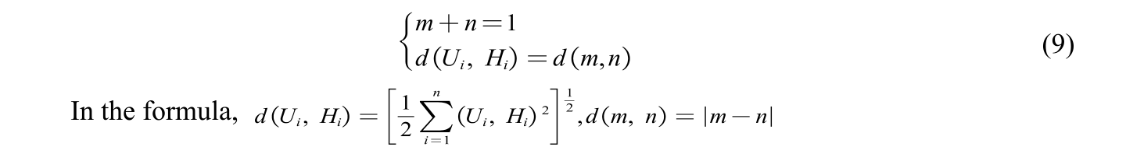
Solve the equation to get the values of 𝑚𝑚 and 𝑛𝑛, Bring 𝑈𝑈_{𝑖𝑖} and 𝐻𝐻_{𝑖𝑖} into formula (8) then get the comprehensive weight 𝑄𝑄_{𝑖𝑖}.
求解该方程得到 𝑚 与 𝑛 的取值，将 𝑈_𝑖 与 𝐻_𝑖 代入式 (8)，即可得到综合权重 𝑄_𝑖。
— 原文第 11 页 —
4.3 The Solution of Task 1
4.3 任务 1 的求解
The subjective and objective weights are combined by the AHP-EWM method, and the weight values occupied by different indicators are finally obtained as shown in the figure 6.
通过 AHP-EWM 方法将主观权重与客观权重相结合，最终得到不同指标所占的权重值，如图 6 所示。
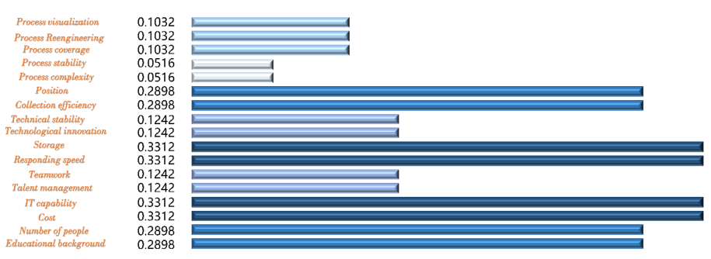
Figure 6 Weight values for different indicators
图 6：不同指标的权重值
图中文字对照（英文 → 中文）
Process visualization | 流程可视化 | Process Reengineering | 流程再造
Process coverage | 流程覆盖 | Process stability | 流程稳定性
Process complexity | 流程复杂度 | Position | 定位能力
Collection efficiency | 采集效率 | Technical stability | 技术稳定性
Technological innovation | 技术创新 | Storage | 存储能力
Responding speed | 响应速度 | Teamwork | 团队合作
Talent management | 人才管理 | IT capability | IT 能力
Cost | 成本 | Number of people | 人数
Educational background | 学历背景
Due to the different weights occupied by the different evaluation indicators above, we use the following formula
由于上述不同评价指标所占的权重不同，我们采用下式
In the formula (10), 𝑀𝑀_{𝑠𝑠𝑠𝑠𝑠𝑠𝑠𝑠𝑠𝑠} represents the data analysis system maturity score, For the above results, based on the idea of Topsis method, We process and analyze the score 𝑀𝑀_{𝑠𝑠𝑠𝑠𝑠𝑠𝑠𝑠𝑠𝑠} and introduce a membership function
式 (10) 中，M_start 表示数据分析系统成熟度得分。对上述结果，基于 TOPSIS 方法的思想，我们对得分 M_start 进行处理分析，并引入隶属函数
In the formula, 𝑀𝑀_{𝑠𝑠𝑠𝑠𝑠𝑠𝑠𝑠𝑠𝑠} represents the data analysis system maturity score, represents the theoretical maximum, similarly, 𝑀𝑀_{𝑚𝑚𝑚𝑚𝑚𝑚} represents the theoretical minimum, based on the above method, the calculated maturity score of ICM's data analysis system is 0.8173. According to the analysis in the figure 7, the existing data analysis system is in a relatively mature range, with a relatively high degree of maturity, and there is still room for improvement to a certain extent.
式中，M_start 表示数据分析系统成熟度得分，M_max 表示理论最大值，类似地 M_min 表示理论最小值。基于上述方法，计算得到 ICM 数据分析系统的成熟度得分为 0.8173。由图 7 的分析可知，现有数据分析系统处于较成熟区间，成熟度较高，但在一定程度上仍有提升空间。
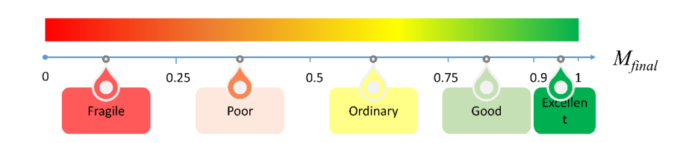
Figure 7 Maturity grading chart
图 7：成熟度分级图
图中文字对照（英文 → 中文）
M_final | 最终成熟度得分 | Fragile | 脆弱
Poor | 较差 | Ordinary | 一般
Good | 良好 | Excellent | 优秀
— 原文第 12 页 —
5 TASK 2: Linear programming and System Dynamics
5 任务 2：线性规划与系统动力学
5.1 Model Overview
5.1 模型概述
For the second problem, in order to maximize the potential of ICM's D&A system, consider adopting the goal planning model, combined with the DAMM model constructed in the first question, to convert the goal to maximize the score of the data analysis system. As shown in the figure 8, after ICM uses our model to evaluate the maturity of its own D&A system, we need to point out the best method to optimize the maturity of the D&A system through the demonstration analysis of the DAMM system, so that ICM can use its data assets maximum potential.
针对第二个问题，为最大化 ICM 数据分析（D&A）系统（Data Analysis (D&A) System）的潜力，考虑采用目标规划模型，结合第一问所构建的 DAMM 模型，将目标转化为使数据分析系统的得分最大化。如图 8 所示，在 ICM 运用本文模型对自身 D&A 系统的成熟度进行评价后，需要通过 DAMM 系统的论证分析，指出优化 D&A 系统成熟度的最佳方法，使 ICM 能够最大限度地发挥其数据资产的潜力。
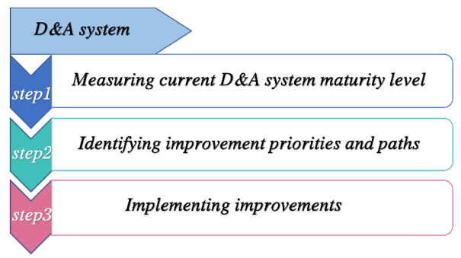
Figure 8 TASK 2 Process
图 8：任务 2 流程
图中文字对照（英文 → 中文）
D&A system | 数据分析系统 | step1 | 步骤 1
Measuring current D&A system maturity level | 测量当前数据分析系统的成熟度水平 | step2 | 步骤 2
Identifying improvement priorities and paths | 识别改进的优先级与路径 | step3 | 步骤 3
Implementing improvements | 实施改进
5.2 Establishment of Model
5.2 模型建立
5.2.1 Linear programming
5.2.1 线性规划
The maturity score of the existing data analysis system is 0.8173 points, which belongs to a relatively mature category, but there is still a certain gap from the mature category (higher than 0.9 points). The maturity score of the data analysis system maximizes the score under certain constraints.
现有数据分析系统的成熟度得分为 0.8173 分，属于较为成熟的类别，但与成熟类别（高于 0.9 分）仍存在一定差距。数据分析系统的成熟度得分是在一定约束条件下使得分最大化。
The maturity index of the data analysis system after being evaluated by the DAMM model： Step 1: Determination of decision variables
经 DAMM 模型评价后的数据分析系统成熟度指标：步骤 1：确定决策变量
According to the requirements of the problem, this paper assumes that the cost required to increase different evaluation indicators by 1% is known, and determines the size of the improvement of different indicators as a decision variable, and optimizes the target by adjusting the size of the improvement of the indicators.
根据题目要求，本文假设将不同评价指标提高 1% 所需的成本已知，并将不同指标提升幅度的大小确定为决策变量，通过调整指标的提升幅度来优化目标。
Step 2: Analysis of the objective function
步骤 2：目标函数分析
Analyzing the background of the problem, in order to maximize the potential of the data assets of ICM's data analysis system, this paper determines the objective function as follows:
分析问题背景，为使 ICM 数据分析系统的数据资产潜力最大化，本文确定目标函数如下：
Where 𝑀𝑀_{𝑓𝑖𝑛𝑎𝑙}′ represents the maturity score of the optimized D&A system, and
其中 𝑀′_final 表示优化后 D&A 系统的成熟度得分，且
— 原文第 13 页 —
represent the upper limit of the index improvement.
表示指标提升的上限。
Step 3: Constraint Analysis
步骤 3：约束分析
Ⅰ Question 2 also satisfies the assumption of task 1, so the optimization model needs to meet the constraints established by the DAMM model. The highest score of the optimized index is still 1 point, thus
Ⅰ 问题 2 同样满足任务 1 的假设，因此优化模型需满足 DAMM 模型所建立的约束。优化后指标的最高得分仍为 1 分，因此
Ⅱ At the same time, when improving the index parameters, the sum of the cost 𝑏𝑏 for the improvement of the index parameters cannot exceed the cost that the company can
Ⅱ 同时，在提升指标参数时，指标参数提升的成本 𝑏 之和不能超过公司为提升 D&A 系统所能承受的成本，因此

bear for the improvement of the D&A system, thus
为提升 D&A 系统所承担的成本，因此
Ⅲ In addition, due to the improvement of the indicators to play the potential of the data analysis system, the existing indicators can only be maintained or improved, in consequence
Ⅲ 此外，为了通过提升指标来发挥数据分析系统的潜力，现有指标只能维持或改进，因此

Ⅳ According to the assumption, the literature data we checked is accurate and scientific, and the sum of all indicators remains unchanged, which is
Ⅳ 根据假设，所查阅的文献数据准确且科学，所有指标之和保持不变，即
𝜇𝜇 means that the number of all indicators is unchanged.
𝜇 表示所有指标的数量保持不变。
Step 4: Model results
步骤 4：模型结果
According to the above linear programming model, assuming that the cost b and total budget cost Δ required to increase different indicators of ICM company by 1% are known, the optimized maturity index score can be obtained according to the model analysis and calculation. The percentage value determines the optimization method of the D&A system.
根据上述线性规划模型，在已知 ICM 公司各指标提升 1% 所需成本 b 与总预算成本 Δ 的条件下，按模型分析计算即可得到优化后的成熟度指数得分，其百分比数值决定了数据分析系统的优化方式。
5.2.2 System Dynamics
5.2.2 系统动力学
System dynamics is a very practical and effective method to solve complex system problems [11]. In the past 30 years, system dynamics has been widely used in research fields such as management, psychology, and environmental science [8]. The D&A system evaluation system covers a very wide range, and the factors affecting the maturity of the system are complex. Using system dynamics theory to systematically study the data analysis system, it can not only conduct comprehensive macro research by integrating all factors, but also conduct micro analysis. Starting from a certain influencing factor, analyze its impact on the exploration of the potential of data assets, which can provide a more scientific and reasonable decision for ICM to improve the maturity of the D&A system.
系统动力学是解决复杂系统问题的一种十分实用且有效的方法 [11]。近 30 年来，系统动力学已广泛应用于管理、心理学与环境科学等研究领域 [8]。D&A 系统评价体系涵盖范围十分广泛，影响系统成熟度的因素复杂。运用系统动力学理论对数据分析系统进行系统研究，既能整合所有因素开展宏观综合研究，也能开展微观分析。从某一影响因素出发，分析其对数据资产潜力挖掘的影响，可为 ICM 提升 D&A 系统成熟度提供更为科学合理的决策。
— 原文第 14 页 —
Here is a simple data verification and analysis. According to problem 1, from the perspective of the data analysis system of five different maturity levels in the DAMM model, the system dynamics model is used to simulate the corresponding index parameter ranges of the five groups of models, and Analysis, the specific steps are as follows
以下进行简单的数据验证与分析。针对问题 1，从 DAMM 模型中五个不同成熟度等级的数据分析系统出发，运用系统动力学模型对五组模型相应的指标参数区间进行仿真与分析，具体步骤如下
Step 1: Convert all the evaluation indicators in the DAMM model into the control variables of the system dynamics, replace the original variables with the products between the control variables and the variables, and analyze and calculate the predicted value;
步骤 1：将 DAMM 模型中的所有评价指标转化为系统动力学的控制变量，以控制变量与变量之间的乘积替代原有变量，并对预测值进行分析与计算；
Step 2: By combining different values of different control variables, five data analysis systems with different maturity levels are simulated and set up;
步骤 2：通过组合不同控制变量的不同取值，仿真并设定五个不同成熟度等级的数据分析系统；
Step 3: The parameters of the model control variables are subjected to multiple pre-experiments to achieve a high degree of simulation.
步骤 3：对模型控制变量的参数进行多次预实验，以达到较高的仿真度。
5.3 The Solution of Task 2
5.3 任务 2 的求解
Finally, the different parameter combination values are obtained as shown in the following table.
最终得到的不同参数组合取值如下表所示。
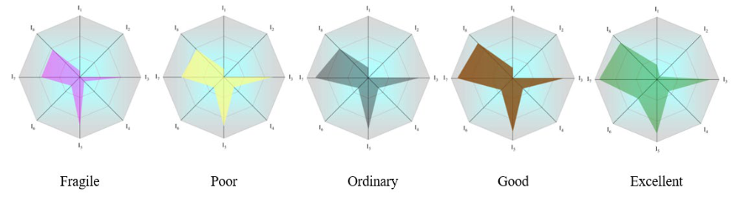
Figure 9 Indicators weight values under different maturity levels
图 9：不同成熟度等级下的指标权重值
图中文字对照（英文 → 中文）
Fragile | 脆弱（M1） | Poor | 较差（M2）
Ordinary | 一般（M3） | Good | 良好（M4）
Excellent | 优秀（M5） | I1–I8 | 8 个指标组，含义见图下正文
I1-I8 in the figure 9 represent I1: process visualization, process coverage, process reengineering; I2: process stability, process complexity; I3: positioning capability, collection efficiency; I4: technical stability, technical innovation; I5: storage Ability, response speed; I6: teamwork, talent management; I7: IT capability, training and employment costs; I8: number of people, education.
图 9 中的 I1-I8 分别表示 I1：流程可视化、流程覆盖度、流程再造；I2：流程稳定性、流程复杂度；I3：定位能力、采集效率；I4：技术稳定性、技术创新；I5：存储能力、响应速度；I6：团队协作、人才管理；I7：IT 能力、培训与用人成本；I8：人员数量、学历。
Analyzing the figure 9, the parameters of the simulated good level are basically the same as the index weight values in task 1. We measure the difference between the model's simulated value and ICM's actual value in terms of mean absolute percent error (MAPE), thus
分析图 9 可知，仿真所得良好等级的参数与任务 1 中的指标权重值基本一致。我们以平均绝对百分比误差（MAPE）衡量模型仿真值与 ICM 实际值之间的差异，因此
(17) Where 𝐴𝐴_{𝑡𝑡} represents the index value in problem 1, 𝐹𝐹_{𝑡𝑡} represents the system dynamics simulation value, 𝑛𝑛 represents the number of simulation values, and 𝑡𝑡 is 8. After calculation, the MAPE value of the good level is 7.6%, lower than 10%, which is high precision Prediction, verifying the validity and stability of the DAMM model. Combined with task 1, according to the simulation of the system dynamics model, the difference between the good level and the excellent level of the different indices is shown in the figure 10:
式 (17) 中，𝐴_𝑡 表示问题 1 中的指标值，𝐹_𝑡 表示系统动力学仿真值，𝑛 表示仿真值的数量，𝑡 为 8。经计算，良好等级的 MAPE 值为 7.6%，低于 10%，属于高精度预测，验证了 DAMM 模型的有效性与稳定性。结合任务 1，根据系统动力学模型的仿真，不同指标在良好等级与优秀等级之间的差异如图 10 所示：
— 原文第 15 页 —
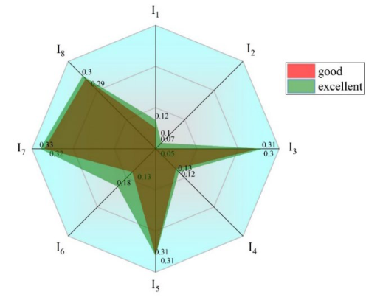
Figure 10 Comparison of the weight value of good grade and excellent grade
图 10：良好等级与优秀等级权重值的比较
图中文字对照（英文 → 中文）
good | 良好级 | excellent | 优秀级
I1–I8 | 8 个指标组，含义见图下正文
According to the analysis of the above figure, the biggest difference between ICM's good grade and excellent grade is the level of teamwork and technical management. If the limited capital is invested in the construction of these two aspects, the greatest potential of data assets can be exerted.
根据对上图的分析，ICM 的良好等级与优秀等级之间差异最大的是团队协作与技术管理水平。若将有限资金投入到这两方面的建设中，可发挥数据资产的最大潜力。
6 TASK 3:System Effectiveness Measure Model Based on Apriori
6 任务 3：基于 Apriori 的系统有效性度量模型
6.1 Model Overview
6.1 模型概述
For problem 3, based on problem 2, we use system dynamics simulation to simulate multiple sets of data for each maturity level, and then set different level standards for people, technology and process. Formulate the standard to measure the effectiveness of the data analysis system, which is mainly solved by the Apriori based on the association relationship.
针对问题 3，在问题 2 的基础上，我们运用系统动力学仿真对每个成熟度等级模拟多组数据，进而为人员、技术与流程设定不同的等级标准。制定衡量数据分析系统有效性的标准，主要通过基于关联关系的 Apriori 求解。
6.2 Data Processing
6.2 数据处理
From task 1 and task 2, the system dynamics simulation obtains a series of score values for people, technology, and process, as shown in the table 3:
由任务 1 与任务 2，系统动力学仿真得到人员、技术与流程的一系列得分值，如表 3 所示：
Ⅰ Set up experimental group data and control group data
Ⅰ 设置实验组数据与对照组数据
Set the data based on system dynamics simulation as the experimental data for correlation analysis, and the data analyzed in Task 1 as the control group data, which is used to verify the results of the association rules for the experimental group data.
Ⅱ Data discretization
Ⅱ 数据离散化
Different index values correspond to different maturity levels, that is, three influencing factors and one affected factor. Discretize these data. Considering the continuous linear nature of human, technical, and process variables, we use the equal-width discrete method. For the division of maturity level, we follow the level division given by DAMM in Task 1.
不同指标值对应不同的成熟度等级，即三个影响因素与一个受影响因素。对这些数据进行离散化。考虑到人员、技术与流程变量的连续线性特征，我们采用等宽离散法。对于成熟度等级的划分，我们遵循任务 1 中 DAMM 给出的等级划分。
— 原文第 16 页 —
Table 3 Simulation data discretization results
表 3：仿真数据的离散化结果
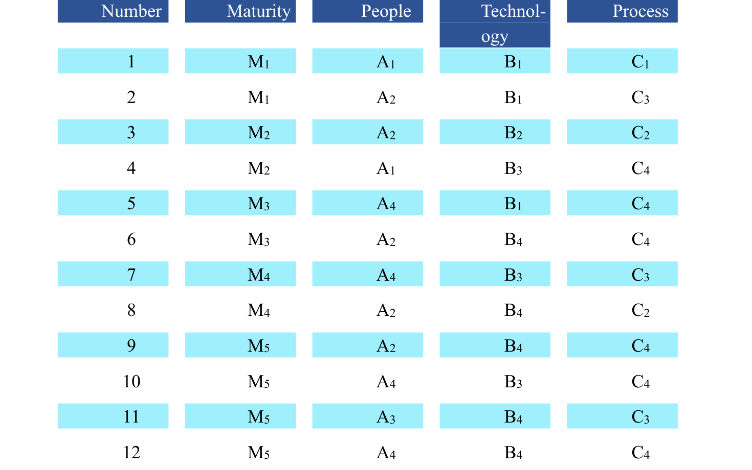
Maturity level M1 (0~0.25), M2 (0.25~0.5), M3 (0.5~0.75), M4 (0.75~0.9), M5 (0.9~1); People level A1 (0~0.25), A2 (0.25~0.5), A3 (0.5~0.75),A4 (0.75~1); Technical level B1 (0~0.25)， B2 (0.25~0.5), B3 (0.5~0.75), B4(0.75~1); Process level B1 (0~0.25), B2 (0.25~0.5), B3 (0.5~0.75), C4(0.75~1);
成熟度等级 M1 (0~0.25)、M2 (0.25~0.5)、M3 (0.5~0.75)、M4 (0.75~0.9)、M5 (0.9~1)；人员等级 A1 (0~0.25)、A2 (0.25~0.5)、A3 (0.5~0.75)、A4 (0.75~1)；技术等级 B1 (0~0.25)、B2 (0.25~0.5)、B3 (0.5~0.75)、B4 (0.75~1)；过程等级 B1 (0~0.25)、B2 (0.25~0.5)、B3 (0.5~0.75)、C4 (0.75~1)；
Classify and arrange the results of the discretization of the data, the level division and specific values are shown in the figure 11：
对数据离散化的结果进行分类整理，等级划分及具体数值如图 11 所示：
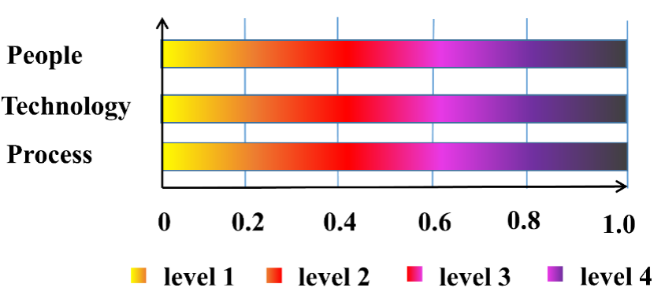
Figure 11 The respective grades of the three indicators
图 11：三项指标各自的等级
图中文字对照（英文 → 中文）
People | 人员 | Technology | 技术
Process | 流程 | level 1 | 等级 1
6.3 Establishment of Apriori
6.3 Apriori 的建立
The specific process of Apriori algorithm analyzing data is shown in the figure 12:
Apriori 算法分析数据的具体流程如图 12 所示：
— 原文第 17 页 —
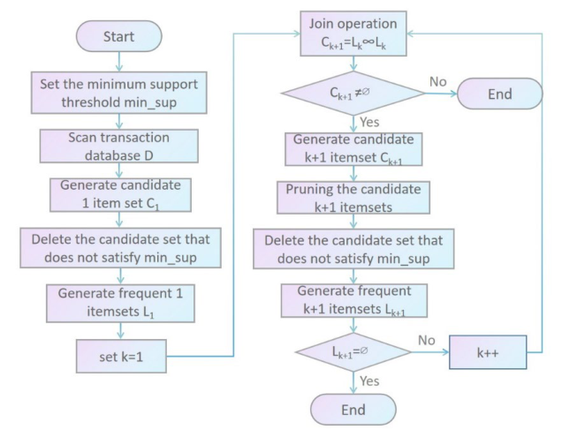
Figure 12 Apriori algorithm analysis process
图 12：Apriori 算法分析流程
图中文字对照（英文 → 中文）
Start | 开始 | Set the minimum support threshold min_sup | 设定最小支持度阈值 min_sup
Scan transaction database D | 扫描事务数据库 D | Generate candidate 1 item set C1 | 生成候选 1 项集 C1
Delete the candidate set that does not satisfy min_sup | 删除不满足 min_sup 的候选项集 | Generate frequent 1 itemsets L1 | 生成频繁 1 项集 L1
set k=1 | 令 k=1 | Join operation C(k+1)=L(k)∘L(k) | 连接运算，得到候选 k+1 项集
C(k+1) ≠ ∅ | 候选集非空 | Generate candidate k+1 itemset C(k+1) | 生成候选 k+1 项集 C(k+1)
Pruning the candidate k+1 itemsets | 对 k+1 候选项集剪枝 | Generate frequent k+1 itemsets L(k+1) | 生成频繁 k+1 项集 L(k+1)
L(k+1) = ∅ | 频繁集为空 | k++ | k 自增
Yes / No | 是／否 | End | 结束
The support and confidence are measured by setting thresholds. In this paper, the minimum support threshold is set to 20%, and the minimum confidence threshold is 60%. We continuously filter candidate sets, iteratively search layer by layer to obtain more candidate sets, and then realize the generation of connection relation.
支持度（Support）与置信度（Confidence）通过设定阈值来衡量。本文将最小支持度阈值设为 20%，最小置信度阈值设为 60%。我们不断筛选候选项集，逐层迭代搜索以获得更多候选项集，进而实现连接关系的生成。
6.4 Analysis of The Result
6.4 结果分析
The final valid association rule data mining table is shown in the table 4:
最终有效的关联规则（Association Rule）数据挖掘表如表 4 所示：
Table 4 Effective Association Rules Mining Table
表 4：有效关联规则挖掘表
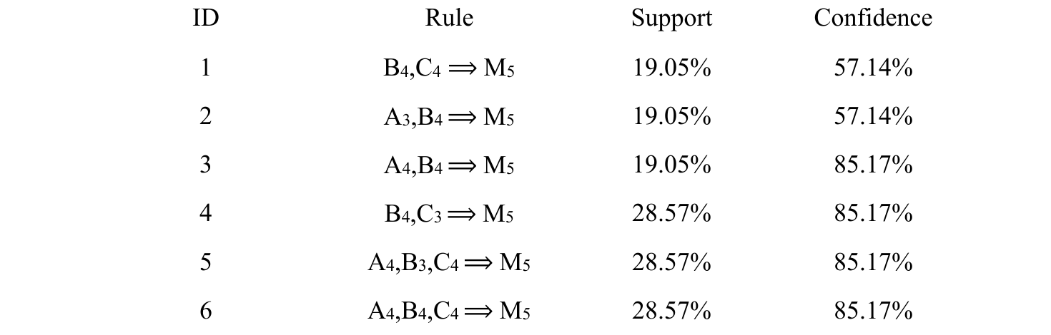
Result analysis:
结果分析：
(1) Rules ID2, ID5, ID6 indicate that the fourth-level people level A4 (0.8~1.0) has extremely high support and confidence (28.57%, 85.71%) to the fifth-level maturity M5 (0.9~1.0), and the third-level people level A3 (0.6~0.8) has high support and confidence (19.05%, 57.14%) for the fifth-level maturity, indicating that when the people level reaches the fourth-level, the maturity of ICM's data analysis system can reach a higher level, that is, a higher level of system
（1）规则 ID2、ID5、ID6 表明，第四级人员水平 A4（0.8~1.0）对第五级成熟度 M5（0.9~1.0）具有极高的支持度与置信度（28.57%，85.71%），第三级人员水平 A3（0.6~0.8）对第五级成熟度也具有较高的支持度与置信度（19.05%，57.14%），说明当人员水平达到第四级时，ICM 数据分析系统的成熟度可达到较高水平，即系统具有较高的有效性。
— 原文第 18 页 —
effectiveness.
有效性。
(2) Rules ID4, ID5, and ID6 indicate that the third-level technical level B3 (0.6~0.8) and the fourth-level technical level B4 (0.8~1.0) have extremely high support for the fifth-level maturity M5 (0.9~1.0). and confidence (28.57%, 85.71%), indicating that the technical requirements are lower than the people level. When the technical level reaches the third and fourth level, the level of the data analysis system can reach a higher level.
（2）规则 ID4、ID5、ID6 表明，第三级技术水平 B3（0.6~0.8）与第四级技术水平 B4（0.8~1.0）对第五级成熟度 M5（0.9~1.0）具有极高的支持度与置信度（28.57%，85.71%），说明技术要求低于人员水平。当技术水平达到第三、第四级时，数据分析系统的水平可达到较高水平。
(3) Rules ID5 and ID6 indicate that the support of the fourth-level process level C4 (0.8~1.0) to the fifth-level maturity M5 (0.9~1.0) is 28.57%, and the confidence level is 85.71%, indicating that the process level reaches the fourth level. At the high level, its data analysis system is more effective.
（3）规则 ID5、ID6 表明，第四级流程水平 C4（0.8~1.0）对第五级成熟度 M5（0.9~1.0）的支持度为 28.57%，置信度为 85.71%，说明流程水平达到第四级。处于较高水平时，其数据分析系统更为有效。
(4) Comprehensive analysis of all rules, when the people of the data analysis system of ICM company reaches the fourth level, the technology reaches the third or fourth level, and the process reaches the fourth level, the effectiveness of the data analysis system is fine.
（4）综合所有规则，当 ICM 公司数据分析系统的人员达到第四级、技术达到第三或第四级、流程达到第四级时，数据分析系统的有效性良好。
7 TASK 4: Sensitivity Analysis and Model promotion
7 任务 4：灵敏度分析与模型推广
Analyzing whether our model can be used for larger or smaller seaport companies, which is essentially a test of the DAMM model. For this problem, the analysis is easy to understand. As shown in the figure below, the amount of data contained in larger seaport companies More, the requirements for technical stability and technical response speed are higher; smaller seaport companies have less data volume and fewer people in the data analysis system, so they have higher requirements for the personal ability of people. Therefore, companies of different scales have different emphases in the evaluation of maturity, and the weight values of the indicators obtained based on the AHP-EWM method in task 1 are different.
分析我们的模型能否用于规模更大或更小的海港企业，这实质上是对 DAMM 模型的检验。对于该问题，分析易于理解。如下图所示，规模较大的海港企业所包含的数据量更多，对技术稳定性与技术响应速度的要求更高；规模较小的海港企业数据量更少、数据分析系统中的人员更少，因而对人员的个人能力要求更高。因此，不同规模的企业在成熟度评价中的侧重点不同，任务 1 中基于 AHP-EWM 方法得到的各指标权重值也不同。
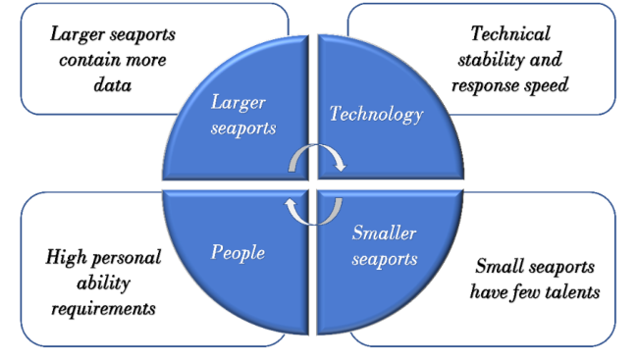
Figure 13 The focus of seaports of different scales
图 13：不同规模海港的关注重点
图中文字对照（英文 → 中文）
Larger seaports | 大型海港 | Smaller seaports | 小型海港
Technology | 技术 | People | 人员
Larger seaports contain more data | 大型海港数据量更大 | Technical stability and response speed | 更看重技术稳定性与响应速度
High personal ability requirements | 对个人能力要求更高 | Small seaports have few talents | 小型海港人才较少
7.1 Sensitivity Analysis
7.1 灵敏度分析
After adjusting the weight values of people, technology and process, the system dynamics model in question 2 is used to re-simulate, and the error value e between the simulation results
调整人员、技术与流程的权重值后，采用问题 2 中的系统动力学模型重新仿真，并分析仿真结果
— 原文第 19 页 —
and the actual evaluation value of DAMM is analyzed, and the error results change graph are obtained as follows:
与 DAMM 实际评价值之间的误差值 e，得到误差结果变化图如下：
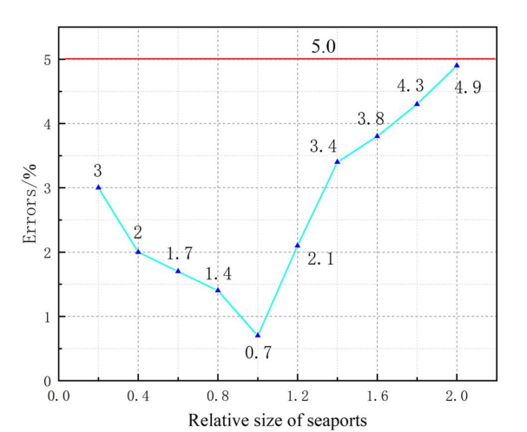
Figure 14 Error value between simulation result and actual evaluation value
图 14：仿真结果与实际评价值之间的误差值
图中文字对照（英文 → 中文）
Errors/% | 误差 /% | Relative size of seaports | 海港相对规模
5.0 | 5% 误差上限
Analyze the figure 14 , with the change of the relative size of the seaport, the error between the evaluation results of the DAMM model and the simulation results is small, and both remain below 5%, which shows the good applicability of the model to seaport companies of different sizes.
分析图 14，随着海港相对规模的变化，DAMM 模型的评价结果与仿真结果之间的误差较小，且均保持在 5% 以下，表明该模型对不同规模的海港企业具有良好的适用性。
7.2 Model promotion
7.2 模型推广
The universality of the DAMM system lies in:
DAMM 体系的普适性在于：
A.DAMM is not directly based on the data level analysis generated by the specific cargo movement of the intercontinental freight company, but conducts evaluation and modeling from the perspectives of people, technology and process. Different types of systematic evaluation are inseparable from people and technology. and process three factors, thus ensuring that the model can be directly transferred in the systematic evaluation of different types of companies; B. For freight companies, based on the ISO9001 "Quality Management System Requirements" international standard plan and grounded theory[12], DAMM is used to evaluate the system based on people, process and technology, which has the characteristics of conformity, Systematic and overall effectiveness.
A. DAMM 并不直接基于洲际货运公司具体货物运输所产生的数据层面进行分析，而是从人员、技术与流程的角度开展评价与建模。不同类型的系统评价都离不开人员、技术与流程三个要素，从而保证该模型可在不同类型公司的系统评价中直接迁移；B.对于货运公司，基于 ISO9001《质量管理体系要求》国际标准方案与扎根理论[12]，DAMM 从人员、流程与技术三个方面对系统进行评价，具有符合性、系统性与整体有效性等特征。
For ICM companies, if their customers also use the DAMM model, there will be the following benefits (as shown in figure 5):
对于 ICM 公司，若其客户也使用 DAMM 模型，将带来以下益处（如图 5 所示）：
A. ICM companies can understand the current maturity index of different customers to help them better analyze customers.
A. ICM 公司可了解不同客户当前的成熟度指标，从而帮助其更好地分析客户。
B. ICM companies can know the current problems of their own services to help them make better decisions.
B. ICM 公司可以了解自身服务当前存在的问题，从而帮助其做出更好的决策。
C. ICM companies can analyze the positioning of current customers and facilitate the development of differentiated plans.
C. ICM 公司可以分析现有客户的定位，并促进差异化方案的制定。
— 原文第 20 页 —
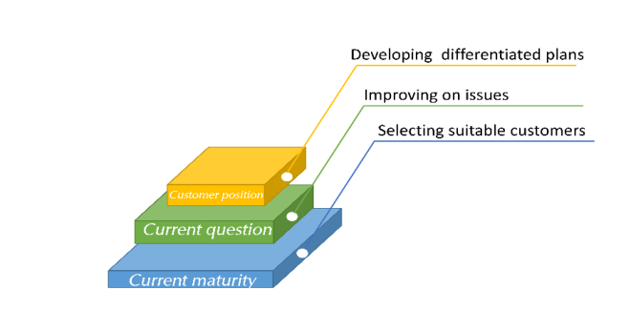
Figure 15 Advantages of the DAMM Model
图 15：DAMM 模型的优势
图中文字对照（英文 → 中文）
Current maturity | 当前成熟度 | Current question | 当前问题
Customer position | 客户定位 | Selecting suitable customers | 筛选合适客户
Improving on issues | 针对问题改进 | Developing differentiated plans | 制定差异化方案
8 Model Evaluation and Further Discussion
8 模型评价与进一步讨论
8.1 Strengths
8.1 优点
• We use the AHP-EWM method to build an evaluation model of the maturity of the data analysis system, and use more sufficient indicators to build a complete maturity evaluation model;
• 我们采用 AHP-EWM 方法构建数据分析系统成熟度的评价模型，并使用更充分的指标构建了完整的成熟度评价模型；
• When analyzing how to maximize the potential of data assets, we use system dynamics simulation to obtain simulation data, and qualitatively give improvement strategies; at the same time, combined with linear programming methods, we quantitatively analyze the focus of model improvement. The combination of the two methods enhances the robustness of the model;
• 在分析如何最大化数据资产潜力时，我们采用系统动力学仿真获得仿真数据，并定性地给出改进策略；同时结合线性规划方法，定量分析模型改进的重点。两种方法的结合增强了模型的稳健性；
• We have done enough visualization of the algorithms and results in this paper for easy understanding;
• 本文对算法和结果做了充分的可视化，便于理解；
• Our maturity evaluation model DAMM is based on three aspects: people, technology and process, and has good promotion significance and value;
• 我们的成熟度评价模型 DAMM 基于人员、技术和流程三个方面，具有良好的推广意义和价值；
• Most of our models are based on innovative ideas or improvements based on the original theory and the problem of this paper, making our models both theoretical and innovative.
• 我们的多数模型基于创新思路，或基于原有理论与本文问题的改进，使我们的模型兼具理论性与创新性。
8.2 Weaknesses
8.2 缺点
• We could have analyzed the relationship between the three levels of factors in more depth, but due to space limitations, our work can only do this for the time being.
• 本可以对三个层次的因素之间的关系进行更深入的分析，但受篇幅限制，我们的工作目前只能做到这一步。
• Due to the lack of actual numerical reference, we can only observe the accuracy of the model from the comparison of simulation and evaluation model, but cannot measure the accuracy of the model through the calculation of actual company data.
• 由于缺乏实际数值参考，我们只能通过仿真与评价模型的对比来观察模型的准确性，而无法通过实际公司数据的计算来衡量模型的准确性。
— 原文第 22 页 —

Dear ICM Seaport Users:
尊敬的 ICM 海港用户：
We are the researchers invited by ICM to as-
我们是受 ICM 邀请的研究人员，负责评估
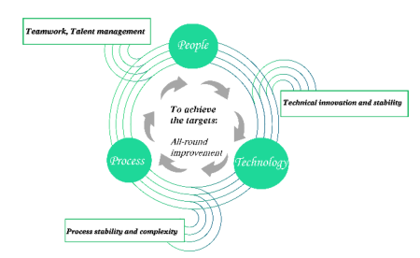
sess the maturity of its D&A system, As a large seaport, ICM generates a large amount of data information every day. Only with a sufficiently mature data analysis system can these data be fully utilized, understand the problems and needs of customers in a timely manner, and then reasonably deploy the work to provide more convenience for port users and save your precious time in the port. Therefore, an objective and reasonable evaluation of the ICM data analysis system to provide optimization advice is necessary and closely related to your vital interests. Our evaluation system is based on a large number of existing professional theories and expert opinions, combined with the actual situation of ICM's D&A system, and has carried out a scientific and reasonable analysis of the concerns of ICM and port users. A number of indicators are considered in all aspects, and then a comprehensive and objective evaluation of ICM's D&A system is carried out.
其 D&A 系统的成熟度。作为大型海港，ICM 每天产生大量的数据信息。只有具备足够成熟的数据分析系统，这些数据才能被充分利用，才能及时了解客户的问题和需求，进而合理地部署工作，为港口用户提供更多便利，并为您节省在港的宝贵时间。因此，对 ICM 数据分析系统进行客观合理的评价并提供优化建议是必要的，且与您的切身利益密切相关。我们的评价体系基于大量现有的专业理论和专家意见，结合 ICM 的 D&A 系统的实际情况，对 ICM 和海港用户所关心的问题进行了科学合理的分析。从各个方面考虑了多项指标，进而对 ICM 的 D&A 系统进行了全面、客观的评价。
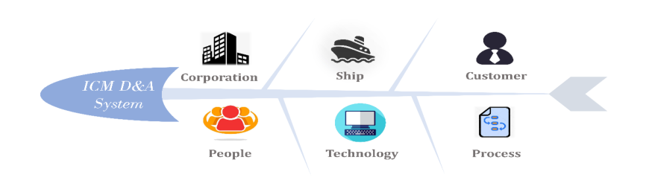
In our evaluation system, ICM's data analysis system finally got a score of 0.8173 (the highest score is 1), which proves that ICM's data analysis system is at a relatively mature level. It also confirms the undoubted data analysis strength of ICM as a large seaport，Only slightly lacking in talent management and teamwork. Reasonable optimizations will be made under our guidance, and finally its data analysis system will reach a quite ideal level. ICM will be more profound to the needs of port users, be more sensitive to problems, and provide better services to facilitate the use of seaports by you.
在我们的评价体系中，ICM 的数据分析系统最终得分为 0.8173（最高分为 1），这证明 ICM 的数据分析系统处于较为成熟的水平。这也印证了 ICM 作为大型海港毋庸置疑的数据分析实力，仅在人才管理和团队协作方面略有不足。在我们的指导下将进行合理的优化，最终其数据分析系统将达到相当理想的水平。ICM 将更深入地了解海港用户的需求，对问题更加敏感，并提供更好的服务，为您使用海港提供便利。
Because our evaluation system is based on people, technology and process, which is consistent in large and small ports and other industries, it is also applicable to all enterprises. I believe that using our evaluation system, you can also have a deeper understanding of yourself. You will also have more trust in ICM's data analysis capabilities to achieve the goal of mutual benefit and win-win.
由于我们的评价体系基于人员、技术和流程，这在大中小型港口以及其他行业中是一致的，因此也适用于所有企业。我相信，使用我们的评价体系，您也能对自己有更深入的了解。您也将更加信任 ICM 的数据分析能力，从而实现互利共赢的目标。
Yours,Team 2215444
此致，2215444 队
— 原文第 21 页 —
References
[1] Paulk M. Comparing ISO 9001 and the Capability Maturity Model for Software[J].
Kluwer Academic Publishers, 1993,2(4): 245-256
[2] Pekka B M，Mikko L J. Assessment of quality and maturity level of R &D [J]. Production Economics,2002,(78):29-35
[3] Kirazli A T, Moetz O B. (2015). “A methodological approach for evaluatingthe influences of Industrie 4.0 on risk management of the goods receiving area in a German automotive manufacturer”, in Proceedings of the 22nd Eur OMA Conference. Operations Management for Sustainable Competitiveness.
[4] Crawford J K. PM Solutions. Project Management Maturity[J].New York:Marcel Dekker,2002:76-81
[5] WILTJER HANNEKE, SEERS KATE, TUTTON ELIZABETH. Understanding assessment on a hospital ward for older people: A qualitative study[J]. Journal of advanced nursing,2019(4). DOI:10.1111/jan.13930.
[6] Tobias Mettlera, Chen, Y. , Wang, H. , Chenjing, Zhang, J. , & Wang, H. , et al. (2011). The study on the influencing factors of patients' loyalty to hospitals of grade three,class a. Modern Hospital Management.
[7] Tao Hongfei, Sun Yixin, Wu Guowei, et al. Maturity assessment of power information system based on big data and AHP[J]. China Electric Power, 2016(10). DOI:
10.11930/j.issn.1004-9649.2016.10.114.05.
[8] Lin Yongyi, Li Minqiang. Research on Maturity Model of Enterprise Business Process Management [J]. Modern Management Science, 2008(7). DOI:10.3969/j.issn.1007-
368X.2008.07.036.
[9] Xie Gang, Feng Ying, Li Zhiwen. The maturity model of customer information quality management under the background of big data [J]. China Circulation Economy,
2015(5). DOI:10.3969/j.issn.1007-8266.2015.05.015.
[10] De Carolis A., Macchi M., Negri E., et al. A Maturity Model for Assessing the Digital Readiness of Manufacturing Companies[M]. Berlin; Springer International Publishing, 2017.
[11] Technology; Reports from Islamic Azad University Describe Recent Advances in Technology (Identification of the determinants of Blockchain-based business model using hybrid method: Content analysis & System Dynamics)[J]. Journal of Engineering, 2019. [12] Triana, Yaya Sudarya and Retnowardhani, Astari. Analyze System of Quality Management Using ISO 9001:2015 (Case Study: PT. XYZ)[J]. Advanced Science Letters, 2018, 24(11) : 8774-8777(4).
（全文完。公式与表格在原 PDF 中是矢量图形，未纳入本对照版；可按文中「原文第 N 页」标记翻到 2215444.pdf 对照查看。）

