2223495 英中对照版
2022 ICM Problem E · Forest Management for Ecological-Economic Balance in the Perspective of Carbon Sequestration
读法：黑字为原文，蓝字为译文，一段英文一段中文，上下对应；蓝字里的小字括号是该术语第一次出现时的英文原词。
术语表（按首次出现排序，20 条）
# | 英文 | 中文 | 说明：为什么容易译错
1 | Carbon Sequestration | 固碳 | 森林吸收并长期储存二氧化碳
2 | Carbon Peaking and Carbon Neutral | 碳达峰与碳中和 | “双碳”目标，全文的立题背景
3 | Differential Equation | 微分方程 | 描述碳储量随时间演化的工具
4 | Forest Management Strategy | 森林管理策略 | 何时砍、砍多少、砍哪一类树
5 | Harvesting Rate | 采伐率 | 每次采伐拿走的木材比例
6 | Carbon Sink | 碳汇 | 从大气中吸收碳的载体
7 | Tree Age Stage | 树龄阶段 | 幼龄/中龄/近熟/成熟等分档
8 | Steady-state Equilibrium | 稳态平衡 | 各龄级面积不再变化的状态
9 | TEV | 总经济价值 | Total Economic Value，把森林价值拆成六项
10 | Value System Balance Model | 价值体系平衡模型 | 在多项价值之间求平衡的模型
11 | Multiple Objective Programming | 多目标规划 | 同时最大化多个目标的优化模型
12 | Simulated Annealing | 模拟退火 | SA 算法，跳出局部最优求全局最优
13 | TTF | 森林生态系统总价值 | Total Forest Ecosystem Value，模型的优化目标
14 | Inverse Mapping Function | 逆映射函数 | 由目标价值反解管理策略
15 | Game Theory | 博弈论 | 研究多方策略互动
16 | Evolutionary Game | 演化博弈 | 策略随种群演化而收敛的博弈
17 | Biomass | 生物量 | 单位面积林木的干物质重量
18 | Climate Zone | 气候带 | 热带/亚热带/温带/寒带等分区
19 | Sensitivity Analysis | 灵敏度分析 | 改动参数看结论是否稳定
20 | Logging Ban | 禁伐 | 极地等生态脆弱区完全禁止采伐

Letting "Carbon" Stay: Forest Management for Ecological-Economic
让“碳”留下：固碳视角下生态-经济平衡的森林经营
Balance in the Perspective of Carbon Sequestration
固碳视角下的生态-经济平衡
Summary
摘要
Forests play an important role in both nature and human society. In the context of "carbon peaking and carbon neutral", how to balance the economic and ecological values of forests has become an academic focus. We used differential equations, multi-objective planning, evolutionary games and simulation to find scientific management strategies for forests in different climates and to guide practice and development.
森林在自然界与人类社会中均发挥着重要作用。在“碳达峰与碳中和（Carbon Peaking and Carbon Neutral）”背景下，如何平衡森林的经济价值与生态价值已成为学术关注的焦点。我们运用微分方程（Differential Equation）、多目标规划（Multiple Objective Programming）、演化博弈（Evolutionary Game）与仿真，为不同气候条件下的森林寻求科学的管理策略，并用以指导实践与发展。
First, we constructed a forest carbon sequestration model. Based on the differential equation, we investigated the carbon sequestration level under different forest management strategies, taking into account the forest area, tree age, climate environment, wood use and depreciation, and found that moderate harvesting helps to increase the carbon sequestration of the whole system. In addition, we simulated the adjustment of the harvesting rateto find the best forest management strategy for carbon sequestration and calculated that .
首先，我们构建了森林固碳（Carbon Sequestration）模型。基于微分方程，我们考察了不同森林管理策略（Forest Management Strategy）下的固碳（Carbon Sequestration）水平，并综合考虑森林面积、树龄、气候环境、木材用途与折旧，发现适度采伐有助于提高整个系统的固碳量。此外，我们模拟采伐率（Harvesting Rate）的调整，以寻找固碳效果最佳的森林管理策略，并计算得出。
Second, in order to balance the multiple values such as economic value and ecological value of the forest system, we constructed six value systems based on the TEV model. Based on this, we constructed a value system balance model using multivariate objectives programming and solved the maximum total forest ecosystem value (TTF) with the help of simulated annealing (SA) algorithm. Thus, the optimal benefit is achieved with balancing the interests of multiple parties, and the TTF is obtained from the experiment in northern China category: 27283~40924.5$/km2/year.
其次，为平衡森林系统的经济价值、生态价值等多重价值，我们基于 TEV 模型构建了六个价值体系。在此基础上，我们运用多目标规划构建了价值体系平衡模型（Value System Balance Model），并借助模拟退火（Simulated Annealing）（SA）算法求解森林生态系统总价值（TTF）（TTF）的最大值。由此，在平衡多方利益的前提下实现了最优效益，并由华北类地区的实验得到 TTF 为 27283~40924.5$/km2/year。
Third, the development of scientific forest management strategies is necessary to achieve the balance and optimum of forest values. The inverse mapping function is constructed based on the value system balance model to analyze the optimal forest management strategy under the corresponding state. Forest management strategies for general and special conditions are developed based on 4 medium forest harvesting strategies simulated for each of the 4 major types of climatic environments. We used a subtropical forest in China as an example, and validated that the 100-year 𝐶𝑂² uptake for a harvest rate of 41.5% ~ 55% for near-mature trees and 80% for mature trees is found to be 442.2 ~ 820.8𝑘𝑡.
第三，制定科学的森林管理策略是实现森林价值平衡与最优的必要条件。基于价值体系平衡模型构建逆映射函数（Inverse Mapping Function），以分析相应状态下的最优森林管理策略。针对 4 大类气候环境各自模拟 4 种中等强度的森林采伐策略，据此制定一般情形与特殊情形下的森林管理策略。我们以中国亚热带森林为例，验证得到：当近熟林采伐率为 41.5%~55%、成熟林采伐率为 80% 时，100 年的 𝐶𝑂2 吸收量为 442.2~820.8𝑘𝑡。
Finally, the problem of adaptation to the transition phase of the optimal forest management strategy is addressed. This paper introduced game theory to complement the model and used an evolutionary game approach to explore the behavioral decisions of forest managers. Moderate deforestation is found to be the optimal outcome that satisfies the demand sensitivity of all parties. The simulation approach is then used to enable the above strategy to be validated in a variety of forest environments.
最后，我们处理了最优森林管理策略在过渡阶段的适应性问题。本文引入博弈论（Game Theory）对模型加以补充，并采用演化博弈方法探讨森林经营者的行为决策。研究发现，适度采伐是满足各方需求敏感性要求的最优结果。随后采用仿真方法，使上述策略得以在多种森林环境中得到验证。
In conclusion, moderate harvesting of forests is the optimal solution to enhance their ecological and economic values. Extending the harvesting cycle will help the current recovery of over-harvested forests. However, it should be noted that for polar regions we still need to prohibit logging in order to protect them well.
综上，对森林进行适度采伐是提升其生态价值与经济价值的最优方案。延长采伐周期将有助于当前过伐森林的恢复。但需注意，对于极地地区，我们仍需实行禁伐（Logging Ban）以对其加以良好保护。
Keywords:Differential Equations ; Multiple Objective Planning ; TEV ; Evolutionary Game
关键词：微分方程；多目标规划；TEV；演化博弈
— 原文第 3 页 —
1 Introduction
1 引言
1.1 Problem Background
1.1 问题背景
Climate change is one of the central issues in international public affairs. Reduction of greenhouse gases is important. Carbon sequestration is considered as an effective method to reduce emissions [1]. Carbon sequestration is the safe capture and storage of carbon in the air [2]. Forests are an effective way to sequester carbon [3]. Forests and forest products are affected by the climatic environment and human disturbances [4]. It has been argued that scientific harvest management can improve the carbon sequestration capacity of forest systems. However, forest managers often need to balance ecological, economic and social values when making decisions.
气候变化是国际公共事务的核心议题之一。减少温室气体十分重要。固碳被视为一种有效的减排方法 [1]。固碳是对空气中碳的安全捕集与封存 [2]。森林是实现固碳的有效途径 [3]。森林及林产品受到气候环境与人类干扰的影响 [4]。有观点认为，科学的采伐管理能够提升森林系统的固碳能力。然而，森林经营者在决策时往往需要平衡生态、经济与社会价值。
1.2 Restatement of the Problem and Our works.
1.2 问题重述与我们的工作
Considering the information identified in the problem statement, we need to address the following questions and perform the following tasks
结合问题陈述中所明确的信息，我们需要解决以下问题并完成以下任务
• Develop a carbon sequestration model to quantify the amount of carbon sequestration in forests and their products, and use this model to design the most effective carbon-sequestration forest management plans.
• 建立固碳模型，以量化森林及其产品的固碳量，并运用该模型设计最有效的固碳型森林经营方案。
• Build a decision model to help forest managers choose the best forest management plan and balance multiple value objectives. The model needs to consider the coverage of forest management plans, discuss the conditions under which forests will not be cut down, transition points between forest management plans, and characteristics of forests in different locations in the world regarding transition points of management plans.
• 建立决策模型，帮助森林经营者选择最优森林经营方案并平衡多重价值目标。该模型需考虑森林经营方案的覆盖范围，讨论森林不被采伐的条件、森林经营方案之间的转换点，以及世界不同地点森林在经营方案转换点方面的特征。
• Apply the model practically to all kinds of forests, identify and select the forest that should adopts a forest management plan that includes a harvesting plan. Project carbon sequestration 100 years from now, identify the best forest management plan and argue its rationale, and develop a transition strategy that takes into account the sensitivity of forest managers' needs.
• 将该模型实际应用于各类森林，识别并选出应当采用包含采伐计划的森林经营方案的森林。预测 100 年后的固碳量，确定最优森林经营方案并论证其合理性，同时制定顾及森林经营者需求敏感性的过渡策略。
• Write a non-technical essay explaining the need for deforestation and convincing local residents that our management plan is the best decision to develop the forest.
• 撰写一篇非技术性短文，说明采伐的必要性，并使当地居民相信我们的管理方案是开发该森林的最佳决策。
1.3 Literature Review
1.3 文献综述
Forests play a crucial role in the carbon cycle [5,6]. According to the Kyoto Protocol and the United Nations Framework Convention on Climate Change (UNFCCC), carbon sequestration in forest ecosystems makes carbon management a promising solution to combat climate change [7,8]. The use of forest resources has entered the stage of multi-value sustainable use of managed forests [9,10]. Currently, maintaining and enhancing carbon sinks and carbon storage (CSS) in forest ecosystems is becoming a fundamental goal of sustainable forest management [10]. Adaptive silvicultural practices, such as reducing intensive harvesting, may be one of the strategies to increase the long-term CSS of ecosystem HWP [11,12]. It has been suggested that the carbon sink capacity of planted forests can be maximized by extending crop rotation and taking appropriate measures [13].
森林在碳循环中起着至关重要的作用 [5,6]。根据《京都议定书》与《联合国气候变化框架公约》（UNFCCC），森林生态系统的固碳使碳管理成为应对气候变化的一种富有前景的解决方案 [7,8]。森林资源的利用已进入经营林多价值可持续利用阶段 [9,10]。目前，维持并增强森林生态系统的碳汇（Carbon Sink）与碳储量（CSS）正成为可持续森林管理的基本目标 [10]。适应性营林实践，例如减少集约化采伐，可能是提高生态系统 HWP 长期 CSS 的策略之一 [11,12]。有研究提出，通过延长轮伐期并采取适当措施，可使人工林的碳汇能力最大化 [13]。
— 原文第 4 页 —
1.4 Our Work
1.4 我们的工作
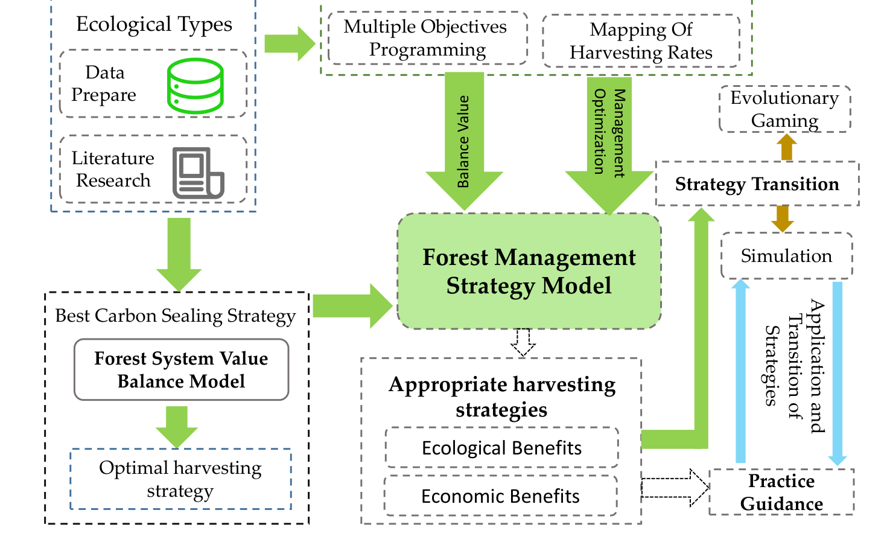
Figue 1: The structure and process of the full text modeling
图 1：全文建模的结构与流程
2 Assumptions & Reasonals
2 假设与理由
• There are no large emergencies in forest ecology. Large-scale emergencies are stochastic in nature and cannot be modeled. Therefore the effects of natural disasters, such as sudden mudslides, forest fires, pests and diseases, and volcanic eruptions, are not considered. • The forest areas involved are all operable in terms of management. Some remote forests that cannot be used by human activities are outside the scope of this model. This is because it is neither "economic" nor "environmentally friendly" to manage them.
• 森林生态中不存在大型突发性事件。大型突发性事件本质上是随机的，无法建模。因此，诸如突发泥石流、森林火灾、病虫害与火山喷发等自然灾害的影响不予考虑。• 所涉及的林区在经营层面均具备可操作性。部分人类活动无法利用的偏远森林不在本模型的讨论范围之内。这是因为对它们进行经营既不符合“经济性”，也不符合“环境友好性”。
• All wood produced by the forest is fully accessible to the market. According to Say's law, in a free market, the total demand of society is always equal to the total supply . Our model defaults to all timber being available for sale.
• 森林所生产的全部木材均可充分进入市场。根据萨伊定律，在自由市场中，社会总需求恒等于总供给。本模型默认全部木材均可出售。
3 Notations
3 符号说明
The key mathematical notations used in this paper are listed in Table 1.
本文所使用的关键数学符号列于表 1。
Table 1: Notations used in this paper
表 1：本文所用符号
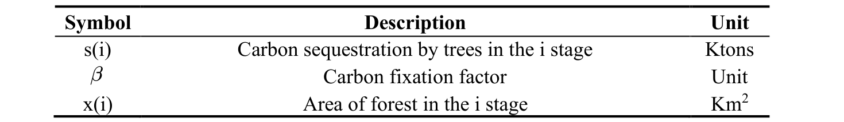
— 原文第 5 页 —
Growth factor
生长因子
Unit
单位
Natural rate of death in the i stage
第 i 阶段的自然死亡率
Unit
单位
Deforestation rate in the i stage
第 i 阶段的采伐率
Unit
单位
Carbon transfer coefficient
碳转移系数
Unit
单位
Carbon tax price
碳税价格
$/ton
Biodiversity coefficient
生物多样性系数
Unit
单位
R
Rhizome ratio
根茎比
Unit
单位
Where we define the main parameters while specific value of those parameters will be given later.
此处定义了主要参数，各参数的具体取值将在后文给出。
4 Whole Process Carbon Sequestration Model for Trees.
4 树木全生命周期固碳模型
In order to construct a full-cycle carbon sequestration model for forest trees, two system levels need to be considered: the forest carbon flow system and the wood product carbon flow system. For the forest system, we need to consider the age of trees, their carbon sequestration capacity, natural growth rate and natural mortality rate under different geographical and environmental conditions. For the wood products carbon flow system, we need to consider the efficiency of wood utilization, the depreciation rate and the end-of-life time of the products. We developed a differential equation-based decision optimization model for the sustainable development of the forest, which takes into account the regeneration continuity and the optimal carbon dioxide sequestration in the forest, so as to achieve the highest level of carbon sequestration for both native ecological and economic products under the premise of "sustainable development" of the forest. In the process of analysis, we use the Volterra model and expand the original model by using the tree growth environment, the environmental and economic values of forest products and the cutting plan of the forest to balance the harvesting strategy with the restoration strategy and the selection of high-quality and low-quality products, and finally solve the differential equation to calculate the CO2 sequestration of the whole system under different cutting conditions.
为构建林木全周期固碳模型，需要考虑两个系统层级：森林碳流系统与木质产品碳流系统。对于森林系统，需要考虑树木的树龄、其固碳能力，以及在不同地理与环境条件下的自然生长率与自然死亡率。对于木质产品碳流系统，需要考虑木材利用率、产品折旧率以及产品的使用寿命终期。我们建立了一个基于微分方程的森林可持续发展决策优化模型，该模型兼顾森林的更新连续性与二氧化碳固存的最优化，从而在森林“可持续发展”的前提下，使原生生态产品与经济产品均达到最高固碳水平。在分析过程中，我们采用 Volterra 模型，并利用树木生长环境、林产品的环境价值与经济价值以及森林的采伐方案对原模型进行扩展，以在采伐策略与恢复策略之间实现平衡，并对优质与劣质产品进行选择，最终通过求解微分方程计算不同采伐条件下整个系统的 CO2 固存量。
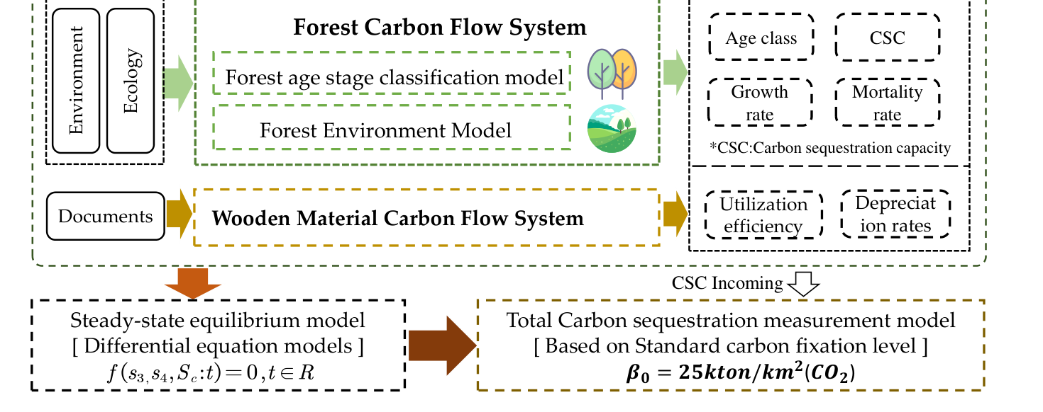
Figue 2: Whole process carbon sequestration model
图 2：全生命周期固碳模型
When the above two systems reach steady-state equilibrium, the total carbon sequestration of the two systems is calculated by referring to the standard unit area of forest land sequestration level, and the sum is the carbon sequestration level of the whole process of forest trees.
当上述两个系统达到稳态平衡（Steady-state Equilibrium）时，两个系统的总固碳量按林地固碳水平的标准单位面积折算求得，其加和即为林木全生命周期的固碳水平。
— 原文第 6 页 —
4.1 Tree Age Stage Classification Model
4.1 树龄阶段划分模型
Different types of trees have different growth cycles and rotation periods, which are analyzed through the papers of the biological model of trees, while the species of trees are different and the geographical variability is significant. Therefore models need to be constructed to deal with this relationship.
不同类型的树木具有不同的生长周期与轮伐期，这些通过树木生物学模型的相关文献加以分析；同时树种各异，地理差异亦十分显著。因此需要构建模型来处理这一关系。
Generally, the growth stages of trees are divided into four stages: young stage, middle stage, near-mature stage, and mature stage. In order to make the model more universal and robust, we fuzzify the years of tree growth and construct the following tree age stage division model with one growth stage of the tree as the minimum time unit t. (It is known from consulting the data that each growth stage of most exploited forest trees is about 10-15 years and the whole life cycle is 40-60 years).
通常将树木的生长阶段划分为四个阶段：幼龄阶段、中龄阶段、近熟阶段与成熟阶段。为使模型更具普适性与稳健性，我们对树木生长年限进行模糊化处理，并以树木的一个生长阶段作为最小时间单位 t，构建如下树龄阶段（Tree Age Stage）划分模型。（据资料查证，多数可采伐林木的每个生长阶段约为 10-15 年，整个生命周期为 40-60 年。）
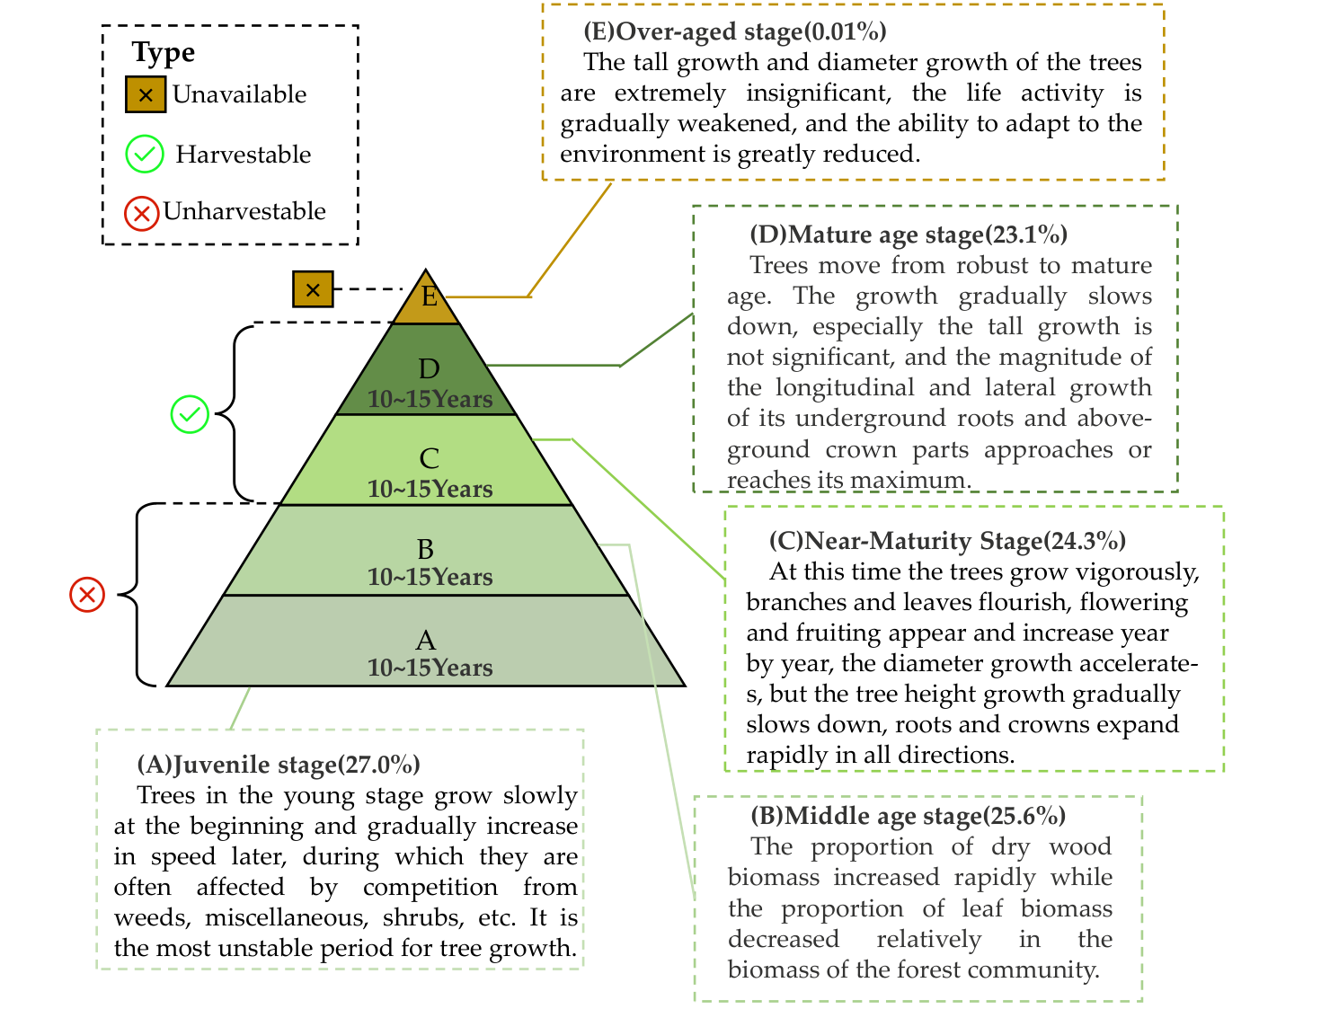
Figue 3: Tree age stage classification
图 3：树龄阶段划分
For plantations, the over-ripe stage accounts for almost a small percentage due to thepresence of management and can be ignored. For natural stands, the number of trees in themature stage is limited by competition due to the presence of natural competition, and again the proportion is small and negligible. The model was constructed for four age stages, A, B, C, and D.
对于人工林，由于存在经营管理，过熟阶段所占比例极小，可以忽略。对于天然林，由于存在自然竞争，成熟阶段的树木数量受到竞争限制，其比例同样很小，可以忽略。该模型针对 A、B、C、D 四个树龄阶段构建。
— 原文第 7 页 —
The trees in stages A and B are in the fast growth stage and the timber stock is small, so cutting will not bring more economic value, so it is assumed not to harvest trees in stages A and B here. For stage C trees, moderate harvesting can be done, and for stage D, more harvesting can be done.
处于 A、B 阶段的树木正处于快速生长阶段，木材蓄积量较小，采伐不会带来更多经济价值，因此此处假设不对 A、B 阶段的树木进行采伐。对于 C 阶段的树木，可进行适度采伐；对于 D 阶段，则可加大采伐强度。
4.2 Forest Ecology Model
4.2 森林生态模型
4.2.1 Climate Impact on Forests
4.2.1 气候对森林的影响
The growth rate and natural mortality of trees are related to the climate and environment in which they live. Drawing on the regularization of the world's major forest area categories in the literature study published by Derrahmane Ameray et al. in 2021, we visualized the forest area characteristics, climatic characteristics of the three major categories and derived the growth coefficient λ and natural mortality rate 𝜌 differently in different forest area types through a comprehensive assessment, as shown in the following Table.
树木的生长率与自然死亡率同其所在的气候环境相关。借鉴 Derrahmane Ameray 等人于 2021 年发表的文献研究中对全球主要林区类别的规范化处理，我们对三大类别的林区特征与气候特征进行了可视化，并通过综合评估推导出不同林区类型下不同的生长系数 λ 与自然死亡率 𝜌，如下表所示。
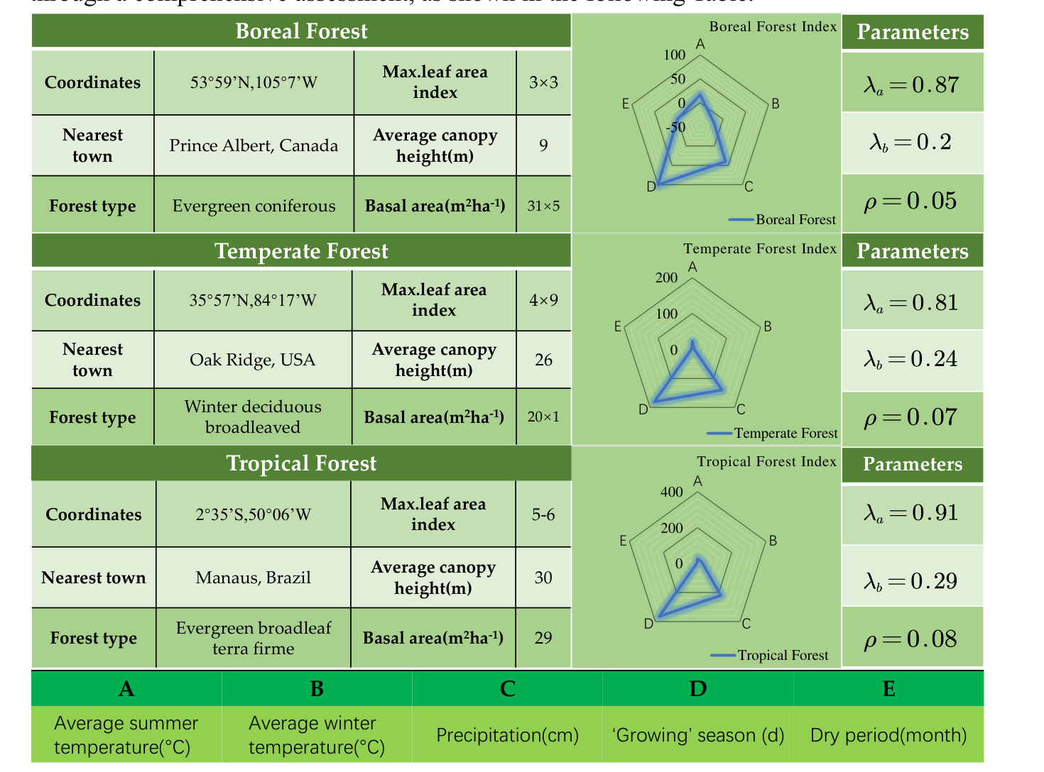
Figue 4: Basic information of the three major forest species
图 4：三大主要森林树种的基本信息
4.2.2 General Forest Properties
4.2.2 森林的一般属性
In order to make the model usable and robust even in the absence of data, the attributes of the forest in general state are measured. The percentage of each tree age stage in the natural forest. Checking the relevant data, we know that the retention rate of saplings growing to maturity in the forest is 85%. The natural mortality rate at each stage can be set as 𝜌 and can be set to. It can be obtained that 𝜌 is approximately equal to 5%. Set up the equation:
为使模型在缺乏数据的情况下仍可使用且稳健，对一般状态下森林的属性进行了测度。天然林中各树龄阶段所占的百分比。查阅相关数据可知，林中幼苗生长至成熟期的保存率为 85%。各阶段的自然死亡率可设为 𝜌，并可设为。可得 𝜌 约等于 5%。建立方程：
— 原文第 8 页 —
The percentage of trees in their natural state at each age stage can be calculated from Equation (1). For each tree age, the carbon sequestration level was set. The carbon sequestration level of larch plantation in northern China measured by Jia Yanlong based on CO2FIX model was set as 25𝑘𝑡𝑜𝑛 𝑘𝑚². Meanwhile, the carbon sequestration level of different tree ages was weighted according to the CO2FIX measurement method, and the summary results are as follows table.
由式 (1) 可计算出天然状态下各树龄阶段的树木所占百分比。对各树龄设定其固碳水平。将贾彦龙基于 CO2FIX 模型测得的中国北方落叶松人工林固碳水平设为 25𝑘𝑡𝑜𝑛 𝑘𝑚²。同时，按照 CO2FIX 测度方法对不同树龄的固碳水平进行加权，汇总结果见下表。
Table 2: Carbon fixation coefficient value
表 2：固碳系数取值
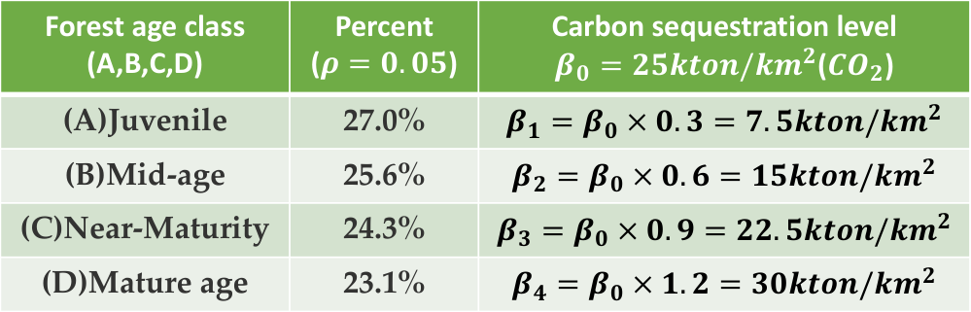
Forest age class
树龄阶段
Percent
占比
Carbon sequestration level
固碳水平
( )
( )
(A,B,C,D)
(A)Juvenile
(A)幼龄林
27.0%
(B)Mid-age
(B)中龄林
25.6%
(C)Near-Maturity
(C)近熟林
24.3%
(D)Mature age
(D)成熟林
23.1%
4.3 Whole Process Forest Wood Model
4.3 森林木材全流程模型
For the wood of the forest, it can be divided into two parts:
就森林的木材而言，可将其分为两部分：
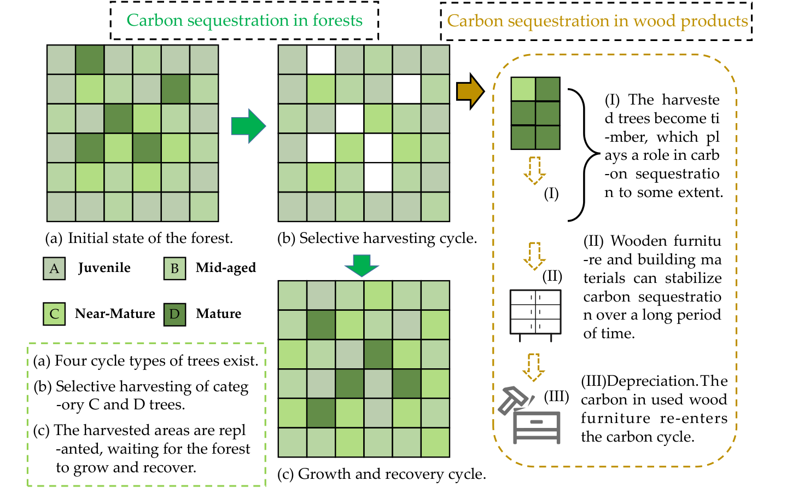
Figue 4: Whole process forest wood
图 4：森林木材全流程
图中文字对照（英文 → 中文）
Forest age class (A,B,C,D) | 森林龄组（A、B、C、D） | Percent (ρ = 0.05) | 百分比（ρ = 0.05）
Carbon sequestration level | 固碳水平 | (A)Juvenile | （A）幼龄林
(B)Mid-age | （B）中龄林 | (C)Near-Maturity | （C）近熟林
(D)Mature age | （D）成熟林
— 原文第 9 页 —
Forest trees and wood products. Both of these parts have carbon sequestration. In order to study the flow of carbon in both parts, the following flow chart of the whole process of forest wood was drawn. The first part, forest carbon sequestration: the model is divided according to the age stage by rasterizing and classifying the area of trees in each age stage of the forest. The specific process is shown in Fig. The second part, wood carbon sequestration, wood is processed, used and finally scrapped.
森林树木与木材制品。这两部分均具有固碳作用。为研究碳在这两部分中的流动，绘制了如下森林木材全流程图。第一部分，森林固碳：模型通过将森林中各树龄阶段的树木面积栅格化并分类，按树龄阶段进行划分。具体流程如图所示。第二部分，木材固碳，即木材经加工、使用直至最终报废。
4.4 Steady-state Equilibrium Model
4.4 稳态平衡模型
c) Introduction of growth rate and natural mortality. The parameters lam and rou were introduced to take into account the variability in age, geography and climate. The parametersandwere introduced.is the growth rate.is the natural mortality rate. The values are taken according to the forest ecological model constructed above.d) Set the carbon sequestration coefficient 𝛽. For the wood carbon sequestration system, the following limitations were assumed:
c) 引入增长率与自然死亡率。引入参数 lam 与 rou，以考虑树龄、地理与气候的差异性。引入参数和。为增长率，为自然死亡率。取值依据上文构建的森林生态模型。d) 设定固碳系数 𝛽。对木材固碳系统作如下限制假设：
•
Wood conversion rate, from trees to wood is 90%:
木材转化率，即由树木转化为木材的比率为 90%：
•
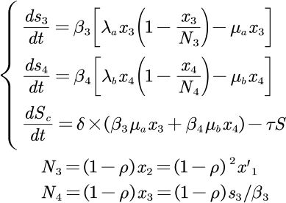
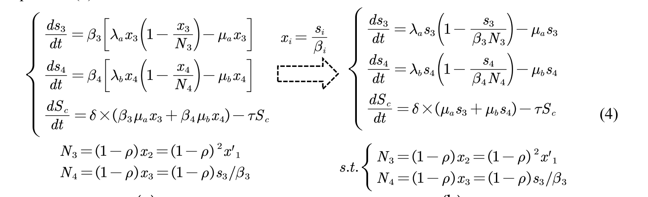
— 原文第 10 页 —
The initial state of the area of each tree stage is set as the area distribution in the natural state, and the initial amount of carbon sequestered by wood products is 0. The equation is solved with the help of Scipy. Let the solution of the differential equation obtained be.
各树龄阶段面积的初始状态设为天然状态下的面积分布，木材制品的初始固碳量为 0。借助 Scipy 对该方程进行求解。设所求得的微分方程的解为。
4.5 Total Carbon Sequestration Measurement Model
4.5 总固碳量测度模型
Referring to the above setting, the following formula can be derived:
参照上述设定，可推导出如下公式：
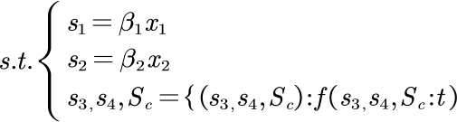
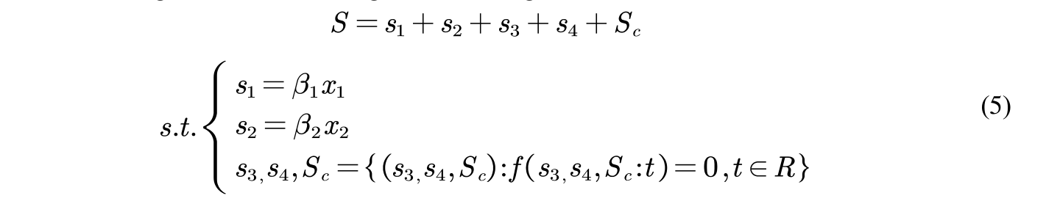
The model was experimented with a larch plantation ecosystem in northern China by taking a 100𝑘𝑚² area stand in natural state, and the trees' carbon sequestration capacity beta referred to the settings in the tree age stage classification model. The total amount of carbon sequestered when the system reached stability was calculated in three ways, respectively.
以中国北方落叶松人工林生态系统为对象，取天然状态下 100𝑘𝑚² 面积的林分对模型进行实验，树木固碳能力 𝛽 参照树龄阶段划分模型中的设定。分别按三种方式计算系统达到稳定时的总固碳量。
Experiment with the model. Taking the 100𝑘𝑚² area of larch plantation ecosystem in northern China as an example, the tree carbon sequestration capacity 𝛽 refers to the setting in the tree age stage division model. The total amount of carbon sequestration when the system reaches stability is calculated in the following three ways：a) Moderate deforestation and exploitation of forests. When the forest is reasonably felled, take 𝜇_{𝑎}=0.3, 𝜇_{𝑏} =1. The total carbon sequestration of the system S=1360.3 kilotons of carbon dioxide.b) No deforestation of the forest. When there is no harvesting of any age stage of the forest, i.e., 𝜇_{𝑎} 𝜇_{𝑏} 0, the solution yields the amount of carbon sequestered by the system at stabilization S=1242.7 kt CO₂.c) Excessive deforestation in general. 𝜇_{𝑎}=0.6, 𝜇_{𝑏} =1, S=1123.6 kilotons of CO₂.
对模型进行实验。以中国北方落叶松人工林生态系统 100𝑘𝑚² 面积为例，树木固碳能力 𝛽 参照树龄阶段划分模型中的设定。系统达到稳定时的总固碳量按以下三种方式计算：a) 对森林进行适度采伐与开发利用。当对森林进行合理采伐时，取 𝜇_{𝑎}=0.3，𝜇_{𝑏}=1。系统总固碳量 S=1360.3 千吨二氧化碳。b) 不对森林进行采伐。当对森林各树龄阶段均不进行采伐，即 𝜇_{𝑎} 𝜇_{𝑏} 0 时，求解可得系统稳定时的固碳量 S=1242.7 kt CO₂。c) 一般情况下的过度采伐。𝜇_{𝑎}=0.6，𝜇_{𝑏}=1，S=1123.6 千吨 CO₂。
Kton(𝐶𝑂₂)
The carbon sequestration (a)system reaches a relatively st-eady-state stage, where
固碳（a）系统进入相对稳态阶段，此时
Kton(𝐶𝑂₂)the amount of carbon sequest-ered by each subject be-gins tovary little or not at all.
Kton(𝐶𝑂₂)各主体所固存的碳量开始变化很小或几乎不变。
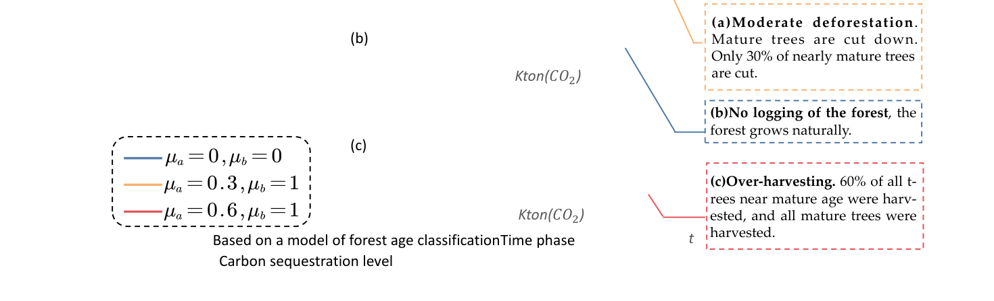
Figue 5: Simulation of harvesting strategies under three values of
图 5：三种……取值下采伐策略的模拟
图中文字对照（英文 → 中文）
s.t. | 约束条件（subject to）
— 原文第 11 页 —
Note: Simulations were performed with 100 𝑘𝑚²of forest in its natural state. t indicates the number of tree age stages experienced.
注：模拟在 100 𝑘𝑚² 处于自然状态的森林中进行。t 表示所经历的树龄阶段数。
The analysis of the figure shows that. First, at the beginning of the system, any degree of deforestation will lead to a small decrease in the amount of carbon sequestered by the system, and then the amount of carbon sequestered will be increased in a short period of time. Second, when the system reaches equilibrium: (a) moderate harvesting of forest land helps to increase the total carbon sequestration; (b) no harvesting of forest will not change the carbon sequestration of forest; (c) excessive harvesting of forest land will lead to a decrease in the total carbon sequestration.
由图分析可知，首先，在系统初期，任何程度的采伐都会导致系统固碳量小幅下降，随后固碳量在短时间内回升。其次，当系统达到平衡时：（a）对林地进行适度采伐有助于提高总固碳量；（b）不对森林进行采伐不会改变森林的固碳量；（c）对林地进行过度采伐会导致总固碳量下降。
Based on the above analysis, the system was simulated separately for different 𝜇_{𝑎} to calculate the carbon sequestration level under each C tree felling rate, and the final results are shown in Fig 6.
基于上述分析，对不同的 𝜇_{𝑎} 分别进行系统模拟，以计算各 C 类树采伐率下的固碳水平，最终结果如图 6 所示。
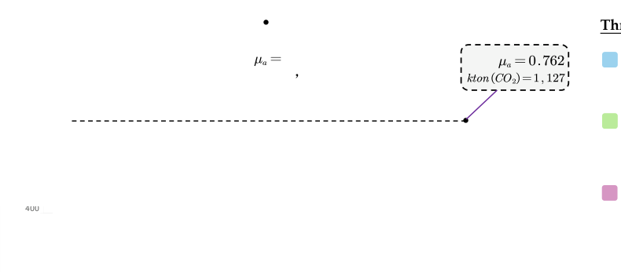
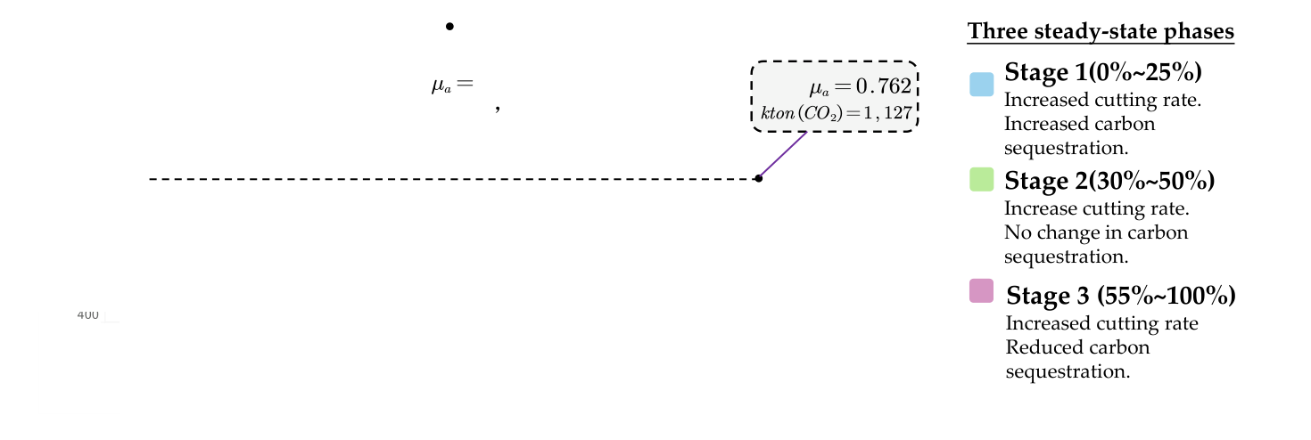
Figue 6: Carbon sequestration levels of forest trees under differentvalues
图 6：不同……取值下林木的固碳水平
图中文字对照（英文 → 中文）
μ_a = 0.762 kton(CO₂)=1,127 | 参数 μa = 0.762，对应固碳量 1,127 千吨 CO₂
From the above figure, it can be seen that the optimal level of carbon sequestration is reached when the felling rate is about 37.48% for trees of category C age.
由上图可知，当 C 类树龄的树木采伐率约为 37.48% 时，固碳水平达到最优。
5 Forest System Value Balance Model
5 森林系统价值平衡模型
TEV model proposed by American economist and environmentalist A Freeman in 2022. We use the idea of TEV model to measure the multiple benefits of forest ecosystem through multi-objective planning (MOP), and use Python to simulate differential equations, SA optimization algorithm and game theory to solve the model, so as to get Pareto solution, which is the better strategy after measuring the interests of all parties.
TEV 模型由美国经济学家与环境学家 A Freeman 于 2022 年提出。我们借鉴 TEV 模型的思想，通过多目标规划（MOP）衡量森林生态系统的多重效益，并运用 Python 对微分方程、SA 优化算法与博弈论进行模拟求解，从而得到 Pareto 解，即在权衡各方利益之后的较优策略。
5.1 TEV: Multiple Value Systems Within and Outside the Forest System
5.1 TEV：森林系统内外的多重价值体系
Total forest ecosystem values can be roughly divided into six categories: output values (EF), carbon tax transfer (MF), tourism values (LF), ecological values (GEP), biomass values (CF), and other values (OF). Among them, the ecological value has a more complete accounting system and values in the academic community, so we will not repeat them here.
森林生态系统总价值大致可分为六类：产出价值（EF）、碳税转移（MF）、旅游价值（LF）、生态价值（GEP）、生物量（Biomass）价值（CF）及其他价值（OF）。其中，生态价值在学术界已有较为完整的核算体系与取值，此处不再赘述。
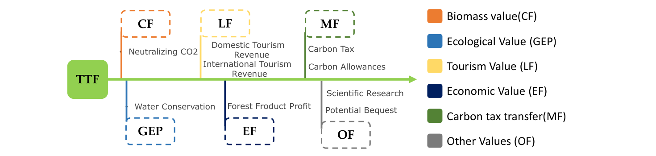
— 原文第 12 页 —
Figue 7: The value composition system of TTF
图 7：TTF 的价值构成体系
5.1.1 Output Value (EF)
5.1.1 产出价值（EF）
We confine the output value of forest trees to the market purchase and sale of forest products, and take up the previous section on the harvesting of forest resources to establish the following set of equations:
我们将林木的产出价值限定为林产品的市场买卖，并承接上一节关于森林资源采伐的内容，建立如下方程组：
Consider the fluctuation of timber prices with time and market conditions. where 𝑃_{𝑡}is the average of the market purchase and sale prices of timber in period 𝑡. Based on the actual situation in felling, we constrain the equation as follows:
考虑木材价格随时间与市场行情波动，其中 𝑃_{𝑡} 为第 𝑡 期木材市场买卖价格的平均值。结合采伐的实际情况，我们对公式作如下约束：
The World Bank gives value transfers to areas that maintain forest ecology to absorb carbon.. The following is how the carbon tax value is calculated:
世界银行向维护森林生态以吸收碳的区域提供价值转移。碳税价值的计算方式如下：
In the first step, the carbon dioxide uptake capacity of the forest system is analyzed. The carbon dioxide uptake per unit time t is given by the equation :
第一步，分析森林系统的二氧化碳吸收能力。单位时间 t 内的二氧化碳吸收量由下式给出：
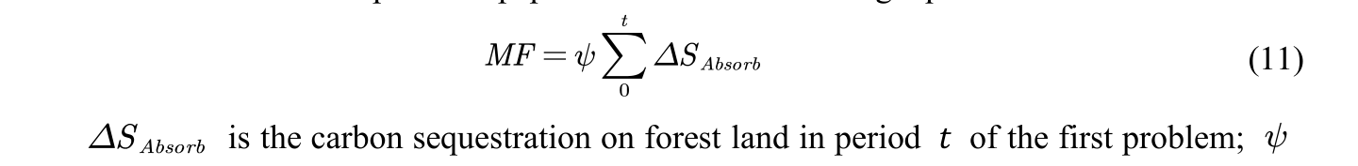
=51.2$/ton (CO₂), and checking the recent news in 2022, we know that the CO₂ price in the U.S. carbon trading market is about 50$/ton, which means the calculation is verified.
=51.2 美元/吨（CO₂），查阅 2022 年的近期新闻可知，美国碳交易市场的 CO₂ 价格约为 50 美元/吨，说明该计算得到验证。
— 原文第 13 页 —
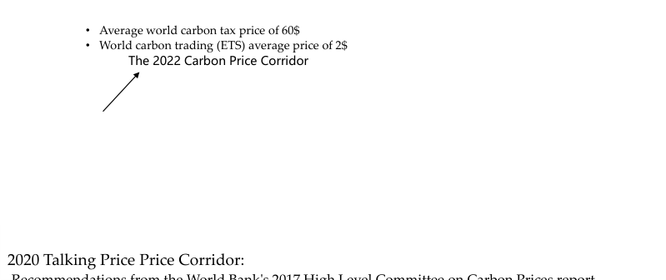
Recommendations from the World Bank's 2017 High Level Committee on Carbon Prices report.
世界银行 2017 年碳价格高级别委员会报告的建议。
Figue 8: Carbon price trends by country
图 8：各国碳价格走势
图中文字对照（英文 → 中文）
Average world carbon tax price of 60$ | 全球平均碳税价格 60 美元 | World carbon trading (ETS) average price of 2$ | 全球碳交易（ETS）平均价格 2 美元
The 2022 Carbon Price Corridor | 2022 年碳价走廊 | 2020 Talking Price Corridor: | 2020 年碳价走廊（讨论建议）：
Recommendations from the World Bank's 2017 High Level Committee on Carbon Prices report | 世界银行 2017 年碳价高级别委员会报告的建议
5.1.3 Biomass Value Equation (CF)
5.1.3 生物量价值方程（CF）
For the establishment of the biomass value equation, we mainly examine the aggregation of the biomass value of the forest ecology itself. We borrowed the TEV model and set up the following equation for forest ecology as follows.
在建立生物量价值方程时，我们主要考察森林生态自身生物量价值的汇总。我们借鉴 TEV 模型，为森林生态建立如下方程。
In the equation, BEF is the conversion factor of stand biomass to wood volume, and the reference value of IPCC biomass expansion factor (BEF) is shown below.
式中，BEF 为林分生物量与木材材积的转换系数，IPCC 生物量扩展因子（BEF）的参考取值如下所示。
Table 3: BEF value range of different forest species
表 3：不同森林树种的 BEF 取值范围
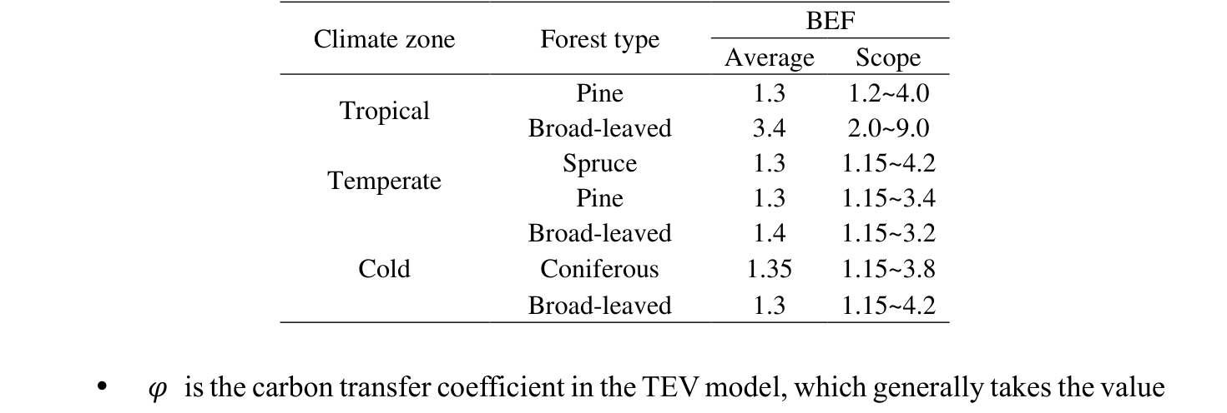
𝜑 is the carbon transfer coefficient in the TEV model, which generally takes the value of 0.5.
𝜑 为 TEV 模型中的碳转移系数，通常取值为 0.5。
•
𝑆_{𝑡} is the area of the stand at period t, while C is the stand density at period t.
𝑆_{𝑡} 为第 t 期林分面积，C 为第 t 期林分密度。
•
5.1.4 Tourism Value (LF)
5.1.4 旅游价值（LF）
Tourism values are mostly divided into human and natural values, and forests are mainly dominated by natural values. The indicators for measuring tourism value vary from place to place, and here the indicators in the literature by Nino Fonseca et al. are used and extended to link tourism value with related factors to construct the following equation.
旅游价值大多划分为人文价值与自然价值，而森林以自然价值为主。衡量旅游价值的指标因地区而异，此处采用 Nino Fonseca 等人的文献中的指标，并将其扩展至将旅游价值与相关因素联系起来，构建如下方程。
— 原文第 14 页 —
5.1.5 Other Values (OF)
5.1.5 其他价值（OF）
The natural conditions of forest formation, the composition of forest tree species, and biological resources are all of scientific value. For this, we measure the ecological diversity value of the forest in terms of the distribution of different age classes, taking into account the correlation between the values, and set the following formula.
森林形成的自然条件、林木树种组成以及生物资源均具有科学价值。为此，我们以不同龄级的分布衡量森林的生态多样性价值，并考虑各价值之间的相关性，设定如下公式。
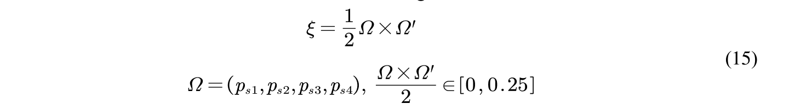
Then the other values are:
则其他价值为：
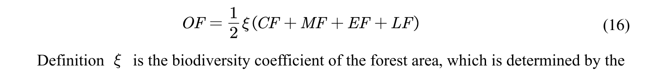
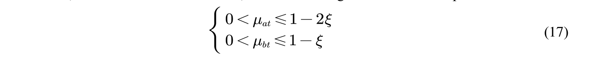
5.2 Value Balance Planning Model
5.2 价值平衡规划模型
Based on the above analysis, a function of the total value of the forest TTF is constructed:
基于上述分析，构建森林总价值 TTF 的函数：
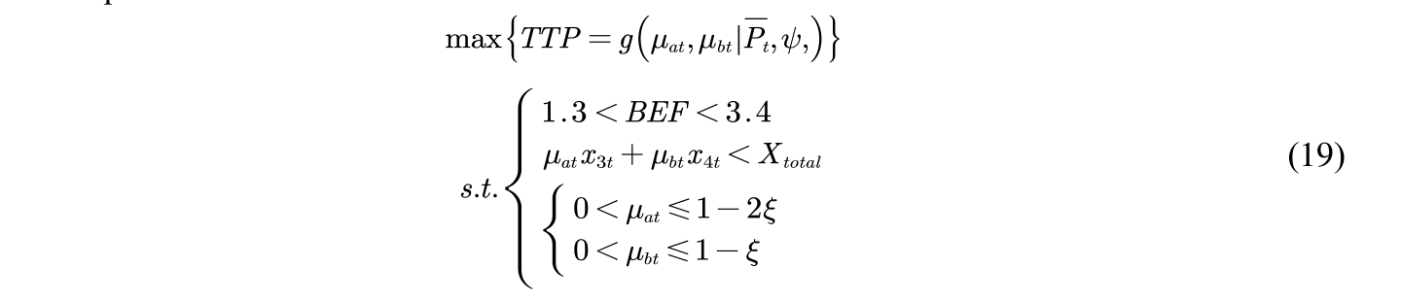
— 原文第 15 页 —
5.3 SA : Solution of Multivariate Objective Programming
5.3 SA：多目标规划的求解
The simulated annealing algorithm benefits from the results of research in statistical mechanics of materials and has been applied to find the global optimal solution to the NP-hard combinatorial optimization problem The algorithmic procedure is described as follows.i.
模拟退火算法得益于材料统计力学的研究成果，已被用于求取 NP-hard 组合优化问题的全局最优解。算法流程描述如下。i.
Solution space. The solution spacecan be represented as the set of all cyclic arrangements of starting and target points of {1,2...n}, i.e:
解空间。解空间可表示为 {1,2…n} 的起点与目标点的全部循环排列所构成的集合，即：
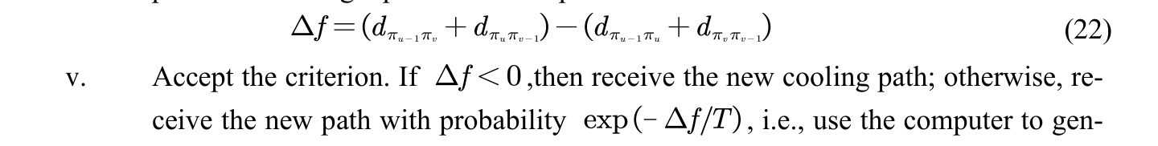
Cooling. The cooling is performed using the selected cooling factor α. The de-novo temperature T is αT (here T is the temperature of the previous iteration), and here α = 0.85 is selected.vii.
降温。采用选定的降温因子 α 进行降温。新温度 T 为 αT（此处 T 为上一次迭代的温度），此处取 α = 0.85。vii.
Ending conditions. Use the selected growing temperature e=10-30,to determine whether the annealing process is finished. If T<e, the algorithm ends and the current state is output.
终止条件。以选定的增长温度 e=10-30 判断退火过程是否结束。若 T<e，算法结束并输出当前状态。
The model was solved by taking larch plantation in northern China as an example, and taking the unit time 𝑡 as 10~15 years. The TTF value was calculated as 27283~40924.5$/km²/year.
以中国北方落叶松人工林为例对模型进行求解，取单位时间 𝑡 为 10~15 年。计算得 TTF 值为 27283~40924.5$/km²/year。
6 Forest Management Strategy Model
6 森林管理策略模型
This forest value balance model solves the problem of the optimal value balance point.
该森林价值平衡模型解决了最优价值平衡点的问题。
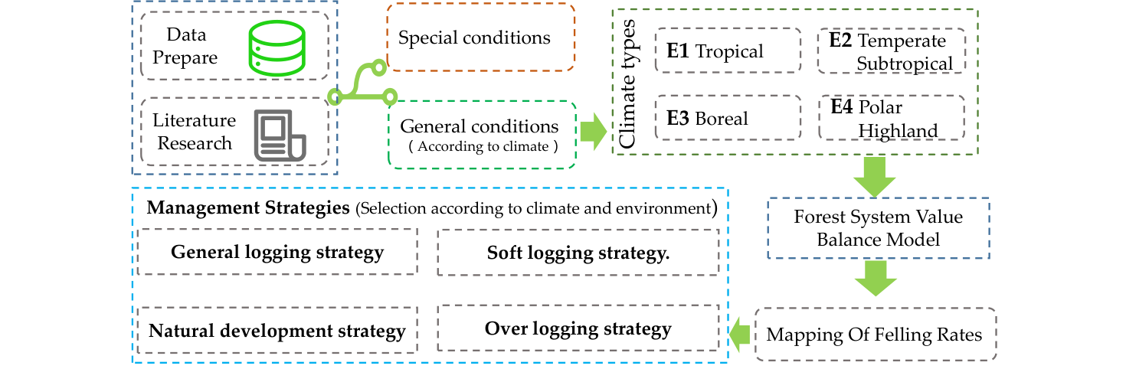
Figue 9: Forest management strategy model
图 9：森林管理策略模型
— 原文第 16 页 —
In order to achieve forest value balance, forest management strategies need to be analyzed. The managed deforestation of the forest is obtained by constructing a carbon sink mapping function. Meanwhile, experiments with different logging strategies are conducted for different forest environments in different regions to analyze the transition point of forest management strategy transformation. The specific process is as follows.
为实现森林价值平衡，需要对森林管理策略进行分析。通过构建碳汇映射函数，得到森林的受管理采伐。同时，针对不同区域的不同森林环境开展不同采伐策略的实验，以分析森林管理策略转变的转折点。具体过程如下。
6.1 Mapping Model of Felling Rate
6.1 采伐率映射模型
The value of carbon tax transfer (ME) solved by using the value equilibrium point is derived by inverse derivation of the tree felling rate 𝜇_{𝑎}for tree age class C. Considering the availability of the model and the realistic situation, the CF,EF,LF,OF of the forest system will not produce large changes in the short term, so the values of the general case calculated above can be maintained.
利用价值平衡点求解得到的碳税转移价值（ME），经反演推导得到树龄阶段 C 的采伐率 𝜇_{𝑎}。考虑模型的可得性与现实情况，森林系统的 CF、EF、LF、OF 在短期内不会发生较大变化，因此可保持上述计算所得的一般情形取值。
Then based on the above planning model the following functions can be set:
于是基于上述规划模型可设定如下函数：
TTF₀ is the equilibrium point of maximum value of forest use solved based on the above linear programming. This function reflects the CO₂ uptake per unit time t (one tree age stage, about 10-15 years) for the specified carbon trading priceunder the forest maximum value condition. Considering that the above planning is based on the simulation of a 100km² forest therefore dividing by 100,is the mass of CO₂ that can be absorbed per square kilometer of forest at each time stage 𝑡 at the time of deforestation.
TTF₀ 为基于上述线性规划求解得到的森林利用最大值的平衡点。该函数反映在森林价值最大化条件下、给定碳交易价格时，单位时间 t（一个树龄阶段，约 10-15 年）的 CO₂ 吸收量。考虑到上述规划基于 100km² 森林的模拟，因此除以 100 即为采伐时每个时间阶段 𝑡 每平方千米森林所能吸收的 CO₂ 质量。
6.2 Management Strategies and Climate Types
6.2 管理策略与气候类型
In order to analyze the effectiveness of various management strategies on forest ecology in different climates. We should analyze the wood output that the forest can carry when the system reaches steady state. Because, the analysis ofis also valid.
为分析各类管理策略在不同气候条件下对森林生态的有效性。我们应分析系统达到稳态时森林所能承载的木材产量。因为，对……的分析同样成立。
6.2.1 General Forest Management Strategy
6.2.1 一般森林管理策略
Using the felling rate mapping model constructed above, we designed four management strategies :(a) general felling strategy,(b) gentle felling strategy,(c) natural development strategy, and (d) excessive felling strategy. The four strategies were applied to four categories of ecological climate :(E1) tropical climate; (E2) Subtropical climate and temperate climate; (E3) Cold zone climate; (E4) Polar climate; Plateau and alpine climate.
利用上述构建的采伐率映射模型，我们设计了四种管理策略：(a) 一般采伐策略，(b) 轻度采伐策略，(c) 自然发展策略，(d) 过度采伐策略。将四种策略应用于四类生态气候：(E1) 热带气候；(E2) 亚热带气候与温带气候；(E3) 寒带气候；(E4) 极地气候；高原与高山气候。
Based on the forest ecological model in the forest whole-process carbon sequestration model (Model 1), the growth rates of trees living in various climates were divided into sections. The range divided by the red dotted line in Fig. 10 can be obtained. We calculateat different growth rates of class C and D aged trees by step of 0.1. Based on Sufer, Natural Neighbor interpolation was used to grid the data, and the results are shown in the figure.
基于森林全过程固碳模型（模型 1）中的森林生态模型，对生长于各类气候下的树木生长速率进行了分段。可得到图 10 中红色虚线所划分的范围。我们按 0.1 的步长计算了 C 类和 D 类树龄树木在不同生长率下的情况。基于 Sufer，采用自然邻点插值法对数据进行网格化处理，结果如图所示。
The wood output that can be carried by forests largely reflects the health of forest systems. The variablerelated to the load-bearing use of wood in each environment was studied. Based on relevant research Settings:
森林可承载的木材产出在很大程度上反映了森林系统的健康状况。研究了各环境中与木材承载利用相关的变量。基于相关研究的设定：
•
In stage
在阶段
>500, it indicates that ecological wood output is normal and has no impact on forest ecology, so there is no need to reduce logging rate.
>500 时，表明生态木材产出正常，不产生影响对森林生态，因此无需降低采伐率。
— 原文第 17 页 —
•
In stage 500>
在阶段 500>
>100, the output of ecological wood is poor, which has a certain negative impact on forest ecology, and the logging rate should be reduced moderately. •
>100 时，生态木材产出较差，对森林生态有一定负面影响，应适度降低采伐率。
In stage 100>
在阶段 100>
>0, the output of ecological wood is extremely poor, and forest management strategy has a strong negative impact on the ecosystem, so logging should be stopped in time.
>0 时，生态木材产出极差，森林管理策略对生态系统有很强的负面影响，因此应及时停止采伐。
E2
E1
E3
E2
E1
E3 (a) General logging strategy (b) Soft logging strategy.
E3(a) 常规采伐策略(b) 轻度采伐策略。
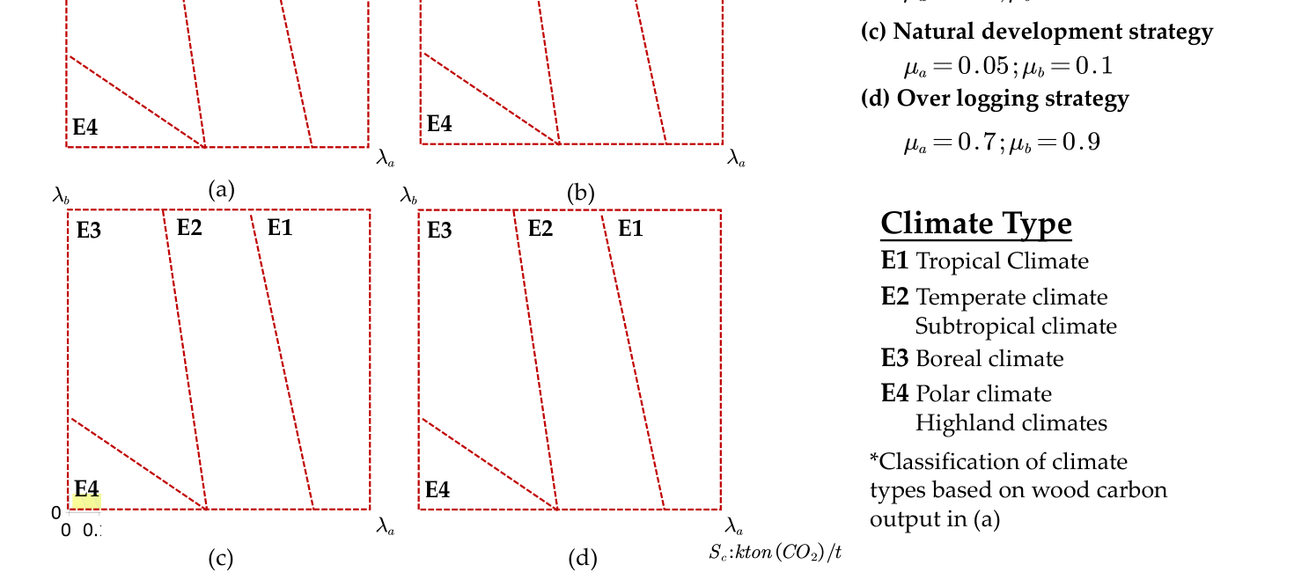
Figue 10: Simulation of different strategies under different environmental conditions Analyze the above figure and summarize the following management strategies for various types of forests:
图 10：不同环境条件下不同策略的模拟 分析上图并总结针对各类森林的以下管理策略：
(a) General logging strategies. Under this forest management strategy, the output of wood that can be carried by the forest in E1 climate is normal. Part of E2 needs to adjust the strategy to reduce the felling rate. E3 and E4 cannot adapt to this logging strategy. (b) Soft logging strategies. Under this forest management strategy, the output of wood that can be carried by the forest in E1 and E2 climate is normal. Part of E3 requires a strategy adjustment to reduce the rate of logging. E4 cannot adapt to this logging strategy.
(a) 常规采伐策略。在该森林管理策略下，E1 气候中森林可承载的木材产出正常。E2 的部分情况需要调整策略以降低采伐率。E3 与 E4 无法适应这种采伐策略。(b) 轻度采伐策略。在该森林管理策略下，E1 与 E2 气候中森林可承载的木材产出正常。E3 的部分情况需要调整策略以降低采伐率。E4 无法适应这种采伐策略。
(c) Natural development strategies. The forest is not deliberately felled, and the output of wood that can be carried by the forest is normal in E1,E2 and E3 climate under this strategy. E4 some conditions need policy adjustment, and some conditions cannot adapt to the logging strategy.
(c) 自然发展策略。不进行人为采伐，在该策略下 E1、E2 与 E3 气候中森林可承载的木材产出正常。E4 的部分条件需要调整政策，部分条件无法适应这种采伐策略。
(d) Excessive logging strategies. Under this logging strategy, only the timber output in part of E1 was normal. E2,E3 and E4 could not adapt to this logging strategy.
(d) 过度采伐策略。在该采伐策略下，仅 E1 的部分情况木材产出正常。E2、E3 与 E4 无法适应这种采伐策略。
— 原文第 18 页 —
The analysis shows that for tropical, subtropical, and boreal climates, there are appropriate forest harvest management strategies, and harvesting strategies can be selected accordingly. However, for polar climates, any logging strategy would exceed the carrying capacity of ecological wood. The ecology can only partially adapt to natural development strategies (c), and therefore deforestation should not occur in these areas.
分析表明，对于热带、亚热带与寒带气候，存在适宜的森林采伐管理策略，可据此选择采伐策略。然而，对于极地气候，任何采伐策略都会超出生态木材的承载力。生态仅能部分适应自然发展策略 (c)，因此这些区域不应进行毁林。
6.2.2 Forest Management Strategies In Special Situations
6.2.2 特殊情况下的森林管理策略
Some forest areas bear important ecological conservation tasks, and the governments of the countries concerned also regard the conservation of forest areas as the primary goal of forest area development, such as Ratanakiri Forest Reserve in Cambodia, Parsar Forest Reserve in Myanmar, and Jiufeng Forest Reserve in China, etc. Such areas rest and conservation The policy of rest and conservation is the mainstream of such forests. At this time , so the existence of this situation makes the forest almost not deforested.
部分林区承担着重要的生态保护任务，相关国家政府也将林区保护视为林区发展的首要目标，如柬埔寨腊塔纳基里森林保护区、缅甸 Parsar 森林保护区以及中国九峰森林保护区等。此类区域以休养与保护为主，休养与保护政策是这类森林的主流。此时，因此这种情况的存在使得森林几乎不被采伐。
6.3 Example of Subtropical Forest Management and Decision Making
6.3 亚热带森林管理与决策示例
Using the above mapping model and management strategies, a subtropical forest in southern China is used as an example to find the forest management strategy under optimal value. The effective value interval under timber price change is also estimated while constructing the effective value interval.
运用上述映射模型与管理策略，以中国南方的一片亚热带森林为例，求出最优价值下的森林管理策略。在构建有效价值区间的同时，也估算了木材价格变动下的有效价值区间。
It was found that a 20% reduction in logging of mature trees (D trees) could shift the effective value range to the left due to the increase in forest ecological diversity, but a greater reduction in logging of mature trees would lead to an ineffective value range. This suggests that the effect of ecosystem diversity on the effective range of values is limited, and that the effective range for logging D trees is.
研究发现，将成熟树木（D 类树）的采伐量减少 20%，可使有效价值区间因森林生态多样性提高而左移，但成熟树木采伐量减少更多则会导致价值区间失效。这表明生态系统多样性对有效价值区间的影响是有限的，而对 D 类树进行采伐的有效区间为。
Under the condition of, the effective interval of value is plotted when the felling rate of fully mature trees is 80%. In the current world carbon trading price fluctuation market: as the carbon trading price increases, the felling rate for C-aged trees also gets decreased, with the minimum felling rate being 41.5% for C-aged trees and the maximum felling rate being 83%. As shown in the blue area of the figure.
在该条件下，绘制了完全成熟树木采伐率为 80% 时的价值有效区间。在当前世界碳交易价格波动市场中：随着碳交易价格上升，C 龄级树木的采伐率也随之下降，C 龄级树木的最低采伐率为 41.5%，最高采伐率为 83%。如图所示蓝色区域。
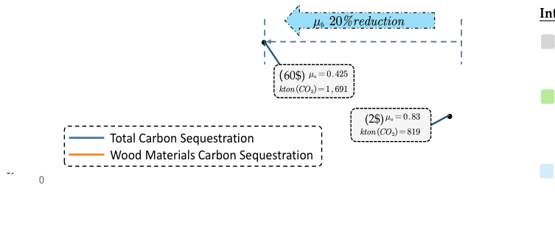
Value inefficient (0%~25%; 83%~100%)
价值无效(0%~25%; 83%~100%)
No viable forest value management （60$)strategy at this stage.
此阶段无可行的森林价值管理（60$）策略。
Carbon sequestrationeffective(25%~50%)
固碳有效 (25%~50%)
Total steady-state carbon
稳态总碳
Total Carbon Sequestrationsequestration in the system reachesits maximum at this stage.
系统总固碳量在此阶段达到最大。
Value effective (42%~83%) 2$~60$
价值有效(42%~83%) 2$~60$
Depending on the carbon tax price, it is possible to achieve value efficient.
视碳税价格而定，有可能实现价值有效。
Figue 11: Scope of management strategy under value balance
图 11：价值平衡下管理策略的范围
图中文字对照（英文 → 中文）
Total Carbon Sequestration | 总固碳量 | Wood Materials Carbon Sequestration | 木质材料固碳量
μ_a 20%reduction | μa 下降 20% | (60$) | （60 美元情景）
(2$) | （2 美元情景）
Considering carbon sequestration, the proposed plan for this forest is to log only 80% of the mature trees (category D) in each time period t (10-15 years) and retain 20% to maintain the range of 41.5% to 55% according to the carbon trading price, which is a value effective and carbon sequestration enhancement.
考虑固碳，对该森林提出的方案是：在每个时间周期 t（10-15 年）仅采伐 80% 的成熟树木（D 类），保留 20% 以维持根据碳交易价格处于 41.5% 至 55% 的范围内，即价值有效且固碳增强。
— 原文第 19 页 —
It is calculated that every 100𝑘𝑚² of forest in 100 years can absorb 442.2~820.8 kilotons of carbon dioxide from the natural state and implement relevant management strategies. The net increase of carbon retention in the system is 68~88 kilotons.
经计算，每 100𝑘𝑚² 森林在 100 年内，从自然状态到实施相关管理策略，可吸收 442.2~820.8 千吨二氧化碳。系统碳留存的净增加量为 68~88 千吨。
7 Demand-sensitive Management Strategy Game
7 需求敏感的森林管理策略博弈
Ignoring the influence of extreme cases such as policies, for a general forest area, it bal-ances ecological, economic and social benefits. Inspired by game theory in sociology and eco-nomics, we divide the managers of forest land and local residents into two game subjects. For non-extreme climate forests, we analyze the impact of the change in management strategy on both.
忽略政策等极端情况的影响，对于一般林区而言，它平衡生态、经济与社会效益。受社会学与经济学中博弈论的启发，我们将林地管理者与当地居民划分为两个博弈主体。对于非极端气候森林，我们分析管理策略变化对双方的影响。
7.1 The Game of Forest Management Strategies
7.1 森林管理策略的博弈
The following is the payment matrix for both based on multiple objective planning.
以下是基于多目标规划的双方支付矩阵。
Table 4: Payment matrix between forest managers and local residents
表 4：森林管理者与当地居民之间的支付矩阵
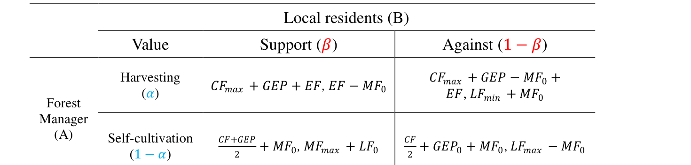
In the matrix, if the forest manager chooses intermittent logging, he can get a maximum carbon value gain and also economic gain regardless of whether the local residents support it or not, the difference is that the government is influenced by public opinion and it is difficult to give the interest of carbon tax transfer to the forest manager normally; while the forest man-ager chooses restoration and conservation, he does not get the full carbon due to the represen-tation in the gain curve proved above The forest manager who chooses conservation does not get the full carbon value and ecological value, but will definitely get a certain amount of carbon tax compensation. Therefore, for the forest manager, the expectation function is:
在收益矩阵中，若森林经营者选择间歇性采伐，则无论当地居民是否支持，他都能获得最大的碳价值收益，同时也能获得经济收益；区别在于，政府受舆论影响，难以将碳税转移收益正常给予森林经营者；而当森林经营者选择恢复与保护时，由于上文已证明的收益曲线中的表征，他无法获得完整的碳价值，选择保护策略的森林经营者无法获得完整的碳价值与生态价值，但一定会得到一定数量的碳税补偿。因此，对于森林经营者而言，其期望函数为：
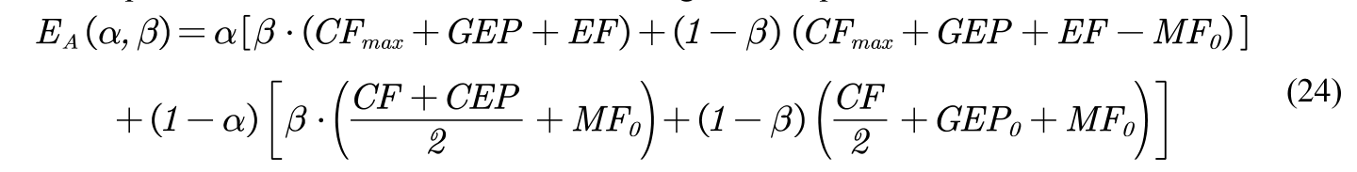
If the residents choose to support any of the actions of the forest, the economic compensa-tion will be different depending on the strategy of the forest; if the residents choose to defend their interests and not to support the forest, the strategy of the forest will have a different impact on the residents, which is expressed in the fluctuation of the tourism income and the carbon tax transfer will be given to the forest or the residents, depending on the situation. Therefore, for the local residents, the expectation function is:
若居民选择支持森林的任何一项行动，则经济补偿会因森林所采取的策略不同而不同；若居民选择维护自身利益而不支持森林，则森林的策略也会对居民产生不同影响，具体表现为旅游收入的波动，而碳税转移收益是给予森林还是给予居民，则视情况而定。因此，对于当地居民而言，其期望函数为：
— 原文第 20 页 —
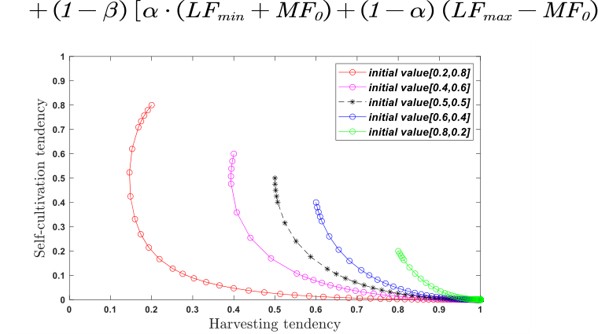
Figure 12: Evolutionary game of policy preference
图 12：政策偏好的演化博弈
图中文字对照（英文 → 中文）
Self-cultivation tendency | 自我培育倾向 | Harvesting tendency | 采伐倾向
initial value | 初始值（图例给出各策略初始组合，如 [0.2,0.8]）
The MATLAB program was used to perform a dynamic evolutionary game between the two subjects to obtain the results of the final deforestation strategy adopted when using the strategy designed above, under the pressure of support or non-support of the population. It can be found that forest management subjects with the strongest restoration policy tendencies (1 α = 0.8) and when restoration and deforestation strategies are insensitive (at α = 0.5) also even-tually tend to adopt the optimized deforestation strategy gradually in the course of the game.
采用 MATLAB 程序对两个主体进行动态演化博弈，以得到在上述所设计策略下、在民众支持或不支持的压力下最终所采用的采伐策略结果。可以发现，恢复政策倾向最强的森林经营主体（α = 0.8），以及在恢复与采伐策略不敏感时（α = 0.5），在博弈过程中也最终逐渐倾向于采用优化后的采伐策略。
7.2 Evolutionary game simulation for managing plan transitions
7.2 管理方案转型的演化博弈仿真
It has been demonstrated above that for non-extreme climate forests, there is no strategy for forest managers to choose not to cut the forest in general. Strategy 1 is the utility of the original management policy (excessive deforestation tendency) and Strategy 2 is the optimized forest management policy: moderate deforestation tendency, i.e., by extending the deforesta
上文已证明，对于非极端气候下的森林，一般不存在森林经营者选择完全不采伐森林的策略。策略 1 为原管理政策（过度采伐倾向）的效用，策略 2 为优化后的森林管理政策：适度采伐倾向，即通过延长采伐
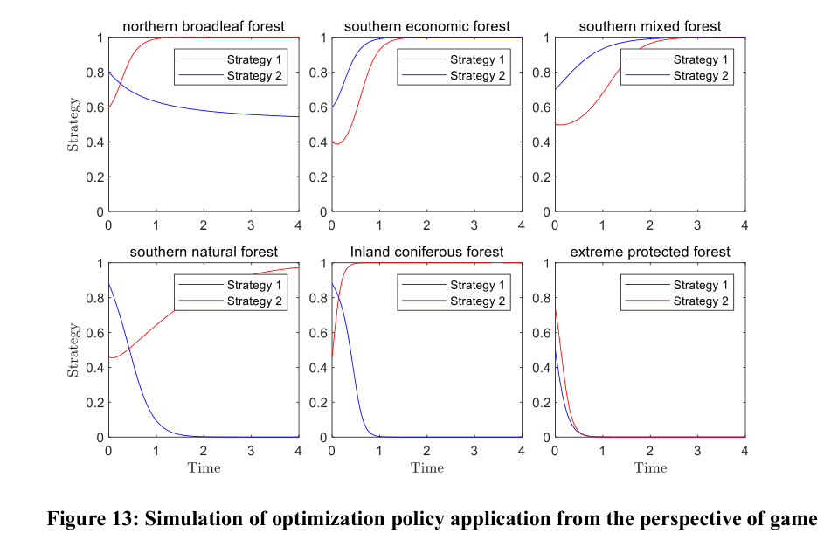
Figure 13: Simulation of optimization policy application from the perspective of game
图 13：基于博弈视角的优化策略应用仿真
— 原文第 21 页 —
tion cycle t (10 years longer recovery than the original cycle), the forest is allowed to grow for a longer period of time. In order to analyze the value game situation of the two management strategies in the transition process. In the following, we will continue to simulate the application of the management policies using the evolutionary game approach. In the simulation process the management policy utility is simulated with the original management utility of the six major forest species over time to observe the process and results of the game, as shown in the following figure.
周期 t（比原周期延长 10 年恢复期），使森林能够生长更长的时间。为分析两种管理策略在转型过程中的价值博弈情况。下面我们将继续采用演化博弈方法对管理政策的应用进行仿真。在仿真过程中，以六大森林类型的原始管理效用随时间的变化来模拟管理政策效用，以观察博弈的过程与结果，如下图所示。
In all simulated scenarios, the new optimized policy has an intersection with the original policy after application and gradually reaches the maximum benefit afterwards; while even the extreme protection case has an intersection with the original policy in the process of benefit decline. Therefore, the new forest management policies constructed above are substitutes for different types of old policies within a certain period.
在所有仿真情景中，新的优化政策在应用后均与原政策存在交点，并在其后逐渐达到最大收益；即使是极端保护情形，也在收益下降过程中与原政策存在交点。因此，上文所构建的新的森林管理政策在一定时期内是不同类型旧政策的替代方案。
8 Sensitivity Analysis
8 灵敏度分析
Since many adjustments have been made to the forest ecological and economic management model by changing the coefficients above, and different types of simulations have been carried out according to the actual situation, the range of sensitivity to changes in controllable system parameters or surrounding conditions has been obtained. better output results. Therefore, we will not continue to observe the changes of the model results repeatedly here.
由于上文已通过改变系数对森林生态与经济管理模型作了多方面调整，并根据实际情况开展了不同类型的仿真，已获得对可控系统参数或周边条件变化的灵敏度范围，从而得到更优的输出结果。因此，此处不再重复观察模型结果的变化。
9 Model Evaluation and Further Discussion
9 模型评价与进一步讨论
9.1 Strengths
9.1 优点
•
The model incorporates economic, ecological and social factors, and examines the sustainable development of forest resources from different subjects, positions and perspectives, responding to the goal of "carbon peaking and carbon neutrality". •
该模型综合了经济、生态与社会因素，从不同主体、立场与视角考察森林资源的可持续发展，回应了“碳达峰与碳中和”目标。
The model considers not only the general adaptive case but also the consequences of using the policy in extreme cases, and gives corresponding guidance with high practical value of the model.
该模型不仅考虑了一般适应性情形，还考虑了极端情形下采用该政策的后果，并给出相应指导，具有较高的实际应用价值。
•
Reasonable and easy-to-practice evaluation of importance level instructs the reconnaissance effectively.
对重要性水平进行合理且易于实践的评估，可有效指导勘察工作。
9.2 Weaknesses
9.2 缺点
The overall framework of the model is relatively large, spanning many fields such as economics, operations research, biology, and geography, and the relationships among the submodels are complex, which is not conducive to linkage analysis and improvement.
模型总体框架较为庞大，跨越经济学、运筹学、生物学与地理学等多个领域，各子模型之间关系复杂，不利于联动分析与改进。
9.3 Further Discussion
9.3 进一步讨论
At the international level, we hope to achieve a win-win situation for both ecological and economic values of forest ecosystems through international cooperation rather than single forest management.
在国际层面，我们希望通过国际合作而非单一的森林经营，实现森林生态系统生态价值与经济价值的双赢。
10 Conclusion
10 结论
1) Single-minded environmentalism can sometimes hinder the sustainability of forest resources, and sound management policies can achieve enhanced forest carbon sequestration and benefits, tapping into the potential value of forest systems.
1）单一的环境保护主义有时会阻碍森林资源的可持续性，而健全的管理政策能够实现森林固碳与效益的提升，挖掘森林系统的潜在价值。
— 原文第 22 页 —
2) For different regions and ecologies, it is necessary to find their adapted forest management strategies to better protect and develop the forests.
2）对于不同区域与生态条件，需要找到与之相适应的森林管理策略，以更好地保护与开发森林。
3) A moderate rate of logging and policy preference can guide the application of different types of forest management strategies so as to balance economic, ecological and social benefits, and to ensure sufficient ecological value while making the best use of things to achieve the highest social and economic value.
3）适度的采伐率与政策偏好可以引导不同类型森林管理策略的应用，从而平衡经济效益、生态效益与社会效益，在充分利用资源的同时确保足够的生态价值，以实现最高的社会与经济价值。
Finally, we hope that local forest managers can take a longer-term view of forest values, improve operation and management methods, strengthen cooperation and communication with other entities, and learn from advanced management experiences to make forests play a better role in carbon sequestration and truly achieve sustainable development.
最后，我们希望当地森林经营者能够以更长远的眼光看待森林价值，改进经营管理方式，加强与其他主体的合作与交流，并借鉴先进的管理经验，使森林在固碳方面发挥更好的作用，真正实现可持续发展。
References
参考文献
CHENG Susu, YI Yongxi, LI Shoude. A differential game of transboundary pollution for carbon capture and storage [J]. [1]
Journal of Systems & Management,2019,28(05):864-872.
ZHANG Shuwei, LIU Deshun. Status and development of carbon sequestration technology [J]. Environmental Science [2]
Trends,2005(04):27-29.
WANG Wei-feng, DUAN Yu-xi, ZHANG Li-xing, WANG Bo, LI Xiao-jing. Effects of different rotations on carbon [3]sequestration in Chinese fir plantations [J]. Chinese Journal of Plant Ecology,2016,40(07):669-678.
WANG Wei-feng, DUAN Yu-xi, ZHANG Li-xing, WANG Bo, LI Xiao-jing. Review on Forest carbon sequestration [4]counting methodology under global Climate change [J]. Journal of Nanjing Forestry University (Natural Sciences Edition),2016,40(03):170-176.
[5]
Pan, Yude, et al. "A large and persistent carbon sink in the world’s forests." science 333.6045 (2011): 988-993.
[6]
Boyd, Philip W., et al. "Multi-faceted particle pumps drive carbon sequestration in the ocean." Nature 568.7752 (2019): 327-335.
[7]
Ontl, Todd A., et al. "Forest management for carbon sequestration and climate adaptation." Journal of Forestry 118.1 (2020): 86-101.
[8]
Noormets, Asko, et al. "Effects of forest management on productivity and carbon sequestration: A review and hypothesis." Forest Ecology and Management 355 (2015): 124-140.
[9]
Mayer, Mathias, et al. "Tamm Review: Influence of forest management activities on soil organic carbon stocks: A knowledge synthesis." Forest Ecology and Management 466 (2020): 118127.
[10] Kurz, Werner A., et al. "Carbon in Canada’s boreal forest—a synthesis." Environmental Reviews 21.4 (2013): 260-292. [11] Sahoo, Gyanaranjan, and Afaq Majid Wani. "Forest biotechnology: current trends and future prospects." Int J Curr Microbiol Appl Sci 11 (2020): 74-85.
[12] Pretzsch, Hans, et al. "Changes of forest stand dynamics in Europe. Facts from long-term observational plots and their relevance for forest ecology and management." Forest Ecology and Management 316 (2014): 65-77.
[13] Vogt K A, Gordon J C, Wargo J P, et al. Ecosystems: Balancing Science with Management [M]. New York: Springer, 1997.
11 Forest Carbon Sequestration Science Articles
11 森林固碳科普文章
— 原文第 23 页 —
New discoveries in carbon sequestration
固碳的新发现
Shouldn't Any Trees Be Cut Down? Forest management: moderatetree harvesting helps carbon sequestration.
难道不应该砍任何树吗？森林管理：适度采伐有助于固碳。
Forest Management(2022) MCM/ICM
I. Introductionorests are the largest carbon reservoir in terrestrial ecosy-
一、引言 森林是陆地生态系统中最大的碳库
Fstems and have a very important and unique role in red-ucing the concentration of greenhouse gases in the atmosp-here and mitigating global warming.
系统，在降低大气温室气体浓度、缓解全球变暖方面具有十分重要而独特的作用。扩大森林
Forest Managementcover is an important mitigation measure that is economica
Forest Management 覆盖是一项重要的减缓措施，在经济上
-lly feasible and less costly in the next 30-50 years. Manycountries and international organizations are actively using
可行，且在未来 30—50 年内成本较低。许多国家和国际组织正在积极利用
Shouldn't Any Trees Be Cutforest carbon sinks to combat climate change.
难道不应该砍任何树吗？ 森林碳汇来应对气候变化。
Down? Forest management: We have always believed that the best way to protect andmoderate tree harvestingmanage forests is to "not cut down trees" and so on.helps carbon sequestration.
？ 森林管理：适度采伐有助于固碳。我们一直认为，保护和管理森林的最佳方式就是“不砍树”等等。
However, recent scientific research has found that the best
然而，近期的科学研究发现，最好的
Table of Contentsway to manage forests is to harvest them wisely, and that
目录 经营森林的方式是明智地采伐树木，而且
1 Introductionmoderate use of wood can, in part, increase the amount of
1 引言 适度利用木材能够在一定程度上增加
Full Process Carbon Flow 1 carbon sequestered by the broader forest ecosystem and its
全过程碳流 1 更广泛的森林生态系统所固定的碳量及其
Impact Of Tree Felling Onsubsequent wood flow. This article will help you to
伐树的影响 后续的木材流。本文将帮助您
Carbon Sequestration 2 understand this by looking at the "whole process of wood
固碳 2 通过考察“木材的全过程
Eliminate Subjective Bias 2 movement" and "carbon sequestration systems".
消除主观偏差 2 流动”和“固碳系统”来理解这一点。
Abstract
摘要
II. Full Process Carbon Flow
二、全过程碳流
Reducing CO2 in the atmosphere requires protecting forests and not cuttingg down trees. This is what we usually used to think.
减少大气中的 CO₂ 需要保护森林、不砍伐树木。这是我们以往通常的想法。
However, Shouldn't Any Trees Be Cut Down? is the best way to manage forests to reduce greenhouse gases? The answer is no. By dismantling and analyzing the whole process of wood carbon sequestrateon system, we found that the real situation is that the rational harvesting and utilization of wood is beneficial to the total carbon sequestration of the system.
然而，“难道不应该砍任何树吗？”是减少温室气体、经营森林的最佳方式吗？答案是否定的。通过对木材固碳系统全过程进行拆解与分析，我们发现真实情况是：对木材进行合理采伐与利用，有利于系统的总固碳量。
Fig. 1 Forest Carbon Flow System And Wood Products Carbon Flow System
图 1：森林碳流系统与木质产品碳流系统
图中文字对照（英文 → 中文）
northern broadleaf forest | 北方阔叶林 | southern economic forest | 南方经济林
southern mixed forest | 南方混交林 | southern natural forest | 南方天然林
Inland coniferous forest | 内陆针叶林 | extreme protected forest | 极端保护林
Strategy 1 | 策略 1 | Strategy 2 | 策略 2
Strategy | 策略（纵轴：策略选择比例） | Time | 时间
Figure 13: Simulation of optimization policy application from the perspective of game | 图 13：博弈视角下优化政策应用的仿真
[The diagram describes the process of carbon sequestration circulation in wood.]
［该图描述了木材中固碳循环的过程。］
Page1
第 1 页
— 原文第 24 页 —
New discoveries in carbon sequestration
固碳的新发现
Shouldn't Any Trees Be Cut Down? Forest management: moderatetree harvesting helps carbon sequestration.
难道不应该砍任何树吗？森林管理：适度采伐有助于固碳。
Forest Management(2022) MCM/ICM
III. Impact Of Tree Felling On Carbon Sequestration .
三、伐树对固碳的影响。
A scientific study has developed a complete scientific and mathematical model that can simulate the carbon sequestration system described above. The simulated carbon sequestration effect of the system is shown in Figure 2. It was found that, from the long-term development perspective, compared with the carbon sequestration level in the natural state without deforestation: the carbon sequestration level of the whole system was enhanced by moderate cutting of trees in each cycle (30% for under-mature trees and 100% for fully mature trees); the carbon sequestration level of the whole system was enhanced by excessive cutting in each cycle (60% for under-mature trees and 100% for fully For each cycle of overcutting (60% for under-mature trees and 100% for mature trees), the carbon sequestration level of the whole system was increased only at the initial stage, but decreased significantly in the long term.
一项科学研究建立了一套完整的科学与，能够对上述固碳系统进行模拟。该系统模拟的固碳效果如图 2 所示。研究发现，从长期发展的角度看，与不采伐森林的自然状态下的固碳水平相比：每个周期对树木进行适度采伐（近熟树 30%，成熟树 100%）可使整个系统的固碳水平得到提升；而每个周期的过度采伐（近熟树 60%，成熟树 100%）仅在初期使整个系统的固碳水平有所提高，但长期来看会显著下降。
Kton(𝐶𝑂₂)
The carbon sequestration system reaches a relatively (a)steady-state stage, where the amount of carbon sequ Kton(𝐶𝑂₂)estered by each subject begins to vary little or not at all.
固碳系统达到相对稳态阶段（a），此时各主体所固定的碳量开始变化很小或几乎不变。Kton(CO₂)
(a)Moderate deforestation. (b)
（a）适度采伐。（b）
Mature trees are cut down. Only 30% of nearly mature t Kton(𝐶𝑂₂)rees are cut.
成熟树被采伐，近熟树中仅 30% 被采伐。
(b)No logging of the forest, the forest grows naturally.
（b）不采伐森林，森林自然生长。
(c)
No logging of the forest, the fore (c)Over-harvesting. 60% of a st grows naturally.ll t-rees near mature age wer Kton(𝐶𝑂₂)e harv-ested, and all mature t
不采伐森林，森林自然生长。（c）过度采伐。60% 的近熟树被采伐，全部成熟树
Based on a model of forest age classificationTime phasetrees were harvested.
基于森林龄级分类模型 时间阶段 树木被采伐。
Carbon sequestration level
固碳水平
Fig. 2 Carbon Sequestration System Simulation( )
图 2：固碳系统模拟
[The simulation results reflect the different impacts on different levels of deforestation.]
［模拟结果反映了不同程度的采伐所带来的不同影响。］
IV. Eliminate subjective bias but be vigilant.
四、消除主观偏差，但须保持警惕。
An understanding of forest carbon flux and sequestration provides a better understanding of forest management and use. Moderate deforestation and full use of wood can enhance carbon sequestration. On the other hand, excessive deforestation can reduce carbon sequestration in the long run and destroy much of the potential value of forest ecology, something we need to be wary of. We need to remember that forests are a precious asset to humanity.
对森林碳通量与固碳的理解，有助于更好地认识森林的经营与利用。适度采伐并充分利用木材能够增强固碳。另一方面，过度采伐从长期看会降低固碳量，并破坏森林生态的诸多潜在价值，这一点需要我们警惕。我们需要牢记，森林是人类宝贵的资产。
Page2
第 2 页
（全文完。公式与表格在原 PDF 中是矢量图形，未纳入本对照版；可按文中「原文第 N 页」标记翻到 2223495.pdf 对照查看。）

