2224021 英中对照版
2022 ICM Problem F · Harvest in Space! Outlook & Equity
读法：黑字为原文，蓝字为译文，一段英文一段中文，上下对应；蓝字里的小字括号是该术语第一次出现时的英文原词。
术语表（按首次出现排序，20 条）
# | 英文 | 中文 | 说明：为什么容易译错
1 | Global Equity | 全球公平 | 全文的核心被解释变量
2 | Asteroid Mining | 小行星采矿 | 题设的新产业，冲击既有资源分配
3 | Indicator System | 指标体系 | 用多个维度量化全球公平
4 | HELEN | HELEN 指标体系 | 本文自建的五维评价体系
5 | Analytic Hierarchy Process | 层次分析法 | AHP，主观赋权
6 | Entropy Weight Method | 熵权法 | EWM，客观赋权
7 | Regional Comparison | 区域对比 | 用地区间差异检验指标体系
8 | Asteroid Mining Market Model | 小行星采矿市场模型 | 描述采矿市场的参与方与产出
9 | System Clustering | 系统聚类 | 把参与者按相似性归并成类
10 | Cobb-Douglas Production Function | 柯布-道格拉斯生产函数 | 用资本与劳动刻画产出
11 | Market Share | 市场份额 | 国际组织给单个参与者设的上限
12 | Equilibrium Point | 均衡点 | 供需与约束同时满足的状态
13 | Structural Equation Modeling | 结构方程模型 | SEM，分析潜变量之间的因果路径
14 | Public Policy | 公共政策 | 政府用来调节公平的工具
15 | Royalty | 权利金 | 开采者按比例上缴给监管方的费用
16 | Gini Coefficient | 基尼系数 | 衡量财富分配不均的程度
17 | Piketty's Index | 皮凯蒂指数 | 衡量资本回报与经济增长的差距
18 | Life Quality | 生活质量 | HELEN 的一个维度
19 | Sensitivity Analysis | 灵敏度分析 | 改动参数看结论是否稳定
20 | Sustainable Development | 可持续发展 | 兼顾当代与后代的资源使用

Harvest in Space! Outlook & Equity
太空中的收获！前景与公平
Summary
摘要
It has always been a puzzle how to allocate resources harvested in space. The advent of asteroid mining seems to even compound the challenges of maintaining global equity. Therefore, based on reality of the current and historical situations, our goal is to propose a global equity evaluation system and study the impact of asteroid mining using it. We present our work as four phases.
一直以来，如何分配在太空中开采的资源都是一个难题。小行星采矿（Asteroid Mining）的出现似乎进一步加剧了维护全球公平（Global Equity）所面临的挑战。因此，基于当前与历史状况的现实，我们的目标是提出一个全球公平评价体系，并运用该体系研究小行星采矿（Asteroid Mining）的影响。我们将工作分为四个阶段呈现。
Firstly, we form the deﬁnition of global equity on the basis of relative literature. We establish a ﬁve-dimensional indicator system, HELEN, to evaluate global equity. The dimensions are Health & Education, Economy, Life Quality, Environment and Natural Resources. For each dimension, there are 2 to 5 indexes for quantiﬁcation. In order to combine the advantages of both empirical judgment and objective data, we decide to use Analytic Hierarchy Process (AHP) and Entropy Weight Method (EWM) to calculate the weights. Then we use regional comparisons to validate our system.
首先，我们在相关文献的基础上形成全球公平的定义。我们建立一个五维指标体系（Indicator System） HELEN，用以评价全球公平。这五个维度分别为健康与教育、经济、生活质量（Life Quality）、环境与自然资源。每个维度下设 2 至 5 个指标用于量化。为了结合经验判断与客观数据二者的优势，我们决定采用层次分析法（Analytic Hierarchy Process）（AHP）与熵权法（Entropy Weight Method）（EWM）计算权重。随后我们通过区域对比（Regional Comparison）验证我们的体系。
Secondly, we introduce the concept of Asteroid Mining Market Model. We use system clustering to analyse the participants in this market. Based on historical data, we estimate Cobb-Douglas production function to describe the output of producers. We also discuss the roles of international organization that sets an upper bound of market share to promote equity. Under above constraints, we calculate the output at the equilibrium point and analyse the impact on global equity. We ﬁnd that the booming of asteriod mining may hamper global equity under initial conditions.
其次，我们引入小行星采矿市场模型（Asteroid Mining Market Model）这一概念。我们运用系统聚类（System Clustering）分析该市场中的参与者。基于历史数据，我们估计柯布-道格拉斯生产函数（Cobb-Douglas Production Function），以描述生产者的产量。我们还讨论了设定市场份额（Market Share）上限以促进公平的国际组织所发挥的作用。在上述约束下，我们计算均衡点（Equilibrium Point）处的产量，并分析其对全球公平的影响。我们发现，在初始条件下，小行星采矿的繁荣可能会损害全球公平。
Thirdly, we discuss changes in conditions, which include changes in mining pattern and national power. For the former, we discuss changes of public policy and participants using simulation method. For the latter, we use Structural Equation Modeling (SEM) to analyse the correlation of production factors, national power and global equity. Based on the results, we conclude that public policy may alleviate global inequity, but has its cost.
再次，我们讨论条件的变化，包括采矿模式的变化与国家实力的变化。对于前者，我们运用模拟方法讨论公共政策（Public Policy）与参与者的变化。对于后者，我们运用结构方程模型（Structural Equation Modeling）（SEM）分析生产要素、国家实力与全球公平之间的相关性。基于上述结果，我们得出结论：公共政策（Public Policy）可能缓解全球不公平，但也要付出代价。
Finally, based on the previous analysis results, we make policy recommendations for the sake of improving global equity. The policy covers three parts: collect royalties, strict approval procedures, and encourage cooperative development. We also analyse the feasibility of the policy recommendations. We perform a sensitivity analysis on the model and discuss the advantages and disadvantages of the study.
最后，基于前述分析结果，我们为改善全球公平提出政策建议。该政策包括三个部分：征收权利金（Royalty）、严格的审批程序，以及鼓励合作开发。我们还分析了这些政策建议的可行性。我们对模型进行灵敏度分析（Sensitivity Analysis），并讨论本研究的优点与不足。
In a nutshell, we propose a reasonable indicator system to measure global equity quantitatively and establish an asteroid mining model to analyse its impacts on global equity. Our model is also applicable to other realms and we look forward to making further discussion about it. Keywords:
总而言之，我们提出了一个合理的指标体系以定量衡量全球公平，并建立小行星采矿模型以分析其对全球公平的影响。我们的模型同样适用于其他领域，我们期待就此展开进一步的讨论。关键词：
Asteroid mining, Global equity index, Cobb-Douglas production, Structural equation modeling
小行星采矿，全球公平指数，柯布-道格拉斯生产，结构方程模型
— 原文第 4 页 —
1 Introduction
1 引言
1.1 Background
1.1 背景
Metallic Minerals on the earth are very limited. With the increasing demand of mineral resources, they will be depleted in the next decates. To reach the goal of sustainable development, the world has set eyes on the distant space, and that is why asteroid mining come into being. According to NASA’s estimation, if asteroid 16 Psyche is successfully mined, each person on earth can share an average of 93 billion dollars. As advances in science and technology, asteroid mining is gradually becoming economically practical.
地球上的金属矿产十分有限。随着对矿产资源需求的不断增长，它们将在未来几十年内枯竭。为实现可持续发展（Sustainable Development）目标，世界已将目光投向遥远的太空，小行星采矿由此应运而生。根据 NASA 的估算，若小行星 16 Psyche 被成功开采，地球上每个人平均可分得 930 亿美元。随着科学技术的进步，小行星采矿正逐渐具备经济可行性。
What does the future of asteroid mining look like? How will this new industry impact the economy and our daily life? Shall we complement regulations to assure the beneﬁt and equity of all human beings? This passage gives a brief answer to these questions.
小行星采矿的未来会是什么样子？这一新兴产业将如何影响经济与我们的日常生活？我们是否应当补充相关法规，以保障全人类的利益与公平？本文对这些问题给出简要的回答。
1.2 Our Work
1.2 我们的工作
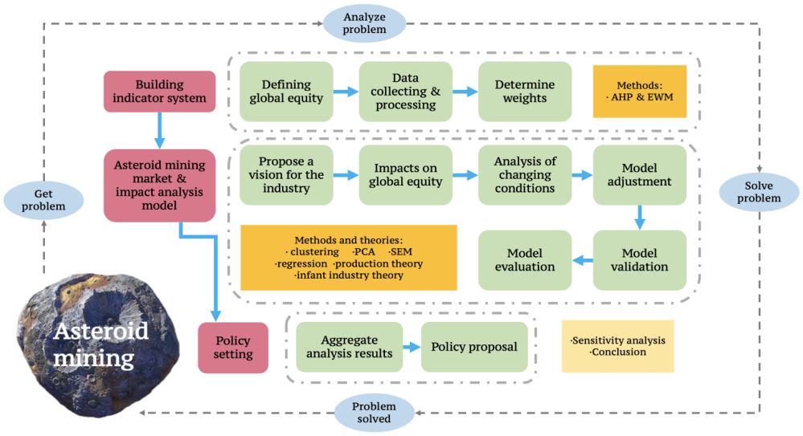
Figure 1: Our Work
图 1：我们的工作
图中文字对照（英文 → 中文）
Building indicator system | 构建指标体系 | Asteroid mining market & impact analysis model | 小行星采矿市场与影响分析模型
Asteroid mining | 小行星采矿 | Defining global equity | 界定全球公平
Data collecting & processing | 数据收集与处理 | Determine weights | 确定权重
Methods: · AHP & EWM | 方法：AHP 层次分析法与 EWM 熵权法 | Methods and theories: · clustering ·PCA ·SEM ·regression ·production theory ·infant industry theory | 方法与理论：聚类 ·主成分分析 ·结构方程模型 ·回归 ·生产理论 ·幼稚产业理论
Propose a vision for the industry | 提出行业发展愿景 | Impacts on global equity | 对全球公平的影响
Analysis of changing conditions | 变化条件分析 | Model adjustment | 模型调整
Model validation | 模型验证 | Model evaluation | 模型评价
Aggregate analysis results | 汇总分析结果 | Policy proposal | 政策建议
Policy setting | 政策制定 | Sensitivity analysis ·Conclusion | 敏感性分析 ·结论
Having understood the problem, we’re required to do the following work:
在理解问题之后，我们需要完成以下工作：
• Develop a model to measure global equity and validate it through regional analyses.
• 建立一个衡量全球公平的模型，并通过区域分析对其加以验证。
• Present one likely vision of asteroid mining market in the future and determine the impact of asteriod mining on global equity.
• 提出一种未来小行星采矿市场的可能图景，并确定小行星采矿对全球公平的影响。
• Change the conditions in asteroid mining sector and analyze the impact of these changes on global equity.
• 改变小行星采矿部门的条件，并分析这些变化对全球公平的影响。
• Propose a set of regulations and policies to encourage the asteroid mining sector to advance in a way that promotes global equity.
• 提出一套法规与政策，以鼓励小行星采矿部门朝着促进全球公平的方向发展。
2 Assumptions
2 假设
• We assume that the resources of asteroid is unlimited. It is assumed to make our discussion of long-round trend possible.
• 我们假设小行星资源是无限的。作出这一假设，是为了使我们关于长期趋势的讨论成为可能。
• At any speciﬁc time, the asteroid resources that humankind is able to utilize are limited and scarce. It is scarcity that leads to inequity, makes our discussion necessary and our economics models useful.
• 在任一特定时刻，人类能够利用的小行星资源是有限的、稀缺的。正是稀缺性导致了不公平，使我们的讨论成为必要，也使我们的经济学模型有用武之地。
— 原文第 5 页 —
• Assuming that all participants in asteroid mining market obey our regulation unconditionally so that we could analyse the impact on global equity.
• 假设小行星采矿市场中的所有参与者都无条件遵守我们的规定，以便我们分析其对全球公平的影响。
• We assume that the statistics we collected from the websites are reliable and accurate. The data we use in our model is mainly collected from some statistics websites such as Our World in Data [1], Statista [2], World Inequality Database [3] and CEIC [4].
• 我们假设从网站收集的统计数据可靠且准确。我们在模型中使用的数据主要收集自 Our World in Data [1]、Statista [2]、World Inequality Database [3] 和 CEIC [4] 等统计网站。
• It is assumed that asteroid mining activities follow basic priciples of economics so that we can build a economic model to analyse this market.
• 假设小行星采矿活动遵循经济学的基本原理，以便我们建立经济模型来分析该市场。
• We assure that asteroid mining activityies are stable and predictable so that we could utilize histical data to predict some unknow parameters.
• 我们确信小行星采矿活动是稳定且可预测的，以便我们能够利用历史数据预测某些未知参数。
3 Notations
3 符号说明
Symbols
符号
Description
说明
Unit
单位
q
Output of mineralskgp
矿物产量 kg p
Price of mineralsdollar/kg
矿物价格 dollar/kg
δ
Market share
市场份额
%
π
Proﬁt of mineralsbillion dollars
矿物利润 billion dollars
C
Cost of miningbillion dollarsk
采矿成本 billion dollars k
Input of capitalbillion dollarsl
资本投入 billion dollars l
Input of laborthousand persons
劳动投入 thousand persons
where we deﬁne the main parameters while speciﬁc value of those parameters will be given later.
在此我们定义了主要参数，这些参数的具体取值将在后文给出。
4 Global Equity Model
4 全球公平模型
4.1 Dimensions of Global Equity
4.1 全球公平的维度
When it comes to equity, it refers to the equity between people in diﬀerent social status, the equity
谈及公平，它指的是不同社会地位的人之间的公平，
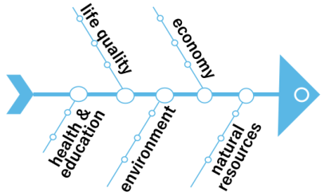
between rich and poor countries, the equity between the present and the future generations.
富国与穷国之间的公平，以及当代人与后代人之间的公平。
Here, we study the equity between countries. In detail, we derive the deﬁnition of global equity:
在此，我们研究国家之间的公平。具体而言，我们得出全球公平的定义：
Global equity is the quality of being globally fair considering natural resources, economy, health & education, environment and life quality, which considers need and justice.
全球公平是指在考虑自然资源、经济、健康与教育、环境与生活质量的情况下实现全球公正的品质，它兼顾需求与正义。
We develop the following HELEN indicator system. In this model, we select ﬁve aspects of equity, health and education (H), environment (E), life quality(L), economy (E), and natural resources (N), to analyse global equity comprehensively.
我们建立如下 HELEN 指标体系（HELEN）。在该模型中，我们选取公平的五个方面，即健康与教育（H）、环境（E）、生活质量（L）、经济（E）与自然资源（N），以全面分析全球公平。
HELEN Model
HELEN 模型
4.2
Figure 2 shows a basic diagram of our model. It is comprised of ﬁve ﬁst-level indicators and sixteen second-level indicators.
图 2 展示了我们模型的基本示意图。该模型由 5 个一级指标和 16 个二级指标构成。
— 原文第 6 页 —
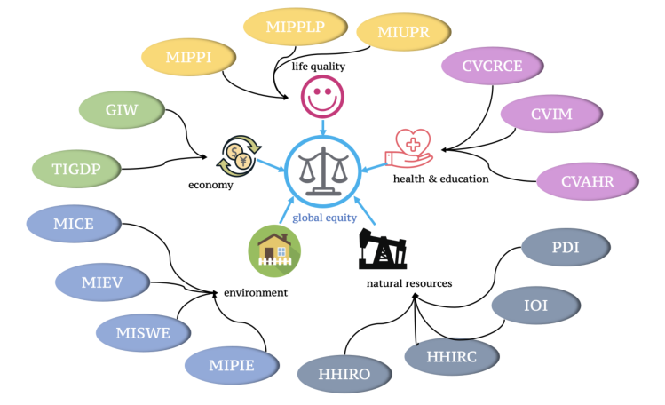
Figure 2: Diagram of HELEN Model
图 2：HELEN 模型示意图
图中文字对照（英文 → 中文）
global equity | 全球公平 | life quality | 生活质量
economy | 经济 | health & education | 健康与教育
environment | 环境 | natural resources | 自然资源
4.2.1 Natural Resources Equity
自然资源公平
The unequal distribution of natural resources results in economic and geopolitical power relationships that can directly or indirectly inﬂuence the occurrence of conﬂicts. We collect the data of some nonrenewable resources including oil, natural gas, coal, iron, non-ferrous and precious metals. Using these data, we calculate four indexes to measure natural resources equity.
自然资源的不均衡分布形成了经济与地缘政治的权力关系，这些关系可能直接或间接地影响冲突的发生。我们收集了若干不可再生资源的数据，包括石油、天然气、煤炭、铁、有色金属与贵金属。基于这些数据，我们计算四个指数以衡量自然资源公平。
1) Production-Demand Index (PDI)
1) 生产—需求指数（PDI）
We collect the data of production and demand of resources for each countries. Then, we calculate the correlation between ranks of the two variables. We use Spearman rank correlation and Kendall rank correlation. The closer the correlation coeﬃcient is to 1, the fairer the allocation of resources.
我们收集各个国家资源的生产量与需求量数据。随后，我们计算这两个变量秩之间的相关性。我们采用斯皮尔曼秩相关与肯德尔秩相关。相关系数越接近 1，资源分配越公平。
2) In and Out Index (IOI)
2) 进出指数（IOI）
We collect the data of import and export of each country. For each resource, we calculate coeﬃcient of variation (CV) denoted as In and Out Index. The smaller the value, the fairer the distribution of natural resources in the entire system.
我们收集各个国家的进口与出口数据。对于每种资源，我们计算变异系数（CV），并将其记为进出指数。该值越小，整个系统中自然资源的分布越公平。
HHI, also known as Herﬁndahl-Hirschman index, is a comprehensive index to measure industrial concentration. Its speciﬁc formula is as follows:
HHI 又称赫芬达尔—赫希曼指数，是衡量产业集中度的综合性指数。其具体公式如下：
_{i=1}(X^{i}
X )² = Σ^{N}
HHI = Σ^{N}_{i=1}S²i
where X_{i} stands for the amount of the ith country and X = Σ^{N}_{i=1}X_{i}.
其中 X_{i} 表示第 i 个国家的数量，且 X = Σ^{N}_{i=1}X_{i}。
3) HHI of Resource Occupancy (HHIRO)
3) 资源占有 HHI（HHIRO）
HHIRO is HHI of resource occupancy, that is, the sum of the squares of the percentage of resource occupancy in each country to the total resource. It is used to measure the dispersion of resource occupancy.
HHIRO 即资源占有的 HHI，也就是各国资源占有量占资源总量的百分比之平方和。它用于衡量资源占有的分散程度。
4) HHI of Resource Consumption (HHIRC)
4) 资源消费 HHI（HHIRC）
HHIRC is HHI of resource consumption in diﬀerent countries. It is used to represent the concentration of resource consumption in diﬀerent countries.
HHIRC 是不同国家资源消费的 HHI。它用于表征不同国家资源消费的集中程度。
— 原文第 7 页 —
4.2.2 Economic Equity
经济公平
1) Gini Coeﬃcient of Wealth per Capita (GIW)
1) 人均财富基尼系数（Gini Coefficient）（GIW）
Gini index measures the extent to which the distribution of income among individuals or households within an economy deviates from a perfectly equal distribution. We regard the world as a whole and get its Gini index.
基尼指数衡量一个经济体内个人或家庭之间收入分布偏离完全均等分布的程度。我们将世界视为一个整体，并求得其基尼指数。
2) Theil Index of GDP per Capita (TIGDP)
2) 人均 GDP 泰尔指数（TIGDP）
Theil index is a special case of the generalized entropy index (GE). It is a measure of inequity. We use GDP of all countries to calculate Theil index.
泰尔指数是广义熵指数（GE）的特例。它是一种不平等的度量。我们使用所有国家的 GDP 计算泰尔指数。
4.2.3 Life Quality Equity
生活质量公平
Global Moran index (MI) is used to determine whether there is autocorrelation in the space. Its formula is as follows:
全局莫兰指数（MI）用于判断空间上是否存在自相关。其公式如下：
= Σ^{N}_{i=1}Σ^{N}_{j=1}w_{ij}(x_{i} −¯x)(y_{i} −¯y)n
S² · Σ^{N}_{i=1}Σ^{N}
S_{0j=1}w_{ij}where wij is the weight showing the adjacent relationship. When the ith and the jth country are adjacent, this value is 1, otherwise, this value is 0; S₀ = Σ^{N}_{i=1}Σ^{N}_{j=1}w_{ij} is the sum of weights.
S_{0j=1}w_{ij}其中 w_{ij} 是表示相邻关系的权重。当第 i 个与第 j 个国家相邻时，该值为 1，否则为 0；S₀ = Σ^{N}_{i=1}Σ^{N}_{j=1}w_{ij} 为权重之和。
S² = 1n · Σ^{N}_{i=1}(x_{i} −¯x)²
where x_{i} stands for the value of the ith country.
其中 x_{i} 表示第 i 个国家的取值。
1) Moran Index of Producer Price Index (MIPPI)
1) 生产者价格指数莫兰指数（MIPPI）
We use MI of Producer Price Index (MIPPI) around the world to measure the extent to which countries diﬀer in the price of goods.
我们使用全球生产者价格指数的 MI（MIPPI）来衡量各国在商品价格上的差异程度。
2) Moran Index of Proportion of People Living in Poverty (MIPPLP)
2) 贫困人口比例莫兰指数（MIPPLP）
We use MI of the proportion of people living in poverty (MIPPLP) in countries around the world to measure the extent to which countries diﬀer in their alleviation of poverty. 3) Moran Index of Urban Population Ratio (MIUPR)
我们使用全球各国贫困人口比例的 MI（MIPPLP）来衡量各国在减贫方面的差异程度。3) 城镇人口比例莫兰指数（MIUPR）
MIUPR is MI of the urbanization rate of countries around the world. It measures the diﬀerence of urban construction between countries.
MIUPR 是全球各国城镇化率的 MI。它衡量各国之间城市建设的差异。
4.2.4 Environmental Equity
环境公平
1) Moran Index of Carbon Emission (MICE)
1) 碳排放莫兰指数（MICE）
MICE is MI of carbon emissions around the world. It measures the diﬀerence of carbon emission control between countries.
MICE 是全球碳排放的 MI。它衡量各国之间碳排放控制的差异。
2) Moran Index of Eﬄuent Volume (MIEV)
2) 废水排放量莫兰指数（MIEV）
MIEV is MI of Eﬄuent Volume around the world. It can be used to measure the variance of wastewater discharge control worldwide.
MIEV 是全球废水排放量的 MI。它可用于衡量全球范围内废水排放控制的差异。
3) Moran Index of Solid Waste Emissions (MISWE)
3) 固体废物排放莫兰指数（MISWE）
MISWE is MI of solid waste emissions around the world. It is used to measure the diﬀerence in solid waste emissions control all over the world.
MISWE 是全球固体废物排放的 MI。它用于衡量世界各地固体废物排放控制的差异。
4) Moran Index of Proportion of Investment in Environmental Pollution Control (MIPIE) MIPIE is MI of investment in environmental pollution control around the world. It measures the diﬀerence of investment in environmental pollution control between countries.
4) 环境污染治理投资比例莫兰指数（MIPIE） MIPIE 是全球环境污染治理投资的 MI。它衡量各国之间环境污染治理投资的差异。
— 原文第 8 页 —
4.2.5 Health & Education Equity
健康与教育公平
1) CV of the Completion Rate for Compulsory Education (CVCRCE)
1) 义务教育完成率变异系数（CVCRCE）
We use CV of the completion rate of compulsory education around the world to measure the status quo of countries in compulsory education. It measures education equity.
我们使用全球义务教育完成率的 CV 来衡量各国义务教育的现状。它衡量教育公平。
2) CV of Infant Mortality (CVIM)
2) 婴儿死亡率变异系数（CVIM）
We measure health equity by CV of newborn infant mortality around the world to measures the current state of newborn health in each country.
我们通过全球新生儿死亡率的 CV 来衡量健康公平，以测度各国新生儿的健康状况。
3) CV of Access to Healthcare Resources (CVAHR)
3) 医疗卫生资源可及性变异系数（CVAHR）
We measure the accessibility of medical and health resources around the world. We collect the number of health technicians per 1,000 people, the number of beds in medical institutions per 1,000 people, and the number of hospitals per 10,000 people. We calculate these three indicators separately. Then we get the average for each country. We get CVAHR by calculating CV of all averages.
我们衡量全球医疗卫生资源的可及性。我们收集每千人卫生技术人员数、每千人医疗机构床位数以及每万人医院数。我们分别计算这三项指标。随后得到每个国家的平均值。我们通过计算所有平均值的 CV 得到 CVAHR。
4.3 Weight of Index
4.3 指标权重
The data we use to evaluate the indicators comes from multiple databases including statista [2]. We use data from 2001 to 2020 including almost all the countries around the world. For each year, we calculate above indexes.
我们用于评价这些指标的数据来自多个数据库，包括 statista [2]。我们使用 2001 年至 2020 年的数据，涵盖全球几乎所有国家。我们逐年计算上述各项指数。
On the basis of above data and relevant literature, we combine the Analytic Hierarchy Process (AHP) and the Entropy Weight Method (EWM). The weights are determined as follows:
在上述数据与相关文献的基础上，我们将层次分析法（AHP）与熵权法（EWM）相结合。权重的确定方式如下：
4.3.1 Determining the Weights of ﬁrst-level indicators by AHP
用 AHP 确定一级指标的权重
We use AHP to determine the weights of the ﬁrst-level indicators.
我们采用 AHP 确定一级指标的权重。
First, we formulate matrix of pair-comparison based on relevant literature and theories. ′ according to the formular:
首先，我们依据相关文献与理论构造成对比较矩阵，并按下式进行计算：
Then, we calculate the initial weight coeﬃcient w_{i}
随后，我们计算初始权重系数 w_{i}。
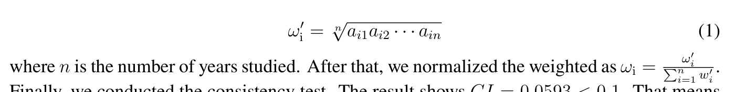
4.3.2 Determining the Weights of second-level indicators by EWM
利用 EWM 确定二级指标的权重
We use EWM to determine the weights of second-level indicators.
我们采用 EWM 确定二级指标的权重。
First, we calculate the proportion of the ith year under the jth index, and regard the proportion as the probability used in the relative entropy calculation. Denote data of the jth index and the ith sample point as z_{ij}. We can derive probability p_{ij} by:
首先，我们计算第 i 年在第 j 项指标下所占的比重，并将该比重视为相对熵计算中所使用的概率。记第 j 项指标在第 i 个样本点处的数据为 z_{ij}。由此可得概率 p_{ij}：
Second, we calculate the information entropy of each indicator, obtain the information utility value, and ﬁnally normalize it to obtain the entropy weight of each indicator. For the jth index, the formula is:
其次，我们计算各项指标的信息熵，进而求得信息效用值，最后对其作归一化处理，得到各项指标的熵权。对于第 j 项指标，其公式为：
— 原文第 9 页 —
Then, we calculate the information utility as:
然后，我们按下式计算信息效用：
Finally, we normalized the information utility and calculate the weight as :
最后，我们对信息效用进行归一化，并按下式计算权重：
4.3.3 Calculation of the Comprehensive Weights and Composite Score
综合权重与综合得分的计算
HELEN Model can alse be used to a speciﬁc region to measure the region equity. We multiply above weights with the formular below to get the comprehensive weights for a speciﬁc region:
HELEN 指标体系亦可用于特定区域，以衡量该区域的公平程度。我们将上述权重按如下公式相乘，得到特定区域的综合权重：
where ω_{ij} stands for weight of the ﬁrst-level indicator. ω_{j|i} stands for weight of the second-level indicator given the weight of ﬁrst-level. n_{i} stands for the number of second-level indicators in the ith ﬁrst-level indicator.
式中，ω_{ij} 表示一级指标的权重；ω_{j|i} 表示在一级指标权重给定条件下二级指标的权重；n_{i} 表示第 i 个一级指标所含二级指标的个数。
Using the obtained comprehensive weights, we can calculate the comprehensive score of each year (or region). The formula is:
利用所得的综合权重，我们可以计算各年份（或各区域）的综合得分。公式为：
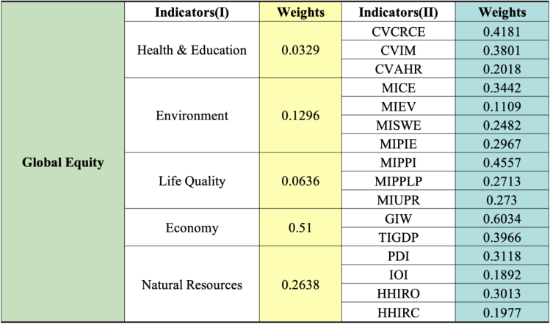
Figure 3: Weight of Index
图 3：指标权重
图中文字对照（英文 → 中文）
Global Equity | 全球公平 | Indicators(I) | 一级指标（第 I 层）
Indicators(II) | 二级指标（第 II 层） | Weights | 权重
Health & Education | 健康与教育 | Environment | 环境
Life Quality | 生活质量 | Economy | 经济
Natural Resources | 自然资源
4.4 Validation
4.4 验证
We apply the global equity model to diﬀerent regions. Figure 3 shows the value of equity index in North America, Latin America, Europe, Asia, Africa, Oceania.
我们将全球公平模型应用于不同区域。图 3 给出了北美、拉丁美洲、欧洲、亚洲、非洲与大洋洲的公平指数取值。
— 原文第 10 页 —
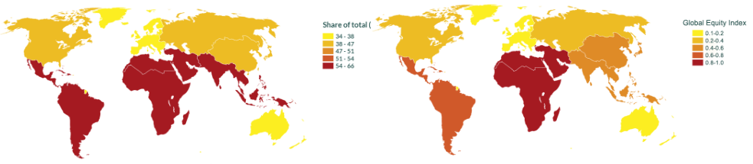
Figure 4: Piketty’s Index
图 4：皮凯蒂指数
图中文字对照（英文 → 中文）
Share of total ( | 占比（图例标题在原图右侧被截断，仅存到此） | Global Equity Index | 全球公平指数
Figure 5: Global equity Index
图 5：全球公平指数
Thomas Piketty uses top 10% national income share as a measurement of inequity [3]. The result is shown in Figure 4. We compare our result with Piketty’s to verify the reliability of the our model.
托马斯·皮凯蒂以全国收入前 10% 的份额作为不平等的度量 [3]。结果如图 4 所示。我们将自身结果与皮凯蒂的结果进行对比，以验证模型的可靠性。
The result of two indexes show a high degree of consistency. Europe and Oceania have the lowest levels of inequity. Africa and Latin America have the highest levels of inequity. Equity index of Asia is higher than Europe and lower than Africa. Therefore, our model are reasonable and reliable.
两项指数的结果呈现高度一致性。欧洲与大洋洲的不平等程度最低。非洲与拉丁美洲的不平等程度最高。亚洲的公平指数高于欧洲，低于非洲。因此，我们的模型是合理且可靠的。
5 Asteroid Mining Market Model
5 小行星采矿市场模型
In this section, we propose a likely mode of asteroid mining, as shown in Figure 6. In this part, we will introduce the model from the factor market side, the production side, and the product market side. We ﬁnally examine the impact of the asteroid mining industry on global equity.
本节提出一种可能的小行星采矿模式，如图 6 所示。本部分我们将从要素市场端、生产端与产品市场端三个方面介绍该模型。最后，我们考察小行星采矿产业对全球公平的影响。
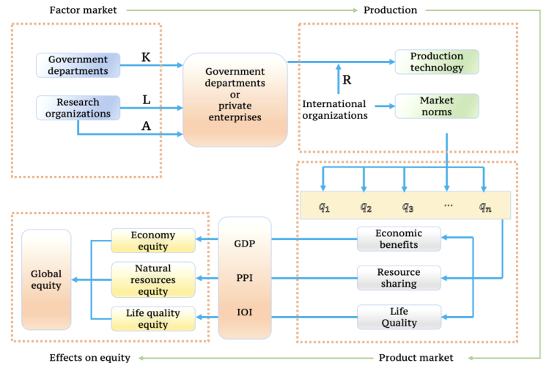
Figure 6: Asteroid Mining Market Model
图 6：小行星采矿市场模型
图中文字对照（英文 → 中文）
Factor market | 要素市场 | Production | 生产
Government departments | 政府部门 | Research organizations | 科研机构
Government departments or private enterprises | 政府部门或私营企业 | Production technology | 生产技术
Market norms | 市场规范 | International organizations | 国际组织
Global equity | 全球公平 | Economy equity | 经济公平
Natural resources equity | 自然资源公平 | Life quality equity | 生活质量公平
GDP | 国内生产总值 | PPI | 生产者价格指数
IOI | 进出口指数 | Economic benefits | 经济效益
Resource sharing | 资源共享 | Life Quality | 生活质量
For the sake of simplicity, we only discuss the change of IOI, MIPPI snd TIGDP, regarding other indexes as invariant.
为简便起见，我们仅讨论 IOI、MIPPI 与 TIGDP 的变化，其余指标视为不变。
5.1 Factor Market of Asteroid Mining
5.1 小行星采矿的要素市场
We analyze the factor market for asteroid mining. The factor market can be analyzed from the two aspects, participants and their relationship (i.e. production function).
我们对小行星采矿的要素市场进行分析。要素市场可从参与者及其相互关系（即生产函数）两个方面加以分析。
— 原文第 11 页 —
5.1.1 Participants
参与者
We analyse the roles of government agencies and scientiﬁc research institutions in our model. Government agencies refer to space exploration departments established by governments. They play two main roles in the asteroid mining market:
我们分析政府机构与科研机构在模型中所扮演的角色。政府机构指各国政府设立的航天探索部门。它们在小行星采矿市场中主要发挥两方面作用：
1) Act as the main producer in the initial stage of the market. Private companies do not have mining capabilities then. They need further support from the government.
1) 在市场初始阶段充当主要生产者。彼时私营企业尚不具备采矿能力。它们需要政府的进一步支持。
2) Provide private enterprises with capital, including land and funding to accelerate their development.
2) 为私营企业提供资本，包括土地与资金，以加快其发展。
Scientiﬁc research institutions refer to research institutes and universities established in the countries. They play two main roles in the asteroid mining market:
科研机构指各国设立的研究院所与大学。它们在小行星采矿市场中主要发挥两方面作用：
1) Provide talents for asteroid mining market.
1) 为小行星采矿市场提供人才。
2) Improve the technological level through research and innovation.
2) 通过研究与创新提升技术水平。
5.1.2 Clustering Analysis of participants
参与者的聚类分析
Asteroid mining has extremely high requirements on the level of technological development and national strength. Obviously, not all countries have enough capital, technology and talent reserves to mine. In the global asteroid mining market, there are huge diﬀerences between various participants. We need the criterion to distinguish the countries from each other. Therefore, we decide to measure a country’s space technology development level through three aspects: technical level, talent investment, and capital investment:
小行星采矿对技术发展水平与国家实力有着极高的要求。显然，并非所有国家都拥有足够的资本、技术与人才储备以开展采矿。在全球小行星采矿市场中，各参与者之间存在巨大差异。我们需要相应标准以区分不同国家。因此，我们决定从技术水平、人才投入与资本投入三个方面衡量一国的航天技术发展水平：
1) Technical level: the number of papers published in the space ﬁeld.
1) 技术水平：航天领域发表的论文数量。
2) Talent input: the number of employees in the space industry.
2) 人才投入：航天产业的从业人员数量。
3) Capital investment: the market value of listed space companies.
3) 资本投入：上市航天公司的市值。
Speciﬁcally, we want to simplify the model by clustering the countries with mining capacity (20 countries) into categories. By doing this, we can also see the internal mechanisms of how global equity is aﬀected. The process is as follows:
具体而言，我们希望通过将具备采矿能力的国家（20 个）聚类为若干类别来简化模型。如此亦可揭示全球公平所受影响的内在机制。具体流程如下：
1) Since our evaluation index has 3 dimensions, it is not convenient to visualize it directly, we consider visualization through Principal Component Analysis (PCA). Compared with general PCA, Kernel PCA (KPCA) can handle nonlinear situations better. To make sure of a good result, here we choose to use KPCA.
1) 由于我们的评价指标包含 3 个维度，直接可视化并不方便，因此我们考虑通过主成分分析（PCA）实现可视化。与一般 PCA 相比，核主成分分析（KPCA）能够更好地处理非线性情形。为确保得到良好的结果，此处我们选择使用 KPCA。
2) After performing KPCA, we cluster the generated data using system clustering. At the beginning, each sample is regarded as a class, and then the closest samples (that is, the groups with the smallest distance) are ﬁrstly clustered into subclasses, and then the aggregated subclasses are merged according to their inter-class distances, and so on.
2) 在执行 KPCA 之后，我们使用系统聚类对生成的数据进行聚类。起初，每个样本被视为一个类，随后最接近的样本（即距离最小的组）首先被聚为子类，然后依据类间距离对已聚合的子类进行合并，依此类推。
At last, we aggregate all subclasses into one big class. Here we compare the eﬀects of diﬀerent measures and types. Finally, we ﬁnd that when using the ward connectivity to measure dissimilarities and dividing the countries into 4 clusters, the clustering eﬀect is the best. The speciﬁc algorithm [5] is shown in Apendix A.
最终，我们将所有子类聚合为一个大类。此处我们比较了不同度量方式与不同类型的效果。最终我们发现，当采用 ward 连接度度量相异性并将国家划分为 4 个类时，聚类效果最佳。具体算法 [5] 见附录 A。
5.1.3 Result of Clustering
聚类结果
The clustering results show that we can divide the countries into 41 categories, which are:
聚类结果表明，我们可以将国家划分为 41 类，即：
1) Leader: The United States, the European Union and other countries with extremely 1For countries that do not have mining capacity, we place them in the ﬁfth category. They correspond to the countries marked in grey in the image above.
1) 领导者：美国、欧盟等空间技术极为 1对于不具备采矿能力的国家，我们将其归入第五类。它们对应上图中以灰色标记的国家。
— 原文第 12 页 —
developed space technology.
发达的国家。
2) Advancer: China, Russia, India and other developing countries with relatively developed space technology.
2) 奋进者：中国、俄罗斯、印度等空间技术相对发达的发展中国家。
3) Pursuer: Israel, South Korea, Japan, Iran, United Arab Emirates and other countries with potential for space technology.
3) 追赶者：以色列、韩国、日本、伊朗、阿拉伯联合酋长国等具有空间技术潜力的国家。
4) Outsider: Mexico, Australia, Brazil, Egypt, New Zealand, Indonesia, Thailand, Saudi Arabia and other countries that lack space exploration technology.
4) 局外者：墨西哥、澳大利亚、巴西、埃及、新西兰、印度尼西亚、泰国、沙特阿拉伯等缺乏空间探索技术的国家。
5) Others: Countries without space exploration technology.
5) 其他：不具备空间探索技术的国家。
The clustering process and the visualization of the clustering results are as follows:
聚类过程与聚类结果的可视化如下：
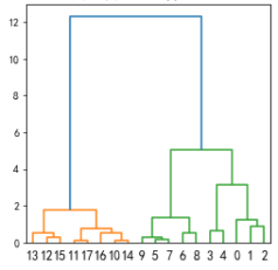
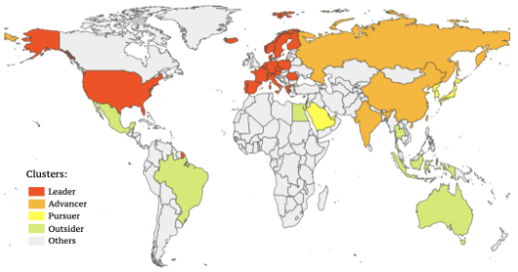
Figure 7: Results of Clustering
图 7：聚类结果
图中文字对照（英文 → 中文）
Clusters: | 聚类类别： | Leader | 领跑者
Advancer | 进阶者 | Pursuer | 追赶者
Outsider | 落后者 | Others | 其他
Figure 8: Process of Clustering
图 8：聚类过程
5.1.4 Production Function
生产函数
Finally, we use the production function to describe the relationship between diﬀerent partipants . Using historical data, we give the values of the parameters in the function. Denote participant i’s output as q_{i}. It is a function of technology, talent input and capital input denoted as A_{i}, k_{i} and l_{i}. We use Cobb–Douglas production function to describe this relationship:
最后，我们使用生产函数描述不同参与者之间的关系。利用历史数据，我们给出函数中各参数的取值。记参与者 i 的产出为 q_{i}。它是技术、人才投入与资本投入的函数，分别记为 A_{i}、k_{i} 与 l_{i}。我们使用柯布-道格拉斯生产函数描述这一关系：
where A_{i}, α_{i}, and β_{i} are all positive constants. The constant α_{i} is then the elasticity of output with respect to capital input, and β_{i} is the elasticity of output with respect to labor input. For α_{i}, β_{i} in the model, we take α_{i} = 0.3, β_{i} = 0.7 [6] for i = 1, 2, · · · , N; for A_{i}, we take one country in each category in the above clustering results, use its historical mineral data for regression analysis using Cobb-Douglas production function, and use the obtained A, denoted as ˆA, as the A value of all countries in the same catagory. Take the United States as example, we derive that ˆA = 7.42. The speciﬁc process is shown in Appendix B.
其中 A_{i}、α_{i} 与 β_{i} 均为正常数。常数 α_{i} 即为产出对资本投入的弹性，β_{i} 为产出对劳动投入的弹性。对于模型中的 α_{i}、β_{i}，我们对 i = 1, 2, · · · , N 取 α_{i} = 0.3、β_{i} = 0.7 [6]；对于 A_{i}，我们在上述聚类结果的每一类中各取一个国家，利用其历史矿产数据，采用柯布-道格拉斯生产函数进行回归分析，并将所得的 A（记为 ˆA）作为同一类别中所有国家的 A 值。以美国为例，我们求得 ˆA = 7.42。具体过程见附录 B。
5.2 Production Side of Asteroid Mining
5.2 小行星采矿的生产端
Next, we analyze the production side of asteroid mining. The production side can also be analyzed from participants and their relationships. For the former, we refer to relevant literature and emphasize the role of international regulatory organizations, and thus form the basic constraints. We use factor analysis to determine the constraints on market share. For the latter, we explain the rationality of the production relationship. We analyze the economic value of asteroid mining, and use the results to conduct a cost-beneﬁt analysis and establish an equilibrium model.
接下来，我们分析小行星采矿的生产端。生产端同样可以从参与者及其关系两方面加以分析。对于前者，我们参考相关文献，强调国际监管组织的作用，并由此形成基本约束。我们使用因子分析确定对市场份额的约束。对于后者，我们阐释生产关系的合理性。我们分析小行星采矿的经济价值，并利用其结果进行成本效益分析，建立均衡模型。
— 原文第 13 页 —
5.2.1 Participant
参与者
Only by building a equitable outlook can we gain the support of developing countries. It is clearly not enough just relying on the sense of responsibility of developed countries to maintain equity, so the intervention of the international regulatory organization is indispensable.
只有树立公平的愿景，我们才能获得发展中国家的支持。仅依靠发达国家的责任感来维护公平显然是不够的，因此国际监管组织的介入不可或缺。
The Agreement Governing the Activities of States on the Moon and Other Celestial Bodies, commonly designated as the Moon Agreement [7], states that “due regard shall be paid to the interest of present and future generations and to promote higher standards of living and conditions of economic and social progress in accordance with the UN Charter”.And based on its spirit, below we list the responsibilities of the international regulatory organization as follows:
《关于各国在月球和其他天体上活动的协定》，通称《月球协定》[7]，规定“应适当顾及今世和后代的利益，并依照《联合国宪章》促进更高的生活水准以及经济与社会进步的条件”。基于其精神，我们在下面列出国际监管组织的职责如下：
1) Properly preserve information on all detected asteroid mineral resources. Disclose necessary information to the world.
1) 妥善保存所有已探测到的小行星矿产资源的信息。向世界披露必要的信息。
2) Determine the upper limit of market share of each country according their situations. Formulate regulations to ensure that no country exceeds the limit.
2) 根据各国情况确定其市场份额的上限。制定规章以确保任何国家均不超过该上限。
3) Review mining requests from the countries.
3) 审查各国提出的采矿申请。
Only the approved mining projects can proceed.
只有获得批准的采矿项目方可实施。
4) Supervise mining activities of all countries. Ensure that there is no unauthorized mining activities taking place. Impose ﬁnes on countries that violate the regulations.
4) 监管各国的采矿活动。确保不发生未经授权的采矿活动。对违反规章的国家处以罚款。
5.2.2 Upper bound of Market Share
市场份额的上界
As mentioned above, we need to determine upper bounds of each country’s market share for asteroid mineral resources. In this regard, we must determine the needs of countries so that the resources can be distributed equitably. Here, we use each country’s resource gap (the diﬀerence between consumption and production, or $0 if production is greater than consumption) to determine the their needs.
如上所述，我们需要确定各国小行星矿产资源市场份额的上界。为此，我们必须确定各国的需求，以便资源能够公平分配。此处，我们使用各国的资源缺口（消费量与产量之差，若产量大于消费量则取 $0）来确定其需求。
We use factor analysis to calculate the need for mineral resources of each country. The process is as follows:
我们使用因子分析计算各国对矿产资源的需求。其过程如下：
First, we assume that there is a latent variable Z (also named as factor) that aﬀects the independant variable X. We centralized X and write the relationship between X and Z as:
首先，我们假设存在一个影响自变量 X 的潜变量 Z（也称为因子）。我们对 X 进行中心化处理，并将 X 与 Z 的关系写为：
X = AZ + ϵwhere ϵ has mean vector 0 and covariance matrix Σ_{ϵ} = diag(σ²₁, σ²₂, · · · , σ²_{p}), where p stands for the dimension of X.
X = AZ + ϵ其中 ϵ 的均值向量为 0，协方差矩阵为 Σ_{ϵ} = diag(σ²₁, σ²₂, · · · , σ²_{p})，其中 p 表示 X 的维数。
Second, we assume the covariance matrix of latent variable Z, Σ_{z} = I.
其次，我们假设潜变量 Z 的协方差矩阵为 Σ_{z} = I。
With some calculation, we get:
经过一些计算，我们得到：
Σ_{x} = AA^{T} + Σ_{ϵ}
Using factor transformation, we can get unique A under certain circumstance. Then, we estimate Z, denoted as ˆZ, using:
使用因子变换，我们可以在一定条件下得到唯一的 A。然后，我们使用下式估计 Z，记为 ˆZ：
ˆZ = A^{T}R⁻¹x Xwhere R_{x} is the correlation matrix of X.
ˆZ = A^{T}R⁻¹x X，其中 R_{x} 为 X 的相关矩阵。
After that, we calculate the eigen value of correlation matrix of X, noted as λ_{i}, i = 1, 2, · · · , p. Then the contribution degree of each dimension of Z is derived by the following expression:
此后，我们计算 X 的相关矩阵的特征值，记为 λ_{i}，i = 1, 2, · · · , p。随后，Z 各维度的贡献度由下式导出：
— 原文第 14 页 —
λ_{j}w_{j} =
Σ^{m}_{i=1}λ_{i}where j is one given dimension of ˆZ and m stands for the number of chosen dimensions of factor. The contribution degree can be used as the weight of each dimension of ˆZ.
Σ^{m}_{i=1}λ_{i}，其中 j 为 ˆZ 的某一给定维度，m 表示所选因子维度的数量。该贡献度可作为 ˆZ 各维度的权重。
Finally, we get the score of factor (the estimated value of ˆZ). Multiply the result with above weights, we can get the ﬁnal score of each observation.
最后，我们得到因子得分（即 ˆZ 的估计值）。将结果与上述权重相乘，即可得到每个观测值的最终得分。
5.2.3 Cost-beneﬁt Analysis
成本效益分析
For participant i , we denote the proﬁt as π_{i} and it is the diﬀerence between revenue and cost:
对于参与者 i，我们将其利润记为 π_{i}，它等于收入与成本之差：
Revenue of participant i is price mutiplied by output. We denote price as p(Q) which is a function of total output. We denote total quantity as Q = P^{n}i=1 q^{i} + q^{e} where q^{e} is the output in traditional mining industry. As for the form of inverse demand function, we assume the form of linear function and obtained its expression as p(Q) = 12016.08 −30.18Q. The speciﬁc calculation process is also shown in Appendix B. So revenue is as follows:
参与者 i 的收入为价格乘以产量。我们将价格记为 p(Q)，它是总产量的函数。我们将总量记为 Q = P^{n}i=1 q^{i} + q^{e}，其中 q^{e} 为传统采矿业的产量。关于逆需求函数的形式，我们假定其为线性函数，并得到其表达式为 p(Q) = 12016.08 −30.18Q。具体计算过程亦见附录 B。因此收入如下：
To minimize the cost [6], we get l^{c}i and k^{c}i :
为使成本 [6] 最小化，我们求得 l^{c}i 与 k^{c}i：

The minimized cost is a function of output, wage and rate. We denote Cost_{i} = C(v_{i}, w_{i}, q_{i}). In detail:
最小化后的成本是产量、工资与利率的函数。我们记 Cost_{i} = C(v_{i}, w_{i}, q_{i})。具体为：
β^{−βi/(αi+βi)}
—a constant that involves only the parameters α_{i} iiand β_{i}.
——仅涉及参数 α_{i} ii与 β_{i} 的常数。
Finally, the proﬁt function of participant i is as follows:
最终，参与者 i 的利润函数如下：
5.2.4 Equilibrium Conditions for Asteroid Mining Market
小行星采矿市场的均衡条件
In particular, if there are only two participants in the market, according to Cournot model, the intersection of the optimal response curves of the two participants is the market equilibrium point:
特别地，若市场中仅有两位参与者，则依据古诺模型，两位参与者最优反应曲线的交点即为市场均衡点：
Generally, in the case of a large number of participants, we get the output of each participant through the following objective functions and constraints:
一般而言，在参与者数量众多的情况下，我们通过以下目标函数与约束条件求得各参与者的产量：
— 原文第 15 页 —
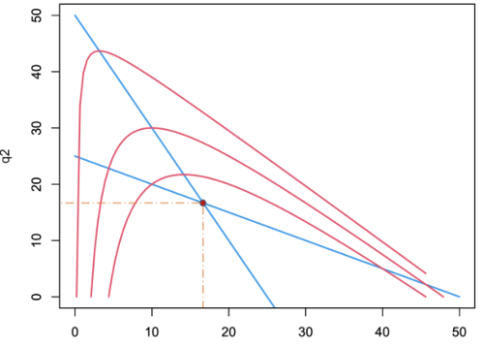
Figure 9: Modeling process
图 9：建模过程
图中文字对照（英文 → 中文）
q2 | q2（第二种产品的产量，纵轴）

After obtaining the output, we solve the market share of countries of above ﬁve catagories, δ_{i} =^{qi}_{Q}, to provide further information for later study. The results are as follows:
在求得产量之后，我们求解上述五类国家的市场份额，δ_{i} =^{qi}_{Q}，以为后续研究提供进一步的信息。结果如下：
Table 1: Market Sharing in Equilibrium Point
表 1：均衡点处的市场份额
5.3 Product Market of Asteroid Mining
5.3 小行星采矿的产品市场
5.3.1 Distribution of Beneﬁts
收益分配
How to distribute the beneﬁts of asteroid mining? It is an important issue. One possible mode is that miners have ownership and resale rights to the minerals they obtained. On one hand, the value of the them can compensate for the cost of the miners. On the other hand, since the amount of resources mined is limited by the regulatory organization, there won’t be large-scale monopoly and proﬁteering. Under this mode, the interests of less developed countries can also be protected. These countries can choose to sell their demand quotas to miners. When the miner exceeds the mining limit, they must purchase the mining limit to continue mining through approval. To a certain extent, it has played a role in supporting the less developed countries. Besides miners themselves, there are multiple parties that can make a proﬁt. We sort out the proﬁters and proﬁt methods of asteroid mining as follows:
如何分配小行星采矿的收益？这是一个重要问题。一种可能的模式是，采矿者对其所获取的矿产享有所有权与转售权。一方面，这些矿产的价值可以补偿采矿者的成本。另一方面，由于开采的资源量受监管机构限制，因而不会出现大规模垄断与暴利。在该模式下，欠发达国家的利益亦可得到保护。这些国家可以选择将其需求配额出售给采矿者。当采矿者超出开采限额时，其必须通过审批购买开采额度方可继续开采。这在一定程度上起到了扶持欠发达国家的作用。除采矿者本身之外，还有多方可以获利。我们将小行星采矿的获利方与获利方式梳理如下：
1) Miners proﬁt as owners and sellers of the minerals. Those mining countries or enterprises can retain minerals to meet their own needs, or else they can dump the minerals to other countries.
1) 采矿者作为矿产的所有者与出售者获利。这些采矿国家或企业可保留矿产以满足自身需求，亦可将其倾销至其他国家。
— 原文第 16 页 —
2) The sponsors of mining enterprises can also earn dividends through investment, but the period of proﬁt is longer. It takes at least ten to ﬁfteen years from project funding to successful proﬁtability.
2) 采矿企业的出资方亦可通过投资获得分红，但获利周期较长。从项目融资到成功实现盈利至少需要十至十五年。
3) The processors of minerals can proﬁt.
3) 矿产加工者可获利。
The total amount of minerals in asteroids is abundant, but the purity is relatively low. It requires further reﬁning and processing to obtain products.
小行星中的矿产总量丰富，但纯度相对较低。需经过进一步精炼与加工才能获得产品。
4) Other practitioners in the asteroid mining industry chain can proﬁt. After the industrial chain forms, it will provide many needs, such as the production of mining spacecraft, mineral transportation, etc. They can boost the economy of mining countries.
4) 小行星采矿产业链上的其他从业者可获利。产业链形成后，将产生诸多需求，如采矿航天器的制造、矿产运输等。它们能够推动采矿国家的经济发展。
5.3.2 Impact on Economy
对经济的影响
GDP reﬂects the economic growth of a country. The asteroid mining industry has a signiﬁcant impact on GDP and thus aﬀects economic life. Therefore, we compare the growth of GDP after the booming of asteroid mining industry. Consider the following equation:
GDP 反映一个国家的经济增长。小行星采矿产业对 GDP 具有显著影响，进而影响经济生活。因此，我们比较小行星采矿产业繁荣之后的 GDP 增长。考虑如下方程：
In the second equation, we compute the change rate of GDP caused by the asteriod mining market. The result is shown as follows:
在第二个方程中，我们计算由小行星采矿市场引起的 GDP 变化率。结果如下所示：
Table 2: Change Rate of GDP
表 2：GDP 变化率
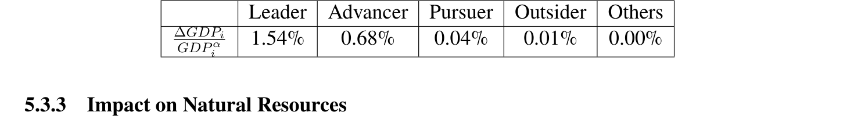
Asteroid mining can alleviate the scarcity of resources on the earth. Countries like China and Japan that depend on imported resources can take this opportunity to change their international status by increasing their natural resources supply from outer space.
小行星采矿能够缓解地球上的资源稀缺。中国、日本等依赖资源进口的国家可以借此机会，通过增加来自外层空间的自然资源供给来改变其国际地位。
We use the Dependence Index (DI) to analyze the changes in the dependent level of these countries on imported resources after booming of asteroid mining industry.
我们使用依赖度指数（DI）分析小行星采矿产业繁荣之后，这些国家对进口资源的依赖程度的变化。
Consider the following equation:
考虑下式：
— 原文第 17 页 —
In the second equation, we compute the change rate of DI caused by the asteriod mining market. The result is shown as follows:
在第二式中，我们计算由小行星采矿市场引起的 DI 变化率。结果如下所示：
Table 3: Change Rate of DI
表 3：DI 变化率
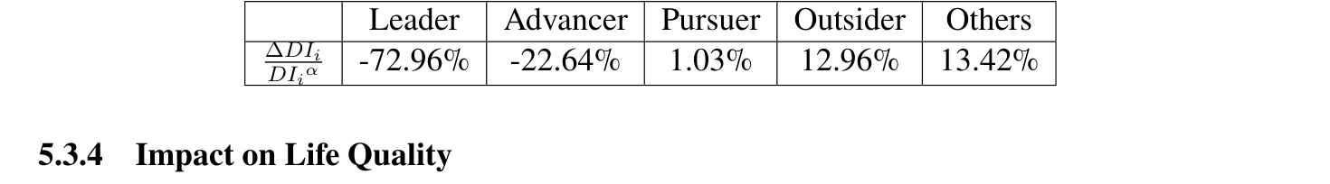
Asteroid mining provides an alternative source of mineral raw materials for industrial production. An increase in the supply of raw materials will reduce the price of raw materials and reduce the cost of the products.
小行星采矿为工业生产提供了矿物原材料的替代来源。原材料供给的增加将降低原材料价格，并降低产品成本。
We use the Producer Price Index (PPI) to analyze the change in the price of raw material after booming of asteroid mining industry. Consider the following equation:
我们使用生产者价格指数（PPI）分析小行星采矿产业繁荣之后原材料价格的变化。考虑下式：
In the second equation, we compute the change rate of PPI caused by the asteriod mining market. The result is showed as follows:
在第二式中，我们计算由小行星采矿市场引起的 PPI 变化率。结果如下所示：
Table 4: Change Rate of PPI
表 4：PPI 变化率
5.4 Impact on Global Equity
5.4 对全球公平的影响
Finally, we analyze the impact of asteroid mining on global equity. Asmentioned above, asteroid mining will aﬀect three aspects of global equity:
最后，我们分析小行星采矿对全球公平的影响。如上所述，小行星采矿将从三个方面影响全球公平：
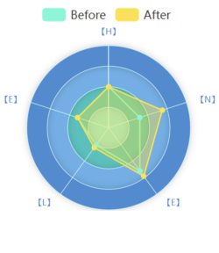
natural resources, economy and life quality. For these eﬀects, we use the
自然资源、经济和生活质量。针对这些影响，我们使用
HELEN model that has been established for analysis. For simpliﬁcation, weonly consider the changes of these three secondary indicators, and assumethat the other secondary indicators remain unchanged. The analysis resultsare as follows: (Note that the larger the value of the global equity index, theworse the equity.)
已建立的 HELEN 模型进行分析。为简化起见，我们仅考虑这三个二级指标的变化，并假定其他二级指标保持不变。分析结果如下：（注意，全球公平指数的数值越大，公平状况越差。）
Table 5: Impact on Equity
表 5：对公平的影响
图中文字对照（英文 → 中文）
Before | 实施前 | After | 实施后
[H] | [H]（HELEN 体系 H 维） | [E] | [E]（HELEN 体系 E 维）
[N] | [N]（HELEN 体系 N 维） | [L] | [L]（HELEN 体系 L 维）
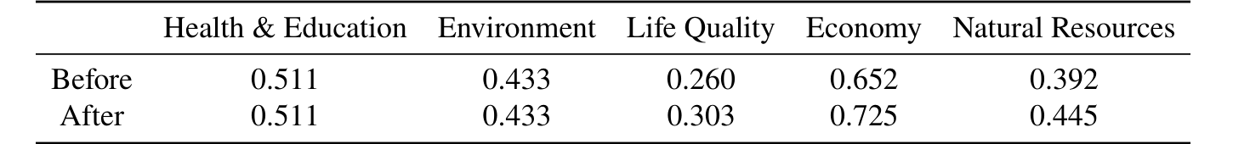
We calculate the Global Equity using HELEN model. The result showsthat Global Equity raises from 0.525 to 0.579 after asteroid mining.
我们使用 HELEN 模型计算全球公平。结果表明，小行星采矿之后全球公平由 0.525 上升至 0.579。
— 原文第 18 页 —
6 Model Adjustment
6 模型调整
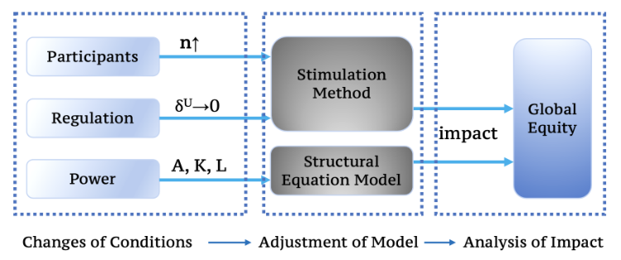
Figure 10: Model Adjustment
图 10：模型调整
图中文字对照（英文 → 中文）
Participants | 参与者 | Regulation | 监管
Power | 权力 | n↑ | 参与者数量 n 上升
δU→0 | 监管强度 δU 趋于 0 | A, K, L | 技术 A、资本 K、劳动 L
Stimulation Method | 模拟方法（原文如此拼写，应为 Simulation） | Structural Equation Model | 结构方程模型
Global Equity | 全球公平 | impact | 影响
Changes of Conditions | 条件变化 | Adjustment of Model | 模型调整
Analysis of Impact | 影响分析
6.1 Changes of Conditions
6.1 条件的变化
6.1.1 Participants
参与者
Just as mentioned above, we assume that the initial mining is conducted by countries. But the countries can also help enterprises develop their own abilities. Finally, the participants of mining will change into private enterprises.
如上所述，我们假定初始阶段的采矿由国家进行。但国家也可以帮助企业培养自身能力。最终，采矿的参与者将转变为私营企业。
We introduce Infant Industry Theory to describe the change process of participants. The basic content of the theory is: government improves the competitiveness of emerging industries against foreign countries by adopting appropriate protection policies. It will adopt transitional protection and support policies when these industries have the ability to export and contribute to the national economy.
我们引入幼稚产业理论来描述参与者的变化过程。该理论的基本内容是：政府通过采取适当的保护政策，提高新兴产业相对于外国的竞争力。当这些产业具备出口能力并能为国民经济做出贡献时，政府将采取过渡性的保护与支持政策。
The policy guides the state to provide higher subsidies for asteroid mining companies in the initial stage to promote their development. When the mining industry gradually matures, costs are reduced. The government will reduce subsidies to stimulate their own development. In this way, the miners changed from countries to private enterprises, and these enterprises will become the main participants in the future.
该政策引导国家在初始阶段对小行星采矿企业提供较高补贴，以促进其发展。当采矿业逐渐成熟、成本下降时，政府将减少补贴，以激励其自身发展。通过这种方式，采矿者由国家转变为私营企业，而这些企业将成为未来的主要参与者。
6.1.2 Changes in the Regulatory System
监管体系的变化
In the original model, international regulatory agencies impose upper bounds of market share to prevent monopoly. Here we want to discuss the pros and cons of this regulation. So we consider another scenario. Under this scenario, the market share of countries will not be restricted. Comparing the global equity index of the two cases, we can get our answer.
在原模型中，国际监管机构设定市场份额上限以防止垄断。在此我们希望讨论这一监管的利弊。因此我们考虑另一种情形。在该情形下，国家的市场份额不受限制。通过比较两种情形下的全球公平指数，我们可以得到答案。
6.1.3 Changes in National Power
国家实力的变化
The talent investment, capital investment, and technical level of diﬀerent countries will change over time. Based on historical data, we predict the future global equity index. We will conduct quantitative analysis accordingly.
不同国家的人才投入、资本投入和技术水平将随时间发生变化。基于历史数据，我们预测未来的全球公平指数。我们将据此进行定量分析。
6.2 Impact on Mining Patterns
6.2 对采矿模式的影响
We see changes in mining patterns in two ways. The makeup of miners and the regulation will both change. The former change is mainly reﬂected in the gradual transition of mining participants from states to enterprises. This will lead to an increase in the number of competitors in the market and increase competition. The latter change is mainly reﬂected in the removal of market share restriction. We build model under these two cases to study the impact of changes in mining patterns on equity.
我们从两个方面考察采矿模式的变化。采矿者的构成与监管方式都将发生变化。前者的变化主要体现在采矿参与者由国家逐步过渡为企业。这将导致市场中竞争者数量增加，竞争加剧。后者的变化主要体现在市场份额限制的取消。我们在这两种情形下建立模型，以研究采矿模式的变化对公平的影响。
— 原文第 19 页 —
6.2.1 Adjustment of Model
模型的调整
We combine the above two changes together to form the model.
我们将上述两种变化结合起来构成模型。
For changes in mining participants, we use the current number of space companies in each country to estimate the proportion of asteroid mining companies for each country in the future. We study the situation with diﬀerent enterprise quantity.
对于采矿参与者的变化，我们使用各国现有的航天企业数量来估计未来各国小行星采矿企业的比例。我们研究不同企业数量下的情形。
For changes in the regulatory system, we compare two situation. For the ﬁrst situation, the upper bound of market share is ﬁxed at 30%. And for the second, the market share is not limited. We use the model established above to solve it and draw the curve of the global equity index changing with enterprise quantity as below. Then we aggregate the data of enterprises for each country.
对于监管体系的变化，我们比较两种情形。在第一种情形下，市场份额上限固定为 30%。在第二种情形下，市场份额不受限制。我们使用上述建立的模型求解，并绘制全球公平指数随企业数量变化的曲线，如下图所示。然后我们对各国的企业数据进行汇总。
6.2.2 Intuitive Analysis
直观分析
The participants in the initial stage are mainly governments. The competitiveness between small number of producers is mild. The output is q₁ for the ﬁrst country and q₂ for the second. As more and more private companies enter the market, the competitiveness becomes ﬁercer. The slope of the response curve become larger for leading country and smaller for the followers.
初始阶段的参与者主要是政府。少数生产者之间的竞争程度较为温和。第一个国家的产量为 q₁，第二个国家的产量为 q₂。随着越来越多的私营企业进入市场，竞争变得愈发激烈。领先国家的响应曲线斜率变大，而追随者的响应曲线斜率变小。
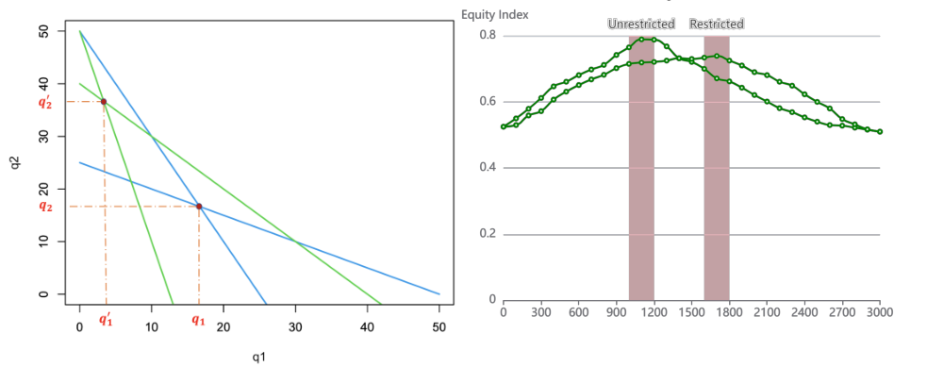
Figure 11: Intuitive Analysis
图 11：直观分析
图中文字对照（英文 → 中文）
q1 | q1（第一种产品产量，横轴） | q2 | q2（第二种产品产量，纵轴）
q1' | q1′（变化前的均衡产量） | q1* | q1*（变化后的均衡产量）
q2' | q2′（变化前的均衡产量） | q2* | q2*（变化后的均衡产量）
Equity Index | 公平指数（右图纵轴） | Unrestricted | 无限制情形
Restricted | 受限情形
Figure 12: Result of Simulation
图 12：模拟结果
The new equilibrium point is shown in Figure 11. The output is q′
新的均衡点如图 11 所示。产量为 q′
1 for the ﬁrst country and 2 for the second. We get^{q′}
1 >^{q2}q^{′q}1 indicating that the distribution of output is more unbalanced. 2q′
1 >^{q2}q^{′q}1，这表明产量的分布更加不均衡。2q′
As a result, it is likely that the inequity would increase.
因此，不公平程度很可能会加剧。
6.2.3 Result of Simulation
模拟结果
The result is shown in Figure 12. With the increase in enterprise quantity, the global equity index ﬁrst increases. But it then gradually decreases and ﬁnally tend to be stable. This is in line with our intuition. In fact, in the early stage of the conversion, the threshold is relatively high. Only advanced enterprises of some developed countries can enter and make proﬁts. Therefore, they can obtain monopoly proﬁts, which increases inequity. As time goes by, technology is spread further, the barrier is struck, and more private companies are able to break the barrier. Therefore, the market will see increased competition, lower costs, a more balanced distribution of proﬁts and less inequity. From vertical comparison we can see that, on adding the restriction of market share, the peak of the curve becomes lower, and the highest point drops from 0.789 to 0.739. This indicates that restricting market share, to some extent, can alleviate global inequity. But we also ﬁnd that, under the restriction, the asteroid mining market reachs its inﬂection point when the number of enterprises increases to 1800. The unrestricted condition reaches the point at 1200, which is faster than restricted condition. So we conclude that the restriction on market share can indeed better maintain global equity, but it also has its cost.
结果如图 12 所示。随着企业数量的增加，全球公平指数首先上升。但随后逐渐下降，最终趋于稳定。这与我们的直觉相符。事实上，在转化的早期阶段，门槛相对较高。只有部分发达国家的先进企业才能进入并获利。因此，它们能够获得垄断利润，从而加剧不公平。随着时间的推移，技术进一步扩散，壁垒被打破，更多私营企业能够突破这一壁垒。因此，市场将出现更激烈的竞争、更低的成本、更均衡的利润分配以及更少的不公平。从纵向对比可以看出，加入市场份额的限制后，曲线的峰值变低，最高点从 0.789 降至 0.739。这表明，限制市场份额在一定程度上能够缓解全球不公平。但我们也发现，在该限制之下，小行星采矿市场在企业数量增至 1800 时才达到其拐点。而无限制条件则在1200 时达到该点，比受限条件更快。因此我们得出结论：对市场份额的限制确实能够更好地维护全球公平，但它也有其代价。
— 原文第 20 页 —
6.3 Impact of Changes in National Power
6.3 国家实力变化的影响
Changes in national power aﬀect secondary indicators in the HELEN system. In order to derive the speciﬁc inﬂuence mode, we introduce Structural Equation Modeling.
国家实力的变化会影响 HELEN 指标体系中的二级指标。为了推导具体的影响方式，我们引入结构方程模型。
Structural Equation Modeling (SEM) is a method for establishing, estimating and testing causal eﬀects. It contains both explicit variables and latent variables. We use SEM to examine the impact of technology, capital investment and labor on global equity. We use AMOS software to obtain regression coeﬃcients and signiﬁcance levels and then draw the roadmap. The result shows that technology, capital investment and labor have an impact on global equity as the following ways. Our SEM passes the χ² test, which demonstrates that our model is feasible.
结构方程模型（SEM）是一种用于建立、估计和检验因果效应的方法。它同时包含显变量和潜变量。我们使用 SEM 考察技术、资本投入和劳动力对全球公平的影响。我们使用 AMOS 软件获得回归系数和显著性水平，然后绘制路径图。结果表明，技术、资本投入和劳动力通过以下方式对全球公平产生影响。我们的 SEM 通过了 χ² 检验，这表明我们的模型是可行的。
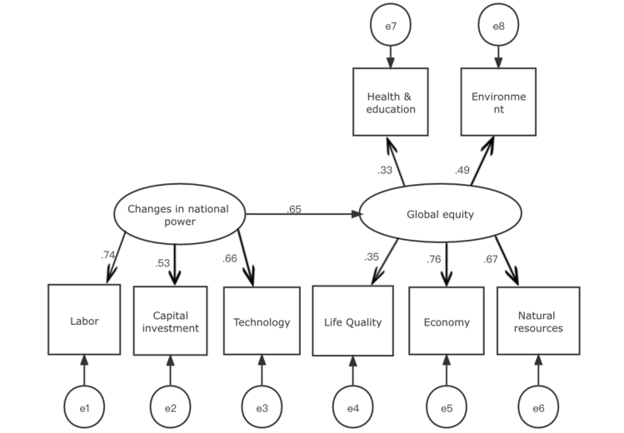
Figure 13: Result of SEM
图 13：SEM 结果
图中文字对照（英文 → 中文）
Changes in national power | 国家实力变化 | Global equity | 全球公平
Health & education | 健康与教育 | Environment | 环境
Labor | 劳动力 | Capital investment | 资本投入
Technology | 技术 | Life Quality | 生活质量
Economy | 经济 | Natural resources | 自然资源
7 Policy Proposal
7 政策建议
7.1 Collect Royalties
7.1 征收权利金
The U.S. enacted the U.S. Commercial Space Launch Competitiveness Act in 2015 to promote the competitiveness of domestic private space industry. The treaty authorizes mining and recognizes the property rights of U.S. citizens to asteroid resources. The United States believes that this does not violate the Outer Space Treaty. The latter emphasizes that "Outer space shall be free for exploration and use by all states". Based on diﬀerent understandings of this, the world is quite controversial about the law of U.S. .
美国于 2015 年颁布《美国商业航天发射竞争力法案》，以提升本国私营航天产业的竞争力。该法案授权进行采矿，并承认美国公民对小行星资源的财产权。美国认为这并不违反《外层空间条约》。后者强调“外层空间应可供所有国家自由探索和利用”。基于对此的不同理解，世界对美国该法律存在较大争议。
In fact, the Moon Treaty considers the moon and other celestial bodies to be the common heritage of mankind. This is also similar to the United Nations Convention on the Law of the Sea. In this convention, the deep sea is considered beyond national territory and is the common property of mankind. Based on this understanding, we can charge some kind of royalties on the mining behavior of the states. These royalties will be redistributed among all countries of the world. We sort out the policy details as follows:
事实上，《月球协定》认为月球及其他天体是人类的共同继承财产。这也与《联合国海洋法公约》相类似。在该公约中，深海被视为超出国家领土范围，是人类的共同财产。基于这一理解，我们可以针对各国的采矿行为征收某种权利金。这些权利金将在世界各国之间重新分配。我们将政策细节梳理如下：
1) Resources completely and privately. The development of asteroid resources requires payment of royalties to the Regulatory Authority.
1) 资源完全归私人所有。小行星资源的开发需要向监管机构支付权利金。
— 原文第 21 页 —
The fee is progressively charged according to the value of the asteroid resources applied for mining, and there are a uniﬁed charging threshold and charging rate for all the countries.
该费用根据申请开采的小行星资源价值累进征收，并且对所有国家实行统一的征收门槛和征收费率。
2) The royalties collected serve as an international fund to distribute interest to citizens around the world. When distributing fees and in-kinds, the supervisory authority shall follow the standard of fair sharing and take into account the interests and needs of developing countries, especially the least developed countries.
2) 所征收的权利金充作国际基金，向世界各国公民分配收益。在分配费用和实物时，监管机构应遵循公平分享的标准，并考虑发展中国家的利益和需求，特别是最不发达国家。
3) A portion of the royalties can also be used to create loan programs to help less developed countries develop space technology and education. It’s aimed to improve their capabilities in asteroid mining, and charge low or even waiver of interest on loans.
3) 部分权利金还可用于设立贷款计划，帮助欠发达国家发展空间技术和教育。其目的是提高这些国家的小行星采矿能力，并对贷款收取低息甚至免息。
In fact, the imposition of royalties is a more moderate public policy than upper bound on market share. It can reduce market share to some extent. It is showed that there is an advantage to reducing market share. This public policy keeps this advantage. At the same time, this policy avoids rigid uniformity, and still reserves some development space for developed countries with high market share. This can further promote the development of the industry. This can also make this industry reach the previously mentioned inﬂection point earlier, thus enabling the industry to develop and curb inequity. In addition, the charging rate and threshold can be adjusted according to the potential output of the industry. Therefore, it is more ﬂexible and is conducive to unleash the potential of the industry.
事实上，征收权利金是一种比设定市场份额上限更为温和的公共政策。它能够在一定程度上降低市场份额。研究表明，降低市场份额具有优势。这一公共政策保留了这种优势。与此同时，该政策避免了僵化的一刀切，仍为市场份额较高的发达国家保留了一定的发展空间。这可以进一步促进行业的发展。这也能使该行业更早达到前述拐点，从而既实现行业发展又抑制不公平。此外，征收费率和门槛可以根据行业的潜在产出进行调整。因此，它更为灵活，有利于释放行业的潜力。
7.2 Strict Approval Procedures
7.2 严格的审批程序
In order to fully consider the common interests and equity of all humankind, international regulatory organizations should examine the mining applications of countries and enterprises more strictly. The mining application includes but is not limited to the applicant’s fund-raising plan, ﬁnancial statements, relevant experience, technical qualiﬁcations, environmental impact report, emergency plan and other documents. Any application that seriously pollutes space, has adverse eﬀects on the security of other countries, or destroys the common property of mankind should be rejected.
为了充分考虑全人类的共同利益和公平，国际监管组织应更加严格地审查各国和企业的采矿申请。采矿申请包括但不限于申请人的筹资计划、财务报表、相关经验、技术资质、环境影响报告、应急预案及其他文件。任何严重污染太空、对其他国家安全产生不利影响或破坏人类共同财产的申请都应被驳回。
1) Strictly review the mining volume and mining value in the international application proposal to ensure a fair and stable price for minerals from space.
1) 严格审查国际申请方案中的开采量与开采价值，以确保来自太空的矿物价格公平且稳定。
2) Quantitatively estimate the possible space pollution and damage caused by mining operations. Prohibit applications that seriously aﬀect the continuation of asteroid mining by other countries in the future.
2) 定量估算采矿作业可能造成的空间污染与损害。禁止批准那些会严重影响其他国家未来继续进行小行星采矿的申请。
3) Strictly review the equipment launched in the application proposal to prevent any country from making military deployments in space or maliciously destroying asteroid resources.
3) 严格审查申请方案中所发射的设备，防止任何国家在太空进行军事部署或恶意破坏小行星资源。
4) Review the integrity of the applicant, the purpose of exploration, and whether the applicant has the corresponding conditions for completing the application plan in terms of funds, technical level, and equipment.
4) 审查申请人的诚信状况、勘探目的，以及申请人在资金、技术水平和设备等方面是否具备完成申请计划的条件。
5) Review the proposal to see if there are any acts that destroy the common heritage of mankind involving history, culture, etc.
5) 审查方案中是否存在涉及历史、文化等人类共同继承财产的破坏行为。
Strict approval procedures can control the market in a timely manner and reduce the occurrence of sales behaviors that endanger the market. In this way, price stability can be indirectly controlled. As in the previous analysis, changes in prices can actually aﬀect factors such as output, resulting in a shift in the game equilibrium point. This eﬀect is transmitted to the entire market through the correlation described by SEM, thereby aﬀecting global equity. We can predict the change direction of the global equity index in advance with the help of strict approval procedures and above conclusions. Then we can control the changes that cause adverse eﬀects in the early stage.
严格的审批程序能够及时调控市场，减少危害市场的销售行为的发生。由此可以间接控制价格的稳定。如前文分析，价格的变化实际上会影响产量等因素，从而导致博弈均衡点发生移动。这一效应通过 SEM 所描述的关联关系传导至整个市场，进而影响全球公平。我们可借助严格的审批程序及上述结论，提前预测全球公平指数的变化方向。进而可以在早期阶段对产生不利影响的变化加以控制。
— 原文第 22 页 —
7.3 Encourage cooperative development
7.3 鼓励合作开发
As mentioned above, due to the unbalanced level of scientiﬁc and technological development, there are many countries that do not have the technical conditions for asteroid mining. Even if they do, their mining is less eﬃcient and extremely costly, making it impossible for these countries to proﬁt. Therefore, international regulatory organizations should encourage developed countries and less developed countries to cooperate, and reduce royalties of developed countries as incentive, so that both countries can beneﬁt from asteroid mining. In addition, international regulatory organizations can also allow backward countries to transfer unattainable market share to countries with productivity surpluses, which to some extent provides the interests of them.
如上所述，由于科学技术发展水平不平衡，许多国家并不具备小行星采矿的技术条件。即使具备，其开采效率也较低且成本极高，使这些国家无法获利。因此，国际监管组织应鼓励发达国家与欠发达国家开展合作，并以降低发达国家权利金作为激励，使双方都能从小行星采矿中获益。此外，国际监管组织还可允许落后国家将其无法实现的市场份额转让给产能过剩的国家，这在一定程度上保障了它们的利益。
Cooperative development could provide backward countries with advanced science and technology, increasing their A value, which in turn increases their productivity and potentially reduce costs. Moreover, this inﬂuence can be transmitted to other aspects through the correlation revealed by SEM, and ﬁnally promote global equity.
合作开发可为落后国家提供先进的科学技术，提高其 A 值，进而提高其生产率并有可能降低成本。而且，这一影响可通过 SEM 所揭示的关联关系传导至其他方面，最终促进全球公平。
8 Sensitivity Analysis
8 灵敏度分析
We conduct sensitivity analysis on upper bound of market shareδ^{U} referred at the third question. We set δ^{U} = 0.26, 0.28, 0.30, 0.32, 0.34 respectively and draw the diagram of global equity index with the change of the number of companies. The result is as follows:
我们对第三问中提到的市场份额上界 δ^{U} 进行灵敏度分析。分别取 δ^{U} = 0.26, 0.28, 0.30, 0.32, 0.34，绘制全球公平指数随公司数量变化的图。结果如下：
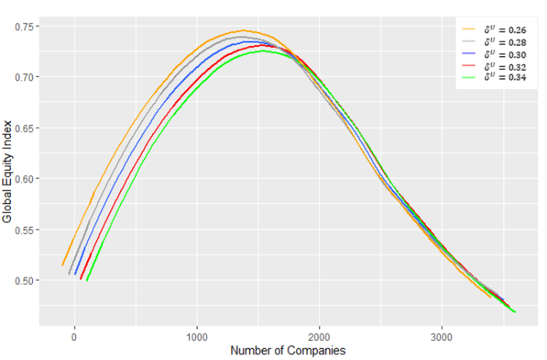
Figure 14: Sensitivity Analysis
图 14：灵敏度分析
图中文字对照（英文 → 中文）
Global Equity Index | 全球公平指数 | Number of Companies | 公司数量
δU = 0.26 | 参数 δU = 0.26 | δU = 0.28 | 参数 δU = 0.28
δU = 0.30 | 参数 δU = 0.30 | δU = 0.32 | 参数 δU = 0.32
δU = 0.34 | 参数 δU = 0.34
The result shows that, for every chosen δ^{U}, with the change of the number of companies, global equity index has the same trend as the third question. The result shows the stability of our model.
结果表明，对于所选取的每一个 δ^{U}，随着公司数量的变化，全球公平指数呈现出与第三问相同的趋势。该结果体现了模型的稳定性。
— 原文第 23 页 —
9 Strength and Weakness
9 优缺点
9.1 Strength
9.1 优点
The selection indicators in our model is scientiﬁc and comprehensive. When determining the indicators, we considered over 20 sets of data from over 180 countries. These indicators represent main factors in the regard of global equity, making our research more reliable.
我们模型中所选取的指标科学且全面。在确定指标时，我们考虑了来自 180 多个国家的 20 余组数据。这些指标反映了全球公平方面的主要因素，使我们的研究更加可靠。
We combine subjective and objective weighting methods, so the weights we calculate are more reliable. As a subjective weighting method, AHP obtains weights through empirical judgment, while the objective EWM obtains weights through data. By Combination of the two, we can make use of literature and experience in life while maintaining objectivity.
我们将主观赋权方法与客观赋权方法相结合，因而计算出的权重更为可靠。作为主观赋权方法，AHP 通过经验判断获取权重；而客观的 EWM 则通过数据获取权重。二者结合，使我们既能利用文献与生活经验，又能保持客观性。
Data Processing. We interpolate data with random forest method, unify data unit and merge multiple indicators from diﬀerent tables by their country codes. During the visualization process, we also take the logarithm of the data appropriately, and ﬁnally obtained more intuitive results.
数据处理方面，我们采用随机森林方法对数据进行插值，统一数据单位，并按国家代码合并来自不同表格的多个指标。在可视化过程中，我们还对数据适当地取对数，最终得到更为直观的结果。
9.2 Weakness
9.2 缺点
The model does not consider the impact of sudden factors. Based on Assumption 6, asteroid mining activityies are stable and predictable, so we did not consider the disturbance of sudden impact factors when considering the international environment as a whole.
模型未考虑突发因素的影响。基于假设 6，小行星采矿活动是稳定且可预测的，因此在将国际环境作为整体考察时，我们未考虑突发冲击因素的扰动。
Our HELEN model has a high demand for original data and contains complex calculations. There will be diﬃculty in collecting all the data. And the indicators we choose, such as the Moran Index, are rather diﬃcult to calculate as well.
我们的 HELEN 指标体系对原始数据要求较高，且包含复杂的计算。在收集全部数据方面会存在困难。而且我们所选取的指标（如莫兰指数）也相当难以计算。
— 原文第 25 页 —
Appendices
附录
Appendix A
附录 A
First appendix
第一附录
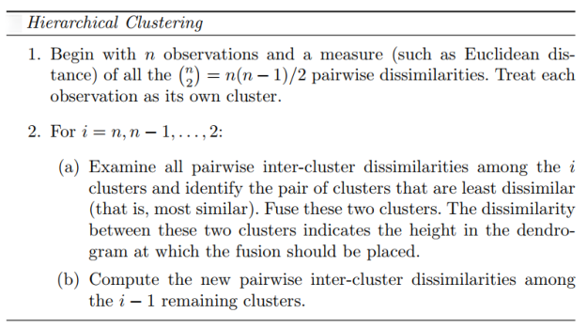
where the ward connectivity measure refers to the requirement to reduce the variance within the cluster as much as possible after each merge.
其中 ward 连通性度量是指每次合并后要求尽可能降低簇内方差的要求。
Appendix B
附录 B
Second appendix
第二附录
Denote Cobb-Douglas production function as follows:
将柯布-道格拉斯生产函数表示如下：
Y = Ak^{α}l^{β}
We take the logarithmic transformation to get:ln Y = ln A + α ln k + β ln l
取对数变换可得：ln Y = ln A + α ln k + β ln l
Using linear regression, we can derive the estimation of A, ˆA from the constant term from the following expression (denote the constant term as ˆβ₀):
利用线性回归，可由下式中的常数项得到 A 的估计值 Â（记常数项为 ˆβ₀）：
ˆ
ˆA = e
β₀
Performing the above calculation on the selected 5 representative countries, we can get the ˆA values of the ﬁve categories of countries. For the form of the inverse demand function, we make the simplest assumptions as follows:p(Q) = a −kQwhere a and k are constant terms for given industry. We use world nickel production and price data in recent years to perform regression analysis, and obtain the following expression:p(Q) = 12016.08 −30.18Q
对所选 5 个代表性国家进行上述计算，即可得到五类国家的 Â 值。关于反需求函数的形式，我们作如下最简假设：p(Q) = a − kQ，其中 a 与 k 为给定行业的常数项。我们利用近年世界镍产量与价格数据进行回归分析，得到如下表达式：p(Q) = 12016.08 − 30.18Q
That is, a = 12016.08, k = 30.18.
即 a = 12016.08，k = 30.18。
— 原文第 24 页 —
References
[1] https://ourworldindata.org/ [2] https://www.statista.com/ [3] https://wid.world/ [4] https://www.ceicdata.com/en [5] James, G. , D Witten, Hastie, T. , & Tibshirani, R. . (2013). An Introduction to Statistical Learning: With Applications in R.
[6] Nicholson, W. . (2011). Microeconomic Theory: Basic Principles and Extensions, 11th Edition. The Dryden.
[7] https://www.unoosa.org/oosa/en/ourwork/spacelaw/treaties/intromoon-agreement.html [8] Steﬀen, O. (2021). Explore to Exploit: A Data-Centred Approach to Space Mining Regulation. Space Policy, 101459.
[9] Fox, S. J. (2019). Policing mining: In outer-space greed and domination vs. peace and equity a governance for humanity!. Resources Policy, 64, 101517.
[10] Carley, M., & Spapens, P. (2017). Sharing the world: sustainable living and global equity in the 21st century. Routledge.
[11] Phylaktis, K., & Xia, L. (2006). The changing roles of industry and country eﬀects in the global equity markets. The European Journal of Finance, 12(8), 627-648.
[12] Ross, S. D. (2001). Near-earth asteroid mining. Space, 1-24.
[13] Lewicki, C., Diamandis, P., Anderson, E., Voorhees, C., & Mycroft, F. (2013). Planetary resources—The asteroid mining company. New Space, 1(2), 105-108.
[14] Von der Dunk, F. G. (2017). Asteroid mining: international and national legal aspects. Mich. St. Int’l L. Rev., 26, 83.
[15] Busch, M. (2004). Proﬁtable asteroid mining. Journal of the British Interplanetary Society, 57, 301-305.
（全文完。公式与表格在原 PDF 中是矢量图形，未纳入本对照版；可按文中「原文第 N 页」标记翻到 2224021.pdf 对照查看。）

