2400996 英中对照版
2024 MCM Problem A · Adaptive Sex of Lamprey under Resource Availability
读法：黑字为原文，蓝字为译文，一段英文一段中文，上下对应；蓝字里的小字括号是该术语第一次出现时的英文原词。
术语表（按首次出现排序，18 条）
# | 英文 | 中文 | 说明：为什么容易译错
1 | Sea Lamprey | 海七鳃鳗 | 题设物种，性别比例随资源变化
2 | Adaptive Sex Ratio | 适应性性别比例 | 个体按环境调整后代性别比例
3 | Ecosystem | 生态系统 | 本文的建模对象层级
4 | Biomass | 生物量 | 衡量种群规模的核心量
5 | Population Iteration Model | 种群迭代模型 | 按时间步递推各龄级数量
6 | Predator-Prey | 捕食者-被捕食者 | 物种间的数量耦合关系
7 | Carrying Capacity | 环境容纳量 | 环境能支撑的最大种群规模
8 | Food Chain | 食物链 | 能量在物种间传递的路径
9 | Life Cycle | 生命周期 | 从幼体到成体的全过程
10 | Larval Stage | 幼体阶段 | 七鳃鳗埋栖的早期阶段
11 | Metamorphosis | 变态发育 | 幼体转变为成体
12 | Spawning | 产卵 | 成体繁殖行为
13 | Differential Equation | 微分方程 | 描述连续变化的种群动态
14 | Multiple Population Evolutionary Model | 多种群演化模型 | 多个物种同时演化的模型
15 | Ecosystem Stability | 生态系统稳定性 | 扰动后恢复平衡的能力
16 | Invasive Species | 入侵物种 | 七鳃鳗在五大湖属于入侵种
17 | Optimization Rate | 优化率 | 调控后指标相对基准的改善幅度
18 | Sensitivity Analysis | 灵敏度分析 | 改动参数看结论是否稳定

Adaptive Sex of Lamprey: gift or curse?
海七鳃鳗的适应性性别：恩赐还是诅咒？
Summary
摘要
While having great food and research value, the lamprey has long been a cause for concern because it is an invasive species in some areas. Because of this complexity, it has long been in the spotlight. Is this a gift or a curse? To explore this phenomenon, we modeled the iterative process of lamprey populations and analyzed the effects of adaptive-sex on lamprey populations and the larger ecosystem.
海七鳃鳗（Sea Lamprey）虽具有极高的食用价值与研究价值，但长期以来一直是人们担忧的对象，因为在某些地区它属于入侵物种（Invasive Species）。正是由于这种复杂性，它长期以来一直处于聚光灯之下。这究竟是恩赐还是诅咒？为探究这一现象，我们对海七鳃鳗种群的迭代过程进行了建模，并分析了适应性性别对海七鳃鳗种群以及更大范围生态系统（Ecosystem）的影响。
Several models are established: Model I: Lamprey Population Iteration Model; Model II: BDS Assessment Model, etc.
本文建立了若干模型：模型一：海七鳃鳗种群迭代模型（Population Iteration Model）；模型二：BDS 评估模型等。
Before all the models are established, based on the special characteristics of lamprey metamorphosis, we divided the lamprey population into two parts: larval and adult bank, so as to simulate the ecosystem with higher simulation. In addition, we collected data and set reasonable parameters through calculation.
在建立全部模型之前，基于海七鳃鳗变态发育（Metamorphosis）的特殊性，我们将海七鳃鳗种群划分为两部分：幼体库与成体库，以期对生态系统进行更高精度的模拟。此外，我们收集了数据，并通过计算设定了合理的参数。
For Model I, we established three sub-models to form the Lamprey Population Iteration Model. The sub-model i is based on Lotka-Volterra basic model, modiﬁed for the nature of the larval and adult bank, which describes the competition between lamprey and other species in the ecosystem. The sub-model ii is based on bioenergetic theory and establishes the relationship between resource availability and sex ratio. The submodel iii is based on the cost of reproduction, and establishes the relationship between sex ratio and fertility rate, which serves as a bridge between sub-models i and ii.
对于模型一，我们建立了三个子模型，以构成海七鳃鳗种群迭代模型。子模型 i 以 Lotka-Volterra 基本模型为基础，并针对幼体库与成体库的特性加以修正，用以描述海七鳃鳗与生态系统中其他物种之间的竞争关系。子模型 ii 以生物能量学理论为基础，建立了资源可得性与性别比例之间的关系。子模型 iii 以繁殖代价为基础，建立了性别比例与繁殖率之间的关系，从而在子模型 i 与子模型 ii 之间起到桥梁作用。
• For task 2, we simulated the iteration with and without adaptive sex lamprey population respectively, and adjusted the environmental parameters downward and upward at the two time points for comparative analysis, and the results show that adaptive sex enhances the resilience stability of the population and reduces the resistance stability of the population, for details, see 4.1.3.
• 针对任务 2，我们分别模拟了具有适应性性别与不具有适应性性别的海七鳃鳗种群的迭代过程，并在两个时间点分别下调与上调环境参数进行对比分析；结果表明，适应性性别增强了种群的恢复力稳定性，同时降低了种群的抵抗力稳定性，详见 4.1.3。
• For task 4, we added a reasonably set Correlation Matrix that covers the basic components of the ecosystem. From it, we selected parasites and parasitized ﬁsh for comparative analysis, and the results and conclusions are presented in 4.2.3. For Model II, we established a complete ecological system assessment model covering Biomass, Diversity and Stability, in which Shannon-Wiener diversity index was introduced to measure the ecosystem’s The Shannon-Wiener diversity index is introduced to measure ecosystem diversity, and a new variance-based measure of Stability, S, is introduced. By substituting the results of Model I into Model II, we are able to compare and analyze the effects of adaptive sex on ecosystems in the three dimensions.
• 针对任务 4，我们加入了一个合理设定的相关性矩阵，其涵盖了生态系统的基本组成部分。由此，我们选取寄生虫与被寄生的鱼类进行对比分析，结果与结论见 4.2.3。对于模型二，我们建立了一个完整的生态系统评估模型，涵盖生物量（Biomass）、多样性与稳定性三个方面；其中引入 Shannon-Wiener 多样性指数以衡量生态系统多样性，并提出了一种新的基于方差的稳定性度量 S。将模型一的结果代入模型二，我们便能够在上述三个维度上对比分析适应性性别对生态系统的影响。
• For task 3, the results show that adaptive has a positive effect on ecosystem stability, and the optimization rate R reaches 73.3%.
• 针对任务 3，结果表明适应性性别对生态系统稳定性（Ecosystem Stability）具有正向作用，优化率（Optimization Rate） R 达到 73.3%。
• For task 1, the results showed that adaptive sex promoted Biomass and diversity, but the optimization rate R reached 5.87% and 5.90%, respectively, compared with that of stability.
• 针对任务 1，结果表明适应性性别促进了生物量与多样性的提升，但与稳定性相比，其优化率 R 分别仅为 5.87% 和 5.90%。
Finally, weconverted ratio k from adult to larval and the endowment growth rate b₀ for sensitivity analysis. The results show the stability of our model is good. Finally, we discussed the strengths and weaknesses of the model and made a conclusion.
最后，我们对由成体向幼体的转化比例 k 以及禀赋增长率 b₀ 进行了灵敏度分析（Sensitivity Analysis）。结果表明，我们模型的稳定性良好。最后，我们讨论了模型的优缺点并得出了结论。
Key Words: lamprey, sex ratio, Lotka-Volterra, correlation matrix, stability
关键词：海七鳃鳗，性别比例，Lotka-Volterra，相关性矩阵，稳定性
— 原文第 3 页 —
1 Introduction
1 引言
1.1 Problem Background
1.1 问题背景
In the world, the lamprey can be regarded as a "star creature" that has attracted much attention. On one hand, lamprey has long been a favorite food for humans in Europe and Southeast Asia, and even captured the hearts of medieval European aristocrats; on the other hand, as a major invasive species in the Great Lakes of North America, it has caused local authorities to struggle to curb its development. Whether you’re a fan or a opponent, there’s no denying that the lamprey is valuable to study because of its unique ecology and adaptive sex.
在世界范围内，海七鳃鳗可被视为一种备受关注的“明星生物”。一方面，海七鳃鳗长期以来是欧洲与东南亚人们喜爱的食物，甚至俘获了中世纪欧洲贵族的心；另一方面，作为北美五大湖区的主要入侵物种，它令当地管理部门疲于遏制其扩张。无论你是它的拥趸还是反对者，都无法否认：因其独特的生态学特性与适应性性别，海七鳃鳗具有很高的研究价值。
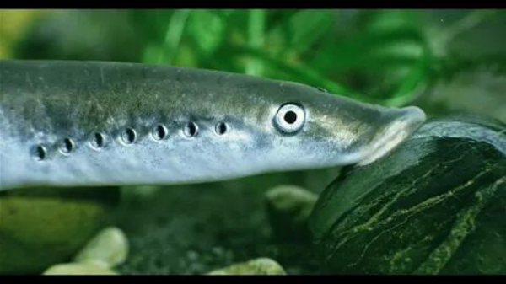
Figure 1: Sea lamprey
图 1：海七鳃鳗
The picture above shows the ecological appearance of lamprey. Lacking paired ﬁns, adult lampreys have one nostril atop the head and seven gill pores on each side of the head.During the larval period (called ammocoetes),they burrow in silt, mud and detritus, taking up an existence as ﬁlter feeders, collecting detritus, algae, and microorganisms. The rate of water moving across the ammocoetes’ feeding apparatus is the lowest recorded in any suspension feeding animal, and they therefore require water rich in nutrients to fulﬁll their nutritional needs [1].As adults, they acquire nutrients by parasitizing other ﬁsh to reach sexual maturity. After spawning is over, all adults die.In addition to double life due to metamorphic development, it is also amazing in its ability to differentiate the sexes according to the environment,also known as adaptive sex ratio variation.
上图展示了海七鳃鳗的生态外观。成体海七鳃鳗缺少成对鳍，头顶具一个鼻孔，头部两侧各具七个鳃孔。在幼体阶段（Larval Stage）（称为 ammocoetes），它们钻入粉砂、淤泥与碎屑之中，以滤食方式生存，摄食碎屑、藻类与微生物。水流经幼体摄食器官的速率是已记录的所有悬食性动物中最低的，因此它们需要富含营养的水体才能满足其营养需求 [1]。成为成体后，它们通过寄生其他鱼类获取营养，以达到性成熟。产卵（Spawning）结束后，所有成体均会死亡。除因变态发育而形成的双重生活史外，其根据环境分化性别的能力同样令人惊叹，这被称为适应性性别比例（Adaptive Sex Ratio）变化。
1.2 Restatement of the Problem
1.2 问题重述
Under the above background,in order to explore the value of the ability for a species to alter its sex ratio depending on resource availability, our group will study the ecosystempopulation interactions and accomplish the following tasks:
在上述背景下，为探究某一物种依据资源可得性改变其性别比例这一能力的价值，本组将研究生态系统中的种群相互作用，并完成以下任务：
(1) Study the impact on the larger ecological system when the population of lampreys can alter its sex ratio.
(1) 研究当海七鳃鳗种群能够改变其性别比例时，对更大范围生态系统的影响。
(2) Study the advantages and disadvantages to the population of lampreys.
(2) 研究这一能力对海七鳃鳗种群自身的利与弊。
(3) Study the impact on the stability of the ecosystem given the changes in the sex ratios of lampreys.
(3) 研究在海七鳃鳗性别比例发生变化的情况下，对生态系统稳定性的影响。
— 原文第 4 页 —
(4) Research whether an ecosystem with variable sex ratios in the lamprey population offer advantages to others in the ecosystem, such as parasites.
(4) 研究在海七鳃鳗种群性别比例可变的生态系统中，是否对其他成员（如寄生虫）具有优势。
1.3 Literature Review
1.3 文献综述
This issue focuses on the implications of the adaptive sex-ratio of lamprey. In recent years, research on population models for lamprey has focused on both the biological nature of lamprey and suitable basic models.
本问题聚焦于海七鳃鳗适应性性别比例所蕴含的意义。近年来，关于海七鳃鳗种群模型的研究同时着眼于海七鳃鳗的生物学特性与相适宜的基础模型。
Biologically, Lamprey differs from the most commonly studied unicellular organisms and mammals in three biological properties: metamorphosis, postnatal-death and adaptive-sex. ﬁrst, the development of Lamprey involves a metamorphosis process. lamprey’s larval are ﬁlter feeders, while adults are parasitic [2].Second, adults die after reproduction, which implies a cycle of peak mortality [3]. Finally, the sex ratio of adults is affected by the growth rate of larval, which is the focus of our study [4].
在生物学上，海七鳃鳗与最常被研究的单细胞生物及哺乳动物在三个生物学特性上存在差异：变态发育、产后死亡与适应性性别。首先，海七鳃鳗的发育过程包含一个变态发育过程。海七鳃鳗的幼体是滤食者，而成体营寄生生活[2]。其次，成体在繁殖后死亡，这意味着存在一个死亡率高峰的周期[3]。最后，成体的性别比例受幼体生长速率的影响，这正是我们研究的重点[4]。
As for the basic models, the most commonly used models are logistic models, lotka-volterra-like models, and food-web models.It is worth noting that neither the lotka-volterra model with lagged effects and functional reactivity functions [5] nor the food-web model [6] based on energy ﬂow can comprehensively take into account the lamprey’s three biological characteristics, which means we need to improve the basic models.
就基础模型而言，最常用的模型是 Logistic 模型、类 Lotka-Volterra 模型和食物网模型。值得注意的是，无论是带滞后效应与功能反应函数的 Lotka-Volterra 模型[5]，还是基于能量流动的食物网模型[6]，都无法全面考虑海七鳃鳗的三个生物学特性，这意味着我们需要对基础模型加以改进。
The advantages and disadvantages of the three basic models are shown below.
三种基础模型的优缺点如下所示。
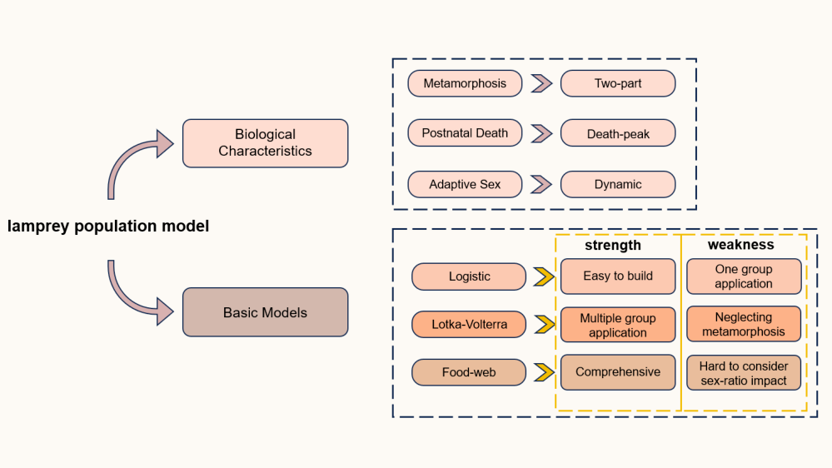
Figure 2: Literature Review
图 2：文献综述
图中文字对照（英文 → 中文）
Biological Characteristics | 生物学特征 | Metamorphosis | 变态发育
Two-part | 两阶段（模型） | Postnatal Death | 出生后死亡
Death-peak | 死亡高峰 | Adaptive Sex | 适应性性别
Basic Models | 基础模型 | Logistic | 逻辑斯蒂（模型）
Lotka-Volterra | Lotka-Volterra（捕食者-被捕食者模型） | Food-web | 食物网
strength | 优势 | weakness | 劣势
Easy to build | 易于构建 | One group application | 单一种群应用
Multiple group application | 多群体应用 | Neglecting metamorphosis | 忽略变态发育
Comprehensive | 综合性 | Hard to consider sex-ratio impact | 难以考虑性别比例影响
1.4 Our Work
1.4 我们的工作
Our solution mindmap is shown below.
我们的求解思路导图如下所示。
— 原文第 5 页 —
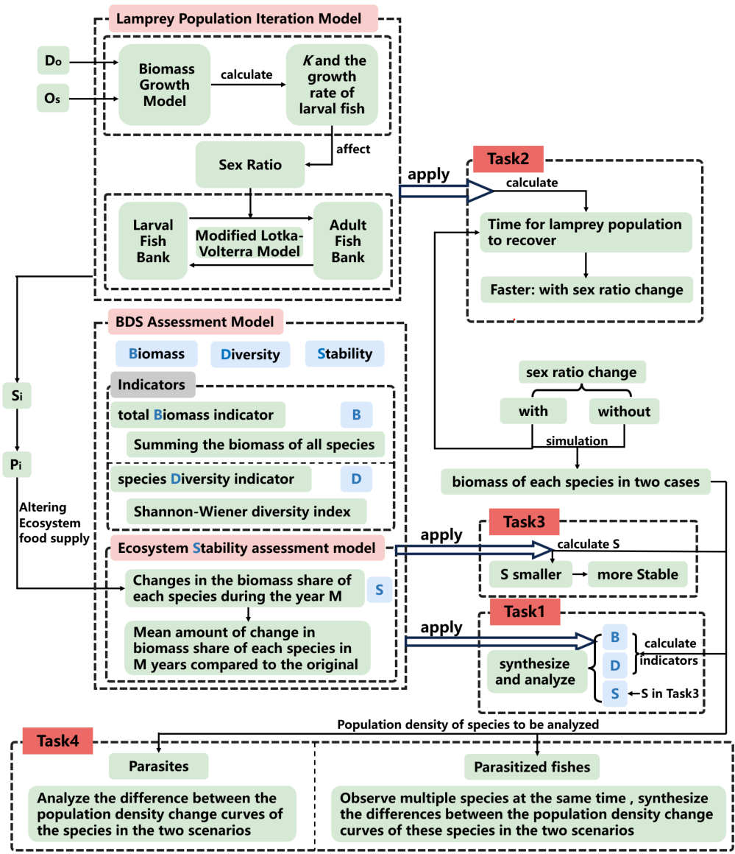
Figure 3: Our work
图 3：我们的工作
图中文字对照（英文 → 中文）
Lamprey Population Iteration Model | 七鳃鳗种群迭代模型 | Biomass Growth Model | 生物量增长模型
K and the growth rate of larval fish | 幼鱼的环境容纳量与增长率 | Sex Ratio | 性别比例
Larval Fish Bank | 幼鱼库 | Modified Lotka-Volterra Model | 修正Lotka-Volterra模型
Adult Fish Bank | 成鱼库 | Time for lamprey population to recover | 七鳃鳗种群恢复所需时间
BDS Assessment Model | BDS评估模型 | total Biomass indicator | 总生物量指标
species Diversity indicator | 物种多样性指标 | Shannon-Wiener diversity index | Shannon-Wiener多样性指数
Ecosystem Stability assessment model | 生态系统稳定性评估模型 | more Stable | 更稳定
Task3 | 任务3 | Task1 | 任务1
Task4 | 任务4 | Parasitized fishes | 被寄生的鱼类
2 Model Preparation
2 模型准备
2.1 Assumptions and Justiﬁcations
2.1 假设与理由
• Assumption 1: The time for adult ﬁsh to migrate, lay eggs, die, and hatch into larval is negligible.
• 假设 1：成鱼洄游、产卵、死亡以及孵化成幼体所需的时间可忽略不计。
Justiﬁcation: Our model calculates in years, so ﬁner time scales will not be considered. The only time we primarily consider is the time it takes for a larval to grow into an adult, which will be counted directly as a yearling after spawning.
理由：我们的模型以年为时间单位进行计算，因此不考虑更细的时间尺度。我们主要考虑的唯一时间量是幼体生长为成体所需的时间，该时间在产卵后将直接按一年计入。
— 原文第 6 页 —
• Assumption 2: Sea lampreys die immediately after spawning.
• 假设 2：海七鳃鳗在产卵后立即死亡。
Justiﬁcation: Based on our review of the literature [7], lampreys die after spawning in a short time, so we neglect the time after them ﬁnish spawning.
理由：根据我们对文献[7]的梳理，海七鳃鳗在产卵后会在短时间内死亡，因此我们忽略其产卵结束之后的时间。
• Assumption 3: Temperatures are suitable and consistent throughout the year in all areas of the water body.
• 假设 3：水体各区域全年的温度均适宜且保持一致。
Justiﬁcation: Temperature plays a considerable role in larval survival, and discussion of lamprey reproduction is only meaningful if temperatures are appropriate. The assumption of consistent temperatures in all zones was made to simplify the model.
理由：温度对幼体的存活起着相当大的作用，只有在温度适宜的情况下讨论海七鳃鳗的繁殖才有意义。假设所有区域温度一致是为了简化模型。
• Assumption 4: Suspended organic solid and dissolved oxygen concentration in the water column are not affected by lamprey and are consistent across regions.
• 假设 4：水体中的悬浮有机固体与溶解氧浓度不受海七鳃鳗影响，且在各区域间保持一致。
Justiﬁcation: Lamprey’s large range and the mobility of the water imply that the environmental resources of the watershed are replenishable. Neglecting anthropogenic factors, we can assume that both are stable over large time scales. item Assumption 5: Ignoring major natural disasters and human impacts.
理由：海七鳃鳗分布范围广，加之水体的流动性，意味着流域的环境资源是可补充的。在忽略人为因素的情况下，我们可以假定两者在较大的时间尺度上均保持稳定。要点 假设 5：忽略重大自然灾害与人类影响。
Justiﬁcation: Since major natural disasters and human disturbances are difﬁcult to predict, our model does not take them into account.
理由：由于重大自然灾害与人类干扰难以预测，我们的模型未将其纳入考虑。
2.2 Notations
2.2 符号说明
This chapter introduces the symbols and their descriptions mentioned in the article.
本章介绍文中涉及的符号及其说明。
Table 1: Notations Table
表 1：符号说明表
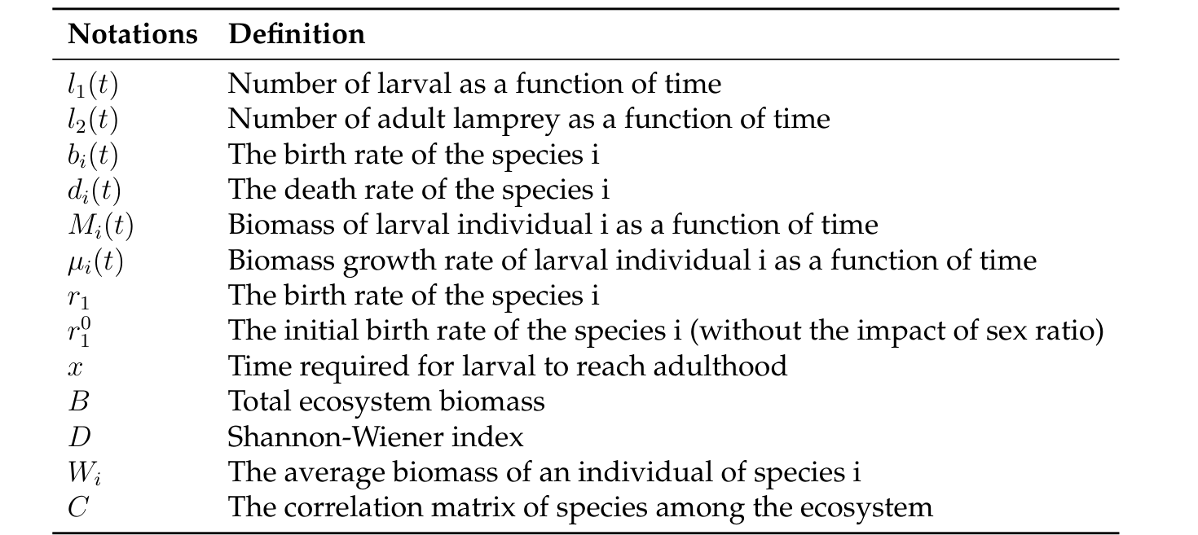
2.3 Data Collection and Visualization
2.3 数据收集与可视化
This article relies on the following table of data sources.
本文依据下列数据来源表。
— 原文第 7 页 —
Table 2: Data Source Websites
表 2：数据来源网站
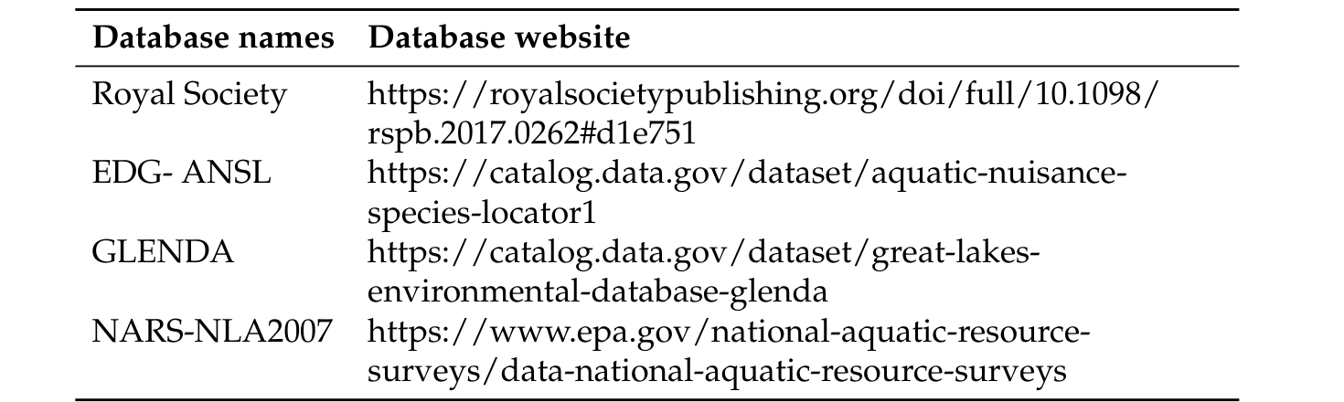
• From the Royal Society we obtained raw data on the sex of lamprey samples.
• 我们从英国皇家学会获得了海七鳃鳗样本性别的原始数据。
• From EDG we obtained data on the distribution of lamprey in the Great Lakes region.
• 我们从 EDG 获得了海七鳃鳗在五大湖地区分布的数据。
• From GLENDA we obtained data on the suspended organic solid concentration of Great Lakes water bodies.
• 我们从 GLENDA 获得了五大湖水体的悬浮有机固体浓度数据。
• From NARS- NLA2007 we obtained dissolved oxygen concentration data for Great Lakes water bodies.
• 我们从 NARS-NLA2007 获得了五大湖水体的溶解氧浓度数据。
The following ﬁgure visualizes the distribution data of Great Lakes lamprey(2021).
下图对五大湖海七鳃鳗（2021 年）的分布数据进行了可视化。
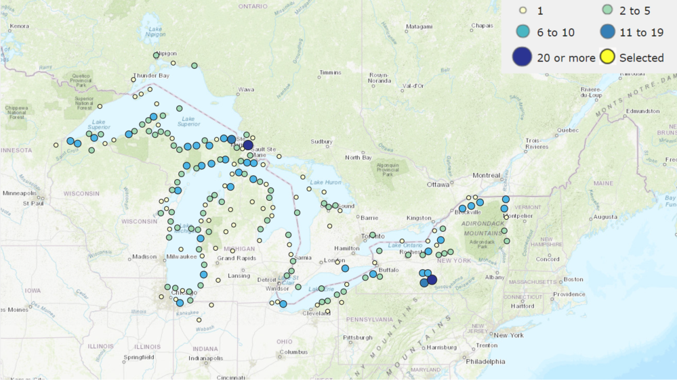
Figure 4: Lamprey samples’ distribution in the Great Lakes region
图 4：海七鳃鳗样本在五大湖地区的分布
图中文字对照（英文 → 中文）
1 | 1（观测点数） | 2 to 5 | 2至5
6 to 10 | 6至10 | 11 to 19 | 11至19
20 or more | 20及以上 | Selected | 选定
It can be seen that lamprey are more heavily concentrated in the more nutrient-rich lake areas; in these areas their densities are approximately the same.
可以看出，海七鳃鳗更集中分布于营养更为丰富的湖域；在这些区域，其密度大致相同。
— 原文第 8 页 —
3 Model Establishment
3 模型建立
3.1 Model I: Lamprey Population Iteration Model
3.1 模型 I：海七鳃鳗种群迭代模型
3.1.1 Research on the life cycle of lampreys
海七鳃鳗生命周期的研究
Based on the relevant literature, we can understand that the life cycle of lampreys can be divided into approximately two stages. The ﬁrst stage is the larval stage, where adult lampreys migrate from the sea to the river to spawn and hatch as ammocoetes. During the larval stage, these ammocoetes tend to reside in the substrate, with only a single mouth exposed to the surface. This submerged life helps them avoid predators and utilize the organic matter in the substrate. They are ﬁlter feeders, feeding primarily on microorganisms suspended in the water, organic particles and organic matter in the substrate. They obtain nutrients by ﬁltering through most of the small gill slits near the mouth. The length of their larval growth period varies among lampreys, with the average length of the larval stage being about 4 to 6 years. After the end of the larval stage, the young ﬁsh will undergo a metamorphosis and grow into a new form that is completely different from the previous one. In the adult stage, the lamprey, as a parasitic ﬁsh, mainly feeds on the body ﬂuids or blood of other ﬁsh, which is very different from the larval stage. Because of the different living environments, biomorphology, and ecological niches, we can divide the lamprey population into two parts, larval and adult, and model the population for each of the two parts. [8]
根据相关文献，我们可以了解到海七鳃鳗的生命周期（Life Cycle）大致可分为两个阶段。第一阶段是幼体阶段，此时成体海七鳃鳗从海洋洄游至河流中产卵，并孵化出七鳃鳗幼体（ammocoetes）。在幼体阶段，这些幼体往往栖息于底质之中，仅露出一个口部与表层相通。这种潜居生活有助于它们躲避捕食者，并利用底质中的有机物。它们是滤食者，主要摄食悬浮于水中的微生物、有机颗粒以及底质中的有机物。它们通过口部附近的大部分小鳃裂进行滤食以获取营养。不同海七鳃鳗的幼体生长期长度各异，幼体阶段平均约为 4 至 6 年。幼体阶段结束后，幼鱼将经历变态发育，长成与先前形态完全不同的新形态。在成体阶段，海七鳃鳗作为寄生性鱼类，主要以其他鱼类的体液或血液为食，这与幼体阶段存在很大差异。由于生活环境、生物形态与生态位不同，我们可以将海七鳃鳗种群划分为幼体与成体两部分，并针对这两部分分别建立种群模型。[8]
The model mindmap is shown below.
模型思维导图如下图所示。
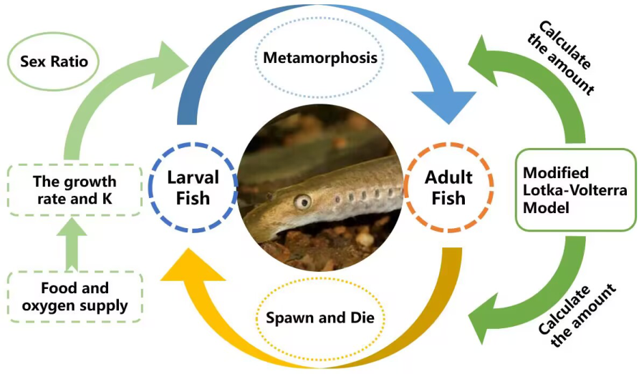
Figure 5: Mindmap for model I
图 5：模型 I 的思维导图
图中文字对照（英文 → 中文）
Sex Ratio | 性别比例 | The growth rate and K | 增长率与环境容纳量K
Food and oxygen supply | 食物与氧气供给 | Metamorphosis | 变态发育
Larval Fish | 幼鱼 | Adult Fish | 成鱼
Modified Lotka-Volterra Model | 修正Lotka-Volterra模型 | Spawn and Die | 产卵与死亡
Calculate the amount | 计算数量
3.1.2 Larval versus adult ﬁsh banking
幼体鱼与成体鱼的分池
Based on the description just given, we innovatively divided the lamprey population into two parts, larval and adult, and each part was calculated separately for indicators such as its birth and death rates. The number of larval can be calculated as follows:
基于上述描述，我们创新性地将海七鳃鳗种群划分为幼体与成体两部分，并分别计算各部分的出生率与死亡率等指标。幼体的数量可按如下方式计算：
— 原文第 9 页 —
₁(t) is the number of larval aged i year(s) as a function of time.
₁(t) 为年龄为 i 年的幼体数量随时间变化的函数。
The number of adult ﬁsh is equal to:
成体鱼的数量等于：
(t) is the number of male adult ﬁsh and l^{female}where l^{male} (t) is the number of female 2
其中 l^{male}(t) 为雄性成体鱼的数量，l^{female}(t) 为雌性 2
2adult ﬁsh.
2成体鱼的数量。
Interestingly, when we divide the lamprey population into these two parts, we can no longer describe it using the simple Lotka-Volterra model, but have to make a simple modiﬁcation to it.
有趣的是，当我们将海七鳃鳗种群划分为这两部分后，便不能再使用简单的 Lotka-Volterra 模型对其进行描述，而必须对该模型作简单修正。
It is worth noting that in our model, larval and adult ﬁsh are interchangeable. larval grow into adults after metamorphosis, while adults die after mating and spawning, which can be viewed as converting into larval, and thus the two, the larval and adult pools, are in an interchangeable relationship. Therefore, we cannot directly decompose these two components into two species for calculation, because we cannot use the number of larval themselves to portray the birth rate of larval alone, nor can we use the number of adults to portray the birth rate of adults alone. Therefore, we split the equation of the Lotka-Volterra model into two parts, with the ﬁrst half representing the birth rate of a species and the second half representing the mortality rate of a species.
值得注意的是，在我们的模型中，幼体鱼与成体鱼是可相互转化的。幼体经变态发育后长成成体，而成体在交配与产卵后死亡，这可视为转化为幼体，因此幼体库与成体库二者处于相互转化的关系。因此，我们不能直接将这两个组分拆解为两个物种进行计算，因为我们既无法仅用幼体自身数量刻画幼体单独的出生率，也无法仅用成体数量刻画成体单独的出生率。因此，我们将 Lotka-Volterra 模型的方程拆分为两部分，前半部分表示某物种的出生率，后半部分表示某物种的死亡率。
In our model, we ﬁnd that the relationship between the larval and adult pools is very special: while the birth rate of the adult pool should originate from the larval pool, the birth rate of the larval pool originates from the adult pool. However, the mortality rates of both are derived from themselves. Therefore, we need to modify the formula, i.e., the birth rate of the larval pool is calculated through the number of adult pools, and the birth rate of the adult pool needs to be calculated through the number of larval growing into adults. In order to simplify the model calculation, we portray the population in terms of years, and consider the growth rate of the population as the ﬁrst-order difference of the population size, we can get the growth rate of the larval and adult pools respectively as follows:
在我们的模型中发现，幼体库与成体库之间的关系十分特殊：成体库的出生率应源于幼体库，而幼体库的出生率则源于成体库。然而，二者的死亡率均来自其自身。因此，我们需要对公式进行修正，即幼体库的出生率通过成体库的数量计算，而成体库的出生率则需通过幼体成长为成体的数量计算。为简化模型计算，我们以年为单位刻画种群，并将种群增长率视为种群规模的一阶差分，由此可分别得到幼体库与成体库的增长率如下：
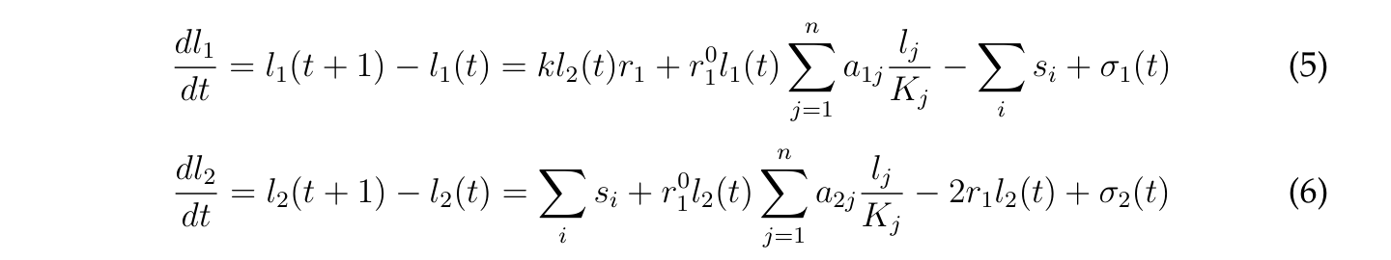
— 原文第 10 页 —
3.1.3 Measurement of growth rate in larval
幼体生长率的测定
From the literature [2], we know that lamprey larval are ﬁlter feeders. Based on the basic bioenergetic growth model, we can get the biomass growth rate of an individual:
由文献 [2] 可知，海七鳃鳗幼体为滤食性动物。基于基本的生物能量学生长模型，可得个体的生物量增长率：
where W is the individual biomass and a depends on food concentration (C), assimilation efﬁciency (AE) and metabolic cost (Rg/G).b is related to the ﬁltration rate of ﬁlter feeders and can be considered as a constant value 3/4 [9] for larval lamprey,a stationary ﬁlter-feeding population.
其中 W 为个体生物量，a 取决于食物浓度 (C)、同化效率 (AE) 与代谢成本 (Rg/G)。b 与滤食性动物的滤食率有关，对于海七鳃鳗幼体这一定居型滤食种群，可视为常数 3/4 [9]。
We wish to highlight the effect of resource availability on the growth rate of larval, so next we will simplify the reality of the situation by establishing a relationship between a and resource availability.
我们希望突出资源可得性对幼体生长率的影响，因此接下来将通过建立 a 与资源可得性之间的关系来简化现实情形。
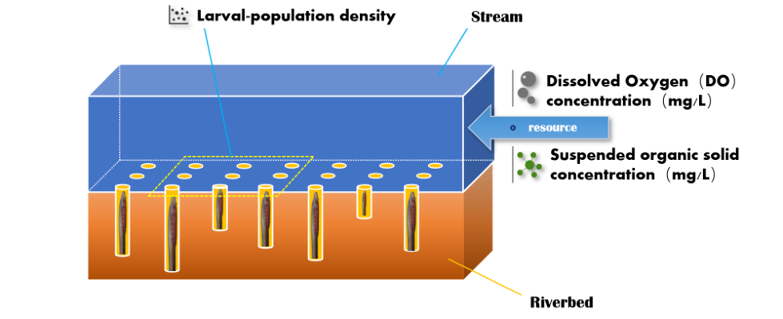
Figure 6: Biomass Growth Model for Larval
图 6：幼体生物量生长模型
图中文字对照（英文 → 中文）
Larval-population density | 幼体种群密度 | Stream | 溪流
Dissolved Oxygen (DO) concentration (mg/L) | 溶解氧（DO）浓度（mg/L） | resource | 资源
Suspended organic solid concentration (mg/L) | 悬浮有机物浓度（mg/L） | Riverbed | 河床
As shown in the ﬁgure, we equate the body of water to a rectangular body. larval exchange energy with the outside world through holes located on the surface of the riverbed. According to Assumption 4, the resource available to all larval within this water body is inversely proportional to the density of larval, i.e., the size of the population. We obtain the formula as follows:
如图所示，我们将水体等效为一个长方体。幼体通过位于河床表面的孔洞与外界交换能量。根据假设 4，该水体内所有幼体可获得的资源与其密度（即种群规模）成反比。我们得到如下公式：
— 原文第 11 页 —
The main food source for ﬁlter feeders is the suspended organic solid in the water, and the amount of dissolved oxygen affects the assimilation efﬁciency. Characterizing the concentration of both, the equation can be obtained as follows
滤食性生物的主要食物来源是水体中的悬浮有机固体，而溶解氧的含量会影响同化效率。对二者的浓度进行刻画，可得如下方程
where γ₁ is the ﬁltration rate factor and γ₂ is the assimilation efﬁciency factor; O_{s} is the suspended organic solid concentration and D_{o} is the dissolved oxygen concentration; and the arctan function is an approximate ﬁt of aerobic respiration efﬁciency to available oxygen. Combining Eq(7), we obtained the differential biomass system of equations for lamprey larval:
其中γ₁为滤食速率因子，γ₂为同化效率因子；O_{s}为悬浮有机固体浓度，D_{o}为溶解氧浓度；arctan函数是对有氧呼吸效率与可用氧之间关系的近似拟合。结合式 (7)，我们得到海七鳃鳗幼体的生物量微分方程（Differential Equation）组：
{
3dM_{i}(t)
O_{s}
= γ₁^{l}1 arctan(γ²Dº)Mi (t)
4dt
M_{i}(0) = M₀
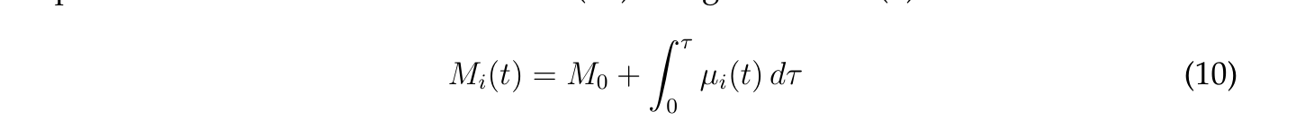
For metamorphic organisms, reaching a sufﬁcient biomass is a critical point for qualitative change. Based on probability theory, it is approximated that the probability of a larval starting to metamorphose(P|_{grown−up}) follows a normal distribution:
对于变态发育的生物而言，达到足够的生物量是发生质变的关键节点。基于概率论，近似认为幼体开始变态发育的概率(P|_{grown−up})服从正态分布：
where M_{b} is the baseline biomass for metamorphosis. When a larval larval begins to metamorphose and develop, according to assumption 1 we consider that it transforms into an adult ﬁsh and note that at this time
其中M_{b}为变态发育的基准生物量。当幼体开始变态发育时，根据假设1，我们认为其转化为成鱼，并注意此时
3.1.4 Effects between growth rate, sex ratio and birth rate
生长率、性别比例与出生率之间的相互影响
The sex ratio of lamprey larval is directly determined by their growth rate. [10] The probability of a larval transforming into an adult male(P) can be calculated by the following formula:
海七鳃鳗幼体的性别比例直接由其生长率决定。[10] 幼体转化为成年雄性的概率(P)可由下式计算：
— 原文第 12 页 —
of larval is shorter, the probability of their transformation into females is higher. This conclusion is consistent with the current state of the study, in which the more deprived the growing conditions, the slower the growth rate of larval and the longer the time required for growth, the higher the probability of becoming male. This characteristic may enable lamprey populations to adapt to the ecological environment faster, and when the ecosystem is damaged, lamprey populations can adjust the sex ratio to reduce the birth rate, so that the population can reach a new equilibrium point faster. Next, we will describe the effect of sex ratio on the birth rate of the population through an equation. Although the lamprey population is monogamous [7], its optimal sex ratio is most likely not 1:1 as it autonomously adjusts its sex ratio when it encounters environmental changes [11]. According to the literature reviewed, ﬁsh tend to have more females spawning and females require more energy to spawn than males to sperm, with a very large number of egg cells not actually being fertilized. Thus when environmental capacity declines, ﬁsh may need more males to reduce the energy overhead and enhance egg fertilization, so the appropriate sex ratio is shifted in a male-biased direction. Conversely, when environmental accommodation rises, more energy is available to the ﬁsh, and they may tend to lay more eggs to increase the overall rate of population development more quickly. [12] Based on the above theory, we have ﬁtted a relatively reasonable function to describe the relationship between sex ratio and birth rate in a population.
……越短，其转化为雌性的概率越高。这一结论与现有研究状况一致：生长条件越差，幼体的生长速率越慢、所需生长时间越长，变为雄性的概率就越高。该特性可能使海七鳃鳗种群更快地适应生态环境；当生态系统受损时，海七鳃鳗种群能够调整性别比例以降低出生率，从而使种群更快地达到新的平衡点。接下来，我们将通过方程描述性别比例对种群出生率的影响。尽管海七鳃鳗种群实行一夫一妻制[7]，但其最优性别比例很可能并非1:1，因为它在遭遇环境变化时会自主调整性别比例[11]。根据所查阅的文献，鱼类往往有更多雌性参与产卵，且雌性产卵所需的能量多于雄性产生精子所需的能量，大量卵细胞实际上并未受精。因此，当环境容纳量（Carrying Capacity）下降时，鱼类可能需要更多雄性以降低能量开销并提高卵的受精率，于是适宜的性别比例向雄性偏斜的方向移动。反之，当环境容纳量上升时，鱼类可获得更多能量，可能倾向于产下更多卵，以更快地提高种群整体的发展速率。[12] 基于上述理论，我们拟合了一个较为合理的函数，用以描述种群中性别比例与出生率之间的关系。
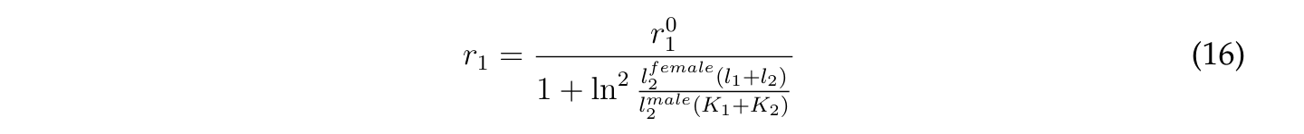
3.2 Model II: BDS Assessment Model
3.2 模型 II：BDS 评估模型
In order to determine how the ecosystem is affected by the change of the sex ratio of the seven-gill eel, we established a BDS Evaluation Model using the total ecosystem biomass, ecosystem species diversity, and ecosystem stability as the evaluation criteria. The idea of modeling is shown below:
为了确定海七鳃鳗性别比例的变化如何影响生态系统，我们以生态系统总生物量、生态系统物种多样性和生态系统稳定性为评价标准，建立了 BDS 评价模型。建模思路如下图所示：
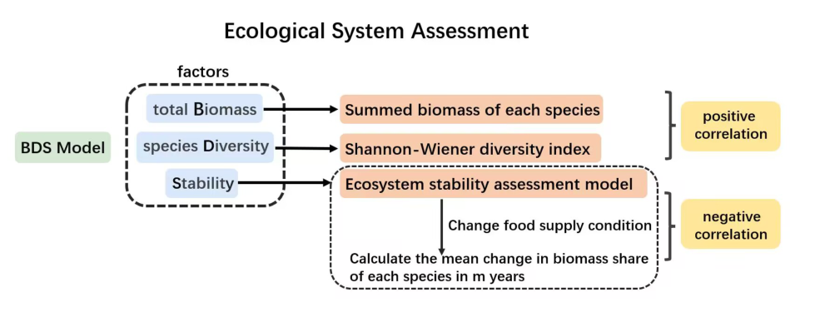
Figure 7: Mindmap for BDS Assessment Model
图 7：BDS 评估模型思维导图
图中文字对照（英文 → 中文）
Ecological System Assessment | 生态系统评估 | BDS Model | BDS模型
factors | 因素 | total Biomass | 总生物量
species Diversity | 物种多样性 | Stability | 稳定性
Summed biomass of each species | 各物种生物量之和 | Shannon-Wiener diversity index | Shannon-Wiener多样性指数
Ecosystem stability assessment model | 生态系统稳定性评估模型 | Change food supply condition | 改变食物供给条件
Calculate the mean change in biomass share of each species in m years | 计算m年内各物种生物量占比的平均变化 | positive correlation | 正相关
negative correlation | 负相关
— 原文第 13 页 —
3.2.1 Total Ecosystem Biomass
生态系统总生物量
Total ecosystem biomass is one of the most important indicators of ecosystems, which can reﬂect the development of biomes in ecosystems.
生态系统总生物量是生态系统最重要的指标之一，能够反映生态系统中生物群落的发展状况。
3.2.2 Shannon-Wiener Diversity Index
Shannon-Wiener 多样性指数
Evaluating species diversity is an indispensable step in assessing ecosystem condition. Generally speaking, the higher the species richness, the more balanced the biomass among species, and the better the ecosystem condition.
评价物种多样性是评估生态系统状况不可或缺的步骤。一般而言，物种丰富度越高、物种之间的生物量越均衡，生态系统状况就越好。
_{B}, representing the proportion of the biomass of species i in ecosystem.
_{B}，表示物种 i 在生态系统中的生物量占比。
3.2.3 Ecosystem Stability Assessment
生态系统稳定性评估
Stability is one of the necessary conditions for maintaining the normal functioning of an ecosystem. When the external environment changes, the internal biomass distribution within the ecosystem will also undergo changes through the interactions and regulations among species. In this case, ecosystems with more species and complex food webs can adjust their structure and function more quickly, and the resulting changes in biomass distribution tend to be relatively stable. Therefore, in this model, we evaluate the stability of an ecosystem by analyzing the changes in the proportion of biomass for each species in response to external environmental changes.
稳定性是维持生态系统正常运转的必要条件之一。当外部环境发生变化时，生态系统内部的生物量分布也会通过物种间的相互作用与调节而发生变化。在这种情况下，物种数量更多、食物网更复杂的生态系统能够更快地调整其结构与功能，由此产生的生物量分布变化往往相对稳定。因此，在本模型中，我们通过分析各物种生物量占比对外部环境变化的响应来评估生态系统的稳定性。
Here, S represents the stability index after adjusting the food supply to the corresponding value, and p_{ij} is the proportion of biomass for species i after j years of change.
式中，S 表示将食物供给调整至相应数值后的稳定性指数，p_{ij} 为物种 i 在经历 j 年变化后的生物量占比。
The smaller the value of S, the smaller the relative change in biomass proportions of various species after adjusting the food supply for n years, indicating a stronger stability of the ecosystem.
S 的取值越小，表明在调整食物供给 n 年后各物种生物量占比的相对变化越小，生态系统的稳定性越强。
— 原文第 14 页 —
4 Modeling Applications and Problem Solving
4 模型应用与问题求解
4.1 Simulation of the Lamprey Population Iteration Model
4.1 海七鳃鳗种群迭代模型的仿真
4.1.1 Algorithm of the Model
模型算法
Our model performs calculations in a differential form, with the results of each calculation derived from the previous one, to simulate iterations of the lamprey population based on the input parameters and to investigate whether it is able to maintain stability over time.
本模型以差分形式进行计算，每一次计算结果均由上一次结果推得，从而依据输入参数模拟海七鳃鳗种群的迭代过程，并考察其能否随时间推移保持稳定。
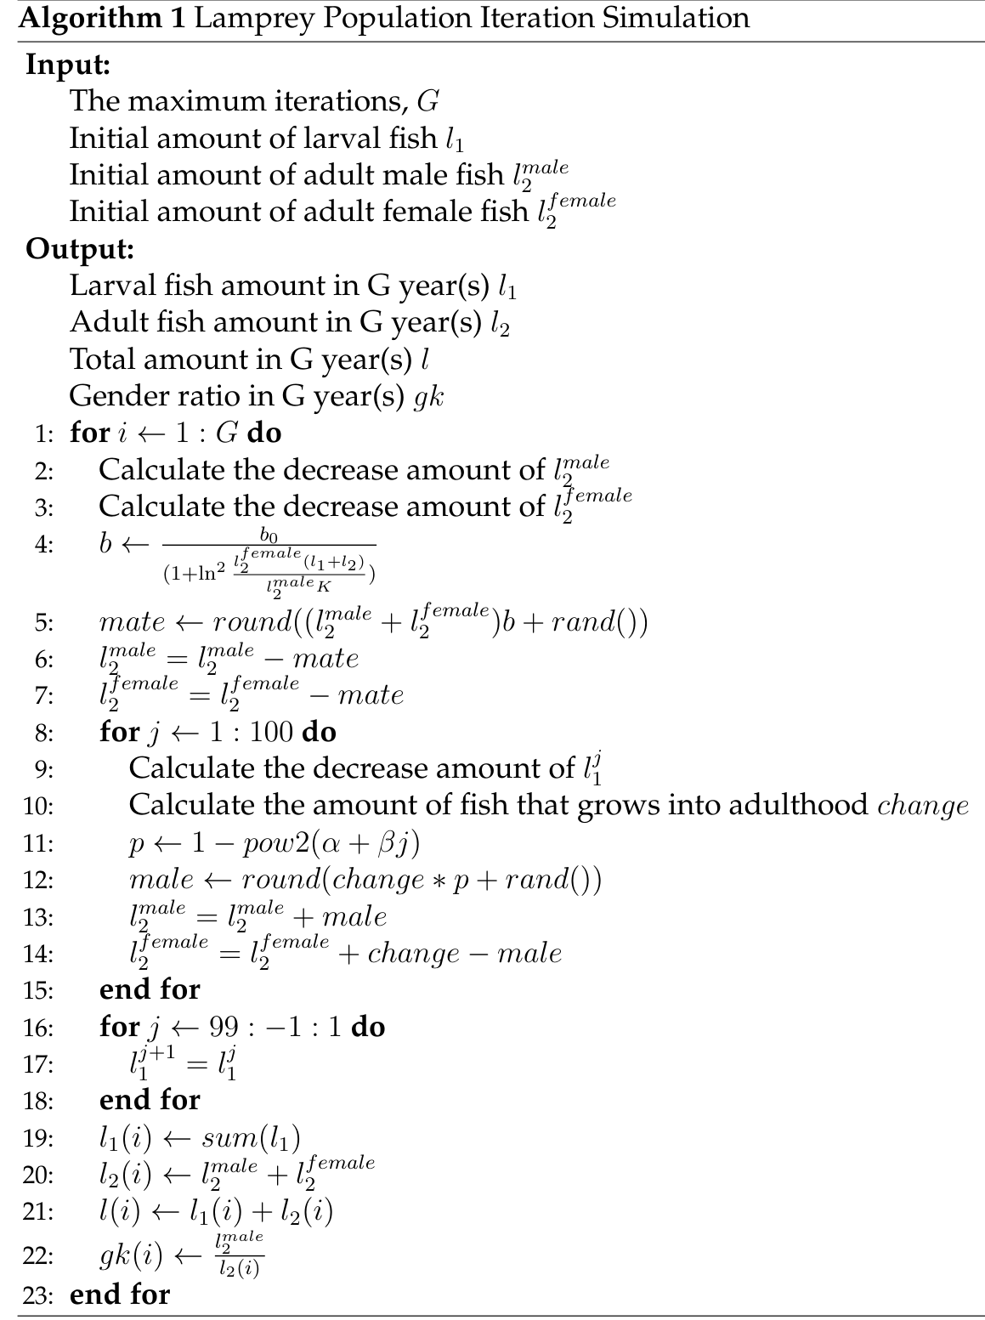
— 原文第 15 页 —
4.1.2 Model Parameter Settings
模型参数设置
First, all the formulas in the model will be shown below:
首先，模型中的全部公式如下所示：
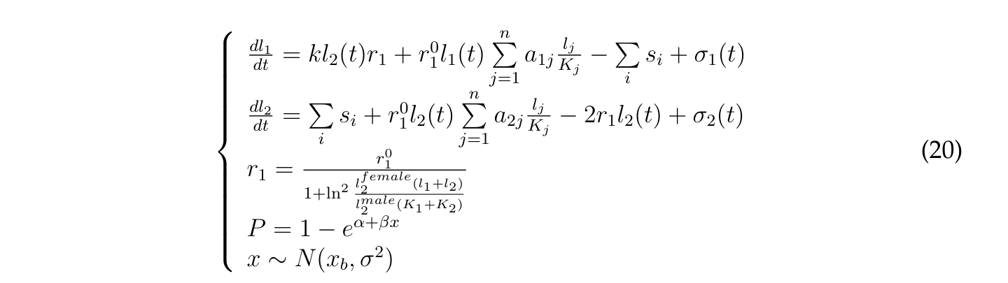
Using Great Lakes’ data as a reference,we set some of the parameters in the model to appropriate values and adjusted them to see how the model performs with different parameters. Eventually, we determined the model parameters to the following values and used the model to solve the results.
以五大湖的数据为参照，我们将模型中的部分参数设定为适当取值，并通过调整这些参数来考察模型在不同参数下的表现。最终，我们确定了模型的参数取值如下，并运用该模型求解结果。
It is worth noting that our model is highly adaptive and does not apply only to the Great Lakes region. When the model is migrated to other regions, local data are needed to support it.
值得注意的是，本模型具有很强的自适应性，并非仅适用于五大湖地区。当模型迁移至其他地区时，需要当地数据予以支持。
Table 3: Parameter Settings
表 3：参数设置

4.1.3 Result of the Simulation
仿真结果
We input G = 500, l₁ = 6000 (1,000 lampreys each from one to six years old), = 5000, l^{female}l^{male}
我们输入 G = 500，l₁ = 6000（一至六龄各 1,000 尾海七鳃鳗），= 5000，l^{female}l^{male}
= 5000.
2 2
In order to obtain the advantages and disadvantages of the sex ratio adjustment mechanism for the lamprey population, We adjust O_{s} downward to 50% of the original value(22.5) and the environmental capacity K₂ to same 50% of the original value (5,000) at the 100th year, and then adjusted O_{s}, K₂ to the initial value at the 300th year to observe the population evolution. At the same time, we set up a control group, canceled the sex ratio adjustment mechanism, i.e., the probability of larval transforming into females and males at any time was the same, and other parameters remained unchanged, simulated the population evolution, and observed the pattern of the evolution of the two populations against each other. The simulation results are shown below.
为考察性别比例调节机制对海七鳃鳗种群的利弊，我们在第 100 年时将 O_{s} 下调至原值（22.5）的 50%，并将环境容纳量 K₂ 同样下调至原值（5,000）的 50%，随后在第 300 年时将 O_{s}、K₂ 调回初始值，以观察种群的演化过程。与此同时，我们设置对照组，取消性别比例调节机制，即幼体在任何时刻转变为雌性与雄性个体的概率相同，其余参数保持不变，对种群演化进行仿真，并观察两个种群此消彼长的演化规律。仿真结果如下所示。
In order to see the differences between the experimental and control groups more clearly, we plotted the population size of the experimental and control lamprey populations in a single graph and extended G to 1000, with the rest of the conditions unchanged, and the results are shown below.
为了更清晰地看出实验组与对照组之间的差异，我们将实验组与对照组海七鳃鳗种群的种群规模绘制在同一张图中，并将 G 扩展至 1000，其余条件保持不变，结果如下图所示。
— 原文第 16 页 —
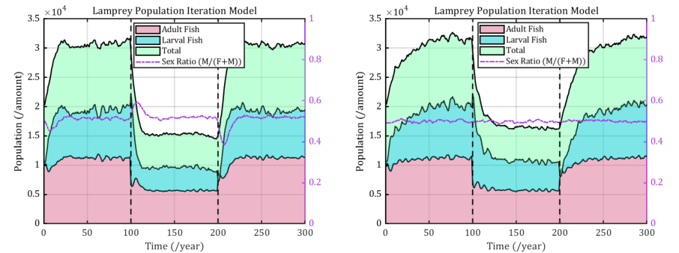
Figure 8:
图 8：
图中文字对照（英文 → 中文）
Lamprey Population Iteration Model | 七鳃鳗种群迭代模型 | Adult Fish | 成鱼
Larval Fish | 幼鱼 | Total | 总量
Sex Ratio (M/(F+M)) | 性别比例（雄/(雌+雄)） | Population (/amount) | 种群数量（/个）
Time (/year) | 时间（/年）
Lamprey Population Iteration
海七鳃鳗种群迭代
Figure 9:
图 9：
Lamprey Population Iteration
海七鳃鳗种群迭代
Model (With Operational Sex Ratio)
模型（含操作性别比例）
Model (Without Operational Sex Ratio)
模型（不含操作性别比例）
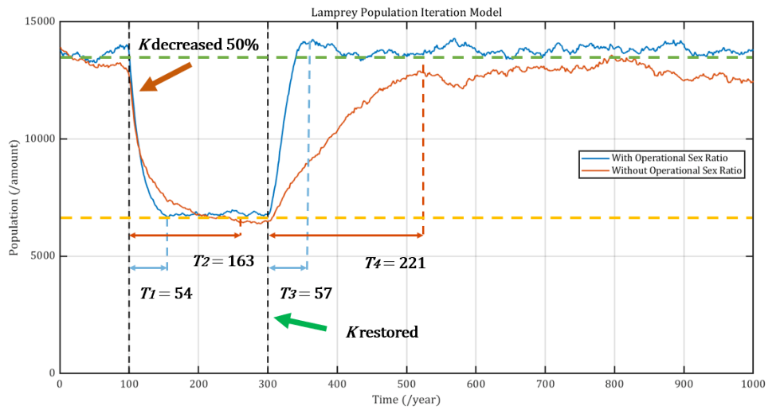
Figure 10: Population size of the Experimental and Control Group
图 10：实验组与对照组的种群规模
图中文字对照（英文 → 中文）
Lamprey Population Iteration Model | 七鳃鳗种群迭代模型 | K decreased 50% | 环境容纳量K下降50%
K restored | 环境容纳量K恢复 | With Operational Sex Ratio | 具运行性别比例
Without Operational Sex Ratio | 无运行性别比例 | T1 = 54 | T1 = 54（第一阶段恢复时间）
T2 = 163 | T2 = 163（无性别比例变化的恢复时间） | T3 = 57 | T3 = 57（第二阶段恢复时间）
T4 = 221 | T4 = 221（有无性别比例变化的总差异时间） | Population (/amount) | 种群数量（/个）
Time (/year) | 时间（/年）
We can see from the ﬁgure that:
从图中可以看出：
• In the 100th year, there is a sudden change in the environment and the environmental capacity drops to half of its original size, and in the following period of time both populations decline, but the one with the sex-ratio regulation mechanism declines faster and is able to reach a new equilibrium in a shorter period of time.
• 在第 100 年，环境发生突变，环境容纳量降至原来的一半，此后一段时间内两个种群均出现下降，但具有性别比例调节机制的种群下降更快，且能在更短时间内达到新的平衡。
• In the 300th year, the environment changed for the better and the environmental holding capacity returned to its initial state. After that, both populations rose, but it was clear that the sex-ratio-regulated population rose much faster and was slightly more numerous than the other group after recovery.
• 在第 300 年，环境好转，环境容纳量恢复至初始状态。此后两个种群均出现回升，但显然性别比例受调节的种群回升速度快得多，且在恢复后数量略多于另一组。
To quantify the advantages, we deﬁne an optimization rate formula:
为了量化这一优势，我们定义一个优化率公式：
where k_{before} represents the metrics before optimization and k_{after} represents the metrics after optimization. k_{before} ≥k_{after}. From the experimental data we can get that the optimization rate R=202% when K decreases and R=288% when K restores. The optimization effect is quite good.
其中 k_{before} 表示优化前的指标，k_{after} 表示优化后的指标，k_{before} ≥k_{after}。由实验数据可得当 K 下降时优化率 R=202%，当 K 恢复时 R=288%。优化效果相当理想。
— 原文第 17 页 —
Through this model, we can give an answer to the question 2.
通过该模型，我们可以对问题 2 给出回答。
• The sex-ratio regulation mechanism of lamprey populations enables the entire population to better adapt to new environments, and the population is more resilient and able to quickly adapt to complex and changing environments.This is also likely what led to the lamprey population’s emergence as an invasive species in the vicinity of the Great Lakes. [14]
• 海七鳃鳗种群的性别比例调节机制使整个种群能够更好地适应新环境，种群更具韧性，能够迅速适应复杂多变的环境。这很可能也是海七鳃鳗种群在五大湖附近成为入侵物种的原因。[14]
• However, this mechanism has some negative consequences in that the population’s resistance to harsh environments may be reduced. When the environment is very poor, lamprey populations may be endangered for a time.
• 然而，该机制也存在一定的负面影响，即种群对恶劣环境的抵抗力可能降低。当环境极为恶劣时，海七鳃鳗种群可能一度濒临灭绝。
4.2 Simulation of Ecological System Assessment Model
4.2 生态系统评估模型的仿真
4.2.1 Lamprey sex ratio and ecosystem stability
海七鳃鳗性别比例与生态系统稳定性
As we noted above, lamprey larvae grow at different rates under different food conditions, and the growth rate of larvae determines their probability of differentiating into males or females. Therefore, the effects of ecosystem changes on lamprey are different from those on other populations. Here, we still discuss larval and adults separately, and use the Ecosystem stability assessment model developed above to analyze the relationship between changes in sex ratio and ecosystem stability.
如上所述，海七鳃鳗幼体在不同食物条件下以不同的速率生长，而幼体的生长速率决定了其分化为雄性还是雌性的概率。因此，生态系统变化对海七鳃鳗的影响与其他种群不同。在此，我们仍将幼体与成体分开讨论，并运用上文建立的生态系统稳定性评估模型分析性别比例变化与生态系统稳定性之间的关系。
First, we simpliﬁed it after carefully examining the biotope relationships of the ecosystem in which lamprey are found. Four base species were added. The relationship between the four species and adult larval is shown below:
首先，我们在仔细考察海七鳃鳗所在生态系统的生物群落关系之后对其进行了简化。我们加入了四个基础物种，这四个物种与成体、幼体之间的关系如下：
• c₁ larval lamprey
• c₁ 海七鳃鳗幼体
• c₂ Adult lamprey
• c₂ 海七鳃鳗成体
• c₃ Predator of adult lamprey (Species 1)
• c₃ 海七鳃鳗成体的捕食者（物种 1）
• c₄ Competitor of adult lamprey (Species 2)
• c₄ 海七鳃鳗成体的竞争者（物种 2）
• c₅ Fish-1 parasitized by adults and capturing larvae (Species 3)
• c₅ 被成体寄生并捕食幼体的鱼类-1（物种 3）
• c₆ Fish-2 parasitized by adults and capturing larvae (Species 4)
• c₆ 被成体寄生并捕食幼体的鱼类-2（物种 4）
After this, we introduced a correlation matrix to describe the interrelationships between species in the ecosystem, which is expressed as follows:
随后，我们引入关联矩阵来描述生态系统中物种之间的相互关系，其表示如下：
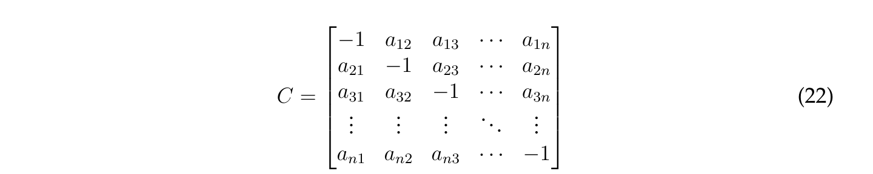
With the known interrelationships between the species, based on the Lamprey Population Iteration Model, we were able to calculate the population densities x₃, x₄, x₅, x₆ for c₃, c₄, c₅, c₆. The calculation formula is shown in Eq.3.
在已知物种间相互关系的基础上，基于海七鳃鳗种群迭代模型，我们能够计算出 c₃、c₄、c₅、c₆ 的种群密度 x₃、x₄、x₅、x₆。计算公式见式 (3)。
— 原文第 18 页 —
The biomass of each population is obtained by multiplying the population density of that ecosystem species by the average weight of individuals in each population. Next, based on the relevant data we have collected, we give the weight matrix W = [0.69, 3.7, 40.3, 1.2, 15.8, 14.0], and the value of C is shown in the heatmap below.
各物种种群的生物量由该生态系统物种的种群密度乘以各物种种群中个体的平均重量得到。接下来，基于我们已收集的相关数据，给出权重矩阵 W = [0.69, 3.7, 40.3, 1.2, 15.8, 14.0]，C 的取值如下图所示的热力图。
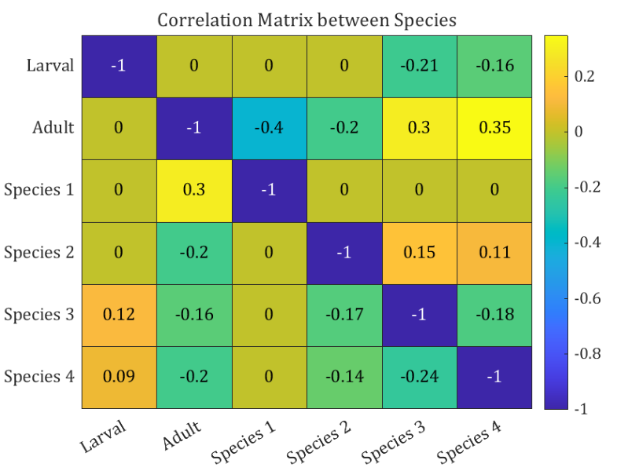
Figure 11: Correlation matrix C
图 11：关联矩阵 C
图中文字对照（英文 → 中文）
Correlation Matrix between Species | 物种间相关矩阵 | Larval | 幼体
Adult | 成鱼 | Species 1 | 物种1
Species 2 | 物种2 | Species 3 | 物种3
Species 4 | 物种4
Simulations were carried out under two scenarios, one with a change in the sex ratio of lampreys and one without, and when the population biomass in both scenarios stabilized, the food supply of the ecosystem was changed so that the environmental capacity decreased, and then the food supply of the ecosystem was changed to the initial food supply after the population biomass in both scenarios had stabilized again. From this, we were able to draw a graph of the changes in the biomass of the various populations in the ecosystem under different scenarios:
我们在两种情景下进行仿真，一种情景中海七鳃鳗的性别比例发生变化，另一种情景中不发生变化；当两种情景下的种群生物量均稳定后，改变生态系统的食物供给使环境容纳量下降，待两种情景下的种群生物量再次稳定后，再将生态系统的食物供给恢复为初始食物供给。由此，我们能够绘制出不同情景下生态系统中各物种种群生物量变化的图像：
Substituting the results into the Ecosystem Stability Assessment Model and taking m = 100, we get Indicators of ecosystem stability S₁ = 3.7175 · 10⁻⁴ for lamprey with change in sex ratio; Indicators of ecosystem stability S₂ = 6.4414 · 10⁻⁴ for lamprey without change in sex ratio in 100 years after the ﬁrst modiﬁcation of K from 100th to 200th year. Since S₁ is smaller than S₂, we can get the conclusion of question 3, when there is a change in the sex ratio of lamprey, the ecosystem can adjust its own structure and function more quickly and the biomass distribution is more stable, i.e., the ecosystem stability is better. The optimization rate of ecosystem stability by the sex ratio adjustment mechanism was calculated to be R = 73.3%.
将结果代入生态系统稳定性评估模型并取 m = 100，可得：在 K 于第 100 年至第 200 年间首次改变之后的 100 年内，性别比例发生变化的海七鳃鳗的生态系统稳定性指标 S₁ = 3.7175 · 10⁻⁴；性别比例未发生变化的海七鳃鳗的生态系统稳定性指标 S₂ = 6.4414 · 10⁻⁴。由于 S₁ 小于 S₂，我们可以得到问题 3 的结论：当海七鳃鳗的性别比例发生变化时，生态系统能够更快地调整自身的结构与功能，生物量分布更加稳定，即生态系统稳定性更好。经计算，性别比例调节机制对生态系统稳定性的优化率为 R = 73.3%。
4.2.2 In-depth Assessment of Impacts on Ecosystem
对生态系统影响的深入评估
In order to obtain more aspects of the effects of sex ratio regulation mechanisms on ecosystems, we calculated the total biomass and Shannon-Wiener Index for each year of the model in the previous section as a way to obtain optimization rates of B and
为了从更多方面获得性别比例调节机制对生态系统的影响，我们对上一节模型逐年的总生物量与香农-维纳指数进行了计算，从而得到 B 与
— 原文第 19 页 —
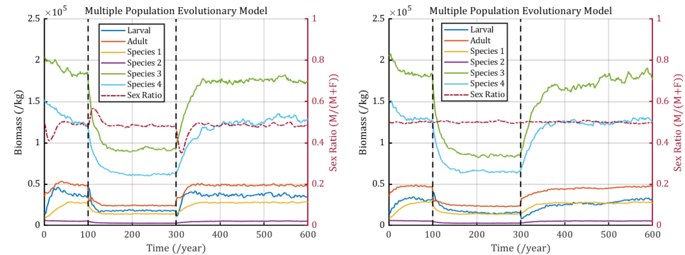
Figure 12: Multiple Population Evolutionary
图 12：多种群演化
图中文字对照（英文 → 中文）
Multiple Population Evolutionary Model | 多种群演化模型 | Larval | 幼体
Adult | 成鱼 | Species 1 | 物种1
Species 2 | 物种2 | Species 3 | 物种3
Species 4 | 物种4 | Sex Ratio | 性别比例
Biomass (/kg) | 生物量（/kg） | Sex Ratio (M/(F+M)) | 性别比例（雄/(雌+雄)）
Time (/year) | 时间（/年）
Figure 13: Multiple Population Evolutionary Model (With Operational Sex Ratio)
图 13：多种群演化模型（含操作性性别比）
Model (Without Operational Sex Ratio)
模型（不含操作性性别比）
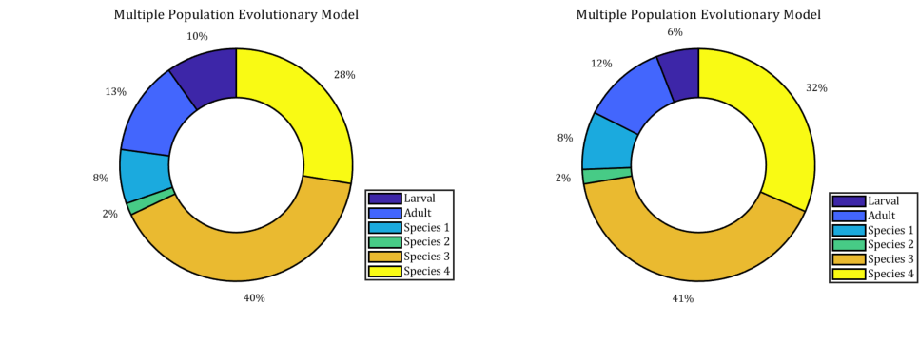
Figure 14: Biomass Proportion in 600-th year
图 14：第 600 年的生物量占比
图中文字对照（英文 → 中文）
Multiple Population Evolutionary Model | 多种群演化模型 | Larval | 幼体
Adult | 成鱼 | Species 1 | 物种1
Species 2 | 物种2 | Species 3 | 物种3
Species 4 | 物种4
Figure 15: Biomass Proportion in 600-th year (With Operational Sex Ratio)
图 15：第 600 年的生物量占比（含操作性性别比）
(Without Operational Sex Ratio)
（不含操作性性别比）
D for an ecosystem. Keeping the model parameters constant, the effects of lamprey populations on the ecosystem were simulated with and without the sex ratio regulation mechanism. The results are shown below.
D 的优化率。在保持模型参数不变的情况下，分别模拟了在具有与不具有性别比例调节机制时海七鳃鳗种群对生态系统的影响。结果如下所示。
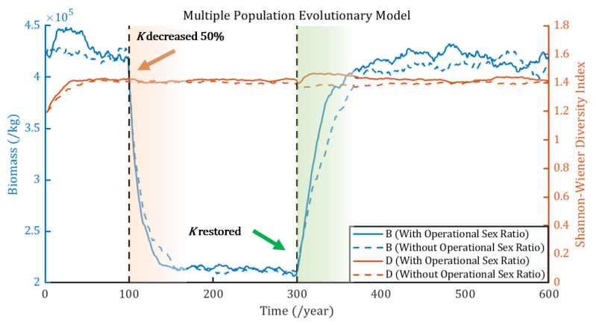
Figure 16: Biomass and Shannon-Wiener Index in Multiple Population Evolutionary Model
图 16：多种群演化模型中的生物量与香农-维纳指数
图中文字对照（英文 → 中文）
Multiple Population Evolutionary Model | 多种群演化模型 | K decreased 50% | 环境容纳量K下降50%
K restored | 环境容纳量K恢复 | B (With Operational Sex Ratio) | B（具运行性别比例）
B (Without Operational Sex Ratio) | B（无运行性别比例） | D (With Operational Sex Ratio) | D（具运行性别比例）
D (Without Operational Sex Ratio) | D（无运行性别比例） | Biomass (/kg) | 生物量（/kg）
Shannon-Wiener Diversity Index | Shannon-Wiener多样性指数 | Time (/year) | 时间（/年）
Since we need to study the effect of the sex ratio regulation mechanism when the environmental holding capacity of the ecosystem is changed, in order to amplify the effect, we chose the 300th to the 400th year for analysis. The mean value of ecosystem biomass and the mean value of Shannon-Wiener Index are calculated for this period of time, and by comparison we can ﬁnd that the biomass of ecosystems with sexregulation mechanisms is 3.7117 · 10⁵, and the Shannon-Wiener Index is 1.4588; while the two indexes of ecosystems without sex-regulation mechanisms are 3.5059 · 10⁵, and 1.3775, respectively.
由于我们需要研究在生态系统环境容纳量发生改变时性别比例调节机制的作用效果，为放大该效应，我们选取第 300 年至第 400 年进行分析。计算该时间段内生态系统生物量的均值与香农-维纳指数的均值，通过比较可以发现：具有性别比例调节机制的生态系统生物量为 3.7117 · 10⁵，香农-维纳指数为 1.4588；而不具有性别比例调节机制的生态系统的这两项指标分别为 3.5059 · 10⁵ 与 1.3775。
— 原文第 20 页 —
At this point, we can answer question 1.
至此，我们可以回答问题 1。
• After calculation, the optimization rate of ecosystem biomass for the sex ratio regulation mechanism was R = 5.87% and the optimization rate of Shannon-Wiener Index was R = 5.90%. The optimization rate is not signiﬁcant.
• 经计算，性别比例调节机制对生态系统生物量的优化率为 R = 5.87%，对香农-维纳指数的优化率为 R = 5.90%。优化率并不显著。
• From the ﬁgure, we can see that the ecosystems with sex ratio regulation mechanism have a slightly shorter time to re-establish equilibrium when the environmental holding capacity is changed.
• 从图中可以看出，当环境容纳量发生改变时，具有性别比例调节机制的生态系统重新建立平衡所需的时间略短。
• This may be due to the fact that the effect of sex ratio on the lamprey population is partially masked by its overall optimization effect when it is scaled up to the ecosystem due to the interactions of a very large number of other species. Combining the result in question 3, however, it can still serve to accelerate ecosystem regulation.
• 这可能是由于性别比例对海七鳃鳗种群的作用在放大到生态系统尺度时，被其整体的优化效应部分掩盖，原因在于大量其他物种之间存在相互作用。然而，结合问题 3 的结果，它仍然能够起到加速生态系统调节的作用。
4.2.3 Detailed Impacts on Other Species
对其他物种的具体影响
In the previous chapter, we explored the macroscopic effects of the sex ratio regulation mechanism on the ecosystem as a whole, and this chapter will focus on analyzing the effects of this mechanism on different species in the ecosystem. We analyzed the effects of this mechanism on ﬁsh parasites and lamprey parasitic species of the same status as lampreys. Keeping other parameters constant, the ecosystem was simulated and the changes in population density of the above species with and without the sex ratio regulation mechanism were plotted.
在上一章中，我们探讨了性别比例调节机制对整个生态系统的宏观影响，本章将着重分析该机制对生态系统中不同物种的影响。我们分析了该机制对鱼类寄生生物以及与海七鳃鳗处于相同地位的海七鳃鳗寄生宿主物种的影响。在保持其他参数不变的情况下对生态系统进行模拟，绘制了上述物种在具有与不具有性别比例调节机制时种群密度的变化。
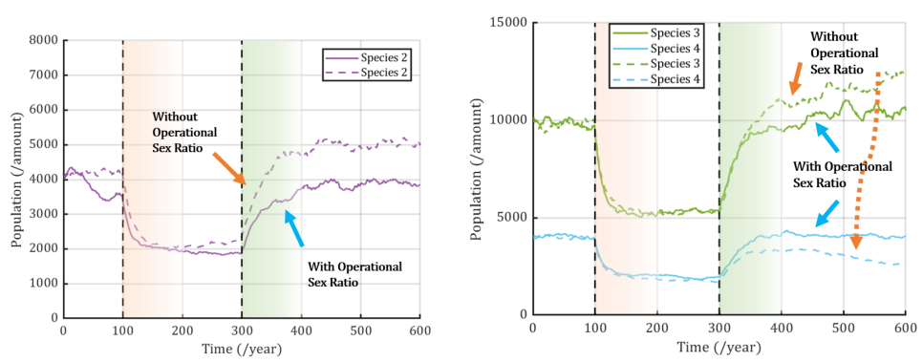
Figure 17: Species 2 Populations
图 17：物种 2 的种群数量
图中文字对照（英文 → 中文）
Without Operational Sex Ratio | 无运行性别比例 | With Operational Sex Ratio | 具运行性别比例
Species 2 | 物种2 | Species 3 | 物种3
Species 4 | 物种4 | Population (/amount) | 种群数量（/个）
Time (/year) | 时间（/年）
Figure 18: Species 3 and 4 Populations
图 18：物种 3 与物种 4 的种群数量
First we analyze the changes in parasites (Species 2). Because the sex ratio mechanism can increase the resilience of lamprey populations, when the ecosystem environment improves, lamprey populations will reach a new equilibrium point faster and take over the resources of other organisms, resulting in the suppression of parasites competing with them. As a result, Species 2 will recover and equilibrate with slightly fewer species than an ecosystem without sex ratio regulation.
首先我们分析寄生生物（物种 2）的变化。由于性别比例机制能够提高海七鳃鳗种群的恢复力，当生态系统环境改善时，海七鳃鳗种群将更快地达到新的平衡点，并占据其他生物的资源，从而导致与它们竞争的寄生生物受到抑制。因此，与不具有性别比例调节的生态系统相比，物种 2 将以略小的种群规模恢复并达到平衡。
— 原文第 21 页 —
The effects on lamprey hosts were analyzed next. We set Species 3 to be more competitive relative to Species 4, so Species 3 would be more affected by lampreys. After the experiment, we found that due to the sex ratio regulation mechanism of lampreys, the population density of Species 3 became smaller, while the population density of Species 4 increased instead, suggesting that this mechanism prompted the reproduction of the lamprey population, which caused Species 3 to be suppressed more, and thus brought more room for Species 4 to survive.
接下来分析对海七鳃鳗寄生宿主的影响。我们设定物种 3 相对于物种 4 具有更强的竞争力，因此物种 3 将受到海七鳃鳗更大的影响。实验后我们发现，由于海七鳃鳗的性别比例调节机制，物种 3 的种群密度变小，而物种 4 的种群密度反而增大，这表明该机制促进了海七鳃鳗种群的繁殖，使物种 3 受到更强的抑制，从而为物种 4 带来了更大的生存空间。
At this point, we can answer question 4.
至此，我们可以回答问题 4。
• The sex ratio regulation mechanism of the lamprey population affects changes in its own population density while also affecting other organisms in the ecosystem.
• 海七鳃鳗种群的性别比例调节机制在影响其自身种群密度变化的同时，也会影响生态系统中的其他生物。
• For the lamprey’s competitors (other ﬁsh parasites), it will make the survival of these competitors are suppressed, so it is not conducive to the survival of these competitors.
• 对于海七鳃鳗的竞争者（其他鱼类寄生生物）而言，该机制将抑制这些竞争者的生存，因此不利于这些竞争者的存活。
• For the lamprey parasitic hosts, it will be a better balance of the whole ecosystem of the size of the population density, which is conducive to the coordination and alleviation of the competitive relationship between the different species.
• 对于海七鳃鳗的寄生宿主而言，该机制将使整个生态系统的种群密度规模达到更好的平衡，有利于协调并缓解不同物种之间的竞争关系。
5 Model Evaluation and Discussion
5 模型评价与讨论
5.1 Sensitivity Analysis
5.1 灵敏度分析
In this article, we have developed two models: the Lamprey Population Iteration Model and the Ecological System Assessment Model, and we focus on the former in our sensitivity analysis. In our model, there are many parameters that need to be given by human, and most of them have been simulated to obtain appropriate values. However, there are still some parameters that may vary in real situations. For example, the conversion ratio k from adult to larval and the endowment growth rate b₀ may ﬂuctuate within a small range by environmental factors, so we change k and b₀ respectively, and other parameters remain unchanged, and re-simulate the lamprey population model in 5.1, and observe the results of the model calculations.
本文建立了两个模型：海七鳃鳗种群迭代模型与生态系统评估模型，在灵敏度分析中我们重点关注前者。在我们的模型中，有许多参数需要人为给定，其中大部分已通过模拟获得合适的取值。然而，仍有一些参数在实际情况中可能发生变化。例如，成体向幼体的转化率 k 以及禀赋增长率 b₀ 可能因环境因素而在较小范围内波动，因此我们分别改变 k 与 b₀，其余参数保持不变，并对 5.1 中的海七鳃鳗种群模型重新进行仿真，观察模型的计算结果。
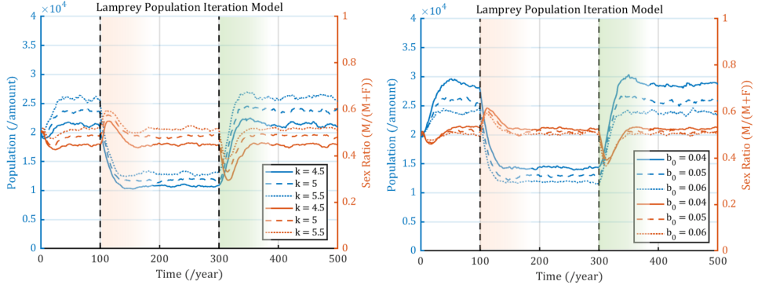
Figure 20: Inﬂuence of different values of b₀ Figure 19: Inﬂuence of different values of k
图 20：b₀ 取不同值的影响 图 19：k 取不同值的影响
图中文字对照（英文 → 中文）
Lamprey Population Iteration Model | 七鳃鳗种群迭代模型 | k = 4.5 | k = 4.5
k = 5 | k = 5 | k = 5.5 | k = 5.5
b0 = 0.04 | b0 = 0.04（初始性别比例偏移） | b0 = 0.05 | b0 = 0.05
b0 = 0.06 | b0 = 0.06 | Population (/amount) | 种群数量（/个）
Sex Ratio (M/(F+M)) | 性别比例（雄/(雌+雄)） | Time (/year) | 时间（/年）
First, we set the value of k to 4.5, 5 and 5.5 to simulate the slight ﬂuctuation of spawning rate and survival rate in the population; then we adjusted b₀ to 0.04, 0.05 and 0.06 to simulate the ﬂuctuation of endowment growth rate in the population, and observed the changes in the number of lampreys in the population and the proportion of the sexes. The results showed that when k and b₀ ﬂuctuated within a certain range, the population size and sex ratio did not change greatly, and the trend was basically consistent, indicating that the stability of the model was good.
首先，我们将 k 的取值设为 4.5、5 和 5.5，以模拟种群中产卵率与存活率的轻微波动；随后我们将 b₀ 调整为 0.04、0.05 和 0.06，以模拟种群中禀赋增长率的波动，并观察种群中海七鳃鳗数量与性别比例的变化。结果表明，当 k 与 b₀ 在一定范围内波动时，种群规模与性别比例并未发生较大变化，变化趋势基本一致，说明模型的稳定性良好。
— 原文第 22 页 —
In fact, we also did a sensitivity analysis of the effects of k and b₀ on indicators such as total biomass under the multiple population model. However, due to the complexity of the interactions between different species in the multiple population model, the indicators of lamprey population do not signiﬁcantly affect the total biomass of the whole ecosystem in the case of a small ﬂuctuation, therefore, to save space, the sensitivity analysis graphs of the multiple population model were not listed. Overall, the model is stable enough to be applied in real-world scenarios.
事实上，我们还就 k 与 b₀ 对多种群模型下总生物量等指标的影响进行了灵敏度分析。然而，由于多种群模型中不同物种之间相互作用的复杂性，在波动较小的情况下，海七鳃鳗种群的指标并不会显著影响整个生态系统的总生物量，因此为节省篇幅，未列出多种群模型的灵敏度分析图。总体而言，该模型足够稳定，可应用于现实情景。
5.2 Strengths and Weaknesses
5.2 优点与不足
5.2.1 Strengths
优点
• The growth habit of lampreys was considered. We have reviewed many related literatures to fully understand the development and metamorphosis process of lamprey in depth. The body size, living environment and food source of lamprey larval and adults are very different, so our model divides lampreys into larval and adult pools, which makes the model more relevant to the current situation.
• 考虑了海七鳃鳗的生长习性。我们查阅了大量相关文献，以充分而深入地理解海七鳃鳗的发育与变态发育过程。海七鳃鳗幼体与成体在体型、生存环境与食物来源方面差异很大，因此我们的模型将海七鳃鳗划分为幼体池与成体池，使模型更贴合实际状况。
• The life cycle of lampreys was taken into account. Adult lampreys will die directly after spawning, which is different from the common Lotka-Volterra, so we divided the larval and adult lampreys into two parts to be considered separately, and the larval lampreys originated from the adult lampreys and the adult lampreys originated from the larval lampreys, which formed a cycle and made the model more in line with the reality.
• 考虑了海七鳃鳗的生命周期。成体海七鳃鳗在产卵后会直接死亡，这与常见的 Lotka-Volterra 模型不同，因此我们将幼体与成体海七鳃鳗分为两部分分别考虑，且幼体海七鳃鳗来源于成体海七鳃鳗、成体海七鳃鳗来源于幼体海七鳃鳗，从而形成循环，使模型更符合实际。
• When the model is calculated, we assign each larval a label of growth year and weight, and each larval is calculated separately for its maturity time. This makes the model calculations more accurate and more convincing.
• 在模型计算时，我们为每一条幼体赋予生长年数与体重的标签，并对每一条幼体的成熟时间分别进行计算。这使模型计算更为准确、也更具说服力。
• The parameter indicators of the model were determined by reviewing relevant literature and extensive experiments. Our model indicators are not given by human, but more accurate calculation parameters based on relevant data and simulation experiments, which makes the model more stable and precise.
• 模型的参数指标通过查阅相关文献与大量实验确定。我们的模型指标并非人为给定，而是基于相关数据与仿真实验得到的更精确的计算参数，这使模型更加稳定和精确。
• Multi-dimensional indicators are used to assess the ecological environment. We adopt Biomass, Shannon-Wiener Index, Stability Index to evaluate an ecological environment comprehensively. The multidimensional evaluation can reﬂect the impact of lamprey population on the whole ecosystem more comprehensively.
• 采用多维度指标评估生态环境。我们采用生物量、Shannon-Wiener 指数与稳定性指数对生态环境进行综合评价。多维度评价能够更全面地反映海七鳃鳗种群对整个生态系统的影响。
5.2.2 Weaknesses
不足
• As there is less literature related to the sex ratio regulation mechanism of lamprey, the formulas of our model in terms of sex ratio regulation are given by ourselves based on the relevant data reviewed, which may have some deviation from the reality.
• 由于与海七鳃鳗性别比例调控机制相关的文献较少，我们模型中关于性别比例调控的公式是依据所查阅的相关数据自行给出的，可能与实际情况存在一定偏差。
• When we modeled ecosystems with multiple populations, we generalized some species into uniform species, such as predators of lampreys, parasitic hosts of lampreys, and so on. The reality may be more complex than our modeling, as there are often thousands of species in an ecosystem.
• 在对包含多个种群的生态系统建模时，我们将部分物种概括为统一的物种，例如海七鳃鳗的捕食者、海七鳃鳗的寄生宿主等。现实情况可能比我们的建模更为复杂，因为一个生态系统中往往存在成千上万个物种。
— 原文第 23 页 —
• We ﬁxed the environmental factors of the ecosystem for our calculations, but in reality these metrics also change over time. However, our model iteration time is in years, so stability is guaranteed.
• 在计算中我们固定了生态系统的环境因素，但在现实中这些指标也会随时间变化。不过，我们的模型迭代时间以年为单位，因此稳定性是有保证的。
5.3 Conclusion
5.3 结论
The mechanism of sex ratio regulation in lampreys is also a very complex issue in biology. So far it is inconclusive, and it may take more and longer to get to a good explanation of the laws embedded in it.The earth is inclusive, life is marvelous, the existence of each species must have its meaning, and there are still many secrets waiting to be unveiled by human beings. We hope that our model can provide some help for the further study of the lamprey species, and we also hope that readers can give us some suggestions to improve our model.
海七鳃鳗性别比例的调控机制在生物学中同样是一个极为复杂的问题。迄今尚无定论，要对其内在规律给出良好的解释或许还需要更多、更长的时间。地球是包容的，生命是奇妙的，每一个物种的存在必有其意义，仍有许多奥秘等待人类去揭开。我们希望我们的模型能够为海七鳃鳗物种的进一步研究提供一些帮助，也希望读者能够提出建议以改进我们的模型。
— 原文第 24 页 —
References
[1] JON Mallatt. Zoological Journal of the Linnean Society, 82(3):261–272, 1984.
[2] Using stable isotopes and c:n ratios to examine the lifehistory strategies and nutritional sources of larval lampreys. Journal of Fish Biology, 2016.
[3] F. W. H. Beamish and T. E. Medland. Age determination for lampreys. Transactions of the American Fisheries Society, 117(1):63–71, 1988.
[4] Nicholas S. Johnson, William D. Swink, and Travis O. Brenden. Field study suggests that sex determination in sea lamprey is directly inﬂuenced by larval growth rate. Proceedings of the Royal Society B: Biological Sciences, 284(1851):20170262, 2017.
[5] zhangqin. Some problems with the lotka-volterra model. Master’s thesis, Jilin University, 2006.
[6] Li Ran. Module- and keystone species-based food web stability studies. Master’s thesis, North China Electric Power University (Beijing), 2018.
[7] Michael J. Hansen, Charles P. Madenjian, Jeffrey W. Slade, Todd B. Steeves, Pedro R. Almeida, and Bernardo R. Quintella. Population ecology of the sea lamprey (petromyzon marinus) as an invasive species in the laurentian great lakes and an imperiled species in europe. Reviews in Fish Biology and Fisheries, 2016.
[8] Richard G. Manzon, John H. Youson, and John A. Holmes. Lamprey Metamorphosis, pages 139–214. Springer Netherlands, Dordrecht, 2015.
[9] Poul Scheel Larsen and Hans Ulrik Riisgård. Size-speciﬁc growth of ﬁlter-feeding marine invertebrates. Journal of Marine Science and Engineering, 2022.
[10] Margaret F. Docker, F. William, and H. Beamish. Age, growth, and sex ratio among populations of least brook lamprey,lampetra aepyptera, larvae: an argument for environmental sex determination. Environmental Biology of Fishes, 1994.
[11] Nicholas S Johnson, William D Swink, and Travis O Brenden. Field study suggests that sex determination in sea lamprey is directly inﬂuenced by larval growth rate. Proceedings of the Royal Society B: Biological Sciences, 2017.
[12] Margaret F Docker, F William H Beamish, Tamanna Yasmin, Mara B Bryan, and Arfa Khan. The lamprey gonad. In Lampreys: Biology, Conservation and Control: Volume 2, pages 1–186. Springer, 2019.
[13] Emmanuel Mzungu Dennis Omayio. Modiﬁcation of shannon-wiener diversity index towards quantitative estimation of environmental wellness and biodiversity levels under a non-comparative scenario. Journal of Environment and Earth Science, 9(46-57), 2019.
[14] Kelly F. Robinson, Scott M. Miehls, and Michael J. Siefkes. Understanding sea lamprey abundances in the great lakes prior to broad implementation of sea lamprey control. Journal of Great Lakes Research, 2021.
（全文完。公式与表格在原 PDF 中是矢量图形，未纳入本对照版；可按文中「原文第 N 页」标记翻到 2400996.pdf 对照查看。）

