2419984 英中对照版
2024 MCM Problem B · Search for the Submersible
读法：黑字为原文，蓝字为译文，一段英文一段中文，上下对应；蓝字里的小字括号是该术语第一次出现时的英文原词。
术语表（按首次出现排序，18 条）
# | 英文 | 中文 | 说明：为什么容易译错
1 | Submersible | 潜水器 | 失联目标，本文的搜索对象
2 | Search and Rescue | 搜救 | 找到失联目标的整体行动
3 | Dynamics Model | 动力学模型 | 描述潜水器运动状态的方程
4 | Monte Carlo Simulation | 蒙特卡洛模拟 | 大量随机抽样估计概率分布
5 | Ant Colony Algorithm | 蚁群算法 | 用信息素启发式搜索路径
6 | Bayesian Detection | 贝叶斯检测 | 用后验概率更新搜索判断
7 | Cost-Benefit Analysis | 成本收益分析 | 比较投入与搜救效果
8 | Entropy Weight Method | 熵权法 | 客观赋权，用于综合评价
9 | Seafloor Topography | 海底地形 | 影响探测与运动的起伏
10 | Sonar | 声呐 | 水下探测设备
11 | Probability Distribution | 概率分布 | 目标位置的置信范围
12 | Trajectory | 轨迹 | 潜水器的运动路径
13 | Buoyancy | 浮力 | 决定上浮下潜的力
14 | Drag Force | 阻力 | 水中运动受到的阻碍
15 | Detection Probability | 探测概率 | 单次搜索发现目标的概率
16 | Search Path | 搜索路径 | 搜索设备的行进路线
17 | Resource Allocation | 资源分配 | 把有限设备与时间分到各区域
18 | Bayesian Updating | 贝叶斯更新 | 按新证据修正概率

Time is Life: Precise Localization and Faster Search
时间即生命：精确定位与更快的搜寻
Summary
摘要
After losing contact with the main ship, a suitable positioning model, search equipment, andsearch strategy for the submersible can signiﬁcantly reduce rescue time and increase the successrate of the rescue mission. In this paper, based on diﬀerent malfunction scenarios of the sub-mersible, a positioning model and search strategy for the submersible’s movement have been es-tablished, providing some suggestion for maritime rescue.
在与母船失去联系后，为潜水器（Submersible）建立合适的定位模型、配备恰当的搜寻设备并制定合理的搜寻策略，能够显著缩短救援时间并提高救援任务的成功率。本文针对潜水器的不同故障情形，建立了潜水器运动的定位模型与搜寻策略，为海上救援提供参考建议。
For Problem 1, ﬁrstly, we searched for the depth and ocean current information in the Ionian
针对问题 1，首先，我们检索了伊奥尼亚海的深度与洋流信息，
Sea and ﬁtted the seaﬂoor topography. Then, a location model is conducted. Utilizing the fourth-order Runge-Kutta method, numerical solutions are obtained, and potential motion trajectoriesare plotted. The primary uncertainties in the model include the submersible’s initial state, oceancurrents, and fault conditions. Therefore, the submersible should be equipped with sensors such as
并拟合了海底地形（Seafloor Topography）。随后，建立了定位模型。利用四阶龙格-库塔法求得数值解，并绘制出可能的运动轨迹（Trajectory）。模型中的主要不确定性包括潜水器的初始状态、洋流以及故障状况。因此，潜水器应配备诸如
GPS and inertial navigation systems, regularly sending position information, depth, motion data,and surrounding ocean current data to the host ship.
GPS 与惯性导航系统等传感器，定期向母船发送位置信息、深度、运动数据以及周围洋流数据。
For Problem 2, we used the entropy-weight method to calculate the weights of performancedata and costs for the corresponding rescue devices. Employing a cost-beneﬁt model, scores areobtained.Considering the characteristics of each rescue device, we determined the following strat-egy: primarily using drones for surface search, sonar for underwater search, and purchasing a smallquantity of AUVs for deeper regions.
针对问题 2，我们采用熵权法（Entropy Weight Method）计算相应救援设备性能数据与成本的权重。采用成本收益分析（Cost-Benefit Analysis）模型得到各项得分。结合各救援设备的特点，我们确定了如下策略：主要使用无人机进行水面搜寻，使用声呐（Sonar）进行水下搜寻，并采购少量 AUV 用于更深区域。
For Problem 3, we ﬁrst discretize the search area into grids and added realistic disturbancesto ocean currents and fault conditions. Using the Monte Carlo simulation method, we obtainthe probability of the submersible appearing in each grid over time. Subsequently, utilizing the antcolony algorithm and continually updating the objective function based on the Bayesian probabilitymodel over time, we identify the most eﬃcient search path, achieving a 43% probability of ﬁndingthe submersible within 10 hours. Finally, by setting diﬀerent search start times, we ﬁnd that startinglater resulted in a lower probability of ﬁnding the submersible within 10 hours.
针对问题 3，我们首先将搜索区域离散化为网格，并在洋流与故障状况中加入贴近实际的扰动。采用蒙特卡洛模拟（Monte Carlo Simulation）方法，我们得到潜水器随时间推移在各网格中出现的概率。随后，利用蚁群算法（Ant Colony Algorithm）并随时间不断基于贝叶斯概率模型更新目标函数，我们确定了最高效的搜索路径（Search Path），实现了在 10 小时内发现潜水器的概率达到 43%。最后，通过设定不同的搜索开始时间，我们发现开始时间越晚，10 小时内发现潜水器的概率越低。
For Problem 4, the possible extensions of the model is discussed. For areas with more complexterrain and stronger ocean currents, such as the Caribbean Sea, relevant disturbances need to beincreased. In cases with multiple submersibles, communication between them would facilitatesearch and rescue.
针对问题 4，讨论了模型可能的拓展方向。对于地形更为复杂、洋流更强的海域，如加勒比海，需要增加相应的扰动。在存在多个潜水器的情况下，它们之间的通信将有助于搜救（Search and Rescue）。
Finally, we analyze the impact of drag coeﬃcient errors on the model and evaluate the strengths
最后，我们分析了阻力（Drag Force）系数误差对模型的影响，并评估其优势
2
— 原文第 3 页 —
1 Introduction
1 引言
1.1 Problem Background
1.1 问题背景
With the development of diving technology, deep-sea diving has gradually found its way intothe tourism industry and has become a favorite among many tourists. With the help of divingequipment such as submarines, tourists can explore the mysterious underwater world and enjoythe beauty of the ocean ﬂoor. A Greek company called "Maritime Cruises Mini-Submarines " (MCMS) manufactures submersibles capable of descending into the deep sea. MCMS now hopesto use their submersibles to lead tourists on an adventurous exploration of the sunken shipwrecksin the Ionian Sea.
随着潜水技术的发展，深海潜水逐渐进入旅游业，并成为众多游客的喜好。借助潜艇等潜水设备，游客能够探索神秘的水下世界，欣赏海底之美。一家名为“Maritime Cruises Mini-Submarines”的希腊公司（MCMS）制造能够下潜至深海的潜水器。MCMS 目前希望利用其潜水器，带领游客在伊奥尼亚海对沉船残骸进行探险式探索。
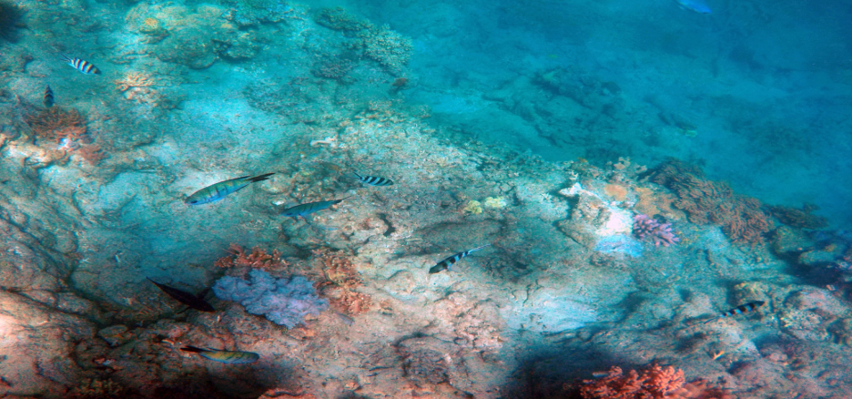
Figure 1: Beautiful Deep Sea Bottom[1]
图 1：美丽的深海海底[1]
However, due to the current state of diving technology and submarine manufacturing tech-niques, there may be issues such as communication interruptions and loss of propulsion during thedescent. When encountering such problems, it is crucial to quickly and accurately determine theapproximate location of the submersible for subsequent rescue operations. This requires a compre-hensive consideration of factors such as underwater topography, seawater density, ocean currents,and other practical considerations.
然而，受当前潜水技术与潜艇制造技术的限制，下潜过程中可能出现通信中断、推进失效等问题。遇到此类问题时，快速准确地确定潜水器的大致位置对后续救援行动至关重要。这需要综合考虑水下地形、海水密度、洋流等因素以及其他实际因素。
1.2
nication with the host ship, and analyze the uncertain factors during the prediction process.
……与母船的通信，并分析预测过程中的不确定因素。
Based on this, determine the equipment that the underwater vehicle should be equipped withto reduce prediction uncertainty and the information that should be sent to the host shipbefore an incident.
在此基础上，确定水下航行器应配备何种设备以降低预测不确定性，以及事故前应向母船发送的信息。
— 原文第 4 页 —
• Taking into account costs associated with availability, maintenance, readiness, and usage ofthis equipment, determine the additional search or rescue equipment that the host ship andrescue vessels should carry, if necessary.
• 在考虑该设备的可用性、维护、待命与使用相关成本的前提下，确定母船与救援船在必要时还应额外携带的搜寻或救援设备。
• Develop a model based on the information from the location model in Task 1 to determinethe initial deployment point and search pattern , in order to minimize the time it takes to ﬁnda lost submersible. Then provide a probability function for ﬁnding the submersible.
• 基于任务 1 中定位模型的信息建立模型，以确定初始部署点与搜索方式，从而最小化找到失联潜水器所需的时间。随后给出发现潜水器的概率函数。
• Extend the model established above to make it applicable in diﬀerent marine environmentsand with varying numbers of submersibles.
• 对上述所建模型进行拓展，使其适用于不同的海洋环境以及不同数量的潜水器。
1.3 Our Work
1.3 我们的工作
To address the mentioned issues, our work can be illustrated with the following ﬂowchart:
为解决上述问题，本文工作可由以下流程图加以说明：
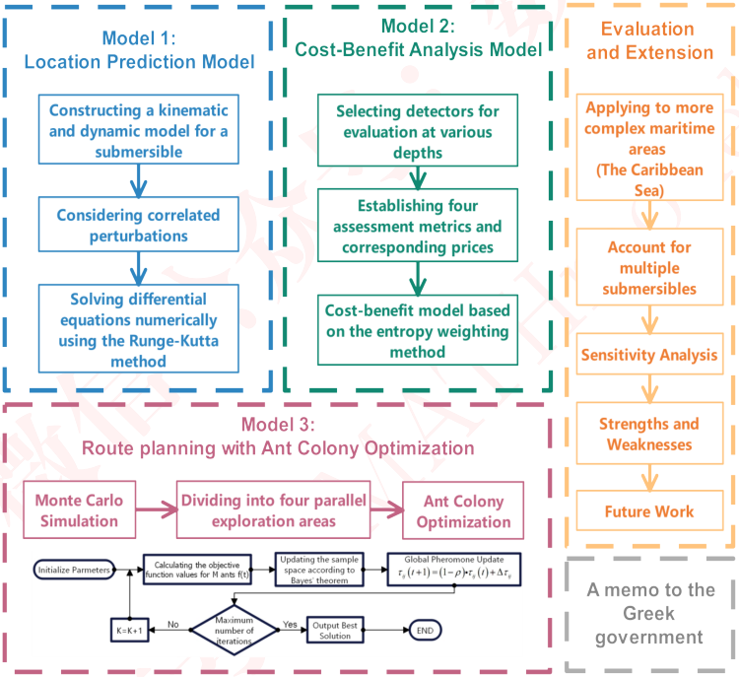
Figure 2: The Framework of Our Work
图 2：本文工作框架
图中文字对照（英文 → 中文）
Model 1: Location Prediction Model | 模型一：位置预测模型 | Constructing a kinematic and dynamic model for a submersible | 构建潜水器的运动学与动力学模型
Considering correlated perturbations | 考虑相关扰动 | Solving differential equations numerically using the Runge-Kutta method | 用龙格-库塔法数值求解微分方程
Model 2: Cost-Benefit Analysis Model | 模型二：成本效益分析模型 | Selecting detectors for evaluation at various depths | 选取用于不同深度评估的探测设备
Establishing four assessment metrics and corresponding prices | 建立四项评估指标及对应价格 | Cost-benefit model based on the entropy weighting method | 基于熵权法的成本效益模型
Evaluation and Extension | 评价与推广 | Applying to more complex maritime areas (The Caribbean Sea) | 应用于更复杂的海域（加勒比海）
Account for multiple submersibles | 考虑多艘潜水器 | Model 3: Route planning with Ant Colony Optimization | 模型三：基于蚁群算法的路径规划
Monte Carlo Simulation | 蒙特卡洛模拟 | Dividing into four parallel exploration areas | 划分为四个并行搜索区域
Ant Colony Optimization | 蚁群算法 | Updating the sample space according to Bayes' theorem | 依据贝叶斯定理更新样本空间
Global Pheromone Update τ_ij(t+1)=(1-ρ)·τ_ij(t)+Δτ_ij | 全局信息素更新 | A memo to the Greek government | 致希腊政府的一份备忘录
In most cases, the ocean is calm. Moreover,abrupt weather changes are not the focus of the model study.
在大多数情况下，海洋是平静的。此外，天气的突变并非本模型研究的重点。
— 原文第 5 页 —
• If a submersible touches the bottom during the descent process, it will be unable tomove on its own. Due to the presence of abundant sediment on the seabed, the buoyancywill signiﬁcantly decrease, making it diﬃcult for the submersible to resurface on its own.
• 若潜水器在下潜过程中触底，它将无法自行移动。由于海底存在大量沉积物，浮力（Buoyancy）将显著下降，使潜水器难以自行上浮。
• All rescue equipment can be deployed within one hour after the submersible goes miss-ing. For maritime search and rescue, time is precious. One hour is suﬃcient if the rescuepreparations are thorough.
• 所有救援设备均可在潜水器失联后一小时内完成部署。对于海上搜救而言，时间十分宝贵。若救援准备充分，一小时是足够的。
Note: There are some notations that are not listed here and will be discussed in detail in eachsection.
注：此处未列出的部分符号将在各节中详细讨论。
4 Model Preparation
4 模型准备
4.1 Safety Strategy
4.1 安全策略
In the actual submersion process of a submersible, in the event of an accident, communicationwith the main ship may be lost. Based on the fundamental principles of search and rescue, toensure safety, it is advisable to stay in place after losing contact with the main ship. Due tothe diﬃculty of determining the submersible’s position in the deep sea and the main ship beingunaware of the submersible’s status, it is recommended that, after losing contact with the main ship,the submersible, regardless of whether it still has propulsion, should immediately cease movementto avoid complicating the search and rescue eﬀorts.
在潜水器的实际下潜过程中，一旦发生事故，可能失去与母船的通信。根据搜救的基本原则，为确保安全，宜在与母船失去联系后原地待援。由于在深海中确定潜水器的位置十分困难，且母船并不知晓潜水器的状态，因此建议潜水器在与母船失去联系后，无论其是否仍具备推进能力，都应立即停止运动，以免增加搜救的复杂程度。
— 原文第 6 页 —
4.2 Seaﬂoor Topography
4.2 海底地形
When the submersible loses propulsion, its movement may be inﬂuenced by the underwatertopography. Therefore, we consulted relevant information[2] on the underwater topography of the
当潜水器失去推进能力时，其运动可能受到水下地形的影响。因此，我们查阅了有关水下地形的相关资料[2]，
Ionian Sea and ﬁtted the seaﬂoor terrain.
即爱奥尼亚海，并对海底地形进行了拟合。
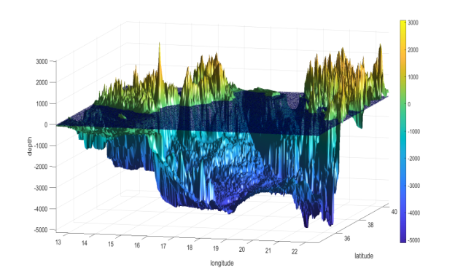
Figure 3: The topographic map of the Ionian Sea
图 3：爱奥尼亚海的地形图
图中文字对照（英文 → 中文）
depth | 深度 | longitude | 经度
latitude | 纬度
4.3 The relevant parameters of the submersible
4.3 潜水器的相关参数
When establishing the model,obtaining appropriate parameters for
在建立模型时，获取
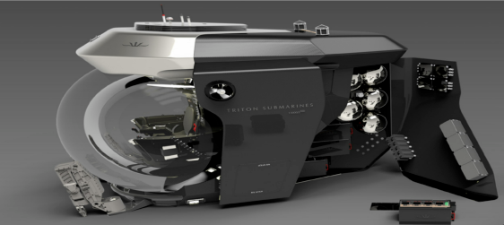
the submersible is essential.
潜水器的适当参数至关重要。
The
右图
ﬁgure on the right illustrates onetype of submersible, indicating rele-vant dimensions of the submersible.
展示了某一类型的潜水器，并标明了该潜水器的相关尺寸。
The maximum designed depth forthe submersible in the right ﬁgureis 4000 meters, which correspondsto the maximum depth of the Ionian
右图中潜水器的最大设计深度为 4000 米，这对应于爱奥尼亚
Figure 4: The submersible[3]
图 4：潜水器[3]
图中文字对照（英文 → 中文）
TRITON SUBMARINES | 特里顿潜水器公司（船体上的品牌标识）
Location Model
定位模型
For the convenience of model establishment and subsequent analytical calculations, we takethe sea level as the xy-plane, with the vertical direction as the z-axis.
为便于模型建立及后续分析计算，我们以海平面为 xy 平面，以竖直方向为 z 轴。
• Location model in the vertical direction
• 竖直方向上的定位模型
Based on the previously mentioned safety strategy, after losing communication with the hostship, the submersible immediately ceases active movement, regardless of whether it still has propulsion, and ascends promptly. According to Newton’s second law, we have:
根据前文所述的安全策略，在与母船失去通信后，潜水器立即停止主动运动，无论其是否仍具备推进能力，并迅速上浮。根据牛顿第二定律，有：
— 原文第 7 页 —
where a_{z} represents the vertical acceleration of the submersible, F_{B} is the buoyancy it experiences,and F f is the resistance acting on the submersible in the vertical direction.
其中 a_{z} 表示潜水器的竖直加速度，F_{B} 为其所受浮力，F f 为潜水器在竖直方向上所受的阻力。
It is worth noting that after losing propulsion, other power systems of the submersible
值得注意的是，失去推进能力后，潜水器的其他动力系统
may also fail. If the submersible’s other power systems have not failed, it can ascend normally.
也可能发生故障。若潜水器的其他动力系统未发生故障，则其能够正常上浮。
However, if the other power systems of the submersible fail, it will be unable to ascend by expellingwater from the ballast tank. Instead, it may sink to the seabed or ascend to certain neutral buoyancypoints under the inﬂuence of initial velocity and acceleration. At this point, the mass of water inthe tank remains at its initial value. The impact of whether the submersible can drain and ascendnormally will be discussed and validated in subsequent model solutions.
然而，若潜水器的其他动力系统失效，它将无法通过排出压载水舱中的水而上浮。相反，在初速度与加速度的影响下，它可能下沉至海底，或上浮至某一中性浮力点。此时，水舱中水的质量保持为初始值。潜水器能否正常排水上浮所带来的影响，将在后续模型求解中予以讨论与验证。
According to Archimedes’ principle of buoyancy[4], we have:
根据阿基米德浮力原理[4]，有：
where ρ is the density of seawater and V is the volume of the submersible.
其中 ρ 为海水密度，V 为潜水器的体积。
Due to the relatively small ascent and descent speeds of the submersible, the water ﬂow aroundits surface is in a laminar state during motion.Therefore, the water ﬂow resistance acting on thesubmersible can be expressed as follows:
由于潜水器的上浮与下潜速度相对较小，其运动过程中表面周围的水流处于层流状态。因此，作用于潜水器的水流阻力可表示为：
where C_{d} is the drag coeﬃcient, A is the area of the submersible’s upper and lower surfaces, ρ isthe density of water, and v is the speed of the submersible.Moreover, the direction of water ﬂowresistance is always opposite to the direction of the submersible’s movement.
其中 C_{d} 为阻力系数，A 为潜水器上下表面的面积，ρ 为水的密度，v 为潜水器的速度。此外，水流阻力的方向始终与潜水器的运动方向相反。
At diﬀerent ﬂow rates, the Reynolds number varies. Since the relative velocity is time-varying,we assume a constant value for Re based on empirical values, and subsequently calculate the
在不同流速下，雷诺数会发生变化。由于相对速度随时间变化，我们依据经验值假定 Re 为一常数，并随后计算
2
— 原文第 8 页 —
So far, by simultaneously combining equations (2), (3), (4), (5), and (6), the diﬀerential equa-tion for the vertical motion of the submersible can be obtained:
至此，联立式 (2)、(3)、(4)、(5)、(6)，可得潜水器竖直运动的微分方程：
• Location model in the XY plane
• XY 平面内的位置模型
At this point, the submersible is only inﬂuenced by ocean currents.
此时，潜水器仅受洋流影响。
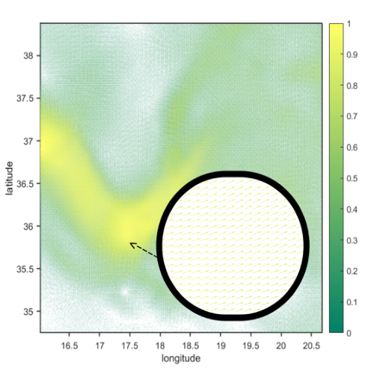
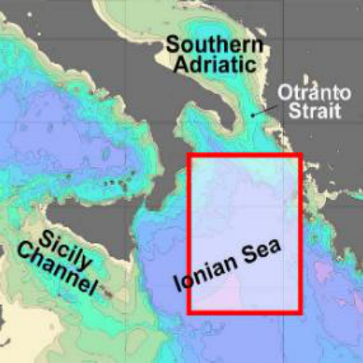
Figure 5: Currents in Ionian Sea[5]
图 5：爱奥尼亚海的海流[5]
图中文字对照（英文 → 中文）
Southern Adriatic | 南亚得里亚海 | Otranto Strait | 奥特朗托海峡
Sicily Channel | 西西里海峡 | Ionian Sea | 爱奥尼亚海
The ﬁgure displays a schematic representation of the currents in a speciﬁc area of the Ionian
该图展示了爱奥尼亚海某一特定区域海流的示意图
Sea at a certain time. The diagram provides information about the general direction and averagevelocity of the currents[6] in the depicted region.
该图提供了所示区域内海流的总体方向与平均速度信息[6]。
2
— 原文第 9 页 —
Similarly, we can obtain a similar motion model for the submersible in the y-direction. Com-pared to the model in the vertical direction, the challenge in determining the coordinates of thesubmersible in the xy-plane lies in the uncertainty of ocean currents.
类似地，我们可以得到潜水器在 y 方向上类似的运动模型。与垂直方向上的模型相比，确定潜水器在 xy 平面内坐标的难点在于洋流的不确定性。
5.2 Model Solving
5.2 模型求解
In the vertical direction, due to the complexity of equation (7), it is diﬃcult to obtain an analyti-cal solution through mathematical methods. Therefore, we use a numerical method —Runge-Kuttamethod for solving.
在垂直方向上，由于式 (7) 的复杂性，难以通过数学方法获得解析解。因此，我们采用数值方法——龙格-库塔法进行求解。
• The fourth-order Runge-Kutta method
• 四阶龙格-库塔法
When solving the model, we employ the fourth-order Runge-Kutta method with a higher pre-cision, and the truncation error is O(h⁵), where h is the chosen step size.
在求解模型时，我们采用精度更高的四阶龙格-库塔法，其截断误差为 O(h⁵)，其中 h 为所选步长。
The recursive formula for solving using the fourth-order Runge-Kutta method is:
采用四阶龙格-库塔法求解的递推公式为：
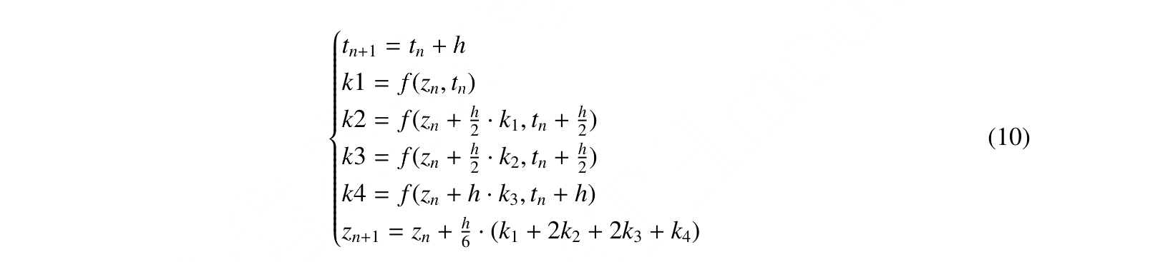
y_{n} is determined by the sum of the current y₍n −1) and the unit time change. The unit time changeis the product of the time interval h and the approximate slope.
y_{n} 由当前的 y₍n −1) 与单位时间变化量之和确定。单位时间变化量为时间间隔 h 与近似斜率的乘积。
• Algorithm improvement and application
• 算法改进与应用
⋄Step1:Determination of Initial Conditions: The data such as the submersible’s velocityand acceleration can be obtained from corresponding sensors. The velocity and accelerationtransmitted to the main ship at the last moment can be considered as the submersible’s initial
⋄步骤 1：初始条件的确定：潜水器的速度与加速度等数据可由相应的传感器获得。上一时刻传回主船的速度与加速度可视为潜水器的初始
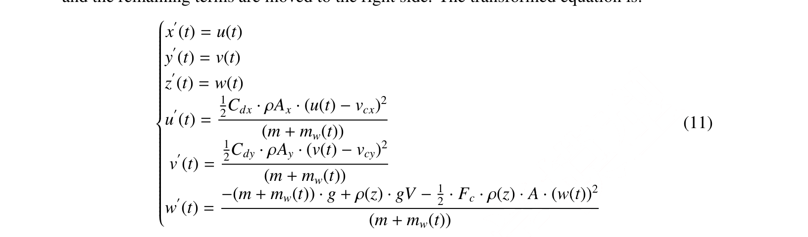
— 原文第 10 页 —
⋄Step3:Iterative solution of the algorithm: Set the step size h=1s, iterate over a length of
⋄步骤 3：算法的迭代求解：设定步长 h=1s，迭代长度为
10 hours, calculate the values of k₁, k₂, k₃, k₄ corresponding to the two diﬀerential equationsusing the recursive formula, and then determine the next discrete value z(n + 1).
10 小时，利用递推公式计算两个微分方程对应的 k₁, k₂, k₃, k₄ 值，进而确定下一个离散值 z(n + 1)。
• Results and Analysis
• 结果与分析
To solve and validate the model we established, we randomly select a point in the deep sea asthe initial position of the submersible, and provide initial velocity and acceleration values for thesubmersible.
为求解并验证我们建立的模型，我们在深海随机选取一点作为潜水器的初始位置，并给定潜水器的初始速度与加速度值。
⋄When the submersible can resurface normally:
⋄当潜水器能够正常上浮时：
At this point, the submersible’s water tank drains normally until it is empty. By substitutingthe initial velocity and acceleration of the submersible and iterating continuously, we can plot the
此时，潜水器的水舱正常排水直至排空。代入潜水器的初始速度与加速度并不断迭代，我们可绘制出
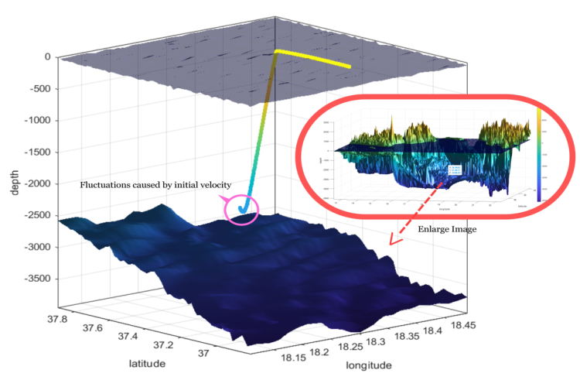
2
— 原文第 11 页 —
The selected initial point in the ﬁgure is (18, 37, -3147) (where x and y coordinates representlongitude and latitude, and z is the depth). The submersible initially descends a short distanceunder the inﬂuence of the initial velocity and then begins to resurface. In the xy plane, due to theinﬂuence of ocean currents, the position continuously shifts over time.
图中选取的初始点为 (18, 37, -3147)（其中 x、y 坐标表示经度与纬度，z 为深度）。潜水器在初始速度的作用下先短暂下潜，随后开始上浮。在 xy 平面内，受洋流影响，其位置随时间不断偏移。
⋄When the submersible cannot resurface normally:
⋄当潜水器无法正常上浮时：
At this point, there is a malfunction in the water tank. Considering real-world scenarios, we as-sume that after the water tank failure, its mass follows a uniform distribution between the minimumand maximum mass:
此时，水舱发生故障。考虑现实情形，我们假设水舱故障后其质量在最小质量与最大质量之间服从均匀分布：
In this case, due to the uncertainty in the initial state and water tank mass, the submersible mayeither touch the bottom or reach the neutral buoyancy point. Through multiple simulations, weobtained trajectories where the submersible either hits the bottom or hovers, as shown below:
在此情形下，由于初始状态与水舱质量的不确定性，潜水器可能触底，也可能到达中性浮力点。通过多次模拟，我们得到了潜水器或触底或悬停的轨迹，如下图所示：
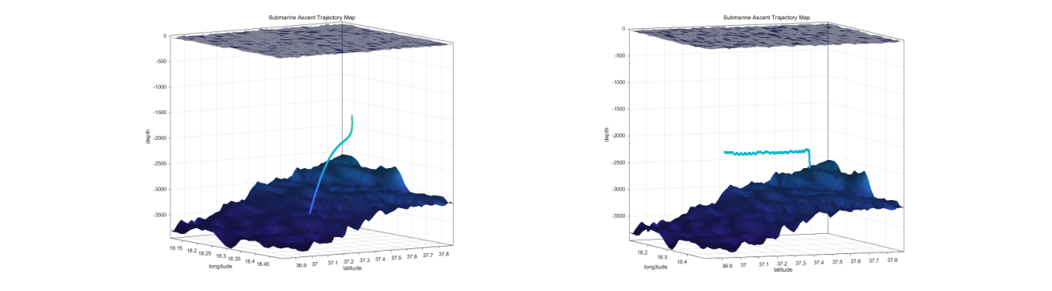
Figure 7: Possible trajectories of the submersible’s movement
图 7：潜水器运动的可能轨迹
图中文字对照（英文 → 中文）
Submarine Ascent Trajectory Map | 潜水器上浮轨迹图 | depth | 深度
longitude | 经度 | latitude | 纬度
In the left ﬁgure, due to a malfunction in the water tank, the submersible continuously sinks tothe seabed as gravity exceeds buoyancy.
左图中，由于水箱发生故障，重力超过浮力，潜水器持续下沉至海底。
In the right ﬁgure, a portion of the water in the submersible’s water tank is discharged. Uponreaching a speciﬁc depth, the submersible remains in a suspended state due to the decreased densityof seawater, experiencing slight oscillations above and below the neutral buoyancy point.
右图中，潜水器水箱中的一部分水被排出。到达特定深度后，由于海水密度减小，潜水器保持悬浮状态，并在中性浮力点上下轻微振荡。
5.3 Uncertainty of the Model
5.3 模型的不确定性
During the process of model establishment and solving, we have identiﬁed that the position of
在模型建立与求解的过程中，我们已识别出……的位置
— 原文第 12 页 —
• Initial Velocity and Acceleration: According to the safety strategy mentioned earlier, thesubmersible will immediately deactivate propulsion after losing contact with the main ship.
• 初速度与加速度：根据前文所述的安全策略，潜水器在与母船失去联系后将立即关闭推进装置。
The submersible will then commence movement with initial velocity and acceleration. Theinitial conditions have a signiﬁcant impact on the predicted results of the model.
随后潜水器将以一定的初速度与加速度开始运动。初始条件对模型的预测结果具有显著影响。
• Ocean Currents: For a submersible that has lost propulsion, the force exerted by oceancurrents is the primary reason for its continuous movement. Ocean currents vary with time,seasons, and the temperature of seawater, exhibiting signiﬁcant short-term randomness. Thisrandomness is a crucial uncertainty factor in the model.
• 洋流：对于已失去推进能力的潜水器，洋流所施加的作用力是其持续运动的主要原因。洋流随时间、季节以及海水温度而变化，呈现出显著的短期随机性。这种随机性是模型中至关重要的不确定性因素。
• Seabed Topography: As the exact underwater topography cannot be precisely determinedin advance, the submersible’s movement may be constrained by the terrain, introducing un-certainty to the model.
• 海底地形：由于无法事先精确确定水下地形的确切形态，潜水器的运动可能受到地形的约束，从而为模型引入不确定性。
5.4 Measures and Equipment to Reduce Uncertainty
5.4 降低不确定性的措施与设备
5.4.1 Measures
措施
For potential accidents, reducing uncertainty factors means improving safety. To minimizeuncertainties in the model, enhance the likelihood and accuracy of predictions, the submersibleshould regularly transmit its position information, movement speed and acceleration, oceancurrent information, as well as data about the surrounding environment or terrain to themain ship before losing contact with the host ship.
针对潜在事故，减少不确定性因素就意味着提升安全性。为尽可能降低模型中的不确定性、提高预测的可能性与准确性，潜水器应在与母船失去联系之前，定期向母船传输其位置信息、运动速度与加速度、洋流信息，以及有关周围环境或地形的数据。
5.4.2 Equipment
设备
We recommend equipping the submersible with the following devices:
我们建议为潜水器配备以下设备：
• GPS Positioning Device:GPS is a technology that determines location using satellite sig-nals. However, underwater, GPS signals cannot penetrate the water surface directly, so thesubmersible’s GPS positioning typically requires coordination with buoys or surface vessels.
• GPS 定位装置：GPS 是一种利用卫星信号确定位置的技术。然而在水下，GPS 信号无法直接穿透水面，因此潜水器的 GPS 定位通常需要与浮标或水面船只配合完成。
• Inertial Navigation System:An inertial navigation system uses sensors such as accelerome-ters and gyroscopes to measure the submersible’s acceleration and angular velocity. Velocitycan be obtained through integration.
• 惯性导航系统：惯性导航系统利用加速度计和陀螺仪等传感器测量潜水器的加速度与角速度。速度可通过积分获得。
• Underwater High-Deﬁnition Camera:Can be used to observe underwater environments,acquire seaﬂoor topography, thereby reducing the risk of encountering hazards.
• 水下高清摄像机：可用于观测水下环境、获取海底地形，从而降低遭遇危险的风险。
• Pressure Sensor:As the water pressure in the deep sea is approximately linearly related todepth, the depth at which the submersible is located can be calculated based on the measuredwater pressure.
• 压力传感器：由于深海中的水压与深度近似呈线性关系，因此可根据测得的水压推算潜水器所处的深度。
— 原文第 13 页 —
6 Models and Solutions of Problem 2
6 问题 2 的模型与求解
6.1 Rescue Equipment
6.1 救援设备
According to the position model established in the previous section, when the submersible losescontact with the main ship, it may sink to the seaﬂoor, remain at certain neutral buoyancy points, orrise to the sea surface depending on diﬀerent failure scenarios. This presents varied requirementsfor search and rescue operations. We deﬁne regions with depths below 3000 meters as deep-waterzones and those above 3000 meters as shallow-water zones. To address all possible situations,we have researched equipment designed for search and rescue in surface, shallow-water, anddeep-water areas. The speciﬁcations and costs of these devices are presented in the table below:
根据上一节建立的位置模型，当潜水器与母船失去联系时，依据不同的故障情形，其可能下沉至海底、停留在某些中性浮力点，或上浮至海面。这对搜救行动提出了各不相同的要求。我们将深度大于 3000 米的区域定义为深水区，将深度小于 3000 米的区域定义为浅水区。为应对所有可能的情形，我们调研了分别用于水面、浅水区与深水区搜救的设备。这些设备的规格与成本列于下表：
Table 1: Equipment and Parameters[7]
表 1：设备与参数[7]
Maritime Search
海上搜索
6 × 10⁶
0.5 11.6 94 3415 100
20and Rescue Boats
20 与救援船
Side-scan Sonar
侧扫声呐
0.05 224 10.2 98 24995 200 90
Shallow-water Zone
浅水区
Autonomous Underwater
自主水下
0.1 30 2.5 99.4 35248 900 87
Robot
机器人
Autonomous Underwater
自主水下
0.2 67 5 98.6 45652 1000 120
Vehicle
航行器
Side-scan Sonar
侧扫声呐
0.2 400 40.8 95 24995 200 90
Deep-water Zone
深水区
Autonomous Underwater
自主水下
0.4 30 4.5 98.9 35248 900 87
Robot
机器人
Autonomous Underwater
自主水下
1.0 65 6 96 45652 1000 120
Vehicle
航行器
where, precision represents the minimum distance that the equipment can resolve.The smaller thevalue, the stronger the resolution capability of the device.
其中，precision 表示设备能够分辨的最小距离。该值越小，设备的分辨能力越强。
Taking into account the performance of the equipment and the associated costs of purchasing,maintaining, and using, we adopt a cost-beneﬁt model based on the entropy weight method toevaluate various rescue devices. This aims to achieve the optimal conﬁguration while ensuringrescue eﬃciency.
综合考虑设备性能以及购置、维护与使用等相关成本，我们采用基于熵权法的成本收益模型对各类救援设备进行评价。以期在保证救援效率的同时实现最优配置。
6.2 Cost-Beneﬁt Model Based on Entropy Weight Method
6.2 基于熵权法的成本收益模型
• Entropy weight method to determine weights (1) Standardize the performance parameters
• 熵权法确定权重(1) 对性能参数进行标准化
Input the various performance indicators and cost indicators of the three types of equipmentin the shallow water area into the matrix. For the failure rate and minimum resolution ac-curacy in the beneﬁt indicators, since smaller values indicate better equipment performance,
将浅水区三类设备的各项性能指标与成本指标输入矩阵。对于效益指标中的故障率与最小分辨精度，由于数值越小表示设备性能越好，
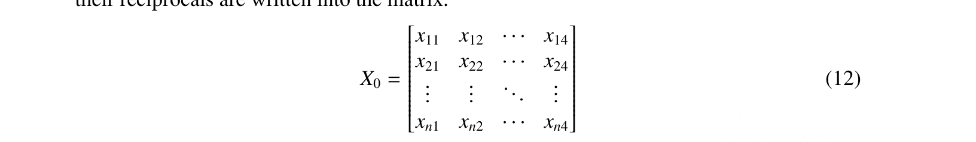
— 原文第 14 页 —
Then we can get the standardized matrix Z₀.
由此可得标准化矩阵 Z₀。
(2) Entropy Calculating
(2) 熵值计算
The range of entropy value e_{j} is [0, 1].The larger the e j is,the greater the diﬀerentiationdegree of index j is, and more information can be derived. Hence, higher weight should begiven to the index. Therefore,the weight W_{j} is deﬁned as follows:
熵值 e_{j} 的取值范围为 [0, 1]。e_{j} 越大，指标 j 的区分度越大，可导出的信息越多。因此，应赋予该指标更高的权重。因此，权重 W_{j} 定义如下：
• Cost-beneﬁt evaluation model
• 成本收益评价模型
Where E_{i} represents the beneﬁt indicator, and C_{i} represents the cost indicator. C_{i} includesthe expenses for the purchase, maintenance, and single-use of the equipment. To achievebetter visual representation, we have also normalized C.
其中，E_{i} 表示收益指标，C_{i} 表示成本指标。C_{i} 包括设备的购置、维护和单次使用费用。为获得更好的可视化表现，我们还对 C 进行了归一化。
2
— 原文第 15 页 —
6.3 Evaluation Results and Analysis
6.3 评价结果与分析
Based on the evaluation model, combined with the relevant data in Table 2, we conducted eval-uations of rescue equipment in the sea surface, shallow water area, and deep water area, obtaining
基于该评价模型，结合表 2 中的相关数据，我们对海面、浅水区和深水区的救援设备进行了评价，得到
scores for ﬁve types of rescue equipment: Autonomous Underwater Vehicle (AUV), Autonomous
五类救援设备的得分：自主水下航行器（AUV）、自主
Underwater Robot (AUR), Side-scan Sonar (SSS), Search and Rescue Drones (SRD), and Mar-itime Search and Rescue Boats (MSRB). The results are displayed as follows:
水下机器人（AUR）、侧扫声呐（SSS）、搜救无人机（SRD）和海上搜救船（MSRB）。结果如下所示：
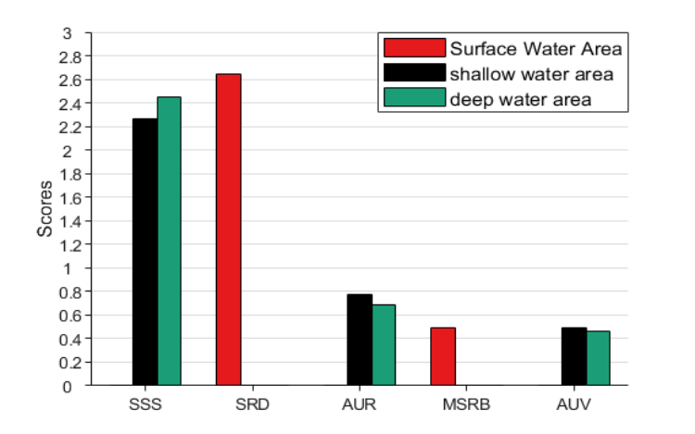
Figure 8: Evaluation Results
图 8：评价结果
图中文字对照（英文 → 中文）
Surface Water Area | 表层水域 | shallow water area | 浅水水域
deep water area | 深水水域 | Scores | 得分
From the chart, it can be observed that in surface search and rescue, the score of Search and
从图中可以看出，在海面搜救中，搜救
Rescue Drones (SRD) is signiﬁcantly higher than Maritime Search and Rescue Boats, demonstrat-ing higher search and rescue eﬃciency and lower costs. In shallow water and deep water areas, thescore of Side-scan Sonar (SSS) is also signiﬁcantly higher than others. Therefore, the combinationof Drones and Sonar as the main search and rescue equipment is reasonable.
无人机（SRD）的得分显著高于海事搜救船，表明其搜救效率更高、成本更低。在浅水区和深水区，侧扫声呐（SSS）的得分同样显著高于其他设备。因此，将无人机与声呐组合作为主要搜救设备是合理的。
It is worth noting that, although SSS has a high score, it is powerless in deeper depths. How-ever, AUVs can operate in deeper regions. And AUR has the highest exploration accuracy, makingit advantageous in dealing with more complex seabed terrain. Therefore, we recommend the mainsearch and rescue equipment to be Search and Rescue Drones and Side-scan Sonar, with asmaller number of AUVs and AURs. This approach can ensure search and rescue eﬃciency asmuch as possible within an acceptable cost range, preparing for any possible scenarios.
值得注意的是，尽管 SSS 得分较高，但在更深处却无能为力。然而，AUV 能够在更深的区域作业。而 AUR 的探测精度最高，使其在处理更复杂的海底地形时具有优势。因此，我们建议以搜救无人机和侧扫声呐作为主要搜救设备，并配备数量较少的 AUV 和 AUR。该方案能够在可接受的成本范围内尽可能保证搜救效率，为任何可能的情形做好准备。
Using the location model, we can determine the trajectory of the submersible if the initialposition of the submersible, fault conditions, ocean current data, and seaﬂoor topography are allknown.However, in reality, the fault conditions of the submersible, ocean current speed, and di-rection are subject to signiﬁcant randomness. Therefore, the submersible may appear in diﬀerent locations in the ocean with varying probabilities, and these probability distributions will changeover time. To obtain the probability distribution of the submersible’s position over time, we employ
利用定位模型，若潜水器的初始位置、故障状况、洋流数据和海底地形均已知，我们便可以确定潜水器的轨迹。然而在现实中，潜水器的故障状况、洋流速度与方向都具有显著的随机性。因此，潜水器可能出现在不同的海洋位置，且其概率各不相同，而这些概率分布（Probability Distribution）会随时间变化。为获得潜水器位置随时间的概率分布，我们采用
— 原文第 16 页 —
Monte Carlo simulation.
蒙特卡洛模拟。
• Divide Search Area into Grids
• 将搜索区域划分为网格
As the submersible loses or shuts oﬀpropulsion, its speed gradually approaches the speed ofocean currents over time. Therefore, we calculated the maximum range the submersible couldreach after 10 hours. We divided the area into grids with dimensions of 400m in length and width,resulting in a total of 30 × 75 grids. By discretizing the region, we can use numerical methods tosimulate the probability of the submersible appearing at various points. This approach is helpfulin actual search operations to avoid overlooking potential locations.
随着潜水器失去或关闭推进力，其速度会随时间逐渐接近洋流速度。因此，我们计算了潜水器在 10 小时后可能达到的最大范围。我们将该区域划分为长宽均为 400 m 的网格，共得到 30 × 75 个网格。通过离散化该区域，我们可以用数值方法模拟潜水器在各点出现的概率。该方法有助于实际搜索作业避免遗漏潜在位置。
• Monte Carlo Simulation
• 蒙特卡洛模拟
To simulate the real movement of the submersible, we ﬁrst simulated the uncertainty of oceancurrents. Over a short period, the stable speed and direction angle of ocean currents can be approx-
为模拟潜水器的真实运动，我们首先模拟了洋流的不确定性。在短时间内，洋流的稳定速度与方向角可近似
imated to follow a normal distribution:
近似为服从正态分布：
where v_{c} and θ represent the average speed and average direction angle of the ocean currents,respectively.
其中，v_{c} 和 θ 分别表示洋流的平均速度和平均方向角。
Additionally, if the submersible can resurface normally, the rescue operation will be mucheasier. Therefore, we focus on analyzing the situation of a malfunction in the submersible’s watertank and assume that the mass of water in the tank follows a uniform distribution:
此外，若潜水器能够正常上浮，救援行动将容易得多。因此，我们着重分析潜水器水舱发生故障的情形，并假设水舱中水的质量服从均匀分布：
We selected the same longitude and latitude as in Question 1 for the moment when the sub-mersible lost contact with the main ship, with a depth set at 1500 meters.Then, using Monte Carlorandom number simulation, we generated 100,000 sets of possible states and substituted them intothe positioning model to determine the coordinates of the submersible at 1, 2, ..., 10 hours later.
我们选取与问题 1 相同的经度和纬度作为潜水器与母船失联时刻的位置，并将深度设为 1500 m。随后，利用蒙特卡洛随机数模拟生成 100 000 组可能状态，并将其代入定位模型，以确定潜水器在 1、2、…、10 小时后的坐标。
In Figure 9, we can observe the results simulated from these 100,000 initial state points.
在图 9 中，我们可以观察到由这 100 000 个初始状态点模拟得到的结果。
• The left graph illustrates the distribution of these points after 10 hours. Due to the initialperturbations, among these points, 19.1% can reach the sea surface, 17.2% remain at depthsbetween 0 to 1500 meters, 36% stay at depths between 1500 to 3000 meters, and 27.67%are at the seaﬂoor.As the number of simulations is suﬃcient, the proportion of occurrencesin a speciﬁc area can approximate the probability of the submersible appearing there.
• 左图展示了这些点在 10 小时后的分布情况。由于初始扰动的影响，在这些点中，19.1% 能够到达海面，17.2% 停留在 0 至 1500 米深度之间，36% 停留在 1500 至 3000 米深度之间，27.67% 位于海底。由于模拟次数足够充分，某一特定区域内出现的比例可以近似为潜水器出现在该处的概率。
• In the diagram on the right, a top-down view of the trajectories of these simulated pointswithin 10 hours is depicted. It can be observed from the diagram that the trajectories diverge
• 在右图中，给出了这些模拟点在 10 小时内轨迹的俯视图。从图中可以观察到，各条轨迹呈现发散态势
2
— 原文第 17 页 —
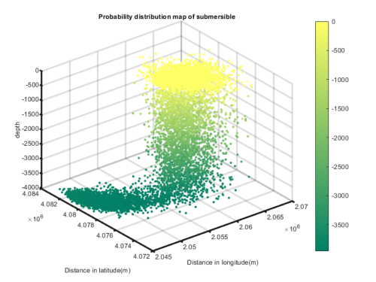
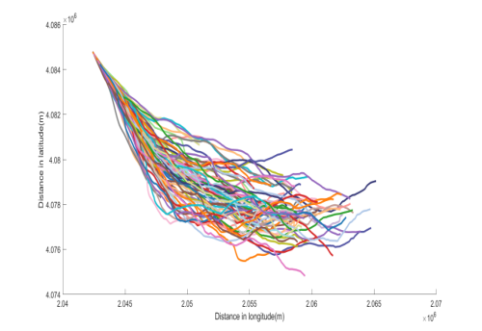
Figure 9: Possible trajectories of the submersible’s movement
图 9：潜水器可能运动的轨迹
图中文字对照（英文 → 中文）
Distance in latitude(m) | 纬度方向距离（m） | Distance in longitude(m) | 经度方向距离（m）
In the left of ﬁgure 10, we speciﬁcally depict the trajectories of points that sink to the seaﬂoorand those that resurface to the neutral buoyancy point over the course of 10 hours. The trajecto-ries of points resurfacing to the neutral buoyancy point are roughly similar to those described in
在图 10 的左图中，我们具体刻画了下沉至海底的点以及上浮至中性浮力点的点在 10 小时内的轨迹。上浮至中性浮力点的轨迹与
Problem 1.
问题 1 中所述的轨迹大致相似。
And the probability heatmap depicting the likelihood of the submersible resurfacing to the sealevel over time is shown in the right in ﬁgure 10.From the heatmap, it can be observed that the watertanks capable of resurfacing normally can reach the sea surface in approximately 1 hour. With theincrease in time, there is a slight increase in the number of submersibles capable of resurfacing tothe sea surface. This aligns well with the actual scenario.
而刻画潜水器随时间内上浮至海面可能性的概率热力图如图 10 右图所示。由该热力图可以观察到，能够正常上浮的压载水舱大约可在 1 小时内到达海面。随着时间的增加，能够上浮至海面的潜水器数量略有增加。这与实际情形高度吻合。
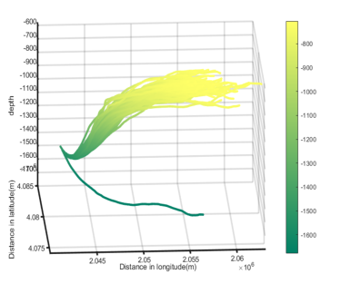
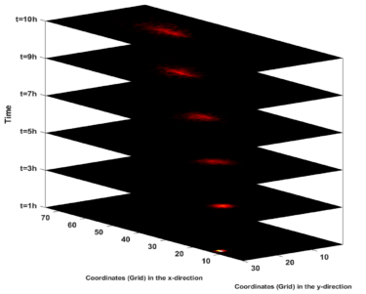
Figure 10: Some speciﬁc simulation points
图 10：一些具体的模拟点
图中文字对照（英文 → 中文）
Time | 时间 | t=1h | t=1 小时
t=3h | t=3 小时 | t=5h | t=5 小时
t=7h | t=7 小时 | t=9h | t=9 小时
t=10h | t=10 小时 | Coordinates (Grid) in the x-direction | x 方向坐标（网格）
Coordinates (Grid) in the y-direction | y 方向坐标（网格）
7.2 Model for Searching
7.2 搜索模型
— 原文第 18 页 —
ment and sonar as the primary underwater search equipment. Maritime and underwater searchesshould be conducted simultaneously.
设备与声呐作为主要的水下搜索设备。海上搜索与水下搜索应同时进行。
7.2.2 Ant Colony Algorithm for Planning Search Paths
用于规划搜索路径的蚁群算法
Through Monte Carlo simulation, we can determine the probability of the submersible appear-ing in a speciﬁc grid at a certain moment and simulate the trajectory of the submersible over aperiod of time. For points that have already been searched, we can simulate their subsequentpositions. These points will disappear from the subsequent search maps. Taking into accountthe time required for each set of equipment to search a grid, we set the search period T = 1h. Since
通过蒙特卡洛模拟，我们可以确定潜水器在某一时刻出现在特定网格中的概率，并模拟潜水器在一段时间内的轨迹。对于已被搜索过的点，我们可以模拟其后续位置。这些点将从后续的搜索图中消失。考虑到每组设备搜索一个网格所需的时间，我们设定搜索周期 T = 1h。由于
T is relatively short, and the submersible’s position changes minimally, we assume its positionremains unchanged within one search cycle and update the position at the beginning of the nextsearch cycle.
T 相对较短，且潜水器的位置变化很小，我们假定其位置在一个搜索周期内保持不变，并在下一搜索周期开始时更新位置。
▲Bayesian Probability Model
▲贝叶斯概率模型
The probability of ﬁnding the submersible is time-varying and depends on the search results
发现潜水器的概率是随时间变化的，并取决于
of the previous cycle.
上一周期的搜索结果。采用贝叶斯概率模型：
where: P(i) represents the probability of ﬁnding it until the i-th search, and P_{i} represents theprobability of ﬁnding it in a single search.
其中：P(i) 表示截至第 i 次搜索时发现它的概率，P_{i} 表示单次搜索中发现它的概率。
▲Objective Function for Search
▲搜索的目标函数
The probability of ﬁnding the submersible after time t is denoted as P(t). In addition to beingrelated to the choice of the search route, with the increase in search time, P(t) generallyexhibits a trend of initially increasing and then decreasing[8]. To minimize the time requiredto locate the submersible, we have established the following objective function:
经过时间 t 后发现潜水器的概率记为 P(t)。除与搜索路线的选择有关外，随着搜索时间的增加，P(t) 总体呈现先增后减的趋势[8]。为使定位潜水器所需的时间最短，我们建立了如下目标函数：
where the urgency level based on time is reﬂected in the parameter k.
其中，基于时间的紧迫程度由参数 k 体现。
▲Determine the starting point
▲确定起点
Since all the uncertain factors in the simulation approximately follow a normal distribution,the probability is relatively large around the point of maximum probability. Therefore, toimprove search eﬃciency and reduce search time, we choose the grid with the highest prob-ability as the starting point for the search.
由于模拟中的全部不确定因素近似服从正态分布，因此在最大概率点附近的概率相对较大。因此，为提高搜索效率、缩短搜索时间，我们选择概率最高的网格作为搜索起点。
▲Algorithm ﬂowchart
▲算法流程图
2
— 原文第 19 页 —
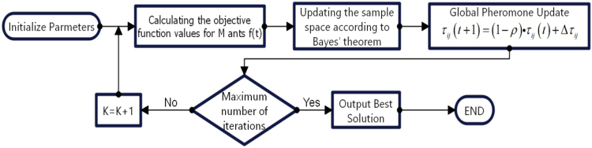
Figure 11: Flowchart for Ant Colony Algorithm
图 11：蚁群算法流程图
图中文字对照（英文 → 中文）
Initialize Parmeters | 初始化参数（原文拼写为 Parmeters） | Calculating the objective function values for M ants f(t) | 计算 M 只蚂蚁的目标函数值 f(t)
Updating the sample space according to Bayes' theorem | 依据贝叶斯定理更新样本空间 | Global Pheromone Update τ_ij(t+1)=(1-ρ)·τ_ij(t)+Δτ_ij | 全局信息素更新
K=K+1 | 迭代计数 K 加一 | Maximum number of iterations | 达到最大迭代次数？
No | 否 | Yes | 是
Output Best Solution | 输出最优解 | END | 结束
7.3 Results and Analysis
7.3 结果与分析
7.3.1 Planning Results of Search Route
搜索路线规划结果
One hour after the loss of contact, relevant equipment begins the search. The grid with thehighest probability at 1 hour is selected as the initial deployment point. By applying the ant colonyalgorithm and periodically updating the search map, iterating until convergence, we can obtain the
失联 1 小时后，相关设备开始搜索。选取 1 小时时概率最高的网格作为初始布放点。通过应用蚁群算法并周期性更新搜索图，迭代直至收敛，即可得到
search route as shown in the following diagram:
如下图所示：的搜索路线
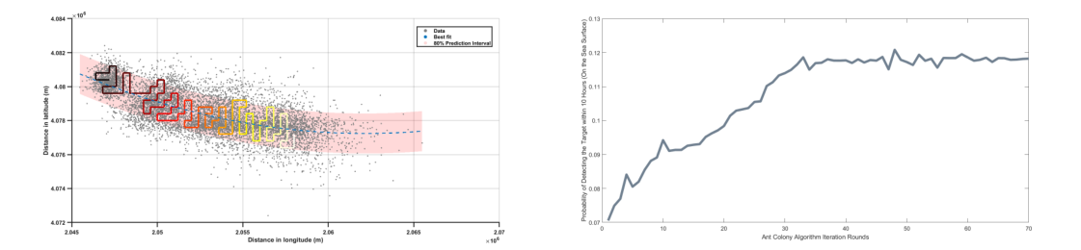
(a) Planning Route (b) Iteration Results
(a) 规划路线(b) 迭代结果
Figure 12: Diﬀerent probabilities with diﬀerent t
图 12：不同 t 对应的不同概率
图中文字对照（英文 → 中文）
Data | 数据点 | Best Fit | 最优拟合线
<不可辨>% Prediction Interval | 预测区间（百分数不可辨，疑为 90%） | Distance in latitude (m) | 纬度方向距离（m）
Distance in longitude (m) | 经度方向距离（m） | Probability of Detecting the Target within 10 Hours (On the Sea Surface) | 10 小时内探测到目标的概率（海面探测）
Ant Colony Algorithm Iteration Rounds | 蚁群算法迭代轮次
The diagram (a) provides a top-down view of 100,000 simulated points, with the black areaindicating the initial point positions and the white area representing the stopping points after 10hours of search. The light red bands cover 80% of the simulated points along the direction of theocean currents.
图 (a) 给出了 100,000 个模拟点的俯视图，其中黑色区域表示初始点位置，白色区域表示搜索 10 小时后的停止点。浅红色条带沿洋流方向覆盖了 80% 的模拟点。
It can be observed that most simulated points are distributed near the direction of the oceancurrents, and the search path obtained through the ant colony algorithm also follows the directionof the currents. This result is reasonable as it aligns with the actual outcomes.
可以观察到，大多数模拟点分布在洋流方向附近，并且通过蚁群算法得到的搜索路径也沿洋流方向延伸。该结果是合理的，因为它与实际结果相符。
In (b) of ﬁgure 12, the probability of ﬁnding the submersible on the sea surface during eachiteration of the ant colony algorithm is displayed. When the number of iterations reaches 40, theprobability of ﬁnding the submersible on the sea surface within 10 hours converges to around 12%.
在图 12 的 (b) 中，展示了蚁群算法每次迭代时在海面发现潜水器的概率。当迭代次数达到 40 次时，10 小时内在海面发现潜水器的概率收敛至约 12%。
— 原文第 20 页 —
7.3.2 The Impact of Start Time for Searching
搜索起始时刻的影响
In the above model, we took t=1h. However, in reality, t is often greater than one hour due tovarious factors. Therefore, to study the impact of t on the 10-hour model, we obtained the time-
在上述模型中，我们取 t=1h。然而在现实中，由于多种因素，t 往往大于 1 小时。因此，为研究 t 对 10 小时模型的影响，我们得到了时间
dependent overall probability of ﬁnding the submersible within 10 hours of search initiation underthe conditions of t=1h, 3h, and 5h, with the remaining parameters being the same, as shown in thefollowing graph:
在其余参数相同的条件下，t=1h、3h 和 5h 时，自搜索开始起 10 小时内找到潜水器的时间依赖总体概率，如下图所示：
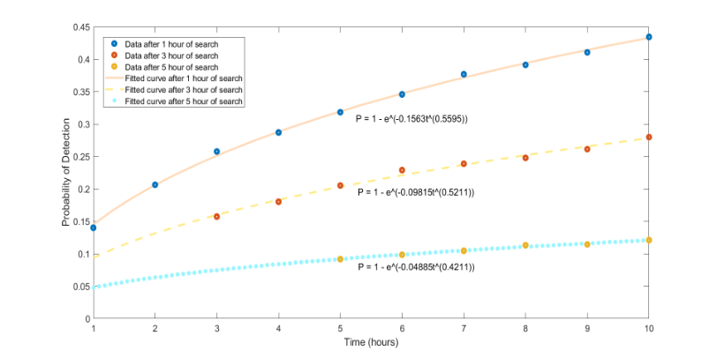
Figure 13: Planning Results of Search Route
图 13：搜索路径的规划结果
图中文字对照（英文 → 中文）
Probability of Detection | 探测概率 | Time (hours) | 时间（小时）
Data after 1 hour of search | 搜索 1 小时后的数据 | Data after 3 hour of search | 搜索 3 小时后的数据
Data after 5 hour of search | 搜索 5 小时后的数据 | Fitted curve after 1 hour of search | 搜索 1 小时后的拟合曲线
Fitted curve after 3 hour of search | 搜索 3 小时后的拟合曲线 | Fitted curve after 5 hour of search | 搜索 5 小时后的拟合曲线
From the graph, it can be observed that if the search starts at t=1h, the probability of ﬁnding thesubmersible within 10 hours reaches 43%. The later the search is initiated, the lower the probabilityof ﬁnding the submersible within 10 hours. If the search begins at t=5h, the probability of ﬁndingthe submersible within 10 hours is only about 10%. This tells us that time is crucial for rescueoperations. Therefore, after the submersible loses contact with the main ship, rescue eﬀorts shouldbe deployed as soon as possible to increase the probability of ﬁnding it in a short time.
从图中可以看出，若在 t=1h 时开始搜索，10 小时内找到潜水器的概率可达 43%。搜索开始得越晚，10 小时内找到潜水器的概率越低。若在 t=5h 时开始搜索，10 小时内找到潜水器的概率仅约为 10%。这表明时间对于救援行动至关重要。因此，在潜水器与母船失去联系后，应尽快部署救援力量，以提高在短时间内找到它的概率。
8 Model Expansion and Promotion for Problem 4
8 问题 4 的模型扩展与推广
The model, being based on the actual parameters of the submersible and the ocean, possessesstrong generalizability.
该模型基于潜水器与海洋的实际参数建立，具有很强的可推广性。
Diﬀerent Maritime Regions
不同的海域
8.1
When considering rescue operations in diﬀerent maritime regions, it is crucial to have a com- tions and the presence of tropical storms locally from June to November each year. There-fore, compared to the Mediterranean climate in the Ionian Sea, the surface ocean currents in the Caribbean Sea are more intense and complex. When simulating ocean current data inthe relevant area, it is necessary to increase the perturbation values of local ocean currentsover time. This will cause a submersible that loses power to quickly lose the inﬂuence of itsinitial velocity, resulting in a more divergent movement trajectory.
在考虑不同海域的救援行动时，至关重要的是具备全面的……条件以及每年 6 月至 11 月当地热带风暴的出现情况。因此，与爱奥尼亚海的地中海气候相比，表层洋流在加勒比海更为剧烈且复杂。在模拟相关区域的洋流数据时，需要随时间增大局部洋流的扰动值。这将使失去动力的潜水器迅速失去其初始速度的影响，从而产生更为发散的移动轨迹。
— 原文第 21 页 —
• Topography
• 地形
The terrain in the Ionian Sea is relatively ﬂat, but it is the opposite near the Caribbean
爱奥尼亚海的地形相对平坦，但加勒比海附近则恰恰相反
Sea. The underwater terrain in the vicinity of the Caribbean Sea has large ﬂuctuations,with numerous reefs and rocks, contributing to numerous shipwrecks in the Caribbean Sea.
加勒比海附近的水下地形起伏较大，礁石与岩石众多，致使加勒比海沉船事故频发。
Therefore, when simulating, accidents caused by the submersible hitting rocks must be con-sidered. It is necessary to enhance the physical model to simulate the impact of collisions onthe submersible’s path. After hitting a rock, the submersible immediately loses power andits original velocity, with a probability of mass loss. It should be able to drift with the oceancurrents to prevent the simulation from mistakenly detecting it as being stuck at the bottom.
因此，在模拟时必须考虑潜水器撞击岩石所导致的事故。需要强化物理模型，以模拟碰撞对潜水器路径的影响。撞击岩石后，潜水器立即失去动力及其原有速度，并存在质量损失的概率。它应能够随洋流漂移，以避免模拟错误地将其判定为停滞于海底。
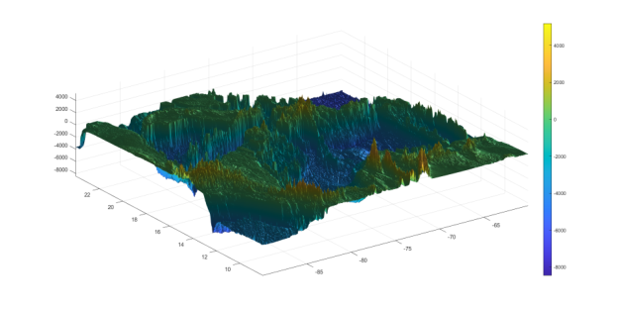
Figure 14: The Topography of Caribbean Sea
图 14：加勒比海的海底地形
Combining these two factors makes search operations in the Caribbean more complex, placinghigher demands on the accuracy of the model and simulated data.
综合这两个因素，加勒比海的搜索行动更为复杂，对模型与模拟数据的精度提出了更高要求。
8.2 Multiple Submersibles
8.2 多潜水器情形
In scenarios where there are multiple submersibles in a relatively small area, we analyze that,assuming normal communication with the mothership, simultaneous loss of communication ormechanical failure for multiple submersibles is rare and can be disregarded. Therefore, after the
在相对较小区域内存在多台潜水器的场景下，我们分析认为：假设与母船通信正常，多台潜水器同时失去通信或发生机械故障的情况十分罕见，可以忽略。因此，在
ﬁrst submersible loses contact, judgment needs to be made based on its last communication status.
第一台潜水器失去联系后，需依据其最后的通信状态作出判断。
In the event of a submersible loss, real-time ocean currents, atmospheric conditions, and thegeographical status of the last known position before the loss should be checked.
在潜水器失联事件中，应核查实时洋流、大气条件以及失联前最后已知位置的地理状况，
— 原文第 22 页 —
for timely deployment of subsequent search and rescue eﬀorts. According to the results ofthe third question, this signiﬁcantly increases the probability of locating the missing sub-mersible.
9 Sensitivity Analysis
9 灵敏度分析
Due to the close relationship between the drag coeﬃcients of the submersible and the shape,size, and maritime conditions of the actual submersible, the drag coeﬃcients in all three direc-tions are estimated values. In this section, a sensitivity analysis is conducted on these three dragcoeﬃcients. By varying them by ±1%, 2%,and 4%, while keeping other conditions constant, thetrajectories for these six scenarios are simulated. A comparison is made between these simulatedtrajectories and the original trajectory, resulting in the two graphs presented below.
由于潜水器的阻力系数与其实际形状、尺寸及海况密切相关，三个方向上的阻力系数均为估计值。本节对这三个阻力系数进行灵敏度分析。在保持其他条件不变的情况下，将其分别改变 ±1%、2% 和 4%，并模拟这六种情形下的轨迹。将这些模拟轨迹与原始轨迹进行比较，得到下面两幅图。
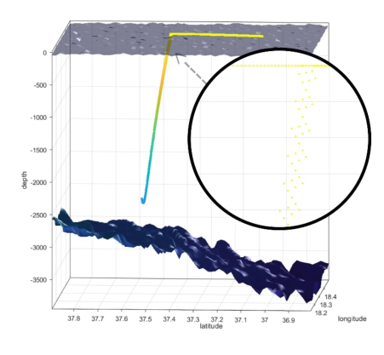
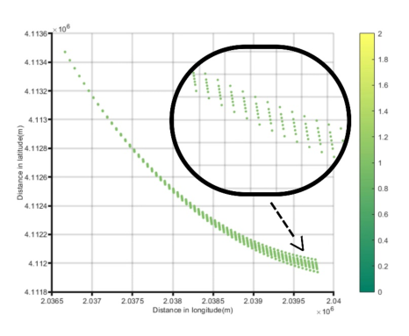
Figure 15: The impact of drag coeﬃcient errors
图 15：阻力系数误差的影响
图中文字对照（英文 → 中文）
Distance in latitude(m) | 纬度方向距离（m） | Distance in longitude(m) | 经度方向距离（m）
From the graph a, it can be observed that after 10 hours in the xy dimensions, the deviationof the trajectory does not exceed 400 meters in any direction. This is within an acceptable range,indicating that it does not signiﬁcantly aﬀect the main direction of the trajectory. Additionally,in the grid-based map used in the third question, such deviations also have no impact.Throughextensive practical simulations, it has been observed that the position region in the z-direction ofthe submersible stabilizes after 3 hours. Therefore, a deviation value at 3 hours is considered.
从图 a 可以看出，在 xy 平面内经过 10 小时后，轨迹的偏差在任何方向上均不超过 400 米。这处于可接受的范围内，表明其不会显著影响轨迹的主要方向。此外，在第三问所使用的栅格化地图中，此类偏差也不产生影响。通过大量实际模拟可以发现，潜水器在 z 方向上的位置区域在 3 小时后趋于稳定。因此，采用 3 小时处的偏差值。
10.1 Strengths
10.1 优点
• This model, starting from a dynamics perspective, has established a relatively accurate pre-dictive model for the submersible, oﬀering high precision in its predictions.
• 该模型从动力学角度出发，为潜水器建立了较为准确的预测模型，其预测精度较高。
— 原文第 23 页 —
• The paper adopts a cost-beneﬁt model based on the entropy weighting method to evaluatesensors, ensuring more accurate assignment of weight values when calculating beneﬁts.
• 本文采用基于熵权法的成本收益模型对传感器进行评价，在计算效益时确保了权重赋值更为准确。
• The paper utilizes theories related to Bayesian detection and combines them with Ant Colony
• 本文运用贝叶斯检测（Bayesian Detection）相关理论，并将其与蚁群
Optimization. It considers the impact of certain probabilities being tested ﬁrst on the subse-quent sample space during detection, aligning more closely with reality.
算法优化相结合。该模型考虑了检测过程中某些概率被优先检验对后续样本空间所产生的影响，从而更贴近实际情况。
10.2 Weaknesses
10.2 缺点
• Due to the diﬃculty in calculating the drag coeﬃcient, this paper only estimates an ap-proximate value. Accurate measurement is required when extending the model to practicalapplication scenarios.
• 由于阻力系数难以计算，本文仅对其进行了近似估算。在将模型推广至实际应用场景时，需要进行精确测量。
• In the predictive model, a method of discretizing time is used to determine the ﬁnal probabil-ity of successful rescue. Due to the insuﬃcient level of discretization, there may be certainerrors.
• 在预测模型中，采用时间离散化的方法确定最终的救援成功概率。由于离散化程度不足，可能存在一定误差。
References
参考文献
[1] https://pxhere.com/en/photo/1237494?utm_content=shareClip&utm_medium=referral&utm_source=pxhere [2] NOAA National Centers for Environmental Information. 2022: ETOPO 2022 15 Arc-Second
Global Relief Model. NOAA National Centers for Environmental Information. https://doi.org/10.25921/fd45-gt74 Accessed [3 February,2024].
[3] https://tritonsubs.com [4] Zeng Guanghui, Zang Haipeng, Gu Zezue. Study on the Longitudinal Motion Characteristicsof a Powerless Submarine Underwater Drift [C]// Salvage and Rescue Committee of The
China Institute of Navigation. Proceedings of the 8th China International Salvage Forum.
Naval Submarine Academy, 2014: 3.
[5] Gai,˘aM.,˘aG.
Civitarese,˘aG.
Borzelli,˘aV.
Kovaevi,˘aP.-M.
Poulain,˘aA.
L.
Eusebi
Theocharis,˘aM. Menna,˘aA. Catucci, and˘aN. Zarokanellos˘a(2011),˘aOn the relationshipbetween the decadal oscillations of the northern Ionian Sea and the salinity distributions inthe eastern Mediterranean,˘aJ. Geophys. Res.,˘a116, C12002, doi:10.1029/2011JC007280.
[6] ESR; Dohan, Kathleen. 2022. Ocean Surface Current Analyses Real-time (OSCAR) Sur-face Currents - Interim 0.25 Degree (Version 2.0). Ver. 2.0. PO.DAAC, CA, USA. Dataset
Search and Rescue.
— 原文第 24 页 —
Memo
备忘录
To: The Government of Greece
致：希腊政府
From: MCM Team #2419984
自：MCM 第 2419984 队
Date: Feb 5th,2024
日期：2024 年 2 月 5 日
Subject:Scientiﬁc positioning and rescue eﬀorts ensure the safety of deep-sea tourism.
主题：科学定位与救援工作保障深海旅游安全
Dear Oﬃcer of the Government of Greece,
尊敬的希腊政府官员：
It has come to our attention that a company in your country, MCMS, has developed a type ofsubmersible suitable for tourists to explore the seabed. However, the potential for loss of commu-nication restricts its application and development. Therefore, we have established a dynamic andkinematic model of the submersible (see page ten), as well as a search and rescue strategy basedon this model.
我们注意到，贵国一家名为 MCMS 的公司开发了一种适用于游客探索海底的潜水器。然而，通信失联的潜在风险限制了其应用与发展。因此，我们建立了潜水器的动力学模型（Dynamics Model）与运动学模型（见第十页），并基于该模型提出了搜救策略。
Firstly, after conducting a comprehensive force analysis on the submersible, we established a
首先，在对潜水器进行全面受力分析之后，我们建立了
kinematic model considering the impact of ocean currents in the Ionian Sea region on its move-ment.
一个考虑伊奥尼亚海区域洋流对潜水器运动影响的运动学模型。我们发现，潜水器一旦失去通信，其可能位置将极大程度地受到洋流的影响。更不利的是，我们发现伊奥尼亚海附近的洋流监测点十分稀少，致使洋流数据不准确，进而导致潜水器位置的不确定性过大。在伊奥尼亚海增设更多的洋流探测站，可显著提高确定失联潜水器位置的准确性。
Secondly, through a comprehensive evaluation of the performance and cost indicators of var-ious search and rescue devices, we determined that the optimal equipment for surface and under-water searches are drones and sonar, respectively.
其次，通过对各类搜救装置的性能指标与成本指标进行综合评估，我们确定水面搜索与水下搜索的最优装备分别为无人机和声呐。
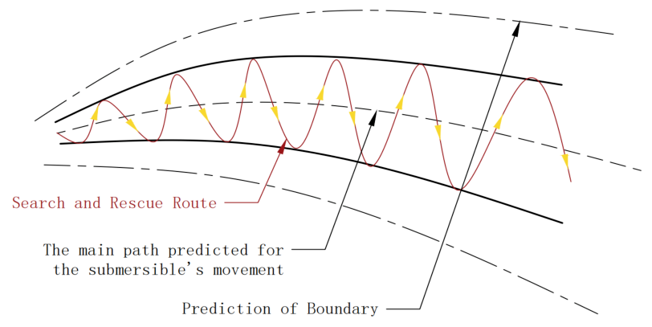
2
— 原文第 25 页 —
The results suggest that the search path should be as perpendicular as possible to the curvepredicted by the dynamic model, and the one-way search path should increase with time.
结果表明，搜索路径应尽可能垂直于动力学模型所预测的曲线，且单向搜索路径的长度应随时间增加。
Additionally, for a lost submersible, time is of the essence, and the probability of successfully
此外，对于失联潜水器而言，时间至关重要，成功
ﬁnding it decreases sharply with increasing time, as shown in the table below:
找到它的概率随时间的增加而急剧下降，如下表所示：
The search and rescue route should be as perpendicular as possible to the trajectory predictedby the dynamic model, and as time progresses, the length of each search path should also increase.
搜救路线应尽可能垂直于动力学模型预测的轨迹，且随着时间推移，每段搜索路径的长度也应增加。
Additionally, we have found that the probability of successfully detecting the submersible steeplydecreases over time. The results are as follows in the table below:
此外，我们发现成功探测到潜水器的概率随时间急剧下降。结果如下表所示：
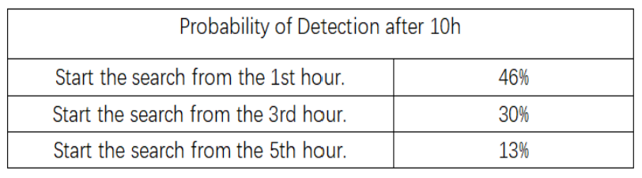
Therefore, we recommend dispatching relevant detection equipment to the designated area asquickly as possible once the mothership loses communication with the submersible. Our modelalso indicates that deploying more detectors, with larger detection widths and higher accuracy, in-creases search eﬃciency and the probability of successfully detecting the submersible. Purchasingand stockpiling more advanced detection equipment (such as underwater detection vehicles, under-water robots, high-precision sonar, etc.) and strengthening cooperation with the MCMS companywill signiﬁcantly increase the probability of ﬁnding the lost submersible.
因此，我们建议一旦母船与潜水器失去通信，应尽快向指定区域派遣相关探测设备。我们的模型还表明，部署更多的探测器、采用更大的探测宽度和更高的精度，可提高搜索效率以及成功探测到潜水器的概率。采购并储备更先进的探测设备（如水下探测车、水下机器人、高精度声呐等），并加强与 MCMS 公司的合作，将显著提高找到失联潜水器的概率。
In conclusion, with the use of advanced sensors and the position and search models we haveestablished, there is a high probability of quickly locating the submersible after an accident, whileensuring the speed of rescue operations. We sincerely hope that the Greek government considersthese suggestions to ensure the safety of tourists and promote the development of deep-sea tourism.
总之，借助先进的传感器以及我们所建立的位置模型与搜索模型，在事故发生后快速定位潜水器具有很高的可能性，同时还能保证救援行动的速度。我们诚挚希望希腊政府考虑这些建议，以保障游客安全并推动深海旅游业的发展。
Thank you for considering this vital matter. I am available for any further discussion or clariﬁ-cation regarding the proposed model and technology.
感谢您考虑这一至关重要的事项。如就所提出的模型与技术有任何进一步讨论或澄清的需要，我随时可以提供。
2
（全文完。公式与表格在原 PDF 中是矢量图形，未纳入本对照版；可按文中「原文第 N 页」标记翻到 2419984.pdf 对照查看。）

