2429211 英中对照版
2024 ICM Problem D · Water Resources of the Great Lakes
读法：黑字为原文，蓝字为译文，一段英文一段中文，上下对应；蓝字里的小字括号是该术语第一次出现时的英文原词。
术语表（按首次出现排序，18 条）
# | 英文 | 中文 | 说明：为什么容易译错
1 | Great Lakes | 五大湖 | 北美五大湖，本文的研究对象
2 | Water Resources | 水资源 | 湖区可供分配的水量
3 | Linear Programming | 线性规划 | 在约束下求最优分配
4 | Dynamic Flow Network | 动态流网络 | 把水的流动建成网络随时间演化
5 | Human-Centered | 以人为本 | 优先满足居民与生态需求的分配取向
6 | Multigranular Approach | 多粒度方法 | 在州/流域/城市等不同尺度上分析
7 | Water Allocation | 水量分配 | 把有限水量分给各用水方
8 | Reservoir | 水库 | 调节水量的蓄水设施
9 | Water Level | 水位 | 衡量湖区水量的直接指标
10 | Watershed | 流域 | 汇水的地理单元
11 | Stakeholder | 利益相关方 | 居民、农业、航运、生态等用水方
12 | Ecosystem Service | 生态系统服务 | 水生态给人类带来的收益
13 | Optimization Model | 优化模型 | 本文的建模框架
14 | Constraint | 约束条件 | 水量、预算、生态红线等限制
15 | Objective Function | 目标函数 | 要最大化的综合效益
16 | Equity | 公平性 | 各方获益是否均衡
17 | Sensitivity Analysis | 灵敏度分析 | 改动参数看结论是否稳定
18 | Scenario Analysis | 情景分析 | 设定不同未来情境比较结果

Dynamic Dams Model: A Multigranular, Human-Centered Approach For
动态水坝模型：一种多粒度、以人为本的方法，用于
Modeling Water In The Great Lakes
五大湖水资源建模
Summary
摘要
The Great Lakes serve as the heart of North America with their ebbs and flows providing thelifeblood of both the surrounding environment and societies. Because of the lake’s incredibleimportance, it is in the best interest of the world to protect them. Plan 2014, proposed by the
五大湖（Great Lakes）是北美大陆的心脏，其水位（Water Level）的涨落为周边环境与社会提供了生命血脉。由于这些湖泊具有极其重要的意义，保护它们符合全世界的最大利益。由
International Joint Committee (ĲC), manages the water in the Great Lakes by building up waterbehind both the Compensating Works dam at the Sault St. Marie River and Moses-Saunders damand taking action as needed. To better serve the Great Lakes region, we seek to expand Plan 2014to regulate water levels optimizing for human needs and the preservation of ecosystems.
国际联合委员会（IJC）提出的《2014 计划》通过在苏圣玛丽河（Sault St. Marie River）的补偿工程坝与摩西-桑德斯坝后方蓄积水量，并视需要采取行动，来管理五大湖的水量。为更好地服务五大湖地区，我们力求扩展《2014 计划》，以人类需求与生态系统保护为优化目标来调控水位。
To determine optimal dam scheduling we modeled the Great Lakes as a dynamic flow networkand created two control algorithms that utilize linear programming to solve for optimal damschedules and water levels. The first control algorithm determines the optimal water level in eachlake that is achievable through use of the Compensating Works and Moses-Saunders dams over thecourse of a multiple-month time horizon. After the optimal water levels have been determined, weemploy another control algorithm to plan how to schedule the dams over a daily time horizon toachieve the water levels that equitably benefit stakeholders, but still adhere to the larger schedule. Byutilizing these two control algorithms, it is possible to generate dam schedules that meet stakeholderneeds while avoiding catastrophic events like flooding or dangerously low water levels.
为确定最优的水坝调度方案，我们将五大湖建模为动态流网络（Dynamic Flow Network），并构建了两种控制算法，利用线性规划（Linear Programming）求解最优的水坝调度与水位。第一种控制算法确定在多个月的时间尺度上，通过使用补偿工程坝与摩西-桑德斯坝所能实现的各湖最优水位。在确定最优水位之后，我们采用另一种控制算法，规划如何在逐日的时间尺度上调度水坝，以达到能够公平惠及利益相关方（Stakeholder）的水位，同时仍遵循更大时间尺度的调度安排。通过运用这两种控制算法，可以生成既满足利益相关方需求、又避免洪水或水位过低等灾难性事件的水坝调度方案。
An important aspect of our model is that it is mechanistic. Since we model real flows, it isimportant to determine accurate parameters to encode natural and artificial processes. However,the Great Lakes are a highly complex system, and they are influenced by several stochastic andhighly volatile processes. To account for this complexity, we utilized a data-based approach to bestcoincide with the data that the ĲC will have access to. By utilizing time lagged cross-correlation,we were able to determine the relationship of flow rates between Great Lakes. We also utilizedlinear regression to model the relationship between the height of each Great Lake and the rateof flow in its distributaries. This allowed us to include necessary complexities while maintainingaccurate and faithful parameters.
我们模型的一个重要特征在于其机理性质。由于我们对真实水流进行建模，确定准确的参数以刻画自然过程与人工过程十分重要。然而，五大湖是一个高度复杂的系统，受若干随机且高度波动的过程影响。为应对这种复杂性，我们采用基于数据的方法，以尽可能与 IJC 所能获取的数据相吻合。通过运用时滞互相关，我们得以确定五大湖之间流量的关系。我们还运用线性回归对每个五大湖的水面高度与其分流河道流量之间的关系进行建模。这使我们能够纳入必要的复杂性，同时保持参数准确可靠。
Our model provides a number of key insights into effective management of the Great Lakes. Weobserve that using adaptive control algorithms, it is possible to determine schedules that avoidflooding in most cases and allow the ĲC to be prepared when flooding is inevitable and to influencethe location and time of the flood. Moreover, we observe that despite the large amount of time ittakes for Lake Ontario to experience the effects of changes in Lake Superior, it is crucial to manage
我们的模型为五大湖的有效管理提供了若干关键洞见。我们观察到，采用自适应控制算法可以确定在多数情形下避免洪水的调度方案，并使 IJC 在洪水不可避免时有所准备，且能够影响洪水发生的位置与时间。此外，我们观察到，尽管安大略湖需要经过很长时间才会感受到苏必利尔湖变化的影响，但在管理
Lake Superior with the downstream effects on Lake Ontario in mind. When Lake Ontario faces achallenging climate event, effective scheduling at Lake Superior can mitigate the damage and allow
苏必利尔湖时充分考虑其对下游安大略湖的影响至关重要。当安大略湖面临严峻的气候事件时，苏必利尔湖的有效调度可以减轻损害，并使得
2
— 原文第 3 页 —
1 Introduction
1 引言
1.1 Background
1.1 背景
The Great Lakes are one of the most promi-nent features of the North American continent;
五大湖是北美大陆最显著的地理特征之一；
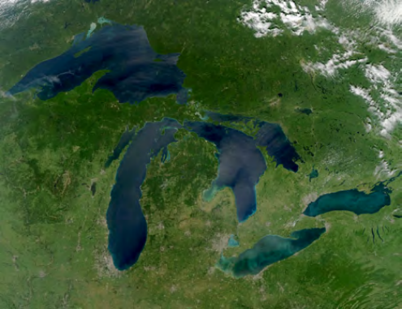
they not only make up 20 percent of the world’sfreshwater, but they also have a tremendous im-pact on the economy, climate, and ecosystemsof the United States and Canada. The Great
它们不仅占全球淡水资源（Water Resources）的 20%，而且对美国与加拿大的经济、气候和生态系统有着巨大影响。五大湖
Lakes region is one of the largest economiesin the world, supporting 1.5 million people andforming the backbone for other industries whichare valued at over 6 trillion dollars [8]. Addi-tionally, they also are the source of life for over
地区是世界上最大的经济体之一，为 150 万人提供生计支持，并构成其他产业的支柱，其价值超过 6 万亿美元 [8]。此外，它们还是超过
3500 species of plants and animals across awide range of biomes making them indispens-able to the North American ecosystems [18].
3500 种植物与动物的生命之源，这些物种分布于广泛的生物群落，使五大湖对北美生态系统不可或缺 [18]。
Figure 1: A cloudless view of all of the Great
图 1：全部五大湖的无云影像
Due to the invaluable benefit that the Great
鉴于五大湖为我们提供的宝贵效益，
Lakes taken by a NASA satellite in August 2010
由 NASA 卫星于 2010 年 8 月拍摄
Lakes provide us, it is of the utmost importance [13].to society that they are flourishing in the bestway possible.
让它们以最佳状态繁荣发展，[13]。对社会而言至关重要。
To ensure that the Great Lakes community is well-serviced, it is necessary to analyze the impactson the stakeholders dependent on the lakes. The stakeholders identified in the report by the Inter-national Joint Committee (ĲC) are: domestic water supply, commercial navigation, hydropower,environment, recreational boaters, docking companies, and shoreline (riparian) property owners [10].
为确保五大湖地区获得良好服务，有必要分析对依赖这些湖泊的利益相关方所造成的影响。国际联合委员会（IJC）报告中确定的利益相关方包括：生活供水、商业航运、水力发电、环境、休闲船艇使用者、码头公司以及滨岸（沿岸）物业所有者[10]。
The current methodology of managing the water flow in Lake Ontario is based on Plan 2014.
目前安大略湖水量管理的方法基于《2014 计划》。
Plan 2014 prioritizes natural flow out of Lake Ontario into the St. Lawrence River while continuallychecking if a number of critical points have been reached. When a critical point has been reached,the ĲC takes action to control the level of water in the dam [2]. After the initiation of Plan 2014in 2017, record precipitation hit the area and Lake Ontario experienced severe flooding [7]. Thiscaused millions of dollars of damage and increased the risk for invasive species (like zebra mussels),harmful algae bloom, and sewage blockage [15] [19] [10]. This event brought the effectiveness ofthe plan under scrutiny. Flooding has proven to be a continual threat to the lives and livelihoodsof the stakeholders. Thus, ICM has set out to formulate water level control mechanisms that couldprevent such dire events.
《2014 计划》优先考虑安大略湖向圣劳伦斯河的自然出流，同时持续检查是否已达到若干临界点。当达到临界点时，IJC 采取行动控制坝内水位 [2]。《2014 计划》于 2017 年启动后，该地区遭遇创纪录降水，安大略湖发生严重洪水 [7]。这造成了数百万美元的损失，并增加了入侵物种（如斑马贻贝）、有害藻华和污水堵塞的风险 [15] [19] [10]。这一事件使该计划的有效性受到审视。洪水已被证明对利益相关方的生命与生计构成持续威胁。因此，ICM 着手制定能够预防此类严重事件的水位控制机制。
1.2
Ontario and the St. Lawrence River. Our models and algorithms are fit to address the needs ofvarious stakeholders, while ensuring that the water levels within the lakes remain safe. Motivatedby the flooding damage from 2017, our model focuses on achieving water levels and currents that
安大略湖与圣劳伦斯河。我们的模型与算法能够满足各类利益相关方的需求，同时确保各湖水位保持在安全范围之内。受 2017 年洪水灾害的驱动，我们的模型着眼于实现这样的水位与水流：
2
— 原文第 4 页 —
benefit the stakeholders subject to hard constraints on the risk of flooding and low-water levels. Ouroutlook differs significantly from that of Plan 2014 to be more resilient in a highly volatile climate.
在洪水风险与低水位风险的硬性约束条件（Constraint）下，为利益相关方带来收益。我们的展望与 2014 计划（Plan 2014）显著不同，以便在高度多变的气候中具有更强的韧性。
We propose using a linear program to model the needs of the stakeholders with respect to the waterlevel and modulating it with dynamic control of dams that account for the transportation times ofthe water. Inspired by the successes of Plan 2014 as a method to solve a complex constrainedscheduling problem and equipped with the knowledge of where Plan 2014 falls short, we proposea model that utilizes the Compensating Works dam at the Sault. St. Marie River as well as the
我们提出采用线性规划来建模利益相关方对水位的需求，并通过考虑水体传输时间的水坝动态控制加以调节。受 2014 计划作为求解复杂约束调度问题之方法所获成功的启发，并基于对 2014 计划不足之处的认识，我们提出一个利用苏圣玛丽河（Sault Ste. Marie River）上的补偿工程坝（Compensating Works dam）以及圣玛丽河（St. Marie River）上的
Moses-Saunders dam to do the following:
摩西—桑德斯坝（Moses-Saunders dam），以实现以下目标：
1. Center the human impacts by modeling the needs of the stakeholders
1. 通过建模利益相关方的需求，将以人为本的影响置于核心
2. Robustness to severe climate events
2. 对严重气候事件具有鲁棒性
3. Dynamic control of the system
3. 对系统进行动态控制
1.3 Overview of Linear Programs
1.3 线性规划概述
Our control algorithms are implemented as linear programs. Linear programming is a widely-used optimization technique in the field of operations research and network science. It has variousapplications from policymaking to power plant deployment to production logistics to watershedmanagement [11, 20]. Linear programs rapidly found applications across the natural sciences,industry, government, and many other fields, and are a natural way to model many schedulingproblems where it is important to understand how to plan a series of actions to maximize anobjective (typically profit or some other measure of overall utility) subject to some constraints (e.g.there might only be so much time available to us) [21]. Within the realm of environmental decisions,linear programming has been applied to solve complex questions like green-energy planning [5].
我们的控制算法以线性规划的形式实现。线性规划是运筹学与网络科学领域中一种广泛使用的优化技术。它有着多种应用，从政策制定到电厂布局，从生产物流到流域（Watershed）管理 [11, 20]。线性规划迅速在自然科学、工业、政府以及许多其他领域得到应用，并且是建模许多调度问题的一种自然方式——在这类问题中，重要的是理解如何规划一系列行动，以在某些约束条件（例如我们可能只有这么多可用时间）下最大化某个目标（通常是利润或某种其他整体效用度量）[21]。在环境决策领域，线性规划已被应用于求解诸如绿色能源规划之类的复杂问题 [5]。
Inspired by the success of linear programs in related fields, our control algorithms employ linearprogramming to determine how to utilize the dams within the Great Lakes. The advantages to beexpected from utilizing linear programming are as follows:
受线性规划在相关领域取得成功的启发，我们的控制算法采用线性规划来确定如何利用五大湖内的水坝。采用线性规划可预期的优势如下：
• Algorithms for solving linear programs are widely available and extremely fast. Due to theeffectiveness of the famous Simplex algorithm and its variants, linear programs can be solvedwith incredible speed which is advantageous for testing out a variety of weather scenarios.
• 求解线性规划的算法广泛可得且速度极快。得益于著名的单纯形算法及其变体的有效性，线性规划能够以惊人的速度求解，这对于测试各种天气情景十分有利。
• Linear programs are interpretable. Practitioners need access to a white-box control algo-rithm where it is possible to understand their decision.
• 线性规划具有可解释性。实务工作者需要能够获得白盒控制算法，从而有可能理解其决策。
• Linear programs are not defined with specific parameter values in mind. If practitioners needto revise their predictions for environmental factors, they can easily rerun the model with theadjusted parameters.
• 线性规划在定义时并不针对特定的参数取值。如果实务工作者需要修正其对环境因素的预测，他们可以用调整后的参数轻松地重新运行模型。
However, it’s also important to acknowledge the downsides that accompany linear programs:
然而，同样重要的是要认识到线性规划伴随的缺点：
• The objective and constraints must be linear. This limits the ways we can model our system
• 目标函数（Objective Function）与约束条件必须是线性的。这限制了我们建模系统的方式
2
— 原文第 5 页 —
• When a linear program is impossible to solve, it is difficult to visualize what is going wrong.
• 当线性规划无解时，很难直观地看出问题出在哪里。
If our control algorithms determine that there is no valid schedule that meets all constraints,it will be difficult for the practitioner to find a way to determine a valid schedule.
如果我们的控制算法判定不存在满足所有约束条件的有效调度方案，实务工作者将难以找到确定有效调度方案的办法。
By keeping these disadvantages in mind, we designed our control algorithms to be effective evenwith the drawbacks of linear programming.
在牢记这些缺点的基础上，我们将控制算法设计为即便存在线性规划的不足也仍然有效。
1.4 Assumptions And Justifications
1.4 假设与论证
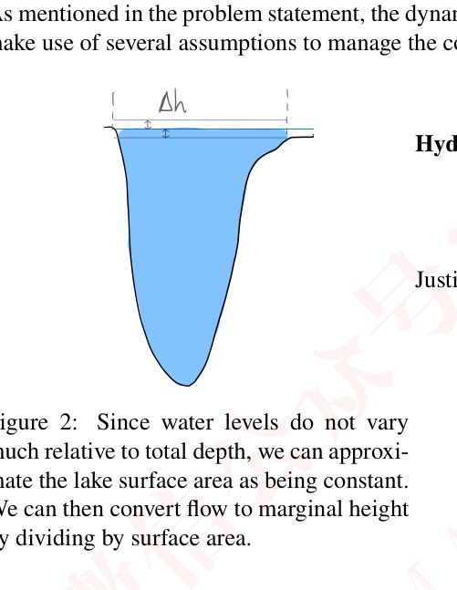
we make use of several assumptions to manage the complexity of our models.
我们利用若干假设来控制模型的复杂性。
↓i
W
Hydrology: The lake’s sizes remain con-stant and our system can be simplifiedto five nodes by not factoring in theauxiliaries like lake St. Claire.
水文：湖泊面积保持不变，并且通过不考虑诸如圣克莱尔湖（Lake St.Claire）之类的辅助水体，我们的系统可简化为五个节点。
Justification: Keeping the lake sizes con-stant provides us with a consistent con-version metric, as seen in figure 2 be-tween flow and height for each lake.
理由：保持湖泊面积恒定为我们提供了一致的换算指标，即如图 2 所示各湖泊流量与水位高度之间的换算关系。
Based on the correlation data for the
基于……的相关性数据，
Figure 2: Since water levels do not varyflow rates, the other nodes are negligi-much relative to total depth, we can approxi-ble as compared to the main outflowsmate the lake surface area as being constant.between the Great Lakes.
图 2：由于水位相对总深度变化不大，我们可以将湖面面积近似视为常数。就流量而言，与五大湖之间的主要出流量相比，其他节点可忽略不计。
图中文字对照（英文 → 中文）
Δh | Δh（水位变化量） | Figure 2: | 图 2：
Since water levels do not vary much relative to total depth, we can approximate the lake surface area as being constant. | 由于水位相对于总深度变化不大，我们可以近似认为湖面面积保持不变。 | We can then convert flow to marginal height by dividing by surface area. | 进而将流量除以水面面积，即可转换为边际水位变化量。
We can then convert flow to marginal heightby dividing by surface area.
随后，我们可以通过除以表面积将流量换算为边际水位高度。
Systemic: Dams can be fully opened or closed within an hour and they have zero downtime.
系统性：水坝可以在一小时内完全开启或关闭，且停机时间为零。
Additionally, the lag times calculated from correlation data are accurate (Figure 2).
此外，由相关性数据计算得到的滞后时间是准确的（图 2）。
Justification: We want to encapsulate granular dam schedules to minimize flooding and drought ofthe Great Lakes community. Also, we need the lag times to be accurate to simulate the waterflowing between the lakes.
理由：我们希望纳入精细的水坝调度方案，以尽量减少五大湖社区的洪水与干旱。同时，我们需要准确的滞后时间来模拟湖泊之间的水流。
Scaling: The regressions we found for the flow rates from the lakes are linear (Figure 3) and thetime horizon of the data is on the order of a few months.
尺度：我们所得到的各湖泊流量回归关系是线性的（图 3），且数据的时间跨度在数月量级。
used dynamically based on current data.
基于当前数据动态使用。
2
— 原文第 6 页 —
2 Macroschedule Model
2 宏观调度模型
Here, we describe our algorithm for determining the optimal achievable water levels in the greatlakes over a large time-period.
在此，我们描述用于确定五大湖在较长时期内可实现的最优水位的算法。
2.1 Dynamic Network Formulation
2.1 动态网络表述
We begin with a high-level overview of the model. The Great Lake water level problem can bestudied as a dynamic network flow problem on the network shown in Figure 3. There are two arcsthat we have some level of control over. The Sault St. Marie Dam allows us to send a constrainedamount of water from Lake Superior to Lakes Huron and Michigan. Water then flows naturallyfrom Lakes Huron and Michigan into Lake Erie and from Lake Erie to Lake Ontario. Through the
我们首先对该模型作高层次的概述。五大湖水位问题可以作为图 3 所示网络上的动态流网络问题来研究。有两条弧是我们具有一定控制能力的。苏圣玛丽大坝使我们能够将限定数量的水从苏必利尔湖输送到休伦湖和密歇根湖。随后，水从休伦湖和密歇根湖自然流入伊利湖，再从伊利湖流入安大略湖。通过
Moses-Saunders Dam, we can let a constrained amount of water out of Lake Ontario into the St.
摩西—桑德斯大坝，我们可以让限定数量的水从安大略湖流出，进入圣
Lawrence River.
劳伦斯河。
The reason why our analysis differs from the well-studied static flow problem is because it takestime for water to flow between each node. For instance, it takes roughly one month for flows in
我们的分析与已被充分研究的静态流问题不同，其原因在于水在各节点之间流动需要时间。例如，大约需要一个月的时间，
Lake Superior to be observed in Lakes Huron and Michigan; it takes roughly three months to beobserved in Lake Ontario. Thus, the network flow becomes dynamic–which significantly increasesthe problem’s modeling and computational difficulty.
苏必利尔湖的水流才能在休伦湖和密歇根湖中被观测到；大约需要三个月才能在安大略湖中被观测到。因此，网络流变为动态的——这显著增加了问题的建模难度与计算难度。
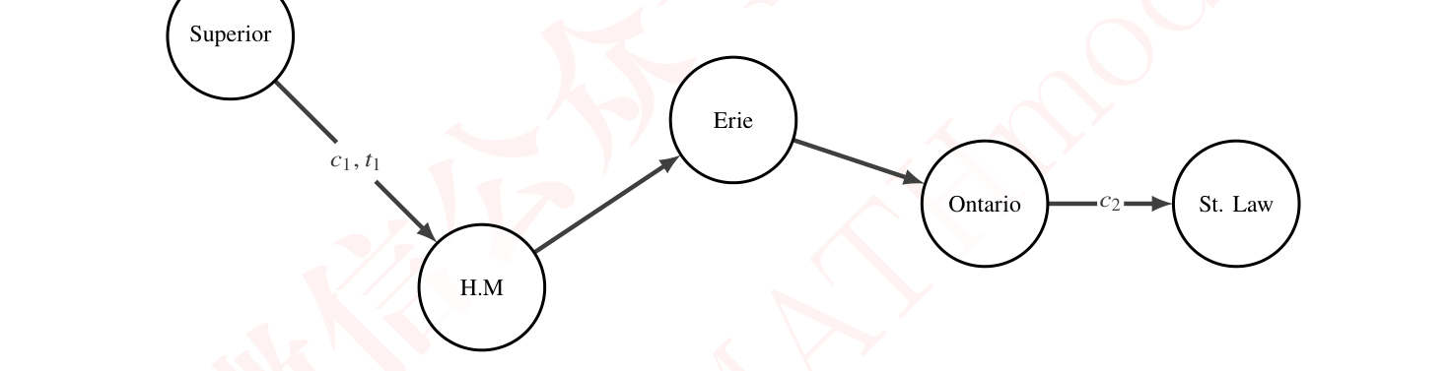
Figure 3: Network used in the model. 𝑐_{𝑖}is the capacity of the arc and 𝑡_{𝑖}is the transit time of thearc.
图 3：模型中使用的网络。𝑐_{𝑖} 为弧的容量，𝑡_{𝑖} 为弧的通行时间。所有未标注的弧对应于不受控制的水流。
More formally, the dynamic flow problem is defined over a network 𝑁= (𝑉, 𝐸, 𝜇, 𝜏,𝑉⁺,𝑉⁻).
更形式化地，动态流问题定义在网络 𝑁= (𝑉, 𝐸, 𝜇, 𝜏,𝑉⁺,𝑉⁻) 上。
The vertex set is given by 𝑉∪𝑉⁺ ∪𝑉⁻where 𝑉⁺ represent source nodes, 𝑉⁻represent sink nodes,and 𝑉represent transit nodes. Each edge 𝐸_{𝑖}has a corresponding capacity 𝜇_{𝑖𝑡}and transit time 𝜏_{𝑖}[6].
顶点集由 𝑉∪𝑉⁺ ∪𝑉⁻ 给出，其中 𝑉⁺ 表示源节点，𝑉⁻ 表示汇节点，𝑉 表示中转节点。每条边 𝐸_{𝑖} 具有相应的容量 𝜇_{𝑖𝑡} 和通行时间 𝜏_{𝑖}[6]。
The goal is to find the min-cost flow over a fixed time horizon 𝑇that satisfies a particular objective.
目标是在固定时间范围 𝑇 内找到满足特定目标的最小费用流。
To make this problem tractable, we employ Ford and Fulkerson’s time-expansion methodto convert the problem into static flow [14]. We discretize the model over a fixed timestep, and
为使该问题易于处理，我们采用 Ford 与 Fulkerson 的时间扩展方法，将问题转化为静态流 [14]。我们在固定时间步长上对模型进行离散化，并
This formulation is amenable to static-flow analysis.
该表述适用于静态流分析。
2
— 原文第 7 页 —
2.2 Ideal Water Determination Algorithm
2.2 理想水位确定算法
To determine the ideal water levels for each body of water, we developed a utility functionfor each shareholder that determines their optimal water level based on the historical averages.
为确定各水体的理想水位，我们为每个利益相关方构建了一个效用函数，该函数基于历史平均值确定其最优水位。
This optimal water level is determined based on the fluctuations in the water level and what eachof the stakeholders listed as their ideal scenario from the ĲC report. While navigation, docks,hydropower, and recreational boaters all prefer a fixed level of water, riparian owners, domesticwater supply, and the environment prefer natural oscillations in water level [10]. To account forthis discrepancy, we simulated sinusoidal oscillations about the mean height of the lake for theirpreferred timescales and amplitudes scaled compared to the natural processes:
该最优水位依据水位的波动情况，以及各利益相关方在 ĲC 报告中所列出的理想情景来确定。尽管航运、码头、水电和休闲船艇爱好者都偏好固定的水位，但滨岸所有者、生活供水和生态环境则偏好水位的自然波动 [10]。为考虑这一差异，我们针对其偏好的时间尺度，以及相对于自然过程缩放后的振幅，模拟了围绕湖泊平均水位的正弦振荡：
Environment: The environment prefers natural annual water level oscillations to best align withthe natural mating seasons of species like wetland birds [12].
生态环境：生态环境偏好自然的年度水位波动，以最大程度契合湿地鸟类等物种的自然繁殖季节 [12]。
Domestic Water Supply: To preserve high water quality, the domestic water supply needs tooscillate close to the average to prevent the inflow of sewage and harmful algae blooms [15][10].
生活供水：为保持高水质，生活供水需要在水位平均值附近波动，以防止污水流入和有害藻华[15][10]。
Riparian Owners: The riparian owners prefer lower water levels with smaller amplitude os-cillations, with higher frequency to increase the amount of sand re-deposition and dunereplenishment [10].
滨岸所有者：滨岸所有者偏好水位较低、振幅较小且频率较高的波动，以增加泥沙再沉积量和沙丘补给量 [10]。
Navigation: Navigation prefers steadily high water levels because lower water levels can increasecosts by 30 percent and double emissions in the Great Lakes [16]. Additionally, they want itto not flood because they need ships to get through [10].
航运：航运偏好稳定较高的水位，因为在五大湖中较低水位会使成本增加 30%，并使排放翻倍 [16]。此外，他们希望不发生洪水，因为需要让船舶通行 [10]。
Hydropower: The dams prefer their flow rates to be constant or near their ideal operating range ofaround 7, 000^{𝑚3}_{𝑠}, so they prefer to be above the average water levels, similar to navigation, tomaintain that [9].
水电：大坝偏好其流量保持恒定，或接近约 7, 000^{𝑚3} 的理想运行范围_{𝑠}，因此与航运类似，它们偏好高于平均水位，以维持该状态 [9]。
Boaters: Boaters also prefer to be in a similar range of slightly above the average water level toimprove the speed they can travel through the water during the day [10].
船艇爱好者：船艇爱好者也偏好处于略高于平均水位的类似范围，以提高其白天在水中的航行速度 [10]。
Docks: For the shipping ports in Montreal, they prefer to have constant low water levels so theamount of the ideal amount of water coming downstream from the Moses-Saunders Damshould be minimized during working hours.
码头：对于蒙特利尔的航运港口，其偏好恒定较低的水位，因此在工作时段内，从摩西—桑德斯大坝下泄的理想水量应最小化。
There are conflicting interests among the stakeholders, and it is impossible to please eachstakeholder. To account for this, we introduced a weighting system into our model to allow eachstakeholder to be considered with different severity. As a result, our ideal water plots look likefigure 4 compared to the historical data
各利益相关方之间存在利益冲突，不可能使每个利益相关方都满意。为考虑这一点，我们在模型中引入了权重体系，使每个利益相关方能够以不同的重要程度被纳入考虑。因此，与历史数据相比，我们的理想水位图如图 4 所示
2.3
Bodies of Water and (2) Time. Our decision variables are the amount of water we let flow from the
水体与（2）时间。我们的决策变量是我们允许从
2
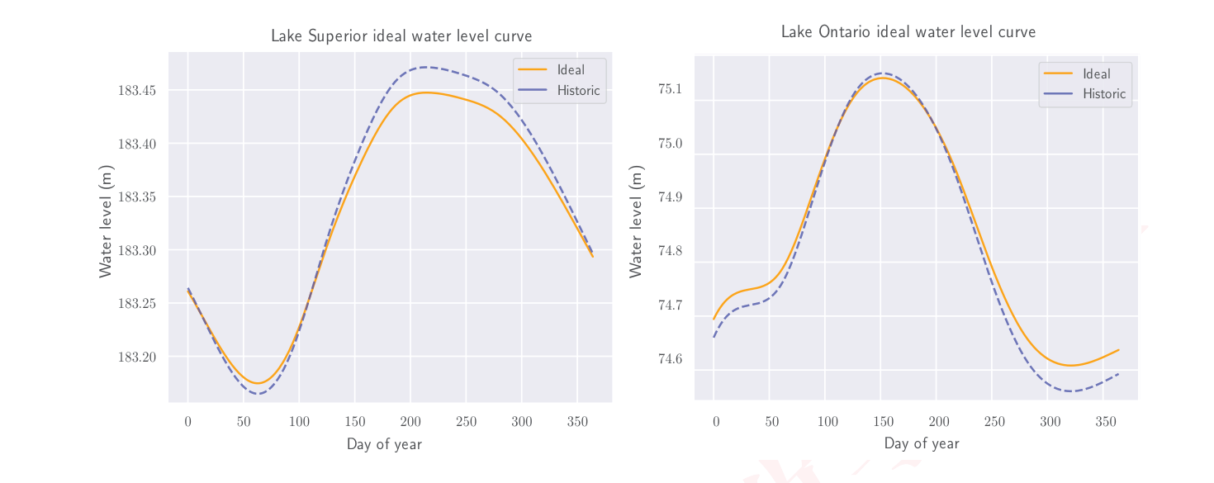
— 原文第 8 页 —
Figure 4: Plot of the ideal water levels (solid orange lines) based on stakeholder needs for Lake
图 4：基于利益相关方需求得到的理想水位图（橙色实线），涉及
Superior and Lake Ontario compared to the historical averages (dotted blue lines) from the dataset.
苏必利尔湖与安大略湖，并与数据集中的历史平均值（蓝色虚线）进行比较。
Superior to the St. Mary River at each time-step and the amount of water we let flow from Lake
苏必利尔湖流入圣玛丽河的水量，以及我们允许从
Ontario to the St. Lawrence River1. The objective of the LP is to minimize the absolute differencebetween the achieved water level and the “ideal” water level. The LP is constrained by limits on thewater level ensuring no flooding occurs and the water level is never critically low. The variablesand parameters and described in the first table in Appendix A. The algebraic form of the linearprogram is shown below:
安大略湖流入圣劳伦斯河的水量1。LP 的目标是最小化实际达到的水位与“理想”水位之间的绝对差。该 LP 受水位限制条件的约束，以确保不发生洪水，且水位从不会处于危险低值。变量与参数在附录 A 的第一张表中给出。该线性规划（LP）的代数形式如下所示：
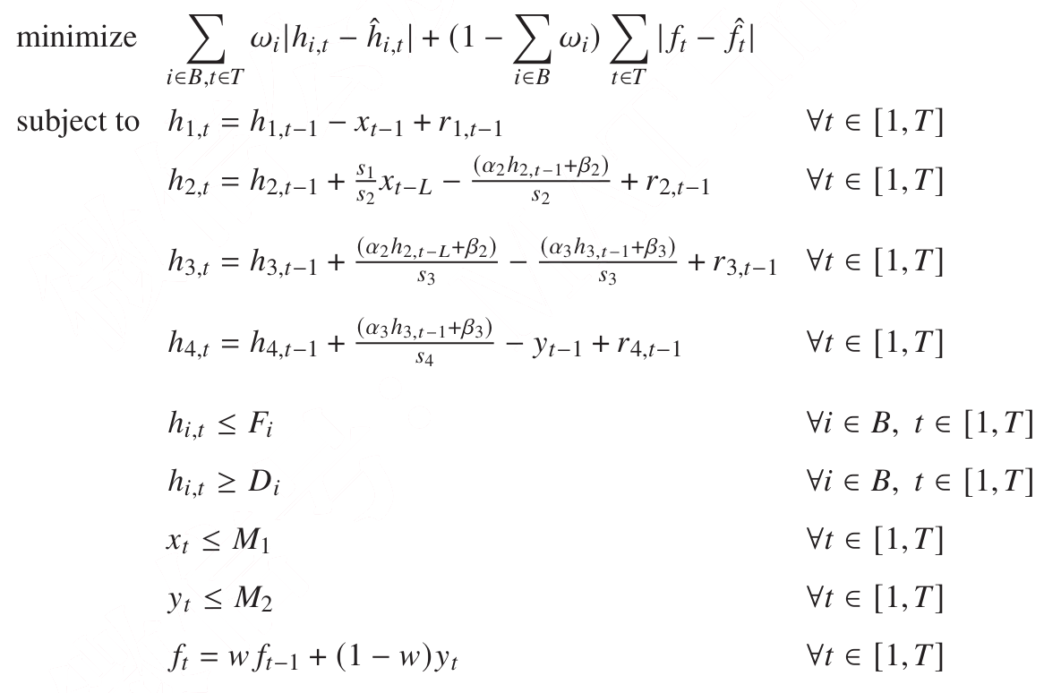
1In Appendix A, more variables are listed, but these are completely determined by equality constraints and are thusnot listed as decision variables here.
1 附录 A 中列出了更多变量，但它们完全由等式约束条件确定，因此在此不作为决策变量列出。
— 原文第 9 页 —
All decision variables are nonnegative. The first four constraints capture how the height ofwater in each lake changes over time by tracking how much water enters the lake and how muchleaves. We use the index 𝑥_{𝑡−𝐿}to capture the fact that there is a lag between the changes in Lake
所有决策变量均为非负。前四个约束条件通过追踪流入与流出湖泊的水量，刻画了每个湖泊的水位高度随时间的变化方式。我们采用索引 𝑥_{𝑡−𝐿} 来刻画这一事实，即湖泊
Superior and the changes at other lakes. The 5th and 6th constraints allow us to ensure that noflooding or dangerously-low water levels occur. To capture the fact that dams can only let out somuch water at a time, we introduce the 7th and 8th constraints to bound the amount of water wecan let out of the dams. Lastly, we track the flow in the St. Lawrence River with the 9th constraint.
苏必利尔湖的变化与其他湖泊的变化之间存在滞后。第 5 和第 6 个约束条件使我们能够确保不会出现洪水或危险的低水位。为刻画水坝一次只能下泄有限水量这一事实，我们引入第 7 和第 8 个约束条件来限定可从水坝下泄的水量。最后，我们用第 9 个约束条件追踪圣劳伦斯河的流量。
2.4 Methods for Stakeholder Management
2.4 利益相关方管理方法
As ĲC notes, this problem is particularly difficult because of the often-conflicting requests fromthe various stakeholders around the Lake Ontario and St. Lawrence River regions. Our algorithmprovides a method to weight stakeholder interests, however, it relies on the practitioner to assignthese weights manually. This has the potential to create divides between groups of stakeholders.
正如 ĲC 所指出的，该问题之所以尤为困难，是因为安大略湖与圣劳伦斯河地区各利益相关方常常提出相互冲突的诉求。我们的算法提供了一种对利益相关方利益进行加权的方法，但它依赖于实践者手动分配这些权重。这有可能在利益相关方群体之间造成分化。
Thus, some sort of heuristic should be used to equitably assign these weights on a per-stakeholderbasis.
因此，应当采用某种启发式方法，在逐利益相关方的基础上公平地分配这些权重。
We propose the following methodology to determine fair weightings between ideal water levelcurves:
我们提出以下方法来确定理想水位曲线之间的公平权重：
• We create an initial set of weights 𝑤₀ and set them as parameters in the model.
• 我们建立一组初始权重 𝑤₀，并将其设为模型中的参数。
• Then we simulate roughly five months2, and observe the forecasted ideal water levels.
• 随后我们模拟约五个月2，并观察预测的理想水位。
• We then proceed with the schedule for two months.
• 然后我们按该调度方案执行两个月。
We simulate beyond the necessary time horizon to ensure that our model accounts for futureimpacts of flows in the other lakes. In particular, we designate a three-month buffer since this isthe time taken for an effect in Lake Superior to be observed in Lake Ontario.
我们模拟的时间跨度超出所需时间范围，以确保模型考虑到其他湖泊流量在未来的影响。特别地，我们设置了三个月的缓冲期，因为苏必利尔湖中的影响需要这么长时间才会在安大略湖中显现。
After adopting the given schedule for the two month period, we calculate the net error betweenthe real observed water levels and the ideal curves provided per stakeholder.
在采用给定的调度方案两个月之后，我们计算实际观测水位与各利益相关方所提供的理想曲线之间的净误差。
∑︁
|ℎ_{𝑡}−ˆℎ_{𝑡}|
𝜀_{𝑖}=
𝑡∈[1, 60]
𝑡
This gives us per-stakeholder errors {𝜀₁, . . . 𝜀_{𝑛}} for 𝑛stakeholders. Note that higher values of 𝜀_{𝑖}correspond to a lower level of stakholder 𝑖’s satisfaction. Keeping this in mind, we can reassignweights for the next time horizon with 𝜀_{𝑖}
由此得到 𝑛 个利益相关方的逐利益相关方误差 {𝜀₁, . . . 𝜀_{𝑛}}。注意，𝜀_{𝑖} 取值越大，对应利益相关方 𝑖 的满意度越低。考虑到这一点，我们可以用下式为下一时间范围重新分配权重：𝜀_{𝑖}
𝑤_{1𝑖}=_{𝑘}𝜀_{𝑘}
Í
That is, the new stakeholder weights are their normalized net errors from the last time period.
也就是说，新的利益相关方权重是其上一时间段归一化后的净误差。
This allows stakeholders that had greater deviations to be prioritized during the next time period.
这使得偏差较大的利益相关方在下一时间段能够被优先考虑。
2
— 原文第 10 页 —
2.5 Data-Based Model Of The Hydrosphere
2.5 基于数据的水圈模型
Modeling the movement of water in the Great Lakes is difficult and requires a number ofassumptions to make the problem tractable. To ground our model in reality we used a data-basedapproach to determine time lag, flow rates out of lakes, and other sources of water outside of theflow between the lakes.
对五大湖中的水体运动进行建模十分困难，需要作出若干假设才能使问题可处理。为使模型贴合实际，我们采用基于数据的方法来确定时间滞后、湖泊的出流流量以及湖泊之间水流以外的其他水源。
We first needed to approximate the time lags between the lakes for our LP to create damschedules. For instance, we needed to know that it takes roughly two months for the effect of a flowin Lake Michigan to be observed in Lake Ontario. To identify the latencies, we used time-laggedcross correlation on the provided water level time series to find where the correlation is maximized.
我们首先需要为 LP 估算湖泊之间的时间滞后，以制定水坝调度方案。例如，我们需要知道密歇根湖中的流量大约需要两个月才会在安大略湖中显现。为识别这些滞后，我们对所提供的水位时间序列使用时间滞后互相关分析，以找出相关性达到最大的位置。
For example, the time-lagged cross-correlation between the water levels in Lake Superior and Lake
例如，苏必利尔湖与
Michigan is given by Figure 5.
密歇根湖水位之间的时间滞后互相关如图 5 所示。
Time lagged cross-correlation between Lake Erie and Lake Ontario
伊利湖与安大略湖之间的时间滞后互相关
Time lagged cross-correlation between Lake Huron and Lake Erie
休伦湖与伊利湖之间的时间滞后互相关
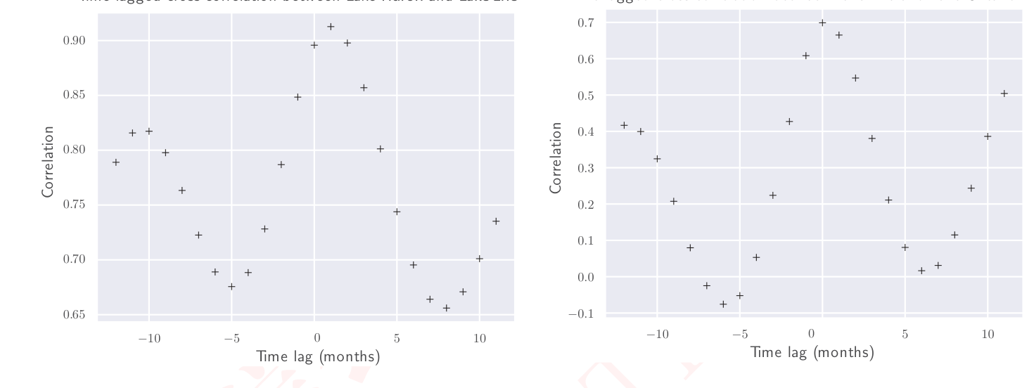
Figure 5: Time lagged cross-correlation examples for between Lake Huron and Erie and between
图 5：休伦湖与伊利湖之间、以及
Lake Erie and Ontario computed from the dataset given for Problem D in [1].
伊利湖与安大略湖之间基于 [1] 中问题 D 所给数据集计算得到的时间滞后互相关示例。
The correlation is maximized at a time lag of 1. Thus, we can interpret that a flow in Lake
相关性在时间滞后为 1 时达到最大。因此，我们可以解读为：湖泊
Superior will take approximately a month to propagate in Lake Michigan. The full matrix of thesetime-lagged correlations is given by Table 1.
苏必利尔湖中的流量大约需要一个月时间传播至密歇根湖。这些时间滞后相关性的完整矩阵见表 1。

Table 1: Time lag matrix between the Great Lakes
表 1：五大湖之间的时间滞后矩阵
Additionally, we used the datasets to run a linear regression, pictured in figure 6, to obtain theflow rates as a function of the height of the lake, which we will use to model the flow in and out of
此外，我们使用这些数据集进行线性回归（如图 6 所示），以得到流量随湖泊水位高度变化的函数关系，我们将用它来建模湖泊水体的流入与流出
2
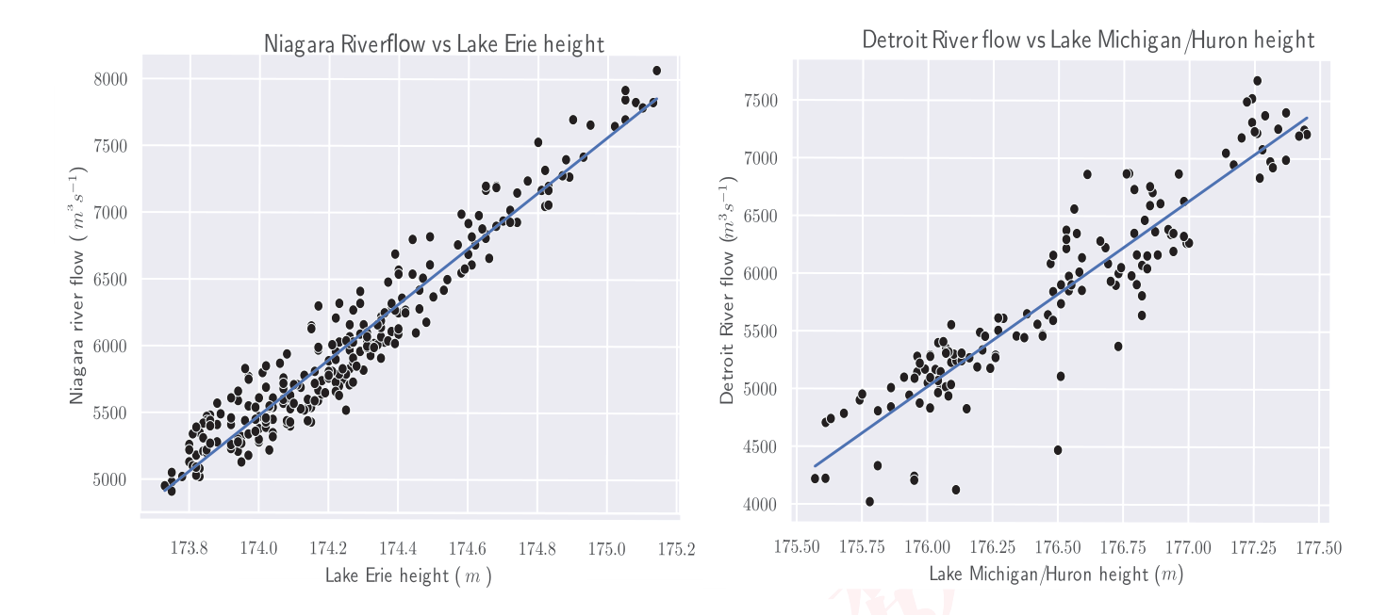
— 原文第 11 页 —
Figure 6: Flow along the Niagara River and Detroit River as a function of the height (relative tosea level) of the lakes they flow from.
图 6：尼亚加拉河与底特律河的流量随其所流出的湖泊高度（相对于海平面）变化的函数关系。回归公式为：
𝑓_{Niagara} = 2088.917ℎ_{Erie} −357993.824 with (R² = 0.928) 𝑓_{Detroit} = 1611.581ℎ_{Huron} −278618.674 with (R² = 0.850)
𝑓_{Niagara} = 2088.917ℎ_{Erie} −357993.824，其中 (R² = 0.928)𝑓_{Detroit} = 1611.581ℎ_{Huron} −278618.674，其中 (R² = 0.850)
Lastly, we also approximated other aspects of the hydrosphere (precipitation, groundwater,evaporation, and surface runoff) by modeling the inflow of water based on how much it rainedbecause according to the biohydrological database for the Great Lakes makes up 20 percent of thewater flowing into the Great Lakes [3]. Using the NOAA data set of rainfall, evaporation, andrunoff into the Great Lakes [17], we determined the total inflow that would occur each month basedon historical data. We visualize the historical rainfall that occurred during each month in Figure 7.
最后，我们还对水圈的其它方面（降水、地下水、蒸发与地表径流）进行了近似，其做法是依据降雨量对水的流入量建模，因为根据五大湖生物水文数据库，这一部分占流入五大湖水量的 20% [3]。利用 NOAA 关于降雨、蒸发与流入五大湖的径流的数据集 [17]，我们基于历史数据确定了每个月将会发生的总流入量。我们在图 7 中展示了每个月发生的历史降雨量。
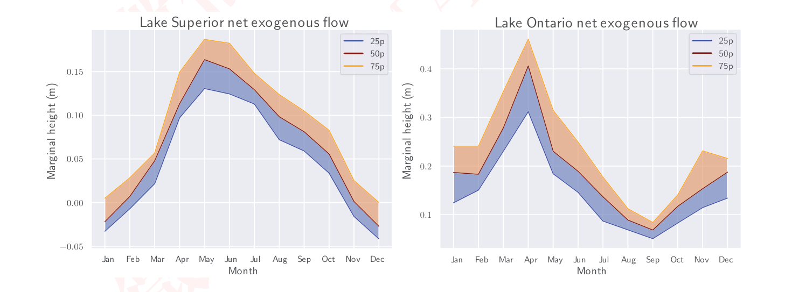
Figure 7: 1st (in blue), 2nd (in red), and 3rd (in orange) quartiles of exogenous flow into Lakes
图 7：流入各湖的外生流量的第一四分位数（蓝色）、第二四分位数（红色）与第三四分位数（橙色）
Superior and Ontario
苏必利尔湖与安大略湖
— 原文第 12 页 —
2.6 Additional Considerations
2.6 其他考量
Aside from the data-driven parameters we obtained, we considered other parameters to helpmake our model more realistic:
除我们所获得的这些数据驱动的参数之外，我们还考虑了其它参数，以使模型更贴近现实：
Seasonal Wave Attenuation: To consider the seasonality of the Great Lakes we also add anattenuation factor that reduces the flow between the lakes. We added this factor because astudy by Peng Bai showed that ice attenuates the waves in the Great Lakes and thus shouldreduce their flow from their turbulent effects [4].
季节性波浪衰减：为考虑五大湖的季节性，我们还加入了一个衰减因子，以削减湖泊之间的流量。我们加入该因子，是因为 Peng Bai 的一项研究表明，冰会衰减五大湖中的波浪，因而应当削减由其湍流效应所产生的流量 [4]。
Fuzzing The Model: Since exogenous inflow is highly random, we added noise to historical inflowdata to increase the robustness of our model. This makes the model more robust by removingbiases towards certain shores at different water levels and helps us accurately assess thedrought and flooding risk factors.
模型模糊化：由于外生流入具有高度随机性，我们对历史流入数据加入了噪声，以提高模型的稳健性。这通过消除在不同水位下对某些湖岸的偏向而使模型更为稳健，并帮助我们准确评估干旱与洪水的风险因子。
3 Microschedule Model
3 微观调度模型
One aspect that our Macroschedule model does not incorporate are the proximal effects ofopening the Moses-Saunders Dam. As noted by the problem statement, even small variances in thewater level can have drastic implications for stakeholders around Lake Ontario and the St. Lawrence
我们的宏观调度模型未纳入的一个方面，是开启摩西-桑德斯水坝（Moses-Saunders Dam）所带来的近端效应。正如问题陈述所指出的，即便是水位的微小变化，也可能对安大略湖与圣劳伦斯河周边的利益相关方产生剧烈影响。
River. As such, it is not enough to know how to release water in a day. It is also important to timeoutflows when it is generally most beneficial for these stakeholders. We develop a linear programthat schedules intra-day outflows to maximize community benefit.
因此，仅仅知道如何在一天之内泄水是不够的。同样重要的是，要在对这些利益相关方总体最有利的时段安排出流。我们建立了一个线性规划，对日内出流进行调度，以最大化社区收益。
Unlike the macroscheduling problem, there is no substantial time lag on flows between nodes inthe microscheduling problem. Thus, we can exert more immediate control over the water level andflows in Lake Ontario and the St. Lawrence River. We use a similarly formulated linear programto represent these flows, and the objective of maximizing proximity to ideal water levels and flows.
与宏观调度问题不同，微观调度问题中各节点之间的流量不存在显著的时间滞后。因此，我们可以对安大略湖与圣劳伦斯河的水位与流量施加更为即时的控制。我们用一个构造方式相似的线性规划来表示这些流量，其目标为最大化与理想水位及流量的接近程度。
The variables of the problems are defined in the second table of Appendix A
问题的变量在附录 A 的第二张表中定义
And the LP is formulated as follows:
该 LP 表述如下：
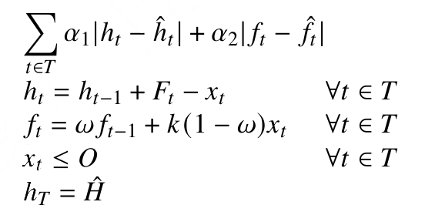
The first two constraints implement height and flow rate updates in Lake Ontario and the St.
前两个约束条件分别实现安大略湖与圣
Lawrence river respectively. Notice that the second constraint models the river flow rate as a convexcombination of inflow from the dam and its prior flow rate. This is influenced by sound physicalintuition, but it is difficult to accurately model this parameter based on available data. The third and microscheduler is show in Figure 8
劳伦斯河的水位与流量更新。注意，第二个约束条件将河流流量建模为来自水坝的入流与其先前流量的凸组合。这一点受合理的物理直觉所启发，但基于现有数据难以对该参数进行准确建模。第三个以及微观调度器如图 8 所示
2
— 原文第 13 页 —
Due to lower lag times, the model cansatisfy daily requirements relatively well. This is importantbecause there are likely days when dam usage must be limited to coordinate with monthly schedules.
由于滞后时间较短，该模型能够较好地满足每日需求。这一点很重要，因为很可能存在某些日子必须限制水坝的使用，以与月度调度相协调。
However, the water level can still be modulated to a level where stakeholders can still be largelysatisfied.
然而，水位仍可被调节到使利益相关方大体上仍然满意的水平。
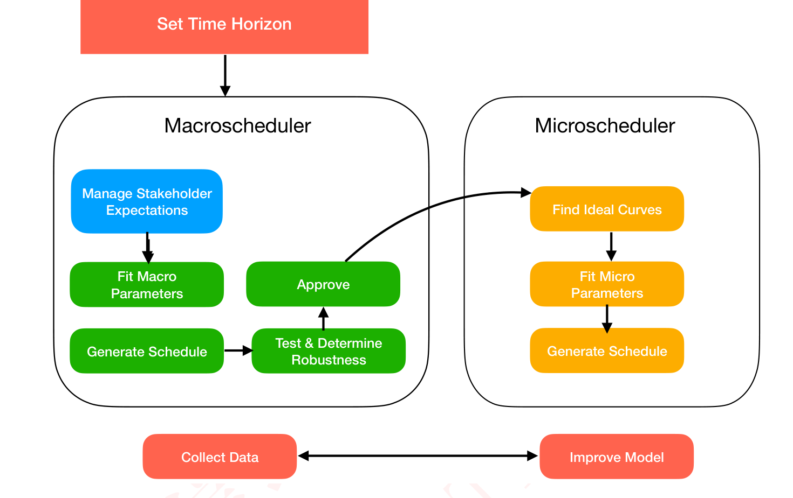
Figure 8: The pipeline for using our control algorithms.
图 8：使用我们的控制算法的流程。
4 Model Insights
4 模型洞见
Here we outline a brief overview of the main insights of our model:
此处我们简要概述模型的主要洞见：
• Effectively managing Lake Ontario means effectively Managing Lake Superior. Lake Supe-rior is able to influence Lake Ontario after a significant time delay which makes proactivescheduling at Lake Superior able to create desirable water levels at Lake Ontario.
• 有效管理安大略湖即意味着有效管理苏必利尔湖。苏必利尔湖能够在经历显著的时间延迟之后影响安大略湖，这使得在苏必利尔湖进行前瞻性调度能够营造出安大略湖的理想水位。
• Our model successfully achieves the desired water levels in most lakes even with varyingdegrees of rainfall.
• 即便在降雨量存在不同程度变化的情况下，我们的模型仍能在大多数湖泊成功实现所期望的水位。
• After determining optimal water levels through our macro-schedule algorithm, our micro-
• 在通过我们的宏观调度算法确定最优水位之后，我们的微观
2
— 原文第 14 页 —
4.1 Dynamic Control Of The System
4.1 系统的动态控制
Most dams use a heuristic approach for dam scheduling called rule curves. That is, dams aregiven fixed schedules depending on water level and precipitation thresholds. While our model isamenable to producting rule curves, we believe that the dynamic nature of scheduling makes itsuperior to this approach.
大多数大坝采用一种称为调度曲线的启发式方法来进行大坝调度。也就是说，大坝依据水位与降水阈值被赋予固定的调度方案。尽管我们的模型能够生成调度曲线，但我们认为调度的动态特性使其优于这一方法。
One of the most critical aspects of the model is that it can make decisions by “looking ahead”.
该模型最关键的方面之一在于，它能够通过“前瞻”来做出决策。
That is, given a range of forecasts, the model can schedule flows that are both robust to climateevents and still satisfy the needs of stakeholders. This way, action can be taken to mitigate potentialcrises well before they actually occur.
也就是说，在给定一组预测的情况下，模型能够制定出既对气候事件具有稳健性、又能满足利益相关方需求的流量调度方案。这样，就可以在潜在危机实际发生之前很早就采取行动加以缓解。
After we “look ahead” we can then use a combination of the macroscheduler and microschedulermodel to forecast both the four-month time horizon and then locally on the daily horizon. Bymodeling both of these time horizons, we gain valuable insights on the importance of factoring inthe time lags to forecasting the dam schedules. The efficacy of our model is shown in Figure 9:
在完成“前瞻”之后，我们可以结合宏观调度器与微观调度器模型，先对四个月的时间尺度进行预测，再在局部按日尺度进行预测。通过对这两个时间尺度建模，我们获得了关于在预测大坝调度方案时考虑时间滞后之重要性的宝贵洞见。我们模型的有效性如图 9 所示：
1.4 1.2 1.0
Error (%)
误差（%）
0.8 0.6 0.4 0.2 0.0 0 5 10 15 20
Hour
小时
2
— 原文第 15 页 —
4.2 Robustness to Severe Climate Events
4.2 对极端气候事件的稳健性
We tested the schedules produced by ourcontrol algorithm using past rain/runoff/evap-
我们利用从 [17] 收集的历史降雨/径流/蒸发数据，对我们控制算法生成的调度方案进行了检验。
Quartile 1oration data collected from [17].
四分位 1 从 [17] 收集的数据。
We deter-
我们确定
Superiormined the average amount of total rain, runoff,
Superior 的总降雨、径流
Huron/Michigan
休伦/密歇根
176.5
183.4and evaporation for each month from 1980 to
183.4 以及 1980 年至各月的蒸发量
176.4
Water Height
水位
176.3 183.2 2020.
Due to the fact that our model uses
由于我们的模型采用
176.2a time-step of one day and the data available
176.2 以一天为一个时间步长，而可获得的数据
183.0 176.1
176.0form [17] tracks how much rain/runoff/evap-
176.0 来自 [17] 的数据追踪了降雨/径流/蒸发
182.8
175.9oration occurred each month, we determined
175.9 各月的发生量，因此我们确定
175.8 182.6
175.7how much it rained per day by running a cu-
175.7 每日的降雨量：通过拟合三次
Ontario
安大略
Eriebic spline through the historical averages and
Erie 样条曲线穿越历史平均值，并
174.5then dividing the value for total rain, runoff,
174.5 随后将总降雨、径流
75.0
174.4 Water Heightand evaporation by 30 to account for the fact
水位与蒸发量的值除以 30，以计入
74.8
174.3that the month data was the total over a month
74.6
174.2 (roughly 30 days). This allows us to capture the
174.2（约 30 天）这一事实。这使我们能够捕捉
74.4
174.1natural patterns of rain, runoff, and evaporation
174.1 降雨、径流与蒸发的自然规律，
74.2
174.0while making the data usable in our model. We
174.0 同时使这些数据能够用于我们的模型。我们
0 50 100 150 200 250 300 350 0 50 100 150 200 250 300 350
Days
天
Daysran a similar procedure to determine the 25th
天 我们采用类似流程确定第 25 百分位
Qaurtile 2and 75th percentile amount of rain, runoff, and
四分位 2 以及降雨、径流量的第 75 百分位
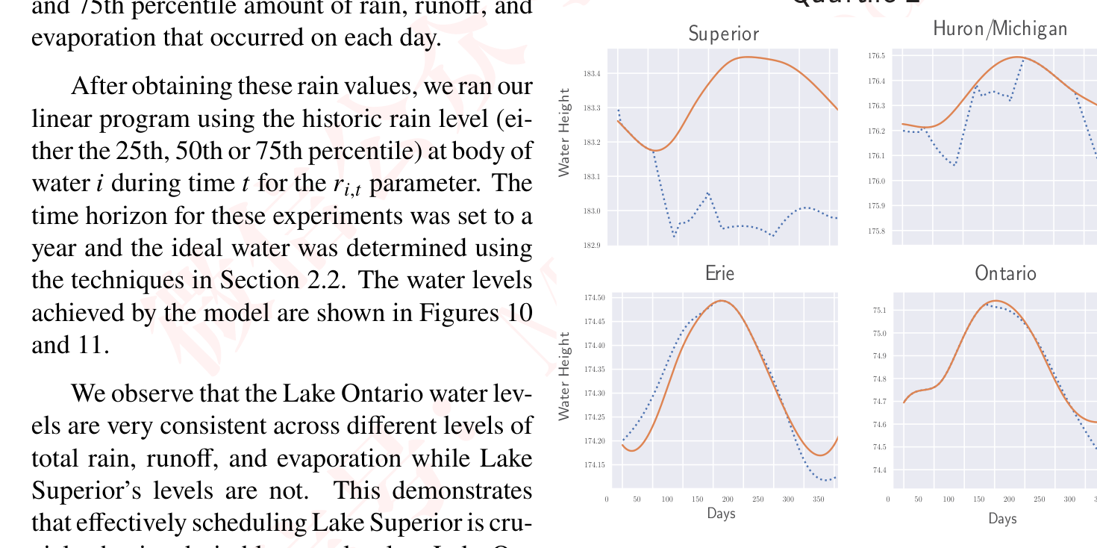
Figure 10: Plots of the 1st and 2nd quartiles of thetario.
图 10：由历史降雨数据绘制的五大湖各湖水位第一与第二四分位图。所需的那类调度方案……
Lake Superior to create desirable water levels atthe historic rain data. The water levels achievedby the model are shown with dotted blue lines andthe ideal water levels with solid orange lines.
安大略湖。在苏必利尔湖形成理想水位所需的调度方案类型……模型所达到的水位以蓝色虚线表示，理想水位以橙色实线表示。
robust to climate events.
对气候事件具有稳健性。
2
— 原文第 16 页 —
Quartile 3
四分位 3
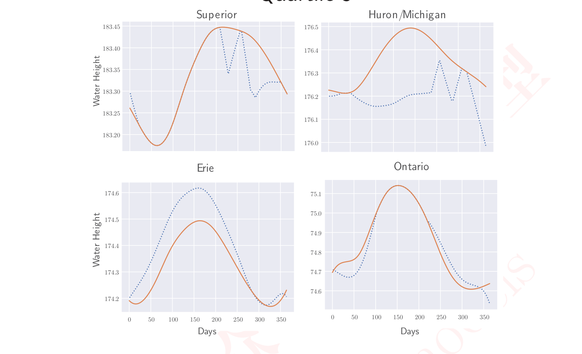
Figure 11: Plots of achieved water levels using the third quartile rain data (extreme rain).
图 11：使用第三四分位降雨数据（极端降雨）时达到的水位图。模型所达到的水位以蓝色虚线表示，理想水位以橙色实线表示。
5 Sensitivity Analysis
5 灵敏度分析
Since our model is primarily mechanistic, it relies heavily on parameters that represent real-lifevalues such as flow rates, flow decay, and attenuation. As such, it is reasonable to observe how themodel’s output changes as we modulate some of these parameters. Specifically, we vary 𝜔–the St.
由于我们的模型主要是机理性的，它高度依赖于代表真实现实取值的参数，例如流量、流量衰减与衰减系数。因此，考察模型输出随其中部分参数调整而发生的变化是合理的。具体而言，我们改变 𝜔 —— 即圣
Lawrence river flow decay rate.
劳伦斯河的流量衰减率。
Moreover, we determine that it is possible to avoid flooding and dangerously low water levelswhile achieving desirable water levels in all lakes even with varying degrees of total inflow tothe lakes. This demonstrates the value of our linear programming approach as a valuable tool todetermine dam schedules.
此外，我们确定，即使在流入各湖泊的总水量存在不同程度变化的情况下，也能够在所有湖泊中实现理想水位，同时避免洪水与危险的低水位。这表明我们的线性规划方法是确定大坝调度方案的有力工具。
The value that was used in the final model was 0.8. This was chosen based off observing flows inthe St. Lawrence River and how they change with respect to the height of Lake Ontario. However,since there isn’t data on the status of the dam at these times, this link is admittedly tenuous. Thus,
最终模型中所采用的取值为 0.8。该取值是基于对圣劳伦斯河，以及这些流量如何随安大略湖水位的变化而变化。然而，由于缺乏这些时段大坝状态的数据，这一联系诚然是薄弱的。因此，
2
— 原文第 17 页 —
We uniformly vary the parameter 𝜔in the range [0.7, 0.825] and observe the net error rate. Wesee that:
我们在 [0.7, 0.825] 区间内均匀改变参数 𝜔，并观察净误差率。我们看到：
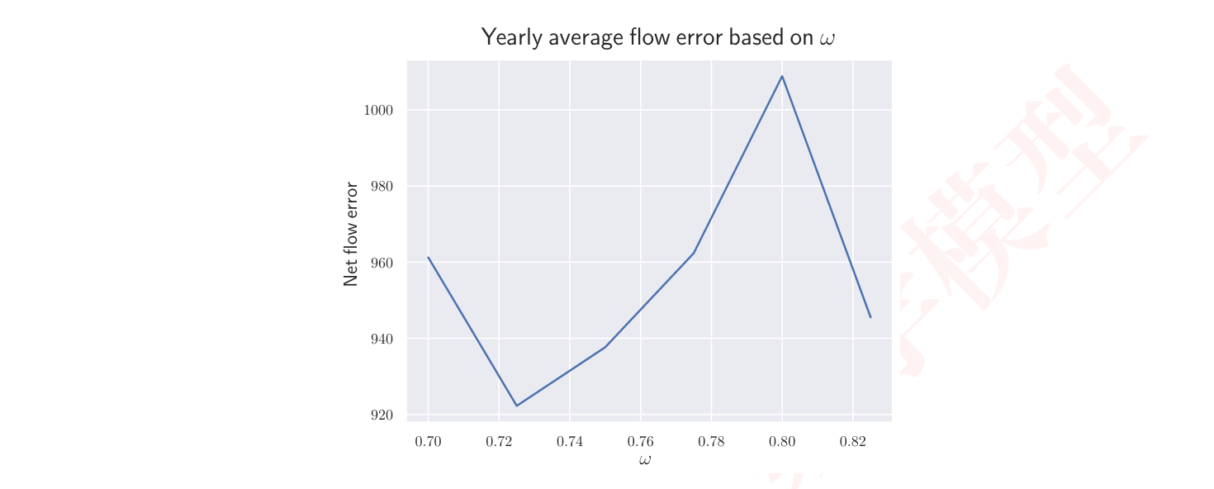
Figure 12: Flow in the St. Lawrence River is sensitive to 𝜔
图 12：圣劳伦斯河的流量对 𝜔 敏感
The error here varies quite significantly. In some sense, this is not surprising. Complex systemssuch as the Great Lakes are very sensitive to slight physical changes. To maximize the effectivenessof the model, it is therefore important to be able to measure these parameters accurately, and providethem to the model with high-resolution.
此处的误差变化相当显著。在某种意义上，这并不令人意外。像五大湖这样的复杂系统对微小的物理变化非常敏感。因此，为使模型的有效性最大化，能够准确测量这些参数并以高分辨率将其提供给模型十分重要。
In conclusion, the model is largely robust to changes in climate forecasting. However, dueto its mechanistic nature, it is quite sensitive to parameters describing natural and artificial flowprocesses.
总之，该模型对气候预测的变化在很大程度上是稳健的。然而，由于其机理性质，它对描述自然与人工流动过程的参数相当敏感。
6 Conclusions
6 结论
• Our model demonstrates that to effectively manage Lake Ontario, the ĲC must also effectivelymanage Lake Superior. Lake Superior has the capacity to send large amounts of water to
• 我们的模型表明，为有效管理安大略湖，IJC 也必须有效管理苏必利尔湖。苏必利尔湖有能力将大量水量输送至
Lake Ontario. While the time it takes for Lake Ontario to feel the effects of actions taken at
安大略湖。虽然在苏必利尔湖采取的行动需要经过一段时间才能让安大略湖感受到其影响，
Lake Superior, by proactively increasing the water sent from Lake Superior, Lake Ontariocan more effectively manage its water levels.
苏必利尔湖，但通过主动增加从苏必利尔湖输送的水量，安大略湖可以更有效地管理其水位。
• Dam schedules will consistently make tradeoffs betweeen flood/drought security and stake-holder satisfaction. It is important to manage stakeholder expectations and use equitableprioritization methods to ensure overall contentedness.
• 大坝调度方案将始终在防洪/防旱安全性与利益相关方满意度之间进行权衡。管理利益相关方的预期并采用公平的优先排序方法以确保整体满意度十分重要。
• Testing schedules against different severities of exogenous inflow yield outcomes that aresignificantly more robust to climate and hydrologic events. Regardless of the scheduling
• 针对不同强度的外源来水检验调度方案，所得到的结果对气候与水文事件的稳健性显著更高。无论调度
2
— 原文第 18 页 —
6.1 Strengths
6.1 优势
1. Due the speed of solving linear programs, our model can be employed to develop schedulesfor a large number of potential forecasts and ideal water levels. This allows practitioners tobe more prepared for extreme weather events by being able to prep schedules for best-case,worst-case, and average-case weather events. If it becomes evident that the environmentaldata that the dam control schedule was created from is poor, a new schedule can be quicklysubstituted in to mitigate damage.
1. 由于线性规划求解速度快，我们的模型可用于为大量潜在预报与理想水位制定调度方案。这使得从业者能够为最佳情形、最差情形和平均情形的天气事件预先制定调度方案，从而为极端天气事件做好更充分的准备。如果事实证明大坝控制调度方案所依据的环境数据质量较差，则可以迅速替换新的调度方案以减轻损害。
2. Our control algorithms can effectively meet stakeholder demands while the water levels re-main close to historical averages. The Great Lakes water system needs to flow naturally whilestill accounting for the demands of stakeholders, so our model must meet this benchmark.
2. 我们的控制算法能够有效满足利益相关方的需求，同时使水位保持在接近历史平均值的水平。五大湖水资源系统需要在自然流动的同时兼顾利益相关方的需求，因此我们的模型必须达到这一基准。
3. Due to the constrained nature of our control algorithms, practitioners will always be awareof the maximum and minimum water levels that are produced by the schedule. Since actionstaken at Lake Superior affect Lake Ontario with a severe delay, there is an associated riskwith increasing or decreasing the flow through the Compensating Works dam. Our controlalgorithms allow for practitioners to predict the effect of the schedules they implement.
3. 由于我们的控制算法具有约束性质，从业者始终能够了解调度方案所产生的水位最大值与最小值。由于在苏必利尔湖采取的行动会以严重的滞后影响安大略湖，增加或减少通过 Compensating Works 大坝的流量存在相应风险。我们的控制算法使从业者能够预测其所实施调度方案的效果。
4. Our model is extremely flood and drought-resistant. In our analysis using realistic precipita-tion data our model didn’t experience any droughts or floods.
4. 我们的模型具有极强的防洪与抗旱能力。在我们使用真实降水数据进行的分析中，模型没有出现任何干旱或洪水。
6.2 Weaknesses
6.2 不足
Practitioners need to be aware of the flaws of our model so that unexpected results from ourcontrol algorithms can be mitigated. The weaknesses of our model are as follows:
从业者需要了解我们模型的缺陷，以便能够减轻控制算法产生的意外结果。我们模型的弱点如下：
• Due to the mechanistic nature of our model, the schedule of the model is noticeably sensitiveto changes in parameters related to natural processes. For example, if the rate of flow decayin the St. Lawrence River is poorly measured, the model will produce a schedule that differsslightly, but noticeably, from the true ideal schedule. Practitioners should be aware of thisflaw and apply the model several times with varying values for parameters like the decay rateand rain schedule. While the schedule will be sensitive to poor measurements, it will providevaluable insights into how to best manage the dams.
• 由于模型的机理性质，其调度方案对与自然过程相关的参数变化明显敏感。例如，如果圣劳伦斯河的流量衰减率测量不准，模型将产生一个与真正理想的调度方案略有差异但可察觉不同的调度方案。从业者应当意识到这一缺陷，并对衰减率与降雨调度等参数取不同值多次应用该模型。尽管调度方案会对糟糕的测量结果敏感，但它仍将为如何最好地管理大坝提供有价值的洞见。
• Our model assumes a linear relationship between the height of a body of water and the totaloutflow which may change over time as the landscape of the Great Lakes changes. To accountfor this, practitioners should routinely track the relationship between the height of each lakeand the observed flows of each lake’s distributaries.
• 我们的模型假设水体高度与总出流量之间为线性关系，而这一关系可能随着五大湖地貌的变化随时间而改变。为应对这一点，从业者应定期跟踪各湖高度与各湖支流观测流量之间的关系。
• Due to the constraints placed on flooding and dangerously low water levels, our model willoccasionally determine that an adequate schedule is possible. If practitioners encounter this is sufficiently safe.
• 由于对洪水和危险低水位施加了约束条件，我们的模型偶尔会判定存在充分的调度方案。如果从业者遇到这种是足够安全的。
2
— 原文第 19 页 —
7 Future Exploration
7 未来探索
To address some of the weaknesses we identified, we believe that our model could be expandedin the following ways:
为解决我们发现的一些弱点，我们认为我们的模型可以通过以下方式扩展：
• Pull from more refined data: By pulling from more refined data, our model would have moreaccurate information hydrological information. As a result, our model could improve themechanistic nature of our model.
• 采用更精细的数据：通过采用更精细的数据，我们的模型将拥有更准确的水文信息。因此，我们的模型可以改进其机理性质。
• Safety Optimizer: Another extension of our model could be using the results from runningmany fuzzy trials to determine which dam schedule is optimal against random weatherconditions. This would allow practitioners to understand the risk assosiated with the schedulesthey select.
• 安全优化器：我们模型的另一项扩展可以是利用大量模糊试验的运行结果，确定哪种大坝调度方案在随机天气条件下最优。这将使从业者能够了解其所选调度方案相关的风险。
• Create an algorithm to determine which stakeholders to prioritize. The time of year has a
• 创建一个算法以确定应优先考虑哪些利益相关方。一年中的时节具有
2
— 原文第 20 页 —
8 Memo To The ĲC
8 致 ĲC 的备忘录
Dear ĲC Leadership,
尊敬的 ĲC 领导层：
In light of the successes and failures experienced by Plan 2014 in regards to controlling the
鉴于 2014 年方案在控制
Moses-Saunders dam at Lake Ontario, we developed two linear programming-based controlalgorithms to effectively determine how to jointly manage the Compensating Works Dam at Lake
安大略湖 Moses-Saunders 坝方面所取得的成功与遭遇的失败，我们开发了两种基于线性规划的控制算法，以有效确定如何联合管理苏必利尔湖的 Compensating Works 坝
Superior and the Moses-Saunders Dam at Lake Ontario to achieve ideal water levels throughout the
与安大略湖的 Moses-Saunders 坝，从而在整个
Great Lakes. We believe that our algorithms build off of the adaptive control approach that Plan
五大湖范围内实现理想水位。我们认为，我们的算法建立在 2014 年方案
2014 has successfully implemented while avoiding the limitations of Plan 2014 that have allowedfor flooding in recent years.
已成功实施的自适应控制方法之上，同时规避了 2014 年方案中导致近年来发生洪水的那些局限。
In our model, we employ linear programming and a series of algorithms that forecast the needsof the stakeholders to determine how much we need to open dams at Lake Superior and Ontario.
在我们的模型中，我们采用线性规划和一系列用于预测利益相关方需求的算法，来确定我们需要在苏必利尔湖和安大略湖开启多少座坝。
Because we are using a linear program, our model can simulate hundreds of thousands of scenarioswithin a few minutes, this would allow for the ĲC to have a more holistic approach to assessingthe risks of running certain dam schedules for their stakeholders. Our algorithm for determiningthe optimal levels of stakeholders is based on their desires outlined in the ĲC report and draws fromhistorical water levels [10]. Our model also utilizes historical data to simulate natural processesin the hydrosphere in the following ways:
由于我们使用的是线性规划，我们的模型可以在几分钟内模拟数十万种情景，这将使 ĲC 能够以更为整体的方式评估为其利益相关方运行特定坝调度方案所伴随的风险。我们用于确定利益相关方最优水平的算法，基于 ĲC 报告中所述的各方意愿，并借鉴历史水位数据 [10]。我们的模型还利用历史数据，通过以下方式模拟水圈中的自然过程：
• We account for the time it takes water to flow between lakes. We were able to correlate thewater level data between different lakes to estimate the time it taken for flows to propagatethrough the system.
• 我们考虑了水在湖泊之间流动所需的时间。我们能够关联不同湖泊之间的水位数据，以估计水流在该系统中传播所需的时间。
• We use a data-driven approach to determine flow rates of naturally flowing sources. More-over, using the data available to us, we found a strong linear relationship between height andthe rate and which water flows out.
• 我们采用数据驱动的方法来确定自然流动水源的流量。此外，利用我们可获得的数据，我们发现水位高度与水流出速率之间存在很强的线性关系。
• Our model accounts for various levels of rainfall and other hydrological processes. We utilizeda combination of precipitation from NOAA and preexisting models to get randomized, butrepresentative rain data to run our situations [17] [22].
• 我们的模型考虑了不同水平的降雨及其他水文过程。我们结合使用 NOAA 的降水数据与已有模型，获得随机但具有代表性的降雨数据，以运行我们的情景 [17] [22]。
To show the resilience of our model we ran it under various extreme climate events and foundit was effective in preventing floods and droughts. Specifically, the way our algorithms achievenear-optimal water levels even with severe climate events is by creatively managing Lake Superior.
为展示模型的韧性，我们在各种极端气候事件下运行模型，发现其在防止洪水和干旱方面是有效的。具体而言，我们的算法即使在严重气候事件下也能实现接近最优的水位，其途径是创造性地管理苏必利尔湖。
By incorporating the relationship between Lake Superior and Lake Ontario into our model, we areable to achieve schedules that allow Lake Ontario to remain safe and beneficial to the stakeholders.
通过将苏必利尔湖与安大略湖之间的关系纳入模型，我们能够制定出使安大略湖保持安全且对利益相关方有利的调度方案。
We believe that our model provides the ĲC with valuable insights about how to best managethe Compensating Works and Sault. St. Marie dams. Our model will allow the ĲC to use themost recent sets of data being gathered at the monitoring points along the Great Lakes and adapt
我们相信，我们的模型为 ĲC 提供关于如何最好地管理 Compensating Works 与 SaultSt. Marie 坝的宝贵见解。我们的模型将使 ĲC 能够利用沿五大湖各监测点正在收集的最新数据集，并调整
2
— 原文第 21 页 —
A
Notation
符号说明
Name
名称
Type
类型
Description.
说明。
𝑇
Set
Set of time-steps.
𝐵
Set
Set of Bodies of Water.
𝑥_{𝑡}
Height of water let through the Sault St. Marie Dam at time 𝑡.
通过 Sault St.Marie 坝在时刻 𝑡 下泄的水位高度。
Variable
变量
𝑦_{𝑡}
Height of water let through the Moses-Saunders Dam at time 𝑡.
通过 Moses-Saunders 坝在时刻 𝑡 下泄的水位高度。
Variable
变量
𝑓_{𝑡}
Flow at River Lawrence at time 𝑡.
劳伦斯河在时刻 𝑡 的流量。
Variable
变量
ℎ_{𝑖,𝑡}
Height of water in body of water 𝑖at time 𝑡.
水体 𝑖 在时刻 𝑡 的水位高度。
Variable
变量
𝜔_{𝑖}
Weighting term for the objective function. High 𝜔_{𝑖}
目标函数的权重项。较高的 𝜔_{𝑖}
Parameter
参数
𝑟_{𝑖,𝑡}
The total height added by environmental factors in body of water 𝑖at time 𝑡.
水体 𝑖 在时刻 𝑡 由环境因素增加的总高度。
Parameter
参数
𝑠_{𝑖}
The surface area of body of water 𝑖.
水体 𝑖 的表面积。
Parameter
参数
𝛼_{𝑖}
Parameter
参数
Determined slope from regression.
由回归确定的斜率。
𝛽_{𝑖}
Parameter
参数
Determined bias from regression.
由回归确定的偏置。
𝐿
Parameter
参数
Lag time between specified bodies of water.
指定水体之间的滞后时间。
𝐹_{𝑖}
Height of water required for a flood at body of water 𝑖.
水体 𝑖 发生洪水所需的水位高度。
Parameter
参数
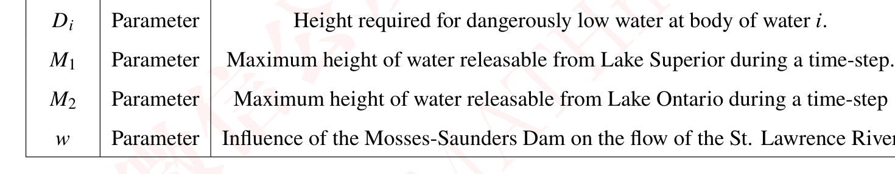
Table 2: Description of variables involed in the mathematical program used to determine dam
表 2：用于确定坝的数学规划中所涉及变量的说明
2
— 原文第 22 页 —
Name
名称
Type
类型
Description.
说明。
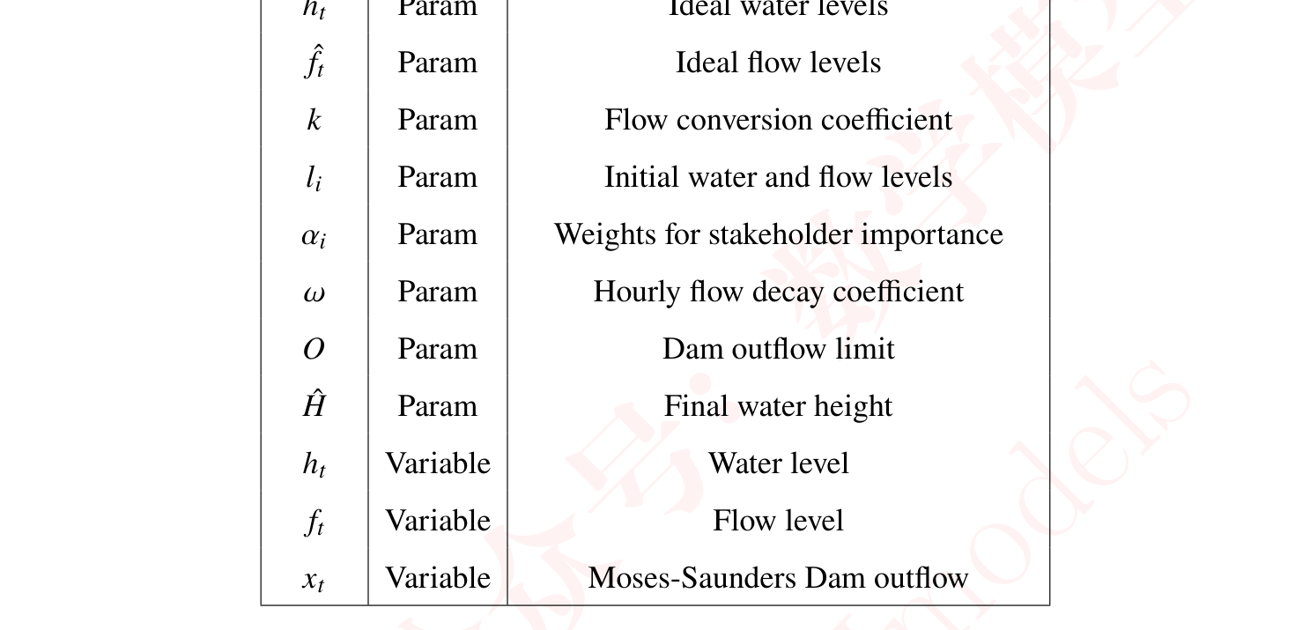
Table 3: Microschedule LP formulation.
表 3：微观调度 LP 公式。所有水位均为以米为单位的高度，所有时间均以小时计，所有流量均以立方米每秒计
— 原文第 23 页 —
References
[1] 2024MCM/ICM Problems. https://www.immchallenge.org/mcm/index.html.
[2] International Joint Commission (2014). Lake Ontario St. Lawrence River Plan 201: Protectingagainst extreme water levels, restoring wetlands and preparing for climate change, 2014.
[3] US army Corps of Engineers. John glenn great lakes basin program biohydrological informa-tion base, 2007.
[4] Peng Bai, Jia Wang, Philip Chu, Nathan Hawley, Ayumi Fujisaki-Manome, James Kessler,
Brent M Lofgren, Dmitry Beletsky, Eric J Anderson, and Yaru Li. Modeling the ice-attenuatedwaves in the great lakes. Ocean Dynamics, 70:991–1003, 2020.
[5] Chiranjib Bhowmik, Sumit Bhowmik, Amitava Ray, and Krishna Murari Pandey. Optimalgreen energy planning for sustainable development: A review. Renewable and Sustainable
Energy Reviews, 71:796–813, 2017.
[6] Thomas Bläsius, Adrian Feilhauer, and Jannik Westenfelder.
Dynamic flows with time-dependent capacities, 2023.
[7] Murray Clamen and Daniel Macfarlane. Plan 2014: The historical evolution of lake ontario–
Canadian Water Resources Journal/Revue canadienne desst. lawrence river regulation.ressources hydriques, 43(4):416–431, 2018.
[8] Great Lakes Commission.
[9] International Joint Commission. Options for managing lake ontario and st. lawrence riverwater levels and flows (final report), 2006.
[10] International Joint Commission. Section 5: Impacts on various interests, 2023.
[11] George B Dantzig. Linear programming. History of mathematical programming, pages
19–31, 1991.
[12] Jean-Luc Desgranges, Joel Ingram, Bruno Drolet, Jean Morin, Caroline Savage, and Daniel
Borcard. Modelling wetland bird response to water level changes in the lake ontario–st.lawrence river hydrosystem. Environmental monitoring and assessment, 113:329–365, 2006.
[13] Google Earth. Great lakes, no clouds, 2010.
[14] Lester Randolph Ford. Flows in networks. 2015.
[15] Inga Kanoshina, Urmas Lips, and Juha-Markku Leppänen. The influence of weather con-ditions (temperature and wind) on cyanobacterial bloom development in the gulf of finland (baltic sea). Harmful Algae, 2(1):29–41, 2003.
[16] Frank Millerd. The economic impact of climate change on canadian commercial navigationon the great lake. Canadian Water Resources Journal, 30(4):269–280, 2005.
[17] NOAA. Noaa glerl data, 2021.
[18] National Oceanic and Atmospheric Administration. Great lakes ecoregion - national oceanicand atmospheric administration, 2019.
[19] Frank J Rahel and Julian D Olden. Assessing the effects of climate change on aquatic invasive
2 [20] Charles S. Revelle, Daniel P. Loucks, and Walter R. Lynn. Linear programming applied towater quality management. Water Resources Research, 4(1):1–9, 1968.
— 原文第 24 页 —
[21] Michael H Veatch. Linear and convex optimization: A Mathematical Approach. John Wiley
& Sons, 2020.
[22] Daniel S Wilks and Robert L Wilby. The weather generation game: a review of stochasticweather models. Progress in physical geography, 23(3):329–357, 1999.
（全文完。公式与表格在原 PDF 中是矢量图形，未纳入本对照版；可按文中「原文第 N 页」标记翻到 2429211.pdf 对照查看。）

