2413552 英中对照版
2024 ICM Problem E · Sustainability of Property Insurance
读法：黑字为原文，蓝字为译文，一段英文一段中文，上下对应；蓝字里的小字括号是该术语第一次出现时的英文原词。
术语表（按首次出现排序，18 条）
# | 英文 | 中文 | 说明：为什么容易译错
1 | Property Insurance | 财产保险 | 承保房屋等财产的险种
2 | Climate Change | 气候变化 | 推高巨灾频率的长期趋势
3 | Risk Assessment | 风险评估 | 量化灾害损失的可能性
4 | Underwriting | 承保 | 保险公司决定是否接保及定价
5 | Premium | 保费 | 投保人支付的费用
6 | Claim | 理赔 | 出险后保险公司的赔付
7 | Catastrophe Model | 巨灾模型 | 估计极端事件的损失分布
8 | Extreme Weather | 极端天气 | 干旱、洪水、风暴等
9 | Community Development | 社区发展 | 保险与社区韧性的互动
10 | Historical Heritage | 历史遗产 | 需要特别保护的老城区建筑
11 | Multi-scale Geographically Weighted Regression | 多尺度地理加权回归 | MGWR，允许各因素影响随空间变化
12 | Entropy Weight Method | 熵权法 | 客观赋权
13 | Multi-Objective Optimization | 多目标优化 | 同时兼顾可负担性与盈利
14 | Insurance Gap | 保障缺口 | 实际损失与赔付之间的差额
15 | Reinsurance | 再保险 | 保险公司为自己买的保险
16 | Vulnerability | 脆弱性 | 受灾后难以恢复的程度
17 | Sustainability | 可持续性 | 保险体系能否长期运转
18 | Data Visualization | 数据可视化 | 用图表呈现空间差异

Weather Conditions
天气状况
Summary
摘要
In the context of global climate change, the increasing frequency of extreme weather eventsposes significant challenges to the property insurance industry. This study presents a comprehensiveanalytical framework addressing the sustainability of the property insurance sector under extremeweather conditions. Initially, we employed a Multi-Scale Geographically Weighted Regression (MGWR) model, integrating climate data, geographical location, and insurance claims data, toanalyze the impact of extreme weather on insurance payouts.
在全球气候变化（Climate Change）的背景下，极端天气（Extreme Weather）事件发生频率不断上升，给财产保险（Property Insurance）业带来了严峻挑战。本研究提出了一个综合分析框架，用以探讨极端天气（Extreme Weather）条件下财产保险部门的可持续性（Sustainability）。首先，我们采用了多尺度地理加权回归（Multi-scale Geographically Weighted Regression）（MGWR）模型，融合气候数据、地理位置与保险理赔（Claim）数据，分析极端天气（Extreme Weather）对保险赔付的影响。
The model results indicate thatconsidering spatial heterogeneity allows for more accurate predictions of insurance claim amounts,offering insurance companies a scientific risk assessment tool. For instance, we observed a signifi-cant positive correlation between insurance payouts and the probability of extreme environmentalevents in certain high-risk areas.
模型结果表明，考虑空间异质性能够更准确地预测保险理赔金额，为保险公司提供科学的风险评估（Risk Assessment）工具。例如，我们观察到在某些高风险地区，保险赔付与极端环境事件发生概率之间存在显著的正相关关系。
Addressing the first issue, we proposed a risk-based insurance pricing strategy that balancesthe long-term health of insurance companies with the financial burden on property owners. Byincorporating a humanitarian adjustment coefficient and a profitability adjustment factor, our modelprices insurance products at different risk levels, achieving a balance between social responsibilityand economic efficiency. For example, our model predicted insurance amounts for California (ahigh-risk area) to be $20.1394 million in 2023, with an anticipated increase to $31.0054 millionby 2034.
针对第一个问题，我们提出了一种基于风险的保险定价策略，在保险公司的长期健康与财产所有者的财务负担之间取得平衡。通过引入人道主义调整系数与盈利性调整因子，我们的模型对不同风险水平的保险产品进行定价，实现了社会责任与经济效率之间的平衡。例如，我们的模型预测加利福尼亚州（高风险地区）2023 年的保险金额为 $20.1394 million，并预计到 2034 年将增至 $31.0054 million。
For the second issue, we developed community building and development strategies to adaptto risks posed by climate change. Using data standardization, entropy calculation, and weighting,we provided property owners with strategies to influence insurance company decisions, therebyreducing insurance costs. For example, we suggested communities could lower insurance costsby enhancing per capita GDP, controlling population density, improving healthcare quality, andsupporting educational development.
针对第二个问题，我们制定了社区建设与发展策略，以适应气候变化带来的风险。通过数据标准化、熵值计算与赋权，我们为财产所有者提供了影响保险公司决策、从而降低保险成本的策略。例如，我们建议社区可以通过提升人均 GDP、控制人口密度、改善医疗保健质量以及支持教育发展来降低保险成本。
In addressing the third issue, we focused on the protection of historical landmarks, specificallythe Statue of Liberty. Utilizing the MGWR model, combined with building conservation priorities,we assessed the protective needs of the Statue of Liberty. Our detailed protection plan providedthe community with measures to mitigate the potential impacts of extreme weather on this culturalsymbol. For example, the proposed protection measures included structural reinforcement, envi-ronmental monitoring system installation, and emergency response planning, with an estimatedannual investment of about $2.5 million.
在应对第三个问题时，我们聚焦于历史地标的保护，具体为自由女神像。利用 MGWR 模型并结合建筑保护优先级，我们评估了自由女神像的保护需求。我们制定的详细保护方案为社区提供了减轻极端天气对这一文化象征潜在影响的措施。例如，所提出的保护措施包括结构加固、环境监测系统安装以及应急响应规划，预计每年投入约 $2.5 million。
In summary, this study provides insurance companies with decision support for underwriting inextreme weather conditions and offers practical strategies for community and heritage conservation.
综上所述，本研究为保险公司在极端天气条件下的承保（Underwriting）提供了决策支持，并为社区与遗产保护提供了切实可行的策略。
Our framework emphasizes the importance of scientific analysis, community involvement, andmulti-objective optimization, presenting a comprehensive approach to addressing the challengesposed by climate change.
我们的框架强调了科学分析、社区参与和多目标优化（Multi-Objective Optimization）的重要性，为应对气候变化带来的挑战提供了一种综合性方法。
Keywords: climate change, property insurance, risk assessment, community development,
关键词：气候变化，财产保险，风险评估，社区发展（Community Development），
2
— 原文第 3 页 —
1 Introduction
1 引言
1.1 Problem Background
1.1 问题背景
”Nature is kind of a loving mother, but also a butcher in cold blood.” —Victor Hugo. It suggests that nature possesses both a generous aspect, bestowing survival and prosperity upon humanity, and a ruthless, unpredictable side. The latest data indicates that the past seven years are poised to become the hottest seven years on record (WMO 2023). Due to climate change, more severe and frequent extreme weather events such as tropical cyclones, heatwaves, floods, and droughts are becoming the new norm. These extreme weather events have a significant impact on society, not only claiming approximately 35,000 lives annually but also causing substantial economic losses. For instance, in 2016, flash floods and storms in Germany, Belgium, and Switzerland resulted in $2.2 billion in losses, with around 50% of the costs covered by insurance companies [2].
“自然既是一位慈爱的母亲，也是一位冷血的屠夫。”——维克多·雨果。这表明自然既具有慷慨的一面，赐予人类生存与繁荣，也具有无情而不可预测的一面。最新数据表明，过去七年有望成为有记录以来最热的七年（WMO 2023）。由于气候变化，热带气旋、热浪、洪水和干旱等更为严重且频繁的极端天气事件正在成为新常态。这些极端天气事件对社会产生了重大影响，不仅每年夺去约 35,000 人的生命，还造成了巨大的经济损失。例如，2016 年德国、比利时和瑞士的暴洪与风暴造成了 $2.2 billion 的损失，其中约 50% 的费用由保险公司承担 [2]。
The insurance industry has long warned about the escalating frequency and material damage caused by weather disasters on a global scale. This surge can be attributed to the rise in both the number and geographical extent of settlements in vulnerable areas, the accumulation of increasingly valuable and delicate assets in these regions, and the evident shifts in climate and the environment [4]. Therefore, determining how to ensure the sustainability of property insurance through appropriate interventions will become one of the key questions and turning points in the future development of human society.
保险业长期以来一直就全球范围内天气灾害日益加剧的发生频率和物质损失发出警告。这一激增可归因于脆弱地区定居点数量与地理范围的扩大、这些地区日益增多的高价值且易损资产的积聚，以及气候与环境方面的明显变化 [4]。因此，如何通过适当的干预措施确保财产保险的可持续性，将成为人类社会未来发展的关键问题与转折点之一。
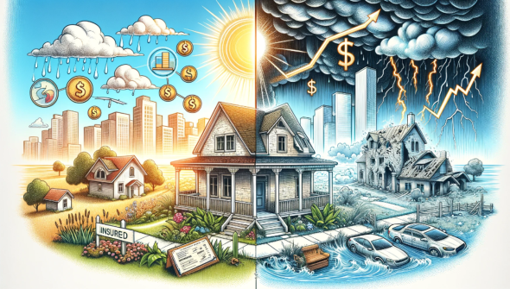
Figure 1: Insurance strategies are all you need
图 1：保险策略便是你所需的一切
图中文字对照（英文 → 中文）
INSURED | 已投保
1.2 Problem Restatement
1.2 问题重述
Q1: Insurance Underwriting Strategies in a Changing Climate: Developing a model to aid insurance companies in deciding whether to underwrite in areas increasingly affected by extreme to changing insurance environments requires a nuanced approach to assess the risks of building and developing in specific locations. Ensuring property resilience and sustainable community development in the face of these risks is pivotal.
问题 1：变化气候条件下的保险承保策略：建立一个模型，帮助保险公司决定是否在日益受极端影响的地区开展承保面对不断变化的保险环境，需要一种细致入微的方法来评估特定地点建设与开发的风险。在这些风险面前确保财产韧性与可持续的社区发展至关重要。
2
— 原文第 4 页 —
Q3: Preservation of Historical Landmarks under Climate Threats: Selecting a historical landmark and applying insurance and protection models to assess its value poses a unique challenge. For communities, this involves proposing a comprehensive protection plan, which includes recommended measures, timelines, and associated costs to safeguard these cultural treasures against the ravages of extreme weather.
问题 3：气候威胁下历史地标的保护：选择一处历史地标，并运用保险与保护模型评估其价值，是一项独特的挑战。对社区而言，这涉及提出一项全面的保护方案，其中包括建议措施、时间表与相关成本，以保护这些文化瑰宝免受极端天气的破坏。
1.3 Related Work
1.3 相关工作
In addressing insurance industry pricing strategies under extreme weather conditions, current literature highlights several key strategies and methods. Firstly, insurance companies are enhancing their internal measures to more accurately assess and price risks. This includes developing enhanced predictive capabilities and integrating artificial intelligence with spatial imaging for more accurate asset vulnerability assessments. For instance, Canadian technology company Riskthinking. [1]
在探讨极端天气条件下保险业的定价策略时，现有文献突出了若干关键策略与方法。首先，保险公司正在加强其内部措施，以更准确地评估与定价风险。这包括提升预测能力，并将人工智能与空间成像相结合，以更准确地评估资产脆弱性（Vulnerability）。例如，加拿大科技公司 Riskthinking。[1]
Secondly, insurers are intensifying interactions with clients to raise risk awareness and promote effective mitigation measures. This involves risk consultancy, raising awareness of risks, and providing post-disaster services to build resilience. A study by JBA Risk Management emphasizes that even a 5% enhancement in household preventative measures can significantly reduce losses. [3]
其次，保险人正在加强与客户的互动，以提高风险意识并推动有效的缓解措施。这涉及风险咨询、提高风险意识以及提供灾后服务以增强韧性。JBA Risk Management 的一项研究强调，即便家庭预防措施仅提升 5%，也能显著减少损失。[3]
Thirdly, product innovation in insurance is also a response to the new climate realities [7]. This includes adapting insurance products to cover a broader range of climate-related risks and developing policies more aligned with current and future climate conditions.
第三，保险产品创新也是对新的气候现实的回应 [7]。这包括对保险产品进行调整，使其覆盖更广泛的气候相关风险，并制定与当前及未来气候状况更为契合的保单。
Fourthly, insurers are collaborating with policymakers, regulatory bodies, and other industry stakeholders to adapt to the evolving climate realities. This includes advocating for regulatory changes, sharing data, and investing in climate-adaptive infrastructure projects [5].
第四，保险公司正与政策制定者、监管机构及其他行业利益相关方合作，以适应不断演变的气候现实。这包括倡导监管变革、共享数据，以及投资于气候适应性基础设施项目[5]。
Additionally, the variability of climate risks renders traditional models based on historical data less reliable. This necessitates a shift towards predictive risk assessment methods. For instance, Risk Management Solutions (RMS) has adjusted its models to account for the changing frequency and severity of extreme weather events like hurricanes and floods [8].
此外，气候风险的可变性使基于历史数据的传统模型可靠性下降。这就要求向预测性风险评估方法转变。例如，风险管理解决方案公司（Risk Management Solutions, RMS）已对其模型进行调整，以考虑飓风与洪水等极端天气事件在发生频率与严重程度上的变化[8]。
Finally, insurers are focusing on building financial resilience by considering low-probability catastrophic events and diversifying their investment portfolios. This involves using risk models that hypothesize non-fixed risks and reducing reliance on historical data, thereby enabling insurers to better understand and measure the impact of climate risks on their financial resilience [6].
最后，保险公司正着力构建财务韧性，其途径是考虑低概率巨灾事件并使投资组合多元化。这涉及采用假设风险非固定的风险模型并减少对历史数据的依赖，从而使保险公司能够更好地理解与度量气候风险对其财务韧性的影响[6]。
1.4 Our work
1.4 我们的工作
1. In the first study, we developed a Multiscale Geographically Weighted Regression (MGWR) model by integrating climatic factors, geographical locations, and financial data from insurance companies. This model is designed to provide a scientific basis for property insurance pricing. Initially, Principal Component Analysis (PCA) was employed to reduce the dimensions of climate data. Subsequently, we utilized the MGWR model to analyze the impact of spatial heterogeneity on insurance claims. Finally, by applying asset pricing models and long-term health development models, we offered protection model incorporates protective measures and calculates the optimal level of intervention
1. 在第一项研究中，我们整合气候因素、地理位置以及保险公司的财务数据，构建了多尺度地理加权回归（MGWR）模型。该模型旨在为财产保险定价提供科学依据。我们首先采用主成分分析（PCA）对气候数据进行降维。随后，我们利用 MGWR 模型分析空间异质性对保险理赔的影响。最后，通过应用资产定价模型与长期健康发展模型，我们提供了保护模型纳入保护措施并计算最优干预水平
2
— 原文第 5 页 —
based on risk and cost considerations. For property owners, we employed the Improved Entropy Weight Method to determine the Humanitarian Adjustment Coefficient (HIC), guiding them on strategies to influence insurance decisions and reduce potential losses.
基于风险与成本的考量。对于财产所有者，我们采用改进熵权法（Entropy Weight Method）确定人道主义调整系数（HIC），指导其采取影响保险决策并减少潜在损失的相关策略。
3. Our work also addressed the unique challenge of preserving historical landmarks under climate threats. By adapting the MGWR model to prioritize building conservation, we assessed the protection needs of iconic structures like the Statue of Liberty. We considered architectural factors and geographic coordinates to determine the required level of protection and proposed a comprehensive protection plan, including recommended measures, timelines, and associated costs to safeguard these cultural treasures against extreme weather events.
3. 我们的工作还应对了在气候威胁下保护历史地标的独特挑战。通过调整 MGWR 模型以优先考虑建筑保护，我们评估了自由女神像等标志性建筑的保护需求。我们考虑建筑因素与地理坐标以确定所需的保护水平，并提出了一套综合保护方案，包括推荐措施、时间安排及相关成本，以使这些文化瑰宝免受极端天气事件的侵害。
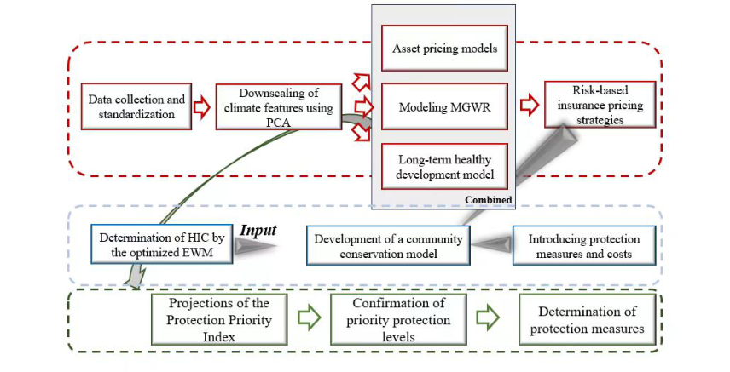
Figure 2: Flow Chart of Our Work
图 2：我们的工作流程图
图中文字对照（英文 → 中文）
Data collection and standardization | 数据收集与标准化 | Downscaling of climate features using PCA | 基于 PCA 的气候特征降尺度
Asset pricing models | 资产定价模型 | Modeling MGWR | MGWR 建模
Long-term healthy development model | 长期健康发展模型 | Combined | 组合（综合）
Risk-based insurance pricing strategies | 基于风险的保险定价策略 | Determination of HIC by the optimized EWM | 以优化的 EWM 确定 HIC
Input | 输入 | Development of a community conservation model | 社区保护模型构建
Introducing protection measures and costs | 引入保护措施与成本 | Projections of the Protection Priority Index | 保护优先指数预测
Confirmation of priority protection levels | 优先保护等级确认 | Determination of protection measures | 保护措施确定
2 Preparation of the Models
2 模型的准备
2.1 Assumptions
2.1 假设
To simplify our model and eliminate the complexity, we make the following main assumptions in this literature. All assumptions will be re-emphasized once they are used in the construction of our model:
为简化模型并消除复杂性，本文作出以下主要假设。所有假设在模型构建中被使用时将再次予以强调：
1. Data Completeness and Quality: The official dataset contains all necessary information required for the research, eliminating the need for supplementary data. This dataset comprehensively covers the required variables and is of high quality, ensuring the reliability of the analysis.
1. 数据的完整性与质量：官方数据集包含研究所需的全部信息，无需补充数据。该数据集全面覆盖了所需变量且质量较高，从而保证了分析的可靠性。
Regression (MGWR) model, leading to more accurate insurance pricing and risk assessment.
回归（MGWR）模型，从而实现更准确的保险定价与风险评估。
2
— 原文第 6 页 —
3. Correlation of Socio-Economic Factors with Insurance Needs: Socio-economic factors, such as per capita GDP, population density, and education levels, show a significant correlation with insurance demand and risk assessment. This underpins the validity of using the entropy weighting method to determine the Humanitarian Adjustment Coefficient (HAC), highlighting the importance of these factors in developing insurance strategies.
3. 社会经济因素与保险需求的相关性：人均 GDP、人口密度与教育水平等社会经济因素与保险需求和风险评估呈显著相关。这为使用熵权法确定人道主义调整系数（HAC）的有效性提供了依据，凸显了这些因素在制定保险策略中的重要性。
2.2 Notations
2.2 符号说明
In this work, we use the nomenclature in Table 1 in the model construction. Other nonefrequentused symbols will be introduced once they are used.
在本工作中，我们在模型构建中使用表 1 所列的符号体系。其他不常用的符号将在使用时予以介绍。
Table 1: List of Symbols and Abbreviations
表 1：符号与缩写一览表
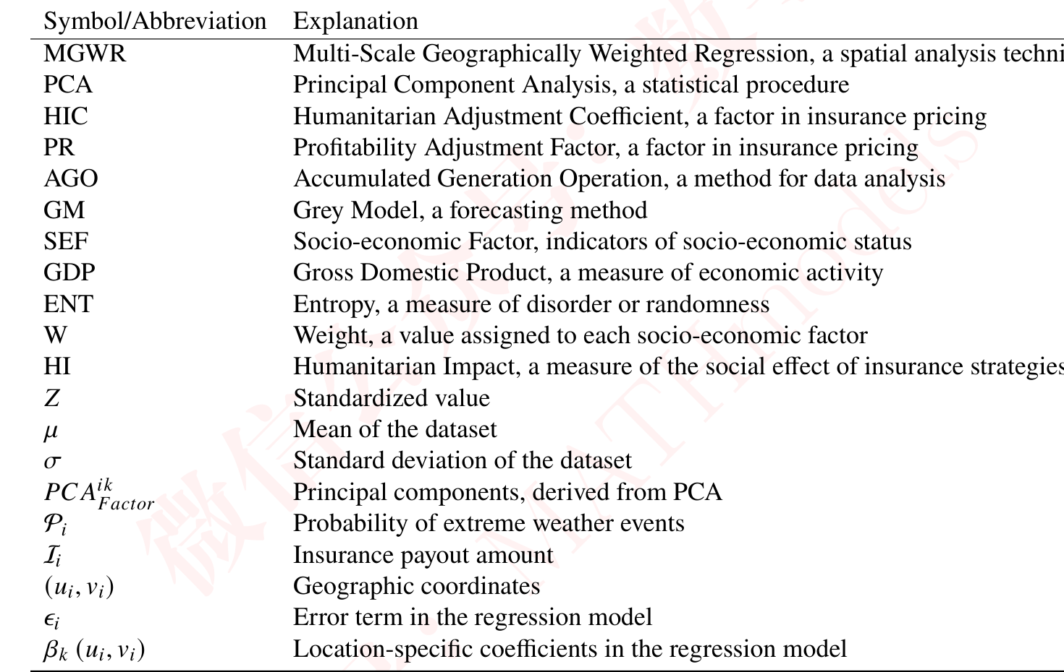
3 Insurance Strategy Formulation Model
3 保险策略制定模型
In our study, we evaluated the assumptions of risk in the design of insurance policies across specific regions. Our methodology encompassed the aggregation of environmental factors, followed by employing a Multi-Scale Geographically Weighted Regression (MGWR) model to conduct regression analysis on the loss amounts.
在我们的研究中，我们评估了特定区域保险保单设计中的风险假设。我们的方法包括对环境因素进行聚合，随后采用多尺度地理加权回归（MGWR）模型对损失金额进行回归分析。
with the risk-bearing capacity of each region, as identified by a Risk-Based Generalized Pricing
与各区域的风险承受能力相匹配，该能力由基于风险的广义定价
2
— 原文第 7 页 —
Model. Moreover, we implemented a humanitarian low-threshold setting to ensure fundamental safety protection for residents. This approach not only aligns with actuarial principles but also embeds an element of social responsibility in the formulation of insurance strategies.
模型识别。此外，我们设置了人道主义低门槛，以确保为居民提供基本的安全保障。该方法不仅符合精算原则，还在保险策略的制定中融入了社会责任要素。
3.1 Data Collection
3.1 数据收集
• Climatic Factors: We collected climatic data for the United States region from ERA5-Land 1, which provides data at an hourly resolution with a spatial resolution of 0.1° × 0.1° latitude and longitude. This dataset includes but is not limited to 96 variables such as precipitation, temperature, and soil moisture. We segmented the region based on the latitude and longitude of the United States and collected climate data spanning from 2013 to 2023, covering the past decade.
• 气候因素：我们收集了美国区域的 ERA5-Land 1 气候数据，该数据的时间分辨率为小时级，空间分辨率为 0.1° × 0.1° 经纬度。该数据集包括但不限于降水、气温与土壤湿度等 96 个变量。我们依据美国的经纬度对该区域进行划分，并收集了 2013 年至 2023 年、覆盖过去十年的气候数据。
• Geographical Data: We gathered latitude and longitude coordinates of extreme weather events in the United States region from the Global Disaster Data Platform 2. This dataset includes event dates, states, as well as latitude and longitude information, along with financial losses.
• 地理数据：我们从全球灾害数据平台 2 获取了美国地区极端天气事件的经纬度坐标。该数据集包括事件日期、所在州，以及经纬度信息和财务损失。
• Insurance Data: We obtained annual payout and insurance premium amounts from NAIC 3, which serve as the dependent variables for our regression model.
• 保险数据：我们从 NAIC 3 获取了年度赔付金额与保费（Premium）金额，二者作为我们回归模型的因变量。
3.2 Data Preprocessing
3.2 数据预处理
• Standardization: To ensure comparability and analytical precision, we transformed all variables into a uniform, dimensionless scale. This was achieved by applying the standardization formula.
• 标准化：为确保可比性与分析精度，我们将所有变量转换为统一的无量纲尺度。这一转换通过应用标准化公式实现。
• Principal Component Analysis (PCA): Given the high dimensionality of our climatic dataset, comprising 96 variables, we employed Principal Component Analysis (PCA) to distill this complexity into a more manageable form.
• 主成分分析（PCA）：鉴于我们的气候数据集维数较高，共包含 96 个变量，我们采用主成分分析（PCA）将这一复杂性提炼为更易处理的形式。
The goal was to reduce these variables to four principal components, capturing the most significant variance in the dataset. PCA was executed using the following linear transformation:
目标是将这些变量降维为四个主成分，以捕捉数据集中最重要的方差。PCA 通过以下线性变换执行：
where 𝑋denotes the original data matrix. In this formula, 𝑈and 𝑉are orthogonal matrices representing the eigenvectors, and Σ is a diagonal matrix consisting of eigenvalues. This transformation effectively captures the essence of the data in fewer dimensions, aiding in more efficient and insightful analysis. The decision to use PCA was driven by its ability to identify patterns in
其中 𝑋 表示原始数据矩阵。在该公式中，𝑈 与 𝑉 是表示特征向量的正交矩阵，Σ 是由特征值构成的对角矩阵。该变换以更少的维度有效捕捉了数据的本质，有助于开展更高效、更具洞察力的分析。决定采用 PCA，是因其具备识别……中模式的能力
3https://content.naic.org/
2
— 原文第 8 页 —
• Extreme Weather Event Identification: In light of the incomplete records of extreme weather events, our approach incorporates a rigorous analysis of interpolated environmental data. Specifically, we focus on identifying potential extreme weather occurrences based on climatic thresholds. This involves comparing the interpolated environmental variables, such as precipitation levels, against established benchmarks indicative of extreme conditions. The mathematical formulation for this analysis is as follows:
• 极端天气事件识别：鉴于极端天气事件的记录并不完整，我们的方法纳入了对插值环境数据的严格分析。具体而言，我们侧重于依据气候阈值识别潜在的极端天气发生情况。这涉及将插值环境变量（例如降水量）与指示极端条件的既定基准进行比较。该分析的数学表述如下：
where 𝐸signifies the classification of an event as extreme weather, 𝑆(𝑥, 𝑦) represents the interpolated environmental value at a specific location, and 𝑇_{extreme} is the threshold value that defines an extreme weather condition, such as a specific level of precipitation for torrential rain. This methodology ensures that even in cases where extreme weather is not officially recorded, our analysis can still identify and account for such events based on environmental data, thereby providing a more comprehensive understanding of the impact of extreme weather on insurance-related occurrences.
其中 𝐸 表示将某事件归类为极端天气，𝑆(𝑥, 𝑦) 表示特定位置的插值环境值，𝑇_{extreme} 是界定极端天气条件的阈值，例如暴雨所对应的特定降水量水平。该方法确保即使在极端天气未被官方记录的情况下，我们的分析仍能基于环境数据识别并计入此类事件，从而更全面地理解极端天气对保险相关事件的影响。
3.3 Multi-Scale Geographically Weighted Regression (MGWR)
3.3 多尺度地理加权回归（MGWR）
Multi-scale Geographically Weighted Regression (MGWR) is an advanced spatial analysis technique that extends the traditional Geographically Weighted Regression (GWR) framework. Unlike GWR, which assumes a single bandwidth for all covariates, MGWR allows for different spatial scales (bandwidths) for each covariate, offering a more nuanced understanding of spatial relationships. This flexibility makes MGWR particularly suited for complex spatial datasets where relationships vary across space and at different scales. The MGWR model can be expressed as follows:
多尺度地理加权回归（MGWR）是一种先进的空间分析技术，它扩展了传统的地理加权回归（GWR）框架。与对所有协变量假定单一带宽的 GWR 不同，MGWR 允许每个协变量具有不同的空间尺度（带宽），从而对空间关系提供更细致的理解。这种灵活性使 MGWR 特别适用于关系随空间位置和尺度而变化的复杂空间数据集。MGWR 模型可表述如下：
Here, 𝑦_{𝑖}represents the dependent variable for the 𝑖-th location, (𝑢_{𝑖}, 𝑣_{𝑖}) are the geographic coordinates,
此处，𝑦_{𝑖} 表示第 𝑖 个位置的因变量，(𝑢_{𝑖}, 𝑣_{𝑖}) 为地理坐标，
2
— 原文第 9 页 —
In this model 6, I_{𝑖}is the dependent variable representing the insurance payout amount at location 𝑖. 𝑃𝐶𝐴^{𝑖𝑘}_{𝐹𝑎𝑐𝑡𝑜𝑟}are the four principal components of the environment derived from the PCA, serving as independent variables. P_{𝑖}is an additional independent variable representing the probability of extreme environmental events at location 𝑖. 𝛽₀ (𝑢_{𝑖}, 𝑣_{𝑖}) and 𝛽_{𝑘}(𝑢_{𝑖}, 𝑣_{𝑖}) are the geographically varying coefficients for the intercept and each covariate, respectively.
在该模型 6 中，I_{𝑖} 是因变量，表示位置 𝑖 处的保险赔付金额。𝑃𝐶𝐴^{𝑖𝑘}_{𝐹𝑎𝑐𝑡𝑜𝑟} 是由 PCA 导出的四个环境主成分，作为自变量。P_{𝑖} 是另一个自变量，表示位置 𝑖 处极端环境事件的发生概率。𝛽₀ (𝑢_{𝑖}, 𝑣_{𝑖}) 与 𝛽_{𝑘}(𝑢_{𝑖}, 𝑣_{𝑖}) 分别为截距与各协变量的地理变化系数。
3.4 Risk-Based Insurance Pricing
3.4 基于风险的保险定价
We extend the traditional insurance pricing model by integrating both humanitarian considerations and profitability objectives. This novel approach addresses the dual need for ethical responsibility and economic viability in insurance pricing. We propose a comprehensive multi-objective optimization model, as detailed below:
我们通过整合人道主义考量与盈利目标，对传统保险定价模型进行了扩展。这一新颖方法回应了保险定价中伦理责任与经济可行性的双重需求。我们提出一个综合的多目标优化模型，详见下文：
The model is formulated to balance the trade-offs between humanitarian impacts and profitability. The primary components of the model include a humanitarian adjustment coefficient, profitability adjustment factor, and a final premium calculation that incorporates multi-objective optimization. The mathematical representation is as follows:
该模型的构建旨在平衡人道主义影响与盈利能力之间的权衡。模型的主要组成部分包括人道主义调整系数、盈利调整因子，以及纳入多目标优化的最终保费计算。其数学表述如下：
1. Humanitarian Adjustment Coefficient (𝐻_{𝑖}): This coefficient adjusts the insurance premium based on socio-economic factors relevant to each geographical location. It is calculated as:
1. 人道主义调整系数（𝐻_{𝑖}）：该系数依据各地理位置相关的社会经济因素调整保费。其计算方式为：
where 𝑔is a function that reflects adjustments based on local socio-economic factors 𝑆𝐸𝐹_{𝑖}.
其中 𝑔 是一个反映基于当地社会经济因素 𝑆𝐸𝐹_{𝑖} 进行调整的函数。
3. Final Premium Calculation: The final premium for a policyholder, denoted as 𝐹𝑃_{𝑖}, is determined by the MGWR model’s risk score (𝑅𝑆_{𝑖}) , 𝐻_{𝑖}, and 𝑃:
3. 最终保费计算：保单持有人的最终保费记为 𝐹𝑃_{𝑖}，由 MGWR 模型的风险评分（𝑅𝑆_{𝑖}）、𝐻_{𝑖} 与 𝑃 共同确定：
2
— 原文第 10 页 —
3.5 Multi-Objective Optimization
3.5 多目标优化
To optimally balance the humanitarian and profitability objectives, a multi-objective optimization strategy is employed. This could involve techniques like linear programming or genetic algorithms to find an equilibrium point that satisfies both objectives without compromising either:
为最优地平衡人道主义目标与盈利性目标，本文采用多目标优化策略。该策略可借助线性规划或遗传算法等技术，寻找一个在不损害任一目标的前提下同时满足两个目标的均衡点：
where HI stands for Humanitarian Impact and PR for Profitability.
其中 HI 表示人道主义影响，PR 表示盈利性。
3.6 Future Data Prediction
3.6 未来数据预测
Accumulated Generation Operation (AGO) Initially, the pre-processed data set, denoted as 𝑋∗, undergoes an Accumulated Generation Operation to stabilize fluctuations and reveal intrinsic trends, defined as 𝑌⁽¹⁾(𝑖) = Í^{𝑖} 𝑘=1 𝑋∗(𝑘) for 𝑖= 1, 2, . . . , 𝑛.
累加生成运算（Accumulated Generation Operation, AGO） 首先，对预处理后的数据集 𝑋∗ 进行累加生成运算，以稳定波动并揭示内在趋势，其定义为 𝑌⁽¹⁾(𝑖) = Í^{𝑖}𝑘=1 𝑋∗(𝑘)，其中 𝑖= 1, 2, . . . , 𝑛。
Grey Model Construction (GM Construction) An improved GM (1, 1) model is constructed, + 𝑎𝑌⁽¹⁾ = 𝑏. This model assumes a linear relationship with its differential equation formulated as^{𝑑𝑌(1)}
灰色模型构建（GM 构建） 构建改进的 GM (1, 1) 模型，+ 𝑎𝑌⁽¹⁾ = 𝑏。该模型假设存在线性关系，其微分方程表述为^{𝑑𝑌(1)}
Model Solution and Forecasting The solution of the model is given by
模型求解与预测 模型的解由下式给出
utilized for forecasting future data points 𝑘(e.g., 2024-2034). Subsequently, an inverse accumulated generation operation is conducted to obtain the actual forecast values: ˆ𝑋(𝑘) = ˆ𝑌⁽¹⁾(𝑘) −ˆ𝑌⁽¹⁾(𝑘−1).
用于预测未来数据点 𝑘（例如 2024-2034 年）。随后，进行逆累加生成运算以获得实际预测值：ˆ𝑋(𝑘) = ˆ𝑌⁽¹⁾(𝑘) −ˆ𝑌⁽¹⁾(𝑘−1)。
Validation and Adjustment The model is validated using historical data, comparing predicted values with actual observations to assess the model’s efficacy and accuracy. Parameters are adjusted as needed based on forecast accuracy.
验证与调整 利用历史数据对模型进行验证，将预测值与实际观测值进行比较，以评估模型的有效性与准确性。根据预测精度按需调整参数。
3.7 Solution of Insurance Strategy
3.7 保险策略的求解
3.7.1 Historical insurance data and climate data.
历史保险数据与气候数据。
We conducted a statistical analysis of extreme weather occurrences in the United States over the past 20 years. We visualized the probabilities of drought and flood disasters, as illustrated in Figure 3. The results indicate a higher likelihood of drought disasters in the western regions of the United States,
我们对美国过去 20 年极端天气的发生情况进行了统计分析。我们对干旱与洪涝灾害的发生概率进行了可视化，如图 3 所示。结果表明，美国西部地区发生干旱灾害的可能性更高，
In the methodology described above, we initially employed Principal Component Analysis (PCA) on a comprehensive dataset of 96 environmental factors. This PCA process yielded four principal components, each encapsulating distinct and crucial aspects of the meteorological and surface variables.
在上述方法中，我们首先对包含 96 项环境因素的综合性数据集进行了主成分分析（PCA）。该 PCA 过程得到四个主成分，每个主成分分别概括了气象变量与地表变量中不同且关键的方面。
2
— 原文第 11 页 —
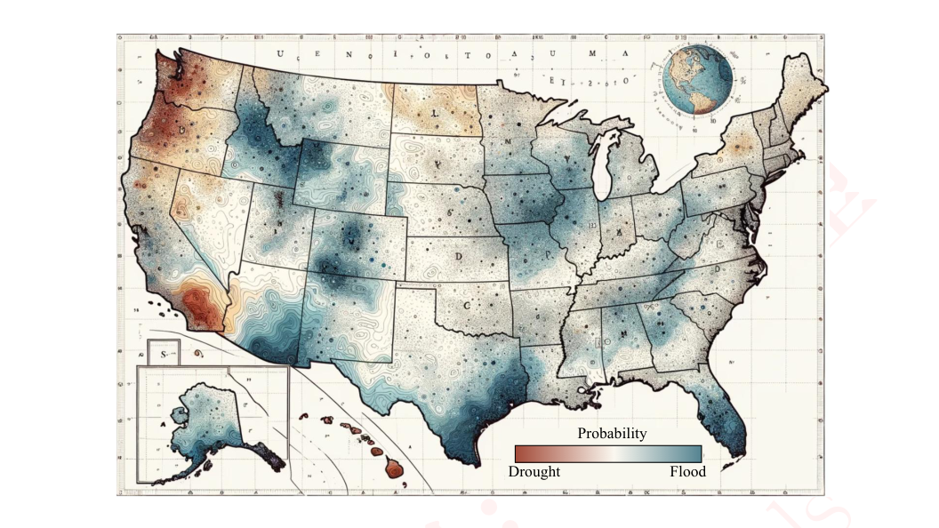
Figure 3: Probability statistics of extreme weather occurrences in American history.
图 3：美国历史上极端天气发生情况的概率统计。
图中文字对照（英文 → 中文）
Probability | 概率（色标：洪水／干旱发生概率） | Drought | 干旱
Flood | 洪涝 | <不可辨> | <推测：地图上方散布的装饰性字母（U E N O I O L T O A·S U M A 等），非真实单词>
The first principal component predominantly captured vital data related to evaporation, precipitation, potential evaporation, and surface heat flux, offering insights into the core dynamics of hydrological circulation and energy exchange processes. The second principal component primarily encompassed variables associated with radiation, surface temperature, surface mixed layer depth, surface heat flux, and longwave radiation downward, highlighting the pivotal role of surface energy balance and the complex mechanisms of radiation transfer. The third principal component was primarily informative about precipitation, soil moisture, and surface water layer moisture, elucidating the impact of precipitation and soil moisture on water resources and ecosystems. Lastly, the fourth principal component was chiefly concerned with variables linked to surface temperature, soil temperature, shortwave radiation downward, and longwave radiation downward, uncovering the seasonal and regional variations in surface temperature and energy transfer, with explained variances of 42.1%, 16.6%, 13.7%, and 10.6% respectively.
第一主成分主要捕获了与蒸发、降水、潜在蒸发及地表热通量相关的重要数据，为理解水文循环与能量交换过程的核心动力学提供了洞见。第二主成分主要涵盖与辐射、地表温度、地表混合层深度、地表热通量及向下长波辐射相关的变量，凸显了地表能量平衡的关键作用以及辐射传输的复杂机制。第三主成分主要反映降水、土壤湿度与地表水层湿度的信息，阐明了降水与土壤湿度对水资源和生态系统的影响。最后，第四主成分主要涉及与地表温度、土壤温度、向下短波辐射及向下长波辐射相关的变量，揭示了地表温度与能量传输的季节性和区域性变化，其解释方差分别为 42.1%、16.6%、13.7% 和 10.6%。
Subsequently, we utilized latitude and longitude data, the four environmental PCA factors, and population data as independent variables to model the losses due to extreme weather events. Leveraging the Improved Grey Prediction Model, we further forecasted the environmental factors for the next decade and predicted the resultant losses from extreme weather events for the same period. The predictive outcomes are illustrated in Figure 4.
随后，我们以经纬度数据、四个环境 PCA 因子及人口数据作为自变量，对极端天气事件造成的损失进行建模。借助改进的灰色预测模型，我们进一步预测了未来十年的环境因子，并预测了同期极端天气事件导致的损失。预测结果如图 4 所示。
Following this, based on our proposed humanitarian risk-based insurance model, we evaluated the feasibility of undertaking insurance coverage.
在此基础上，基于我们提出的人道主义风险导向保险模型，我们评估了承保的可行性。
The results of our model are presented in the accompanying Table 2, demonstrating the practical application and effectiveness of our approach in assessing insurance strategies in the context of extreme weather events.
模型结果列于随附的表 2 中，展示了我们的方法在极端天气事件背景下评估保险策略的实际应用与有效性。
We segmented the United States into three distinct insurance strategy categories based on demographic, economic, and environmental risk factors. These categories were High Risk, Medium Risk, and Low Risk, each tailored to the specific needs and characteristics of various states.
我们依据人口、经济与环境风险因素，将美国划分为三类不同的保险策略类别。这三类分别为高风险、中风险与低风险，各自针对不同州的具体需求与特征而设计。
1. High Risk Strategy This strategy is designed for states with dense populations, robust economies,
1. 高风险策略 该策略面向人口密集、经济强劲、
— 原文第 12 页 —
Extreme Weather Events and Hypothetical Insurance Industry Performance in the USA (2000-2034)
美国极端天气事件与假设保险业表现（2000-2034）
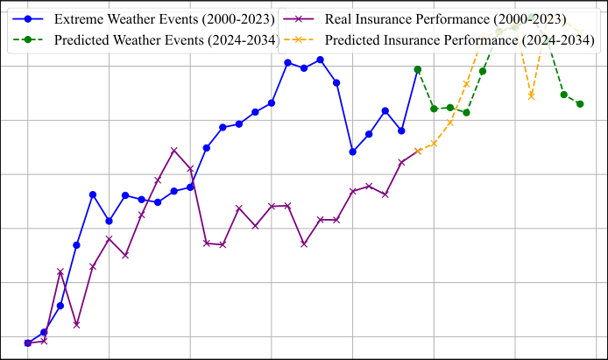
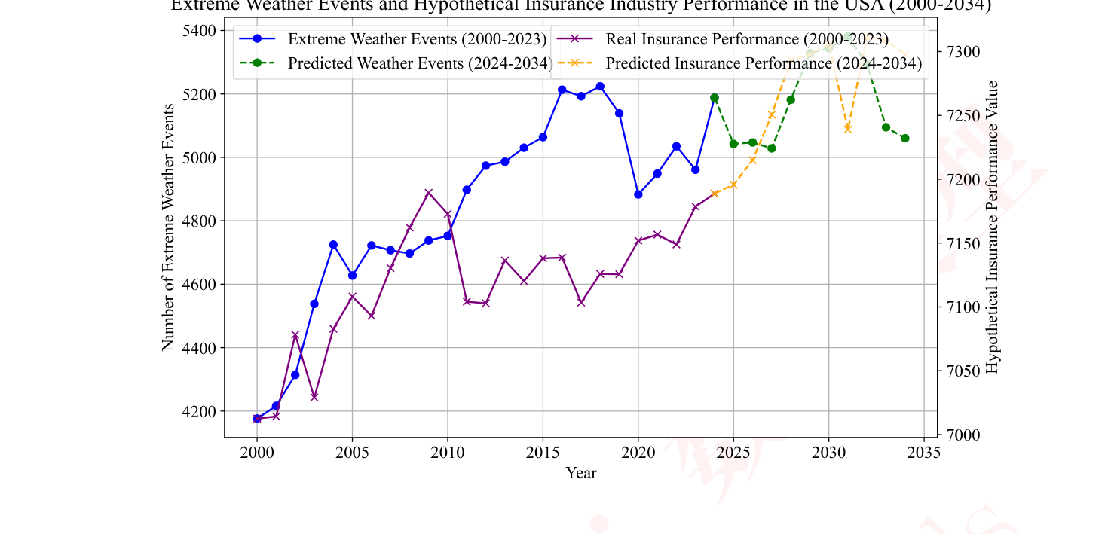
Figure 4: Future extreme weather and predictions for the insurance industry.
图 4：未来极端天气及对保险业的预测。
图中文字对照（英文 → 中文）
Extreme Weather Events (2000-2023) | 极端天气事件（2000—2023） | Predicted Weather Events (2024-2034) | 预测极端天气事件（2024—2034）
Real Insurance Performance (2000-2023) | 实际保险表现（2000—2023） | Predicted Insurance Performance (2024-2034) | 预测保险表现（2024—2034）
Table 2: Insurance Amount Forecast by State with Fluctuations for 2023-2034
表 2：2023-2034 年各州保险金额预测及波动
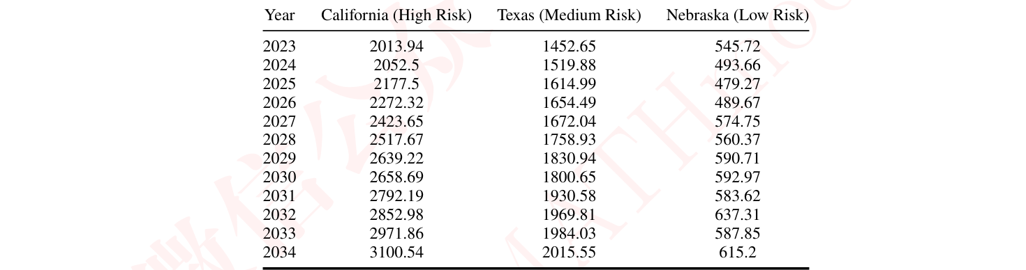
and a high frequency of extreme weather events. Such states require the highest level of insurance coverage to mitigate the substantial risks they face. For instance, California, characterized by its large population and strong economy, frequently experiences wildfires, making it a prime candidate for the High Risk strategy.
且极端天气事件发生频率较高的州。此类州需要最高水平的保险覆盖，以缓释其面临的重大风险。例如，加利福尼亚州人口众多、经济发达，且频繁发生野火，因而成为高风险策略的首要适用对象。
2. Medium Risk Strategy States falling under this category have moderate population sizes and economic scales, or they experience a moderate frequency of extreme weather events. Texas, for example, with its significant population and economic strength, faces moderate risks, such as occasional hurricanes. Similarly, Nebraska, with a moderate population and economic size, also experiences moderate weather risks, making both states suitable for the Medium Risk strategy.
2. 中等风险策略 归入此类别的州具有中等的人口规模与经济规模，或经历中等频率的极端天气事件。例如，得克萨斯州凭借其庞大的人口与经济实力，面临中等程度的风险，如偶发的飓风。同样，内布拉斯加州的人口与经济规模中等，也经历中等程度的天气风险，因此这两个州都适合采用中等风险策略。
3. Low Risk Strategy The Low Risk strategy is applicable to states with smaller populations, lower economic scales, and fewer occurrences of extreme weather events. Vermont, for example, with its smaller population and economic size, coupled with low risk of extreme weather events, is an ideal candidate for this strategy.
3. 低风险策略 低风险策略适用于人口较少、经济规模较低、极端天气事件发生次数较少的州。例如，佛蒙特州人口与经济规模较小，且极端天气事件风险较低，是该策略的理想候选对象。
— 原文第 13 页 —
3.7.3 Compare with North America and Asia.
与北美和亚洲的比较。
We conducted a comparative analysis of insurance strategies between Asia and North America. By adapting the MGWR (Multiscale Geographically Weighted Regression) model with modified latitude and longitude information along with corresponding population data, we derived the respective insurance strategies for countries in Asia. The specific strategies are outlined in Table 3.
我们对亚洲与北美洲之间的保险策略进行了对比分析。通过调整 MGWR（多尺度地理加权回归）模型的经纬度信息并配以相应的人口数据，我们推导出了亚洲各国的相应保险策略。具体策略列于表 3。
In this study, we aimed to evaluate the suitability of insurance strategies in response to varying demographic, economic, and environmental factors in both regions. The MGWR model allowed us to capture the spatial heterogeneity and adapt insurance coverage accordingly.
在本研究中，我们旨在评估保险策略在两个地区不同人口、经济与环境因素下的适用性。MGWR 模型使我们能够捕捉空间异质性，并据此调整保险覆盖范围。
Table 3: Insurance Amount Forecast by Asian Country with Fluctuations for 2024-2034
表 3：2024—2034 年亚洲各国保险金额预测及波动
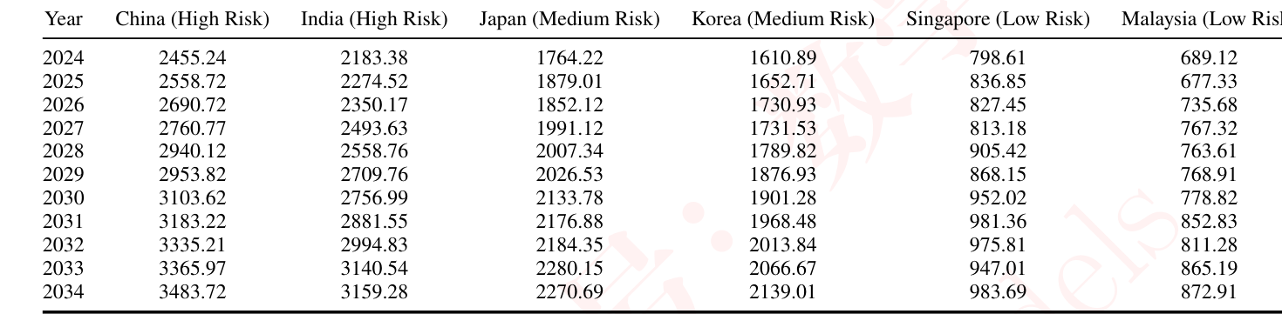
Based on the model predictions for Asia and North America, it is evident that Asia exhibits a greater degree of variability in its insurance strategies compared to North America, with geographical factors playing a significant role in the divergence between the two regions. The vast expanse of Asia, with its diverse geography and climate, subjects its countries to a wide array of natural disaster risks, including earthquakes, typhoons, and floods. Consequently, insurance strategies in Asian nations must be more diversified to accommodate these varied risks. In contrast, the United States, situated in a relatively stable geographical zone, may have more targeted insurance strategies for specific types of risks, such as natural disasters. Environmental factors also influence insurance strategies in both regions. Asian countries face distinct environmental challenges, including climate change, pollution, and resource scarcity, which could lead to an increased demand for specific environmental insurance products.
基于对亚洲与北美洲的模型预测，可以明显看出，与北美洲相比，亚洲的保险策略呈现出更大程度的差异性，而地理因素在两个地区的分化中起着重要作用。亚洲幅员辽阔，地理与气候多样，使其各国面临多种自然灾害风险，包括地震、台风与洪水。因此，亚洲各国的保险策略必须更加多样化，以适应这些不同的风险。相比之下，位于相对稳定地理区域的美国，可能针对特定类型的风险（如自然灾害）制定了更具针对性的保险策略。环境因素同样影响两个地区的保险策略。亚洲国家面临独特的环境挑战，包括气候变化、污染与资源短缺，这可能导致对特定环境保险产品的需求增加。
4 Community Building Protection Strategies
4 社区建筑保护策略
As previously mentioned, we have categorized different cities into three risk zones. However, in the event of significant natural disasters or exceptionally low risk in certain areas, insurance coverage
如前所述，我们已将不同城市划分为三个风险区。然而，在发生重大自然灾害或某些地区风险极低的情况下，保险覆盖
2
— 原文第 14 页 —
4.1 Community Protection Model
4.1 社区保护模型
Our goal is to minimize risk 𝐷_{𝑖}and cost 𝐶_{𝑖}. Risk can be defined as:
我们的目标是最小化风险 𝐷_{𝑖} 与成本 𝐶_{𝑖}。风险可定义为：
The cost 𝐶_{𝑖}is given by:
成本 𝐶_{𝑖} 由下式给出：
Our objective is to minimize the following loss function:
我们的目标是最小化如下损失函数：
Here, 𝜆represents the trade-off coefficient between risk and cost.
此处，𝜆 表示风险与成本之间的权衡系数。
This protection model allows community leaders to determine the level of protective measures based on their specific circumstances and needs. Adjusting 𝑃_{𝑖}enables communities to make decisions considering both risk and economic factors.
该保护模型使社区领导者能够根据其具体情况与需求确定防护措施的水平。调整 𝑃_{𝑖} 使社区能够在同时考虑风险与经济因素的基础上作出决策。
4.2 Property Owner Strategies
4.2 财产所有者策略
For property owners, we utilize the Improved Entropy Weight Method to determine the Humanitarian Adjustment Coefficient (HIC, as shown in Equation 7). Specifically, our modeling process is as follows:
对于财产所有者，我们采用改进熵权法确定人道主义调整系数（HIC，如式 (7) 所示）。具体而言，我们的建模过程如下：
4.2.1 Data Normalization
数据归一化
Firstly, we normalize the collected socio-economic factor (SEF) data to eliminate scale differences. These data encompass 12 resident indicators, including population size, per capita GDP, and residents’ educational attainment, among others. The normalized value 𝑆𝐸𝐹′_{𝑖𝑗}is calculated as:
首先，我们对收集到的社会经济因子（SEF）数据进行归一化，以消除量纲差异。这些数据涵盖 12 项居民指标，包括人口规模、人均 GDP 与居民受教育程度等。归一化值 𝑆𝐸𝐹′_{𝑖𝑗} 的计算方式为：
max(𝑆𝐸𝐹_{𝑗}) are the minimum and maximum values of the 𝑗-th factor across all locations.
max(𝑆𝐸𝐹_{𝑗}) 分别为第 𝑗 个因子在所有地点中的最小值与最大值。
2
— 原文第 15 页 —
4.2.2 Entropy Calculation
熵值计算
𝑆𝐸𝐹′
𝑖𝑗where 𝑝_{𝑖𝑗}=_{𝑘𝑗}is the proportion of the 𝑗-th factor at the 𝑖-th location, and 𝑛is the total number Í_{𝑛} 𝑘=1 𝑆𝐸𝐹′of locations.
𝑖𝑗其中 𝑝_{𝑖𝑗}=_{𝑘𝑗} 为第 𝑗 个因子在第 𝑖 个地点的占比，而 𝑛 为总数 Í_{𝑛}𝑘=1 𝑆𝐸𝐹′地点数。
4.2.3 Weight Calculation
权重计算
Determine the weights 𝑤_{𝑗}for each indicator based on their entropy values:
根据各指标的熵值确定其权重 𝑤_{𝑗}：
4.2.4 Weighted Average
加权平均
Construction of the 𝑔Function
𝑔函数的构建
4.2.5
Assuming the 𝑔function is linear, it can be expressed as:
假设𝑔函数为线性，则可表示为：
4.2.6 Model Training and Validation
模型训练与验证
Train the 𝑔function using historical data by minimizing the difference between actual and predicted premiums to determine the values of 𝑎and 𝑏.
利用历史数据训练𝑔函数，通过最小化实际保费与预测保费之间的差异，确定𝑎与𝑏的取值。
4.3 Solution for Property Owners and Community Models
4.3 面向财产所有者与社区模型的求解
4.3.1 Strategies Implemented by the Community
社区实施的策略
As mentioned earlier, the strategies adopted by the community essentially constitute a multiobjective optimization problem involving the level of protective measures, denoted as 𝑃_{𝑖}, risk denoted
如前所述，社区所采取的策略本质上构成一个多目标优化问题，涉及防护措施水平（记为𝑃_{𝑖}）、风险（记为
2
— 原文第 16 页 —
weather conditions, these three metrics exhibit a positive correlation. The greater the potential loss that may arise from risks, the higher the cost should be for the community’s investment in protective measures. An approximate protective level of 70% is required in relation to the potential losses, with associated costs amounting to around 30%.
天气条件下，这三项指标呈现正相关关系。风险可能造成的潜在损失越大，社区在防护措施上的投入成本就应越高。针对潜在损失，大约需要70%的防护水平，相应成本约为30%。
Fictitious Protective Measures, Risk, and Cost Across US States
美国各州的虚拟防护措施、风险与成本
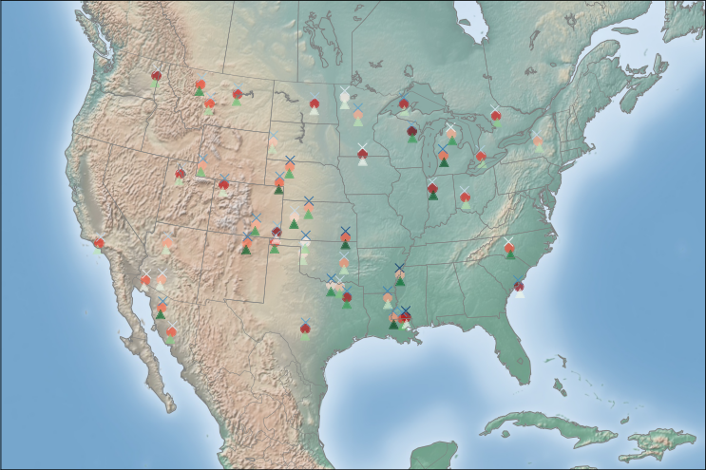
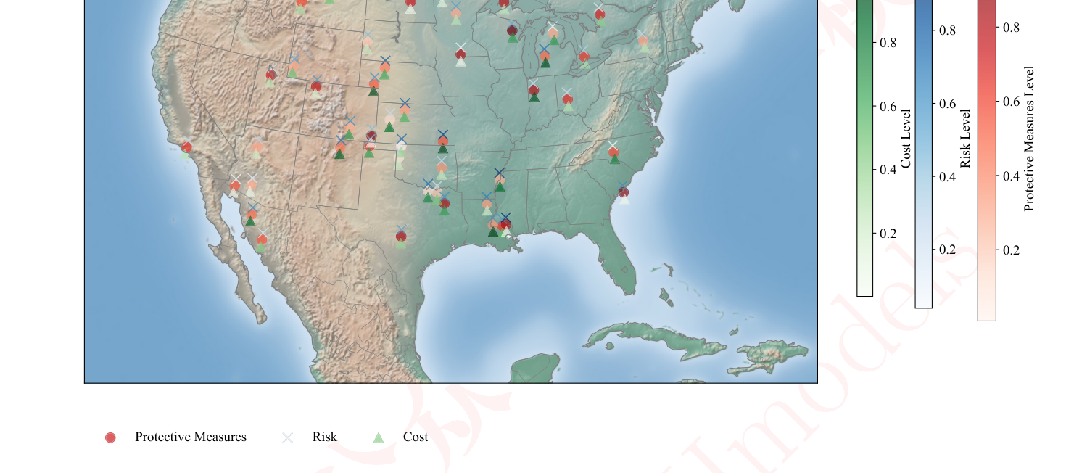
Figure 5: Visualization of Community Protection Level, Extreme Weather Risks, and Costs.
图 5：社区防护水平、极端天气风险与成本的数据可视化。
4.3.2 Strategies Employed by Property Owners
财产所有者采取的策略
We utilized the entropy weighting method to model healthcare quality, population size, GDP per capita, and education levels. The results of our model are presented in Table 4.
我们采用熵权法对医疗质量、人口规模、人均GDP与教育水平进行建模。模型结果见表 4。
Table 4: Entropy Weight Method Results for Socio-economic Indicators
表 4：社会经济指标的熵权法结果
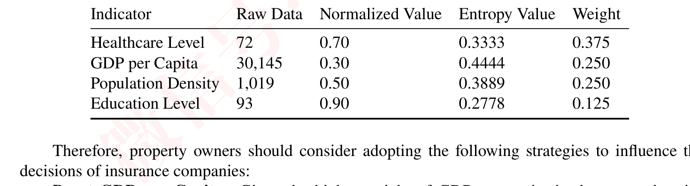
Boost GDP per Capita: Given the higher weight of GDP per capita in the comprehensive assessment of property losses (0.444), property owners can reduce insurance costs by enhancing the region’s economic development. This may involve promoting business and industrial growth, attracting investments, and increasing employment rates to mitigate potential property losses.
提升人均GDP：鉴于人均GDP在财产损失综合评价中的权重较高（0.444），财产所有者可通过提升该地区的经济发展水平来降低保险成本。这可能包括推动商业与工业增长、吸引投资以及提高就业率，从而减轻潜在的财产损失。
— 原文第 17 页 —
Control Population Density: Population density also holds considerable importance in decisionmaking (weight of 0.389). Property owners can take measures to control or strategically plan population density within the region to lower insurance costs. This could include adjustments to urban planning and land-use policies to prevent excessive population density.
控制人口密度：人口密度在决策中同样具有相当的重要性（权重为0.389）。财产所有者可采取措施控制或战略性规划区域内的人口密度，以降低保险成本。这可包括调整城市规划与土地利用政策，以防止人口密度过高。
Enhance Healthcare Quality: Improving healthcare quality is crucial for reducing casualties during disasters, which is integral to insurance companies’ risk assessments. Property owners can invest in healthcare facilities and healthcare infrastructure to elevate the region’s healthcare standards, thus decreasing potential property losses.
提升医疗质量：改善医疗质量对于减少灾害期间的人员伤亡至关重要，而这是保险公司风险评估中不可或缺的组成部分。财产所有者可投资于医疗设施与医疗基础设施，以提升该地区的医疗水平，从而减少潜在的财产损失。
Support Educational Development: Despite its relatively lower weight (0.278), education level remains a significant factor affecting long-term regional development and residents’ quality of life. Property owners can support educational initiatives and advocate for improved education levels to enhance overall quality within the region, subsequently reducing risks and insurance costs.
支持教育发展：尽管权重相对较低（0.278），教育水平仍是影响区域长期发展与居民生活质量的重要因素。财产所有者可支持教育举措并倡导提升教育水平，以增强区域整体素质，进而降低风险与保险成本。
By implementing these strategies, property owners can influence risk factors within the region to some extent, thereby reducing the potential for higher insurance costs in insurance company decisions, while concurrently elevating the region’s overall development level.
通过实施上述策略，财产所有者可在一定程度上影响区域内的风险因素，从而降低保险公司决策中保险成本上升的可能性，同时提升区域的整体发展水平。
4.3.3 The Final Impact of Communities and Property Owners
社区与财产所有者的最终影响
Losses in North America Under Different Interventions
不同干预措施下的北美损失
Losses in Asia Under Different Interventions
不同干预措施下的亚洲损失
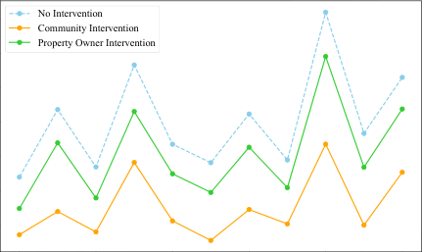
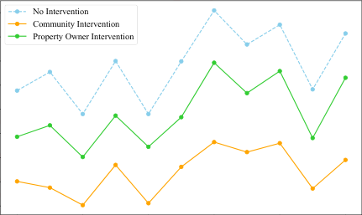
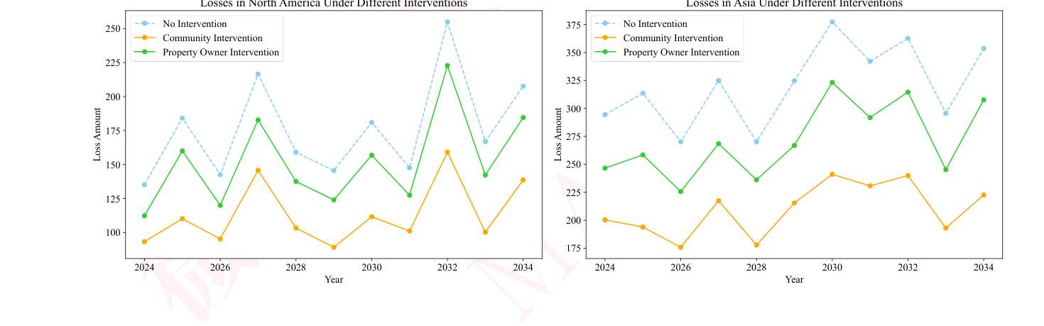
Figure 6: depict the potential reduction in property loss achievable through the efforts of both communities and property owners during extreme weather conditions in North America and Asia.
图 6：展示在北美与亚洲的极端天气条件下，社区与财产所有者共同努力所能实现的财产损失潜在削减。
图中文字对照（英文 → 中文）
No Intervention | 不干预 | Community Intervention | 社区干预
Property Owner Intervention | 业主干预
The figure in Figure 6 presents property loss scenarios in North America and Asia under different intervention measures from 2024 to 2034. These interventions include ”No Intervention,” ”Community Intervention,” and ”Property Owner Intervention.”
图 6 呈现了 2024 至 2034 年北美与亚洲在不同干预措施下的财产损失情景。这些干预措施包括“无干预”“社区干预”与“财产所有者干预”。
Analysis of Property Loss in North America:
北美财产损失分析：
In North America, we can observe the impact of three different intervention levels on property losses. Under ”No Intervention,” the loss amount increases from 100 units in 2024 to 250 units in 2034. This suggests that without any measures, extreme weather events may lead to a significant increase in property losses over time.
在北美，我们可以观察到三种不同干预水平对财产损失的影响。在“无干预”情形下，损失金额从 2024 年的 100 个单位上升至 2034 年的 250 个单位。这表明，在没有任何措施的情况下，极端天气事件可能随时间推移导致财产损失显著增加。
When ”Community Intervention” is implemented, the loss amount is 125 units in 2024, increasing to 275 units by 2034. This indicates that community-level intervention measures such as infrastructure development, emergency preparedness, and community education can slow down the growth of property losses.
当实施“社区干预”时，2024 年损失金额为 125 个单位，到 2034 年增至 275 个单位。这表明社区层面的干预措施，例如基础设施建设、应急准备与社区教育，可以减缓财产损失的增长。
— 原文第 18 页 —
”Property Owner Intervention” further reduces losses, decreasing from 150 units in 2024 to 225 units in 2034.
“财产所有者干预”进一步降低损失，从 2024 年的 150 个单位降至 2034 年的 225 个单位。
This implies that measures taken by property owners, such as improving the weather resistance of buildings, purchasing appropriate insurance, and implementing risk management strategies, can more effectively reduce property losses.
这意味着财产所有者采取的措施，如提高建筑物的耐候性、购买适当的保险以及实施风险管理策略，能够更有效地降低财产损失。
Analysis of Property Loss in Asia:
亚洲财产损失分析：
In Asia, property losses under ”No Intervention” increase from 175 units in 2024 to 375 units in 2034. This indicates that the rate of property loss growth is faster in Asia compared to North America in the absence of intervention.
在亚洲，“无干预”情形下的财产损失从 2024 年的 175 个单位增至 2034 年的 375 个单位。这表明在缺乏干预的情况下，亚洲的财产损失增长速度比北美更快。
”Community Intervention” has a more significant effect in Asia, reducing the loss amount from 200 units in 2024 to 325 units in 2034. This may suggest that community intervention measures in the Asian region, such as collective disaster preparedness and resource sharing, are more effective in reducing losses.
“社区干预”在亚洲的效果更为显著，使损失金额从 2024 年的 200 个单位降至 2034 年的 325 个单位。这可能表明，亚洲地区的社区干预措施，例如集体灾前准备与资源共享，在减少损失方面更为有效。
”Property Owner Intervention” is also effective in Asia, with the loss amount decreasing from 225 units in 2024 to 350 units in 2034. This shows that despite the faster rate of loss growth in the Asian region, efforts by property owners, such as investing in disaster-resistant facilities and risk diversification, can still significantly reduce losses.
“业主干预”在亚洲同样有效，损失额从 2024 年的 225 个单位下降至 2034 年的 350 个单位。这表明，尽管亚洲地区损失的增长速度更快，但业主的努力，例如投资于抗灾设施与风险分散，仍能显著减少损失。
In conclusion, it can be inferred that interventions by both communities and property owners are crucial for reducing property losses during extreme weather events.
总之，可以推断，社区与业主双方的干预对于减少极端天气事件期间的财产损失至关重要。
- In North America, both community intervention and property owner intervention effectively slow down the growth of losses, with property owner intervention being more effective in reducing losses.
- 在北美，社区干预与业主干预均能有效减缓损失的增长，其中业主干预在减少损失方面更为有效。
- In Asia, community intervention shows a more pronounced effect, possibly due to the higher risk of extreme weather events in the region, necessitating closer community cooperation and collective action.
- 在亚洲，社区干预的效果更为显著，这可能是因为该地区极端天气事件的风险更高，因而需要更紧密的社区合作与集体行动。
- Over time, whether in North America or Asia, regions implementing intervention measures demonstrate a deceleration in the rate of loss growth, emphasizing the importance of long-term planning and sustained efforts.
- 随着时间推移，无论在北美还是亚洲，实施干预措施的地区其损失增长率均呈现放缓，这凸显了长期规划与持续努力的重要性。
To further reduce losses, the following recommendations are suggested:
为进一步减少损失，建议如下：
For North America: Continue to strengthen community and property owner intervention measures, especially in improving building weather resistance and risk management strategies.
对于北美：继续加强社区与业主干预措施，尤其是提升建筑物的耐候性与风险管理策略。
For Asia: Given the faster rate of loss growth, prioritize community-level interventions while encouraging property owners to adopt more proactive disaster mitigation measures.
对于亚洲：鉴于损失增长速度更快，应优先考虑社区层面的干预，同时鼓励业主采取更为主动的减灾措施。
5 Preservation of Historical Landmarks
5 历史地标的保护
In this particular problem, we continue to employ a Multi-Scale Spatial Model to characterize the features of buildings in relation to the damage caused by natural disasters. Simultaneously, we extend
在本问题中，我们继续采用多尺度空间模型来刻画建筑物特征与自然灾害所致损害之间的关系。同时，我们扩展
2
— 原文第 19 页 —
5.1 Construction of Model
5.1 模型构建
For modeling the preservation of buildings, we use a multi-criteria decision model. Such models can combine multiple factors to assess the significance of a building in a more comprehensive way.
为对建筑物的保护进行建模，我们采用多准则决策模型。此类模型能够综合多个因素，从而更全面地评估一座建筑物的意义。
We collected data on buildings in the U.S. that have experienced extreme weather and have historical and cultural value in four dimensions: cultural, historical, economic, and community. Preprocessing of the features using Min-Max normalization yielded cultural, historical, economic, and community importance scores for each building.
我们收集了美国境内曾经历极端天气且具有历史文化价值的建筑物数据，涵盖文化、历史、经济与社区四个维度。采用 Min-Max 归一化对特征进行预处理，得到每座建筑物的文化、历史、经济与社区重要性得分。
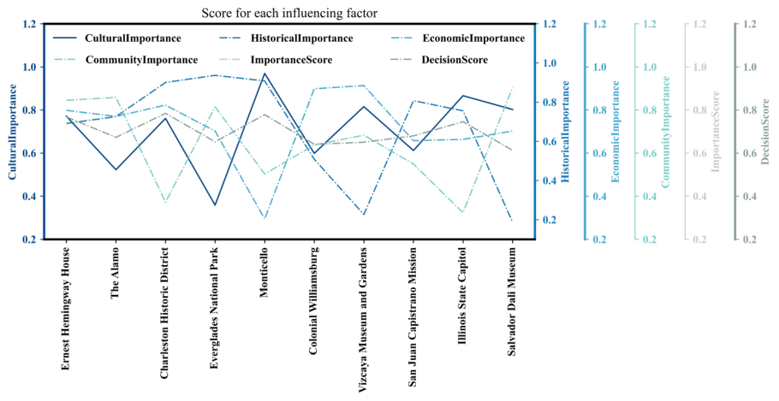
Figure 7: Score for each influencing factor
图 7：各影响因素的得分
图中文字对照（英文 → 中文）
Score for each influencing factor | 各影响因素的得分 | CulturalImportance | 文化重要性（图例／纵轴名）
HistoricalImportance | 历史重要性（图例／纵轴名） | EconomicImportance | 经济重要性（图例／纵轴名）
CommunityImportance | 社区重要性（图例／纵轴名） | ImportanceScore | 重要性得分（图例／纵轴名）
DecisionScore | 决策得分（图例／纵轴名） | Ernest Hemingway House | 海明威故居
The Alamo | 阿拉莫要塞 | Charleston Historic District | 查尔斯顿历史街区
Everglades National Park | 大沼泽地国家公园 | Monticello | 蒙蒂塞洛（杰斐逊故居）
Colonial Williamsburg | 殖民地威廉斯堡 | Vizcaya Museum and Gardens | 维兹卡亚博物馆与花园
San Juan Capistrano Mission | 圣胡安·卡皮斯特拉诺传教站 | Illinois State Capitol | 伊利诺伊州议会大厦
Salvador Dali Museum | 萨尔瓦多·达利博物馆
As can be seen from the figure, Ernest Hemingway House scores highly on cultural importance, which may reflect its value as a literary heritage site and its significant relevance to Hemingway’s personal life and work. However, it scores relatively low on community significance, which may mean that it has less impact on the daily life of the local community. In contrast to the Illinois State Capitol, which had a higher rating on historical significance, perhaps its historical connection to state government, it had a lower rating on economic significance, which may indicate that it does not have a strong role as a tourist attraction or center of economic activity.
从图中可以看出，Ernest Hemingway House 在文化重要性上得分很高，这可能反映了其作为文学遗产的价值，以及其与海明威个人生活与创作的密切关联。然而，其在社区意义方面得分相对较低，这可能意味着它对当地社区日常生活的影响较小。与之相对，Illinois State Capitol 在历史意义方面评分较高，这或许与其同州政府的历史联系有关；但其在经济意义方面评分较低，这可能表明它作为旅游景点或经济活动中心的作用并不突出。
Regression (MGWR) model, incorporating architectural factors, follow these steps:
回归（MGWR）模型，并纳入建筑因素，具体步骤如下：
2
— 原文第 20 页 —
5.2.1 Define Variables
定义变量
Identify the dependent variable (required protection level, categorized into three levels to align with the previous risk levels) and independent variables, including architectural factors such as building size, age, material cost, and structural complexity. Include the geographic coordinates (latitude and longitude) of the buildings.
确定因变量（所需保护水平，划分为三个等级以与前述风险等级相对应）与自变量，自变量包括建筑规模、建筑年龄、材料成本与结构复杂度等建筑因素。纳入建筑物的地理坐标（经度与纬度）。
5.2.2 Data Collection
数据收集
Gather data relevant to the buildings and their surrounding areas, including architectural details, historical significance, visitor statistics, and potential risks associated with their locations.
收集与建筑物及其周边地区相关的数据，包括建筑细节、历史意义、游客统计数据以及与其所在位置相关的潜在风险。
5.2.3 Construct MGWR Model
构建 MGWR 模型
Formulate an MGWR model for each location, utilizing a local regression equation:
针对每个位置构建 MGWR 模型，采用局部回归方程：
Here, 𝑦_{𝑖}represents the dependent variable for location 𝑖, (𝑢_{𝑖}, 𝑣_{𝑖}) denotes the geographic coordinates of the buildings, 𝑋_{𝑖𝑘}stands for the independent variables (architectural factors), 𝛽_{𝑘}(𝑢_{𝑖}, 𝑣_{𝑖}) are locationspecific coefficients, and 𝜖_{𝑖}represents the error term. Calibrate the MGWR model using statistical software to estimate the 𝛽coefficients for the buildings.
其中，𝑦_{𝑖} 表示位置 𝑖 的因变量，(𝑢_{𝑖}, 𝑣_{𝑖}) 表示建筑物的地理坐标，𝑋_{𝑖𝑘} 表示自变量（建筑因素），𝛽_{𝑘}(𝑢_{𝑖}, 𝑣_{𝑖}) 为位置特定系数，𝜖_{𝑖} 表示误差项。利用统计软件标定 MGWR 模型，以估计建筑物的 𝛽 系数。
5.3 Preserving Historic Architecture: The Case of the Statue of Liberty
5.3 保护历史建筑：自由女神像案例

Figure 8: Using the Insurance Industry to Protect the Statue of Liberty
图 8：利用保险业保护自由女神像
图中文字对照（英文 → 中文）
INSURANCE | 保险
The Statue of Liberty, a symbol of freedom and democracy, is located on Liberty Island in New York Harbor at the coordinates 40°41’21.30”N, 74°02’40.20”W. This monumental sculpture, a gift from France to the United States, was dedicated on October 28, 1886, to celebrate the centennial of
自由女神像是自由与民主的象征，位于纽约港的自由岛上，坐标为 40°41’21.30”N, 74°02’40.20”W。这座纪念性雕塑是法国赠予美国的礼物，于 1886 年 10 月 28 日落成，以庆祝
2
— 原文第 21 页 —
Weighing 225 tons, the Statue of Liberty is a hollow copper structure supported by a steel framework, and it has become an enduring symbol of the United States, welcoming immigrants and embodying the nation’s values of liberty and opportunity.
自由女神像重 225 吨，为一座由钢框架支撑的空心铜结构，已成为美国持久的象征，迎接移民的到来，并体现着美国自由与机会的价值观。
We conducted spatial regression using the MGWR model for the Statue of Liberty, and the average regression coefficient distribution is shown in Figure 9. The regression results indicate the following:
我们采用 MGWR 模型对自由女神像进行了空间回归，平均回归系数分布如图 9 所示。回归结果表明：
MGWR Regression Results for the Statue of Liberty
自由女神像的 MGWR 回归结果
Building Age
建筑年龄
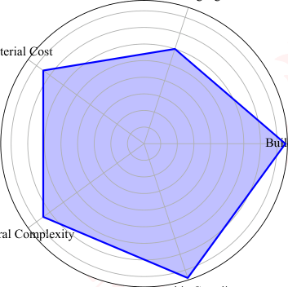
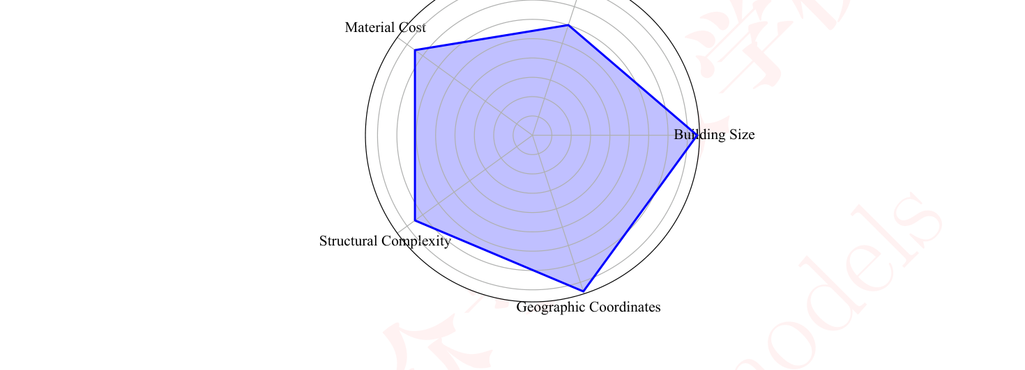
Figure 9: The distribution of the regression coefficients for the MGWR model
图 9：MGWR 模型回归系数的分布
图中文字对照（英文 → 中文）
terial Cost | 材料成本（左缘被裁，应为 Material Cost） | Buil | 建筑类指标（右缘被裁，疑为 Building…）
ral Complexity | 复杂度（左下被裁，疑为 Operational Complexity 运营复杂度） | <不可辨> | <推测：顶部第 2 个类目名完全在画面外>
• Building Size: Due to the enormous size of the Statue of Liberty, extensive maintenance and protection work is required, necessitating a high level of protection. The coefficient for building size ranges from 0.7 to 1.0.
• 建筑规模：由于自由女神像体量巨大，需要进行大量的维护与保护工作，因此要求较高的保护等级。建筑规模系数取值范围为 0.7 至 1.0。
• Building Age: The Statue of Liberty has a relatively old age, with many years of history, requiring a moderate level of protection. The coefficient for building age ranges from 0.5 to 0.7.
• 建筑年代：自由女神像建成年代相对较早，历史悠久，需要中等程度的保护等级。建筑年代系数取值范围为 0.5 至 0.7。
• Material Cost: The Statue of Liberty uses relatively expensive building materials, demanding high-quality maintenance and repair. The coefficient for material cost ranges from 0.5 to 1.0.
• 材料成本：自由女神像使用了造价相对高昂的建筑材料，需要高质量的维护与修缮。材料成本系数取值范围为 0.5 至 1.0。
• Structural Complexity: The Statue of Liberty’s structure is relatively complex, necessitating specialized knowledge and skills for maintenance and protection. The coefficient for structural complexity ranges from 0.5 to 1.0.
• 结构复杂度：自由女神像的结构相对复杂，其维护与保护需要专业知识和技能。结构复杂度系数取值范围为 0.5 至 1.0。
• Geographic Coordinates: The Statue of Liberty is located in a geographically high-risk area, such as a waterfront or multiple hazard zones, requiring a high level of protection. The coefficient for geographic coordinates ranges from 0.7 to 1.0.
• 地理坐标：自由女神像位于地理高风险区域，例如滨水地带或多重灾害区，因此要求较高的保护等级。地理坐标系数取值范围为 0.7 至 1.0。
To further refine the insurance pricing model under the consideration of risk, it becomes evident that the Statue of Liberty necessitates the highest level of protection.
在考虑风险的前提下进一步细化保险定价模型后可以明显看出，自由女神像需要最高等级的保护。
— 原文第 22 页 —
5.4 A Letter to the Community
5.4 致社区的一封公开信
In order to better safeguard the Statue of Liberty, we have drafted a recommendation letter for the community. This letter includes future plans, a timeline, and a cost proposal, which can be found on the attached letterhead at the end of this document.
为更好地保护自由女神像，我们为社区起草了一封建议信。该信函包含未来规划、时间表与费用方案，可在本文末尾附带的信笺中查阅。
6 Senitivity Analysis
6 敏感性分析
In this section, we conduct a robustness check of our model. Given that our model involves relatively few parameters, with only some hyperparameters manually adjusted in the entropy weighting method, we perform an ablation study on these parameters. We adopt new weighted coefficients, and the relationship between insurance losses and community interventions is presented in Figure 10. We observe that despite changes in the model’s parameters, the trend of losses caused by extreme weather events continues to fluctuate and rise. Moreover, the beneficial impact of community interventions consistently exceeds that of individual property owners. This indicates that our model is sufficiently robust, demonstrating consistent performance under different parameter settings.
本节对模型进行稳健性检验。鉴于本模型涉及的参数相对较少，仅在熵权法中人工调整了部分超参数，我们针对这些参数开展了消融研究。我们采用新的权重系数，保险损失与社区干预之间的关系如图 10 所示。我们观察到，尽管模型参数发生变化，极端天气事件所造成的损失仍呈持续波动上升的趋势。此外，社区干预的有益影响始终大于单个财产所有者干预的有益影响。这表明本模型具有足够的稳健性，在不同参数设置下表现出稳定一致的性能。
Losses in North America Under Different Interventions
不同干预措施下北美洲的损失
Losses in Asia Under Different Interventions
不同干预措施下亚洲的损失
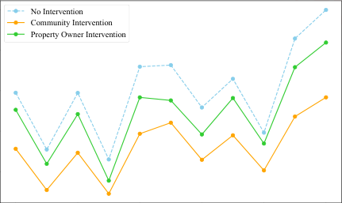
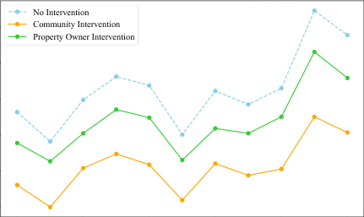
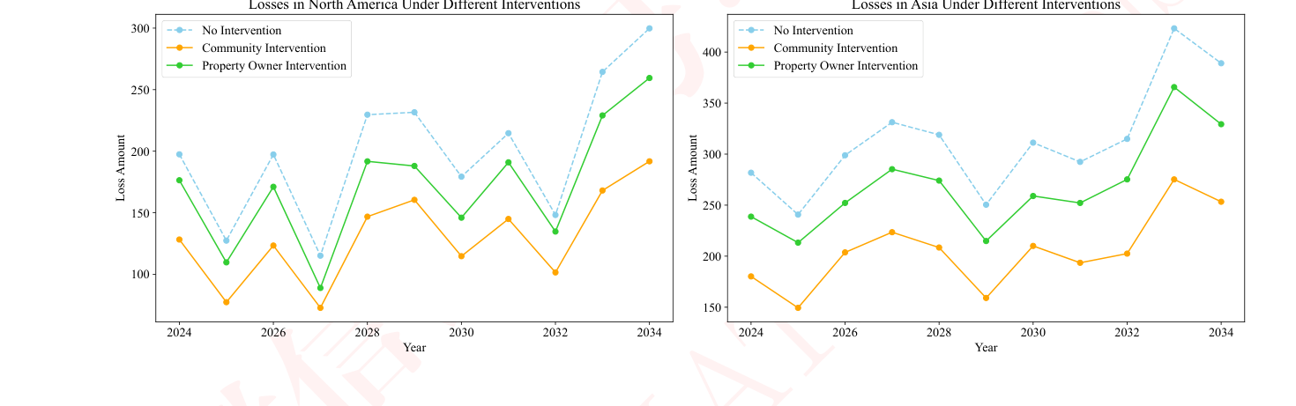
Figure 10: Results of the sensitivity analysis for the entropy weighting method
图 10：熵权法敏感性分析结果
图中文字对照（英文 → 中文）
No Intervention | 不干预 | Community Intervention | 社区干预
Property Owner Intervention | 业主干预
7 Strengths and Weaknesses
7 优缺点
7.1
predictions and providing insurance companies with a scientific tool for risk assessment.
预测，并为保险公司提供科学的风险评估工具。
• Risk and Profitability Balance: The risk-based insurance pricing strategy balances the longterm health of insurance companies with the financial burden on property owners, achieving a balance between social responsibility and economic efficiency through a humanitarian adjustment coefficient and a profitability adjustment factor.
• 风险与盈利的平衡：基于风险的保险定价策略在保险公司的长期健康运营与财产所有者承担的财务负担之间取得平衡，并通过人道主义调整系数与盈利性调整因子，实现社会责任与经济效率之间的均衡。
2
— 原文第 23 页 —
• Multi-Objective Optimization: The model employs a multi-objective optimization strategy to balance humanitarian impact (HI) and profitability (PR), aiding insurance companies in making comprehensive decisions in the face of extreme weather events.
• 多目标优化：模型采用多目标优化策略，在人道主义影响（HI）与盈利性（PR）之间取得平衡，帮助保险公司在极端天气事件面前作出综合性决策。
7.2 Weaknesses
7.2 薄弱之处
• Data Dependency: The model’s accuracy is highly dependent on the quality and completeness of the input data, which could be affected by biases or incompleteness.
• 数据依赖性：模型的准确性高度依赖输入数据的质量与完整性，而数据可能受到偏差或不完整的影响。
• Model Complexity: The MGWR model and associated multi-objective optimization algorithms are complex, requiring specialized knowledge and skills, potentially increasing the difficulty and cost of implementation.
• 模型复杂性：MGWR 模型及相关多目标优化算法较为复杂，需要专业知识和技能，可能增加实施的难度与成本。
7.3 Potential Future Applications
7.3 潜在的未来应用
• Risk Management in the Insurance Industry: The model can be applied to assess and manage risks associated with extreme weather events, optimizing insurance product design and pricing strategies.
• 保险业风险管理：该模型可用于评估与管理极端天气事件的相关风险，优化保险产品设计与定价策略。
• Urban Planning and Disaster Prevention: Planners can use the model to understand regional risk levels and develop appropriate building standards and disaster prevention measures.
• 城市规划与防灾减灾：规划者可利用该模型了解区域风险水平，并制定适宜的建筑标准与防灾措施。
• Policy Making and Resource Allocation: Governments and agencies can use the model’s predictive outcomes to formulate effective climate adaptation strategies, allocate resources judiciously, and enhance societal resilience to extreme weather events.
• 政策制定与资源配置：政府与相关机构可利用模型的预测结果制定有效的气候适应策略，合理配置资源，并增强社会对极端天气事件的韧性。
8 Conclusion
8 结论
In conclusion, the comprehensive analytical framework presented in this study offers a robust approach to addressing the challenges faced by the property insurance industry under extreme weather conditions. The integration of the Multi-Scale Geographically Weighted Regression (MGWR) model with risk-based insurance pricing strategies and multi-objective optimization techniques has demonstrated the potential to provide insurance companies with a more nuanced understanding of spatial risk patterns and to inform strategic decision-making. The model’s ability to balance humanitarian considerations with economic efficiency is a significant advancement in the field of insurance risk assessment.
综上所述，本研究提出的综合分析框架为应对极端天气条件下财产保险业所面临的挑战提供了稳健的途径。将多尺度地理加权回归（MGWR）模型与基于风险的保险定价策略及多目标优化技术相结合，已展现出为保险公司提供对空间风险格局更为细致的理解并支撑战略决策的潜力。该模型在人道主义考量与经济效率之间取得平衡的能力，是保险风险评估领域的一项重要进展。
Despite the model’s strengths, it is crucial to acknowledge its dependencies on accurate and comprehensive data, as well as the complexity of the underlying algorithms. Future research and policymakers, and communities in preparing for and mitigating the impacts of climate change. By leveraging this framework, society can take proactive steps towards building a more resilient future in the face of increasing environmental uncertainties.
尽管模型具有上述优势，但必须承认其依赖于准确而全面的数据，以及底层算法的复杂性。未来研究与政策制定者和社区为应对与减缓气候变化影响所做的准备。借助这一框架，社会可以采取主动措施，在日益增加的环境不确定性面前建设更具韧性的未来。
2
— 原文第 24 页 —
References
[1] CW Fraisse, NE Breuer, D Zierden, JG Bellow, J Paz, VE Cabrera, A Garcia y Garcia, KT Ingram, U Hatch, G Hoogenboom, et al. Agclimate: A climate forecast information system for agricultural risk management in the southeastern usa. Computers and electronics in agriculture, 53(1):13–27, 2006.
[2] Paul Hudson, Lars T De Ruig, Marco C De Ruiter, Onno J Kuik, WJ Wouter Botzen, Xavier Le Den, Magnus Persson, Anthony Benoist, and CN Nielsen. An assessment of best practices of extreme weather insurance and directions for a more resilient society. Environmental Hazards, 19(3):301–321, 2020.
[3] Paula Jarzabkowski, Konstantinos Chalkias, Daniel Clarke, Ekhosuehi Iyahen, Daniel Stadtmueller, and Astrid Zwick. Insurance for climate adaptation: Opportunities and limitations. 2019.
[4] Wolfgang Kron, Petra L¨ow, and Zbigniew W Kundzewicz. Changes in risk of extreme weather events in europe. Environmental Science & Policy, 100:74–83, 2019.
[5] Evan Mills. A global review of insurance industry responses to climate change. The Geneva Papers on Risk and Insurance-Issues and Practice, 34:323–359, 2009.
[6] Barry Sheehan, Martin Mullins, Darren Shannon, and Orla McCullagh. On the benefits of insurance and disaster risk management integration for improved climate-related natural catastrophe resilience. Environment Systems and Decisions, 43(4):639–648, 2023.
[7] Patrick Alexander Maria Vermeulen. Organizing product innovation in financial services: How banks and insurance companies organize their product innovation processes. [Nijmegen]: Nijmegen University Press, 2001.
[8] Jessica Weinkle. Experts, regulatory capture, and the “governor’s dilemma”: The politics of hurricane risk science and insurance. Regulation & Governance, 14(4):637–652, 2020.
AI Utilization Report
In this document, we have employed AI technology, specifically ChatGPT, to enhance various aspects of our content. The illustrations featured in this report were generated using this advanced AI tool, showcasing its capability in creating visually appealing and relevant images. Additionally, ChatGPT was instrumental in refining and polishing the language used throughout the text, ensuring
2
References
[1] CW Fraisse, NE Breuer, D Zierden, JG Bellow, J Paz, VE Cabrera, A Garcia y Garcia, KT Ingram, U Hatch, G Hoogenboom, et al. Agclimate: A climate forecast information system for agricultural risk management in the southeastern usa. Computers and electronics in agriculture, 53(1):13–27, 2006.
[2] Paul Hudson, Lars T De Ruig, Marco C De Ruiter, Onno J Kuik, WJ Wouter Botzen, Xavier Le Den, Magnus Persson, Anthony Benoist, and CN Nielsen. An assessment of best practices of extreme weather insurance and directions for a more resilient society. Environmental Hazards, 19(3):301–321, 2020.
[3] Paula Jarzabkowski, Konstantinos Chalkias, Daniel Clarke, Ekhosuehi Iyahen, Daniel Stadtmueller, and Astrid Zwick. Insurance for climate adaptation: Opportunities and limitations. 2019.
[4] Wolfgang Kron, Petra L¨ow, and Zbigniew W Kundzewicz. Changes in risk of extreme weather events in europe. Environmental Science & Policy, 100:74–83, 2019.
[5] Evan Mills. A global review of insurance industry responses to climate change. The Geneva Papers on Risk and Insurance-Issues and Practice, 34:323–359, 2009.
[6] Barry Sheehan, Martin Mullins, Darren Shannon, and Orla McCullagh. On the benefits of insurance and disaster risk management integration for improved climate-related natural catastrophe resilience. Environment Systems and Decisions, 43(4):639–648, 2023.
[7] Patrick Alexander Maria Vermeulen. Organizing product innovation in financial services: How banks and insurance companies organize their product innovation processes. [Nijmegen]: Nijmegen University Press, 2001.
[8] Jessica Weinkle. Experts, regulatory capture, and the “governor’s dilemma”: The politics of hurricane risk science and insurance. Regulation & Governance, 14(4):637–652, 2020.
AI Utilization Report
In this document, we have employed AI technology, specifically ChatGPT, to enhance various aspects of our content. The illustrations featured in this report were generated using this advanced AI tool, showcasing its capability in creating visually appealing and relevant images. Additionally, ChatGPT was instrumental in refining and polishing the language used throughout the text, ensuring
2
（全文完。公式与表格在原 PDF 中是矢量图形，未纳入本对照版；可按文中「原文第 N 页」标记翻到 2413552.pdf 对照查看。）

