2209466 英中对照版
2022 MCM Problem A · Optimal Power Distribution of a Cyclist
读法：黑字为原文，蓝字为译文，一段英文一段中文，上下对应；蓝字里的小字括号是该术语第一次出现时的英文原词。
术语表（按首次出现排序，18 条）
# | 英文 | 中文 | 说明：为什么容易译错
1 | Fatigue Physiological Model | 疲劳生理模型 | 本文两大主模型之一，描述平均输出功率与持续输出时间的关系
2 | power curve | 功率曲线 | 原文另有 power profile / power-time curve / power output curve 三种写法，均指同一物
3 | aerobic respiration | 有氧呼吸
4 | anaerobic respiration | 无氧呼吸
5 | Aerobic and Anaerobic Energy Fatigue Model | 有氧与无氧能量疲劳模型 | 由上面两个子模型合并而成
6 | ordinary least squares | 普通最小二乘法（OLS） | 用数据拟合模型参数的估计方法
7 | Single Objective Programming | 单目标规划 | 目标函数只有完赛时间一个
8 | decision variable | 决策变量 | 本文指骑行者在赛道各位置施加的功率
9 | constraints | 约束条件 | 骑手状态与赛道条件
10 | dynamic programming | 动态规划 | 求解功率分配最优策略的算法
11 | sensitivity analysis | 灵敏度分析 | 改变输入看结果变化幅度
12 | wind resistance | 风阻
13 | rolling resistance | 滚动阻力
14 | FTP | 功能性阈值功率（Functional Threshold Power） | 有氧供能的上限功率
15 | time trial | 个人计时赛 | 车手单独出发、按时间排名
16 | draft strategy | 跟骑策略 | 跟在队友身后减少风阻
17 | camber | 路拱（赛道横坡） | 赛道左右倾斜的角度
18 | insensitive | 不敏感的 | 结果对该因素变化不敏感＝该因素影响小

目录（Contents）
页码为原 PDF 页码，可按正文中的「— 原文第 N 页 —」定位。
1 引言（Introduction） 3
1.1 问题背景（Problem Background） 3
1.2 问题重述（Restatement of the Problem） 3
1.3 文献综述（Literature Review） 4
1.4 本文工作（Our Work） 4
2 模型假设与合理性说明（Assumptions and Justifications） 5
3 定义与符号说明（Definitions and Notations） 6
3.1 定义（Definitions） 6
3.2 符号说明（Notations） 6
4 自行车运动员疲劳生理模型（Cyclist’s Physiological Model of Fatigue） 6
4.1 模型建立（The Establishment of the Model） 7
4.2 结果与讨论（Result and Discussion） 8
5 最优个人功率分配模型（Optimal Individual Power Distribution Model） 10
5.1 数据处理（Data Processing） 10
5.2 模型建立（The Establishment of the Model） 11
5.3 模型求解（Solve the Model） 14
5.4 结果与分析（Results and Analysis） 14
6 灵敏度分析（Sensitivity Analysis） 17
6.1 天气与环境影响（Weather and Environmental Effects） 17
6.2 偏差影响（Deviation effects） 18
7 模型评价与进一步讨论（Model Evaluation and Further Discussion） 19
7.1 优点（Strengths） 19
7.2 缺点（Weaknesses） 19
7.3 模型推广（Model Extension） 20
8 结论（Conclusion） 21
男子精英个人计时赛策略指导（Men Elite Individual Time Trial Guidance） 22
参考文献（References） 24
附录（Appendix） 25

Optimal Power Distribution of a Cyclist
自行车手的最优功率分配
Bicycle road races have always been popular and competitive. For the cyclists, it is of vital importance to distribute the power properly on the course. In order to help riders distribute their limited energy reasonably, we established a model to simulate the rider's power output to find the optimal distribution of their power.
自行车公路赛历来广受欢迎，且竞争激烈。对车手而言，在赛道上合理地分配功率至关重要。为了帮助车手合理地分配有限的能量，我们建立了一个模拟车手功率输出的模型，以寻找其功率的最优分配方案。
Firstly, we established a Fatigue Physiological Model to characterize riders' power curve, which describes a rider's average power output as a function of sustained output time. From the perspective of aerobic respiration and anaerobic respiration, we fully consider the limitation of energy and the process of energy recovery, and establish Aerobic and Anaerobic Energy Fatigue Model. We fit the model to the obtained data using the ordinary least squares to verify the validity of the model, considering different types and genders of the riders. The power curves of different riders are provided, and the relationship between their features and model parameters was also explored. The specific results are shown in Figure 6 and its analysis.
首先，我们建立了疲劳生理模型（Fatigue Physiological Model）来刻画车手的功率曲线（power curve），该曲线将车手的平均功率输出描述为持续输出时间的函数。我们从有氧呼吸（aerobic respiration）与无氧呼吸（anaerobic respiration）的角度出发，充分考虑能量的限制与能量恢复过程，建立了有氧与无氧能量疲劳模型（Aerobic and Anaerobic Energy Fatigue Model）。我们采用普通最小二乘法（ordinary least squares）将模型拟合到所获得的数据，并考虑不同类别与性别的车手，以验证模型的有效性。给出了不同车手的功率曲线，并探讨了其特征与模型参数之间的关系。具体结果见图 6 及其分析。
Secondly, we establish an Optimal Individual Power Distribution Model to provide an optimal power allocation strategy, which describes the relationship between the power applied by the rider and the position on the track. A Single Objective Programming model is established, using the race time as the optimization objective, the rider state and track conditions as constraints, and the power applied by the rider as the decision variable. A resistance model is built to describe resistance and a track undulation and turn model are used to describe the track conditions. Based on above model and rider's power curve, we use dynamic programming to obtain the optimal power distribution strategy and corresponding shortest time. The effect of track conditions and rider status on rider power distribution was also investigated. Distribution diagrams of power output and discussions will be shown in Section 5.4.
其次，我们建立了最优个体功率分配模型，以给出最优的功率分配策略，该策略描述车手所施加的功率与赛道上位置之间的关系。建立了单目标规划（Single Objective Programming）模型，以比赛时间为优化目标，以车手状态与赛道条件为约束条件（constraints），以车手所施加的功率为决策变量（decision variable）。建立了阻力模型以描述阻力，并采用赛道起伏与转弯模型来描述赛道条件。基于上述模型与车手的功率曲线，我们使用动态规划（dynamic programming）求得最优功率分配策略及相应的最短时间。还探究了赛道条件与车手状态对车手功率分配的影响。功率输出的分配图与相关讨论将在第 5.4 节中给出。
Thirdly, we performed a sensitivity analysis for weather conditions, including wind direction and wind speed. The previous resistance model was improved to wind resistance model. In 24 environments with eight directions of wind and three levels of wind speed, the shortest game time was calculated, as shown in Figure 13. Completion time has changed greatly, reaching a maximum of 16%, so the results are considered sensitive to weather conditions.
第三，我们针对天气条件进行了灵敏度分析（sensitivity analysis），包括风向与风速。将先前的阻力模型改进为风阻（wind resistance）模型。在由八种风向与三个风速等级构成的 24 种环境中，计算了最短的比赛时间，如图 13 所示。完赛时间变化很大，最大达到 16%，因此认为结果对天气条件是敏感的。
Fourthly, we performed a sensitivity analysis of rider deviations from the power distribution strategy. We use MATLAB to randomly make change on optimal power distribution strategy, using the mean absolute value of the deviation between the rider's actual power output and the optimal power at each position as a measure of the degree of deviation. The relationship between completion time and degree of deviation is shown in Table 4. Completion time did not increase by 10% until the average deviation change reached 5%. Therefore, we believe that the model results are insensitive to rider deviation from target power. For a near-optimal time, the time reference ranges for each position of the track are shown in Table 5.
第四，我们针对车手偏离功率分配策略的情况进行了灵敏度分析。我们使用 MATLAB 对最优功率分配策略进行随机改动，并以车手实际功率输出与各位置最优功率之差的绝对值的平均值，作为偏离程度的度量。完赛时间与偏离程度之间的关系见表 4。直到平均偏离变化达到 5% 时，完赛时间才增加 10%。因此，我们认为模型结果对车手偏离目标功率是不敏感（insensitive）的。对于接近最优的时间，赛道上各位置的时间参考范围见表 5。
Finally, we consider the features of team time trial and generalize the individual game model to the Team Strategy Decision Model. We consider the effect of blocking wind among team members, modify the wind resistance model, and propose the draft strategy and drop strategy. In addition, we also provide a guidance for individual time trial.
最后，我们考虑团队计时赛的特征，将个人比赛模型推广为团队策略决策模型。我们考虑了队员之间挡风的影响，修正了风阻模型，并提出了跟骑（draft strategy）策略与掉队策略。此外，我们还为个人计时赛（time trial）提供了指导。
Keywords: Individual Time Trial, Power Curve, Optimal Power Distribution, Dynamic Programming
关键词：个人计时赛，功率曲线，最优功率分配，动态规划
— 原文第 3 页 —
1 Introduction
1 引言
1.1 Problem Background
1.1 问题背景
There are many types of road cycling competitions, in which the individual time trial requires the cyclist to ride a certain distance alone, with the completion time as the result, and the one with the shortest time wins.
公路自行车比赛种类繁多，其中个人计时赛要求车手独自骑行一定距离，以完赛时间作为成绩，用时最短者获胜。
The curvilinear relationship between power output and its duration can serve as an essential feature of high-intensity exercise, a concept known as a power curve. Essentially, this concept describes the tolerable duration of high-intensity exercise. It represents the maximum power an athlete can deliver over a certain period of time and has enormous potential applications in optimizing athletic training programs and performance and improving the quality of life of individuals with chronic diseases [1].
功率输出与其持续时间之间的曲线关系可作为高强度运动的一项本质特征，这一概念被称为功率曲线。本质上，这一概念描述的是高强度运动可耐受的持续时间。它表示运动员在一定时间内能够输出的最大功率，在优化运动训练方案与运动表现、改善慢性疾病患者的生活质量方面具有巨大的应用潜力 [1]。
Different types of riders have different shapes of power curves. In a given time-trial run, they need to manage their power distribution so that to finish the race in the least amount of time. Figure 1 shows a cyclist in competition.
不同类型的车手具有不同形状的功率曲线。在一次给定的计时赛骑行中，他们需要管理自身的功率分配，以便以最少的时间完成比赛。图 1 展示了一名正在比赛的车手。
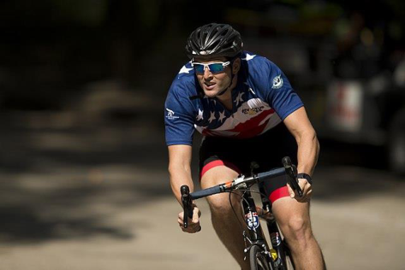
Figure 1: A cyclist in competition [2]
图 1：比赛中的车手 [2]
1.2 Restatement of the Problem
1.2 问题的重述
Considering the background information and restricted conditions identified in the problem statement, we need to develop a model to determine the optimal power distribution of one rider for one course and solve the following problems:
结合问题陈述中给出的背景信息与限制条件，我们需要建立一个模型，以确定一名车手在一条赛道上的最优功率分配，并解决以下问题：
• Problem 1: Give the definition of power profiles for both types of riders, taking into account riders of different genders. One of the riders is a time trial specialist; the other is required to be of another type.
• 问题 1：给出两类车手的功率曲线的定义，并考虑不同性别的车手。其中一名车手是计时赛专家；另一名则要求为其他类型。
• Problem 2: Apply the above model to three specific time trial courses.
• 问题 2：将上述模型应用于三条具体的计时赛赛道。
• Problem 3: Analyze the influence of weather conditions on model results and sensitivity of the model to this influence.
• 问题 3：分析天气条件对模型结果的影响，以及模型对这种影响的灵敏度。
• Problem 4: Analyze the sensitivity of the model to deviation from the result power distribution.
• 问题 4：分析模型对偏离所得功率分配结果的灵敏度。
• Problem 5: Discuss how to develop the model to provide the best power usage scenario for a six-person team competing in a team time trial.
• 问题 5：讨论如何发展该模型，为参加团队计时赛的六人团队提供最佳的功率使用方案。
— 原文第 4 页 —
1.3 Literature Review
1.3 文献综述
The problem that this paper aims at is the power distribution of cyclist during cycling, which has been discussed in previous studies. Andrew M. Jones et al. introduced the power curve into intermittent high-intensity exercise, and used the existing two-parameter model (hyperbolic relationship between power and duration) to make better predictions for athlete fatigue monitoring [3]. Morton extended the two-parameter model to a three-parameter model, and established a new power curve model [4]. Dr. Andrew Coggan et al. used a three-parameter model to analyze the advantages and disadvantages of different types of riders through statistical data, and obtained the corresponding power curve [5].
本文旨在研究的问题是骑行过程中车手的功率分配问题，这一问题在已有研究中已有讨论。Andrew M. Jones 等人将功率曲线引入间歇性高强度运动，并利用现有的双参数模型（功率与持续时间之间的双曲关系）对运动员疲劳监测作出了更好的预测 [3]。Morton 将双参数模型扩展为三参数模型，并建立了新的功率曲线模型 [4]。Andrew Coggan 博士等人利用三参数模型，结合统计数据分析了不同类型车手的优势与不足，并得到了相应的功率曲线 [5]。
There is also a lot of research on how to properly distribute power for the rider to win. The critical power model of Monod and Scherrer is a widely recognized model for optimizing pace strategy and analyzing the endurance capacity of cyclists. It consists of two parts: infinite aerobic and limited anaerobic [6]. A more complex model is the three-component Morton-Margaria model, or the 3-Tank model [7], which is another feasible bioenergy model that provides a direction for research on power distribution in bicycle racing.
关于如何合理分配功率以帮助车手获胜，同样有大量研究。Monod 与 Scherrer 提出的临界功率模型，是用于优化配速策略、分析自行车手耐力能力的广受认可的模型。该模型由两部分组成：无限的有氧能力与有限的无氧能力 [6]。更为复杂的模型是三组分的 Morton-Margaria 模型，即三槽模型 [7]，它是另一种可行的生物能量模型，为自行车比赛中的功率分配研究指明了方向。
1.4 Our Work
1.4 本文工作
We need a model that works for any type of rider to characterize the relationship between the rider's position on the track and the force applied. Our work mainly includes the following parts:
我们需要一个适用于任何类型车手的模型，以刻画车手在赛道上的位置与所施加力之间的关系。本文的工作主要包括以下几个部分：
Firstly, we refer to previous literature and propose our Cyclist’s Physiological Model of Fatigue based on the three-Tank model, including aerobic energy fatigue model and anaerobic energy fatigue model. We used this model to explain the rider's power curve. After that, we performed least squares fitting on the curves of different riders, and used the obtained parameters to distinguish riders into different categories.
首先，我们参考已有文献，在三槽模型的基础上提出了车手疲劳生理模型，包括有氧能量疲劳模型与无氧能量疲劳模型。我们利用该模型解释了车手的功率曲线。随后，我们对不同车手的曲线进行了最小二乘拟合，并利用所得参数将车手划分为不同类别。
Next, we established a resistance model dominated by aerodynamic resistance and rolling friction resistance, and revised the resistance model when considering the influence of weather conditions. In addition, we abstract the track as a function of ground undulation as a function of race schedule and curves as a function of race schedule. This is our Optimal Individual Power Distribution model. After that, we used the specific track data and the proposed fatigue physiological model to solve it by dynamic programming, and obtained the best power-race curve and the best finish time of the player on the track.
接着，我们建立了以空气阻力与滚动摩擦（rolling resistance）阻力为主的阻力模型，并在考虑天气条件影响时对该阻力模型作了修正。此外，我们将赛道抽象为地面起伏随赛程变化的函数，以及弯道随赛程变化的函数。这就是我们的最优个体功率分配模型。随后，我们利用具体赛道数据与所提出的疲劳生理模型，通过动态规划对其求解，得到了车手在该赛道上的最佳功率—赛程曲线与最佳完赛时间。
Then, we separately conduct sensitivity analysis to wind speed and direction and power deviation, and analyze the strengths and weaknesses of the model.
然后，我们分别针对风速与风向以及功率偏差进行了灵敏度分析，并分析了模型的优势与不足。
Finally, we generalized the model to team time trials. To account for the resistance reduction effect between teams, we reworked the resistance model for individuals in team matches. After that, we considered the possible strategies in the team game—Draft and Drop, and took the positions of these strategies as new decision variables, and theoretically the optimal solution in the team game can be obtained.
最后，我们将模型推广至团体个人计时赛。为计入队伍成员之间的减阻效应，我们重新构建了团体比赛中个体的阻力模型。此后，我们考虑了团体比赛中的可能策略——跟骑与脱离（Draft and Drop），并将这些策略所处的位置作为新的决策变量，从而在理论上可求得团体比赛中的最优解。
For better understanding of the overall model, a flowchart is provided to describe our process.
为更好地理解整体模型，我们提供了一张流程图来描述我们的研究过程。
— 原文第 5 页 —
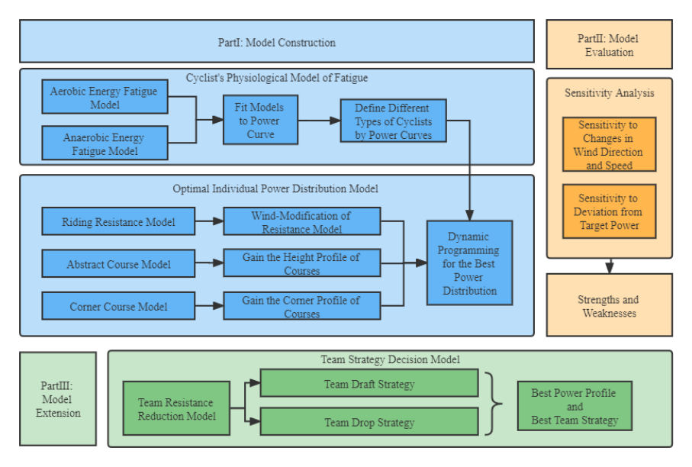
Figure 2：Overview of our work
图 2：本文工作概览
图中文字对照（英文 → 中文）
Part I: Model Construction | 第一部分：模型构建 | Cyclist's Physiological Model of Fatigue | 车手疲劳生理模型
Aerobic Energy Fatigue Model | 有氧能量疲劳模型 | Anaerobic Energy Fatigue Model | 无氧能量疲劳模型
Fit Models to Power Curve | 用功率曲线拟合模型 | Define Different Types of Cyclists by Power Curves | 按功率曲线划分车手类型
Optimal Individual Power Distribution Model | 最优个人功率分配模型 | Riding Resistance Model | 骑行阻力模型
Wind-Modification of Resistance Model | 阻力模型的风阻修正 | Abstract Course Model | 赛道抽象模型
Gain the Height Profile of Courses | 得到赛道高度剖面 | Corner Course Model | 弯道模型
Gain the Corner Profile of Courses | 得到赛道弯道剖面 | Dynamic Programming for the Best Power Distribution | 用动态规划求最优功率分配
Part II: Model Evaluation | 第二部分：模型评价 | Sensitivity Analysis | 灵敏度分析
Sensitivity to Changes in Wind Direction and Speed | 对风向与风速变化的灵敏度 | Sensitivity to Deviation from Target Power | 对偏离目标功率的灵敏度
Strengths and Weaknesses | 优缺点 | Part III: Model Extension | 第三部分：模型推广
Team Strategy Decision Model | 团队策略决策模型 | Team Resistance Reduction Model | 团队减阻模型
Team Draft Strategy | 团队跟骑策略 | Team Drop Strategy | 团队掉队策略
Best Power Profile and Best Team Strategy | 最优功率曲线与最优团队策略
2 Assumptions and Justifications
2 假设与理由
Considering that practical problems always contain many complex factors, first of all, we need to make reasonable assumptions to simplify the model, and each hypothesis is closely followed by its corresponding explanation:
考虑到实际问题总是包含许多复杂因素，首先我们需要作出合理假设以简化模型，每条假设之后都紧跟其相应的说明：
• Assumption 1: Cyclists will never be influenced by others during the race. According to the cycling individual time trial rules of UCI, the riders start alone at certain intervals. So, the rider will not be influenced by others during the race.
• 假设 1：车手在比赛中不会受到他人的影响。根据国际自行车联盟（UCI）的自行车个人计时赛规则，车手按一定间隔单独出发。因此，车手在比赛中不会受到他人的影响。
• Assumption 2: Energy of cyclists is limited during the race. On the one hand, this comes from the limitation of the topic, and on the other hand, cyclists usually do not supplement energy in actual races.
• 假设 2：车手在比赛中的能量是有限的。一方面，这来自题目的限定；另一方面，车手在实际比赛中通常不会补充能量。
• Assumption 3: The only sources of resistance are the viscous resistance of the air and the rolling friction of the ground. Because these two resistances account for the largest part [8], while the small resistance from the transmission efficiency of the bicycle chain can be ignored.
• 假设 3：阻力的唯一来源是空气的黏性阻力与地面的滚动摩擦。因为这两种阻力所占比例最大 [8]，而由自行车链条传动效率带来的微小阻力可以忽略。
• Assumption 4: Cyclists move in one dimension along the track, regardless of track width. This is a reasonable simplification of the model. Analysis of lateral motion introduces unnecessary complexity.
• 假设 4：车手沿赛道作一维运动，不考虑赛道宽度。这是对模型的合理简化。对横向运动的分析会引入不必要的复杂性。
• Assumption 5: The influence of weather on the players only exists in the wind direction and speed, and does not consider the influence of rainfall or snowfall. This is a reasonable simplification of the model, as actual races are generally not played in harsher weather conditions.
• 假设 5：天气对选手的影响仅体现在风向与风速上，不考虑降雨或降雪的影响。这是对模型的合理简化，因为实际比赛一般不会在更为恶劣的天气条件下进行。
— 原文第 6 页 —
3 Definitions and Notations
3 定义与符号说明
3.1 Definitions
3.1 定义
Power-to-weight ratio: The ratio of the rider's output power to his own body weight. The higher the value, the stronger the climbing ability.
功重比：车手输出功率与其自身体重之比。该值越高，爬坡能力越强。
Functional Threshold Power: The maximum average power a rider can achieve during an hour of full and steady riding. It is an important indicator of a rider's aerobic capacity. Also known as lactate threshold, it is usually determined by testing.
功能性阈值功率（FTP）（FTP）：车手在一小时全力且稳定骑行中能够达到的最大平均功率。它是衡量车手有氧能力的重要指标。又称乳酸阈值，通常通过测试确定。
Critical Power: The maximum average power a rider can get during a given period of time while riding with full force and stability.
临界功率：车手在给定时间段内全力且稳定骑行时能够获得的最大平均功率。
Sharp turn: The turning angle is greater than or equal to 90 degrees within 50 meters.
急弯：在 50 米范围内转弯角度大于或等于 90 度。
3.2 Notations
3.2 符号说明
The key mathematical notations used in this paper are listed in Table 1.
本文所使用的关键数学符号列于表 1。
Table 1: Notations used in this paper
表 1：本文使用的符号
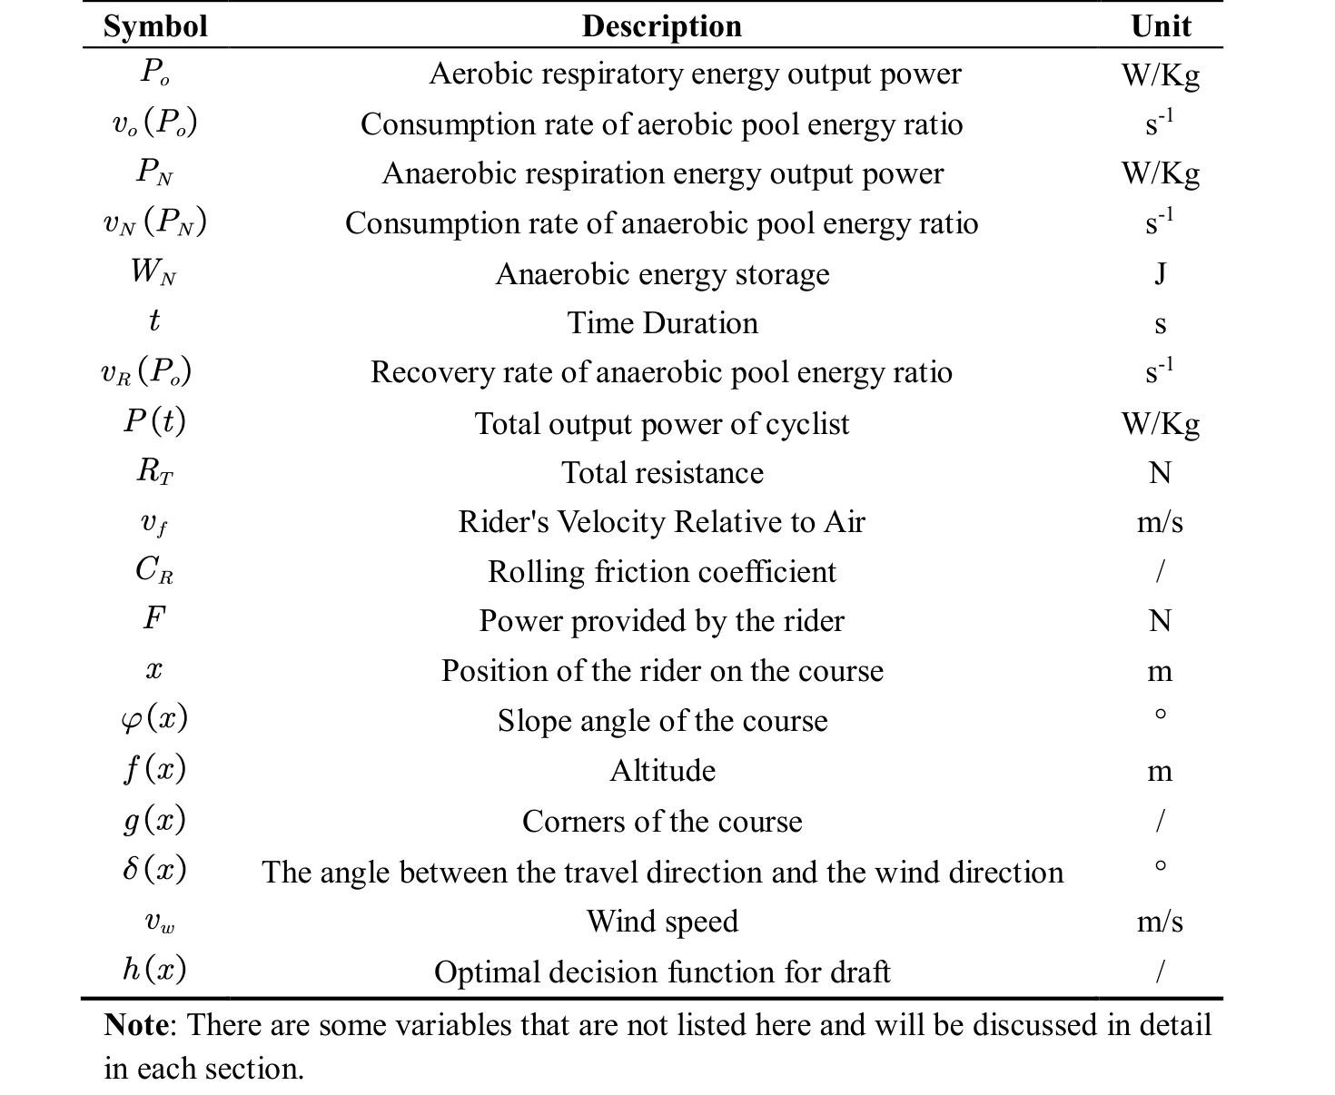
4 Cyclist’s Physiological Model of Fatigue
4 车手疲劳生理模型
We will now elaborate on our model. Based on the 3-Tank model, we propose an aerobic and anaerobic energy fatigue model, and use the least squares fitting curve to obtain the powertime curves of different types of players.
下面我们将详细阐述我们的模型。基于三槽模型，我们提出了一种有氧以及无氧能量疲劳模型，并利用最小二乘拟合曲线得到不同类型车手的功率—时间曲线。
— 原文第 7 页 —
4.1 The Establishment of the Model
4.1 模型的建立
4.1.1 Power Curve Model
4.1.1 功率曲线模型
The three-Tank model [7] mentioned above theoretically holds that an aerobic source can provide unlimited energy. However, in the actual process, according to Assumption 2, the total energy is limited. So, we can assume that there is a negative correlation between aerobic respiratory power and duration.
上文提到的三槽模型[7]在理论上认为，有氧供能系统能够提供无限的能量。然而在实际过程中，根据假设 2，总能量是有限的。因此，我们可以假设有氧呼吸功率与持续时间之间呈负相关关系。
When a person is fully active, the power provided by aerobic respiration is limited due to the limited rate of aerobic respiration. When the output power exceeds the functional power threshold (FTP), anaerobic respiration is required to make up. So aerobic breathing power belongs to an interval with an upper limit, and the consumption rate also has an upper limit.
当人体处于充分运动状态时，由于有氧呼吸速率有限，有氧呼吸所提供的功率也是有限的。当输出功率超过功能性阈值功率（FTP）时，就需要由无氧呼吸进行补充。因此，有氧呼吸功率属于一个有上限的区间，其消耗速率同样存在上限。
From the above two points, combined with other energy models, we normalize the energy of the aerobic pool and define the rate at which the rider consumes the energy of the aerobic pool as:
由上述两点，结合其他能量模型，我们对有氧池的能量进行归一化，并定义车手消耗有氧池能量的速率如下：
(1) where, P_{o} is aerobic respiratory energy output power. γ, δ are both undetermined parameters. When the output power exceeds the functional power threshold, the aerobic respiration power reaches saturation, and the excess part needs to be supplemented by anaerobic respiration. And the initial power of anaerobic respiration can be approximated as FTP.
（1）式中，P_{o} 为有氧呼吸能量输出功率，γ、δ 均为待定参数。当输出功率超过功能性阈值功率时，有氧呼吸功率达到饱和，超出部分需要由无氧呼吸来补充。而无氧呼吸的初始功率可近似取为 FTP。
From the two-parameter model, there is a hyperbolic relationship between the anaerobic respiration power and the duration, that is, the energy storage of the anaerobic energy pool is a fixed value. Therefore, the output power of the anaerobic respiration part can be expressed as:
由双参数模型可知，无氧呼吸功率与持续时间之间呈双曲线关系，即无氧能量池的储能是一个定值。因此，无氧呼吸部分的输出功率可表示为：
(2)
where,represents the energy storage of the anaerobic energy pool. is time duration.
式中，表示无氧能量池的储能，为持续时间。
Considering that the higher the output power of the human body is, the faster the energy consumption is. According to the two-parameter model, we normalize the anaerobic energy pool to one, and define the rate at which the rider consumes the energy of the anaerobic energy pool as:
考虑到人体的输出功率越高，能量消耗越快。根据双参数模型，我们将无氧能量池归一化为 1，并定义车手消耗无氧能量池能量的速率如下：
(3) where, α is the ratio of the anaerobic energy consumption rate of the human body to the anaerobic respiration output power.
（3）式中，α 为人体无氧能量消耗速率与无氧呼吸输出功率之比。
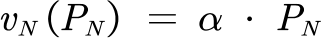
Additionally, a cyclist may choose to temporarily exceed the limits of their power curve. However, after the output power drops below FTP, the cyclist needs additional time to restore the energy of the anaerobic energy pool at a lower power level, and we define the speed of the rider to restore the energy ratio of the anaerobic energy pool here.
此外，车手可能选择在短时间内超出其功率曲线的限制。然而，当输出功率降至 FTP 以下后，车手需要额外的时间在较低功率水平下恢复无氧能量池的能量，我们在此定义车手恢复无氧能量池能量比例的速度。
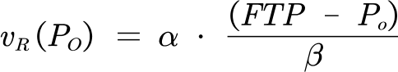
(4)
where, β is the coefficient of recovery, which means that when the output power exceeds the limit of the curve, the rider needs roughly twice the time to restore the stored energy in the energy pool.
式中，β 为恢复系数，其含义是：当输出功率超过曲线的限制时，车手大约需要两倍的时间才能恢复能量池中储存的能量。
Therefore, when the output power is kept constant, the time for the rider to maintain the power can be expressed as:
因此，当输出功率保持恒定时，车手能够维持该功率的时间可表示为：
— 原文第 8 页 —
(5)
It should be noted that the above formula does not involve the recovery of anaerobic pool energy. This is because the rider keeps the power constant. When the output power is higher than FTP, the energy of the anaerobic pool is consumed and will not recover; when the output power is lower than FTP, the energy of the anaerobic pool will not be consumed.
需要说明的是，上式并未涉及无氧池能量的恢复。这是因为车手在此过程中保持功率恒定。当输出功率高于 FTP 时，无氧池的能量被消耗而不会恢复；当输出功率低于 FTP 时，无氧池的能量不会被消耗。
To sum up, we can get the relationship between the total output power and the duration as:
综上所述，可以得到总输出功率与持续时间之间的关系为：
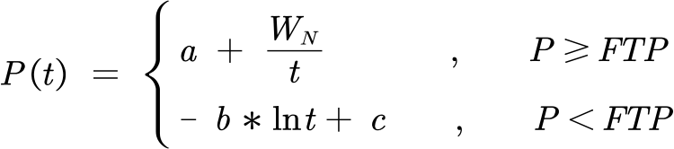
(6)
where,are adjustment coefficients to ensure that the function satisfies . represents the rate of energy consumption when aerobic respiration supplies energy.
式中，为调整系数，用于保证函数满足 。表示有氧呼吸供能时的能量消耗速率。
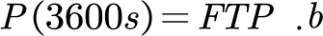
4.2 Result and Discussion
4.2 结果与讨论
4.2.1 Model Validation
4.2.1 模型验证
The above analysis provides a basic model for power-time curves for various types of cyclists. Parameters of different cyclists will differ due to their own conditions, thereby affecting their power-time curves. For different players, the specific power-time curve can be obtained by measurement to reflect various indicators, and then the consumption functions of the corresponding aerobic energy pool and anaerobic energy pool can be obtained, which is of great significance for fatigue monitoring and other aspects.
上述分析给出了适用于各类车手的功率—时间曲线的基本模型。不同车手的参数会因其自身条件而有所差异，从而影响其功率—时间曲线。对于不同的车手，可以通过测量得到具体的功率—时间曲线以反映各项指标，进而得到相应的有氧能量池与无氧能量池的消耗函数，这对于疲劳监测等方面具有重要意义。
Using the data mentioned above, we conducted the least squares method to fit the curve, and the fitting results of the power-time curve are shown in Figures 4 and 5 below:
利用上文所述数据，我们采用最小二乘法对曲线进行拟合，功率—时间曲线的拟合结果如下图 4 和图 5 所示：
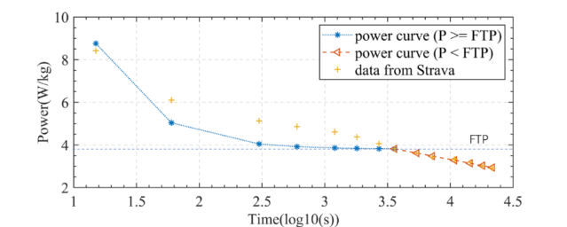
Figure 3: Curve Fitting Results for Men
图 3：男性曲线拟合结果
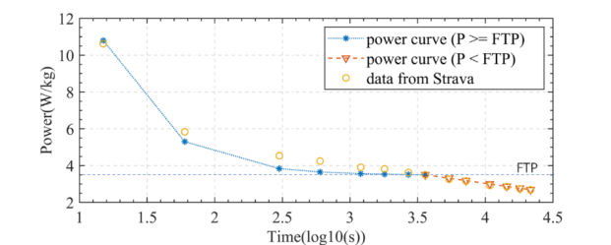
Figure 4: Curve Fitting Results for Women
图 4：女性曲线拟合结果
— 原文第 9 页 —
First of all, it should be noted that since human beings have limits in power output, the output power when the output time is very short is not considered. So, the image abscissa starts at 10s. To describe the rider's power curve more fairly, we consider the power applied by the rider normalized by weight as the ordinate.
首先需要说明的是，由于人体在功率输出上存在极限，因此不考虑输出时间极短时的输出功率。因此，图像的横坐标从 10 s 开始。为了更公平地描述车手的功率曲线，我们以车手施加的功率经体重归一化后的值作为纵坐标。
From the above figure, from the fitting effect, the result curve of the two fits well with the original data, especially for segments where. The result curve of women is more in line with the original data than the result curve of men, which may be related to the accuracy and chance of the data, or it may be related to the conservative estimation of model parameters. From the fitting results, the trend of the power time curves of men and women is the same, and the power decreases in an S-shaped manner with the increase of time. This is consistent with Assumption 2. The FTP of women is slightly smaller than that of men, but the limit power in a short time is higher than that of men. This reflects the effect of rider gender on that curve. The reason may be that women are lighter in weight and have higher power bursts for short periods of time, but weaker oxygen supply capacity for long periods of time. The difference between the two curves after a certain period of time is small, which indicates that in a relatively long period of riding, the difference caused by gender can be ignored.
由上图可见，从拟合效果来看，两次拟合得到的结果曲线与原始数据吻合良好，特别是在 的区间内。女性的结果曲线比男性的结果曲线更符合原始数据，这可能与数据的精度和偶然性有关，也可能与模型参数的保守估计有关。从拟合结果看，男性与女性的功率—时间曲线趋势相同，功率随时间增加而呈 S 形下降。这与假设 2 相符。女性的 FTP 略小于男性，但短时间内的极限功率高于男性。这体现了车手性别对该曲线的影响。其原因可能在于女性体重较轻、短时间内的功率爆发更高，但长时间的氧气供应能力较弱。经过一定时间后两条曲线的差异较小，这表明在相对较长的骑行时间内，性别造成的差异可以忽略。
4.2.2 Power curves of different types of riders
4.2.2 不同类型车手的功率曲线
In addition to the gender of the rider, we should also consider the characteristics of different types of riders to determine their corresponding power-time curves. Sprinters need a lot of power against wind resistance, so they will have heavier body weight and muscle mass, and their anaerobic pools will have high energy storage, but their power-to-weight ratio will be less suitable for climbing. In order to resist gravity, the Puncheur is lighter in weight, has a low muscle limit, and a high sprinting ability, but it is inferior to sprinters. Rouleur is good in all aspects, has strong stamina, and is usually aggressive in attacking. In order to visually represent the relationship between the player's ability index and the model parameters, the radar chart of each type of rider's index is shown in Figure 5 below:
除车手性别外，我们还应考虑不同类型车手的特点，以确定其相应的功率—时间曲线。冲刺型车手需要大量功率以对抗风阻，因此其体重和肌肉量较大，无氧池储能较高，但功重比不太适合爬坡。为对抗重力，爆发型车手（Puncheur）体重较轻、肌肉极限较低、冲刺能力较强，但不及冲刺型车手。全能型车手（Rouleur）各方面表现均衡、耐力强，通常在进攻时较为积极。为直观表示车手能力指标与模型参数之间的关系，各类车手指标的雷达图如下图 5 所示：
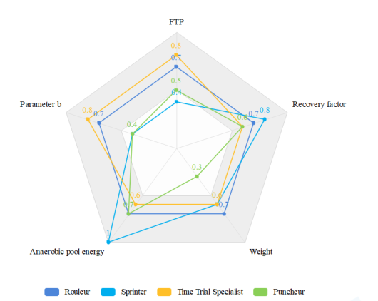
Figure 5: Metrics for all types of cyclists
图 5：各类车手的能力指标
As shown above, select FTP, restore factor, the model parameters, body weight, anaerobic pool energyas indicators to characterize the output power of various types of riders. Different weights are given and normalized according to the characteristics of each type of rider. Based on this, we assign different parameter values to the above model to obtain the corresponding power-time curve, as shown in Figure 6:
如上所示，选取 FTP、恢复系数、模型参数、体重、无氧池能量作为表征各类车手输出功率的指标。并根据各类车手的特点赋予不同权重并进行归一化。在此基础上，我们对上述模型赋予不同的参数取值，以得到对应的功率-时间曲线，如图 6 所示：
— 原文第 10 页 —
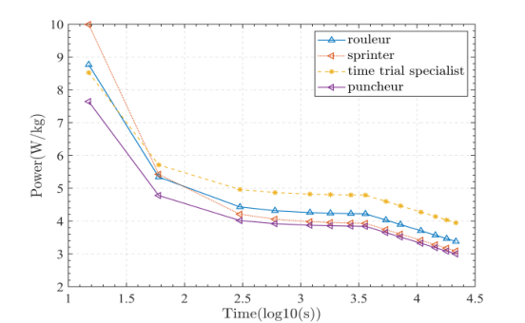
Figure 6: Power time curves for various types of riders
图 6：不同类型车手的功率-时间曲线
The graph above shows the power-time curves for each type of rider. Due to the different abilities of various riders, the model parameters are different, and so are the curves. The analysis leads to the following conclusions, which are consistent with the radar chart:
上图给出了各类车手的功率-时间曲线。由于各类车手的能力不同，模型参数存在差异，曲线也随之不同。由此分析可得出以下结论，这些结论与雷达图相一致：
• Rouleur is balanced in all aspects, so his/her power-time curve is in the middle section as a whole. His/Her sprint ability is strong, and he/she can also maintain a certain power during long-term riding.
• 全能型车手各方面能力均衡，因此其功率-时间曲线整体处于中间区段。其冲刺能力较强，在长时间骑行中也能维持一定的功率。
• The Sprinter has a strong sprinting ability, and his/her power-time curve presents a very high front, that is, the extreme power is very large in a short time, which is suitable for short-term explosive riding. He/She has a relatively prominent anaerobic energy supply capacity and a large anaerobic pool energy storage.
• 冲刺型车手冲刺能力强，其功率-时间曲线前端很高，即在短时间内极限功率很大，适合短时间的爆发性骑行。其无氧供能能力较为突出，无氧库储能较大。
• Puncheur has poor endurance, and his/her power-time curve is generally low, with a certain explosive power in a short period of time. The anaerobic energy supply capacity is slightly better.
• 陡坡冲刺型车手耐力较差，其功率-时间曲线整体偏低，在短时间内具有一定的爆发力。其无氧供能能力略好。
• The time trial specialist has the strongest comprehensive ability, and can maintain a high power during a long-term riding process. He/She has a relatively prominent aerobic energy supply capacity and a high FTP, which corresponds to a larger aerobic energy supply rate in the above model.
• 个人计时赛型车手的综合能力最强，能够在长时间骑行过程中维持较高的功率。其有氧供能能力较为突出，功能性阈值功率（FTP）较高，对应上述模型中较大的有氧供能速率。
5 Optimal Individual Power Distribution Model
5 最优个体功率分配模型
By analyzing the force of the rider during the riding process, combined with the track conditions, we propose an Optimal Individual Power Distribution Model, and use the dynamic programming method to find the optimal power distribution suitable for riding.
通过分析车手在骑行过程中的受力情况，并结合赛道条件，我们提出了最优个体功率分配模型，并采用动态规划方法求解适合骑行的最优功率分配。
5.1 Data Processing
5.1 数据处理
We need to apply the first model built to three specific tracks. So, we need to collect the altitude data and camber data of the track. The relevant datasets and source websites are shown in Table 2:
我们需要将所建立的第一个模型应用于三条具体赛道。因此，我们需要采集赛道的海拔数据与路拱（赛道横坡）数据。相关数据集及来源网站如表 2 所示：
Table 2: Data and Database Websites
表 2：数据与数据库网站
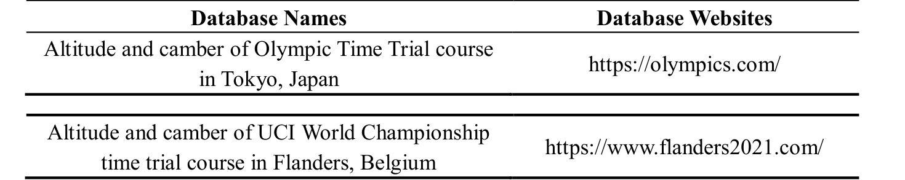
— 原文第 11 页 —
In order to facilitate research analysis and application to modeling, we present the collected data in the form of a function graph in Figure 7:
为便于研究分析并应用于建模，我们将采集的数据以函数图像的形式呈现在图 7 中：
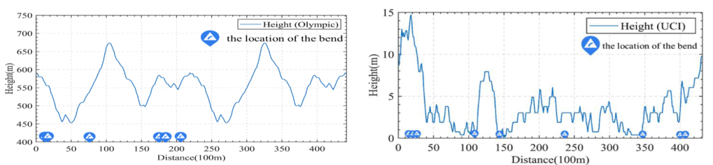
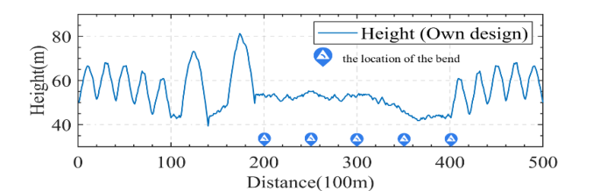
Figure 7: Altitude and Camber of the Course
图 7：赛道的海拔与路拱（赛道横坡）
From the figure, the top left picture among the three represents the data of the Tokyo Olympics time trial, the top right picture represents the data of UCI time trial, and the bottom picture is the data of self-designed track. In fact, in the UCI time trial, the men's and women's runners have different tracks. In the Olympics Time Trial, the men and women use the same track, but the men run an extra lap. Due to space limitations, the specific situation will be given in detail in the result analysis.
由图可知，三幅图中左上图为东京奥运会个人计时赛的数据，右上图为 UCI 个人计时赛的数据，下图为自主设计赛道的数据。事实上，在 UCI 个人计时赛中，男子与女子选手使用的赛道不同。在奥运会个人计时赛中，男子与女子使用同一赛道，但男子要多骑行一圈。受篇幅所限，具体情况将在结果分析中详细给出。
We can see that the UCI time trial track has a lower altitude, is flatter but has slightly more corners. The track of the Olympics Time Trial Circuit has a higher altitude, is steeper, has fewer turns, and the turns are concentrated in the first half of the track. The altitude of our self-designed track is in between the two, the slopes are concentrated in the first half and the end of the race, and there are five corners, which are concentrated in the second half of the race. The purpose of our design is to distinguish between slopes and corners to a certain extent, so that it is convenient to study the effect of the two on the rider's power separately.
可以看出，UCI 个人计时赛赛道海拔较低、更为平坦，但弯道略多。奥运会个人计时赛环线赛道海拔较高、坡度较陡、弯道较少，且弯道集中分布在赛道前半段。我们自主设计赛道的海拔介于两者之间，坡度集中在赛程前半段与终点段，共有五个弯道，且集中在赛程后半段。我们设计的目的是在一定程度上将坡度与弯道区分开，以便分别研究二者对车手功率的影响。
5.2 The Establishment of the Model
5.2 模型的建立
In the process of establishing the model, we mainly consider the resistance of the rider during his cycling, analyze the force of the rider, and propose a Riding Resistance Model.
在建立模型的过程中，我们主要考虑车手骑行过程中所受的阻力，对车手进行受力分析，并提出骑行阻力模型。
5.2.1 Riding Resistance Model
5.2.1 骑行阻力模型
In individual races, the interference effects of other riders are not considered. Therefore, we consider that the resistance received by the rider during the riding process is mainly composed of two parts, one of which is aerodynamic resistance, and the other is the rolling friction between the bicycle and the ground. According to the experimental research of others [8], we give the total resistance received by the rider in the process of flat ground movement as:
在个人赛中，不考虑其他车手的干扰影响。因此，我们认为车手在骑行过程中所受的阻力主要由两部分组成：一部分为空气阻力，另一部分为自行车与地面之间的滚动摩擦。根据他人的实验研究 [8]，我们给出车手在平地运动过程中所受的总阻力为：
— 原文第 12 页 —
(7) where, ρ is the fluid density, and it is the air density here. A_{p} is the frontal area of the total projection of the rider and the bicycle, that is, the effective area. C_{D} is the resistance coefficient. v_{f} is the speed of the rider relative to the fluid. C_{R} is the coefficient of rolling friction. M is the total mass of the rider and bike. g is the gravitational acceleration.
（7）式中，ρ 为流体密度，此处即为空气密度；A_{p} 为车手与自行车总投影的迎风面积，即有效面积；C_{D} 为阻力系数；v_{f} 为车手相对于流体的速度；C_{R} 为滚动摩擦系数；M 为车手与自行车的总质量；g 为重力加速度。
In order to obtain a more specific expression, we discuss the above parameters to directly use the existing data to facilitate the solution. For fluid density we have:
为得到更具体的表达式，我们对上述参数进行讨论，以便直接利用已有数据、便于求解。对于流体密度，有：
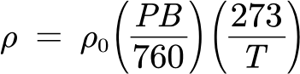
(8) (9) where, ρ₀ is a constant, the general value is 1.293Kg/m3. PB is air pressure. T is the temperature in Kelvin. Alt is the local altitude.
（8）（9）式中，ρ₀ 为常数，一般取 1.293Kg/m3；PB 为气压；T 为以开尔文计的温度；Alt 为当地海拔。
For the projected effective area, we have:
对于投影有效面积，有：
(10) where,are the rider's height and weight, respectively.is the horizontal declination angle of the rider's helmet, in order to simplify the problem, we take its value as zero.
（10）式中，分别为车手的身高与体重；为车手头盔的水平偏角，为简化问题，取其值为零。
For the resistance coefficient, we have:
对于阻力系数，有：
(11) Considering the coefficient of rolling friction, according to empirical data [9], the coefficient of rolling friction of mountain bikes on asphalt roads is 0.003, while the coefficient of rolling friction of road bicycles is usually smaller. Since rolling friction accounts for about 10% of the total resistance, and in order to simplify the problem, we do not consider the material of the track, we take.
（11）考虑滚动摩擦系数，根据经验数据 [9]，山地自行车在沥青路面上的滚动摩擦系数为 0.003，而公路自行车的滚动摩擦系数通常更小。由于滚动摩擦约占总阻力的 10%，且为简化问题，我们不考虑赛道的材质，取。
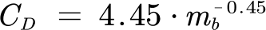
5.2.2 Abstract Course Model
5.2.2 赛道抽象模型
For the individual cycling track, we mainly consider the situation analysis of the rider going up and down and turning during the riding process.
对于个人自行车赛道，我们主要考虑车手在骑行过程中上坡、下坡与转弯的情形分析。
For the uphill process, we simplify the rider as a mass point and perform force analysis on it, as shown in Figure 8:
对于上坡过程，我们将车手简化为质点并对其进行受力分析，如图 8 所示：
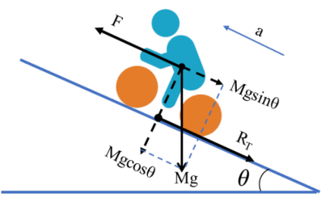
Figure 8: Analysis of the rider's force during the uphill process
图 8：上坡过程中车手的受力分析
As shown in the above analysis, we can simply get the physical model of the uphill process:
如上分析所示，我们可以直接得到上坡过程的物理模型：
(12)
Where, F is the motivation provided to the rider, which is related to the power provided by the rider.is the slope angle, when the rider is going downhill, it is an obtuse angle.
式中，F 为提供给车手的动力，其与所提供的功率有关，其中，车手的……为坡度角，当车手下坡行驶时，该角为钝角。
— 原文第 13 页 —
It should be pointed out that the force analysis of the rider in the process of going downhill is the same as the force analysis in the process of going uphill, and the above physical model is applicable to both scenarios.
需要指出的是，车手在下坡过程中的受力分析与上坡过程中的受力分析相同，上述物理模型对两种情形均适用。
For the curve process, in order to simplify the model and calculation, we consider the process as a circular motion. We perform a simple force analysis on it, as shown in Figure 8:
对于弯道过程，为简化模型与计算，我们将其视为圆周运动。我们对其作简单的受力分析，如图 8 所示：
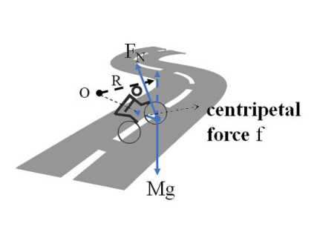
Figure 9: Analysis of the rider's force in the process of turning
图 9：车手转弯过程中的受力分析
According to the graph above, in the tangential direction of the corner, the rider is exposed to the total resistance as well as the power provided by himself. This is in line with what a rider would do when riding on straight roads.
根据上图，在弯道的切向方向上，车手受到总阻力以及自身输出功率的作用。这与车手在直道上骑行时的情况一致。
In the radial direction, the combined force of the rider's gravity and the supporting force of the road surface provides the centripetal force. However, due to the limited inclination of the rider to the road during cornering, the resultant force is limited. Therefore, during a turn, the rider's speed cannot exceed a certain threshold. In addition, we divide the corners into two categories according to the size of the turning radius, sharp turns and soft turns.
在径向方向上，车手重力与路面支持力的合力提供向心力。然而，由于转弯时车手相对路面的倾角有限，该合力的大小受到限制。因此，在转弯过程中，车手的速度不能超过某一阈值。此外，我们按转弯半径的大小将弯道分为两类：急弯与缓弯。
From this, we get the processing method for the curve process:
由此，我们得到弯道过程的处理方法：
• For the sharp turning process, the speed of the rider should not be too high, and the rider should reduce the output power to lower the speed below this threshold, otherwise the turning process cannot be completed. That is to say, we consider the corners to be speed checkpoints on the track, which can only be passed below the speed threshold.
• 对于急弯过程，车手的速度不宜过高，应降低输出功率以将速度降至该阈值以下，否则无法完成转弯过程。也就是说，我们将弯道视为赛道上的限速检查点，只有低于速度阈值才能通过。
• For the soft turning process, we regard it as a straight course and do not do special treatment.
• 对于缓弯过程，我们将其视为直道，不作特殊处理。
We represent the track elevation map obtained earlier as a function of altitude as a function of the rider's position on the track. We think the rider is on an uphill course when the altitude goes up and downhill when the altitude goes down. Therefore, by taking the derivation of this function, we can get the slope angle as a function of the rider's position on the track.
我们将先前得到的赛道高程图表示为海拔关于车手在赛道上位置的函数。我们认为，当海拔上升时车手处于上坡赛道，当海拔下降时处于下坡赛道。因此，对该函数求导，即可得到坡度角关于车手在赛道上位置的函数。
In the same way, since we simplified the curve model, we only consider whether the current position of the rider is a straight or a curve, and do not care about the radius of the curve. So we express the camber of the track as a binary function
同理，由于我们简化了弯道模型，我们只考虑车手当前位置是直道还是弯道，而不关心弯道的半径。于是我们将赛道的路拱（赛道横坡）表示为一个二元函数
，that is：
，即：
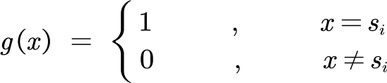
(13)
where, s_{i} is the position of each corner in the track.
其中，s_{i} 为每个弯道在赛道中的位置。
— 原文第 14 页 —
Through the above analysis, we summarize the basic idea of modeling as shown in below:
通过上述分析，我们将建模的基本思路总结如下：
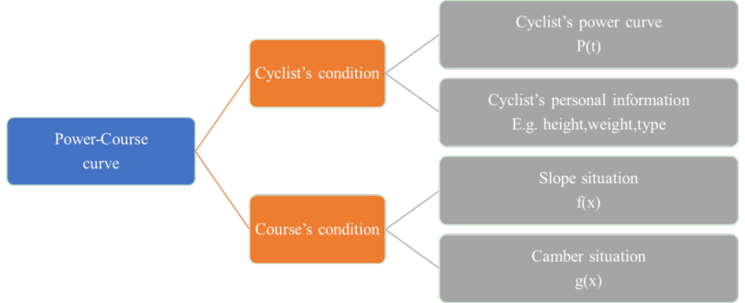
Figure 10: The framework of the model
图 10：模型框架
5.3 Solve the Model
5.3 模型求解
We need to use the existing model to obtain the optimal power distribution of the rider in a race while ensuring that the energy of the aerobic pool and the anaerobic pool is not less than zero, so that the rider can reach the destination in the shortest time. Therefore, solving the model using a dynamic programming algorithm is a good choice.
我们需要利用已有模型，在保证有氧池与无氧池能量均不小于零的前提下，获得车手在比赛中的最优功率分配，使车手能够以最短时间到达终点。因此，采用动态规划算法求解该模型是一个较好的选择。
The dynamic programming algorithm is an algorithm that divides the problem and defines the relationship between the state of the problem and the state, so that the problem can be solved in a recursive way. When applying this method to the above model, the main ideas are:
动态规划算法是一种将问题分解、并定义问题状态与状态之间关系的算法，从而使问题能够以递推方式求解。将该方法应用于上述模型时，主要思路为：
◆ Break the original problem into sub-problems. Divide the track into a certain number of small sections, and find the minimum time to complete this part of the track when each section has the same amount of aerobic energy remaining, anaerobic energy remaining, and the end speed. Gradually increase with the schedule until the entire track is covered. Then the minimum time to complete the track is the minimum time calculated under the condition of any remaining aerobic energy, anaerobic energy remaining, and ending speed.
将原问题分解为子问题。将赛道划分为一定数量的小段，求在各段具有相同的有氧能量剩余量、无氧能量剩余量与末端速度时，完成该部分赛道的最短时间。随着赛程推进逐步增加，直至覆盖整条赛道。则完成整条赛道的最短时间，即为在任意有氧能量剩余量、无氧能量剩余量与末端速度条件下计算得到的最短时间。
◆ Determine the status. When the remaining amount of aerobic energy is, the remaining amount of anaerobic energy is, and the end speed is, the minimum time consumed bymeters before completion.
确定状态。当有氧能量剩余量为、无氧能量剩余量为、末端速度为时，完成前米所需的最短时间。
◆ Given an initial value. The initial velocity is zero, the residual amount of aerobic energy is one, and the residual amount of anaerobic energy is one.
给定初始值。初始速度为零，有氧能量剩余量为 1，无氧能量剩余量为 1。
◆ State transition. For every segment, the value of its state function may come from all state values of the previous segment of the track. Therefore, we try all power for all state values of the previous segment of the track. If it transitions to its own state, record it. Take the minimum value after the traversal is complete.
状态转移。对于每一段，其状态函数的值可能来自上一段赛道的所有状态值。因此，我们对上一段赛道的所有状态值尝试所有功率。若其转移到自身状态，则记录下来。遍历完成后取最小值。
It should be noted that, except for time, all values are discretized to ensure incremental traversal. When the difference between the values is sufficiently small, the resulting value can be considered accurate.
需要说明的是，除时间外，所有数值均进行离散化处理，以保证能够逐步遍历。当数值之间的间隔足够小时，所得结果可认为是精确的。
5.4 Results and Analysis
5.4 结果与分析
Taking into account the gender and type of runners, when applying the model to the track, we discussed the Time Trial Specialists and Sprinters divided into male and female runners.
考虑到车手的性别与类型，在将模型应用于赛道时，我们分别讨论了分为男、女车手的个人计时赛选手与冲刺手。
— 原文第 15 页 —
In the three tracks, the power distribution strategies of the two types of male riders are shown in Figure 11 below:
在三条赛道中，两类男子车手的功率分配策略如下图 11 所示：
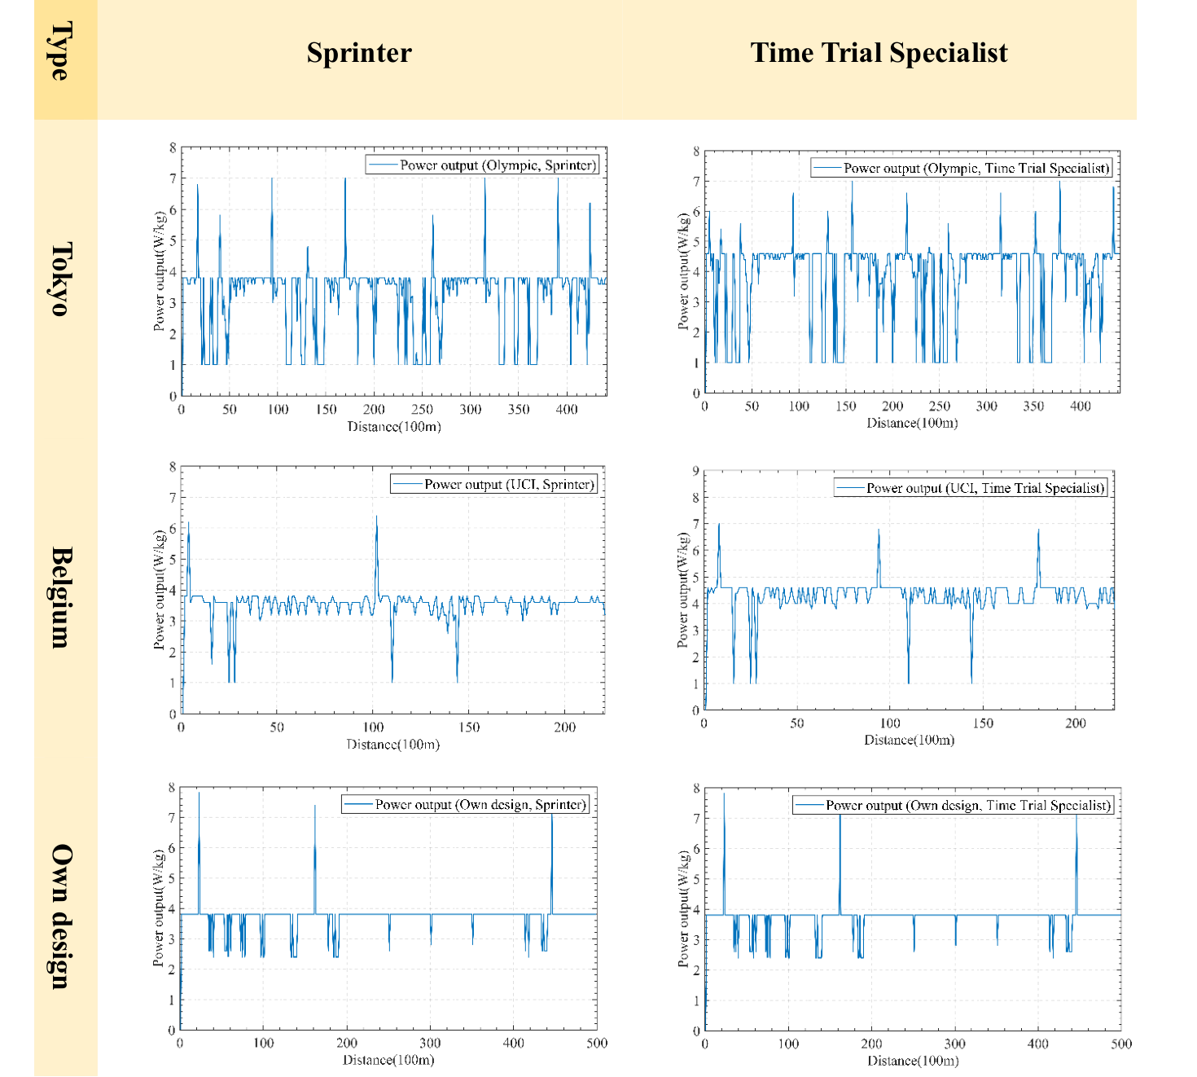
Figure 11: Men's Rider Power Distribution Strategy
图 11：男子车手功率分配策略
Based on the graph above, we got the optimal power distribution for different types of riders. According to this strategy, the corresponding power is applied at the corresponding position of the race schedule, and the rider will complete the race in the shortest time under his own conditions. When the curve increases sharply, the rider should initiate a sprint; when the curve drops sharply, the rider should reduce the power to restore the energy of the anaerobic pool; most of the time, the curve fluctuates around the FTP, and the rider should maintain a relatively stable power to ride. We have also plotted the changes in anaerobic pool energy and aerobic pool energy to testify to this. Details can be found in the appendix. Furthermore, we can draw the following conclusions:
根据上图，我们得到了不同类型车手的最优功率分配方案。按照该策略，在比赛赛程的相应位置施加相应的功率，车手便能在自身条件下以最短时间完成比赛。当曲线急剧上升时，车手应发起冲刺；当曲线急剧下降时，车手应降低功率以恢复无氧池能量；大部分时间里，曲线在功能性阈值功率（FTP）附近波动，车手应保持相对稳定的功率骑行。我们还绘制了无氧池能量与有氧池能量的变化曲线，以对此加以验证。具体内容见附录。此外，我们可以得出以下结论：
• The power distribution strategies of various types of riders on the same track are basically the same. It can be seen from the foregoing that different types of riders have power curves with similar trends. When they are applied to the same track conditions, the power distribution strategies obtained have the same trend.
• 各类车手在同一赛道上的功率分配策略基本相同。由上述内容可以看出，不同类型的车手具有相似趋势的功率曲线。当将其应用于相同的赛道条件时，所得到的功率分配策略具有相同的趋势。
— 原文第 16 页 —
• Riders need to sprint more frequently in high-altitude races. While the average resistance at higher altitudes is less than it at lower altitudes, the gradients are more variable, so riders need to increase power to climb and then lower to recover. Therefore, on denser hills, the rider's power fluctuates more. At the same time, this also shows that the effect of gravity on the rider is greater than that of resistance.
• 车手在高海拔比赛中需要更频繁地冲刺。虽然较高海拔处的平均阻力小于较低海拔处，但坡度变化更大，因此车手需要提高功率以爬坡，随后降低功率以恢复。因此，在更为密集的坡道上，车手的功率波动更大。同时，这也表明重力对车手的影响大于阻力的影响。
• Turning reduces the power output to the rider. It can be seen from the self-designed track that the rider has a certain degree of power reduction in the corners. This is also consistent with our previous analysis.
• 转弯会降低车手的功率输出。从自行设计的赛道可以看出，车手在弯道处的功率有一定程度的下降。这也与我们此前的分析相一致。
• The Sprinter can launch a more powerful attack in the first half of the schedule than the Time Trial Specialist. Comparing the above picture horizontally, in the first half of the race, we can see that the power peak corresponding to the sprint initiated by the Sprinter is higher. In the second half of the race, the number of sprints and power peaks were slightly reduced due to the Sprinter's slightly poorer endurance.
• 在赛程前半段，冲刺型车手能够比个人计时赛型车手发起更有力的进攻。横向比较上图可以看出，在比赛前半段，冲刺型车手发起冲刺所对应的功率峰值更高。在比赛后半段，由于冲刺型车手的耐力略差，冲刺次数与功率峰值略有减少。
• The Sprinter is less affected by corners than the Time Trial Specialist. At Tokyo, where the corners are denser, the Sprinter has fewer power cuts. This may be related to the lower average power of this type of riders.
• 冲刺型车手受弯道的影响小于个人计时赛型车手。在弯道更为密集的东京赛道上，冲刺型车手的功率削减次数更少。这可能与该类车手的平均功率较低有关。
• Sprinter is more affected by altitude than Time Trial Specialist. At the higher elevation and steeper slope changes at the Olympics track, the Sprinter's power curve has a lower center of undulation and lower average power.
• 冲刺型车手受海拔的影响大于个人计时赛型车手。在奥运会赛道海拔更高、坡度变化更陡的情况下，冲刺型车手功率曲线的起伏中心更低，平均功率也更低。
Due to space limitations, the optimal power strategy graph for the women's race and the women's UCI track map are attached in the appendix. Due to the difference between the men's and women's tracks in the Olympics track and the UCI track, in order to control the variables, we only analyze the tracks designed by ourselves, and we can draw the following conclusions: ➢ The average power of women is lower than that of men. It can be seen that the power curve of women is generally lower.
由于篇幅限制，女子比赛的最优功率策略图与女子 UCI 赛道图见附录。由于奥运会赛道与 UCI 赛道中男子与女子赛道存在差异，为控制变量，我们仅对自行设计的赛道进行分析，并可得出以下结论：女子的平均功率低于男子。可以看出，女子的功率曲线整体更低。
➢ Women's sprint intensity in the first half of the race can reach higher, even more than the men's. The women's power curve peaked higher in the first half of the race. ➢ Women are more affected by slopes and curves than men. The women's power map fluctuates more often on successive ramps and corners.
女子在比赛前半段的冲刺强度可以达到更高水平，甚至超过男子。女子功率曲线在比赛前半段的峰值更高。与男子相比，女子受坡度和弯道的影响更大。女子功率图在连续的坡道和弯道处波动更为频繁。
In addition, we present a statistical graph of the minimum time required by the rider, providing intuitive data for analysis. As shown in Figure 12 below:
此外，我们给出了车手所需最短时间的统计图，为分析提供直观的数据。如下图 12 所示：
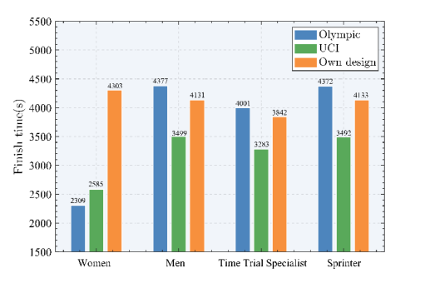
Figure 12: Minimum time spent by the rider
图 12：车手所花费的最短时间
— 原文第 17 页 —
Through this graph, we give the specific time of different riders under the optimal power distribution. As mentioned above, we only refer to the self-designed track for comparison between men and women. It can be seen that the men's players have a shorter time, 172s ahead of the women's players, and the average power is higher. In addition, the overall time of the Time Trial Specialist is shorter than that of the Sprinter, and the average score is about 300s ahead of the latter. Their average power is higher, their comprehensive ability is stronger, and they are less affected by altitude. Especially at high altitudes, the former leads the latter by 371s, which is the largest difference between the two among the three tracks. This is in great agreement with our previous model, while validating the validity and rationality of the model.
通过该图，我们给出了不同车手在最优功率分配下的具体时间。如上所述，我们仅在自行设计的赛道上进行男女之间的比较。可以看出，男子选手用时更短，领先女子选手 172s，且平均功率更高。此外，个人计时赛型车手的总用时短于冲刺型车手，平均成绩领先后者约 300s。他们的平均功率更高，综合能力更强，且受海拔的影响更小。尤其是在高海拔赛道上，前者领先后者 371s，这是三条赛道中两者差距最大的一次。这与我们此前的模型高度吻合，同时验证了模型的有效性与合理性。
6 Sensitivity Analysis
6 灵敏度分析
6.1 Weather and Environmental Effects
6.1 天气与环境影响
The model was revised to account for the potential effects of weather. We considered the effect of wind direction and wind strength (i.e. wind speed) on the model parameters and made new assumptions:
对模型进行了修正，以考虑天气的潜在影响。我们考虑了风向与风力（即风速）对模型参数的影响，并作出新的假设：
Wind direction and wind speed are only functions related to space, forming a vector field of wind in space, regardless of time. And we consider the wind as only horizontal air flow. This is due to the slow change of wind speed and direction on the field, and usually only the average wind speed within an hour is detected. Table 3 below gives the wind speed and direction data we used [10]:
风向与风速仅是空间相关的函数，在空间中构成风矢量场，与时间无关。并且我们将风视为仅存在水平气流。这是由于赛场上风速与风向变化缓慢，且通常只检测一小时内的平均风速。下表 3 给出了我们所使用的风速与风向数据 [10]：
Table 3: Direction and Speed of the Wind in Course
表 3：赛道中的风向与风速
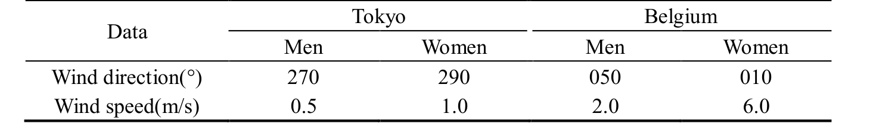
The effect of wind on the model results is only due to air resistance. To simplify the model, we only consider wind in the same or opposite direction as the rider's travel to have an effect on the travel, wind in the vertical direction does not affect the ride. From this, we correct the total resistance in the previous model to be:
风对模型结果的影响仅通过空气阻力产生。为简化模型，我们仅考虑与车手行进方向相同或相反的风对行进产生影响，垂直方向的风不影响骑行。据此，我们将前文模型中的总阻力修正为：
(14) where, δ is the angle between the traveling direction and the wind direction (less than or equal to the flat angle), which is essentially function of x, denoted by δ = δ(x). sign() is the symbolic function. v_{f}, v_{w} are the horizontal speed of the rider and the wind speed, respectively.
(14) 其中，δ 为行进方向与风向之间的夹角（小于或等于平角），其本质是 x 的函数，记为 δ = δ(x)。sign() 为符号函数。v_{f}、v_{w} 分别为车手的水平速度与风速。
To sum up, the new model is an improvement of the original model. We can solve the model using the above data and similar methods, and modify the values of wind direction and speed to analyze the sensitivity.
综上所述，新模型是对原模型的改进。我们可以利用上述数据和类似方法求解该模型，并通过修改风向与风速的取值来分析灵敏度。
In order to explore the influence of weather conditions on the results, we took the performance of women on the UCI track as an example, and set up 8 wind directions and 3 wind levels, with a total of 24 wind environments. In these environments, we simulated the performance of athletes in the wind. The results obtained are presented in Figure 13:
为探究天气条件对结果的影响，我们以女子在 UCI 赛道上的表现为例，设置了 8 个风向与 3 个风力等级，共 24 种风环境。在这些环境中，我们模拟了运动员在风中的表现。所得结果见图 13：
— 原文第 18 页 —
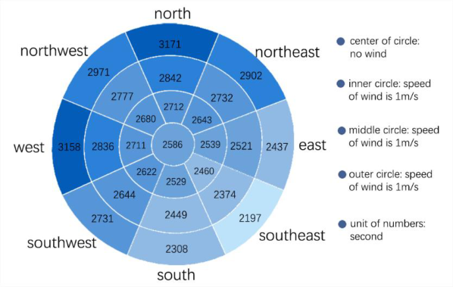
Figure 13: Finishing times in different weather conditions
图 13：不同天气条件下的完赛时间
The wind direction adopts eight gradient settings of due north, due south, due west, due east, northeast, southeast, northwest, and southwest; the wind speed is set with three gradient settings of 1m/s, 2m/s and 3m/s.
风向取正北、正南、正西、正东、东北、东南、西北、西南 8 个梯度设置；风速取 1m/s、2m/s、3m/s 三个梯度设置。
According to the above figure, When the wind direction is constant, every time the wind speed changes by one level, the completion time will change by 20~330s, and the change proportion is less than 10%. When the wind is constant, each time the wind direction changes in one direction, the completion time will change by 30~460s, and the maximum change ratio is 16%. Therefore, considering the influence of two factors, we believe that our model is more sensitive to changes in the weather environment.
由上图可知，当风向不变时，风速每变化一个等级，完赛时间将变化 20~330s，变化比例小于 10%。当风速不变时，风向每变化一个方向，完赛时间将变化 30~460s，最大变化比例为 16%。因此，综合考虑两个因素的影响，我们认为模型对天气环境的变化较为敏感。
6.2 Deviation effects
6.2 偏差影响
During a race, the rider cannot accurately implement the determined optimal power distribution strategy. For example, the rider did not increase to optimal power on a stage where he should have increased power. Thus, the rider's power position curve is likely to deviate from the optimal curve. To simulate this deviation, we randomly change the optimal power distribution curve so that the rider may output sub-optimal power at any position. We use the average absolute value of the deviation of the rider's actual output power curve from the optimal power curve at all positions as the degree to which the rider deviates from the optimal curve.
比赛中，车手无法精确执行所确定的最优功率分配策略。例如，在本应提高功率的赛段上，车手未能提升至最优功率。因此，车手的功率—位置曲线很可能偏离最优曲线。为模拟这种偏差，我们对最优功率分配曲线进行随机扰动，使车手在任意位置都可能输出次优功率。我们以车手实际输出功率曲线与最优功率曲线在所有位置上偏差绝对值的平均值，作为车手偏离最优曲线的程度。
We use random numbers to generate non-optimal power distributions and plug them into the model to solve for the corresponding finish times, as shown in Table 4:
我们利用随机数生成非最优功率分配，并将其代入模型求解相应的完赛时间，如表 4 所示：
Table 4: Non-optimal Finish Time
表 4：非最优完赛时间
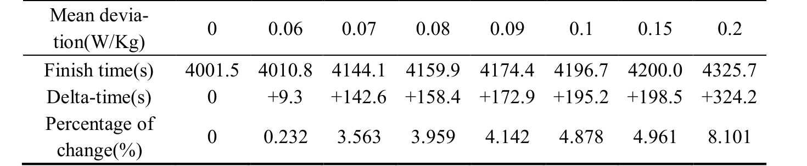
From the data in the table, we can find that as the deviation value increases, the completion time of the rider gradually increases, which verifies that our model is indeed the best solution to a certain extent. When the average deviation is below 0.06, the variation in completion time is small, less than 0.5%. After the deviation increases to a certain value between 0.06 and 0.07, the change in the completion time increases, but is less than 5%. But when the average deviation is between 0.15 and 0.2, the variation of completion time increases greatly, more than 5%. If the average deviation continues to increase, the rider will not be able to finish the race properly due to not meeting the finite energy limit.
从表中的数据可以发现，随着偏差值的增大，车手的完赛时间逐渐增加，这在一定程度上验证了我们的模型确实是最优解。当平均偏差低于 0.06 时，完赛时间的变化较小，不足 0.5%。当偏差增大到 0.06 至 0.07 之间的某一数值后，完赛时间的变化随之增大，但仍小于 5%。但当平均偏差处于 0.15 至 0.2 之间时，完赛时间的变化幅度显著增大，超过 5%。若平均偏差继续增大，车手将因无法满足有限的能量限制而无法正常完成比赛。
— 原文第 19 页 —
After the above analysis, when the average deviation changes by about 5%, the completion time changes by about 10%. Therefore, we believe that the model results have some insensitivity to the rider's deviation from the target power.
经过上述分析，当平均偏差变化约 5% 时，完赛时间约变化 10%。因此，我们认为模型结果对车手偏离目标功率具有一定的不敏感性。
Additionally, we divided the entire course into sections. The endpoint of each segment is a checkpoint. Through multiple simulations, we get the time frame for reaching each checkpoint. If the rider arrives at these checkpoints within these ranges, the final finish time is guaranteed to be no later than 1 minute after the optimal finish time. Table 5 shows the acceptable time range for arriving at each checkpoint after dividing the UCI Men's ITT circuit into 11 segments.
此外，我们将整条赛道划分为若干路段。每一段的端点即为一个检查点。通过多次仿真，我们得到了到达各检查点的时间范围。若车手在这些范围内到达各检查点，则可保证最终完赛时间不晚于最优完赛时间 1 分钟。表 5 给出了将 UCI 男子个人计时赛赛道划分为 11 段后，到达各检查点的可接受时间范围。
Table 5: Acceptable time range at each checkpoint
表 5：各检查点可接受的时间范围
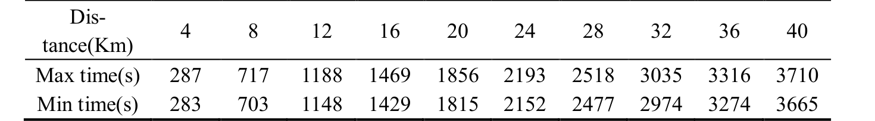
7 Model Evaluation and Further Discussion
7 模型评价与进一步讨论
7.1 Strengths
7.1 优点
Our model offers the following strengths:
我们的模型具有以下优点：
We performed a more in-depth analysis of the three-tank model and proposed aerobic and anaerobic energy fatigue models. Drawing on the research of others, we divided rider’s power output into aerobic and anaerobic components. Finally, we found that our model fits the data fairly well. The validity of the model has been verified.
我们对三槽模型进行了更深入的分析，并提出了有氧与无氧能量疲劳模型。借鉴他人的研究，我们将车手的功率输出划分为有氧部分与无氧部分。最终我们发现，模型对数据的拟合效果相当好。模型的有效性得到了验证。
Considering a variety of factors, a rider track model is proposed. In this process, we considered various factors such as the rider's energy consumption limit and stress situation, the slope and camber of the track, wind direction and speed, etc., which is more comprehensive. The model is highly generalizable. When building model, we started with an individual time trial. Then we revised the model based on the characteristics of the team competition, and proposed the Draft strategy to generalize the model to be suitable for team time trials.
综合考虑多种因素，我们提出了车手赛道模型。在这一过程中，我们考虑了车手的能量消耗限制与受力状况、赛道的坡度与路拱（赛道横坡）、风向与风速等多种因素，因而更为全面。该模型具有较强的可推广性。建模时我们从个人计时赛入手，随后依据团体赛的特点对模型加以修正，并提出跟骑策略，使模型可推广至团体计时赛。
7.2 Weaknesses
7.2 缺点
Our model has the following limitations and related improvements:
我们的模型存在以下局限及相应改进方向：
In the Anaerobic Energy Fatigue Model, we treat the recovery factor as a constant. Doing so simplifies the model but reduces the authenticity of the model to some extent. In fact, due to loss of energy, it is more appropriate to describe the recovery factor as a variable.
在无氧能量疲劳模型中，我们将恢复系数视为常数。这样做简化了模型，但在一定程度上降低了模型的真实性。事实上，由于存在能量损耗，将恢复系数描述为变量更为合适。
In the construction of the Optimal Individual Power Distribution Model, the consideration of the Abstract Course Model is relatively simple. We only care about whether there is a turn at a certain position on the race schedule, and do not consider the size of the corner radius. Although the model is simplified, the authenticity of the model is weakened. In fact, this factor may affect a rider's low-power ride time, which in turn affects the results.
在构建最优个体功率分配模型时，对抽象赛道模型的考虑相对简单。我们只关注赛程中某一位置是否存在弯道，而未考虑弯道半径。虽然模型得到了简化，但模型的真实性被削弱。事实上，这一因素可能影响车手低功率骑行的时间，进而影响结果。
— 原文第 20 页 —
7.3 Model Extension
7.3 模型拓展
In this section, we mainly discuss the generalization of the model. The context for the model we built earlier was the individual time trial. As for the team time trial, Aristotle once said: "A team is more than the sum of its parts." So, we need to further modify the model.
本节主要讨论模型的推广。我们此前所建模型的背景是个人计时赛。至于团体计时赛，亚里士多德曾说：“整体大于部分之和。”因此，我们需要对模型作进一步修正。
According to the rules of the team time trial given by UCI [11], different teams should keep a certain distance, the team members should not push each other, and the following auxiliary vehicles should not be used. Therefore, the influence between teams and other factors that affect resistance, motivation and energy consumption are ignored. The important thing is that in team time trial, the front players can reduce drag for the rear players by arranging in front and back. Therefore, the main difference between team time trial and individual time trial is that we need to consider the different resistance between different riders.
根据 UCI [11] 给出的团体计时赛规则，不同车队之间应保持一定距离，队员之间不得相互推扶，也不得借助尾随的保障车辆。因此，车队之间的相互影响以及其他影响阻力、动力与能量消耗的因素均被忽略。重要的是，在团体计时赛中，位于前方的车手可以通过前后排列为后方车手减小阻力。因此，团体计时赛与个人计时赛的主要区别在于，我们需要考虑不同车手之间阻力的差异。
The resistance model needs to be revised first as follows:
阻力模型需首先作如下修正：
(15)
where, C_{dr} is a constant, related to the total number of riders and the position of the rider in the cohort.
其中，C_{dr} 是常数，与车手总数以及车手在队列中的位置有关。
When the total number of team members is 6, the values in the expression of resistance received by riders at various positions are shown in Table 6 below:
当队员总数为 6 时，各位置车手所受阻力表达式中各系数的取值如下表 6 所示：
Table 6: Resistance coefficient of players at different positions
表 6：不同位置车手的阻力系数
Furthermore, the decisions we need to consider are not limited to when to speed up and when to slow down. To make good use of the drag reduction brought by the team, the team as a whole needs to remain relatively static and move forward at a certain team speed. Because the players at the back of the team face less resistance, the movement is more labor-saving, and the players at the front are more laborious.
此外，我们需要考虑的决策并不限于何时加速、何时减速。为充分利用车队带来的减阻效果，整个车队需保持相对静止的队形，并以一定的车队速度前进。由于车队后方的车手所受阻力较小，骑行更为省力，而前方车手则更为费力。
In team time trial, teams tend to use "Draft" to achieve the balance of team workload. The process of "Draft" is: the first player of the team moves laterally out of the queue, making the second player the leader of the team, then the first player of the team slows down, moves to the tail of the team. A schematic diagram of the process (taking four players as an example) is shown in Figure 14:
在团体计时赛中，各队往往采用“跟骑”来实现队内工作量的平衡。“跟骑”的过程为：车队第一名车手向侧方移出队列，使第二名车手成为车队领骑，随后原第一名车手减速，移至队尾。该过程的示意图（以四名车手为例）见图 14：
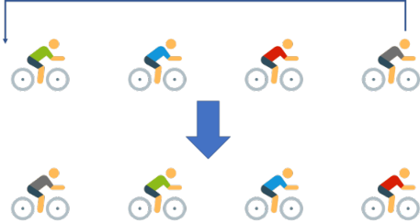
Figure 14: The strategy of Draft
图 14：跟骑策略
— 原文第 21 页 —
So when and where to "draft" is a key decision in team time trials. So, we define a discretevalued function to represent the replacement case:
因此，何时、何地“跟骑”是团体计时赛中的关键决策。于是，我们定义一个离散取值函数来表示换位情形：
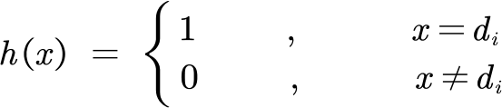
(16)
where, d_{i} is the position that needs to be drafted in the schedule.
其中，d_{i} 为赛程中需要进行跟骑换位的位置。
This function provides a new decision variable, and we can find the optimal solution through more complex dynamic programming.
该函数提供了一个新的决策变量，我们可以通过更复杂的动态规划求得最优解。
In addition, since the competition is based on the performance of the fourth team member, we can combine the different abilities of different team members and discard the weak players at certain points during the march to obtain better results.
此外，由于比赛成绩以第四名队员的表现计算，我们可以结合不同队员的能力差异，在行进途中某些时点舍弃能力较弱的队员，以获得更好的成绩。
There are more strategies in team time trials. In order to highlight the goal, we only select a representative strategy to simplify the decision. We can also consider that the rider who was at the front of the team does not move to the tail, but exchanges positions with the second rider or returns to other positions other than the tail of the team. This can also be modified according to the different ability levels of different riders.
团体计时赛中还有更多策略。为突出目标，我们仅选取一种有代表性的策略以简化决策。我们也可以考虑，原本位于车队前方的车手不移至队尾，而是与第二名车手交换位置，或回到队尾之外的其他位置。这同样可以根据不同车手的能力水平加以调整。
In the team time trials, based on our previous model, we can consider more constraints and decision variables, and propose an improved model to solve with more complex dynamic programming. Due to space limitations, the solution process of the model is not described here.
在团体计时赛中，基于此前的模型，我们可以考虑更多的约束条件与决策变量，并提出改进模型，以更复杂的动态规划求解。受篇幅所限，此处不再赘述模型的求解过程。
8 Conclusion
8 结论
In this paper, we establish a model suitable for various types of riders to analyze the relationship between the power that the rider should apply and the position of the race, and give the optimal power distribution strategy.
本文建立了一个适用于各类车手的模型，用以分析车手应施加的功率与比赛位置之间的关系，并给出最优功率分配策略。
First, we established aerobic and anaerobic energy fatigue models. On this basis, we quantitatively give power curves for different rider types and genders, and use model parameters to define different types and genders of cyclists.
首先，我们建立了有氧与无氧能量疲劳模型。在此基础上，我们定量给出了不同车手类型与性别的功率曲线，并用模型参数界定不同类别与性别的自行车运动员。
Secondly, we consider the force of the rider, the slope of the track and the cornering situation, and combine the power curve of the player to establish Optimal Individual Power Distribution Model. We used dynamic programming to obtain the optimal power distribution diagram for different cyclists. In addition, we also give the characteristics of different players' adaptability to different track environments, such as slopes and corners, and calculated their shortest time.
其次，我们考虑车手的受力、赛道坡度与转弯情形，并结合车手的功率曲线，建立了最优个体功率分配模型。我们运用动态规划得到了不同自行车运动员的最优功率分配图。此外，我们还给出了不同车手对坡度、弯道等不同赛道环境的适应特性，并计算了其最短用时。
Thirdly, we take into account wind direction and speed to make corrections to the model, and perform a sensitivity analysis for weather conditions. We found that a 1m/s change in wind speed resulted in a change of no more than 10% in the results, and a 45-degree change in wind direction caused a change in the results by no more than 16%. So, we think our model is more sensitive to wind direction and wind speed. We also investigated the sensitivity of the model to deviation of the power distribution, only to find that our model is not sensitive to the deviation. Then we gave the acceptable range of deviation.
再次，我们计入风向与风速对模型进行修正，并针对天气条件开展灵敏度分析。我们发现，风速变化 1m/s 引起的结果变化不超过 10%，风向变化 45 度引起的结果变化不超过 16%。因此，我们认为模型对风向与风速较为敏感。我们还考察了模型对功率分配偏差的灵敏度，结果发现模型对该偏差并不敏感。随后我们给出了可接受的偏差范围。
Finally, we consider the effect of wind resistance on the team and generalize the individual time trial model to the team time trial model. We give considerations about draft and drop strategies. And at the end of the paper, we provide a race guide for rider and the Directeur.
最后，我们考虑风阻对车队的影响，并将个人计时赛模型推广到团体计时赛模型。我们给出了关于跟骑与掉队策略的考虑。并在文末为车手与车队经理提供了比赛指南。
— 原文第 22 页 —
Men Elite Individual Time Trial Guidance
男子精英个人计时赛指导
—— 2021 UCI World Championships in Flanders, Belgium
—— 2021 年比利时弗兰德斯 UCI 世界锦标赛
1. Analysis of the Race Track and Weather
1. 赛道与天气分析
The competition takes place in the Belgian province of Flanders. Riders need to travel from Knokke Heist to Bruges in northern Belgium.
比赛在比利时弗兰德斯省举行。车手需从克诺克-海斯特（Knokke Heist）骑行至比利时北部的布鲁日。
The height fluctuation of the race track is shown in figure 1. The total length of the track is 43.3 kilometers, the average altitude is 15m, the range is 15m, and the standard deviation is only 3m. The track is flat and is more suitable for Flat Time Trial Specialist.
赛道的高程起伏如图 1 所示。赛道总长为 43.3 千米，平均海拔为 15m，高差为 15m，标准差仅为 3m。赛道平坦，更适宜平路个人计时赛专精型车手（Flat Time Trial Specialist）。
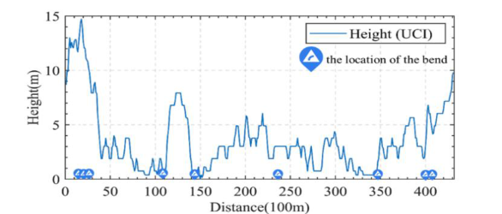
Figure 1: Elevation map of the track
图 1：赛道高程图
The track has 7 sharp turns, which are 1.5km, 2.4km, 2.7km, 11.2km, 14.3km, 17.6km and 27.6km. NOTE: Riders need to slow down early when going through these corners. It is recommended to control the speed below 10m/s to avoid rushing out of the track.
赛道共有 7 个急弯，分别位于 1.5km、2.4km、2.7km、11.2km、14.3km、17.6km 和 27.6km 处。注：车手通过上述弯道时需提前减速。建议将速度控制在 10m/s 以下，以免冲出赛道。
According to the Zeebrugge Weather Observatory data provided by NOAA, the wind direction is 50° north by east at 16:00, on the day of the competition, that is, on September 19, 2021. The wind speed is 2m/s. It is downwind. The effect of wind on performance is about 1%, about ±10s.
根据 NOAA 提供的泽布吕赫（Zeebrugge）气象观测站数据，比赛当日即 2021 年 9 月 19 日 16:00 的风向为北偏东 50°。风速为 2m/s，为顺风。风对成绩的影响约为 1%，即约 ±10s。
2. Analysis of the Cyclist's Profile
2. 车手特征分析
Based on the given rider data, the rider's power curve can be obtained and is listed in figure 2. His FTP is 4.79W/kg, so his aerobic respiration can provide high power efficiency. His total anaerobic energy is 56.28J/Kg, so his anaerobic respiration has poor short-term power efficiency. That means his staying power is good, but his short-term explosiveness is poor. He's the quintessential Flat Time Trial Specialist. He is more suitable for riding on flat terrain with few hills, which is in line with the characteristics of the track. Below is his power curve.
根据给定的车手数据，可得到该车手的功率曲线，如图 2 所示。其功能性阈值功率（FTP）为 4.79W/kg，因此其有氧呼吸能够提供较高的功率效率。其无氧总能量为 56.28J/Kg，因此其无氧呼吸的短时功率效率较差。这表明其耐力较好，但短时爆发力较差。他是典型的平路个人计时赛专精型车手。他更适合在丘陵较少的平坦地形上骑行，这与赛道特征相符。其功率曲线如下。
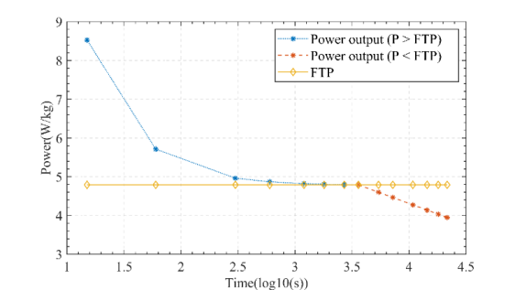
Figure 2: The power curve of a Time Trial Specialist
图 2：个人计时赛专精型车手的功率曲线
— 原文第 23 页 —
3. Overview of the Directions
3. 指导方向概述
By comprehensively analyzing the track model and the player's model, we can obtain the recommended power-distance distribution diagram for this rider who wants to achieve the best results. The P-D diagram is shown in Figure 3 below.
综合赛道模型与车手模型，可得到该车手为取得最佳成绩所推荐的功率—距离分布图。P-D 图如下图 3 所示。
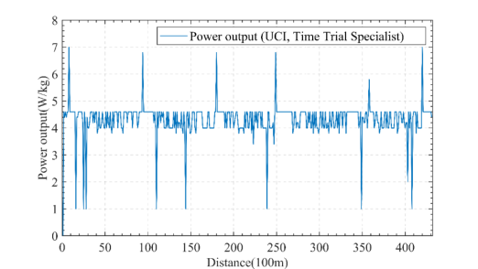
Figure 3: The P-D diagram
图 3：P-D 图
As can be seen, there are several key nodes that require more force to accelerate. Besides, there are also nodes that need to reduce power to restore stamina, including reducing power in downhill positions, and before sharp turns. The rider recommended to increase the output power at x=1km, 9.6km, 17.8km and other positions to complete the acceleration; while at x=1.6km, 2.7km and other positions to reduce power output to about 1W/kg. The rest of the time, try to maintain near the FTP, that is, the maximum value of aerobic respiration.
可以看出，存在若干需要加大发力以完成加速的关键节点。此外，也存在需要降低功率以恢复体力的节点，包括下坡位置以及急弯之前。建议车手在 x=1km、9.6km、17.8km 等位置提高输出功率以完成加速；而在 x=1.6km、2.7km 等位置将输出功率降至约 1W/kg。其余时间尽量维持在 FTP 附近，即有氧呼吸的最大值。
Completing the entire track according to this curve can optimize the performance of the players, and the estimated finishing time is 3499s (58m 19s).
按照该曲线完成整个赛道可优化车手表现，预计完赛时间为 3499s（58m 19s）。
However, it is impossible to highly detailed follow the above power distribution. Small deviations in power output still yield near-optimal results. So, we provide acceptable time frames for riders to reach some positions, part of which are shown in the table below. As long as the range of players arriving at these positions is within the Max Time and Min Time, the final finishing time can be no later than 57h 19s , 1min later than the optimal time.
然而，完全严格地遵循上述功率分配是不现实的。输出功率的小幅偏差仍可获得接近最优的结果。因此，我们给出了车手到达某些位置的容许时间区间，其中一部分如下表所示。只要车手到达这些位置的时间处于 Max Time 与 Min Time 之间，最终完赛时间就不晚于 57h 19s，即比最优时间晚 1min。
Table 1: Time constraints
表 1：时间约束
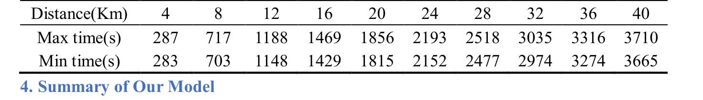
Our model starts from studying the aerobic and anaerobic respiration of the rider and determines the relationship between energy expenditure and power output. The model depicts the rider's energy profile, which is expressed externally as a power curve. For any given track, we simulate the relationship between the rider state and various resistances on the track. When combining the above models, we use dynamic programming to obtain the relationship between optimal output power and track position, which has great reference value for the rider. The best results are achieved as long as the rider performs for the given power output. In order to reduce the difficulty of the players' execution, we provide a relatively loose reference time, which can get close to the best results.
我们的模型从研究车手的有氧与无氧呼吸出发，确定能量消耗与输出功率之间的关系。该模型刻画了车手的能量特征，并在外部表现为功率曲线。对于任意给定赛道，我们模拟车手状态与赛道上各种阻力之间的关系。在结合上述模型时，我们采用动态规划得到最优输出功率与赛道位置之间的关系，这对车手具有重要的参考价值。只要车手按给定的输出功率执行，即可取得最佳成绩。为降低车手的执行难度，我们提供了相对宽松的参考时间，同样可以接近最佳成绩。
— 原文第 24 页 —
References
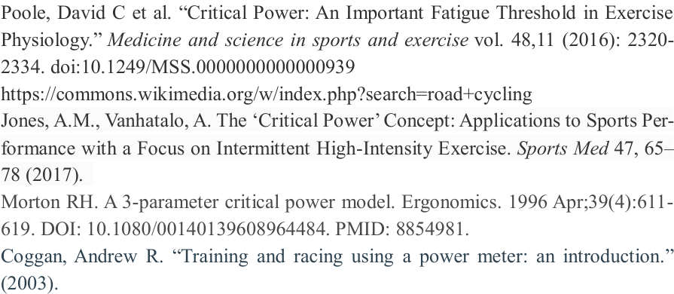
[1]. Poole, David C et al. “Critical Power: An Important Fatigue Threshold in Exercise Physiology.” Medicine and science in sports and exercise vol. 48,11 (2016): 23202334. doi:10.1249/MSS.0000000000000939 [2]. https://commons.wikimedia.org/w/index.php?search=road+cycling [3]. Jones, A.M., Vanhatalo, A. The ‘Critical Power’ Concept: Applications to Sports Performance with a Focus on Intermittent High-Intensity Exercise. Sports Med 47, 65– 78 (2017).
[4]. Morton RH. A 3-parameter critical power model. Ergonomics. 1996 Apr;39(4):611619. DOI: 10.1080/00140139608964484. PMID: 8854981.
[5]. Coggan, Andrew R. “Training and racing using a power meter: an introduction.” (2003).
[6]. Monod, H., & Scherrer, J. (1965). The work capacity of a synergic muscular group. Ergonomics, 8(3), 329-338.
[7]. Morton, R. H. (1986). A three component model of human bioenergetics. Journal of mathematical biology, 24(4), 451-466.
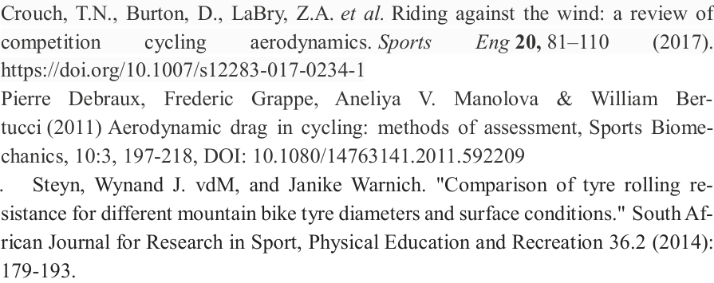
[8]. Crouch, T.N., Burton, D., LaBry, Z.A. et al. Riding against the wind: a review of Eng 20, 81–110 (2017). https://doi.org/10.1007/s12283-017-0234-1 [9]. Pierre Debraux, Frederic Grappe, Aneliya V. Manolova & William Bertucci (2011) Aerodynamic drag in cycling: methods of assessment, Sports Biomechanics, 10:3, 197-218, DOI: 10.1080/14763141.2011.592209
Steyn, Wynand J. vdM, and Janike Warnich. "Comparison of tyre rolling resistance for different mountain bike tyre diameters and surface conditions." South African Journal for Research in Sport, Physical Education and Recreation 36.2 (2014): 179-193.
[11].https://www.ncei.noaa.gov/products/land-based-station/integrated-surface-database.
— 原文第 25 页 —
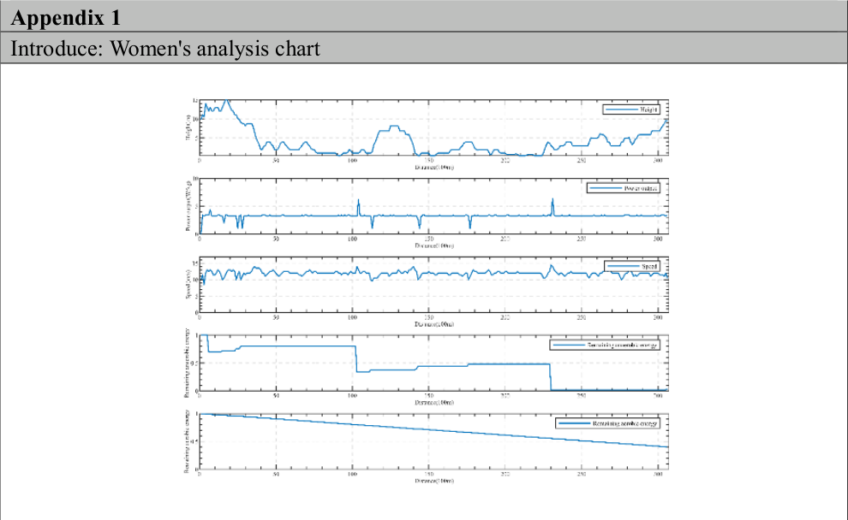
Introduce: Women's analysis chart
1.UCI Women's track map 2.Women’s power output 3.Women’s speed
4.5.Women’s Remaining aerobic and anaerobic energy
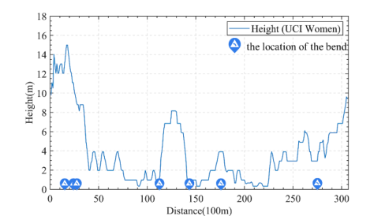
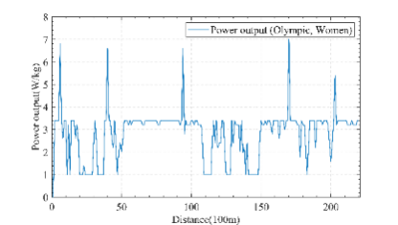
UCI Women's track map
Women’s power output of Olympics
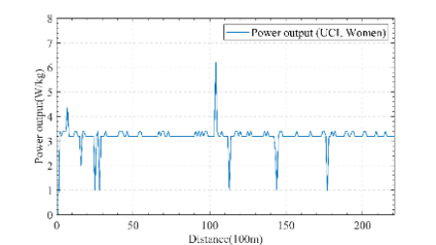
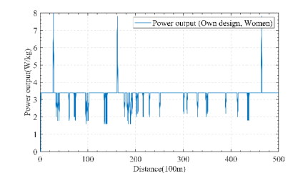
Women’s power output of UCI
Women’s power output of own design
（全文完。公式与表格在原 PDF 中是矢量图形，未纳入本对照版；可按文中「原文第 N 页」标记翻到 2209466.pdf 对照查看。）

