2200084 英中对照版
2022 MCM Problem B · A Model for Better Use of Water Resources Based on Marginal Utility and Auction Theory
读法：黑字为原文，蓝字为译文，一段英文一段中文，上下对应；蓝字里的小字括号是该术语第一次出现时的英文原词。
术语表（按首次出现排序，18 条）
# | 英文 | 中文 | 说明：为什么容易译错
1 | Marginal Utility | 边际效用 | 每增一单位资源的效用增量
2 | Resources Allocation Network (RAN) | 资源分配网络 | 模型一：水与电的网络流
3 | Lake Mead | 米德湖 | 下游水库，胡佛坝以上
4 | Lake Powell | 鲍威尔湖 | 上游水库，格伦峡谷坝以上
5 | hydropower | 水电 | 下泄水流发电
6 | linear programming | 线性规划 | 目标与约束均线性的优化
7 | Time-varying Linear Optimization Algorithm | 时变线性优化算法 | 模型一的逐日滚动算法
8 | utility function | 效用函数 | 资源量映射为满足程度
9 | Auction Theory | 拍卖理论 | 模型三借用的经济学工具
10 | independent private value (IPV) | 独立私人价值 | 估值私有且相互独立
11 | Pareto optimum | 帕累托最优 | 无法再无损改进的配置
12 | Generalized Backwards-Shooting (BS) Algorithm | 广义反向射击算法 | 由终点条件反推初值
13 | conservation equation | 守恒方程 | 入流−出流−蒸发＝蓄量变化
14 | reservoir | 水库 | 本文研究对象
15 | drought | 干旱 | 美国西南部持续缺水
16 | penalty mechanism | 惩罚机制 | 超额用水用电的加价
17 | flow direction | 流向 | 五州间水与电的输送方向
18 | sustainability | 可持续性 | 不损害后续年份的供水

目录（Contents）
页码为原 PDF 页码，可按正文中的「— 原文第 N 页 —」定位。
1 引言（Introduction） 2
1.1 研究背景（Background） 2
1.2 问题重述与分析（Problem Restatement and Analysis） 2
1.3 本文工作概览（Overview of our work） 3
2 模型假设（Assumptions） 4
3 符号说明（List of Notation） 4
4 科罗拉多河水资源配置网络（A Resources Allocation Network of River Colorado） 4
4.1 配置网络的求解：伪代码（Solution for the Allocation Network: A Pseudo-Code） 8
4.2 结果与分析（Results and Analysis） 9
5 边际效用模型：各州的资源利益与价值评估（Marginal Utility Model: Resources Interests and Valuation of Each State） 11
6 竞争性利益下的拍卖理论：独立私人价值（IPV）模型（Auction Theory for Competing Interests: Independent Private Value (IPV) Model） 12
6.1 独立私人价值（IPV）模型的求解（Solution of the Independent Private Value (IPV) Model） 14
6.2 结果与分析——模型对更复杂情形的处理（Results and Analysis –Our Model Dealing with More Complex Situations 17） 15
7.1 受影响地区的发展与萎缩（Growth or Shrinkage in Affected Areas） 17
7.2 可再生能源技术占比的提升（Increase of the Proportion of Renewable Energy Technologies） 17
7.3 节水与节电措施（Water and Electricity Conservation Measures） 18
8 讨论（Discussion） 19
8.1 优缺点（Strengths and Weaknesses） 19
8.1.1 优点（Strengths） 19
8.1.2 缺点（Weaknesses） 19
8.2 未来工作（Future Work） 19
9 结论（Conclusion） 20

A Model for Better Use of Water Resources Based on
一个更好地利用水资源的模型——基于
Marginal Utility and Auction Theory
边际效用与拍卖理论
Summary
摘要
With the intensification of drought in southwestern United States during the past 20 years, Lake Mead and Lake Powell, as important water suppliers, are facing water shortage. To solve a series of problems of optimizing water resources allocation, here are three models.
随着过去 20 年美国西南部干旱（drought）的加剧，作为重要供水者的米德湖（Lake Mead）和鲍威尔湖（Lake Powell）正面临缺水。为解决优化水资源分配的一系列问题，这里给出三个模型。
For Model 1, the whole process of resources allocation carefully simulated, we propose a Resources Allocation Network(RAN) of water availability and electricity requirements. In the case of sufficient resources but without the additional water, the allocation problem is transformed into a linear programming problem. Then the corresponding algorithm (Time-varying Linear Optimization Algorithm) is designed to solve this problem efficiently. The results of the optimization show that the Allocation Network can last for 21 days without the additional water with the allocation plan of the five states.
对于模型一，在仔细模拟资源分配全过程的基础上，我们提出了一个水资源可用量与电力需求的资源分配网络（Resources Allocation Network）（RAN）。在资源充足但没有额外水资源的情况下，分配问题被转化为一个线性规划（linear programming）问题。随后设计了相应的算法（时变线性优化算法（Time-varying Linear Optimization Algorithm））以高效求解该问题。优化结果表明，在没有额外水资源的情况下，按照五个州的分配方案，该分配网络可以维持 21 天。
For Model 2, to measure the scarcity of general usage water and hydropower as well as evaluate the value of resources brought to each state when making a decision, we introduce the notion of Marginal Utility in economics and set up the I_{i} function, the Utility_{i} function and the V alue_{i} function (i = 1, 2, · · · , 5) , the important basis of the Model 3 (IPV model), to quantify the competing interests of water availability and electricity production.
对于模型二，为了度量一般用水与水电（hydropower）的稀缺程度，并评估在做决策时资源给每个州带来的价值，我们引入经济学中的边际效用（Marginal Utility）概念，建立 Ii 函数、Utilityi 函数和 Valuei 函数（i = 1, 2, · · · , 5），它们是模型三（IPV 模型）的重要基础，用于量化水资源可用量与电力生产之间的利益竞争。
For Model 3, considering the situation of inadequate water resources and hydropower, we innovatively introduce the Auction Theory to try our utmost to close to the optimal of the allocation, namely Pareto optimum. Thus the independent Private Value (IPV) Model was proposed and it can be solved out by the Generalized Backwards-Shooting (BS) Algorithm. Based on the V alue_{i} function (i = 1, 2, · · · , 5) proposed by the Marginal Utility model, the allocation scheme proposed by the IPV model is better than the Resources Allocation Network (Model 1), and the calculation results show that the scheme is more economical and more sustainable.
对于模型三，考虑到水资源与水电不足的情形，我们创新性地引入拍卖理论（Auction Theory），力求尽可能接近分配的最优，即帕累托最优（Pareto optimum）。由此提出了独立私人价值（independent private value）（IPV）模型，并可用广义反向射击（BS）算法求解。基于边际效用模型提出的 Valuei 函数（i = 1, 2, · · · , 5），IPV 模型给出的分配方案优于资源分配网络（模型一），计算结果表明该方案更经济、更具可持续性（sustainability）。
Then we deal with more complex situations with our models and give detailed descriptions about the whole principle. At the same time, we did sensitivity analysis for the models and the robustness of the models is verified. In order to meet the needs of the model, we finally give a specific rule for calculating the amount of fine to promote water and electricity conservation measures for citizens and businesses.
随后我们用模型处理更复杂的情形，并对整个原理给出详细说明。同时，我们对模型进行了敏感性分析，并验证了模型的稳健性。为满足模型的需要，我们最终给出了计算罚款金额的具体规则，以促进公民和企业采取节水节电措施。
By careful analysis of the strengths and weaknesses, we further suggest possible future work and make a conclusion.
通过仔细分析优缺点，我们进一步提出未来可能的工作并作出结论。
Keywords: Resource Allocation Network(RAN); Linear Programming; Marginal Utility; Auction Theory; Marginal Utility; Independent Private Value (IPV) Model;
关键词：资源分配网络（RAN）；线性规划；边际效用；拍卖理论；边际效用；独立私人价值（IPV）模型；
— 原文第 3 页 —
1 Introduction
1 引言
1.1 Background
1.1 背景
According to historical research, the reservoir was first built around 600 BC. With the development of science and technology, the function of reservoirs has gradually expanded to irrigating farmland, supplying domestic water, preventing floods and developing hydropower to help maintain people’s normal life.
据历史研究，水库（reservoir）最早建于约公元前 600 年。随着科学技术的发展，水库的功能逐渐扩展到灌溉农田、供给生活用水、防洪以及开发水电，以帮助维持人们的正常生活。
However, because of the deterioration of the ecological environment in recent years, in some areas, people face a serious shortage of water resources in their daily life. In 2021, the United States suffered a severe drought. As the important source of water supply for the western, the water levels of the Lake Mead and Lake Powell were declining, creating a new historical low. Take Lake Mead as an example. In the past two decades, the water storage of the Lake Mead has always been lower than its normal volumetric capacity, and the current water storage is only 34%. The water level of Lake Mead also dropped to about 1067 feet, approaching the minimum power generation level of 950 feet of Hoover Dam. [1].
然而，由于近年来生态环境的恶化，在一些地区，人们在日常生活中面临严重的水资源短缺。2021 年，美国遭遇了严重干旱。作为西部重要的供水来源，米德湖和鲍威尔湖的水位持续下降，创下新的历史低点。以米德湖为例。在过去二十年中，米德湖的蓄量一直低于其正常库容，目前的蓄量仅为 34%。米德湖的水位也降至约 1067 feet，接近胡佛坝 950 feet 的最低发电水位。[1]。
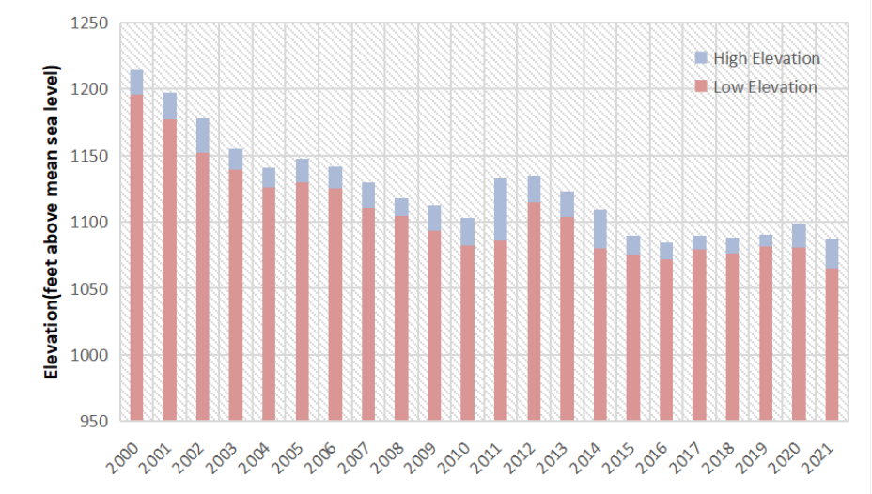
Figure 1: A Fact: Lake Mead Annual High and Low Elevations 2000-2021
图 1：一个事实：2000-2021 年米德湖年最高与最低高程
图中文字对照（英文 → 中文）
High Elevation | 高水位 | Low Elevation | 低水位
Elevation (feet above mean sea level) | 海拔（英尺，以平均海平面起算）
Short-term water saving and electricity saving can only alleviate a temporary shortage of water. Therefore, how to allocate and utilize water resources has become an urgent problem to be solved. This is also the problem to be solved by our model.
短期节水节电只能缓解暂时的缺水。因此，如何分配和利用水资源已成为亟待解决的问题。这也是我们的模型所要解决的问题。
1.2 Problem Restatement and Analysis
1.2 问题重述与分析
• Problem One: Establish a model to calculate how much water needs to be pumped from those two lakes to meet the demand under the conditions that the water level of Lake Meade is M, the water level of Lake Powell is P, and the demand of water is fixed. Besides, how long the the first model can lasts and how much additional water are needed to meet the fixed
• 问题一：在米德湖水位为 M、鲍威尔湖水位为 P、且用水需求固定的条件下，建立一个模型，计算需要从这两个湖抽取多少水以满足需求。此外，第一个模型能维持多久，以及需要多少额外水量才能满足固定的
— 原文第 4 页 —
demand.
需求。
• Problem Two: A standard for dealing with competition is formulated in advance, and then how to allocate general usage water and hydropower usage water when there is interest competition.
• 问题二：预先制定处理竞争的标准，然后确定在存在利益竞争时如何分配一般用水与水电用水。
• Problem Three: The model needs to include practices when water is not enough which means supply quantity is less than demand.
• 问题三：模型需要包含水量不足（即供给量小于需求）时的做法。
• Problem Four: The models are able to respond to these situations, including the relevant factors in affected areas change, the proportion of other renewable energy increases, and water-saving and electricity-saving are taken.
• 问题四：模型能够对这些情形作出响应，包括受影响地区的相关因素发生变化、其他可再生能源比例上升，以及采取节水节电措施。
• An Article:Write an article which wii be published in the journal Drought and Thirst to illustrate the results of the model.
• 一篇文章：撰写一篇将在《干旱与干渴》（Drought and Thirst）期刊上发表的文章，以说明模型的结果。
1.3 Overview of our work
1.3 本文工作概述
To avoid complicated description , intuitively reflect our work process, the flow chart is show as the following figure:
为避免繁琐的描述、直观反映我们的工作流程，流程图如下图所示：
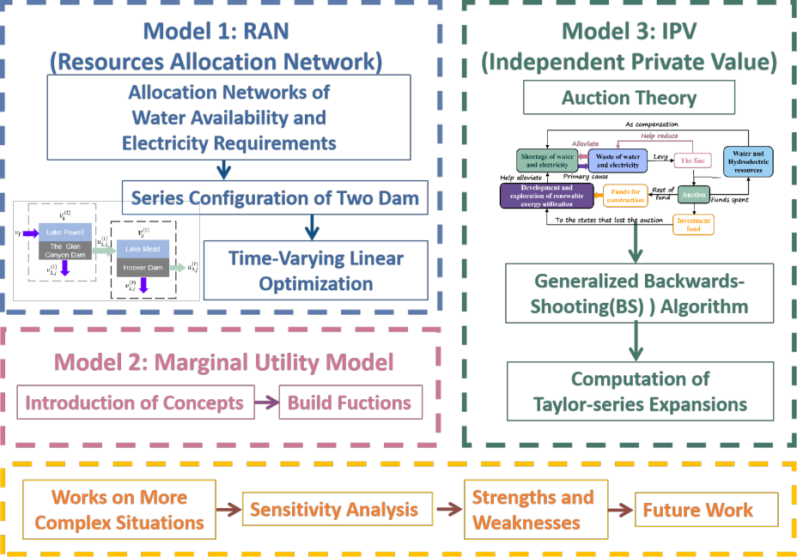
Figure 2: The Framework of Our Work
图 2：本文工作的框架
图中文字对照（英文 → 中文）
Model 1: RAN (Resources Allocation Network) | 模型一：RAN（资源分配网络） | Allocation Networks of Water Availability and Electricity Requirements | 可用水量与电力需求的分配网络
Series Configuration of Two Dam | 两座大坝的串联结构 | Time-Varying Linear Optimization | 时变线性优化
Model 2: Marginal Utility Model | 模型二：边际效用模型 | Introduction of Concepts | 概念引入
Build Fucntions | 构造函数 | Model 3: IPV (Independent Private Value) | 模型三：IPV（独立私人价值）
Auction Theory | 拍卖理论 | Generalized Backwards-Shooting(BS) Algorithm | 广义反向射击（BS）算法
Computation of Taylor-series Expansions | 泰勒级数展开的计算 | Works on More Complex Situations | 处理更复杂的情形
Sensitivity Analysis | 灵敏度分析 | Strengths and Weaknesses | 优缺点
Future Work | 未来工作 | Shortage of water and electricity | 水与电的短缺
Waste of water and electricity | 水与电的浪费 | Water and Hydroelectric resources | 水资源与水电资源
Development and exploration of renewable energy utilization | 可再生能源的开发利用 | Funds for construction | 建设资金
Investment fund | 投资基金 | The fine | 罚款
Auction | 拍卖 | Alleviate / Help reduce / As compensation | 缓解 / 帮助减少 / 作为补偿
Primary cause / Levy / Rest of fund / Funds spent | 主要原因 / 征收 / 剩余资金 / 资金支出 | To the states that lost the auction | 给未中标各州
— 原文第 5 页 —
2 Assumptions
2 假设
• Assumption 1: All water in Lake Mead and Lake Powell is used for general usage and hydropower production only.
• 假设 1：米德湖与鲍威尔湖中的全部水量仅用于一般用途与水电生产。
• Assumption 2: Both water and hydropower for Arizona, California, Colorado, New Mexico and Wyoming all come from the Hoover Dam and the Glen Canyon Dam.
• 假设 2：亚利桑那州、加利福尼亚州、科罗拉多州、新墨西哥州和怀俄明州的水与水电均来自胡佛坝和格伦峡谷坝。
• Assumption 3: In the calculation of water consumption in the five states involved, public supply and domestic are classified as residental, irrigation, aquaculture and livestock as agricultural, industrial, thermal power and mining as industry. When it comes to hydropower, commercial and residential are classified as residential, five percent of industry as agriculture, and the rest part of industry and transportation as industry.
• 假设 3：在计算所涉及五个州的用水量时，公共供水与生活用水归为居民用水，灌溉、水产养殖与牲畜用水归为农业用水，工业、火电与采矿用水归为工业用水。在水电方面，商业与居民用电归为居民用电，工业用电的 5% 归为农业用电，工业用电的其余部分与交通用电归为工业用电。
• Assumption 4: The loss of water and electricity during transport is proportional to the transporting distance.
• 假设 4：水与电在输送过程中的损失与输送距离成正比。
• Assumption 5: To simplify the calculation, take the lake as a cylindrical container.
• 假设 5：为简化计算，将湖泊视为圆柱形容器。
• Assumption 6: On the way of water flowing from Lake Powell to Lake Mead, the effects of tributaries are not taken into account solely, because the river has much more mainstream water than tributaries.
• 假设 6：在从鲍威尔湖流向（flow direction）米德湖的过程中，不单独考虑支流的影响，因为干流水量远多于支流。
3 List of Notation
3 符号说明
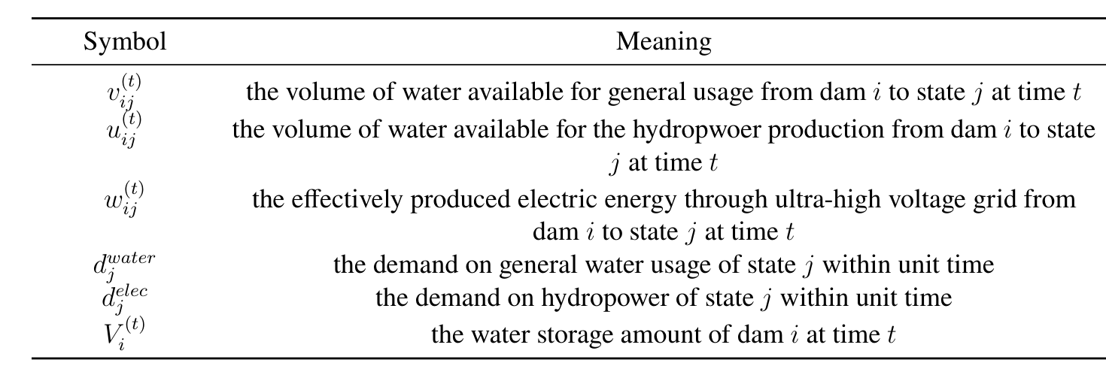
Table 1: The List of Notation
表 1：符号说明
Notice: The index i = 1, 2 refers to the Glen Canyon Dam and the Hoover Dam respectively. And the index j = 1, 2, 3, 4, 5 refers to state Arizona, California, Wyoming, New Mexico and Colorado respectively.
注：指标 i = 1, 2 分别指格伦峡谷坝与胡佛坝。而指标 j = 1, 2, 3, 4, 5 分别指亚利桑那州、加利福尼亚州、怀俄明州、新墨西哥州和科罗拉多州。
4 A Resources Allocation Network of River Colorado
4 科罗拉多河的资源分配网络
The flow direction map of the River Colorado is shown in the following figure [3]. In the map, locations of two dams (the Glen Canyon Dam, the Hoover Dam) and two lakes (Lake Powell, Lake Mead) are clearly marked. For a dam, the direction of water flows that we care about are the
科罗拉多河的流向图如下图所示 [3]。图中清晰标出了两座大坝（格伦峡谷坝、胡佛坝）与两个湖泊（鲍威尔湖、米德湖）的位置。对于一座大坝而言，我们所关心的水流方向是
— 原文第 6 页 —
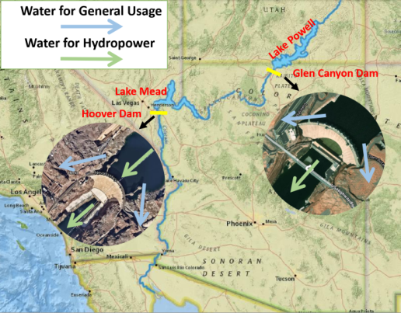
Figure 3: Flow Direction Map of River Colorado: (a) the blue arrow indicates that some water resources are used for agricultural, industrial and residential, (b) while the green arrow indicates that some water resources are used for power generation and flood discharge.
图 3：科罗拉多河流向图：(a) 蓝色箭头表示部分水资源用于农业、工业与居民用水；(b) 绿色箭头表示部分水资源用于发电与泄洪。
图中文字对照（英文 → 中文）
Water for General Usage | 一般用水 | Water for Hydropower | 发电用水
Lake Mead | 米德湖 | Hoover Dam | 胡佛坝
Glen Canyon Dam | 格伦峡谷坝 | Colorado River | 科罗拉多河
direction of water for general usage and the direction of water for hydropower, as you can see below figure [3].
一般用途用水方向与水电用水方向，如下图所示 [3]。
Since there exist inevitable natural loss and consumption in the process of water transportation and hydropower, we introduce transportation rate to measure the transmission efficiency from dam i to state j, namely the percentage of successful transmission. If not specifically mentioned in the following article, the transportation rate is defined as above.[4]
由于水的输送与水电生产过程中存在不可避免的自然损失与消耗，我们引入输送率来度量从大坝 i 到州 j 的输送效率，即成功输送的百分比。若下文未特别说明，输送率均按上述定义。[4]
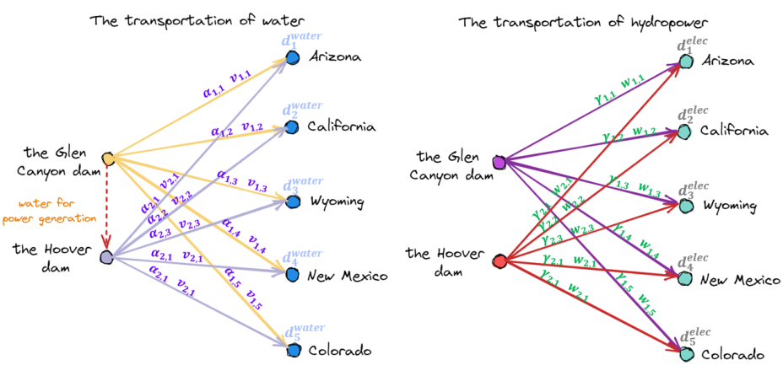
Figure 4: Allocation Networks of Water Availability And Electricity Requirements
图 4：可用水量与电力需求的分配网络
图中文字对照（英文 → 中文）
The transportation of water | 水的输送 | The transportation of hydropower | 水电的输送
the Glen Canyon dam | 格伦峡谷坝 | the Hoover dam | 胡佛坝
water for power generation | 发电用水 | Arizona | 亚利桑那州
California | 加利福尼亚州 | Wyoming | 怀俄明州
New Mexico | 新墨西哥州 | Colorado | 科罗拉多州
alpha, v (yellow) | 输水系数 α 与输水量 v（黄色箭头） | gamma, w (purple) | 输电系数 γ 与输电量 w（紫色箭头）
Let v^{(t)}ij be the volume of water available for general usage from dam i to state j and let α^{ij} be
设 v(t)ij 为从大坝 i 可供州 j 一般用途的水量，并设 αij 为
— 原文第 7 页 —
the transportation rate, we get the following conservation equation.
输送率，则得到如下守恒方程（conservation equation）。
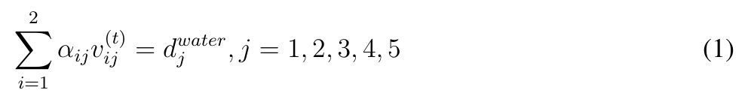
It guarantees that the total amount of v^{(t)}ij transported to state j meets state j’s water demand . The same is true for electricity. Let w^{(t)}d^{water}ij be the effectively produced electric energy through jultra-high voltage grid from dam i to state j and let γ_{ij} be the transportation rate, we derive the identity equation of electric quantity as follows.
它保证输送到州 j 的 v(t)ij 总量满足州 j 的用水需求。电力也是如此。设 w(t)ij 为由大坝 i 经特高压电网输送到州 j 的有效发电量，并设 γij 为输送率，则得到如下电量恒等式。
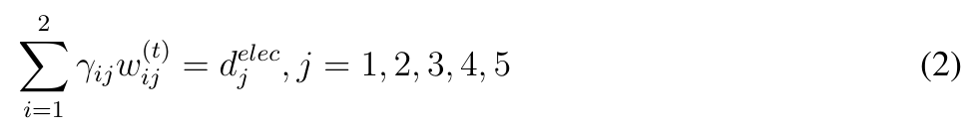
To update volume parameter V^{(t)}for Lake Powell to V^{t+1}, we need the following iterative 1
为将鲍威尔湖的蓄量参数 V (t)1 更新为 V (t+1)1，需要如下迭代
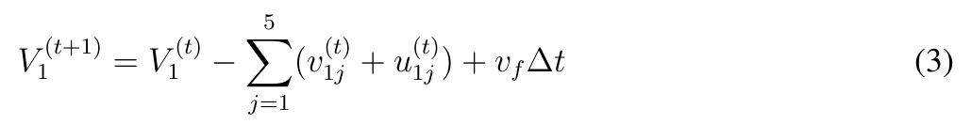
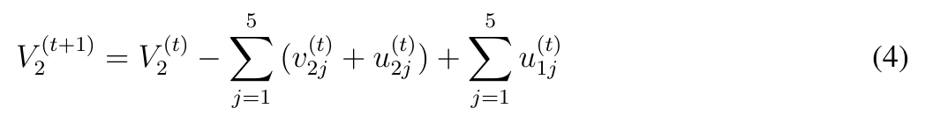
The specific process is shown below (figure [5]).
具体过程如下图所示（图 [5]）。
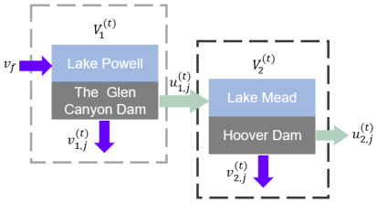
Figure 5: Series Configuration of Two Dams
图 5：两座大坝的串联结构
图中文字对照（英文 → 中文）
Lake Powell | 鲍威尔湖 | Lake Mead | 米德湖
The Glen Canyon Dam | 格伦峡谷坝 | Hoover Dam | 胡佛坝
v, u | 水量与水头
In order to simplify the model and make it easy to be solved, the model of reservoirs is abstracted as a cylinder and the water level h^{(t)}at time t can be calculated by the cylinder volume formula. i
为简化模型并使其易于求解，将水库模型抽象为圆柱体，t 时刻的水位 h(t)i 可由圆柱体积公式计算。
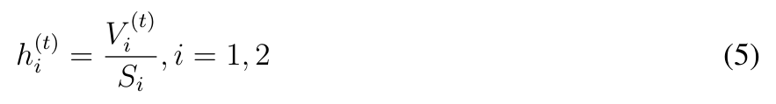
— 原文第 8 页 —
Where S_{i} represents for the base area of the lake.
其中 Si 表示湖泊的底面积。
Then, we should further consider how u_{ij} (the amount of water utilized to generate electricity) which is converted to w^{(t)}ij (the amount of electric energy effectively converted from the potential energy) by a generator.
然后，我们应进一步考虑 uij（用于发电的水量）如何由发电机转换为 w(t)ij（由势能有效转换而来的电能）。
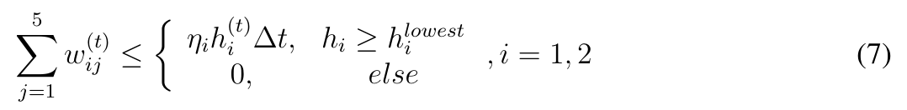
What’s more, in order to save energy, we should reduce v^{(t)}ij and u^{(t)}ij as much as possible.
此外，为节约能源，我们应尽可能减小 v(t)ij 与 u(t)ij。
Taking all the factors above into account, we obtain the following optimization problem by considering the formulas Eq (1)(2)(3)(4)(5)(6)(7).
综合考虑上述所有因素，并结合式(1)(2)(3)(4)(5)(6)(7)，我们得到如下优化问题。
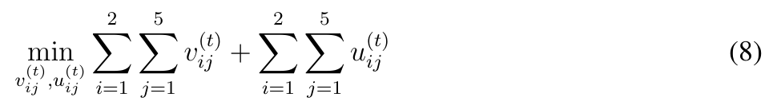
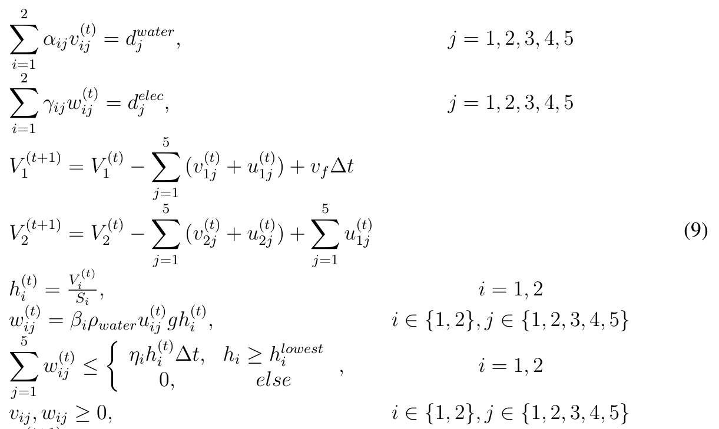
≥0,i = 1, 2
i
— 原文第 9 页 —
4.1 Solution for the Allocation Network: A Pseudo-Code
4.1 分配网络的求解：伪代码
The problem Eq(8)(9) is a time-varying linear optimization problem. Therefore, our algorithm idea is to use an iterative method, in which we optimize the water and hydropower allocation of the network in the (t) step. The following is the pseudo-code (Algorithm [1]) for this stage, which gives a good representation of the entire code flow.
问题式(8)(9)是一个时变线性优化问题。因此，我们的算法思路是采用迭代方法，在其中对网络在第 (t) 步的水与水电分配进行优化。以下是该阶段的伪代码（算法 [1]），它很好地展示了整个代码流程。
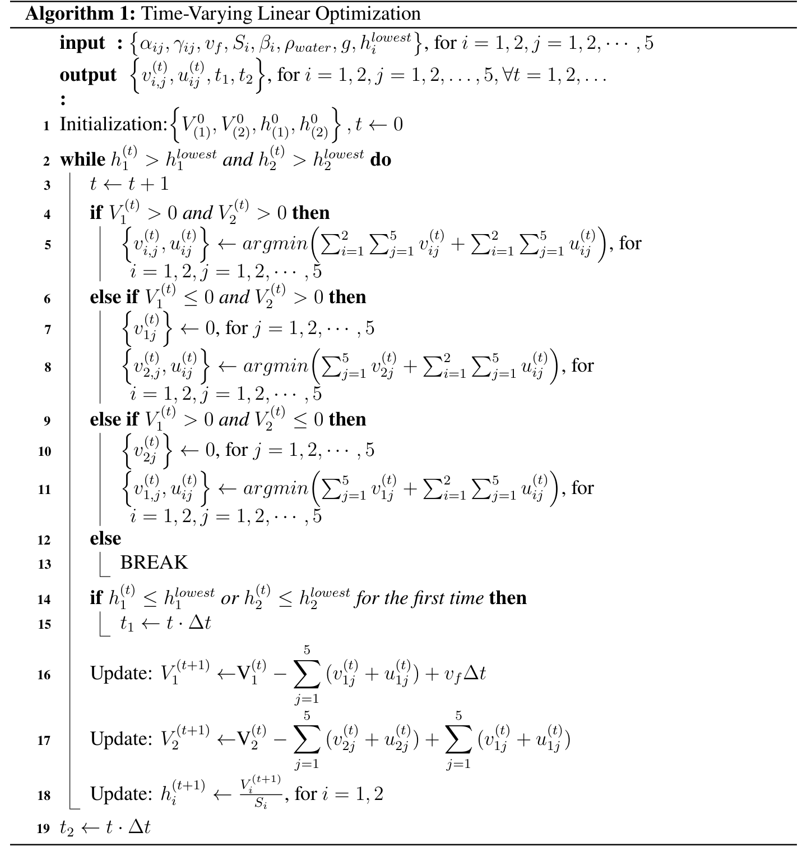
According to the constraints in Eq [9], when the water level of the dam is lower than the minimum water level of the power generation, but higher than the minimum water level of the
根据式[9]中的约束，当大坝水位低于发电的最低水位、但高于
— 原文第 10 页 —
dam, the dam can still provide water resources, but cannot generate hydropower. What is more, the algorithm is terminated immediately when the water levels of both dams are below their respective minimum water levels, or cannot meet the demands of the individual states.
大坝的最低水位时，该大坝仍可提供水资源，但不能产生水电。此外，当两座大坝的水位均低于各自的最低水位，或无法满足各州的需求时，算法立即终止。
4.2 Results and Analysis
4.2 结果与分析
By looking up the relevant data, we get the data on the water level of the two dams (tab [2]) and the Agricultural, industrial, residential demand in five states (figre [4.2]).
通过查阅相关数据，我们得到两座大坝的水位数据（表 [2]）以及五个州的农业、工业与居民用水需求（图 [4.2]）。
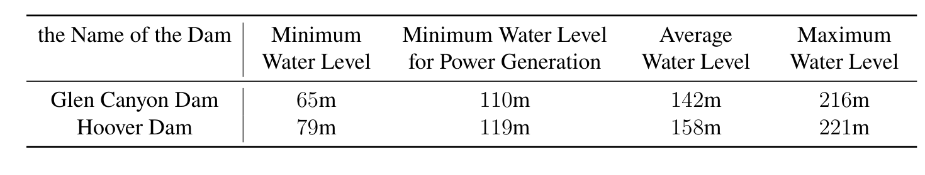
Table 2: List of Water Level Constraints
表 2：水位约束列表
For the water level P and M given by the problem, we compute the allocation schemes in three cases respectively,
对于题目给出的水位 P 与 M，我们分别计算三种情形下的分配方案，
• P = 142m (dark blue line), M = 158m (red-brown line), the average water level
• P = 142m（深蓝色线），M = 158m（红棕色线），平均水位
Before 18 days, the curve was a straight line, indicating that a single dam had enough water for five states. From the 18th day to the 21st day, the curve has twists and turns, indicating that there is a dam that cannot generate electricity (but can supply water). After the 21st day, the two dams were unable to meet the water and electricity needs of the five states.
在 18 天之前，曲线为一条直线，表明单座大坝的水量足以供给五个州。从第 18 天到第 21 天，曲线出现转折，表明有一座大坝无法发电（但可以供水）。在第 21 天之后，两座大坝已无法满足五个州的用水与用电需求。
• P = 110m (brownish yellow line), M = 119m (purple line), the minimum water level for power generation
• P = 110m（棕黄色线），M = 119m（紫色线），发电的最低水位
Before 4 days, the curve was a straight line, indicating that a single dam had enough water for five states. After the 4st day, the two dams were unable to meet the water and electricity needs of the five states.
在 4 天之前，曲线为一条直线，表明单座大坝的水量足以供给五个州。在第 4 天之后，两座大坝已无法满足五个州的用水与用电需求。
• P = 216m (green line), M = 221m (light blue line), the maximum water level
• P = 216m（绿色线），M = 221m（浅蓝色线），最高水位
Before 32 days, the curve was a straight line, indicating that a single dam had enough water for five states. From the 32th day to the 49st day, the curve has twists and turns, indicating that there is a dam that cannot generate electricity (but can supply water). After the 49st day, the two dams were unable to meet the water and electricity needs of the five states.
在 32 天之前，曲线为一条直线，表明单座大坝的水量足以供给五个州。从第 32 天到第 49 天，曲线出现转折，表明有一座大坝无法发电（但可以供水）。在第 49 天之后，两座大坝已无法满足五个州的用水与用电需求。
Obviously, the algorithm is closely related to time and the initial water level. Taking these three cases into consideration, we choose the first case as the average. We get that in these 21 days, in the absence of rain and other water supply, the water allocation for the Problem One is (visualized results shown in figure [4.2]):
显然，该算法与时间及初始水位密切相关。综合考虑这三种情形，我们选择第一种情形作为平均情形。由此得到，在这 21 天内，在没有降雨及其他供水的情况下，问题一的水资源分配为（可视化结果如图 [4.2] 所示）：
There are some conclusions for the Resources Allocation Network:
关于资源分配网络，可得到如下若干结论：
• From the 1th day to the 18th day, the Glen Canyon Dam distributes 4.42 × 10⁸m³ to WY each day; the Hoover 2.38 × 10⁸m³ to AZ, 1.12 × 10⁹m³ to CA, 1.23 × 10⁸m³ to NW and 4.45 × 10⁸ to CO each day.
• 从第 1 天到第 18 天，格伦峡谷坝每天向 WY 分配 4.42 × 108m3；胡佛坝每天向 AZ 分配 2.38 × 108m3、向 CA 分配 1.12 × 109m3、向 NW 分配 1.23 × 108m3、向 CO 分配 4.45 × 108。
— 原文第 11 页 —
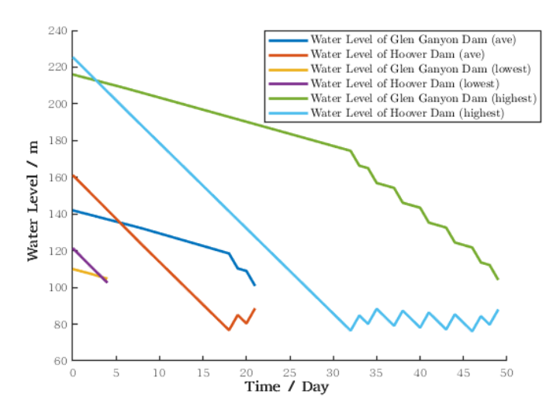
Figure 6: Result of Problem One
图 6：问题一的结果
• From the 19th day to the 21th day, the Glen Canyon Dam distributes 2.66 × 10⁸m³ to AZ each day, 1.35 × 10⁹m³ to CA, 4.42 × 10⁸m³ to WY, 1.26 × 10⁸m³ to NW and 4.56 × 10⁸ to CO each day.
• 从第 19 天到第 21 天，格伦峡谷坝每天向 AZ 分配 2.66 × 108m3、向 CA 分配 1.35 × 109m3、向 WY 分配 4.42 × 108m3、向 NW 分配 1.26 × 108m3、向 CO 分配 4.56 × 108。
• The Allocation Network can last for 21 consecutive days without the additional water.
• 该分配网络在无额外供水的情况下可连续维持 21 天。
• The water allocation plan recommend re-run the model every 21 days.
• 该水资源分配方案建议每 21 天重新运行一次模型。
• There is P⁵j=1 u²j = 3.51 × 10⁷m³/day allowed to flow from the Colorado River into the Gulf of California.
• 有 P5j=1 u2j = 3.51 × 107m3/day 允许从科罗拉多河流入加利福尼亚湾。
With the help of data from USGS [9] and EIA [10], two pie charts of water usage and hydropower allocation for each department in each state are made in figure[7] and figure[8].
借助 USGS [9] 与 EIA [10] 的数据，在图 [7] 和图 [8] 中绘制了各州各部门用水量与水电分配的两个饼图。
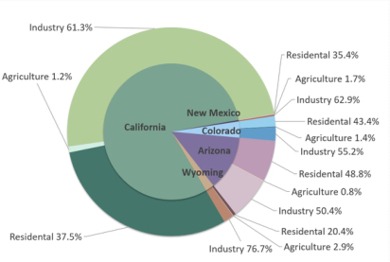
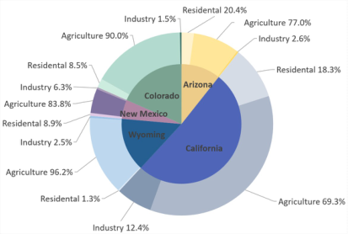
Figure 8: Overview of State Hydropower
图 8：各州水电概况
Figure 7: Overview of State Water Usage
图 7：各州用水概况
Usage Allocation
用水分配
Allocation
分配
— 原文第 12 页 —
The result of the first model,which contains the water usage and hydropower allocation for each department in each state,can be made into sankey diagrams better showing the flow of the process in figure[4.2].
第一个模型的结果包含各州各部门的用水量与水电分配，可进一步绘制为桑基图，以更好地展示该过程的流动情况，见图 [4.2]。
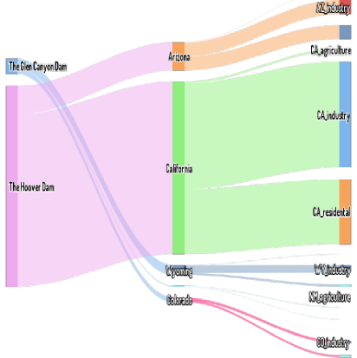
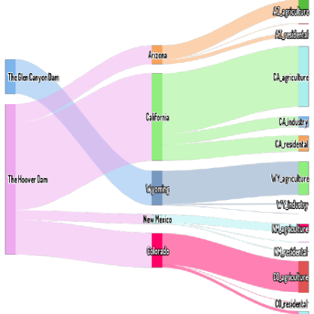
Figure 10: Sankey Diagram of Hydropower
图 10：水电桑基图
图中文字对照（英文 → 中文）
The Glen Canyon Dam / The Hoover Dam | 格伦峡谷坝 / 胡佛坝 | Arizona / California / Wyoming / Colorado | 亚利桑那 / 加利福尼亚 / 怀俄明 / 科罗拉多
industry | 工业用电 | agriculture | 农业用电
residential | 居民用电 | commercial | 商业用电
Figure 9: Sankey Diagram of Usage Water
图 9：用水桑基图
Usage
用水
5 Marginal Utility Model: Resources Interests and Valuation
5 边际效用模型：资源利益与估值
of Each State
各州的
Due to the large number of variables in the model, we tend to do the following simplification to avoid making the expression verbose.
由于模型中变量数量众多，为避免表述冗长，我们倾向于作如下简化。
where arg^{water}, arg^{elec}represent the water resources and hydropower allocated to the agriculiitural in i-th state respectively, and similarly, ind^{water}, ind^{elec}to the industrial, res^{water}, res^{elec} to iiiithe residential. We will refer to Resource_{i} as six variables including arg^{water}, ind^{water}, res^{water} , iiiarg^{elec}, ind^{elec}, res^{elec}.iii
其中 argwater、argelec 分别表示分配给第 i 个州农业的水资源与水电，类似地，indwater、indelec 对应工业，reswater、reselec 对应居民。我们将 Resourcei 称为包含 argwater、indwater、reswater、argelec、indelec、reselec 六个变量的集合。
There is a strong nexus between water and energy [2]. For example, machines in factories need to be heated by electricity and cooled by water, and in farmland, they can only be driven by electricity for irrigation. Therefore, we assume that only when water and hydropower are allocated in a certain proportion, the two resources can jointly play the maximum effect. In economics, we call the result coincide with Pareto Optimum. The Marginal Utility function is often utilized in economics to help determine whether or not the final result coincides with Pareto optimum. By similar ideas, we define a function whose range is in [0, 1] and increases first and then decreases, with the only condition that the maximum value is: water and hydropower are in a certain proportion. It is obvious that the magnitude of the negative gradient of the marginal utility efficiency function represents the corresponding profit of the unit effort along the direction. The definitions related are as follows.
水与能源之间存在紧密的关联 [2]。例如，工厂中的机器需要用电加热、用水冷却，而在农田中，只能依靠电力驱动进行灌溉。因此，我们假设只有当水与水电按一定比例分配时，这两种资源才能共同发挥最大效用。在经济学中，我们将与此相符的结果称为帕累托最优。边际效用函数（utility function）常用于经济学中，以帮助判断最终结果是否符合帕累托最优。依照类似思路，我们定义一个值域为 [0, 1] 且先增后减的函数，其唯一条件是最大值出现在：水与水电处于某一确定比例时。显然，边际效用效率函数负梯度的模长表示沿该方向单位努力所对应的收益。相关定义如下。
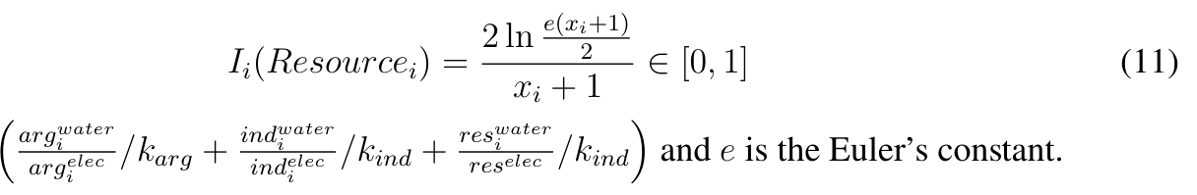
— 原文第 13 页 —
According to the definition of the Marginal Utility by R. Layard et al. (2008) [1], the key issue for Competing Interests is how this effect changes with income, but not how strongly income affects the utility of the states. Therefore, we define the utility function as follows,
根据 R.Layard 等（2008）[1] 对边际效用的定义，竞争性利益的关键问题在于这一效应如何随收入变化，而不在于收入对州效用的影响有多强。因此，我们将效用函数定义如下，
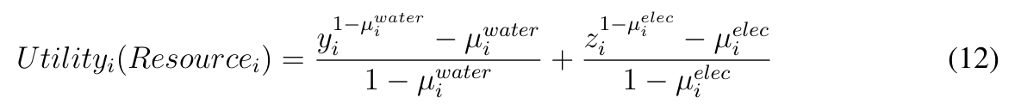
+ ind^{water}
+ res^{water}and z_{i} = arg^{elec}
+ reswater 且 zi = argelec
+ ind^{elec}
+ res^{elec}. The parameter iiiiii
+ reselec。参数 iiiiii
µ^{water}, µ^{elec}represent the effect induced by the change of the independent variable on the utility iiof the states. However, It is difficult to determine the value of µ^{water}and µ^{elec}, especially in the iiabsence of data. In this paper, to simplify the model, we determine these two parameters µ^{water} i and µ^{elec}based on the demand for water and electricity in different states.i
µwater、µelec 表示自变量的变化对各州效用 ii 所产生的影响。然而，µwater 与 µelec 的取值难以确定，尤其是在 ii 缺乏数据的情况下。本文为简化模型，根据不同州对水与电力的需求来确定 µwater i 与 µelec 这两个参数。i
By multiplying I_{i} function and Utility_{i} function, we derive the V alue_{i} function, which means that the five states assess the value of the same resource differently. We implement V alue_{i} function to quantify the competing interests of water availability and electricity production.
将 Ii 函数与 Utilityi 函数相乘，我们得到 Valuei 函数，这意味着五个州对同一资源的价值评估各不相同。我们运用 Valuei 函数来量化水资源可得性与电力生产之间的利益竞争。
Notice: IPV Model in Section 6 is based on the Marginal Utility Model, so we will discuss the results of the Marginal Utility Model in the next section.
注意：第 6 节中的 IPV 模型以边际效用模型为基础，因此我们将在下一节讨论边际效用模型的结果。
6 Auction Theory for Competing Interests: Independent Pri-
6 面向竞争利益的拍卖理论：独立私
vate Value (IPV) Model
人价值（IPV）模型
From now on, the water from the Colorado River has become more and more scarce, and if we continue to exploit it without restraint,the entire river would be drained to the last drop of water. In this sense, we should at our utmost to take less water from the Colorado River. But water and electricity are essential to the basic needs of every industry. This suggests that we need to find another solutions to make the whole program feasible and sustainable.
从今往后，科罗拉多河的水正变得越来越稀缺；若继续无节制地开发，整条河将被抽干至最后一滴水。就此而言，我们应尽最大努力从科罗拉多河取用更少的水。但水与电力是每个行业基本需求所不可或缺的。这表明我们需要另寻方案，使整个计划可行且可持续。
Based on the above considerations, we introduce the following IPV model (figure[11]).
基于上述考虑，我们引入如下 IPV 模型（图[11]）。
In point of fact, one of the primary causes of the scarcity of water and electricity resources in the western United States is the widespread wasting habits among the American population. The Colorado River is becoming more and more dangerous and both water and hydropower resources are becoming increasingly valuable. But many Americans are unabated in their habits of extravagance and waste. The current crisis could be ameliorated considerably if the waste could be minimized. As a good means of monitoring, fining wasters is an effective method. In addition, fines can raise a large amount of money, which helps a lot in our IPV model.
事实上，美国西部水与电力资源稀缺的主要原因之一，是美国民众中普遍存在的浪费习惯。科罗拉多河正变得越来越危险，水与水电资源也日益宝贵。但许多美国人的奢侈与浪费习惯并未减弱。若能最大限度减少浪费，当前的危机便可大为缓解。作为一种良好的监管手段，对浪费者罚款是行之有效的方法。此外，罚款可筹集大量资金，这对我们的 IPV 模型大有帮助。
Here comes the core of the IPV model. The model is mainly based on Auction Theory,
下面进入 IPV 模型的核心。该模型主要基于拍卖理论，
— 原文第 14 页 —
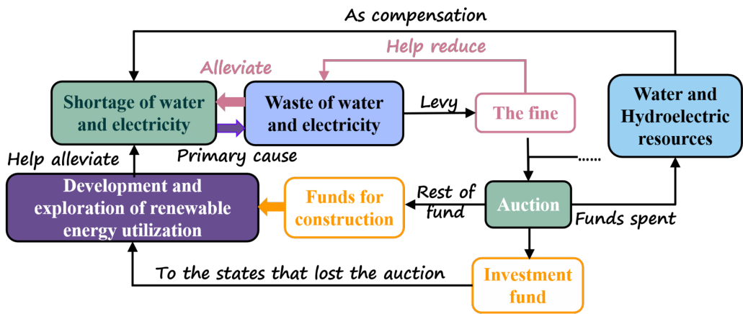
Figure 11: The Framework of IPV Model
图 11：IPV 模型的框架
图中文字对照（英文 → 中文）
Shortage of water and electricity | 水与电的短缺 | Waste of water and electricity | 水与电的浪费
Water and Hydroelectric resources | 水资源与水电资源 | Development and exploration of renewable energy utilization | 可再生能源的开发利用
Funds for construction | 建设资金 | Investment fund | 投资基金
The fine | 罚款 | Auction | 拍卖
Primary cause | 主要原因 | Alleviate | 缓解
Help reduce | 帮助减少 | As compensation | 作为补偿
Levy | 征收 | Rest of fund | 剩余资金
Funds spent | 资金支出 | To the states that lost the auction | 流向未中标各州
Help alleviate | 帮助缓解
which is an important branch of microeconomics. Historically, auction theory, which was awarded several Nobel Prizes in economics , has its unique role and significance. In our model, the creative introduction of this theory and modification combined with specific scenes is to achieve the optimal solution (in economics we call it Pareto Optimality [3]) of the whole problem. The specific algorithm to figure out this problem will be explained later and here we only need to know that it is at the core of the model and how it works in the whole system.
它是微观经济学的一个重要分支。从历史上看，拍卖理论曾数度获得诺贝尔经济学奖，具有独特的作用与意义。在我们的模型中，创造性地引入该理论并结合具体情景加以修正，是为了求得整个问题的最优解（在经济学中我们称之为帕累托最优[3]）。求解该问题的具体算法将在后文说明；此处我们只需了解它处于模型的核心地位，以及它在整个系统中如何运作。
• At first a certain amount of water and electricity were divided equally among five states. Treat each state as an independent bidder and then there are five bidders bidding for the remaining water. Each bidder will weigh its own interest and decide whether to pay his bid(mainly from fines and other sources can be included). At the same time, the highest bidder gets the resources, which meets the bidding rules we all know.
• 首先，将一定量的水与电力在五个州之间平均分配。将每个州视为独立的竞标者，于是有五名竞标者对剩余的水进行竞价。每位竞标者都会权衡自身利益，决定是否支付其出价（主要来自罚款，也可包括其他来源）。同时，出价最高者获得资源，这符合我们所熟知的竞价规则。
• After the rest of the resources having been divided up, each state can manage the money left itself. Our suggestion is to put the money left as much as possible to the construction in the development and exploration of renewable energy. That is beacause such investment will be positive in the long run.
• 剩余资源分配完毕后，各州可自行支配剩余的资金。我们的建议是，将剩余资金尽可能投入到可再生能源开发与勘探的建设中。这是因为此类投资从长期看将是正向的。
• The money from the auction for the remaining resources will be used as investment capital to help those states, who profit least or none from the auction, in their construction. In this way, the successful bidder can use capital in exchange for resources they deem worthwhile.
• 剩余资源拍卖所得资金将作为投资资本，用于帮助那些从拍卖中获利最少或未获利的州进行建设。如此一来，竞标成功者可以用资本换取其认为值得的资源。
• Those water and hydroelectric resources are also reckoned as a compensation to alleviate the shortage of water and electricity. Although such compensation is limited, it is believed that such benefits are still positive for the bidder contributing to the auction because the bidding behavior is based on sufficient interest considerations. In short, those who bid for resources obtained at least a short-term gain from the auction, and the results for them were positive.
• 这些水与水电资源也被视为一种补偿，以缓解水与电力的短缺。尽管这种补偿有限，但可以认为，对参与拍卖的竞标者而言此类收益仍是正向的，因为竞价行为是基于充分的利益考量。简言之，为资源出价者至少从拍卖中获得了短期收益，其结果对他们而言是正向的。
— 原文第 15 页 —
• One the other hand, the states that benefit least from the auctions get the corresponding investment to help with construction, and the results must be positive in the long run. They can gradually wean themselves off the river’s associated resources and turn to seawater desalination, solar power generation and so on as to replace.
• 另一方面，从拍卖中获益最少的州获得相应的投资以助其建设，从长期看结果必然是正向的。它们可以逐步摆脱对这条河相关资源的依赖，转而以海水淡化、太阳能发电等作为替代。
In general, both sides benefit from it, and the pressure on the river decreases over time, which is conducive to ecological restoration and sustainable development.
总体而言，双方均可从中受益，且河流所承受的压力随时间推移而减小，这有利于生态修复与可持续发展。
Thus, we consider here an Independent Private Value (IPV) first-price auction [4] [5]: The N = 5 states , called bidders, submit sealed bids and the highest bidder wins and pays his bid. Only those whose private valuation is higher than the reserve price, R, set by the auctioneer submit competitive bids.
因此，我们在此考虑独立私人价值（IPV）第一价格拍卖[4][5]：N = 5 个州作为竞标者提交密封报价，出价最高者获胜并支付其出价。只有私人估值高于拍卖方设定的保留价格 R 的竞标者才会提交有竞争力的报价。
Different states (bidders) value the water and the electricity resources differently, following the marginal utility [1], which means that more resources bring less incremental utility. Each state is assumed to be risk neutral with utility, and characterized by a distribution function H_{i} on a common support [p_{left}, p_{right}]. Bid functions are denoted by φ_{i}, i = 1, · · · N.
不同州（竞标者）对水资源与电力资源的估值各不相同，遵循边际效用[1]，即资源越多，所带来的增量效用越少。假设每个州在效用上是风险中性的，并由共同支撑集 [pleft, pright] 上的分布函数 Hi 刻画。竞价函数记为 φi，i = 1, · · · N。
Let t = φ_{i}(p) denote the equilibrium bid submitted by state i with private signal p ∈ [p_{left}, p_{right}]. And let p = λ_{i}(t) denote inverse bid functions. State i with signal p ∈[R, p] submits a bid t, which is solution of the optimization problem.
令 t = φi(p) 表示州 i 在私人信号 p ∈ [pleft, pright] 下提交的均衡报价。并令 p = λi(t) 表示反竞价函数。信号为 p ∈[R, p] 的州 i 提交报价 t，t 为下述优化问题的解。
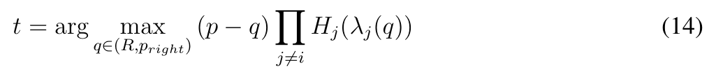
Defined by the First Order Conditions, the following formula derived as,
由一阶条件定义，推导出如下公式，
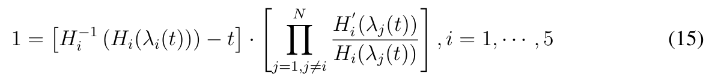
6.1 Solution of the Independent Private Value (IPV) Model
6.1 独立私人价值（IPV）模型的求解
In order to solve such problem, Gayle and Richard (2008) [6] generalized the BackwardsShooting(BS) Algorithm of Marshall et al. (1994) [7] which is a numerical solution in auction. Gale and Richard’s algorithm relies on valuation support which is equally spaced subdivisions. According to the [6], the expected profit of the state i is given by
为求解该问题，Gayle 与 Richard（2008）[6] 推广了 Marshall 等（1994）[7] 的反向射击（BS）算法，该算法是拍卖中的一种数值解法。Gale 与 Richard 的算法依赖于等间距细分的估值支撑集。根据文献[6]，州 i 的期望利润为
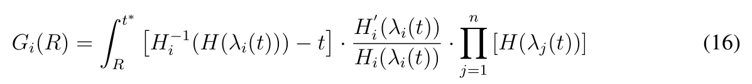
The Generalized Backwards-Shooting(BS) Algorithm incorporates the following steps [6]. First, we input Taylor-series expansions of H⁻¹to the algorithm (the method [3] to calculate H⁻¹ ii will be mentioned below), where iteration equation Eq.(17)(18)(19)(20) in the Generalized Backwards-Shooting(BS) Algorithm [2] are:
广义反向射击（BS）算法包含以下步骤[6]。首先，将 H−1 的泰勒级数展开输入该算法（计算 H−1 ii 的方法[3]将在下文提及），其中广义反向射击（BS）算法[2]中的迭代方程 式(17)(18)(19)(20) 为：
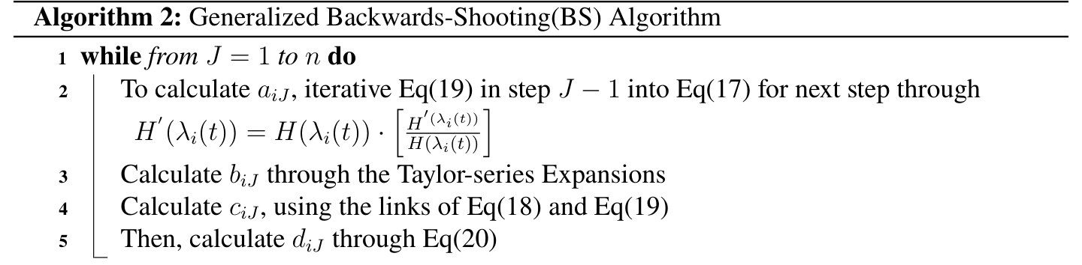
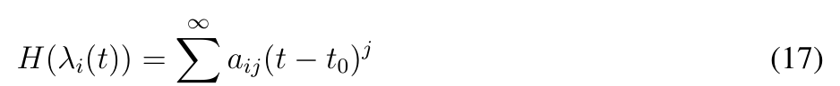
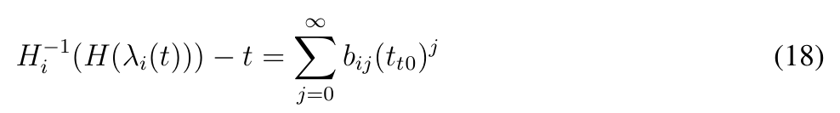
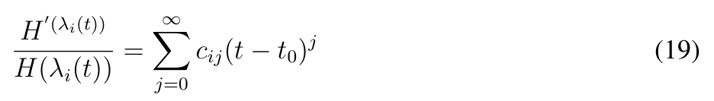
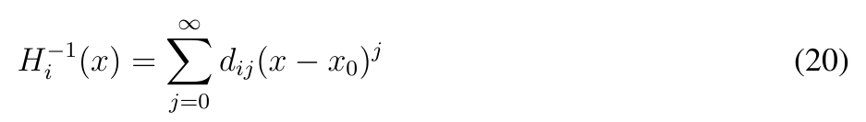
— 原文第 16 页 —
To calculate the Taylor-series expansions mentioned above in Algorithm [2], the following steps are incorporated:
为计算上文算法[2]中提及的泰勒级数展开，包含以下步骤：
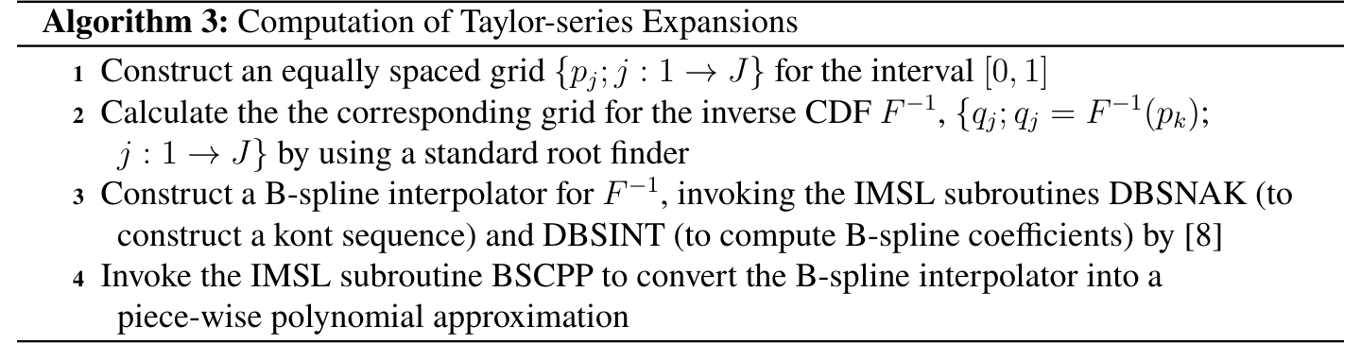
6.2 Results and Analysis
6.2 结果与分析
It has been assumed that in the case of scarce water resources only come from the upstream of the River Colorado, that is, 505m³ flow per second is the only source of water for the whole river. In this case, we take this source as an auction, which is auctioned by the five states at the highest price. According the generalized the Backwards-Shooting(BS) Algorithm by Gayle and Richard (2008) [6], we compute the best competitive strategy which may bring the best interests for all the states and Mexico,
假设在水资源稀缺的情形下，水源仅来自科罗拉多河上游，即每秒 505m3 的流量是整条河流唯一的水源。在此情形下，我们将该水源视为一场拍卖，由五个州以最高价格竞拍。依据 Gayle 与 Richard（2008）[6] 的广义反向射击（BS）算法，我们计算了可为所有州以及墨西哥带来最大利益的最优竞争策略，
According to the IPV model, we divide the whole water resource into two pieces and set a
根据 IPV 模型，我们将全部水资源分为两部分，并设定一个
— 原文第 17 页 —
corresponding ratio (a parameter) to modify the total amount of auctioned water resources, while the unauctioned portions are used for average distribution to five states. Here is the results in tab [3].
相应的比例（一个参数）来调整参与拍卖的水资源总量，而未参与拍卖的部分则用于向五个州平均分配。结果见表[3]。
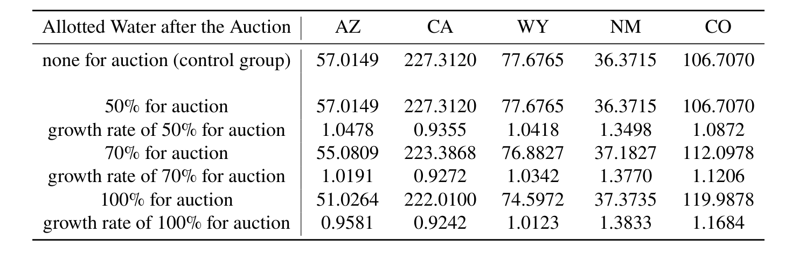
Table 3: List of Water Level Constraints
表 3：水位约束列表
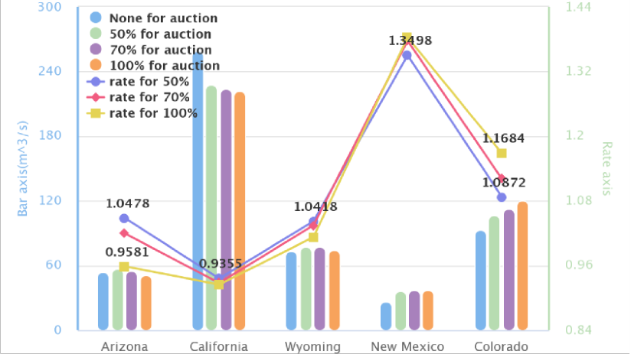
Figure 12: the Impact of the Ratio of Auction Resources to Total Resources on the Overall Value of Each State
图 12：拍卖资源占总资源的比例对各州总体价值的影响
In figure [12], compared with the control group (the case of all water resources are equally distributed to the states, blue bar in the figure), the more water resources are auctioned, the less water resources are obtained in California, while the water resources obtained in the other four states are increased or almost equal, which means that the equality between different states has improved. What is more, the sustainable use of natural resources is respected by our world today. On the other hand, in the figure, the variable "rate" represents the ratio of the value obtained by the state after a competitive game to that by the control group. Obviously, the values of Wyoming, New Mexico and Colorado are rising, and the overall values of the five states are also rising. In summary, the IPV auction model has promoted the development of the five states. Moreover, the money paid for bidding can be used to compensate Mexico or regions with relatively backward water conservancy systems.
在图[12]中，与对照组（即全部水资源在各州间平均分配的情形，图中蓝色柱）相比，拍卖的水资源越多，加利福尼亚获得的水资源越少，而其余四个州获得的水资源则增加或基本持平，这意味着各州之间的平等性有所改善。此外，自然资源的可持续利用在当今世界受到尊重。另一方面，图中变量“rate”表示各州在竞争博弈后获得的价值与对照组价值之比。显然，怀俄明、新墨西哥和科罗拉多的价值在上升，五个州的总体价值也在上升。综上，IPV 拍卖模型促进了五个州的发展。此外，用于竞价的资金可用于补偿墨西哥或水利系统相对落后的地区。
— 原文第 18 页 —
7 Sensitivity Analysis
7 灵敏度分析
–Our Model Dealing with More Complex Situations
–我们的模型处理更复杂的情形
7.1 Growth or Shrinkage in Affected Areas
7.1 受影响地区的增长或萎缩
In general, If there is population, agricultural, and industrial growth in Affected areas, the demand for water and hydropower in these areas will certainly rise. In order to avoid more losses and derive development, those states must be willing to bid for more water than before, even if the price is much higher. At this point, they are willing to accept higher price because even one more drop of water is reckoned to be more meaningful and valuable to them than ever before. The increase in auction prices improves the amount of investment fund for those benefit least in the auction. According to our previous interpretation of the model, the investment should be utilized for construction to ease the pressure on energy needs in the long run, At the same time, to reduce the high dependence on both water and hydropower resources from the Colorado River basin in the future. This helps a lot to achieve long-term sustainable development.
一般而言，如果受影响地区出现人口、农业与工业的增长，这些地区对水与水电的需求必然上升。为避免更多损失并求得发展，这些州必须愿意比以往出价竞取更多的水，即使价格高得多。此时，它们愿意接受更高的价格，因为对它们而言，即使多一滴水也被认为比以往任何时候都更有意义、更有价值。拍卖价格的上升提高了拍卖中获益最少的各方的投资基金数额。根据我们此前对模型的阐释，这些投资应当用于建设，以在长期上缓解能源需求压力，同时降低未来对科罗拉多河流域水与水电资源的高度依赖。这非常有助于实现长期可持续发展。
On the contrary, when the shrinkage occurs, the total pressure of resource demands on the river basin will decrease, and the corresponding bidding expenditure will also decrease.
相反，当出现萎缩时，资源需求对流域的总压力将会下降，相应的竞价支出也会减少。
• Population & Agricultural & Industrial
• 人口与农业与工业
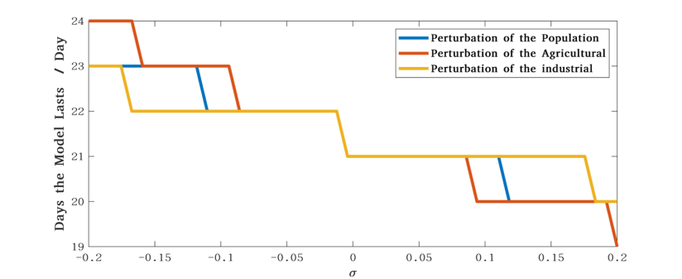
Figure 13: Sensitivity Analysis: Perturbation of the Population, Agricultural and Industrial
图 13：灵敏度分析：人口、农业与工业的扰动
We assume that there is some perturbation, σ, in one of these three, which affects the maximum time the model will last without additional water.
我们假设这三者之一存在某种扰动 σ，它会影响模型在无额外来水条件下所能维持的最长时间。
Specifically, from the Figure [13], it is not difficult to see that, under slight perturbations, days that the model lasts remain basically unchanged. The error fluctuation keeps no more than three days, which shows the good robustness of our model.
具体而言，从图 [13] 不难看出，在轻微扰动下，模型所能维持的天数基本不变。误差波动不超过三天，这表明我们的模型具有良好的稳健性。
7.2 Increase of the Proportion of Renewable Energy Technologies
7.2 可再生能源技术占比的提高
First of all, the increase of the proportion of renewable energy technologies means less energy consumption and more efficient use of resources. In our model, this is equivalent to the gradual
首先，可再生能源技术占比的提高意味着更少的能源消耗与更高效的资源利用。在我们的模型中，这等价于
— 原文第 19 页 —
decrease of the demands for resources from the Colorado River basin, which is mainly reflected in the gradual shift of the focus of resource utilization.
科罗拉多河流域资源需求的逐步下降，这主要体现为资源利用重心的逐步转移。
In fact, the improvement of the proportion of the renewable energy (especially when it exceeds the initial default value we set in the model) will extend the duration of the model to a certain extent, which can also be verified in the sensitivity tests of the model. This is also confirmed in our tests. As shown in the Figure [14], good resistance to disturbance is again demonstrated.
事实上，可再生能源占比的提高（尤其当其超过我们在模型中所设的初始默认值时）会在一定程度上延长模型的持续时长，这也可在模型的灵敏度检验中得到验证。这一点在我们的检验中同样得到证实。如图 [14] 所示，模型再次展现出良好的抗扰动能力。
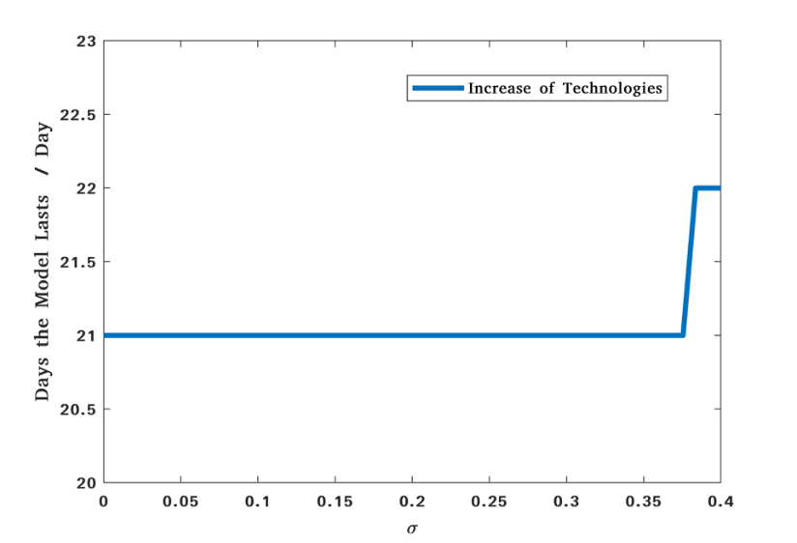
Figure 14: Sensitivity Analysis: Improvement of Technologies
图 14：灵敏度分析：技术的改进
7.3 Water and Electricity Conservation Measures
7.3 水与电的节约措施
As a matter of fact, once additional water and electricity conservation measures have been implemented, the efficiency of water and electricity usage would be greatly improved. In our model, additional water and hydropower conservation measures comes in the form of penalties for wasteful practices, namely fines. Under the pressure of fines, more efficient use of water and electricity could help reduce unnecessary wastage. In our model, this has great significance for long-term development and is the fundamental guarantee of long-term interests.
事实上，一旦实施额外的节水节电措施，水与电的使用效率将大幅提高。在我们的模型中，额外的水与水电节约措施以对浪费行为的惩罚形式出现，即罚款。在罚款的压力下，更高效地用水用电有助于减少不必要的浪费。在我们的模型中，这对长期发展具有重要意义，是长期利益的根本保障。
However, if there isn’t a complete and effective penalty rules, it would be difficult to realize the plans and visions. Here we offer the following suggestions for constructing a set of penalty rules.
然而，如果没有一套完整有效的惩罚规则，这些计划与愿景将难以实现。在此，我们为构建一套惩罚规则提出以下建议。
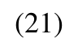
where the total amount of the i-th penalty is composed of the basic penalty amount and the additional penalty amount. The total amount of the i-th basic penalty is equal to i ∗Fine_{basic}, and the extra penalty amount represents the opportunity cost of the i-th waste, which can be well described by the utility function.
其中，第 i 次惩罚的总额由基础罚款额与额外罚款额两部分构成。第 i 次基础罚款的总额等于 i ∗Finebasic，而额外罚款额代表第 i 次浪费的机会成本，该成本可由效用函数很好地刻画。
— 原文第 20 页 —
8 Discussion
8 讨论
8.1 Strengths and Weaknesses
8.1 优缺点
8.1.1 Strengths
优点
• Comprehensive consideration
• 考虑全面
We take into account as many details as possible, such as the possible losses during the transportation etc. Our model also comprehensively considers the whole interest, and pursues the global optimization under the premise of satisfying the interest of each state and Mexico.
我们尽可能考虑了众多细节，例如运输过程中可能产生的损失等。我们的模型还综合考虑整体利益，在满足各州与墨西哥利益的前提下追求全局最优。
• Specially innovative
• 具有创新性
We utilize economic concepts and theory(like marginal utility, auction theory) to establish models, which provides a unique and revolutionary view of the resource competition system.
我们运用经济学概念与理论（如边际效用、拍卖理论）建立模型，为资源竞争系统提供了独特而具有革命性的视角。
• Good visualization
• 可视化良好
The visualization work is done well by us, including the framework of our work, the visualization of locations of dams and two lakes, the overview of state water distribution by double-deck pie chart,the schematic diagram of IPV model etc.
我们的可视化工作完成得较好，包括工作框架、大坝与两个湖泊位置的可视化、用双层饼图呈现的各州水资源分配概况、IPV 模型示意图等。
• Highly extensible
• 可扩展性强
The problems about optimizing resource allocation are much common in daily life. The model has strong theoretical guarantee, and can be applied with a little modification combined with the actual background. What’s more, our models are less dependent on data.
资源分配优化问题在日常生活中十分常见。该模型具有很强的理论保证，结合实际背景稍作修改即可应用。此外，我们的模型对数据的依赖性较小。
8.1.2 Weaknesses
缺点
• Rough approximation
• 近似较粗
In the assumption 5, we regard the lake as two cylinders to calculate the volumes. Although the calculation is simplified, there must be an error with the actual situation. In this problem, we think that the volume calculation is not the core problem that needs to be solved. Due to time constraints and schedule requirements, we finally choose to simplify this step.
在假设 5 中，我们将湖泊视为两个圆柱体来计算体积。尽管计算得到了简化，但与实际情况必然存在误差。在本问题中，我们认为体积计算并非需要解决的核心问题。由于时间限制与进度要求，我们最终选择对这一步骤进行简化。
• Idealized design
• 理想化设计
Our models are intended to capture the essence of the problems through idealized and abstract descriptions first. Therefore, the model is relatively complete in theory, but there maybe a deviation from the actual, for the model lacks practical testing.
我们的模型旨在首先通过理想化与抽象化的描述来把握问题的本质。因此，该模型在理论上较为完备，但由于缺乏实际检验，可能与实际情况存在偏差。
8.2 Future Work
8.2 未来工作
The essence of this problem is the optimal allocation of resources. Solving this kind of problem is of great significance in our daily life. In the case of full resources, many problems involve the allocation of hundreds or even thousands of objects. In this regard, our future work can focus on extending the model to a larger number of objects and improving the computational speed of the algorithm, or designing algorithms that can be applied to a wider range and are more convenient and efficient.
该问题的本质是资源的最优分配。求解此类问题在我们的日常生活中具有重要意义。在资源充足的情形下，许多问题涉及数百甚至数千个对象的分配。就此而言，我们未来的工作可以着眼于将模型扩展至更多数量的对象并提升算法的计算速度，或者设计适用范围更广、更为便捷高效的算法。
— 原文第 21 页 —
In the subsequent model introduced in the case of resources shortage, due to time constraints, we did not jump out of the problem and have an in-depth research. For example, we put forward using the model to provide bidders benefiting least in the auction with considerable benefits to develop technology and infrastructure like desalination, solar power and wind power generation. Our model is able to explain the existence of long-term returns theoretically, but how to maximizing profits and where should be selected as the optimal construction site have still yet to be solved. These questions are related to, but not central to, the problem. However, It is undeniable that the solution of these problems also contributes to the detailed implementation, which needs further reasearch.
在随后介绍的资源短缺情形下的模型中，由于时间限制，我们未能跳出问题本身进行深入研究。例如，我们提出利用该模型为拍卖中获益最少的竞拍者提供可观的收益，以用于开发海水淡化、太阳能发电和风力发电等技术及基础设施。我们的模型能够在理论上解释长期收益的存在，但如何实现利润最大化以及应选择何处作为最优建设地点，仍有待解决。这些问题与本题相关，但并非本题的核心。然而，不可否认的是，这些问题的解决也有助于方案的具体实施，而这仍有待进一步研究。
9 Conclusion
9 结论
Based on our work, it is not difficult to draw the following conclusions. Since the Colorado River is one of the most important source of general usage water and hydropower for the western United States, necessary protective measures neeed to be taken. In addition, despite the fact that the United States is a developed country with abundant recources, American citizens should be encouraged to develop good habits of saving water and electricity. As a supplement, we believe that imposing fines on wasteful behaviors is an effective way. What’s more, for long-term sustainable development, priority should be given to the development and construction about new renewable energy sources. Only in this way could the Colorado River be revitalized. Only by this way can the rights of both the United States and Mexico be protected simutaneously.
基于我们的工作，不难得出以下结论。由于科罗拉多河是美国西部最重要的生活用水与水电来源之一，因此必须采取必要的保护措施。此外，尽管美国是一个资源丰富的发达国家，仍应鼓励美国公民养成节约用水与用电的良好习惯。作为补充，我们认为对浪费行为处以罚款是一种有效的方式。更进一步，为实现长期可持续发展，应优先发展和建设新型可再生能源。唯有如此，科罗拉多河才能重焕生机。唯有如此，美国与墨西哥双方的权益才能同时得到保障。
— 原文第 23 页 —
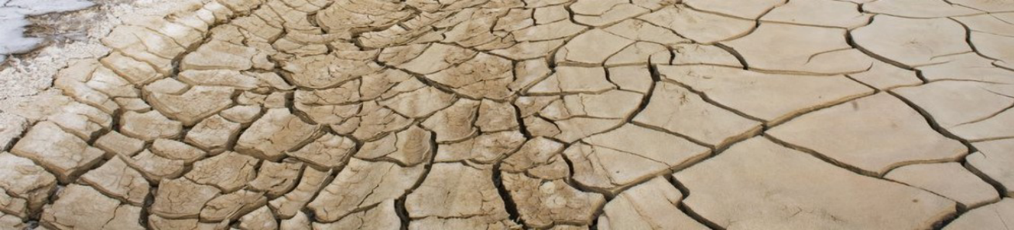
Attention Please : Time to Save
请注意：是时候节约了
Author: Team #2200084
作者：队伍 #2200084
Keywords: Drought; Water; Optimization;
关键词：干旱; 水; 优化;
The past 22 years have been America's worst drought in nearly 1200 years. From 2000 to 2022, the drought situation in the southwestern United States intensified, especially during recent years. The proportion of regions with extreme water shortage, which is shown as the darkest part in the figure, continued to expand. Five states, including Arizona, California, Colorado, New Mexico and Wyoming, which rely on water supply and hydropower from Lake Mead and Lake Powell, are facing an urgent situation of resource optimization.
过去 22 年是美国近 1200 年来最严重的干旱。2000 年至 2022 年，美国西南部的干旱形势不断加剧，近年来尤为严重。极端缺水区域（即图中颜色最深的部分）所占比例持续扩大。包括亚利桑那州、加利福尼亚州、科罗拉多州、新墨西哥州与怀俄明州在内的五个州依赖米德湖与鲍威尔湖的供水与水电，正面临资源优化的紧迫局面。
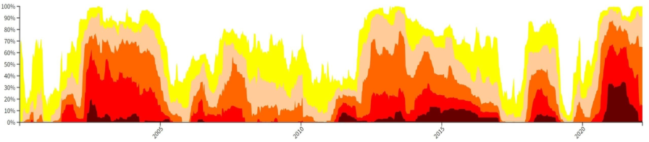
Figure 1 :The Propotion of Different Drought Level in Southwest America
图 1：美国西南部不同干旱等级所占比例
We establish the RAN ( Resources Allocation Network ) model to simulate the supply direction of water and electricity from two dams. We believe that the water flows into Lake Powell from the upstream, and this part of water is used to provide domestic water and power generation, respectively. After the power generation water flows out of the dam, it will continue to flow to Lake Meade for further use. Considering the various water levels of Lake Meade and Lake Powell, we calculate and analyze these different situations. We find that in a certain period of time in the future, the two dams can meet the needs of water and electricity of those five states at the same time. However, after more than this period of time, the power supply first appeared insufficient.
我们建立 RAN（资源分配网络）模型，以模拟两座大坝的水与电的供给流向。我们认为水从上游流入鲍威尔湖，这部分水分别用于提供生活用水与发电。发电用水流出大坝后，将继续流向米德湖以供进一步使用。考虑到米德湖与鲍威尔湖的不同水位，我们对这些不同情形进行了计算与分析。我们发现，在未来某一时期内，两座大坝能够同时满足这五个州的用水与用电需求。然而，超过这一时段之后，电力供给首先出现不足。
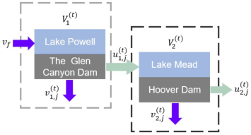
Figure 2 : Series Configuration of Two Dam
图 2：两座大坝的串联结构
— 原文第 24 页 —
According to the theory of diminishing marginal utility, we find that there is a strong correlation between water and energy. We expect that the final effect of the two resources can reach Pareto Optimum through the ratio of water and hydropower.
根据边际效用递减理论，我们发现水与能源之间存在很强的相关性。我们期望通过水与水电的配比，使这两种资源的最终效果达到帕累托最优。
Most importantly, we use the IPV(Independent Private Value) model in the auction theory to compensate or assist the weak areas in the development and construction of new energy by auctioning the funds obtained from the remaining water in the case of insufficient water resources, so as to alleviate the shortage of resources to a certain extent. The whole process can form a closed-loop development and can bring positive feedback to the system.
最重要的是，我们运用拍卖理论中的 IPV（独立私人价值）模型，在水资源不足的情形下通过拍卖剩余水所获得的资金，来补偿或扶助薄弱地区进行新能源的开发与建设，从而在一定程度上缓解资源短缺。整个过程可以形成闭环式发展，并能为系统带来正反馈。
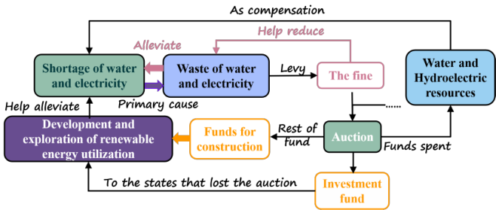
Figure 3 : The Theory of IPV Model
图 3：IPV 模型的理论
In addition, we hope to further urge people to save water and electricity by establishing a reasonable penalty mechanism.
此外，我们希望通过建立合理的惩罚机制（penalty mechanism），进一步督促人们节约用水与用电。
The continuous deterioration of the ecological environment reminds us all the time that we should cherish the resources endowed by nature and cherish the homeland on which we live.
生态环境的持续恶化时刻提醒我们，应当珍惜自然赋予的资源，珍惜我们赖以生存的家园。
— 原文第 22 页 —
References
[1] Layard R, Mayraz G, Nickell S. The marginal utility of income[J]. Journal of Public Economics, 2008, 92(8-9): 1846-1857.
[2] Kenway S J, Priestley A, Cook S, et al. Energy use in the provision and consumption of urban water in Australia and New Zealand[J]. Water Services Association of Australia (WSAA): Sydney, Australia, 2008.
[3] Censor Y. Pareto optimality in multiobjective problems[J]. Applied Mathematics and Optimization, 1977, 4(1): 41-59.
[4] Osborne M J, Rubinstein A. A course in game theory[M]. MIT press, 1994.
[5] Krishna V. Auction theory[M]. Academic press, 2009.
[6] Gayle W R, Richard J F. Numerical solutions of asymmetric, first-price, independent private values auctions[J]. Computational Economics, 2008, 32(3): 245-278.
[7] Marshall R C, Meurer M J, Richard J F, et al. Numerical analysis of asymmetric first price auctions[J]. Games and Economic behavior, 1994, 7(2): 193-220.
[8] De Boor C, De Boor C. A practical guide to splines[M]. New York: springer-verlag, 1978. [9] USGS. https://www.usbr.gov [10] EIA. http://www.eia.gov
（全文完。公式与表格在原 PDF 中是矢量图形，未纳入本对照版；可按文中「原文第 N 页」标记翻到 2200084.pdf 对照查看。）

