2401298 英中对照版
2024 MCM Problem C · Momentum in Tennis
读法：黑字为原文，蓝字为译文，一段英文一段中文，上下对应；蓝字里的小字括号是该术语第一次出现时的英文原词。
术语表（按首次出现排序，20 条）
# | 英文 | 中文 | 说明：为什么容易译错
1 | Momentum | 势头 | 比赛中的状态惯性与转折
2 | Bayesian Network | 贝叶斯网络 | 刻画变量间条件依赖的图模型
3 | Statistical Analysis | 统计分析 | 用数据检验假设
4 | Performance Metrics | 表现指标 | 衡量球员发挥的量化指标
5 | Probability Difference | 概率差 | 两名球员得分概率之差
6 | Feature Importance | 特征重要性 | 各因素对预测的贡献度
7 | AUC | AUC（曲线下面积） | 二分类模型的整体判别能力
8 | Data Cleaning | 数据清洗 | 剔除异常与缺失记录
9 | Random Forest | 随机森林 | 集成多棵决策树的模型
10 | Logistic Regression | 逻辑回归 | 把特征映射为胜率
11 | Maximum Likelihood Estimation | 极大似然估计 | 由数据反推参数
12 | EM Algorithm | EM 算法 | 含隐变量时的迭代估计
13 | Hidden Markov Model | 隐马尔可夫模型 | 用隐藏状态解释观测序列
14 | Swing | 挥拍 | 一次完整击球动作
15 | Shot | 击球 | 单次回球
16 | Point | 一分 | 比分的原子单位
17 | Momentum Shift | 势头转折 | 优势方发生逆转的时刻
18 | Predictive Accuracy | 预测准确率 | 预测正确的比例
19 | Sensitivity Analysis | 灵敏度分析 | 改动参数看结论是否稳定
20 | Run Test | 游程检验 | 检验序列是否随机

目录（Contents）
页码为原 PDF 页码，可按正文中的「— 原文第 N 页 —」定位。
1 引言（Introduction） 3
1.1 问题背景（Problem Background） 3
1.2 问题澄清与重述（Clarifications and Restatements） 3
1.3 本文工作（Our work） 3
2 建模准备（Preparation for Modeling） 4
2.1 模型假设（Model Assumptions） 4
2.2 符号说明（Notations） 4
2.3 数据清洗（Data Cleaning） 5
3 问题一：概率差评估策略（Problem 1: Probability Difference Evaluation Strategy） 5
3.1 发球方的重要影响（Important Impact of Server） 5
3.2 滑动比分区间法（Sliding Point Interval Approach） 6
3.3 滑动时间窗口法（Sliding Time Window Approach） 7
4 问题二：势头的存在性（Problem 2: Momentum Existence） 8
4.1 假设检验准备（Hypothesis Testing Preparation） 8
4.2 Ljung-Box Q 检验与游程检验统计分析（Ljung-Box Q Test and Runs Test Statistical Analysis） 9
4.3 瞬时胜率（Instantaneous Winning Rates） 10
5 问题三：势头预测（Problem 3: Momentum Prediction） 11
5.1 基础构件：朴素二项模型（The building block: Naive Binomial Model） 11
5.2 势头作为残差效应（Momentum as residual effect） 12
5.2.1 变量识别（Variable identification） 13
5.2.2 模型构建（Model Construction） 15
5.2.3 数据拟合（Data fitting） 17
5.2.4 比赛数据推断（Inference on Match Data） 19
5.2.5 建议（Advisement） 19
6 问题四：势头转折预测与模型推广（Problem 4 : Swings Prediction and Model Generalization） 20
7 模型分析（Model Analysis） 22
7.1 优缺点分析（Strengths and Weaknesses） 22
7.2 灵敏度分析（Sensitivity Analysis） 22
7.3 结论（Conclusion） 23
8 备忘录（Memorandum） 23
参考文献（References） 25

"Momentum" Exists In Tennis Game As Residual Effect -
网球比赛中存在作为残差效应的“势头”——
A Dual-Temporal Bayesian Network Model
一种双时间尺度贝叶斯网络模型
Summary
摘要
This study investigates tennis match dynamics through sophisticated statistical mod-eling and a novel Dual-Temporal Bayesian Network approach. By analyzing Wimble-don data, we address five key questions:
本研究通过精细的统计建模与新颖的双时间尺度贝叶斯网络（Bayesian Network）方法，考察网球比赛的动态特征。通过分析温布尔登数据，我们回答五个关键问题：
Performance Metrics (Problem 1): We introduce a server/returner reweightingstrategy to accurately evaluate the performance of a player. We further utilize slidingwindow and Area Under Curve (AUC) methods to ensure continuity and locality, thusbetter capturing the fluctuations within the game.
表现指标（Performance Metrics）（问题 1）：我们引入一种发球方/接发球方重新加权策略，以准确评估球员的表现。我们进一步利用滑动窗口与 AUC（曲线下面积）（AUC）方法，以确保连续性与局部性，从而更好地捕捉比赛内部的波动。
Momentum Existence (Problem 2): Rigorous hypothesis testing (Ljung-Box Q Testand Runs Test) fails to reject null hypothesis of complete randomness. But instanta-neous winning rates can reveal slight deviations from randomness, suggesting thepresence of subtle momentum effects, albeit not overwhelmingly conclusive.
势头（Momentum）存在性（问题 2）：严格的假设检验（Ljung-Box Q 检验与游程检验（Run Test））未能拒绝完全随机性的原假设。但瞬时胜率可以揭示出对随机性的轻微偏离，表明存在细微的势头效应，尽管其结论性并不具压倒性。
Momentum Prediction (Problem 3): We take a 2-step approach. We first separateout the momentum effect by considering it as the residual of a Naive Binomial Model.
势头预测（问题 3）：我们采取两步走的做法。我们首先将势头效应分离出来，把它视为朴素二项模型的残差。
Subsequently, we develop a Dual-Temporal Bayesian Network Model to predict thisresidual effect. The network incorporates various latent variables such as physiology,perception, and self-efficacy. An additional outcome of this model is the calculation ofthe importance of factors on momentum through the reduction of information entropy.
随后，我们构建双时间尺度贝叶斯网络模型来预测这一残差效应。该网络纳入了诸如生理状态、感知与自我效能等多种潜变量。该模型的另一项产出是，通过信息熵的减少量计算各因素对势头的重要性。
Predictive Analysis (Problem 4): Our model is tested on the Wimbledon 2023 com-petition, where it successfully predicts most match fluctuations. We analyze instancesof failure and propose potential future enhancements. The model framework is alsoapplied to an additional dataset of female tennis matches, revealing intriguing dif-ferences. Most importantly, we generalize our data into a universal framework forpredicting momentum in sports games.
预测分析（问题 4）：我们的模型在温布尔登 2023 赛事上接受检验，成功预测了大多数比赛波动。我们分析了失败的情形，并提出未来可能的改进方向。该模型框架还被应用于另一份女子网球比赛数据集，揭示出若干耐人寻味的差异。最重要的是，我们将数据推广为一个用于预测体育比赛中势头的通用框架。
Coaching Strategies (Memo) : Finally, we draft a memo for coaches, synthesiz-ing our findings into statistical findings and targeted recommendations of minimisingerrors, strategic aggression, resilience building, and more. Our goal is to offer a com-petitive advantage.
执教策略（备忘录）：最后，我们为教练撰写一份备忘录，将研究发现综合为统计结论与针对性建议，涉及减少失误、策略性进攻、韧性建设等方面。我们的目标是提供一种竞争优势。
Our findings highlight the complexity of tennis match dynamics, combining rigor-ous statistical validation with sophisticated predictive modeling. Our model not onlydemonstrates effective prediction and significant robustness but is also broadly appli-cable across various sports scenarios.
我们的发现凸显了网球比赛动态特征的复杂性，将严格的统计验证与精细的预测建模相结合。我们的模型不仅展现出有效的预测能力与显著的稳健性，而且在各类体育场景中具有广泛适用性。
2
— 原文第 3 页 —
1 Introduction
1 引言
1.1 Problem Background
1.1 问题背景
The historic Wimbledon 2023 match between Carlos Alcaraz and Novak Djokovicilluminated the profound impact of momentum in tennis. This match not only capti-vated tennis enthusiasts but also highlighted a complex, yet underexplored, aspect ofcompetitive sports: the ability of players to shift the match’s dynamics through "mo-mentum". The significance of momentum in determining match outcomes has become^{[9]}. Thisa key area of interest. Volleyball players even use this for allocation decisionsunderscores the need for a sophisticated model that captures the essence of momentumand explains the underlying rationale.
2023 年温布尔登卡洛斯·阿尔卡拉斯与诺瓦克·德约科维奇之间那场具有历史意义的比赛，彰显了势头在网球中的深远影响。这场比赛不仅令网球爱好者着迷，也凸显了竞技体育中一个复杂却尚未被充分探讨的方面：球员借“势头”改变比赛态势的能力。势头在决定比赛结果方面的意义已成为^{[9]}。这是一个备受关注的关键领域。排球运动员甚至将其用于人员调配决策，这进一步说明有必要建立一个精细的模型，以捕捉势头的本质并解释其内在机理。
1.2 Clarifications and Restatements
1.2 澄清与重述
Our task revolves around developing a quantifiable model of momentum in tennis,which aims to identify key indicators of momentum shifts, evaluate their impact onmatch results, and discern the extent to which these shifts can be attributed to skill,strategy, or mere chance. We will do the following steps:
我们的任务围绕建立一个可量化的网球势头模型展开，其目标是识别势头转折（Momentum Shift）的关键指标，评估这些指标对比赛结果的影响，并辨明这些转折在多大程度上可归因于技术、策略或纯粹的偶然。我们将完成以下步骤：
1. create a model that delineates the flow of a tennis match, quantifying player perfor-mance over time.
1. 建立一个刻画网球比赛进程的模型，对球员随时间推移的表现进行量化。
2. construct a hypothesis testing framework to evaluate whether swings in matchesare due to momentum or mere chance.
2. 构建一个假设检验框架，以评估比赛中的转折是源于势头还是纯粹的偶然。
3. use our model to predict changes in match dynamics, identifying potential indica-tors signaling a shift in match.
3. 运用我们的模型预测比赛态势的变化，识别预示比赛转折的潜在指标。
4. test the predictive power of our model across various matches, surfaces, and possi-bly other similar sports, assessing its generalizability.
4. 在各类比赛、不同场地以及可能的其他同类运动中检验模型的预测能力，评估其可推广性。
5. synthesize our findings into actionable strategies for coaches, aiding them in prepar-ing players for shifts in match dynamics and responding effectively to momentumchanges during play.
5. 将我们的发现综合为可供教练实施的策略，帮助其为球员应对比赛态势的转变做好准备，并在比赛中对势头变化作出有效回应。
1.3 Our work
1.3 我们的工作
pinpoint patterns and correlations that signify momentum shifts. Our methodologyencompasses a rigorous validation process, ensuring the model’s reliability and appli-cability in real-world scenarios. Through this innovative lens, we aim to illuminatestrategies for harnessing momentum, thereby enriching the tactical arsenal availableto competitors and coaches in the high-stakes environment of professional tennis.
精确识别标志势头转折的模式与相关性。我们的方法包含严格的验证过程，以确保模型在真实场景中的可靠性与适用性。借助这一创新视角，我们力求阐明驾驭势头的策略，从而充实职业网球这一高风险环境中选手与教练可用的战术储备。
2
— 原文第 4 页 —
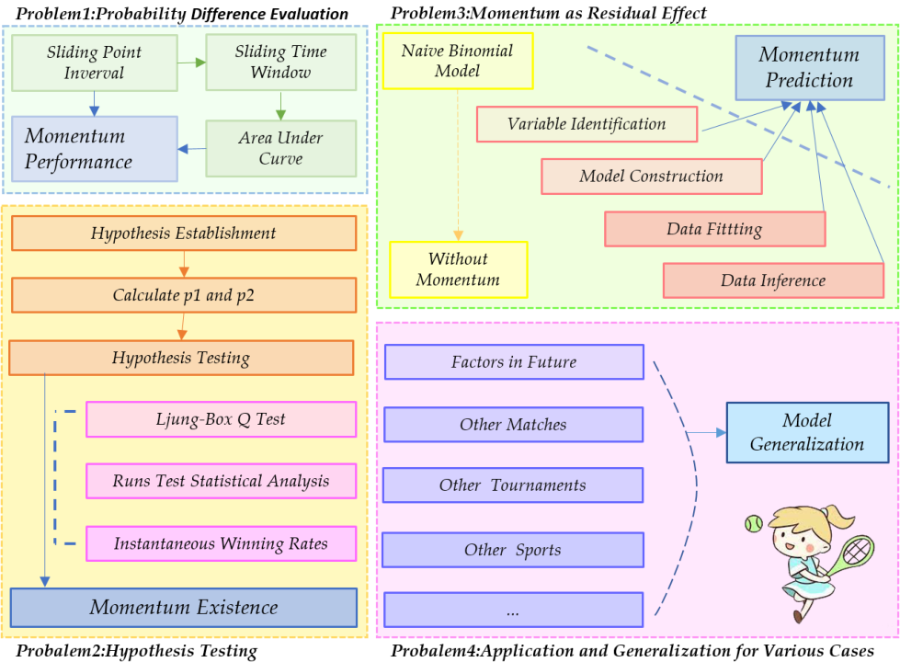
Figure 1: Framework of Our Work
图 1：我们的工作框架
图中文字对照（英文 → 中文）
Problem1:Probability Difference Evaluation | 问题1：概率差评估 | Sliding Point Interval | 滑动分区间
Sliding Time Window | 滑动时间窗 | Area Under Curve | 曲线下面积
Momentum Performance | 势头表现 | Probalem2:Hypothesis Testing | 问题2：假设检验（原文误拼为 Probalem）
Hypothesis Establishment | 假设的建立 | Calculate p1 and p2 | 计算 p1 与 p2
Ljung-Box Q Test | Ljung-Box Q 检验 | Runs Test Statistical Analysis | 游程检验统计分析
Instantaneous Winning Rates | 瞬时得分率 | Momentum Existence | 势头的存在性
Problem3:Momentum as Residual Effect | 问题3：势头作为残差效应 | Naïve Binomial Model | 朴素二项模型
Momentum Prediction | 势头预测 | Without Momentum | 无势头（不含势头项）
Model Generalization | 模型推广 | Probalem4:Application and Generalization for Various Cases | 问题4：面向各类情形的应用与推广
2 Preparation for Modeling
2 建模准备
2.1 Model Assumptions
2.1 模型假设
Some fundamental assumptions are listed below.
以下列出若干基本假设。
• Assumption 1: Factors such as weather, crowd support, and minor injuries donot significantly affect the match outcome.
• 假设 1：天气、观众支持与轻微伤病等因素不会显著影响比赛结果。
→Justification: While these factors can influence a match, including them in amodel adds complexity and unpredictability. For a broad analysis, it’s practicalto focus on more measurable and consistent factors.
→ 理由：尽管这些因素可能影响一场比赛，但将其纳入模型会增加复杂性与不可预测性。对于总体分析而言，聚焦于更易测量且更为一致的因素是切合实际的。
• Assumption 2: A player’s current world ranking is reliable indicators of their
• 假设 2：球员当前的世界排名是其……的可靠指标
2.2 Notations
2.2 符号说明
Some primary notations are listed below.
以下列出若干主要符号。
2
— 原文第 5 页 —
Table 1: Notations Table
表 1：符号说明表
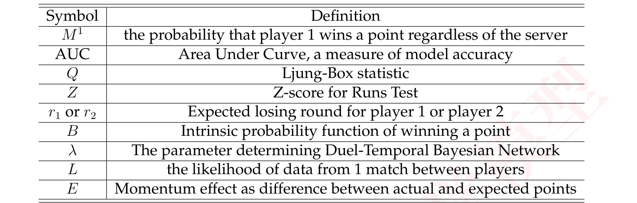
2.3 Data Cleaning
2.3 数据清洗
After observing the Wimbledon_featured_matches.csv data set, we handle outliervalues in column elapsed_time (rows 586 to 636), and delete the speed_mph columnbecause of a significant number of missing values in it, which can impact the wholeanalysis.
在观察 Wimbledon_featured_matches.csv 数据集之后，我们对 elapsed_time 列中的异常值（第 586 行至第 636 行）进行了处理，并删除了 speed_mph 列，因为该列存在大量缺失值，会影响整体分析。
3 Problem 1: Probability Difference Evaluation Strategy
3 问题 1：概率差评估策略
3.1 Important Impact of Server
3.1 发球方的重要影响
Let’s consider the change in the points difference between player 1 and player
让我们考虑球员 1 与球员
2 in a match, according to Wimbledon_featured_matches.csv data set, we subtractp2_points_won data from p1_points_won to get points difference, namely:
2 在一场比赛中的分差变化，根据 Wimbledon_featured_matches.csv 数据集，我们将 p2_points_won 数据从 p1_points_won 中减去以得到分差，即：
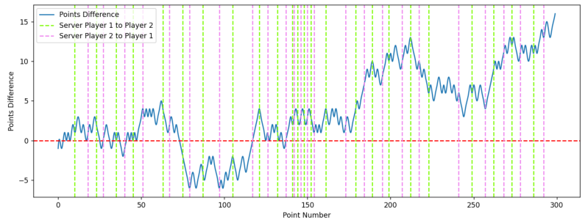
Figure 2: Points Difference for Match 2023-wimbledon-1301
图 2：2023-wimbledon-1301 比赛的分差
图中文字对照（英文 → 中文）
Points Difference | 分数差（累计得分差） | Server Player 1 to Player 2 | 发球方由球员1转为球员2
Server Player 2 to Player 1 | 发球方由球员2转为球员1 | Point Number | 分数序号
Where two colored dotted lines have also been added: green represents the server from player 1 to player 2, and purple represents the server from player 2 to player 1.
其中还添加了两条彩色虚线：绿色代表发球方从球员 1 变为球员 2，紫色代表发球方从球员 2 变为球员 1。
2
— 原文第 6 页 —
A key observation is that the player currently serving has a higher chance of win-ning the point, especially when point number = [20, 50] or [180, 220] . However, theoverall trend of points difference remains relatively stable, regardless of who serves,indicating that serving alone doesn’t drastically shift match momentum. So, we cannotbe influenced by who is the server when we try to identify which player is performingbetter at a given time in the match.
一个关键观察是，当前发球的球员赢得该分的概率更高，尤其是在 point number = [20, 50] 或 [180, 220] 时。然而，无论由谁发球，分差的总体趋势都保持相对稳定，这表明仅凭发球并不能大幅改变比赛势头。因此，当我们试图判断在比赛的某一时刻哪位球员表现更好时，不能受谁是发球方的影响。
3.2 Sliding Point Interval Approach
3.2 滑动分区间方法
To further analyse match dynamics, we focus on the probability difference betweenthe players winning a point. In a match, the performance of two players depends onthe probability difference M¹ or M², M¹ is the probability that player 1 wins a pointregardless of the server, and M² is the probability that player 2 wins a point regardlessof the server.
为了进一步分析比赛动态，我们关注两名球员赢得一分（Point）的概率差（Probability Difference）。在一场比赛中，两名球员的表现取决于概率差 M¹ 或 M²，M¹ 是球员 1 不论发球方为谁而赢得一分（Point）的概率，M² 是球员 2 不论发球方为谁而赢得一分的概率。
Next, according to the column point_no in the given data set, we can calculate p₁and p₂ by choosing a fixed length ω of the data, p₁ is the probability that player 1 wins apoint on serve and p₂ is the probability that player 2 wins a point on serve, ω is the pointinterval. If player 1 serves n₁ times and player 2 serves n₂ times (where w = n₁ + n₂),player 1 wins x₁ points and player 2 wins x₂ points, then p₁ =^{x1n}1 and p² =^{x2}_{n2}. Actually,
接下来，根据给定数据集中的 point_no 列，我们可以通过选取固定长度为 ω 的数据来计算 p₁ 与 p₂，p₁ 是球员 1 在发球时赢得一分的概率，p₂ 是球员 2 在发球时赢得一分的概率，ω 为分区间。若球员 1 发球 n₁ 次、球员 2 发球 n₂ 次（其中 w = n₁ + n₂），球员 1 赢得 x₁ 分、球员 2 赢得 x₂ 分，则 p₁ =^{x1n}1，且 p² =^{x2}_{n2}。实际上，

1 −p₂p₁. If player 1 and player 2 havewe can obtain the performance metric:
1 −p₂p₁。若球员 1 与球员 2 具有我们可以得到表现指标：
1 −p₁p₂the same chance of serving, the ideal value of p₁ and p₂ should be equal, then
1 −p₁p₂相同的发球机会，则 p₁ 与 p₂ 的理想值应当相等，于是
When M¹ > 0.5, it means player 1 performs better than player 2, and for M¹ < 0.5the opposite. Futhermore, the higher the value, the better the performance of the player
当 M¹ > 0.5 时，意味着球员 1 的表现优于球员 2；当 M¹ < 0.5 时则相反。此外，该值越高，球员
1, thus it can identify which player is performing better at a given time in the match,as well as how much better they are performing.
1 的表现就越好，因此它可以识别在比赛的某一时刻哪位球员表现更好，以及他们的表现好多少。
To visualize the differenent performance of players 1 and 2, we bring in a rollingwindow of length ω. For each match, we can utilize this "rolling window" to calcu-late the difference between the performance of player 1 and player 2, and combinedwith cubic spline interpolation, we can plot the corresponding change in the degree ofperformance, and draw the following curve (ω = 30):
为了可视化球员 1 与球员 2 的表现差异，我们引入长度为 ω 的滚动窗口。对于每场比赛，我们可以利用这一“滚动窗口”计算球员 1 与球员 2 表现之间的差值，并结合三次样条插值绘制出相应的表现程度变化，得到如下曲线（ω = 30）：
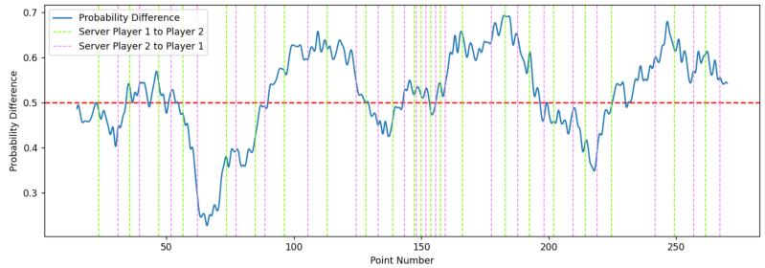
2
— 原文第 7 页 —
pluses 1 when two players finish a ball, corresponding to the column point_no in thegiven data), the ordinate represents the probability difference M¹. Compared with
每当两名球员完成一球时加 1，对应给定数据中的 point_no 列），纵坐标表示概率差 M¹。与
Figure 2, we find that the changing of the server has nothing to do with the probabilitydifference, which means comparing with the probability difference is more significantthan comparing with the points difference.
图 2 相比，我们发现发球方的变化与概率差无关，这意味着比较概率差比比较分差更有意义。
From Figure 3, the part above the red line indicates that player 1 (Carlos Alcaraz)is better than player 2 (Nicolas Jarry), and the part below the red line indicates thatplayer 2 (Nicolas Jarry) is better than player 1 (Carlos Alcaraz), besides, the position ofthe peaks and valleys indicates that the player is performing particularly well.
由图 3 可知，红线以上的部分表示球员 1（Carlos Alcaraz）优于球员 2（Nicolas Jarry），红线以下的部分表示球员 2（Nicolas Jarry）优于球员 1（Carlos Alcaraz）；此外，波峰与波谷的位置表明该球员此时表现尤为出色。
3.3 Sliding Time Window Approach
3.3 滑动时间窗口方法
However, it is not enough to select data points to draw according to the uniforminterval of the total score, we should also do even segmentation from the perspectiveof the time of the game, remember that L represents the length of the time window,
然而，仅按总比分的均匀间隔选取数据点来绘图是不够的，我们还应从比赛时间的角度进行均匀分割，记 L 表示时间窗口的长度，
λ represents the step size of each time window move, replace the point number witht_{i} as the abscissa, t_{i} = λ seconds, 2λ seconds, . . . For instance, if L = 600 seconds isused as the length of the time window, two players may play a total of 12 points or 18points, and then set λ = 60 seconds as the step size of the time window movement, theresult is more reflective of the player’s performance and more natural.
λ 表示每次时间窗口移动的步长，以 t_{i} 代替分序号作为横坐标，t_{i} = λ 秒、2λ 秒、……例如，若取时间窗口的长度 L = 600 秒，则两名球员总共可能打出 12 分或 18 分，此时再设 λ = 60 秒作为时间窗口移动的步长，所得结果更能反映球员的表现，也更为自然。
By adjusting different L and λ, we plot the variation as follows:
通过调整不同的 L 与 λ，我们绘制出其变化如下：
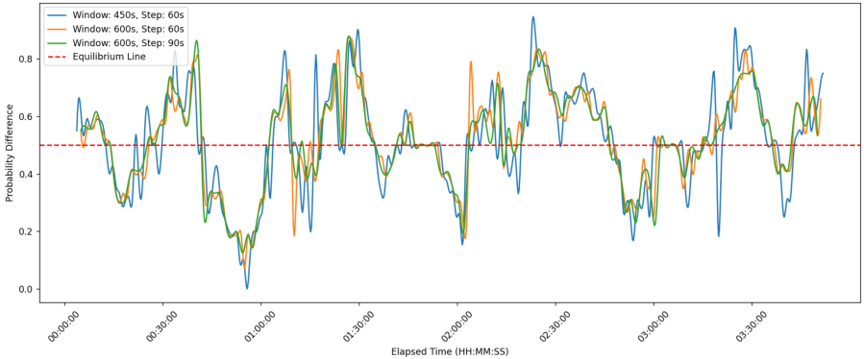
Figure 4: Performance Evaluation with Different Windows for Match 2023-wimbledon-1301
图 4：2023-wimbledon-1301 场比赛在不同窗口下的表现评估
图中文字对照（英文 → 中文）
Window: 450s, Step: 60s | 窗口长度450秒，步长60秒 | Window: 600s, Step: 60s | 窗口长度600秒，步长60秒
Window: 600s, Step: 90s | 窗口长度600秒，步长90秒 | Equilibrium Line | 均衡线
Probability Difference | 概率差 | Elapsed Time (HH:MM:SS) | 已用时间（时:分:秒）
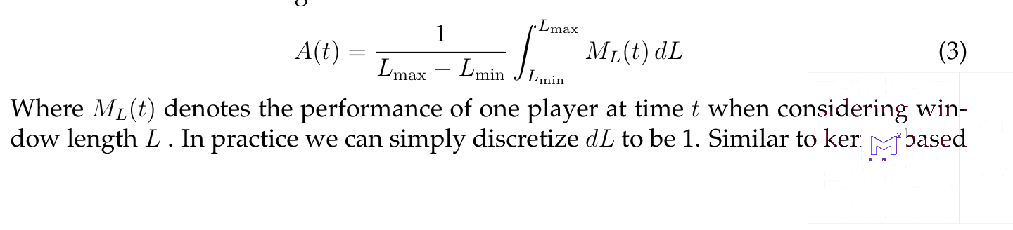
— 原文第 8 页 —
methods, AUC also weights the points winning with temporal distance (this can beeasily seen by expressing M_{L}(t) as sum of indicator functions then switching the sum-mation order, we skip the details here). The following is the generated graph usingthis method.
方法中，AUC 同样对得分点按时间距离加权（只需将 M_{L}(t) 表示为指示函数之和并交换求和次序，即可容易看出这一点，此处略去细节）。以下为使用该方法生成的图。
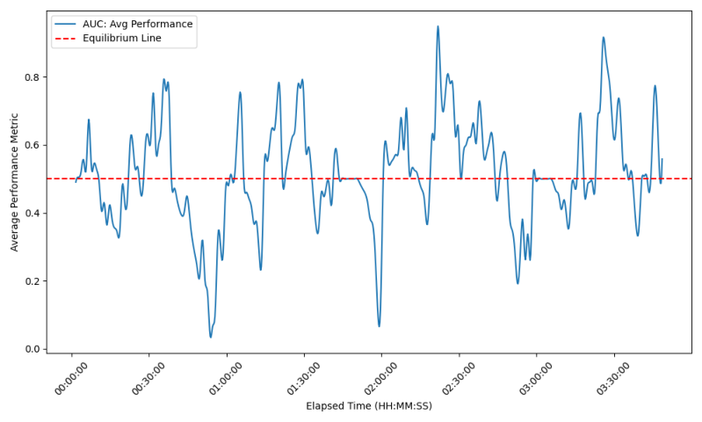
Figure 5: AUC-Time Plot for Match 2023-wimbledon-1301
图 5：2023-wimbledon-1301 场比赛的 AUC-时间图
图中文字对照（英文 → 中文）
AUC: Avg Performance | AUC：平均表现 | Equilibrium Line | 均衡线
Average Performance Metric | 平均表现指标 | Elapsed Time (HH:MM:SS) | 已用时间（时:分:秒）
From this graph we can determine which player is performing better at a certaintime. When the curve is above 0.5, player 1 takes an upper hand, while the contraryhappens when player 2 performs better. And the farther the curve’s distance from theequilibrium line, the greater the difference between players’ performance.
从该图我们可以判断某一球员在某一时刻的表现更优。当曲线位于 0.5 以上时，球员 1 占据上风；反之，当球员 2 表现更好时则情况相反。且曲线距均衡线越远，两名球员表现之间的差异越大。
4 Problem 2: Momentum Existence
4 问题 2：势头的存在性
Given our analysis revealing potential patterns in "momentum", we now rigorouslyexamine these observations through hypothesis testing to validate the presence of mo-mentum.
鉴于我们的分析揭示了“势头”中可能存在的规律，我们现在通过假设检验严格考察这些观测结果，以验证势头的存在性。
4.1 Hypothesis Testing Preparation
4.1 假设检验的准备工作
We first constructed the Hypothesis Testing Framework:
我们首先构建假设检验框架：
Null Hypothesis (H₀): For a fixed server, the scoring of points by a player is inde-pendent and identically distributed (i.i.d.) and thus follows a binomial distribution.
原假设（H₀）：对于固定的发球方，球员的得分是独立同分布（i.i.d.）的，因而服从二项分布。
Alternative Hypothesis (H₁): The complement of H₀, suggesting that scoring is notentirely random, and some form of "momentum" or sequence dependency exists.
备择假设（H₁）：H₀ 的补集，即得分并非完全随机，存在某种形式的“势头”或序列依赖性。
To evaluate the claim regarding the non-existence of "momentum", we denoted thatin any given match, when Player 1 serves, the probability of Player 1 winning a point
为评估关于“势头”不存在的论断，我们记：在任一场比赛中，当球员 1 发球时，球员 1 赢得一分的概率
For each match, we calculated the winning probabilities by: counting the numberof points won and the total number of serves by Player 1 to calculate p₁ and counting 2 the number of points won by Player 1 against the total serves of Player 2 to calculatep₂.
对每场比赛，我们通过以下方式计算获胜概率：统计球员 1 赢得的分数与球员 1 的总发球数，以计算 p₁；并统计 2球员 1 在球员 2 总发球数中赢得的分数，以计算 p₂。
— 原文第 9 页 —
4.2 Ljung-Box Q Test and Runs Test Statistical Analysis
4.2 Ljung-Box Q 检验与游程检验统计分析
If scoring was entirely random, we would expect no significant autocorrelation be-tween consecutive points.
若得分完全随机，我们预期相邻各分之间不存在显著的自相关。
We separate out the scenarios for Player 1’s serve and Player 2’s serve and build se-quences for each match.Then calculate the autocorrelation for each sequence and Em-ploy an appropriate statistical test (Ljung-Box Q test) to assess whether the sequence’sautocorrelation is significant.
我们将球员 1 发球与球员 2 发球的情形分别列出，并为每场比赛构建序列。随后计算各序列的自相关，并采用适当的统计检验（Ljung-Box Q 检验）评估序列的自相关是否显著。
The statistic for the Ljung-Box Q test is calculated as follows:
Ljung-Box Q 检验的统计量计算如下：
Where: n is the sample size of the time series. h is the maximum number of lagsconsidered for autocorrelation detection. ˆρ_{k} is the sample autocorrelation coefficient atlag k. Q is the Ljung Box statistic, which follows an approximate chi square distributionunder the null hypothesis with degrees of freedom h −m, where m is the number ofparameters in the model (for simple time series analysis, m is typically taken as m = 0).
其中：n 为时间序列的样本量。h 为自相关检测所考虑的最大滞后阶数。ˆρ_{k} 为滞后 k 处的样本自相关系数。Q 为 Ljung-Box 统计量，在原假设下近似服从卡方分布，自由度为 h − m，其中 m 为模型中的参数个数（对于简单时间序列分析，m 通常取 m = 0）。
The Ljung-Box Q test results for the first match, with a corresponding p-value of
第一场比赛的 Ljung-Box Q 检验结果，对于滞后至 10 个观测的自相关，相应的 p 值为
0.497 for autocorrelations up to 10 observations, indicated a p-value greater than com-mon significance levels (e.g., 0.05). The results of other matches are similar. This sug-gests insufficient evidence to reject the null hypothesis H₀.
0.497，表明 p 值大于常规显著性水平（如 0.05）。其他比赛的结果类似。这表明证据不足以拒绝原假设 H₀。
Then we conducted the runs test to analyze the number of "runs" in a data sequence,where a "run" is defined as a sequence of identical elements occurring consecutively.
随后我们进行游程检验，以分析数据序列中“游程”的数目，其中“游程”定义为连续出现的相同元素所构成的序列。
We calculate the Expected Number of Runs and Variance,and get theZ-Score by:
我们计算游程数的期望与方差，并通过下式得到 Z 分数：
Where: R represents the actual number of runs. E[R] is the expected number of runs,calculated as E[R] = 1+^{2n1n2}_{n1+n2}. Var(R) is the variance of the number of runs, calculatedas Var(R) =^{2n1n2(2n1n2−n1−n2)} (n₁+n₂)²(n₁+n₂−1) . n¹ and n² are the counts of the two outcomes (e.g., winsand losses) in the sequence.
其中：R 表示实际游程数。E[R] 为游程数的期望，计算为 E[R] = 1+^{2n1n2}_{n1+n2}。Var(R) 为游程数的方差，计算为 Var(R) =^{2n1n2(2n1n2−n1−n2)}(n₁+n₂)²(n₁+n₂−1)。n¹ 与 n² 为序列中两种结果（如胜与负）的计数。
Then we calculate the P-Value Calculation by: P = 2(1 −Φ(|Z|)) to get the P =
然后我们通过下式计算 P 值：P = 2(1 −Φ(|Z|))，从而得到 P =
0.691, which is greater than common significance levels (e.g., 0.05) suggests that thehypothesis of the points being i.i.d cannot be dismissed. The results of other matchesare similar.
0.691，大于常见的显著性水平（如 0.05），表明各分相互独立同分布（i.i.d.）的假设无法被否定。其他比赛的结果类似。
Here we plot the results of 2 methods with different matches. As evidenced by P
此处我们绘制了两种方法在不同比赛中的结果。正如 P 所表明的
2
— 原文第 10 页 —
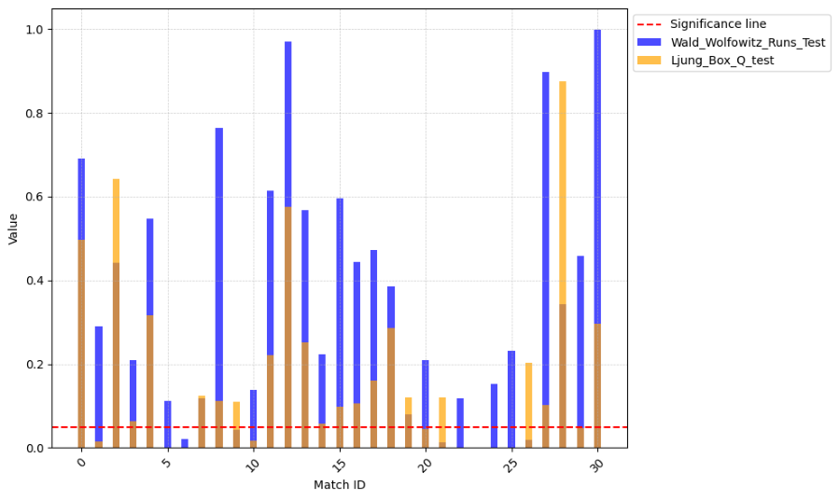
Figure 6: feature importance
图 6：特征重要性
图中文字对照（英文 → 中文）
Significance line | 显著性线 | Wald_Wolfowitz_Runs_Test | Wald-Wolfowitz 游程检验
Ljung_Box_Q_test | Ljung-Box Q 检验 | Value | 数值
Match ID | 比赛编号
4.3 Instantaneous Winning Rates
4.3 瞬时胜率
^{[4]}, we employed
^{[4]}，我们采用了
To check the i.i.d. argument, inspired by the paper [Sun, Y., 2004]an instantaneous winning rate approach. This rate refers to the probability of a playerwinning the next point immediately after winning a point, under a constant server con-dition. We calculated and compared the instantaneous winning rates in two scenarios:
为检验 i.i.d. 这一论点，受文献 [Sun, Y., 2004] 的启发，我们采用瞬时胜率方法。该比率指在发球方保持不变的条件下，球员在赢下一分之后紧接着赢得下一分的概率。我们计算并比较了两种情形下的瞬时胜率：
The rate at which Player 1 wins the next point immediately after winning a point whileserving and the rate at which Player 1 wins the next point immediately after winninga point against Player 2’s serve.
球员 1 在发球时赢下一分后紧接着赢得下一分的比率，以及球员 1 在接球员 2 发球时赢下一分后紧接着赢得下一分的比率。
Table 2: Probability of Winning Based on Serving State
表 2：基于发球状态的获胜概率
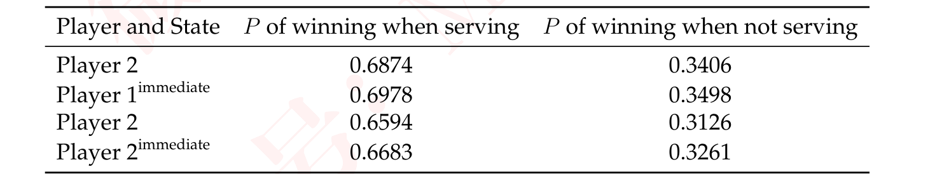
The observed increase in winning rates by around 1% might indicate the influenceof momentum, challenging the claim of randomness in scoring sequences within tennismatches.
观察到的约 1% 的胜率提升可能表明势头的影响，从而对网球比赛中得分序列具有随机性的说法构成挑战。
Delving into the subtleties of the match data revealed an intriguing pattern: playersdemonstrated a marginally increased probability of securing the next point following
深入探究比赛数据的细微之处，揭示出一个有趣的模式：球员在……之后赢得下一分的概率略有上升
2
— 原文第 11 页 —
5 Problem 3: Momentum Prediction
5 问题 3：势头预测
5.1 The building block: Naive Binomial Model
5.1 基本构件：朴素二项模型
One immediate issue in identifying "momentum" in competition is that all variableswe observe are mixed with the momentum effect and the effect from the skill leveldifference of the players. In order to "separate out" the effect of momentum, we firstdevelop a naive model without considering any momentum. Or, equivalently, a modelunder the assumption that the points won are identically distributed random variables.
在比赛中识别“势头”的一个直接问题在于，我们观察到的所有变量都混合了势头效应与球员技术水平差异所带来的效应。为了“分离出”势头效应，我们首先建立一个不考虑任何势头的朴素模型。或者等价地说，一个建立在所得各分为同分布随机变量这一假设之下的模型。
^{[5]}.
We term this model the Binomial Model, denoted by BM
我们将该模型称为二项模型，记为 BM
To develop this model, we collect the world rank of players as additional priorinformation ... And convert them into relative rank in 2023 Wimbledon competition.
为建立该模型，我们收集球员的世界排名作为额外的先验信息……并将其转换为 2023 年温布尔登锦标赛中的相对排名。
By "relative", we re-rank the 32 players according to their rankings relative to eachother, resulting an array of integers between 1 and 32. Then BM is simply a functionof (Rank₁, Rank₂).
所谓“相对”，即按 32 名球员彼此之间的排名重新排序，得到一个取值介于 1 与 32 之间的整数数组。于是 BM 仅是 (Rank₁, Rank₂) 的函数。
Our Binomial model takes the rank of two players then return the "intrinsic proba-bility" of winning a certain point, which under the naive assumption, stay constantlyacross the whole match.
我们的二项模型输入两名球员的排名，输出赢得某一分的“内在概率”，在朴素假设下，该概率在整场比赛中保持不变。
It’s notable that in tennis competition, strength difference between top rank playersare often more evident than players with lower ranks. For example, we may expectthe difference between rank 1 and rank 2 players larger than the difference betweenrank 31 and rank 32 players. On the contrary, the notion of "expected losing round"^{[5]}. Specifically, we definecan capture this prior well
值得注意的是，在网球比赛中，顶尖排名球员之间的实力差异往往比排名较低的球员之间更为明显。例如，我们可能预期排名第 1 与第 2 的球员之间的差异大于排名第 31 与第 32 的球员之间的差异。相反，“预期出局轮次”这一概念能够很好地刻画这一先验^{[5]}。具体地，我们定义
Consequently, we can define BM(Rank₁, Rank₂) := f₁(r₁, r₂). Set f₂(x, y) = f₁(^{x+y}
因此，我们可以定义 BM(Rank₁, Rank₂) := f₁(r₁, r₂)。令 f₂(x, y) = f₁(^{x+y}
2 ,x−y
2 ) we have BM = f²(r¹ −r², r¹ + r²) . We provide the following approximation forf₂ :
2 )，则有 BM = f²(r¹ −r², r¹ + r²)。我们对 f₂ 给出如下近似：
Where s > 0 is the server advantage. Alternatively, we can set the right hand side ase^{λ(r1−r2)+µ(r1+r2)}_{1+e}λ(r₁−r₂₎₊µ(r₁₊r₂₎ + s with more parameters.
其中 s > 0 为发球方优势。或者，我们可以将右端设为 e^{λ(r1−r2)+µ(r1+r2)}_{1+e}λ(r₁−r₂₎₊µ(r₁₊r₂₎ + s，以引入更多参数。
But during experiment we have found the value of mu to be considerably small thuswe ignore it here. Ideally, if the Formula (6) has captured the rank-strength relationshipwell enough, then this simplification makes sense. Refer to [Klaassen and Magnus, [2] for further justification.
但在实验过程中我们发现 µ 的取值相当小，因此在此将其忽略。理想情况下，若式 (6) 已充分刻画了排名与实力之间的关系，那么这一简化是合理的。参见 [Klaassen and Magnus，[2] 以获得进一步论证。
2001]
We then estimate the parameter λ on our point-to-point data of 31 matches by max-imizing the likelyhood.
随后，我们通过对 31 场比赛的逐分数据极大化似然来估计参数 λ。
Step 1: Likelihood Function
第 1 步：似然函数
be represented as a binomial distribution:
可表示为二项分布：
2
— 原文第 12 页 —
Step 2: Log-Likelihood
第 2 步：对数似然
To simplify calculations and to deal with potential numerical underflow, it’s com-mon to work with the log-likelihood rather than the likelihood itself.
为简化计算并处理可能的数值下溢，通常采用对数似然而非似然本身进行运算。
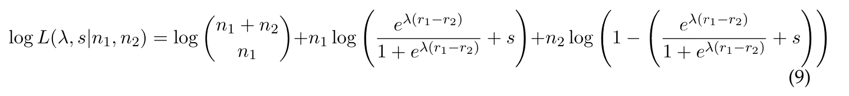
Step 3: Aggregate Log-Likelihood Over All Matches
第 3 步：汇总所有比赛的对数似然
To estimate λ, s using data from all 31 matches, we sum the log-likelihoods acrossall matches:
为利用全部 31 场比赛的数据估计 λ、s，我们对所有比赛的对数似然求和：
Step 4: Maximizing the Log-Likelihood
第 4 步：极大化对数似然
Owing to the smoothness of the function, we can easily apply Newton method,which requires the computation of first and second derivative, to iteratively adjust λ, sto find the maximum. The optimal value is computed as lambda = 0.0624, s = 0.1742 .
由于该函数光滑，我们可以方便地应用牛顿法，该方法需要计算一阶与二阶导数，以迭代调整 λ、s 求得最大值。最优值计算为 lambda = 0.0624，s = 0.1742。
5.2 Momentum as residual effect
5.2 作为残差效应的势头
It’s easy for us to observe the equivalence between no momentum statement and
我们很容易观察到，无势头陈述与
⇐⇒memoryless statement. "Momentum doesn’t exist"
⇐⇒无记忆性陈述之间是等价的。“势头并不存在”
"The process of winningpoints is independent of the past of the game, or in another word, memoryless"
“得分过程与比赛的过去相互独立，换言之，即无记忆性”
Now by inversing both sides, we can measure the momentum effect as:
现在，对等式两端取逆，我们即可将势头效应度量如下：
Where S is the points winning in reality while ˆS is the points winning predicted bythe Binomial model. Since no strict definition of momentum exists as a statistic. Wenow use formula (11) to define the value of momentum. This formula can be under-stand intuitively, as previous critics on momentum often describe it as “seeing some- [4]thing out of randomness.”
其中 S 为现实中赢得的分数，而 ˆS 为二项模型所预测的赢得的分数。由于势头作为一种统计量并不存在严格的定义。我们转而使用式 (11) 来定义势头的取值。该公式可以直观地理解，正如此前对势头的批评者常将其描述为“从随机性中看出某些[4]东西”。
In order to design a model to predict the residual, there are several key facts worthnoticing:
为了设计一个预测残差的模型，有若干关键事实值得注意：
The reason why "momentum" is so hard to grasp statistically is that this conceptimplies some "hidden state" exists in the system of sports play. So a generative modelis preferred. The direct 1-step prediction can be extremely noisy and thus posing achallenge for effective model-fitting. We need specific approach to reduce the impact
“势头”之所以在统计上如此难以把握，是因为这一概念意味着运动比赛系统中存在某种“隐藏状态”。因此更宜采用生成式模型。直接的单步预测可能噪声极大，从而对有效的模型拟合构成挑战。我们需要特定的方法来削弱其影响
2
— 原文第 13 页 —
Taking all these into account, we introduce our novel Duel-Temporal Bayesian Net-work. As a variation of normal Dynamical Bayesian Network, it not only constructsa hidden model for the tennis game play, but also encodes long-short term memoryfrom the past, enabling a comprehensive detection of "momentum".
综合以上各点，我们引入新颖的 Duel-Temporal 贝叶斯网络。作为常规动态贝叶斯网络的一种变体，它不仅为网球比赛构建了隐藏模型，还编码了来自过去的长短期记忆，从而能够全面地检测“势头”。
5.2.1 Variable identification
变量识别
In tennis, what’s not seen can be just as influential as the scoreboard. For example,a player’s sudden surge or dip in performance isn’t always from the visible aces ordouble faults. It’s often the hidden triggers – maybe how the match’s strain is weighingon their shoulders – that can turn the tide. A tennis game is not only a competition instrength or technique, but also involves complicated psychological and physiologicaldynamics.
在网球中，看不见的因素可能与记分板同样具有影响力。例如，球员表现的突然提升或下滑并不总是源于可见的 ACE 球或双误。往往正是那些隐藏的触发因素——也许是比赛的压力如何压在他们肩上——才能扭转局势。一场网球比赛不仅是力量或技术的较量，还涉及复杂的心理与生理动态。
^{[1]}, we see that momentum is a complex
^{[1]}，我们可以看到，势头是一个复杂的
Drawing from the insights of [Taylor J., 1994]system of cognition, physiology, and emotion, all sparked by precipitating events andmanifesting in performance changes. This paper’s concept of a "momentum chain",which suggests that an initial event can trigger alterations in an athlete’s cognition,affect, and physiology, leading to behavioral changes that influence performance, res-onates with the invisible forces at play in tennis, guiding us to consider latent variables.
借鉴 [Taylor J., 1994] 的见解，由认知、生理与情绪构成的系统，皆由诱发事件所激发，并表现为表现上的变化。本文提出的“势头链”概念认为，初始事件能够引发运动员认知、情感与生理的改变，进而导致影响表现的行为变化，这与网球中发挥作用的无形力量相呼应，引导我们去考虑潜变量。
Based on this framework, we select 3 latent variables in our model: "Physiology",
基于这一框架，我们在模型中选择 3 个潜变量：“生理”、
"perception of control", and "self-efficacy". They play a crucial role in capturing thecomplex, non-observable factors that influence the momentum swings in a tennis match.
“控制感知”与“自我效能”。它们在捕捉影响网球比赛中势头波动的复杂、不可观测因素方面发挥着关键作用。
1. Physiology: The physical condition of the players, like fatigue, energy levels,and even subtle injuries.
1. 生理：球员的身体状况，如疲劳、能量水平，甚至细微的伤病。
2. Perception of Control: This represents a player’s ability to control the match.
2. 控制感知：这代表球员掌控比赛的能力。
3. Self-efficacy: Self-efficacy is a player’s belief in their capability,which is the fuelthat powers player’s persistence.
3. 自我效能：自我效能是球员对自身能力的信念，它是驱动球员坚持不懈的动力源泉。
^{[1]}, precipitating events, such as specific shots, critical
^{[1]}，诱发事件，例如特定的击球（Shot）、关键的
According to [Taylor J., 1994]points shift a player’s mental and physiological state indirectly. These hidden state arethe undercurrents of the game, unseen but vital. Incorporating these into our modelallows for a more accurate understanding and prediction of momentum swings.
根据 [Taylor J., 1994]，这些分数会间接改变球员的心理与生理状态。这些隐藏状态是比赛的暗流，虽不可见却至关重要。将它们纳入模型，可以更准确地理解与预测势头波动。
Then we get the diagram below. The arrows in the following diagram representinfluential relationships between various factors. This complex network of influencesreflects the multifaceted nature of competitive sports, where physical, mental, and sit-uational factors all intertwine to affect the outcome of a match.
于是我们得到下图。下图中的箭头表示各因素之间的影响关系。这一复杂的影响网络反映了竞技体育的多面性：身体、心理与情境因素相互交织，共同影响比赛的结局。
— 原文第 14 页 —
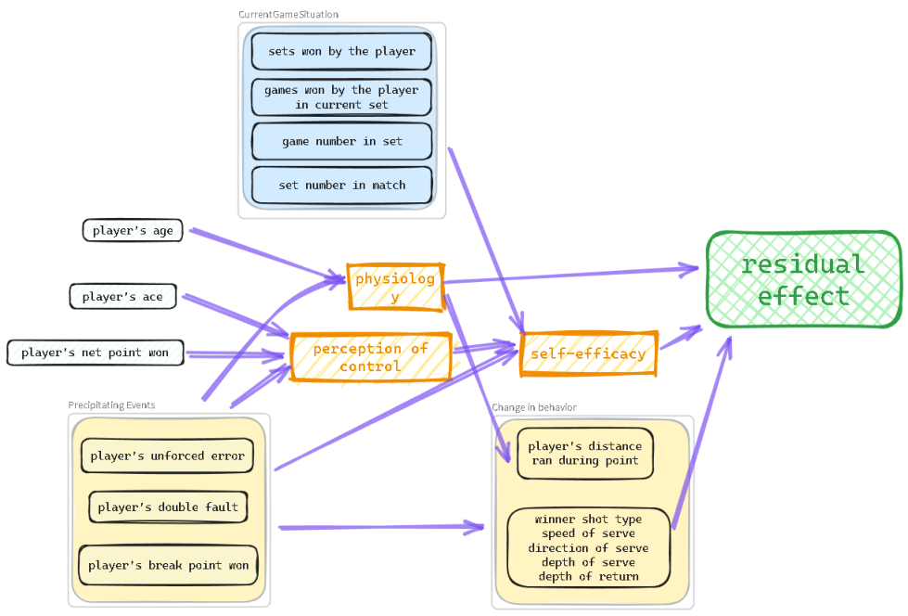
Figure 7: Identified Variables
图 7：识别出的变量
图中文字对照（英文 → 中文）
CurrentGameSituation | 当前比赛形势 | sets won by the player | 该球员已赢得的盘数
games won by the player in current set | 该球员当前盘已赢得的局数 | game number in set | 盘内的局序号
set number in match | 比赛中的盘序号 | player's age | 球员年龄
player's ace | 球员的 Ace 球 | player's net point won | 球员的网前得分
physiology | 生理状态 | perception of control | 控制感
self-efficacy | 自我效能 | residual effect | 残差效应（势头）
Precipitating Events | 诱发事件 | player's unforced error | 球员的非受迫性失误
player's double fault | 球员的双误 | player's break point won | 球员的破发点得分
Change in behavior | 行为的变化 | player's distance ran during point | 一分内的跑动距离
Due to the limitation of our data (only 31 matches), a complicated model like thisis prone to overfitting and thus not suitable for robustness prediction. To simplify themodel construction, we utilized random forest to search for variables that are insignif-icant for prediction.Here are some top features:
受数据限制（仅 31 场比赛），如此复杂的模型容易过拟合，因而并不适合用于稳健性预测。为简化模型构建，我们利用随机森林（Random Forest）搜索对预测不显著的变量。以下为部分最重要的特征：
Table 3: Feature Importancep₁_unf_errp₂_winnerp₂_unf_errp₁_winner
表 3：特征重要性 p₁_unf_err p₂_winner p₂_unf_err p₁_winner
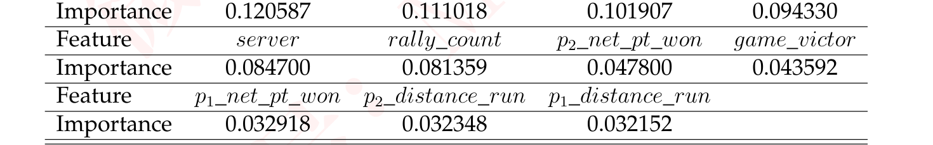
To simplify our network, we should visualize the correlation between features us-ing a correlation heatmap. This is crucial for feature engineering. The correlationheatmap of the top-10 features shows the relationships between variables that aremost predictive of the point victor in a tennis match. Here are some insights fromthe heatmap:
为简化我们的网络，我们应使用相关性热力图来可视化特征之间的相关性。这对特征工程至关重要。前 10 个特征的相关性热力图展示了那些对网球比赛中一分归属最具预测力的变量之间的关系。以下是从该热力图中得到的若干见解：
Unforced Errors (p_1_unf_err, p_2_unf_err): These features show a significant cor-relation with the outcome of points, implying that players’ mistakes can crucially in-fluence point results.
非受迫性失误（p_1_unf_err、p_2_unf_err）：这些特征与一分的归属呈现显著相关，意味着球员的失误能够关键性地影响一分的结果。
Winners (p_1_winner, p_2_winner): Points won by players due to winning shots are highly correlated with the match outcome.
制胜分（p_1_winner、p_2_winner）：球员凭借制胜击球赢得的分数与比赛结果高度相关。
Serving (server): The role of the server in a point has a notable correlation with point outcomes.
发球（server）：发球方在一分中的作用与一分的归属之间具有显著相关性。
— 原文第 15 页 —
Physical and Strategic Aspects (rally_count, p_1_net_pt_won, p_2_net_pt_won): Thesefeatures suggest the physical exertion and strategic play involved in points, such aslonger rallies and successful net plays contributing to point outcomes.
体能与战术层面（rally_count、p_1_net_pt_won、p_2_net_pt_won）：这些特征表明一分之中所涉及的体能消耗与战术运用，例如更长的多拍相持与成功的网前击球有助于一分的结果。
This reveals several layers of the game that potentially contribute to momentum,such as the direct impact like unforced errors, winning shots, and the advantage con-ferred by serving. Additionally, the physical and strategic elements like rally countsand net points could influence a player’s dominance during a match as well.
这揭示了比赛中可能促成势头的若干层面，例如非受迫性失误、制胜分以及发球所带来的优势等直接影响。此外，多拍回合数与上网得分等体能与战术要素也可能影响一名球员在比赛中的统治力。
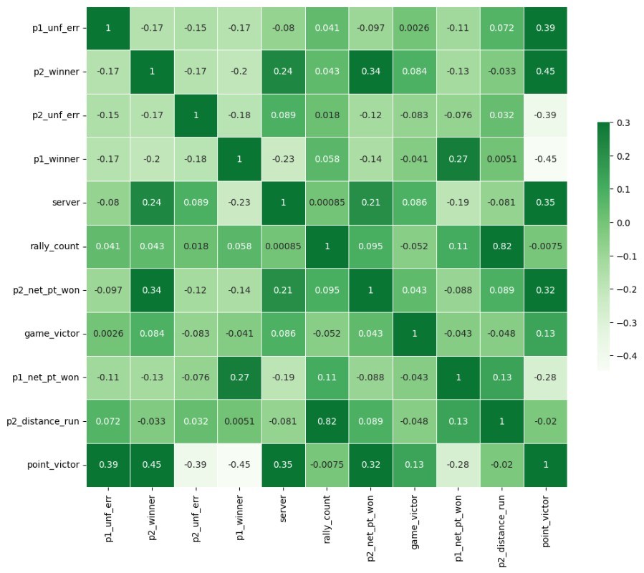
Figure 8: Correlation Heatmap of Top-10 Features
图 8：前 10 个特征的相关性热力图
图中文字对照（英文 → 中文）
p1_unf_err | 球员1非受迫性失误 | p2_winner | 球员2制胜分
p2_unf_err | 球员2非受迫性失误 | p1_winner | 球员1制胜分
server | 发球方 | rally_count | 回合拍数
p2_net_pt_won | 球员2网前得分 | game_victor | 本局胜者
p1_net_pt_won | 球员1网前得分 | p2_distance_run | 球员2跑动距离
point_victor | 本分胜者
5.2.2 Model Construction
模型构建
Through this method, we ascertained and dropped insignificant features such asphysiology. The remaining features forms the bedrock of our network. The simplifiedversion is depicted in the following graph:
通过该方法，我们确定并剔除了诸如生理状态等不显著的特征。剩余特征构成了我们网络的基石。简化版本如下图所示：
— 原文第 16 页 —
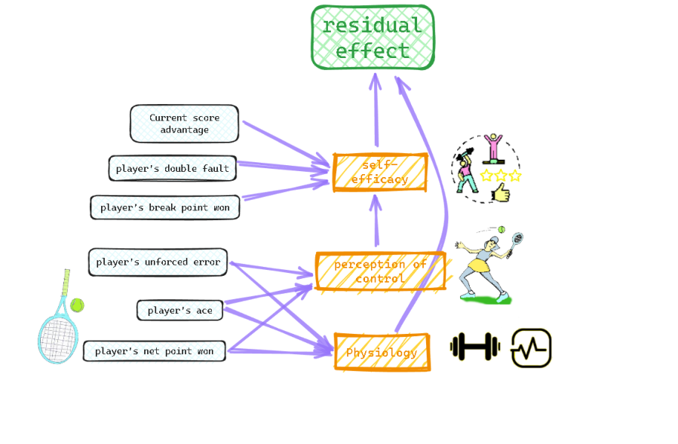
Figure 9: One Building Block of the Bayesian Network
图 9：贝叶斯网络的一个构建模块
图中文字对照（英文 → 中文）
residual effect | 残差效应（势头） | self-efficacy | 自我效能
perception of control | 控制感 | Physiology | 生理状态
Current score advantage | 当前比分领先 | player's double fault | 球员的双误
player's break point won | 球员的破发点得分 | player's unforced error | 球员的非受迫性失误
player's ace | 球员的 Ace 球 | player's net point won | 球员的网前得分
Using this simpler network as one building block, we can stack two blocks togetherto form our Duel-Temporal Bayesian Network:
以这一更为简单的网络作为一个构建模块，我们可以将两个模块堆叠起来，构成我们的双时间层贝叶斯网络：
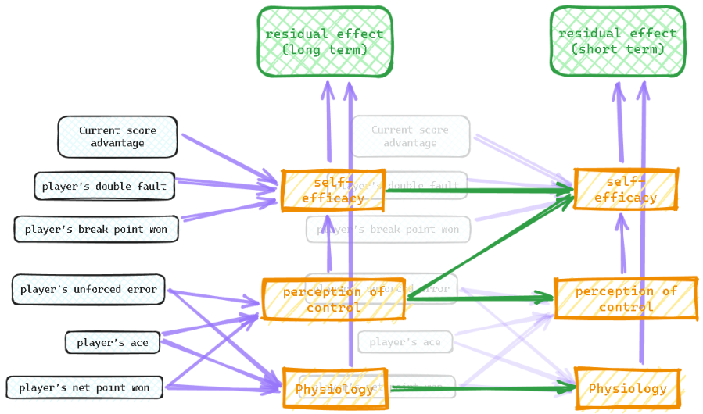
Figure 10: Duel-Temporal Bayesian Network
图 10：双时间层贝叶斯网络
图中文字对照（英文 → 中文）
residual effect (long term) | 残差效应（长期） | residual effect (short term) | 残差效应（短期）
self-efficacy | 自我效能 | perception of control | 控制感
Physiology | 生理状态 | Current score advantage | 当前比分领先
player's double fault | 球员的双误 | player's break point won | 球员的破发点得分
player's unforced error | 球员的非受迫性失误 | player's ace | 球员的 Ace 球
player's net point won | 球员的网前得分
We have added green arrows between hidden variables in these two layers, repre-senting the continuity of mental and physical state.
我们在这两层的隐变量之间添加了绿色箭头，表示心理状态与生理状态的连续性。
— 原文第 17 页 —
5.2.3 Data fitting
数据拟合
One obstacle for effectively training this model is noise. Although we have takeninto account the original strength difference and the serving advantage, we must ad-mit the residual effect of gaining/losing at a certain point is still (and should be still)largely random. Instead of letting the model predict the state in the next point, we letit predict **the sum** of the effect in the next n points. Because of Central Limit The-orem, this reduces the noise and thus making the network’s training possible. In thesame manner, all the observed variables such as player’s double fault is aggregated ina certain time interval. Specifically, suppose the current point index is t , the long-termlayer’s data is aggregated in [t −40, t −10] and the effect in [t −10, t] , while the short-term layer’s data is aggregated in [t −10, t] and the effect in [t, t + 10] . We carefullyseparate the past game information and the future game outcome to guarantee ourmodel is completely predictive.
有效训练该模型的一个障碍是噪声。尽管我们已考虑了原始实力差异与发球优势，但必须承认，在某一分上得分或失分的残余效应在很大程度上仍然是（并且也应当是）随机的。我们没有让模型预测下一分的状态，而是让它预测接下来 n 分效应的**求和**。由于中心极限定理，这样做降低了噪声，从而使网络的训练成为可能。以同样的方式，所有观测变量（例如球员的双误）都在某一时间区间内进行聚合。具体而言，假设当前分的序号为 t，则长期层的数据在 [t −40, t −10] 内聚合、效应在 [t −10, t] 内聚合，而短期层的数据在 [t −10, t] 内聚合、效应在 [t, t + 10] 内聚合。我们谨慎地将过去的比赛信息与未来的比赛结果分开，以保证我们的模型具有完全的预测性。
The following graph depicts the shifting of denoised residual effect in the matchbetween Carlos Alcaraz and Djokovic from Carlos’ perspective.
下图描绘了在卡洛斯·阿尔卡拉斯与德约科维奇的比赛中，从卡洛斯视角出发的去噪后残余效应的变化。
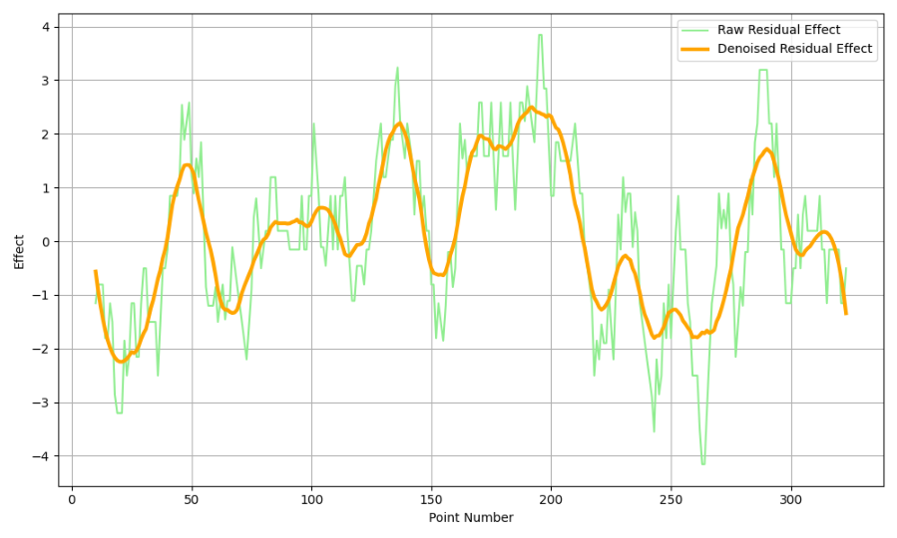
Figure 11: Denoised Residual Effect Cruve
图 11：去噪后的残余效应曲线
图中文字对照（英文 → 中文）
Raw Residual Effect | 原始残差效应 | Denoised Residual Effect | 去噪后的残差效应
Effect | 效应值 | Point Number | 分数序号
Due to the existence of latent variables in our model, we utilize the Expectation-
由于模型中存在隐变量，我们采用期望
Maximization (EM) algorithm to train the network on the data of 31 matches in Wim-bledon 2023. EM is used in statistics for finding maximum likelihood estimates ofparameters in probabilistic models, where the model depends on unobserved latentvariables.
最大化（EM）算法，利用 2023 年温布尔登网球锦标赛 31 场比赛的数据对该网络进行训练。EM 算法（EM Algorithm）在统计学中用于求解概率模型参数的极大似然估计（Maximum Likelihood Estimation），此类模型依赖于不可观测的隐变量。
The EM algorithm consists of two steps: the Expectation step (E step) and the Max-imization step (M step). In the E step, the algorithm calculates the expected valuesof the latent variables given the current parameters of the model. In the M step, itmaximizes the likelihood function to update the parameters based on these expectedvalues. This process is repeated until convergence.
EM 算法包含两个步骤：期望步（E 步）与最大化步（M 步）。在 E 步中，算法在给定模型当前参数的条件下计算隐变量的期望值。在 M 步中，算法基于这些期望值最大化似然函数以更新参数。该过程重复进行，直至收敛。
Q(θ|θ^{(t)}) = E_{Z|X,θ}(t)[log L(θ; X, Z)]
E step:
E 步：
— 原文第 18 页 —
In these equations, θ represents the parameters of the model, X represents the ob-served data which consists both the output - residual effect and the input - point-to-point data, Z represents the latent variables(6 latent variables in our model), L is thelikelihood function, and Q is a function that depends on the expected values of thelatent variables.
在上述各式中，θ 表示模型的参数，X 表示观测数据，它由输出（残余效应）与输入（逐分数据）共同构成，Z 表示隐变量（我们的模型中有 6 个隐变量），L 为似然函数，Q 为依赖于隐变量期望值的函数。
During our first training, we spotted an unexpected bias in this dataset: the player 1has overall better residual effect than the player 2. Consequently, the prior distribution (i.e. when NO evidence provided) of "player 1 has better residual effect" vs "player
在首次训练过程中，我们注意到该数据集存在一个意外的偏差：球员 1 的总体残余效应优于球员 2。因此，先验分布（即在未提供任何证据时）中，“球员 1 具有更优残余效应”与“球员
2 has better residual effect" predicted by our model is about 53% vs 47%. We couldmirror the dataset (i.e. switch the position of player 1 and player 2) but will also doubletraining cost. To solve this in a more general manner, we reweight the expression of
2 具有更优残余效应”这两者的模型预测值约为 53% 与 47%。我们可以对数据集做镜像处理（即交换球员 1 与球员 2 的位置），但这也会使训练成本翻倍。为以更为通用的方式解决该问题，我们对
Q(θ|θ^{(t)}) as
Q(θ|θ^{(t)}) 的表达式进行重新加权，即
Where P(X) is the prior of X occurring when considering some of its features - in ourcase, the residual effect advantage.
其中 P(X) 是在考虑 X 的某些特征时 X 出现的先验概率——在我们的情形中，即残余效应优势。
For effectively training the network, we need first discretize the variables. Theterms residual_effect_1(0) and residual_effect_1(1) refer to the momentum attributedto the opponent and oneself, respectively. Similarly, unf_err_1 ranges from 0 to 2, in-dicating the relative unforced error levels between players; ’0’ implies more unforcederrors in the opponent, ’1’ denotes equal levels, and ’2’ suggests more unforced errorsin oneself. As for latent variables, like self_efficacy_1 values range from 0 to 1, indi-cating the relative self-efficacy levels between players; ’0’ implies higher self-efficacyin the opponent, and ’1’ suggests higher self-efficacy in oneself.
为有效地训练网络，我们需要首先对变量进行离散化。项 residual_effect_1(0) 与 residual_effect_1(1) 分别指归于对手与归于自身的势头。类似地，unf_err_1 的取值范围为 0 至 2，表示球员之间非受迫性失误的相对水平；‘0’表示对手的非受迫性失误更多，‘1’表示两者水平相当，‘2’表示自身的非受迫性失误更多。至于隐变量，例如 self_efficacy_1 的取值范围为 0 至 1，表示球员之间自我效能感的相对水平；‘0’表示对手的自我效能感更高，‘1’表示自身的自我效能感更高。
To measure the importance of variables, we compute the information gain (or equiv-alently, "entropy reduction") when given each variable. The entropy values provide ameasure of uncertainty or unpredictability associated with the predictions of differentvariables’ effects on momentum. A greater information gain indicates greater impor-tance.
为衡量变量的重要性，我们计算在给定各变量时的信息增益（或等价地，“熵减”）。熵值为不同变量对势头影响的预测所伴随的不确定性或不可预测性提供了一种度量。信息增益越大，表明重要性越高。
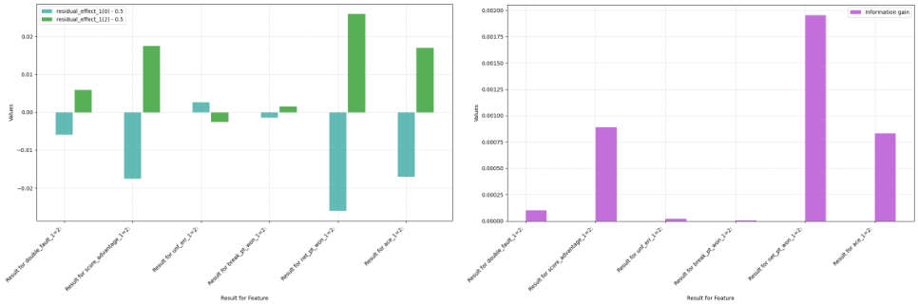
(a) (b)
Figure 12: Differences in Residual Effects and Entropy
图 12：残余效应与熵的差异
图中文字对照（英文 → 中文）
residual_effect_[0; 0.5] | 残差效应区间[0, 0.5] | residual_effect_[1;0; 0.5] | 残差效应区间[1;0, 0.5]
information gain | 信息增益 | Values | 数值
Residual For Feature | 各特征的残差值 | Residual for double_fault_1.2 | 双误特征的残差
— 原文第 19 页 —
As can be seen from the graph, the most substantial positive influence on momen-tum is from player’s net point won, closely followed by aces and maintaining a scoringlead. These results suggest that proactive and aggressive playstyles significantly con-tribute to a player’s momentum. In stark contrast, unforced errors are shown to under-mine momentum, emphasizing the importance of consistency and error managementin maintaining psychological advantage on the court. Double faults unexpectedly ap-pear to increase momentum slightly. We suspect this is due to the correlation betweendouble fault and aggressive serving. Since the player’s aggressiveness isn’t identifiedas variable in our model, the true causal effect is thus hard to learn.
从图中可以看出，对势头最为显著的正向影响来自球员的网前得分，紧随其后的是 ACE 球与保持比分领先。这些结果表明，积极主动且富于进攻性的打法对球员的势头有显著贡献。与之形成鲜明对比的是，非受迫性失误被证明会削弱势头，这凸显了保持稳定性与控制失误对于在球场上维持心理优势的重要性。出人意料的是，双误似乎会略微提升势头。我们推测这是由于双误与进攻性发球之间的相关性所致。由于球员的进攻性在我们的模型中并未被识别为变量，因此真实的因果效应难以获知。
To further clarify the counterintuitive increase in momentum following double faults,our investigation delved into the patterns of serving. Baseline ace rates for servers p^{ace}
为进一步厘清双误之后势头反而上升这一反直觉现象，我们的研究深入考察了发球模式。发球方的基线 ACE 球率 p^{ace}₁ 与 p^{ace}₂
1and p^{ace}stood at 9.70% and 8.61%, respectively. Intriguingly, analysis post-double fault
分别为 9.70% 和 8.61%。有趣的是，对双误之后的分析
2revealed an uptick in ace frequency, with player 1’s ace rate p^{ace next double fault}ascending
显示 ACE 球频率有所上升，球员 1 的 ACE 球率 p^{ace next double fault}₁ 升至
1to 10.61% and p^{ace next double fault}to 9.59% within the ensuing ten serves. This suggests a
10.61%，而 p^{ace next double fault}₂ 升至 9.59%，且均发生在随后的十次发球之内。这表明
2correlation shortcut or data bias learned by the model.
模型学到的是一种相关性捷径或数据偏差。
5.2.4 Inference on Match Data
基于比赛数据的推断
During inference, all observed variables, including long term residual effect arefeeding into the model. Based on these known evidence, our Bayesian network candetermine the distribution of the output and latent variables, and ultimately, the mo-mentum (as residual effect) in a match. Specifically, given the structure of the network,we can describe the mathematical relationship between these variables’ distributionusing the conditional dependencies depicted in the network. For computational de-^{[11]}.tail, refer to [(Ben, 2007)]
在推断阶段，所有观测变量（包括长期残余效应）都被输入模型。基于这些已知证据，我们的贝叶斯网络可以确定输出变量与潜变量的分布，并最终确定一场比赛中的势头（以残余效应表示）。具体而言，给定网络结构，我们可以借助网络中描绘的条件依赖关系，刻画这些变量分布之间的数学关系。有关计算细节，参见 [11]（Ben, 2007）。
5.2.5 Advisement
建议
Based on the statistical analysis from our Bayesian network, we propose the follow-ing strategies for players to potentially improve their momentum:
基于我们贝叶斯网络的统计分析（Statistical Analysis），我们提出以下策略，以供球员潜在地提升其势头：
1. Minimize Unforced Errors: Prioritize consistency in rallies to avoid giving awaymomentum through avoidable mistakes.
1. 尽量减少非受迫性失误：在相持中优先保持稳定性，避免因可避免的失误而白白让出势头。
2. Leverage Aggressive Plays: Integrate more net approaches and aim for aces tocapitalize on these actions’ strong positive impact on momentum.
2. 善用进攻性打法：更多地融入上网打法并力争发出 ACE 球，以利用这些行为对势头的强烈正向影响。
3. Strategic Serving: Focus on serve accuracy and variety, reducing double faultseven though they may not significantly dampen momentum, as maintaining serve isstill critical for match success.
3. 策略性发球：注重发球的准确性与变化，减少双误——尽管双误可能并不会显著削弱势头，但保住发球局对比赛胜利依然至关重要。
4. Mental Resilience: Develop psychological resilience to withstand the pressureof facing break points, as overcoming them contributes less to momentum than antici-pated.
4. 心理韧性：培养心理韧性以承受面对破发点的压力，因为化解破发点对势头的贡献低于预期。
5. Maintain Lead: Strive to build and maintain a lead, as staying ahead fosterspositive momentum and can exert psychological pressure on the opponent.
5. 保持领先：努力建立并保持领先，因为保持领先能够培育正向势头，并可对对手施加心理压力。
Incorporating these strategies into training and match-play can help players har-ness and maintain momentum, which is a pivotal aspect of competitive tennis.
将这些策略融入训练与实战，有助于球员驾驭并保持势头，而这是竞技网球的关键方面。
— 原文第 20 页 —
6 Problem 4 : Swings Prediction and Model Generaliza-
6 问题 4：挥拍预测与模型
tion
泛化
We first evaluated our model on the final match between Carlos Alcaraz and No-vak Djokovic. The outcomes, together with those from three additional matches, arepresented in the subsequent graph. It’s notable that our model accurately forecastedthe first few up and downs of the residual effect, but failed at the 230th
我们首先在卡洛斯·阿尔卡拉斯与诺瓦克·德约科维奇的决赛上评估了我们的模型。其结果连同另外三场比赛的结果一并展示在下图中。值得注意的是，我们的模型准确预测了残余效应的前几次起伏，但在第 230 次
280th pointswhich corresponds to the fourth set. During this phase, Novak Djokovic unexpectedlygained a significant advantage. This is probably due to the effect of factors that ourmodel does not account for.
至第 280 分（对应第四盘）处失准。在这一阶段，诺瓦克·德约科维奇出人意料地取得了显著优势。这可能是由于我们的模型未纳入的因素所产生的影响。
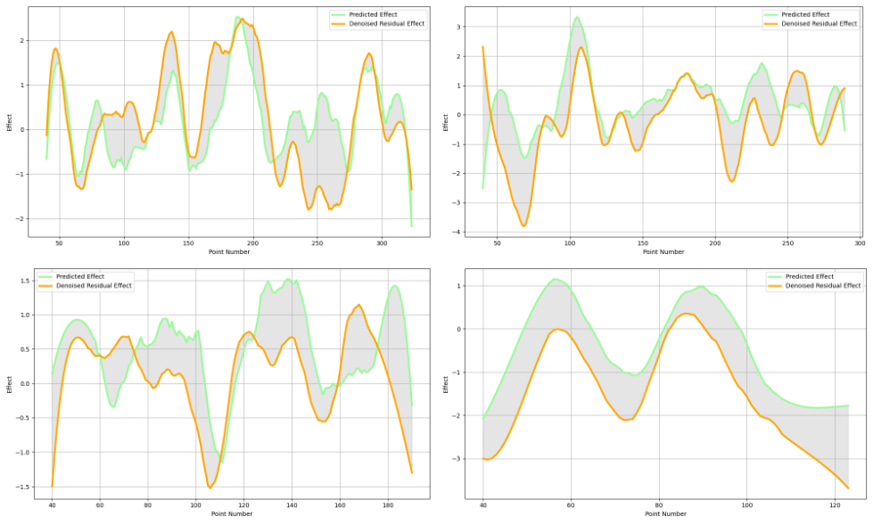
Figure 13: Predicted vs Actual
图 13：预测值与实际值
图中文字对照（英文 → 中文）
Predicted Effect | 预测效应 | Denoised Residual Effect | 去噪后的残差效应
Effect | 效应值 | Point Number | 分数序号
A possible factor that significantly influences outcomes in tennis is the personalplay style of specific players, like surface preferences, injury history. These can onlybe modeled through their historical performances and can’t be inferred through ourcurrent approach (i.e. only consider players’ rankings). A data-based integration ofplayer’s personal information may further boost our model’s performance.
在网球中可能显著影响比赛结果的一个因素，是特定球员的个人打法，例如场地偏好、伤病史。这些只能通过其历史表现来建模，无法通过我们当前的方法（即仅考虑球员排名）推断得出。基于数据的球员个人信息融合，可能会进一步提升我们模型的性能。
Besides, the given Wimbledon dataset, we also test our model on a dataset of
此外，除给定的温布尔登数据集之外，我们还在一个数据集上测试了我们的模型
2
— 原文第 21 页 —
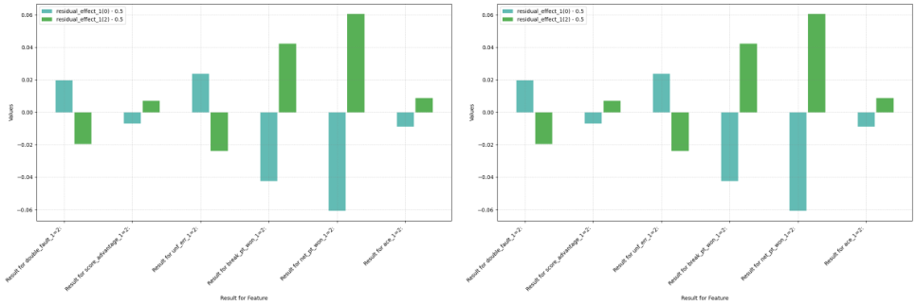
(a) (b)
Figure 14: Differences in Residual Effects and Entropy
图 14：残余效应与熵的差异
图中文字对照（英文 → 中文）
residual_effect_[0; 0.5] | 残差效应区间[0, 0.5] | residual_effect_[1;0; 0.5] | 残差效应区间[1;0, 0.5]
Values | 数值 | Residual For Feature | 各特征的残差值
Compared with Figure 12 , one notable distinction is the impact of aces. In ourdataset, male players have a 9.14% likelihood of achieving an ace, whereas femaleplayers only 4.25%. Additionally, the occurrence of double faults now clearly has adetrimental effect, as it is no longer the result of aggressive attempts to achieve an ace.
与图 12 相比，一个显著差异在于 ACE 球的影响。在我们的数据集中，男球员发出 ACE 球的概率为 9.14%，而女球员仅为 4.25%。此外，双误的出现如今明显具有不利影响，因为它不再是力求发出 ACE 球的进攻性尝试所导致的结果。
To demonstrate the adaptability of our model framework, we further generalizeit into a more abstract and comprehensive form, as depicted in the following graph.
为展示我们模型框架的适应能力，我们进一步将其推广为一种更抽象、更全面的形式，如下图所示。
This framework can be instantiated into models that are capable of dealing all kinds ofsports games such as table tennis, basketball, soccer...
该框架可实例化为能够处理各类体育比赛的模型，例如乒乓球、篮球、足球……
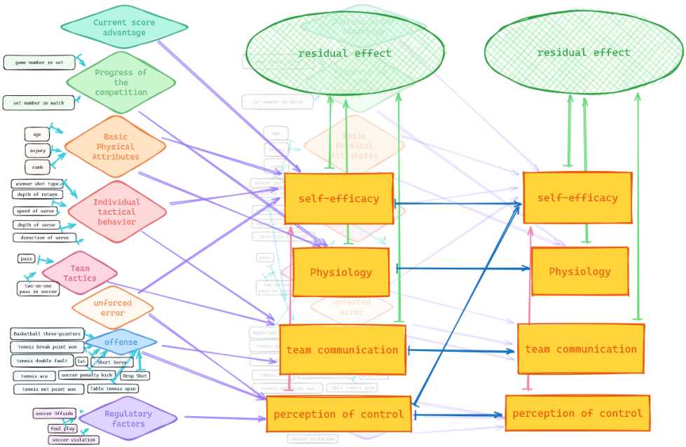
Figure 15: General Framework
图 15：总体框架
图中文字对照（英文 → 中文）
Current score advantage | 当前比分领先 | Progress of the competition | 比赛进程
Basic Physical Attributes | 基本身体属性 | Individual tactical behavior | 个人战术行为
Team Tactics | 团队战术 | unforced error | 非受迫性失误
offense | 进攻 | defense | 防守
Regulatory factors | 调节因素 | residual effect | 残差效应（势头）
self-efficacy | 自我效能 | Physiology | 生理状态
team communication | 团队沟通 | perception of control | 控制感
set number in match | 比赛中的盘序号 | game number in set | 盘内的局序号
shot direction of serve | 发球方向 | shot speed of serve | 发球速度
— 原文第 22 页 —
7 Model Analysis
7 模型分析
7.1 Strengths and Weaknesses
7.1 优劣势
Strengths:
优势：
1. Captures both short-term and long-term momentum effects through the two-layer structure. This allows the model to account for momentum shifts arising fromrecent in-game events as well as longer-term psychological factors.
1. 通过双层结构同时捕捉短期与长期势头效应。这使得模型能够刻画由近期比赛中的事件所引发的势头转折，以及更为长期的心理因素。
2. Incorporates latent variables like physiology, perception of control, and self-efficacy that are not directly observable but play an important role in momentum. Thisprovides a more comprehensive representation of the factors influencing momentum.
2. 纳入生理状态、控制感与自我效能感等在势头的形成中发挥重要作用、却无法直接观测的潜变量。这为影响势头的因素提供了更为全面的刻画。
3. Uses advanced machine learning techniques like expectation maximization tohandle the latent variables and make the model trainable on real match data. Thisenables practical application of the model.
3. 采用期望最大化（EM 算法）等先进机器学习技术处理潜变量，使模型可在真实比赛数据上训练。这使模型具备实际应用的可能。
4. Achieves good generalization across different players and matches in the dataset,demonstrating robustness.
4. 在数据集中的不同球员与不同比赛之间均取得良好的泛化效果，体现出稳健性。
5. Provides interpretable insights into how different factors like unforced errors,aggressive plays, break points etc. influence momentum.
5. 对非受迫性失误、进攻性击球、破发点等不同因素如何影响势头，给出了具有可解释性的洞见。
Weaknessess:
不足之处：
1. Difficult to fully validate accuracy of latent variable representations and theirdynamics without access to actual measurements of players’ psychological states.
1. 在无法获取球员心理状态实际测量值的情况下，难以充分验证潜变量表征及其动态变化的准确性。
2. Requires aggregation of data over intervals to reduce noise for training, losingsome granularity.
2. 为降低噪声，训练时需按时间区间对数据加以聚合，从而损失了一定的粒度。
3. Does not account for opponent adaptive strategies and their influence on mo-mentum. Assumes independent player behaviors.
3. 未考虑对手的适应性策略及其对势头的影响。模型假定双方球员的行为相互独立。
7.2 Sensitivity Analysis
7.2 灵敏度分析
To evaluate the robustness of our proposed model, we conduct a sensitivity analysison two aspects. 1. Modifying the model’s prediction interval. 2. Changing the trainingdata by randomly sampling 70% and 50% from the original dataset, corresponding to
为评估所提出模型的稳健性，我们从两个方面开展灵敏度分析（Sensitivity Analysis）。1. 调整模型的预测区间。2.通过从原始数据集中随机抽取 70% 与 50% 的数据来改变训练集，二者分别对应
22 and 16 matches, respectively.
22 场比赛与 16 场比赛。
The following is the altered information gain from observed variables. The changes model trained on 50% appears notable changes, likely due to the altered distribution ofmatches. On the other hand, the model trained with 70% of the data remained stable,indicating a threshold of data sufficiency.
以下为观测变量信息增益的变化情况。这些变化在以 50% 数据训练的模型中表现得较为显著，这很可能源于比赛样本分布的改变。另一方面，以 70% 数据训练的模型保持稳定，表明存在一个数据充分性的阈值。
2
— 原文第 23 页 —
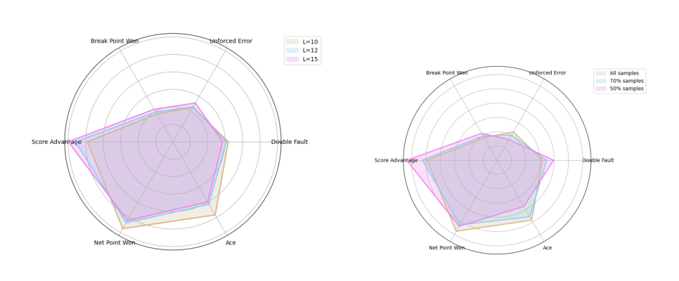
(a) (b)
Figure 16: Differences in Residual Effects and Entropy
图 16：残差效应与熵的差异
图中文字对照（英文 → 中文）
Break Point Won | 破发点得分 | Unforced Error | 非受迫性失误
Double Fault | 双误 | Ace | Ace 球
Net Point Won | 网前得分 | Score Advantage | 比分领先
L=10 | 窗口长度 L=10 | L=12 | 窗口长度 L=12
L=15 | 窗口长度 L=15 | All samples | 全部样本
70% samples | 70% 样本 | 50% samples | 50% 样本
7.3 Conclusion
7.3 结论
In this paper, we establish our momentum predictor through a two-step process.
本文通过两个步骤建立了我们的势头预测器。
Initially, we develop a naive binomial model aimed at recovering the "ideal" state ofthe game. Subsequently, the residual of its prediction is utilized as the label for ourmomentum predictor, the dual-temporal Bayesian network. This model framework,demonstrated to be highly generalizable and robust, allows us to uncover the latentsystems underlying observable sports games.
首先，我们构建一个朴素二项模型，旨在还原比赛的“理想”状态。随后，将其预测的残差用作势头预测器——双时间维度贝叶斯网络——的标签。该模型框架已被证明具有高度的泛化能力与稳健性，使我们得以揭示可观测体育比赛背后的潜在系统。
8 Memorandum
8 备忘录
To: Tennis Coaches
致：网球教练
From: Team #2401298
自：2401298 队
Subject: Leveraging Momentum in Tennis - Insights and Strategies for Coaching
主题：在网球中善用势头——执教的洞见与策略
Date: February 6, 2024
日期：2024 年 2 月 6 日
Dear Coaches,
尊敬的教练：
We are thrilled to share with you our suggestions derived from our Duel-Temporal
我们十分荣幸与您分享基于双时间维度
Bayesian network model, to enhance player performance through the nuanced con-cept of "momentum" in tennis. In the dynamic world of competitive tennis, the concept tangible strategies that can be methodically applied.
贝叶斯网络模型得出的建议，即借助网球中“势头”这一细腻概念来提升球员表现。在竞争激烈的网球运动的动态世界中，这一概念可以转化为可系统实施的具体策略。
2
— 原文第 24 页 —
Figure 17: Momentum in Tennis
图 17：网球中的势头
"Momentum" is not an isolated concept, it represents the existence of complex la-tent states of tennis matches, beyond what can be captured by simply counting points.
“势头”并非孤立的概念，它代表着网球比赛中复杂潜在状态的存在，这远非单纯计分所能刻画。
Our study analyzed the intricate dynamics of momentum in tennis matches. We haveutilized statistical models and a Duel-Temporal Bayesian Network to quantify and pre-dict the influence of psychological and physiological factors on in-game performance.
本研究分析了网球比赛中势头错综复杂的动态变化。我们运用统计模型与双时间维度贝叶斯网络，量化并预测心理与生理因素对比赛中表现的影响。
Our analysis suggests that while each point’s outcome may appears statistically inde-pendent to some extent, the Bayesian network we developed tells a richer story. Itreveals the hidden threads of self-efficacy, strategy, and physiological responses thatweave together to form the fabric of momentum.
分析表明，尽管每一分的结果在某种程度上可能在统计上相互独立，但我们所构建的贝叶斯网络揭示了更为丰富的内涵。它揭示了自我效能感、策略与生理反应之间隐秘的线索，这些线索交织而成势头的整体图景。
To enable players to harness the positive aspects of momentum while mitigating itspressures, we recommend following strategic pivots:
为使球员能够利用势头的积极一面并缓解其带来的压力，我们建议遵循以下策略要点：
1. Consistency is Key: Encourage players to minimize unforced errors; our findingslink consistent play to maintaining momentum.
1. 稳定性至关重要：鼓励球员尽量减少非受迫性失误；我们的研究结果将稳定的发挥与保持势头联系起来。
2. Aggressiveness Pays Off: Advise players to assert dominance with net approachesand serves to build positive momentum.
2. 进攻性有所回报：建议球员通过上网与发球确立主导地位，以建立积极的势头。
3. Serve Smart: Emphasize varied and accurate serving techniques to upholdmomentum without risking double faults.
3. 智慧发球：强调富于变化且精准的发球技术，在维持势头的同时避免双误的风险。
4. Build Resilience: Cultivate players’ mental fortitude, essential for navigating thepressures of break points and shifting tides within matches.
4. 培养韧性：锤炼球员的心理坚韧度，这对于在破发点压力与比赛局势转变中从容应对至关重要。
5. Lead to Succeed: Strive for early leads; our model suggests this exertspsychological pressure on opponents, bolstering momentum for the leading player.
5. 领先以制胜：力争在比赛早期取得领先；我们的模型表明，此举会向对手施加心理压力，并增强领先球员的势头。
We trust this memo provides a clear and actionable strategy for leveraging the con-cept of momentum to your advantage. Implementing these recommendations couldfoster a competitive edge, vital for triumphing in the modern, fast-paced game of ten-nis.
我们相信本备忘录提供了清晰且可操作的策略，可帮助您将势头这一概念转化为自身优势。落实上述建议有助于形成竞争优势，这对于在当今节奏飞快的网球比赛中取胜至关重要。
Looking forward to seeing these strategies manifest in your players’ enhanced per-formance.
期待看到这些策略体现为球员表现的提升。
Yours Sincerely,
谨启
— 原文第 25 页 —
References
[1] Taylor, J., & Demick, A. (1994). A multidimensional model of momentum insports. _Journal of Applied Sport Psychology_, _6_(1), 51-70.
[2] Klaassen, F. J., & Magnus, J. R. (2001). Are points in tennis independent and iden-tically distributed? Evidence from a dynamic binary panel data model. _Journalof the American Statistical Association_, _96_(454), 500-509.
[3] Motoi, S., Misu, T., Nakada, Y., Yazaki, T., Kobayashi, G., Matsumoto, T., &
Yagi, N. (2012). Bayesian event detection for sport games with hidden Markovmodel. _Pattern Analysis and Applications_, _15_, 59-72.
[4] Sun, Y. (2004). Detecting the hot hand: An alternative model. In _Proceedings ofthe Annual Meeting of the Cognitive Science Society_ (Vol. 26, No. 26).
[5] Klaassen, F. J., & Magnus, J. R. (2003). Forecasting the winner of a tennismatch. _European Journal of Operational Research_, _148_(2), 257-267.
[6] Ge, X., & Lin, A. (2021). Dynamic causality analysis using overlapped slidingwindows based on the extended convergent cross-mapping. _Nonlinear Dynam-ics_, _104_, 1753-1765.
[7] Morber, J. R. (2008). _One-dimensional nanowires: Understanding growth andproperties as steps toward biomedical and electrical application_. Georgia Insti-tute of Technology.
[8] Madhavan, V. (2016). Predicting NBA game outcomes with hidden Markov mod-els. _Berkeley University_.
[9] Raab, M., Gula, B., & Gigerenzer, G. (2012). The hot hand exists in volleyballand is used for allocation decisions. _Journal of Experimental Psychology: Ap-plied_, _18_(1), 81.
[10] https://github.com/JeffSackmann/tennis_MatchChartingProject.
[11] Ben Gal I (2007). "Bayesian Networks" (PDF). In Ruggeri F, Kennett RS, Faltin
FW (eds.). Support-Page. Encyclopedia of Statistics in Quality and Reliabil-ity. John Wiley & Sons. doi:10.1002/9780470061572.eqr089. ISBN 978-0-470-01861-
2
（全文完。公式与表格在原 PDF 中是矢量图形，未纳入本对照版；可按文中「原文第 N 页」标记翻到 2401298.pdf 对照查看。）

