2409949 英中对照版
2024 ICM Problem F · Reducing Illegal Wildlife Trade
读法：黑字为原文，蓝字为译文，一段英文一段中文，上下对应；蓝字里的小字括号是该术语第一次出现时的英文原词。
术语表（按首次出现排序，18 条）
# | 英文 | 中文 | 说明：为什么容易译错
1 | Illegal Wildlife Trade | 非法野生动植物贸易 | 本文要压制的对象
2 | Wildlife Trafficking | 野生动植物贩运 | 跨境运输与销售链条
3 | Supply Chain | 供应链 | 从偷猎到终端消费的环节
4 | Network Analysis | 网络分析 | 把贩运关系建成图来分析
5 | System Dynamics | 系统动力学 | 用反馈回路仿真政策效果
6 | Machine Learning | 机器学习 | 从历史案件里找规律
7 | Enforcement | 执法 | 巡护、查获与起诉
8 | Poaching | 偷猎 | 在野外非法捕杀
9 | Demand Reduction | 需求抑制 | 减少终端消费的干预
10 | Intervention | 干预措施 | 政策或执法动作
11 | SMART | SMART 监测数据 | 保护区巡护的空间监测与报告工具
12 | Random Forest | 随机森林 | 集成多棵决策树的分类模型
13 | Feature Importance | 特征重要性 | 各变量对预测的贡献
14 | Simulation | 仿真 | 在模型里试跑不同政策
15 | Policy Recommendation | 政策建议 | 给 WWF 的行动清单
16 | Biodiversity | 生物多样性 | 受贸易威胁的生态价值
17 | Ivory | 象牙 | 最典型的非法贸易品
18 | Trafficking Route | 贩运路线 | 从源头国到消费国的路径

目录（Contents）
页码为原 PDF 页码，可按正文中的「— 原文第 N 页 —」定位。
1.1 研究背景（Background） 3
1.2 问题重述（Restatement of the Problem） 3
1.3 本文工作（Our Work） 4
2 模型准备（Model Preparation） 5
2.1 模型假设与合理性说明（Assumptions and Justification） 5
2.2 术语表（Glossary） 5
2.3 数据预处理（Data Pre-processing） 6
2.3.1 数据收集（Data Collection） 6
2.3.2 数据填补与处理（Data Filling and Processing） 6
3 任务一：制定打击非法野生动植物贸易的项目（Task1: Develop A Counter-IWT Project） 7
3.1 以往项目的趋势探究（Discover the Trend of Former Projects） 7
3.2 项目设计（Design the Project） 7
4 任务二：选择并说服最合适的客户（Task2: Choose and Convince the Most Suitable Client） 9
4.1 项目执行主体的确定（Who Can Do the Project） 9
4.2 优指标与劣指标的讨论（Discussion of Superior and Inferior Indicators） 10
4.3 基于熵权法分析劣指标权重（Analyze the Weights for Inferior Indicators by EWM） 11
4.4 目标客户的选择与说服（Choose and Convince the Targeting Client） 12
4.4.1 客户评价得分计算（Calculate Client Evaluation Score） 12
4.4.2 客户说服（Convince the Client） 12
5 任务三：建立跨组织合作模型（Task3: Establish a Cross-Organizations Cooperation Model） 14
5.1 项目实施的其他要求（Extra Requirements to Execute the Project） 14
5.2 连接非法野生动植物贸易与各类犯罪活动的复杂系统（A Complex System Connecting IWT with All Criminal Activities） 14
5.3 跨组织合作对项目的助益（How Cross-Organizations Cooperation Benefits Our Project） 15
6 任务四：评估项目影响（Task4: Evaluate the Impact of the Project） 16
6.1 构建岭回归模型度量相关性（Construct a Ridge Regression Model to Measure Correlation） 16
6.2 基于回归模型预测项目效果（Predict the Effects of Project by the Regression Model） 18
6.3 灵敏度分析（Sensitivity Analysis） 19
7 优缺点分析（Strength and Weakness） 20
备忘录（Memorandum） 21
参考文献（References） 22
附录（Appendix） 22

Roaring Silence: Can We Break the Chains of
咆哮的沉默：我们能否打破
Illegal Wildlife Trade?
非法野生动植物贸易的锁链？
Summary
摘要
Our work outlines a comprehensive strategy for combating illegal wildlife trade (IWT),specifically targeting the illegal trade of tigers in Southeast Asia. It is structured into severalkey tasks:
我们的工作提出了一套打击非法野生动植物贸易（Illegal Wildlife Trade）（IWT）的综合策略，并特别针对东南亚地区的非法老虎贸易。全文按以下几项关键任务展开：
Developing a Counter-IWT Project: We analyze trends from previous projects based on 764former projects data and create a targeted project named “Safeguarding Tigers of Southeast
制定反非法野生动植物贸易项目：我们基于 764 个既往项目的数据分析以往项目的趋势，并创建了一个名为“守护东南亚虎”的针对性项目，
Aisa”, focusing on the supply chain of illegal tiger trading. The project design employs methodslike Results-Based Management (RBM) and Logic Framework Approach (LFA), all outcomesand activities follow “Specific, Measurable, Appropriate, Realistic, and Time-bound”principle (SMART), with a detailed Gantt Chart for the 5-year plan.
聚焦于非法老虎贸易的供应链（Supply Chain）。项目设计采用成果导向管理（RBM）与逻辑框架法（LFA）等方法，所有成果与活动均遵循“具体、可衡量、适当、现实且有时限”原则（SMART），并配有详细的 5 年规划甘特图。
Choosing and Convincing the Most Suitable Client: We discuss and select an appropriateinternational organization as our client, with the World Wildlife Fund (WWF) emerging as thetop choice. The selection process involves a comprehensive client assessment model with a three-level indicators system, using Entropy Weighted Method (EWM) to calculate weights of eachindicator. To persuade the WWF to undertake the project, we firstly organize global IWT capitalflows to stress the significance of Southeast Aisa, then we prove the importance of the illegaltrade of tigers in the whole IWT system in this area by Grey Relational Analysis (GRA) basedon the data of wildlife trafficking in Southeast Asia.
选择并说服最合适的客户：我们讨论并选定了一个合适的国际组织作为客户，世界自然基金会（WWF）成为首选。选择过程构建了一个包含三级指标体系的综合客户评估模型，并采用熵权法（EWM）计算各指标的权重。为说服 WWF 承担该项目，我们首先梳理全球非法野生动植物贸易的资金流向，以强调东南亚的重要性；随后基于东南亚野生动植物贩运（Wildlife Trafficking）数据，通过灰色关联分析（GRA）证明老虎非法贸易在该地区整个非法野生动植物贸易体系中的重要地位。
Establishing Cross-Organization Cooperation: We propose a model for cooperation between
建立跨组织合作：我们提出了一个跨组织合作模型，
WWF and Interpol, leveraging their respective strengths to enhance the effectiveness of theproject. We further elaborate on the benefits of this cooperation, using an Optimal Expected
即 WWF 与 Interpol 之间的合作，充分发挥双方各自的优势以提升项目成效。我们进一步阐述该合作的收益，运用不确定性下的最优期望
Utility Model under uncertainty and analyzing the model mathematically.
效用模型，并对该模型进行数学分析。
Evaluating the Impact of the Project: We introduce a Ridge Regression Model to assess theproject's impact on illegal tiger trade, measuring the correlation between the number of illegaltigers’ trade and four objective verifiable indicators (OVIs) of project outcomes respectively.
评估项目的影响：我们引入岭回归模型评估项目对非法老虎贸易的影响，分别度量非法老虎贸易数量与项目成果的四项客观可验证指标（OVIs）之间的相关性。
We employ this regression model to predict the futural impact by comparing IWT numbers oftigers with and without our project. We also perform a sensitivity analysis to identify the mostimpactful variable.
我们运用该回归模型，通过比较有无本项目情形下老虎非法野生动植物贸易数量的差异，预测未来的影响。我们还进行了敏感性分析，以确定影响最大的变量。
2
— 原文第 3 页 —
1 Introduction
1 引言
1.1 Background
1.1 背景
Illegal wildlife trade (IWT), based on OECD (2019) definition, refers to the commerce in wildlife,or their parts, or by-products, which contravenes international legal agreements or the domesticlaws of the countries involved. It covers the full spectrum of unlawful activities in the wildlifecrime chain. This includes various illegal actions. Additionally, it involves related criminalactivities necessary for these transactions, such as money laundering, corruption, and the sale ofthese illegal goods.
根据 OECD（2019）的定义，非法野生动植物贸易（IWT）是指违反国际法律协定或相关国家国内法的野生动植物及其器官、制品的贸易活动。它涵盖野生动植物犯罪链条中各类非法活动的完整谱系。这包括多种非法行为。此外，它还包括这些交易所需的关联犯罪活动，例如洗钱、腐败以及这些非法商品的销售。
IWT endangers multiple aspects of human society and environment, hence the efforts to counter
非法野生动植物贸易威胁人类社会的多个方面与生态环境，因此打击此类贸易的努力
IWT should never stop. However, current projects may be not effective enough to solve theproblem entirely, more novel ideas are being collected continually. To break through existinglimitations, we must try to develop more targeted and cooperative projects to deal with theproblem by stages in a long term.
绝不应停止。然而，现有项目可能不足以彻底解决问题，更多新颖的思路正不断被汇集。为突破现有局限，我们必须努力制定更具针对性、更强调合作的项目，分阶段、长期地应对这一问题。
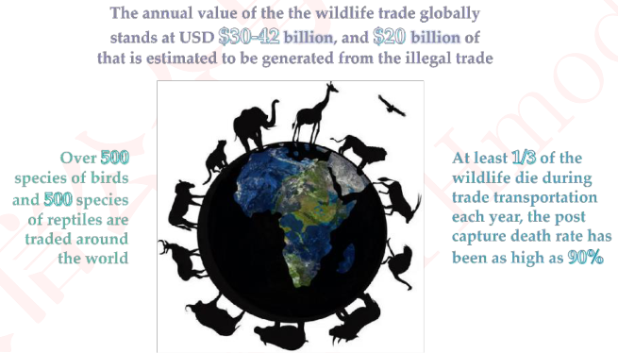
Figure 1: Combating IWT for a better World
图 1：为更美好的世界而打击非法野生动植物贸易
图中文字对照（英文 → 中文）
The annual value of the the wildlife trade globally stands at USD $30-42 billion, and $20 billion of that is estimated to be generated from the illegal trade | 全球野生动植物贸易年价值达300亿至420亿美元，其中估计有200亿美元来自非法贸易 | Over 500 species of birds and 500 species of reptiles are traded around the world | 全球有超过500种鸟类和500种爬行动物被交易
At least 1/3 of the wildlife die during trade transportation each year, the post capture death rate has been as high as 90% | 每年至少三分之一的野生动植物在运输途中死亡，捕获后死亡率高达90%
1.2 Restatement of the Problem
1.2 问题重述
Considering the background information and restricted conditions identified in the problemstatement, we need to tackle the following five tasks:
结合问题陈述中给出的背景信息与限制条件，我们需要完成以下五项任务：
Task1: Develop a 5-year Counter-IWT project which is effective and executable.
任务 1：制定一个有效且可执行的 5 年期反非法野生动植物贸易项目。
Task2: With the goal of the project, choose and convince the most suitable client according toits power, resources and interests.
任务 2：以项目目标为导向，依据其权力、资源与利益，选择并说服最合适的客户。
Task3: Analyze and give ways to satisfy extra requirements to carry out the project.
任务 3：分析并给出满足项目实施所需额外要求的途径。
Task4: Evaluate the impact of the project by stages and consider expectation and sensitivityanalysis.
任务 4：分阶段评估项目的影响，并考虑期望与敏感性分析。
2
— 原文第 4 页 —
1.3 Our Work
1.3 我们的工作
For clarity, we draw a structure map (Figure 2) to represent our work clearly.
为清晰起见，我们绘制了结构图（图 2）以清楚呈现我们的工作。
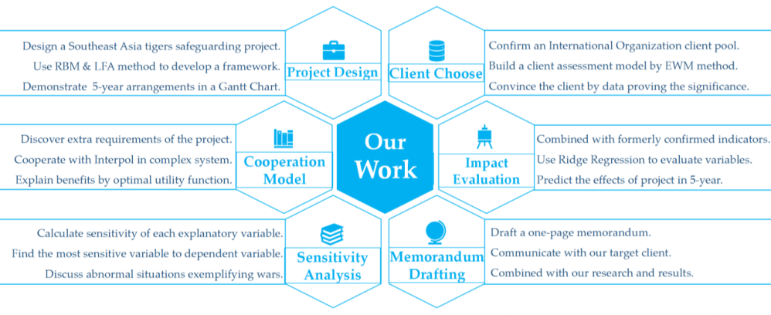
Figure 2: Work Structure
图 2：工作结构
图中文字对照（英文 → 中文）
Project Design | 项目设计 | Client Choose | 客户选择
Cooperation Model | 合作模式 | Our Work | 我们的工作
Impact Evaluation | 影响评估 | Sensitivity Analysis | 敏感性分析
Memorandum Drafting | 备忘录撰写 | Design a Southeast Asia tigers safeguarding project. | 设计一个东南亚虎保护项目
Use RBM & LFA method to develop a framework. | 采用RBM（成果管理）与LFA（逻辑框架）方法构建框架 | Demonstrate 5-year arrangements in a Gantt Chart. | 用甘特图展示五年期安排
Confirm an International Organization client pool. | 确定国际组织客户群 | Build a client assessment model by EWM method. | 用EWM（熵权法）建立客户评估模型
Cooperate with Interpol in complex system. | 在复杂系统中与国际刑警组织合作 | Calculate sensitivity of each explanatory variable. | 计算各解释变量的敏感性
Use Ridge Regression to evaluate variables. | 使用岭回归评估变量 | Predict the effects of project in 5-year. | 预测项目五年内的效果
Draft a one-page memorandum. | 起草一页纸备忘录 | Communicate with our target client. | 与目标客户沟通
To solve Task 1, we design our specific project based on analysis of total trend. We collect 764former projects information and identify Southeast Asia as the most trending area based onfunding data. Then we design a targeted project named “STSEA” for Counter-IWT of tigers in
为完成任务 1，我们在总体趋势分析的基础上设计了具体项目。我们收集了 764 个既往项目的信息，并基于资金数据确定东南亚为最具趋势性的地区。随后，我们设计了一个名为“STSEA”的针对性项目，用于打击老虎的非法野生动植物贸易，实施地点位于
Southeast Aisa by intervening at supply part in the industrial value chain. We use a combinationof RBM and LFA methods to design a project by analyzing the problem tree and the objective tree.
东南亚，其方式是在产业价值链的供给环节实施干预措施（Intervention）。我们结合运用 RBM 与 LFA 方法，通过分析问题树与目标树来设计项目。
Following SMART principle, all our outcomes are corresponded with measure indictors shown ina Logframe Matrix. The whole 5-year arrangement is clearly demonstrated in a Gantt Chart.
遵循 SMART 原则，我们的所有成果均与逻辑框架矩阵中所示的衡量指标相对应。整个五年期的安排清晰地展示在甘特图中。
As to Task 2, we narrow our choices to seven international organizations based on the requirementsof our project. To choose the most suitable client for our project, we build a client assessmentmodel with three-level indicators. We use Entrop Weighted Method to confirm the weight of eachindicator and calculate the score of client pools. We choose World Wildlife Fund (WWF) with thehighest score as our most suitable client. To convince WWF to undertake our project, we firstlyemphasize the significance of Southeast Asia by analyzing the global IWT capital flow, then weuse Grey Correlation Degree Analysis based on SEA IWT data to show the necessity ofundertaking tigers-targeted project in combating IWT.
对于任务 2，我们根据项目要求将选择范围缩小至七个国际组织。为选出最适合本项目的客户，我们构建了一个包含三级指标的客户评估模型。我们采用熵权法确定各指标的权重，并计算候选客户池的得分。我们选择得分最高的世界自然基金会（WWF）作为最合适的客户。为使 WWF 愿意承接本项目，我们首先通过分析全球非法野生动植物贸易的资金流向来强调东南亚的重要性，随后基于东南亚非法野生动植物贸易数据运用灰色关联度分析，以表明开展针对老虎的项目在打击非法野生动植物贸易中的必要性。
For Task 3, we consider extra requirements of our project which are not satisfied by WWF. Wenotice that wildlife crime crackdown requires armed forces, so we consider the possibility ofcooperating with Interpol. As for a complex crime system, wildlife crime is tightly connected withglobal criminal activities, giving the inspiration to Interpol to the cooperation. To explain thebenefit of cooperation, we built an optimal expected utility model under uncertainty. It sees legaland illegal trade of tigers as two accessible investment choices, and concludes that brought by thecooperation, the raising of detection rate contributes to the decrease of illegal wildlife trade.
对于任务 3，我们考虑了本项目提出但 WWF 无法满足的额外要求。我们注意到打击野生动植物犯罪需要武装力量，因此我们考虑了与国际刑警组织合作的可能性。作为一个复杂的犯罪体系，野生动植物犯罪与全球犯罪活动紧密相连，这为与国际刑警组织合作提供了启示。为说明合作带来的收益，我们构建了一个不确定性条件下的最优期望效用模型。该模型将老虎的合法贸易与非法贸易视为两种可选择的投资方案，并得出结论：由合作带来的检测率提升有助于减少非法野生动植物贸易。
Then come to the Task 4, using indicators we used in project framework, we build a ridgeregression model to measure the correlation between our project activities and project goals. We predict SEA IWT number of tigers in the 5-year of the project, which demonstrate the quantitativeeffects of our project. For sensitivity analysis, we calculate sensitivity of each explanatory variableto dependent variable to find out the most sensitive variable. We discuss abnormal situationsexemplifying wars.
接下来是任务 4，我们运用项目框架中所使用的指标构建岭回归模型，以衡量项目活动与项目目标之间的相关性。我们预测项目五年期内东南亚非法野生动植物贸易中老虎的数量，从而展示本项目的定量效果。在敏感性分析中，我们计算各解释变量对因变量的敏感性，以找出最敏感的变量。我们讨论了异常情形，并以战争为例加以说明。
— 原文第 5 页 —
As for Task 5, we organize our research and results, communicating with our targeting client in aone-page memorandum with the expectation and effects of our project.
对于任务 5，我们梳理了研究与结果，并以一页纸的备忘录形式与目标客户沟通，说明本项目的预期与效果。
2 Model Preparation
2 模型准备
2.1 Assumptions and Justification
2.1 假设与合理性说明
To simplify the problem, we make the following assumptions. Other assumptions will beintroduced once they are used in specific models.
为简化问题，我们作出以下假设。其他假设将在具体模型中使用时予以介绍。
Assumption 1: Futural Counter-IWT projects will be consistent with current total trend.
假设 1：未来的打击非法野生动植物贸易项目将与当前总体趋势保持一致。
Justification 1: Multiple Counter-IWT projects have been executed in different areas withdifferent strengths. The whole progress is a long-term effort with consistent direction. Therefore, itis feasible to judge the most trending area of futural projects according to previous project fundingand description data.
合理性说明 1：多个打击非法野生动植物贸易的项目已在不同地区以不同力度实施。整个进程是一项方向一致的长期努力。因此，根据以往项目的资金数据与描述数据判断未来项目最具趋势性的领域是可行的。
Assumption 2：An effective Counter-IWT project should be specifical and trans-regional.
假设 2：有效的打击非法野生动植物贸易项目应当是具体的且跨区域的。
Justification 2: IWT is a complex systematic problem, identifying and intervening at key linkin the industrial value chain is more executable and practical. Wildlife habitats as well as IWTbehaviors are always cross-border. Hence, a specific and trans-regional project can be moreeffective than general and domestic project.
合理性说明 2：非法野生动植物贸易是一个复杂的系统性问题，在产业价值链的关键环节进行识别与干预更具可执行性和实用性。野生动植物栖息地以及非法野生动植物贸易行为往往跨越国界。因此，具体且跨区域的项目可能比一般性的国内项目更为有效。
Assumption 3: Individuals make decisions by logically and consistently pursuing their own self-interest, aiming to maximize utility or profit.
假设 3：个体通过逻辑一致地追求自身利益来作出决策，旨在实现效用或利润最大化。
Justification 3: Human rationality implies that given all relevant information and options, aperson will evaluate and act upon them in a way that maximizes their personal benefit orsatisfaction.
合理性说明 3：人的理性意味着，在给定所有相关信息和选项的情况下，个人会以使其个人利益或满足感最大化的方式对其进行评估并采取行动。
2.2 Glossary
2.2 术语表
Table1: Glossary
表 1：术语表
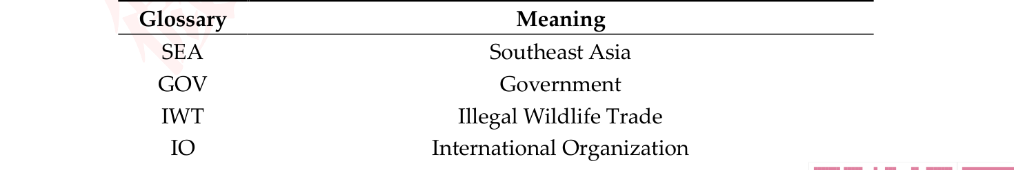
2
— 原文第 6 页 —
SMART
Specific, Measurable, Appropriate, Realistic, and Time-bound
具体的、可衡量的、适当的、现实可行的、有时限的
LFA
Logic framework approach
逻辑框架法
RBM
Results-based management
基于结果的管理
OVI
Objective verifiable indicator
客观可验证指标
LNR
Local natural reserve
地方自然保护区
Interpol
The international criminal police organization
国际刑事警察组织
ITT
Illegal trade of tigers
老虎的非法贸易
Note: Other none frequent-used symbols will be introduced once they are used.
注：其他不常用的符号将在其被使用时予以介绍。
2.3 Data Pre-processing
2.3 数据预处理
2.3.1 Data Collection
2.3.1 数据收集
We select former projects data to discover the trend for project design, and we build a selected IOsbasic information dataset to assess the most suitable client for our project. Additionally, we alsosome wildlife trade and trafficking data for our further research.
我们选取以往项目的数据以发现项目设计的趋势，并构建一个精选的国际组织（IO）基本信息数据集，用以评估最适合我们项目的客户。此外，我们还收集了一些野生动植物贸易与贩运数据，以供进一步研究。
To ensure the comprehensiveness and authority of our data, we choose the following websites asour data sources.
为确保数据的全面性与权威性，我们选择以下网站作为数据来源。
Table2: Data Source
表2：数据来源

2.3.2 Data Filling and Processing
2.3.2 数据填补与处理
Data availability is crucial, as unreliable or false data hinders accurate assessments of global equity.
数据的可得性至关重要，因为不可靠或虚假的数据会妨碍对全球公平性的准确评估。
Therefore, ensuring data continuity and authenticity is essential. Nonetheless, data gaps oftenoccur due to incomplete disclosure from countries. for data completion, we use many methodsincluding regression, averaging, etc.
因此，确保数据的连续性与真实性十分关键。然而，由于各国披露不完整，数据缺口时常出现。对于数据补全，我们采用回归、取平均等多种方法。
These methods help in maintaining the integrity of the data, which is vital for accurate and reliableanalysis. Other data processing methods will be introduced once they are used in specific models.
这些方法有助于保持数据的完整性，而完整性对于准确、可靠的分析至关重要。其他数据处理方法将在其应用于具体模型时予以介绍。
— 原文第 7 页 —
3 Task1: Develop A Counter-IWT Project
3 任务1：设计一个打击非法野生动植物贸易的项目
3.1 Discover the Trend of Former Projects
3.1 发现以往项目的趋势
Since IWT is a serious problem, multiple projects have been carried out in different countries withdifferent strengths. By collecting 764 former projects data, we draw a Funding Map (Figure 3)based on the normalized funding data (range from 0 to 100) by countries to demonstrate the flowdirection of most project fundings. It is visualized to find that SEA countries draw large amountsof fundings, which identifies SEA as a trending area. Our project will target in this area to beconsistent with total trend.
由于非法野生动植物贸易是一个严重问题，多个国家已开展了力度各异的多个项目。通过收集 764 个以往项目的数据，我们依据各国归一化（取值范围 0 至 100）的资金数据绘制了资金地图（图 3），以展示多数项目资金的流向。可视化结果显示，东南亚（SEA）国家吸引了大量资金，这表明东南亚是一个趋势性区域。我们的项目将针对该区域，以与总体趋势保持一致。
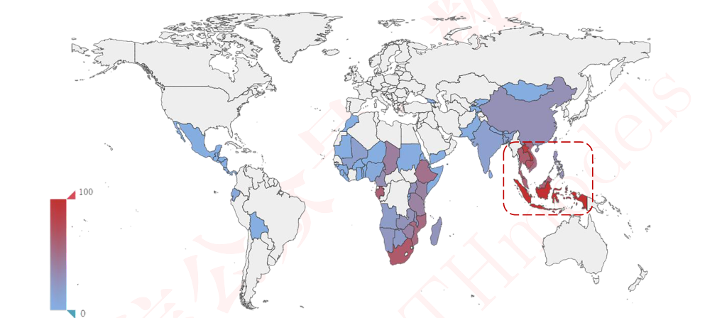
Figure 3: Project Funding Map by countries¹
图 3：按国家划分的项目资金地图¹
3.2 Design the Project
3.2 设计项目
To design an executable, we firstly draw an IWT industrial value chain according to comprehensiverelevant information to simple show each part of IWT activities. Since IWT is a complex andsystematic problem, it is more practical to intervene one part in a project specially. Based onpractical condition in SEA, we find out that SEA plays a more significant rule as Suppliers &
为设计一个可执行的项目，我们首先依据全面的相关信息绘制非法野生动植物贸易产业价值链，以简明展示非法野生动植物贸易活动的各个环节。由于非法野生动植物贸易是一个复杂且系统性的问题，在项目中专门干预其中某一环节更为实际。基于东南亚的实际情况，我们发现东南亚作为供应者与中介者扮演着更为重要的角色。
Mediaries. Combining with previous research and project, we are about to create a special projecttargeted to SEA IWT supply part of Tigers. We call our project as: Safeguarding Tigers in
结合以往的研究与项目，我们拟创建一个专门针对东南亚老虎非法野生动植物贸易供应环节的专项项目。我们将项目命名为：
Southeast Asia (STSEA).
守护东南亚老虎（STSEA）。
¹ Countries in white color in the image means either they have no project funding or their projects are notselected as our sample.
¹ 图中白色国家表示其没有项目资金，或其项目未被选为我们的样本。
— 原文第 8 页 —
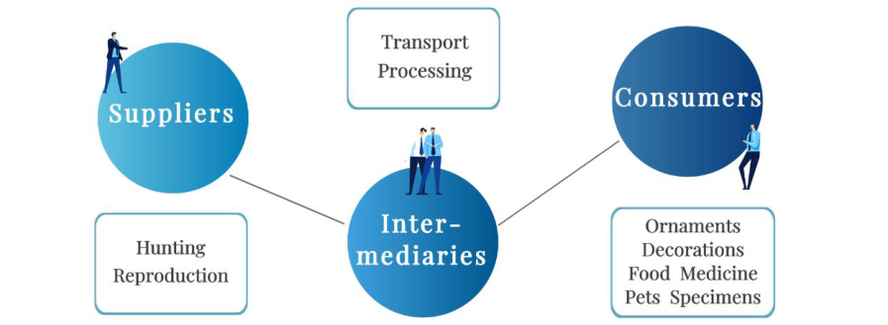
Figure 4: Regular IWT industrial value chain
图 4：常规非法野生动植物贸易产业价值链
图中文字对照（英文 → 中文）
Suppliers | 供应方 | Intermediaries | 中间商
Consumers | 消费者 | Transport Processing | 运输与加工
Hunting Reproduction | 猎捕与繁殖 | Ornaments Decorations Food Medicine Pets Specimens | 装饰品 摆件 食品 药材 宠物 标本
Using Results-Based Management (RBM) and Logic Framework Approach (LFA), which arepopular methods for many IO projects, we start with analyzing and drawing the problem tree andthe objective tree. We identify the main problem as the rampant illegal trade of tigers, with
运用成果导向管理（RBM）与逻辑框架法（LFA）——这两者是众多国际组织项目普遍采用的方法——我们首先分析并绘制问题树与目标树。我们将主要问题界定为老虎非法贸易的猖獗，并把
Biodiversity decline in SEA as a long-term effect as well as four main reasons:
东南亚生物多样性（Biodiversity）下降视为长期影响，同时归纳出四个主要原因：
-Inadequate construction of ecological conservation areas,
-生态保护区建设不足，
-Insufficient efforts to combat wildlife crimes,
-打击野生动植物犯罪的力度不足，
-Lack of legal and sustainable development and utilization of wildlife resources,
-野生动植物资源缺乏合法、可持续的开发与利用，
-Lack of public awareness and protection of wildlife.then we design the objective tree combing our goals with intervening activities. All objectives aredetermined following SMART principle. Our specific goal, “The decrease of illegal trade of tigers”,has four branching targets, each target respectively responds the reason of problem above:
-公众对野生动植物缺乏认知与保护意识。随后，我们将目标与干预活动相结合，设计目标树。所有目标均依照 SMART 原则确定。我们的具体目标“老虎非法贸易的减少”包含四个分支目标，每个目标分别对应上述问题的成因：
- Strengthening the construction of ecological conservation areas,
- 加强生态保护区建设，
- Intensifying efforts to combat wildlife crimes,
- 加大打击野生动植物犯罪的力度，
- Developing wildlife resources legally to increase residents' income,
- 合法开发野生动植物资源以提高居民收入，
- Enhancing public awareness and protection of wildlife.
- 增强公众对野生动植物的认知与保护意识。
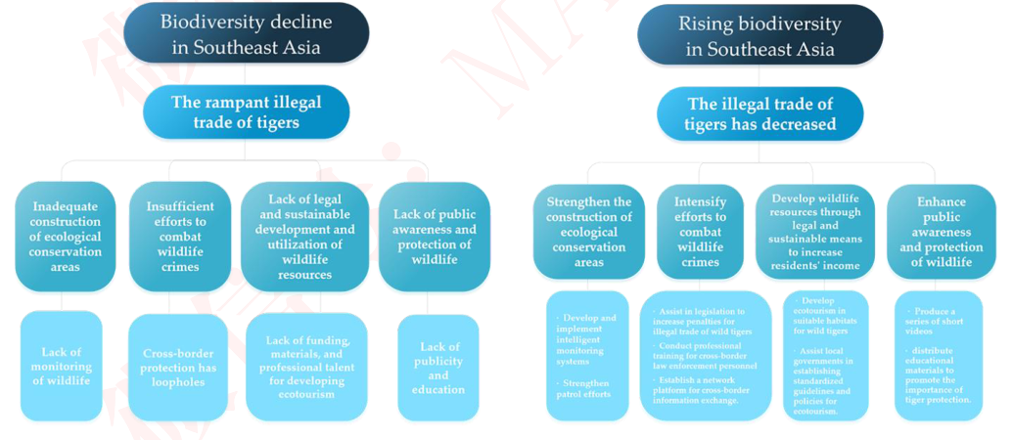
Figure 5: The problem tree(left) & objective tree(right) of STSEA
图 5：STSEA 的问题树（左）与目标树（右）
图中文字对照（英文 → 中文）
Biodiversity decline in Southeast Asia | 东南亚生物多样性下降 | Rising biodiversity in Southeast Asia | 东南亚生物多样性上升
The rampant illegal trade of tigers | 猖獗的老虎非法贸易 | The illegal trade of tigers has decreased | 老虎非法贸易已减少
Inadequate construction of ecological conservation areas | 生态保护区建设不足 | Insufficient efforts to combat wildlife crimes | 打击野生动植物犯罪的力度不足
Lack of legal and sustainable development and utilization of wildlife resources | 野生动植物资源缺乏合法可持续的开发与利用 | Lack of public awareness and protection of wildlife | 公众对野生动植物的认知与保护意识不足
Lack of monitoring of wildlife | 缺乏对野生动植物的监测 | Cross-border protection has loopholes | 跨境保护存在漏洞
Lack of funding, materials, and professional talent for developing ecotourism | 发展生态旅游缺乏资金、物资与专业人才 | Lack of publicity and education | 缺乏宣传与教育
Strengthen the construction of ecological conservation areas | 加强生态保护区建设 | Intensify efforts to combat wildlife crimes | 加大打击野生动植物犯罪力度
Develop wildlife resources through legal and sustainable means to increase residents' income | 以合法可持续方式开发野生动植物资源以增加居民收入 | Enhance public awareness and protection of wildlife | 提高公众的保护意识与野生动植物保护
Develop and implement intelligent monitoring system | 开发并实施智能监测系统 | Establish a network for regional law enforcement information exchange | 建立区域执法信息交流网络
All our outcomes have specific measures to reach, which are also demonstrate at the bottom of the objective tree. Then we build OVIs to measure the results and outcomes. Here we draw a Logframe
我们所有的成果都有具体措施加以实现，这些措施也在目标树的底部予以展示。随后我们构建客观验证指标（OVIs）以衡量成果与结果。此处我们绘制逻辑框架矩阵，以展示目标与预期成果的客观可验证指标（OVI）。
— 原文第 9 页 —
Matrix to demonstrate OVIs of goals and expected results.
以展示目标与预期成果的 OVI。
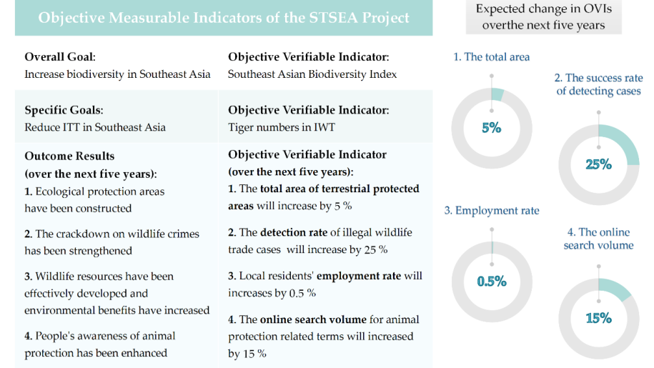
Figure 6: Logframe matrix of STSEA
图 6：STSEA 的逻辑框架矩阵
图中文字对照（英文 → 中文）
Objective Measurable Indicators of the STSEA Project | STSEA项目的客观可衡量指标 | Overall Goal: | 总体目标：
Increase biodiversity in Southeast Asia | 提升东南亚生物多样性 | Objective Verifiable Indicator: | 客观可验证指标：
Southeast Asian Biodiversity Index | 东南亚生物多样性指数 | Specific Goals: | 具体目标：
Reduce ITT in Southeast Asia | 减少东南亚非法虎贸易（ITT） | Tiger numbers in IWT | 非法野生动植物贸易中的虎数量
Outcome Results (over the next five years): | 成果结果（未来五年）： | Objective Verifiable Indicator (over the next five years): | 客观可验证指标（未来五年）：
1. The total area of terrestrial protected areas will increase by 5 % | 1. 陆地保护区总面积将增加5% | 2. The detection rate of illegal wildlife trade cases will increase by 25 % | 2. 非法野生动植物贸易案件侦破率将提高25%
3. Local residents' employment rate will increase by 0.5 % | 3. 当地居民就业率将提高0.5% | Expected change in OVIs over the next five years | 未来五年客观可验证指标（OVIs）的预期变化
1. The total area | 1. 总面积 | 2. The success rate of detecting cases | 2. 案件侦破成功率
3. Employment rate | 3. 就业率 | 4. The online search volume | 4. 网络搜索量
Eventually, we develop a Gantt Chart to organize the whole 5-year time schedule. We clearly showour plan of each activity in the chart which is considerably executable.
最终，我们编制甘特图，以统筹整个五年期的时间安排。我们在图中清晰展示了各项活动的安排，其可执行性相当高。
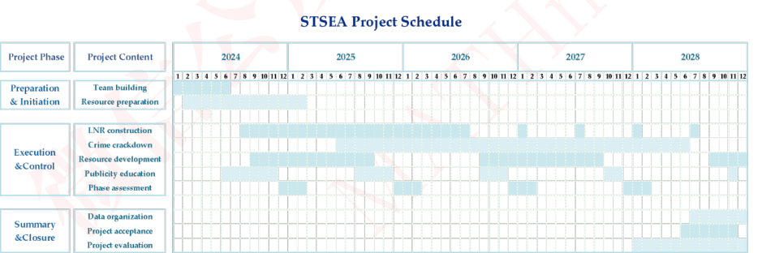
Figure 7: Gantt Chart of the 5-year schedule of STSEA
图 7：STSEA 五年期进度的甘特图
图中文字对照（英文 → 中文）
STSEA Project Schedule | STSEA项目进度计划 | Project Phase | 项目阶段
Project Content | 项目内容 | Preparation & Initiation | 准备与启动
Team building | 团队组建 | Resource preparation | 资源准备
Execution & Control | 执行与控制 | LNR construction | LNR（地方自然保护区）建设
Crime crackdown | 犯罪打击 | Resource development | 资源开发
Publicity education | 宣传教育 | Phase assessment | 阶段评估
Summary & Closure | 总结与收尾 | Data organization | 数据整理
Project acceptance | 项目验收 | Project evaluation | 项目评估
4 Task2: Choose and Convince the Most Suitable Client
4 任务 2：选择并说服最合适的委托方
4.1 Who Can Do the Project
4.1 谁能够承担该项目
We believe an effective Counter-IWI project should be specific and trans-regional. We firstlyconsider the type of our clients: Governments (GOVs), International Organizations (IOs), and
我们认为，一项有效的反非法野生动植物贸易项目应当是具体的且跨区域的。我们首先考虑委托方的类型：政府（GOV）、国际组织（IO）以及
Entrepreneurs. GOVs are undoubtedly more capable in general and domestic projects because itsnational system. However, as for specific and trans-regional projects raised by one GOV, it may
企业家。由于拥有国家体系，GOV 在一般性项目与国内项目上无疑更具能力。然而，对于由某一 GOV 提出的具体且跨区域的项目而言，它可能
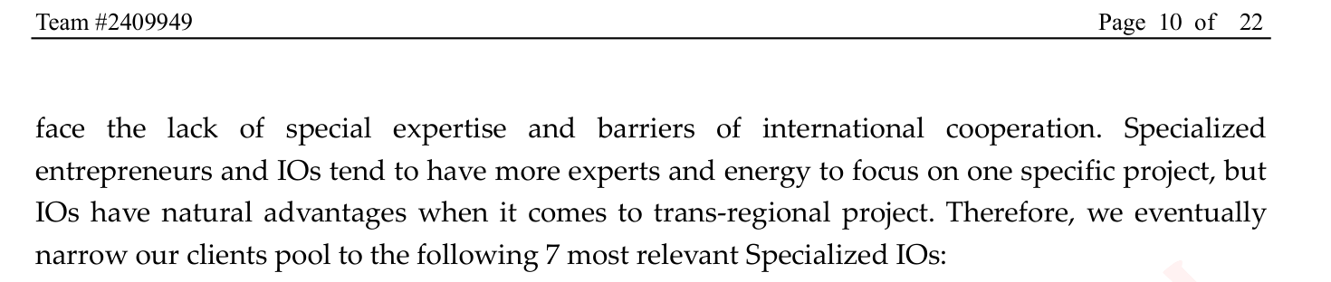
— 原文第 10 页 —
Table3: Clients Pool
表 3：委托方备选库
Abbr.
缩写
Full Name
全称
IFAW
International Fund for Animal Welfare
国际爱护动物基金会
IUCN
International Union for Conservation of Nature
国际自然保护联盟
TRAFFIC
Wildlife Trade Monitoring Network
野生动植物贸易监测网络
UNEP
United Nations Environment Programme
联合国环境规划署
WCS
Wildlife Conservation Society
国际野生生物保护学会
WILDAID
WildAid
WWF
World Wildlife Fund
世界自然基金会
4.2 Discussion of Superior and Inferior Indicators
4.2 优指标与劣指标的讨论
Since we have confirmed the clients pool, we need to measure the degree of capability and fitnessof different IOs to evaluate the most suitable and realistic client.
既然已确定委托方备选库，我们需要度量不同 IO 的能力与适配程度，以评估出最合适且最现实的委托方。
To create a IOs capability&fitness assessment system, we need to select representativeindicators. Combined with previous researches, we have concluded that the analysis can be carriedout by measuring the three major factors of Organizational Influence, Communication Influence,and Special Influence. The three-levels indicators are clearly shown in Table3.
为构建 IO 能力与适配度评估体系，我们需要选取具有代表性的指标。结合已有研究，我们归纳出：可通过衡量组织影响力、传播影响力与专业影响力这三大因素来开展该分析。三级指标如表 3 所示。
Table4: Three-levels Indicators
表 4：三级指标
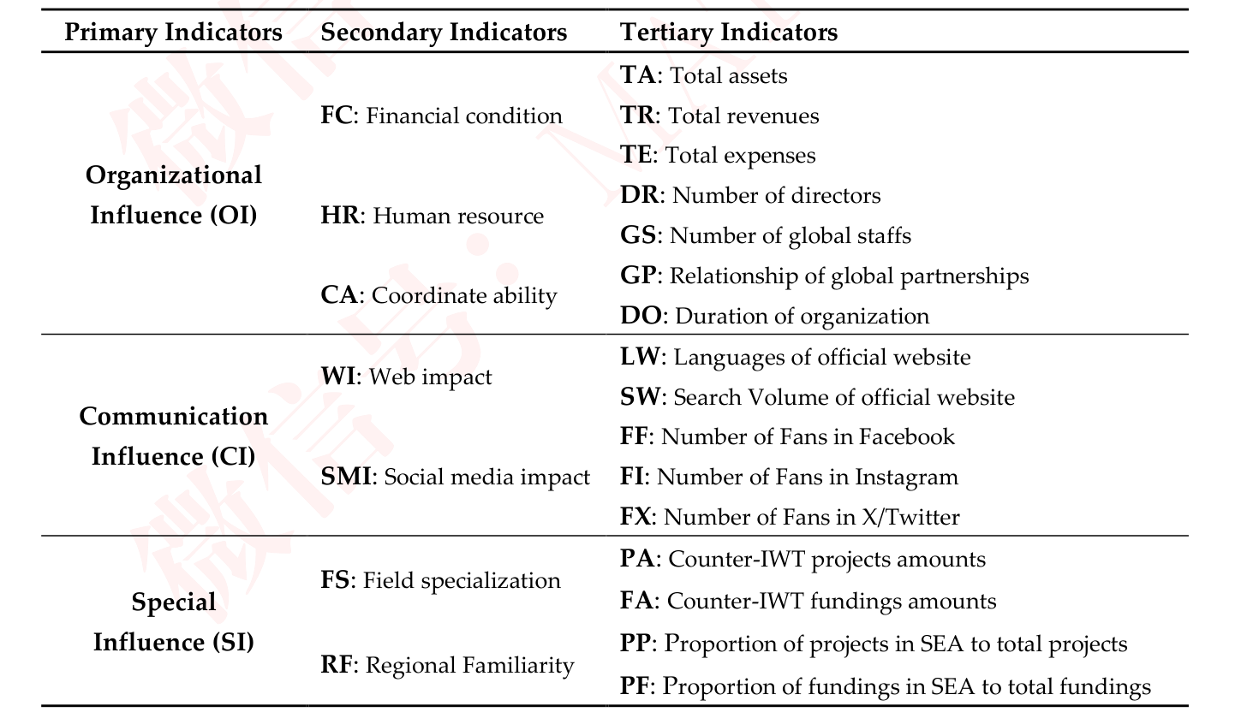
— 原文第 11 页 —
4.3 Analyze the Weights for Inferior Indicators by EWM
4.3 基于 EWM 分析劣指标的权重
After making indicator system and collecting data, we establish a model based on Entrop Weighted
在构建指标体系并收集数据之后，我们建立了一个基于熵权法的模型
Method (EWM) to calculate weights of different indicators. The principle is using the degree ofvariation between different data to judge information it reflects, then weight will be assigned to it.
（EWM），用以计算各不同指标的权重。其原理是利用不同数据之间的变异程度判断其所反映的信息量，进而为其赋权。
We start with data normalization. Indicators constructed above are all benefit attributes (thebigger, the better), hence we get positive-definite matrix X. We do vector normalization by:
我们从数据归一化开始。上述构建的指标均为效益型属性（越大越好），因此我们得到正定矩阵 X。我们通过下式进行向量归一化：

whereis the sum of squares of all elements in thecolumn, and n is the numberof rows in the column j. Then we get a normalized matrix Y.
其中为该列所有元素的平方和，n 为第 j 列的行数。由此得到归一化矩阵 Y。
Then, we calculate the proportion 𝑝^{𝑖𝑗} of the 𝑗^{𝑡ℎ} indicator in the 𝑖^{𝑡ℎ} sample.
随后，我们计算第 j 个指标在第 i 个样本中所占的比重 𝑝^{𝑖𝑗}。
where 𝑦_{𝑖𝑗} refers to the normalized value of the 𝑗^{𝑡ℎ} indicator in the 𝑖^{𝑡ℎ} sample, and 1≤𝑖≤𝑚.
其中 𝑦_{𝑖𝑗} 表示第 i 个样本中第 j 个指标的归一化值，且 1≤𝑖≤𝑚。
Next, we get the Entropy Value of the 𝑗^{𝑡ℎ} indicator by:
接下来，我们由下式得到第 j 个指标的熵值：
Therefore, we can get 𝑊_{𝑗} as the Weight of the 𝑗^{𝑡ℎ} indicator:
因此，我们可以得到 𝑊_{𝑗}，即第 j 个指标的权重：

where m is the number of indicators in special levels. Based on calculated processing, weget:
其中 m 为特殊层级中指标的个数。基于上述计算处理，我们得到：
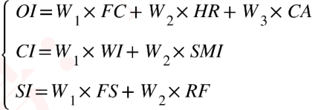
where the value of each secondary indicators can be calculated similarly. And we use
其中各二级指标的取值可同理计算。我们采用
TOPSIS model to normalize all scores (ranging from 0 to 1). Therefore, we get the equation tomeasure the capability & fitness score (0-100) of theselected IO.
TOPSIS 模型对所有得分进行归一化处理（取值范围为 0 至 1）。由此，我们得到用于度量所选国际组织（IO）的能力与适配度得分（0—100）的公式。
— 原文第 12 页 —
4.4 Choose and Convince the Targeting Client
4.4 选择并说服目标客户
4.4.1 Calculate Client Evaluation Score
4.4.1 计算客户评价得分
Following the calculating process above, we gain weights matrices of indicators in different levels.
按照上述计算流程，我们得到各层级指标的权重矩阵。
The weighted results are clearly demonstrated in Figure 8:
加权结果在图 8 中清晰展示：
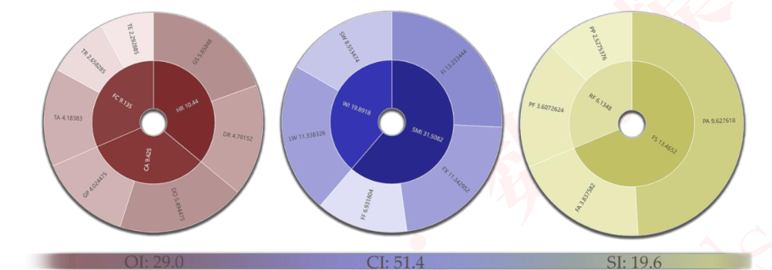
Figure 8: Indicator weights for client assessment
图 8：客户评估的指标权重
Based on the weights, we calculate scores of all clients in our pools and the result is:
基于上述权重，我们计算候选池中所有客户的得分，结果如下：
IFAW 15.81, IUCN 26.53, TRAFFIC 55.05, UNEP 64.35, WCS 57.47, WILDAID 11.12, WWF 78.70.
All scores ranging from 0-100 manifest the degree of capability & fitness for an IO to carry out ourproject. OI and CI reveal the ability of an organization considering its power, scale, resources, etc.
所有得分均落在 0—100 区间，体现了某一国际组织执行本项目的能力与适配度水平。OI 与 CI 从权力、规模、资源等方面反映了一个组织的能力。
While SI reveals the interest and experience of carrying out a Counter-IWT project in SEA.
而 SI 则反映了在东南亚开展反非法野生动植物贸易项目的兴趣与经验。
4.4.2 Convince the Client
4.4.2 说服客户
An idealized client for our project should have relatively strong power, experience, and interest in
本项目的理想客户应在东南亚反非法野生动植物贸易方面具备相对较强的权力、经验与兴趣。
SEA Counter-IWT. Our evaluation scores manifest that WWF with the highest score may executethe project better. Hence, we choose WWF as our client.
我们的评价得分表明，得分最高的 WWF 可能更好地执行该项目。因此，我们选择 WWF 作为我们的客户。
Since our project focuses on Counter-IWT of tigers in SEA, we try to convince WWF to undertakethis project from two aspects: the seriousness of SEA IWT, and the seriousness of tigers IWT in SEA.
由于本项目聚焦于东南亚老虎的反非法野生动植物贸易，我们尝试从两个方面说服 WWF 承担该项目：东南亚非法野生动植物贸易的严重性，以及东南亚老虎非法野生动植物贸易的严重性。
Firstly, data shows the seriousness of SEA IWT. Based on UN Comtrade Data, we draw a mapto clearly demonstrate big IWT flow centering SEA in the World. It is evident that SEA plays andirreplaceable role in global IWT activities. As a core supplying place of various illegal wildlifeproducts, SEA attracts plenty of illegal trade flow. From the map, we can see Indonesia, Malaysia,
首先，数据表明了东南亚非法野生动植物贸易的严重性。基于 UN Comtrade 数据，我们绘制了一幅地图，以清晰展示全球范围内以东南亚为中心的巨额非法野生动植物贸易流。显而易见，东南亚在全球非法野生动植物贸易活动中扮演着不可替代的角色。作为多种非法野生动植物产品的核心供应地，东南亚吸引了大量非法贸易流。从地图中可以看出，印度尼西亚、马来西亚、
Thailand, Cambodia, Vietnam are intensively connected with flow lines, combining a crucial areaof global IWT activities.
泰国、柬埔寨、越南之间由流线密集相连，共同构成全球非法野生动植物贸易活动的关键区域。
— 原文第 13 页 —
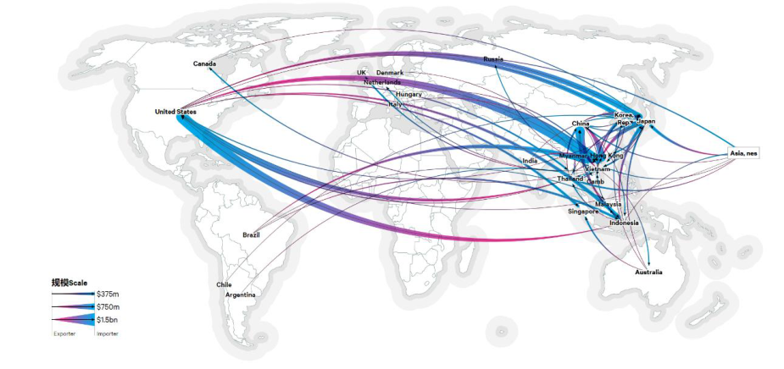
Figure 9: Global IWT Flow Centering SEA
图 9：以东南亚为中心的全球非法野生动植物贸易流
图中文字对照（英文 → 中文）
Scale | 规模 | Exporter | 出口方
Importer | 进口方 | United States | 美国
Canada | 加拿大 | Brazil | 巴西
UK | 英国 | Netherlands | 荷兰
China | 中国 | Japan | 日本
South Korea | 韩国 | India | 印度
Thailand | 泰国 | Vietnam | 越南
Indonesia | 印度尼西亚 | Malaysia | 马来西亚
Singapore | 新加坡 | Australia | 澳大利亚
Secondly, we collect SEA wildlife trafficking data in UNODC Statistics and establish a Grey
其次，我们收集 UNODC 统计数据库中的东南亚野生动植物贩运数据，并建立灰色
Relational Analysis (GRA) to discover the most crucial species/products in SEA wildlifetrafficking. Generally, the trafficking data is always uncertain and incomplete, hence GRA can beone of best methods to discover the relational degree between species.
关联分析（GRA）模型，以识别东南亚野生动植物贩运中最为关键的物种／产品。总体而言，贩运数据往往具有不确定性与不完整性，因此 GRA 可以成为揭示物种间关联程度的最佳方法之一。
We start with constructing an annual sequence of total SEA trafficking by countries as the referencesequence Y, and a matrix of annual SEA trafficking data by animals/products as the comparisonsequence X. The dimensionless processing of sequences is as following:
我们首先以各国东南亚贩运总量的年度序列构建参考序列 Y，并以按动物／产品划分的东南亚年度贩运数据矩阵构建比较序列 X。序列的无量纲化处理如下：
where 𝑥_{𝑘𝑖} refers to the value of the 𝑖^{𝑡ℎ}animal/product in the 𝑘^{𝑡ℎ} year, and m is the numberof columns in matrix X, which stands for the type of animal/product. After dimensionlessprocessing, we calculate correlation coefficients of indicators in comparison sequence:
其中，𝑥_{𝑘𝑖} 表示第 𝑖 种动物／产品在第 𝑘 年的取值，m 为矩阵 X 的列数，代表动物／产品的种类。完成无量纲化处理后，我们计算比较序列中各指标的相关系数：
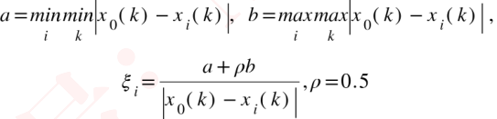
whererefers to the correlation coefficient of theindicator, andis the resolutioncoefficient. Hence, we get the correlation degree of theindicator:
其中，指该指标的相关系数，为分辨系数。由此，我们得到该指标的关联度：
The sequence of correlation degrees is shown in figure, and the comprehensive correlationdegrees of each specie/product are:
关联度序列如图所示，各物种／产品的综合关联度分别为：
Tigers 0.83, Live reptiles 0.80, European eels 0.76, Elephant 0.74, Rhino horns 0.71, Pangolins 0.68
老虎 0.83，活体爬行动物 0.80，欧洲鳗鲡 0.76，大象 0.74，犀牛角 0.71，穿山甲 0.68
Tigers indeed plays the most important role in SEA total IWT activities.
老虎确实在东南亚非法野生动植物贸易活动中发挥着最为重要的作用。
— 原文第 14 页 —
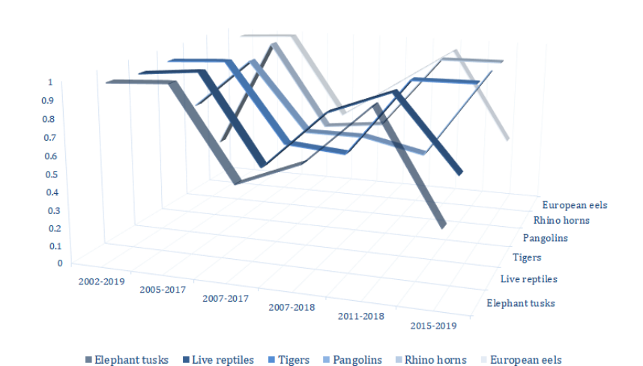
Figure 10: Sequence of Correlation Degrees
图 10：关联度序列
图中文字对照（英文 → 中文）
European eels | 欧洲鳗鲡 | Rhino horns | 犀牛角
Pangolins | 穿山甲 | Tigers | 虎
Live reptiles | 活体爬行动物 | Elephant tusks | 象牙
Therefore, since the mission of WWF is “to conserve nature and reduce the most pressingthreats to the diversity of life on Earth”, combating IWT in most serious area by protecting the mostimportant animals in the industrial chain is advisable. Currently, WWF’s efforts in SEA are limited.
因此，鉴于 WWF 的使命是“保护自然并减少地球上生命多样性所面临的最紧迫威胁”，通过保护产业链中最重要的动物来打击问题最严重地区的非法野生动植物贸易是明智之举。目前，WWF 在东南亚的投入仍然有限。
It is highly suggested that SEA is serious areas and tigers are most serious species worthy moreattention, which is also our project targeted to.
我们强烈建议，东南亚属于问题严重区域，老虎属于最严重、最值得关注的物种，这也正是本项目所针对的对象。
5 Task3: Establish a Cross-Organizations Cooperation Model
5 任务 3：建立跨组织合作模型
5.1 Extra Requirements to Execute the Project
5.1 执行项目的额外要求
Our project still has some extra requirements that WWF may not satisfy, one of which is tocombating wildlife crimes by intensifying crime crackdown. WWF focuses on conservation andenvironmental issues through a variety of non-military methods without its own military forces. Itis also impractical to advise WWF to build its own forces for wildlife crime fighting. Many illegal
我们的项目仍有一些 WWF 可能无法满足的额外要求，其中之一是通过加大犯罪打击力度来打击野生动植物犯罪。WWF 通过多种非军事手段关注保护与环境议题，其自身并不拥有军事力量。建议 WWF 为打击野生动植物犯罪而自建武装力量同样不切实际。许多非法
IWT criminals are armed fully, the work of crime crackdown must have a tight connection withother institutions with military forces. Additionally, IWT crimes are always cross-boarders, makingit more difficult for governments to manage. To meet the extra requirement featuring armed forces,here we give an idea to inspire the connection with Interpol by analyzing the complex globalcriminal system as well as building an optimal expected utility model.
野生动植物贸易犯罪分子全副武装，打击犯罪的工作必须与拥有军事力量的其他机构保持紧密联系。此外，野生动植物贸易犯罪往往具有跨境性质，这使各国政府的管理更加困难。为满足对武装力量的额外需求，我们在此提出一种思路：通过分析复杂的全球犯罪体系并构建最优期望效用模型，来启发与 Interpol 建立联系。
5.2 A Complex System Connecting IWT with All Criminal Activities
5.2 将非法野生动植物贸易与全部犯罪活动相联系的复杂系统
Considering a complex system of crime, we can find a tight relationship between IWT and who global criminal activities, from which we can get the inspiration of Interpol to join into thecooperation.
考察一个复杂的犯罪系统，我们可以发现非法野生动植物贸易与谁之间存在紧密的联系全球犯罪活动之间的联系，由此我们可以获得让 Interpol 加入合作的启示。
— 原文第 15 页 —
Wildlife crime has a long derivative criminal chain. Based on the industrial value chain aboveand other researches, we find poaching, trafficking and smuggling are tightly connected with thewhole criminal system. Poaching criminals always have access to illegal arms linked with illegalarms dealer and other production chain. As for trafficking and smuggling, they are tightlyconnected with global illegal transportation system, especially in SEA as a sensitive area, whichmay also contain the transportation of other illegal products like drugs.
野生动植物犯罪具有长长的衍生犯罪链条。基于上述产业价值链及其他研究，我们发现偷猎（Poaching）、贩运与走私同整个犯罪体系紧密相连。偷猎犯罪分子总能获取非法武器，这些武器与非法军火商及其他生产链条相联系。至于贩运与走私，它们与全球非法运输体系紧密相连，东南亚（SEA）作为敏感地区尤为如此，该体系还可能包含毒品等其他非法产品的运输。
Therefore, SEA wildlife crime is tightly connected with global criminal system. It is beneficialfor Interpol’s further crackdown of other types of crimes by taking part in combating SEA wildlife.
因此，东南亚的野生动植物犯罪与全球犯罪体系紧密相连。通过参与打击东南亚野生动植物犯罪，Interpol 能更有力地进一步打击其他类型的犯罪。
The inspiration of Interpol for cooperation is built accordingly.
Interpol 参与合作的启示由此建立。
5.3 How Cross-Organizations Cooperation Benefits Our Project
5.3 跨组织合作如何惠及我们的项目
To explain the benefits of cooperation between WWF and INTERPOL, we use the optimal expectedutility function considering the choices available to all individuals as a gamble with certainoutcomes (legal income) and associated probabilities (IWT income). The expected utility functionallows us to represent the preferences of different individuals under uncertainty.
为说明 WWF 与 INTERPOL 合作的收益，我们使用最优期望效用函数，将所有个体面临的选择视为一种赌博：具有确定的结果（合法收入）与相应的概率（非法野生动植物贸易收入）。期望效用函数使我们能够刻画不同个体在不确定性下的偏好。
Here we see an individua’s all energy and capability to take part in activities as the investmentcapital to invest different activities, which is similar to the “endowment” concept. And forsimplification, we only consider two activities here: legal activities and illegal trade of tigers (ITT),we consider take part in the two activities as similarly investment behaviors, i.e. use all capital ina ratio to invest both activities respectively.
在此，我们将个体参与活动的全部精力与能力视为用于投入不同活动的投资资本，这类似于“禀赋”概念。为简化起见，我们在此只考虑两种活动：合法活动与老虎非法贸易（ITT），我们将参与这两种活动视为类似的投资行为，即按一定比例将全部资本分别投入两种活动。
Here, we follow the Rational Individual Assumption, individuals will try the best to maximize theutility under constraints. We also assume all individuals are equal with the same investment capital
在此，我们遵循理性个体假设，个体会尽最大努力在约束条件下最大化效用。我们还假设所有个体均相同，拥有相同的投资资本
Z, and use X in legal activities and Y in ITT. The utility function of legal activities is, and of
Z，并在合法活动中投入 X、在 ITT 中投入 Y。合法活动的效用函数为，而
ITT activities is. Once deciding to take part in ITT activities, individual will face risk to bedetected and punished like arrestment. We assume detection rate is, and being detected meansno payoff from the ITT activities as well as cost for the penalty, we define cost function of penaltyis. Here we make following explanation:
ITT 活动的效用函数为。一旦决定参与 ITT 活动，个体将面临被侦测并受到逮捕等惩罚的风险。我们假设侦测率为，被侦测意味着 ITT 活动没有收益且需承担罚款成本，我们定义罚款成本函数为。在此我们作如下说明：
1)Bothandare increasing and concave functions because of the nature ofutility functions, their first-order derivatives are positive while the second-order ones are negative.
1) 由于效用函数的性质，与均为递增的凹函数，其一阶导数为正而二阶导数为负。
2)is also an increasing and concave function because once y increases, which meanstaking more ITT activities, the penalty will increase, and we assume the marginal penalty cost isdecreasing.
2) 同样是递增的凹函数，因为一旦 y 增加，即参与更多 ITT 活动，罚款将增加，且我们假设边际罚款成本递减。
Therefore, we get the following situation: an individual can both take part in two activities,with the expected utility function:
因此，我们得到如下情形：个体可以同时参与两种活动，其期望效用函数为：

— 原文第 16 页 —
Here we get the Lagrange function calculate FOCs as following:
在此我们得到拉格朗日函数，并按如下方式计算一阶条件：
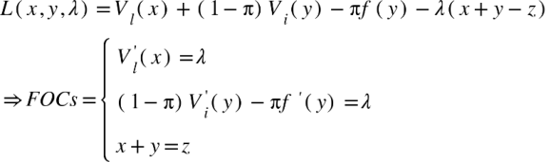
Based on results above, we see x as a function of y and hence we can calculate the relationbetween y and:
基于上述结果，我们将 x 视为 y 的函数，从而可以计算 y 与之间的关系：
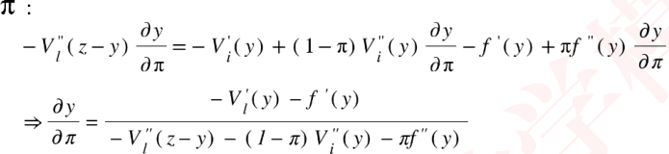
According the explanation of functions above, we can know the numerator is negative and the
根据上文对函数的说明，我们可知分子为负，而
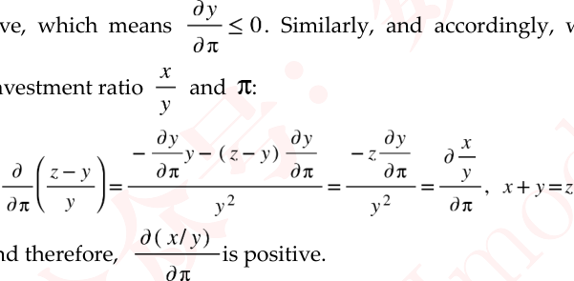
denominator is positive, which means. Similarly, and accordingly, we calculate the relation between the investment ratio
分母为正，这意味着。同理，据此我们计算投资比例之间的关系
whereand therefore,
其中……因此，
Then, the benefits of cross-organization cooperation can be inferred by the raise of. Withcooperation, the detection rate will increase: firstly, WWF is equipped with more specific expertsand wildlife crime experience since it concentrates on this field, while Interpol has more armedforces to crackdown criminals. The cooperation can help raise the detection rate by combiningforces of Interpol and expertise of WWF. By raising the rate, combining with former calculatingresults, we get:
随后，跨组织合作的收益可由……的提升推断得出。在合作条件下，侦破率将会提升：首先，WWF 由于专注于该领域，拥有更专门的专家与野生动植物犯罪经验，而国际刑警组织拥有更多武装力量用于打击犯罪分子。该合作能够通过结合国际刑警组织的力量与 WWF 的专业知识来提升侦破率。通过提升该比率，并结合此前的计算结果，我们得到：
As a rational individual, ifraises, the capital using in ITT ( ) will decrease, while theinvestment ratio () will increase. It means the cooperation can better reduce individual’sinspiration of taking part in ITT activities, bringing a more effective result of our project in termsof wildlife crime crackdown.
作为理性个体，若……上升，则投入 ITT 的资金（……）将会减少，而投资比例（……）将会增加。这意味着合作能够更好地降低个体参与 ITT 活动的动机，从而使我们的项目在打击野生动植物犯罪方面取得更有效的成果。
6 Task4: Evaluate the Impact of the Project
6 任务 4：评估项目的影响
6.1 Construct a Ridge Regression Model to Measure Correlation
6.1 构建岭回归模型以度量相关性
Using the OVIs built in project design (Figure 6), we try to measure the correlation between thespecific goal and the outcome results. Here our notation is as following:
利用项目设计中构建的 OVI（图 6），我们尝试度量具体目标与结果产出之间的相关性。此处我们的符号表示如下：
— 原文第 17 页 —
Table5: Variable notation
表 5：变量符号说明
Explanatory Variable:online search volume for animal protection related terms.local residents' employment rate.total area size of terrestrial protected areas.the detection rate of illegal wildlife trade cases.
解释变量：动物保护相关术语的在线搜索量；当地居民就业率；陆地保护区的总面积；非法野生动植物贸易案件的侦破率。
We consider multiple linear regression model initially; the basic form of this model is:
我们首先考虑多元线性回归模型；该模型的基本形式为：
then calculate Variance Inflation Factor (VIF) to judge potential multicollinearity concerns:
随后计算方差膨胀因子（VIF）以判断潜在的多重共线性问题：
Therefore, we get results in Table6:
因此，我们得到表 6 中的结果：
Table6: Multiple linear regression results
表 6：多元线性回归结果
Constant
常数项
395.276 112.543 3.512
0.072*
-0.002 0.002 -0.338 -1.447 0.285 15.069
F=68.411
-5.433 1.504 -0.787 -3.612
0.069*
13.08 0.993 0.978
P=0.014**
-1.14 1.053 -0.26 -1.083 0.392 15.908 -0.215 0.05 -0.55 -4.336
0.049**
4.43
Note：***p < 0.01, **p < 0.05, and *p < 0.10。
注：***p < 0.01，**p < 0.05，*p < 0.10。
We notice high VIF values (above 10), indicating potential multicollinearity concerns. We turnto Ridge Regression Model to solve this problem; the basic equation of this model is:
我们注意到 VIF 值偏高（大于 10），表明存在潜在的多重共线性问题。我们转而采用岭回归模型来解决该问题；该模型的基本方程为：
whereis a parameter andis a regularization term. Calculateby:
其中……为参数，……为正则化项。通过下式计算……：
whereis the weight of each explanatory variable. So firstly, we draw Ridge Trace toconfirm the value of parameterthrough VIF method. Based on Figure11, the value of parameteris chose as 0.022.
其中……为各解释变量的权重。因此，我们首先绘制岭迹图，通过 VIF 方法确定参数……的取值。根据图 11，参数……的取值选定为 0.022。
— 原文第 18 页 —
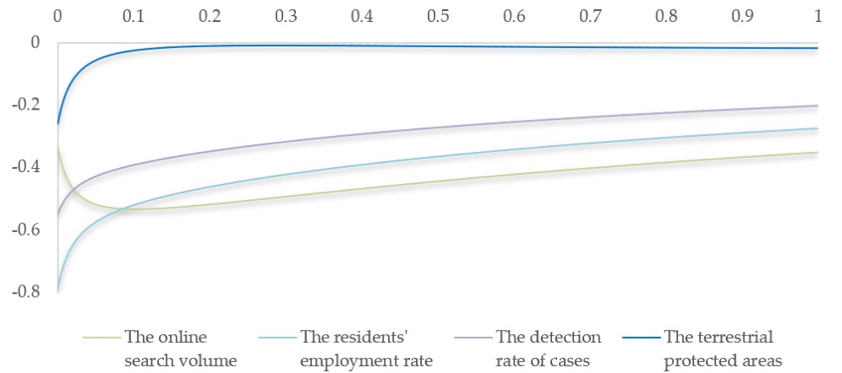
Figure 11: Ridge Trace
图 11：岭迹图
图中文字对照（英文 → 中文）
The online search volume | 网络搜索量 | The residents' employment rate | 当地居民就业率
The detection rate of cases | 案件侦破率 | The terrestrial protected areas | 陆地保护区
Then we can eventually get the results of Ridge Regression Model in Table7:
随后我们最终可在表 7 中得到岭回归模型的结果：
Table7: Results of Ridge Regression
表 7：岭回归结果
P＞|t|
Variable
变量
Coef.
系数
Std.Errort-Statistic
标准误 t 统计量
R²
F
-0.003 0.001 -3.496
0.073*
-4.417 0.887 -4.982
0.038**
F=54.485
-0.183 0.035 -5.248
0.034**
0.991
P=0.018**
-0.488 0.612 -0.797 0.509
Constant
常数项
319.466 65.293 4.893
0.039**
Note：***p < 0.01, **p < 0.05, and *p < 0.10.
注：***p < 0.01，**p < 0.05，*p < 0.10。
The regression equation we get is:
我们得到的回归方程为：
6.2 Predict the Effects of Project by the Regression Model
6.2 利用回归模型预测项目效果
We firstly use collected data as testing set to predict the value ofin previous years, thefitting result are shown in Figure12. This indicates our model is relatively feasible.
我们首先将收集到的数据作为测试集，预测……在以往年份的取值，拟合结果如图 12 所示。这表明我们的模型具有相对可行性。
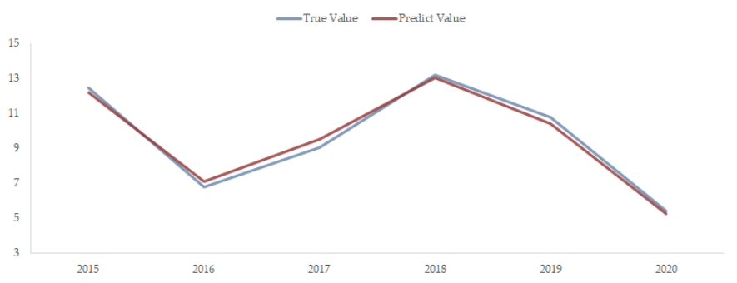
Figure 12: Testing results of regression model
图 12：回归模型的检验结果
图中文字对照（英文 → 中文）
True Value | 真实值 | Predict Value | 预测值
— 原文第 19 页 —
As we expected in our project design, over the 5-year project, the search volume, theemployment rate, the size of terrestrial protected areas, and the crime detection rate will raise by
正如我们在项目设计中所预期的，在 5 年项目期内，搜索量、就业率、陆地保护区面积和犯罪侦破率将分别提升
15%, 0.5%, 5%, 25% respectively. Using the expectation and the regression model to predict, wedemonstrate the effect of the project in Figure13.
15%、0.5%、5%、25%。利用该预期并结合回归模型进行预测，我们在图 13 中展示了项目效果。
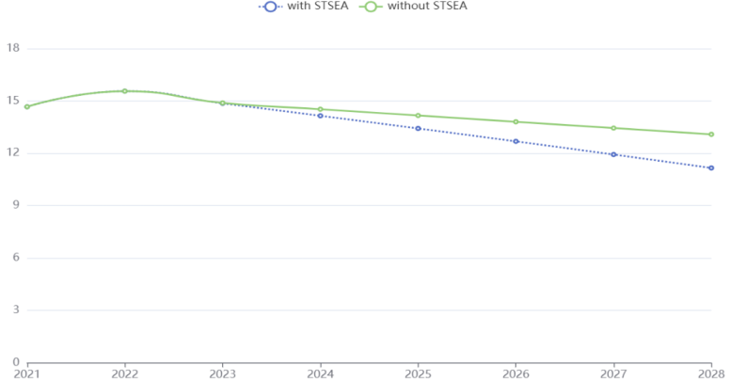
Figure 13: Predicted effect of the project
图 13：项目效果的预测
图中文字对照（英文 → 中文）
with STSEA | 采用STSEA项目 | without STSEA | 不采用STSEA项目
The effect of reserving tigers is feasible based on results above, and we believe the effects canbe more generalized. Here is our generalization effects framework:
基于上述结果，保护老虎的效果是可行的，我们相信该效果可以更具推广性。以下为我们的推广效果框架：
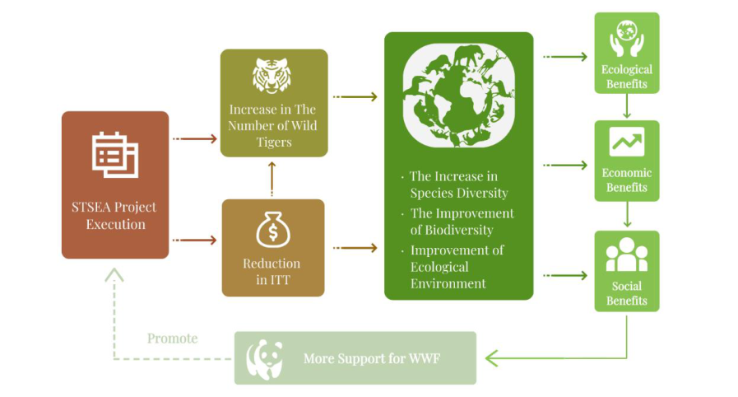
Figure 14: Generalization effects framework
图 14：推广效果框架
图中文字对照（英文 → 中文）
STSEA Project Execution | STSEA项目实施 | Increase in The Number of Wild Tigers | 野生虎数量增加
Reduction in ITT | 非法虎贸易（ITT）减少 | The Increase in Species Diversity | 物种多样性提升
The Improvement of Biodiversity | 生物多样性改善 | Improvement of Ecological Environment | 生态环境改善
Ecological Benefits | 生态效益 | Economic Benefits | 经济效益
Social Benefits | 社会效益 | Promote | 促进
More Support for WWF | 为世界自然基金会（WWF）提供更多支持
6.3 Sensitivity Analysis
6.3 敏感性分析
We use the following formula to calculate the sensitivity degree of each explanatory variable tothe dependent variable:
我们使用以下公式计算各解释变量对因变量的敏感程度：

— 原文第 20 页 —
whererefers to the prediction equation inyear. The results are demonstrated in following chart (Figure15), which means the most sensitive variable to the number of illegal tradeof tigers is the size of the terrestrial protected areas, this inspires more strength to expand the areasfor SEA tigers’ protection:
其中 指的是第 年的预测方程。结果展示于下图（图 15）展示了结果，这意味着对 SEA 老虎非法贸易数量最为敏感的变量是陆地保护区的面积，这启发我们应投入更大的力度扩大 SEA 老虎保护区的范围：
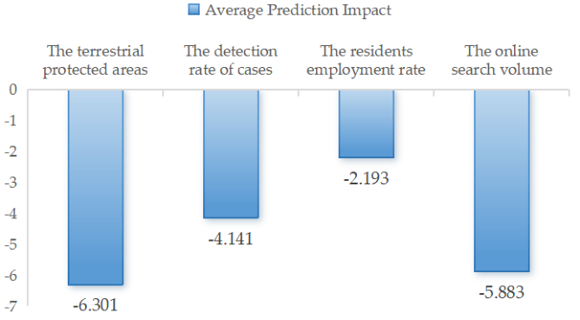
Figure 15: Average prediction sensitivity
图 15：平均预测敏感度
图中文字对照（英文 → 中文）
Average Prediction Impact | 平均预测影响 | The terrestrial protected areas | 陆地保护区
The detection rate of cases | 案件侦破率 | The residents employment rate | 当地居民就业率
The online search volume | 网络搜索量
Here we discuss an abnormal situation: regional war in SEA. Firstly, Active conflict can haltconservation activities, as the safety of personnel is compromised. Research, monitoring, and activefieldwork are often stopped. Moreover, enforcement of wildlife protection laws can be weakenedduring conflicts, as attention and resources are diverted. This can lead to an increase in poaching.
在此我们讨论一种异常情形：SEA 的区域性战争。首先，正在发生的冲突会使保护活动陷入停滞，因为人员的安全无法得到保障。研究与监测以及实地工作往往被迫中止。此外，冲突期间执法（Enforcement）部门的注意力与资源被转移，野生动植物保护法律的执法可能被削弱。这可能导致偷猎行为增加。
It is concluded that similar devastating effects can also reverse years of progress and lead to long-term ecological damage. Conservationists and organizations must frequently work in post-conflictscenarios to rebuild these efforts and address the environmental impacts of the conflict.
由此可以得出结论：类似的破坏性影响还可能使多年取得的进展发生逆转，并造成长期的生态损害。保护工作者与相关组织必须经常在冲突后情境中开展工作，以重建上述努力并应对冲突带来的环境影响。
7 Strength and Weakness
7 优势与不足
Strength：
优势：
Consistence. Our models are consistent with relatively high accuracy, the link of models islogical and reasonable. We build a complete model system for IWT project, ranging fromproject design to effect evaluation.
一致性。我们的模型具有较高精度且彼此一致，模型之间的衔接合乎逻辑、合理可信。我们为非法野生动植物贸易项目构建了完整的模型体系，涵盖从项目设计到效果评估的全过程。
Concreteness. Our project and models are concrete to be understood. We design a specificproject targeted to counter illegal trade of wild tigers in SEA. Our models have either concreteexamples and data or the complete logic chain and suitable mathematic formulas.
具体性。我们的项目与模型具体明确，易于理解。我们设计了一个针对 SEA 野生老虎非法贸易的具体项目。我们的模型或具备具体的实例与数据，或具备完整的逻辑链条与恰当的数学公式。
Persuasiveness. Our models present a relatively good performance of predicting and fitting.
说服力。我们的模型在预测与拟合方面表现出较好的性能。
Weakness：
不足：
Natural shortcomings of mathematic models we use will have effect on the application ofpractical situations.
我们所使用的自身的固有缺陷会影响其在实际情形中的应用。
Due to the lack of related environmental knowledge, the variables of models are not fullyequipped for further analysis.
由于缺乏相关环境领域的知识，模型的变量尚不足以支撑进一步的分析。
— 原文第 21 页 —
Memorandum
备忘录
Dear Manager of World Wildlife Fund:
尊敬的世界自然基金会（WWF）负责人：
Hello! We are writing to express our keen interest to make contribution to counter againstillegal wildlife trade. Our team has developed a specific project targeted the illegal trade of tigersin Southeast Asia. We believe WWF is our best client.
您好！我们致信是希望表达我们对于为打击非法野生动植物贸易作出贡献的浓厚兴趣。本团队已开发出一个针对东南亚老虎非法贸易的具体项目。我们相信 WWF 是我们最合适的客户。
Our project is a five-year project aimed to reduce illegal trade of tigers in Southeast Aisa. Itcontains constructing ecological protection areas, strengthening crackdown on wildlife crimes,developing wildlife resources reasonably, and raising people's awareness of animal protection in
我们的项目为期五年，旨在减少东南亚地区的老虎非法贸易。该项目包括建设生态保护区、加大对野生动植物犯罪的打击力度、合理开发野生动植物资源，以及提高民众的动物保护意识，
Southeast Asia. We have a clear time schedule of whole five years.
上述工作均在东南亚开展。我们对整个五年期制定了明确的时间安排。
Our specific goal is to Reduce illegal trade of tigers in Southeast Asia. We all know, the missionof WWF is “to conserve nature and reduce the most pressing threats to the diversity of life on
我们的具体目标是减少东南亚地区的老虎非法贸易。众所周知，WWF 的使命是“保护自然，减少对地球生命多样性最为紧迫的威胁”，
Earth”, which is consistent with our project. WWF is undoubtedly a significant non-governmentalorganization in terms of wildlife protection. We notice that the effort made to Southeast Asia tigersis limitless in recently years. However, by the analysis of capital flow and the data-driven specieschoosing, we prove the necessity to pay more attention to Southeast Asia and tigers for combatingglobal illegal wildlife trade.
这与我们的项目相一致。在野生动植物保护方面，WWF 无疑是一家重要的非政府组织。我们注意到，近年来针对东南亚老虎所投入的努力是巨大的。然而，通过资金流分析以及数据驱动的物种选择，我们证明了在打击全球非法野生动植物贸易中应更加关注东南亚与老虎的必要性。
We consider the shortcomings of WWF when it comes to actual crime crackdown. So, we givea way out by cooperating with Interpol. By analyzing the complex global crime system and anoptimal utility function, we believe the cooperation between WWF and Interpol can bring theraising of detection rate, resulting in the decrease of wildlife crime.
我们考虑了 WWF 在实际打击犯罪方面的不足。因此，我们给出了与国际刑警组织合作的一条解决途径。通过分析复杂的全球犯罪系统与一个最优效用函数，我们认为 WWF 与国际刑警组织的合作能够带来侦破率的提升，从而减少野生动植物犯罪。
Furthermore, the expectation of our project is also bright. We measure the effect of eachconcrete activities in our project and get a hopeful prediction. WWF is the best client with the mostsuitable capabilities and interest for our project. We will be more than grateful if you can take ourproject into consideration.
此外，我们项目的前景同样光明。我们衡量了项目中各项具体活动的效果，并得到了令人乐观的预测。WWF 拥有最合适的能力与兴趣，是我们项目最理想的客户。若您能将我们的项目纳入考虑，我们将不胜感激。
Best wishes!
谨致最美好的祝愿！
Yours Sincerely
谨启
2
— 原文第 22 页 —
References [1] OECD (2019), The Illegal Wildlife Trade in Southeast Asia: Institutional Capacities in Indonesia,
Singapore,
Thailandand
Viet
Nam,
Illicit
Trade,
OECD
Publishing,
Paris, https://doi.org/10.1787/14fe3297-en.
[2] Wildlife Conservancy Society. (2021). Impact of Illegal Trafficking on Wildlife. Retrieved fromhttps://wildlifetrade.wcs.org/Wildlife-Trade/What-is-its-impact-on-wildlife.aspx.
[3] Wildlife Conservancy Society. (2021). Wildlife Trafficking Impact on our Society. Retrieved fromhttps://wildlifetrade.wcs.org/Wildlife-Trade/What-is-its-impact-on-the-society.aspx.
[4] European Union. (2022). Logical Framework Approach – LFA. Retrieved from https://wikis.ec.europa.eu/display/ExactExternalWiki/Logical+Framework+Approach+-+LFA.
[5]
UN-Habitat.
(2017).
Results-Based
Management
Handbook.
Retrievedfromhttps://unhabitat.org/results-based-management-handbook.
Appendix
Table: Weights of indicators and scores in client assessment
Weight_1
Weight_2
Weight_3
Score
TA: 45.8%
FC: 31.5%
TR: 29.1%
IFAW:15.82
TE: 25.1%
OI: 29%
DR: 45.8%
IUCN:26.53
HR: 36%
GS: 54.2%
GP: 41.7%
TRAFFIC:14.09
CA: 32.5%
DO: 58.3%
LW: 57%
UNEP:64.35
WI: 38.7%
SW: 43%
WCS:57.47
CI: 51.4%
FF: 22%
SMI: 61.3%
FI: 42%
WILDAID:11.12
FX: 36%
PA: 71.5%
FS: 68.7%
WWF: 78.71
FA: 28.5%
SI: 19.6%
PP: 41.2%
RF: 31.3%
PF: 58.8%
（全文完。公式与表格在原 PDF 中是矢量图形，未纳入本对照版；可按文中「原文第 N 页」标记翻到 2409949.pdf 对照查看。）

