下载对应版本，并上传

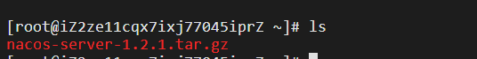

解压

# tar -xvf nacos-server-1.2.1.tar.gz

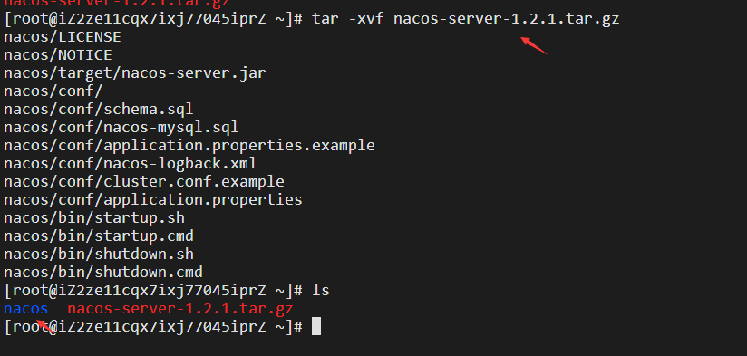

进行bin 并 启动（单机模式）

# cd nacos/bin

# sh startup.sh -m standalone

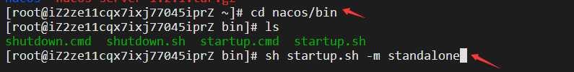



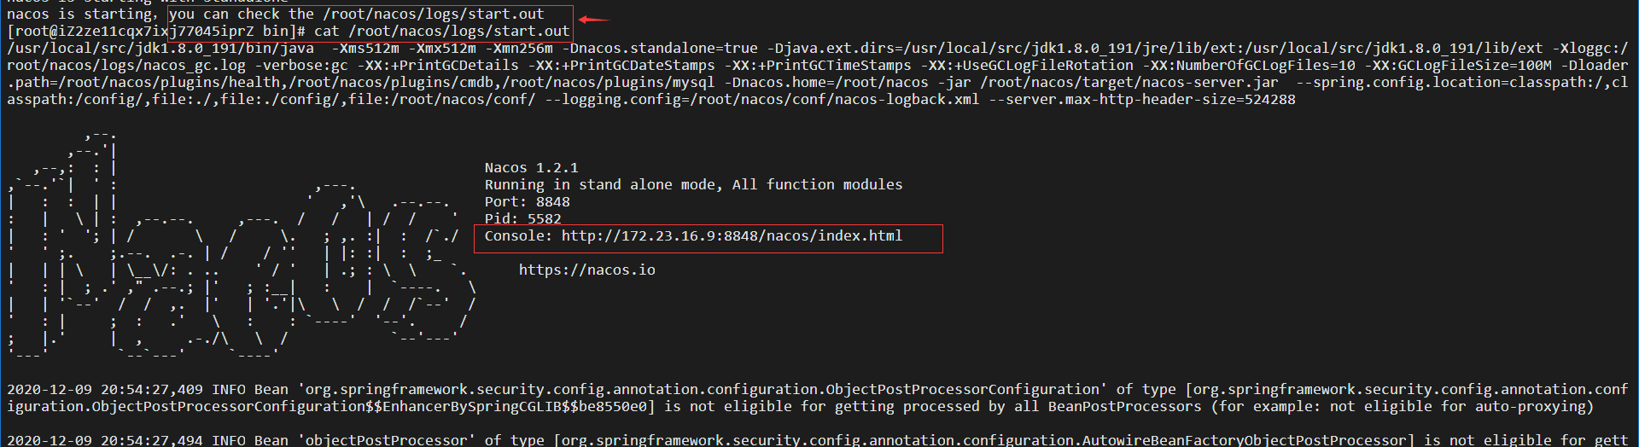

**启动Nacos报错**which: no javac in (/usr/local/sbin:/usr/local/bin:/usr/sbin:/usr/bin:/root/bin)

[root@iZ2ze11cqx7ixj77045iprZ bin]# sh startup.sh -m standalone

which: no javac in (/usr/local/sbin:/usr/local/bin:/usr/sbin:/usr/bin:/root/bin)

readlink: missing operand

Try 'readlink --help' for more information.

dirname: missing operand

Try 'dirname --help' for more information.

ERROR: Please set the JAVA_HOME variable in your environment, We need java(x64)! jdk8 or later is better! !!