Exercise: Write a usability test

**Overview**

In this exercise, you will write a usability test script for the wireframe you created in a previous activity:

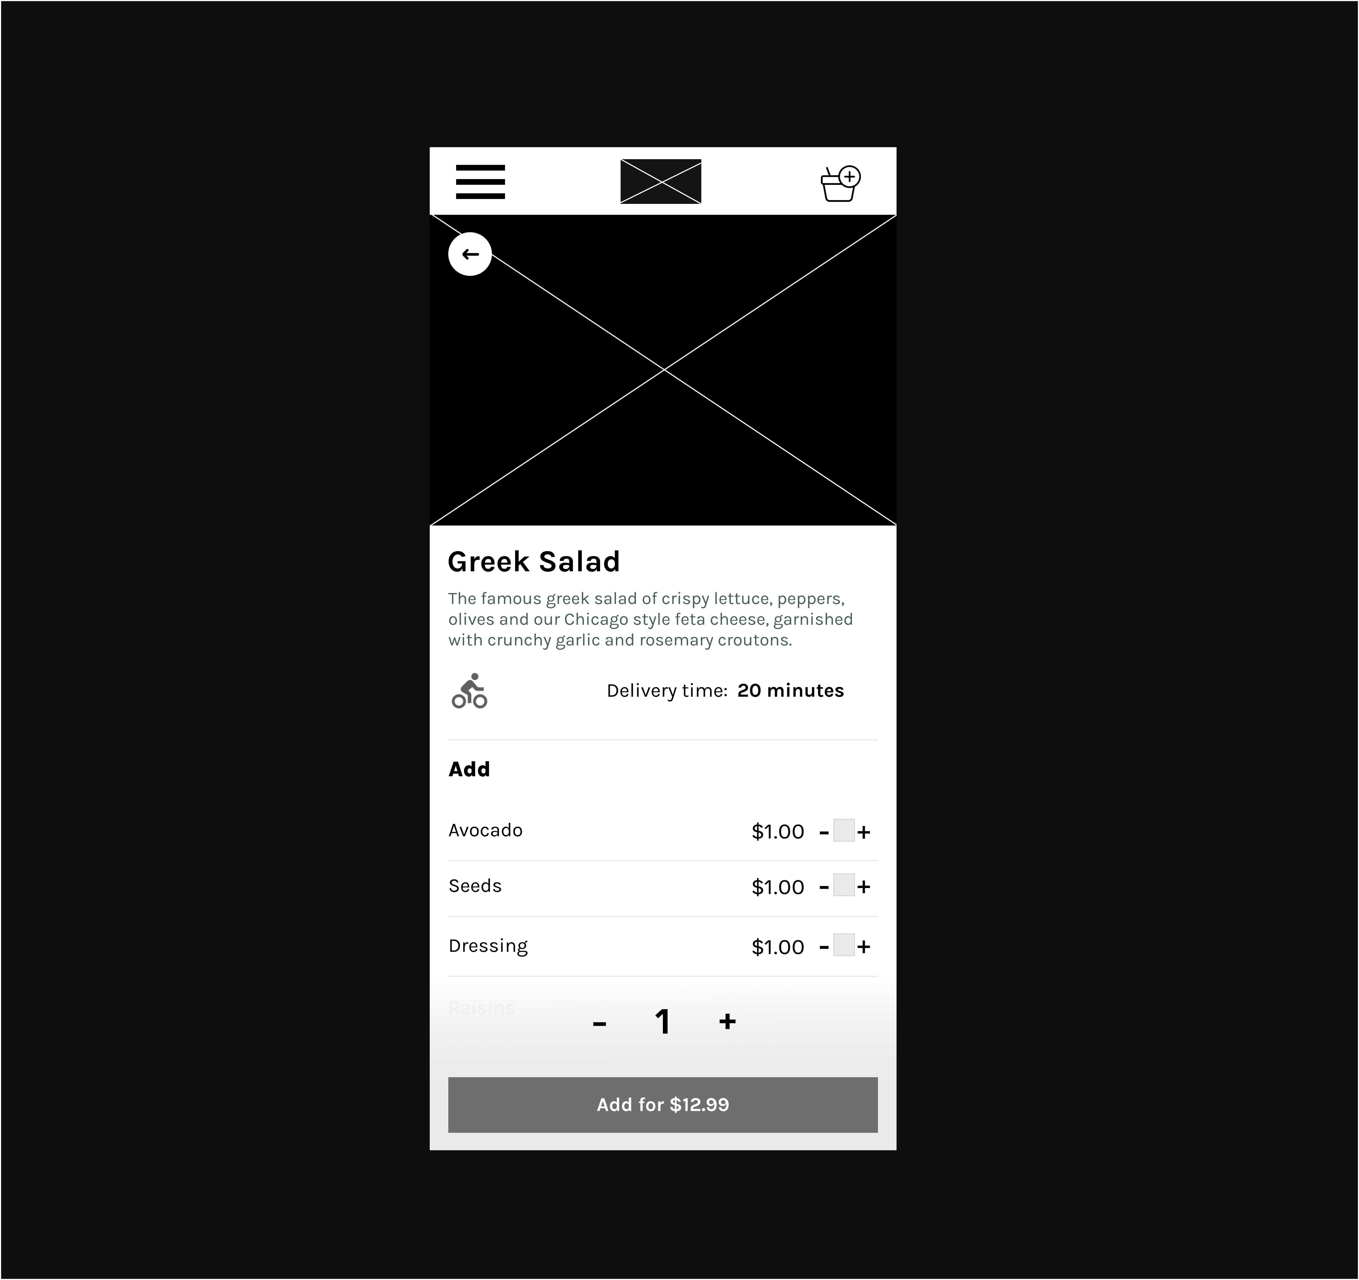

A usability test is the total time participants spend performing tasks with the product and filling out questionnaires about it. As a result, before conducting usability testing, you should adjust your questions to align with your testing objectives. To get the most out of them, you'll need to prepare a proper script and know how to ask good questions.

**The Test Script Guide**

**Instructions**

Use the following Test Script Guide to complete the accompanying Test Script Template.

**Introduction**

Here, please introduce yourself and explain what you require them to do to participants.

Reassure them that they are not being tested and that you value their time and feedback. If you are recording the interview, give them a recording permission form to sign and let them know you will only use the recording internally and not share it with a third party.

**Warm-up questions**

Establish rapport with participants by asking them some general information questions like "Would you introduce yourself?" and "What is your occupation?" "What type(s) of mobile device(s) do you use?" etc.

**Screen tour**

Give the participants an overview of what they are looking at and ask general questions. For example, you could ask: What do you think the screen is for?

**The tasks**

Let participants know how you will guide them through the tasks. Give an overview of the tasks they are required to do. Remember, the test is on the navigation and functions offered by the screen. Write down the answers.

**Wrap-up questions and feedback**

After each task, ask a few questions and conduct a rating exercise to elicit more feedback and information about the users' reasoning.

**Post-Test Interview**

You don't have to ask many questions, but it's essential to have a few prepared. For example, an additional question could be: Was there anything you felt was missing or thought could have been better?

Answer any questions the participants may have.

Thank the participants.

**Test Script Template**

| **Topic** | **Testing Script** |
| --- | --- |
| Introduction |  |
| Warm-up questions |  |
| Screen tour |  |
| The tasks |  |
| Wrap-up questions and feedback |  |
| Post-test interview |  |