**LAPORAN PRAKTIKUM 3  
ACTIVITY DAN INTENT**

**NPM : 22.12.2610**

**Nama :Yuana Setyaningrum**

Bahan : Modul Praktikum 3 – Acitivity dan Intent

Alat : Android Studio

**Desain Halaman Login**

Source code layout :

<?xml version="1.0" encoding="utf-8"?>  
<LinearLayout xmlns:android="http://schemas.android.com/apk/res/android"  
 xmlns:app="http://schemas.android.com/apk/res-auto"  
 xmlns:tools="http://schemas.android.com/tools"  
 android:layout_width="match_parent"  
 android:layout_height="match_parent"  
 android:background="#FF7F00"  
 android:orientation="vertical"  
 tools:context=".LoginActivity">  
  
  
 <ImageView  
 android:id="@+id/imageView"  
 android:layout_width="170dp"  
 android:layout_height="170dp"  
 android:layout_gravity="center"  
 android:layout_marginTop="50dp"  
 app:srcCompat="@drawable/read" />  
  
 <TextView  
 android:id="@+id/textView3"  
 android:layout_width="wrap_content"  
 android:layout_height="wrap_content"  
 android:textSize="25dp"  
 android:textColor="@color/white"  
 android:layout_gravity="center"  
 android:textStyle="bold"  
 android:layout_marginTop="15sp"  
 android:text="LOGIN" />  
  
 <EditText  
 android:id="@+id/editTextText2"  
 android:layout_width="wrap_content"  
 android:layout_height="wrap_content"  
 android:ems="15"  
 android:inputType="text"  
 android:layout_gravity="center"  
 android:textColor="@color/white"  
 android:backgroundTint="@color/white"  
 android:layout_marginTop="30sp"  
 android:text="Username" />  
  
 <EditText  
 android:id="@+id/editTextText4"  
 android:layout_width="wrap_content"  
 android:layout_height="wrap_content"  
 android:ems="15"  
 android:inputType="text"  
 android:layout_gravity="center"  
 android:textColor="@color/white"  
 android:backgroundTint="@color/white"  
 android:layout_marginTop="15sp"  
 android:text="Password" />  
  
 <Button  
 android:id="@+id/button"  
 android:layout_width="150dp"  
 android:layout_height="wrap_content"  
 android:backgroundTint="@color/white"  
 android:textColor="#FE7E87"  
 android:textSize="16sp"  
 android:textStyle="bold"  
 android:layout_gravity="center"  
 android:layout_marginTop="45sp"  
 android:text="Login" />  
  
 <TextView  
 android:id="@+id/textView6"  
 android:layout_width="wrap_content"  
 android:layout_height="wrap_content"  
 android:layout_gravity="center"  
 android:textColor="@color/white"  
 android:textStyle="bold"  
 android:layout_marginTop="15sp"  
 android:text="Don't have an account. Register Here" />  
  
</LinearLayout>

Design UI :

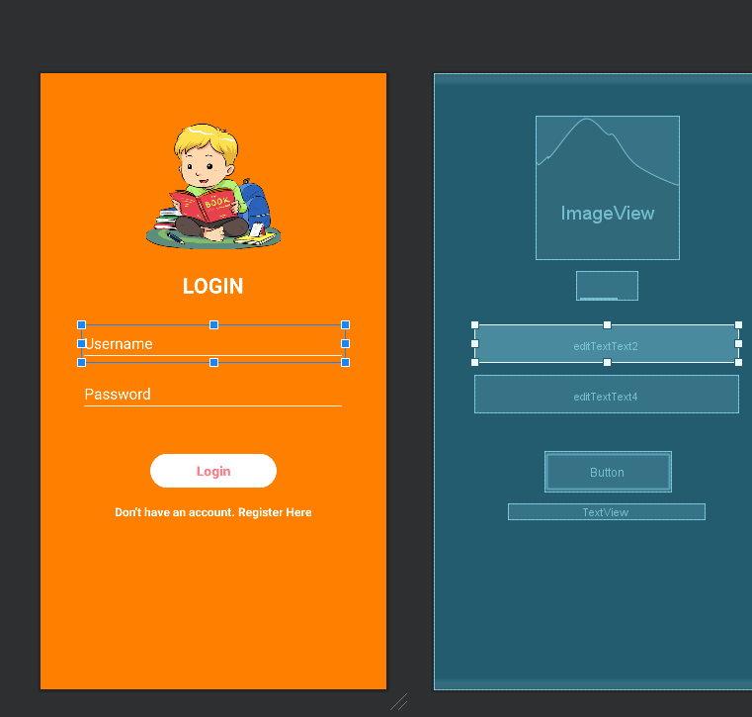

**Desain Halaman About Us**

Source code layout :

Design UI :

**EXPLICIT INTENT**

1. Menampilkan Activity Home (home page) dari Activity Login
2. Menampilkan Activity About dari Activity Home

**IMPLICIT INTENT**

1. Dial Number
2. Web Browser
3. Google Maps