**郑州轻工业大学**

**《C#程序设计》****实验报告**

实验名称：2048

姓 名： 原彬贺

学 号： 542001020223

指导老师： 吴庆岗

专业班级： 计算机20-02班

实验成绩：

一、目的与任务

对c#中的控件熟悉并掌握。

二、内容、要求与安排方式

1、实验内容

设计一个窗体，为一个2048小游戏，通过屏幕上按键对其进行上下左右移动。 显示历史最高成绩。

三、实验设备

1、所用设备：装有Microsoft Visual Studio集成环境的计算机。

2、消耗性器材：无

四、实验代码

using System;

using System.Collections.Generic;

using System.ComponentModel;

using System.Data;

using System.Drawing;

using System.Linq;

using System.Text;

using System.Threading.Tasks;

using System.Windows.Forms;

using System.IO;

namespace 代码

{

public partial class Form2 : Form

{

public Form2()

{

InitializeComponent();

}

private void Form2_Load(object sender, EventArgs e)

{

}

private void Form2_FormClosing(object sender, FormClosingEventArgs e)

{

}

private void Form2_FormClosed(object sender, FormClosedEventArgs e)

{

}

private void label1_Click(object sender, EventArgs e)

{

}

public void add(int a)

{

Random rand = new Random();

int i = 1;

while (i == 1)

{

int num;

num = rand.Next(1, 10);

switch (num)

{

case 1:

if (label1.Text.Length == 0)

{

label1.Text = "2";

i = 0;

break;

}

else

break;

case 2:

if (label2.Text.Length == 0)

{

label2.Text = "2";

i = 0;

break;

}

else

break;

case 3:

if (label3.Text.Length == 0)

{

label3.Text = "2";

i = 0;

break;

}

else

break;

case 4:

if (label4.Text.Length == 0)

{

label4.Text = "2";

i = 0;

break;

}

else

break;

case 5:

if (label5.Text.Length == 0)

{

label5.Text = "2";

i = 0;

break;

}

else

break;

case 6:

if (label6.Text.Length == 0)

{

label6.Text = "2";

i = 0;

break;

}

else

break;

case 7:

if (label7.Text.Length == 0)

{

label7.Text = "2";

i = 0;

break;

}

else

break;

case 8:

if (label8.Text.Length == 0)

{

label8.Text = "2";

i = 0;

break;

}

else

break;

case 9:

if (label9.Text.Length == 0)

{

label9.Text = "2";

i = 0;

break;

}

else

break;

}

}

}

public void beging(int i)

{

label12.Text = "000";

label1.Text = "";

label2.Text = "";

label3.Text = "";

label4.Text = "";

label5.Text = "";

label6.Text = "";

label7.Text = "";

label8.Text = "";

label9.Text = "";

}

public int top=0;

public void ending(int x)

{

string tops = Convert.ToString(top);

if (label1.Text.Length != 0 & label2.Text.Length != 0 & label3.Text.Length != 0 & label4.Text.Length != 0 & label5.Text.Length != 0 & label6.Text.Length != 0 & label7.Text.Length != 0 & label8.Text.Length != 0 & label9.Text.Length != 0)

{

int its = Convert.ToInt32(label12.Text);

if (top <= its)

{

top = its;

label14.Text = label12.Text;

DialogResult a = MessageBox.Show("恭喜您，突破了记录！"+"您的最终成绩为：" + label12.Text + "\n是否开始一局新游戏?", "最终成绩", MessageBoxButtons.YesNo);

if (a == DialogResult.Yes)

{

beging(1);

}

else

{

this.Hide();

this.Close();

}

}

else

{

DialogResult a = MessageBox.Show("您的历史最好成绩为："+tops+"\n您的最终成绩为：" + label12.Text + "\n是否开始一局新游戏?", "最终成绩", MessageBoxButtons.YesNo);

if (a == DialogResult.Yes)

{

beging(1);

}

else

{

this.Hide();

this.Close();

}

}

}

}

private void label8_Click(object sender, EventArgs e)

{

}

private void label9_Click(object sender, EventArgs e)

{

}

private void label2_Click(object sender, EventArgs e)

{

}

private void groupBox1_Enter(object sender, EventArgs e)

{

}

private void button1_Click(object sender, EventArgs e)

{

this.Hide();

Form2 form2 = new Form2();

form2.ShowDialog();

this.Close();

}

private void Form2_KeyDown(object sender, KeyEventArgs e)

{

}

private void button2_Click(object sender, EventArgs e)

{

if (label4.Text == label1.Text & label4.Text.Length != 0)

{

int a = Convert.ToInt32(label1.Text);

a = 2 * a;

label1.Text = Convert.ToString(a);

a=a+ Convert.ToInt32(label12.Text);

label12.Text = Convert.ToString(a);

label4.Text = "";

}

if (label4.Text == label7.Text & label4.Text.Length != 0)

{

int a = Convert.ToInt32(label4.Text);

a = 2 * a;

label4.Text = Convert.ToString(a);

a = a + Convert.ToInt32(label12.Text);

label12.Text = Convert.ToString(a);

label7.Text = "";

}

if (label1.Text == label7.Text & label1.Text.Length != 0 & label4.Text.Length == 0)

{

int a = Convert.ToInt32(label1.Text);

a = 2 * a;

label1.Text = Convert.ToString(a);

a = a + Convert.ToInt32(label12.Text);

label12.Text = Convert.ToString(a);

label7.Text = "";

}

if (label1.Text.Length == 0)

{

if (label4.Text.Length != 0)

{

label1.Text = label4.Text;

label4.Text = label7.Text;

label7.Text = "";

}

else

{

label1.Text = label7.Text;

label7.Text = "";

}

}

else

{

if (label4.Text.Length == 0)

{

label4.Text = label7.Text;

label7.Text = "";

}

}

if (label5.Text == label2.Text & label5.Text.Length != 0)

{

int a = Convert.ToInt32(label2.Text);

a = 2 * a;

label2.Text = Convert.ToString(a);

a = a + Convert.ToInt32(label12.Text);

label12.Text = Convert.ToString(a);

label5.Text = "";

}

if (label5.Text == label8.Text & label5.Text.Length != 0)

{

int a = Convert.ToInt32(label5.Text);

a = 2 * a;

label5.Text = Convert.ToString(a);

a = a + Convert.ToInt32(label12.Text);

label12.Text = Convert.ToString(a);

label8.Text = "";

}

if (label2.Text == label8.Text & label2.Text.Length != 0 & label5.Text.Length == 0)

{

int a = Convert.ToInt32(label2.Text);

a = 2 * a;

label2.Text = Convert.ToString(a);

a = a + Convert.ToInt32(label12.Text);

label12.Text = Convert.ToString(a);

label8.Text = "";

}

if (label2.Text.Length == 0)

{

if (label5.Text.Length != 0)

{

label2.Text = label5.Text;

label5.Text = label8.Text;

label8.Text = "";

}

else

{

label2.Text = label8.Text;

label8.Text = "";

}

}

else

{

if (label5.Text.Length == 0)

{

label5.Text = label8.Text;

label8.Text = "";

}

}

if (label6.Text == label3.Text & label6.Text.Length != 0)

{

int a = Convert.ToInt32(label3.Text);

a = 2 * a;

label3.Text = Convert.ToString(a);

a = a + Convert.ToInt32(label12.Text);

label12.Text = Convert.ToString(a);

label6.Text = "";

}

if (label6.Text == label9.Text & label6.Text.Length != 0)

{

int a = Convert.ToInt32(label6.Text);

a = 2 * a;

label6.Text = Convert.ToString(a);

a = a + Convert.ToInt32(label12.Text);

label12.Text = Convert.ToString(a);

label9.Text = "";

}

if (label3.Text == label9.Text & label3.Text.Length != 0 & label6.Text.Length == 0)

{

int a = Convert.ToInt32(label3.Text);

a = 2 * a;

label3.Text = Convert.ToString(a);

a = a + Convert.ToInt32(label12.Text);

label12.Text = Convert.ToString(a);

label9.Text = "";

}

if (label3.Text.Length == 0)

{

if (label6.Text.Length != 0)

{

label3.Text = label6.Text;

label6.Text = label9.Text;

label9.Text = "";

}

else

{

label3.Text = label9.Text;

label9.Text = "";

}

}

else

{

if (label6.Text.Length == 0)

{

label6.Text = label9.Text;

label9.Text = "";

}

}

add(0);

ending(1);

}

private void button6_Click(object sender, EventArgs e)

{

beging(1);

add(1);

groupBox2.Visible = true;

groupBox3.Location = label16.Location;

label16.Visible = false;

}

private void label6_Click(object sender, EventArgs e)

{

}

private void label4_Click(object sender, EventArgs e)

{

}

private void groupBox2_Enter(object sender, EventArgs e)

{

}

private void button4_Click(object sender, EventArgs e)

{

if (label4.Text == label7.Text & label4.Text.Length != 0)

{

int a = Convert.ToInt32(label7.Text);

a = 2 * a;

label7.Text = Convert.ToString(a);

a = a + Convert.ToInt32(label12.Text);

label12.Text = Convert.ToString(a);

label4.Text = "";

}

if (label4.Text == label1.Text & label4.Text.Length != 0)

{

int a = Convert.ToInt32(label4.Text);

a = 2 * a;

label4.Text = Convert.ToString(a);

a = a + Convert.ToInt32(label12.Text);

label12.Text = Convert.ToString(a);

label1.Text = "";

}

if (label7.Text == label1.Text & label7.Text.Length != 0 & label4.Text.Length == 0)

{

int a = Convert.ToInt32(label7.Text);

a = 2 * a;

label7.Text = Convert.ToString(a);

a = a + Convert.ToInt32(label12.Text);

label12.Text = Convert.ToString(a);

label1.Text = "";

}

if (label7.Text.Length == 0)

{

if (label4.Text.Length != 0)

{

label7.Text = label4.Text;

label4.Text = label1.Text;

label1.Text = "";

}

else

{

label7.Text = label1.Text;

label1.Text = "";

}

}

else

{

if (label4.Text.Length == 0)

{

label4.Text = label1.Text;

label1.Text = "";

}

}

if (label5.Text == label8.Text & label5.Text.Length != 0)

{

int a = Convert.ToInt32(label8.Text);

a = 2 * a;

label8.Text = Convert.ToString(a);

a = a + Convert.ToInt32(label12.Text);

label12.Text = Convert.ToString(a);

label5.Text = "";

}

if (label5.Text == label2.Text & label5.Text.Length != 0)

{

int a = Convert.ToInt32(label5.Text);

a = 2 * a;

label5.Text = Convert.ToString(a);

a = a + Convert.ToInt32(label12.Text);

label12.Text = Convert.ToString(a);

label2.Text = "";

}

if (label8.Text == label2.Text & label8.Text.Length != 0 & label5.Text.Length == 0)

{

int a = Convert.ToInt32(label8.Text);

a = 2 * a;

label8.Text = Convert.ToString(a);

a = a + Convert.ToInt32(label12.Text);

label12.Text = Convert.ToString(a);

label2.Text = "";

}

if (label8.Text.Length == 0)

{

if (label5.Text.Length != 0)

{

label8.Text = label5.Text;

label5.Text = label2.Text;

label2.Text = "";

}

else

{

label8.Text = label2.Text;

label2.Text = "";

}

}

else

{

if (label5.Text.Length == 0)

{

label5.Text = label2.Text;

label2.Text = "";

}

}

if (label6.Text == label9.Text & label6.Text.Length != 0)

{

int a = Convert.ToInt32(label9.Text);

a = 2 * a;

label9.Text = Convert.ToString(a);

a = a + Convert.ToInt32(label12.Text);

label12.Text = Convert.ToString(a);

label6.Text = "";

}

if (label6.Text == label3.Text & label6.Text.Length != 0)

{

int a = Convert.ToInt32(label6.Text);

a = 2 * a;

label6.Text = Convert.ToString(a);

a = a + Convert.ToInt32(label12.Text);

label12.Text = Convert.ToString(a);

label3.Text = "";

}

if (label9.Text == label3.Text & label9.Text.Length != 0 & label6.Text.Length == 0)

{

int a = Convert.ToInt32(label9.Text);

a = 2 * a;

label9.Text = Convert.ToString(a);

a = a + Convert.ToInt32(label12.Text);

label12.Text = Convert.ToString(a);

label3.Text = "";

}

if (label9.Text.Length == 0)

{

if (label6.Text.Length != 0)

{

label9.Text = label6.Text;

label6.Text = label3.Text;

label3.Text = "";

}

else

{

label9.Text = label3.Text;

label3.Text = "";

}

}

else

{

if (label6.Text.Length == 0)

{

label6.Text = label3.Text;

label3.Text = "";

}

}

add(0);

ending(1);

}

private void button3_Click(object sender, EventArgs e)

{

if (label2.Text == label3.Text & label2.Text.Length != 0)

{

int a = Convert.ToInt32(label3.Text);

a = 2 * a;

label3.Text = Convert.ToString(a);

a = a + Convert.ToInt32(label12.Text);

label12.Text = Convert.ToString(a);

label2.Text = "";

}

if (label2.Text == label1.Text & label2.Text.Length != 0)

{

int a = Convert.ToInt32(label2.Text);

a = 2 * a;

label2.Text = Convert.ToString(a);

a = a + Convert.ToInt32(label12.Text);

label12.Text = Convert.ToString(a);

label1.Text = "";

}

if (label3.Text == label1.Text & label3.Text.Length != 0 & label2.Text.Length == 0)

{

int a = Convert.ToInt32(label3.Text);

a = 2 * a;

label3.Text = Convert.ToString(a);

a = a + Convert.ToInt32(label12.Text);

label12.Text = Convert.ToString(a);

label1.Text = "";

}

if (label3.Text.Length == 0)

{

if (label2.Text.Length != 0)

{

label3.Text = label2.Text;

label2.Text = label1.Text;

label1.Text = "";

}

else

{

label3.Text = label1.Text;

label1.Text = "";

}

}

else

{

if (label2.Text.Length == 0)

{

label2.Text = label1.Text;

label1.Text = "";

}

}

if (label5.Text == label6.Text & label5.Text.Length != 0)

{

int a = Convert.ToInt32(label6.Text);

a = 2 * a;

label6.Text = Convert.ToString(a);

a = a + Convert.ToInt32(label12.Text);

label12.Text = Convert.ToString(a);

label5.Text = "";

}

if (label5.Text == label4.Text & label5.Text.Length != 0)

{

int a = Convert.ToInt32(label5.Text);

a = 2 * a;

label5.Text = Convert.ToString(a);

a = a + Convert.ToInt32(label12.Text);

label12.Text = Convert.ToString(a);

label4.Text = "";

}

if (label6.Text == label4.Text & label6.Text.Length != 0 & label5.Text.Length == 0)

{

int a = Convert.ToInt32(label6.Text);

a = 2 * a;

label6.Text = Convert.ToString(a);

a = a + Convert.ToInt32(label12.Text);

label12.Text = Convert.ToString(a);

label4.Text = "";

}

if (label6.Text.Length == 0)

{

if (label5.Text.Length != 0)

{

label6.Text = label5.Text;

label5.Text = label4.Text;

label4.Text = "";

}

else

{

label6.Text = label4.Text;

label4.Text = "";

}

}

else

{

if (label5.Text.Length == 0)

{

label5.Text = label4.Text;

label4.Text = "";

}

}

if (label8.Text == label9.Text & label8.Text.Length != 0)

{

int a = Convert.ToInt32(label9.Text);

a = 2 * a;

label9.Text = Convert.ToString(a);

a = a + Convert.ToInt32(label12.Text);

label12.Text = Convert.ToString(a);

label8.Text = "";

}

if (label8.Text == label7.Text & label8.Text.Length != 0)

{

int a = Convert.ToInt32(label8.Text);

a = 2 * a;

label8.Text = Convert.ToString(a);

a = a + Convert.ToInt32(label12.Text);

label12.Text = Convert.ToString(a);

label7.Text = "";

}

if (label9.Text == label7.Text & label9.Text.Length != 0 & label8.Text.Length == 0)

{

int a = Convert.ToInt32(label9.Text);

a = 2 * a;

label9.Text = Convert.ToString(a);

a = a + Convert.ToInt32(label12.Text);

label12.Text = Convert.ToString(a);

label7.Text = "";

}

if (label9.Text.Length == 0)

{

if (label8.Text.Length != 0)

{

label9.Text = label8.Text;

label8.Text = label7.Text;

label7.Text = "";

}

else

{

label9.Text = label7.Text;

label7.Text = "";

}

}

else

{

if (label8.Text.Length == 0)

{

label8.Text = label7.Text;

label7.Text = "";

}

}

add(0);

ending(1);

}

private void button5_Click(object sender, EventArgs e)

{

if (label2.Text == label1.Text & label2.Text.Length != 0)

{

int a = Convert.ToInt32(label1.Text);

a = 2 * a;

label1.Text = Convert.ToString(a);

a = a + Convert.ToInt32(label12.Text);

label12.Text = Convert.ToString(a);

label2.Text = "";

}

if (label2.Text == label3.Text & label2.Text.Length != 0)

{

int a = Convert.ToInt32(label2.Text);

a = 2 * a;

label2.Text = Convert.ToString(a);

a = a + Convert.ToInt32(label12.Text);

label12.Text = Convert.ToString(a);

label3.Text = "";

}

if (label1.Text == label3.Text & label1.Text.Length != 0 & label2.Text.Length == 0)

{

int a = Convert.ToInt32(label1.Text);

a = 2 * a;

label1.Text = Convert.ToString(a);

a = a + Convert.ToInt32(label12.Text);

label12.Text = Convert.ToString(a);

label3.Text = "";

}

if (label1.Text.Length == 0)

{

if (label2.Text.Length != 0)

{

label1.Text = label2.Text;

label2.Text = label3.Text;

label3.Text = "";

}

else

{

label1.Text = label3.Text;

label3.Text = "";

}

}

else

{

if (label2.Text.Length == 0)

{

label2.Text = label3.Text;

label3.Text = "";

}

}

if (label5.Text == label4.Text & label5.Text.Length != 0)

{

int a = Convert.ToInt32(label4.Text);

a = 2 * a;

label4.Text = Convert.ToString(a);

a = a + Convert.ToInt32(label12.Text);

label12.Text = Convert.ToString(a);

label5.Text = "";

}

if (label5.Text == label6.Text & label5.Text.Length != 0)

{

int a = Convert.ToInt32(label5.Text);

a = 2 * a;

label5.Text = Convert.ToString(a);

a = a + Convert.ToInt32(label12.Text);

label12.Text = Convert.ToString(a);

label6.Text = "";

}

if (label4.Text == label6.Text & label4.Text.Length != 0 & label5.Text.Length == 0)

{

int a = Convert.ToInt32(label4.Text);

a = 2 * a;

label4.Text = Convert.ToString(a);

a = a + Convert.ToInt32(label12.Text);

label12.Text = Convert.ToString(a);

label6.Text = "";

}

if (label4.Text.Length == 0)

{

if (label5.Text.Length != 0)

{

label4.Text = label5.Text;

label5.Text = label6.Text;

label6.Text = "";

}

else

{

label4.Text = label6.Text;

label6.Text = "";

}

}

else

{

if (label5.Text.Length == 0)

{

label5.Text = label6.Text;

label6.Text = "";

}

}

if (label8.Text == label7.Text & label8.Text.Length != 0)

{

int a = Convert.ToInt32(label7.Text);

a = 2 * a;

label7.Text = Convert.ToString(a);

a = a + Convert.ToInt32(label12.Text);

label12.Text = Convert.ToString(a);

label8.Text = "";

}

if (label8.Text == label9.Text & label8.Text.Length != 0)

{

int a = Convert.ToInt32(label8.Text);

a = 2 * a;

label8.Text = Convert.ToString(a);

a = a + Convert.ToInt32(label12.Text);

label12.Text = Convert.ToString(a);

label9.Text = "";

}

if (label7.Text == label9.Text & label7.Text.Length != 0 & label8.Text.Length == 0)

{

int a = Convert.ToInt32(label7.Text);

a = 2 * a;

label7.Text = Convert.ToString(a);

a = a + Convert.ToInt32(label12.Text);

label12.Text = Convert.ToString(a);

label9.Text = "";

}

if (label7.Text.Length == 0)

{

if (label8.Text.Length != 0)

{

label7.Text = label8.Text;

label8.Text = label9.Text;

label9.Text = "";

}

else

{

label7.Text = label9.Text;

label9.Text = "";

}

}

else

{

if (label8.Text.Length == 0)

{

label8.Text = label9.Text;

label9.Text = "";

}

}

add(0);

ending(1);

}

五、实验结果

1.初始界面图，图1

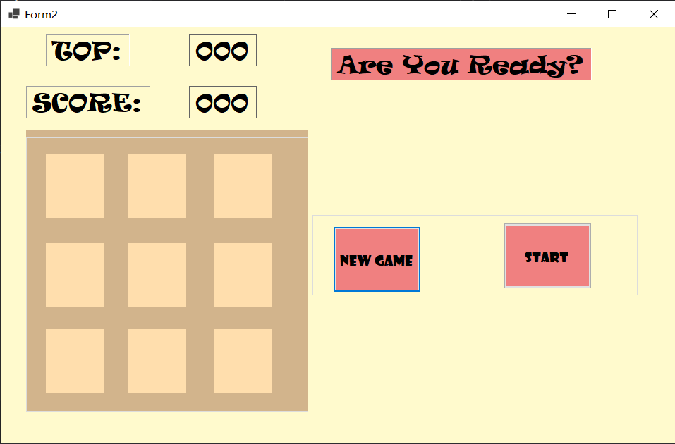

图1 初始界面图

2.开始游戏，点击start后开始玩，当游戏结束后显示分数对话框。

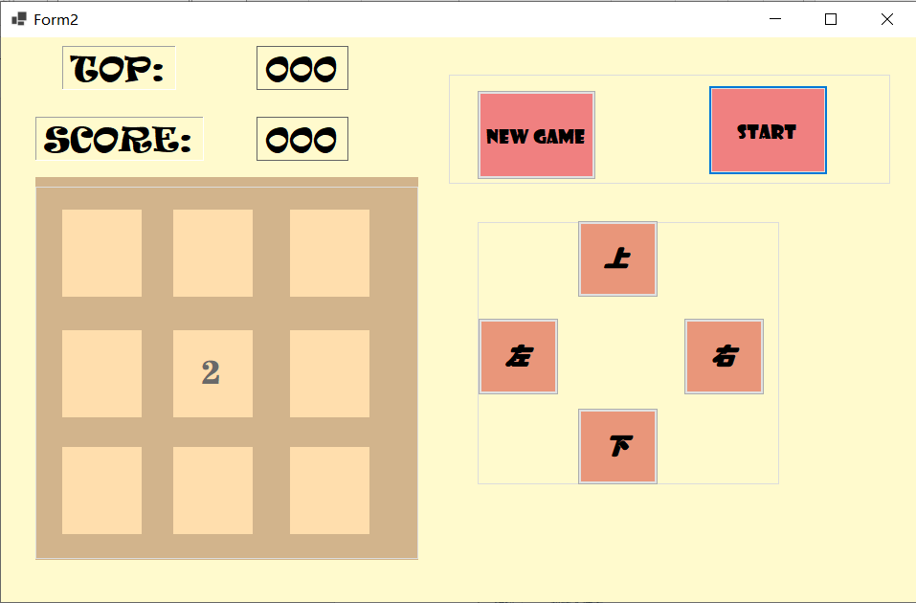

图2 点start开始游戏后界面

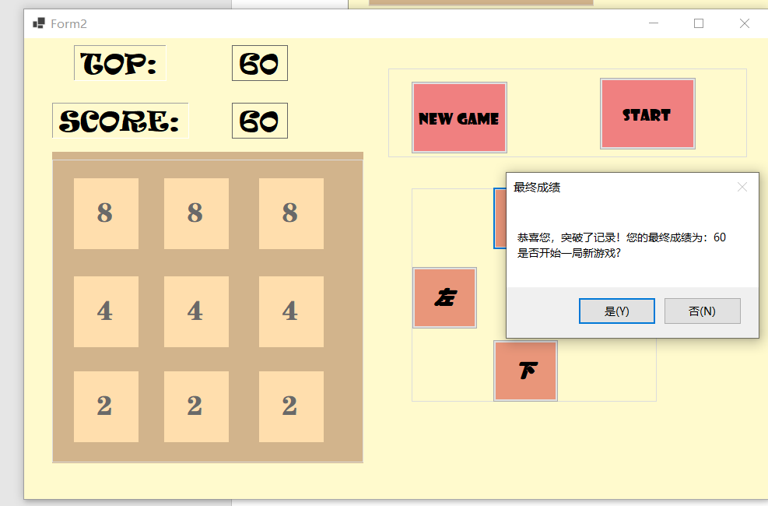

图3 结束游戏后进行提示

3.超过历史成绩后显示恭喜对话框并更改历史成绩，如图4

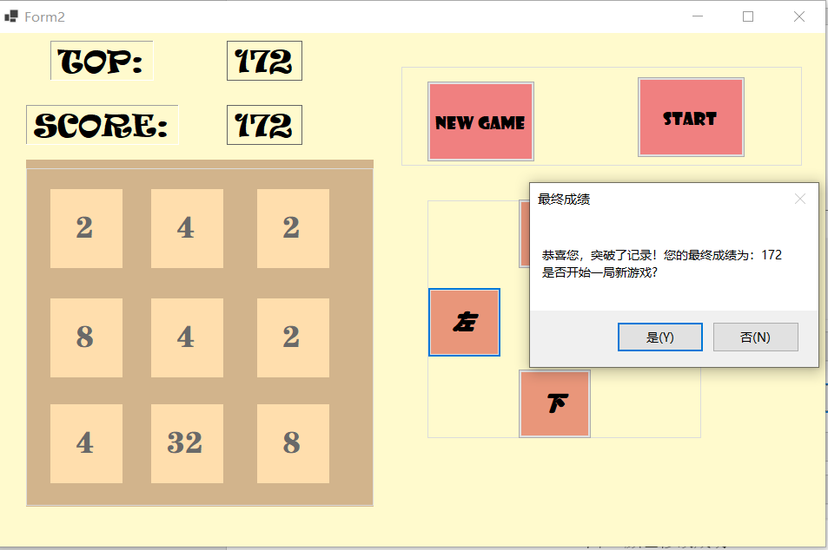

图4 突破记录对话框

4. 修改选择文本的字体，图5

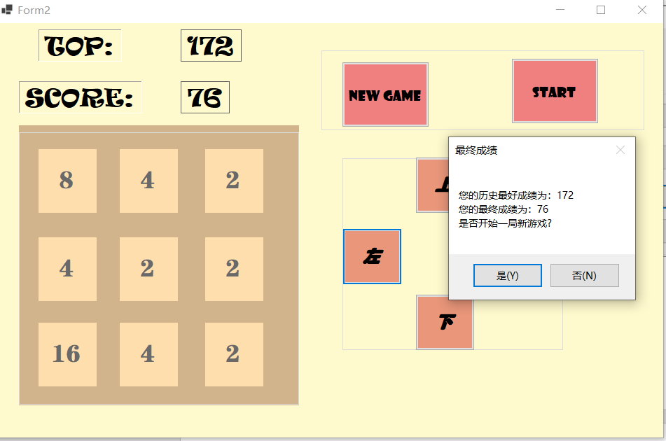

图5 未超过历史成绩对话框

六、实验总结

通过本次项目，我尝试使用c#写小项目，在进行编写时，一开始对于选择数字的容器不确定，最后决定使用lable标签。在使用lable标签时，由于对其熟悉，无法控制其大小，后懂得了lable标签需要修改属性，不使其随内容而变化。在进行具体的操作函数编写时，由于需要将数字相加消除，需要考虑每一种情况。我在编写时，先对于上键进行编写，然后考虑其向上移动时的可能，然后再通过寻找规律，将下左右按键的函数通过替换标签的名字进行替换从而求得。设置公共变量，存储历史最大值，当每局游戏结束，得分与历史最高值，进行比较。并刷新历史最高值。当游戏结束输出对话框。提示是否进行下一局游戏。

通过本次作业，我收获很多，在编写时，通过查阅资料，将两个groupboc的显示与否通过按键进行控制。进而实现了更为良好的界面效果。在进行多行代码的编写时，懂得了函数名与变量名定义要语义化，以待下次再用。这次的作业，使我学到了很多有用的知识。

|  |
| --- |
| **评语**（不要删除，指导老师填写评语，放置在实验报告后面单独成页） |
|  |