10.10

Total number of images: 2860
Number of successfully aligned images: 369
--- 3216.34459805 seconds ---

Total number of images: 1759
Number of successfully aligned images: 416
--- 751.419348955 seconds ---

Embedding
Run time: 234.898060083

./Siegfried_Kasche_convict
./Christopher_Soghoian_computer_scientist
./Rubin_Carter_convict
./Harry_Rosen_businessperson
./Hanns_Ludin_convict
./David_S._H._Rosenthal_computer_scientist
./Roger_Mohr_computer_scientist
./Álvaro_Longoria_film_producer
./Cyrille_Cahen_physician
./Johan_Alfred_Ander_convict
./Reuven_(Robert)_Viskoper_physician
./Hans_Loritz_convict
./Alfons_Karabuda_convict
./Lluís-Anton_Baulenas_writer
./Roland_Bourneuf_writer
./Emil_Pleissner_convict
./Olivier_Sebban_writer
./Ferdinand_Schörner_convict
./Max_Simon_convict
./Ekkehard_Klemm_conductor
./Anton_Houtsma_politician
./Thomas_Peterffy_businessperson
./Paul_Ludwig_Ewald_von_Kleist_convict
./Refree_businessperson
./Pavo_Raudsepp_politician
./Jacek_Lipiński_politician
./Mario_Coppola_painter
./Chakir_El_Homrani_Lesfar_politician

Actor: 363-1-1-1-1-1-1
Artist: 194-1
businessperson: 397-1-1-1
CS: 307
convict: 222
musician: 221-1
philosopher: 312-1-1-1-1-1-1
physician: 227
politician: 374-1
writer: 389-1-1-1-1-1-1-1-1-1-1-1-1-1-1-1

2879

2643
3004

2955

Actor Align
--- 365.506808043 seconds --- ~ 6 min

./Maury_Ginsberg_actor_m
./Lluís-Anton_Baulenas_actor_m

MTCNN 160 Male

Total number of images: 5134
Number of successfully aligned images: 1654
--- 4056.89770007 seconds --- ~67.61 min

Unable to Align

./Florent_Buca_artist_m
./Mohamed_Belhaj_Amor_politician_m
./Lluís-Anton_Baulenas_writer_m
./Antoni_Egea_artist_m
./Peter_Janich_philosopher_m
./William_Henry_Buryconvict_m
./José_Gordon_writer_m
./Roger_Mohr_computer_scientist_m
./Eftichios_Bitsakis_philosopher_m
./Maury_Ginsberg_actor_m
./Salvador_Gallardo_Cabrera_philosopher_m
./Gordon_Ramsay_politician_m
./John_Christie_artist_m
./Werner_Kampeconvict_m
./Chakir_El_Homrani_Lesfar_politician_m
./Cyrille_Cahen_physician_m
./Harry_Rosen_businessperson_m
./Christopher_Soghoian_computer_scientist_m
./John_Trivers_musician_m
./Xavier_Besalú_i_Costa_writer_m
./David_S._H._Rosenthal_computer_scientist_m
./Udham_Singhconvict_m
./Reuven_(Robert)_Viskoper_physician_m
./Mohamad_Salahshour_artist_m
./Lluís-Anton_Baulenas_actor_m
./Paul_Ludwig_Ewald_von_Kleistconvict_m
./Ahmet_İnam_philosopher_m
./Francisco_Caja_philosopher_m
./László_Bárdossyconvict_m
./Siegfried_Kascheconvict_m
./Alfons_Karabudaconvict_m
./Bili_Bidjocka_artist_m
./Sawney_Beanconvict_m

Facenet extract embeddings

Number of images: 5101
Run time: 235.566972017

convict
212
writer
365
soccer
735
physician
225
musician
219
golf
558
computer scientist
300
actor
354
politician
369
philosopher
300
fighter
560
businessperson
389
artist
188
tennis
102
basketball
225
5101
Comparison of Feature Extraction Methods and F-Measure of Clustering Algorithms
Clustering/Feature Extraction Method | FaceNet | OpenFace | Dlib | ArcFace
K-Means
Hierarchical Agglomerative
Spectral
EM (Gaussian Mixture Model)
Birch

Evaluation of Clustering Algorithms

1. FaceNet

Clustering method | Number of clusters | F-Measure | Precision | Recall | False Positives | Runtime (seconds)
K-Means | 15 | 0.2 | 0.22 | 0.18 | 694023 | 6.03
Hierarchical Agglomerative | 15 | 0.21 | 0.14 | 0.44 | 2878163 | 7.11
Spectral | 15 | 0.2 | 0.14 | 0.38 | 2475186 | 6.57
EM (Gaussian Mixture Model) | 15 | 0.21 | 0.14 | 0.44 | 2944493 | 22.88
Birch | 15 | 0.21 | 0.14 | 0.45 | 2967260 | 5.90

FaceNet

False Negative
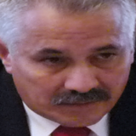

Dagoberto Rodríguez Barrera politician

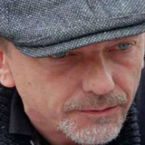

Peter Terryn politician m
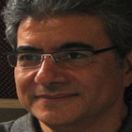

Mohammad Firouzi musician m

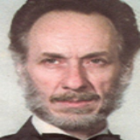

Mojtaba Mirzadeh musician m
False Positive

Jon Mikl Thor actor Leonardo León convict m


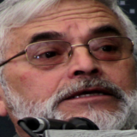

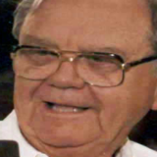
Benny Binion convict P. W. Singer politician
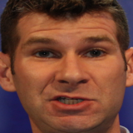

Homi K. Bhabha philosopher James Cameron actor

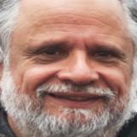
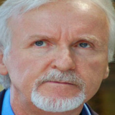
Female
Actor: 287
Artist: 321
Basketball: 271
Business: 180
CS: 67
Convict: 113
Fighter: 35
Golf: 181
Music: 151
Philosopher: 70
Physician: 65
Politicians: 421
Soccer: 434
Tennis: 430
Writer: 438

3552

