Step 1 Create an Ubuntu Server

Sign into Amazon AWS account Get into AWS console page. Click EC2 sever, chose Ubuntu server.

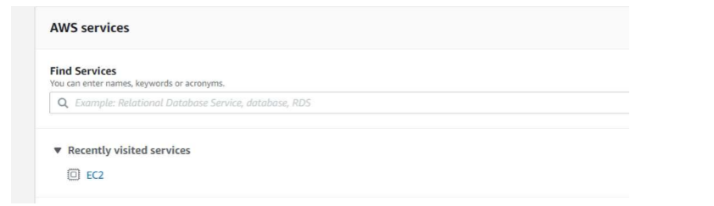

Download the security key (xxx.pem).

Step 2 Connect to the Ubuntu Server

Put the security key in to the .ssh folder and changes its permissions to 400.

Commend: chmod 400 .ssh

Sign in: sudo ssh -i xxx.pem [ubuntu@xx.xxx.xxx.xx](mailto:ubuntu@xx.xxx.xxx.xx)

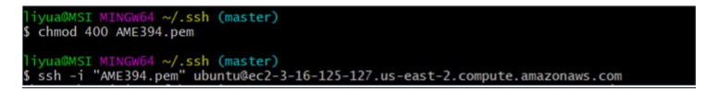

After finish instilling, open git bash and test if it’s instilled successfully.

Step 3 setup the ubuntu server

Install Node, Build from Source

curl -O http://nodejs.org/dist/v0.10.29/node-v0.10.29.tar.gz

tar -xvzf node-v0.10.29.tar.gz

cd node-v0.10.29

./configure --prefix=/opt/node

make

sudo mkdir -p /opt/node

sudo chown -R ubuntu.ubuntu /opt/node

make install

Use git clone to clone all the stuff to the server

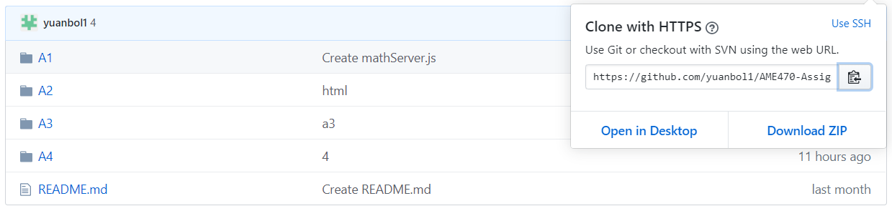

git clone https://github.com/yuanbol1/AME470-Assignment.git

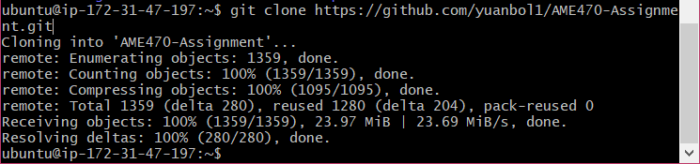

Step 4 run the program on the server

Setup the mongodb on the server

Type

sudo apt update && sudo apt upgrade -y

sudo apt install mongodb

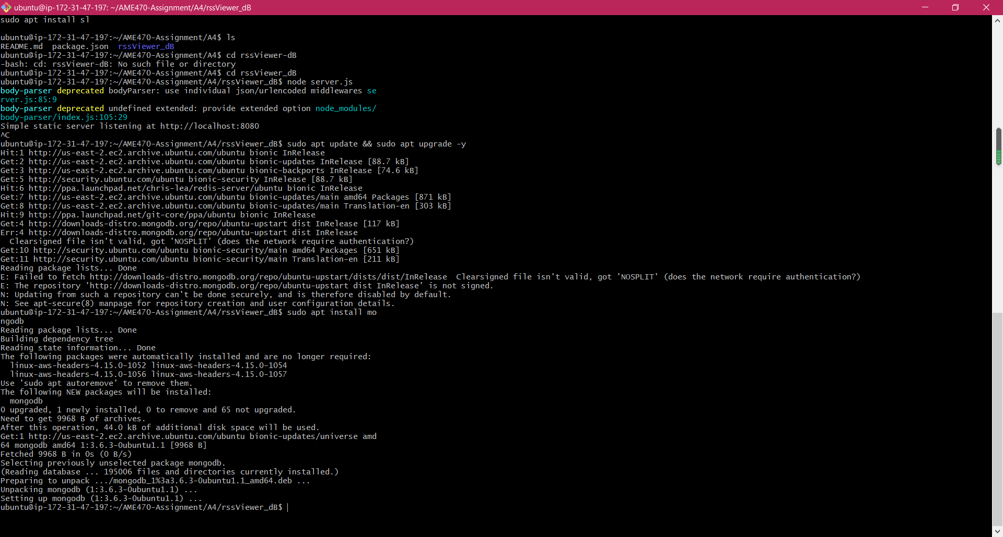

then type

mongo to open the mongo shell

and connect to the localhost

mongo://localhost

Set up the ubuntu port 8080 open in the security group

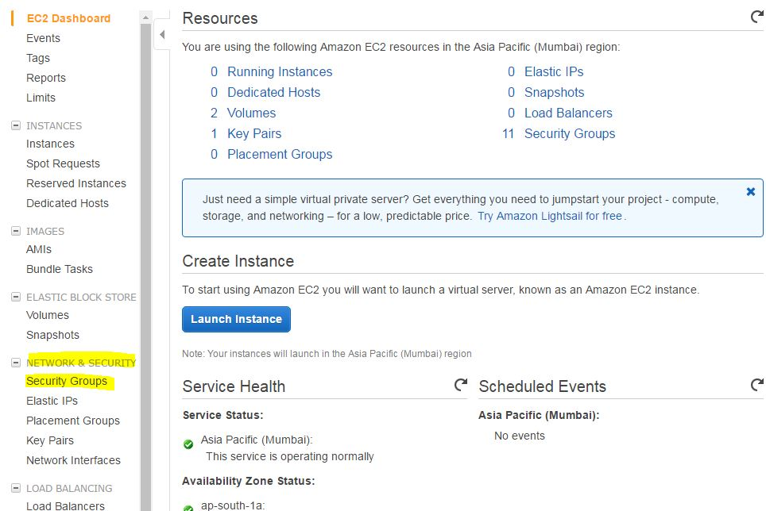



Locate to the folder

Run the program

node server.js

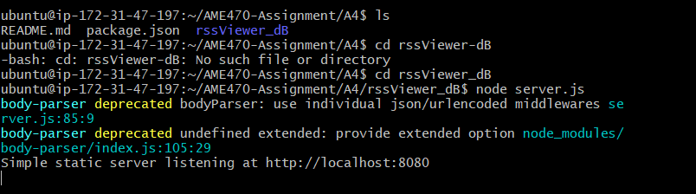

Then type the server IP address and the port number to open the html page



Add some feeds from <https://rss.itunes.apple.com/en-us>

