Stack.pop()和stack.peek()都一样能返回栈顶元素，区别就在于stack.pop同时弹出元素

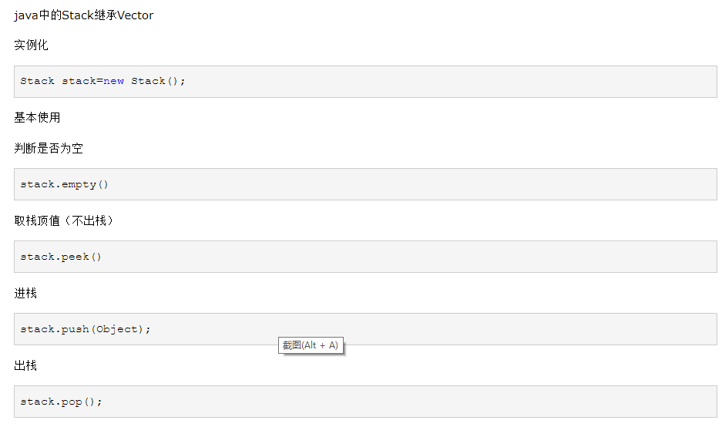

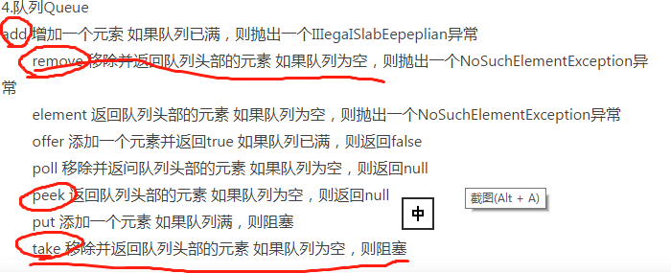

public class Test01 {

public static void main(String[] args) {

Stack stack=new Stack();

//1.empty()栈是否为空

System.out.println(stack.empty());

//2.peek()栈顶值 3.进栈push()

stack.push(new Integer(1));

stack.push("b");

System.out.println(stack.peek());

//4.pop()出栈

stack.pop();

System.out.println(stack.peek());

}

}