|  |  |
| --- | --- |
| LIGN 110: Phonetics | Fall 2020 |
| Section M 9-9:50 Week 1 | October 5, 2020 |

|  |  |
| --- | --- |
| TA | Yuan Chai [ɥɛn˩˥ ʈʂʰai˩˥] |
| Email | [yuc521@ucsd.edu](mailto:yuc521@ucsd.edu) |
| Section time | M 9 – 9:50 AM |
| Office hour | T 11 AM – 12 PM |
| Zoom link | <https://ucsd.zoom.us/my/ychai> |

* **The materials for the section will be emailed to you before the start of the section. The keys will be emailed to you after each section.**
* **All the materials are also available on** [**https://yuanucsd.github.io/website/lign110fall2020.html**](https://yuanucsd.github.io/website/lign110fall2020.html)

**What to expect in a section?**

* A place to do exercises relating to the class materials;
* A space to ask questions about the class materials, quizzes, assignments, and project;
* Any questions, comments, or concerns related to the class are welcome.

**What to prepare?**

* Watch the asynchronous lectures and attend the synchronous lectures on Thursday (if your time zone allows) of the previous week;
* Read the assigned readings of the previous week;
* Participate in the exercises; memorize the IPA symbols; practice saying and transcribing words. Don’t worry if you cannot get everything at the beginning. You will master it by the end of the quarter.

**Goals of Section Week 1**

* Be able to distinguish phonemes from allophones;
* Be able to distinguish voiced from voiceless sounds;
* Familiar yourself with the name of the passive and active articulators;
* Be able to name the place of articulation for sounds in English.

**Exercises**

1. **English consonants** (Textbook p.40 Q4 & 5) The following words all have the vowel /i/, /ɪ/, /ʊ/ (as in “put”), or /ʌ/ (as in “putt”). Transcribe these words and pay attention to the consonants. Some of the consonant sounds have special symbols: /ŋ/, as in “song”, /ɹ/, as in “are”; and /ʃ/, as in wash. Note that /ŋ/ is a single sound, although usually written with two letters -ng.
2. be
3. leaks
4. neat
5. piece
6. deal
7. sing
8. trick
9. ship
10. wick
11. rid
12. wring
13. nicked
14. squish
15. book
16. nut
17. foot
18. lug
19. good
20. should
21. **Voiceless vs. voiced** (Textbook p.41, Q12) Note the difference in voicing between the initial consonants. Transcribe the following words:
22. myth
23. three
24. thee
25. save (vowel: /ej/)
26. safe (vowel: /ej/)
27. nose (vowel: /ow/)
28. keys (vowel: /i/)
29. kiss (vowel: /ɪ/)
30. **Pronounce IPA** (Textbook p.41, Q10) Pronounce:
31. sæg
32. pʌg
33. zɛn
34. pʊt
35. mejt
36. mɪl
37. ʃɪm
38. læs
39. wʌn
40. væt
41. kʌd
42. kʊd
43. **Transcription practice** (Textbook p.42 Q15) Correct these transcriptions:
44. glue /glju/
45. knives /knajvz/
46. reef /ɹɪf/
47. shoot /sut/
48. chew /cu/
49. yes /yɛs/
50. jump /jʌmp/
51. gouge /gawz/
52. wealth /wɛlð/
53. bloom /blʊm/
54. done /dəwn/
55. roy /ɹoj/
56. says /sez/
57. lamb /læmb/
58. **Phonemic vs. allophonic (broad vs. narrow) transcription** (review Book Chapter 3 and the Weeks 0-1 Lecture: Review of phonemes and allophones)

|  |  |  |  |
| --- | --- | --- | --- |
|  | **phonemic (broad)** | **allophonic (narrow)** | **hint** |
| 1. pick (example) | **/**pɪk**/** | [pʰɪk] | aspiration |
| 1. pick |  |  | aspiration |
| 1. type |  |  | aspiration |
| 1. topic |  |  | aspiration |
| 1. please |  |  | devoicing |
| 1. feel |  |  | /l/ allophone |
| 1. dream |  |  | /d/ allophone |
| 1. key |  |  | /k/ allophone |
| 1. cook |  |  | /k/ allophone |
| 1. tenth |  |  | dental assimilation |
| 1. width |  |  | dental assimilation |
| 1. city |  |  | /t/ tapping |
| 1. letter |  |  | /t/ tapping |
| 1. ladder |  |  | /t/ tapping |
| 1. button |  |  | /t/ glottalization |
| 1. meet you |  |  | palatalization |
| 1. stop |  |  | unrealized stop |

1. **Naming the place of articulation (Textbook p.13)**

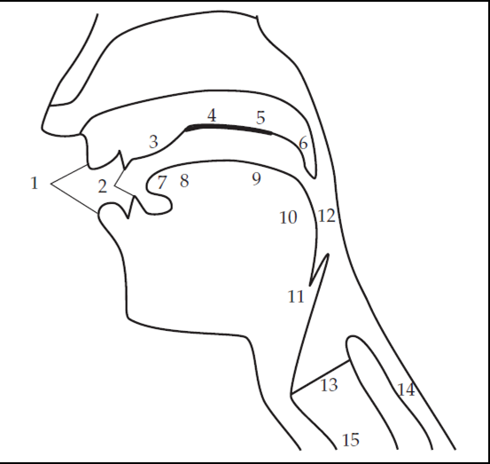

1.

2.

3.

4.

5.

6.

7.

8.

9.

10.

11.

12.

13.

14.

15.